Taxon | Epoch | Locality | Element(s) | Source(s)
Tupaia sp. | Pliocene | Upper Siwaliks of India | Rib cage | Dutta (1975)
Tupaia sivalicus | Miocene | Middle Siwaliks of India | Skull frag., left maxillary frag., right m2 | Chopra and Vasishat (1979); Chopra et al., (1979); Luckett and Jacobs (1980)
Tupaiidae | Miocene | Siwaliks of Pakistan | Skull frag., left m1, lower molar talonid | Jacobs (1980)
Tupaia miocenica | Miocene | Li Mae Long, Thailand | Left M2 | Mein and Ginsburg (1997)
Prodendrogale yunnanica* | Miocene | Lufeng, China | 17 isolated teeth | Qiu (1986)
Prodendrogale engesseri | Miocene | Yuanmou, China | 2 m2 frags., m3 frag., p3 frag., p4 frag., 3 M2 frags., M1 frag., right P4, left P4, left M3, right p4, left M1, right M1/M2, left p4, right m2, right m1/m2 talonid, right M1 | Ni and Qiu (2002); Ni and Qiu (2012)
Tupaia storchi | Miocene | Yuanmou, China | Right P4, right p4, left m3 | Ni and Qiu (2012)
Ptilocercidae gen. et. sp. nov? | Miocene | Yuanmou, China | Dentary with m1 and p4 frag., lower molar frag. | Ni and Qiu (2002)
Ptilocercus kylin* | Oligocene | Lijiawa Mammalian Fossil locality, China | 4 M1 frags., 2 M2 frags., M3 frag., right M2, right c1, right dentary frag. with p3-4 and m1, left c1, right p4, left m1, left m2, left m3, right dentary frag. with m2, left dentary frag. | Li and Ni (2016)
Eodendrogale parvum | Eocene | Henan, China | Upper left molar, right M1 and M3, 2 lower molar talonids | Tong (1988)
Table S1. Currently known treeshrew fossil record modified from Sargis (2004).

Table S2. List of specimens included in the analyses and results of the topographic analysis for Dirichlet normal energy (DNE), three-dimensional orientation patch count rotated (3D-OPCR), and relief index (RFI). DOI/ MorphoSource information is given when available.
Specimen ID | Species | Both Analyses? | DNE | 3D-OPCR | RFI | DOI/ MorphoSource Code
USNM 481107 | Ptilocercus lowii | No | 370.128 | 75.625 | 0.53767 | doi:10.17602/M2/M6391
USNM 488052 | Ptilocercus lowii | Yes | 379.562 | 78.125 | 0.55395 | doi:10.17602/M2/M6415
USNM 488055 | Ptilocercus lowii | Yes | 362.591 | 76.625 | 0.56344 | doi:10.17602/M2/M6418
USNM 481103 | Ptilocercus lowii | No | 364.716 | 75.625 | 0.5901 | doi:10.17602/M2/M6388
USNM 481108 | Ptilocercus lowii | Yes | 421.374 | 93 | 0.59132 | doi:10.17602/M2/M6408
YPM MAM 10179 | Ptilocercus lowii | Yes | 334.67 | 71.875 | 0.538354 | N/A
MCZ 36390 | Dendrogale melanura | Yes | 343.196 | 78.875 | 0.630791 | N/A
FMNH 49262 | Dendrogale melanura | No | 361.815 | 88.875 | 0.66367 | N/A
FMNH 46630 | Dendrogale murina | Yes | 317.582 | 71.25 | 0.656996 | N/A
FMNH 46629 | Dendrogale murina | No | 300.742 | 65 | 0.67611 | M12994-22150
UAM:Mamm:103000 | Dendrogale murina | Yes | 359.359 | 63.375 | 0.64571704 | N/A
AMNH M-103110 | Tupaia chrysogaster | Yes | 332.942 | 69.5 | 0.621501 | doi:10.17602/M2/M59520
AMNH M-103093 | Tupaia chrysogaster | Yes | 309.473 | 66.875 | 0.631357 | doi:10.17602/M2/M59550
AMNH M-103101 | Tupaia chrysogaster | Yes | 346.114 | 70.125 | 0.647911 | doi:10.17602/M2/M58673
AMNH M-103096 | Tupaia chrysogaster | Yes | 339.482 | 66.375 | 0.65322 | doi:10.17602/M2/M59075
AMNH M-103095 | Tupaia chrysogaster | Yes | 357.632 | 63.875 | 0.664597 | doi:10.17602/M2/M59072
AMNH M-103614 | Tupaia salatana | No | 295.734 | 68.75 | 0.573701 | doi:10.17602/M2/M59588
AMNH M-103613 | Tupaia salatana | No | 285.186 | 71.125 | 0.588558 | doi:10.17602/M2/M59416
AMNH M-103609 | Tupaia salatana | Yes | 331.949 | 67 | 0.593922 | doi:10.17602/M2/M59087
AMNH M-103611 | Tupaia salatana | Yes | 309.336 | 63.375 | 0.624521 | doi:10.17602/M2/M59591
AMNH M-103612 | Tupaia salatana | Yes | 323.095 | 71.375 | 0.641161 | doi:10.17602/M2/M59078
USNM 311311 | Tupaia glis | Yes | 306.132 | 74.375 | 0.60269 | doi:10.17602/M2/M6602
USNM 487950 | Tupaia glis | No | 303.424 | 76.125 | 0.61292 | doi:10.17602/M2/M6611
USNM 112662 | Tupaia glis | Yes | 365.046 | 70.375 | 0.66101 | doi:10.17602/M2/M6465
USNM 311305 | Tupaia glis | No | 321.18 | 71.375 | 0.66697 | doi:10.17602/M2/M6382
USNM 320655 | Tupaia belangeri | Yes | 377.84 | 72.625 | 0.63796 | doi:10.17602/M2/M6583
USNM 320690 | Tupaia belangeri | Yes | 351.873 | 73.75 | 0.66499 | doi:10.17602/M2/M6608
USNM 320666 | Tupaia belangeri | Yes | 407.507 | 77.25 | 0.67182 | doi:10.17602/M2/M6604
USNM 320689 | Tupaia belangeri | Yes | 389.733 | 77.125 | 0.72051 | doi:10.17602/M2/M6384
USNM 320680 | Tupaia belangeri | Yes | 375.359 | 70.625 | 0.73313 | doi:10.17602/M2/M6606
AMNH M-106110 | Tupaia gracilis | Yes | 342.648 | 64.75 | 0.586241 | doi:10.17602/M2/M59409
AMNH M-103619 | Tupaia gracilis | Yes | 292.991 | 60.25 | 0.613209 | doi:10.17602/M2/M59379
AMNH M-103620 | Tupaia gracilis | Yes | 314.55 | 67.75 | 0.616572 | doi:10.17602/M2/M59373
AMNH M-103850 | Tupaia gracilis | Yes | 315.06 | 69.875 | 0.626239 | doi:10.17602/M2/M59350
AMNH M-103892 | Tupaia dorsalis | No | 347.641 | 73.375 | 0.587323 | doi:10.17602/M2/M59400
AMNH M-106107 | Tupaia dorsalis | Yes | 352.666 | 65.125 | 0.651864 | doi:10.17602/M2/M59370
AMNH M-32631 | Tupaia dorsalis | Yes | 405.886 | 65.875 | 0.655381 | doi:10.17602/M2/M59090
AMNH M-106104 | Tupaia dorsalis | Yes | 401.98 | 67.5 | 0.661011 | doi:10.17602/M2/M59406
AMNH M-106106 | Tupaia dorsalis | Yes | 401.208 | 77.125 | 0.673387 | doi:10.17602/M2/M59361
AMNH M-101670 | Tupaia javanica | No | 292.809 | 81.5 | 0.475056 | doi:10.17602/M2/M59364
AMNH M-101663 | Tupaia javanica | Yes | 343.665 | 71.625 | 0.557407 | doi:10.17602/M2/M59412
AMNH M-101672 | Tupaia javanica | Yes | 309.468 | 67.75 | 0.567472 | doi:10.17602/M2/M59376
AMNH M-101664 | Tupaia javanica | Yes | 372.709 | 69.5 | 0.568756 | doi:10.17602/M2/M59367
AMNH M-101832 | Tupaia javanica | Yes | 345.632 | 71.125 | 0.594074 | doi:10.17602/M2/M59388
AMNH M-242088 | Tupaia palawanensis | No | 257.144 | 72.25 | 0.465294 | doi:10.17602/M2/M59403
AMNH M-207597 | Tupaia palawanensis | No | 296.412 | 78.875 | 0.503431 | doi:10.17602/M2/M59397
AMNH M-29725 | Tupaia palawanensis | No | 347.082 | 84 | 0.515167 | doi:10.17602/M2/M59391
AMNH M-175465 | Tupaia palawanensis | No | 322.934 | 83.875 | 0.555929 | doi:10.17602/M2/M59523
AMNH M-207599 | Tupaia palawanensis | No | 281.925 | 71.375 | 0.571474 | doi:10.17602/M2/M59356
FMNH 62948 | Tupaia palawanensis | Yes | 343.778 | 66.625 | 0.64969 | M13013-22189
AMNH M-102526 | Tupaia minor | Yes | 317.232 | 67.5 | 0.522606 | doi:10.17602/M2/M59382
AMNH M-102527 | Tupaia minor | Yes | 307.54 | 67.625 | 0.539375 | doi:10.17602/M2/M59385
AMNH M-103906 | Tupaia minor | No | 323.261 | 78.25 | 0.549639 | doi:10.17602/M2/M59353
AMNH M-102529 | Tupaia minor | Yes | 366.905 | 69.375 | 0.574177 | doi:10.17602/M2/M59394
FMNH 141464 | Tupaia minor | Yes | 326.098 | 72.875 | 0.61467 | M13037-22242
UMZC E.4063.A | Tupaia picta | No | - | - | - | N/A
AMNH M-102830 | Tupaia tana | Yes | 314.964 | 62.75 | 0.586705 | doi:10.17602/M2/M59081
AMNH M-102831 | Tupaia tana | Yes | 264.571 | 62 | 0.602236 | doi:10.17602/M2/M59084
AMNH M-102829 | Tupaia tana | Yes | 303.78 | 67.875 | 0.613356 | doi:10.17602/M2/M59578
AMNH M-102518 | Tupaia tana | Yes | 349.247 | 59.25 | 0.649551 | doi:10.17602/M2/M59422
FMNH 68793 | Tupaia tana | No | 346.772 | 80.75 | 0.65349 | M13020-22205
UMZC E.4062.A | Tupaia montana | No | - | - | - | N/A
IVPP V20696 | Ptilocercus kylin† | Yes | 343.994 | 66.25 | 0.551966 | N/A
IVPP V8282.13 | Prodendrogale yunnanica† | No | - | - | - | N/A

Table S3. Eigenvalues and percent variance explained for the first four principal components (PC) in the geometric morphometric analysis (GMA) and the three PCs in the dental topographic analysis (DTA).
Principal Component | Eigenvalue | % Variance Explained
GMA
PC 1 | 0.003394 | 22.56
PC 2 | 0.002359 | 15.68
PC 3 | 0.001676 | 11.14
PC 4 | 0.001551 | 10.31
DTA
PC 1 | 1.475330 | 49.18
PC 2 | 1.042890 | 34.76
PC 3 | 0.481776 | 16.06

Table S4. Loadings of the PCA of the topographic variables Dirichlet normal energy (DNE), three-dimensional orientation patch count rotated (3D-OPCR), and relief index (RFI).
 | PC 1 | PC 2 | PC 3
DNE | 0.72215 | 0.012114 | -0.69163
3D-OPCR | 0.52768 | -0.65614 | 0.53948
RFI | 0.44727 | 0.75454 | 0.48022

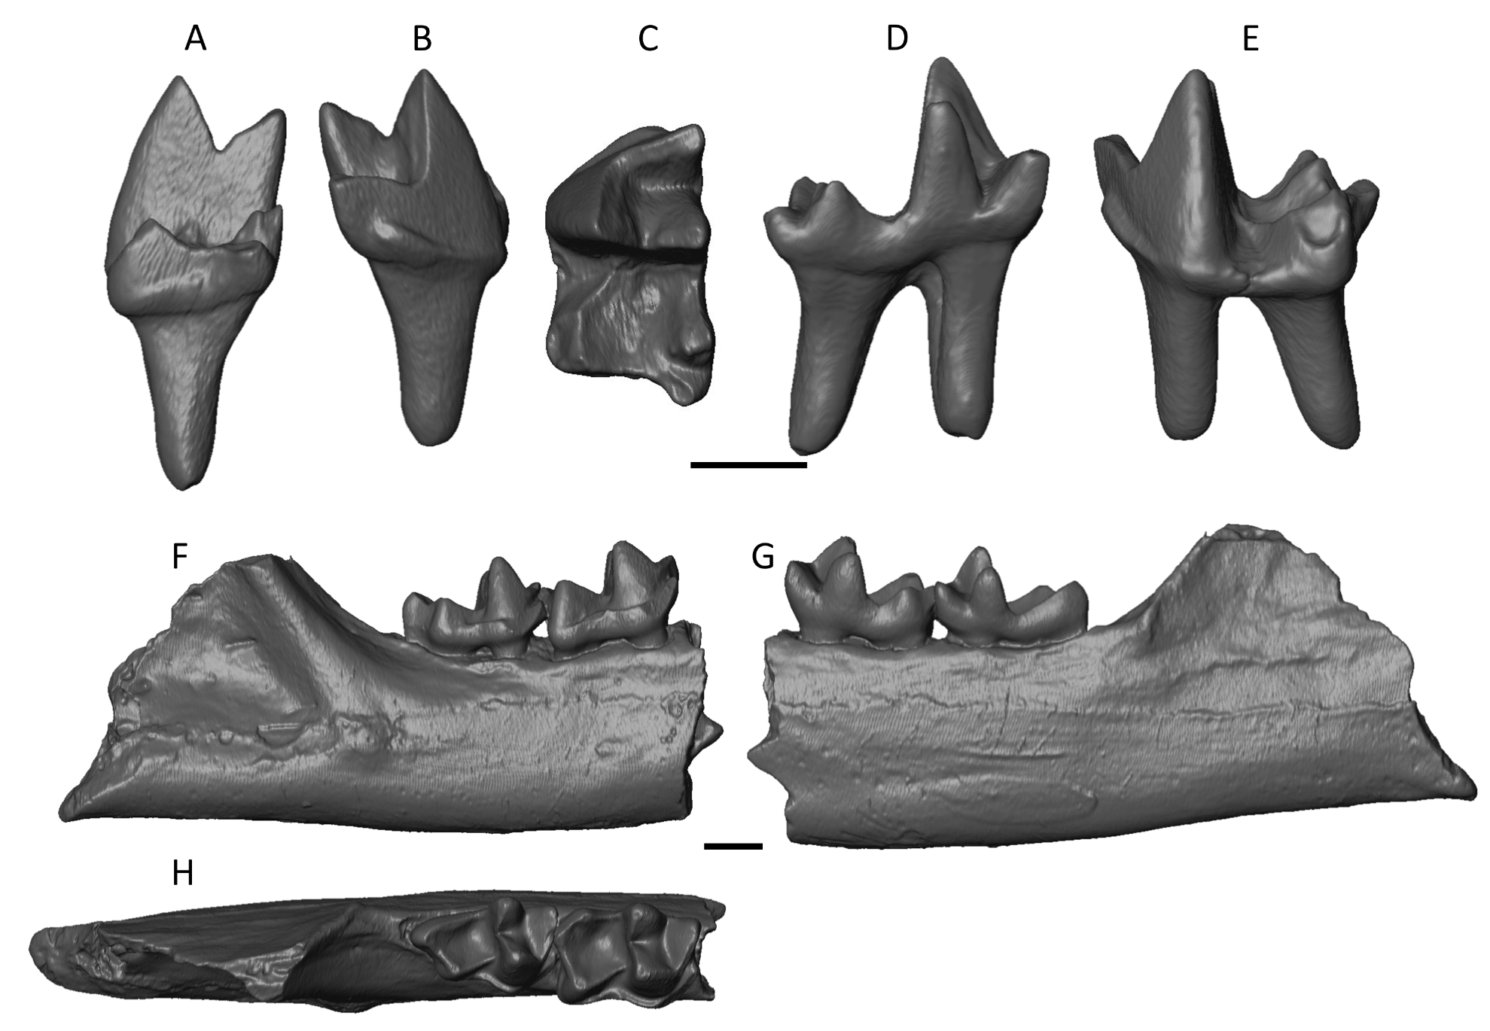

Figure S1. Top: micro-CT rendering of Prodendrogale yunnanica left m2 (IVPP V8282.13) in A, distal; B, mesial; C, occlusal; D, lingual; and E, buccal views. Bottom: micro-CT rendering of Ptilocercus kylin right partial dentary cast (IVPP V20696, holotype) in F, buccal; G, lingual; and H, occlusal views. Scale bars equal 1 mm.

