Table 1 Sequence of SSR and Indel primers for the genetic linkage map of the numerous spines gene in cucumber
Table 2 Validity of the SSRns-127 marker tightly linked to the numerous spines gene was tested using an F₂ population with 60 plants derived from the cross of Coolgreen×NCG-127
Table 3 Annotation of genes located in the ns genetic mapping region
Figure 1. Phenotype pictures of the parental lines and F₁. a: P₁ (NCG-122 fruit with numerous spines); b: P₂ (NCG-121 fruit with few spines); c: F₁ (fruit with few spines).
Figure 2. Molecular marker linkage and chromosomal mapping of the numerous spines gene in cucumber. a: chromosome 2 of cucumber; b: SSR linkage of the numerous spines gene for preliminary mapping; c: linkage of molecular markers to the ns gene for second mapping; d: physical map of partial molecular markers; e: predicted genes among the flanking markers. (The number on the bars shows number of recombinant plants between ns and flanking markers.)

Table 1
Primer name | Forward primer | Reverse primer | Motif | Fragment size
SSR04869 | CCAACACCACCCTTCGTTTA | CGGAACCGTTCGTCTTCTT | (TC)27 | 202
SSR22338 | GGTGGATGAAGAGGGGAAAT | TACTCCTTCCTTCGCCCTTT | (AGA)16 | 159
SSRns-10 | TGAATGCATCTCTGTTGTGGA | GGCCATCCTCAAGTTCTCAA | (TCAC)5(CT)10 | 197
SSRns-36 | TGATCACTTGCTTGGTGTTACC | GGCGTTTAGGCCCATAATTT | (AT)10 | 152
Indelns-4 | AGAAAAGACGTTTGTTGGAG | ACCCTTATCGAGTCTTCAAA | Insertion (ACATG) | 223/228
SSRns-40 | GCCATATTAAGAAAAACCAATTCAC | GCTCTGCTTGATTTCTTCTGC | (AAG)9 | 172
SSRns-59 | AAGCAAAATGGGAATCCAAG | CCCTCCCTCCTTTGCTTAAT | (AAAG)5 | 240
SSR11596 | TCACATAGGCTTGCTCCAAA | TCAAACACCGCGAAAGAGAT | (TA)18 | 150
Indelns-16 | ATGACAAATGATCTGGTGGT | CAATATCCCGTTGTTGTCTT | Deletion (TTTCA) | 228/223
SSR07108 | TAAGCAATTCCAGGAGAGGG | GTTCTTTGATGGGTGCCTGT | (GA)19 | 210
SSRns-82 | AGATCCTAAAAGGGGATCTTGA | TCCAGAGGTTTTTCCTTTTCTC | (TA)9 | 155
SSRns-123 | CGAAGGTGAAGGCAAAGAAG | TTTAGGGTTTCCAGCCGATA | (AC)9 | 198
SSRns-127 | AGTGACAAAAAGACTAACTCAACAAA | TTGGGTATATAGATTGTCACTACTCCT | (TTA)7 | 206
SSR04219 | GAGACATTGTGGGCATTTGA | CTCATTTTCATCCAAAGGGC | (AT)17 | 218
SSR10518 | TCTAATTCGCTCCGGATGAT | TTGCAGCGAACAATCCTGTA | (ATTA)5(A)30 | 211
SSR15172 | GGTGTGGGTTATTTTGGCAC | GAAGAAATCAAAGAGGGGGC | (CTCTTT)7 | 168
SSR13818 | TTGTTAGTTCATTTGAGGTGTCAAG | TCCATATTAACTCTCTCAGGCTAACA | (TA)32 | 189

Table 2
Material code | Fruit spines Phenotype | SSRns-127 | Material code | Phenotype | SSRns-127 | Material code | Phenotype | SSRns-127
Coolgreen | numerous | b | F₂-19 | few | h | F₂-40 | few | h
NCG127 | few | a | F₂-20 | few | h | F₂-41 | few | a
F₁ | few | h | F₂-21 | numerous | b | F₂-42 | few | a
F₂-1 | few | h | F₂-22 | few | h | F₂-43 | few | h
F₂-2 | few | a | F₂-23 | few | h | F₂-44 | numerous | b
F₂-3 | few | h | F₂-24 | numerous | b | F₂-45 | few | h
F₂-4 | few | a | F₂-25 | few | a | F₂-46 | numerous | b
F₂-5 | few | h | F₂-26 | few | a | F₂-47 | few | h
F₂-6 | few | b | F₂-27 | few | h | F₂-48 | numerous | b
F₂-7 | few | a | F₂-28 | few | h | F₂-49 | few | a
F₂-8 | numerous | b | F₂-29 | few | a | F₂-50 | few | h
F₂-9 | few | h | F₂-30 | few | h | F₂-51 | few | h
F₂-10 | few | h | F₂-31 | few | h | F₂-52 | few | h
F₂-11 | few | a | F₂-32 | few | h | F₂-53 | few | h
F₂-12 | few | h | F₂-33 | few | h | F₂-54 | numerous | h
F₂-13 | numerous | b | F₂-34 | few | h | F₂-55 | numerous | b
F₂-14 | few | a | F₂-35 | few | a | F₂-56 | few | a
F₂-15 | numerous | b | F₂-36 | few | a | F₂-57 | few | a
F₂-16 | numerous | b | F₂-37 | few | a | F₂-58 | few | h
F₂-17 | numerous | h | F₂-38 | few | h | F₂-59 | few | a
F₂-18 | few | a | F₂-39 | few | h | F₂-60 | numerous | b

Table 3
Predicted genes | Functions | Predicted genes | Functions
Csa2G285330 | Glycoside hydrolase family 43;  Glycosyl hydrolase family 43 five-bladed beta-propellor domain | Csa2G286490 | Protein kinase catalytic domain;  Serine/threonine-protein kinase domain;  kinase ATP binding site
Csa2G285340 | Transcription factor GRAS | Csa2G286500 | Zinc finger LIM-type;  Ubiquitin interacting motif
Csa2G285350 | Ribosomal protein L26/L24P eukaryotic/archaeal;  KOW;  Translation protein SH3-like | Csa2G286510 | Protein kinase catalytic domain;  Serine-threonine/tyrosine-protein kinase
Csa2G285360 | Porin eukaryotic type | Csa2G286520 | Pentatricopeptide repeat
Csa2G285390 | WD40 repeat; WD40 repeat-like-containing domain | Csa2G286530 | Pentatricopeptide repeat
Csa2G285890 | Helix-loop-helix DNA-binding domain | Csa2G287040 | Ankyrin repeat;  Ankyrin repeat-containing domain
Csa2G285900 | Lipase class 3 | Csa2G287050 | Proteinase inhibitor I13 potato inhibitor I
Csa2G285910 | RNA recognition motif domain;  Nucleotide-binding alpha-beta plait | Csa2G287060 | mRNA splicing factor thioredoxin-like U5 snRNP;  Thioredoxin fold;  Thioredoxin-like fold
Csa2G285920 | Peptidase M24 structural domain;  Peptidase M24A methionine aminopeptidase subfamily 1 | Csa2G287080 | Allergen V5/Tpx-1-related;  CAP domain
Csa2G285930 | Transcriptional factor B3;  Restriction endonuclease type II EcoRII N-terminal | Csa2G287090 | Domain of unknown function DUF547
Csa2G286440 | Calcium-binding EF-hand;  EF-hand-like domain | Csa2G287110 | POX;  Homeodomain-like;Homeodomain-related
Csa2G286450 | Calcium-binding EF-hand;  EF-hand-like domain | Csa2G287130 | Zinc finger C2H2-type
Csa2G286470 | Pentatricopeptide repeat;  Tetratricopeptide-like helical | Csa2G287160 | Transcriptional factor B3;  Restriction endonuclease type II EcoRII N-terminal
Csa2G286480 | Multicopper oxidase type 1;  Multicopper oxidase type 2;  Multicopper oxidase type 3

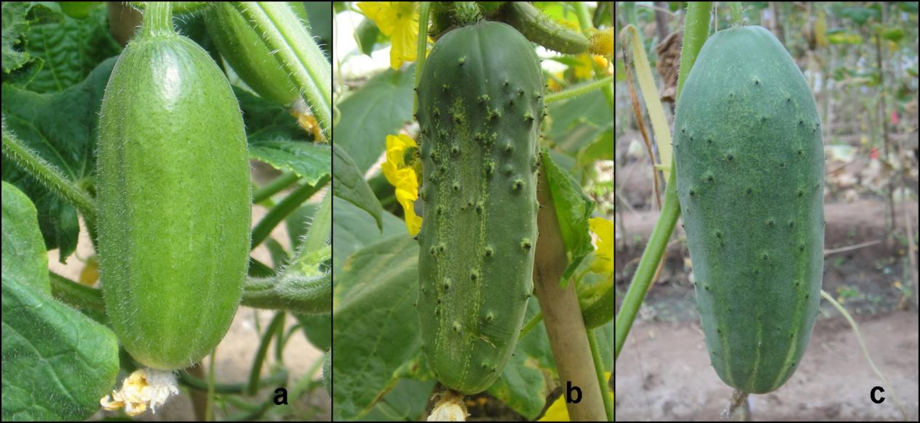
Figure1.

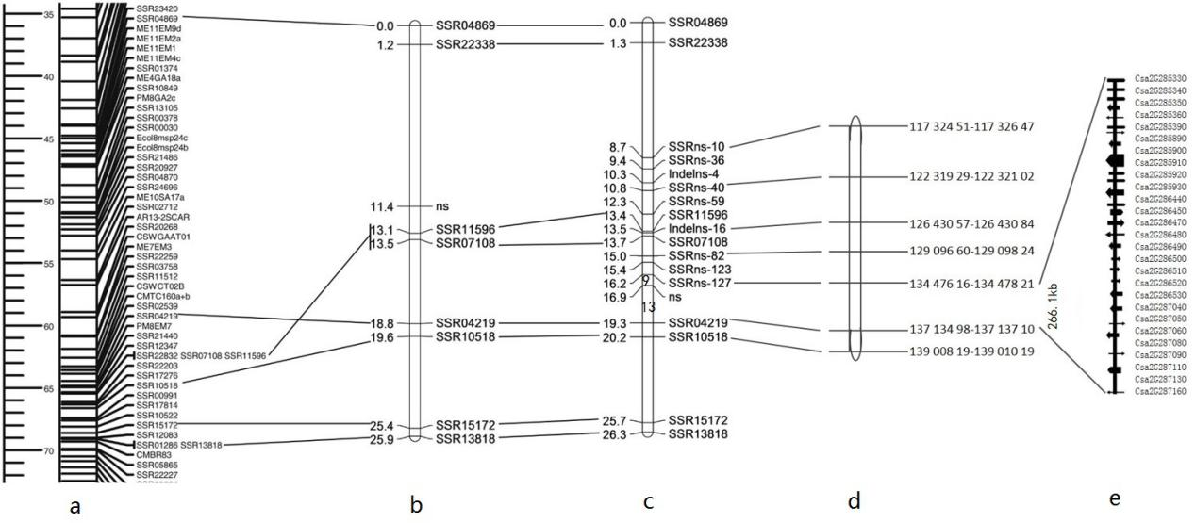

Figure 2.

