Supplementary Materials for

Towards an understanding of cosmopolitanism in deep time: a case study of ammonoids from the middle Permian to the Middle Triassic
Xu Dai, Haijun Song*

Table of contents
- Supplementary methods
- Supplementary figures
- Supplementary tables
- Supplementary references

- Supplementary methods

source code

  - resampling method to calculate BC.

TL.matrix<-read.table("data.txt")
n.rows<-nrow(TL.matrix)
n.cols<-ncol(TL.matrix)
n<-n.rows
TL.rs<-rep(NA,5000)
a<-rep(NA,n.cols)
for(i in 1:5000){
sr<-sample(n.rows, size=n, replace=T)
bootsur<-TL.matrix[sr,]
for(j in 1:n.cols){
if(sum(bootsur[,j])>0){a[j]=1}
else{a[j]=0}}
o<-sum(bootsur)
BC <- (o-n)/(sum(a)*n-n)
TL.rs[i]<-BC
}
TL.mean<-mean(TL.rs,na.rm=TRUE)
TL.sd<-sd(TL.rs,na.rm=TRUE)
TL.low<-quantile(TL.rs,0.025,na.rm=TRUE)
TL.up<-quantile(TL.rs,0.975,na.rm=TRUE)
c(TL.mean,TL.sd,TL.low,TL.up)
hist(TL.rs)

- Supplementary figures

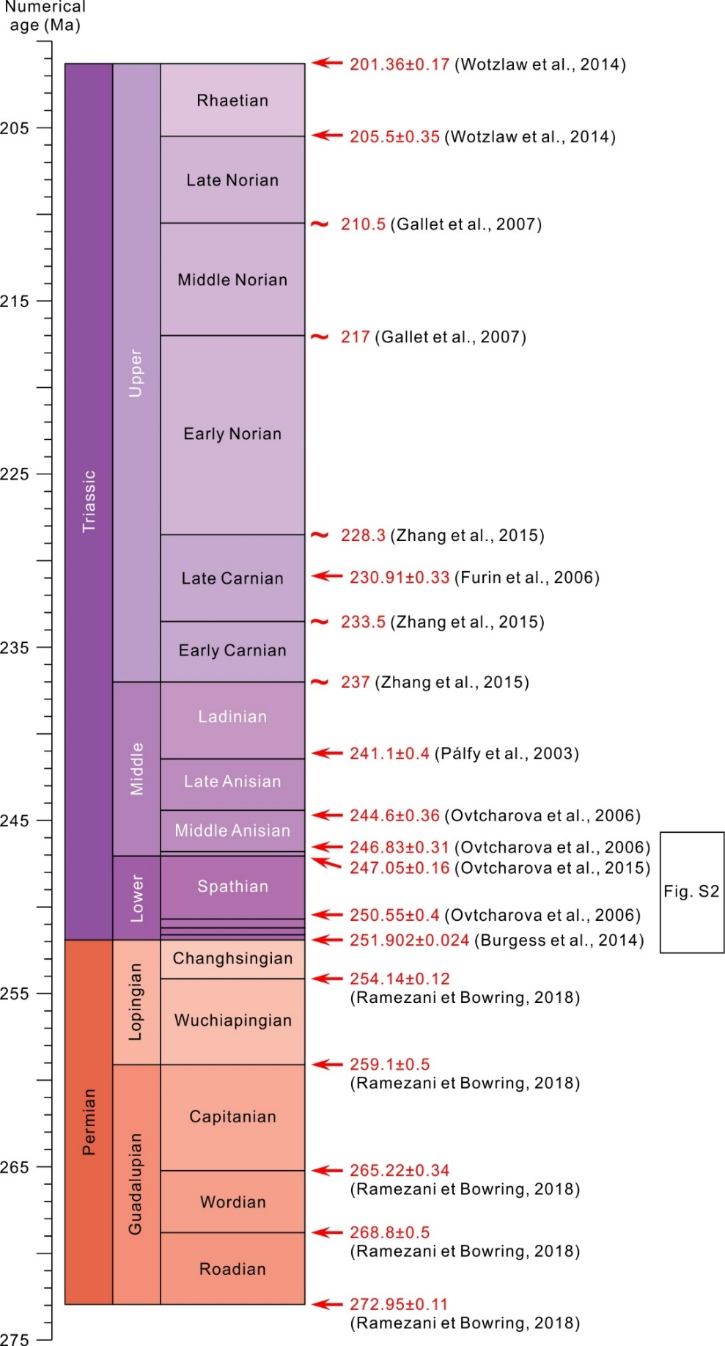
Figure S1. Middle Permian to Middle Triassic numerical age.
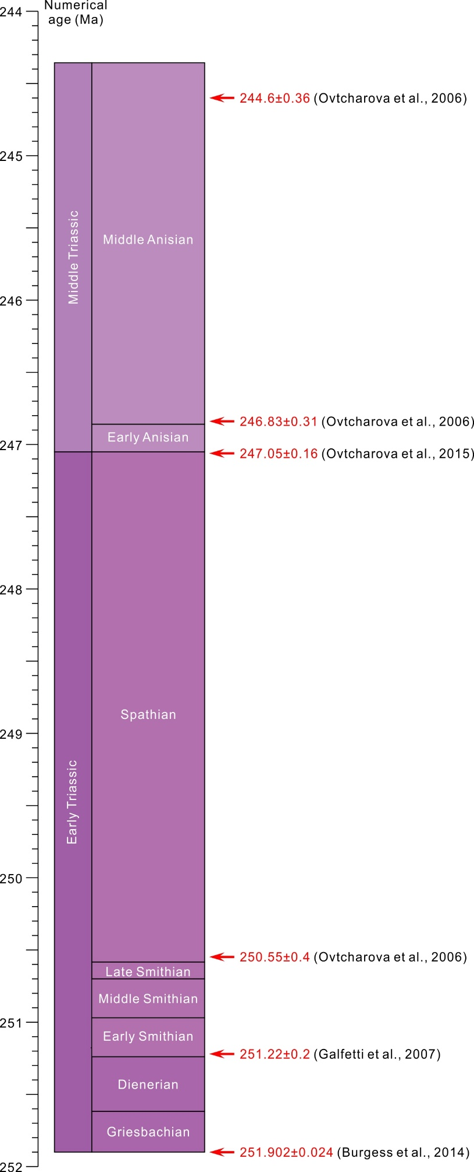
Figure S2. Early Triassic numerical age.
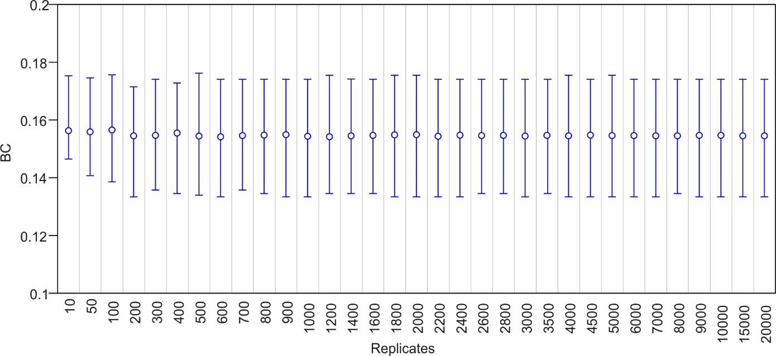
Figure S3. Estimated BC with different replications of the Wordian ammonoid. The vertical bars indicate 95% confidence interval.

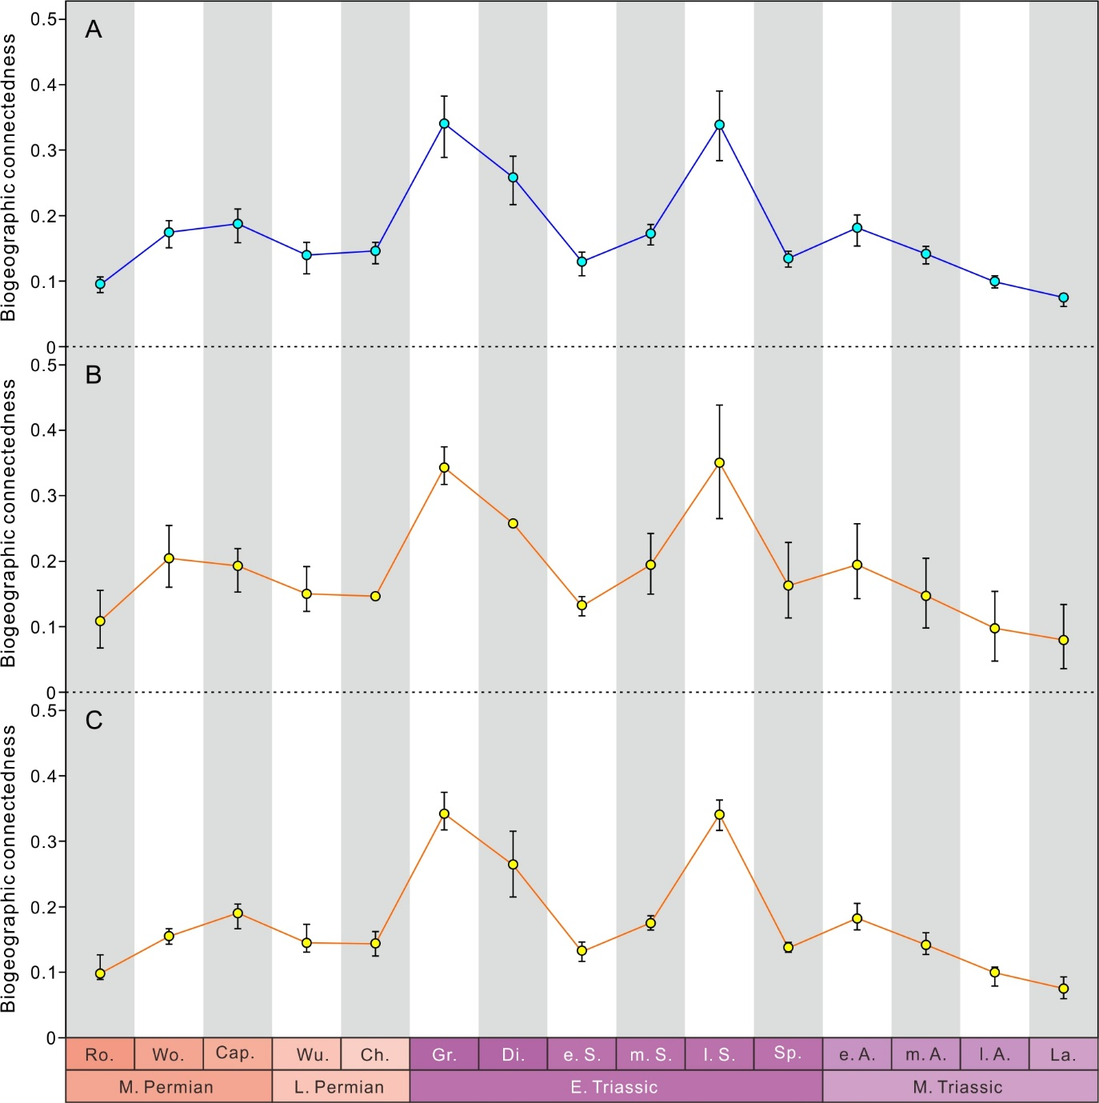
Figure S4. A, Estimated mean biogeographic connectedness with 95% confidence interval (sample size = 90% genera); B, Estimated mean biogeographic connectedness with 95% confidence interval, calculated by even resample size, eight locations, with 5000 runs; C, Estimated mean biogeographic connectedness with 95% confidence interval, calculated by jackknife method on locations with 5000 runs. Ro., Roadian; Wo., Wordian; Cap., Capitanian; Wu., Wuchiapingian; Ch., Changhsingian; Gr., Griesbachian; Di., Dienerian; e. S., early Smithian; m. S., middle Smithian; l. S., late Smithian; Sp., Spathian; e. A., early Anisian; m. A., middle Anisian; l. A., late Anisian; La., Ladinian; E., Early; M., Middle; L., Late.

- Supplementary tables
Table S1. middle Permian-Middle Triassic ammonoid geographic occurrences. (separated as the supplementary excel file).
Table S2. middle Permian-Middle Triassic ammonoid genera-location matrixes. (separated as the supplementary excel file).
Table S3. Abbreviations of locations in Figure 3.

Ab | Albania | Gc | Greece | Ma | Malaysia | SC | South China | Tu | Turkey
AC | Arctic Canada | Ge | Germany | Md | Madagascar | Si | Siberia | Tm | Timor
Af | Afghanistan | Gr | Greenland | Me | Mexico | Sn | Spain | Tn | Tunisia
Al | Alaska | Hi | Himalayas | Mo | Mongolia | SP | South_Primorye | Ur | Volga-Ural
Ap | Alps | Hu | Hungary | NC | North China | SR | Salt_Range | Ve | Verkhoyansk
BC | British Columbia | Ik | Irak | Ol | Olenek | Tb | Tibet | Vi | NE_Vietnam
Ca | Caucasus | Ir | Iran | Om | Oman | Te | Texas | WA | Western Australia
Ch | Chios | Is | Israel | PA | Pamirs-Afghanistan | Th | Thailand | WU | Western USA
CI | Central Iran | It | Italy | Qh | Qinghai | TI | Transcaucasia-North Iran | Yu | Yugoslavia
Cr | Crimea | JP | Japan | Ru | Rumania
FE | Far East, Russian | Ki | Kirovsk | Sb | Spitsbergen

- Supplementary references.

References of Middle Permian to Middle Triassic numerical age:

Burgess, S. D., S. Bowring, and S.-z. Shen. 2014. High-precision timeline for Earth's most severe extinction. Proceedings of the National Academy of Sciences of the United States of America 111(9):3316–3321.
Furin, S., N. Preto, M. Rigo, G. Roghi, P. Gianolla, J. L. Crowley, and S. A. Bowring. 2007. High-precision U-Pb zircon age from the Triassic of Italy: Implications for the Triassic time scale and the Carnian origin of calcareous nannoplankton and dinosaurs (vol 34, pg 1009, 2006). Geology 35(2):146–146.
Galfetti, T., H. Bucher, M. Ovtcharova, U. Schaltegger, A. Brayard, T. Bruehwiler, N. Goudemand, H. Weissert, P. A. Hochuli, F. Cordey, and K. Guodun. 2007. Timing of the Early Triassic carbon cycle perturbations inferred from new U-Pb ages and ammonoid biochronozones. Earth and Planetary Science Letters 258(3–4):593–604.
Gallet, Y., L. Krystyn, J. Marcoux, and J. Besse. 2007. New constraints on the End-Triassic (Upper Norian-Rhaetian) magnetostratigraphy. Earth and Planetary Science Letters 255(3–4):458–470.
Ovtcharova, M., H. Bucher, U. Schaltegger, T. Galfetti, A. Brayard, and J. Guex. 2006. New Early to Middle Triassic U-Pb ages from South China: Calibration with ammonoid biochronozones and implications for the timing of the Triassic biotic recovery. Earth and Planetary Science Letters 243(3–4):463–475.
Ovtcharova, M., N. Goudemand, O. Hammer, K. Guodun, F. Cordey, T. Galfetti, U. Schaltegger, and H. Bucher. 2015. Developing a strategy for accurate definition of a geological boundary through radio-isotopic and biochronological dating: The Early-Middle Triassic boundary (South China). Earth-Science Reviews 146:65–76.
Palfy, J., R. R. Parrish, K. David, and A. Voros. 2003. Mid-Triassic integrated U-Pb geochronology and ammonoid biochronology from the Balaton Highland (Hungary). Journal of the Geological Society 160:271–284.
Ramezani, J., and S. A. Bowring. 2018. Advances in numerical calibration of the Permian timescale based on radioisotopic geochronology. Geological Society, London, Special Publications 450(1):51–60.
Wotzlaw, J.-F., J. Guex, A. Bartolini, Y. Gallet, L. Krystyn, C. A. McRoberts, D. Taylor, B. Schoene, and U. Schaltegger. 2014. Towards accurate numerical calibration of the Late Triassic: High-precision U-Pb geochronology constraints on the duration of the Rhaetian. Geology 42(7):571–574.
Zhang, Y., M. Li, J. G. Ogg, P. Montgomery, C. Huang, Z.-Q. Chen, Z. Shi, P. Enos, and D. J. Lehrmann. 2015. Cycle-calibrated magnetostratigraphy of middle Carnian from South China: Implications for Late Triassic time scale and termination of the Yangtze Platform. Palaeogeography Palaeoclimatology Palaaeoecology 436:135–166.

