Appendix S3. Measurements of postcranial elements of Simomylodon uccasamamensis from the Bolivian Altiplano and corresponding descriptions and depictions. Modified from Toledo et al. (2014).

FORELIMB

Scapula

SL: Scapular Length – supraglenoid tubercle to dorso-posterior border of scapula at end of spine
SGL: Scapular Glenoid Fossa Length – supraglenoid apophysis to ventral border of glenoid fossa
SW: Scapular Glenoid Fossa Width – maximum transverse width of glenoid fossa
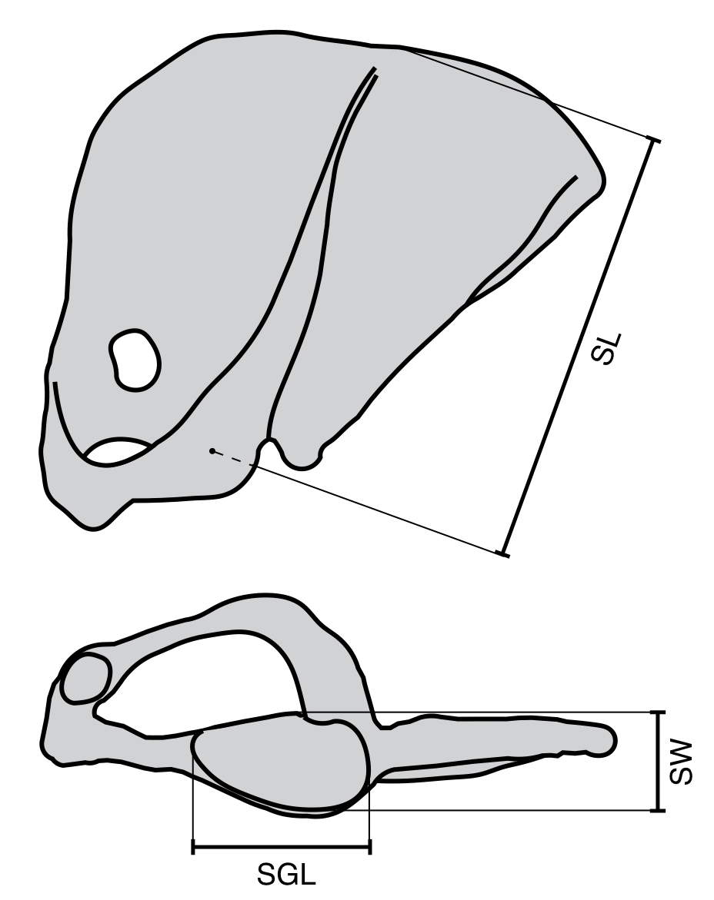

Locality | Collection Number | SL | SGL | SW
Inchasi | MNHN-Bol V 3718 | 227.3 | 60.5 | 39.6

Humerus:

HL: Humerus Length – between head and trochlea
TDH: Transverse Diameter of Humerus – at midshaft
APDH: Antero-Posterior Diameter of Humerus – at midshaft
HDEW: Humeral Distal Epiphysis Width
Wtub: Width Across Tuberosities
HHW: Humeral Head Width
HHL: Humeral Head Length
HGT: Humeral Great Tuberosity Length
HLT: Humeral Lesser Tuberosity Length
HEMP: Humeral Entepicondyle Medial Protrusion
HTD: Humeral Trochlea Depth
HDASW: Humeral Distal Articular Surface Width
HTVL: Humeral Trochlear Valley Length

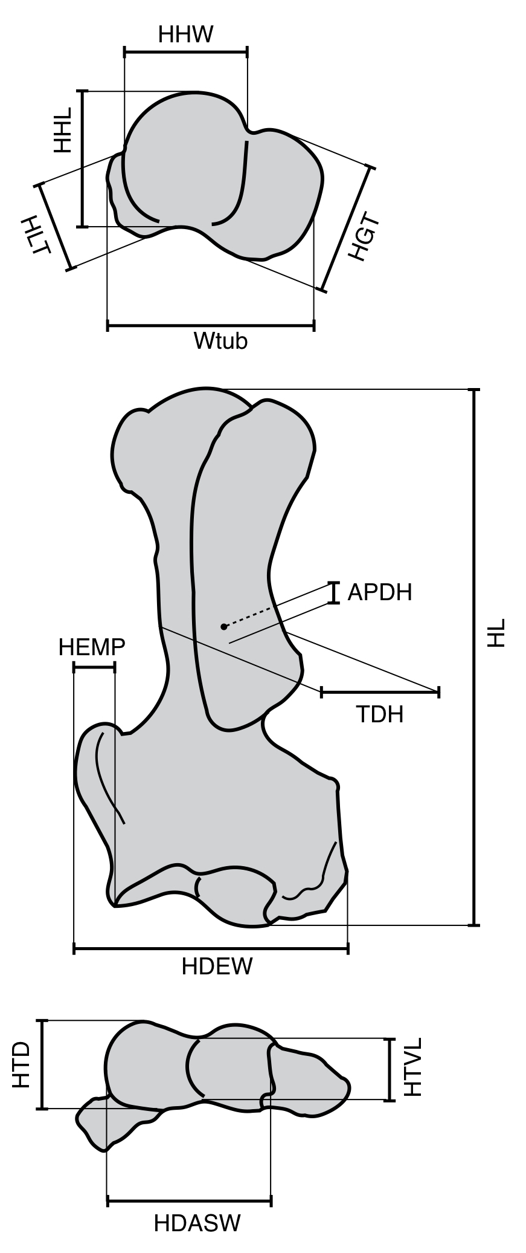

Locality | Collection Number | HL | TDH | APDH | HDEW | Wtub | HHW | HHL | HGT | HLT | HEMP | HTD | HDASW | HTVL
Ayo Ayo | MNHN.F.AYO102 | 256.6 | 52.6 | 45.5 |  | 98.4 | 65.8 | 59.9 | 43 | 49 | 22.9 | 43.2 | 75.4 | 32.8
Ayo Ayo | MNHN.F.AYO110 |  | 49.4 | 44.7 | 122.0 |  |  |  |  |  | 23.9 | 43.7 | 73.5 | 34.3
Ayo Ayo | MNHN.F.AYO121 |  |  |  |  |  | 58.9 | 59.5 | 35.6 | 51.4
Ayo Ayo | MNHN.F.AYO222 |  |  |  | 113.2 |  |  |  |  |  | 27.5 | 37.6
Ayo Ayo | MNHN.F.AYO228 |  |  |  |  |  |  |  |  |  |  | 41.5 |  | 33.2
Pomata | MNHN.F.POM25 |  | 26.7 | 22
Viscachani | MNHN.F.VIZ3 |  |  |  |  |  |  |  |  |  |  | 44.4 |  | 33
Ayo Ayo | MNHN-Bol V 3303 |  | 48.7 | 43.6 | 110.5 |  |  |  |  |  | 22.9 | 47.9 | 74.5 | 32.3
Viscachani | MNHN-Bol V 11795 |  | 38.9 | 44.5 | 107.9 |  |  |  |  |  | 21.5 | 41.3 | 68.3 | 27.3
Ayo Ayo | MNHN-Bol V 11766 |  | 56.5 | 42.2 |  | 94 | 56.1 | 58 | 61.6 | 37.6
Viscachani | MNHN-Bol V 11776 |  | 40.1 | 38.5 |  | 81.1 | 51.1 | 49.3 | 49.2 | 33.6
Viscachani | MNHN-Bol V 12518 |  | 54.9 | 43.6 |  | 96.3 | 58.9 | 59.8 | 66.9 | 39
Inchasi | MNHN-Bol V 6573 |  | 44.2 | 45.2 |  |  |  |  |  |  | 21 | 38.5 | 64.6 | 32.1
Ayo Ayo | MNHN-Bol V 3792 |  |  |  | 128.9 |  |  |  |  |  | 17.3 | 48.3 | 77.2 | 35.6
Pomata | MNHN-Bol V 12949 | 208 | 35.3 | 40.6 | 103.6 |  |  |  | 41.7 | 33 | 21.7 | 35.2 | 59 | 28.3
Ayo Ayo | MNHN-Bol V 13367 | 251.3 | 53.9 | 47.9 | 121.1 | 86.3 | 56.7 | 57.2 | 65.6 | 37.3 | 22.4 | 41.8 | 68.7 | 33.2
Radius:

RL: Radius Length
TDR: Transverse Diameter of Radius – at midshaft;
APDR: Antero-Posterior Diameter of Radius – at midshaft;
RHL: Radial Head Length
RHW: Radial Head Width
RDFL: Radial Distal Facet Length
RDEW: Radial Distal Epiphysis Width

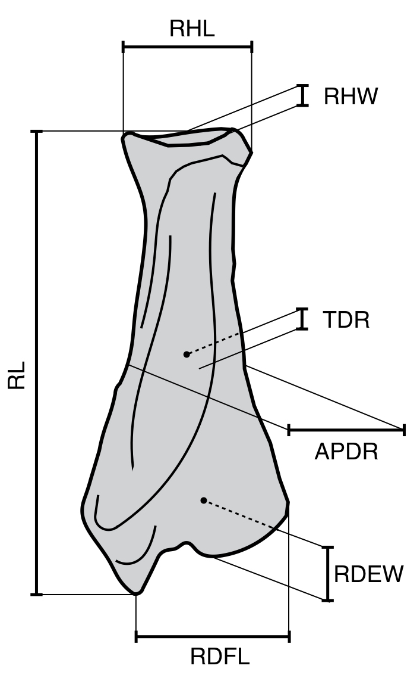

Locality | Collection Number | RL | TDR | APDR | RHL | RHW | RDFL | RDEW
Ayo Ayo | MMHN AYO 126 |  |  |  | 35.7 | 29.1
Ayo Ayo | MMHN AYO 178 |  | 21 | 51.4 |  |  | 57.5 | 34.9
Ayo Ayo | MMHN AYO 179 |  |  |  | 36.5 | 27.5
Ayo Ayo | MMHN AYO 180 | 189.2 | 21.2 | 47.6 | 33.3 | 27.5 | 62.4 | 35.3
Ayo Ayo | MMHN AYO 223 |  | 22.7 | 48.3 |  |  | 59.9 | 39.7
Viscachani | MNHN.F.VIZ16 |  |  |  | 33.5 | 26.9
Inchasi | MNHN-Bol V 3375 | 201.1 | 19.2 | 44.7 | 33.4 | 27.6 | 60.7 | 40.3
Inchasi | MNHN-Bol V 6573 |  |  |  | 39.5 | 27.7

Ulna:

UL: Ulnar Length
THU: Transverse Height of Ulna – at midshaft
TDU: Transverse Diameter of Ulna – at midshaft
THUn: Transverse Height of Ulna – at notch level
UAPSO: Ulnar Anconeal Process to Summit of Olecranon
OTL: Olecranon – Trochlear notch Length
UTNL: Ulnar Trochlear Notch Length
UPNL: Ulnar Pre-Notch Length
UCPDE: Ulnar Coronoid Process to Distal End
UTNW: Ulnar Trochlear Notch Width – at posterior border

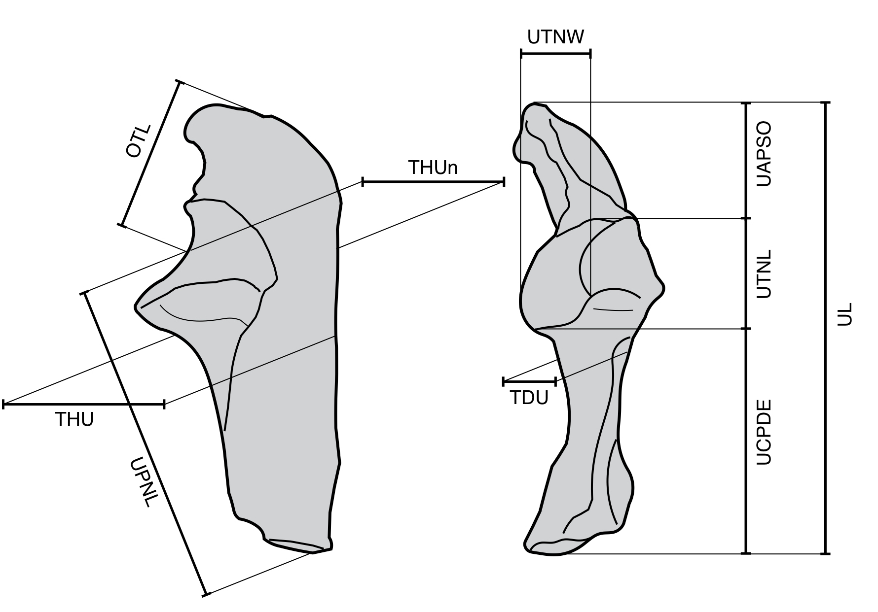

Locality | Collection Number | UL | THU | TDU | THUn | UAPSO | OTL | UTNL | UPNL | UCPDE | UTNW
Casira | MNHN-Bol V 3717 | - | 54.6 | 21 | 61.2 | 56.7 | 74.7 | 56 | 130.8 | 118.9 | 28.6

Carpals:

D-Pd: Dorso-Palmar depth
M-Lw: Medio-Lateral width
P-Dl: Proximo-Distal length

 |  | Scaphoid |  |  | Lunar |  |  | Cuneiform
Locality | Collection Number | D-Pd | M-Lw | P-Dl | D-Pd | M-Lw | P-Dl | D-Pd | M-Lw | P-Dl
Ayo Ayo | MNHN.F.AYO111 |  |  |  | 30.5 | 37.8 | 37.8
Ayo Ayo | MNHN.F.AYO109 |  |  |  |  |  |  | 31.7 | 37.2 | 31.3
Ayo Ayo | MNHN.F.AYO180 | 43.3 | 26.7 | 50 | 32.1 | 36.5 | 35.9
Viscachani | MNHN.F.VIZ17 |  |  |  | 30.1 | 33.8 | 34.8
Casira | MNHN-Bol V 6564 |  |  |  | 31.2 | 34.7 | 28.7
Pomata Ayte | MNHN-Bol V 12953
Viscachani | MNHN-Bol V 11784 |  |  |  | 28.8 | 32.1 | 30.7
Inchasi | MNHN-Bol V 6573 |  |  |  | 26.6 | 36.4 | 28.3 | 27.8 | 32.5 | 29.3
 |  | Trapezoid |  |  | Unciform
Locality | Collection Number | D-Pd | M-Lw | P-Dl | D-Pd | M-Lw | P-Dl
Ayo Ayo | MNHN.F.AYO111
Ayo Ayo | MNHN.F.AYO109
Ayo Ayo | MNHN.F.AYO180 | 21.1 | 23.9 | 19.3
Viscachani | MNHN.F.VIZ17
Casira | MNHN-Bol V 6564
Pomata Ayte | MNHN-Bol V 12953 |  |  |  | 27 | 33.7 | 38.5
Viscachani | MNHN-Bol V 11784
Inchasi | MNHN-Bol V 6573

Metacarpals:

D-Pd: Dorso-Palmar depth
M-Lw: Medio-Lateral width
TL: Total Length
Prox Epi: Proximal Epiphysis
Mid Diam: Mid Diameter
Dist Epi: Distal Epiphysis

Mtc1 |  |  | Prox Epi |  | Mid Diam |  | Dist Epi
Locality | Collection Number | TL | D-Pd | M-Lw | D-Pd | M-Lw | D-Pd | M-Lw
Viscachani | MNHN.F.VIZ32 | 37.6 | 30 | 23 | 16 | 15.8 | 13.7 | 16
Inchasi | MNHN-Bol V 6573 | 33.6 | 28.9 | 18.5 | 14.4 | 14.6 | 10.5 | 15.5
Mtc2 |  |  | Prox Epi |  | Mid Diam |  | Dist Epi
Locality | Collection Number | TL | D-Pd | M-Lw | D-Pd | M-Lw | D-Pd | M-Lw
Ayo Ayo | MNHN.F.AYO180 | 54.2 | 28.4 | 21.5 | 20.9 | 20.8 | 28.3 | 25.5
Ayo Ayo | MNHN.F.AYO190 | 55.9 | 28 | 23.6 | 18.1 | 19.5 | 32.7 | 24
Ayo Ayo | MNHN-Bol V 3318 | 49.3 | 26.1 | 20.1 | 21.4 | 19.6 | 29.6 | 19.5
Inchasi | MNHN-Bol V 6573 | 51 | 23.2 | 19.4 | 15.9 | 17.1 | 26.5 | 17.6
Mtc3 |  |  | Prox Epi |  | Mid Diam |  | Dist Epi
Locality | Collection Number | TL | D-Pd | M-Lw | D-Pd | M-Lw | D-Pd | M-Lw
Ayo Ayo | MNHN.F.AYO179 | x | x | x | 23.2 | 21.2 | 34.6 | 30.2
Ayo Ayo | MNHN.F.AYO180 | x | x | x | 23.4 | 22.2 | 35 | 27.8
Pomata | MNHN.F.POM79 |  |  |  |  |  | 30.7 | 26.4
Viscachani | MNHN.F.VIZ5 | 67.7 | 31.3 | 39.7 | 29.8 | 18.7 | 29.2 | 25.7
Viscachani | MNHN.F.VIZ27 | 66.8 | 36.4 | 41.9 | 23.3 | 23.9 | 34.5 | 30.1
Casira | MNHN-Bol V 6564 | 71.9 | 39.5 | 34.1 | 26.5 | 26 | 33.7 | 28.4
Inchasi | MNHN-Bol V 6573 | 64.6 | 31.9 | 35.6 | 16.3 | 23.1 | 30.9 | 26.1
Pomata | MNHN-Bol V 12927 | 62.1 | 32.2 | 34.4 | 23.9 | 21 | 27.5 | 25.3
Mtc4 |  |  | Prox Epi |  | Mid Diam |  | Dist Epi
Locality | Collection Number | TL | D-Pd | M-Lw | D-Pd | M-Lw | D-Pd | M-Lw
Viscachani | MNHN.F.VIZ24 |  | 28.6 | 23.5 | 19.8 | 17.7
Viscachani | MNHN.F.VIZ33 |  | 34.6 | 26.9 | 29 | 13.9
Inchasi | MNHN-Bol V 6573 | 80.6 | 28.8 | 26.2 | 20.1 | 13.6 | 25.7 | 22.6
Mtc5 |  |  | Prox Epi |  | Mid Diam |  | Dist Epi
Locality | Collection Number | TL | D-Pd | M-Lw | D-Pd | M-Lw | D-Pd | M-Lw
Ayo Ayo | MNHN-Bol V 13367 | 71.9 | 17.5 | 19.1 | 17.2 | 9.1 | 14.5 | 15.9

HINDLIMB

Femur:

FL: Femoral Length – between head and medial condyle
TDF: Transverse Diameter of Femur – at midshaft
APDF: Antero-Posterior Diameter of Femur – at midshaft
Wtroc: Width across trochanters
FHL: Femoral Head Length
FHW: Femoral Head Width
FMDEW: Femoral Maximum Distal Epiphysis Width
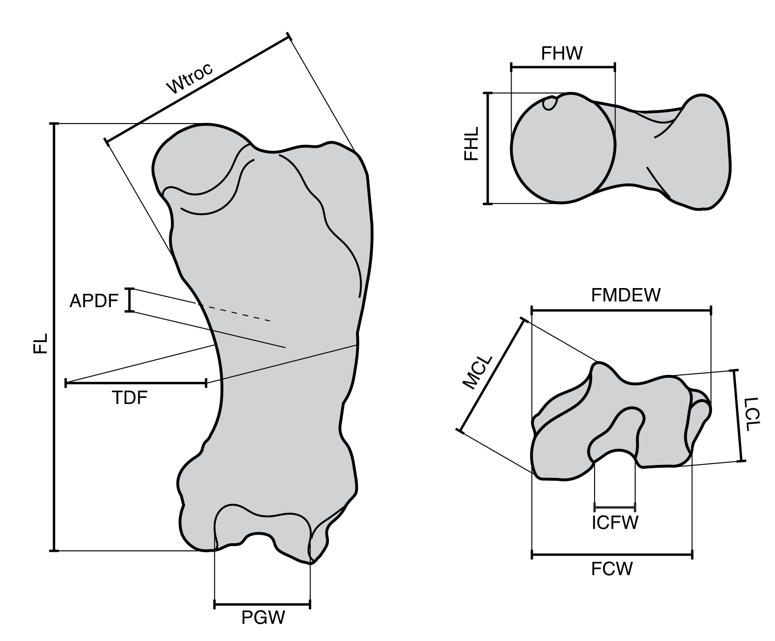
PGW: Patellar Groove Width
FCW: Femoral Condylar Width
ICFW: Inter-Condylar Femoral Width
MCL: Medial Condyle Length
LCL: Lateral Condyle Length

Locality | Collection Number | FL | TDF | APDF | Wtroc | FHL | FHW | FMDEW | PGW | FCW | ICFW | MCL | LCL
Ayo Ayo | MNHN.F.AYO129 |  |  |  |  | 65.3 | 57.6
Ayo Ayo | MNHN.F.AYO166 |  | 77.5 | 38.4
Ayo Ayo | MNHN.F.AYO167 |  | 87.6 | 33.5
Ayo Ayo | MNHN.F.AYO168 |  |  |  |  |  |  | 115.4 | 50.7 | 94.6 | 23.9 | 75 | 51.7
Ayo Ayo | MNHN.F.AYO169 |  |  |  |  |  |  |  | 58.7 | 105.2 | 25.2 |  | 60.6
Ayo Ayo | MNHN.F.AYO196 |  | 70.2 | 28.2
Ayo Ayo | MNHN.F.AYO197 |  | 96.2 | 35.6
Pomata Ayte | MNHN-Bol V 12953 | 337 | 95.3 | 43.3 | 140.8 | 74.4 | 69.1 | 132.1 | 64.6 | 105.4 | 22.8 | 84.6 | 56.8
Inchasi | MNHN-Bol V 3365 |  | 82.1 | 35.4 |  |  |  | 121.8 | 53.3 | 93.2 | 21 | 71.6 | 52.8
Ayo Ayo | MNHN-Bol V 3299 | 343.6 | 94 | 41.6 | 136.2 | 66.9 | 64.7 | 134 | 58.4 | 101.9 | 21.6 | 85.2 | 55.1
Ayo Ayo | MNHN-Bol V 3301 |  |  |  |  |  |  |  | 59.8 | 98.8 | 20.5 | 83.8 | 59.5
Viscachani | MNHN-Bol V 12518 | 307.2 | 85.3 | 37.3 | 133.4 | 62 | 60 | 122 | 55.2 | 94.4 | 18.7 | 74.2 | 49.2
Viscachani | MNHN-Bol V 12277 | 337.8 | 99.7 | 38.7 | 135.4 | 65.5 | 61.6 | 128 | 60.1 | 103.2 | 28.2 | 82.3 | 54.6
Ayo Ayo | MNHN-Bol V 8541 |  | 91.1 | 36.7 |  | 58.1 | 54.3 | 119.8
Ayo Ayo | MNHN-Bol V 3773 |  | 100.3 | 42.6
Ayo Ayo | MNHN-Bol V 10919 |  | 95.7 | 36.5 |  |  |  | 125.8 | 55.7 | 101.1 | 22.4 | 80.9 | 49.2
Pomata Ayte | MNHN-Bol V 12881 |  |  |  |  |  |  | 89 | 31.6 | 64.5 | 17.9 | 58.1 | 46.6
Ayo Ayo | MNHN-Bol V 11673 |  | 91 | 36.6 | 135.5 | 67.7 | 68.8
Tibia:

TL: Tibial Length – from interfacet eminence to tibial malleolus
TDT: Transverse Diameter of Tibia – at midshaft
APDT: Antero-Posterior Diameter of Tibia – at midshaft
TPEW: Tibial Proximal Epiphysis Width
TPEL: Tibial Proximal Epiphysis Length
MTFL: Medial Tibial Facet Length
MTFW: Medial Tibial Facet Width
LTFL: Lateral Tibial Facet Length
LTFW: Lateral Tibial Facet Width
TMW: Tibial Mortise Width
TML: Tibial Mortise Length
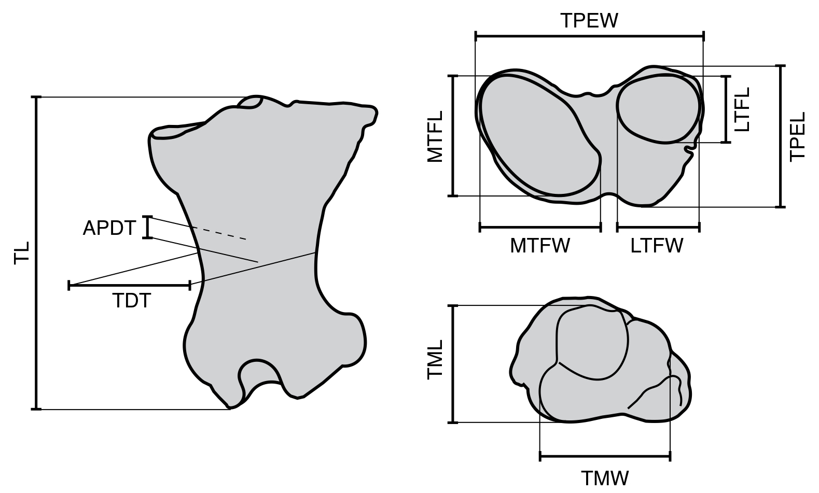

Locality | Collection Number | TL | TDT | APDT | TPEW | TPEL | MTFL | MTFW | LTFL | LTFW | TMW | TML
Ayo Ayo | MNHN.F.AYO200 |  |  |  |  |  |  |  |  |  | 61.5 | 37.2
Ayo Ayo | MNHN.F.AYO201 |  |  |  |  |  |  |  |  |  | 61.7 | 44.1
Pomata | MNHN.F.POM62 | 160.5 | 50.7 | 29.4 | 79.3 | 41 | 33.2 | 54.8 |  |  | 50 | 40.5
Viscachani | MNHN.F.VIZ22 |  |  |  |  |  |  |  |  |  | 60.6 | 43.7
Inchasi | MNHN-Bol V 3365 |  | 43.8 | 23.2 | 82.9 |  |  | 54.2
Ayo Ayo | MNHN-Bol V 3300 | 188.5 | 51 | 30 | 102.6 | 73.9 | 65.7 | 60.4 | 39.1 | 40.6 | 75 | 62.4
Ayo Ayo | MNHN-Bol V 3305 |  | 47.3 | 27.7 | 95.7 | 60.1 | 57.8 | 53.4 | 33.1 | 39.2
Viscachani | MNHN-Bol V 12507 | 173.5 | 46.4 | 23.5 | 99.1 | 74.6 | 56.8 | 57.8 | 34.1 | 37.4 | 68.1 | 52
Pomata | MNHN-Bol V 11876 | 168.8 | 43.9 | 23.5 | 87.6 | 61.6 | 46.4 | 54.7 | 27.1 | 27.7 | 64.8 | 49.6
Viscachani | MNHN-Bol V 11772 |  | 54.9 | 32.2 | 107.9 | 85.4 | 67.2 | 60.6 | 42 | 48
Viscachani | MNHN-Bol V 11777 |  |  |  |  |  |  |  |  |  | 73.6 | 59.1
Viscachani | MNHN-Bol V 12518 | 173.9 | 49 | 26.8 | 101.3 | 62.8 | 50.4 | 56.3 | 33.1 | 37.5 | 68.4 | 52.6
Pomata | MNHN-Bol 013216 | 154.1 | 40.2 | 23.9 | 85.8 | 62.7 | 44.1 | 43.9 | 28.3 | 33.2 | 63.7 | 46.2
Ayo Ayo | MNHN-Bol 013220 | 180 | 54.4 | 31.3 | 103.7 | 84.7 | 53.4 | 53.8 | 36.2 | 37.1 | 75.9 | 58.2
Ayo Ayo | MNHN-Bol 013221 | 177.6 | 50.3 | 28 | 96.5 | 63.8 | 55.3 | 51.5 | 28.8 | 35.2 | 69.6 | 57.4

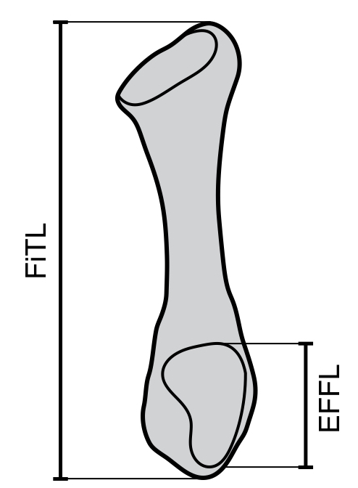
Fibula:

FiTL: Fibular Total Length
EFFL: Ectal Fibular Facet Length

Locality | Collection Number | FiTL | EFFL
Viscachani | MNHN-Bol V 12507 | 176.5 | 35.4
Viscachani | MNHN-Bol V 11767 | 183.9 | 37.6
Viscachani | MNHN-Bol V 12518 | 180.3 | 40
Ayo Ayo | MNHN-Bol V 8541 | 164.9 | 36.3

Tarsals:

D-Pd: Dorso-Palmar depth
M-Lw: Medio-Lateral width
P-Dl: Proximo-Distal length

 |  | Astragalus |  |  | Cuboid |  |  | Navicular
Locality | Collection Number | D-Pd | M-Lw | P-Dl | D-Pd | M-Lw | P-Dl | D-Pd | M-Lw | P-Dl
Ayo Ayo | MNHN.F.AYO128 |  |  |  | 26 | 42.5 | 31.7
Viscachani | MNHN.F.VIZ39 | 56.7 | 78 | 64.2
Ayo Ayo | MNHN.F.AYO182 | 62.4 | 82.6 | 74.8
Pomata | MNHN.F.POM64 | 45.5 | 78.8 | 73.8
Pomata | MNHN.F.POM66 |  |  |  | 29.8 | 42.1 | 32.5
Viscachani | MNHN-Bol V 11788 | 57.4 | 80.8 | 73.5
Viscachani | MNHN-Bol V 11779 | 57.6 | 80 | 71.8
Viscachani | MNHN-Bol V 11780 |  |  |  |  |  |  | 44.4 | 33.7 | 17.9
Viscachani | MNHN-Bol V 12518 | 58.4 | 76.9 | 72.2 | 28.8 | 51.1 | 34.1
Ayo Ayo | MNHN-Bol V 8541 |  |  |  |  |  |  | 39.6 | 31.7 | 18.3
Ayo Ayo | UF 312843 | 54.2 | 74.4 | 70.1
Ayo Ayo | MNHN-Bol V 13367 | 53.1 | 74.2 | 70.4

Metatarsals:

D-Pd: Dorso-Palmar depth
M-Lw: Medio-Lateral width
TL: Total Length

Prox Epi: Proximal Epiphysis
Mid Diam: Mid Diameter
Dist Epi: Distal Epiphysis

Mtt3 |  |  | Prox Epi |  | Mid Diam |  | Dist Epi
Locality | Collection Number | TL | D-Pd | M-Lw | D-Pd | M-Lw | D-Pd | M-Lw
Ayo Ayo | MNHN-Bol V 13372 | 45.9 | 29.6 | 22.1 | 10.5 | 10 | 20.9 | 15.2
Viscachani | MNHN-Bol V 13495 | 46.1 | 27.5 | 23.5 | 14.3 | 10.7 | 21.8 | 14.7
Mtt4 |  |  | Prox Epi |  | Mid Diam |  | Dist Epi
Locality | Collection Number | TL | D-Pd | M-Lw | D-Pd | M-Lw | D-Pd | M-Lw
Viscachani | MNHN.F.VIZ28 |  | 37.2 | 28.7 | 16.1 | 20

