Supplementary files

Association between hemostatic profile and migraine: a Mendelian randomization analysis
Short title for the running head: Hemostatic profile and migraine: an MR study
Yanjun Guo, Pamela M. Rist, Maria Sabater-Lleal, Paul S. de Vries, Cohorts for Heart and Aging Research in Genomic Epidemiology (CHARGE) Hemostasis Working Group, The International Headache Genetics Consortium, 23andMe Research Team, Nicholas L. Smith, Paul M Ridker, Tobias Kurth, Daniel I. Chasman
Contents
Supplementary Table 1 Detailed information for the genome-wide association study summary statistics used in the current study. 4
Supplementary Table 2 Distribution of the instruments for all the hemostatic profiles used in the current study. 6
Supplementary Table 3 Instrumental estimates of hemostatic profiles with migraine, migraine with aura (MA), and migraine without aura (MO). 14
Supplementary Table 4 Instrumental estimates of migraine and migraine without aura (MO) with hemostatic profiles. 16
Supplementary Table 5 Sensitivity analysis of instrumental estimates of hemostatic profiles with migraine, migraine with aura (MA), and migraine without aura (MO) using MR-PRESSO. 17
Supplementary Table 6 Sensitivity analysis of instrumental estimates of hemostatic profiles with migraine, migraine with aura (MA), and migraine without aura (MO) using IVW, simple median, weighted median, and MR-Egger. 19
Supplementary Table 7 Sensitivity analysis of instrumental estimates of hemostatic profiles with migraine, migraine with aura (MA), and migraine without aura (MO) after removing instruments on ABO gene. 22
Supplementary Table 8 Sensitivity analysis of instrumental estimates of hemostatic profiles with migraine, migraine with aura (MA), and migraine without aura (MO) after removing instruments within 200kb of ABO gene. 24
Supplementary Table 9 Sensitivity analysis of instrumental estimates of hemostatic profiles with migraine, migraine with aura (MA), and migraine without aura (MO) after removing instruments on chromosome 9. 26
Supplementary Table 10 Sensitivity analysis of instrumental estimates of hemostatic profiles with migraine, migraine with aura (MA), and migraine without aura (MO) with cis-only variants…………………………………………………………………………………………………….28
Supplementary Figure 1 Sensitivity analysis of instrumental estimates of hemostatic profiles with migraine after removing instruments on ABO gene (A), within 200kb of ABO gene (B), and on chromosome 9 (C). 29
Supplementary Figure 2 Sensitivity analysis of instrumental estimates of hemostatic profiles with migraine with aura (MA) after removing instruments on ABO gene (A), within 200kb of ABO gene (B), and on chromosome 9 (C). 30
Supplementary Figure 3 Sensitivity analysis of instrumental estimates of hemostatic profiles with migraine without aura (MO) after removing instruments on ABO gene (A), within 200kb of ABO gene (B), and on chromosome 9 (C). 31
Supplementary Figure 4 Leave-one-out sensitivity analysis of instrumental estimates of D-dimer with migraine, migraine with aura (MA), and migraine without aura (MO). 32
Supplementary Figure 5 Leave-one-out sensitivity analysis of instrumental estimates of fibrinogen with migraine, migraine with aura (MA), and migraine without aura (MO). 32
Supplementary Figure 6 Leave-one-out sensitivity analysis of instrumental estimates of coagulation factor VII (FVII) with migraine, migraine with aura (MA), and migraine without aura (MO). 33
Supplementary Figure 7 Leave-one-out sensitivity analysis of instrumental estimates of coagulation factor VIII (FVIII) with migraine, migraine with aura (MA), and migraine without aura (MO). 33
Supplementary Figure 8 Leave-one-out sensitivity analysis of instrumental estimates of coagulation factor XI (FXI) with migraine, migraine with aura (MA), and migraine without aura (MO). 34
Supplementary Figure 9 Leave-one-out sensitivity analysis of instrumental estimates of von Willebrand factor (VWF) with migraine, migraine with aura (MA), and migraine without aura (MO). 34
Supplementary Figure 10 Leave-one-out sensitivity analysis of instrumental estimates of plasminogen activator inhibitor-1 (PAI-1) with migraine, migraine with aura (MA), and migraine without aura (MO).. 35
Supplementary Figure 11 Leave-one-out sensitivity analysis of instrumental estimates of tissue plasminogen activator (tPA) with migraine, migraine with aura (MA), and migraine without aura (MO). 35
Supplementary Figure 12 Leave-one-out sensitivity analysis of instrumental estimates of activated partial thromboplastin time (aPTT) with migraine, migraine with aura (MA), and migraine without aura (MO). 36
Supplementary Figure 13 Leave-one-out sensitivity analysis of instrumental estimates of prothrombin time ( PT/INR) with migraine, migraine with aura (MA), and migraine without aura (MO). 36
Supplementary Figure 14 Single SNP sensitivity analysis of instrumental estimates of fibrinopeptide A with migraine, migraine with aura (MA), and migraine without aura (MO). 37
Supplementary Figure 15 Single SNP sensitivity analysis of instrumental estimates of Phosphorylated fibrinopeptide A with migraine, migraine with aura (MA), and migraine without aura (MO). 37

Supplementary Table 1 Detailed information for the genome-wide association study summary statistics used in the current study.

Trait | PMID | Title | N
Migraine, MA, MO | 27322543 | Meta-analysis of 375,000 individuals identifies 38 susceptibility loci for migraine. | 59,674 cases and 316,078 controls
aPTT | 22703881 | Genetic Associations for Activated Partial Thromboplastin Time and Prothrombin Time, their Gene Expression Profiles, and Risk of Coronary Artery Disease | 11,851
D-dimer | 21502573 | Genetic predictors of fibrin D-dimer levels in healthy adults | 21,052
Fibrinogen | 26561523 | A meta-analysis of 120 246 individuals identifies 18 new loci for fibrinogen concentration | 120,246
FVII | 30642921 | A genome-wide association study identifies new loci for factor VII and implicates factor VII in ischemic stroke etiology | 20,014
FVIII | 30586737 | Genome-Wide Association Transethnic Meta-Analyses Identifies Novel Associations Regulating Coagulation Factor VIII and von Willebrand Factor Plasma Levels | 25,897
FXI | 28053049 | Genome-wide association study with additional genetic and post-transcriptional analyses reveals novel regulators of plasma factor XI levels | 16,169
VWF | 30586737 | Genome-Wide Association Transethnic Meta-Analyses Identifies Novel Associations Regulating Coagulation Factor VIII and von Willebrand Factor Plasma Levels | 42,379
PT/INR | 22703881 | Genetic Associations for Activated Partial Thromboplastin Time and Prothrombin Time, their Gene Expression Profiles, and Risk of Coronary Artery Disease | 3,569
PAI-1 | 22990020 | Genome-wide association study for circulating levels of PAI-1 provides novel insights into its regulation | 19,599
tPA | 24578379 | Genome-Wide Association Study for Circulating Tissue Plasminogen Activator (tPA) Levels and Functional Follow-up Implicates Endothelial STXBP5 and STX2 | 26,929
ADSGEGDFXAEGGGVR* and ADpSGEGDFXAEGGGVR* | 24816252 | An atlas of genetic influences on human blood metabolites | 7,824
Abbreviations: MA: migraine with aura; MO: migraine without aura; aPTT: activated partial thromboplastin time; FVII: coagulation factors VII; FVIII: coagulation factors VIII; FXI: coagulation factors XI; VWF: von Willebrand factor; PAI-1: plasminogen activator inhibitor-1; tPA: tissue plasminogen activator; PT/INR: prothrombin time; ADSGEGDFXAEGGGVR*: fibrinopeptide A; ADpSGEGDFXAEGGGVR*: phosphorylated fibrinopeptide A.

Supplementary Table 2 Distribution of the instruments for all the hemostatic profiles used in the current study.

SNP | CHR | BP | A1 | A2 | freq | aPTT | D-dimer | fibrinogen | FVII | FVIII | FXI | PT/INR | PAI-1 | tPA | ADSGEGDFXAEGGGVR* | ADpSGEGDFXAEGGGVR* | VWF
rs1892534 | 1 | 66105944 | T | C | 0.39 | - | - | Yes | - | - | - | - | - | - | - | - | -
rs2794475 | 1 | 95025193 | T | G | 0.17 | - | Yes | - | - | - | - | - | - | - | - | - | -
rs12029080 | 1 | 95053353 | T | G | 0.70 | - | Yes | - | - | - | - | - | - | - | - | - | -
rs12083537 | 1 | 154381103 | A | G | 0.81 | - | - | Yes | - | - | - | - | - | - | - | - | -
rs2228145 | 1 | 154426970 | A | C | 0.65 | - | - | Yes | - | - | - | - | - | - | - | - | -
rs9426829 | 1 | 154592201 | T | C | 0.53 | - | - | Yes | - | - | - | - | - | - | - | - | -
rs6687813 | 1 | 169477574 | A | C | 0.07 | - | Yes | - | - | - | - | - | - | - | - | - | -
rs1557570 | 1 | 169507844 | T | G | 0.32 | - | Yes | - | - | - | - | - | - | - | - | - | -
rs6028 | 1 | 169551682 | T | C | 0.70 | Yes | - | - | - | - | - | - | - | - | - | - | -
rs12239046 | 1 | 247601595 | T | C | 0.36 | - | - | Yes | - | - | - | - | - | - | - | - | -
rs4925671 | 1 | 247622874 | T | C | 0.28 | - | - | Yes | - | - | - | - | - | - | - | - | -
rs6542680 | 2 | 3640142 | T | C | 0.78 | - | - | Yes | - | - | - | - | - | - | - | - | -
rs1260326 | 2 | 27730940 | T | C | 0.41 | - | - | - | Yes | - | - | - | - | - | - | - | -
rs780094 | 2 | 27741237 | T | C | 0.42 | - | - | - | - | - | Yes | - | - | - | - | - | -
rs1558643 | 2 | 102731691 | T | C | 0.43 | - | - | Yes | - | - | - | - | - | - | - | - | -
rs11897907 | 2 | 113727061 | T | C | 0.50 | - | - | Yes | - | - | - | - | - | - | - | - | -
rs4145013 | 2 | 113830688 | A | G | 0.69 | - | - | Yes | - | - | - | - | - | - | - | - | -
rs6734238 | 2 | 113841030 | A | G | 0.59 | - | - | Yes | - | - | - | - | - | - | - | - | -
rs766271 | 2 | 135667131 | T | C | 0.55 | - | - | Yes | - | - | - | - | - | - | - | - | -
rs715 | 2 | 211543055 | T | C | 0.71 | - | - | Yes | - | - | - | - | - | - | - | - | -
rs59104589 | 2 | 242237902 | T | C | 0.34 | - | - | Yes | - | - | - | - | - | - | - | - | -
rs62246343 | 3 | 9543642 | T | C | 0.13 | - | - | Yes | - | - | - | - | - | - | - | - | -
rs11128603 | 3 | 12385828 | A | G | 0.88 | - | - | - | - | - | - | - | Yes | - | - | - | -
rs6775517 | 3 | 58358967 | T | G | 0.38 | - | - | - | - | - | - | - | - | - | - | - | Yes
rs2717219 | 3 | 122868438 | A | G | 0.65 | - | - | Yes | - | - | - | - | - | - | - | - | -
rs66505225 | 3 | 129241528 | T | C | 0.11 | - | - | Yes | - | - | - | - | - | - | - | - | -
rs7628146 | 3 | 135998453 | T | G | 0.24 | - | - | Yes | - | - | - | - | - | - | - | - | -
rs1868146 | 3 | 186221871 | A | G | 0.11 | Yes | - | - | - | - | - | - | - | - | - | - | -
rs1071592 | 3 | 186338425 | A | C | 0.24 | Yes | - | - | - | - | - | - | - | - | - | - | -
rs35799453 | 3 | 186338540 | T | C | 0.98 | - | - | - | - | - | Yes | - | - | - | - | - | -
rs78954048 | 3 | 186383709 | A | G | 0.97 | - | - | - | - | - | Yes | - | - | - | - | - | -
rs9898 | 3 | 186390627 | T | C | 0.33 | Yes | - | - | - | - | - | - | - | - | - | - | -
rs2378117 | 3 | 186422256 | A | G | 0.88 | - | - | - | - | - | Yes | - | - | - | - | - | -
rs55746367 | 3 | 186429140 | A | G | 0.18 | - | - | - | - | - | Yes | - | - | - | - | - | -
rs5030103 | 3 | 186448928 | T | C | 0.98 | Yes | - | - | - | - | - | - | - | - | - | - | -
rs35477316 | 3 | 186451584 | T | C | 0.05 | - | - | - | - | - | Yes | - | - | - | - | - | -
rs5030094 | 3 | 186461158 | T | C | 0.99 | Yes | - | - | - | - | - | - | - | - | - | - | -
rs266767 | 3 | 186464731 | T | G | 0.85 | Yes | - | - | - | - | - | - | - | - | - | - | -
rs111444674 | 3 | 186476193 | A | G | 0.11 | - | - | - | - | - | Yes | - | - | - | - | - | -
rs266714 | 3 | 186498925 | T | C | 0.21 | - | - | - | - | - | Yes | - | - | - | - | - | -
rs266771 | 3 | 186545338 | A | G | 0.62 | - | - | - | - | - | Yes | - | - | - | - | - | -
rs822387 | 3 | 186556037 | T | C | 0.92 | Yes | - | - | - | - | - | - | - | - | - | - | -
rs75050741 | 3 | 186589499 | T | C | 0.85 | - | - | - | - | - | Yes | - | - | - | - | - | -
rs59950280 | 4 | 3452345 | A | G | 0.31 | - | - | Yes | - | - | - | - | - | - | - | - | -
rs6532796 | 4 | 100042242 | A | G | 0.30 | - | - | - | Yes | - | - | - | - | - | - | - | -
rs6855246 | 4 | 103112470 | A | G | 0.91 | - | - | - | - | - | - | - | - | - | - | - | Yes
rs4696532 | 4 | 155072373 | T | C | 0.22 | - | - | Yes | - | - | - | - | - | - | - | - | -
rs78997818 | 4 | 155215322 | A | C | 0.97 | - | - | Yes | - | - | - | - | - | - | - | - | -
rs1352713 | 4 | 155243811 | T | G | 0.02 | - | - | Yes | - | - | - | - | - | - | - | - | -
rs6811038 | 4 | 155299346 | T | C | 0.69 | - | - | Yes | - | - | - | - | - | - | - | - | -
rs13133450 | 4 | 155369941 | A | G | 0.04 | - | - | Yes | - | - | - | - | - | - | - | - | -
rs73856419 | 4 | 155432364 | T | C | 0.19 | - | - | Yes | - | - | - | - | - | - | - | - | -
rs80325712 | 4 | 155445115 | T | G | 0.14 | - | - | Yes | - | - | - | - | - | - | - | - | -
rs72681206 | 4 | 155478278 | A | G | 0.78 | - | - | Yes | - | - | - | - | - | - | - | - | -
rs2227432 | 4 | 155485742 | T | C | 0.99 | - | - | Yes | - | - | - | - | - | - | - | - | -
rs13109457 | 4 | 155514879 | A | G | 0.24 | - | Yes | - | - | - | - | - | - | - | - | - | -
rs35147053 | 4 | 155517842 | A | G | 0.76 | - | - | Yes | - | - | - | - | - | - | - | - | -
rs13137121 | 4 | 155548453 | A | G | 0.58 | - | - | Yes | - | - | - | - | - | - | - | - | -
rs4696598 | 4 | 155553408 | T | C | 0.47 | - | - | Yes | - | - | - | - | - | - | - | - | -
rs75357674 | 4 | 186990842 | T | G | 0.95 | - | - | - | - | - | Yes | - | - | - | - | - | -
rs10866290 | 4 | 187114479 | T | C | 0.67 | - | - | - | - | - | Yes | - | - | - | - | - | -
rs34852777 | 4 | 187139062 | T | C | 0.86 | - | - | - | - | - | Yes | - | - | - | - | - | -
rs4253236 | 4 | 187148071 | T | C | 0.34 | - | - | - | - | - | - | - | - | - | Yes | - | -
rs4253325 | 4 | 187178473 | A | G | 0.12 | Yes | - | - | - | - | - | - | - | - | - | - | -
rs4253408 | 4 | 187193858 | A | G | 0.08 | - | - | - | - | - | Yes | - | - | - | - | - | -
rs4253414 | 4 | 187196853 | T | C | 0.97 | - | - | - | - | - | Yes | - | - | - | - | - | -
rs7687352 | 4 | 187239747 | A | G | 0.51 | - | - | - | - | - | Yes | - | - | - | - | - | -
rs7688348 | 4 | 187247239 | A | G | 0.97 | - | - | - | - | - | Yes | - | - | - | - | - | -
rs78134251 | 4 | 187263919 | T | G | 0.03 | - | - | - | - | - | Yes | - | - | - | - | - | -
rs75440104 | 4 | 187267791 | T | C | 0.93 | - | - | - | - | - | Yes | - | - | - | - | - | -
rs4456995 | 4 | 187270966 | T | G | 0.84 | - | - | - | - | - | Yes | - | - | - | - | - | -
rs12517661 | 5 | 71745716 | T | C | 0.87 | - | - | - | - | - | - | - | - | - | - | - | Yes
rs548630 | 5 | 72406659 | A | C | 0.45 | - | - | - | - | Yes | - | - | - | - | - | - | Yes
rs114283007 | 5 | 131777682 | A | G | 0.04 | - | - | Yes | - | - | - | - | - | - | - | - | -
rs2057655 | 5 | 131807624 | A | G | 0.21 | - | - | Yes | - | - | - | - | - | - | - | - | -
rs2070729 | 5 | 131819921 | A | C | 0.47 | - | - | Yes | - | - | - | - | - | - | - | - | -
rs1295683 | 5 | 131998876 | A | G | 0.12 | - | - | Yes | - | - | - | - | - | - | - | - | -
rs11954311 | 5 | 176554850 | A | G | 0.02 | Yes | - | - | - | - | - | - | - | - | - | - | -
rs13159114 | 5 | 176661808 | T | C | 0.10 | Yes | - | - | - | - | - | - | - | - | - | - | -
rs8119 | 5 | 176758786 | T | C | 0.03 | Yes | - | - | - | - | - | - | - | - | - | - | -
rs11749830 | 5 | 176766547 | A | G | 0.34 | Yes | - | - | - | - | - | - | - | - | - | - | -
rs2545801 | 5 | 176841339 | T | C | 0.23 | Yes | - | - | - | - | - | - | - | - | - | - | -
rs2731672 | 5 | 176842474 | T | C | 0.23 | - | - | - | - | - | - | - | - | - | Yes | - | -
rs2731664 | 5 | 176859848 | A | C | 0.50 | Yes | - | - | - | - | - | - | - | - | - | - | -
rs1165165 | 6 | 25862466 | T | C | 0.23 | - | - | Yes | - | - | - | - | - | - | - | - | -
rs78593564 | 6 | 31906828 | A | G | 0.02 | - | - | - | - | - | - | - | - | - | - | - | Yes
rs3798228 | 6 | 116321156 | T | C | 0.59 | - | - | Yes | - | - | - | - | - | - | - | - | -
rs9390460 | 6 | 147694334 | T | C | 0.48 | - | - | - | - | - | - | - | - | - | - | - | Yes
rs9390462 | 6 | 147701221 | A | G | 0.44 | - | - | - | - | Yes | - | - | - | - | - | - | -
rs7765526 | 6 | 147713764 | A | G | 0.48 | - | - | - | - | - | - | - | - | Yes | - | - | -
rs2177652 | 7 | 17894933 | A | G | 0.45 | - | - | Yes | - | - | - | - | - | - | - | - | -
rs71520386 | 7 | 22853521 | T | C | 0.18 | - | - | Yes | - | - | - | - | - | - | - | - | -
rs498475 | 7 | 28256240 | A | G | 0.64 | - | - | - | Yes | - | - | - | - | - | - | - | -
rs2700938 | 7 | 36085142 | T | C | 0.62 | - | - | Yes | - | - | - | - | - | - | - | - | -
rs35866503 | 7 | 73005776 | T | C | 0.19 | - | - | - | Yes | - | - | - | - | - | - | - | -
rs6976053 | 7 | 100512119 | T | C | 0.46 | - | - | - | - | - | - | - | Yes | - | - | - | -
rs2227631 | 7 | 100769538 | A | G | 0.60 | - | - | - | - | - | - | - | Yes | - | - | - | -
rs35512856 | 7 | 150294291 | T | C | 0.78 | - | - | - | - | - | - | - | - | - | - | - | Yes
rs35464700 | 7 | 150308090 | A | G | 0.78 | - | - | Yes | - | - | - | - | - | - | - | - | -
rs7012814 | 8 | 9173358 | A | G | 0.47 | - | - | Yes | - | - | - | - | - | - | - | - | -
rs10104221 | 8 | 27791780 | T | G | 0.60 | - | - | - | - | Yes | - | - | - | - | - | - | -
rs4276643 | 8 | 27803599 | T | C | 0.68 | - | - | - | - | - | - | - | - | - | - | - | Yes
rs62496810 | 8 | 27815481 | T | C | 0.04 | - | - | - | - | - | - | - | - | - | - | - | Yes
rs11780263 | 8 | 27823832 | A | G | 0.19 | - | - | - | - | Yes | - | - | - | - | - | - | -
rs3136739 | 8 | 42205080 | A | G | 0.96 | - | - | - | - | - | - | - | - | Yes | - | - | -
rs7010330 | 8 | 145036615 | T | C | 0.59 | - | - | Yes | - | - | - | - | - | - | - | - | -
rs13291088 | 9 | 13929919 | T | G | 0.14 | - | - | - | - | Yes | - | - | - | - | - | - | -
rs3138493 | 9 | 92219260 | T | C | 0.47 | - | - | Yes | - | - | - | - | - | - | - | - | -
rs10985344 | 9 | 124416940 | A | G | 0.22 | - | - | - | - | - | - | - | - | - | - | - | Yes
rs10901192 | 9 | 135480259 | T | C | 0.18 | - | - | - | - | Yes | - | - | - | - | - | - | Yes
rs191197998 | 9 | 135711405 | A | G | 0.01 | - | - | - | - | - | - | - | - | - | - | - | Yes
rs615667 | 9 | 135863485 | A | G | 0.62 | - | - | - | - | - | - | - | - | - | - | - | Yes
rs77643237 | 9 | 135889210 | A | G | 0.06 | - | - | - | - | - | - | - | - | - | - | - | Yes
rs117405640 | 9 | 135891267 | A | G | 0.97 | - | - | - | - | Yes | - | - | - | - | - | - | Yes
rs4962090 | 9 | 135903038 | A | G | 0.51 | - | - | - | - | - | - | - | - | - | - | - | Yes
rs3761824 | 9 | 135985796 | T | C | 0.27 | - | - | - | - | - | - | - | - | - | - | - | Yes
rs671050 | 9 | 136001966 | T | C | 0.29 | - | - | - | - | Yes | - | - | - | - | - | - | -
rs2073927 | 9 | 136031346 | A | G | 0.49 | - | - | - | - | Yes | - | - | - | - | - | - | Yes
rs4962095 | 9 | 136031751 | T | G | 0.51 | Yes | - | - | - | - | - | - | - | - | - | - | -
rs117804300 | 9 | 136034364 | A | G | 0.03 | - | - | - | - | Yes | - | - | - | - | - | - | Yes
rs7034230 | 9 | 136043357 | T | C | 0.67 | - | - | - | - | - | - | - | - | - | - | - | Yes
rs7033553 | 9 | 136043471 | A | G | 0.67 | - | - | - | - | Yes | - | - | - | - | - | - | -
rs4962110 | 9 | 136105687 | A | G | 0.08 | - | - | - | - | Yes | - | - | - | - | - | - | Yes
rs35664240 | 9 | 136117495 | T | C | 0.11 | - | - | - | - | Yes | - | - | - | - | - | - | -
rs8176744 | 9 | 136131350 | T | G | 0.04 | - | - | - | - | Yes | - | - | - | - | - | - | Yes
rs687621 | 9 | 136137065 | A | G | 0.63 | Yes | - | - | - | - | - | - | - | - | - | - | -
rs687289 | 9 | 136137106 | A | G | 0.37 | - | - | - | - | - | - | - | - | - | - | - | Yes
rs66697526 | 9 | 136144593 | T | G | 0.03 | - | - | - | - | - | - | - | - | - | - | - | Yes
rs491626 | 9 | 136144873 | T | C | 0.37 | - | - | - | - | Yes | - | - | - | - | - | - | -
rs651007 | 9 | 136153875 | T | C | 0.22 | - | - | - | - | - | - | - | - | - | - | Yes | -
rs55988407 | 9 | 136156064 | A | G | 0.04 | - | - | - | - | - | - | - | - | - | - | - | Yes
rs558240 | 9 | 136157133 | A | G | 0.39 | - | - | - | - | Yes | - | - | - | - | - | - | Yes
rs7859913 | 9 | 136171550 | A | C | 0.91 | - | - | - | - | Yes | - | - | - | - | - | - | -
rs4962127 | 9 | 136178277 | A | G | 0.04 | - | - | - | - | Yes | - | - | - | - | - | - | -
rs590488 | 9 | 136178951 | T | C | 0.47 | - | - | - | - | - | - | - | - | - | - | - | Yes
rs551924 | 9 | 136181539 | A | G | 0.28 | - | - | - | - | Yes | - | - | - | - | - | - | -
rs554710 | 9 | 136181848 | T | C | 0.70 | Yes | - | - | - | - | - | - | - | - | - | - | -
rs150148506 | 9 | 136209558 | A | G | 0.01 | - | - | - | - | - | - | - | - | - | - | - | Yes
rs117509822 | 9 | 136240909 | A | G | 0.95 | - | - | - | - | - | - | - | - | - | - | - | Yes
rs3124747 | 9 | 136268084 | A | G | 0.31 | - | - | - | - | - | - | - | - | - | - | - | Yes
rs36220944 | 9 | 136303993 | T | C | 0.97 | - | - | - | - | - | - | - | - | - | - | - | Yes
rs117164445 | 9 | 136317767 | T | C | 0.02 | - | - | - | - | Yes | - | - | - | - | - | - | Yes
rs3124758 | 9 | 136344853 | A | G | 0.16 | - | - | - | - | Yes | - | - | - | - | - | - | Yes
rs79135817 | 9 | 136349643 | T | C | 0.13 | - | - | - | - | Yes | - | - | - | - | - | - | -
rs4962156 | 9 | 136350478 | A | C | 0.87 | - | - | - | - | - | - | - | - | - | - | - | Yes
rs112151537 | 9 | 136455785 | T | C | 0.02 | - | - | - | - | - | - | - | - | - | - | - | Yes
rs75505227 | 9 | 136466678 | T | G | 0.95 | - | - | - | - | Yes | - | - | - | - | - | - | -
rs3025336 | 9 | 136469322 | T | G | 0.95 | - | - | - | - | - | - | - | - | - | - | - | Yes
rs10822168 | 10 | 65165184 | A | G | 0.49 | - | - | Yes | - | - | - | - | - | - | - | - | -
rs10761778 | 10 | 65273782 | A | G | 0.51 | - | - | - | Yes | - | - | - | - | - | - | - | -
rs73362918 | 10 | 122853958 | T | G | 0.92 | - | - | Yes | - | - | - | - | - | - | - | - | -
rs6486122 | 11 | 13361524 | T | C | 0.70 | - | - | - | - | - | - | - | Yes | - | - | - | -
rs7934094 | 11 | 43505707 | T | G | 0.81 | - | - | Yes | - | - | - | - | - | - | - | - | -
rs7946992 | 11 | 59944810 | T | C | 0.60 | - | - | - | Yes | - | - | - | - | - | - | - | -
rs72920867 | 11 | 60005424 | T | C | 0.60 | - | - | Yes | - | - | - | - | - | - | - | - | -
rs1149616 | 11 | 76498369 | T | C | 0.15 | - | - | - | Yes | - | - | - | - | - | - | - | -
rs35458154 | 11 | 126296825 | A | G | 0.02 | - | - | - | - | - | - | - | - | - | - | - | Yes
rs12423482 | 12 | 6070845 | A | G | 0.95 | - | - | - | - | Yes | - | - | - | - | - | - | -
rs34230288 | 12 | 6103094 | A | C | 0.02 | - | - | - | - | - | - | - | - | - | - | - | Yes
rs2854871 | 12 | 6133079 | T | C | 0.90 | - | - | - | - | - | - | - | - | - | - | - | Yes
rs80336293 | 12 | 6142205 | T | C | 0.04 | - | - | - | - | - | - | - | - | - | - | - | Yes
rs216324 | 12 | 6145225 | A | G | 0.09 | - | - | - | - | - | - | - | - | - | - | - | Yes
rs216335 | 12 | 6148005 | T | C | 0.09 | - | - | - | - | Yes | - | - | - | - | - | - | -
rs2283335 | 12 | 6157394 | T | C | 0.63 | - | - | - | - | Yes | - | - | - | - | - | - | Yes
rs112814955 | 12 | 6225931 | A | G | 0.07 | - | - | - | - | - | - | - | - | - | - | - | Yes
rs4762707 | 12 | 21715049 | A | G | 0.75 | - | - | Yes | - | - | - | - | - | - | - | - | -
rs2684898 | 12 | 51046825 | T | C | 0.37 | - | - | Yes | - | - | - | - | - | - | - | - | -
rs10467022 | 12 | 103813706 | T | C | 0.87 | - | - | - | - | - | - | - | - | - | - | - | Yes
rs11111614 | 12 | 103892504 | T | C | 0.91 | - | - | - | - | - | - | - | - | - | - | - | Yes
rs2723889 | 12 | 104000470 | T | C | 0.32 | - | - | - | - | Yes | - | - | - | - | - | - | Yes
rs1032450 | 12 | 104046601 | A | G | 0.84 | - | - | - | - | - | - | - | - | - | - | - | Yes
rs703632 | 12 | 104051407 | A | G | 0.60 | - | - | - | - | Yes | - | - | - | - | - | - | -
rs73192004 | 12 | 104127353 | A | G | 0.05 | - | - | - | - | - | - | - | - | - | - | - | Yes
rs35102665 | 12 | 104136289 | A | G | 0.02 | - | - | - | - | - | - | - | - | - | - | - | Yes
rs3751198 | 12 | 104147207 | A | G | 0.37 | - | - | - | - | Yes | - | - | - | - | - | - | -
rs7296626 | 12 | 104149251 | T | C | 0.94 | - | - | - | - | Yes | - | - | - | - | - | - | -
rs4981022 | 12 | 104149874 | A | G | 0.69 | - | - | - | - | - | - | - | - | - | - | - | Yes
rs10774625 | 12 | 111910219 | A | G | 0.48 | - | - | Yes | - | - | - | - | - | - | - | - | -
rs6486599 | 12 | 131287011 | T | C | 0.34 | - | - | - | - | - | - | - | - | - | - | - | Yes
rs7301826 | 12 | 131291101 | T | C | 0.56 | - | - | - | - | - | - | - | - | Yes | - | - | -
rs35786512 | 13 | 113669874 | A | G | 0.30 | - | - | - | Yes | - | - | - | - | - | - | - | -
rs117989138 | 13 | 113697671 | A | G | 0.01 | - | - | - | Yes | - | - | - | - | - | - | - | -
rs116980211 | 13 | 113717241 | A | G | 0.03 | - | - | - | Yes | - | - | - | - | - | - | - | -
rs9549655 | 13 | 113725367 | A | G | 0.15 | - | - | - | Yes | - | - | - | - | - | - | - | -
rs912196 | 13 | 113733335 | T | C | 0.35 | - | - | - | Yes | - | - | - | - | - | - | - | -
rs72663544 | 13 | 113739126 | A | G | 0.08 | - | - | - | Yes | - | - | - | - | - | - | - | -
rs553702 | 13 | 113744669 | A | G | 0.11 | - | - | - | - | - | - | Yes | - | - | - | - | -
rs3093230 | 13 | 113757968 | A | G | 0.22 | - | - | - | Yes | - | - | - | - | - | - | - | -
rs561241 | 13 | 113760034 | T | C | 0.88 | - | - | - | - | - | - | Yes | - | - | - | - | -
rs1475931 | 13 | 113763926 | T | G | 0.22 | - | - | - | Yes | - | - | - | - | - | - | - | -
rs569557 | 13 | 113769917 | A | G | 0.12 | - | - | - | Yes | - | - | - | - | - | - | - | -
rs3211719 | 13 | 113777509 | A | G | 0.77 | - | - | - | Yes | - | - | - | - | - | - | - | -
rs3213001 | 13 | 113784540 | A | C | 0.92 | - | - | - | Yes | - | - | - | - | - | - | - | -
rs3211756 | 13 | 113789282 | T | C | 0.04 | - | - | - | Yes | - | - | - | - | - | - | - | -
rs3213004 | 13 | 113796138 | A | G | 0.05 | - | - | - | - | - | - | Yes | - | - | - | - | -
rs34201467 | 13 | 113830329 | T | C | 0.81 | - | - | - | Yes | - | - | - | - | - | - | - | -
rs9549731 | 13 | 113944627 | T | C | 0.16 | - | - | - | Yes | - | - | - | - | - | - | - | -
rs34264706 | 13 | 113992885 | A | G | 0.10 | - | - | - | Yes | - | - | - | - | - | - | - | -
rs59416814 | 13 | 114006151 | A | G | 0.95 | - | - | - | Yes | - | - | - | - | - | - | - | -
rs1274953 | 14 | 69297212 | A | G | 0.74 | - | - | Yes | - | - | - | - | - | - | - | - | -
rs61988257 | 14 | 92217670 | A | G | 0.32 | - | - | - | - | Yes | - | - | - | - | - | - | -
rs2402074 | 14 | 92293518 | A | G | 0.45 | - | - | - | - | - | - | - | - | - | - | - | Yes
rs28364388 | 15 | 42676437 | A | G | 0.13 | - | - | Yes | - | - | - | - | - | - | - | - | -
rs10467994 | 15 | 51008687 | T | C | 0.67 | - | - | Yes | - | - | - | - | - | - | - | - | -
rs141272690 | 15 | 51188758 | T | C | 0.95 | - | - | Yes | - | - | - | - | - | - | - | - | -
rs11637089 | 15 | 62458184 | T | C | 0.40 | - | - | - | - | - | - | - | - | - | - | - | Yes
rs2469184 | 15 | 87191977 | A | G | 0.46 | Yes | - | - | - | - | - | - | - | - | - | - | -
rs8062405 | 16 | 28837906 | A | G | 0.67 | - | - | Yes | - | - | - | - | - | - | - | - | -
rs62047987 | 16 | 53163796 | T | C | 0.73 | - | - | Yes | - | - | - | - | - | - | - | - | -
rs2278027 | 16 | 72051369 | A | G | 0.59 | - | - | Yes | - | - | - | - | - | - | - | - | -
rs9903204 | 17 | 40288062 | A | G | 0.24 | - | - | Yes | - | - | - | - | - | - | - | - | -
rs2277998 | 19 | 7831628 | A | G | 0.30 | - | - | - | - | - | - | - | - | - | - | - | Yes
rs601338 | 19 | 49206674 | A | G | 0.44 | - | - | - | - | - | - | - | - | - | - | Yes | -
rs73058052 | 19 | 50099422 | T | C | 0.17 | - | - | Yes | - | - | - | - | - | - | - | - | -
rs2295888 | 20 | 33722863 | A | G | 0.91 | - | - | - | - | - | - | Yes | - | - | - | - | -
rs112928119 | 20 | 33726451 | T | C | 0.23 | - | - | - | Yes | - | - | - | - | - | - | - | -
rs11907011 | 20 | 33767770 | T | C | 0.09 | - | - | - | Yes | - | - | - | - | - | - | - | -
rs1800961 | 20 | 43042364 | T | C | 0.04 | - | - | Yes | - | - | - | - | - | - | - | - | -
rs9808651 | 21 | 40466468 | A | G | 0.26 | - | - | Yes | - | - | - | - | - | - | - | - | -
rs5757680 | 22 | 39844793 | T | C | 0.28 | - | - | - | - | - | - | - | - | - | - | - | Yes
rs68174505 | 22 | 51108072 | A | G | 0.22 | - | - | Yes | - | - | - | - | - | - | - | - | -
Abbreviations: CHR: chromosome; BP: position based on build37; A1:allele 1; A2: Allele 2; freq: allele 1 frequency; aPTT: activated partial thromboplastin time; FVII: coagulation factors VII; FVIII: coagulation factors VIII; FXI: coagulation factors XI; VWF: von Willebrand factor; PAI-1: plasminogen activator inhibitor-1; tPA: tissue plasminogen activator; PT/INR: prothrombin time; ADSGEGDFXAEGGGVR*: fibrinopeptide A; ADpSGEGDFXAEGGGVR*: phosphorylated fibrinopeptide A. SNPS highlighted with yellow: instruments within ABO gene; . SNPS highlighted with yellow and green: instruments within 200kb of ABO gene.

Supplementary Table 3 Instrumental estimates of hemostatic profiles with migraine, migraine with aura (MA), and migraine without aura (MO).
Outcome | Instrumental estimate | se | OR | 95%CI | P | nsnp | global_heidi_outlier
aPTT
Anymigraine | -0.02 | 0.01 | 0.98 | 0.96, 1.00 | 0.01 | 18 | 0.18
MA | -0.07 | 0.03 | 0.93 | 0.87, 1.00 | 0.02 | 19 | 0.14
MO | 0.00 | 0.02 | 1.00 | 0.96, 1.05 | 0.96 | 17 | 0.65
D-dimer †
Anymigraine | 0.06 | 0.04 | 1.06 | 0.99, 1.14 | 0.11 | 5
MA | 0.09 | 0.13 | 1.10 | 0.85, 1.41 | 0.48 | 5
MO | -0.04 | 0.10 | 0.96 | 0.79, 1.18 | 0.74 | 5
Fibrinogen
Anymigraine | -0.08 | 0.03 | 0.93 | 0.87, 0.98 | 9.68E-03 | 58 | 0.09
MA | -0.27 | 0.09 | 0.76 | 0.64, 0.91 | 2.32E-03 | 63 | 0.52
MO | 0.01 | 0.08 | 1.01 | 0.86, 1.18 | 0.91 | 63 | 0.19
FVII
Anymigraine | 0.02 | 0.01 | 1.02 | 1.00, 1.04 | 0.11 | 23 | 0.06
MA | 0.05 | 0.04 | 1.05 | 0.98, 1.13 | 0.20 | 25 | 0.12
MO | 0.00 | 0.03 | 1.00 | 0.94, 1.07 | 0.91 | 25 | 0.81
FVIII
Anymigraine | 0.05 | 0.01 | 1.05 | 1.03, 1.08 | 6.08E-05 | 31 | 0.32
MA | 0.12 | 0.04 | 1.13 | 1.05, 1.22 | 1.74E-03 | 31 | 0.98
MO | 0.04 | 0.03 | 1.04 | 0.97, 1.11 | 0.27 | 31 | 0.96
FXI
Anymigraine | 0.03 | 0.02 | 1.03 | 0.99, 1.07 | 0.18 | 20 | 0.47
MA | -0.05 | 0.07 | 0.95 | 0.83, 1.09 | 0.50 | 20 | 0.61
MO | -0.06 | 0.06 | 0.94 | 0.84, 1.06 | 0.33 | 20 | 0.19
vWF
Anymigraine | 0.05 | 0.01 | 1.05 | 1.03, 1.08 | 2.25E-06 | 55 | 0.18
MA | 0.11 | 0.03 | 1.12 | 1.05, 1.20 | 7.98E-04 | 55 | 0.50
MO | 0.00 | 0.03 | 1.00 | 0.95, 1.06 | 0.93 | 55 | 0.89
PT/INR
Anymigraine | -0.01 | 0.02 | 0.99 | 0.96, 1.03 | 0.76 | 5
MA | -0.01 | 0.06 | 0.99 | 0.87, 1.11 | 0.82 | 5
MO | 0.03 | 0.04 | 1.03 | 0.95, 1.12 | 0.44 | 5
PAI-1 †
Anymigraine | -0.07 | 0.05 | 0.93 | 0.84, 1.03 | 0.17 | 4
MA | -0.08 | 0.15 | 0.93 | 0.68, 1.25 | 0.62 | 4
MO | 0.01 | 0.15 | 1.01 | 0.76, 1.34 | 0.93 | 4
tPA †
Anymigraine | 0.14 | 0.15 | 1.15 | 0.86, 1.55 | 0.34 | 3
MA | 0.48 | 0.44 | 1.61 | 0.67, 3.84 | 0.29 | 3
MO | 0.09 | 0.18 | 1.10 | 0.77, 1.57 | 0.61 | 3
ADSGEGDFXAEGGGVR* (fibrinogen A-alpha) †
Anymigraine | 0.03 | 0.04 | 1.03 | 0.98, 1.08 | 0.26 | 2
MA | -0.01 | 0.03 | 0.99 | 0.88, 1.11 | 0.87 | 2
MO | 0.03 | 0.06 | 1.03 | 0.93, 1.14 | 0.59 | 2
ADpSGEGDFXAEGGGVR* (fibrinogen peptide A phosphorylated) †
Anymigraine | 0.12 | 0.03 | 1.13 | 1.07, 1.19 | 5.44E-06 | 2
MA | 0.20 | 0.03 | 1.22 | 1.01, 1.48 | 0.04 | 2
MO | -0.02 | 0.10 | 0.98 | 0.84, 1.14 | 0.77 | 2
Abbreviations: MA: migraine with aura; MO: migraine without aura; OR: odds ratio; CI: confidence interval; aPTT: activated partial thromboplastin time; FVII: coagulation factors VII; FVIII: coagulation factors VIII; FXI: coagulation factors XI; VWF: von Willebrand factor; PAI-1: plasminogen activator inhibitor-1; tPA: tissue plasminogen activator; PT/INR: prothrombin time; ADSGEGDFXAEGGGVR*: fibrinopeptide A; ADpSGEGDFXAEGGGVR*: phosphorylated fibrinopeptide A.
All the analyses were conducted using Generalized Summary-data-based Mendelian Randomization (GSMR) except for D-dimer, PT/INR, PAI-1, tPA, fibrinopeptide A, and phosphorylated fibrinopeptide A, which were estimated using inverse-variance weighted (IVW) MR implemented in the R package TwoSampleMR due to limited number of instruments (less than 10).
All the instrumental estimates were interpreted as the odds ratio of per standard deviation (SD) change of the hemostatic profiles being tested. P values are two-sided.

Supplementary Table 4 Instrumental estimates of migraine and migraine without aura (MO) with hemostatic profiles.
Exposure | Outcome | Causal Estimate | se | P
Anymigraine | aPTT | -0.04 | 0.08 | 0.43
 | d-dimer | 0.01 | 0.01 | 0.45
 | Fibrinogen | 0.00 | 0.00 | 0.64
 | FVII | 0.00 | 0.00 | 0.82
 | FVIII | -0.01 | 0.00 | 0.21
 | FXI | 0.01 | 0.00 | 0.41
 | PT/INR | 0.00 | 0.00 | 0.38
 | VWF | -0.01 | 0.00 | 0.15
 | PAI-1 | 0.00 | 0.03 | 0.95
 | tPA | 0.00 | 0.01 | 0.80
 | ADSGEGDFXAEGGGVR* (fibrinogen A-alpha) | 0.00 | 0.00 | 0.85
 | ADpSGEGDFXAEGGGVR* (fibrinogen peptide A phosphorylated) | 0.02 | 0.00 | 0.30
MO † | aPTT | -0.02 | 0.08 | 0.74
 | d-dimer | 0.00 | 0.01 | 0.69
 | Fibrinogen | 0.00 | 0.00 | 0.53
 | FVII | -0.01 | 0.00 | 0.27
 | FVIII | -0.02 | 0.00 | 0.04
 | FXI | 0.00 | 0.00 | 0.83
 | PT/INR | 0.00 | 0.00 | 0.70
 | VWF | -0.01 | 0.00 | 0.18
 | PAI-1 | 0.01 | 0.03 | 0.71
 | tPA | 0.00 | 0.01 | 0.68
 | ADSGEGDFXAEGGGVR* (fibrinogen A-alpha) | -0.01 | 0.00 | 0.48
 | ADpSGEGDFXAEGGGVR* (fibrinogen peptide A phosphorylated) | -0.02 | 0.00 | 0.41
Abbreviations: MO: migraine without aura; OR: odds ratio; aPTT: activated partial thromboplastin time; FVII: coagulation factors VII; FVIII: coagulation factors VIII; FXI: coagulation factors XI; VWF: von Willebrand factor; PAI-1: plasminogen activator inhibitor-1; tPA: tissue plasminogen activator; PT/INR: prothrombin time; ADSGEGDFXAEGGGVR*: fibrinopeptide A; ADpSGEGDFXAEGGGVR*: phosphorylated fibrinopeptide A.
†All the analyses for migraine without aura were conducted using inverse-variance weighted (IVW) MR implemented in the R package TwoSampleMR due to limited number of instruments (less than 10).
As migraine is a binary variable, we interpreted the reverse causal estimates as the average change in hemostatic factors per doubling (2-fold increase) in the odds of migraine, which could be obtained by multiplying the reverse causal estimate by 0.693 (loge2). P values are two-sided.

Supplementary Table 5 Sensitivity analysis of instrumental estimates of hemostatic profiles with migraine, migraine with aura (MA), and migraine without aura (MO) using MR-PRESSO.

MR_PRESSO
aPTT
Outcome | Causal Estimate | Sd | OR | 95%CI | T-stat | P-value
Anymigraine | -0.03 | 0.01 | 0.98 | 0.96, 0.99 | -2.48 | 0.02
MA | -0.06 | 0.03 | 0.94 | 0.88, 1.00 | -1.90 | 0.07
MO | 0.01 | 0.02 | 1.00 | 0.96, 1.05 | 0.17 | 0.87
D-dimer
Outcome | Causal Estimate | Sd | OR | 95%CI | T-stat | P-value
Anymigraine | 0.06 | 0.04 | 1.06 | 0.99, 1.14 | 1.61 | 0.18
MA | 0.09 | 0.13 | 1.09 | 0.85, 1.41 | 0.70 | 0.52
MO | -0.04 | 0.10 | 0.97 | 0.79, 1.18 | -0.34 | 0.75
fibrinogen
Outcome | Causal Estimate | Sd | OR | 95%CI | T-stat | P-value
Anymigraine | -0.06 | 0.03 | 0.94 | 0.88, 1.01 | -1.78 | 0.08
MA | -0.25 | 0.08 | 0.78 | 0.66, 0.92 | -2.90 | 0.01
MO | 0.01 | 0.08 | 1.01 | 0.86, 1.18 | 0.09 | 0.93
FVII
Outcome | Causal Estimate | Sd | OR | 95%CI | T-stat | P-value
Anymigraine | 0.01 | 0.01 | 1.01 | 0.98, 1.03 | 0.51 | 0.61
MA | 0.03 | 0.04 | 1.03 | 0.95, 1.11 | 0.74 | 0.47
MO | 0.00 | 0.03 | 1.00 | 0.95, 1.05 | -0.03 | 0.98
FVIII
Outcome | Causal Estimate | Sd | OR | 95%CI | T-stat | P-value
Anymigraine | 0.05 | 0.01 | 1.05 | 1.04, 1.08 | 4.27 | 1.81E-04
MA | 0.12 | 0.03 | 1.13 | 1.10, 1.19 | 4.76 | 4.52E-05
MO | 0.04 | 0.02 | 1.04 | 1.01, 1.09 | 1.44 | 0.16
FXI
Outcome | Causal Estimate | Sd | OR | 95%CI | T-stat | P-value
Anymigraine | 0.03 | 0.02 | 1.03 | 0.99, 1.08 | 1.46 | 0.16
MA | -0.06 | 0.06 | 0.95 | 0.83, 1.07 | -0.86 | 0.40
MO | -0.06 | 0.07 | 0.94 | 0.82, 1.07 | -0.95 | 0.36
VWF
Outcome | Causal Estimate | Sd | OR | 95%CI | T-stat | P-value
Anymigraine | 0.05 | 0.01 | 1.05 | 1.03, 1.07 | 4.75 | 1.51E-05
MA | 0.11 | 0.03 | 1.12 | 1.06, 1.19 | 3.85 | 3.11E-04
MO | -0.00 | 0.02 | 1.00 | 0.96, 1.04 | -0.06 | 0.95
PT/INR
Outcome | Causal Estimate | Sd | OR | 95%CI | T-stat | P-value
Anymigraine | -0.01 | 0.02 | 0.99 | 0.95, 1.04 | -0.28 | 0.80
MA | -0.03 | 0.07 | 0.97 | 0.85, 1.11 | -0.45 | 0.68
MO | 0.06 | 0.01 | 1.06 | 1.03, 1.08 | 4.44 | 0.02
PAI-1
Outcome | Causal Estimate | Sd | OR | 95%CI | T-stat | P-value
Anymigraine | -0.07 | 0.04 | 0.93 | 0.87, 1.00 | -1.91 | 0.15
MA | -0.08 | 0.11 | 0.93 | 0.75, 1.14 | -0.71 | 0.53
MO | 0.01 | 0.14 | 1.01 | 0.76, 1.34 | 0.08 | 0.94
tPA
Outcome | Causal Estimate | Sd | OR | 95%CI | T-stat | P-value
Anymigraine | 0.14 | 0.15 | 1.15 | 0.86, 1.55 |  | 0.33
MA | 0.47 | 0.44 | 1.61 | 0.67, 3.84 |  | 0.29
MO | 0.09 | 0.19 | 1.10 | 0.76, 1.58 |  | 0.61
Abbreviations: MR-PRESSO: Mendelian Randomization pleiotropy residual sum and outlier test; OR: odds ratio; MA: migraine with aura; MO: migraine without aura; CI: confidence interval; aPTT: activated partial thromboplastin time; FVII: coagulation factors VII; FVIII: coagulation factors VIII; FXI: coagulation factors XI; VWF: von Willebrand factor; PAI-1: plasminogen activator inhibitor-1; tPA: tissue plasminogen activator; PT/INR: prothrombin time; ADSGEGDFXAEGGGVR*: fibrinopeptide A; ADpSGEGDFXAEGGGVR*: phosphorylated fibrinopeptide A.
All the instrumental estimates were interpreted as the odds ratio of per standard deviation (SD) change of the hemostatic profiles being tested. P values are two-sided.

Supplementary Table 6 Sensitivity analysis of instrumental estimates of hemostatic profiles with migraine, migraine with aura (MA), and migraine without aura (MO) using IVW, simple median, weighted median, and MR-Egger.

 | IVW |  |  |  | Simple Median |  |  |  | Weighted Median |  |  |  | MR-Egger
aPTT
Outcome | OR | 95%CI | P-value |  | OR | 95%CI | P-value |  | OR | 95%CI | P-value |  | OR | 95%CI | P-value
Anymigraine | 0.97 | 0.95, 0.99 | 0.01 |  | 0.99 | 0.95, 1.03 | 0.56 |  | 0.97 | 0.95, 1.00 | 0.07 |  | 0.97 | 0.92, 1.01 | 0.15
MA | 0.94 | 0.88, 1.00 | 0.06 |  | 0.91 | 0.82, 1.01 | 0.07 |  | 0.90 | 0.83, 0.98 | 0.01 |  | 0.95 | 0.84, 1.08 | 0.43
MO | 0.98 | 0.91, 1.05 | 0.48 |  | 0.95 | 0.87, 1.03 | 0.20 |  | 0.99 | 0.93, 1.06 | 0.81 |  | 1.00 | 0.87, 1.14 | 0.98
D-dimer
Outcome | OR | 95%CI | P-value |  | OR | 95%CI | P-value |  | OR | 95%CI | P-value |  | OR | 95%CI | P-value
Anymigraine | 1.06 | 0.99, 1.14 | 0.11 |  | 1.12 | 1.01, 1.23 | 0.03 |  | 1.05 | 0.97, 1.13 | 0.22 |  | 0.91 | 0.76, 1.09 | 0.39
MA | 1.09 | 0.85, 1.41 | 0.48 |  | 1.43 | 0.99, 2.08 | 0.06 |  | 1.08 | 0.83, 1.41 | 0.56 |  | 0.63 | 0.36, 1.10 | 0.20
MO | 0.97 | 0.79, 1.18 | 0.74 |  | 0.95 | 0.72, 1.25 | 0.71 |  | 1.01 | 0.80, 1.26 | 0.95 |  | 0.97 | 0.50, 1.90 | 0.93
fibrinogen
Outcome | OR | 95%CI | P-value |  | OR | 95%CI | P-value |  | OR | 95%CI | P-value |  | OR | 95%CI | P-value
Anymigraine | 0.93 | 0.86, 1.00 | 0.04 |  | 0.95 | 0.87, 1.04 | 0.25 |  | 0.89 | 0.81, 0.98 | 0.01 |  | 0.88 | 0.75, 1.02 | 0.09
MA | 0.78 | 0.66, 0.92 | 3.83E-03 |  | 0.77 | 0.59, 1.01 | 0.06 |  | 0.81 | 0.61, 1.08 | 0.14 |  | 0.73 | 0.51, 1.03 | 0.08
MO | 1.01 | 0.86, 1.18 | 0.93 |  | 1.03 | 0.82, 1.30 | 0.78 |  | 1.05 | 0.80, 1.38 | 0.70 |  | 1.04 | 0.74, 1.45 | 0.82
FVII
Outcome | OR | 95%CI | P-value |  | OR | 95%CI | P-value |  | OR | 95%CI | P-value |  | OR | 95%CI | P-value
Anymigraine | 1.01 | 0.98, 1.04 | 0.51 |  | 1.02 | 0.97, 1.06 | 0.44 |  | 1.01 | 0.99, 1.04 | 0.29 |  | 1.00 | 0.96, 1.04 | 0.90
MA | 1.03 | 0.95, 1.11 | 0.46 |  | 1.05 | 0.92, 1.19 | 0.49 |  | 1.04 | 0.95, 1.14 | 0.40 |  | 1.00 | 0.89, 1.12 | 0.98
MO | 1.00 | 0.94, 1.06 | 0.98 |  | 1.03 | 0.92, 1.15 | 0.63 |  | 0.97 | 0.89, 1.05 | 0.44 |  | 0.98 | 0.90, 1.07 | 0.65
FVIII
Outcome | OR | 95%CI | P-value |  | OR | 95%CI | P-value |  | OR | 95%CI | P-value |  | OR | 95%CI | P-value
Anymigraine | 1.05 | 1.03, 1.08 | 1.96E-05 |  | 1.04 | 0.99, 1.08 | 0.11 |  | 1.05 | 1.02, 1.09 | 9.08e-04 |  | 1.06 | 1.02, 1.10 | 4.29E-3
MA | 1.13 | 1.05, 1.21 | 5.92E-04 |  | 1.14 | 1.01, 1.29 | 0.04 |  | 1.11 | 1.02, 1.22 | 0.02 |  | 1.11 | 0.99, 1.24 | 0.07
MO | 1.04 | 0.97, 1.10 | 0.27 |  | 1.04 | 0.93, 1.17 | 0.51 |  | 1.04 | 0.93, 1.17 | 0.51 |  | 1.06 | 0.96, 1.17 | 0.24
FXI
Outcome | OR | 95%CI | P-value |  | OR | 95%CI | P-value |  | OR | 95%CI | P-value |  | OR | 95%CI | P-value
Anymigraine | 1.03 | 0.99, 1.08 | 0.15 |  | 1.03 | 0.97, 1.09 | 0.35 |  | 1.02 | 0.96, 1.08 | 0.56 |  | 1.02 | 0.90, 1.16 | 0.74
MA | 0.95 | 0.83, 1.08 | 0.42 |  | 0.92 | 0.76, 1.11 | 0.36 |  | 0.92 | 0.76, 1.11 | 0.36 |  | 1.07 | 0.72, 1.59 | 0.75
MO | 0.94 | 0.82, 1.07 | 0.34 |  | 0.98 | 0.82, 1.16 | 0.79 |  | 0.99 | 0.83, 1.17 | 0.89 |  | 0.92 | 0.62, 1.38 | 0.69
VWF
Outcome | OR | 95%CI | P-value |  | OR | 95%CI | P-value |  | OR | 95%CI | P-value |  | OR | 95%CI | P-value
Anymigraine | 1.05 | 1.03, 1.07 | 1.97E-06 |  | 1.05 | 1.01, 1.09 | 0.02 |  | 1.04 | 1.02, 1.07 | 1.00E-03 |  | 1.04 | 1.01, 1.07 | 0.01
MA | 1.12 | 1.06, 1.19 | 1.25E-04 |  | 1.14 | 1.02, 1.27 | 0.02 |  | 1.10 | 1.02, 1.19 | 0.02 |  | 1.11 | 1.02, 1.21 | 0.01
MO | 1.00 | 0.95, 1.05 | 0.96 |  | 1.00 | 0.90, 1.11 | 0.99 |  | 1.04 | 0.97, 1.12 | 0.29 |  | 1.02 | 0.94, 1.10 | 0.62
PT/INR
Outcome | OR | 95%CI | P-value |  | OR | 95%CI | P-value |  | OR | 95%CI | P-value |  | OR | 95%CI | P-value
Anymigraine | 0.99 | 0.95, 1.04 | 0.78 |  | 0.99 | 0.95, 1.02 | 0.47 |  | 0.98 | 0.95, 1.02 | 0.39 |  | 0.87 | 0.77, 0.97 | 0.13
MA | 0.97 | 0.85, 1.11 | 0.65 |  | 0.97 | 0.86, 1.09 | 0.59 |  | 0.97 | 0.86, 1.08 | 0.53 |  | 0.70 | 0.48, 1.02 | 0.20
MO | 1.06 | 0.97, 1.16 | 0.21 |  | 1.05 | 0.95, 1.16 | 0.35 |  | 1.05 | 0.95, 1.17 | 0.34 |  | 1.09 | 0.78, 1.52 | 0.65
PAI-1
Outcome | OR | 95%CI | P-value |  | OR | 95%CI | P-value |  | OR | 95%CI | P-value |  | OR | 95%CI | P-value
Anymigraine | 0.93 | 0.85, 1.03 | 0.17 |  | 0.89 | 0.79, 1.00 | 0.06 |  | 0.90 | 0.79, 1.01 | 0.07 |  | 1.06 | 0.67, 1.69 | 0.82
MA | 0.93 | 0.68, 1.25 | 0.62 |  | 0.92 | 0.65, 1.30 | 0.63 |  | 0.93 | 0.64, 1.34 | 0.68 |  | 0.55 | 0.13, 2.30 | 0.50
MO | 1.01 | 0.76, 1.34 | 0.93 |  | 1.08 | 0.78, 1.49 | 0.63 |  | 1.07 | 0.78, 1.47 | 0.68 |  | 1.50 | 0.32, 7.07 | 0.65
tPA
Outcome | OR | 95%CI | P-value |  | OR | 95%CI | P-value |  | OR | 95%CI | P-value |  | OR | 95%CI | P-value
Anymigraine | 1.15 | 0.86, 1.55 | 0.34 |  | 1.03 | 0.85, 1.25 | 0.75 |  | 1.03 | 0.86, 1.24 | 0.73 |  | 0.62 | 0.23, 1.67 | 0.51
MA | 1.61 | 0.67, 3.84 | 0.29 |  | 1.09 | 0.56, 2.13 | 0.81 |  | 1.08 | 0.63, 1.86 | 0.78 |  | 0.32 | 0.01, 15.29 | 0.66
MO | 1.10 | 0.76, 1.58 | 0.61 |  | 1.00 | 0.62, 1.61 | 0.99 |  | 1.02 | 0.68, 1.52 | 0.93 |  | 0.70 | 0.18, 2.79 | 0.70
Abbreviations: OR: odds ratio; CI: confidence interval; MA: migraine with aura; MO: migraine without aura; aPTT: activated partial thromboplastin time; FVII: coagulation factors VII; FVIII: coagulation factors VIII; FXI: coagulation factors XI; VWF: von Willebrand factor; PAI-1: plasminogen activator inhibitor-1; tPA: tissue plasminogen activator; PT/INR: prothrombin time; ADSGEGDFXAEGGGVR*: fibrinopeptide A; ADpSGEGDFXAEGGGVR*: phosphorylated fibrinopeptide A.
All the analyses were conducted using inverse-variance weighted (IVW), simple median, weighted median, and MR-Egger implemented in the R package TwoSampleMR.
As migraine is a binary variable, we interpreted the reverse causal estimates as the average change in hemostatic factors per doubling (2-fold increase) in the odds of migraine, which could be obtained by multiplying the reverse causal estimate by 0.693 (loge2). P values are two-sided.

Supplementary Table 7 Sensitivity analysis of instrumental estimates of hemostatic profiles with migraine, migraine with aura (MA), and migraine without aura (MO) after removing instruments on ABO gene.

trait1 | trait2 | CausalEstimate | se | OR | 95%CI | P-value
D-dimer | Anymigraine | 0.06 | 0.04 | 1.06 | 0.99, 1.14 | 0.18
D-dimer | MA | 0.09 | 0.13 | 1.09 | 0.85, 1.41 | 0.52
D-dimer | MO | -0.04 | 0.10 | 0.97 | 0.79, 1.18 | 0.75
fibrinogen | Anymigraine | -0.06 | 0.03 | 0.94 | 0.88, 1.01 | 0.08
fibrinogen | MA | -0.25 | 0.08 | 0.78 | 0.66, 0.92 | 0.00
fibrinogen | MO | 0.01 | 0.08 | 1.01 | 0.86, 1.18 | 0.93
FVII | Anymigraine | 0.01 | 0.01 | 1.01 | 0.98, 1.03 | 0.61
FVII | MA | 0.03 | 0.04 | 1.03 | 0.95, 1.11 | 0.47
FVII | MO | 0.00 | 0.03 | 1.00 | 0.95, 1.05 | 0.98
FVIII | Anymigraine | 0.05 | 0.02 | 1.05 | 1.02, 1.09 | 0.01
FVIII | MA | 0.14 | 0.04 | 1.14 | 1.06, 1.23 | 1.43E-03
FVIII | MO | 0.02 | 0.04 | 1.02 | 0.95, 1.09 | 0.62
FXI | Anymigraine | 0.03 | 0.02 | 1.03 | 0.99, 1.08 | 0.16
FXI | MA | -0.06 | 0.06 | 0.95 | 0.83, 1.07 | 0.40
FXI | MO | -0.06 | 0.07 | 0.94 | 0.82, 1.07 | 0.36
VWF | Anymigraine | 0.05 | 0.01 | 1.05 | 1.02, 1.08 | 8.10E-04
VWF | MA | 0.13 | 0.04 | 1.14 | 1.05, 1.24 | 3.82E-03
VWF | MO | -0.05 | 0.03 | 0.95 | 0.90, 1.01 | 0.14
PAI-1 | Anymigraine | -0.07 | 0.04 | 0.93 | 0.87, 1.00 | 0.15
PAI-1 | MA | -0.08 | 0.11 | 0.93 | 0.75, 1.14 | 0.53
PAI-1 | MO | 0.01 | 0.14 | 1.01 | 0.76, 1.34 | 0.94
tPA | Anymigraine | 0.14 | 0.15 | 1.15 | 0.86, 1.55 | 0.34
tPA | MA | 0.47 | 0.44 | 1.61 | 0.67, 3.84 | 0.29
tPA | MO | 0.09 | 0.19 | 1.10 | 0.76, 1.58 | 0.61
aPTT | Anymigraine | -0.02 | 0.01 | 0.98 | 0.97, 1.01 | 0.17
aPTT | MA | -0.04 | 0.04 | 0.96 | 0.89, 1.03 | 0.26
aPTT | MO | 0.02 | 0.03 | 1.02 | 0.97, 1.07 | 0.43
PT/INR | Anymigraine | -0.01 | 0.02 | 0.99 | 0.95, 1.04 | 0.80
PT/INR | MA | -0.03 | 0.07 | 0.97 | 0.85, 1.11 | 0.68
PT/INR | MO | 0.06 | 0.01 | 1.06 | 1.03, 1.08 | 0.02
Fibrinopeptide A | Anymigraine | 0.03 | 0.04 | 1.03 | 0.98, 1.08 | 0.26
Fibrinopeptide A | MA | -0.01 | 0.03 | 0.99 | 0.88, 1.11 | 0.87
Fibrinopeptide A | MO | 0.03 | 0.06 | 1.03 | 0.93, 1.14 | 0.59
Phosphorylated fibrinopeptide A | Anymigraine | 0.12 | 0.03 | 1.13 | 1.07, 1.19 | 5.44E-06
Phosphorylated fibrinopeptide A | MA | 0.20 | 0.03 | 1.22 | 1.01, 1.48 | 0.04
Phosphorylated fibrinopeptide A | MO | -0.02 | 0.10 | 0.98 | 0.84, 1.14 | 0.77

Abbreviations: OR: odds ratio; CI: confidence interval; MA: migraine with aura; MO: migraine without aura; aPTT: activated partial thromboplastin time; FVII: coagulation factors VII; FVIII: coagulation factors VIII; FXI: coagulation factors XI; VWF: von Willebrand factor; PAI-1: plasminogen activator inhibitor-1; tPA: tissue plasminogen activator; PT/INR: prothrombin time; ADSGEGDFXAEGGGVR*: fibrinopeptide A; ADpSGEGDFXAEGGGVR*: phosphorylated fibrinopeptide A. P values are two-sided.

Supplementary Table 8 Sensitivity analysis of instrumental estimates of hemostatic profiles with migraine, migraine with aura (MA), and migraine without aura (MO) after removing instruments within 200kb of ABO gene.

trait1 | trait2 | CausalEstimate | se | OR | 95%CI | P-value
D-dimer | Anymigraine | 0.06 | 0.04 | 1.06 | 0.99, 1.14 | 0.18
D-dimer | MA | 0.09 | 0.13 | 1.09 | 0.85, 1.41 | 0.52
D-dimer | MO | -0.04 | 0.10 | 0.97 | 0.79, 1.18 | 0.75
fibrinogen | Anymigraine | -0.06 | 0.03 | 0.94 | 0.88, 1.01 | 0.08
fibrinogen | MA | -0.25 | 0.08 | 0.78 | 0.66, 0.92 | 4.84E-03
fibrinogen | MO | 0.01 | 0.08 | 1.01 | 0.86, 1.18 | 0.93
FVII | Anymigraine | 0.01 | 0.01 | 1.01 | 0.98, 1.03 | 0.61
FVII | MA | 0.03 | 0.04 | 1.03 | 0.95, 1.11 | 0.47
FVII | MO | 0.00 | 0.03 | 1.00 | 0.95, 1.05 | 0.98
FVIII | Anymigraine | 0.02 | 0.02 | 1.02 | 0.97, 1.07 | 0.45
FVIII | MA | 0.10 | 0.05 | 1.11 | 1.00, 1.23 | 0.06
FVIII | MO | -0.02 | 0.06 | 0.98 | 0.88, 1.10 | 0.77
FXI | Anymigraine | 0.03 | 0.02 | 1.03 | 0.99, 1.08 | 0.16
FXI | MA | -0.06 | 0.06 | 0.95 | 0.83, 1.07 | 0.40
FXI | MO | -0.06 | 0.07 | 0.94 | 0.82, 1.07 | 0.36
VWF | Anymigraine | 0.05 | 0.02 | 1.05 | 1.01, 1.08 | 0.01
VWF | MA | 0.10 | 0.06 | 1.11 | 0.99, 1.24 | 0.07
VWF | MO | -0.07 | 0.04 | 0.93 | 0.86, 1.01 | 0.09
PAI-1 | Anymigraine | -0.07 | 0.04 | 0.93 | 0.87, 1.00 | 0.15
PAI-1 | MA | -0.08 | 0.11 | 0.93 | 0.75, 1.14 | 0.53
PAI-1 | MO | 0.01 | 0.14 | 1.01 | 0.76, 1.34 | 0.94
tPA | Anymigraine | 0.14 | 0.15 | 1.15 | 0.86, 1.55 | 0.34
tPA | MA | 0.47 | 0.44 | 1.61 | 0.67, 3.84 | 0.29
tPA | MO | 0.09 | 0.19 | 1.10 | 0.76, 1.58 | 0.61
aPTT | Anymigraine | -0.02 | 0.01 | 0.98 | 0.96, 1.01 | 0.16
aPTT | MA | -0.04 | 0.04 | 0.96 | 0.89, 1.04 | 0.31
aPTT | MO | 0.02 | 0.03 | 1.02 | 0.96, 1.07 | 0.54
PT/INR | Anymigraine | -0.01 | 0.02 | 0.99 | 0.95, 1.04 | 0.80
PT/INR | MA | -0.03 | 0.07 | 0.97 | 0.85, 1.11 | 0.68
PT/INR | MO | 0.06 | 0.01 | 1.06 | 1.03, 1.08 | 0.02
Fibrinopeptide A | Anymigraine | 0.03 | 0.03 | 1.03 | 0.98, 1.08 | 0.26
Fibrinopeptide A | MA | -0.01 | 0.06 | 0.99 | 0.88, 1.11 | 0.87
Fibrinopeptide A | MO | 0.03 | 0.05 | 1.03 | 0.93, 1.14 | 0.59
Phosphorylated fibrinopeptide A | Anymigraine | 0.09 | 0.05 | 1.10 | 1.00, 1.20 | 0.04
Phosphorylated fibrinopeptide A | MA | 0.07 | 0.14 | 1.07 | 0.82, 1.41 | 0.60
Phosphorylated fibrinopeptide A | MO | -0.06 | 0.12 | 0.94 | 0.74, 1.20 | 0.63
Abbreviations: OR: odds ratio; CI: confidence interval; MA: migraine with aura; MO: migraine without aura; aPTT: activated partial thromboplastin time; FVII: coagulation factors VII; FVIII: coagulation factors VIII; FXI: coagulation factors XI; VWF: von Willebrand factor; PAI-1: plasminogen activator inhibitor-1; tPA: tissue plasminogen activator; PT/INR: prothrombin time; ADSGEGDFXAEGGGVR*: fibrinopeptide A; ADpSGEGDFXAEGGGVR*: phosphorylated fibrinopeptide A. P values are two-sided.

Supplementary Table 9 Sensitivity analysis of instrumental estimates of hemostatic profiles with migraine, migraine with aura (MA), and migraine without aura (MO) after removing instruments on chromosome 9.
trait1 | trait2 | CausalEstimate | Sd | OR | 95%CI | P-value
D-dimer | Anymigraine | 0.06 | 0.04 | 1.06 | 0.99, 1.14 | 0.18
D-dimer | MA | 0.09 | 0.13 | 1.09 | 0.85, 1.41 | 0.52
D-dimer | MO | -0.04 | 0.10 | 0.97 | 0.79, 1.18 | 0.75
fibrinogen | Anymigraine | -0.06 | 0.03 | 0.94 | 0.88, 1.00 | 0.07
fibrinogen | MA | -0.24 | 0.09 | 0.78 | 0.66, 0.93 | 0.01
fibrinogen | MO | 0.01 | 0.08 | 1.01 | 0.86, 1.18 | 0.95
FVII | Anymigraine | 0.01 | 0.01 | 1.01 | 0.98, 1.03 | 0.61
FVII | MA | 0.03 | 0.04 | 1.03 | 0.95, 1.11 | 0.47
FVII | MO | 0.00 | 0.03 | 1.00 | 0.95, 1.05 | 0.98
FVIII | Anymigraine | 0.03 | 0.03 | 1.03 | 0.97, 1.09 | 0.41
FVIII | MA | 0.09 | 0.08 | 1.10 | 0.93, 1.29 | 0.29
FVIII | MO | -0.06 | 0.08 | 0.94 | 0.81, 1.10 | 0.45
FXI | Anymigraine | 0.03 | 0.02 | 1.03 | 0.99, 1.08 | 0.16
FXI | MA | -0.06 | 0.06 | 0.95 | 0.83, 1.07 | 0.40
FXI | MO | -0.06 | 0.07 | 0.94 | 0.82, 1.07 | 0.36
VWF | Anymigraine | 0.06 | 0.02 | 1.06 | 1.01, 1.11 | 0.02
VWF | MA | 0.12 | 0.08 | 1.12 | 0.96, 1.31 | 0.15
VWF | MO | -0.04 | 0.05 | 0.96 | 0.88, 1.05 | 0.43
PAI-1 | Anymigraine | -0.07 | 0.04 | 0.93 | 0.87, 1.00 | 0.15
PAI-1 | MA | -0.08 | 0.11 | 0.93 | 0.75, 1.14 | 0.53
PAI-1 | MO | 0.01 | 0.14 | 1.01 | 0.76, 1.34 | 0.94
tPA | Anymigraine | 0.14 | 0.15 | 1.15 | 0.86, 1.55 | 0.34
tPA | MA | 0.47 | 0.44 | 1.61 | 0.67, 3.84 | 0.29
tPA | MO | 0.09 | 0.19 | 1.10 | 0.76, 1.58 | 0.61
aPTT | Anymigraine | -0.02 | 0.01 | 0.98 | 0.96, 1.01 | 0.16
aPTT | MA | -0.04 | 0.04 | 0.96 | 0.89, 1.04 | 0.31
aPTT | MO | 0.02 | 0.03 | 1.02 | 0.96, 1.07 | 0.54
PT/INR | Anymigraine | -0.01 | 0.02 | 0.99 | 0.95, 1.04 | 0.80
PT/INR | MA | -0.03 | 0.07 | 0.97 | 0.85, 1.11 | 0.68
PT/INR | MO | 0.06 | 0.01 | 1.06 | 1.03, 1.08 | 0.02
Fibrinopeptide A | Anymigraine | 0.03 | 0.03 | 1.03 | 0.98, 1.08 | 0.26
Fibrinopeptide A | MA | -0.01 | 0.06 | 0.99 | 0.88, 1.11 | 0.87
Fibrinopeptide A | MO | 0.03 | 0.05 | 1.03 | 0.93, 1.14 | 0.59
Phosphorylated fibrinopeptide A | Anymigraine | 0.09 | 0.05 | 1.10 | 1.00, 1.20 | 0.04
Phosphorylated fibrinopeptide A | MA | 0.07 | 0.14 | 1.07 | 0.82, 1.41 | 0.60
Phosphorylated fibrinopeptide A | MO | -0.06 | 0.12 | 0.94 | 0.74, 1.20 | 0.63
Abbreviations: OR: odds ratio; CI: confidence interval; MA: migraine with aura; MO: migraine without aura; aPTT: activated partial thromboplastin time; FVII: coagulation factors VII; FVIII: coagulation factors VIII; FXI: coagulation factors XI; VWF: von Willebrand factor; PAI-1: plasminogen activator inhibitor-1; tPA: tissue plasminogen activator; PT/INR: prothrombin time; ADSGEGDFXAEGGGVR*: fibrinopeptide A; ADpSGEGDFXAEGGGVR*: phosphorylated fibrinopeptide A. P values are two-sided.

Supplementary Table 10 Sensitivity analysis of instrumental estimates of hemostatic profiles with migraine, migraine with aura (MA), and migraine without aura (MO) with cis-only variants.

exposure | outcome | Number of instruments | OR | 95%CI | P value
fibrinogen | Anymigraine | 12 | 0.91 | 0.83, 1.00 | 0.06
 | MA | 12 | 0.75 | 0.56, 1.01 | 0.06
 | MO | 12 | 1.02 | 0.79, 1.31 | 0.89
FVII | Anymigraine | 16 | 1.01 | 0.98, 1.03 | 0.55
 | MA | 16 | 1.04 | 0.96, 1.13 | 0.36
 | MO | 16 | 1.01 | 0.95, 1.08 | 0.80
FXI | Anymigraine | 10 | 1.05 | 0.99, 1.11 | 0.14
 | MA | 10 | 0.87 | 0.71, 1.06 | 0.16
 | MO | 10 | 0.94 | 0.76, 1.15 | 0.55
PAI-1 | Anymigraine | 2 | 0.96 | 0.85, 1.09 | 0.56
 | MA | 2 | 1.05 | 0.71, 1.57 | 0.80
 | MO | 2 | 1.07 | 0.76, 1.52 | 0.69
VWF | Anymigraine | 6 | 1.07 | 1.00, 1.14 | 0.06
 | MA | 6 | 1.21 | 0.99, 1.49 | 0.06
 | MO | 6 | 0.84 | 0.70, 1.01 | 0.06

Abbreviations: OR: odds ratio; CI: confidence interval; MA: migraine with aura; MO: migraine without aura; OR: odds ratio; FVII: coagulation factors VII; FXI: coagulation factors XI; VWF: von Willebrand factor; PAI-1: plasminogen activator inhibitor-1. P values are two-sided.

Supplementary Figure 1 Sensitivity analysis of instrumental estimates of hemostatic profiles with migraine after removing instruments on ABO gene (A), within 200kb of ABO gene (B), and on chromosome 9 (C). Abbreviations: aPTT: activated partial thromboplastin time; FVII: coagulation factors VII; FVIII: coagulation factors VIII; VWF: von Willebrand factor; PAI-1: plasminogen activator inhibitor-1; tPA: tissue plasminogen activator; PT/INR: prothrombin time. The x-axis in on log scale. All the instrumental estimates were interpreted as the odds ratio of per standard deviation (SD) change of the hemostatic profiles being tested. P values are two-sided.

Supplementary Figure 2 Sensitivity analysis of instrumental estimates of hemostatic profiles with migraine with aura (MA) after removing instruments on ABO gene (A), within 200kb of ABO gene (B), and on chromosome 9 (C). Abbreviations: aPTT: activated partial thromboplastin time; FVII: coagulation factors VII; FVIII: coagulation factors VIII; VWF: von Willebrand factor; PAI-1: plasminogen activator inhibitor-1; tPA: tissue plasminogen activator; PT/INR: prothrombin time. The x-axis in on log scale. All the instrumental estimates were interpreted as the odds ratio of per standard deviation (SD) change of the hemostatic profiles being tested. P values are two-sided.

Supplementary Figure 3 Sensitivity analysis of instrumental estimates of hemostatic profiles with migraine without aura (MO) after removing instruments on ABO gene (A), within 200kb of ABO gene (B), and on chromosome 9 (C). Abbreviations: aPTT: activated partial thromboplastin time; FVII: coagulation factors VII; FVIII: coagulation factors VIII; VWF: von Willebrand factor; PAI-1: plasminogen activator inhibitor-1; tPA: tissue plasminogen activator; PT/INR: prothrombin time. The x-axis in on log scale. All the instrumental estimates were interpreted as the odds ratio of per standard deviation (SD) change of the hemostatic profiles being tested. P values are two-sided.
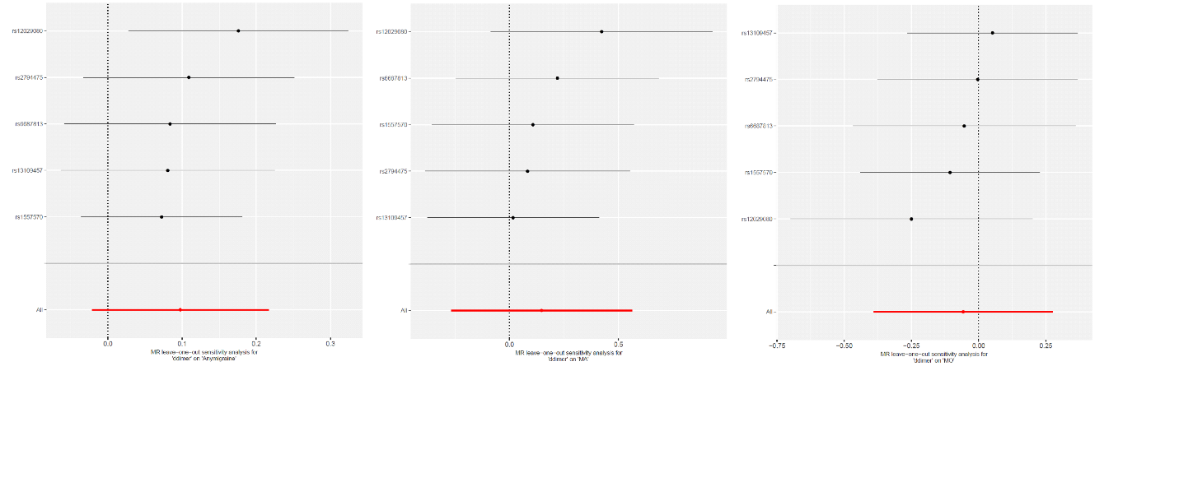

Supplementary Figure 4 Leave-one-out sensitivity analysis of instrumental estimates of D-dimer with migraine, migraine with aura (MA), and migraine without aura (MO). All the analyses were conducted using leave-one-out method implemented in the R package TwoSampleMR. All the instrumental estimates were corresponding to per standard deviation (SD) change of the hemostatic profiles being tested. P values are two-sided.

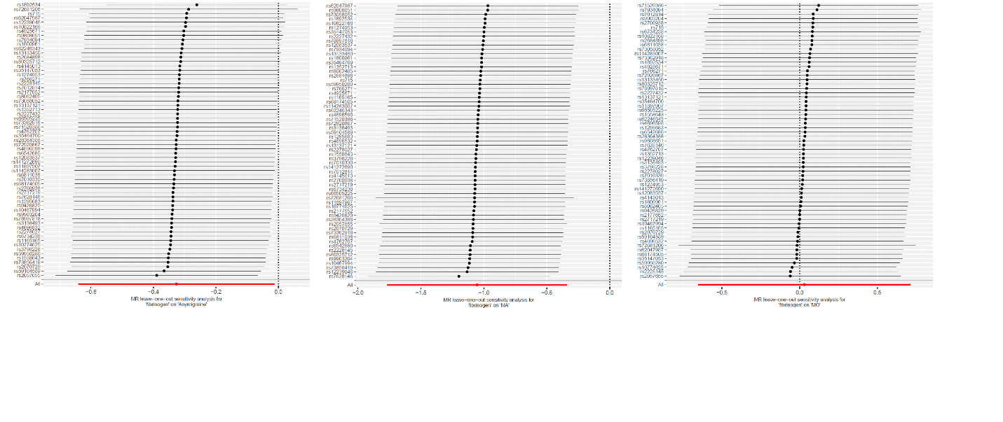

Supplementary Figure 5 Leave-one-out sensitivity analysis of instrumental estimates of fibrinogen with migraine, migraine with aura (MA), and migraine without aura (MO). All the analyses were conducted using leave-one-out method implemented in the R package TwoSampleMR.All the instrumental estimates were corresponding to per standard deviation (SD) change of the hemostatic profiles being tested. P values are two-sided.

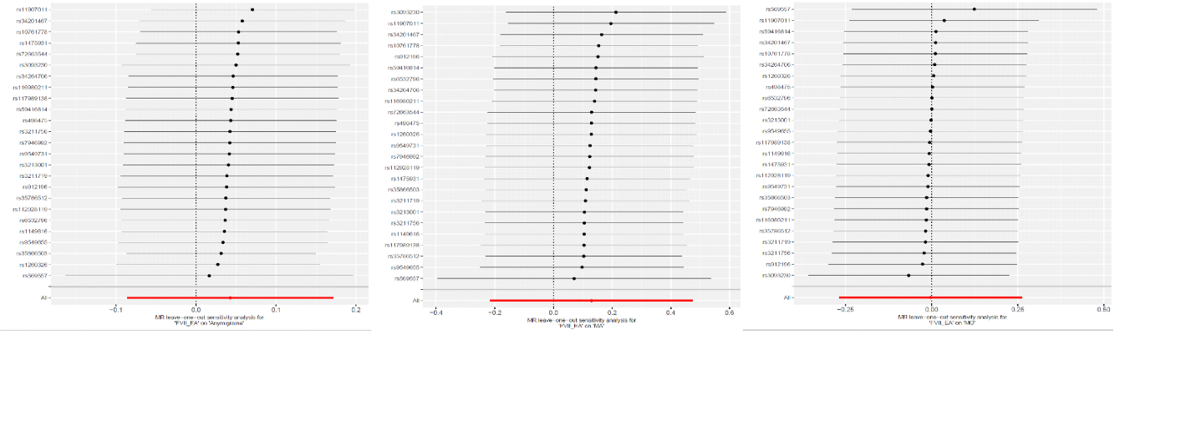

Supplementary Figure 6 Leave-one-out sensitivity analysis of instrumental estimates of coagulation factor VII (FVII) with migraine, migraine with aura (MA), and migraine without aura (MO). All the analyses were conducted using leave-one-out method implemented in the R package TwoSampleMR. All the instrumental estimates were corresponding to per standard deviation (SD) change of the hemostatic profiles being tested. P values are two-sided.

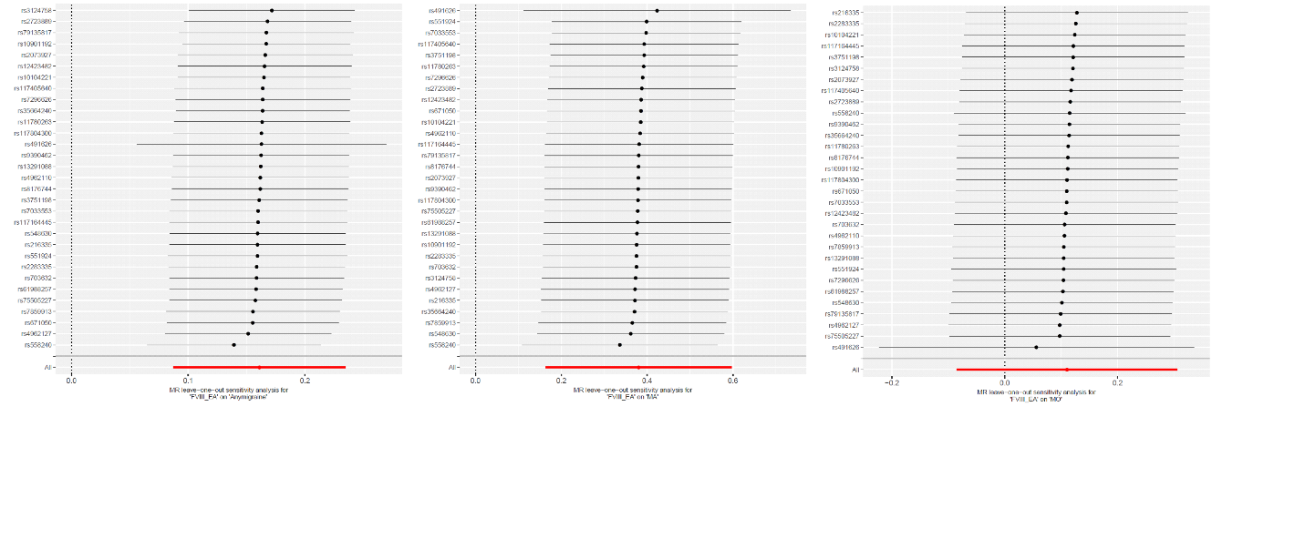

Supplementary Figure 7 Leave-one-out sensitivity analysis of instrumental estimates of coagulation factor VIII (FVIII) with migraine, migraine with aura (MA), and migraine without aura (MO). All the analyses were conducted using leave-one-out method implemented in the R package TwoSampleMR. All the instrumental estimates were corresponding to per standard deviation (SD) change of the hemostatic profiles being tested. P values are two-sided.

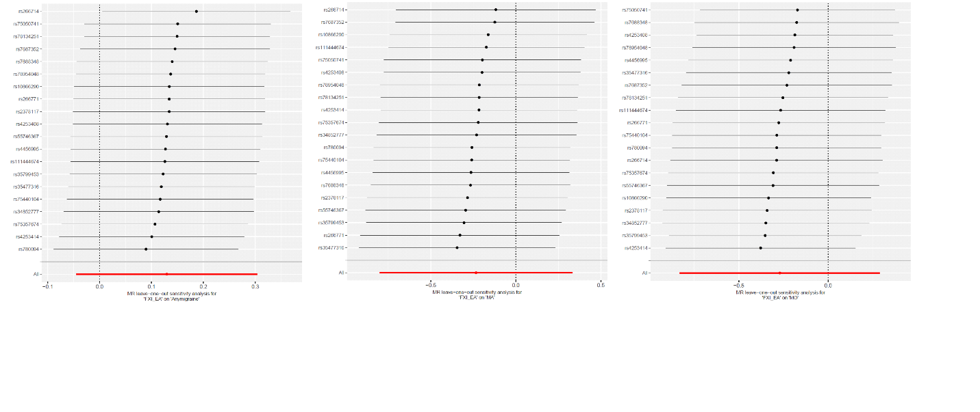

Supplementary Figure 8 Leave-one-out sensitivity analysis of instrumental estimates of coagulation factor XI (FXI) with migraine, migraine with aura (MA), and migraine without aura (MO). All the analyses were conducted using leave-one-out method implemented in the R package TwoSampleMR. All the instrumental estimates were corresponding to per standard deviation (SD) change of the hemostatic profiles being tested. P values are two-sided.

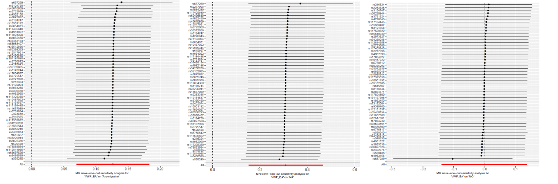

Supplementary Figure 9 Leave-one-out sensitivity analysis of instrumental estimates of von Willebrand factor (VWF) with migraine, migraine with aura (MA), and migraine without aura (MO). All the analyses were conducted using leave-one-out method implemented in the R package TwoSampleMR. All the instrumental estimates were corresponding to per standard deviation (SD) change of the hemostatic profiles being tested. P values are two-sided.

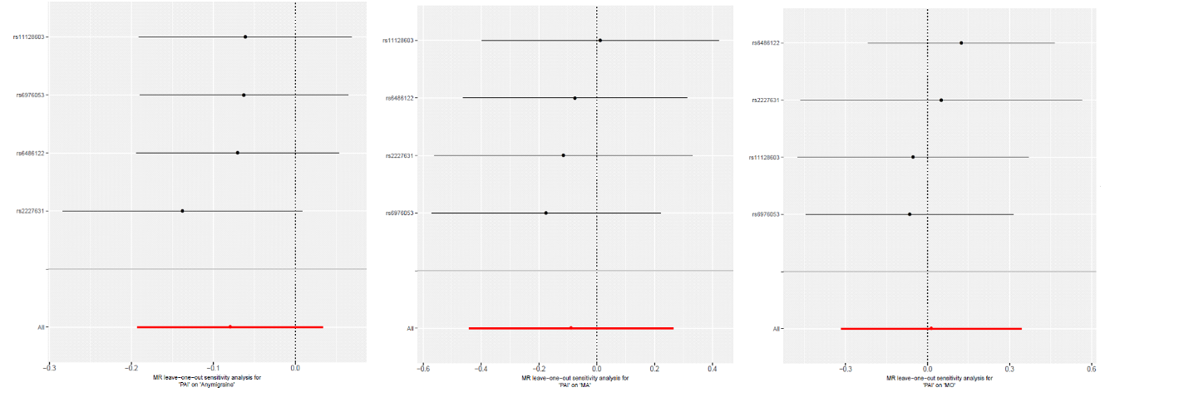

Supplementary Figure 10 Leave-one-out sensitivity analysis of instrumental estimates of plasminogen activator inhibitor-1 (PAI-1) with migraine, migraine with aura (MA), and migraine without aura (MO). All the analyses were conducted using leave-one-out method implemented in the R package TwoSampleMR. All the instrumental estimates were corresponding to per standard deviation (SD) change of the hemostatic profiles being tested. P values are two-sided.

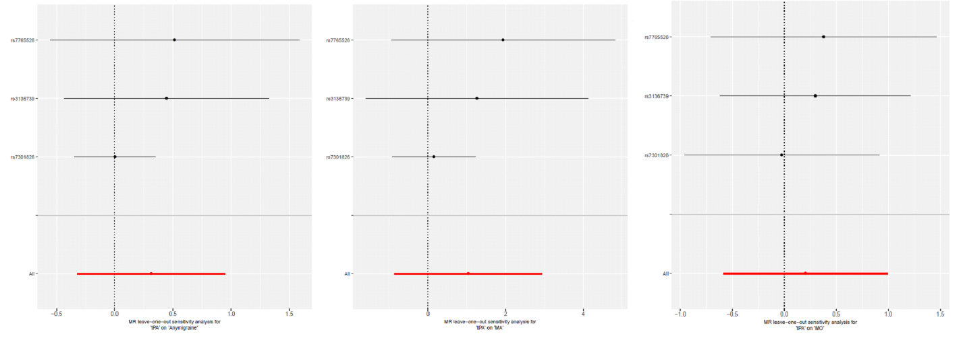

Supplementary Figure 11 Leave-one-out sensitivity analysis of instrumental estimates of tissue plasminogen activator (tPA) with migraine, migraine with aura (MA), and migraine without aura (MO). All the analyses were conducted using leave-one-out method implemented in the R package TwoSampleMR. All the instrumental estimates were corresponding to per standard deviation (SD) change of the hemostatic profiles being tested. P values are two-sided.

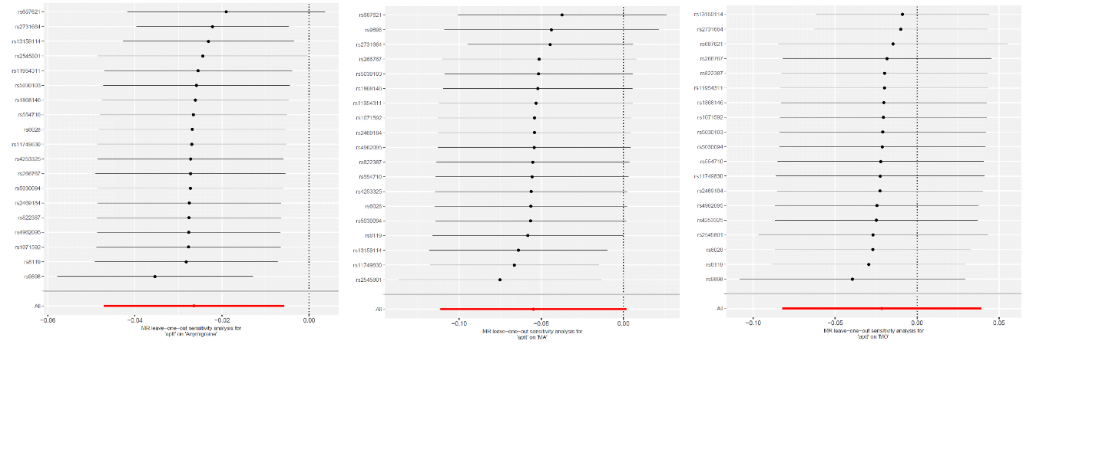

Supplementary Figure 12 Leave-one-out sensitivity analysis of instrumental estimates of activated partial thromboplastin time (aPTT) with migraine, migraine with aura (MA), and migraine without aura (MO). All the analyses were conducted using leave-one-out method implemented in the R package TwoSampleMR. All the instrumental estimates were corresponding to per standard deviation (SD) change of the hemostatic profiles being tested. P values are two-sided.

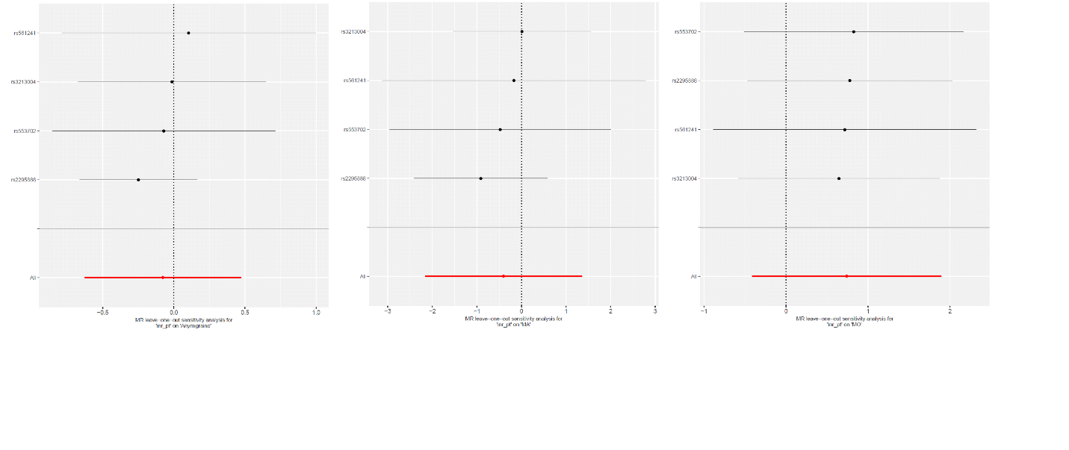

Supplementary Figure 13 Leave-one-out sensitivity analysis of instrumental estimates of prothrombin time ( PT/INR) with migraine, migraine with aura (MA), and migraine without aura (MO). All the analyses were conducted using leave-one-out method implemented in the R package TwoSampleMR. All the instrumental estimates were corresponding to per standard deviation (SD) change of the hemostatic profiles being tested. P values are two-sided.

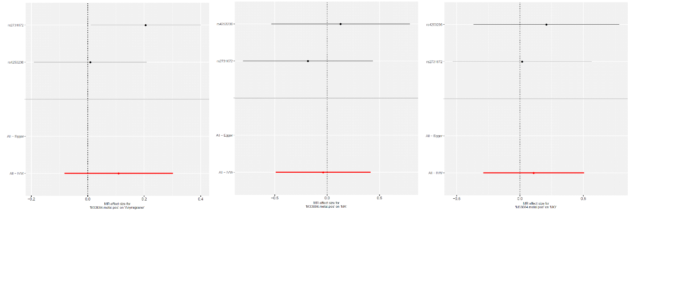

Supplementary Figure 14 Single SNP sensitivity analysis of instrumental estimates of fibrinopeptide A with migraine, migraine with aura (MA), and migraine without aura (MO). All the analyses were conducted using single SNP method implemented in the R package TwoSampleMR. All the instrumental estimates were corresponding to per standard deviation (SD) change of the hemostatic profiles being tested. P values are two-sided.

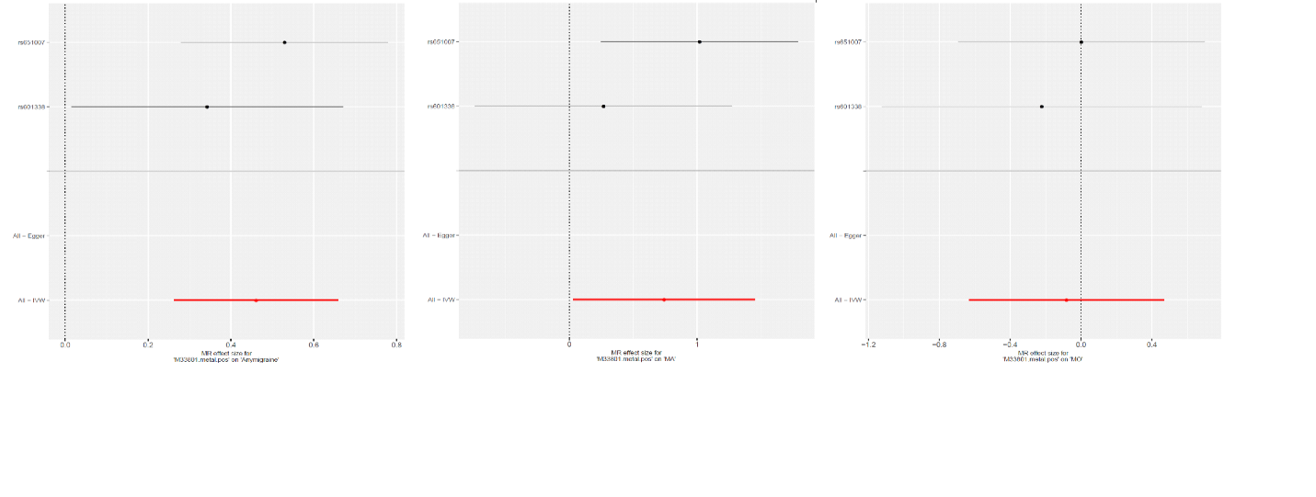

Supplementary Figure 15 Single SNP sensitivity analysis of instrumental estimates of Phosphorylated fibrinopeptide A with migraine, migraine with aura (MA), and migraine without aura (MO). All the analyses were conducted using single SNP method implemented in the R package TwoSampleMR. All the instrumental estimates were corresponding to per standard deviation (SD) change of the hemostatic profiles being tested. P values are two-sided.

