SUPPORTING INFORMATION FOR

THE PLUMAGE AND COLOURATION OF AN ENANTIORNITHINE BIRD FROM THE EARLY CRETACEOUS OF CHINA

by Jennifer A. Peteya^{1*}, Julia A. Clarke², Quanguo Li³, Ke-Qin Gao⁴ and Matthew D. Shawkey^{1,5}
Table S1. Measurements of the new bohaiornithid specimen (CUGB P1202). Measurements are in millimeters.
Skull length | 26.51
Skull height | 13.56
Antorbital length | 8.21
Antorbital height | 3.00
Pygostyle length | 13.06
Coracoid length (left) | 19.35
Coracoid distal width (left) | 10.06
Furcula length | 26.22
Furcula proximal width | 11.40
Furcula, hypocleidium length | 4.16
Humerus length (right) | 33.36
Humerus, midshaft width (left) | 3.18
Ulna length (left) | 27.56
Ulna, midshaft width (left) | 2.73
Radius length (left) | 23.88
Radius, midshaft width (left) | 1.80
Metacarpal I length (right) | 3.37
Metacarpal II length (right) | 11.76
Metacarpal III length (right) | 11.89
First phalanx of manual digit I length (right) | 6.35
First phalanx of manual digit II length (left) | 7.16
Second phalanx of manual digit II length (left) | 4.84
Femur length | > 25.65
Tibiotarsus length (right) | 35.61
Tarsometatarsus length (right) | 17.09
Pedal digit I-1 length (right) | 4.74
Pedal digit I ungual length (counterpart, left) | 10.02
Pedal digit II-1 length | 7.16
Pedal digit II-2 length (left) | 5.19
Pedal digit II ungual length (counterpart, right) | 10.22
Pedal digit III-1 length (counterpart, right) | 9.61
Pedal digit III-2 length (counterpart, left) | 6.64
Pedal digit III-3 length (counterpart, right) | 7.72
Pedal digit III ungual length (counterpart, right) | 10.27
Pedal digit IV ungual length (counterpart, right) | 6.88
Crown feather (counterpart) | 19.54
Alula (counterpart right) | 12.80
First primary remige (counterpart, right) | 129.82
Elongate rectrice (counterpart, right) | > 86.82
Elongate rectrice total width (counterpart, right) | 2.27
Elongate rectrice midshaft rachis width (counterpart, right) | 1.21
Short rectrice (counterpart, right) | 20.02
Body contour feather (counterpart, right) | 32.78

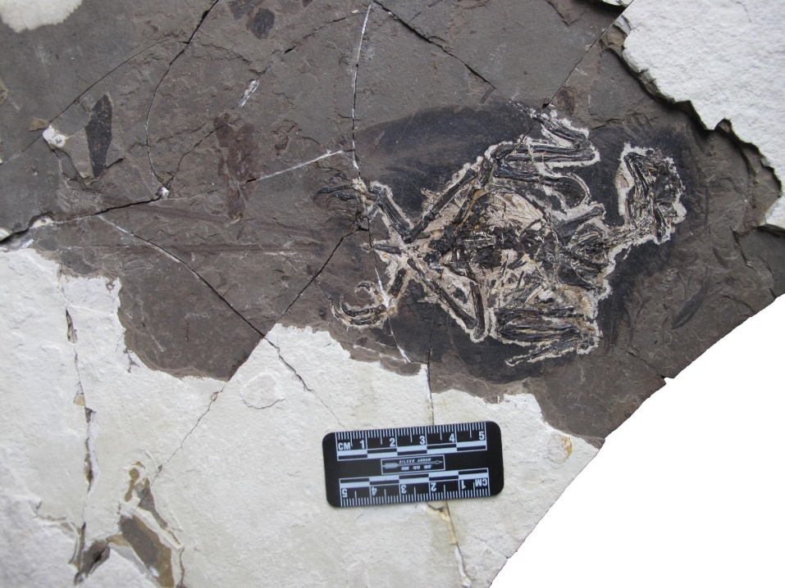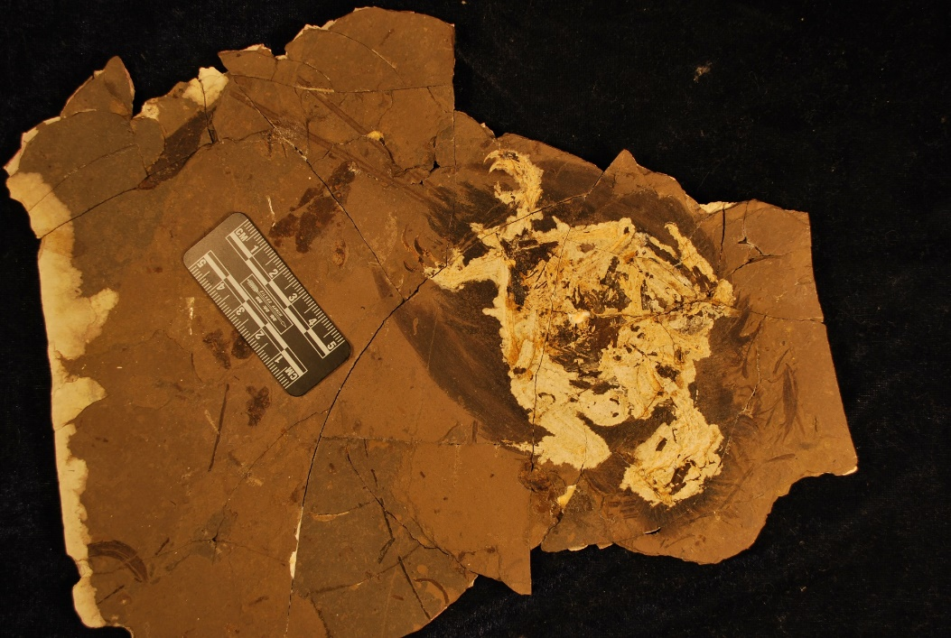
63
62
64
65
70
h1
69
g1
68
A
i1
B
Fig. S1. Melanosome sampling sites on CUGB P1202. A, primary slab; and B, counter slab. Solid lines represent samples taken from feathers and dashed lines represent matrix samples.

Fig S2. Quadratic canonical discriminate analysis that includes raw melanosome measurements for CUGB P1202 as well as measurements rescaled up to account for proposed taphonomic shrinkage of 10% (62, 10%) to 20% (62, 20%). Open circles and numbers refer to average measurements for CUGB P1202 samples and sampling sites from Fig. S1. Coloured points refer to extant feather melanosome morphologies (average values) from the Li et al. (2012) database. Circles represent the 95% confidence interval.

Table S2. Eigenvalues, canonical likelihood scores, and standardized scoring coefficients for the quadratic canonical discriminant analysis estimating colour in CUGB P1202 samples (Fig. S1; Table S3) and extant bird feathers (from Li et al. 2012).
Canonical Axis | Eigenvalue | % Variation Explained | Canonical Correlation | Length | Length CV | Diameter | Diameter CV | Aspect Ratio | Aspect Ratio Skew
Canonical 1 | 1.89 | 61.94 | 0.81 | 0.36 | -0.04 | -0.01 | 0.28 | 0.83 | 0.07
Canonical 2 | 0.77 | 25.23 | 0.66 | 0.80 | 0.52 | 0.09 | -0.14 | -0.50 | -0.29
Canonical 3 | 0.23 | 7.56 | 0.43 | 0.44 | 0.01 | -0.16 | 0.76 | -0.34 | 0.80
Canonical 4 | 0.16 | 5.27 | 0.37 | -1.16 | -0.44 | 1.74 | 0.35 | 1.16 | 0.19

Table S3. Number of complete melanosomes measured (n) and average measurements of melanosomes preserved in each CUGB P1202 sample (Fig. S1) plus or minus standard deviation.
Sample | n | Average Length (nm) | Average Width (nm) | Average Aspect Ratio
Crown (Sample 62) | 21 | 1159.23 ± 325.65 | 168.41 ± 41.17 | 7.13 ± 2.09
Nape (Sample 63) | 21 | 1721.36 ± 345.70 | 330.68 ± 99.94 | 5.74 ± 2.24
Body Contour (Sample 64) | 4 | 1628.83 ± 140.22 | 243.91 ± 63.48 | 7.11 ± 2.30

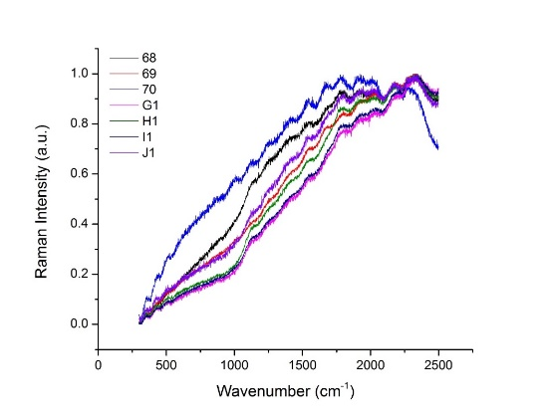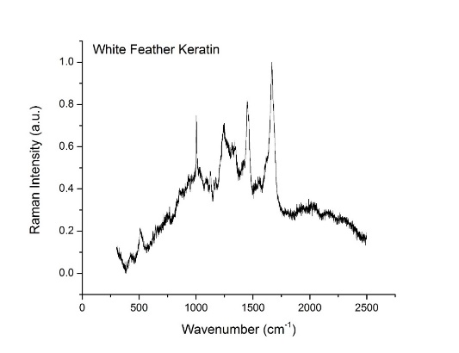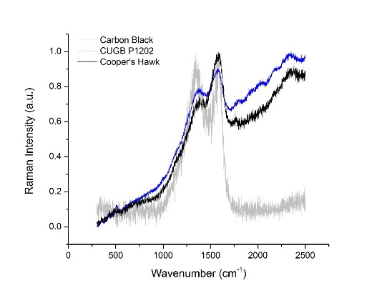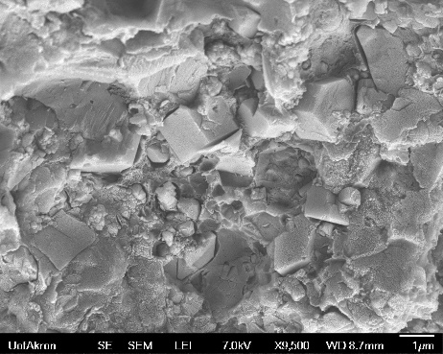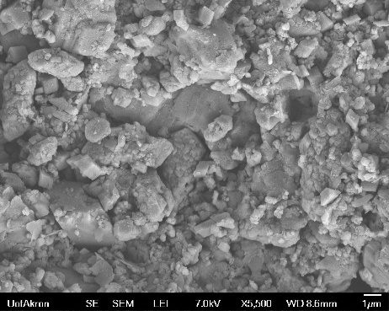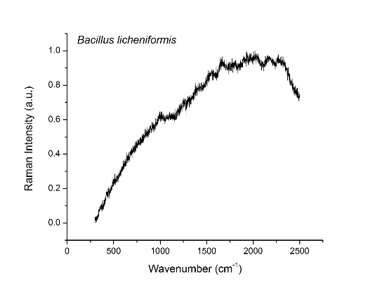
D
E
c
F
B
A
Fig. S3. Raman spectra and SEM images compared to CUGB P1202 feather samples. A, Raman spectra generated by extant eumelanin extracted from a brown Cooper’s Hawk feather compared to spectra from CUGB P1202 and carbon black to control for the potential effects of carbon on the surface of the fossil; B, Raman spectra produced by keratin from an unpigmented primary remige from the Sulfur-crested Cockatoo; C, Raman spectra generated by the keratinolytic bacterium Bacillus licheniformis (strain 138B); and D-F, Raman spectra (D) and SEM images (E and F) for matrix samples from CUGB P1202. For D, numbers and letters in legend indicate sampling numbers for CUGB P1202.

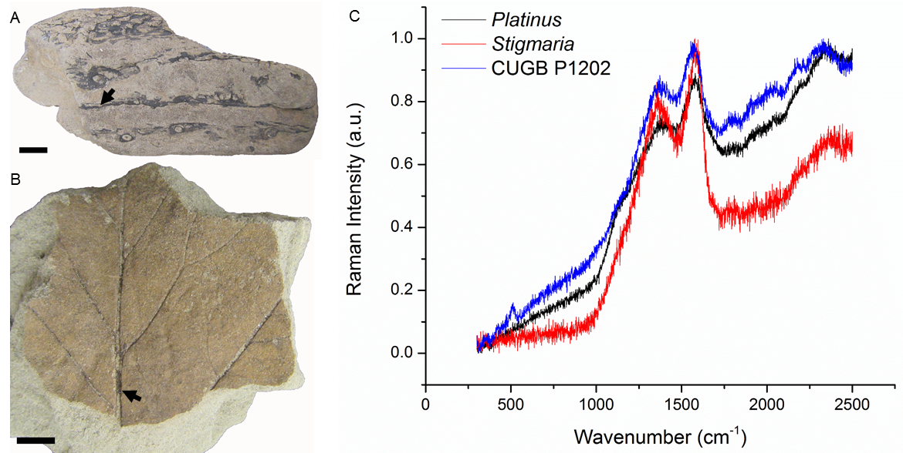
Figure S4. Comparison of Raman spectra generated by fossil plants and CUGB P1202. A, Stigmaria (CMNH P-21773) from the Carboniferous Joggins Formation, Joggins, Nova Scotia; B, Platinus (PTRM #20639) from the Late Cretaceous Hell Creek Formation, Mud Buttes, North Dakota; C, Raman spectra for Stigmaria, Platinus, and CUGB P1202. Arrows indicate sampling locations. Scale bars=1 cm.

Table S4. Peak fitting for Raman spectra generated by melanosomes in extant feathers and fossil feathers preserved in CUGB P1202 (top) and Platinus, Stigmaria, carbon black, feather keratin from an unpigmented primary remige from the Sulfur-crested Cockatoo, and the keratinolytic bacterium Bacillus licheniformis (strain 138B).

Sample | Color | Raman Peaks
 |  | 1 | 2 | 3
Chicken | Black |  | 1378.52 | 1578.80
Red-winged Blackbird | Black | 1194.45 | 1385.90 | 1584.22
Mallard | Iridescent | 1166.35 | 1372.28 | 1576.94
Wild Turkey | Iridescent | 1157.54 | 1374.42 | 1577.92
Cooper's Hawk | Brown | 1166.51 | 1373.92 | 1577.06
House Wren | Brown | 1128.57 | 1384.21 | 1574.98
Black Bird Sample 62 | Fossil | 1143.75 | 1363.74 | 1574.59
Black Bird Sample 63 | Fossil | 1132.47 | 1360.58 | 1572.33
Black Bird Sample 64 | Fossil | 1142.33 | 1353.83 | 1571.23
Black Bird Sample 65 | Fossil |  | 1354.78 | 1566.72

Sample | Raman Peaks
Platinus | 1151.30 | 1351.69 | 1578.68
Stigmaria | 1369.49 | 1584.15
Carbon Black | 1360.57 | 1590.91
Feather Keratin | 514.12 | 1003.42 | 1127.33 | 1146.01 | 1206.87 | 1244.22 | 1454.63 | 1665.68
Bacillus licheniformis | 1006.05 | 1543.03 | 1665.28 | 2028.89 | 2169.47 | 2302.65

Supplementary References

LI, Q., GAO, K., MENG, Q, CLARKE, J. A., SHAWKEY, M. D., D’ALBA, L., PEI, R., ELLISON, M., NORELL, M. A. and VINTHER, J. 2012. Reconstruction of Microraptor and the evolution of iridescent plumage. Science, 335, 1215-1219.

