Appendix S3. Analyses of spatial autocorrelation for assemblage-based models
To account for non-independence among spatial units (i.e. grid cells) and subsequent spatial autocorrelation, we first inspected the corrected significance of simple correlations between response variables (mean peak frequency and mean standard deviation of frequency) and predictors (mean annual temperature, net primary productivity and species richness). Issues derived from spatial autocorrelation are derived from the fact that in its presence, degrees of freedom are overestimated, and thus uncorrected p-values are underestimated. Applying Dutilleul’s et al. (1993) method allows for computing a modified t-test that corrects the degrees of freedom, based on the amount of autocorrelation in the data, using Moran’s I to estimate the spatial autocorrelation in the data sets. The corrected degrees of freedom can then be used to test the corrected significance of the correlations.

Table S3.1 Simple spatially corrected correlations using Dutilleul’s et al. (1993) modified t-test to correct the number of degrees of freedom and the significances. Note the dramatic decrease in geographically effective degrees of freedom (Cor. DF) in comparison to n-2 degrees of freedom found either in the New World (4,000 degrees of freedom) or in the Old World (8,635 degrees of freedom). Overall, the explanatory variables more strongly associated with response variables in a multiple OLS context (e.g. temperature, negatively associated with peak frequency and productivity, positively associated with the standard deviation of frequency) showed significant (or marginally significant, P≤ 0.68) correlations with the responses, even after accounting for spatial autocorrelation.
 |  | Peak Frequency |  |  |  | StdDev Frequency
Variable | metric | New World (n=4002) | Old World (n=8637) |  |  |  | New World (n=4002) | Old World (n=8637)
Species richness | r | -0.597 | 0.187 |  |  |  | 0.538 | -0.156
 | Cor. DF | 12.43 | 64.199 |  |  |  | 12.396 | 133.23
 | Cor. P ≤ | 0.022 | 0.133 |  |  |  | 0.043 | 0.07
Annual Temperature | r | -0.735 | -0.612 |  |  |  | 0.585 | 0.230
 | Cor. DF | 4.759 | 12.855 |  |  |  | 6.345 | 63.909
 | Cor. P ≤ | 0.053 | 0.016 |  |  |  | 0.117 | 0.064
Net Primary Productivity | r | -0.739 | -0.309 |  |  |  | 0.627 | 0.552
 | Cor. DF | 5.468 | 48.707 |  |  |  | 7.133 | 73.177
 | Cor. P ≤ | 0.047 | 0.027 |  |  |  | 0.068 | 0.001
Mean log-Body size | r | 0.16 | -0.207 |  |  |  | -0.367 | -0.331
 | Cor. DF | 10.736 | 59.447 |  |  |  | 9.975 | 82.273
 | Cor. P ≤ | 0.607 | 0.108 |  |  |  | 0.241 | 0.002

Subsequently, we examined Moran’s I patterns in both the observed values of the response variables and the residuals of OLS models using Moran’s I (see e.g. Diniz-Filho et al. 2003). Contrasting the amounts of spatial autocorrelation in observed values and model residuals is informative of how well the predictor variables account for the spatial structure in the response variables. Whenever autocorrelation in model residuals informs that relevant predictors are lacking from the model and the spatial scales at which those predictors matter the most. Moreover, residual autocorrelation indicates that significance of regression coefficients will be biased by pseudo-replication and subsequent inflated degrees of freedom, but any bias in the coefficients cannot be easily predicted (Bini et al. 2009). Nevertheless, model coefficients are here only indicative of the rank in importance of predictor variables and of the direction of the relationships between response and predictor variables, which was additionally confirmed by exploration of univariate relationships (see Figure 5).
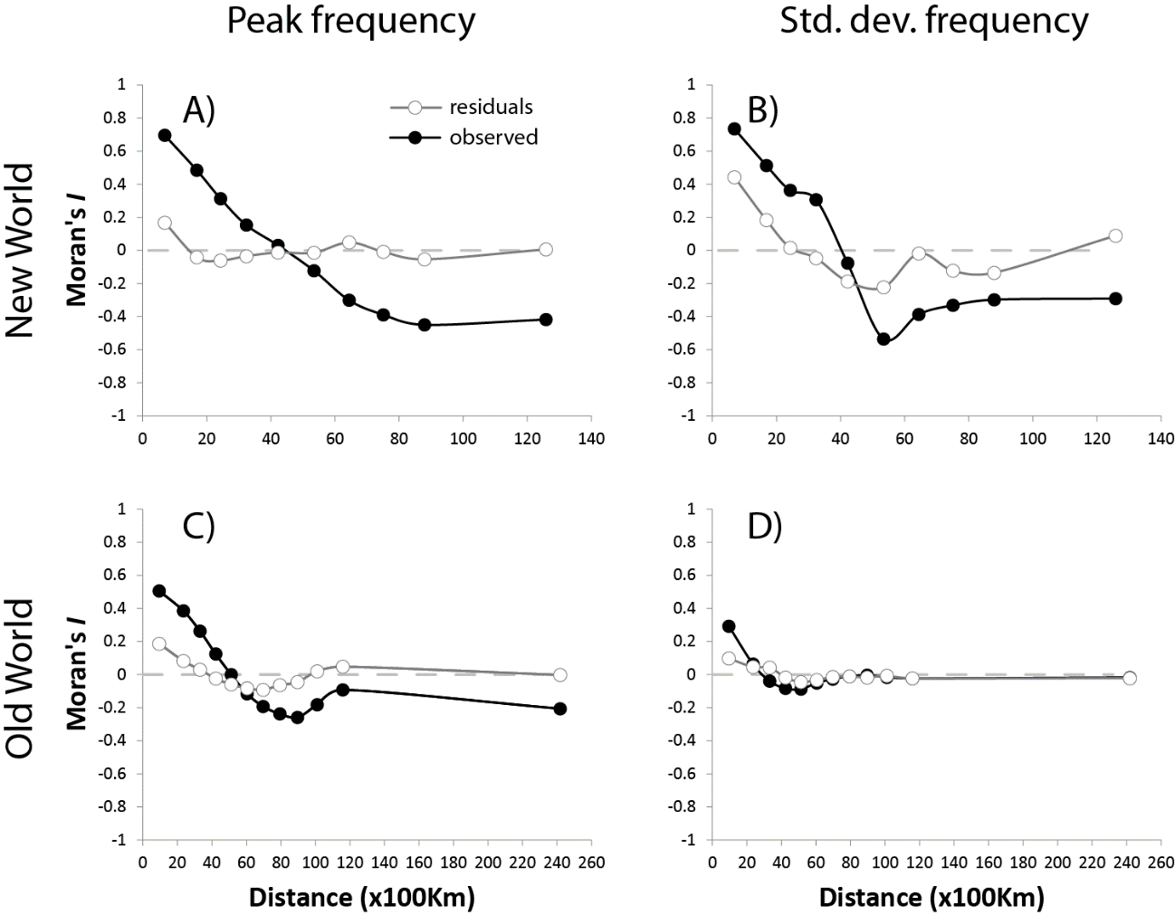
Figure S3.1 Spatial autocorrelation patterns in observed values of response variables (filled dots) and residuals (empty dots) from assemblage based OLS models performed for peak frequency (A,C), and standard deviation of the frequency (B,D). Note that in most cases, residual autocorrelation at first distance classes have values of Moran’s I < 0.2, informing that spatial autocorrelation patterns in the response variable are absorbed by the predictors. Residuals of the OLS model for standard deviation of the frequency in the New World (B) shows moderate levels of spatial autocorrelation (Moran’s I > 0.4), which suggest that the model is ill informed and that additional predictor variables would be needed to inform the spatial structure in the response variable.

The spatial autocorrelation results presented here, remain unaltered when run for the subset of data selected to check for possible biases due to the quality of bird song recording, and are not shown to avoid redundancy.

Literature cited:
Mauricio Bini, L., Diniz‐Filho, J. A. F., Rangel, et al. (2009). Coefficient shifts in geographical ecology: an empirical evaluation of spatial and non‐spatial regression. Ecography, 32(2), 193-204.
Dutilleul, P., Clifford, P., Richardson, S., & Hemon, D. (1993). Modifying the t test for assessing the correlation between two spatial processes. Biometrics, 305-314.
Diniz‐Filho, J. A. F., Bini, L. M., & Hawkins, B. A. (2003). Spatial autocorrelation and red herrings in geographical ecology. Global ecology and Biogeography, 12(1), 53-64.

