Supporting Information
Supplementary Table S1. Litter traits and environmental variables used to replace the observed effects of phylogenetic isolation on decomposition of oak litter as predicted in Table 1.

Variables | Definition or calculation
Phytophagy | Phytophagy was estimated as leaf damage. Leaf damage was estimated with 1 x 1 cm² dot grid. The percentage of leaf damage was quantified from the number of dots above damaged parts of leaves relative to the number of dots above an entire, undamaged leaf of the same size (from Yguel et al. 2011).
Phenolics | Total phenolic concentrations of initial oak litter were measured colorimetrically using the method of Santonja et al. (2015) with gallic acid as a standard.
Budburst delay | The number of days required to reach the score indicating full budburst for all buds. Budburst phenology was monitored from the 15th March to the end of budburst in 2011, by scoring the phenological state of 10 random apical buds from the upper layer of the crown of each sampled oak, every 3.5 day (from Yguel et al. 2011)s.
Vegetation period | The duration of leaves on each oak (days from budburst to litter fall).
Soil pH | Soil pH under each oak. Soil pH was measured only once before budburst (from Yguel et al. 2014).
Soil moisture | Soil moisture content under each oak. Soil humidity was measured with a wet sensor (WET-2 e WET Sensor, AT delta-T devices) in March and April 2011 and the average of both measurements were used in our analyses (from Yguel et al. 2014).

Supplementary Table S2. Explanation of phylogenetic isolation effects on litter mass loss, C loss and N losss by litter traits or environmental variables. Significance was shown as follows: * P < 0.05; ** P <0.01; *** P < 0.001. Residual degree of freedom ranged from 29 to 42.
(a) PIA replaced by Phytophagy
 | Mass loss |  |  |  |  |  | Carbon loss |  |  |  |  |  | Nitrogen loss
 | 8 months |  |  | 14 months |  |  | 8 months |  |  | 14 months |  |  | 8 months |  |  | 14 months
 | t-value | P-value |  | t-value | P-value |  | t-value | P-value |  | t-value | P-value |  | t-value | P-value |  | t-value | P-value
Phytophagy |  |  |  |  |  |  | -3.32 | ** |  | -1.33 |  |  |  |  |  | 0.97
PIB | 2.31 | * |  | -2.10 | * |  | -3.23 | ** |  | -0.23 |  |  | -1.08 |  |  | 1.62
Collembola abundance (CA) | 1.87 |  |  |  |  |  |  |  |  | -0.69
Acari abundance (AA) | 2.64 | * |  | 4.97 | *** |  | -2.88 | ** |  | -4.87 | *** |  | -1.79 |  |  | 2.31 | *
Microbial biomass (MB) |  |  |  | -1.60 |  |  | -3.21 | ** |  | 2.35 | * |  | -2.13 | * |  | 1.35
Phytophagy × CA |  |  |  |  |  |  |  |  |  | 3.32 | **
Phytophagy × AA |  |  |  |  |  |  |  |  |  |  |  |  |  |  |  | -2.12 | *
Phytophagy × MB |  |  |  |  |  |  | 2.65 | *
PIB × CA
PIB × AA | -2.61 | * |  |  |  |  | 2.23 | * |  | 4.90 | *** |  | 1.74
PIB × MB |  |  |  | 2.08 | * |  |  |  |  | -2.12 | * |  |  |  |  | -1.74

(b) PIA replaced by Phenolics
 | Mass loss |  |  |  |  |  | Carbon loss |  |  |  |  |  | Nitrogen loss
 | 8 months |  |  | 14 months |  |  | 8 months |  |  | 14 months |  |  | 8 months |  |  | 14 months
 | t-value | P-value |  | t-value | P-value |  | t-value | P-value |  | t-value | P-value |  | t-value | P-value |  | t-value | P-value
Phenolics | -1.86 |  |  |  |  |  |  |  |  | 0.09 |  |  | 1.34 |  |  | -0.91
PIB | 2.77 | ** |  | 2.29 | * |  | -2.24 | * |  | -2.95 | ** |  | -1.32 |  |  | 1.60
Collembola abundance (CA) |  |  |  | -1.34 |  |  | 1.40 |  |  | 2.88 | **
Acari abundance (AA) | -3.38 | ** |  | 2.84 | ** |  | -2.76 | ** |  | -3.80 | *** |  | 1.11 |  |  | -1.59
Microbial biomass (MB) | 1.54 |  |  | 2.84 | ** |  | -2.80 | ** |  |  |  |  | -2.24 | * |  | 1.41
Phenolics × CA |  |  |  |  |  |  |  |  |  | -2.44 | *
Phenolics × AA | 3.94 | *** |  |  |  |  |  |  |  |  |  |  | -1.50 |  |  | 1.65
Phenolics × MB | -1.39
PIB × CA
PIB × AA | -2.44 | * |  |  |  |  | 1.98 |  |  | 3.91 | ***
PIB × MB | -1.41 |  |  | -1.97 |  |  |  |  |  |  |  |  | 1.92 |  |  | -1.75

(c) PIA replaced by CN
 | Mass loss |  |  |  |  |  | Carbon loss |  |  |  |  |  | Nitrogen loss
 | 8 months |  |  | 14 months |  |  | 8 months |  |  | 14 months |  |  | 8 months |  |  | 14 months
 | t-value | P-value |  | t-value | P-value |  | t-value | P-value |  | t-value | P-value |  | t-value | P-value |  | t-value | P-value
CN | 2.25 | * |  | -0.73 |  |  | 0.57 |  |  | 1.44 |  |  | -7.19 | *** |  | -1.64
PIB | 2.03 |  |  | 2.82 | ** |  | -2.52 | * |  | -0.11 |  |  | -0.98 |  |  | 1.33
Collembola abundance (CA) | 1.92 |  |  | -1.62 |  |  | 1.33 |  |  | 3.09 | ** |  | -2.09 | *
Acari abundance (AA) | 2.84 | ** |  | 2.94 | ** |  | -2.76 | ** |  | -4.01 | *** |  | -2.62 | * |  | 2.06 | *
Microbial biomass (MB) |  |  |  | 2.67 | * |  | -2.50 | * |  | 2.10 | * |  | -2.13 | * |  | 1.21
CN × CA | -1.31 |  |  | 1.75 |  |  | -1.36
CN × AA |  |  |  |  |  |  |  |  |  |  |  |  |  |  |  | -2.08 | *
CN × MB
PIB × CA |  |  |  | -1.65 |  |  | 1.28
PIB × AA | -2.27 | * |  |  |  |  | 1.76 |  |  | 4.18 | ***
PIB × MB |  |  |  | -1.75 |  |  |  |  |  | -1.68 | * |  | 1.72 |  |  | -1.37

(d) PIB replaced by Vegetation period
 | Mass loss |  |  |  |  |  | Carbon loss |  |  |  |  |  | Nitrogen loss
 | 8 months |  |  | 14 months |  |  | 8 months |  |  | 14 months |  |  | 8 months |  |  | 14 months
 | t-value | P-value |  | t-value | P-value |  | t-value | P-value |  | t-value | P-value |  | t-value | P-value |  | t-value | P-value
PIA | -0.09 |  |  | -1.99 |  |  | 1.43 |  |  | 1.42 |  |  | -0.46 |  |  | -1.18
Vegetation Period | -3.11 | ** |  | -0.90 |  |  |  |  |  | 0.85 |  |  | 2.97 | **
Collembola abundance (CA) | -2.40 | * |  | 0.94 |  |  | 2.47 | * |  | 2.41 | *
Acari abundance (AA) | 1.98 |  |  | 0.77 |  |  | -2.44 | * |  | 1.21 |  |  | 0.67 |  |  | -1.27
Microbial biomass (MB) | -1.26 |  |  | -1.44 |  |  | -2.99 | ** |  | 1.18 |  |  | 2.49 | *
PIA × CA | -2.41 | * |  | -1.44 |  |  |  |  |  | -2.01
PIA × AA |  |  |  | -1.84 |  |  |  |  |  |  |  |  | -1.70 |  |  | 2.06 | *
PIA × MB | 1.51 |  |  |  |  |  |  |  |  | -1.27 |  |  | 1.57
Vegetation Period × CA | 2.61 | *
Vegetation period × AA |  |  |  |  |  |  |  |  |  | -1.27
Vegetation period × MB |  |  |  | 1.45 |  |  |  |  |  |  |  |  | -2.55 | *

(e) PIB replaced by Budburst delay
 | Mass loss |  |  |  |  |  | Carbon loss |  |  |  |  |  | Nitrogen loss
 | 8 months |  |  | 14 months |  |  | 8 months |  |  | 14 months |  |  | 8 months |  |  | 14 months
 | t-value | P-value |  | t-value | P-value |  | t-value | P-value |  | t-value | P-value |  | t-value | P-value |  | t-value | P-value
PIA |  |  |  | -2.15 | * |  | 1.73 |  |  | 0.03 |  |  | 1.46 |  |  | -1.18
Budburst delay | 2.52 | * |  | 0.63 |  |  | -2.01 | * |  | 0.41
Collembola abundance (CA) | 2.30 | * |  | 0.62 |  |  | 2.07 | * |  | 2.73 | * |  | 1.89
Acari abundance (AA) | 2.11 | * |  | 1.52 |  |  | -3.32 | ** |  | -1.90 |  |  |  |  |  | -1.27
Microbial biomass (MB) |  |  |  |  |  |  | -2.86 | ** |  | 1.01 |  |  | -2.09 | *
PIA × CA |  |  |  | -2.40 | * |  | -1.29 |  |  | -2.63 | * |  | -1.78
PIA × AA |  |  |  | 2.37 | * |  |  |  |  |  |  |  |  |  |  | 2.06 | *
PIA × MB
Budburst delay× CA |  |  |  | 2.23 | *
Budburst delay × AA | -2.43 | * |  | -1.89 |  |  | 2.33 | * |  | 2.09 | *
Budburst delay × MB |  |  |  |  |  |  |  |  |  | -1.28

(f) PIB replaced by Soil pH
 | Mass loss |  |  |  |  |  | Carbon loss |  |  |  |  |  | Nitrogen loss
 | 8 months |  |  | 14 months |  |  | 8 months |  |  | 14 months |  |  | 8 months |  |  | 14 months
 | t-value | P-value |  | t-value | P-value |  | t-value | P-value |  | t-value | P-value |  | t-value | P-value |  | t-value | P-value
PIA | 1.15 |  |  | -1.69 |  |  | 1.99 | * |  | 0.30 |  |  |  |  |  | 1.52
Soil pH |  |  |  |  |  |  | -0.94 |  |  | 2.10 | * |  |  |  |  | -0.88
Collembola abundance (CA) | 2.01 |  |  | 0.79 |  |  | 1.59 |  |  | 2.37 | * |  |  |  |  | -2.23 | *
Acari abundance (AA) |  |  |  | 0.95 |  |  | 1.31 |  |  | 1.97
Microbial biomass (MB) |  |  |  |  |  |  | -1.56 |  |  |  |  |  | -2.15 | *
PIA × CA | -1.48 |  |  | -1.46 |  |  |  |  |  | -1.91
PIA × AA |  |  |  | 1.64
PIA × MB |  |  |  |  |  |  | -1.52
Soil pH × CA |  |  |  |  |  |  |  |  |  |  |  |  |  |  |  | 2.26 | *
Soil pH × AA |  |  |  |  |  |  | -1.36 |  |  | -2.02 | *
Soil pH × MB |  |  |  |  |  |  | 1.54

(g) PIB replaced by Soil moisture
 | Mass loss |  |  |  |  |  | Carbon loss |  |  |  |  |  | Nitrogen loss
 | 8 months |  |  | 14 months |  |  | 8 months |  |  | 14 months |  |  | 8 months |  |  | 14 months
 | t-value | P-value |  | t-value | P-value |  | t-value | P-value |  | t-value | P-value |  | t-value | P-value |  | t-value | P-value
PIA | 0.93 |  |  | -2.05 | * |  | 1.43 |  |  | 0.20 |  |  |  |  |  | -0.94
Soil moisture | -3.13 | ** |  | -1.39 |  |  |  |  |  | 0.83 |  |  | 1.54 |  |  | -1.15
Collembola abundance (CA) | 2.27 | * |  | 1.70 |  |  | 2.47 | * |  | 2.86 | **
Acari abundance (AA) |  |  |  | 0.64 |  |  | -2.44 | * |  | 0.63 |  |  |  |  |  | -1.38
Microbial biomass (MB) |  |  |  | -2.16 | * |  | -2.99 | ** |  |  |  |  | -2.06 | * |  | -1.24
PIA × CA | -1.40 |  |  | -2.03 |  |  |  |  |  | -2.28 | *
PIA × AA |  |  |  | 1.76 |  |  |  |  |  |  |  |  |  |  |  | 1.76
PIA × MB |  |  |  | 1.33
Soil moisture × CA |  |  |  | -1.37 |  |  |  |  |  | -1.32
Soil moisture × AA
Soil moisture × MB |  |  |  | 2.52 | * |  |  |  |  |  |  |  |  |  |  | 1.58

Supplementary Table S3. Effects of phylogenetic isolation aboveground and belowground (PIA + PIB) on decomposition of oak litter at 8 months, i.e. mass loss, carbon loss and nitrogen loss, based on multiple regression analyses, which involved fungal abundance and diversity as predictive co-variables. Significance was shown as follows: * p < 0.05; ** p <0.01; *** p < 0.001.

 | Mass loss |  |  | Carbon loss |  |  | Nitrogen loss
 | t-value | P-value |  | t-value | P-value |  | t-value | P-value
PIA | 2.09 | * |  | 1.88 | 0.06 |  | -2.36 | *
PIB |  |  |  | 0.49
Fungal abundance (FA) |  |  |  | 1.39 |  |  | -2.39 | *
Fungal diversity (FD) | 3.11 | ** |  | 0.95 |  |  | -1.51 | *
PIA × FA |  |  |  |  |  |  | 1.94 | 0.06
PIA × FD | -2.72 | ** |  |  |  |  | 1.55
PIB × FA
PIB × FD |  |  |  | -2.06 | *

Supplementary Figure S1 Effects of phylogenetic isolation aboveground and belowground on the fungal abundance and diversity after 8-month decomposition according to multiple regression analysis. * indicates partial residuals. Residual degree of freedom is 39.
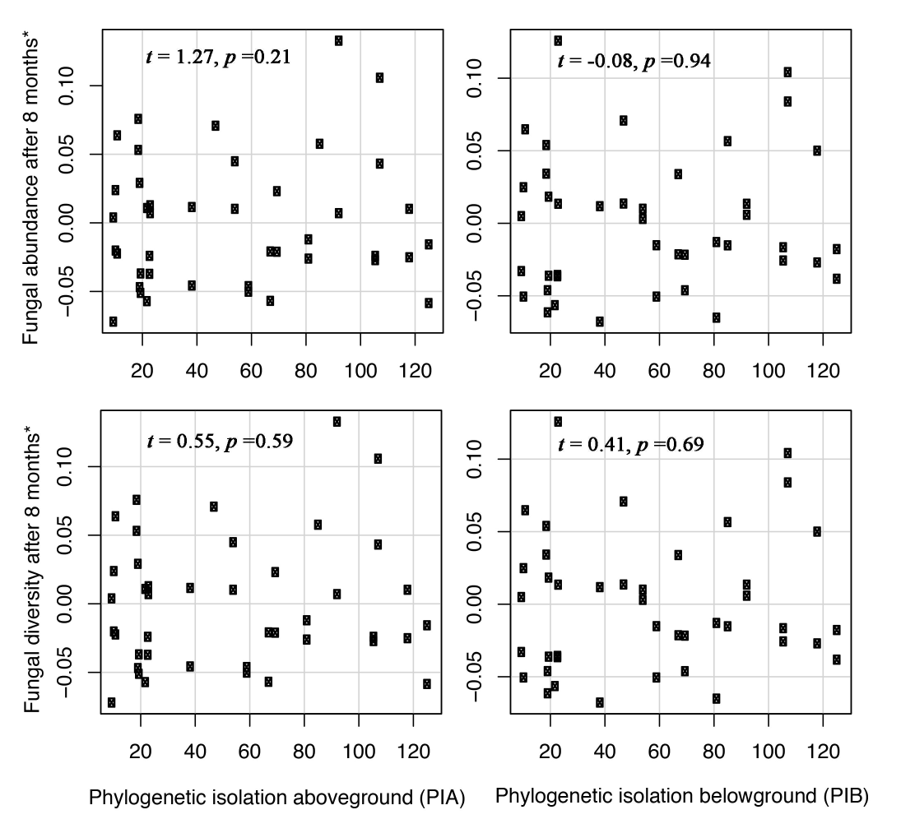

Supplementary Methodology S1. Brief introduction to the studied forest, the selection of trees and phylogenetic distance estimation between focal oaks and their neighbors
The forest was located in Rennes, Brittany (France), dating back to at least the 12th century. This forest has a typical oceanic climate with a mean annual precipitation of 644 mm and a mean annual temperature of 11.4 °C with a seasonal amplitude of 15.2 °C (Raffalli-Delerce et al. 2004). The most dominant species in this forest were oaks (Quercus petraea or Q. robur; unpublished microsatellite analyses showing that all are to some degree hybrids) and pines (Pinus sylvestris), and the other main tree species are similar to the typical oceanic European temperate forests (Yguel et al. 2011). We selected 22 focal oaks whose tree circumferences at breast height are 62.1 ± 16.7 cm. Neighboring trees (i.e. overlap of projected crown surfaces) were Fagus sylvatica, Castanea sativa, Sorbus torminalis, Carpinus betulus, Quercus petraea, Quercus robur, Abies alba, Rhamnus frangula, Betula pendula and Pinus sylvestris. Trees were chosen by pair, with one tree in a canopy dominated by oaks and Fagus (i.e. under low phylogenetic isolation, Fig. 1c), and the other trees in a canopy dominated by pines, Ilex and other angiosperms (i.e. under high phylogenetic isolation, Fig. 1c). Trees within a pair were close to each other (30–150 m apart), and belonged to the same oak species, Q. petraea or Q. robur. Pairs were spread across the entire forest. Such an approach of pairing or blocking has been recommended to partial out spatially varying environmental factors such as soil composition (Legendre et al. 2004).

In order to quantify phylogenetic distance, we used the younger of the crown ages of the two lineages involved, i.e. of the two ages of earliest diversification within the two lineages (identified based on APG 2016). For instance, we ranked the comparison between oak and pine species as a comparison between two classes, Gymnosperms and Angiosperms, of which the younger is approximately 140 million years old (the crown age of angiosperms), and the phylogenetic distance is hence 140 million years. Thus, the younger of the two crown ages represents biologically the time when the oak lineage and the other lineage started to be physically and physiologically distinct from a point of view of mycorrhizal fungi or of other decomposers tightly interacting with the tree. Moreover, this age also avoids giving overly weight to gymnosperms, in contrast to stem-age distance which would in many cases simply be a descriptor of % of gymnosperms in the neighborhood. Overall, mean phylogenetic isolation ranged from 10 to 125.66 million years, and varied continuously between these extremes.

References
Chase, M. W., Christenhusz, M., Fay, M. F., Byng, J. W., Judd, W. S., Soltis, D. E., et al. (2016). An update of the Angiosperm Phylogeny Group classification for the orders and families of flowering plants: APG IV. Botanical Journal of the Linnean Society, 181(1), 1–20.
Legendre, P., Dale, M.R., Fortin, M.-J., Casgrain, P. & Gurevitch, J. (2004). Effects of spatial structures on the results of field experiments. Ecology, 85, 3202-3214.
Raffalli‐Delerce, G., Masson‐Delmotte, V., Dupouey, J., Stievenard, M., Breda, N. & Moisselin, J. (2004). Reconstruction of summer droughts using tree‐ring cellulose isotopes: A calibration study with living oaks from Brittany (western France). Tellus B, 56, 160-174.
Yguel, B., Bailey, R., Tosh, N.D., Vialatte, A., Vasseur, C., Vitrac, X. et al. (2011). Phytophagy on phylogenetically isolated trees: why hosts should escape their relatives. Ecology Letters, 14, 1117-1124.

Supplementary Methodology S2. Measurements on fungal abundance and diversity
Total DNA was extracted from 44 litter samples (0.5 g) using the FastDNA SPIN kit for soil (MP Biomedicals, Illkirch, France). The extraction was done twice for each litter sample and pooled. The quantity and quality of the DNA extracted were evaluated by agarose gel electrophoresis and Qubit (Qubit Fluorometer, Invitrogen, CA 92008, USA). ITS amplicon pyrosequencing was performed using the fungal primer pair ITS1F and ITS2. The primers used included unique barcodes to generate PCR ITS rRNA fragments of about 400 bp. Four microliters of 1/10 diluted DNA extract (corresponding to a total of 25 ng of DNA) were used in a PCR containing 2-U Kapa HiFi DNA Polymerase, 1× Fidelity Buffer, 300-μM dNTP, 250-nM ITS1 primer, and 250-nM ITS2 primer in a final volume of 100 μl. PCR was performed with initial denaturation at 95 °C for 5 min, followed by 30 cycles of 98 °C for 20 s, 65 °C for 25 s and 72 °C for 1 min, with a final extension of 72 °C for 2 min. Three separate amplification reactions of 50 μl for each sample were performed and pooled before purification. The PCR products were purified using a Qiagen QIAquick Gel Extraction kit and the concentration of the purified PCR products was measured using Qubit (Qubit Fluorometer, Invitrogen, CA 92008, USA). An equimolar mix of all amplicon libraries was used for pyrosequencing using the GS FLX Titanium Sequencing Kit XLR70 (Roche) on the Genome Sequencer FLX 454 Titanium platform (Roche) at the Biogenouest genomic plateforme (Rennes, France). Beckman Coulter Genomics (Danvers, MA, USA). Pyrosequencing gave a total of 506,276 raw sequences.
ITS pyrosequences were demultiplexed according to the multiplex identifier (MID) using Mothur v.1.22.2 (Schloss et al. 2009) and UPARSE pipeline (Usearch v7.0.1001) was used for trimming (200 bp; 480,625 sequences retained at this step), filtering (quality score ≥ 30/40), and operational taxonomic units (OTUs) clustering (Edgar 2013). After the chimera check step, 424,149 sequences were retained. According to Edgar (2013), OTUs are defined using a single representative sequence and a centroid approach. The clusterisation of OTUs was done using abundance-sorted sequences with the cluster_otus command of Usearch with a 97% similarity threshold. Post-processing is needed to map reads to OTUs and construct an OTU table. The taxonomic assignation was determined for each OTU using the Basic Local Alignment Search Tool (BLAST) algorithm v 2.2.23 (Altschul et al. 1990) against the UNITE database release 5.0 (Kõljalg et al. 2013). We considered the cutoff similarity point for between-species distinctions to be about 97% (Tedersoo et al. 2006).

References
Altschul, S.F., Gish, W., Miller, W., Myers, E.W., & Lipman, D.J. (1990). Basic local alignment search tool. Journal of Molecular Biology, 21, 403-410.
Edgar, R.C. (2013). UPARSE: highly accurate OTU sequences from microbial amplicon reads. Nature Methods, 10, 996-998.
Kõljalg, U., Nilsson, R.H., Abarenkov, K., Tedersoo, L., Taylor, A.F.S., Bahram, M. et al. (2013). Towards a unified paradigm for sequence-based identification of fungi. Molecular Ecology, 22, 5271-5277.
Schloss, P.D., Westcott, S.L., Ryabin, T., Hall, J.R., Hartmann, M., Hollister, E.B. et al. (2009). Introducing mothur: open-source, platform-independent, community-supported software for describing and comparing microbial communities. Applied and Environmental Microbiology, 75, 7537-7541.
Tedersoo, L., Suvi, T., Larsson, E. & Koljalg, U. (2006). Diversity and community structure of ectomycorrhizal fungi in a wooded meadow. Mycological Research, 110, 734-748.

Supplementary Methodology S3 Procedure of identifying outliers in our analysis
Searching for the impact of an individual tree on decomposition necessitates exposing litter close to the trunk of the tree (1 m distance in our case). Unfortunately, this trunk-near micro-environment is particularly heterogeneous, due to steep radial gradients of abiotic (Deniau et al. 2017) and biotic conditions (Deniau et al. 2018), due to sectorial variation e.g. through stem flow and due to trampling by large mammals (Ellenberg 2009). Inevitably this heterogeneity and disturbance results in extreme values that do not represent the decomposition of oaks, let alone oaks of a given level of phylogenetic isolation. Given that regression analyses can be markedly influenced by one or a few extreme values (Reiss et al. 2007; Kleinbaum et al. 2013), we checked for both extreme values, i.e. values outside 1.5 times the interquartile range, in data distribution and for residual outliers: (1) we first identified extreme values in each dependent variable using the ‘boxplot’ function in R software. We removed extreme values from further analyses (note that most extreme values produced residual outliers and would have been spotted at the latest in the next step); (2) after regressing the corresponding variable against PIA and PIB combined, we further identified residual outliers in our regression models using the ‘plot’ function to show the residual and leverages, and using the ‘outlierTest’ function in package ‘car’. We verified whether deletion would render significant effects insignificant or the inverse. If yes, we removed those residual outliers from the regression analyses. For all the analyses, we removed at most 3 residual outliers from the analyses based on the diagnostic procedures. We note that after these removals residual distributions approached normality and homogeneity and that the residual outliers would have remained outliers also assuming Poisson or other non-normal error distributions.

References
Deniau, M., Jung, V., Le Lann, C., Kellner, H., Béchade, B., Morra, T. et al. (2018). Janzen–Connell patterns can be induced by fungal‐driven decomposition and offset by ectomycorrhizal fungi accumulated under a closely related canopy. Functional Ecology, 32, 785-798.
Deniau, M., Jung, V., Le Lann, C., Morra, T., Murray, P.J. & Prinzing, A. (2017). Janzen-Connell patterns are not the result of Janzen-Connell process: Oak recruitment in temperate forests. Perspectives in Plant Ecology, Evolution and Systematics, 24, 72-79.
Ellenberg, H. H. (1988). Vegetation ecology of central Europe. Cambridge University Press.
Kleinbaum, D.G., Kupper, L.L., Nizam, A. & Rosenberg, E.S. (2013). Applied regression analysis and other multivariable methods. Cengage Learning.
Reiss, R.-D., Thomas, M. & Reiss, R. (2007). Statistical analysis of extreme values. Springer.

