SYSTEMATIC BIOLOGY
Supplementary Figures
for
What’s in an Outgroup? The Impact of Outgroup Choice on the Phylogenetic Position of Thalattosuchia (Crocodylomorpha) and the Origin of Crocodyliformes
Eric W. Wilberg
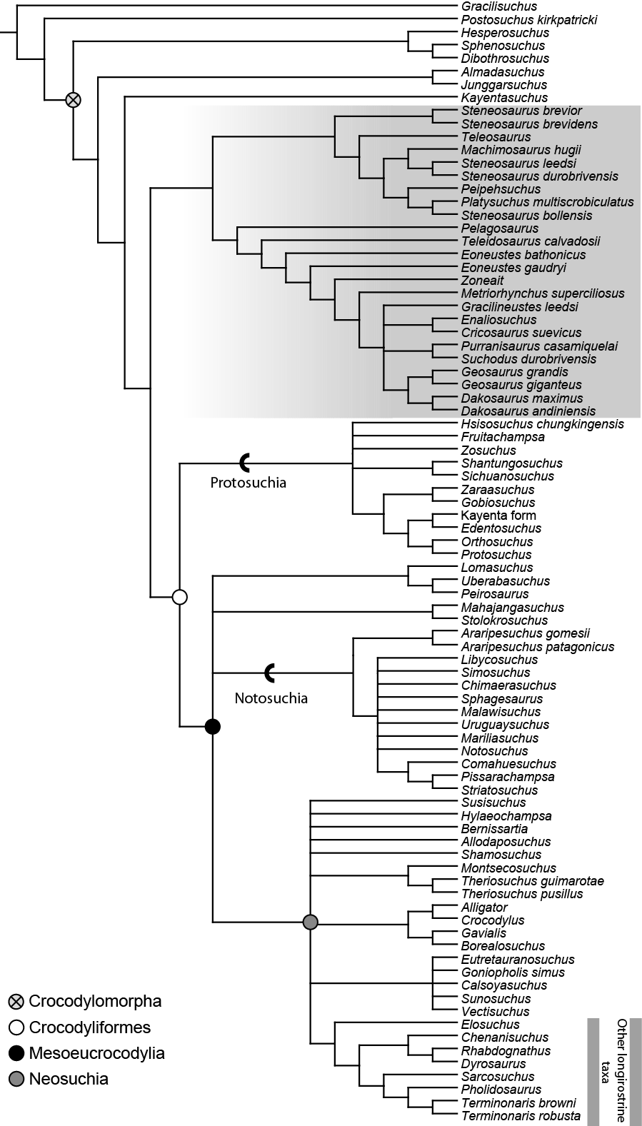
Figure S2. Strict consensus of 96 MPTs of length 1697 (CI=0.305; RI=0.709) when thalattosuchians are constrained to fall within Crocodyliformes (ordered analysis). Thalattosuchia is highlighted in gray.
Figure S1. Strict consensus of 566 MPTs of length 1649 (CI = 0.312; RI = 0.703) resulting from the unordered character analysis. Thalattosuchia is highlighted in gray.

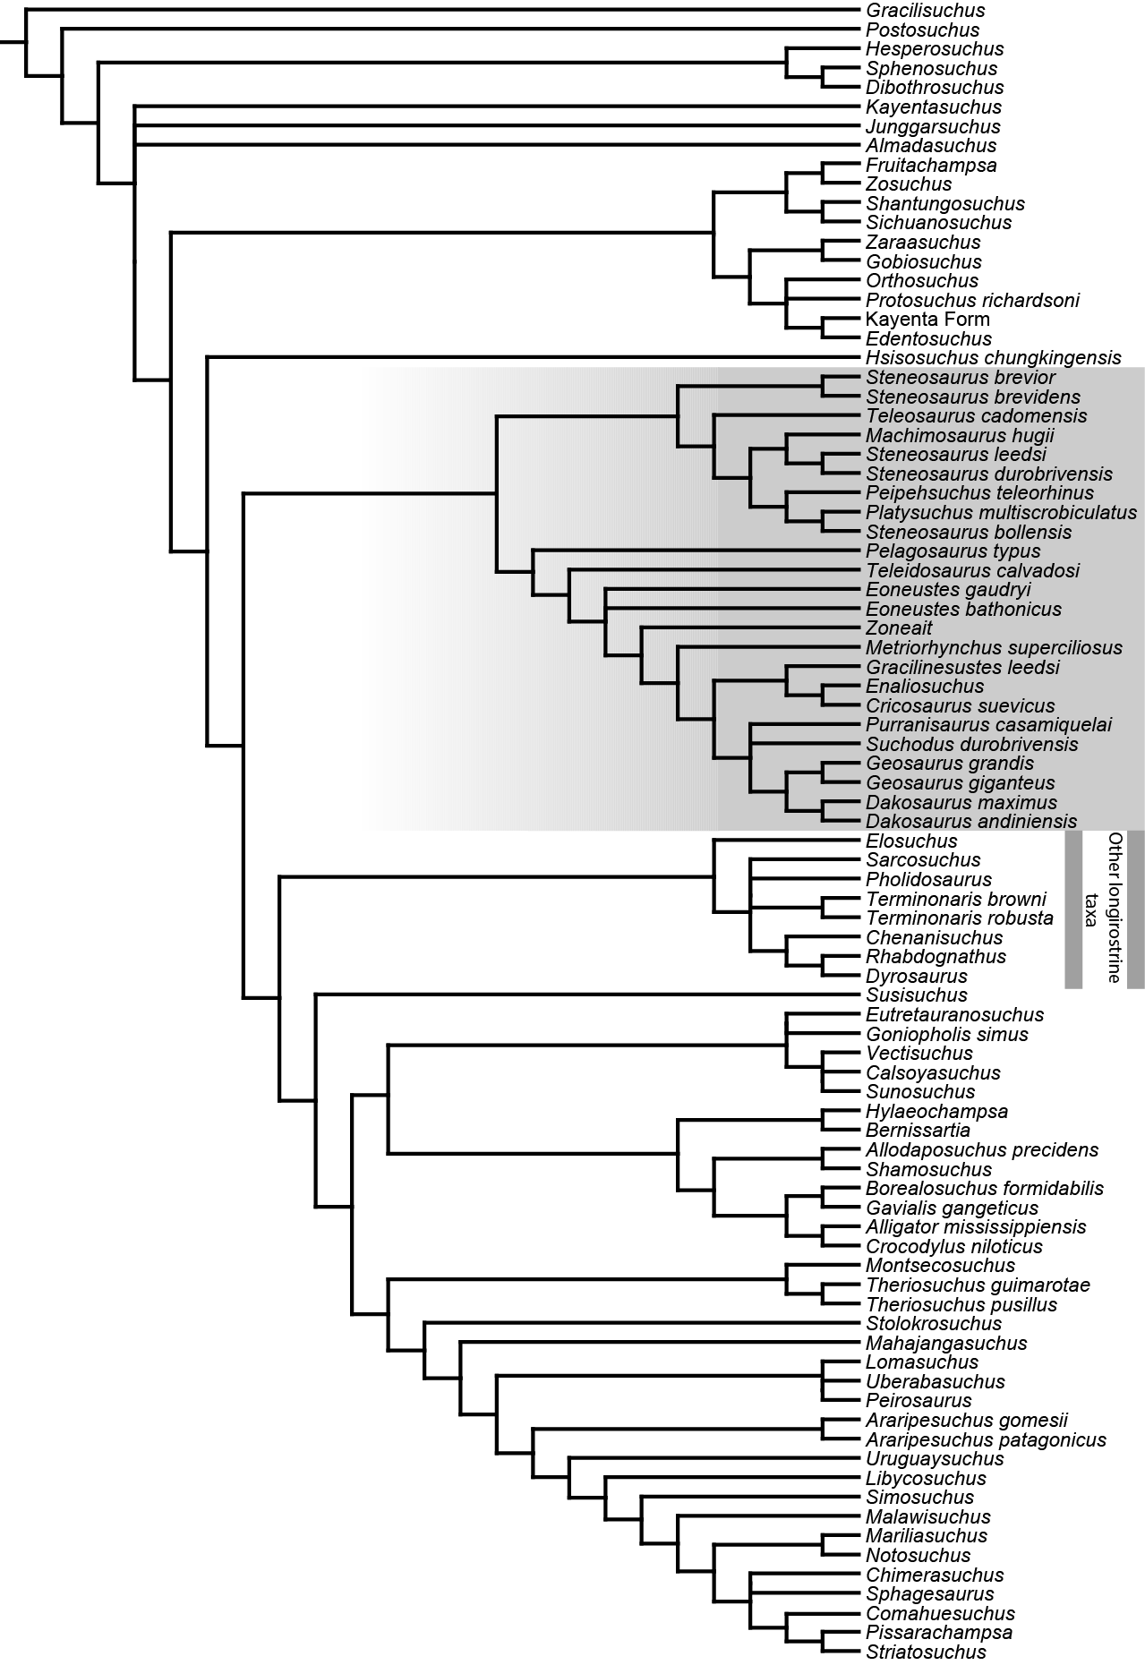
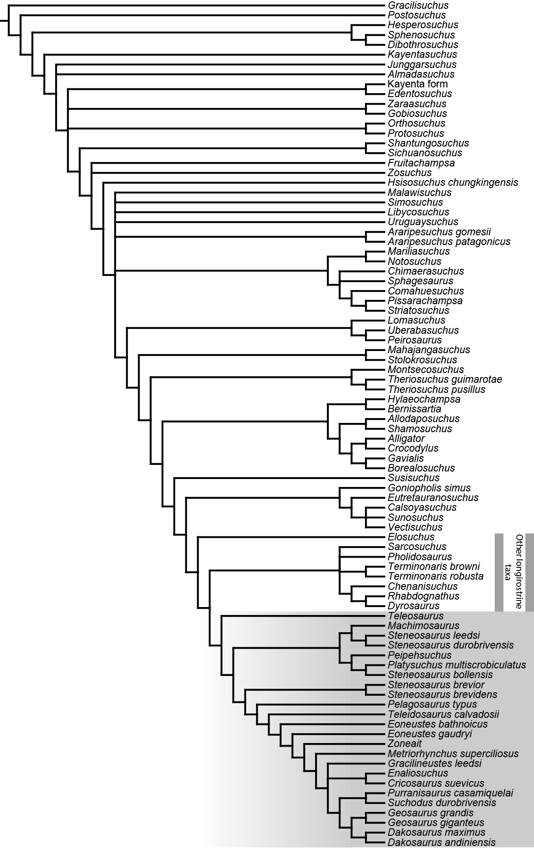
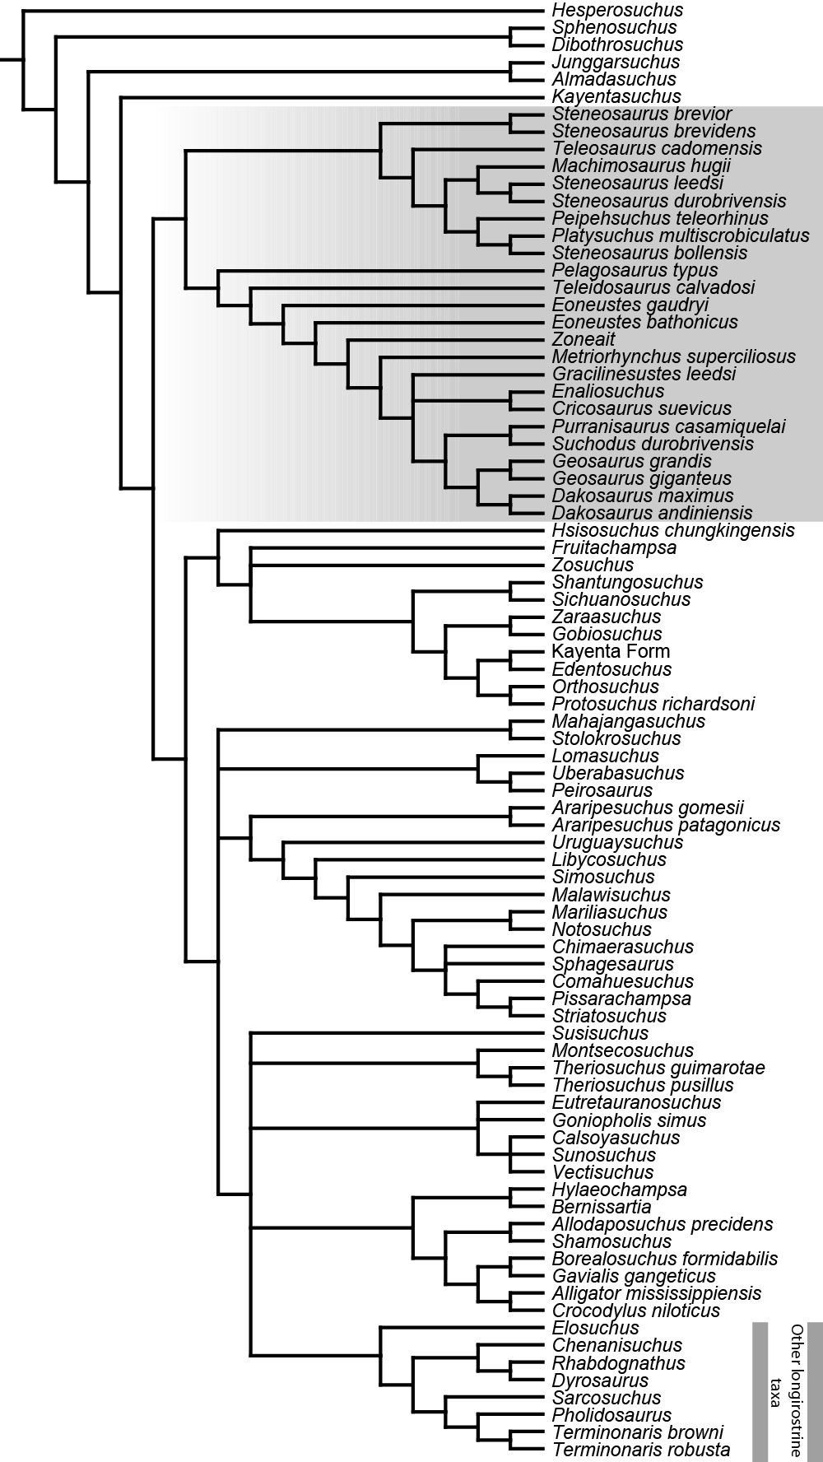
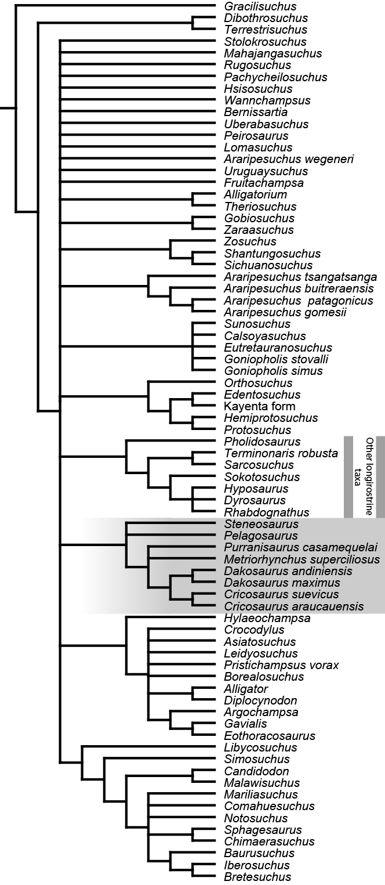
Figure S3. Strict consensus of 256 MPTs of length 1704 (CI=0.303; RI=0.707) when thalattosuchians are constrained to form a clade with pholidosaurs and dyrosaurids (ordered analysis). Thalattosuchia is highlighted in gray.
Figure S4. Strict consensus of 42 MPTs of length 1632 when non-crocodylomorph outgroup taxa are excluded and trees are rooted on Hesperosuchus agilis (ordered analysis). Thalattosuchia is highlighted in gray.
Figure S5. Strict consensus of 2038 MPTs of length 1121 resulting from reanalysis of the matrix of Turner and Buckley (2008) with modification to characters 3, 26, and 63. Thallatosuchia is highlighted in gray. In some MPTs Thalattosuchia is recovered as the sister group to Crocodyliformes.

