Read me for data for Cox Gillis ‘Vision is not important for coordinating asymmetric landings in toads’

There are 8 files in this archive:

ReadCSVsTrig.m Matlab code to compile digitized video into one file
RollCSVTrigdata10 Mar 2016.mat Output of ReadCSVsTrig.m
ViewData6.m Matlab code to link EMG and digitized data
emgdataInt28Nov 2015. mat Raw EMG data by animal and hop
AllRollData-3-30 Nov 2015.csv Output of ViewData6 that's fed into Roll2.Rmd
MuscleDataRoll.csv Links emg trace number to each muscle for each toad
VideoTimes.csv hop event frame numbers (liftoff, touchdown, ect...)
Roll2.Rmd R markdown code used to generate document

ReadCSVsTrig.m: Compiles digitized points from high speed video and trigger frame numbers to sync with EMG data. Also reads in MuscleDataRoll.csv and VideoTimes.csv and compiles all the data by toad and hop.

RollCSVTrigdata10 Mar 2016.mat is a matlab file that contains a structure 'csvdata' that includes the fields for each toad and hop:
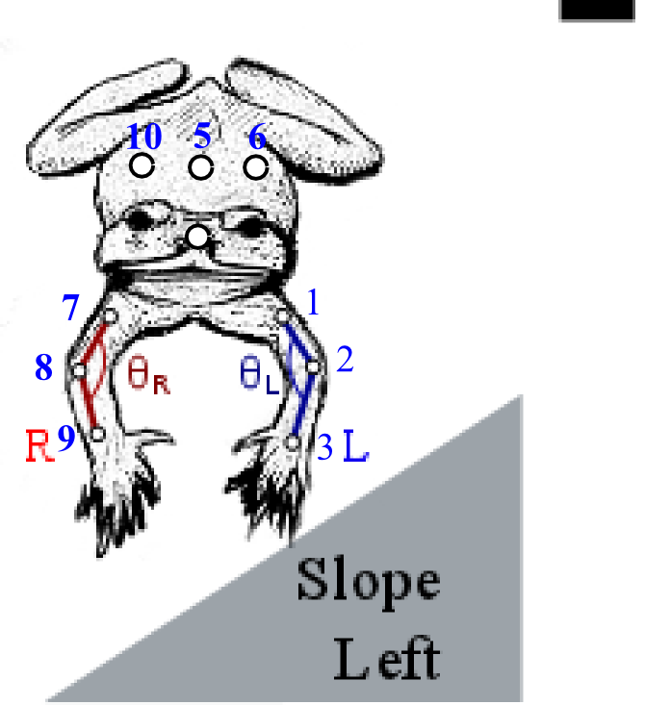
pt1x, pt1y, pt1z The xyz coordinates of the midpoint of the left humerus
pt2x, pt2y, pt2z The xyz coordinates of the left elbow
pt3x, pt3y, pt3z The xyz coordinates of the left wrist
pt4x, pt4y, pt4z The xyz coordinates of the tip of the snout
pt5x, pt5y, pt5z The xyz coordinates of along the long axis of the toad and midway along the back
pt6x, pt6y, pt6z The xyz coordinates of along the left of the toad and midway along the back
pt7x, pt7y, pt7z The xyz coordinates of the midpoint of the right humerus
pt8x, pt8y, pt8z The xyz coordinates of the right elbow
pt9x, pt9y, pt9z The xyz coordinates of the right wrist
pt10x, pt10y, pt10z The xyz coordinates of along the right of the toad and midway along the back
toad The name of the toad
hop Hop number. The letter designates treatment. 'r10' is roll hop 10. v1 is valley (slope) hop 1
triggerFrameNum The frame in video of trigger
longname name of video
csvt time array corresponding to video in sec
takeoffs seconds after beginning of video when last toe of toad lifts off
ltouchs seconds after beginning of video touch of left forelimb touchdown
rtouchs seconds after beginning of video touch of right forelimb touchdown
valleyRL Whether the toad jumped onto a right or left sloping surface. Right slope corresponded to a surface where the toad's right side would be closer to the ground than its left
mass mass of the toad in mg
lanc2 emg trace number of the left anconeus muscle
lanc1 2nd emg trace number of the left anconeus muscle
ranc2 2nd emg trace number of the right anconeus muscle
ranc1 emg trace number of the right anconeus muscle

ViewData6.m: Matlab code and gui that complies EMG data with RollCSVTrigdata10 Mar 2016.mat and allows user to define the onset of emg activity for each trace. Also calculates elbow angles and other kinematic variables. Outputs AllRollData-3-30 Nov 2015.csv

AllRollData-3-30 Nov 2015.csv: Condensed data that is read into R markdown file containing the columns:

toad, hop, takeoffs, ltouchs, rtouchs, valleyRL, mass, lanc2, lanc1, ranc2, ranc1 as described above
noCSVs 1: this hop didn't have digitized video data to go with it 0: there was video data
maxV maximum linear velocity cm/s during the hop
dist horizontal distance of the hop in cm
height maximum vertical height of the hop in cm
T0 First time linear velocity reached 5 cm/s
T4 Time of end of landing (smallest elbow angle)
T1R beginning of right elbow flexion during takeoff (sec)
T2R beginning of right elbow extension (sec)
T3R Touchdown right forelimb (sec)
T1 beginning of left elbow flexion during takeoff (sec)
T2 beginning of left elbow extension (sec)
T3 Touchdown left forelimb (sec)
treat V: valley (slope) or r: roll treatment
L EMG trace number used for left anconeus data
R EMG trace number used for right anconeus data
touchs time of first touchdown (sec)
ltouchcsv frame number of left touchdown
rtouchcsv frame number of right touchdown
touchCSV frame number of first touchdown
touchd2CSV frame number of second touchdown
T2CSV frame number of T2
T2RCSV frame number of T2R
T4csv frame number of T4
avIPextV average extension velocity of left elbow from T2 to T3 (deg/sec)
T260Vel average extension velocity of left elbow from T2 to T2+60 ms
TDext Extension of left elbow at touchdown (deg)
TD2ext Extension of left elbow at touchdown of 2nd limb (deg)
T2ext Extension of left elbow at T2
T4ext Extension of left elbow at T4
avIPextVR average extension velocity of right elbow from T2 to T3 (deg/sec)
T260VelR average extension velocity of right elbow from T2 to T2+60 ms
T2Rext Extension of right elbow at T2R (deg)
TDextR Extension of right elbow at TD (deg)
T4extR Extension of right elbow at T4
rollTD roll of the animal at touchdown
firsttouch ‘l’ if left forelimb touched first, ‘r’ if right
treat4 treatment with both roll and left or right first touch
inRanc rectified integrated EMG from Right anconcus to right limb touchdown
onRanc onset of Right anconeus in seconds
intR2touchd rectified integrated EMG from Right anconcus to first limb touchdown
inLanc rectified integrated EMG from left anconcus to left limb touchdown
onLanc onset of left anconeus in seconds
intL2touchd rectified integrated EMG from Right anconcus to first limb touchdown
diffextT3 Extension of left elbow-extension of right elbow at T3
ninRanc normalized (by animal) integrated right anconues EMG signal from onset to touchdown
nintLanc normalized integrated left anconeus EMG signal from onset to touchdown
nint2touchR normalized integrated right anconeus EMG signal from onset to touchdown of 2nd limb
nint2touchL normalized integrated left anconeus EMG signal from onset to touchdown of 2nd limb

MuscleDataRoll.csv includes columns
Toad Animal name
Ranc1 emg trace number of 1st right anconeus electrode
Ranc2 emg trace number of 2nd right anconeus electrode
Lanc1 emg trace number of 1st left anconeus electrode
Lanc2 emg trace number of 2nd left anconeus electrode
Mass_g mass of the toad in mg

VideoTimes.csv includes the columns

Toad Animal name
Hop Hop number
Takeoff frame number of takeoff time
Ltouchdown frame number of left forelimb touchdown
Rtouchdown frame number of right forelimb touchdown
Valley RL Whether the toad hopped on to a left or right sloped surface

