Supplemental Table 1 : Characteristics of the patients who died within the first 6 months after PCNSL diagnosis

|  |  |
| --- | --- |
| N | 239 |
| Age : median (range) | 73 years (18-91) |
| KPS : median (range) | 50 (10-90) |
| Sex ratio M/W | 1.2 |
| Cause of death  Multifactorial  Lymphoma before any treatment  Progression of disease despite treatment  Treatment-related toxicity  Unknown | 105 (44%)  31 (13%)  74 (31%)  12 (5%)  17 (7%) |
| Median OS (months) | 2.4 |

Supplemental Figure 1 : OS in patients treated with HCT-ASCT in first line

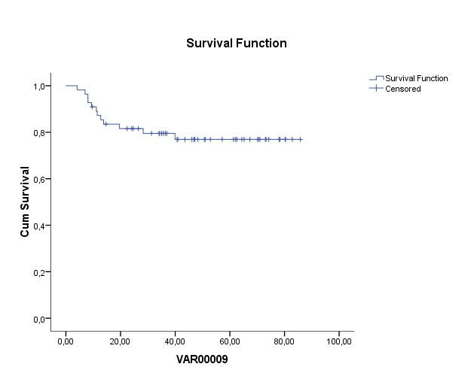

% OS

Time (months)

Supplemental Figure 2 : OS according to the MSKCC prognostic model

% OS

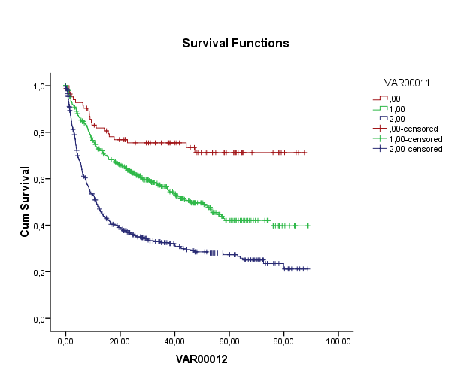

Time (months)

Age ≤ 50

Age > 50, KPS ≥ 70

Age > 50, KPS < 70

Supplemental Figure 3 : PFS (A) and OS (B) according to consolidation in first line treatment in patients <60 years, in CR after initial chemotherapy

