Table 1. The typical definition of lightning current.
The typical lightning current waveform is composed of four parts: first return stroke, intermediate current, long continuing current and subsequent stroke according to the International Electrotechnical Commission (IEC) and the Society of Automotive Engineers (SAE) standards.
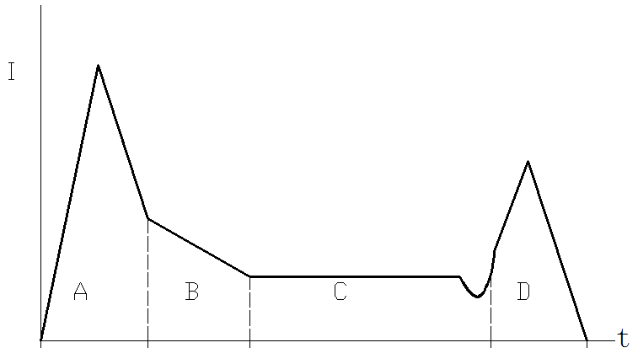 | definition
first return stroke  (part A) | The maximum value of current is 200 kA. The rise time is less than 50 µs. The current attenuates to 1% of the peak is no more than 500 µs.
intermediate current  (part B) | The average value of current is 2 kA. The duration is less than 5 ms.
long continuing current  (part C) | The value of current is 200-800 A. The duration is 0.25-1 s.
subsequent stroke  (part D) | The maximum value of current is 100 kA. The rise time is less than 25 µs. The current attenuates to 1% of the peak is no more than 500 µs.

