Data were collected as described in O’Brien et al., 2022 warm acclimation alters antioxidant defences but not metabolic capacities in the Antarctic fish, Notothenia coriiceps. Conservation Physiology.

Experimental details
N. coriiceps (Richardson 1844) were collected from two locations in the Western Antarctic Peninsula region (Low Island [63° 25’ S; 62° 10’ W], and Dallmann Bay [64° 10’ S; 62° 35’ W]) using benthic otter trawls and baited fish pots deployed from US ARSV Laurence M. Gould during the austral fall and winter of 2013. Fish were held in circulating seawater tanks onboard the ship before transfer to the aquarium at the US Antarctic Research Station, Palmer Station, where they were held in tanks with circulating seawater at 0.1 ± 0.5°C. In 2017, N. coriiceps were captured by hook and line off the pier at Palmer Station and then immediately transferred to the aquarium. All tanks were equipped with oxygen diffusers and blocks of frozen seawater were added as needed to maintain the temperature of the control tanks. Animals were fed a diet of chopped fish every other day and all uneaten food was removed from the tanks. Ammonia levels were measured every two days. All experimental procedures were approved by the University of Alaska IACUC committee (247598-11 and 570217-9).

Warm acclimation
In 2013, N. coriiceps were placed in two 700-L insulated recirculating seawater tanks at 0.1 ± 0.5°C (3 or 4 fish per tank). Fish were held for 24 hours before the temperature was increased 0.5°C per day for six days using 3-KW Elecro Titanium inline heaters (Aqualogic, San Diego, CA, USA) until the tanks reached 4°C. Flow rate in the heated tank was maintained at 1 gallon per minute (gpm) so that the volume of the tank turned over within 1 hour. Warm-acclimated animals were held at 4 ± 0.2° while control animals were held in 2000 L tanks at 0.1 ± 0.5°C for 22 days (n = 7 for each temperature group).
In 2017, N. coriiceps were held in two 2000 L tanks (20-21 animals per tank), one of which was fitted with a 6 kW submersible heater (Aqualogic) to heat the tank as described above. A submersible pump was used to facilitate mixing. Animals were held at -0.6 ± 0.4° (control) or 5.1 ± 0.3°C (warm-acclimated) for 42 days. Flow rate was maintained between 5 (heated tank) and 8 (control tank) gpm so that the volume of the tank turned over within 2 hours. Sixteen animals from each temperature group were used for assays described herein.
The length of acclimation period was shorter and the acclimation temperature was lower in 2013 than 2017 because in 2013 we also attempted to warm acclimate icefish, which have a lower thermal tolerance than N. coriiceps (Beers and Sidell, 2011).
Fish were euthanized with a sharp blow to the head followed by cervical transection. Hearts were excised and allowed to contract in notothenioid Ringer’s solution (260 mmol l⁻¹ NaCl, 2.5 mmol l⁻¹ MgCl₂, 5.0 mmol l⁻¹ KCl, 2.5 mmol l⁻¹ NaHCO₃, 5.0 mmol l⁻¹ NaH₂PO₄, pH 8.0) to clear blood from the ventricular lumen. The atrium was removed, and the ventricle then blotted dry and weighed. The spleen was also removed, blotted dry and weighed. Heart ventricle, pectoral adductor muscle, glycolytic muscle, liver, and gill tissues were flash frozen in liquid nitrogen and stored at -80°C to -70°C. Frozen tissues collected in 2013 were used for measuring the maximal activities of citrate synthase (CS), superoxide dismutase (SOD) and catalase (CAT), levels of ubiquitinated proteins, and the activity of the 20S proteasome within one year. Fresh tissues were used for measuring the activity of cytochrome c oxidase (CCO) immediately upon harvest. Tissues collected in 2017 were used for measuring mitochondrial function, levels of triacylglycerol (TAG) and glycogen, and maximal activities of CS (in gill only), 3-hydroxyacyl-CoA dehydrogenase (HOAD), carnitine palmitoyltransferase (CPT), lactate dehydrogenase (LDH), pyruvate kinase (PK), and glutamate dehydrogenase (GDH), the latter two enzymes in gill tissue only. Enzymes were all assayed within two years of tissue collection; TAG and glycogen levels were measured in 2020. For all experiments, control and acclimated samples were measured at the same time.

Abbreviations:
VENT = heart ventricle
PECT = oxidative skeletal muscle
WM = glycolytic skeletal muscle
Enzyme activity was measured at 5ºC in 2013 and at 2.5ºC in 2017.
A visual description of the experimental design is shown below.

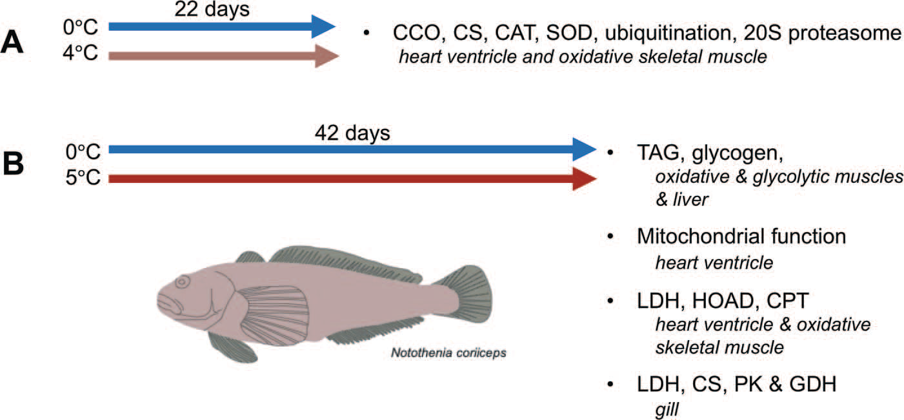

Figure 1: Experimental design used in acclimation experiments. In 2013 (A) N. coriiceps were acclimated to 4◦C for 22 days. Tissues were
harvested and activities of CS, CCO, CAT, SOD, levels of ubiquitinated proteins and the activity of the 20S proteasome were quantified in heart ventricle and oxidative skeletal muscle to determine the impacts of warm acclimation on metrics of oxidative stress. In 2017 (B) N. coriiceps were warm acclimated to 5◦C for 42 days. Animals were harvested and levels of TAG and glycogen were measured in oxidative and glycolytic skeletal muscles and liver. Mitochondrial function was measured inmitochondria isolated from heart ventricles. And, a suite of metabolic enzymes (LDH, HOAD, CPT, PK, GDH and CS) were measured in oxidative skeletal muscle, heart ventricle and/or gill.

