Journal of Biogeography
SUPPORTING INFORMATION
Convergent evolution in lemur environmental niches
James P. Herrera
Department of Evolutionary Anthropology
Duke University, Durham NC 27708

Phylogeny in Newick format:
((((((((((Propithecus_coronatus:1.284909,Propithecus_deckenii:1.284909):0.3584417,Propithecus_verreauxi:1.643351):2.846604,Propithecus_candidus:4.489955):2.126983,(Propithecus_coquereli:2.226296,Propithecus_tattersalli:2.226296):4.390642):4.161572,((Propithecus_diadema:2.881493,Propithecus_edwardsi:2.881493):1.719196,Propithecus_perrieri:4.600689):6.17782):9.862771,(((((Avahi_meridionalis:0.9213011,Avahi_ramanantsoavanai:0.9213011):0.4465011,Avahi_peyrierasi:1.367802):0.1448863,Avahi_betsileo:1.512688):0.6682169,Avahi_laniger:2.180905):4.898079,((Avahi_cleesei:1.587157,Avahi_occidentalis:1.587157):0.2600867,Avahi_unicolor:1.847244):5.231741):13.5623):2.985066,Indri_indri:23.62635):11.203919,(((((((((Eulemur_albifrons:0.6718302,Eulemur_sanfordi:0.6718302):1.029611,Eulemur_fulvus:1.701441):0.9961293,Eulemur_rufifrons:2.69757):1.032768,Eulemur_rufus:3.730338):0.8386488,(Eulemur_cinereiceps:1.895786,Eulemur_collaris:1.895786):2.673201):3.530054,(Eulemur_mongoz:6.758921,Eulemur_rubriventer:6.758921):1.34012):1.826728,((Eulemur_flavifrons:3.717495,Eulemur_macaco:3.717495):4.689523,Eulemur_coronatus:8.407018):1.518751):12.01502,(((((Hapalemur_alaotrensis:0.539791,Hapalemur_occidentalis:0.539791):1.279758,(Hapalemur_griseus:0.09438916,Hapalemur_meridionalis:0.09438916):1.72516):6.381962,Hapalemur_aureus:8.201511):2.693145,Hapalemur_simus:10.89466):3.903179,Lemur_catta:14.79783):7.142951):4.531448,(Varecia_rubra:2.558486,Varecia_variegata:2.558486):23.91375):8.358033):2.867191,((((((((((((((((Microcebus_berthae:2.014978,Microcebus_myoxinus:2.014978):0.3063087,(Microcebus_lehilahytsara:1.949077,Microcebus_rufus:1.949077):0.3722101):0.98095,Microcebus_mittermeieri:3.302237):0.6964799,((Microcebus_arnholdi:1.575058,Microcebus_sambiranensis:1.575058):1.336974,(Microcebus_mamiratra:0.9897155,Microcebus_margotmarshae:0.9897155):1.922317):1.086685):0.3352969,Microcebus_simmonsi:4.334014):0.649903,Microcebus_tavaratra:4.983917):0.2726239,Microcebus_jollyae:5.256541):0.3110127,Microcebus_danfossi:5.567553):0.5929594,(Microcebus_gerpi:1.26941,Microcebus_marohita:1.26941):4.891103):0.6627046,((Microcebus_bongolavensis:0.5307805,Microcebus_ravelobensis:0.5307805):3.213992,Microcebus_macarthurii:3.744773):3.078445):1.781026,(Microcebus_griseorufus:6.209577,Microcebus_murinus:6.209577):2.394666):7.327394,(Mirza_coquereli:2.258375,Mirza_zaza:2.258375):13.67326):3.298618,Allocebus_trichotis:19.23026):5.49286,(((Cheirogaleus_crossleyi:12.843169,Cheirogaleus_major:12.84317):2.725539,Cheirogaleus_medius:15.56871):2.479432,Cheirogaleus_sibreei:18.04814):6.674975):6.777675,Phaner_furcifer:31.50079):2.709397,(((((Lepilemur_edwardsi:1.1096179,Lepilemur_otto:1.109618):6.301239,((Lepilemur_randrianasoloi:2.870028,Lepilemur_ruficaudatus:2.870028):2.366709,Lepilemur_hubbardorum:5.236737):2.174119):2.787945,Lepilemur_leucopus:10.1988):2.102411,(((((Lepilemur_ankaranensis:2.585282,Lepilemur_dorsalis:2.585282):0.7911691,Lepilemur_septentrionalis:3.376452):0.4706927,Lepilemur_mittermeieri:3.847144):1.242456,Lepilemur_sahamalazensis:5.089601):3.107497,Lepilemur_aeeclis:8.197098):4.104115):4.044456,((Lepilemur_mustelinus:9.69339,Lepilemur_microdon:9.69339):1.134112,Lepilemur_seali:10.8275):5.518167):17.86452):3.48727):17.571184,Daubentonia_madagascariensis:55.268643)

Figure S1. Tree with climate niches inferred by surface model illustrated by different colors, represented in the map of Madagascar.
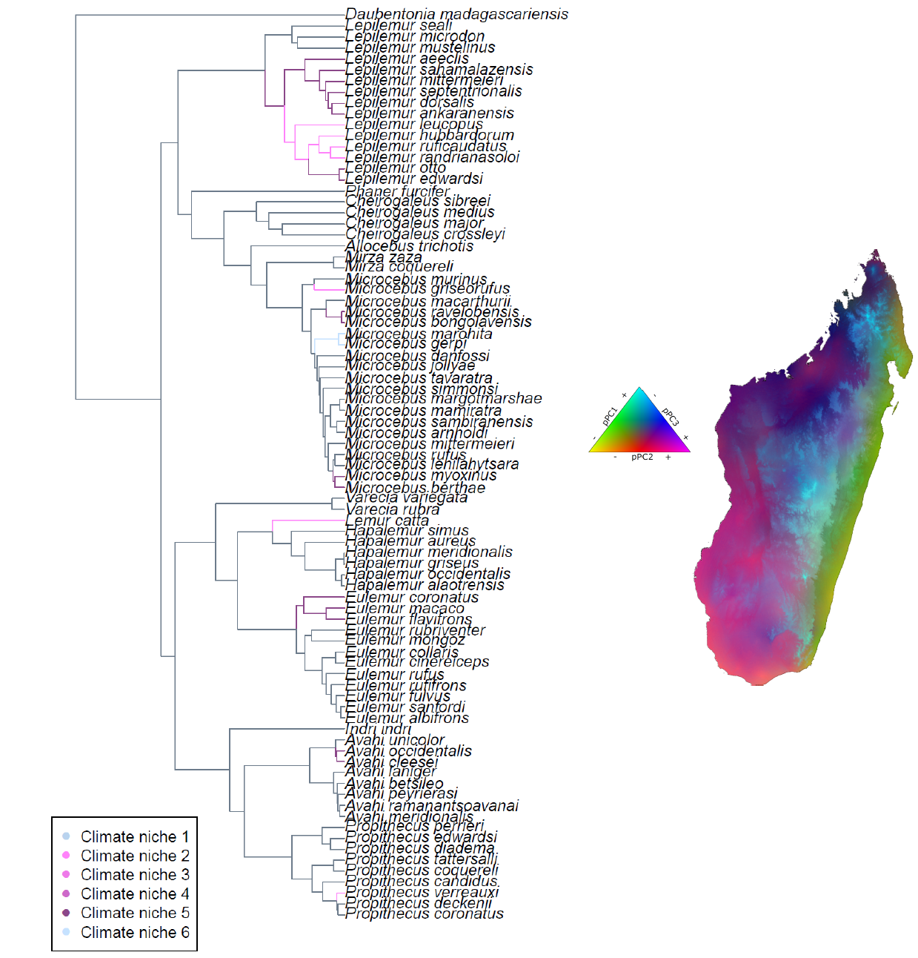
Figure S2. Histograms showing the distribution of the number of convergent climate niches (left) and the number of shifts (right) inferred across 100 trees from the posterior distribution of trees. Red line illustrates the number of climate niches and shifts observed in the MCC tree.
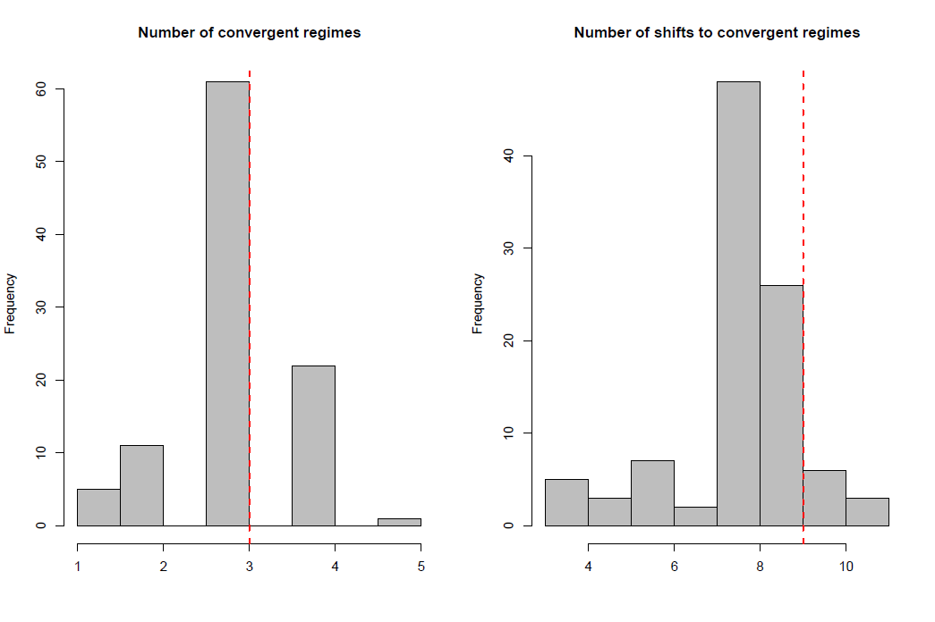
Figure S3. Histograms showing the distribution of the number of convergent climate niches (left) and the number of shifts to convergent niches (right) inferred across 1000 simulations under a Brownian motion model. Red line illustrates the number of climate niches and shifts observed in the MCC tree.
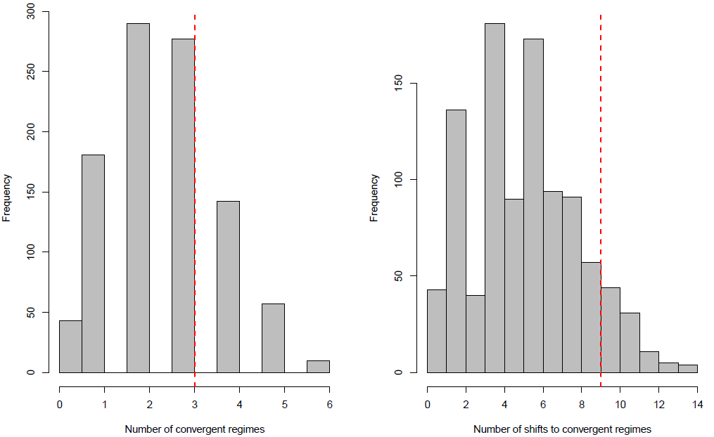

Fig S4. Location and magnitude of climate niche shift for each pPC axis based on the bayou analysis. Grey branches indicate the lineage in the unique climate niche, and the size of circles on the branches indicate the posterior probability of regime shift. Note that the maximum posterior probability of a shift was 0.30.
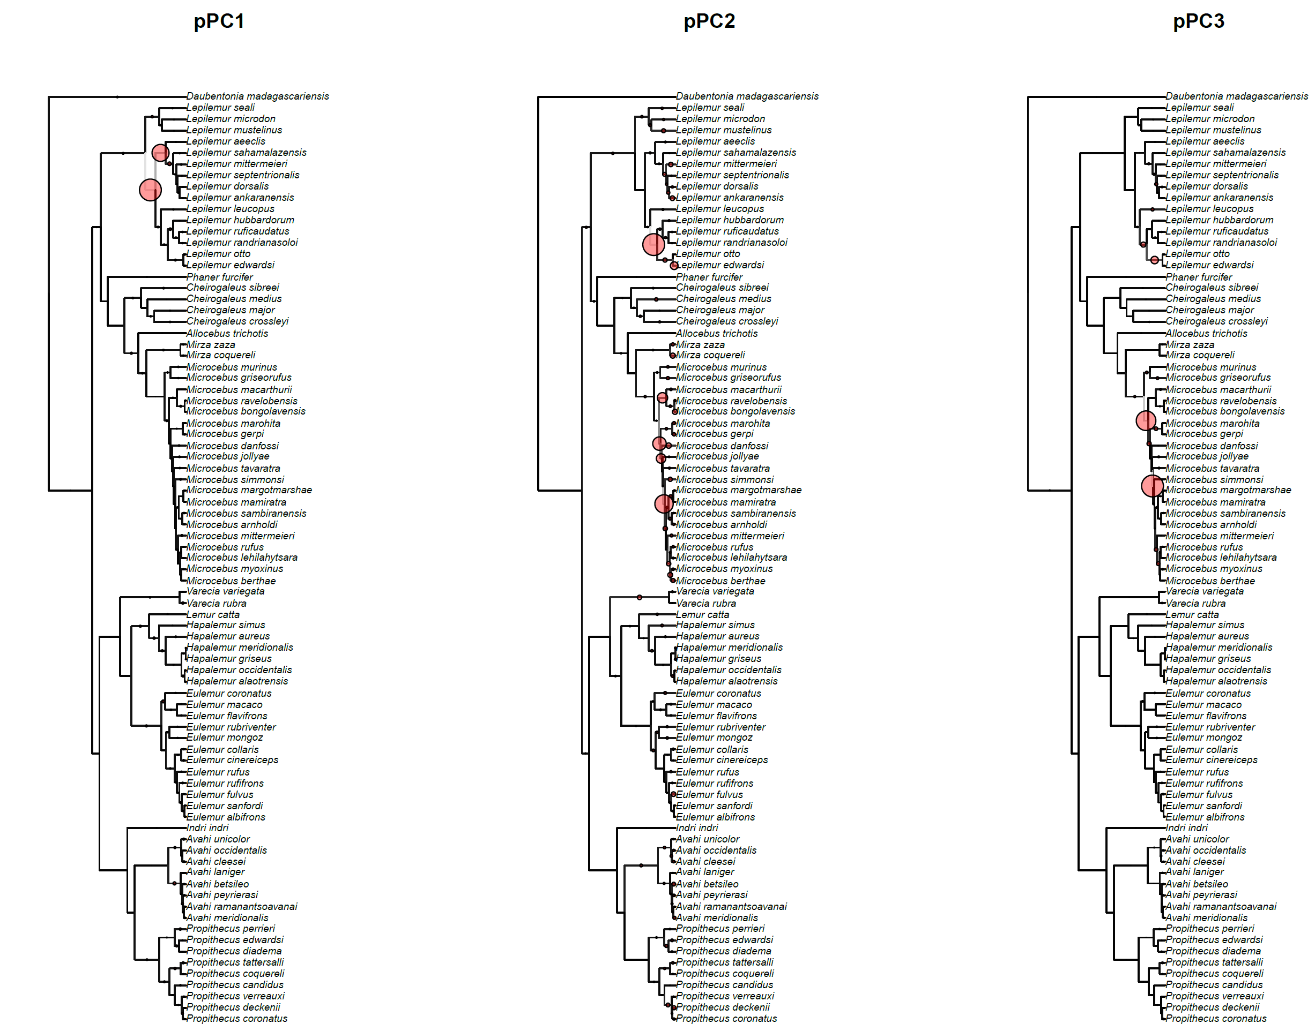

Table S1. Raw data on lemur climate variables.
Binomial | bio_3 | bio_4 | bio_5 | bio_6 | bio_7 | bio_15 | bio_16 | bio_17 | alt | bio_12sd
Propithecus coronatus | 196.50 | 133.20 | 329.70 | 1713.93 | 67.65 | 3.42 | 402.43 | 1559.21 | 588.18 | 134.73
Propithecus deckenii | 170.95 | 161.35 | 332.30 | 1602.76 | 67.09 | 1.72 | 387.79 | 1308.88 | 132.21 | 125.97
Propithecus verreauxi | 212.49 | 123.09 | 335.57 | 2679.43 | 63.76 | 5.03 | 168.55 | 658.11 | 222.01 | 196.73
Propithecus candidus | 162.39 | 118.60 | 280.99 | 2132.34 | 68.88 | 46.20 | 314.72 | 1739.02 | 920.88 | 124.56
Propithecus coquereli | 180.69 | 164.63 | 345.32 | 1512.17 | 67.87 | 1.73 | 453.79 | 1561.39 | 131.14 | 71.86
Propithecus tattersalli | 128.32 | 181.32 | 309.64 | 1359.87 | 71.30 | 29.92 | 273.41 | 1412.42 | 160.91 | 42.24
Propithecus diadema | 166.58 | 109.79 | 276.37 | 2456.88 | 64.54 | 32.91 | 308.53 | 1604.78 | 962.60 | 333.06
Propithecus edwardsi | 169.75 | 93.05 | 262.80 | 2529.60 | 61.32 | 35.22 | 311.61 | 1514.58 | 1113.37 | 240.07
Propithecus perrieri | 131.48 | 175.15 | 306.63 | 1279.56 | 71.57 | 18.18 | 323.08 | 1392.34 | 284.36 | 44.93
Avahi meridionalis | 168.78 | 119.73 | 288.52 | 2416.24 | 62.69 | 51.66 | 231.37 | 1468.32 | 499.10 | 375.29
Avahi ramanantsoavanai | 177.13 | 105.19 | 282.32 | 2539.27 | 62.52 | 35.90 | 304.56 | 1598.79 | 744.35 | 342.43
Avahi peyrierasi | 167.68 | 105.40 | 273.09 | 2517.69 | 61.14 | 39.92 | 328.84 | 1617.22 | 871.95 | 303.15
Avahi betsileo | 173.70 | 81.59 | 255.29 | 2590.05 | 62.85 | 41.91 | 317.04 | 1689.71 | 1299.79 | 170.57
Avahi laniger | 157.83 | 126.73 | 284.56 | 2293.81 | 64.94 | 45.08 | 333.61 | 1860.09 | 743.49 | 422.18
Avahi cleesei | 190.88 | 139.00 | 329.88 | 1843.09 | 65.27 | 2.04 | 349.07 | 1314.20 | 369.88 | 63.65
Avahi occidentalis | 187.30 | 162.04 | 349.34 | 1471.71 | 67.70 | 1.08 | 451.98 | 1515.15 | 137.10 | 21.89
Avahi unicolor | 171.38 | 116.12 | 287.50 | 1638.91 | 71.95 | 8.35 | 363.63 | 1514.41 | 1015.77 | 134.43
Indri indri | 158.90 | 123.34 | 282.25 | 2349.23 | 64.92 | 41.87 | 327.64 | 1797.99 | 797.41 | 388.64
Eulemur albifrons | 146.51 | 144.73 | 291.24 | 2112.28 | 64.88 | 59.54 | 340.04 | 2132.33 | 549.11 | 398.42
Eulemur sanfordi | 131.98 | 174.39 | 306.37 | 1272.18 | 71.24 | 15.71 | 347.76 | 1435.33 | 312.95 | 133.44
Eulemur fulvus | 168.53 | 133.53 | 302.06 | 2036.49 | 65.90 | 23.67 | 370.88 | 1656.49 | 604.11 | 338.66
Eulemur rufifrons | 206.70 | 119.91 | 326.61 | 2528.61 | 63.32 | 8.19 | 236.07 | 911.63 | 363.40 | 365.19
Eulemur rufus | 172.86 | 161.68 | 334.54 | 1626.19 | 66.93 | 1.65 | 388.31 | 1306.78 | 125.34 | 164.16
Eulemur cinereiceps | 166.56 | 113.32 | 279.88 | 2495.43 | 61.18 | 40.58 | 303.05 | 1597.11 | 723.84 | 347.54
Eulemur collaris | 175.89 | 106.39 | 282.29 | 2507.03 | 62.93 | 38.12 | 276.56 | 1500.18 | 729.33 | 320.72
Eulemur mongoz | 164.68 | 172.23 | 336.91 | 1360.78 | 68.84 | 4.65 | 440.52 | 1506.61 | 110.82 | 53.76
Eulemur rubriventer | 165.02 | 114.53 | 279.55 | 2262.41 | 66.00 | 34.52 | 324.99 | 1664.07 | 917.94 | 292.55
Eulemur flavifrons | 146.27 | 175.08 | 321.35 | 1142.75 | 72.40 | 6.87 | 446.23 | 1728.65 | 193.94 | 83.23
Eulemur macaco | 149.77 | 157.07 | 306.84 | 1400.80 | 70.38 | 15.39 | 429.49 | 1803.04 | 427.43 | 199.24
Eulemur coronatus | 130.90 | 178.85 | 309.75 | 1273.28 | 71.02 | 18.68 | 333.04 | 1428.37 | 238.06 | 120.63
Hapalemur alaotrensis | 186.76 | 110.98 | 297.74 | 2360.60 | 67.38 | 4.09 | 279.51 | 1146.53 | 755.84 | 8.92
Hapalemur occidentalis | 150.99 | 140.32 | 291.30 | 2030.85 | 66.13 | 42.36 | 345.56 | 1888.10 | 605.15 | 419.57
Hapalemur griseus | 169.06 | 139.83 | 308.88 | 1949.79 | 65.56 | 18.78 | 373.05 | 1549.32 | 457.11 | 392.10
Hapalemur meridionalis | 174.55 | 106.33 | 280.88 | 2494.70 | 62.91 | 39.83 | 271.04 | 1500.68 | 728.90 | 289.86
Hapalemur aureus | 167.60 | 98.04 | 265.65 | 2521.22 | 60.94 | 36.18 | 317.78 | 1533.91 | 1031.88 | 221.91
Hapalemur simus | 169.10 | 105.14 | 274.25 | 2534.88 | 62.56 | 39.57 | 333.14 | 1684.54 | 933.32 | 350.34
Lemur catta | 216.39 | 117.28 | 333.67 | 2716.80 | 64.23 | 6.02 | 168.11 | 681.10 | 331.14 | 184.27
Varecia rubra | 135.96 | 156.51 | 292.47 | 2051.52 | 62.35 | 72.75 | 339.85 | 2454.39 | 383.85 | 277.72
Varecia variegata | 162.93 | 116.01 | 278.94 | 2394.06 | 64.76 | 42.59 | 332.78 | 1798.43 | 881.06 | 350.62
Microcebus berthae | 205.19 | 137.20 | 342.39 | 2204.25 | 63.53 | 1.16 | 298.08 | 958.34 | 69.25 | 34.36
Microcebus myoxinus | 171.68 | 159.41 | 331.09 | 1710.33 | 66.23 | 1.89 | 363.71 | 1227.25 | 104.45 | 112.80
Microcebus lehilahytsara | 170.02 | 95.29 | 265.31 | 2573.40 | 64.07 | 37.26 | 320.84 | 1688.24 | 1153.40 | 262.85
Microcebus rufus | 168.04 | 96.38 | 264.41 | 2517.33 | 61.12 | 35.85 | 319.63 | 1544.48 | 1062.97 | 246.88
Microcebus mittermeieri | 168.66 | 104.52 | 273.18 | 2219.08 | 70.01 | 39.72 | 328.39 | 1702.80 | 1161.00 | 76.68
Microcebus arnholdi | 131.50 | 134.67 | 266.16 | 1397.08 | 73.68 | 15.40 | 313.14 | 1366.58 | 1019.21 | 11.38
Microcebus sambiranensis | 160.94 | 130.16 | 291.09 | 1503.28 | 71.65 | 10.37 | 389.80 | 1633.32 | 845.45 | 166.29
Microcebus mamiratra | 114.51 | 197.90 | 312.41 | 1286.13 | 67.09 | 28.71 | 461.24 | 2088.22 | 77.71 | 37.54
Microcebus margotmarshae | 178.00 | 95.15 | 273.14 | 1793.15 | 71.57 | 10.30 | 335.04 | 1450.70 | 1356.11 | 84.73
Microcebus simmonsi | 160.31 | 117.85 | 278.16 | 2373.83 | 64.89 | 29.59 | 284.67 | 1535.44 | 897.89 | 544.92
Microcebus tavaratra | 135.28 | 179.30 | 314.58 | 1277.37 | 70.92 | 20.66 | 335.64 | 1488.33 | 180.35 | 116.54
Microcebus jollyae | 155.52 | 140.78 | 296.30 | 2397.89 | 59.61 | 69.70 | 396.34 | 2285.36 | 171.71 | 53.30
Microcebus danfossi | 177.47 | 165.00 | 342.47 | 1460.41 | 68.04 | 1.40 | 453.36 | 1545.36 | 125.04 | 12.84
Microcebus gerpi | 138.51 | 164.08 | 302.59 | 2140.23 | 60.64 | 75.23 | 503.74 | 2767.13 | 96.92 | 10.36
Microcebus marohita | 161.98 | 126.58 | 288.56 | 2466.78 | 62.87 | 52.29 | 362.13 | 2201.76 | 631.33 | 26.03
Microcebus bongolavensis | 200.89 | 151.43 | 352.33 | 1737.12 | 65.81 | 0.98 | 461.92 | 1532.06 | 153.49 | 6.61
Microcebus ravelobensis | 189.36 | 162.60 | 351.96 | 1474.84 | 67.89 | 1.15 | 449.14 | 1515.48 | 128.61 | 25.45
Microcebus macarthurii | 159.55 | 129.04 | 288.59 | 2229.42 | 67.68 | 48.18 | 353.98 | 1943.91 | 786.75 | 209.19
Microcebus griseorufus | 210.48 | 123.74 | 334.21 | 2835.05 | 63.60 | 7.97 | 113.98 | 523.25 | 164.50 | 101.93
Microcebus murinus | 197.47 | 138.45 | 335.92 | 2182.13 | 65.27 | 3.17 | 278.02 | 977.48 | 193.19 | 323.05
Mirza coquereli | 205.95 | 133.13 | 339.08 | 2236.32 | 65.04 | 2.07 | 274.58 | 952.47 | 237.73 | 241.82
Mirza zaza | 143.95 | 172.92 | 316.87 | 1257.12 | 70.64 | 13.62 | 451.04 | 1835.67 | 207.32 | 149.53
Allocebus trichotis | 153.42 | 133.65 | 287.07 | 2238.04 | 64.72 | 48.58 | 327.92 | 1899.12 | 666.25 | 428.62
Cheirogaleus crossleyi | 163.24 | 115.36 | 278.60 | 2425.38 | 64.39 | 37.27 | 314.23 | 1680.36 | 871.49 | 234.78
Cheirogaleus major | 161.92 | 124.93 | 286.86 | 2417.51 | 62.51 | 53.68 | 351.57 | 2023.49 | 594.54 | 397.28
Cheirogaleus medius | 195.62 | 138.88 | 334.50 | 2214.03 | 65.45 | 4.71 | 266.46 | 975.02 | 205.42 | 393.89
Cheirogaleus sibreei | 174.51 | 79.17 | 253.68 | 2555.27 | 61.63 | 31.44 | 280.28 | 1409.88 | 1360.04 | 68.37
Phaner furcifer | 149.40 | 138.03 | 287.43 | 2188.18 | 64.58 | 49.64 | 322.36 | 1934.90 | 625.71 | 453.58
Lepilemur edwardsi | 179.58 | 166.85 | 346.43 | 1447.42 | 67.20 | 1.16 | 450.61 | 1499.37 | 72.26 | 19.46
Lepilemur otto | 202.20 | 152.32 | 354.52 | 1766.99 | 64.81 | 0.99 | 461.87 | 1523.85 | 85.71 | 18.32
Lepilemur randrianasoloi | 191.48 | 139.09 | 330.57 | 1846.79 | 65.20 | 2.01 | 348.23 | 1311.32 | 362.36 | 62.38
Lepilemur ruficaudatus | 209.78 | 131.42 | 341.20 | 2403.89 | 63.15 | 0.96 | 261.41 | 855.82 | 106.69 | 130.31
Lepilemur hubbardorum | 240.27 | 98.08 | 338.35 | 2597.12 | 66.08 | 4.40 | 191.81 | 736.52 | 639.96 | 12.96
Lepilemur leucopus | 215.33 | 116.35 | 331.68 | 2848.07 | 66.29 | 18.21 | 126.47 | 712.91 | 194.89 | 98.96
Lepilemur ankaranensis | 136.69 | 176.11 | 312.80 | 1252.92 | 70.97 | 16.47 | 360.04 | 1500.65 | 239.32 | 122.34
Lepilemur dorsalis | 161.86 | 135.39 | 297.25 | 1561.48 | 70.48 | 14.52 | 391.83 | 1685.70 | 724.46 | 226.23
Lepilemur septentrionalis | 121.97 | 196.04 | 318.01 | 1224.42 | 69.69 | 17.94 | 310.17 | 1265.86 | 73.03 | 33.75
Lepilemur mittermeieri | 125.86 | 186.86 | 312.72 | 1172.43 | 70.71 | 16.25 | 477.04 | 1935.77 | 122.51 | 45.83
Lepilemur sahamalazensis | 138.64 | 186.98 | 325.62 | 955.92 | 72.78 | 5.13 | 458.20 | 1738.04 | 81.18 | 35.88
Lepilemur aeeclis | 165.48 | 175.54 | 341.02 | 1331.26 | 69.29 | 1.16 | 451.61 | 1495.83 | 89.37 | 40.48
Lepilemur mustelinus | 166.26 | 115.51 | 281.77 | 2440.78 | 64.35 | 38.22 | 329.47 | 1770.03 | 853.43 | 461.06
Lepilemur microdon | 169.23 | 94.22 | 263.45 | 2556.81 | 61.00 | 39.37 | 341.01 | 1653.08 | 1065.67 | 159.56
Lepilemur seali | 159.06 | 125.25 | 284.32 | 2162.01 | 67.52 | 49.97 | 337.81 | 1973.94 | 826.37 | 209.19
Daubentonia madagascariensis | 161.30 | 131.88 | 293.18 | 2143.09 | 65.06 | 35.73 | 339.25 | 1720.68 | 604.94 | 469.40

Table S2. Optimal climate niche estimates estimated using the surface model across 100 trees chosen randomly from the posterior distribution of trees. Values are medians for each PC axis, and the number of trees for which those climate niches were found.
Climate niche | PC1 | PC2 | PC3 | n
1 | 0.61 | -0.37 | -0.01 | 100
2 | 0.02 | 3.44 | -0.28 | 100
3 | 1.00 | 4.52 | -1.55 | 80
4 | -2.57 | -1.32 | -0.75 | 95
5 | -2.64 | 1.04 | 1.53 | 54
6 | -2.70 | 1.30 | 1.46 | 34
7 | -3.15 | 1.30 | 1.75 | 52
8 | -3.21 | 1.30 | 1.78 | 10
9 | 0.00 | -1.61 | 2.13 | 19
10 | -0.01 | -1.61 | 2.13 | 18
11 | 0.00 | -1.61 | 2.14 | 3
12 | -31.47 | -1.93 | -5.86 | 1
13 | -9.52 | -2.17 | 3.72 | 1

Table S3. Optimal climate niche estimates based on the l1-ou model.
Climate niche | pPC1 | pPC2 | pPC3
1 | -0.83 | 3.19 | 0.21
2 | 0.99 | 4.92 | -2.1
3 | 1.37 | 2.76 | -1.36
4 | 1.09 | 4.54 | -1.23

Table S4. Optimal climate niche estimates estimated using the l1-ou model across 100 trees chosen randomly from the posterior distribution of trees. Values are medians for each PC axis, and the number of trees for which those climate niches were found.
Climate niche | PC1 | PC2 | PC3 | n
1 | -0.88 | 2.97 | 0.15 | 100
2 | 0.55 | 3.04 | -1.15 | 100
3 | 0.23 | 2.55 | -1.09 | 97
4 | 0.67 | 3.55 | -1.20 | 96
5 | -1.10 | 2.82 | -0.45 | 84
6 | 0.57 | 3.79 | -1.17 | 71
7 | 0.19 | 2.96 | -1.06 | 56
8 | 0.27 | 3.00 | -1.07 | 44
9 | -2.12 | 0.76 | 1.12 | 25
10 | -8.52 | 2.96 | -0.23 | 2
11 | -15.22 | -0.25 | -1.58 | 1
12 | 12.49 | 0.07 | 0.00 | 1

Table S5. Results of Bayou analysis searching for multiple adaptive optima in climate niches. The mean (standard deviation) of posterior parameter estimates are given for each parameter of the Ornstein-Uhlenbeck model, as well as the number of shifts inferred (shifts).
Parameter | pPC1 | pPC2 | pPC3
α | 0.47 (0.52) | 1.39 (7.28) | 0.76 (0.99)
Phylogenetic half-life | 1.47 | 0.50 | 0.91
σ² | 3.89 (4.09) | 5.87 (36.20) | 1.17 (1.34)
Shifts | 3.59 (1.86) | 5.06 (2.20) | 5.49 (2.41)

Table S6. Results of phylogenetic generalized least squares regressions, testing if climate pPC scores are predicted by species’ traits. Traits included: activity pattern (cathemeral, diurnal, nocturnal; cathemeral was the reference category for dummy coding), diet (folivorous, omnivorous, frugivorous; folivorous set to reference category), and body mass (grams, natural log transformed). All models used the Martins alpha transformations.
Dependent variable | Independent variable | Coefficient | t | p
pPC1 | Frugivore | -1.67 | -1.59 | 0.12
 | Omnivore | 1.56 | 1.46 | 0.15
 | Diurnal | -1.46 | -2.70 | 0.009
 | Nocturnal | -1.89 | -1.70 | 0.09
 | Mass | 0.40 | 0.98 | 0.33
pPC2 | Frugivore | -0.60 | -0.64 | 0.52
 | Omnivore | -0.79 | -0.85 | 0.39
 | Diurnal | -0.87 | -2.07 | 0.04
 | Nocturnal | -0.40 | -0.41 | 0.68
 | Mass | -0.27 | -0.76 | 0.45
pPC3 | Frugivore | -0.19 | -0.41 | 0.69
 | Omnivore | 0.15 | 0.31 | 0.76
 | Diurnal | -0.04 | -0.13 | 0.90
 | Nocturnal | 0.17 | 0.35 | 0.73
 | Mass | 0.03 | 0.17 | 0.87

