BSkyOpenNewDataset( datasetName='Dataset1')
Open Dataset
Anova (1 Way and 2 Way)
[Digging.plots.final.10.06.20.xlsx.data.for.Anova.in.R] - C:\Users\User\Documents\Marg I\Clean data D&R trials\Digging plots final 10.06.20.xlsx
`summarise()` ungrouping output (override with `.groups` argument)
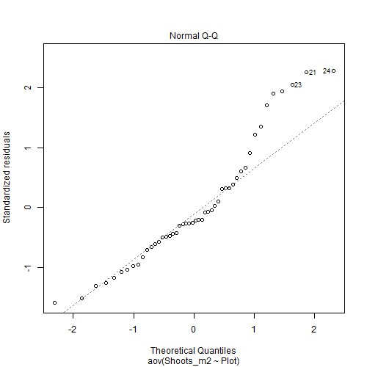
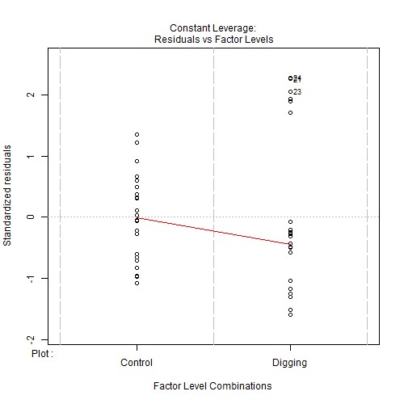
Levene's test for homogenity of variances (center=mean) for Shoots_m2 against Plot
 | Df | F value | Pr(>F)
Group | 1 | 2.6551 | 0.1101
 | 46 | NA | NA
Note. Signif. codes: 0 '***' 0.001 '**' 0.01 '*' 0.05 '.' 0.1 ' ' 1
Post-hoc tests for Shoots_m2 by Plot (using method = pairwise)
contrast | estimate | SE | df | t.ratio | p.value
Control Digging | 970 | 144.7675 | 46 | 6.7004 | <.001***
Note. Signif. codes: 0 '***' 0.001 '**' 0.01 '*' 0.05 '.' 0.1 ' ' 1
Comparing means compactly for Shoots_m2 by Plot using pairwise comparison (p values adjusted using tukey)
Plot | emmean | SE | df | lower.CL | upper.CL | .group
Digging | 1151.333 | 102.3661 | 46 | 1144.879 | 1157.788 | 1
Control | 2121.333 | 102.3661 | 46 | 2114.879 | 2127.788 | 2
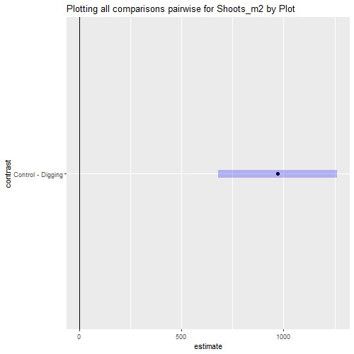
Anova (1 Way and 2 Way)
[Digging.plots.final.10.06.20.xlsx.data.for.Anova.in.R] - C:\Users\User\Documents\Marg I\Clean data D&R trials\Digging plots final 10.06.20.xlsx
`summarise()` ungrouping output (override with `.groups` argument)

Summaries for Shoots_m2 by factor variable Plot
Plot | n | Mean | median | min | max | sd
Control | 24 | 2121.333 | 2116 | 1592 | 2784 | 337.5547
Digging | 24 | 1151.333 | 970 | 368 | 2272 | 623.7309
variance
113943.2
389040.2
`summarise()` ungrouping output (override with `.groups` argument)

Summaries for Shoots_m2 by factor variable Time
Time n mean median min max sd
T1 | 12 | 1169.667 | 1116 | 368 | 2136 | 709.1638
T2 | 12 | 1542.667 | 1334 | 868 | 2720 | 685.546
T3 | 12 | 1631 | 1376 | 916 | 2784 | 686.1712
T4 | 12 | 2202 | 2216 | 1824 | 2568 | 195.3607

variance 502913.3
469973.3
470830.9
38165.82

`summarise()` regrouping output by 'Plot' (override with `.groups` argument)
Summaries for Shoots_m2 by factor variables Plot*Time
Plot |  | Time |  | n | mean | median | min | max
Control |  | T1 |  | 6 | 1833.333 | 1786 | 1592 | 2136
Control |  | T2 |  | 6 | 2156 | 2092 | 1652 | 2720
Control |  | T3 |  | 6 | 2236 | 2278 | 1640 | 2784
Control |  | T4 |  | 6 | 2260 | 2290 | 1824 | 2568
Digging |  | T1 |  | 6 | 506 | 524 | 368 | 640
Digging |  | T2 |  | 6 | 929.3333 | 924 | 868 | 1016
Digging |  | T3 |  | 6 | 1026 | 1038 | 916 | 1112
Digging |  | T4 |  | 6 | 2144 | 2130 | 1988 | 2272
Sd | variance
196.6547 | 38673.07
358.6642 | 128640
391.281 | 153100.8
252.7798 | 63897.6
103.1891 | 10648
49.746 | 2474.667
65.3238 | 4267.2
109.5153 | 11993.6

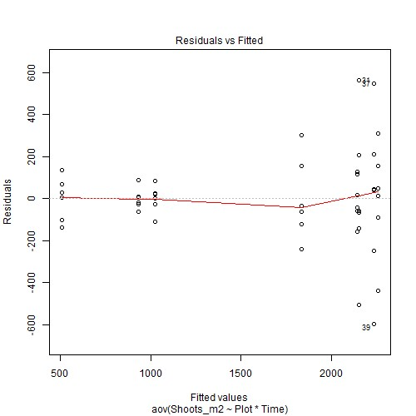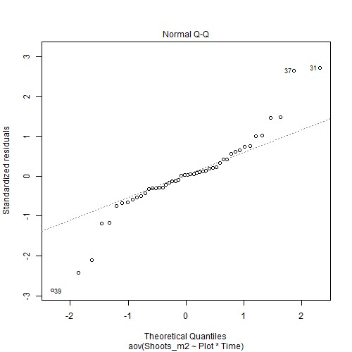
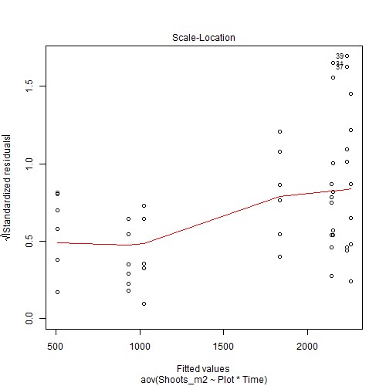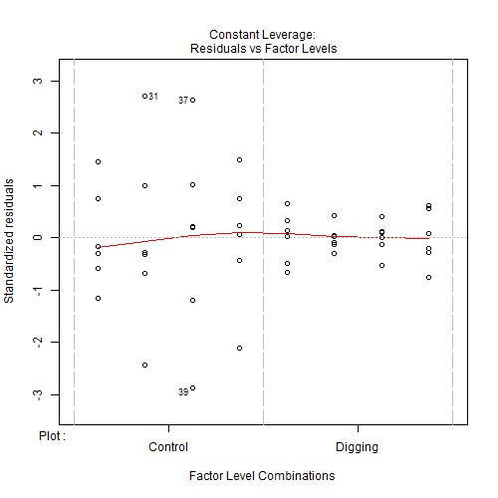

Anova table with type III sum of squares for Shoots_m2 by Plot*Time
 | Df | Sum Sq | Mean Sq | F value | Pr(>F)
Plot | 1 | 11290800 | 11290800 | 218.3406 | <.001***
Time | 3 | 6558701 | 2186234 | 42.2772 | <.001***
Plot:Time | 3 | 2941443 | 980480.9 | 18.9605 | <.001***
Residuals | 40 | 2068475 | 51711.87 | NA | NA
Note. Signif. codes: 0 '***' 0.001 '**' 0.01 '*' 0.05 '.' 0.1 ' ' 1
NOTE: Results may be misleading due to involvement in interactions
Estimated Marginal Means for Shoots_m2 by Plot
Plot emmean SE df lower.CL |  |  |  | upper.CL
Control 2121.333 46.4183 40 2027.518 |  |  |  | 2215.148
Digging 1151.333 46.4183 40 1057.518 |  |  |  | 1245.148
NOTE: Results may be misleading due to involvement in interactions
Estimated Marginal Means for Shoots_m2 by Time
Time emmean | SE | df | lower.CL | upper.CL
T1 1169.667 | 65.6454 | 40 | 1036.992 | 1302.341
T2 1542.667 | 65.6454 | 40 | 1409.992 | 1675.341
T3 1631 | 65.6454 | 40 | 1498.326 | 1763.674
T4 2202 | 65.6454 | 40 | 2069.326 | 2334.674
Estimated Marginal Means for Shoots_m2 by Plot*Time
Plot | Time | emmean | SE | df | lower.CL | upper.CL
Control | T1 | 1833.333 | 92.8367 | 40 | 1645.704 | 2020.963
Digging | T1 | 506 | 92.8367 | 40 | 318.3701 | 693.6299
Control | T2 | 2156 | 92.8367 | 40 | 1968.37 | 2343.63
Digging | T2 | 929.3333 | 92.8367 | 40 | 741.7035 | 1116.963
Control | T3 | 2236 | 92.8367 | 40 | 2048.37 | 2423.63
Digging | T3 | 1026 | 92.8367 | 40 | 838.3701 | 1213.63
Control | T4 | 2260 | 92.8367 | 40 | 2072.37 | 2447.63
Digging | T4 | 2144 | 92.8367 | 40 | 1956.37 | 2331.63
Levene's test for homogenity of variances (center=mean) for Shoots_m2 against Plot
 | Df | F value | Pr(>F)
Group | 1 | 2.6551 | 0.1101
 | 46 | NA | NA
Note. Signif. codes: 0 '***' 0.001 '**' 0.01 '*' 0.05 '.' 0.1 ' ' 1
Levene's test for homogenity of variances (center=mean) for Shoots_m2 against Time
 | Df | F value | Pr(>F)
Group | 3 | 9.6508 | <.001***
 | 44 | NA | NA
Note. Signif. codes: 0 '***' 0.001 '**' 0.01 '*' 0.05 '.' 0.1 ' ' 1
Results are averaged over the levels of: Time
Post-hoc tests for Shoots_m2 by Plot (using method = pairwise)
contrast |  |  |  | estimate |  |  | SE df t.ratio |  |  |  |  |  | p.value
Control Digging |  |  |  | 970 |  |  | 65.6454 40 14.7764 |  |  |  |  |  | <.001***
Note. Signif. codes: 0 '***' 0.001 '**' 0.01 |  |  |  | '*' 0.05 '.' 0.1 ' ' 1
Results are averaged over the levels of: Plot
P value adjustment: tukey method for comparing a family of 4 estimates
Post-hoc tests for Shoots_m2 by Time (using method = pairwise)
contrast |  |  |  | estimate |  |  | SE |  | df |  | t.ratio |  | p.value
T1 - T2 |  |  |  | -373 |  |  | 92.8367 |  | 40 |  | -4.0178 |  | 0.0014 **
T1 - T3 |  |  |  | -461.3333 |  |  | 92.8367 |  | 40 |  | -4.9693 |  | <.001***
T1 - T4 |  |  |  | -1032.333 |  |  | 92.8367 |  | 40 |  | -11.1199 |  | <.001***
T2 - T3 |  |  |  | -88.3333 |  |  | 92.8367 |  | 40 |  | -0.9515 |  | 0.7773
T2 - T4 |  |  |  | -659.3333 |  |  | 92.8367 |  | 40 |  | -7.1021 |  | <.001***
T3 - T4 |  |  |  | -571 |  |  | 92.8367 |  | 40 |  | -6.1506 |  | <.001***
Note. Signif. codes: 0 '***' 0.001 '**' 0.01 |  |  |  | '*' 0.05 '.' 0.1 ' ' 1
P value adjustment: tukey method for comparing a family of 8 estimates
Simple effects for Shoots_m2 by Plot*Time (using method = pairwise)
contrast estimate SE df t.ratio |  |  |  |  |  |  |  |  |  |  |  |  | p.value
 | Control,T1 Digging,T1 | 1327.333 |  |  | 131.2909 |  |  | 40 |  | 10.1099 |  | <.001***
 | Control,T1 Control,T2 | -322.6667 |  |  | 131.2909 |  |  | 40 |  | -2.4576 |  | 0.2430
 | Control,T1 Digging,T2 | 904 |  |  | 131.2909 |  |  | 40 |  | 6.8855 |  | <.001***
 | Control,T1 Control,T3 | -402.6667 |  |  | 131.2909 |  |  | 40 |  | -3.067 |  | 0.0681 .
 | Control,T1 Digging,T3 | 807.3333 |  |  | 131.2909 |  |  | 40 |  | 6.1492 |  | <.001***
 | Control,T1 Control,T4 | -426.6667 |  |  | 131.2909 |  |  | 40 |  | -3.2498 |  | 0.0439 *
 | Control,T1 Digging,T4 | -310.6667 |  |  | 131.2909 |  |  | 40 |  | -2.3662 |  | 0.2853
 | Digging,T1 Control,T2 | -1650 |  |  | 131.2909 |  |  | 40 |  | -12.5675 |  | <.001***
contrast |  |  | estimate |  |  | SE |  |  | df |  | t.ratio |  | p.value
Digging,T1 Digging,T2 |  |  | -423.3333 |  |  | 131.2909 |  |  | 40 |  | -3.2244 |  | 0.0467 *
Digging,T1 Control,T3 |  |  | -1730 |  |  | 131.2909 |  |  | 40 |  | -13.1769 |  | <.001***
Digging,T1 Digging,T3 |  |  | -520 |  |  | 131.2909 |  |  | 40 |  | -3.9607 |  | 0.0066 **
Digging,T1 Control,T4 |  |  | -1754 |  |  | 131.2909 |  |  | 40 |  | -13.3597 |  | <.001***
Digging,T1 Digging,T4 |  |  | -1638 |  |  | 131.2909 |  |  | 40 |  | -12.4761 |  | <.001***
Control,T2 Digging,T2 |  |  | 1226.667 |  |  | 131.2909 |  |  | 40 |  | 9.3431 |  | <.001***
Control,T2 Control,T3 |  |  | -80 |  |  | 131.2909 |  |  | 40 |  | -0.6093 |  | 0.9986
Control,T2 Digging,T3 |  |  | 1130 |  |  | 131.2909 |  |  | 40 |  | 8.6068 |  | <.001***
Control,T2 Control,T4 |  |  | -104 |  |  | 131.2909 |  |  | 40 |  | -0.7921 |  | 0.9926
Control,T2 Digging,T4 |  |  | 12 |  |  | 131.2909 |  |  | 40 |  | 0.0914 |  | 1
Digging,T2 Control,T3 |  |  | -1306.667 |  |  | 131.2909 |  |  | 40 |  | -9.9525 |  | <.001***
Digging,T2 Digging,T3 |  |  | -96.6667 |  |  | 131.2909 |  |  | 40 |  | -0.7363 |  | 0.9953
Digging,T2 Control,T4 |  |  | -1330.667 |  |  | 131.2909 |  |  | 40 |  | -10.1353 |  | <.001***
Digging,T2 Digging,T4 |  |  | -1214.667 |  |  | 131.2909 |  |  | 40 |  | -9.2517 |  | <.001***
Control,T3 Digging,T3 |  |  | 1210 |  |  | 131.2909 |  |  | 40 |  | 9.2162 |  | <.001***
Control,T3 Control,T4 |  |  | -24 |  |  | 131.2909 |  |  | 40 |  | -0.1828 |  | 1.0000
Control,T3 Digging,T4 |  |  | 92 |  |  | 131.2909 |  |  | 40 |  | 0.7007 |  | 0.9965
Digging,T3 Control,T4 |  |  | -1234 |  |  | 131.2909 |  |  | 40 |  | -9.399 |  | <.001***
Digging,T3 Digging,T4 |  |  | -1118 |  |  | 131.2909 |  |  | 40 |  | -8.5154 |  | <.001***
Control,T4 Digging,T4 |  |  | 116 |  |  | 131.2909 |  |  | 40 |  | 0.8835 |  | 0.9859
Note. Signif. codes: 0 '***' 0.001 '**' 0.01 '*' 0.05 '.' 0.1 ' ' 1
Comparing means compactly for Shoots_m2 by Plot using pairwise comparison (p values adjusted using tukey)
Plot | emmean | SE | df | lower.CL | upper.CL | .group
Digging | 1151.333 | 46.4183 | 40 | 1148.404 | 1154.262 | 1
Control | 2121.333 | 46.4183 | 40 | 2118.404 | 2124.262 | 2
Comparing means compactly for Shoots_m2 by Time using pairwise comparison (p values adjusted using tukey)
Time | emmean | SE | df | lower.CL | upper.CL | .group
T1 | 1169.667 | 65.6454 | 40 | 1165.524 | 1173.809 | 1
T2 | 1542.667 | 65.6454 | 40 | 1538.524 | 1546.809 | 2
T3 | 1631 | 65.6454 | 40 | 1626.858 | 1635.142 | 2
T4 | 2202 | 65.6454 | 40 | 2197.858 | 2206.142 | 3
Comparing means compactly for Shoots_m2 by Plot*Time using pairwise comparison (p values adjusted using tukey)
Plot | Time | emmean | SE | Df | lower.CL | upper.CL
Digging | T1 | 506 | 92.8367 | 40 | 500.1419 | 511.8581
Digging | T2 | 929.3333 | 92.8367 | 40 | 923.4752 | 935.1915
Digging | T3 | 1026 | 92.8367 | 40 | 1020.142 | 1031.858
Control | T1 | 1833.333 | 92.8367 | 40 | 1827.475 | 1839.191
Digging | T4 | 2144 | 92.8367 | 40 | 2138.142 | 2149.858
Control | T2 | 2156 | 92.8367 | 40 | 2150.142 | 2161.858
Control | T3 | 2236 | 92.8367 | 40 | 2230.142 | 2241.858
Control | T4 | 2260 | 92.8367 | 40 | 2254.142 | 2265.858
.group
1
2
2
3
34
34
34
4

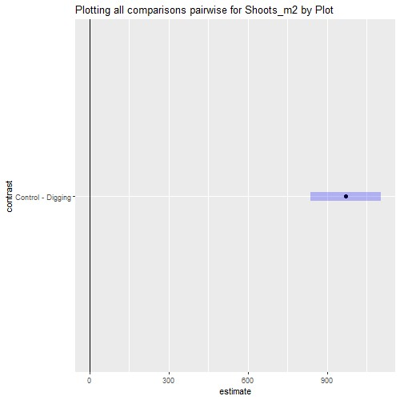

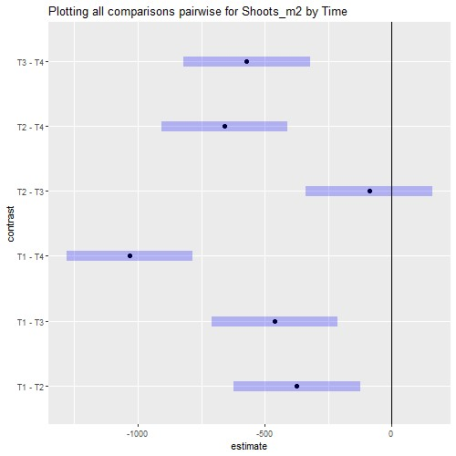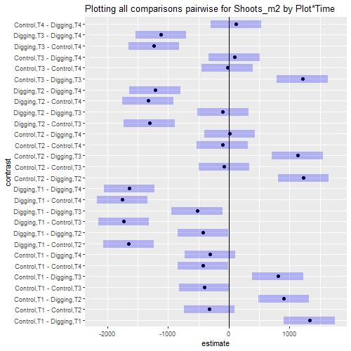

Interaction plot with Confidence Intervals
