Simulation PPF report
Report date | Nov 16, 2022, 9:54:44 PM

Contents
1. Global Definitions
1.1. Functions
1.2. Shared Properties
2. Component
2.1. Definitions
2.2. Geometry
2.3. Transport of Diluted Species
2.4. Electrostatics
2.5. Mesh
3. Study_1 no bias
3.1. Steady state
3.2. Solver Configurations
4. Study_2 PPF
4.1. Time dependent
4.2. Solver Configurations
5. Results
5.1. Dataset
5.2. Tables
5.3. Plot Groups

- Global Definitions
Date | Nov 16, 2022, 7:08:19 PM

Global settings
Name | Simulation PPF report.mph
Path | G:\xty\Simulation PPF report.mph
Version | COMSOL Multiphysics 6.0 (Build: 318)

Used products
COMSOL Multiphysics
Chemical Reaction Engineering Module

Computer information
CPU | Intel(R) Xeon(R) CPU E5-2680 v4 @ 2.40GHz, 56 cores
Operating system | Windows 7

  - Functions
    - Piecewise 1
Function name | pw1
Function type | Piecewise

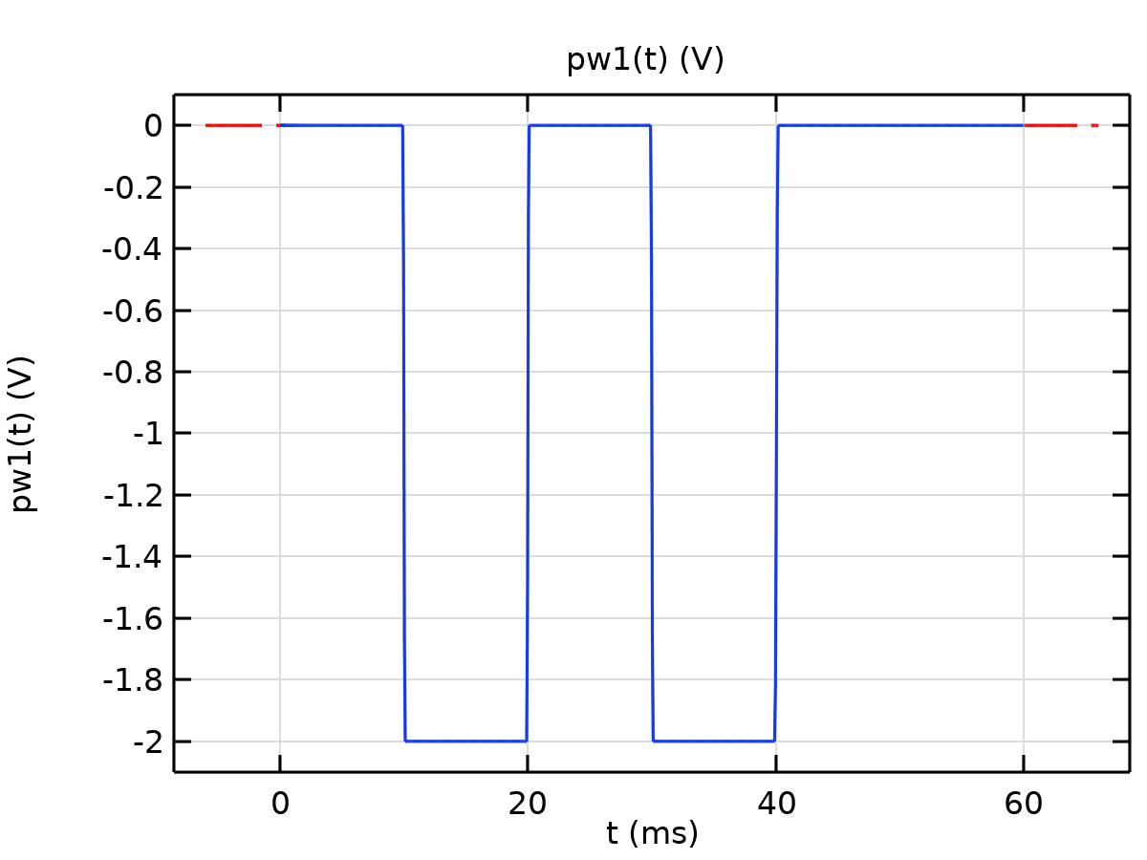
Piecewise 1
Definition
Description | Value
Argument | t
Extrapolation | Constant
Smoothing | Continuous second derivative
Size of transition zone | 0.01
Smooth at endpoints | On

Definition
Start | End | Function
0 | 10 | 0
10 | 20 | 2
20 | 30 | 0
30 | 40 | 2
40 | 60 | 0

Units
Description | Value
Arguments | ms
Function | V

  - Shared Properties
    - Default Model Inputs
Tag | cminpt

- Component
Settings
Description | Value
Unit system | Same as global system (SI)
Avoid inverted elements by curving interior domain elements | Off

  - Definitions
    - Coordinate Systems

Boundary System
Coordinate system type | Boundary system
Tag | sys1

Coordinate names
First | Second | Third
t1 | to | n

  - Geometry
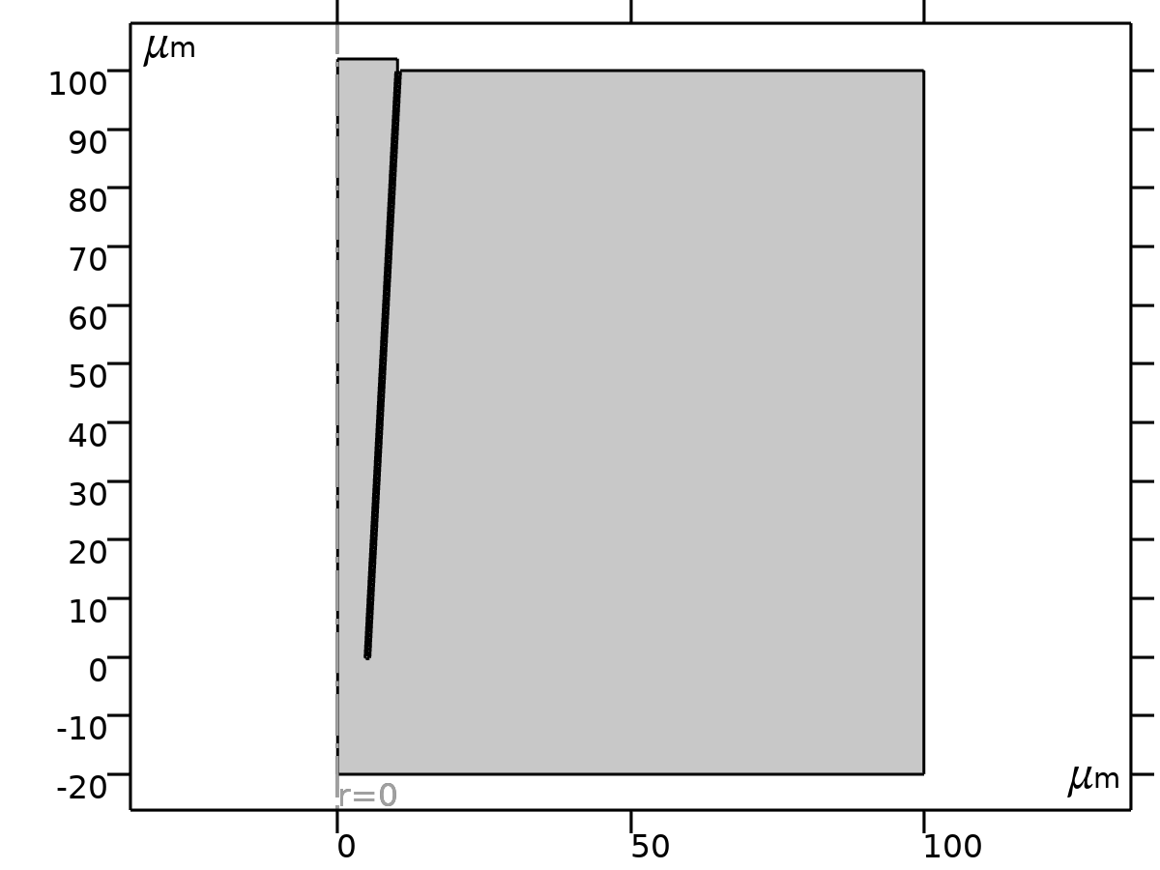
Geometry
Units
Length unit | µm
Angular unit | deg

Geometry statistics
Description | Value
Space dimension | 2
Number of domains | 2
Number of boundaries | 19
Number of vertices | 18

    - Polygon (pol1)
Object type
Description | Value
Type | Solid

Coordinates
Description | Value
Data source | Table

Coordinates
r (µm) | z (µm)
0 | -20
100 | -20
100 | 100
10.74 | 100
5.5 | 0
5 | 0
10.24 | 100
10.24 | 102
0 | 102
0 | -20

    - Bezier Polygon (b1)
Polygon segments
Description | Value
Control points | {{10.24, 9.94, 4.7, 4.7, 5.5, 5.5, 5, 10.24}, {100, 100, 0, -0.3, -0.3, 0, 0, 100}}
Degree | {1, 1, 1, 1, 1, 1, 1}
Weights | {1, 1, 1, 1, 1, 1, 1, 1, 1, 1, 1, 1, 1, 1}
Type | Solid

    - Fillet (fil1)
Settings
Description | Value
Radius | 0.28

    - Fillet 2 (fil2)
Settings
Description | Value
Radius | 0.28

  - Transport of Diluted Species
Used products
COMSOL Multiphysics
Chemical Reaction Engineering Module

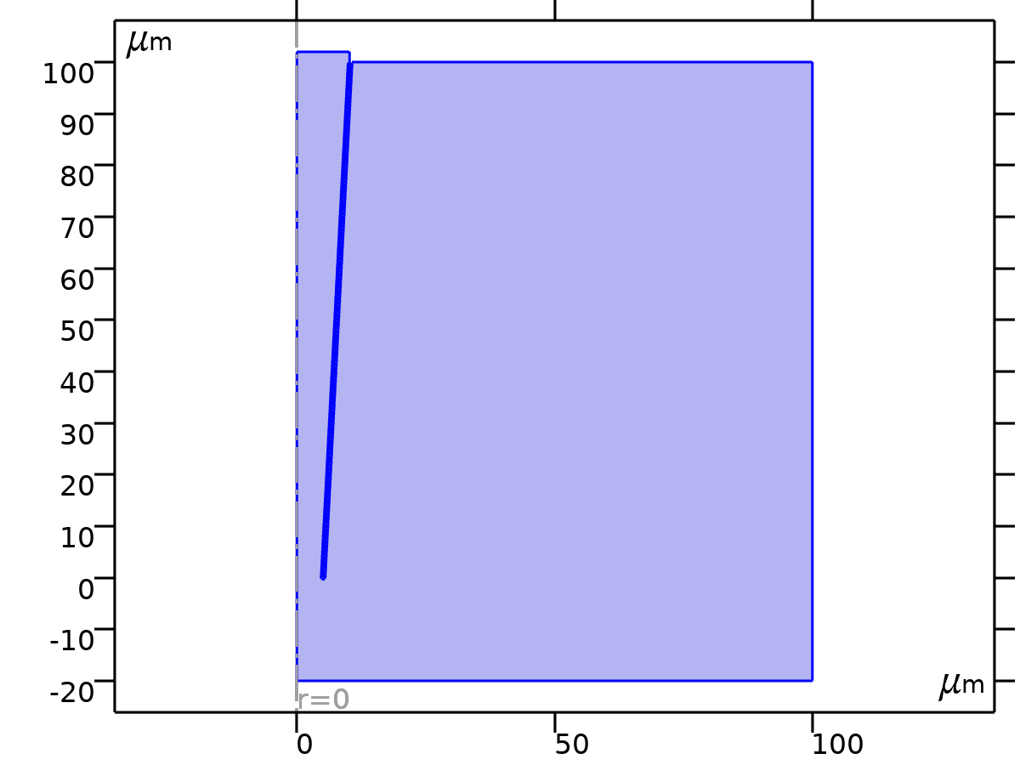
Transport of Diluted Species
Selection
Geometric entity level | Domain
Selection | Geometry geom1: Dimension 2: All domains

Equations
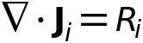
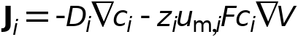
    - Interface Settings

Discretization
Settings
Description | Value
Concentration | Linear

Settings
Description | Value
Equation form | Study controlled

Transport Mechanisms
Settings
Description | Value
Convection | Off
Migration in electric field | On
Mass transfer in porous media | Off

    - Variables
Name | Expression | Unit | Description | Selection | Details
tds.d | 1 | 1 | Out-of-plane geometry extension | Global
tds.nr | nr | 1 | Normal vector, r component | Boundaries 4–6, 9, 11, 15–16, 18–19
tds.nphi | 0 | 1 | Normal vector, phi component | Boundaries 4–6, 9, 11, 15–16, 18–19
tds.nz | nz | 1 | Normal vector, z component | Boundaries 4–6, 9, 11, 15–16, 18–19
tds.nr | dnr | 1 | Normal vector, r component | Boundaries 1–3, 7–8, 10, 12–14, 17
tds.nphi | 0 | 1 | Normal vector, phi component | Boundaries 1–3, 7–8, 10, 12–14, 17
tds.nz | dnz | 1 | Normal vector, z component | Boundaries 1–3, 7–8, 10, 12–14, 17
tds.nrmesh | nrmesh | 1 | Normal vector (mesh), r component | Boundaries 4–6, 9, 11, 15–16, 18–19
tds.nphimesh | 0 | 1 | Normal vector (mesh), phi component | Boundaries 4–6, 9, 11, 15–16, 18–19
tds.nzmesh | nzmesh | 1 | Normal vector (mesh), z component | Boundaries 4–6, 9, 11, 15–16, 18–19
tds.nrmesh | dnrmesh | 1 | Normal vector (mesh), r component | Boundaries 1–3, 7–8, 10, 12–14, 17
tds.nphimesh | 0 | 1 | Normal vector (mesh), phi component | Boundaries 1–3, 7–8, 10, 12–14, 17
tds.nzmesh | dnzmesh | 1 | Normal vector (mesh), z component | Boundaries 1–3, 7–8, 10, 12–14, 17
tds.nrc | root.nrc/tds.ncLen | 1 | Normal vector, r component | Boundaries 1–19
tds.nphic | 0 | 1 | Normal vector, phi component | Boundaries 1–19
tds.nzc | root.nzc/tds.ncLen | 1 | Normal vector, z component | Boundaries 1–19
tds.ncLen | sqrt(root.nrc^2+root.nzc^2+eps) | 1 | Help variable | Boundaries 1–19
tds.R_c | 0 | mol/(m³·s) | Total rate expression | Domains 1–2 | + operation
tds.cP_c | 0 | mol/kg | Concentration species adsorbed to the solid | Domains 1–2 | + operation
tds.cP_c | 0 | mol/kg | Concentration species adsorbed to the solid | Boundaries 1–19 | + operation
tds.KP_c | 0 | m³/kg | Adsorption isotherm, first concentration derivative | Domains 1–2 | + operation
tds.KP_c | 0 | m³/kg | Adsorption isotherm, first concentration derivative | Boundaries 1–19 | + operation
tds.Rads_c | 0 | mol/(m³·s) | Total adsorption rate | Domains 1–2 | + operation
tds.DiT_c | 0 | m²/s | Turbulent diffusivity | Domains 1–2
tds.cVar_c | c | mol/m³ | Species | Boundaries 1–19
tds.R_c2 | 0 | mol/(m³·s) | Total rate expression | Domains 1–2 | + operation
tds.cP_c2 | 0 | mol/kg | Concentration species adsorbed to the solid | Domains 1–2 | + operation
tds.cP_c2 | 0 | mol/kg | Concentration species adsorbed to the solid | Boundaries 1–19 | + operation
tds.KP_c2 | 0 | m³/kg | Adsorption isotherm, first concentration derivative | Domains 1–2 | + operation
tds.KP_c2 | 0 | m³/kg | Adsorption isotherm, first concentration derivative | Boundaries 1–19 | + operation
tds.Rads_c2 | 0 | mol/(m³·s) | Total adsorption rate | Domains 1–2 | + operation
tds.DiT_c2 | 0 | m²/s | Turbulent diffusivity | Domains 1–2
tds.cVar_c2 | c2 | mol/m³ | Species | Boundaries 1–19
tds.poro | 1 | 1 | Porosity | Domains 1–2
tds.theta_g | 0 | 1 | Gas volume fraction | Domains 1–2
tds.theta_l | 1 | 1 | Liquid volume fraction | Domains 1–2
tds.theta | tds.poro | 1 | Mobile fluid volume fraction | Domains 1–2

    - Transport Properties
Transport Properties
Selection
Geometric entity level | Domain
Selection | Geometry geom1: Dimension 2: All domains

Equations
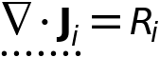

Diffusion
Settings
Description | Value
Source | Material
Material | None
Diffusion coefficient | User defined
Diffusion coefficient | {{1.957e-9[m^2/s], 0, 0}, {0, 1.957e-9[m^2/s], 0}, {0, 0, 1.957e-9[m^2/s]}}
Diffusion coefficient | User defined
Diffusion coefficient | {{2.032e-9[m^2/s], 0, 0}, {0, 2.032e-9[m^2/s], 0}, {0, 0, 2.032e-9[m^2/s]}}

Migration in Electric Field
Settings
Description | Value
Electric potential | Electric potential (es)
Mobility | Nernst - Einstein relation
Charge number | {1, -1}

Coordinate System Selection
Settings
Description | Value
Coordinate system | Global coordinate system

Model Input
Settings
Description | Value
Temperature | User defined
Temperature | 293.15[K]

Variables
Name | Expression | Unit | Description | Selection | Details
domflux.cr | 2*(tds.dflux_cr+tds.mflux_cr)*pi*r*tds.d | mol/(m·s) | Domain flux, r component | Domains 1–2
domflux.cz | 2*(tds.dflux_cz+tds.mflux_cz)*pi*r*tds.d | mol/(m·s) | Domain flux, z component | Domains 1–2
domflux.c2r | 2*(tds.dflux_c2r+tds.mflux_c2r)*pi*r*tds.d | mol/(m·s) | Domain flux, r component | Domains 1–2
domflux.c2z | 2*(tds.dflux_c2z+tds.mflux_c2z)*pi*r*tds.d | mol/(m·s) | Domain flux, z component | Domains 1–2
tds.ndflux_c | tds.dflux_cr*tds.nrc+tds.dflux_cphi*tds.nphic+tds.dflux_cz*tds.nzc | mol/(m²·s) | Normal diffusive flux | Boundaries 2–19
tds.nmflux_c | tds.mflux_cr*tds.nrc+tds.mflux_cphi*tds.nphic+tds.mflux_cz*tds.nzc | mol/(m²·s) | Normal electrophoretic flux | Boundaries 2–19
tds.ntflux_c | tds.bndFlux_c | mol/(m²·s) | Normal total flux | Boundaries 2–19
tds.ndflux_c2 | tds.dflux_c2r*tds.nrc+tds.dflux_c2phi*tds.nphic+tds.dflux_c2z*tds.nzc | mol/(m²·s) | Normal diffusive flux | Boundaries 2–19
tds.nmflux_c2 | tds.mflux_c2r*tds.nrc+tds.mflux_c2phi*tds.nphic+tds.mflux_c2z*tds.nzc | mol/(m²·s) | Normal electrophoretic flux | Boundaries 2–19
tds.ntflux_c2 | tds.bndFlux_c2 | mol/(m²·s) | Normal total flux | Boundaries 2–19
tds.bndFlux_c | 0.25*(uflux_spatial(c)-dflux_spatial(c))/(pi*r*tds.d) | mol/(m²·s) | Boundary flux | Boundaries 4–6, 9, 11, 15–16, 18–19 | Meta
tds.bndFlux_c | -dflux_spatial(c)/tds.d | mol/(m²·s) | Boundary flux | Boundary 1
tds.bndFlux_c | -0.5*dflux_spatial(c)/(pi*r*tds.d) | mol/(m²·s) | Boundary flux | Boundaries 2–3, 7–8, 10, 12–14, 17 | Meta
tds.bndFlux_c2 | 0.25*(uflux_spatial(c2)-dflux_spatial(c2))/(pi*r*tds.d) | mol/(m²·s) | Boundary flux | Boundaries 4–6, 9, 11, 15–16, 18–19 | Meta
tds.bndFlux_c2 | -dflux_spatial(c2)/tds.d | mol/(m²·s) | Boundary flux | Boundary 1
tds.bndFlux_c2 | -0.5*dflux_spatial(c2)/(pi*r*tds.d) | mol/(m²·s) | Boundary flux | Boundaries 2–3, 7–8, 10, 12–14, 17 | Meta
tds.DF_crr | 1.957E-9[m^2/s] | m²/s | Fluid diffusion coefficient, rr component | Domains 1–2
tds.DF_cphir | 0 | m²/s | Fluid diffusion coefficient, phir component | Domains 1–2
tds.DF_czr | 0 | m²/s | Fluid diffusion coefficient, zr component | Domains 1–2
tds.DF_crphi | 0 | m²/s | Fluid diffusion coefficient, rphi component | Domains 1–2
tds.DF_cphiphi | 1.957E-9[m^2/s] | m²/s | Fluid diffusion coefficient, phiphi component | Domains 1–2
tds.DF_czphi | 0 | m²/s | Fluid diffusion coefficient, zphi component | Domains 1–2
tds.DF_crz | 0 | m²/s | Fluid diffusion coefficient, rz component | Domains 1–2
tds.DF_cphiz | 0 | m²/s | Fluid diffusion coefficient, phiz component | Domains 1–2
tds.DF_czz | 1.957E-9[m^2/s] | m²/s | Fluid diffusion coefficient, zz component | Domains 1–2
tds.D_crr | tds.DF_crr+tds.DiT_c | m²/s | Diffusion coefficient, rr component | Domains 1–2
tds.D_cphir | tds.DF_cphir | m²/s | Diffusion coefficient, phir component | Domains 1–2
tds.D_czr | tds.DF_czr | m²/s | Diffusion coefficient, zr component | Domains 1–2
tds.D_crphi | tds.DF_crphi | m²/s | Diffusion coefficient, rphi component | Domains 1–2
tds.D_cphiphi | tds.DF_cphiphi+tds.DiT_c | m²/s | Diffusion coefficient, phiphi component | Domains 1–2
tds.D_czphi | tds.DF_czphi | m²/s | Diffusion coefficient, zphi component | Domains 1–2
tds.D_crz | tds.DF_crz | m²/s | Diffusion coefficient, rz component | Domains 1–2
tds.D_cphiz | tds.DF_cphiz | m²/s | Diffusion coefficient, phiz component | Domains 1–2
tds.D_czz | tds.DF_czz+tds.DiT_c | m²/s | Diffusion coefficient, zz component | Domains 1–2
tds.DF_c2rr | 2.032E-9[m^2/s] | m²/s | Fluid diffusion coefficient, rr component | Domains 1–2
tds.DF_c2phir | 0 | m²/s | Fluid diffusion coefficient, phir component | Domains 1–2
tds.DF_c2zr | 0 | m²/s | Fluid diffusion coefficient, zr component | Domains 1–2
tds.DF_c2rphi | 0 | m²/s | Fluid diffusion coefficient, rphi component | Domains 1–2
tds.DF_c2phiphi | 2.032E-9[m^2/s] | m²/s | Fluid diffusion coefficient, phiphi component | Domains 1–2
tds.DF_c2zphi | 0 | m²/s | Fluid diffusion coefficient, zphi component | Domains 1–2
tds.DF_c2rz | 0 | m²/s | Fluid diffusion coefficient, rz component | Domains 1–2
tds.DF_c2phiz | 0 | m²/s | Fluid diffusion coefficient, phiz component | Domains 1–2
tds.DF_c2zz | 2.032E-9[m^2/s] | m²/s | Fluid diffusion coefficient, zz component | Domains 1–2
tds.D_c2rr | tds.DF_c2rr+tds.DiT_c2 | m²/s | Diffusion coefficient, rr component | Domains 1–2
tds.D_c2phir | tds.DF_c2phir | m²/s | Diffusion coefficient, phir component | Domains 1–2
tds.D_c2zr | tds.DF_c2zr | m²/s | Diffusion coefficient, zr component | Domains 1–2
tds.D_c2rphi | tds.DF_c2rphi | m²/s | Diffusion coefficient, rphi component | Domains 1–2
tds.D_c2phiphi | tds.DF_c2phiphi+tds.DiT_c2 | m²/s | Diffusion coefficient, phiphi component | Domains 1–2
tds.D_c2zphi | tds.DF_c2zphi | m²/s | Diffusion coefficient, zphi component | Domains 1–2
tds.D_c2rz | tds.DF_c2rz | m²/s | Diffusion coefficient, rz component | Domains 1–2
tds.D_c2phiz | tds.DF_c2phiz | m²/s | Diffusion coefficient, phiz component | Domains 1–2
tds.D_c2zz | tds.DF_c2zz+tds.DiT_c2 | m²/s | Diffusion coefficient, zz component | Domains 1–2
tds.Dav_c | 0.5*(tds.D_crr+tds.D_czz) | m²/s | Average diffusion coefficient | Domains 1–2
tds.Dav_c2 | 0.5*(tds.D_c2rr+tds.D_c2zz) | m²/s | Average diffusion coefficient | Domains 1–2
tds.tflux_cr | tds.dflux_cr+tds.mflux_cr | mol/(m²·s) | Total flux, r component | Domains 1–2 | + operation
tds.tflux_cphi | tds.dflux_cphi+tds.mflux_cphi | mol/(m²·s) | Total flux, phi component | Domains 1–2 | + operation
tds.tflux_cz | tds.dflux_cz+tds.mflux_cz | mol/(m²·s) | Total flux, z component | Domains 1–2 | + operation
tds.dfluxMag_c | sqrt(tds.dflux_cr^2+tds.dflux_cphi^2+tds.dflux_cz^2) | mol/(m²·s) | Diffusive flux magnitude | Domains 1–2
tds.tfluxMag_c | sqrt(tds.tflux_cr^2+tds.tflux_cphi^2+tds.tflux_cz^2) | mol/(m²·s) | Total flux magnitude | Domains 1–2
tds.dpflux_cr | 0 | mol/(m²·s) | Dispersive flux, r component | Domains 1–2
tds.dpflux_cphi | 0 | mol/(m²·s) | Dispersive flux, phi component | Domains 1–2
tds.dpflux_cz | 0 | mol/(m²·s) | Dispersive flux, z component | Domains 1–2
tds.mflux_cr | tds.z_c*F_const*c*(-tds.um_crr*d(tds.V,r)-tds.um_crz*d(tds.V,z)) | mol/(m²·s) | Electrophoretic flux, r component | Domains 1–2
tds.mflux_cphi | tds.z_c*F_const*c*(-tds.um_cphir*d(tds.V,r)-tds.um_cphiz*d(tds.V,z)) | mol/(m²·s) | Electrophoretic flux, phi component | Domains 1–2
tds.mflux_cz | tds.z_c*F_const*c*(-tds.um_czr*d(tds.V,r)-tds.um_czz*d(tds.V,z)) | mol/(m²·s) | Electrophoretic flux, z component | Domains 1–2
tds.mfluxMag_c | sqrt(tds.mflux_cr^2+tds.mflux_cphi^2+tds.mflux_cz^2) | mol/(m²·s) | Electrophoretic flux magnitude | Domains 1–2
tds.tflux_c2r | tds.dflux_c2r+tds.mflux_c2r | mol/(m²·s) | Total flux, r component | Domains 1–2 | + operation
tds.tflux_c2phi | tds.dflux_c2phi+tds.mflux_c2phi | mol/(m²·s) | Total flux, phi component | Domains 1–2 | + operation
tds.tflux_c2z | tds.dflux_c2z+tds.mflux_c2z | mol/(m²·s) | Total flux, z component | Domains 1–2 | + operation
tds.dfluxMag_c2 | sqrt(tds.dflux_c2r^2+tds.dflux_c2phi^2+tds.dflux_c2z^2) | mol/(m²·s) | Diffusive flux magnitude | Domains 1–2
tds.tfluxMag_c2 | sqrt(tds.tflux_c2r^2+tds.tflux_c2phi^2+tds.tflux_c2z^2) | mol/(m²·s) | Total flux magnitude | Domains 1–2
tds.dpflux_c2r | 0 | mol/(m²·s) | Dispersive flux, r component | Domains 1–2
tds.dpflux_c2phi | 0 | mol/(m²·s) | Dispersive flux, phi component | Domains 1–2
tds.dpflux_c2z | 0 | mol/(m²·s) | Dispersive flux, z component | Domains 1–2
tds.mflux_c2r | tds.z_c2*F_const*c2*(-tds.um_c2rr*d(tds.V,r)-tds.um_c2rz*d(tds.V,z)) | mol/(m²·s) | Electrophoretic flux, r component | Domains 1–2
tds.mflux_c2phi | tds.z_c2*F_const*c2*(-tds.um_c2phir*d(tds.V,r)-tds.um_c2phiz*d(tds.V,z)) | mol/(m²·s) | Electrophoretic flux, phi component | Domains 1–2
tds.mflux_c2z | tds.z_c2*F_const*c2*(-tds.um_c2zr*d(tds.V,r)-tds.um_c2zz*d(tds.V,z)) | mol/(m²·s) | Electrophoretic flux, z component | Domains 1–2
tds.mfluxMag_c2 | sqrt(tds.mflux_c2r^2+tds.mflux_c2phi^2+tds.mflux_c2z^2) | mol/(m²·s) | Electrophoretic flux magnitude | Domains 1–2
tds.dflux_cr | -tds.D_crr*cr-tds.D_crz*cz | mol/(m²·s) | Diffusive flux, r component | Domains 1–2 | + operation
tds.dflux_cphi | -tds.D_cphir*cr-tds.D_cphiz*cz | mol/(m²·s) | Diffusive flux, phi component | Domains 1–2 | + operation
tds.dflux_cz | -tds.D_czr*cr-tds.D_czz*cz | mol/(m²·s) | Diffusive flux, z component | Domains 1–2 | + operation
tds.grad_cr | cr | mol/m⁴ | Concentration gradient, r component | Domains 1–2
tds.grad_cphi | 0 | mol/m⁴ | Concentration gradient, phi component | Domains 1–2
tds.grad_cz | cz | mol/m⁴ | Concentration gradient, z component | Domains 1–2
tds.dflux_c2r | -tds.D_c2rr*c2r-tds.D_c2rz*c2z | mol/(m²·s) | Diffusive flux, r component | Domains 1–2 | + operation
tds.dflux_c2phi | -tds.D_c2phir*c2r-tds.D_c2phiz*c2z | mol/(m²·s) | Diffusive flux, phi component | Domains 1–2 | + operation
tds.dflux_c2z | -tds.D_c2zr*c2r-tds.D_c2zz*c2z | mol/(m²·s) | Diffusive flux, z component | Domains 1–2 | + operation
tds.grad_c2r | c2r | mol/m⁴ | Concentration gradient, r component | Domains 1–2
tds.grad_c2phi | 0 | mol/m⁴ | Concentration gradient, phi component | Domains 1–2
tds.grad_c2z | c2z | mol/m⁴ | Concentration gradient, z component | Domains 1–2
tds.um_crr | tds.D_crr/(R_const*tds.T) | s·mol/kg | Mobility, rr component | Domains 1–2
tds.um_cphir | tds.D_cphir/(R_const*tds.T) | s·mol/kg | Mobility, phir component | Domains 1–2
tds.um_czr | tds.D_czr/(R_const*tds.T) | s·mol/kg | Mobility, zr component | Domains 1–2
tds.um_crphi | tds.D_crphi/(R_const*tds.T) | s·mol/kg | Mobility, rphi component | Domains 1–2
tds.um_cphiphi | tds.D_cphiphi/(R_const*tds.T) | s·mol/kg | Mobility, phiphi component | Domains 1–2
tds.um_czphi | tds.D_czphi/(R_const*tds.T) | s·mol/kg | Mobility, zphi component | Domains 1–2
tds.um_crz | tds.D_crz/(R_const*tds.T) | s·mol/kg | Mobility, rz component | Domains 1–2
tds.um_cphiz | tds.D_cphiz/(R_const*tds.T) | s·mol/kg | Mobility, phiz component | Domains 1–2
tds.um_czz | tds.D_czz/(R_const*tds.T) | s·mol/kg | Mobility, zz component | Domains 1–2
tds.z_c | 1 | 1 | Charge number | Domains 1–2
tds.um_c2rr | tds.D_c2rr/(R_const*tds.T) | s·mol/kg | Mobility, rr component | Domains 1–2
tds.um_c2phir | tds.D_c2phir/(R_const*tds.T) | s·mol/kg | Mobility, phir component | Domains 1–2
tds.um_c2zr | tds.D_c2zr/(R_const*tds.T) | s·mol/kg | Mobility, zr component | Domains 1–2
tds.um_c2rphi | tds.D_c2rphi/(R_const*tds.T) | s·mol/kg | Mobility, rphi component | Domains 1–2
tds.um_c2phiphi | tds.D_c2phiphi/(R_const*tds.T) | s·mol/kg | Mobility, phiphi component | Domains 1–2
tds.um_c2zphi | tds.D_c2zphi/(R_const*tds.T) | s·mol/kg | Mobility, zphi component | Domains 1–2
tds.um_c2rz | tds.D_c2rz/(R_const*tds.T) | s·mol/kg | Mobility, rz component | Domains 1–2
tds.um_c2phiz | tds.D_c2phiz/(R_const*tds.T) | s·mol/kg | Mobility, phiz component | Domains 1–2
tds.um_c2zz | tds.D_c2zz/(R_const*tds.T) | s·mol/kg | Mobility, zz component | Domains 1–2
tds.z_c2 | -1 | 1 | Charge number | Domains 1–2
tds.V | model.input.V | V | Electric potential | Domains 1–2 | Meta
tds.T | tds.cdm1.minput_temperature | K | Temperature | Domains 1–2
tds.Res_c | d(c*tds.z_c*F_const*(-tds.um_crr*d(tds.V,r)-tds.um_crz*d(tds.V,z)),r)+if(abs(r)<0.001*h_spatial,d(c*tds.z_c*F_const*(-tds.um_crr*d(tds.V,r)-tds.um_crz*d(tds.V,z)),r),c*tds.z_c*F_const*(-tds.um_crr*d(tds.V,r)-tds.um_crz*d(tds.V,z))/r)+d(c*tds.z_c*F_const*(-tds.um_czr*d(tds.V,r)-tds.um_czz*d(tds.V,z)),z)-tds.R_c | mol/(m³·s) | Equation residual | Domains 1–2
tds.Rlin_c | 0 |  | Linear source term coefficient | Domains 1–2
tds.Res_c2 | d(c2*tds.z_c2*F_const*(-tds.um_c2rr*d(tds.V,r)-tds.um_c2rz*d(tds.V,z)),r)+if(abs(r)<0.001*h_spatial,d(c2*tds.z_c2*F_const*(-tds.um_c2rr*d(tds.V,r)-tds.um_c2rz*d(tds.V,z)),r),c2*tds.z_c2*F_const*(-tds.um_c2rr*d(tds.V,r)-tds.um_c2rz*d(tds.V,z))/r)+d(c2*tds.z_c2*F_const*(-tds.um_c2zr*d(tds.V,r)-tds.um_c2zz*d(tds.V,z)),z)-tds.R_c2 | mol/(m³·s) | Equation residual | Domains 1–2
tds.Rlin_c2 | 0 |  | Linear source term coefficient | Domains 1–2

Shape functions
Name | Shape function | Unit | Description | Shape frame | Selection
c | Lagrange (Linear) | mol/m³ | Concentration | Spatial | Domains 1–2
c2 | Lagrange (Linear) | mol/m³ | Concentration | Spatial | Domains 1–2

Weak Expressions
Weak expression | Integration order | Integration frame | Selection
2*(tds.dflux_cr*test(cr)+tds.dflux_cz*test(cz))*tds.d*pi*r | 2 | Spatial | Domains 1–2
2*(tds.dflux_c2r*test(c2r)+tds.dflux_c2z*test(c2z))*tds.d*pi*r | 2 | Spatial | Domains 1–2
2*tds.z_c*F_const*c*((-tds.um_crr*d(tds.V,r)-tds.um_crz*d(tds.V,z))*test(cr)+(-tds.um_czr*d(tds.V,r)-tds.um_czz*d(tds.V,z))*test(cz))*tds.d*pi*r | 2 | Spatial | Domains 1–2
2*tds.z_c2*F_const*c2*((-tds.um_c2rr*d(tds.V,r)-tds.um_c2rz*d(tds.V,z))*test(c2r)+(-tds.um_c2zr*d(tds.V,r)-tds.um_c2zz*d(tds.V,z))*test(c2z))*tds.d*pi*r | 2 | Spatial | Domains 1–2
2*tds.streamline*(isScalingSystemDomain==0)*tds.d*pi*r | 2 | Spatial | Domains 1–2
2*tds.crosswind*(isScalingSystemDomain==0)*tds.d*pi*r | 4 | Spatial | Domains 1–2

    - Axial Symmetry
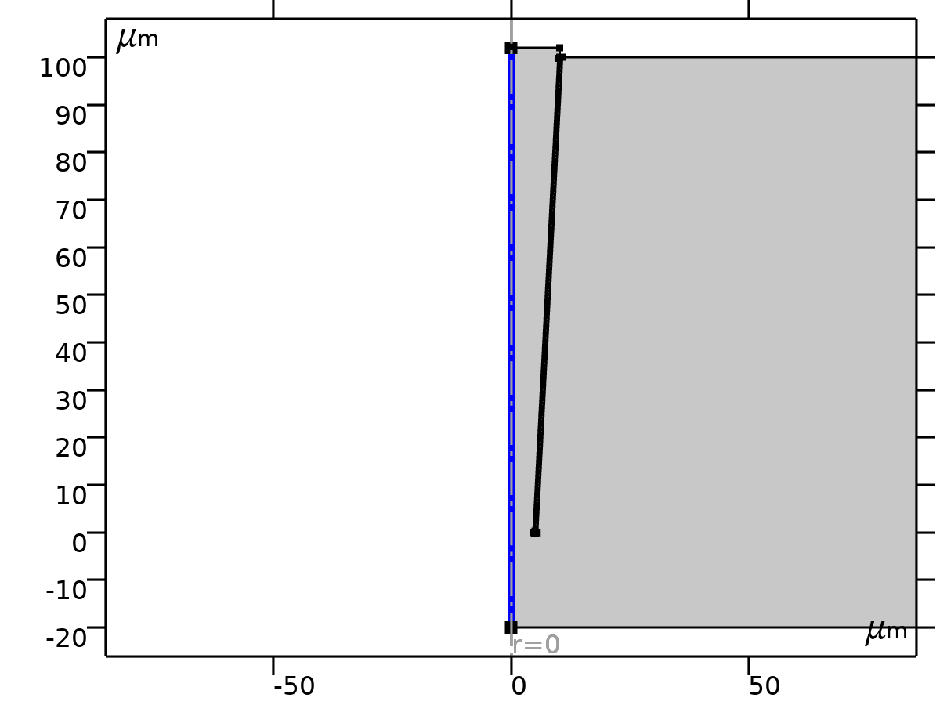
Axial Symmetry
Selection
Geometric entity level | Boundary
Selection | Geometry geom1: Dimension 1: All boundaries

    - No Flux
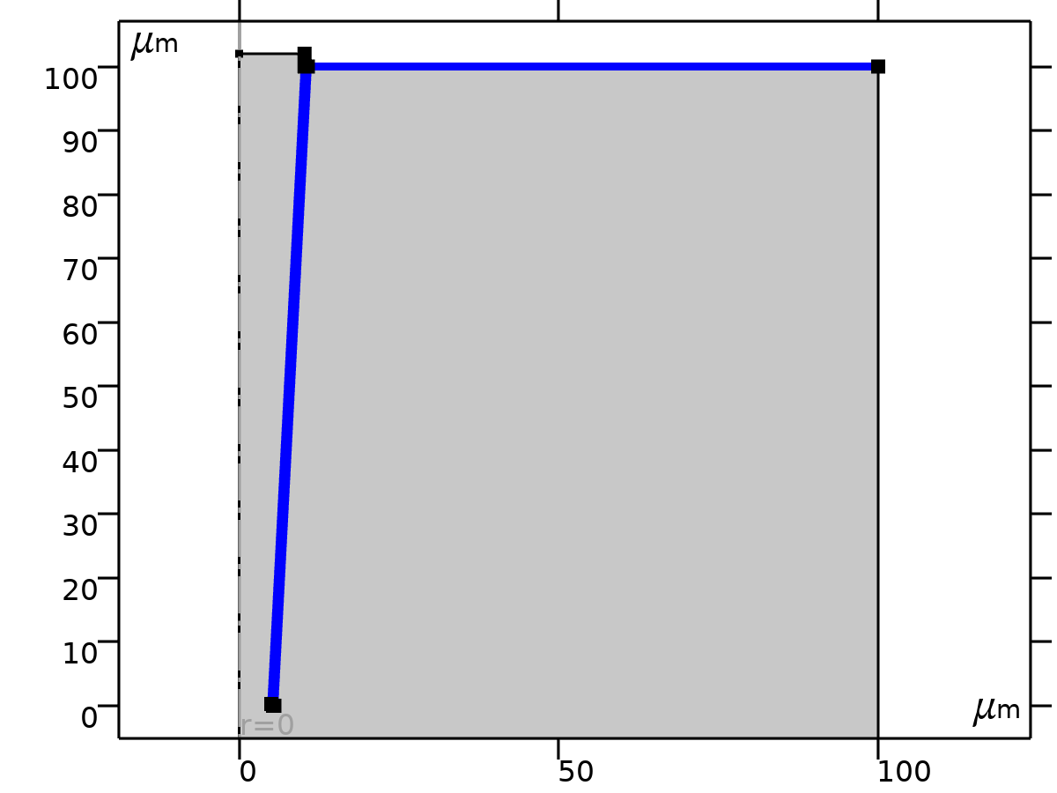
No Flux
Selection
Geometric entity level | Boundary
Selection | Geometry geom1: Dimension 1: All boundaries

Equations
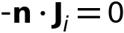
    - Initial Values
Initial Values
Selection
Geometric entity level | Domain
Selection | Geometry geom1: Dimension 2: All domains

Initial Values
Settings
Description | Value
Concentration | {10, 10}

Variables
Name | Expression | Unit | Description | Selection | Details
tds.c0_c | 10 | mol/m³ | Concentration | Domains 1–2 | + operation
tds.c0_c2 | 10 | mol/m³ | Concentration | Domains 1–2 | + operation

    - Concentration
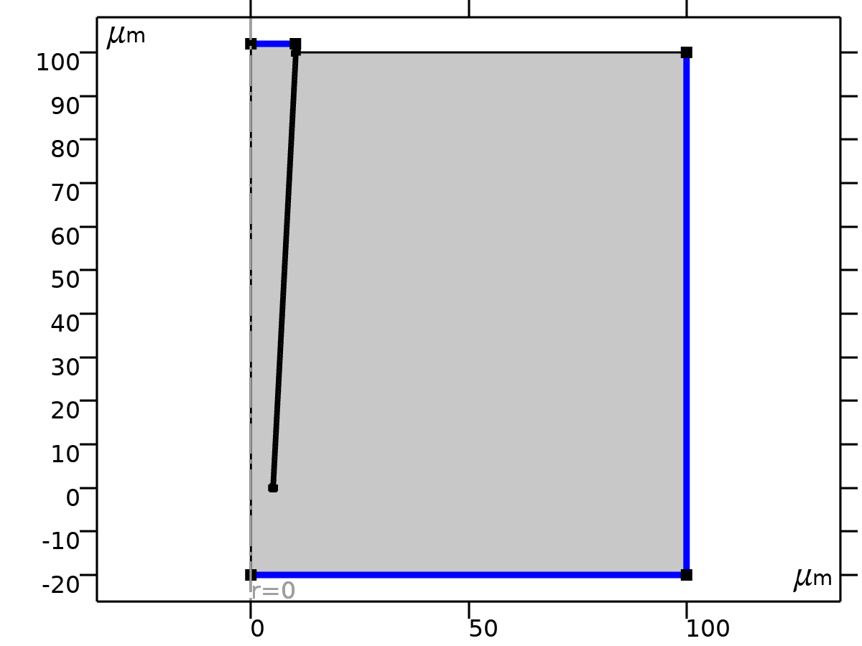
Concentration
Selection
Geometric entity level | Boundary
Selection | Geometry geom1: Dimension 1: Boundaries 2–3, 14

Equations
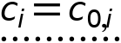

Concentration
Settings
Description | Value
Species c | On
Species c2 | On
Concentration | {10, 10}

Variables
Name | Expression | Unit | Description | Selection | Details
tds.c0_c | 10 | mol/m³ | Concentration | Boundaries 2–3, 14 | + operation
tds.c0_c2 | 10 | mol/m³ | Concentration | Boundaries 2–3, 14 | + operation
tds.conc1.nmflow_c | tds.conc1.int(2*tds.ntflux_c*pi*r)*tds.d | mol/s | Normal molar flow rate | Global
tds.conc1.nmflow_c2 | tds.conc1.int(2*tds.ntflux_c2*pi*r)*tds.d | mol/s | Normal molar flow rate | Global

Constraints
Constraint | Constraint force | Shape function | Selection | Details
-tds.cVar_c+tds.c0_c | test(-tds.cVar_c+tds.c0_c) | Lagrange (Linear) | Boundaries 2–3, 14 | Elemental
-tds.cVar_c2+tds.c0_c2 | test(-tds.cVar_c2+tds.c0_c2) | Lagrange (Linear) | Boundaries 2–3, 14 | Elemental

  - Electrostatics
Used products
COMSOL Multiphysics

Electrostatics
Selection
Geometric entity level | Domain
Selection | Geometry geom1: Dimension 2: All domains

Equations
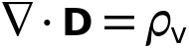
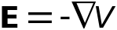
    - Interface Settings

Discretization
Settings
Description | Value
Electric potential | Quadratic

Manual Terminal Sweep Settings
Settings
Description | Value
Use manual terminal sweep | Off
Reference impedance | 50[ohm]

    - Variables
Name | Expression | Unit | Description | Selection | Details
es.d | 1 | 1 | Contribution | Domains 1–2
es.nr | nr |  | Normal vector, r component | Boundaries 4–6, 9, 11, 15–16, 18–19
es.nphi | 0 |  | Normal vector, phi component | Boundaries 4–6, 9, 11, 15–16, 18–19
es.nz | nz |  | Normal vector, z component | Boundaries 4–6, 9, 11, 15–16, 18–19
es.nr | dnr |  | Normal vector, r component | Boundaries 1–3, 7–8, 10, 12–14, 17
es.nphi | 0 |  | Normal vector, phi component | Boundaries 1–3, 7–8, 10, 12–14, 17
es.nz | dnz |  | Normal vector, z component | Boundaries 1–3, 7–8, 10, 12–14, 17
es.nmeshr | nrmesh |  | Mesh normal vector, r component | Boundaries 4–6, 9, 11, 15–16, 18–19
es.nmeshphi | 0 |  | Mesh normal vector, phi component | Boundaries 4–6, 9, 11, 15–16, 18–19
es.nmeshz | nzmesh |  | Mesh normal vector, z component | Boundaries 4–6, 9, 11, 15–16, 18–19
es.nmeshr | dnrmesh |  | Mesh normal vector, r component | Boundaries 1–3, 7–8, 10, 12–14, 17
es.nmeshphi | 0 |  | Mesh normal vector, phi component | Boundaries 1–3, 7–8, 10, 12–14, 17
es.nmeshz | dnzmesh |  | Mesh normal vector, z component | Boundaries 1–3, 7–8, 10, 12–14, 17
es.unmeshr | unrmesh |  | Mesh normal vector, upside, r component | Boundaries 1–19
es.unmeshphi | 0 |  | Mesh normal vector, upside, phi component | Boundaries 1–19
es.unmeshz | unzmesh |  | Mesh normal vector, upside, z component | Boundaries 1–19
es.dnmeshr | dnrmesh |  | Mesh normal vector, downside, r component | Boundaries 1–19
es.dnmeshphi | 0 |  | Mesh normal vector, downside, phi component | Boundaries 1–19
es.dnmeshz | dnzmesh |  | Mesh normal vector, downside, z component | Boundaries 1–19
es.I_sRR | (spatial.invF11*(spatial.invF11*es.I_srr+spatial.invF31*es.I_szr)+spatial.invF31*(spatial.invF11*es.I_srz+spatial.invF31*es.I_szz))*spatial.detF | 1 | Spatial identity matrix, material frame, RR component | Domains 1–2
es.I_sPHIR | if(Rg>0.001*h,R/r,Rr)*(spatial.invF11*es.I_sphir+spatial.invF31*es.I_sphiz)*spatial.detF | 1 | Spatial identity matrix, material frame, PHIR component | Domains 1–2
es.I_sZR | (spatial.invF11*(spatial.invF13*es.I_srr+spatial.invF33*es.I_szr)+spatial.invF31*(spatial.invF13*es.I_srz+spatial.invF33*es.I_szz))*spatial.detF | 1 | Spatial identity matrix, material frame, ZR component | Domains 1–2
es.I_sRPHI | if(Rg>0.001*h,R/r,Rr)*(spatial.invF11*es.I_srphi+spatial.invF31*es.I_szphi)*spatial.detF | 1 | Spatial identity matrix, material frame, RPHI component | Domains 1–2
es.I_sPHIPHI | if(Rg>0.001*h,R/r,Rr)^2*es.I_sphiphi*spatial.detF | 1 | Spatial identity matrix, material frame, PHIPHI component | Domains 1–2
es.I_sZPHI | if(Rg>0.001*h,R/r,Rr)*(spatial.invF13*es.I_srphi+spatial.invF33*es.I_szphi)*spatial.detF | 1 | Spatial identity matrix, material frame, ZPHI component | Domains 1–2
es.I_sRZ | (spatial.invF13*(spatial.invF11*es.I_srr+spatial.invF31*es.I_szr)+spatial.invF33*(spatial.invF11*es.I_srz+spatial.invF31*es.I_szz))*spatial.detF | 1 | Spatial identity matrix, material frame, RZ component | Domains 1–2
es.I_sPHIZ | if(Rg>0.001*h,R/r,Rr)*(spatial.invF13*es.I_sphir+spatial.invF33*es.I_sphiz)*spatial.detF | 1 | Spatial identity matrix, material frame, PHIZ component | Domains 1–2
es.I_sZZ | (spatial.invF13*(spatial.invF13*es.I_srr+spatial.invF33*es.I_szr)+spatial.invF33*(spatial.invF13*es.I_srz+spatial.invF33*es.I_szz))*spatial.detF | 1 | Spatial identity matrix, material frame, ZZ component | Domains 1–2
es.I_srr | 1 | 1 | Spatial identity matrix, rr component | Domains 1–2
es.I_sphir | 0 | 1 | Spatial identity matrix, phir component | Domains 1–2
es.I_szr | 0 | 1 | Spatial identity matrix, zr component | Domains 1–2
es.I_srphi | 0 | 1 | Spatial identity matrix, rphi component | Domains 1–2
es.I_sphiphi | 1 | 1 | Spatial identity matrix, phiphi component | Domains 1–2
es.I_szphi | 0 | 1 | Spatial identity matrix, zphi component | Domains 1–2
es.I_srz | 0 | 1 | Spatial identity matrix, rz component | Domains 1–2
es.I_sphiz | 0 | 1 | Spatial identity matrix, phiz component | Domains 1–2
es.I_szz | 1 | 1 | Spatial identity matrix, zz component | Domains 1–2
es.unTr | es.unTer | Pa | Maxwell upward surface stress tensor, r component | Boundaries 1–19
es.unTphi | es.unTephi | Pa | Maxwell upward surface stress tensor, phi component | Boundaries 1–19
es.unTz | es.unTez | Pa | Maxwell upward surface stress tensor, z component | Boundaries 1–19
es.dnTr | es.dnTer | Pa | Maxwell downward surface stress tensor, r component | Boundaries 1–19
es.dnTphi | es.dnTephi | Pa | Maxwell downward surface stress tensor, phi component | Boundaries 1–19
es.dnTz | es.dnTez | Pa | Maxwell downward surface stress tensor, z component | Boundaries 1–19
es.unr | unr |  | Normal vector up direction, r component | Boundaries 1–19
es.unphi | 0 |  | Normal vector up direction, phi component | Boundaries 1–19
es.unz | unz |  | Normal vector up direction, z component | Boundaries 1–19
es.dnr | dnr |  | Normal vector down direction, r component | Boundaries 1–19
es.dnphi | 0 |  | Normal vector down direction, phi component | Boundaries 1–19
es.dnz | dnz |  | Normal vector down direction, z component | Boundaries 1–19
es.unTer | -0.5*es.dnr*(real(up(es.Dr))*real(up(es.Er))+real(up(es.Dphi))*real(up(es.Ephi))+real(up(es.Dz))*real(up(es.Ez)))+real(up(es.Dr))*(real(up(es.Er))*es.dnr+real(up(es.Ephi))*es.dnphi+real(up(es.Ez))*es.dnz) | Pa | Maxwell upward electric surface stress tensor, r component | Boundaries 4–6, 9, 11, 15–16, 18–19
es.unTephi | -0.5*es.dnphi*(real(up(es.Dr))*real(up(es.Er))+real(up(es.Dphi))*real(up(es.Ephi))+real(up(es.Dz))*real(up(es.Ez)))+real(up(es.Dphi))*(real(up(es.Er))*es.dnr+real(up(es.Ephi))*es.dnphi+real(up(es.Ez))*es.dnz) | Pa | Maxwell upward electric surface stress tensor, phi component | Boundaries 4–6, 9, 11, 15–16, 18–19
es.unTez | -0.5*es.dnz*(real(up(es.Dr))*real(up(es.Er))+real(up(es.Dphi))*real(up(es.Ephi))+real(up(es.Dz))*real(up(es.Ez)))+real(up(es.Dz))*(real(up(es.Er))*es.dnr+real(up(es.Ephi))*es.dnphi+real(up(es.Ez))*es.dnz) | Pa | Maxwell upward electric surface stress tensor, z component | Boundaries 4–6, 9, 11, 15–16, 18–19
es.unTer | 0 | Pa | Maxwell upward electric surface stress tensor, r component | Boundaries 1–3, 7–8, 10, 12–14, 17
es.unTephi | 0 | Pa | Maxwell upward electric surface stress tensor, phi component | Boundaries 1–3, 7–8, 10, 12–14, 17
es.unTez | 0 | Pa | Maxwell upward electric surface stress tensor, z component | Boundaries 1–3, 7–8, 10, 12–14, 17
es.dnTer | -0.5*es.unr*(real(down(es.Dr))*real(down(es.Er))+real(down(es.Dphi))*real(down(es.Ephi))+real(down(es.Dz))*real(down(es.Ez)))+real(down(es.Dr))*(real(down(es.Er))*es.unr+real(down(es.Ephi))*es.unphi+real(down(es.Ez))*es.unz) | Pa | Maxwell downward electric surface stress tensor, r component | Boundaries 1–19
es.dnTephi | -0.5*es.unphi*(real(down(es.Dr))*real(down(es.Er))+real(down(es.Dphi))*real(down(es.Ephi))+real(down(es.Dz))*real(down(es.Ez)))+real(down(es.Dphi))*(real(down(es.Er))*es.unr+real(down(es.Ephi))*es.unphi+real(down(es.Ez))*es.unz) | Pa | Maxwell downward electric surface stress tensor, phi component | Boundaries 1–19
es.dnTez | -0.5*es.unz*(real(down(es.Dr))*real(down(es.Er))+real(down(es.Dphi))*real(down(es.Ephi))+real(down(es.Dz))*real(down(es.Ez)))+real(down(es.Dz))*(real(down(es.Er))*es.unr+real(down(es.Ephi))*es.unphi+real(down(es.Ez))*es.unz) | Pa | Maxwell downward electric surface stress tensor, z component | Boundaries 1–19
es.intWe | es.int_We(es.d*es.dWe) | J | Total electric energy | Global | + operation
es.zref | 50[ohm] | Ω | Reference impedance | Global

    - Charge Conservation
Charge Conservation
Selection
Geometric entity level | Domain
Selection | Geometry geom1: Dimension 2: All domains

Equations
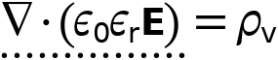

Constitutive Relation D-E
Settings
Description | Value
Dielectric model | Relative permittivity
Relative permittivity | User defined
Relative permittivity | {{78, 0, 0}, {0, 78, 0}, {0, 0, 78}}

Coordinate System Selection
Settings
Description | Value
Coordinate system | Global coordinate system

Variables
Name | Expression | Unit | Description | Selection | Details
es.nD | 0 | C/m² | Surface charge density | Boundaries 1–19 | + operation
es.epsilonrrr | 78 | 1 | Relative permittivity, rr component | Domains 1–2
es.epsilonrphir | 0 | 1 | Relative permittivity, phir component | Domains 1–2
es.epsilonrzr | 0 | 1 | Relative permittivity, zr component | Domains 1–2
es.epsilonrrphi | 0 | 1 | Relative permittivity, rphi component | Domains 1–2
es.epsilonrphiphi | 78 | 1 | Relative permittivity, phiphi component | Domains 1–2
es.epsilonrzphi | 0 | 1 | Relative permittivity, zphi component | Domains 1–2
es.epsilonrrz | 0 | 1 | Relative permittivity, rz component | Domains 1–2
es.epsilonrphiz | 0 | 1 | Relative permittivity, phiz component | Domains 1–2
es.epsilonrzz | 78 | 1 | Relative permittivity, zz component | Domains 1–2
es.epsilonr_iso | 78 | 1 | Relative permittivity, isotropic value | Domains 1–2
es.DrR | 0 | C/m² | Remanent electric displacement, R component | Domains 1–2
es.DrPHI | 0 | C/m² | Remanent electric displacement, PHI component | Domains 1–2
es.DrZ | 0 | C/m² | Remanent electric displacement, Z component | Domains 1–2
es.Dr | epsilon0_const*es.I_srr*es.Er+epsilon0_const*es.I_srphi*es.Ephi+epsilon0_const*es.I_srz*es.Ez+es.Pr+es.Per | C/m² | Electric displacement field, r component | Domains 1–2
es.Dphi | epsilon0_const*es.I_sphir*es.Er+epsilon0_const*es.I_sphiphi*es.Ephi+epsilon0_const*es.I_sphiz*es.Ez+es.Pphi+es.Pephi | C/m² | Electric displacement field, phi component | Domains 1–2
es.Dz | epsilon0_const*es.I_szr*es.Er+epsilon0_const*es.I_szphi*es.Ephi+epsilon0_const*es.I_szz*es.Ez+es.Pz+es.Pez | C/m² | Electric displacement field, z component | Domains 1–2
es.Pr | epsilon0_const*(es.chirr*es.Er+es.chirphi*es.Ephi+es.chirz*es.Ez) | C/m² | Polarization, r component | Domains 1–2
es.Pphi | epsilon0_const*(es.chiphir*es.Er+es.chiphiphi*es.Ephi+es.chiphiz*es.Ez) | C/m² | Polarization, phi component | Domains 1–2
es.Pz | epsilon0_const*(es.chizr*es.Er+es.chizphi*es.Ephi+es.chizz*es.Ez) | C/m² | Polarization, z component | Domains 1–2
es.normD | sqrt(realdot(es.Dr,es.Dr)+realdot(es.Dphi,es.Dphi)+realdot(es.Dz,es.Dz)) | C/m² | Electric displacement field norm | Domains 1–2
es.normP | sqrt(realdot(es.Pr,es.Pr)+realdot(es.Pphi,es.Pphi)+realdot(es.Pz,es.Pz)) | C/m² | Polarization norm | Domains 1–2
es.Per | 0 | C/m² | Polarization contribution, r component | Domains 1–2 | + operation
es.Pephi | 0 | C/m² | Polarization contribution, phi component | Domains 1–2 | + operation
es.Pez | 0 | C/m² | Polarization contribution, z component | Domains 1–2 | + operation
es.chirr | -1+es.epsilonrrr | 1 | Electric susceptibility, rr component | Domains 1–2
es.chiphir | es.epsilonrphir | 1 | Electric susceptibility, phir component | Domains 1–2
es.chizr | es.epsilonrzr | 1 | Electric susceptibility, zr component | Domains 1–2
es.chirphi | es.epsilonrrphi | 1 | Electric susceptibility, rphi component | Domains 1–2
es.chiphiphi | -1+es.epsilonrphiphi | 1 | Electric susceptibility, phiphi component | Domains 1–2
es.chizphi | es.epsilonrzphi | 1 | Electric susceptibility, zphi component | Domains 1–2
es.chirz | es.epsilonrrz | 1 | Electric susceptibility, rz component | Domains 1–2
es.chiphiz | es.epsilonrphiz | 1 | Electric susceptibility, phiz component | Domains 1–2
es.chizz | -1+es.epsilonrzz | 1 | Electric susceptibility, zz component | Domains 1–2
es.Er | -Vr | V/m | Electric field, r component | Domains 1–2
es.Ephi | 0 | V/m | Electric field, phi component | Domains 1–2
es.Ez | -Vz | V/m | Electric field, z component | Domains 1–2
es.tEr | -VTr | V/m | Tangential electric field, r component | Boundaries 1–19
es.tEphi | 0 | V/m | Tangential electric field, phi component | Boundaries 1–19
es.tEz | -VTz | V/m | Tangential electric field, z component | Boundaries 1–19
es.normE | sqrt(realdot(es.Er,es.Er)+realdot(es.Ephi,es.Ephi)+realdot(es.Ez,es.Ez)) | V/m | Electric field norm | Domains 1–2
es.Jr | es.Jdr | A/m² | Current density, r component | Domains 1–2 | + operation
es.Jphi | es.Jdphi | A/m² | Current density, phi component | Domains 1–2 | + operation
es.Jz | es.Jdz | A/m² | Current density, z component | Domains 1–2 | + operation
es.JR | (spatial.invF11*es.Jdr+spatial.invF31*es.Jdz)*spatial.detF | A/m² | Current density, R component | Domains 1–2 | + operation
es.JPHI | if(Rg>0.001*h,R/r,Rr)*es.Jdphi*spatial.detF | A/m² | Current density, PHI component | Domains 1–2 | + operation
es.JZ | (spatial.invF13*es.Jdr+spatial.invF33*es.Jdz)*spatial.detF | A/m² | Current density, Z component | Domains 1–2 | + operation
es.Jdr | 0 | A/m² | Displacement current density, r component | Domains 1–2
es.Jdphi | 0 | A/m² | Displacement current density, phi component | Domains 1–2
es.Jdz | 0 | A/m² | Displacement current density, z component | Domains 1–2
es.normJ | sqrt(realdot(es.Jr,es.Jr)+realdot(es.Jphi,es.Jphi)+realdot(es.Jz,es.Jz)) | A/m² | Current density norm | Domains 1–2
es.ccn1.nJ | es.unr*down(es.Jr)+es.unphi*down(es.Jphi)+es.unz*down(es.Jz) | A/m² | Inward current density | Boundaries 1–3, 7–8, 10, 12–14, 17
es.W | es.We | J/m³ | Energy density | Domains 1–2 | + operation
es.dWe | 2*es.We*pi*r | J/m² | Integrand for total electric energy | Domains 1–2 | Meta
es.We | 0.5*epsilon0_const*(((es.I_srr+es.chirr)*es.Er+(es.I_srphi+es.chirphi)*es.Ephi+(es.I_srz+es.chirz)*es.Ez)*es.Er+((es.I_sphir+es.chiphir)*es.Er+(es.I_sphiphi+es.chiphiphi)*es.Ephi+(es.I_sphiz+es.chiphiz)*es.Ez)*es.Ephi+((es.I_szr+es.chizr)*es.Er+(es.I_szphi+es.chizphi)*es.Ephi+(es.I_szz+es.chizz)*es.Ez)*es.Ez) | J/m³ | Electric energy density | Domains 1–2

Shape functions
Name | Shape function | Unit | Description | Shape frame | Selection
V | Lagrange (Quadratic) | V | Electric potential | Spatial | Domains 1–2
V | Lagrange (Quadratic) | V | Electric potential | Material | Domains 1–2
V | Lagrange (Quadratic) | V | Electric potential | Geometry | Domains 1–2
V | Lagrange (Quadratic) | V | Electric potential | Mesh | Domains 1–2

Weak Expressions
Weak expression | Integration order | Integration frame | Selection
-2*(es.Dr*test(Vr)+es.Dz*test(Vz))*es.d*pi*r | 4 | Spatial | Domains 1–2

    - Axial Symmetry
Axial Symmetry
Selection
Geometric entity level | Boundary
Selection | Geometry geom1: Dimension 1: All boundaries

    - Zero Charge
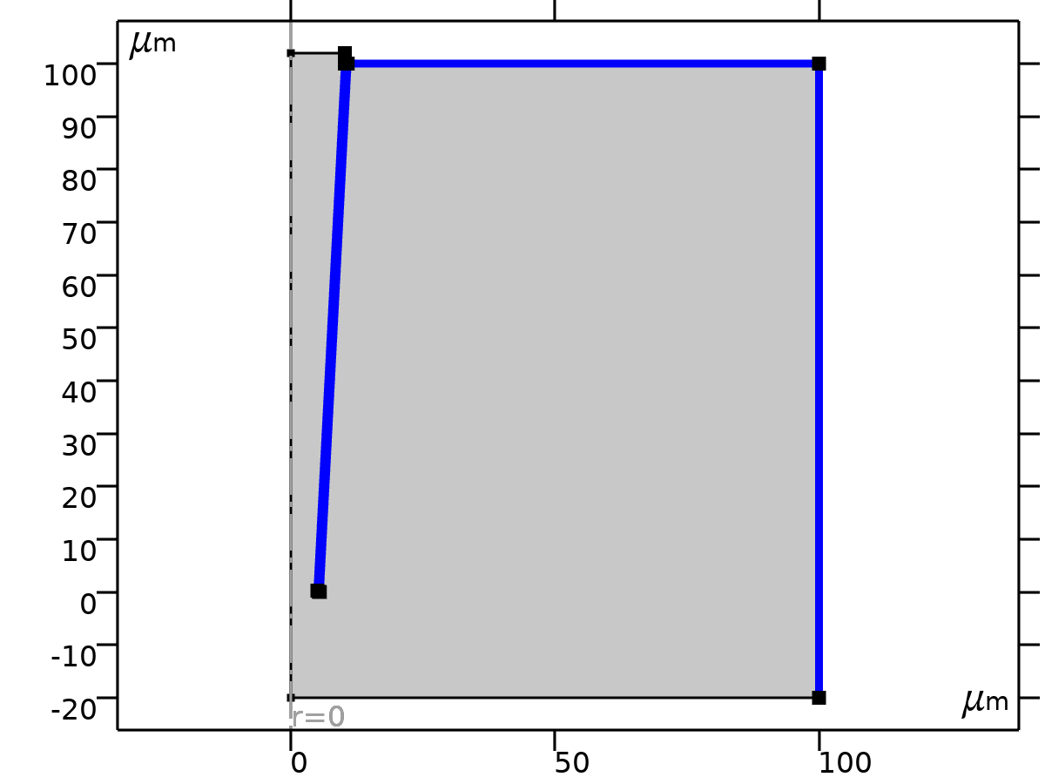
Zero Charge
Selection
Geometric entity level | Boundary
Selection | Geometry geom1: Dimension 1: All boundaries

Equations

Variables
Name | Expression | Unit | Description | Selection | Details
es.nD | 0 | C/m² | Surface charge density | Boundaries 7–8, 10, 12–14, 17 | + operation

Shape functions
Name | Shape function | Unit | Description | Shape frame | Selection | Details
V | Lagrange (Quadratic) | V | Electric potential | Spatial | No boundaries | Slit
V | Lagrange (Quadratic) | V | Electric potential | Material | No boundaries | Slit
V | Lagrange (Quadratic) | V | Electric potential | Geometry | No boundaries | Slit
V | Lagrange (Quadratic) | V | Electric potential | Mesh | No boundaries | Slit

    - Initial Values
Initial Values
Selection
Geometric entity level | Domain
Selection | Geometry geom1: Dimension 2: All domains

Settings
Description | Value
Electric potential | 0

    - Space Charge Density
Space Charge Density
Selection
Geometric entity level | Domain
Selection | Geometry geom1: Dimension 2: Domains 1–2

Equations
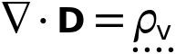

Coordinate System Selection
Settings
Description | Value
Coordinate system | Global coordinate system

Variables
Name | Expression | Unit | Description | Selection | Details
es.rhoq | es.scd1.rhoq | C/m³ | Space charge density | Domains 1–2 | + operation
es.scd1.rhoq | F_const*(c-c2) | C/m³ | Space charge density | Domains 1–2

Weak Expressions
Weak expression | Integration order | Integration frame | Selection
-2*es.scd1.rhoq*test(V)*es.d*pi*r | 4 | Spatial | Domains 1–2

    - Space Charge Density 2
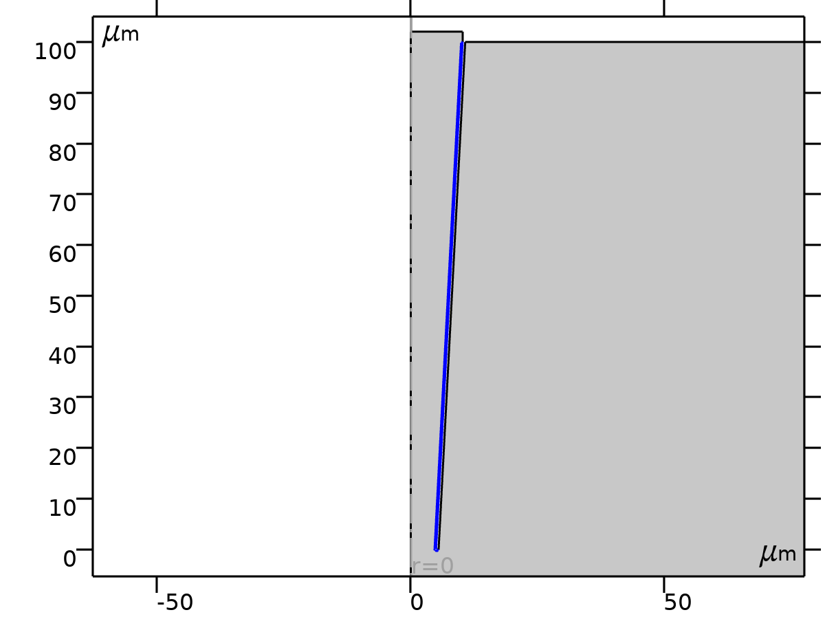
Space Charge Density 2
Selection
Geometric entity level | Domain
Selection | Geometry geom1: Dimension 2: Domain 2

Equations

Coordinate System Selection
Settings
Description | Value
Coordinate system | Global coordinate system

Variables
Name | Expression | Unit | Description | Selection | Details
es.rhoq | es.scd2.rhoq | C/m³ | Space charge density | Domain 2 | + operation
es.scd2.rhoq | 20000000[C/m^3]+F_const*(c-c2) | C/m³ | Space charge density | Domain 2

Weak Expressions
Weak expression | Integration order | Integration frame | Selection
-2*es.scd2.rhoq*test(V)*es.d*pi*r | 4 | Spatial | Domain 2

    - Electric Potential
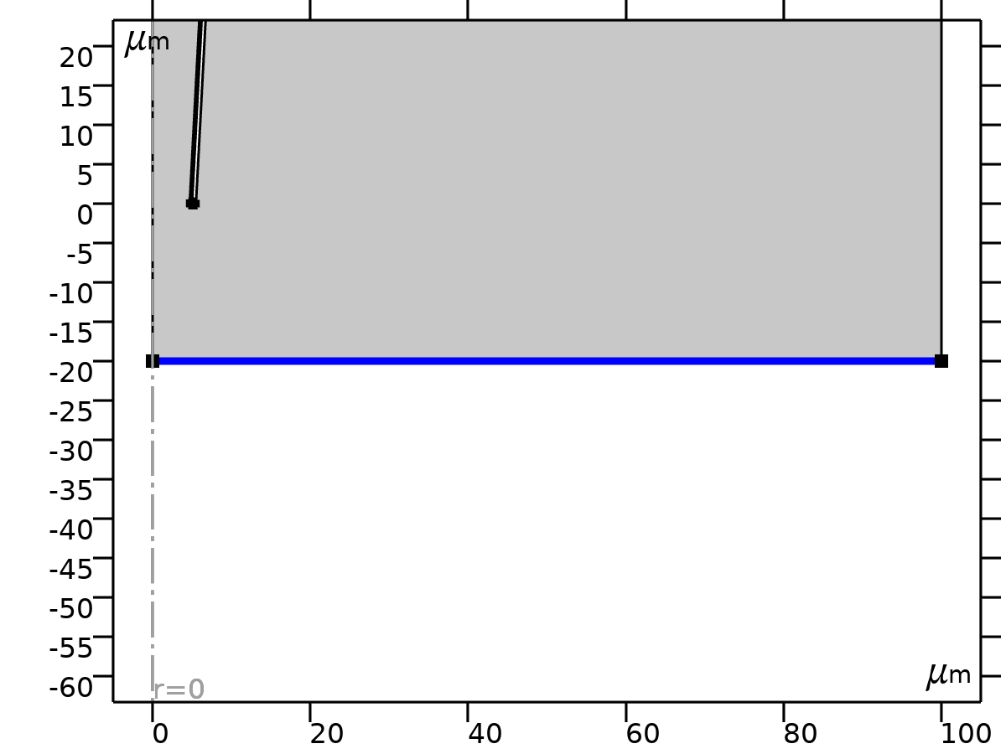
Electric Potential
Selection
Geometric entity level | Boundary
Selection | Geometry geom1: Dimension 1: Boundary 2

Equations
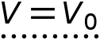

Electric Potential
Settings
Description | Value
Electric potential | 0

Variables
Name | Expression | Unit | Description | Selection | Details
es.nD | es.unr*down(es.Dr)+es.unphi*down(es.Dphi)+es.unz*down(es.Dz) | C/m² | Surface charge density | Boundary 2 | + operation
es.V0 | 0 | V | Electric potential | Boundary 2

Constraints
Constraint | Constraint force | Shape function | Selection | Details
es.V0-V | test(es.V0-V) | Lagrange (Quadratic) | Boundary 2 | Elemental

    - Electric Potential 2
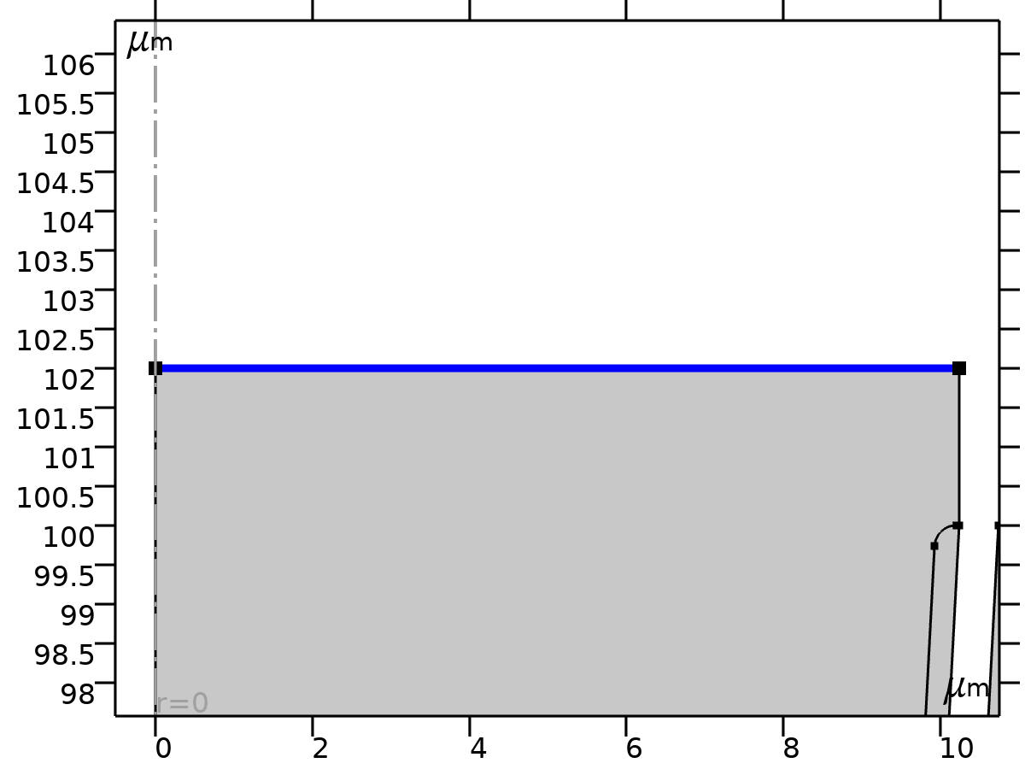
Electric Potential 2
Selection
Geometric entity level | Boundary
Selection | Geometry geom1: Dimension 1: Boundary 3

Equations

Electric Potential
Settings
Description | Value
Electric potential | pw1(t)

Variables
Name | Expression | Unit | Description | Selection | Details
es.nD | es.unr*down(es.Dr)+es.unphi*down(es.Dphi)+es.unz*down(es.Dz) | C/m² | Surface charge density | Boundary 3 | + operation
es.V0 | pw1(t) | V | Electric potential | Boundary 3

Constraints
Constraint | Constraint force | Shape function | Selection | Details
es.V0-V | test(es.V0-V) | Lagrange (Quadratic) | Boundary 3 | Elemental

  - Mesh
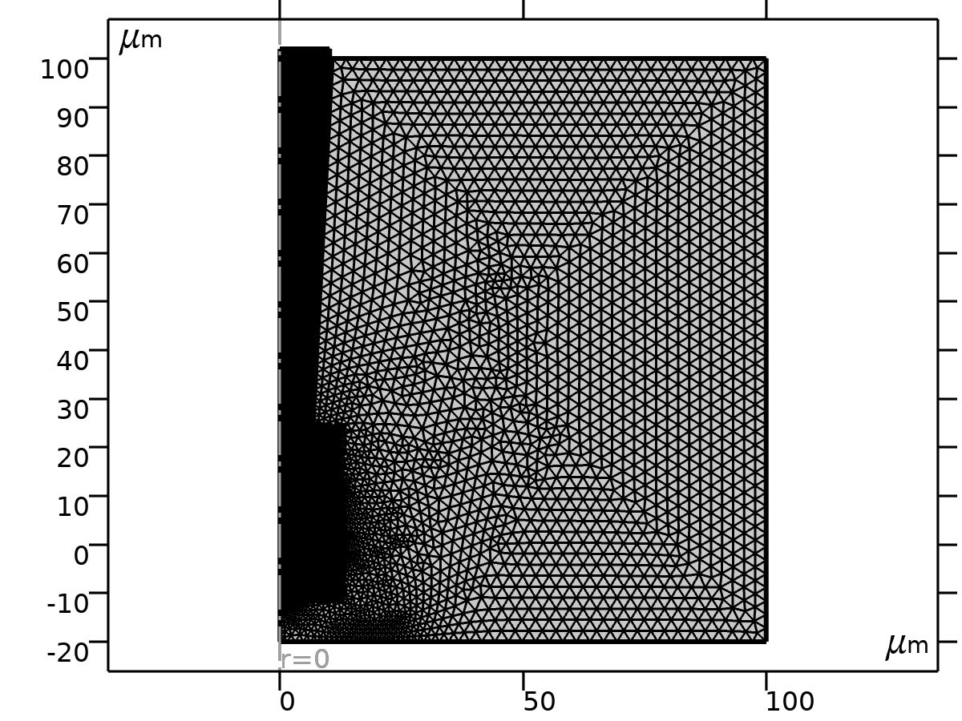
Mesh
    - Size (size)
Settings
Description | Value
Calibrate for | Fluid dynamics
Maximum element size | 0.67
Minimum element size | 0.002
Curvature factor | 0.2
Maximum element growth rate | 1.05
Predefined size | Extremely fine

    - Free Triangular (ftri1)
Selection
Geometric entity level | Domain
Selection | Geometry geom1

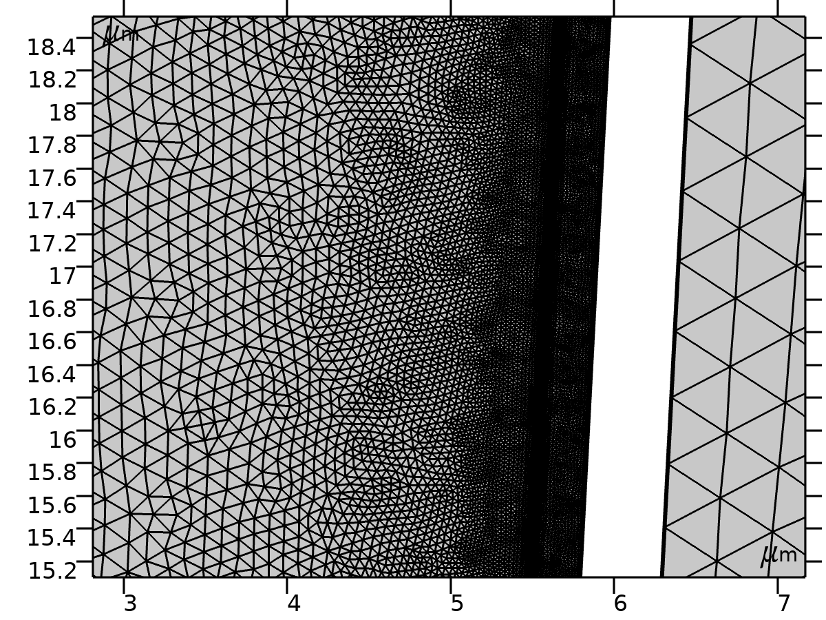
Free Triangular

Size_Pim (size2)
Selection
Geometric entity level | Domain
Selection | Geometry geom1: Dimension 2: Domain 2

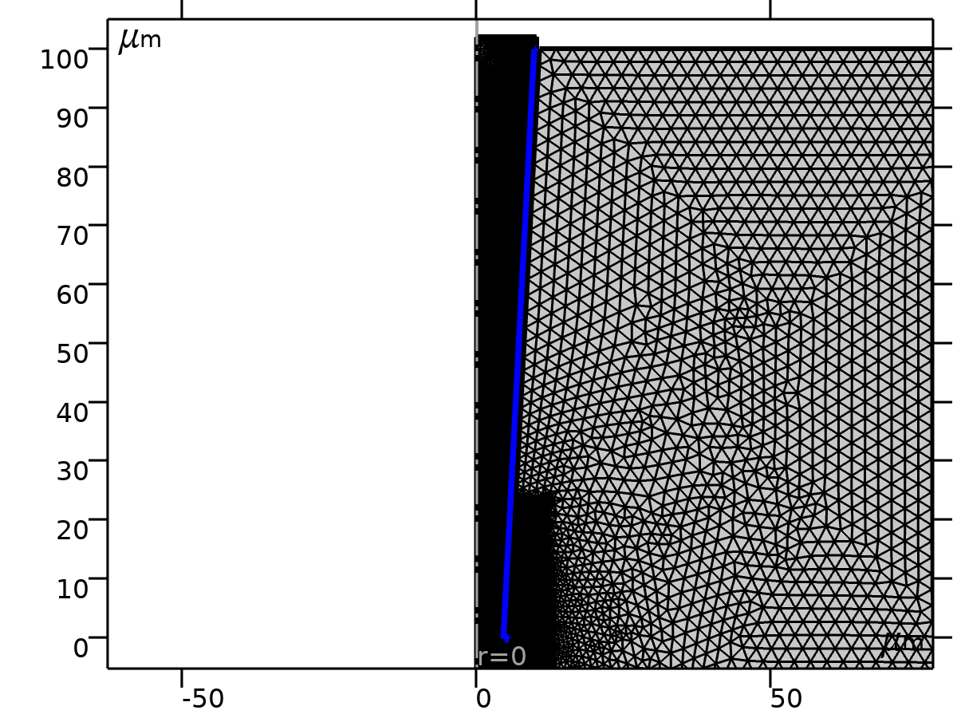
Size_Pim
Settings
Description | Value
Calibrate for | Fluid dynamics
Maximum element size | 0.05
Minimum element size | 0.001
Curvature factor | 0.2
Curvature factor | Off
Resolution of narrow regions | Off
Maximum element growth rate | 1.05
Predefined size | Extremely fine
Custom element size | Custom

Size_bulk (size1)
Selection
Geometric entity level | Domain
Selection | Geometry geom1: Dimension 2: Domain 1

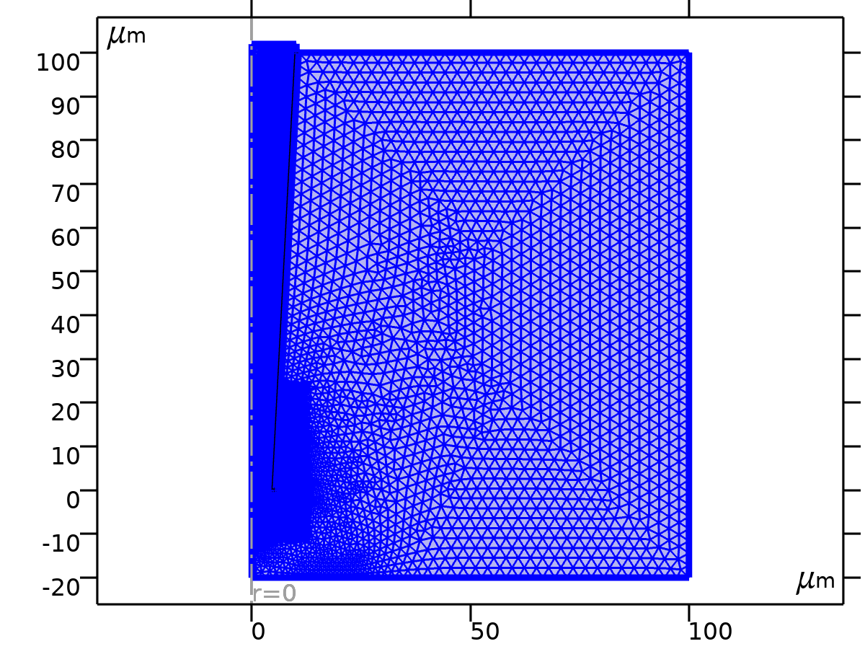
Size_bulk
Settings
Description | Value
Calibrate for | Fluid dynamics
Maximum element size | 2.8
Minimum element size | 0.04
Curvature factor | 0.25
Predefined size | Finer

    - Boundary Layer (bl1)
Selection
Geometric entity level | Domain
Selection | Geometry geom1

Boundary Layer

Boundary Layer Properties (blp)
Selection
Geometric entity level | Boundary
Selection | Geometry geom1: Dimension 1: Boundaries 4–6, 9, 11, 15–16, 18–19

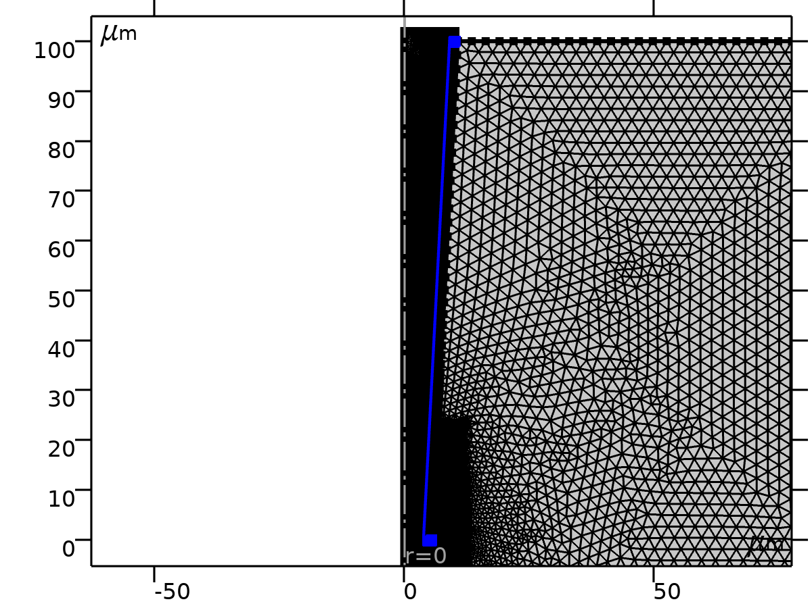
Boundary Layer Properties
Settings
Description | Value
Stretching factor | 1.1

    - Refine (ref1)
Selection
Geometric entity level | Domain
Selection | Geometry geom1

Refine
Settings
Description | Value
Specify bounding box | Use bounding box
xmax | 13.5
xmin | -2.67
ymax | 25
ymin | -12.1

- Study_1 no bias
Computation information
Computation time | 3 min 13 s

  - Steady state
Study settings
Description | Value
Include geometric nonlinearity | Off

Physics and variables selection
Physics interface | Discretization
Transport of Diluted Species (tds) | physics
Electrostatics (es) | physics

Mesh selection
Geometry | Mesh
Geometry (geom1) | mesh1

  - Solver Configurations
    - Solution 1

Compile Equations: Steady state (st1)
Study and step
Description | Value
Use study | Study_1 no bias
Use study step | Steady state

Dependent Variables 1 (v1)
General
Description | Value
Defined by study step | Steady state

浓度 (comp1.c) (comp1_c)
General
Description | Value
Field components | comp1.c
Internal variables | {comp1.uflux.c, comp1.dflux.c}

浓度 (comp1.c2) (comp1_c2)
General
Description | Value
Field components | comp1.c2
Internal variables | {comp1.uflux.c2, comp1.dflux.c2}

电势 (comp1.V) (comp1_V)
General
Description | Value
Field components | comp1.V

Stationary Solver (s1)
General
Description | Value
Defined by study step | Steady state

Advanced Setting (aDef)
Assembly settings
Description | Value
Reuse sparsity pattern | On

全耦合 1 (fc1)
General
Description | Value
Linear solver | 直接 1

Method and termination
Description | Value
Initial damping factor | 0.01
Minimum damping factor | 1.0E-6
Maximum number of iterations | 50

- Study_2 PPF
Computation information
Computation time | 1 h 33 min 55 s

  - Time dependent
Times | Unit
range(0,0.1,60) | ms

Study settings
Description | Value
Include geometric nonlinearity | Off

Study settings
Description | Value
Time unit | ms
Output times | {0, 0.1, 0.2, 0.30000000000000004, 0.4, 0.5, 0.6000000000000001, 0.7000000000000001, 0.8, 0.9, 1, 1.1, 1.2000000000000002, 1.3, 1.4000000000000001, 1.5, 1.6, 1.7000000000000002, 1.8, 1.9000000000000001, 2, 2.1, 2.2, 2.3000000000000003, 2.4000000000000004, 2.5, 2.6, 2.7, 2.8000000000000003, 2.9000000000000004, 3, 3.1, 3.2, 3.3000000000000003, 3.4000000000000004, 3.5, 3.6, 3.7, 3.8000000000000003, 3.9000000000000004, 4, 4.1000000000000005, 4.2, 4.3, 4.4, 4.5, 4.6000000000000005, 4.7, 4.800000000000001, 4.9, 5, 5.1000000000000005, 5.2, 5.300000000000001, 5.4, 5.5, 5.6000000000000005, 5.7, 5.800000000000001, 5.9, 6, 6.1000000000000005, 6.2, 6.300000000000001, 6.4, 6.5, 6.6000000000000005, 6.7, 6.800000000000001, 6.9, 7, 7.1000000000000005, 7.2, 7.300000000000001, 7.4, 7.5, 7.6000000000000005, 7.7, 7.800000000000001, 7.9, 8, 8.1, 8.200000000000001, 8.3, 8.4, 8.5, 8.6, 8.700000000000001, 8.8, 8.9, 9, 9.1, 9.200000000000001, 9.3, 9.4, 9.5, 9.600000000000001, 9.700000000000001, 9.8, 9.9, 10, 10.100000000000001, 10.200000000000001, 10.3, 10.4, 10.5, 10.600000000000001, 10.700000000000001, 10.8, 10.9, 11, 11.100000000000001, 11.200000000000001, 11.3, 11.4, 11.5, 11.600000000000001, 11.700000000000001, 11.8, 11.9, 12, 12.100000000000001, 12.200000000000001, 12.3, 12.4, 12.5, 12.600000000000001, 12.700000000000001, 12.8, 12.9, 13, 13.100000000000001, 13.200000000000001, 13.3, 13.4, 13.5, 13.600000000000001, 13.700000000000001, 13.8, 13.9, 14, 14.100000000000001, 14.200000000000001, 14.3, 14.4, 14.5, 14.600000000000001, 14.700000000000001, 14.8, 14.9, 15, 15.100000000000001, 15.200000000000001, 15.3, 15.4, 15.5, 15.600000000000001, 15.700000000000001, 15.8, 15.9, 16, 16.1, 16.2, 16.3, 16.400000000000002, 16.5, 16.6, 16.7, 16.8, 16.900000000000002, 17, 17.1, 17.2, 17.3, 17.400000000000002, 17.5, 17.6, 17.7, 17.8, 17.900000000000002, 18, 18.1, 18.2, 18.3, 18.400000000000002, 18.5, 18.6, 18.7, 18.8, 18.900000000000002, 19, 19.1, 19.200000000000003, 19.3, 19.400000000000002, 19.5, 19.6, 19.700000000000003, 19.8, 19.900000000000002, 20, 20.1, 20.200000000000003, 20.3, 20.400000000000002, 20.5, 20.6, 20.700000000000003, 20.8, 20.900000000000002, 21, 21.1, 21.200000000000003, 21.3, 21.400000000000002, 21.5, 21.6, 21.700000000000003, 21.8, 21.900000000000002, 22, 22.1, 22.200000000000003, 22.3, 22.400000000000002, 22.5, 22.6, 22.700000000000003, 22.8, 22.900000000000002, 23, 23.1, 23.200000000000003, 23.3, 23.400000000000002, 23.5, 23.6, 23.700000000000003, 23.8, 23.900000000000002, 24, 24.1, 24.200000000000003, 24.3, 24.400000000000002, 24.5, 24.6, 24.700000000000003, 24.8, 24.900000000000002, 25, 25.1, 25.200000000000003, 25.3, 25.400000000000002, 25.5, 25.6, 25.700000000000003, 25.8, 25.900000000000002, 26, 26.1, 26.200000000000003, 26.3, 26.400000000000002, 26.5, 26.6, 26.700000000000003, 26.8, 26.900000000000002, 27, 27.1, 27.200000000000003, 27.3, 27.400000000000002, 27.5, 27.6, 27.700000000000003, 27.8, 27.900000000000002, 28, 28.1, 28.200000000000003, 28.3, 28.400000000000002, 28.5, 28.6, 28.700000000000003, 28.8, 28.900000000000002, 29, 29.1, 29.200000000000003, 29.3, 29.400000000000002, 29.5, 29.6, 29.700000000000003, 29.8, 29.900000000000002, 30, 30.1, 30.200000000000003, 30.3, 30.400000000000002, 30.5, 30.6, 30.700000000000003, 30.8, 30.900000000000002, 31, 31.1, 31.200000000000003, 31.3, 31.400000000000002, 31.5, 31.6, 31.700000000000003, 31.8, 31.900000000000002, 32, 32.1, 32.2, 32.300000000000004, 32.4, 32.5, 32.6, 32.7, 32.800000000000004, 32.9, 33, 33.1, 33.2, 33.300000000000004, 33.4, 33.5, 33.6, 33.7, 33.800000000000004, 33.9, 34, 34.1, 34.2, 34.300000000000004, 34.4, 34.5, 34.6, 34.7, 34.800000000000004, 34.9, 35, 35.1, 35.2, 35.300000000000004, 35.4, 35.5, 35.6, 35.7, 35.800000000000004, 35.9, 36, 36.1, 36.2, 36.300000000000004, 36.4, 36.5, 36.6, 36.7, 36.800000000000004, 36.9, 37, 37.1, 37.2, 37.300000000000004, 37.4, 37.5, 37.6, 37.7, 37.800000000000004, 37.9, 38, 38.1, 38.2, 38.300000000000004, 38.400000000000006, 38.5, 38.6, 38.7, 38.800000000000004, 38.900000000000006, 39, 39.1, 39.2, 39.300000000000004, 39.400000000000006, 39.5, 39.6, 39.7, 39.800000000000004, 39.900000000000006, 40, 40.1, 40.2, 40.300000000000004, 40.400000000000006, 40.5, 40.6, 40.7, 40.800000000000004, 40.900000000000006, 41, 41.1, 41.2, 41.300000000000004, 41.400000000000006, 41.5, 41.6, 41.7, 41.800000000000004, 41.900000000000006, 42, 42.1, 42.2, 42.300000000000004, 42.400000000000006, 42.5, 42.6, 42.7, 42.800000000000004, 42.900000000000006, 43, 43.1, 43.2, 43.300000000000004, 43.400000000000006, 43.5, 43.6, 43.7, 43.800000000000004, 43.900000000000006, 44, 44.1, 44.2, 44.300000000000004, 44.400000000000006, 44.5, 44.6, 44.7, 44.800000000000004, 44.900000000000006, 45, 45.1, 45.2, 45.300000000000004, 45.400000000000006, 45.5, 45.6, 45.7, 45.800000000000004, 45.900000000000006, 46, 46.1, 46.2, 46.300000000000004, 46.400000000000006, 46.5, 46.6, 46.7, 46.800000000000004, 46.900000000000006, 47, 47.1, 47.2, 47.300000000000004, 47.400000000000006, 47.5, 47.6, 47.7, 47.800000000000004, 47.900000000000006, 48, 48.1, 48.2, 48.300000000000004, 48.400000000000006, 48.5, 48.6, 48.7, 48.800000000000004, 48.900000000000006, 49, 49.1, 49.2, 49.300000000000004, 49.400000000000006, 49.5, 49.6, 49.7, 49.800000000000004, 49.900000000000006, 50, 50.1, 50.2, 50.300000000000004, 50.400000000000006, 50.5, 50.6, 50.7, 50.800000000000004, 50.900000000000006, 51, 51.1, 51.2, 51.300000000000004, 51.400000000000006, 51.5, 51.6, 51.7, 51.800000000000004, 51.900000000000006, 52, 52.1, 52.2, 52.300000000000004, 52.400000000000006, 52.5, 52.6, 52.7, 52.800000000000004, 52.900000000000006, 53, 53.1, 53.2, 53.300000000000004, 53.400000000000006, 53.5, 53.6, 53.7, 53.800000000000004, 53.900000000000006, 54, 54.1, 54.2, 54.300000000000004, 54.400000000000006, 54.5, 54.6, 54.7, 54.800000000000004, 54.900000000000006, 55, 55.1, 55.2, 55.300000000000004, 55.400000000000006, 55.5, 55.6, 55.7, 55.800000000000004, 55.900000000000006, 56, 56.1, 56.2, 56.300000000000004, 56.400000000000006, 56.5, 56.6, 56.7, 56.800000000000004, 56.900000000000006, 57, 57.1, 57.2, 57.300000000000004, 57.400000000000006, 57.5, 57.6, 57.7, 57.800000000000004, 57.900000000000006, 58, 58.1, 58.2, 58.300000000000004, 58.400000000000006, 58.5, 58.6, 58.7, 58.800000000000004, 58.900000000000006, 59, 59.1, 59.2, 59.300000000000004, 59.400000000000006, 59.5, 59.6, 59.7, 59.800000000000004, 59.900000000000006, 60}

Values of dependent variables
Description | Value
Settings | User controlled
Method | Solution
Study | Study_1 no bias

Physics and variables selection
Physics interface | Discretization
Transport of Diluted Species (tds) | physics
Electrostatics (es) | physics

Mesh selection
Geometry | Mesh
Geometry (geom1) | mesh1

  - Solver Configurations
    - Solution 2

Compile Equations: Time dependent (st1)
Study and step
Description | Value
Use study | Study_2 -1 V
Use study step | Time dependent

Dependent Variables 1 (v1)
General
Description | Value
Defined by study step | Time dependent

Initial values of variables solved for
Description | Value
Method | Solution
Solution | Solution 1

Residual scaling
Description | Value
Method | Manual

Initial value calculation constants
Constant name | Initial value source
t | range(0,0.1,60)
timestep | 0.06[ms]

Concentration (comp1.c) (comp1_c)
General
Description | Value
Field components | comp1.c
Internal variables | {comp1.uflux.c, comp1.dflux.c, comp1.tds.dt2Inv_c}

Concentration (comp1.c2) (comp1_c2)
General
Description | Value
Field components | comp1.c2
Internal variables | {comp1.uflux.c2, comp1.dflux.c2, comp1.tds.dt2Inv_c2}

Electric potential (comp1.V) (comp1_V)
General
Description | Value
Field components | comp1.V

Time-Dependent Solver 1 (t1)
General
Description | Value
Defined by study step | Time dependent
Time unit | ms
Output times | {0, 0.1, 0.2, 0.30000000000000004, 0.4, 0.5, 0.6000000000000001, 0.7000000000000001, 0.8, 0.9, 1, 1.1, 1.2000000000000002, 1.3, 1.4000000000000001, 1.5, 1.6, 1.7000000000000002, 1.8, 1.9000000000000001, 2, 2.1, 2.2, 2.3000000000000003, 2.4000000000000004, 2.5, 2.6, 2.7, 2.8000000000000003, 2.9000000000000004, 3, 3.1, 3.2, 3.3000000000000003, 3.4000000000000004, 3.5, 3.6, 3.7, 3.8000000000000003, 3.9000000000000004, 4, 4.1000000000000005, 4.2, 4.3, 4.4, 4.5, 4.6000000000000005, 4.7, 4.800000000000001, 4.9, 5, 5.1000000000000005, 5.2, 5.300000000000001, 5.4, 5.5, 5.6000000000000005, 5.7, 5.800000000000001, 5.9, 6, 6.1000000000000005, 6.2, 6.300000000000001, 6.4, 6.5, 6.6000000000000005, 6.7, 6.800000000000001, 6.9, 7, 7.1000000000000005, 7.2, 7.300000000000001, 7.4, 7.5, 7.6000000000000005, 7.7, 7.800000000000001, 7.9, 8, 8.1, 8.200000000000001, 8.3, 8.4, 8.5, 8.6, 8.700000000000001, 8.8, 8.9, 9, 9.1, 9.200000000000001, 9.3, 9.4, 9.5, 9.600000000000001, 9.700000000000001, 9.8, 9.9, 10, 10.100000000000001, 10.200000000000001, 10.3, 10.4, 10.5, 10.600000000000001, 10.700000000000001, 10.8, 10.9, 11, 11.100000000000001, 11.200000000000001, 11.3, 11.4, 11.5, 11.600000000000001, 11.700000000000001, 11.8, 11.9, 12, 12.100000000000001, 12.200000000000001, 12.3, 12.4, 12.5, 12.600000000000001, 12.700000000000001, 12.8, 12.9, 13, 13.100000000000001, 13.200000000000001, 13.3, 13.4, 13.5, 13.600000000000001, 13.700000000000001, 13.8, 13.9, 14, 14.100000000000001, 14.200000000000001, 14.3, 14.4, 14.5, 14.600000000000001, 14.700000000000001, 14.8, 14.9, 15, 15.100000000000001, 15.200000000000001, 15.3, 15.4, 15.5, 15.600000000000001, 15.700000000000001, 15.8, 15.9, 16, 16.1, 16.2, 16.3, 16.400000000000002, 16.5, 16.6, 16.7, 16.8, 16.900000000000002, 17, 17.1, 17.2, 17.3, 17.400000000000002, 17.5, 17.6, 17.7, 17.8, 17.900000000000002, 18, 18.1, 18.2, 18.3, 18.400000000000002, 18.5, 18.6, 18.7, 18.8, 18.900000000000002, 19, 19.1, 19.200000000000003, 19.3, 19.400000000000002, 19.5, 19.6, 19.700000000000003, 19.8, 19.900000000000002, 20, 20.1, 20.200000000000003, 20.3, 20.400000000000002, 20.5, 20.6, 20.700000000000003, 20.8, 20.900000000000002, 21, 21.1, 21.200000000000003, 21.3, 21.400000000000002, 21.5, 21.6, 21.700000000000003, 21.8, 21.900000000000002, 22, 22.1, 22.200000000000003, 22.3, 22.400000000000002, 22.5, 22.6, 22.700000000000003, 22.8, 22.900000000000002, 23, 23.1, 23.200000000000003, 23.3, 23.400000000000002, 23.5, 23.6, 23.700000000000003, 23.8, 23.900000000000002, 24, 24.1, 24.200000000000003, 24.3, 24.400000000000002, 24.5, 24.6, 24.700000000000003, 24.8, 24.900000000000002, 25, 25.1, 25.200000000000003, 25.3, 25.400000000000002, 25.5, 25.6, 25.700000000000003, 25.8, 25.900000000000002, 26, 26.1, 26.200000000000003, 26.3, 26.400000000000002, 26.5, 26.6, 26.700000000000003, 26.8, 26.900000000000002, 27, 27.1, 27.200000000000003, 27.3, 27.400000000000002, 27.5, 27.6, 27.700000000000003, 27.8, 27.900000000000002, 28, 28.1, 28.200000000000003, 28.3, 28.400000000000002, 28.5, 28.6, 28.700000000000003, 28.8, 28.900000000000002, 29, 29.1, 29.200000000000003, 29.3, 29.400000000000002, 29.5, 29.6, 29.700000000000003, 29.8, 29.900000000000002, 30, 30.1, 30.200000000000003, 30.3, 30.400000000000002, 30.5, 30.6, 30.700000000000003, 30.8, 30.900000000000002, 31, 31.1, 31.200000000000003, 31.3, 31.400000000000002, 31.5, 31.6, 31.700000000000003, 31.8, 31.900000000000002, 32, 32.1, 32.2, 32.300000000000004, 32.4, 32.5, 32.6, 32.7, 32.800000000000004, 32.9, 33, 33.1, 33.2, 33.300000000000004, 33.4, 33.5, 33.6, 33.7, 33.800000000000004, 33.9, 34, 34.1, 34.2, 34.300000000000004, 34.4, 34.5, 34.6, 34.7, 34.800000000000004, 34.9, 35, 35.1, 35.2, 35.300000000000004, 35.4, 35.5, 35.6, 35.7, 35.800000000000004, 35.9, 36, 36.1, 36.2, 36.300000000000004, 36.4, 36.5, 36.6, 36.7, 36.800000000000004, 36.9, 37, 37.1, 37.2, 37.300000000000004, 37.4, 37.5, 37.6, 37.7, 37.800000000000004, 37.9, 38, 38.1, 38.2, 38.300000000000004, 38.400000000000006, 38.5, 38.6, 38.7, 38.800000000000004, 38.900000000000006, 39, 39.1, 39.2, 39.300000000000004, 39.400000000000006, 39.5, 39.6, 39.7, 39.800000000000004, 39.900000000000006, 40, 40.1, 40.2, 40.300000000000004, 40.400000000000006, 40.5, 40.6, 40.7, 40.800000000000004, 40.900000000000006, 41, 41.1, 41.2, 41.300000000000004, 41.400000000000006, 41.5, 41.6, 41.7, 41.800000000000004, 41.900000000000006, 42, 42.1, 42.2, 42.300000000000004, 42.400000000000006, 42.5, 42.6, 42.7, 42.800000000000004, 42.900000000000006, 43, 43.1, 43.2, 43.300000000000004, 43.400000000000006, 43.5, 43.6, 43.7, 43.800000000000004, 43.900000000000006, 44, 44.1, 44.2, 44.300000000000004, 44.400000000000006, 44.5, 44.6, 44.7, 44.800000000000004, 44.900000000000006, 45, 45.1, 45.2, 45.300000000000004, 45.400000000000006, 45.5, 45.6, 45.7, 45.800000000000004, 45.900000000000006, 46, 46.1, 46.2, 46.300000000000004, 46.400000000000006, 46.5, 46.6, 46.7, 46.800000000000004, 46.900000000000006, 47, 47.1, 47.2, 47.300000000000004, 47.400000000000006, 47.5, 47.6, 47.7, 47.800000000000004, 47.900000000000006, 48, 48.1, 48.2, 48.300000000000004, 48.400000000000006, 48.5, 48.6, 48.7, 48.800000000000004, 48.900000000000006, 49, 49.1, 49.2, 49.300000000000004, 49.400000000000006, 49.5, 49.6, 49.7, 49.800000000000004, 49.900000000000006, 50, 50.1, 50.2, 50.300000000000004, 50.400000000000006, 50.5, 50.6, 50.7, 50.800000000000004, 50.900000000000006, 51, 51.1, 51.2, 51.300000000000004, 51.400000000000006, 51.5, 51.6, 51.7, 51.800000000000004, 51.900000000000006, 52, 52.1, 52.2, 52.300000000000004, 52.400000000000006, 52.5, 52.6, 52.7, 52.800000000000004, 52.900000000000006, 53, 53.1, 53.2, 53.300000000000004, 53.400000000000006, 53.5, 53.6, 53.7, 53.800000000000004, 53.900000000000006, 54, 54.1, 54.2, 54.300000000000004, 54.400000000000006, 54.5, 54.6, 54.7, 54.800000000000004, 54.900000000000006, 55, 55.1, 55.2, 55.300000000000004, 55.400000000000006, 55.5, 55.6, 55.7, 55.800000000000004, 55.900000000000006, 56, 56.1, 56.2, 56.300000000000004, 56.400000000000006, 56.5, 56.6, 56.7, 56.800000000000004, 56.900000000000006, 57, 57.1, 57.2, 57.300000000000004, 57.400000000000006, 57.5, 57.6, 57.7, 57.800000000000004, 57.900000000000006, 58, 58.1, 58.2, 58.300000000000004, 58.400000000000006, 58.5, 58.6, 58.7, 58.800000000000004, 58.900000000000006, 59, 59.1, 59.2, 59.300000000000004, 59.400000000000006, 59.5, 59.6, 59.7, 59.800000000000004, 59.900000000000006, 60}
Relative tolerance | 0.005

Time stepping
Description | Value
Maximum BDF order | 2
Nonlinear controller | On

Advanced (aDef)
Assembly settings
Description | Value
Reuse sparsity pattern | On

Fully Coupled 1 (fc1)
General
Description | Value
Linear solver | Direct 1

Method and termination
Description | Value
Damping factor | 0.9
Jacobian update | Once per time step
Maximum number of iterations | 8
Stabilization and acceleration | Anderson acceleration
Dimension of iteration space | 5
Mixing parameter | 0.9

- Results
  - Dataset
    - Grid 1D
Data
Description | Value
Function | Triangle Wave 1
Refresh

Parameter bounds
Description | Value
Name | t
Minimum | -1
Maximum | 1

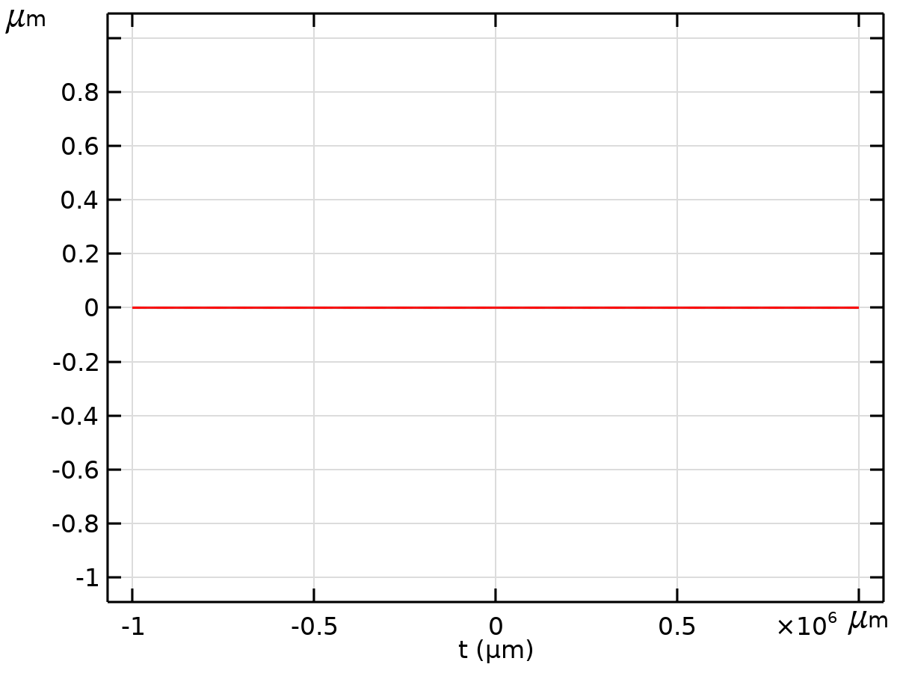
Dataset: Grid 1D
    - Study_1 no bias/Solution 1
Solution
Description | Value
Solution | Solution 1
Component | Compoment 1 (comp1)

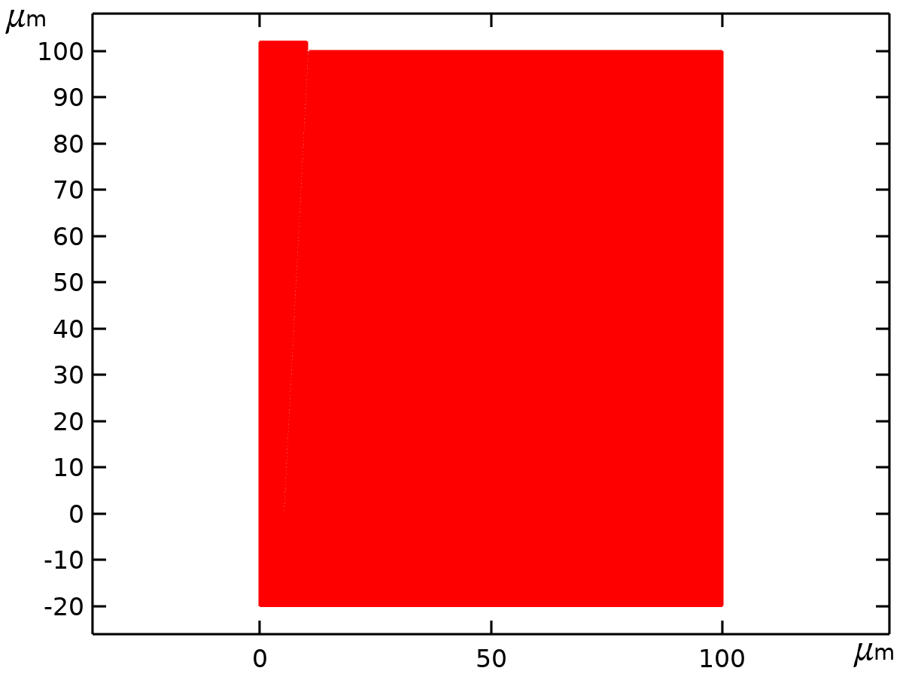
Dataset: Study_1 no bias/Solution 1
    - Revolution 2D
Data
Description | Value
Dataset | Study_1 no bias/Solution 1

Axis data
Description | Value
Axis entry method | Two points
Points | {{0, 0}, {0, 1}}

Revolution layers
Description | Value
Start angle | -90
Revolution angle | 225

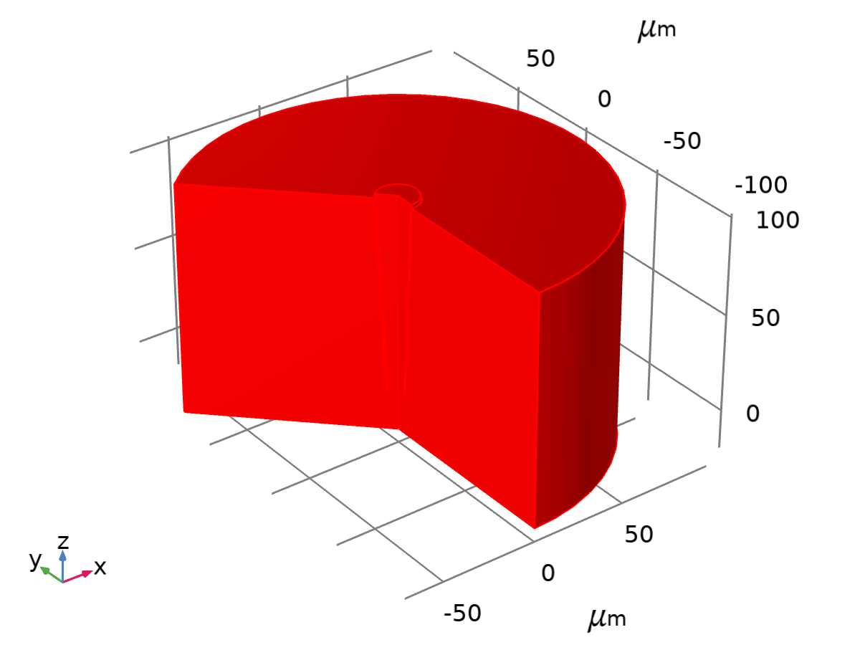
Dataset: Revolution 2D
    - Revolution 2D_2
Data
Description | Value
Dataset | Study_1 no bias/Solution 1

Axis data
Description | Value
Axis entry method | Two points
Points | {{0, 0}, {0, 1}}

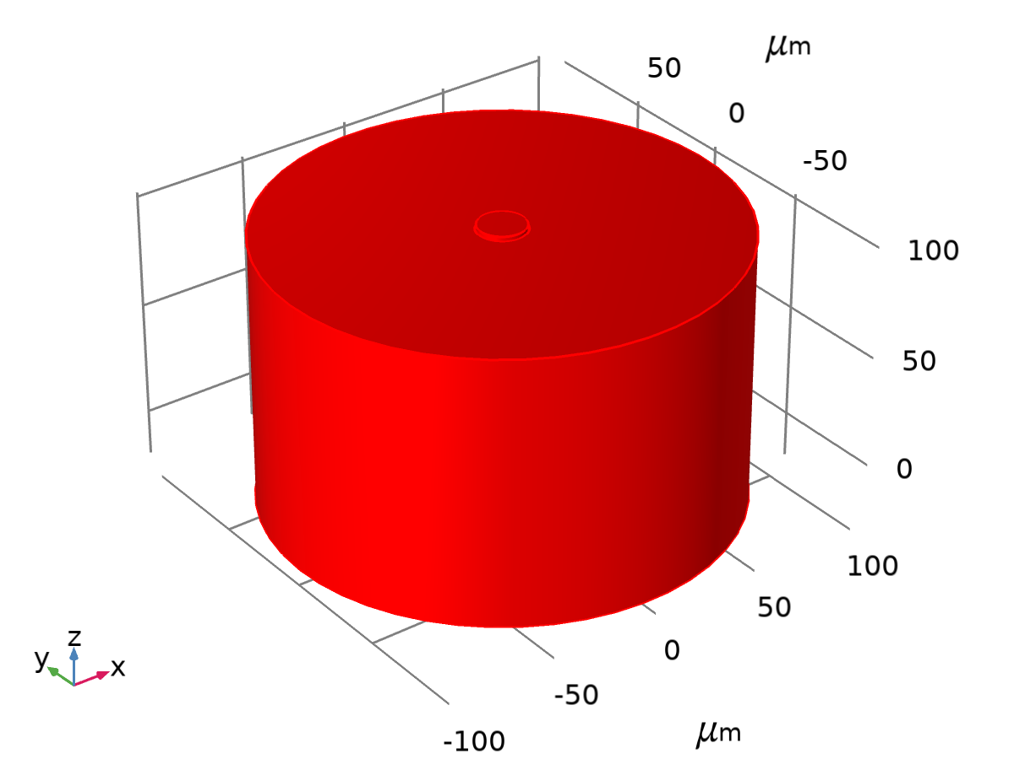
Dataset: Revolution 2D_2
    - Study_2 1 V/Solve 2
Solution
Description | Value
Solution | Solution 2
Component | Component (comp1)

Dataset: Study_2 1 V/Solve 2
    - Revolution 2D_3
Data
Description | Value
Dataset | Study_2 1 V/Solve 2

Axis data
Description | Value
Axis entry method | Two points
Points | {{0, 0}, {0, 1}}

Revolution layers
Description | Value
Start angle | -90
Revolution angle | 225

Dataset: Revolution 2D_3
  - 表格
    - Evaluation 2D
Interactive 2D values
x | y | Value
5.0299 | 18.616 | -0.28936

  - Plot Groups
    - ionic strength no bias
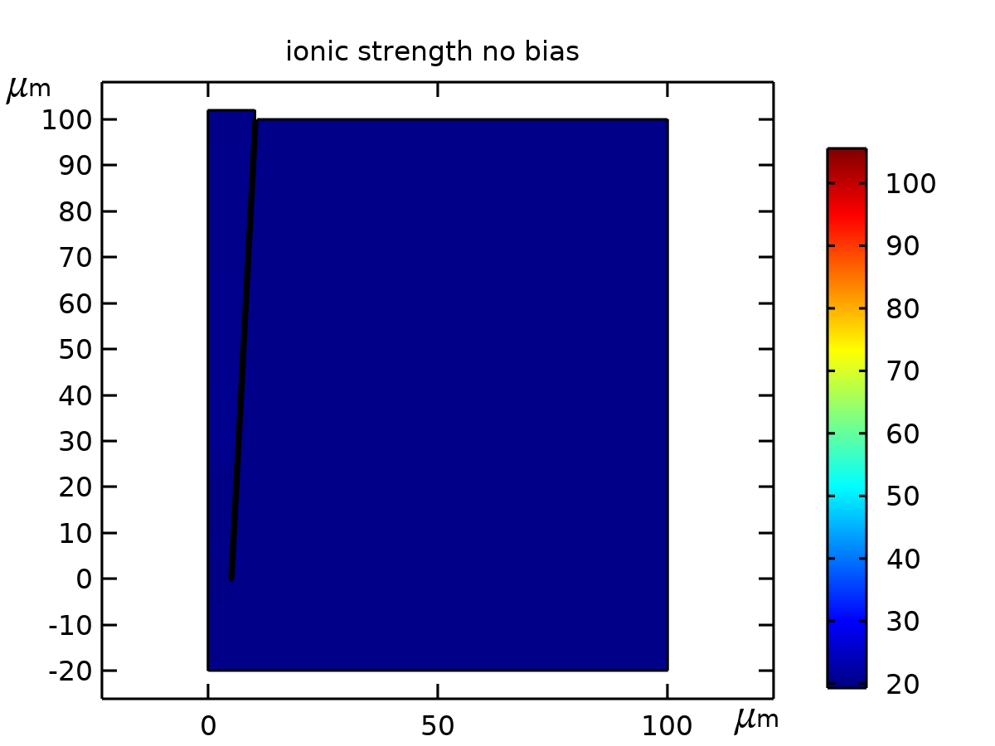
ionic strength no bias
    - electrical potential (0 s)
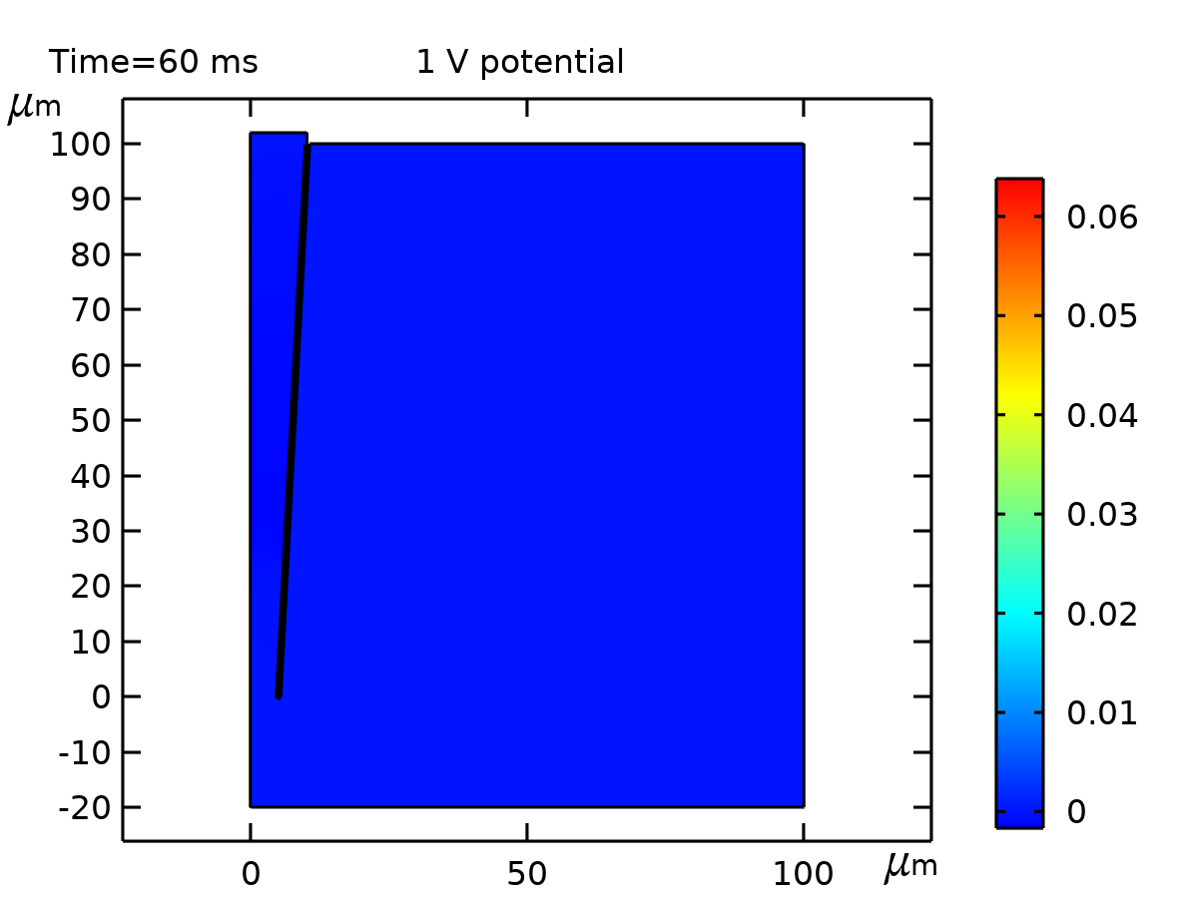
0 s potential
    - K (no bias)
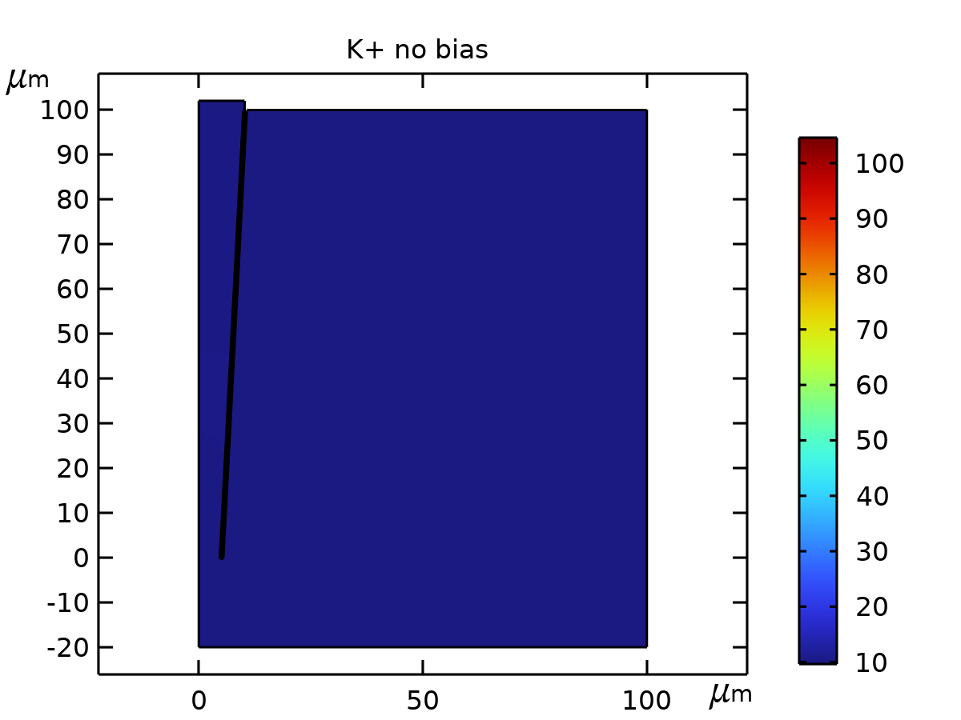
K+ no bias
    - Cl (no bias)
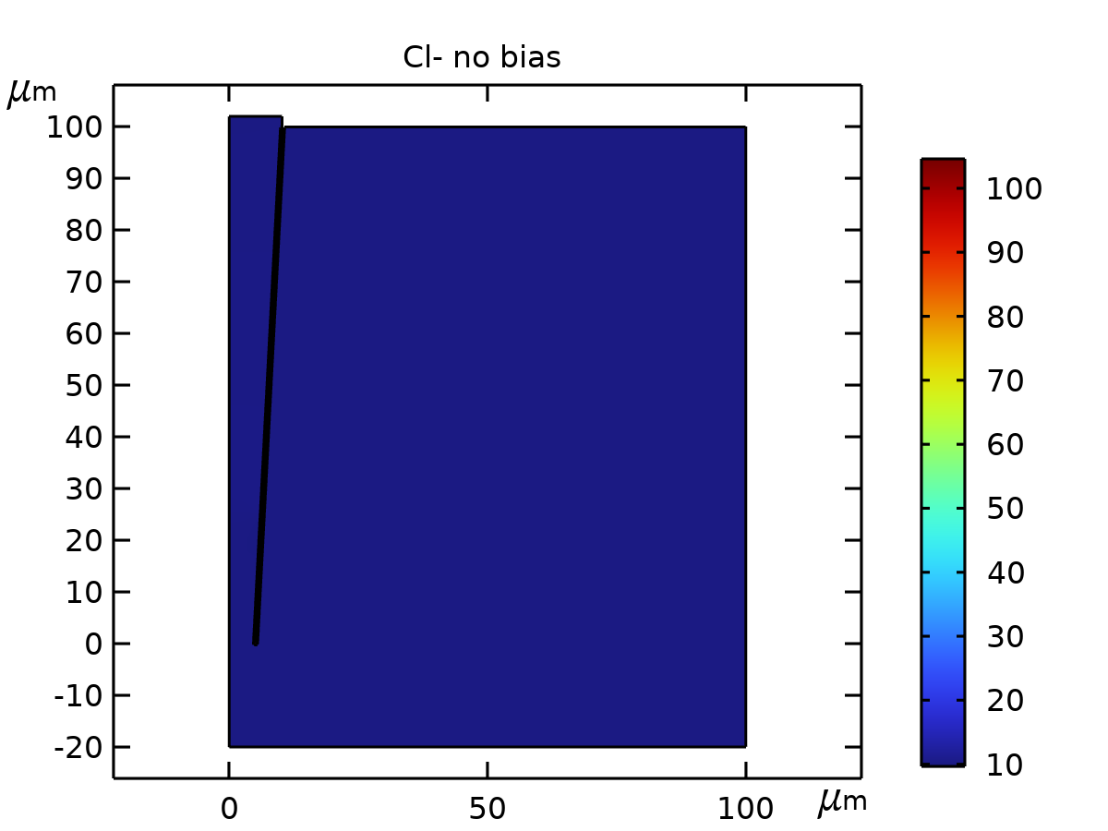
Cl- no bias
    - K (0 s)
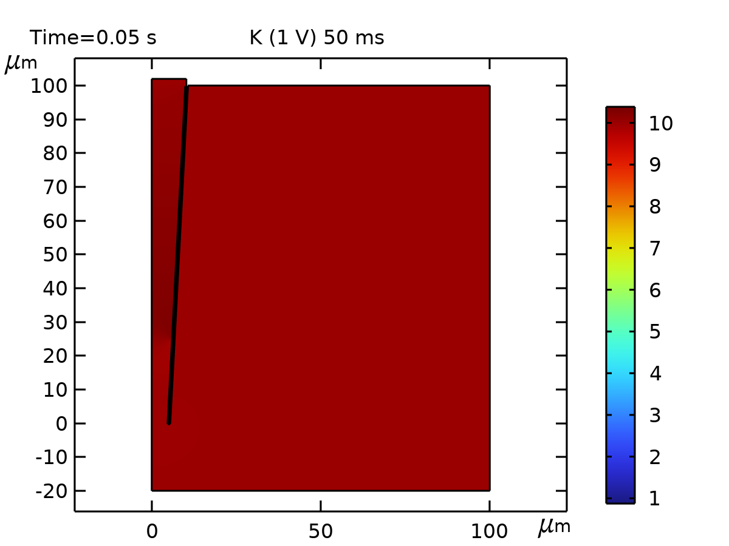
K 0 ms
    - Cl (0 s)
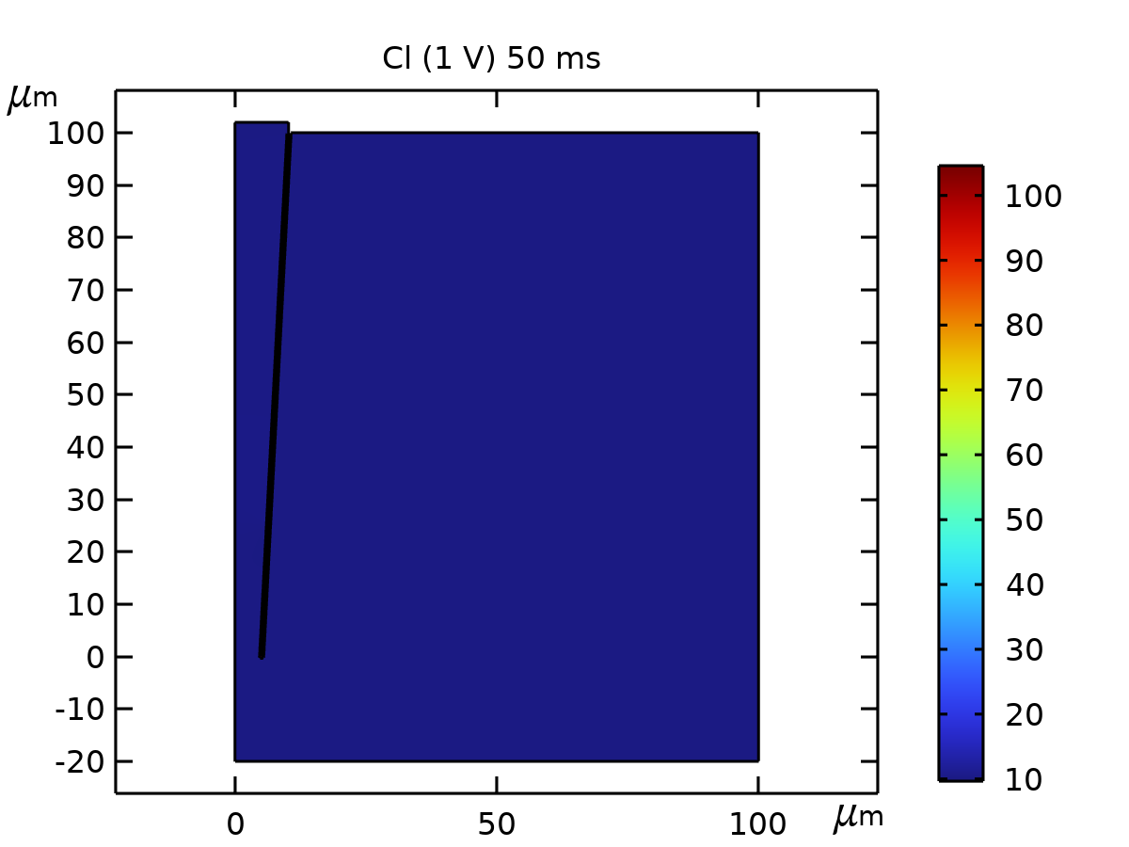
Cl 0 ms

