Table S5: GLMM script and output of recapping rate according to honey bee brood developmental stage in A. cerana in Hangzhou, China.

> library(car)
> library(emmeans)
> library(blmeco)
> library(ggforce)
> library(lme4)

> Stagenac <- read.csv(file.choose(),header=TRUE, sep=";")
> Stagenac$Colony <- as.factor(Stagenac$Colony)
> Stagenac$DevelopmentStage <- as.factor(Stagenac$DevelopmentStage)
>
> str(Stagenac)
'data.frame': 42 obs. of 5 variables:
$ Species : chr "Acerana" "Acerana" "Acerana" "Acerana" ...
$ Colony : Factor w/ 6 levels "AcC1","AcC10",..: 1 1 1 1 1 1 1 5 5 5 ...
$ DevelopmentStage: Factor w/ 7 levels "GreyThorax","PinkEye",..: 4 6 2 5 7 1 3 4 6 2 ...
$ NoRecap : int 36 7 3 15 42 16 20 41 9 4 ...
$ Recap : int 1 1 0 3 17 13 13 5 1 1 ...
>
> Stagenac$DevelopmentStage <- factor(Stagenac$DevelopmentStage, levels=c("PrePupa", "WhiteEye", "PinkEye", "PurpleEye", "YellowThorax", "GreyThorax", "PreAdult"))
> plot(Stagenac$DevelopmentStage, Stagenac$Recap/(Stagenac$Recap+Stagenac$NoRecap), ylab="proportion recapped cells", xlab="develpemental stage")
>

> msnac <- glmer(cbind(NoRecap,Recap)~DevelopmentStage+(1|Colony),data=Stagenac,family="binomial")
> summary(msnac)
Generalized linear mixed model fit by maximum likelihood (Laplace Approximation) ['glmerMod']
Family: binomial ( logit )
Formula: cbind(NoRecap, Recap) ~ DevelopmentStage + (1 | Colony)
Data: Stagenac

AIC BIC logLik deviance df.resid
171.8 185.7 -77.9 155.8 34

Scaled residuals:
Min 1Q Median 3Q Max
-1.79954 -0.60937 0.09823 0.72070 1.62247

Random effects:
Groups Name Variance Std.Dev.
Colony (Intercept) 0.3302 0.5746
Number of obs: 42, groups: Colony, 6

Fixed effects:
Estimate Std. Error z value Pr(>|z|)
(Intercept) 2.91308 0.33758 8.629 < 2e-16 ***
DevelopmentStageWhiteEye -0.30804 0.49049 -0.628 0.5300
DevelopmentStagePinkEye -0.06782 0.57166 -0.119 0.9056
DevelopmentStagePurpleEye -0.86884 0.34279 -2.535 0.0113 *
DevelopmentStageYellowThorax -1.46379 0.29899 -4.896 9.79e-07 ***
DevelopmentStageGreyThorax -1.72273 0.34104 -5.051 4.39e-07 ***
DevelopmentStagePreAdult -2.08917 0.32211 -6.486 8.82e-11 ***
---
Signif. codes: 0 ‘***’ 0.001 ‘**’ 0.01 ‘*’ 0.05 ‘.’ 0.1 ‘ ’ 1

Correlation of Fixed Effects:
(Intr) DvlSWE DvlpmntStgPnE DvlpmntStgPrE DvlSYT DvlSGT
DvlpmntStWE -0.354
DvlpmntStgPnE -0.301 0.219
DvlpmntStgPrE -0.525 0.369 0.314
DvlpmntStYT -0.584 0.405 0.341 0.601
DvlpmntStGT -0.523 0.361 0.304 0.543 0.608
DvlpmntStPA -0.558 0.394 0.333 0.588 0.652 0.586
>
>
> Anova(msnac)
Analysis of Deviance Table (Type II Wald chisquare tests)

Response: cbind(NoRecap, Recap)
Chisq Df Pr(>Chisq)
DevelopmentStage 59.852 6 4.824e-11 ***
---
Signif. codes: 0 ‘***’ 0.001 ‘**’ 0.01 ‘*’ 0.05 ‘.’ 0.1 ‘ ’ 1
>
>
> emmeans(msnac, specs = pairwise ~ DevelopmentStage)
$emmeans
DevelopmentStage emmean SE df asymp.LCL asymp.UCL
PrePupa 2.913 0.338 Inf 2.251 3.57
WhiteEye 2.605 0.487 Inf 1.650 3.56
PinkEye 2.845 0.570 Inf 1.728 3.96
PurpleEye 2.044 0.331 Inf 1.395 2.69
YellowThorax 1.449 0.292 Inf 0.876 2.02
GreyThorax 1.190 0.331 Inf 0.541 1.84
PreAdult 0.824 0.310 Inf 0.216 1.43

Results are given on the logit (not the response) scale.
Confidence level used: 0.95

$contrasts
contrast estimate SE df z.ratio p.value
PrePupa - WhiteEye 0.3080 0.490 Inf 0.628 0.9959
PrePupa - PinkEye 0.0678 0.572 Inf 0.119 1.0000
PrePupa - PurpleEye 0.8688 0.343 Inf 2.535 0.1469
PrePupa - YellowThorax 1.4638 0.299 Inf 4.896 <.0001
PrePupa - GreyThorax 1.7227 0.341 Inf 5.051 <.0001
PrePupa - PreAdult 2.0892 0.322 Inf 6.486 <.0001
WhiteEye - PinkEye -0.2402 0.667 Inf -0.360 0.9998
WhiteEye - PurpleEye 0.5608 0.484 Inf 1.159 0.9092
WhiteEye - YellowThorax 1.1558 0.460 Inf 2.515 0.1538
WhiteEye - GreyThorax 1.4147 0.486 Inf 2.912 0.0555
WhiteEye - PreAdult 1.7811 0.469 Inf 3.800 0.0028
PinkEye - PurpleEye 0.8010 0.567 Inf 1.413 0.7948
PinkEye - YellowThorax 1.3960 0.547 Inf 2.551 0.1414
PinkEye - GreyThorax 1.6549 0.570 Inf 2.904 0.0567
PinkEye - PreAdult 2.0214 0.555 Inf 3.643 0.0050
PurpleEye - YellowThorax 0.5950 0.289 Inf 2.058 0.3783
PurpleEye - GreyThorax 0.8539 0.327 Inf 2.611 0.1224
PurpleEye - PreAdult 1.2203 0.302 Inf 4.035 0.0011
YellowThorax - GreyThorax 0.2589 0.286 Inf 0.906 0.9718
YellowThorax - PreAdult 0.6254 0.260 Inf 2.407 0.1954
GreyThorax - PreAdult 0.3664 0.302 Inf 1.213 0.8896

Results are given on the log odds ratio (not the response) scale.
P value adjustment: tukey method for comparing a family of 7 estimates

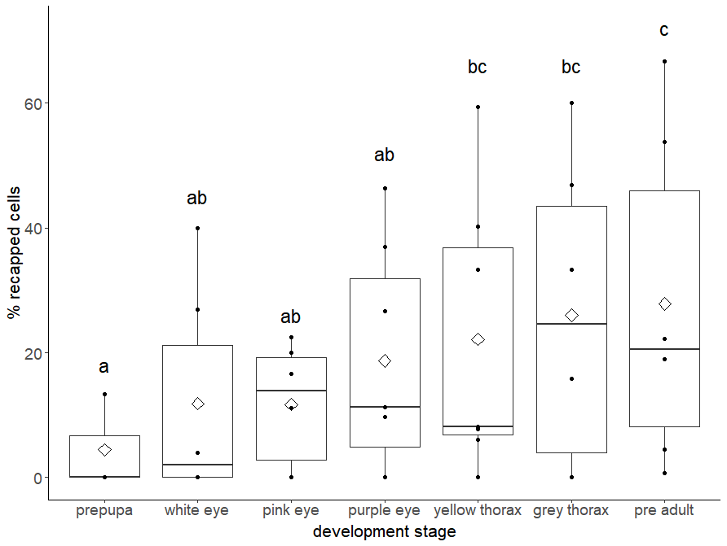
> dispersion_glmer(msnac)
[1] 1.083709
>
> overdisp_fun(msnac)
chisq ratio rdf p
35.1661089 1.0342973 34.0000000 0.4127192

