**SUPPLEMENTARY MATERIALS**

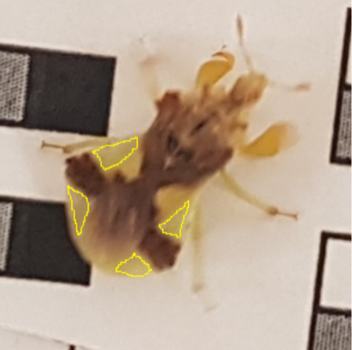 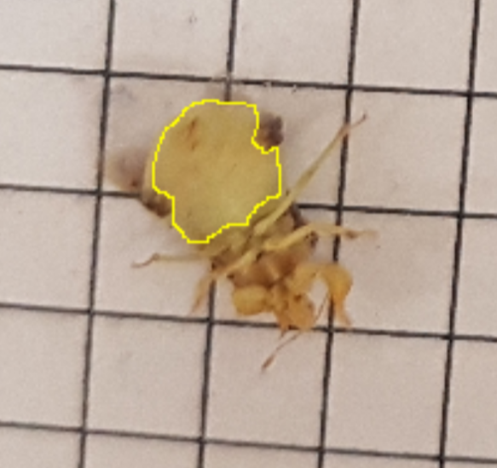 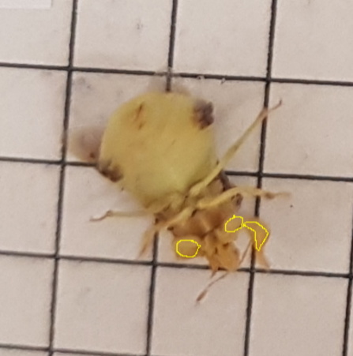

**Figure S1**. *Areas selected for ImageJ*: Yellow outlines indicate the locations on *Phymata americana* that were sampled for RGB and greyscale values. Dorsal is on the left, ventral is middle, arms are right.

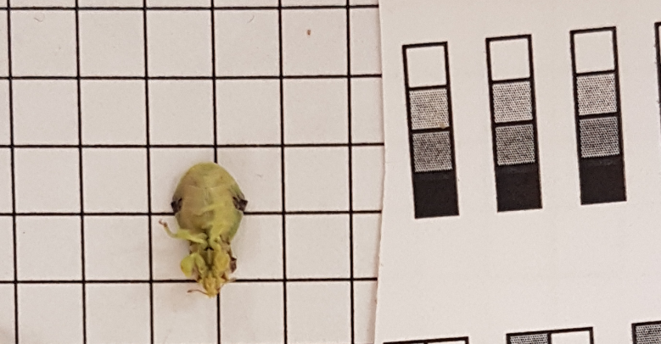

**Figure S2.** *Photo showing greyscale calibration bar:* The greyscale calibration bar was included in every photo of an ambush bug, and was used to calibrate between photos.

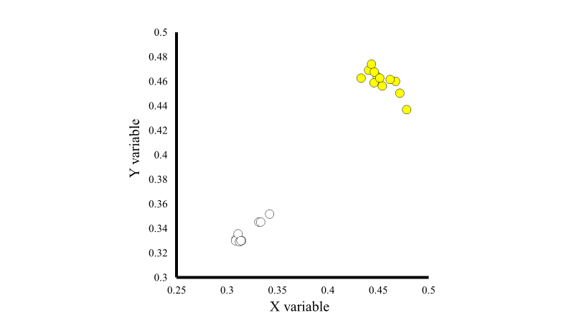

**Figure S3**. *A plot showing where individual QAL (white) and goldenrod (yellow) flowers fall in CIE-xyY colour space.* Note that there is no overlap between flower types and that points are highly clustered. We used this observation as the basis for using mean flower colour when calculating mismatch between ambush bugs and flower backgrounds (i.e. the Euclidean distance in colour space).