Fullerene-like structures of Cretaceous crinoids reveal topologically limited skeletal possibilities
Jennifer Hoyal Cuthill and Aaron W. Hunter

Supporting Information
Table S1. Specimens of Marsupites and Uintacrinus examined in this study with museum collection and stratigraphic information.
Genus | species | Numbers | Collection | Formation | Articulated | Figured
Marsupites | testudinarius | B24289 | Sedgwick Museum of Earth Sciences, University of Cambridge | [Subzone Marsupites] Upper Chalk, UK | Yes | Figure 1
Marsupites | testudinarius | B65206 | Sedgwick Museum of Earth Sciences, University of Cambridge | [Subzone Marsupites] Upper Chalk, UK  Locality Haldon Hill, Devon | Yes | No
Marsupites | testudinarius | B3871, B3874, B3875, B3877, B3878 | Sedgwick Museum of Earth Sciences, University of Cambridge | [Subzone Marsupites] Upper Chalk, UK  Locality Sussex | Yes | No
Marsupites | testudinarius | B3915, B3917 | Sedgwick Museum of Earth Sciences, University of Cambridge | [Subzone Marsupites] Upper Chalk, UK  Locality Yorkshire | Yes | No
Marsupites | testudinarius | B65210-29 | Sedgwick Museum of Earth Sciences, University of Cambridge | [Subzone Marsupites]  Locality Alresford | No | No
Marsupites | testudinarius | NHMUK  E1831 | Natural History Museum, London | [Subzone Marsupites] Upper Chalk, UK | Yes | No
Marsupites | testudinarius | NHMUK E5966 | Natural History Museum, London | [Subzone Marsupites] Upper Chalk, UK | Yes | No
Marsupites | testudinarius | NHMUK E5482a7b | Natural History Museum, London | [Subzone Marsupites] Late Santonian, Brighton, Sussex | Yes | No
Marsupites | testudinarius | NHMUK E57705 | Natural History Museum, London | [Subzone Marsupites] Upper Chalk, Kent | Yes | No
Marsupites | testudinarius | NHMUK E22474 | Natural History Museum, London | [Subzone Marsupites] Late Senonian, Blandford, Dorset | Yes | No
Marsupites | testudinarius | NHMUK EE6304 | Natural History Museum, London | [Subzone Marsupites] Late Santonian, Beverley, Yorkshire | Yes | No
Marsupites | testudinarius | NHMUK E14261 | Natural History Museum, London | [Subzone Marsupites] Late Santonian, Brighton, Sussex | Yes | No
Marsupites | testudinarius | NHMUK E22089 | Natural History Museum, London | [Subzone Marsupites] Late Santonian, Sussex | Yes | No
Marsupites | testudinarius | NHMUK-E14261 | Natural History Museum London | [Subzone Marsupites] Late Santonian, Brighton, Sussex | Yes | Figure S2
Marsupites | testudinarius | BMNH-009665 | Booth Museum of Natural History, Brighton | [Subzone Marsupites] Upper Chalk, Sussex | Yes | No
Marsupites | testudinarius | BMNH-007931 | Booth Museum of Natural History, Brighton | [Subzone Marsupites] Upper Chalk, Sussex | Yes | No
Marsupites | testudinarius | BMNH-007932 | Booth Museum of Natural History, Brighton | [Subzone Marsupites] Upper Chalk, Sussex | Yes | No
Marsupites | testudinarius | BMNH-007933 | Booth Museum of Natural History, Brighton | [Subzone Marsupites] Upper Chalk, Sussex | Yes | No
Marsupites | laevigatus | BMNH-007936 | Booth Museum of Natural History, Brighton | [Subzone Marsupites] Late Santonian, Brighton, Sussex | Yes | No
Marsupites | testudinarius | BMNH-124A | Booth Museum of Natural History, Brighton | [Subzone Marsupites] Late Santonian, Brighton, Sussex | Yes | No
Uintacrinus | socialis | B5035-40 | Sedgwick Museum of Earth Sciences, University of Cambridge | [Subzone Uintacrinus]  Little Woodcote Pit Surrey | No | No
Uintacrinus | socialis | B5042-3 | Sedgwick Museum of Earth Sciences, University of Cambridge | [Subzone  Uintacrinus]  West Clandon Pit Surrey | No | No
Uintacrinus | socialis | B5046 | Sedgwick Museum of Earth Sciences, University of Cambridge | [Subzone Uintacrinus]  West Clandon Pit Surrey | No | No
Uintacrinus | socialis | B74830-9 | Sedgwick Museum of Earth Sciences, University of Cambridge | [Subzone Uintacrinus]  Margate Kent | No | No
Uintacrinus | socialis | B11572, | Sedgwick Museum of Earth Sciences, University of Cambridge | [Subzone Uintacrinus] Niobrara Chalk, USA | Yes | Figure 2.
Uintacrinus | socialis | NHMUK EE8058 | Natural History Museum London | [Subzone Uintacrinus] Upper Santonian, Upper Chalk, Isle of Wight | Yes | Figure S1.
Uintacrinus | sp. | NHMUK-E6927 | Natural History Museum London | [Subzone Uintacrinus] Late Santonian, Upper Chalk, Margate | Yes | Figure S2
Uintacrinus | socialis | NHMUK E 26100a | Natural History Museum, London | [Subzone Uintacrinus] Niobrara Chalk, USA | Yes | Figure S3-4
Uintacrinus | socialis | NHMUK E 26100b | Natural History Museum, London | [Subzone Uintacrinus] Niobrara Chalk, USA | Yes | Figure S3-4
Uintacrinus | socialis | NHMUK E 22402 | Natural History Museum, London | [Subzone Uintacrinus] Niobrara Chalk, USA | Yes | Figure S3 & S5

Table S2. Number of fixed calyx plates for Uintacrinus socialis inferred from 2-dimensionally preserved specimen Sedgwick Museum B11572 (Fig. 2).
Plate location | Plate type | Number | Location total | Cumulative total
cup | centrale | 1
cup | infrabasal | 0
cup | basal | 5
cup | radial | 5 | 11
brachial (arm) | primibrachial | 2 | 10
brachial (arm) | secundibrachial | ~8 (4) | ~80
interbrachial |  | ~41 | ~205
interdistichal |  | ~14 | ~70 | 376
Tegmen opening |  | 1 | 1 | 377

Table S3. Average measured area, thickness and weight, and estimated volume and density, of disarticulated calyx plates for Marsupites testudinarius and Uintacrinus socialis. Values measured for individual plates given in Table S3.
Calyx plate variable | Average | Marsupites | Uintacrinus | Statistical test | Test statistic | Test p
Area (mm²) | Median | 228.20 | 21.10 | Mann-Whitney U | 0 | < 0.0001
Thickness (mm) | Mean | 1.64 | 1.40 | T-test | 2.14 | 0.036
Volume (mm³) | Median | 350.66 | 30.86 | Mann-Whitney U | 0 | < 0.0001
Weight (g) | Median | 0.96 | 0.067 | Mann-Whitney U | 0 | < 0.0001
Density (g/mm³) | Mean | 0.0027 | 0.0021 | T-test | 5.34 | < 0.0001

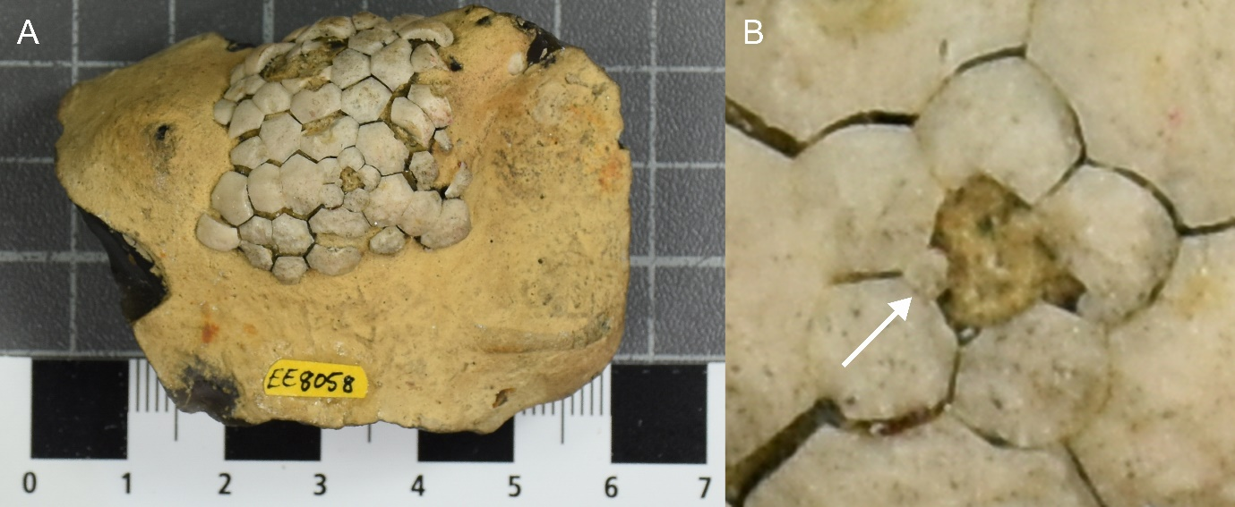
Figure S1. Uintacrinus socialis Grinnell specimen NHMUK EE8058, Natural History Museum London: Lomas Collection. Age and locality: Upper Santonian, Upper Chalk, Isle of Wight. (a) Calyx in aboral view. Scale bar major divisions, cms. (b) Detail of cup. While the central plate is dislocated, at least one small, infrabasal plate is apparent (arrow).
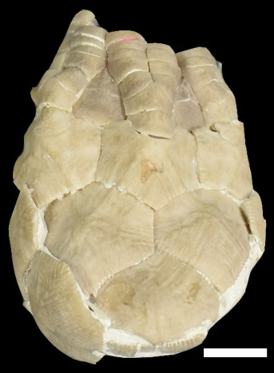
Figure S2. Marsupites testudinarius specimen NHMUK-E14261, Natural History Museum London: Birley bequest. Age and locality: Late Santonian, Brighton, Sussex. Calyx in lateral view. Scale bar 1 cm. At least 4 interbrachial plates are visible between adjacent arms.
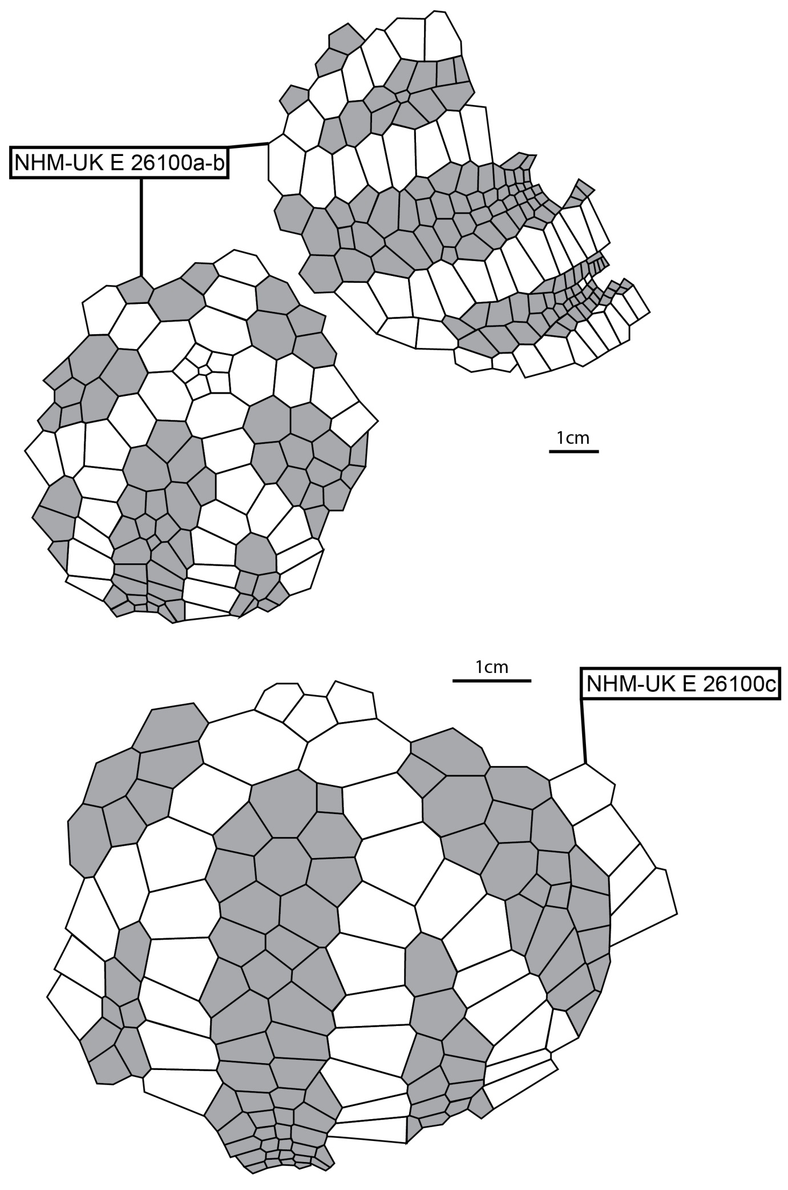
Figure S3. Plate diagrams of Uintacrinus specimens NHMUK E 26100a-b (photograph, Fig. S4) and NHMUK-E26100c (photograph, Fig. S5). Cup and brachial plates shown in white.

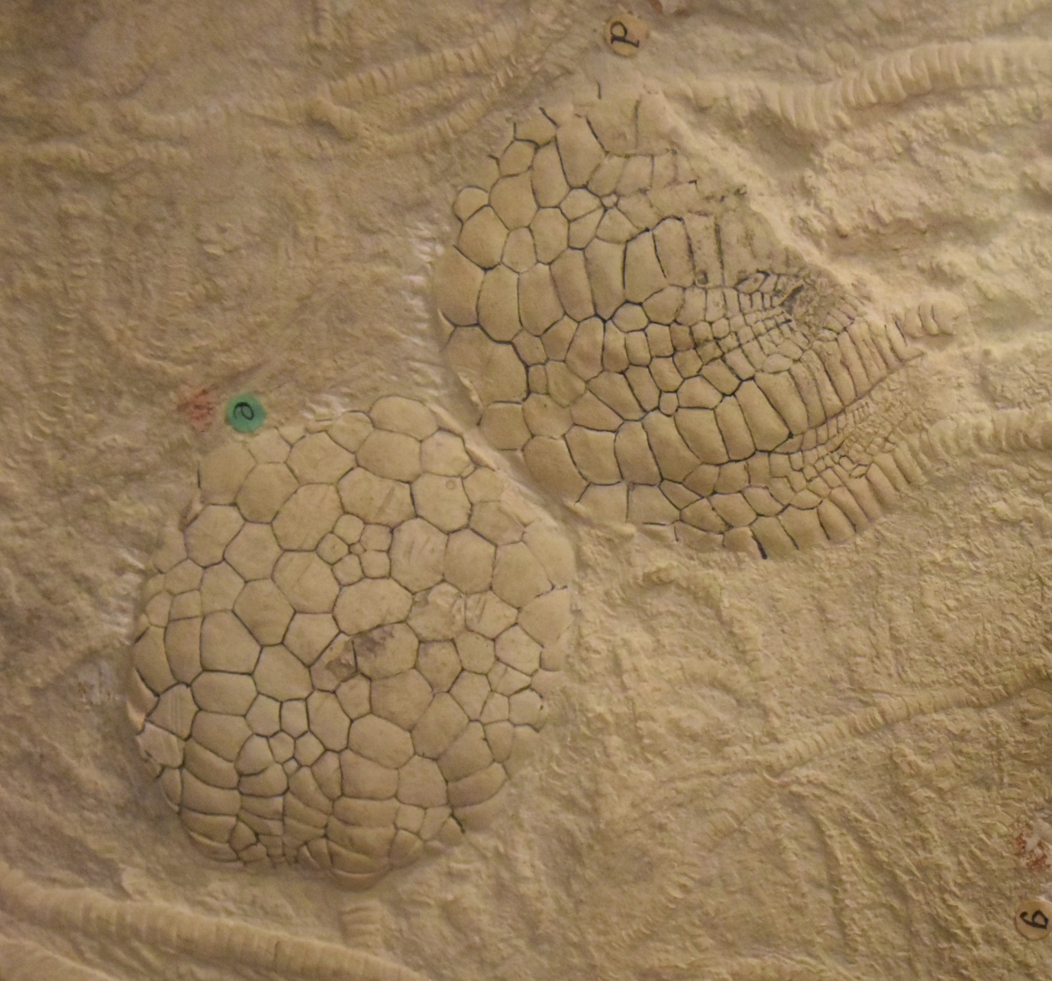
Figure S4. Uintacrinus socialis (Grinnell) specimen NHMUK. Locality: Smoky Hill Member, Niobrara Formation, Logan County, Kansas, USA.
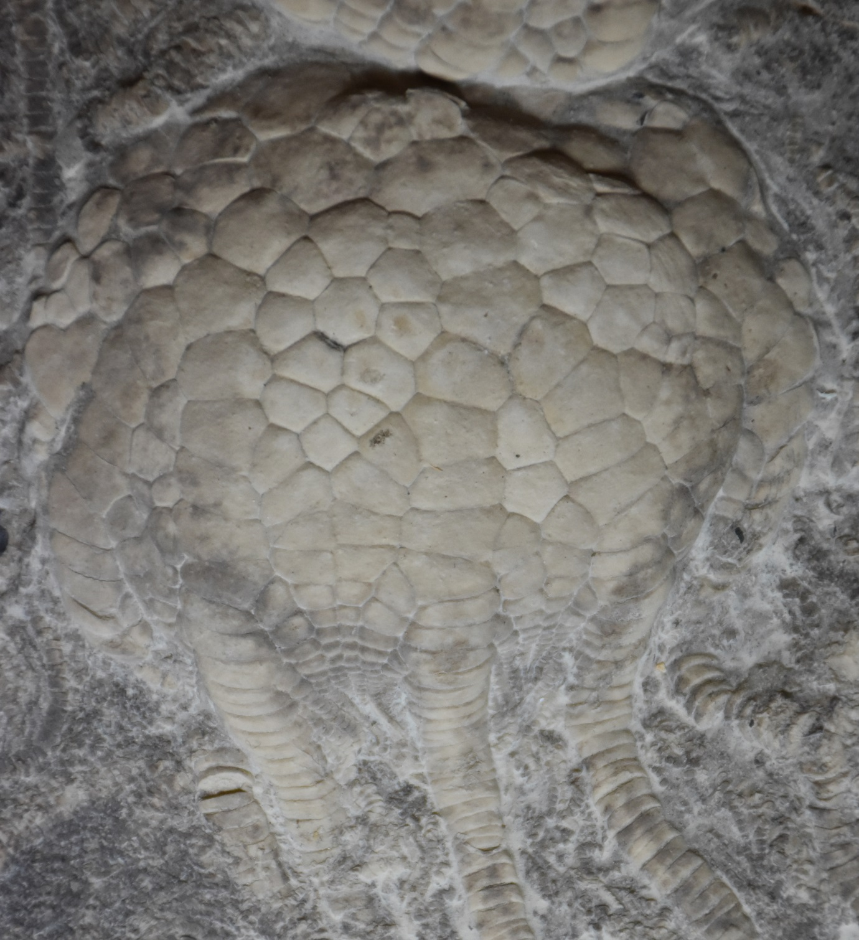
Figure S5. Uintacrinus socialis (Grinnell) specimen NHMUK-E26100c. Age and Locality: Late Cretaceous, Smoky Hill Member, Niobrara Formation, Location number 1, near Elkader, Logan County, Kansas, USA.
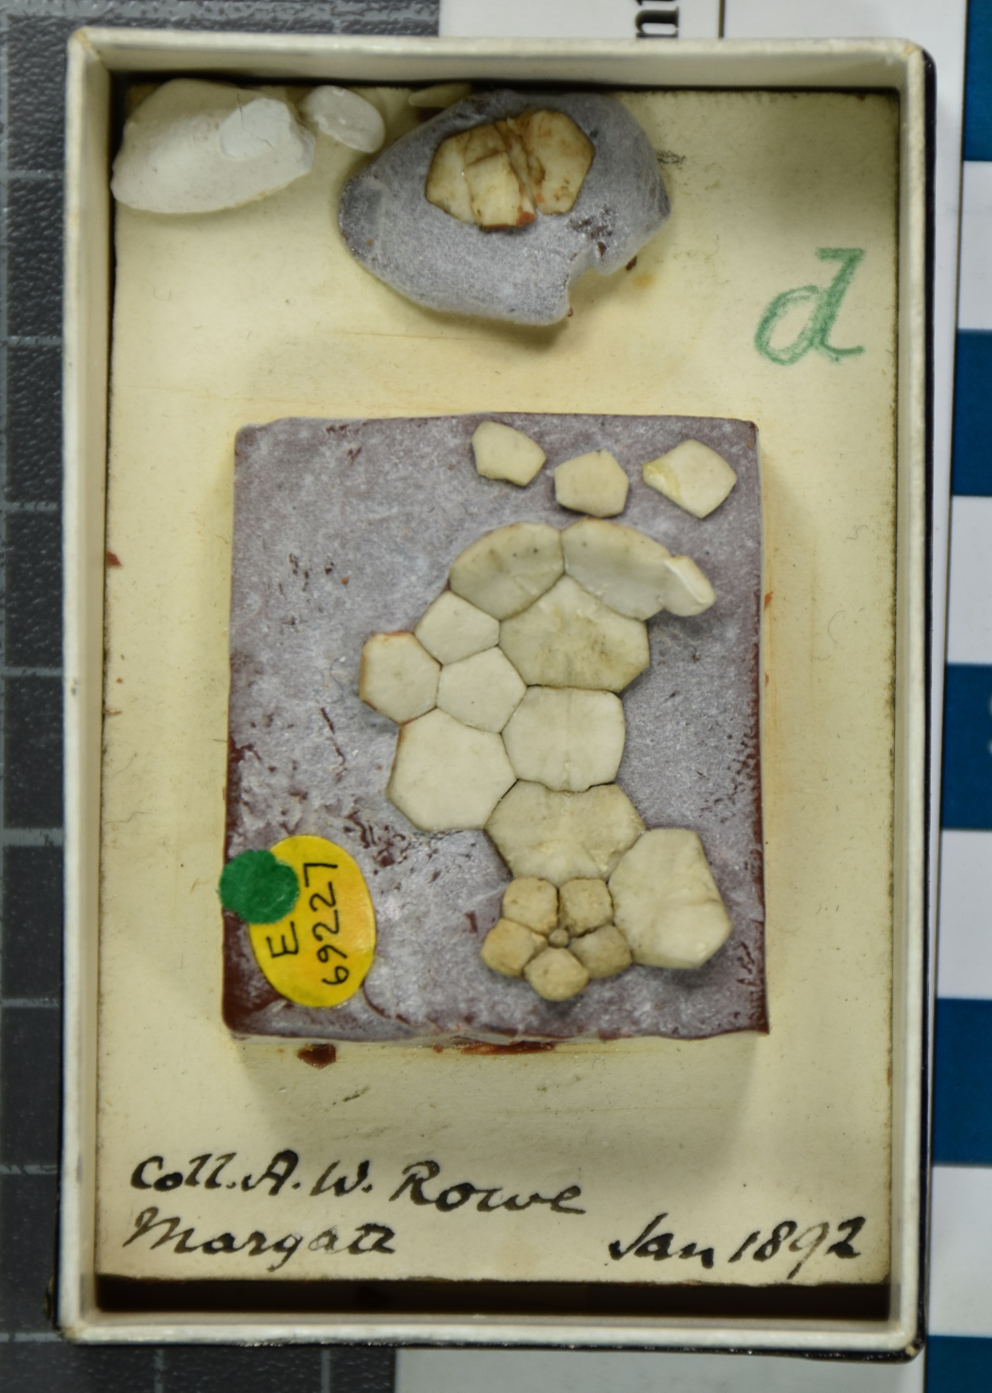
Figure S6. Uintacrinus specimen NHMUK-E6927. Underside of partial calyx.

