Figure S1: Study Disposition
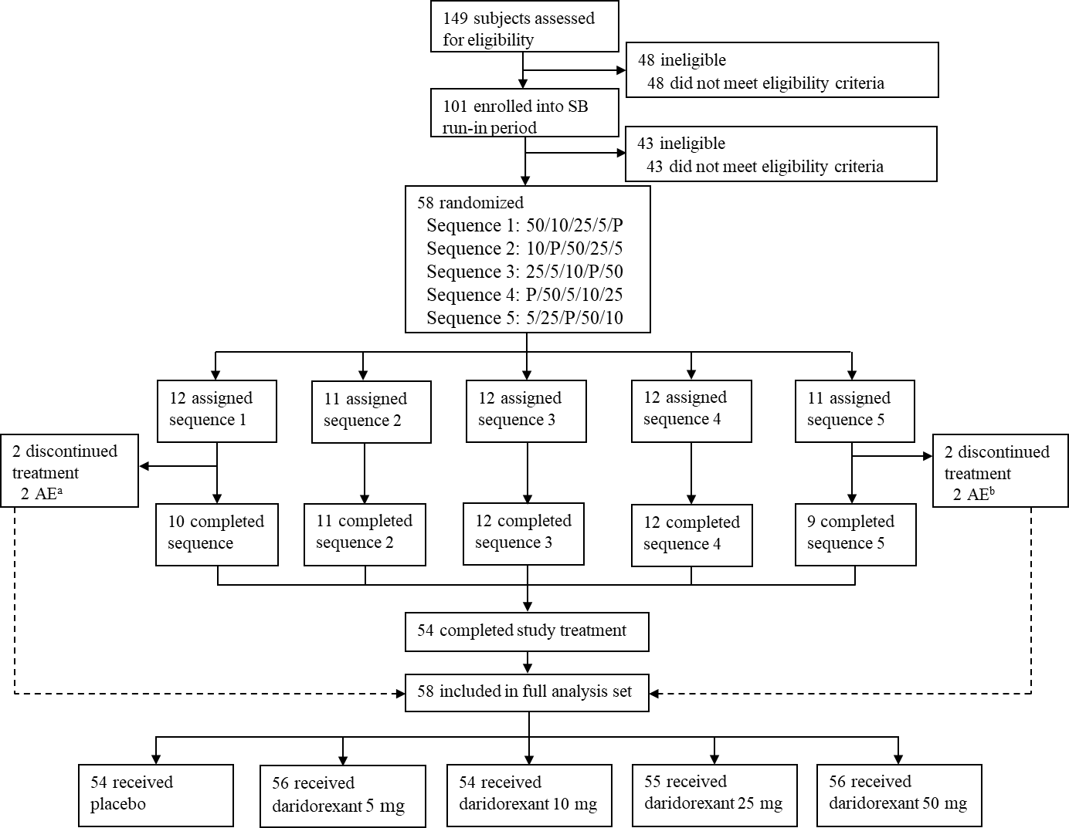

Numbers in the sequences refer to doses of daridorexant and placebo (P).
ªTwo subjects receiving 50 mg daridorexant discontinued due to AEs.
^{b}One subjects receiving 5 mg and the other receiving 25 mg daridorexant discontinued due to AEs.
AE, adverse event; P, placebo; SB, single-blind.

