- Research project:
This dataset results from the PhD research “Ecological Impacts of selective logging in the Amazon: lessons from dung beetles” developed by Filipe França to understand the impacts of selective logging in the Brazilian Amazon on the dung beetle diversity, physiology and associated ecological functions.
This present project was carried out within the 1.7 Mha Jari Florestal landholding, located in the state of Pará in the north-eastern Brazilian Amazonia (00°27′–01°30′ S, 51°40′–53°20′ W). The region comprises a mosaic of Eucalyptus plantations and regenerating secondary forests within ~1.5 Mha of primary forests subjected to very low levels of disturbance (Barlow et al., 2010; Parry et al., 2009a). These forests are characterized as evergreen dense tropical rainforest (Souza, 2009), often dominated by the timber species Dinizia excela Ducke (Fabacea, Mimosoideae) (Laufer et al., 2015), which corresponds to about 50% of exploited timber in some Amazonian regions (Barbosa, 1990). Within this large landscape about 544,000 ha of native forest is divided in “Annual Operating Planning” (POA) subsets, each one planned to be logged every year (since 2003) under a 30 year cutting cycle. Logging activities are planned following the FAO model code of forest harvesting (Dykstra and Heinrich, 1996) and during the pre-harvest inventory each POA is subdivided into 10 ha (250 x 400 m) units planned to be logged with a specific logging intensity (m³ ha⁻¹). The experiments of this project were established in 34 planned logging units (Figure 1), where dung beetles were sampled before and after logging operations at the same sites and following the same methods.

- File name: França_et_al_SelectiveLogging_BrazilianAmazon_DungBeetle_13032016

- Data dictionary: The spreadsheet ‘DataLegends’ presents all the data components provided in the different spreadsheets in the main file.

- Overall Organization of the main file:
- BiodiversityData: Spreadsheet presenting the abundance and relative biomass of all dung beetle species collected within each pitfall trap at each sampled unit (pre- and post-logging). This project followed a before-after control-impact sampling design, thus note that:
  - ‘Species’: dung beetle species sampled;
  - ‘abundance’: number of individuals of each dung beetle species sampled at each ‘pitfall_trap’ from sampled units (see Figure 2 for pitfall traps position);
  - ‘collection_dates’: presents the pre and post-logging data collections conducted in 2012 and 2013, respectively.
  - ‘Habitat’: ‘Undistuberd_primary_forest’ represents pre-logging sampled units (2012) and the post-logging data from control units (without any logging operations) sampled in 2013. ‘Selectively_logged_forests’ are the sampled units which had selective logging after our pre-logging data collection (see Figure 1).
  - ‘biomass’: shows the relative dung beetle dry biomass in grams (g) for each species. The dung beetle dry biomass of each species was measured as the average dry weight from two to fifteen beetles individually weighed.

- BiologicalMetrics: Spreadsheet with the data used in the paper “Do space-for-time assessments underestimate the impacts of logging on tropical biodiversity? An Amazonian case study using dung beetles” published in Journal of Applied Ecology (2016).
  - Most information are presented in the ‘DataLegends’ from the main file.
  - ‘Community_similarity’ columns present the values of species composition measured as the beta-diversity (Socolar et al., 2015) based on the Bray-Curtis similarity index (1-dissimilarity) through the vegdist function from vegan package (Oksanen et al., 2015; R Core Team, 2015).
  - ‘community_similarity_SFT’ is the dung beetle species composition measured as the average similarity between each of the 29 logged units and the five unlogged control units after logging-operations in 2013. The spreadsheets ‘SpeciesCompositionPreLog2012’ and ‘SpeciesCompositionPostLog2013’ were used to calculate this metric.
  - ‘community_similarity_BA’ is the Δ species composition, measured as the pairwise beta-diversity based on the Bray-Curtis similarity index (1 – dissimilarity) among pre- and post-logging collections within each sample unit. This metric was tcalculated from the ‘SpeciesCompositionPostLog2013’ spreadsheet.

- SampleUnitsInformation: Logging information of the sample units. Details are presented in the ‘DataLegends’ spreadsheet in the main file.

- SpeciesCompositionPreLog2012: This spreadsheet is a matrix of species sampled before selective logging operations (columns) × sites (lines). This and the ‘SpeciesCompositionPostLog2013’ spreadsheet were used to calculate the ‘community_similarity_BA’.

- SpeciesCompositionPostLog2013: This spreadsheet is a matrix of species sampled after selective logging operations (columns) × sites (lines) and was used to calculate the ‘community_similarity_SFT’.

- Spatial location:
Sampling was carried out in the Jari Florestal landholding (Figure 1), located at the State of Pará in the north-eastern Brazilian Amazon (0º27’S 51º40’W). The primary forests in the region are subject to low levels of disturbance from subsistence hunting and extraction of non-timber forest products (Parry, Barlow & Peres 2009). The climate is characterized as hot-humid (Köppen’s classification), with annual average temperature and precipitation of 26 ºC and 2115 mm respectively (Coutinho and Pires, 1996).
Reduced-impact commercial logging started in 2003, with plans to log approximately 544 000 ha of native forest over a 30-year cutting cycle. This management is certified by the Forest Stewardship Council (FSC) and is one of the largest certified logging concessions in the Amazon with average annual production of 30 000 m³ of timber (FSC 2014). Logging activities are planned following FAO guidelines (Dykstra and Heinrich, 1996), which included a pre-harvest mapping and measuring of all commercially viable trees with d.b.h. ≥ 45 cm. The harvesting and extraction of timber along skid trails generally take place during the dry season (August to November), and directional felling is used to minimize incidental damage to other trees. During the pre-harvest inventory the logging concession is subdivided into 10 ha (250 × 400 m) planning units (Figure 1). Commercially viable trees are mapped across all of these planning units, and this forms the basis for planning the logging operation in the following year.

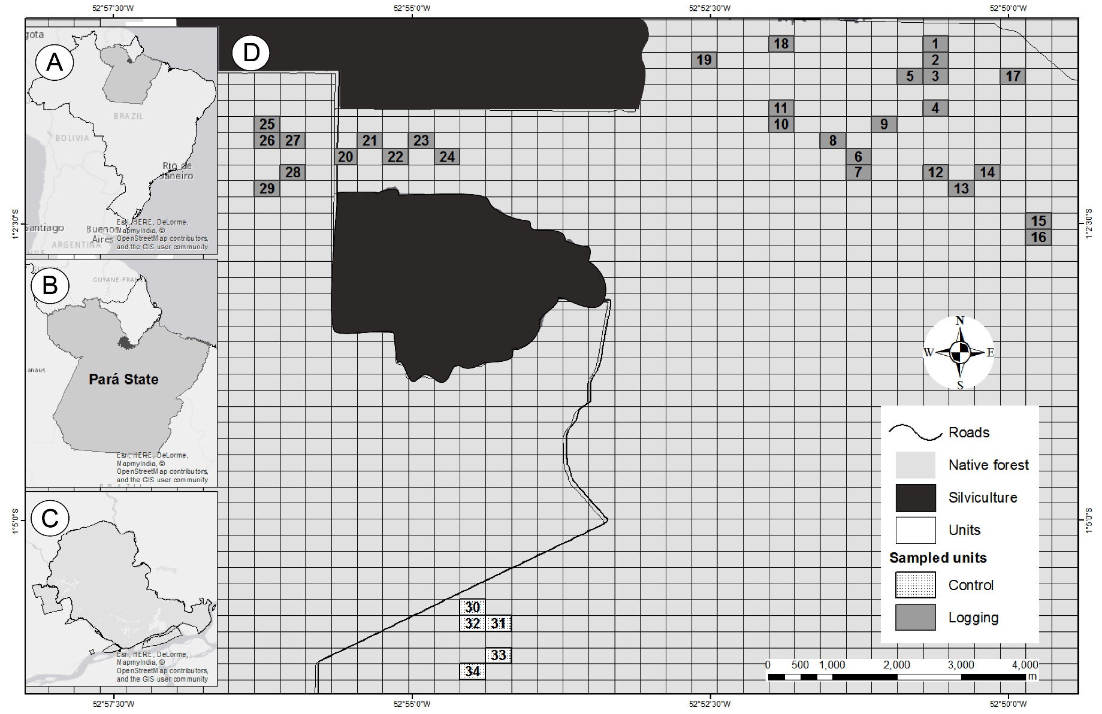
Figure 1: The location of our study sites in a) Brazil; b) State of Pará; c) Jari landholding and d) the sample design in Jari region maps. The main figure showing the study area and the 10 ha sample units. The units which were selectively logged after first dung beetle collection are highlighted in dark grey (1-29), whereas the five control units, which remained unlogged during the course of the study, are clear (30-34). Numbers of sample units related to all tables presented in the main file (França_et_al_SelectiveLogging_BrazilianAmazon_DungBeetle_13032016).

- Date and time: Date of sampling collections are presented in the ‘SampleUnitsInformation’ spreadsheet in the main file. The date format is yyyy-mm-dd, appearing for example as 2012-06-09 (June 06, 2012).

- Methods: Please see the manuscript “Do space-for-time assessments underestimate the impacts of logging on tropical biodiversity? An Amazonian case study using dung beetles” published by the Journal of Applied Ecology for description of methods.

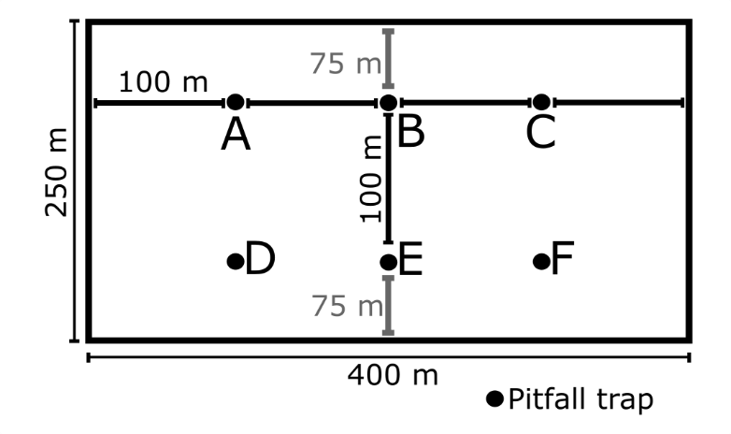
Figure 2. Experimental design within the sampled units. Pitfall traps were distributed in a 2x3 rectangular grid, spaced by 100 m apart each other and at least 75m from the sampled unit borders. Capital letters refers to ‘pitfall_traps’ position within each sampled unit (‘BiodiversityData’ spreadsheet).

- Taxonomic information:
Species identification was based in the key to genera and subgenera of the subfamily Scarabaeinae (Vaz-de-Mello et al., 2011) and by comparing collected beetles with specimens from the Reference Collection of Neotropical Scarabaeinae in the Insect Ecology and Conservation Laboratory, Universidade Federal de Lavras, Brazil, where Voucher specimens were also added. Lastly, taxonomists confirmed the identification of the specimen material (Table 1).
Table 1. Sampled dung beetle species.
Dung beetle TRIBES/species
ATEUCHINI
Ateuchus aff. connexus (Harold, 1868)
Ateuchus aff. murray (Harold, 1868)
Ateuchus pauki (Balthasar, 1939)
Ateuchus sp. A
Ateuchus sp. B
Ateuchus sp. D
Ateuchus sp. E
Ateuchus sp. F
Trichillum pauliani Balthasar, 1939
Uroxys sp. C
CANTHONINI
Canthon (Glaphyrocanthon) quadrigutatus (Olivier, 1789)
Canthon (Trichocanthon) triangularis (Drury, 1770)
Deltochilum (Deltohyboma) aff. submetallicum (Castelnau, 1840)
Deltochilum (Hybomidium) icarus (Olivier, 1979)
Deltochilum (Telhyboma) orbiculare Lansberge, 1874
Deltochilum septemstriatum Paulian, 1938
Deltochilum sp. B
Canthonella sp.
COPRINI
Canthidium aff. deyrolley Harold, 1867
Canthidium aff. lentum Erichson, 1847
Canthidium (Canthidium) sp. A
Canthidium (Canthidium) sp. B
Canthidium (Canthidium) sp. D
Canthidium (Eucanthidium) sp. G
Canthidium (Eucanthidium) sp. I
Canthidium (Eucanthidium) sp. J
Canthidium (Eucanthidium) sp. K
Canthidium (Eucanthidium) sp. M
Dichotomius sp. 1
Dichotomius sp. 2
Dichotomius boreus (Olivier, 1789)
Dichotomius imitator Felsche, 1901
Dichotomius latilobatus (Harold, 1867)
Dichotomius lucasi (Harold, 1869)
Dichotomius subuaneus (Castelnau, 1840)
Dichotomius worontzowi (Pereira, 1942)
Ontherus carinifrons Luederwaldt, 1930
ONITICELLINI
Eurysternus atroscericus Génier, 2009
Eurysternus balachowskyi Halffter & Halffter, 1976
Eurysternus caribaeus (Herbst, 1789)
Eurysternus foedus Guérin-Méneville, 1844
Eurysternus hamaticollis Balthasar, 1939
Eurysternus howdeni Génier, 2009
Eurysternus ventricosus Gill, 1990
ONTHOPHAGINI
Onthophagus (Onthophagus) bidentatus Drapiez, 1819
Onthophagus (Onthophagus) haematopus Harold, 1875
Onthophagus (Onthophagus) onthochromus Arrow, 1913
PHANAEINI
Coprophanaeus (Coprophanaeus) dardanus (MacLeay, 1819)
Coprophanaeus (Coprophanaeus) jasius (Olivier, 1789)
Coprophanaeus (Megaphanaeus) lancifer (Linnaeus, 1767)
Oxysternon (Oxysternon) durantoni Arnaud, 1984
Oxysternon (Oxysternon) festivum (Linnaeus, 1767)
Sulcophanaeus faunus (Fabricius, 1775)

- References:
Barbosa, R.I., 1990. Análise do Setor Madeireiro do Estado de Roraima. Acta Amaz.
Barlow, J., Louzada, J., Parry, L., Hernández, M.I.M., Hawes, J., Peres, C.A., Vaz-de-Mello, F.Z., Gardner, T.A., 2010. J. Appl. Ecol. 47, 779–788.
Coutinho, S.D.C., Pires, M.J.P., 1996. Jari: um banco genético para o futuro, Imago Edit. ed. Rio de Janeiro.
Dykstra, D., Heinrich, R., 1996. FAO Model Code of Forest Harvesting Practice.
Forest Stwardship Council, 2014. FSC [WWW Document]. URL https://us.fsc.org/ (accessed 4.29.14).
Laufer, J., Michalski, F., Peres, C.A., 2015. Biota Neotrop. 15, 1–11.
Oksanen, J., Blanchet, F.G., Kindt, R., Legendre, P., Minchin, P.R., O’Hara, R.B., Simpson, G., Solymos, P., Stevens, M.H.H., Wagner, H., 2015. R Packag. version 2.3-0.
Parry, L., Barlow, J., Peres, C.A., 2009a. Biol. Conserv. 142, 1777–1786.
Parry, L., Barlow, J., Peres, C.A., 2009b. Conserv. Biol. 23, 1270–1280.
R Core Team, 2015. R Found. Stat. Comput. Vienna, Austria.
Socolar, J.B., Gilroy, J.J., Kunin, W.E., Edwards, D.P., 2015. Trends Ecol. Evol. xx, 1–14.
Souza, V.R.D., 2009. Avaliação do manejo florestal das Plantações da Jari Celulose S. A. na região de Almerim, Estado do Pará - Brasil.
Vaz-de-Mello, F.Z., Edmonds, W.D., Ocampo, F.C., Schoolmeesters, P., 2011. Zootaxa 2854, 1–73.

