Tectonics
Supporting Information for
Evolution of the Greater Caucasus basement and formation of the Main Caucasus Thrust, Georgia
Dylan A. Vasey¹, Eric Cowgill ¹, Sarah M. Roeske¹, Nathan A. Niemi², Tea Godoladze³, Irakli Skhirtladze³, Salome Gogoladze³
¹University of California, Davis, California, United States; ²University of Michigan, Michigan, United States; ³Ilia State University, Tbilisi, Georgia
Contents of this file

Text S1
Figures S1 to S10
Tables S1 to S2

Additional Supporting Information (Files uploaded separately)

Captions for Tables S3 to S7
Captions for QTQt Input Files S1 to S5
Introduction
This file contains additional information on methods related to microstructural analysis, U-Pb geochronology, ⁴⁰Ar/³⁹Ar geochronology/thermochronology and He thermochronology (Text S1). Radioisotopic ages reported on Figure S1 are used to assign age populations in Figure 2. Locations of field photos from the Svaneti (Fig. S2) and Kazbegi (Fig. S3) traverses are indicated on Figure 3 in the main text. Individual poles to foliation used to generate contoured stereograms in Figure 3 of the main text are shown in Figure S4, together with lineation measurements. The phases selected for ⁴⁰Ar/³⁹Ar analysis and additional microstructural features are shown in Figure S5. All spots selected for U-Pb analysis for sample N4, which features metamorphic overgrowths of igneous cores, are shown in a cathodoluminescence image in Figure S6. The zircon U-Pb ages used to calculate weighted mean crystallization or maximum depositional ages are shown in Figure S7. Figure S8 shows KDE, PDP, and CAD curves used in Figure 7 of the main text and determined by combining U-Pb ages for the Paleozoic-Jurassic Greater Caucasus. Figure S9 shows a QTQt thermal model not shown in main text Figure 6b, and Figure S10 shows likelihood chains for all QTQt thermal models. Table S1 provides structural information for oriented photomicrographs shown in Figure 4 in the main text and Figure S4. Table S2 provides a summary of zircon U-Pb analyses used to construct Figures 7 and S7. Tables S3-S6 in separate files report detailed results of U-Pb, ⁴⁰Ar/³⁹Ar, zircon (U-Th)/He, and apatite (U-Th-Sm)/He analyses. Table S7 in a separate file reports previously unpublished results of apatite fission track analyses from Avdeev (2011). Input parameters used in the QTQt thermal models are provided in separate input files, with one file per model (S1 to S5).

Text S1.

Additional Methods

Microstructural Analysis
For shear sense, we cut oriented thin sections perpendicular to foliation and parallel to the dominant lineation (Table S1). Assuming this lineation corresponds to the primary stretching lineation, this plane ideally represents the X-Z plane of the finite strain ellipsoid and thus shows the maximum directions of both elongation and shortening. Within this plane, asymmetric structures including S-C fabrics, asymmetric porphyroclasts, and mica fish provide indications of overall sense of shear.

U-Pb Geochronology
The bulk of mineral separation was conducted at UC Davis using standard techniques of crushing, sieving, magnetic separation, and heavy liquids density separation. Final separate cleanup, mounting, and imaging of zircons for U-Pb geochronology was completed by staff at Arizona LaserChron Center. A spot size of 20 μm was used except for samples with considerable zircon of <30μm diameter, in which case a spot size of 15 μm was used. Both rims and cores of 25 grains were analyzed for each igneous sample, and ~300 grains per sample were analyzed for each metasedimentary sample or sample of unknown protolith.
Reduction of U-Pb data was performed by ALC staff using the in-house E2agecalc spreadsheet (Table S3). Analyses with >10% uncertainty (1σ) in ²⁰⁶Pb/²³⁸U age were discarded, as were analyses with >10% uncertainty in ²⁰⁶Pb/²⁰⁷Pb age, with the exception of analyses with a ²⁰⁶Pb/²³⁸U age <400 Ma. Additionally, analyses of >400 Ma ²⁰⁶Pb/²³⁸U age with >20% discordance or >5% reverse discordance were also discarded. For analyses with ²⁰⁶Pb/²³⁸U age < 900 Ma, ²⁰⁶Pb/²³⁸U age is reported as the best age, whereas the ²⁰⁶Pb/²⁰⁷Pb age is used as the best age where ²⁰⁶Pb/²³⁸U age is >900 Ma.
Crystallization and maximum depositional ages were determined by calculating the weighted mean of the youngest population of 3 or more grains that overlap within 2σ using routines in IsoPlot and then incorporating systematic error for the sample as a whole (Table 1, Fig. S5; Ludwig, 2008; Dickinson and Gehrels, 2009). Errors for crystallization and maximum depositional ages are reported at the 2σ level.
To construct a kernel density estimate (KDE), probability density function (PDF), and cumulative area distrubtion (CAD) of zircon U-Pb ages characterizing the Paleozoic-Jurassic Greater Caucasus (Fig. S7), we combined all zircon U-Pb analyses from this study with samples NWGC (100311-2A), NEGC (AZ0620), Inguri River (100411-2), and Kumuk River (080902-2A) from Cowgill et al. (2016), sample CG41 from Allen et al. (2006), and all reported analyses from the Greater Caucasus crystalline core in Somin (2011) and Shengelia et al. (2014) (Table S2). These samples were selected because they either directly sampled the crystalline core, sampled Paleozoic-Jurassic sedimentary rocks draining the basement, or sampled modern rivers currently draining the crystalline core. Zircon U-Pb analyses in rocks younger than Jurassic in age possibly sourcing areas other than the crystalline core were not included.

⁴⁰Ar/³⁹Ar Geochronology/Thermochronology
For each ⁴⁰Ar/³⁹Ar sample (Table S4), incremental heating experiments of 10-12 steps were conducted using a 75 W, 980 nm-wavelength diode laser at the Stanford University Noble Gas Lab. 1 muscovite and 1 biotite separate were hand-picked from 300-500 μm sieve fractions from samples from the MCT hanging wall at Nakra (N6) and Kazbegi (K1), respectively. An additional separate of 45-300 μm muscovite from within the MCT shear zone at Kazbegi (K2) was prepared via Frantz magnetic separation and removing unsuitable phases by hand. Separates were packed in Al foil and irradiated at the USGS TRIGA reactor prior to analysis, using the Fish Canyon sanidine (FCS) with an age of 28.02 ± 0.28 Ma as a standard.

Helium and Fission Track Thermochronology
For (U-Th)/He samples (Tables S5-S6), mean ages were calculated by taking the average of individual grain ages, with standard error of the mean calculated by dividing the standard deviation of single-grain 1σ errors by the square root of the number of grains analyzed.
To produce thermal models in QTQt (Figs. 6b, S9), U, Th, Sm, and He concentrations, along with grain size, were entered for each individual zircon and apatite grain to allow calculation of alpha-ejection corrected ages (Farley et al., 1996; Ketcham et al., 2011). For one sample (N4), we used the ZrDAAM model of Guenthner et al. (2013) and the RDAAM model of Flowers et al. (2009) to account for radiation damage suggested by a negative age-effective uranium (eU) correlation in zircon. We set a 300-0°C range for temperature and a time range depending on the oldest ZHe age for the sample and ran models with a burn-in of 30,000 iterations, 70,000 sampled iterations, and a thinning of 1. We assume present-day surface temperatures of 5 ± 5°C, but no earlier thermal history constraints have been imposed. Likelihood chains for all models are shown in Figure S9.
Colored boxes on the resulting time-temperature plots show the relative probability that the thermal history of a sample passes through the corresponding time-temperature interval, with red/blue indicating higher/lower probability (Figs. 6b, S8). The expected model shown by the black line is a weighted average model with a 95% confidence interval indicated. Input files for each sample were produced using the user interface of QTQt and are provided in .txt format encoded with UTF-8 (QTQt Input Files S1 to S5).
Previously unpublished apatite fission track analyses from Avdeev (2011) were conducted by Apatite to Zircon, Inc. according to analytical methods described in Avdeev and Niemi (2011).
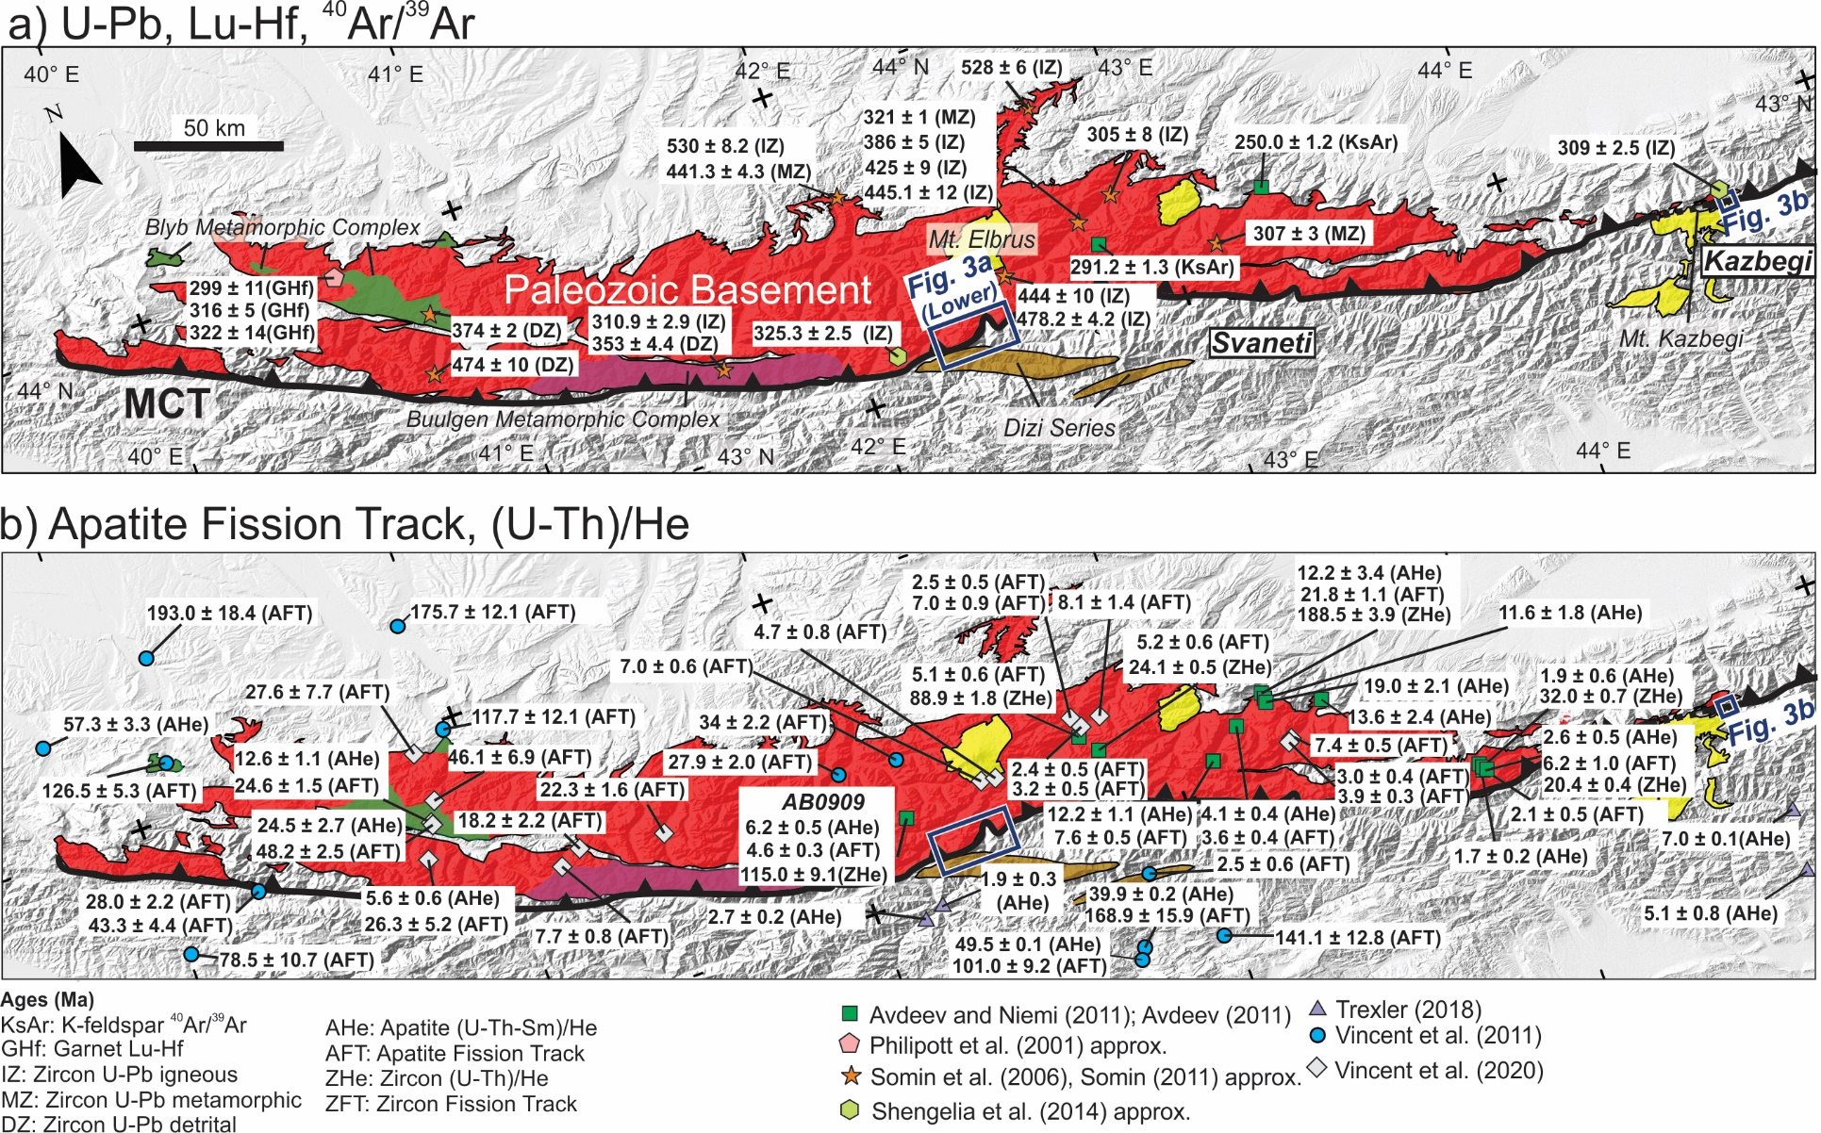Figure S1: Maps shown in Figure 2 with specific geochronologic and thermochronologic ages used to assign age populations in Figure 2.

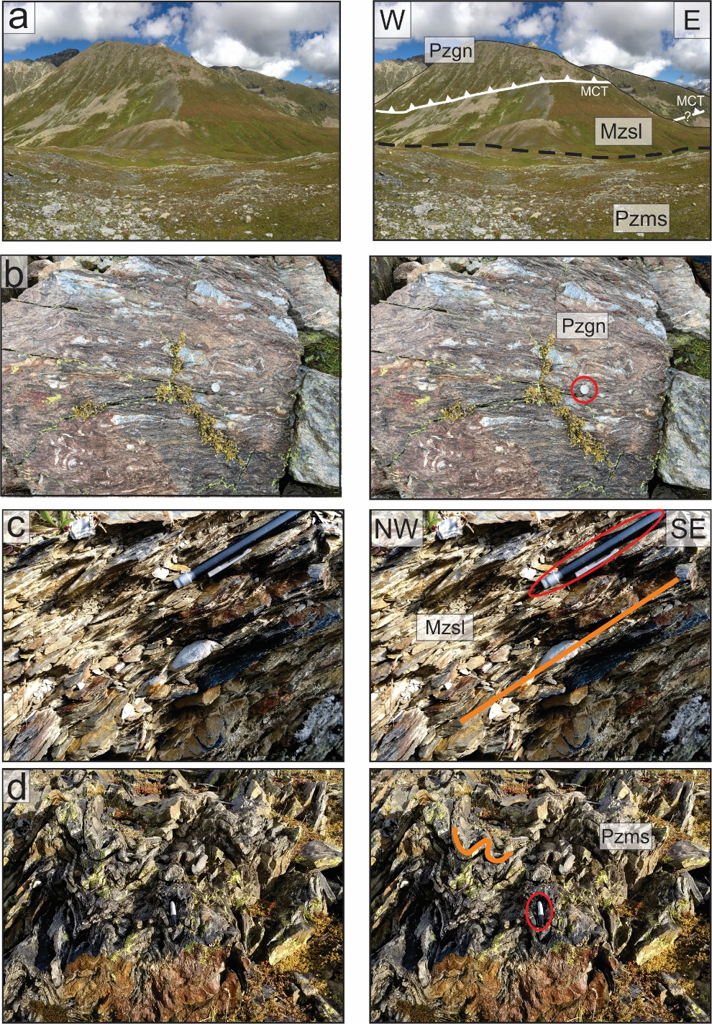

Figure S2. Field photographs from the Svaneti traverse on the Nakra ridge at locations shown in Figure 3a of the main text. Left and right panels indicate original and annotated photographs, respectively. a) Location of the north-dipping Main Caucasus Thrust (MCT) juxtaposing Pzgn gneiss against Mzsl slate. Scale is variable depending on position, but there is ~400 m of vertical relief between the ridgeline and the dashed contact through the saddle. b) Exposure of Pzgn gneiss with coin for scale. c) Foliated, shallowly north-dipping Mzsl slate with pencil for scale. Orange line indicates foliation. d) Tightly-folded Paleozoic quartzite from the Dizi series (Pzms), with pen for scale. Orange line indicates compositional layering.

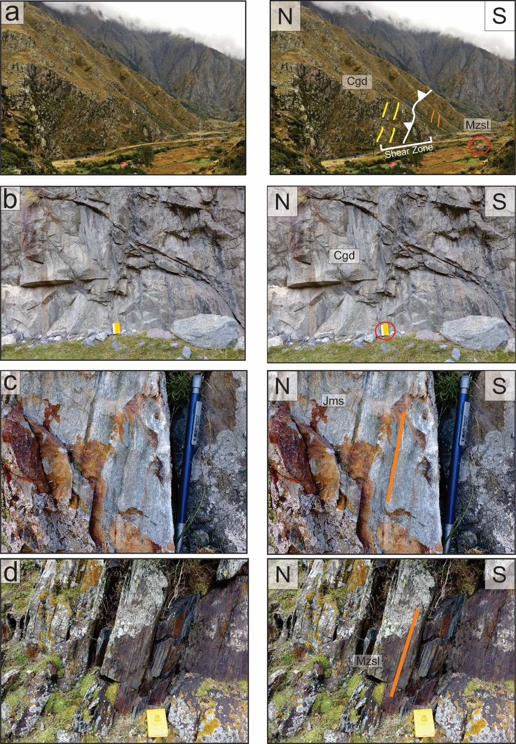

Figure S3. Field photographs from the Kazbegi traverse along the Tergi River at locations shown in Figure 3b of the main text. Left and right panels indicate original and annotated photographs, respectively. a) Location of the steeply north-northeast-dipping MCT shear zone juxtaposing Carboniferous granodiorite (Cgd) against Mzsl slate. A single-story building is circled for scale. b) Outcrop of Carboniferous granodiorite with field notebook for scale. Outcrop-scale fabric in this unit is variable and often poorly-defined away from the MCT. c) Outcrop of steeply north-dipping Jurassic quartzite from the metasedimentary package (Jms) between the two exposures of granodiorite, with pencil for scale and orange line along the trace of foliation. d) Outcrop of foliated, steeply north-dipping Mzsl slate, with notebook for scale and orange line along the trace of foliation.

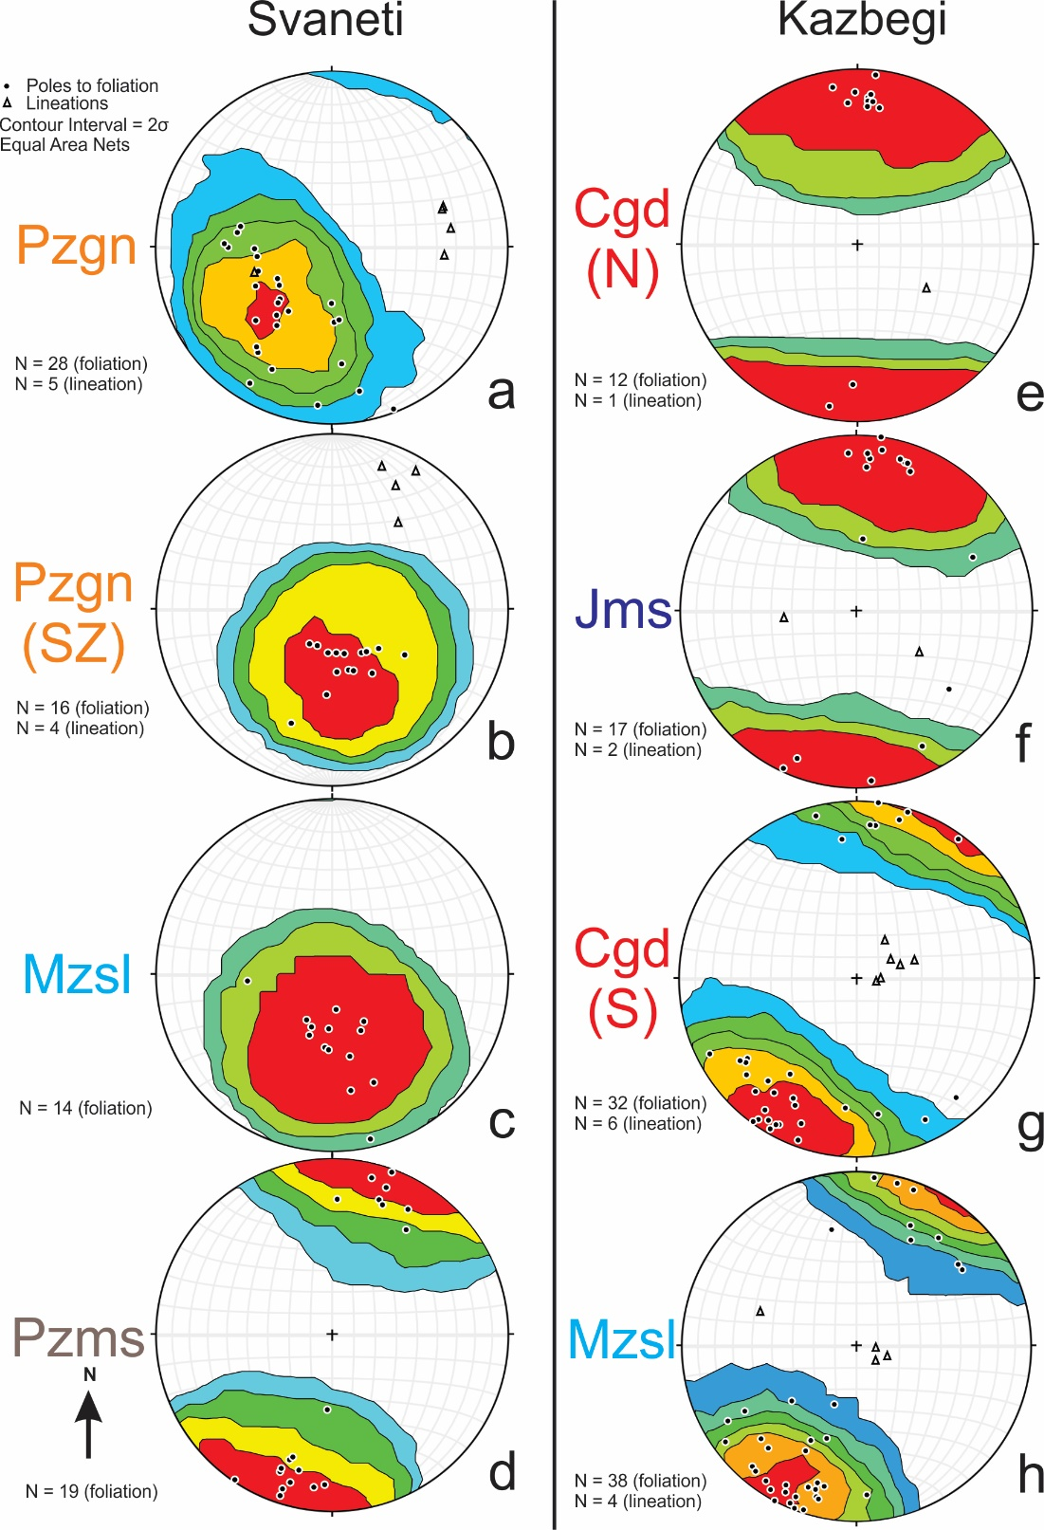

Figure S4. Stereograms from Figure 3 in the main text with individual poles to foliation (black circles) used for Kamb contouring and lineations (triangles) plotted from the Svaneti (a-d) and Kazbegi (e-h) traverses. a) Paleozoic paragneiss (Pzgn) with variable north to east-dipping foliation and rare east-plunging lineations. b) Shallowly north-dipping foliation within the MCT shear zone (SZ) with northeast-plunging lineations. c) Shallowly north-dipping foliation in Mzsl slate in Svaneti. d) Alternating north-northeast and south-southwest steeply-dipping foliation in Paleozoic metasedimentary rocks (Pzms). e-f) Alternating steeply north- and south-dipping foliation in granodiorite (Cgd) and metasedimentary rocks (Jms) north of the MCT. g) Steeply north-northeast-dipping foliation with steeply northeast-plunging lineations in MCT shear zone rocks within southern (S) outcrops of Cgd. h) Steeply north-northeast dipping foliation in slate (Mzsl) south of the MCT at Kazbegi.
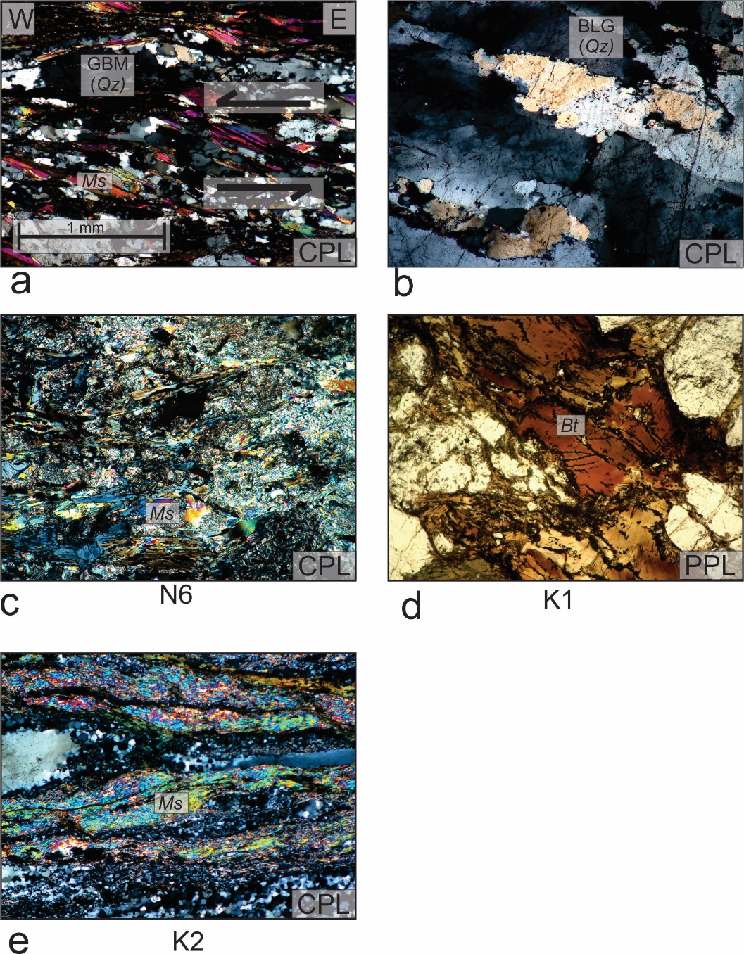

Figure S5. Additional photomicrographs in either plane-polarized (PPL) or cross-polarized light (CPL). a) Paragneiss from the Svaneti traverse with muscovite fish defining reverse top-to-the-west shear sense and amoeboid grain boundary migration (GBM) dynamic recrystallization textures in quartz (Table S1). b) Quartz from within the MCT shear zone on the Svaneti traverse showing overprinting bulging (BLG) dynamic recrystallization on the boundaries of relict grains and subgrains. c) Muscovite (Ms) from sample N6 used for ⁴⁰Ar/³⁹Ar analysis. d) Biotite (Bt) from sample K1 used for ⁴⁰Ar/³⁹Ar analysis. e) Fine-grained muscovite in sample K2 used for ⁴⁰Ar/³⁹Ar analysis.

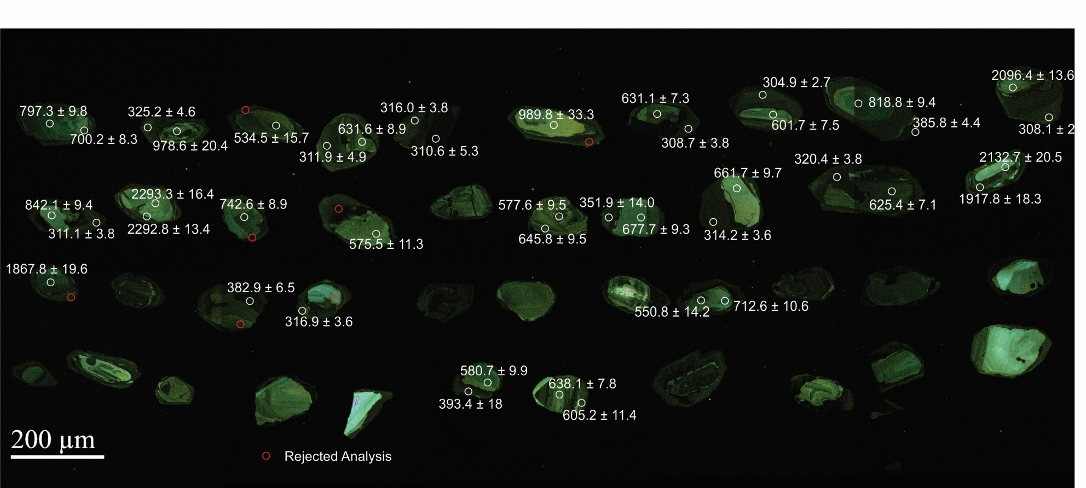

Figure S6. Cathodoluminescence (CL) image of zircons from sample N4 (CT15004B) with all analysis spots indicated. The youngest age population in this sample (~310 Ma) is defined by metamorphic overgrowths on older igneous cores, as shown here. Ages of individual analyses are indicated next to white circles; red circles indicate analyses rejected due to concordance or error (Table S3).

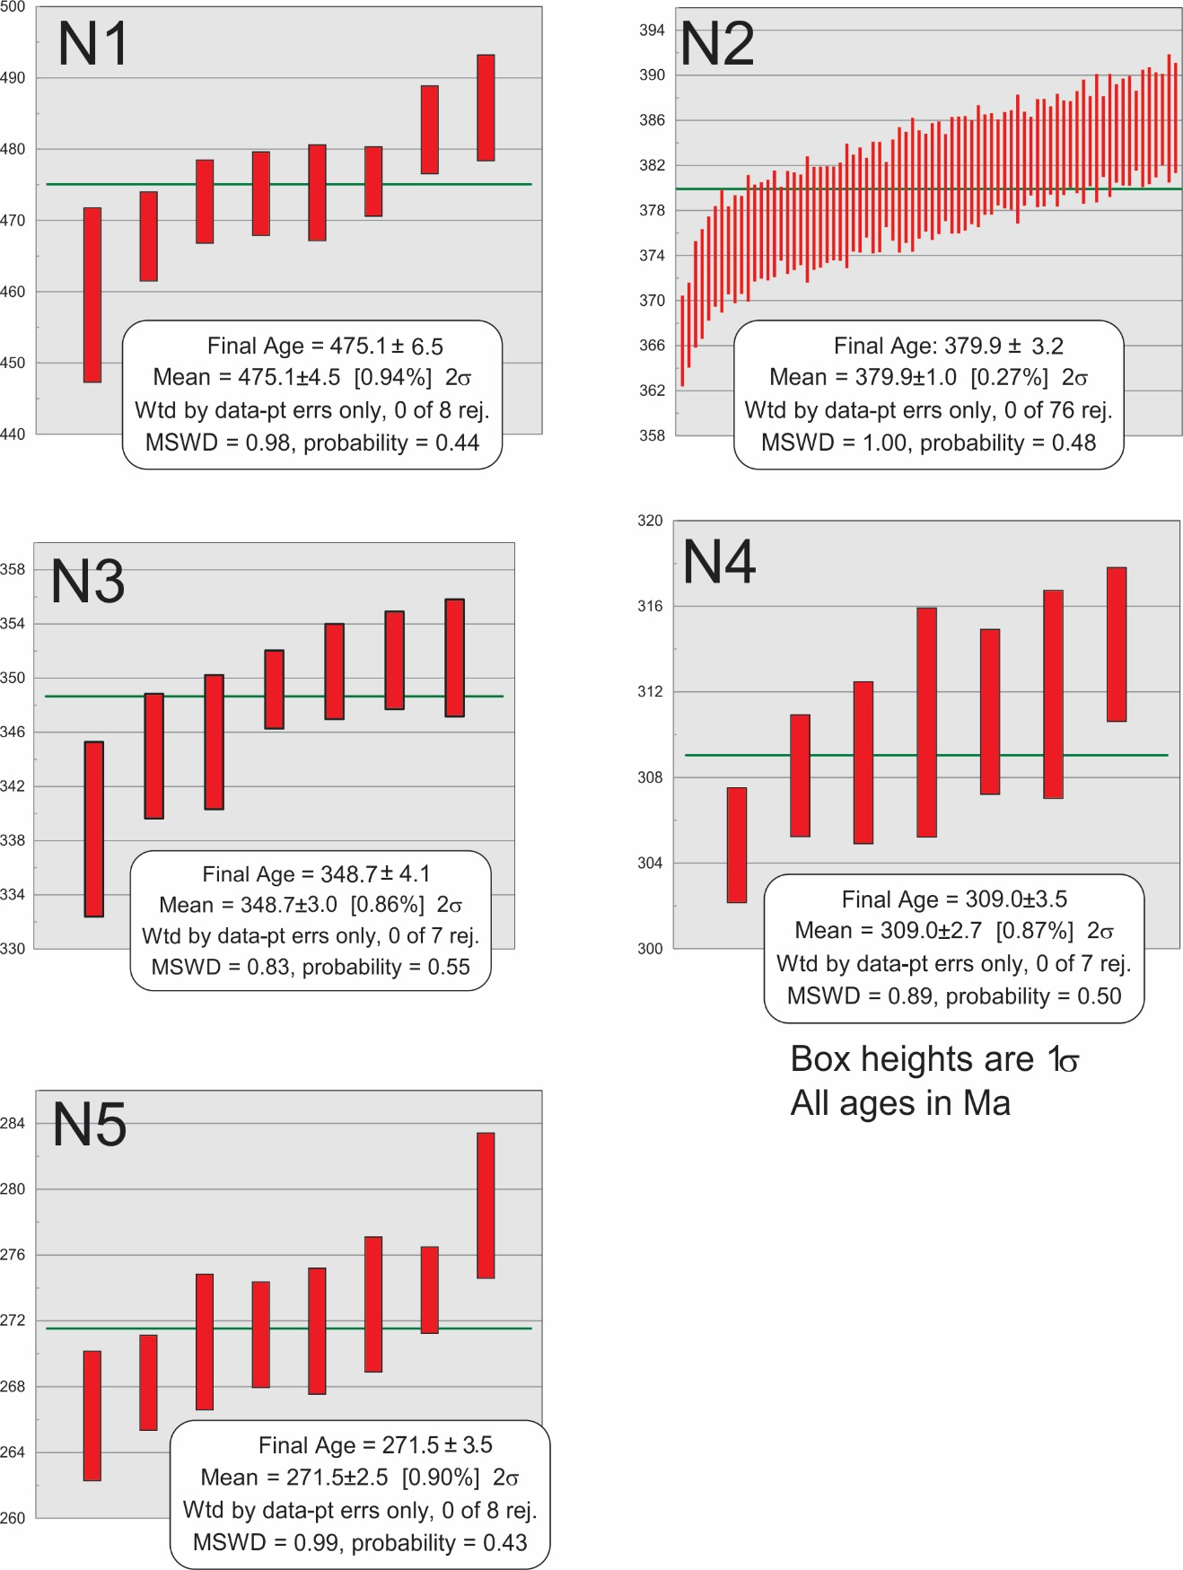

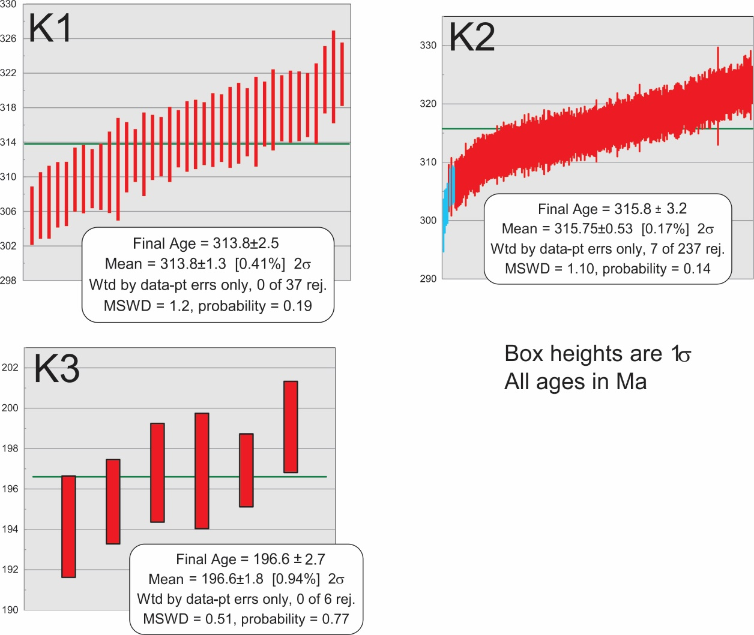

Figure S7. Weighted mean plots used to calculate U-Pb maximum depositional ages and crystallization ages, using IsoPlot (Ludwig, 2008). Ages presented are the weighted means of the youngest population of 3 or more grains that overlap at the 2σ level (Dickinson and Gehrels, 2009). Anomalously young ages with high U levels suggesting Pb loss are excluded (Table S3). Mean ages reflect only internal error; final ages also incorporate systematic error as reported in Table S3.

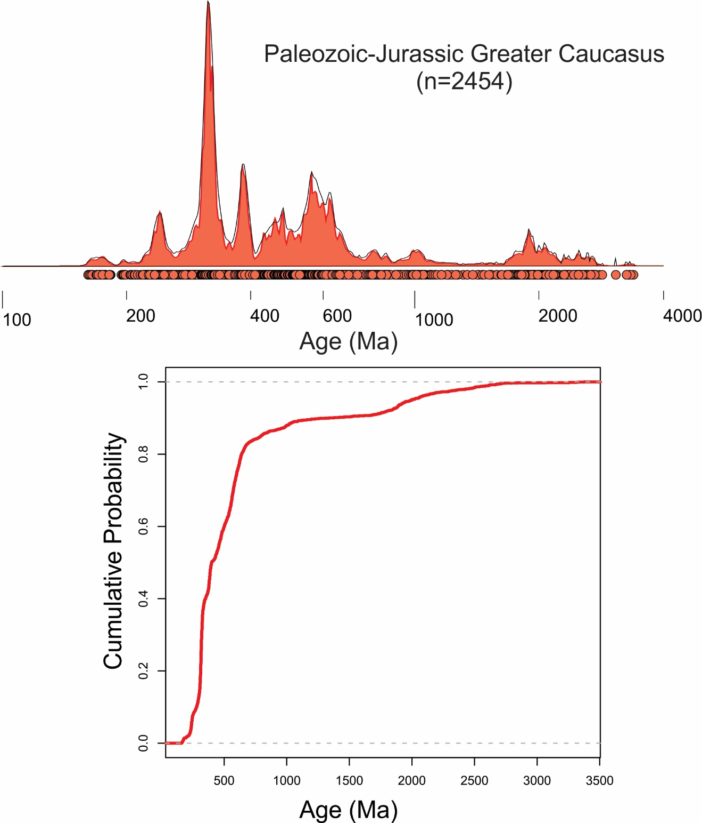

Figure S8. Kernel density estimate and probability distribution function (KDE, PDP - top panel) and cumulative age distribution (CAD – bottom panel) for all zircon U-Pb analyses from this study, combined with data from relevant samples reported in previous studies. The KDE and PDP are plotted according to conventions for Figure 5 in the main text. The CAD is plotted on a linear scale. Samples included are N1-5 and K1-3 from this study, the NWGC, NEGC, modern Enguri River, and modern Kumuk River samples from Cowgill et al. (2016), GC41 from Allen et al. (2006), and all samples from Somin (2011) and Shengelia et al. (2014).

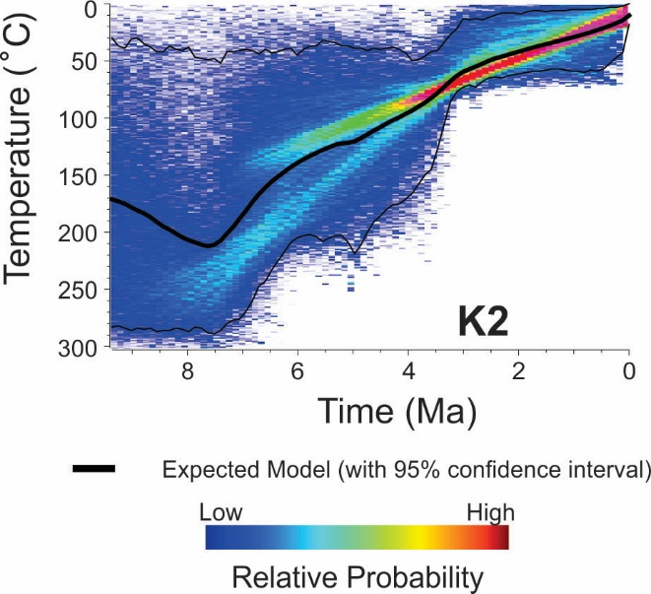

Figure S9. Additional QTQt thermal model for sample K2 not shown in Figure 6b of the main text, according to conventions for Figure 6b.
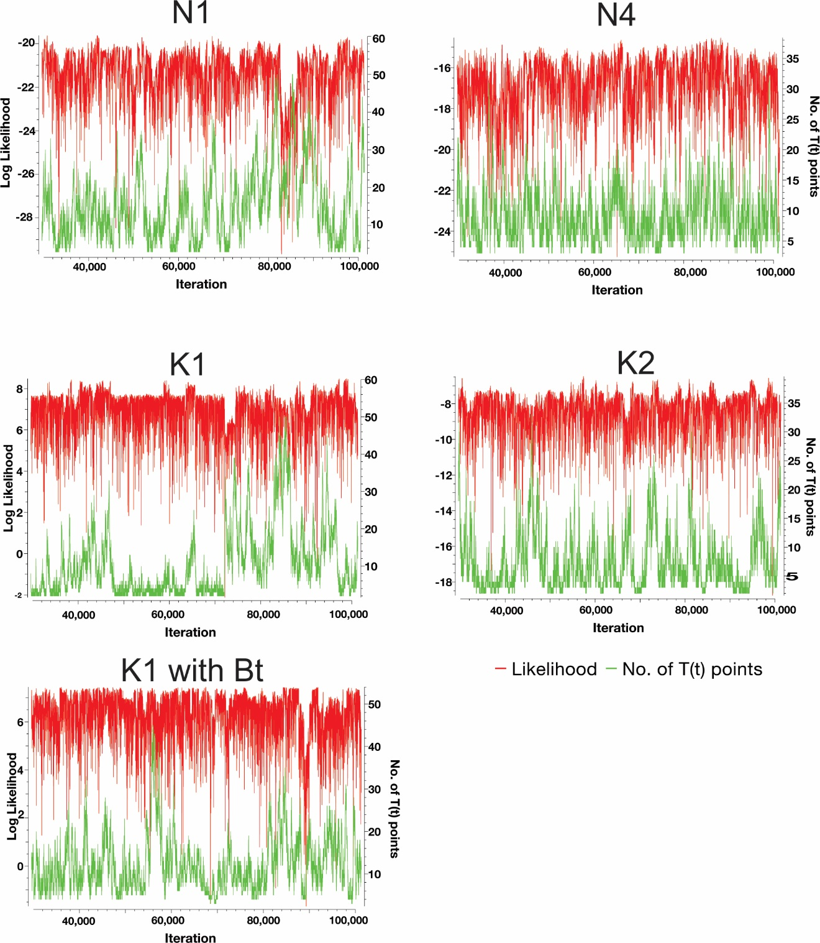

Figure S10. Markov likelihood chains for QTQt thermal models. Red curves indicate the fit of a given iteration to the data; green curves show the number of time-temperature points used to construct the thermal path of a given iteration. Lack of significant structure in the likelihood over 70,000 post-burn-in iterations provides a qualitative indication that the model is converging on a solution (Gallagher, 2012).

Table S1: Structural information for oriented photomicrographs
Figure | Sample Number | Latitude (°N) | Longitude (°E) |  | Foliation Strike/Dip | Lineation Trend/Plunge | Shear Sense |  | Shear Sense Indicator
4b | C16007A | 43.08423 | 42.29445 |  | 274°, 40° | 037°, 38° | Top to North, Normal |  | S/C Fabric
4g | V16052A (K2) | 42.70667 | 44.63115 |  | 284°, 63° | 062°, 53° | Top to South, Reverse |  | Asymmetric Porphyroclasts
S4a | C16014A (N1) | 43.09180 | 42.29313 |  | 305°, 62° | 093°, 45° | Top to West, Reverse |  | Mica Fish
Table S2: Summary of published Caucasus zircon U-Pb analyses used to construct Figures 7 and S7
Sample |  | Source |  | Location |  | Sample Type |  | Number of Analyses
0-81 |  | Somin, 2011 |  | Crystalline Core |  | Igneous |  | 7
P-93-3 |  | Somin, 2011 |  | Crystalline Core |  | Metasedimentary |  | 17
152 |  | Somin, 2011 |  | Crystalline Core |  | Metasedimentary |  | 30
03-10 |  | Somin, 2011 |  | Crystalline Core |  | Igneous |  | 8
0-29 |  | Somin, 2011 |  | Crystalline Core |  | Igneous |  | 9
146 |  | Somin, 2011 |  | Crystalline Core |  | Igneous |  | 11
16 |  | Somin, 2011 |  | Crystalline Core |  | Igneous |  | 10
A-1 |  | Somin, 2011 |  | Crystalline Core |  | Metasedimentary |  | 10
0-41 |  | Somin, 2011 |  | Crystalline Core |  | Metasedimentary |  | 22
UR-1 |  | Somin, 2011 |  | Crystalline Core |  | Igneous |  | 10
K 1-06 |  | Somin, 2011 |  | Crystalline Core |  | Igneous |  | 10
495 |  | Somin, 2011 |  | Crystalline Core |  | Igneous |  | 20
P-81 |  | Somin, 2011 |  | Crystalline Core |  | Metasedimentary |  | 10
0-17 |  | Somin, 2011 |  | Crystalline Core |  | Metasedimentary |  | 17
125 |  | Somin, 2011 |  | Crystalline Core |  | Metasedimentary |  | 13
0-11 |  | Somin, 2011 |  | Crystalline Core |  | Igneous |  | 6
57-A |  | Shengelia et al., 2014 |  | Crystalline Core |  | Igneous |  | 35
GK15GR |  | Shengelia et al., 2014 |  | Crystalline Core |  | Igneous |  | 25
GC41 |  | Allen et al., 2006 |  | Caucasus Basin |  | Sedimentary |  | 60
NWGC (100311-2A) |  | Cowgill et al., 2016 |  | Caucasus Basin |  | Sedimentary |  | 51
NEGC (AZ0620) |  | Cowgill et al., 2016 |  | Caucasus Basin |  | Sedimentary |  | 104
Enguri (100411-2) |  | Cowgill et al., 2016 |  | Modern River |  | Modern Detrital |  | 104
Kumuk (080902-2A) |  | Cowgill et al., 2016 |  | Modern River |  | Modern Detrital |  | 103

Table S3 (see separate file). Results of U-Th-Pb analyses

Table S4 (see separate file). Results of ⁴⁰Ar/³⁹Ar analyses

Table S5 (see separate file). Results of zircon (U-Th)/He analyses

Table S6 (see separate file). Results of apatite (U-Th-Sm)/He analyses

Table S7 (see separate file). Results of unpublished apatite fission track analyses from Avdeev (2011)

QTQt Input File S1 (see separate file). Input parameters for N1 (C16014B)

QTQt Input File S2 (see separate file). Input parameters for N4 (CT15004B)

QTQt Input File S3 (see separate file). Input paramteters for K1 (V16046D)

QTQt Input File S4 (see separate file). Input parameters for K2 (V16052B)

QTQt Input File S5 (see separate file). Input parameters for K1 (V16046D) with biotite ⁴⁰Ar/³⁹Ar.

