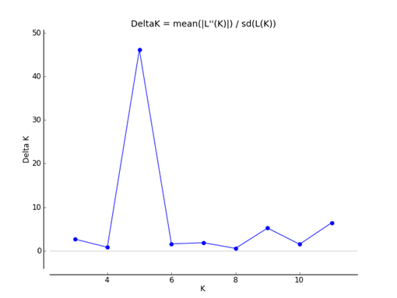
Supplementary Figure S5. ΔK distribution along of different values of clusters (K) for ten populations depending on Evanno’s method (Evanno 2005) using Structure Harvester application.

