**Supplementary Information**

Supplementary Text

Supplementary Figure 1-8

Supplementary Table 1-9

**Supplementary Text**

**Supplementary Fig. 1. Flowchart of enrollment of familial short stature individuals.**

**Supplementary Fig. 2. Principal components analysis for the case and control groups in this study.** The case group were FSS individuals and the controls were those with their body height > 75th percentile of the general population in Taiwan. EIGENSTRAT 2.0 was used to conduct principal components analysis (PCA) with 1000 Genome Phase 3 to correct our data for population stratification in genome-wide association study (GWAS). PCA was performed according to the genotype data of cases and controls used in this study (Cases, N = 1,163; controls, N = 1,071). Populations: AFR, African; AMR, Ad Mixed American; EAS, East Asian; EUR, European; SAS, South Asian.

**Supplementary Fig. 3.** Haplotype blocks for 10 novel bootstrapping obtained SNPs with different chromosome positions for the 1,163 FSS cases and 4,168 controls generated by Haploview (version 4.2). Each box represents the D’ value between pairs of SNPs (ranging from 0 to 1). Dark red, strong LD; light red or white, weak LD. FSS, familial short stature; SNP, single nucleotide polymorphism; LD, linkage disequilibrium.

**Supplementary Fig. 4. Putative gene network analysis for 9 human height GWAS-reported SNPs using Ingenuity Pathway Analysis (IPA) web-based software.** IPA network analysis identified a single cluster of 33 genes that includes 11 associated genes discovered in this study. The lines between genes represent known interactions (solid lines represent direct interactions; dashed lines represent indirect interactions). Each gene is displayed using various shapes that represent the functional class of the gene product, as indicated in the legend.

**Supplementary Fig. 5. Area under curve (AUC) values and their corresponding numbers of single nucleotide polymorphism (SNP).**

**Supplementary Fig. 6. Densities of human height values in the control group (N = 4,168)** (a) Male participants. (b) Female participants.

**Supplementary Fig. 7. Growth charts of height-for-age percentiles in the FSS case group (N = 1,163)** (a) Male participants. (b) Female participants.

**Supplementary Fig. 8. Nine gene structures, their reported mutations, and growth plate-related genetic variants associated with FSS.** (a) *COL11A1* (b) *FLNB* (c) *FGFR3* (d) *TRHR* (e) *COL2A1* (f) *HMGA2* (g) *ACAN* (h) *IGF1R* (i) *NF1*.

**Supplementary Table 1** Top 155 SNPs associated with FSS risk in the training group (*p* value < 1.00E-10 under the Cochran-Armitage trend model).

**Supplementary Table 2** Association of 678 human height-related SNPs with FSS risk in the training group.

**Supplementary Table 3** Investigation of 10 novel genetic variants between FSS and various control subgroups, respectively.

**Supplementary Table 4** Investigation of 9 human height-related genetic variants between FSS and various control subgroups, respectively.

**Supplementary Table 5** Investigation of the 10 novel genetic variants between individuals (height above the 97th percentile) and various shorter groups, respectively.

**Supplementary Table 6** Investigation of 9 human height-related genetic variants between individuals (height above the 97th percentile) and various shorter groups, respectively.

**Supplementary Table 7** Clinical characteristics between individuals (height above the 97th percentile) and individuals (height below the 25th percentile).

**Supplementary Table 8** Top genetic variants between individuals (height above the 97th percentile) and individuals (height below the 25th percentile) (*p* value < 1.00E-5 under the Cochran-Armitage trend model).

**Supplementary Table 9** Investigation of growth plate-related genetic variants between FSS cases and individuals (height above the 75th percentile).

Supplementary Fig. 1

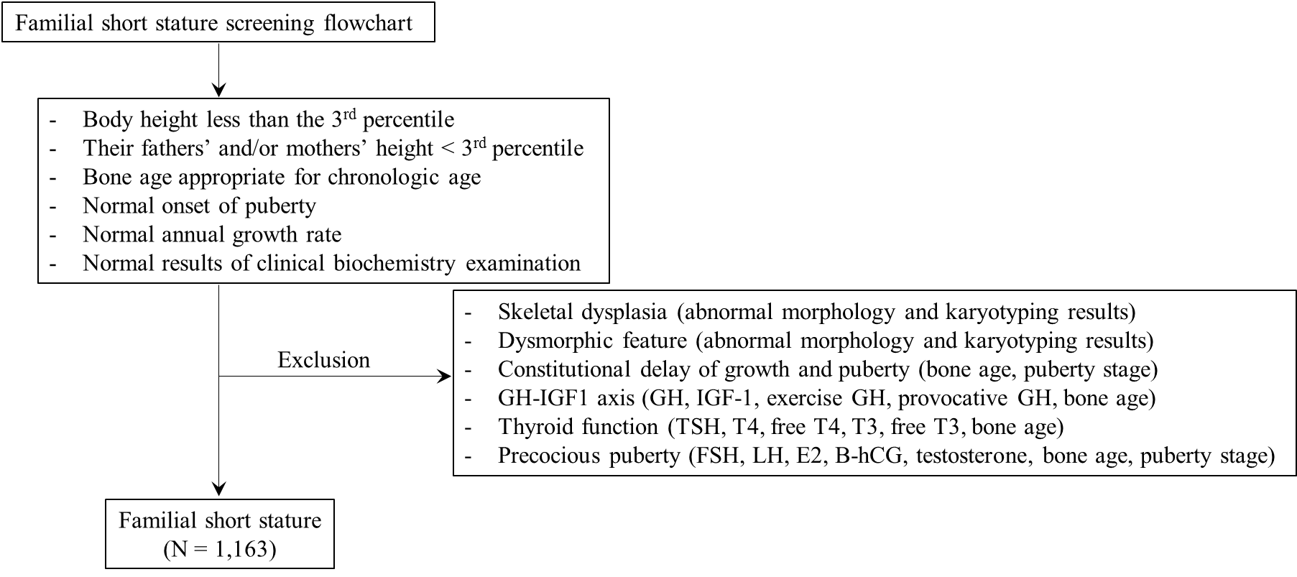

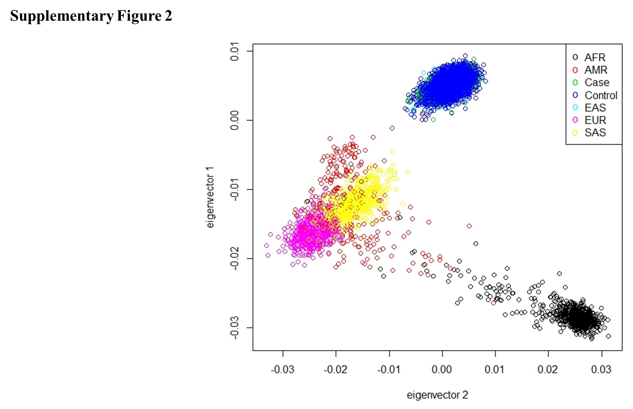 Supplementary Fig. 2

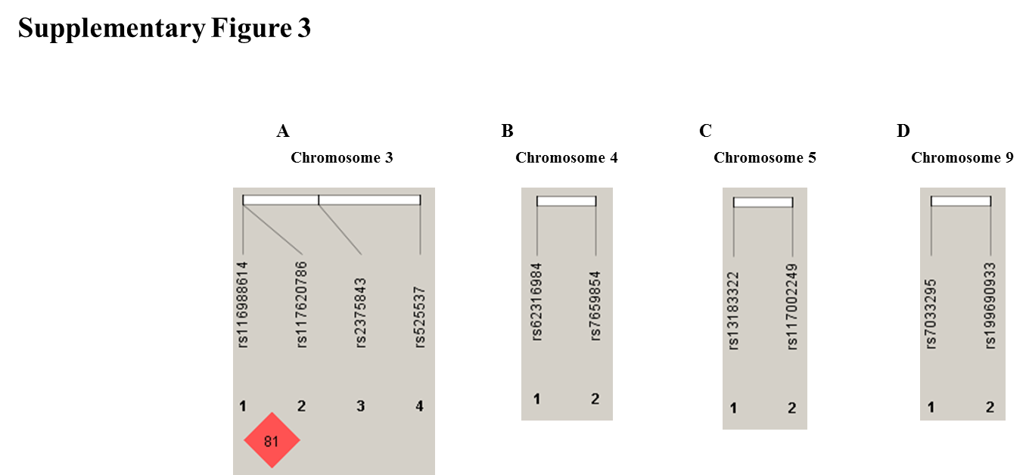

Supplementary Fig. 3

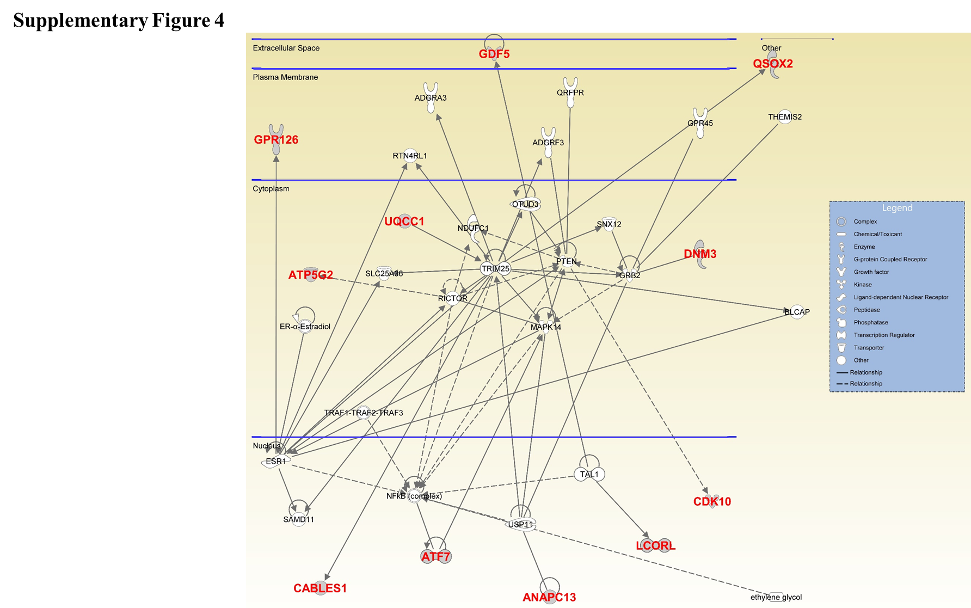Supplementary Fig. 4

Supplementary Fig. 5

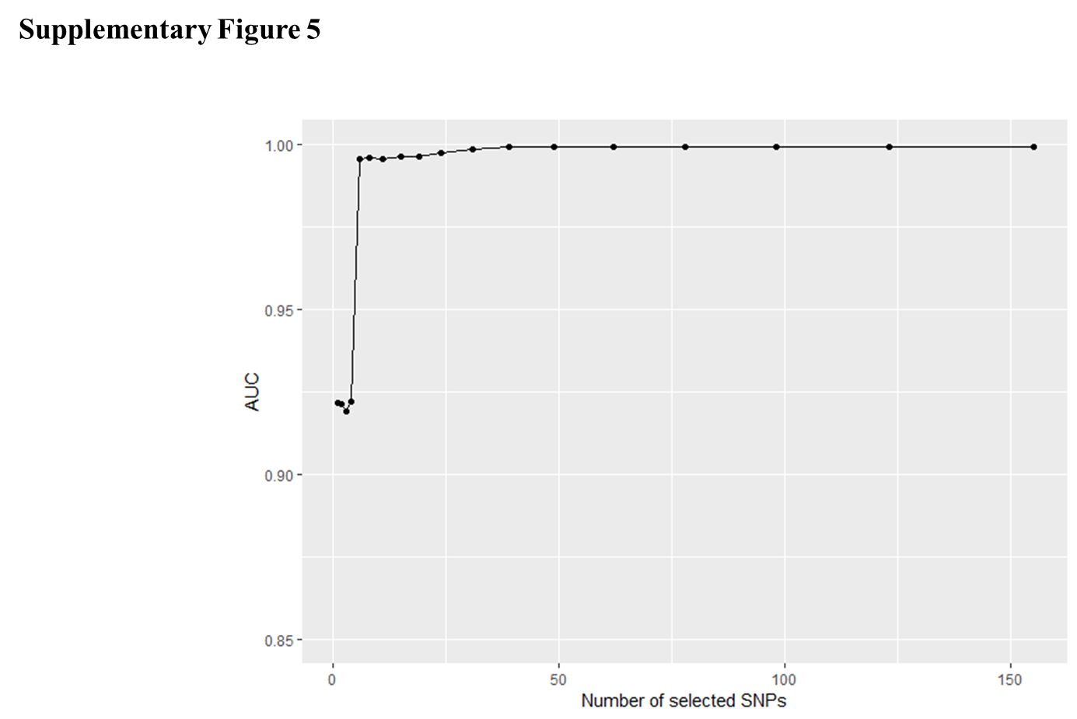

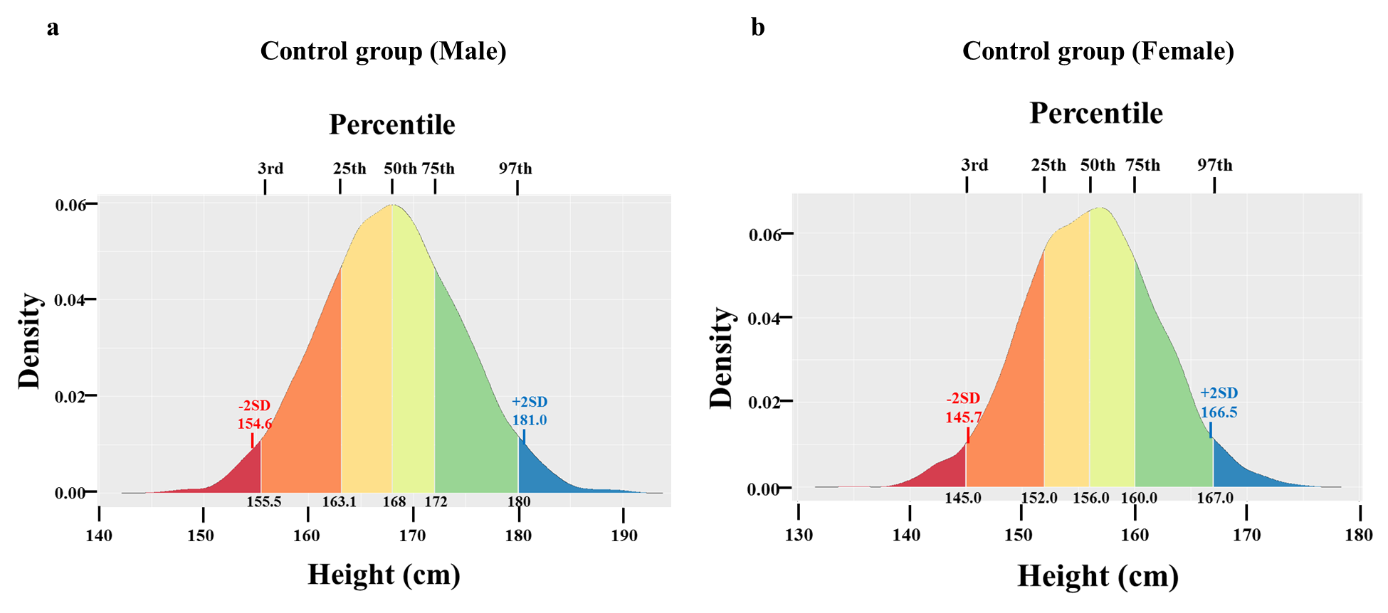Supplementary Fig. 6

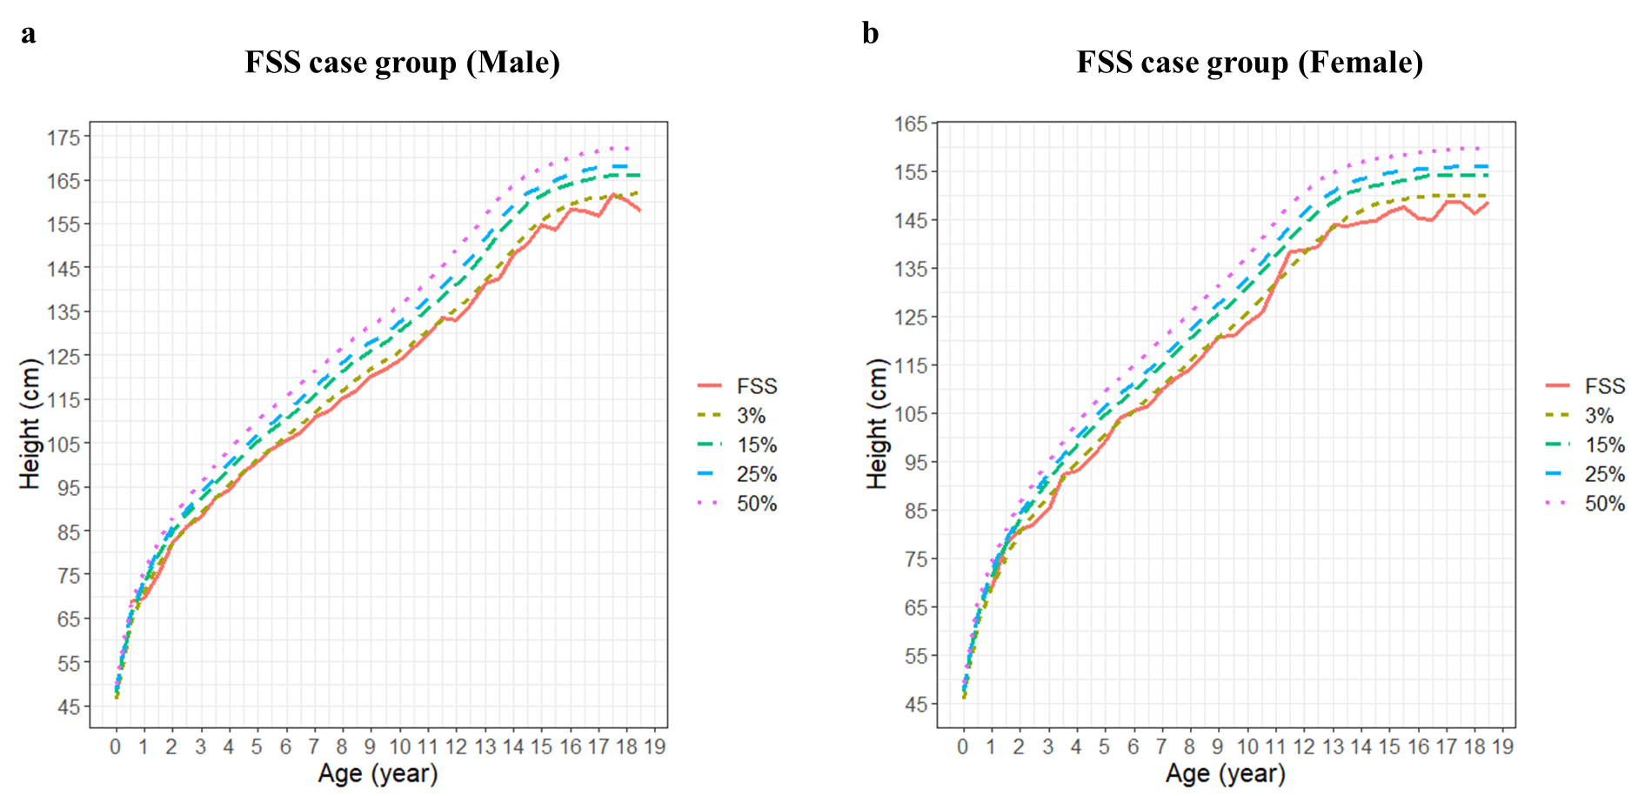Supplementary Fig. 7

Supplementary Fig. 8

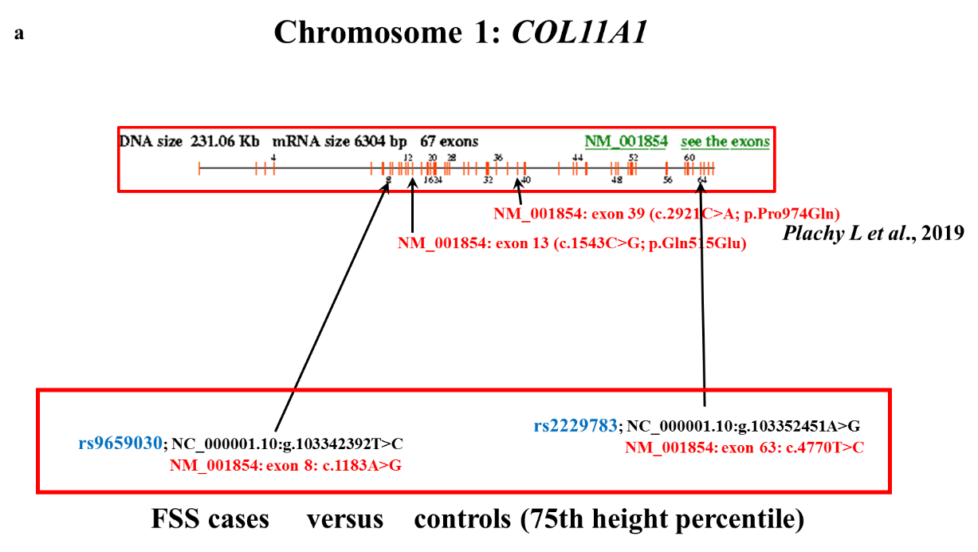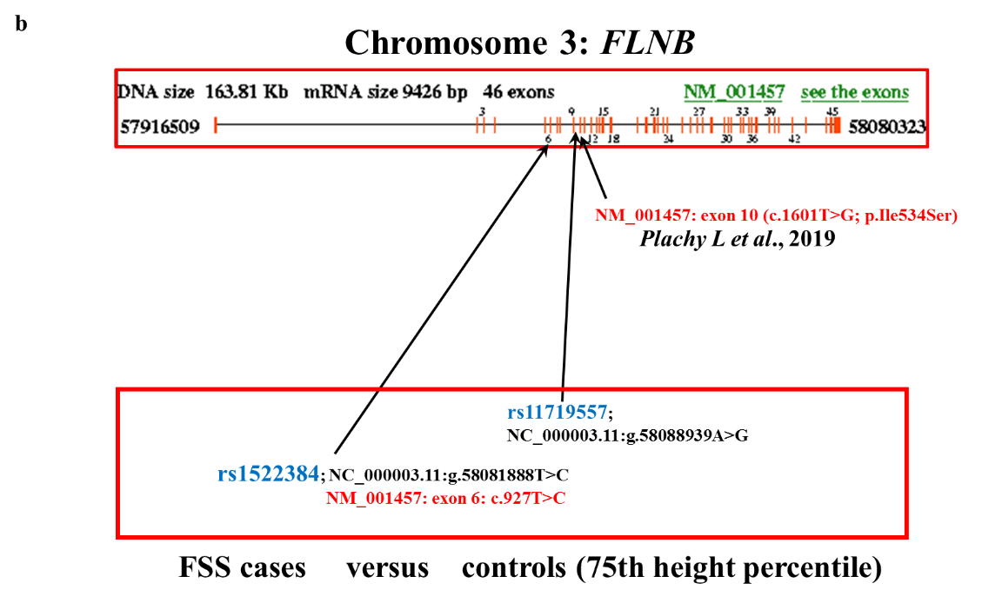

Supplementary Fig. 8

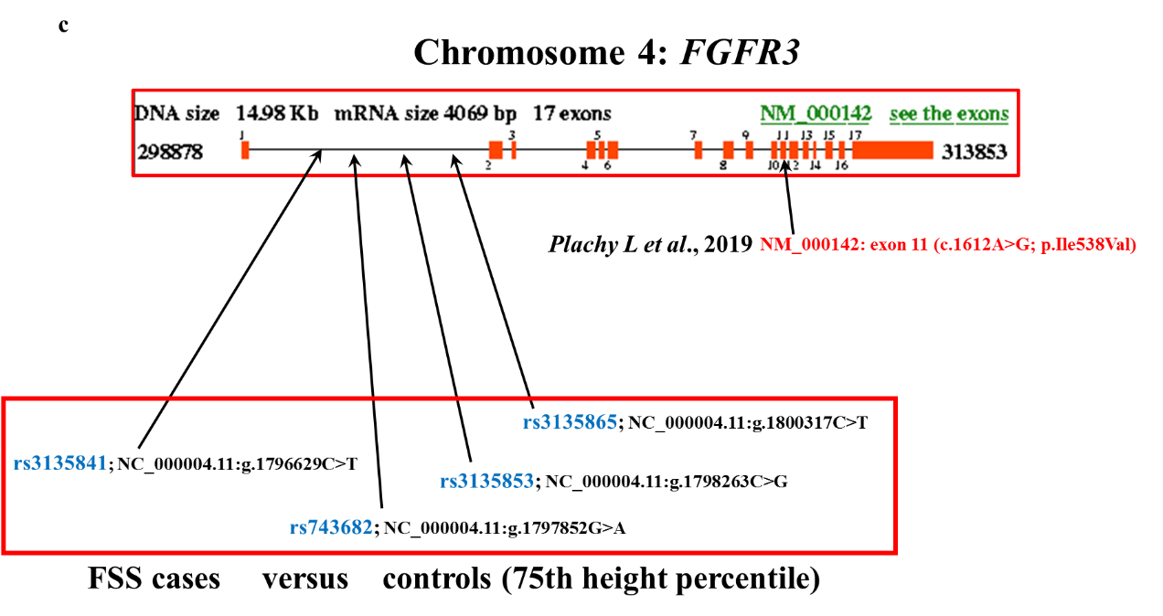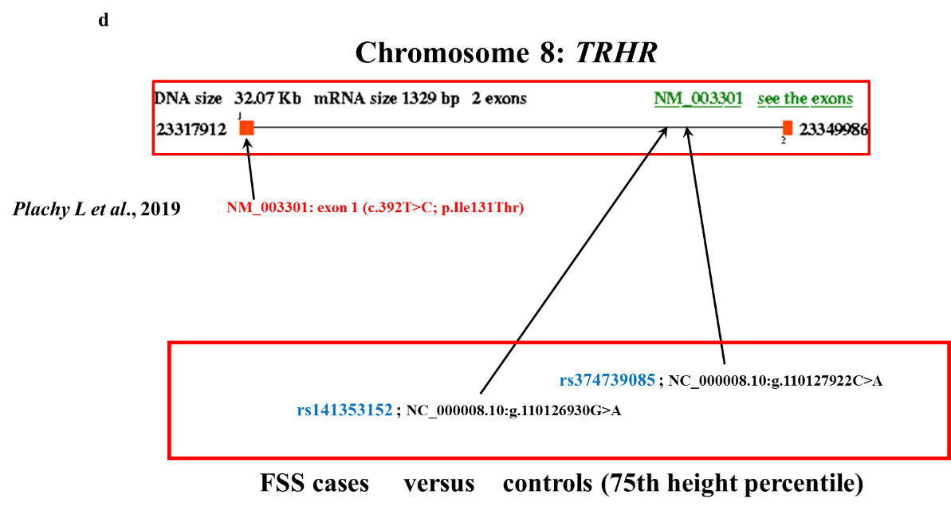

Supplementary Fig. 8

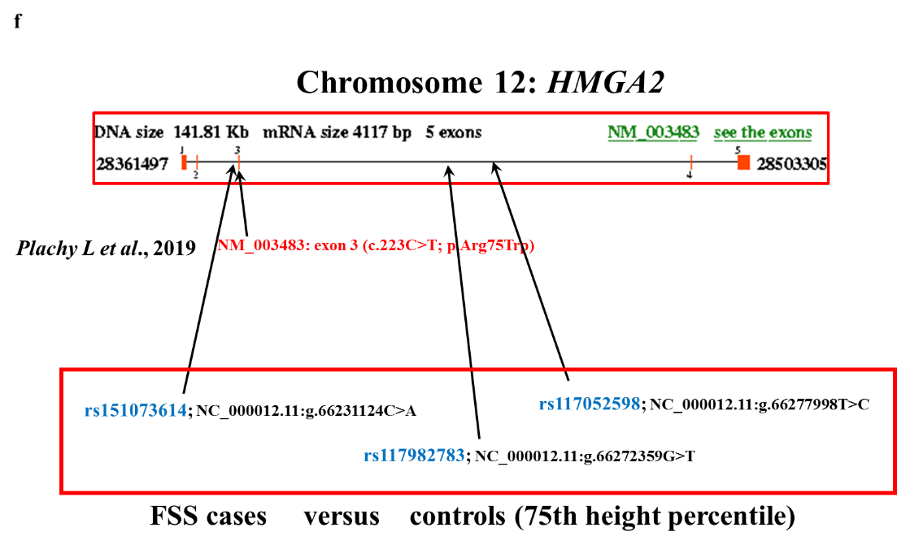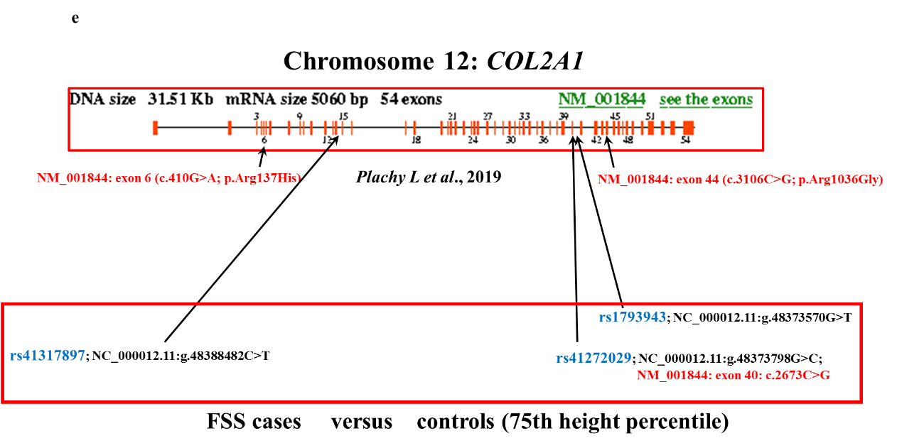

Supplementary Fig. 8

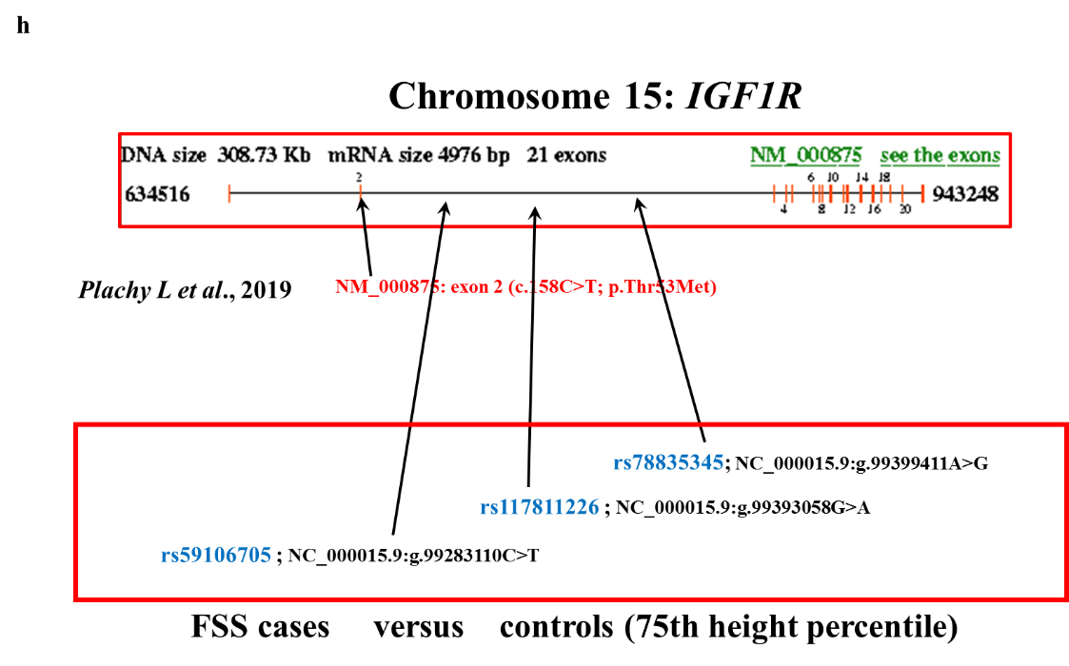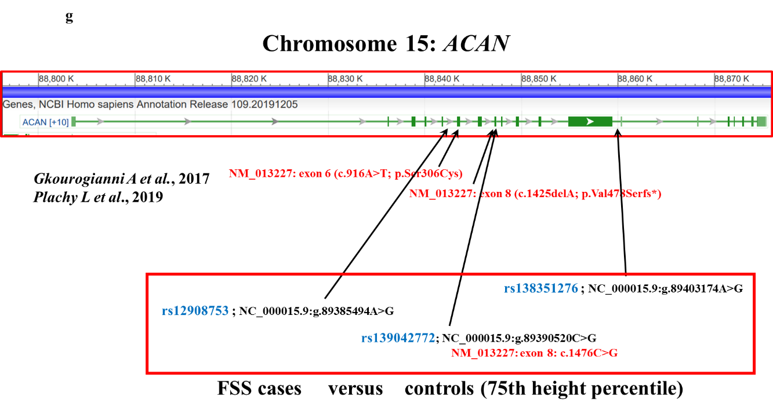

Supplementary Fig. 8

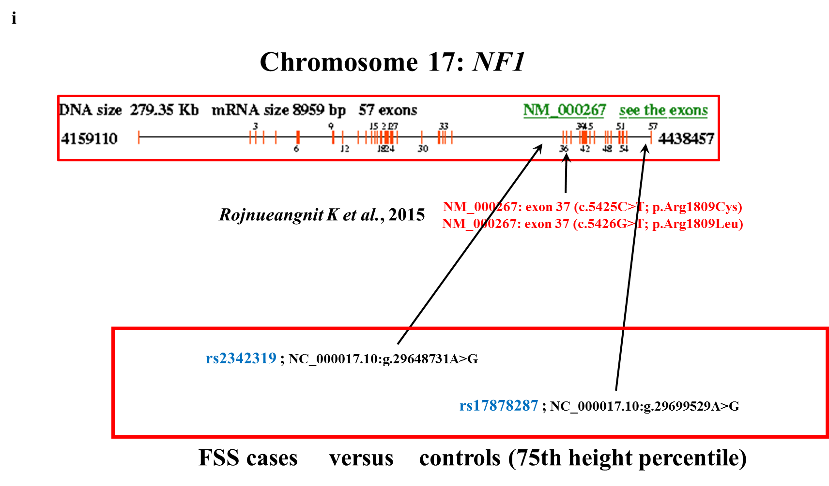

|  |  |  |  |  |  |  |  |  |  |  |
| --- | --- | --- | --- | --- | --- | --- | --- | --- | --- | --- |
| **Supplementary Table 1 Top 155 SNPs associated with FSS risk in the training group (*p* value < 1.00E-10 under the Cochran-Armitage trend model)** | | | | | | | | | | |
| **No.** | **SNP (rs ID)** | **Gene** | **Chr.** | **Position** | **Minor allele** | **Major allele** | **Risk allele** | **Training group (Case: 930 and control: 856)** | | |
| **OR** | **95% CI** | ***p* value** |
| 1 | rs4622073 | *EVI5* | 1 | 93255073 | A | G | G | 2.52 | (2- 3.13) | 4.43E-16 |
| 2 | rs201082708 |  | 1 | 142535974 | C | G | C | 4.51 | (3.09- 6.58) | 6.56E-15 |
| 3 | rs10449867 |  | 1 | 142565449 | C | A | C | 5.55 | (3.98- 7.73) | 4.92E-24 |
| 4 | rs4585995 |  | 1 | 142659031 | C | T | C | 12.87 | (7.25- 22.86) | 2.84E-18 |
| 5 | rs4420097 |  | 1 | 142664625 | C | T | C | 8.96 | (5.63- 14.24) | 1.92E-20 |
| 6 | rs139015442 |  | 1 | 142689086 | T | G | T | 9.88 | (5.27- 18.52) | 8.89E-13 |
| 7 | rs67324521 |  | 1 | 142794818 | T | C | T | 5.43 | (3.77- 7.82) | 1.04E-19 |
| 8 | rs71274042 | *LOC105379566* | 1 | 142853465 | A | G | A | 5.14 | (3.41- 7.75) | 4.71E-15 |
| 9 | rs140176142 | *LOC105379566* | 1 | 142879572 | A | G | A | 5.38 | (3.59- 8.05) | 3.07E-16 |
| 10 | rs150218945 | *LOC105379854* | 1 | 143128113 | T | C | T | 8.77 | (5.39- 14.26) | 2.03E-18 |
| 11 | rs74821874 | *LOC105379854* | 1 | 143131979 | T | G | T | 5.37 | (4.08- 7.08) | 8.35E-33 |
| 12 | rs71660192 | *LOC105379854* | 1 | 143149488 | A | G | A | 12.41 | (7.58- 20.3) | 1.18E-23 |
| 13 | rs141608358 | *LOC105379854* | 1 | 143151447 | G | T | G | 6.85 | (4.79- 9.8) | 5.89E-26 |
| 14 | rs75471995 | *LOC105379854* | 1 | 143151980 | A | G | A | 4.39 | (2.91- 6.62) | 1.72E-12 |
| 15 | rs74544199 | *LOC105379854* | 1 | 143154281 | A | G | A | 7.03 | (4.36- 11.34) | 1.40E-15 |
| 16 | rs76552283 | *LOC105379854* | 1 | 143161910 | T | C | T | 6.52 | (4.52- 9.42) | 1.36E-23 |
| 17 | rs111926595 |  | 1 | 143167374 | T | A | T | 6.09 | (4.17- 8.88) | 7.33E-21 |
| 18 | rs146508914 | *LOC105379521* | 1 | 143185849 | A | C | A | 7.67 | (4.86- 12.1) | 2.21E-18 |
| 19 | rs78014566 | *LOC105379521* | 1 | 143186352 | A | G | A | 10.52 | (5.62- 19.68) | 1.85E-13 |
| 20 | rs200671775 | *LOC101060632* | 1 | 143195495 | G | A | G | 5.09 | (3.71- 6.98) | 8.02E-24 |
| 21 | rs79862009 |  | 1 | 143205021 | T | G | T | 7.55 | (4.58- 12.47) | 2.64E-15 |
| 22 | rs201564917 |  | 1 | 143205920 | G | T | G | 5.52 | (4- 7.62) | 2.72E-25 |
| 23 | rs148223712 |  | 1 | 143208676 | C | T | C | 5.02 | (3.67- 6.85) | 3.56E-24 |
| 24 | rs148629272 |  | 1 | 143261043 | A | G | A | 6.36 | (4.53- 8.93) | 1.50E-26 |
| 25 | rs201999860 |  | 1 | 143281197 | A | G | A | 10.67 | (7.18- 15.87) | 1.41E-31 |
| 26 | rs147833554 |  | 1 | 143285256 | G | T | G | 6.62 | (4.82- 9.1) | 1.56E-31 |
| 27 | rs199561383 |  | 1 | 143289935 | C | T | C | 3.43 | (2.63- 4.47) | 7.15E-20 |
| 28 | rs146158045 |  | 1 | 143291855 | T | G | T | 6.56 | (4.89- 8.79) | 2.87E-36 |
| 29 | rs4111975 |  | 1 | 143480922 | A | G | A | 3.33 | (2.51- 4.43) | 1.14E-16 |
| 30 | rs61800162 |  | 1 | 143496406 | C | G | C | 8.15 | (4.72- 14.06) | 4.99E-14 |
| 31 | rs372357591 |  | 1 | 143521861 | C | A | C | 14.24 | (7.44- 27.27) | 1.13E-15 |
| 32 | rs141325255 |  | 1 | 143535987 | C | G | C | 11.36 | (6.93- 18.61) | 5.33E-22 |
| 33 | rs6692177 |  | 1 | 143543213 | A | G | A | 8.41 | (4.96- 14.25) | 2.71E-15 |
| 34 | rs143322283 |  | 1 | 144569143 | T | A | T | 4.31 | (2.96- 6.27) | 2.26E-14 |
| 35 | rs201996922 |  | 1 | 144574415 | A | G | A | 10.98 | (7.59- 15.89) | 6.12E-37 |
| 36 | rs61803821 | *LOC101929788* | 1 | 144576635 | T | C | T | 6.20 | (3.95- 9.74) | 2.25E-15 |
| 37 | rs61807938 | *LOC107985523* | 1 | 144604144 | G | C | G | 3.43 | (2.46- 4.78) | 3.62E-13 |
| 38 | rs61810918 | *NBPF8* | 1 | 144622265 | C | G | C | 6.07 | (3.55- 10.39) | 4.40E-11 |
| 39 | rs377298160 | *NBPF8* | 1 | 144693812 | T | C | T | 6.70 | (4.1- 10.93) | 2.77E-14 |
| 40 | rs75881026 | *NBPF8* | 1 | 144823593 | C | G | C | 20.64 | (10.48- 40.64) | 2.01E-18 |
| 41 | rs200653619 | *PDE4DIP* | 1 | 144975496 | A | G | A | 37.52 | (20.9- 67.38) | 6.76E-34 |
| 42 | rs2421992 | *DNM3* | 1 | 172241251 | T | C | C | 4.36 | (3.85- 5) | 5.72E-93 |
| 43 | rs916470 |  | 2 | 43186201 | G | A | G | 2.06 | (1.79- 2.38) | 4.82E-24 |
| 44 | rs7586471 |  | 2 | 43187097 | G | C | C | 1.87 | (1.61- 2.17) | 8.21E-18 |
| 45 | rs72803864 |  | 2 | 43188738 | A | G | G | 2.16 | (1.85- 2.5) | 1.47E-23 |
| 46 | rs6745258 |  | 2 | 43189207 | G | T | G | 1.95 | (1.69- 2.25) | 5.74E-20 |
| 47 | rs72876036 |  | 2 | 43193939 | A | G | G | 2.12 | (1.82- 2.44) | 1.54E-22 |
| 48 | rs12479044 |  | 2 | 43195684 | T | C | C | 2.12 | (1.82- 2.5) | 7.05E-21 |
| 49 | rs144499876 |  | 2 | 90166821 | G | A | G | 10.31 | (5.67- 18.75) | 2.08E-14 |
| 50 | rs202128628 |  | 2 | 91971930 | T | C | T | 9.89 | (5.43- 18) | 6.79E-14 |
| 51 | rs192483533 |  | 2 | 92042920 | T | C | T | 8.30 | (5.86- 11.75) | 7.92E-33 |
| 52 | rs80278060 |  | 2 | 92200690 | T | C | T | 9.89 | (5.43- 18) | 6.79E-14 |
| 53 | rs4093787 |  | 2 | 92250974 | A | C | A | 10.53 | (7.2- 15.41) | 7.35E-34 |
| 54 | rs56897783 |  | 2 | 148165961 | G | T | G | 2.27 | (1.91- 2.68) | 2.71E-21 |
| 55 | rs78760716 |  | 3 | 98426047 | A | G | G | 5.30 | (3.57- 7.69) | 1.54E-15 |
| 56 | rs12632227 |  | 3 | 109946440 | A | G | G | 4.12 | (3.57- 4.76) | 6.59E-95 |
| 57 | rs116988614 | *COL6A5* | 3 | 130092364 | G | A | G | 16.24 | (11.4- 23.12) | 6.62E-54 |
| 58 | rs138549875 | *COL6A5* | 3 | 130171337 | T | C | T | 4.78 | (3.43- 6.67) | 3.36E-20 |
| 59 | rs117620786 |  | 3 | 130222392 | A | G | A | 5.49 | (3.81- 7.91) | 5.41E-20 |
| 60 | rs2375843 | *LOC105374144* | 3 | 145352404 | T | C | C | 3.87 | (3.33- 4.55) | 1.40E-70 |
| 61 | rs35510236 | *LOC105374144* | 3 | 145354596 | C | T | T | 2.24 | (1.96- 2.56) | 1.79E-30 |
| 62 | rs525537 |  | 3 | 165355602 | C | G | G | 5.63 | (4.55- 7.14) | 4.01E-61 |
| 63 | rs13120387 |  | 4 | 30108394 | C | T | T | 4.50 | (3.85- 5.26) | 3.31E-86 |
| 64 | rs79350708 |  | 4 | 30111285 | T | G | T | 3.06 | (2.55- 3.68) | 8.26E-33 |
| 65 | rs13149049 |  | 4 | 30121193 | T | G | G | 2.40 | (2.08- 2.78) | 7.33E-35 |
| 66 | rs2603171 |  | 4 | 69350200 | G | A | G | 2.43 | (1.9- 3.11) | 2.25E-12 |
| 67 | rs2708672 | *TMPRSS11E* | 4 | 69363598 | C | G | C | 3.77 | (2.92- 4.88) | 4.87E-24 |
| 68 | rs2603153 |  | 4 | 69365052 | G | T | G | 2.05 | (1.73- 2.44) | 2.33E-16 |
| 69 | rs2603151 |  | 4 | 69367872 | A | G | A | 2.10 | (1.73- 2.54) | 4.63E-14 |
| 70 | rs2603150 |  | 4 | 69368203 | A | G | A | 3.09 | (2.36- 4.06) | 4.21E-16 |
| 71 | rs367549135 |  | 4 | 69373910 | C | G | C | 2.34 | (2.04- 2.68) | 3.14E-34 |
| 72 | rs62317942 |  | 4 | 69374039 | G | A | G | 2.19 | (1.87- 2.56) | 9.57E-23 |
| 73 | rs201123031 |  | 4 | 69381109 | G | A | G | 2.17 | (1.89- 2.49) | 1.36E-27 |
| 74 | rs4576087 |  | 4 | 69384363 | T | A | T | 10.85 | (7.13- 16.53) | 1.15E-28 |
| 75 | rs12498676 |  | 4 | 69386697 | G | C | G | 2.06 | (1.81- 2.35) | 8.01E-27 |
| 76 | rs28369093 |  | 4 | 69391930 | A | G | A | 10.36 | (7.34- 14.62) | 2.41E-40 |
| 77 | rs62316984 | *UGT2B17* | 4 | 69412151 | G | A | G | 3.63 | (2.83- 4.65) | 2.72E-24 |
| 78 | rs367599822 | *UGT2B17* | 4 | 69412874 | G | A | A | 4.12 | (3.45- 4.76) | 4.69E-67 |
| 79 | rs4860964 | *UGT2B17* | 4 | 69417886 | G | A | G | 2.90 | (2.48- 3.38) | 7.35E-42 |
| 80 | rs62316989 | *UGT2B17* | 4 | 69420607 | T | C | T | 3.68 | (3.03- 4.48) | 1.33E-38 |
| 81 | rs12507219 | *UGT2B17* | 4 | 69427899 | C | T | C | 2.33 | (1.88- 2.89) | 1.83E-14 |
| 82 | rs150774660 | *UGT2B17* | 4 | 69434619 | C | T | T | 2.39 | (2- 2.86) | 5.06E-20 |
| 83 | rs56015043 |  | 4 | 69440672 | T | C | T | 2.52 | (2.05- 3.11) | 5.46E-18 |
| 84 | rs28660525 |  | 4 | 69442803 | C | A | C | 4.44 | (3.55- 5.54) | 2.05E-39 |
| 85 | rs13116034 |  | 4 | 69447150 | G | A | G | 3.14 | (2.35- 4.19) | 8.97E-15 |
| 86 | rs6838228 |  | 4 | 69453239 | A | G | A | 5.26 | (4.09- 6.75) | 1.07E-38 |
| 87 | rs10028930 |  | 4 | 69467200 | T | C | T | 5.97 | (4.24- 8.4) | 1.44E-24 |
| 88 | rs9992446 |  | 4 | 69467634 | G | A | G | 6.57 | (4.93- 8.76) | 9.57E-38 |
| 89 | rs10049957 |  | 4 | 69481871 | T | G | T | 4.12 | (2.98- 5.71) | 1.33E-17 |
| 90 | rs10028199 |  | 4 | 69489236 | G | T | G | 8.49 | (5.02- 14.37) | 1.60E-15 |
| 91 | rs10028205 |  | 4 | 69489243 | G | A | G | 6.86 | (3.96- 11.89) | 6.54E-12 |
| 92 | rs7656288 | *LOC105377267* | 4 | 70055799 | T | G | G | 10.64 | (9.09- 12.5) | 9.51E-132 |
| 93 | rs7659854 | *IQCM* | 4 | 150692140 | C | T | C | 5.71 | (4.93- 6.61) | 2.42E-120 |
| 94 | rs181734 |  | 5 | 50939943 | T | C | C | 4.32 | (3.7- 5) | 9.45E-100 |
| 95 | rs109843 | *LINC02062* | 5 | 98320937 | A | T | A | 1.67 | (1.46- 1.91) | 1.68E-13 |
| 96 | rs75488736 |  | 5 | 104949487 | T | G | T | 2.98 | (2.18- 4.08) | 7.06E-12 |
| 97 | rs13183322 |  | 5 | 109237379 | C | T | C | 1.93 | (1.65- 2.25) | 7.01E-17 |
| 98 | rs117002249 |  | 5 | 145793167 | C | T | T | 10.21 | (5.56- 20) | 4.53E-13 |
| 99 | rs3776082 |  | 5 | 149544045 | G | A | A | 1.78 | (1.54- 2.04) | 3.22E-15 |
| 100 | rs13360623 | *CDX1* | 5 | 149546141 | T | C | T | 2.11 | (1.75- 2.53) | 1.79E-15 |
| 101 | rs3776087 | *SLC6A7* | 5 | 149573365 | A | G | G | 2.45 | (1.96- 3.03) | 4.00E-16 |
| 102 | rs9396701 | *OFCC1* | 6 | 9894397 | T | G | G | 2.21 | (1.85- 2.63) | 1.75E-19 |
| 103 | rs1202116 |  | 6 | 73267169 | G | T | G | 3.98 | (2.96- 5.35) | 6.07E-20 |
| 104 | rs1147566 |  | 6 | 73305403 | A | G | A | 5.29 | (3.57- 7.85) | 1.22E-16 |
| 105 | rs1202099 |  | 6 | 73305719 | G | A | G | 7.34 | (4.01- 13.44) | 1.07E-10 |
| 106 | rs1147572 |  | 6 | 73315247 | C | A | A | 2.14 | (1.85- 2.44) | 8.34E-25 |
| 107 | rs28568615 |  | 6 | 115268102 | T | C | T | 4.14 | (3.05- 5.62) | 5.80E-20 |
| 108 | rs144187538 |  | 6 | 115273675 | A | G | A | 3.10 | (2.41- 3.99) | 9.74E-19 |
| 109 | rs190243301 |  | 6 | 133764383 | C | T | C | 3.50 | (2.66- 4.6) | 4.59E-19 |
| 110 | rs714179 |  | 7 | 14182592 | A | G | G | 9.37 | (7.69- 11.11) | 4.62E-130 |
| 111 | rs11975201 |  | 7 | 51674358 | T | C | C | 4.66 | (3.7- 5.88) | 8.10E-45 |
| 112 | rs2382602 |  | 7 | 62004213 | A | G | G | 2.76 | (2.08- 3.57) | 4.46E-13 |
| 113 | rs10953229 |  | 7 | 97396284 | G | A | A | 1.71 | (1.49- 1.96) | 6.57E-15 |
| 114 | rs2156941 |  | 7 | 142202479 | C | G | G | 2.51 | (2.17- 2.94) | 2.76E-34 |
| 115 | rs6954089 |  | 7 | 142205841 | A | T | A | 1.93 | (1.65- 2.26) | 2.19E-16 |
| 116 | rs975494 |  | 7 | 142222582 | G | A | A | 1.95 | (1.69- 2.22) | 5.83E-21 |
| 117 | rs60746355 |  | 7 | 142223632 | G | C | G | 5.20 | (3.64- 7.43) | 1.44E-19 |
| 118 | rs361491 |  | 7 | 142259507 | A | G | G | 2.09 | (1.79- 2.44) | 1.39E-19 |
| 119 | rs144142335 |  | 7 | 142270601 | A | G | A | 2.53 | (2.07- 3.09) | 1.06E-19 |
| 120 | rs4922003 | *LOC100128993* | 8 | 19072672 | T | C | C | 2.74 | (2.38- 3.13) | 6.12E-46 |
| 121 | rs301 | *LPL* | 8 | 19816934 | C | T | C | 1.85 | (1.59- 2.15) | 7.76E-16 |
| 122 | rs2122989 | *ADAM2* | 8 | 39601806 | C | T | T | 2.00 | (1.72- 2.33) | 1.02E-18 |
| 123 | rs10092277 |  | 8 | 57727744 | C | T | T | 5.46 | (4.35- 6.67) | 2.19E-58 |
| 124 | rs7033295 |  | 9 | 2407693 | T | G | G | 4.94 | (4- 6.25) | 2.61E-43 |
| 125 | rs4008868 | *ANKRD18B* | 9 | 33556610 | A | G | G | 3.62 | (2.94- 4.55) | 1.08E-32 |
| 126 | rs139695525 | *ANKRD18B* | 9 | 33566517 | A | G | G | 3.82 | (2.7- 5.26) | 3.00E-14 |
| 127 | rs10971568 | *ANKRD18B* | 9 | 33571779 | A | G | G | 4.07 | (3.23- 5) | 8.94E-34 |
| 128 | rs12378940 | *ANKRD18B* | 9 | 33573212 | A | G | A | 2.29 | (1.88- 2.78) | 8.78E-17 |
| 129 | rs201640679 |  | 9 | 40037431 | C | T | C | 4.52 | (3.25- 6.3) | 3.92E-19 |
| 130 | rs142487483 |  | 9 | 40642471 | T | C | T | 3.58 | (2.59- 4.96) | 1.41E-14 |
| 131 | rs147881953 |  | 9 | 40679139 | G | A | G | 4.79 | (3.46- 6.62) | 2.68E-21 |
| 132 | rs141862937 |  | 9 | 40804323 | C | A | C | 6.36 | (4.52- 8.94) | 1.87E-26 |
| 133 | rs149902530 |  | 9 | 41232101 | T | C | T | 4.80 | (3.25- 7.08) | 2.98E-15 |
| 134 | rs114566304 | *CNTNAP3B* | 9 | 43708629 | C | G | C | 3.77 | (2.69- 5.29) | 1.57E-14 |
| 135 | rs146120946 | *CNTNAP3B* | 9 | 43750504 | A | G | A | 5.96 | (4.31- 8.23) | 2.55E-27 |
| 136 | rs78818376 | *CNTNAP3B* | 9 | 43851562 | A | G | A | 5.66 | (3.99- 8.03) | 2.78E-22 |
| 137 | rs189872889 |  | 9 | 44074954 | T | A | T | 2.01 | (1.72- 2.35) | 8.16E-19 |
| 138 | rs58260886 |  | 9 | 44123510 | T | C | T | 2.04 | (1.75- 2.38) | 1.81E-19 |
| 139 | rs73443649 |  | 9 | 44161670 | G | C | G | 2.04 | (1.75- 2.38) | 1.82E-19 |
| 140 | rs28481838 |  | 9 | 44170038 | T | C | T | 12.93 | (6.94- 24.09) | 7.52E-16 |
| 141 | rs28372615 |  | 9 | 44216201 | T | G | T | 2.02 | (1.73- 2.36) | 5.28E-19 |
| 142 | rs58419287 |  | 9 | 44237167 | C | T | C | 17.11 | (7.93- 36.93) | 4.56E-13 |
| 143 | rs12550878 | *LOC101930090* | 9 | 65615947 | A | G | A | 4.95 | (3.39- 7.22) | 1.20E-16 |
| 144 | rs199690933 | *PGM5P2* | 9 | 69132306 | T | G | T | 5.04 | (3.36- 7.57) | 5.05E-15 |
| 145 | rs201943742 |  | 9 | 69274593 | G | A | G | 3.25 | (2.59- 4.08) | 3.16E-24 |
| 146 | rs7862659 |  | 9 | 69463262 | G | C | G | 4.58 | (3.17- 6.6) | 4.28E-16 |
| 147 | rs367610145 |  | 9 | 69610626 | A | G | A | 6.09 | (4.59- 8.08) | 4.54E-36 |
| 148 | rs150275650 |  | 9 | 69787544 | T | C | T | 4.00 | (2.89- 5.54) | 6.49E-17 |
| 149 | rs145512386 |  | 9 | 69794685 | T | C | T | 5.48 | (3.89- 7.73) | 2.57E-22 |
| 150 | rs200807988 |  | 9 | 69879357 | T | G | T | 4.48 | (3.16- 6.34) | 2.85E-17 |
| 151 | rs200485294 |  | 9 | 69985772 | T | C | T | 5.04 | (3.36- 7.57) | 5.05E-15 |
| 152 | rs201763386 |  | 9 | 69986931 | G | A | G | 4.50 | (3.1- 6.52) | 2.16E-15 |
| 153 | rs117095362 |  | 11 | 58529724 | G | T | G | 15.78 | (12.58- 19.79) | 3.82E-126 |
| 154 | rs1621576 | *LOC107984384* | 11 | 109938758 | A | G | G | 12.30 | (10- 14.29) | 3.00E-127 |
| 155 | rs12821359 |  | 12 | 84721592 | A | C | C | 11.01 | (9.09- 14.29) | 2.45E-122 |
|  |  |  |  |  |  |  |  |  |  |  |
| This analysis was under the additive inheritance model and these SNPs were ordered by the chromosome and position. The positions were based on the NCBI GRCh37 version. Gene was identified based on the gene containing the SNP or the closest gene (within 100 kb up- or downstream) to the SNP. | | | | | | | | | | |
| FSS, familial short stature; SNP, single nucleotide polymorphism; OR, odds ratio; 95% CI, 95% confidence interval for odds ratio. | | | | | | | | | | |

|  |  |  |  |  |  |  |  |  |  |  |  |  |  |
| --- | --- | --- | --- | --- | --- | --- | --- | --- | --- | --- | --- | --- | --- |
| Supplementary Table 2 Association of 678 human height-related SNPs with FSS risk in the training group | | | | | | | | | | | | | |
| No. | SNP (rs ID) | Gene | Chr. | Position | Reference | PMID number | Population | Minor allele | Major allele | Risk allele | Training group (Case: 930 and control: 856) | | |
| OR | 95% CI | *p* value |
|  |  |  |  |  |  |  |  |  |  |  |  |  |  |
| 1 | rs425277 | *PRKCZ* | 1 | 2069172 | Wood AR et al., 2014 | 25282103 | European | T | C | C | 1.03 | (0.9-1.18) | 6.48E-01 |
| 2 | rs9434723 | *H6PD* | 1 | 9292282 | Wood AR et al., 2014 | 25282103 | European | A | G | G | 1.04 | (0.87-1.25) | 6.42E-01 |
| 3 | rs10779751 | *FRAP1* | 1 | 11284336 | Wood AR et al., 2014 | 25282103 | European | A | G | A | 1.07 | (0.87-1.3) | 5.36E-01 |
| 4 | rs2284746 | *MFAP2* | 1 | 17306675 | He M et al., 2015 | 25429064 | European | G | C | C | 1.13 | (1-1.27) | 4.88E-02 |
| 5 | rs3738814 | *ATP13A2* | 1 | 17331676 | He M et al., 2015 | 25429064 | Asian | A | G | G | 1.14 | (1.02-1.29) | 2.60E-02 |
| 6 | rs12137162 | *CAPZB* | 1 | 19763396 | Wood AR et al., 2014 | 25282103 | European | A | C | C | 1.05 | (0.93-1.18) | 4.59E-01 |
| 7 | rs3767141 | *HSPG2* | 1 | 22216279 | Soranzo N et al., 2009 | 19343178 | European | T | C | C | 1.05 | (0.94-1.17) | 3.82E-01 |
| 8 | rs1014987 | *WNT4* | 1 | 22498824 | Wood AR et al., 2014 | 25282103 | European | C | G | C | 1.04 | (0.94-1.15) | 4.80E-01 |
| 9 | rs2806561 | *LUZP1* | 1 | 23504795 | Wood AR et al., 2014 | 25282103 | European | G | A | A | 1.01 | (0.92-1.12) | 7.77E-01 |
| 10 | rs1738475 | *HTR1D* | 1 | 23536891 | Lango Allen H et al., 2010 | 20881960 | European | G | C | C | 1.02 | (0.93-1.13) | 6.34E-01 |
| 11 | rs4601530 | *CLIC4* | 1 | 25044111 | Wood AR et al., 2014 | 25282103 | European | T | C | T | 1.02 | (0.92-1.12) | 7.78E-01 |
| 12 | rs926438 | *TMEM57* | 1 | 25753638 | Chan Y et al., 2015 | 25865494 | Various | T | C | C | 1.01 | (0.9-1.13) | 9.02E-01 |
| 13 | rs7532866 | *LIN28* | 1 | 26741544 | Lango Allen H et al., 2010 | 20881960 | European | G | A | G | 1.19 | (1.02-1.4) | 2.90E-02 |
| 14 | rs2219320 | *HMGN2* | 1 | 26803430 | Wood AR et al., 2014 | 25282103 | European | C | T | C | 1.09 | (0.94-1.28) | 2.56E-01 |
| 15 | rs12119525 | *SLC9A1* | 1 | 27503662 | Wood AR et al., 2014 | 25282103 | European | A | T | A | 1.01 | (0.85-1.2) | 9.03E-01 |
| 16 | rs209918 | *COL9A2* | 1 | 40777842 | Wood AR et al., 2014 | 25282103 | European | A | G | G | 1.12 | (1-1.25) | 5.11E-02 |
| 17 | rs6600365 | *SCMH1* | 1 | 41556253 | Wood AR et al., 2014 | 25282103 | European | C | T | T | 1.01 | (0.91-1.12) | 8.03E-01 |
| 18 | rs2154319 | *SCMH1* | 1 | 41745770 | Lango Allen H et al., 2010 | 20881960 | European | C | T | C | 1.06 | (0.79-1.41) | 6.98E-01 |
| 19 | rs3014219 | *AKR1A1* | 1 | 46024454 | Wood AR et al., 2014 | 25282103 | European | G | A | A | 1.06 | (0.96-1.18) | 2.66E-01 |
| 20 | rs12855 | *CDKN2C* | 1 | 51440093 | Wood AR et al., 2014 | 25282103 | European | T | C | C | 1.17 | (0.98-1.4) | 8.84E-02 |
| 21 | rs3013749 | *GLIS1* | 1 | 54072759 | Cho YS et al., 2009 | 19396169 | Korean | A | T | A | 1 | (0.91-1.11) | 9.44E-01 |
| 22 | rs6699417 | *PKN2* | 1 | 89123443 | Lango Allen H et al., 2010 | 20881960 | European | C | T | C | 1.05 | (0.95-1.16) | 3.60E-01 |
| 23 | rs7551732 | *PKN2* | 1 | 89139041 | Wood AR et al., 2014 | 25282103 | European | T | A | T | 1.05 | (0.95-1.16) | 3.48E-01 |
| 24 | rs12145922 | *PKN2* | 1 | 89146234 | Lanktree MB et al., 2011 | 21194676 | European | C | A | C | 1.05 | (0.95-1.16) | 3.45E-01 |
| 25 | rs17113369 | *RWDD3* | 1 | 95787223 | Wood AR et al., 2014 | 25282103 | European | C | T | C | 1.02 | (0.86-1.21) | 8.43E-01 |
| 26 | rs12047268 |  | 1 | 103473494 | Yang J et al., 2012 | 22426310 | European | C | G | C | 1.01 | (0.86-1.2) | 8.81E-01 |
| 27 | rs7517682 | *COL11A1* | 1 | 103519589 | Wood AR et al., 2014 | 25282103 | European | G | A | G | 1.01 | (0.86-1.19) | 8.87E-01 |
| 28 | rs4338381 | *COL11A1* | 1 | 103572927 | He M et al., 2015 | 25429064 | East Asian | G | A | G | 1.04 | (0.88-1.22) | 6.70E-01 |
| 29 | rs7513464 | *SPAG17* | 1 | 118849762 | He M et al., 2015 | 25429064 | European | C | G | C | 1.14 | (1.03-1.27) | 1.34E-02 |
| 30 | rs9428104 | *SPAG17* | 1 | 118855587 | Wood AR et al., 2014 | 25282103 | European | A | G | A | 1.13 | (1.01-1.25) | 2.67E-02 |
| 31 | rs1409156 | *TBX15* | 1 | 119491784 | Chan Y et al., 2015 | 25865494 | Various | A | G | G | 1 | (0.9-1.11) | 9.93E-01 |
| 32 | rs2120003 |  | 1 | 146690635 | Yang J et al., 2012 | 22426310 | European | T | C | T | 1.06 | (0.92-1.21) | 4.44E-01 |
| 33 | rs6658763 | *FMO5* | 1 | 146692373 | Wood AR et al., 2014 | 25282103 | European | T | C | T | 1.07 | (0.93-1.23) | 3.64E-01 |
| 34 | rs3767627 | *OTUD7B* | 1 | 149938898 | Wood AR et al., 2014 | 25282103 | European | C | T | C | 1.06 | (0.95-1.18) | 2.80E-01 |
| 35 | rs956796 | *ANP32E* | 1 | 150186091 | Chan Y et al., 2015 | 25865494 | Various | A | G | A | 1.01 | (0.91-1.12) | 8.70E-01 |
| 36 | rs2298265 | *ZNF687* | 1 | 151259043 | Wood AR et al., 2014 | 25282103 | European | T | C | C | 1.01 | (0.8-1.27) | 9.49E-01 |
| 37 | rs12086448 |  | 1 | 160393905 | Yang J et al., 2012 | 22426310 | European | G | A | G | 1.06 | (0.95-1.17) | 3.00E-01 |
| 38 | rs6688100 | *VANGL2* | 1 | 160399586 | Wood AR et al., 2014 | 25282103 | European | C | T | C | 1.03 | (0.93-1.14) | 6.07E-01 |
| 39 | rs4656220 | *PRRX1* | 1 | 170649277 | Wood AR et al., 2014 | 25282103 | European | C | T | C | 1.07 | (0.97-1.19) | 1.71E-01 |
| 40 | rs17346452 | *DNM3* | 1 | 172053287 | Lango Allen H et al., 2010 | 20881960 | European | C | T | T | 1.16 | (0.71-1.91) | 5.44E-01 |
| 41 | rs6694089 | *DNM3* | 1 | 172083881 | Wood AR et al., 2014 | 25282103 | European | A | G | G | 1.13 | (0.7-1.83) | 6.22E-01 |
| 42 | rs12125882 | *DNM3* | 1 | 172141403 | Wood AR et al., 2014 | 25282103 | European | T | A | T | 1.05 | (0.93-1.19) | 4.60E-01 |
| 43 | rs12410416 | *DNM3* | 1 | 172193820 | He M et al., 2015 | 25429064 | European | C | T | T | 1.11 | (0.99-1.25) | 6.94E-02 |
| 44 | rs2421992 | *DNM3* | 1 | 172241251 | Wood AR et al., 2014 | 25282103 | European | C | T | C | 6.04 | (5.35-6.82) | 0.00E+00 |
| 45 | rs1325598 | *PAPPA2* | 1 | 176792249 | He M et al., 2015 | 25429064 | European | A | G | A | 1.02 | (0.91-1.15) | 7.36E-01 |
| 46 | rs1325596 | *PAPPA2* | 1 | 176794066 | Wood AR et al., 2014 | 25282103 | European | G | A | G | 1.02 | (0.9-1.14) | 8.02E-01 |
| 47 | rs3814333 | *GLT25D2* | 1 | 184007119 | Wood AR et al., 2014 | 25282103 | European | T | C | C | 1.21 | (1.09-1.34) | 2.10E-04 |
| 48 | rs1926872 | *GLT25D2* | 1 | 184018475 | He M et al., 2015 | 25429064 | European | C | T | T | 1.25 | (1.13-1.38) | 1.00E-05 |
| 49 | rs1046934 | *TSEN15* | 1 | 184023529 | Lango Allen H et al., 2010 | 20881960 | European | C | A | A | 1.25 | (1.13-1.38) | 2.00E-05 |
| 50 | rs10048625 | *MYT1L* | 2 | 1775648 | Wood AR et al., 2014 | 25282103 | European | T | C | C | 1.02 | (0.92-1.13) | 7.34E-01 |
| 51 | rs3885668 | *KLF11* | 2 | 10178479 | Wood AR et al., 2014 | 25282103 | European | C | T | C | 1.07 | (0.93-1.22) | 3.71E-01 |
| 52 | rs2345835 | *RDH14* | 2 | 18574952 | Wood AR et al., 2014 | 25282103 | European | T | C | T | 1.06 | (0.95-1.17) | 2.84E-01 |
| 53 | rs7601531 |  | 2 | 19967944 | Yang J et al., 2012 | 22426310 | European | C | T | T | 1.04 | (0.94-1.15) | 4.50E-01 |
| 54 | rs13006748 | *WDR35* | 2 | 20151819 | Wood AR et al., 2014 | 25282103 | European | C | G | G | 1.06 | (0.94-1.21) | 3.29E-01 |
| 55 | rs6731333 |  | 2 | 24113354 | Yang J et al., 2012 | 22426310 | European | T | C | T | 1.18 | (0.95-1.45) | 1.34E-01 |
| 56 | rs7561273 | *LOC388931* | 2 | 24247514 | Wood AR et al., 2014 | 25282103 | European | A | G | A | 1.06 | (0.93-1.21) | 3.51E-01 |
| 57 | rs2278483 | *CENPO* | 2 | 25040082 | Wood AR et al., 2014 | 25282103 | European | T | C | T | 1.08 | (0.94-1.24) | 2.72E-01 |
| 58 | rs4665736 | *RBJ* | 2 | 25187599 | He M et al., 2015 | 25429064 | European | C | T | T | 1.01 | (0.91-1.11) | 8.74E-01 |
| 59 | rs1866146 | *POMC* | 2 | 25380573 | Lanktree MB et al., 2011 | 21194676 | European | A | G | A | 1.02 | (0.92-1.13) | 7.45E-01 |
| 60 | rs2289195 | *DNMT3A* | 2 | 25463483 | Wood AR et al., 2014 | 25282103 | European | A | G | G | 1.01 | (0.9-1.14) | 8.69E-01 |
| 61 | rs11694842 | *DNMT3A* | 2 | 25482970 | He M et al., 2015 | 25429064 | European | G | A | A | 1.01 | (0.85-1.2) | 9.09E-01 |
| 62 | rs10460566 | *DNMT3A* | 2 | 25483121 | Chan Y et al., 2015 | 25865494 | Various | G | A | A | 1.07 | (0.96-1.18) | 2.14E-01 |
| 63 | rs6751657 | *LTBP1* | 2 | 33405151 | Wood AR et al., 2014 | 25282103 | European | C | T | T | 1.11 | (1-1.23) | 5.51E-02 |
| 64 | rs3769528 | *LTBP1* | 2 | 33471192 | He M et al., 2015 | 25429064 | European | G | A | G | 1.08 | (0.95-1.23) | 2.35E-01 |
| 65 | rs6544089 | *CDC42EP3* | 2 | 37758745 | Wood AR et al., 2014 | 25282103 | European | T | C | C | 1.04 | (0.94-1.16) | 4.57E-01 |
| 66 | rs7606245 | *SLC8A1* | 2 | 42018118 | He M et al., 2015 | 25429064 | East Asian | G | C | G | 1.03 | (0.9-1.18) | 6.50E-01 |
| 67 | rs9309101 | *THADA* | 2 | 43629612 | Wood AR et al., 2014 | 25282103 | European | G | A | A | 1.14 | (0.82-1.6) | 4.38E-01 |
| 68 | rs2341459 | *C2orf34* | 2 | 44768202 | Lango Allen H et al., 2010 | 20881960 | European | C | T | T | 1.18 | (1.05-1.32) | 4.82E-03 |
| 69 | rs12474201 | *SOCS5* | 2 | 46921285 | Wood AR et al., 2014 | 25282103 | European | A | G | A | 1.02 | (0.87-1.18) | 8.46E-01 |
| 70 | rs4146922 | *PNPT1* | 2 | 56067182 | He M et al., 2015 | 25429064 | European | T | A | A | 1.16 | (1.02-1.33) | 2.94E-02 |
| 71 | rs1367226 | *EFEMP1* | 2 | 56089540 | Chan Y et al., 2015 | 25865494 | Various | A | G | G | 1.17 | (0.98-1.4) | 8.82E-02 |
| 72 | rs2120335 | *PPP3R1* | 2 | 68495002 | Wood AR et al., 2014 | 25282103 | European | G | A | A | 1.01 | (0.91-1.12) | 8.69E-01 |
| 73 | rs3771381 | *ZNF638* | 2 | 71560665 | He M et al., 2015 | 25429064 | East Asian | A | T | A | 1.19 | (1.08-1.32) | 6.40E-04 |
| 74 | rs7568069 | *ZNF638* | 2 | 71584485 | Wood AR et al., 2014 | 25282103 | European | A | G | A | 1.22 | (1.09-1.36) | 4.00E-04 |
| 75 | rs867529 | *EIF2AK3* | 2 | 88913273 | He M et al., 2015 | 25429064 | European | C | G | G | 1.02 | (0.92-1.12) | 7.43E-01 |
| 76 | rs11684404 | *EIF2AK3* | 2 | 88924622 | Wood AR et al., 2014 | 25282103 | European | T | C | C | 1.01 | (0.91-1.11) | 9.06E-01 |
| 77 | rs13388725 | *GCC2* | 2 | 109047190 | Wood AR et al., 2014 | 25282103 | European | A | G | G | 1.07 | (0.87-1.32) | 5.41E-01 |
| 78 | rs540652 | *NOSTRIN* | 2 | 169707428 | Wood AR et al., 2014 | 25282103 | European | C | T | C | 1.02 | (0.92-1.12) | 7.69E-01 |
| 79 | rs12987566 | *METTL8* | 2 | 172152646 | Wood AR et al., 2014 | 25282103 | European | T | C | T | 1.01 | (0.79-1.29) | 9.51E-01 |
| 80 | rs6746356 | *SP3* | 2 | 174815898 | Wood AR et al., 2014 | 25282103 | European | C | A | A | 1.02 | (0.8-1.29) | 8.88E-01 |
| 81 | rs7567851 | *PDE11A* | 2 | 178684720 | Wood AR et al., 2014 | 25282103 | European | C | G | C | 1.16 | (1-1.35) | 5.10E-02 |
| 82 | rs12693589 | *STAT1* | 2 | 191832662 | Wood AR et al., 2014 | 25282103 | European | C | T | T | 1.05 | (0.95-1.16) | 3.39E-01 |
| 83 | rs6435143 | *NOP5/NOP58* | 2 | 203194256 | Wood AR et al., 2014 | 25282103 | European | A | C | A | 1.1 | (0.98-1.23) | 1.09E-01 |
| 84 | rs4425077 | *FN1* | 2 | 216410516 | Wood AR et al., 2014 | 25282103 | European | G | C | C | 1.03 | (0.94-1.14) | 5.14E-01 |
| 85 | rs12329133 | *TNP1* | 2 | 217935116 | Chan Y et al., 2015 | 25865494 | Various | T | C | T | 1.02 | (0.86-1.21) | 8.33E-01 |
| 86 | rs1351164 | *TNS1* | 2 | 218271898 | Lango Allen H et al., 2010 | 20881960 | European | T | C | C | 1.01 | (0.91-1.12) | 8.78E-01 |
| 87 | rs994533 | *TNS1* | 2 | 218284278 | Wood AR et al., 2014 | 25282103 | European | G | C | C | 1.08 | (0.96-1.21) | 2.18E-01 |
| 88 | rs992157 | *PNKD/TMBIM1* | 2 | 219154781 | Wood AR et al., 2014 | 25282103 | European | G | A | A | 1.02 | (0.92-1.13) | 6.72E-01 |
| 89 | rs2305833 | *VIL1* | 2 | 219305404 | Wood AR et al., 2014 | 25282103 | European | G | C | G | 1.04 | (0.93-1.17) | 4.93E-01 |
| 90 | rs611203 | *PLCD4* | 2 | 219472325 | He M et al., 2015 | 25429064 | European | G | A | G | 1.05 | (0.93-1.18) | 4.02E-01 |
| 91 | rs1541777 | *TTLL4* | 2 | 219587291 | Yang J et al., 2012 | 22426310 | European | G | A | G | 1.13 | (0.98-1.3) | 1.03E-01 |
| 92 | rs4674354 | *CCDC108* | 2 | 219903723 | Chan Y et al., 2015 | 25865494 | Various | T | C | T | 1.11 | (1-1.22) | 4.88E-02 |
| 93 | rs6741325 | *CCDC108* | 2 | 219907699 | Yang J et al., 2012 | 22426310 | European | G | C | C | 1.02 | (0.88-1.18) | 7.87E-01 |
| 94 | rs12470505 | *CCDC108* | 2 | 219908369 | Wood AR et al., 2014 | 25282103 | European | G | T | T | 1.02 | (0.88-1.18) | 8.08E-01 |
| 95 | rs7588654 | *NHEJ1* | 2 | 219983030 | He M et al., 2015 | 25429064 | European | C | T | T | 1.12 | (1.01-1.24) | 2.48E-02 |
| 96 | rs6753739 | *SLC23A3* | 2 | 220028900 | He M et al., 2015 | 25429064 | European | G | A | G | 1.12 | (1.01-1.23) | 3.12E-02 |
| 97 | rs6761041 | *SERPINE2* | 2 | 225030129 | Wood AR et al., 2014 | 25282103 | European | T | C | C | 1 | (0.91-1.11) | 9.34E-01 |
| 98 | rs2629046 | *SERPINE2* | 2 | 225047744 | Lango Allen H et al., 2010 | 20881960 | European | T | C | C | 1.03 | (0.93-1.14) | 6.05E-01 |
| 99 | rs4973429 | *C2orf52* | 2 | 232377818 | Wood AR et al., 2014 | 25282103 | European | G | T | T | 1.03 | (0.93-1.15) | 5.80E-01 |
| 100 | rs3116168 | *DIS3L2* | 2 | 232989831 | Wood AR et al., 2014 | 25282103 | European | C | T | T | 1.04 | (0.92-1.17) | 5.70E-01 |
| 101 | rs3103296 | *DIS3L2* | 2 | 233034495 | Lanktree MB et al., 2011 | 21194676 | European | T | C | C | 1.16 | (1.04-1.3) | 8.53E-03 |
| 102 | rs6728302 | *DIS3L2* | 2 | 233053961 | He M et al., 2015 | 25429064 | European, East Asian | A | G | G | 1.17 | (1.06-1.3) | 2.19E-03 |
| 103 | rs2343240 | *DIS3L2* | 2 | 233087483 | Wood AR et al., 2014 | 25282103 | European | C | T | C | 1.11 | (1-1.22) | 5.43E-02 |
| 104 | rs4676386 | *KIF1A* | 2 | 241774986 | Yang J et al., 2012 | 22426310 | European | A | C | C | 1.01 | (0.9-1.12) | 9.21E-01 |
| 105 | rs4344931 | *AGXT* | 2 | 241818527 | Wood AR et al., 2014 | 25282103 | European | A | C | A | 1.08 | (0.97-1.21) | 1.65E-01 |
| 106 | rs2633761 | *ITPR1* | 3 | 4728104 | Chan Y et al., 2015 | 25865494 | Various | A | G | G | 1.03 | (0.88-1.2) | 7.46E-01 |
| 107 | rs6772112 |  | 3 | 11641535 | Yang J et al., 2012 | 22426310 | European | C | T | C | 1.03 | (0.88-1.2) | 7.12E-01 |
| 108 | rs13078528 | *VGLL4* | 3 | 11646954 | Wood AR et al., 2014 | 25282103 | European | G | A | G | 1.04 | (0.89-1.21) | 6.08E-01 |
| 109 | rs9816693 | *VILL* | 3 | 38047954 | Wood AR et al., 2014 | 25282103 | European | C | G | G | 1.07 | (0.89-1.28) | 4.86E-01 |
| 110 | rs3915129 | *CTNNB1* | 3 | 41243742 | Wood AR et al., 2014 | 25282103 | European | G | T | G | 1.02 | (0.91-1.15) | 7.20E-01 |
| 111 | rs2240919 | *ITIH3* | 3 | 52831701 | Wood AR et al., 2014 | 25282103 | European | G | C | C | 1.06 | (0.96-1.18) | 2.56E-01 |
| 112 | rs2336725 | *RTF1* | 3 | 53118739 | Lango Allen H et al., 2010 | 20881960 | European | C | T | T | 1.13 | (1-1.26) | 4.29E-02 |
| 113 | rs2581830 | *RFT1* | 3 | 53134098 | Wood AR et al., 2014 | 25282103 | European | T | C | C | 1.15 | (1.02-1.29) | 1.80E-02 |
| 114 | rs2034172 | *WNT5A* | 3 | 55411763 | Wood AR et al., 2014 | 25282103 | European | A | G | G | 1.08 | (0.93-1.25) | 3.31E-01 |
| 115 | rs4681933 |  | 3 | 56660229 | Yang J et al., 2012 | 22426310 | European | A | G | A | 1.06 | (0.8-1.4) | 6.99E-01 |
| 116 | rs9835332 | *C3orf63* | 3 | 56667682 | Wood AR et al., 2014 | 25282103 | European | G | C | G | 1.06 | (0.8-1.4) | 6.99E-01 |
| 117 | rs1098018 | *FLNB* | 3 | 57979767 | Lei SF et al., 2009 | 19039035 | European | G | T | T | 1.08 | (0.85-1.36) | 5.48E-01 |
| 118 | rs1718460 | *FLNB* | 3 | 58006413 | Lei SF et al., 2009 | 19039035 | European | A | G | G | 1.12 | (0.88-1.42) | 3.64E-01 |
| 119 | rs1658351 | *FLNB* | 3 | 58013573 | Wood AR et al., 2014 | 25282103 | European | C | T | T | 1.12 | (0.89-1.41) | 3.38E-01 |
| 120 | rs865726 | *FLNB* | 3 | 58018879 | Lei SF et al., 2009 | 19039035 | European | C | T | T | 1.12 | (0.89-1.41) | 3.38E-01 |
| 121 | rs839232 | *FLNB* | 3 | 58020826 | Lei SF et al., 2009 | 19039035 | European | T | A | A | 1.1 | (0.88-1.39) | 3.98E-01 |
| 122 | rs4681784 | *FLNB* | 3 | 58071644 | Lei SF et al., 2009 | 19039035 | European | C | A | A | 1.22 | (0.89-1.68) | 2.23E-01 |
| 123 | rs3772993 | *FLNB* | 3 | 58114884 | Lei SF et al., 2009 | 19039035 | European | C | T | C | 1.05 | (0.88-1.24) | 6.00E-01 |
| 124 | rs17806888 | *SUCLG2* | 3 | 67416322 | Wood AR et al., 2014 | 25282103 | European | C | T | C | 1.02 | (0.78-1.32) | 8.93E-01 |
| 125 | rs2175513 | *FAM19A1* | 3 | 68622366 | Wood AR et al., 2014 | 25282103 | European | G | A | G | 1.01 | (0.91-1.12) | 8.67E-01 |
| 126 | rs12330322 | *RYBP* | 3 | 72455355 | Wood AR et al., 2014 | 25282103 | European | T | C | C | 1.04 | (0.93-1.16) | 4.84E-01 |
| 127 | rs7633464 | *DCBLD2* | 3 | 98715823 | Wood AR et al., 2014 | 25282103 | European | A | G | A | 1.05 | (0.93-1.18) | 4.55E-01 |
| 128 | rs1797625 | *C3orf17* | 3 | 112826415 | Wood AR et al., 2014 | 25282103 | European | A | T | A | 1.05 | (0.94-1.16) | 3.91E-01 |
| 129 | rs1546391 | *ZBTB20* | 3 | 114697457 | Wood AR et al., 2014 | 25282103 | European | G | C | C | 1.23 | (0.95-1.59) | 1.16E-01 |
| 130 | rs4974480 | *ANAPC13* | 3 | 134178562 | Wood AR et al., 2014 | 25282103 | European | A | T | A | 1.21 | (1.08-1.35) | 9.50E-04 |
| 131 | rs7632381 | *ZBTB38, ACPL2* | 3 | 141106063 | Kim JJ et al., 2010 | 19893584 | Korean | C | T | T | 1.27 | (1.13-1.42) | 3.00E-05 |
| 132 | rs1344672 | *ZBTB38, ACPL2* | 3 | 141125705 | Kim JJ et al., 2010 | 19893584 | Korean | G | C | C | 1.27 | (1.14-1.43) | 2.00E-05 |
| 133 | rs936339 | *PCOLCE2* | 3 | 142535505 | Wood AR et al., 2014 | 25282103 | European | T | C | T | 1.11 | (1-1.24) | 5.75E-02 |
| 134 | rs4325879 | *CCNL1* | 3 | 156851984 | Wood AR et al., 2014 | 25282103 | European | C | T | C | 1.09 | (0.99-1.21) | 8.60E-02 |
| 135 | rs16828478 | *SHOX2* | 3 | 157591239 | Cho YS et al., 2009 | 19396169 | Korean | T | C | T | 1.02 | (0.87-1.2) | 8.00E-01 |
| 136 | rs9818941 |  | 3 | 157686457 | Yang J et al., 2012 | 22426310 | European | A | G | G | 1.1 | (0.99-1.21) | 6.94E-02 |
| 137 | rs6441170 | *SHOX2* | 3 | 157806960 | Wood AR et al., 2014 | 25282103 | European | T | C | C | 1.12 | (1.01-1.24) | 3.27E-02 |
| 138 | rs3958122 | *SLBP* | 4 | 1693931 | Wood AR et al., 2014 | 25282103 | European | C | T | C | 1.01 | (0.91-1.13) | 8.29E-01 |
| 139 | rs867245 | *POLN* | 4 | 2218888 | Wood AR et al., 2014 | 25282103 | European | G | C | G | 1.05 | (0.95-1.16) | 3.73E-01 |
| 140 | rs868489 | *MGC21874* | 4 | 7055253 | Wood AR et al., 2014 | 25282103 | European | T | C | C | 1.08 | (0.97-1.22) | 1.70E-01 |
| 141 | rs6829680 | *AFAP1* | 4 | 7912333 | Wood AR et al., 2014 | 25282103 | European | A | G | G | 1.05 | (0.85-1.29) | 6.42E-01 |
| 142 | rs2302580 | *CPZ* | 4 | 8608634 | Wood AR et al., 2014 | 25282103 | European | T | C | T | 1.08 | (0.98-1.2) | 1.22E-01 |
| 143 | rs763318 | *RAB28* | 4 | 12963574 | Wood AR et al., 2014 | 25282103 | European | A | G | A | 1.03 | (0.94-1.14) | 5.24E-01 |
| 144 | rs16895802 | *NCAPG* | 4 | 17815889 | He M et al., 2015 | 25429064 | European, East Asian | G | C | G | 1.13 | (0.99-1.3) | 7.89E-02 |
| 145 | rs6854334 | *LCORL* | 4 | 17861210 | Soranzo N et al., 2009 | 19343178 | European | C | T | C | 1.15 | (1-1.31) | 5.04E-02 |
| 146 | rs6817306 | *LCORL* | 4 | 17868058 | Soranzo N et al., 2009 | 19343178 | European | C | T | C | 1.13 | (0.99-1.3) | 7.11E-02 |
| 147 | rs13131350 | *LCORL* | 4 | 17877487 | He M et al., 2015 | 25429064 | European, East Asian | G | A | G | 1.17 | (1.05-1.3) | 4.22E-03 |
| 148 | rs7692995 | *LCORL* | 4 | 17936634 | Wood AR et al., 2014 | 25282103 | European | C | T | C | 1.12 | (0.97-1.28) | 1.15E-01 |
| 149 | rs961014 | *LCORL* | 4 | 18010384 | Chan Y et al., 2015 | 25865494 | Various | G | A | A | 1.08 | (0.96-1.21) | 1.86E-01 |
| 150 | rs16896276 | *LCORL* | 4 | 18015156 | Yang J et al., 2012 | 22426310 | European | A | T | T | 1.08 | (0.97-1.19) | 1.45E-01 |
| 151 | rs2011603 | *NCAPG,LCORL* | 4 | 18025484 | Cho YS et al., 2009 | 19396169 | Korean | G | A | A | 1.08 | (0.97-1.19) | 1.46E-01 |
| 152 | rs6449353 | *LCORL* | 4 | 18033488 | Lango Allen H et al., 2010 | 20881960 | European | C | T | C | 1.12 | (0.98-1.29) | 1.08E-01 |
| 153 | rs11096991 | *RFC1* | 4 | 39320631 | Lanktree MB et al., 2011 | 21194676 | European | C | T | C | 1.17 | (1.02-1.34) | 2.29E-02 |
| 154 | rs2306596 | *RFC1* | 4 | 39343940 | Wood AR et al., 2014 | 25282103 | European | C | A | C | 1.22 | (1.1-1.35) | 1.80E-04 |
| 155 | rs1996422 | *FRYL* | 4 | 48687351 | Wood AR et al., 2014 | 25282103 | European | G | A | A | 1.05 | (0.95-1.17) | 3.46E-01 |
| 156 | rs13113518 | *CLOCK* | 4 | 56399648 | Wood AR et al., 2014 | 25282103 | European | T | C | T | 1.05 | (0.94-1.16) | 3.99E-01 |
| 157 | rs4864546 | *CLOCK* | 4 | 56404127 | Lanktree MB et al., 2011 | 21194676 | European | G | A | G | 1.05 | (0.94-1.16) | 3.99E-01 |
| 158 | rs2227901 | *REST* | 4 | 57798189 | He M et al., 2015 | 25429064 | European | A | G | G | 1.14 | (1.02-1.26) | 1.67E-02 |
| 159 | rs17081935 | *C4orf14* | 4 | 57823476 | Wood AR et al., 2014 | 25282103 | European | T | C | C | 1.15 | (1.03-1.27) | 1.11E-02 |
| 160 | rs9993613 | *ADAMTS3* | 4 | 73476014 | Wood AR et al., 2014 | 25282103 | European | G | T | G | 1.04 | (0.94-1.15) | 4.55E-01 |
| 161 | rs7697556 | *ADAMTS3* | 4 | 73515313 | Lango Allen H et al., 2010 | 20881960 | European | C | T | C | 1.04 | (0.94-1.15) | 4.82E-01 |
| 162 | rs7661369 |  | 4 | 82166066 | Yang J et al., 2012 | 22426310 | European | A | G | G | 1.14 | (0.99-1.3) | 6.87E-02 |
| 163 | rs2011962 | *RASGEF1B* | 4 | 82220324 | He M et al., 2015 | 25429064 | European | C | A | A | 1.12 | (0.97-1.28) | 1.14E-01 |
| 164 | rs6813055 | *DMP1* | 4 | 88630031 | Chan Y et al., 2015 | 25865494 | Various | A | T | A | 1.05 | (0.94-1.17) | 4.01E-01 |
| 165 | rs10010325 | *TET2* | 4 | 106106353 | Lango Allen H et al., 2010 | 20881960 | European | C | A | A | 1.13 | (1.02-1.25) | 1.54E-02 |
| 166 | rs2454206 | *TET2* | 4 | 106196951 | He M et al., 2015 | 25429064 | European | G | A | A | 1.04 | (0.92-1.17) | 5.13E-01 |
| 167 | rs12639764 | *TET2* | 4 | 106216205 | Wood AR et al., 2014 | 25282103 | European | C | T | T | 1.05 | (0.93-1.18) | 4.62E-01 |
| 168 | rs2101975 |  | 4 | 106216667 | Yang J et al., 2012 | 22426310 | European | A | G | A | 1.06 | (0.96-1.18) | 2.33E-01 |
| 169 | rs7659107 | *CAMK2D* | 4 | 114742249 | Wood AR et al., 2014 | 25282103 | European | G | A | A | 1.15 | (0.96-1.37) | 1.22E-01 |
| 170 | rs11100790 | *SMARCA5* | 4 | 144442611 | Wood AR et al., 2014 | 25282103 | European | T | C | T | 1.1 | (0.99-1.21) | 8.34E-02 |
| 171 | rs7654571 | *HHIP* | 4 | 145321006 | Wood AR et al., 2014 | 25282103 | European | A | G | G | 1.03 | (0.93-1.14) | 5.82E-01 |
| 172 | rs17720281 | *HHIP* | 4 | 145543776 | Yang J et al., 2012 | 22426310 | European | T | C | C | 1.15 | (1.01-1.31) | 3.34E-02 |
| 173 | rs7689420 | *HHIP* | 4 | 145568352 | Lango Allen H et al., 2010 | 20881960 | European | T | C | T | 1.05 | (0.95-1.16) | 3.86E-01 |
| 174 | rs4240326 | *ANAPC10* | 4 | 145839264 | Wood AR et al., 2014 | 25282103 | European | A | G | G | 1.18 | (1.05-1.33) | 5.41E-03 |
| 175 | rs6823268 | *ANAPC10* | 4 | 145982563 | He M et al., 2015 | 25429064 | European | G | A | A | 1.22 | (1.06-1.42) | 7.42E-03 |
| 176 | rs13150868 | *ESSPL* | 4 | 152180671 | Chan Y et al., 2015 | 25865494 | Various | T | G | T | 1.03 | (0.92-1.14) | 6.26E-01 |
| 177 | rs17410035 | *C5orf22* | 5 | 31541142 | Wood AR et al., 2014 | 25282103 | European | T | G | G | 1.03 | (0.9-1.18) | 6.64E-01 |
| 178 | rs1173735 | *NPR3* | 5 | 32771379 | Yang J et al., 2012 | 22426310 | European | G | A | A | 1.2 | (1.04-1.38) | 1.06E-02 |
| 179 | rs1173736 | *NPR3* | 5 | 32771938 | Lanktree MB et al., 2011 | 21194676 | European | G | A | A | 1.2 | (1.04-1.38) | 1.18E-02 |
| 180 | rs3811958 | *NPR3* | 5 | 32772043 | Wood AR et al., 2014 | 25282103 | European | G | A | A | 1.2 | (1.05-1.39) | 9.83E-03 |
| 181 | rs9292468 | *C5orf23* | 5 | 32819073 | Wood AR et al., 2014 | 25282103 | European | T | C | C | 1.05 | (0.95-1.17) | 3.39E-01 |
| 182 | rs13183624 | *C5orf23* | 5 | 32821168 | Chan Y et al., 2015 | 25865494 | Various | G | A | G | 1.13 | (1.02-1.25) | 1.61E-02 |
| 183 | rs1173727 | *NPR3* | 5 | 32830521 | Lango Allen H et al., 2010 | 20881960 | European | T | C | C | 1.04 | (0.94-1.16) | 4.27E-01 |
| 184 | rs11745439 | *TARS* | 5 | 33230034 | Wood AR et al., 2014 | 25282103 | European | G | A | A | 1.06 | (0.95-1.19) | 2.78E-01 |
| 185 | rs1004202 | *UGT3A2* | 5 | 36065463 | Chan Y et al., 2015 | 25865494 | Various | G | C | C | 1.05 | (0.89-1.24) | 5.62E-01 |
| 186 | rs301901 | *NIPBL* | 5 | 37046626 | Wood AR et al., 2014 | 25282103 | European | A | G | G | 1.15 | (1.04-1.27) | 6.24E-03 |
| 187 | rs3812040 | *DAB2* | 5 | 39426020 | Wood AR et al., 2014 | 25282103 | European | C | T | T | 1.03 | (0.91-1.16) | 6.49E-01 |
| 188 | rs6180 | *GHR* | 5 | 42719239 | He M et al., 2015 | 25429064 | East Asian | A | C | C | 1.1 | (0.99-1.22) | 8.30E-02 |
| 189 | rs2961830 | *ISL1* | 5 | 50454732 | Wood AR et al., 2014 | 25282103 | European | A | T | A | 1.03 | (0.92-1.15) | 6.43E-01 |
| 190 | rs7704138 | *SLC38A9* | 5 | 54944262 | He M et al., 2015 | 25429064 | European | T | C | C | 1 | (0.91-1.11) | 9.75E-01 |
| 191 | rs7716219 | *SLC38A9* | 5 | 54955071 | Wood AR et al., 2014 | 25282103 | European | T | C | T | 1.04 | (0.93-1.15) | 5.29E-01 |
| 192 | rs11958779 | *SLC38A9* | 5 | 55001899 | Lango Allen H et al., 2010 | 20881960 | European | A | G | G | 1 | (0.91-1.11) | 9.71E-01 |
| 193 | rs162089 | *DDX4* | 5 | 55118675 | Cho YS et al., 2009 | 19396169 | Korean | C | T | C | 1.04 | (0.94-1.15) | 4.26E-01 |
| 194 | rs2662027 | *MIER3* | 5 | 56254485 | Wood AR et al., 2014 | 25282103 | European | T | G | G | 1.05 | (0.94-1.18) | 3.91E-01 |
| 195 | rs9291926 | *PIK3R1* | 5 | 67599656 | Wood AR et al., 2014 | 25282103 | European | G | T | G | 1.09 | (0.99-1.21) | 9.28E-02 |
| 196 | rs12519505 | *AP3B1* | 5 | 77505876 | Wood AR et al., 2014 | 25282103 | European | T | C | T | 1.31 | (1.06-1.6) | 1.09E-02 |
| 197 | rs32855 | *FAM151B* | 5 | 79836192 | Wood AR et al., 2014 | 25282103 | European | G | A | A | 1 | (0.9-1.11) | 9.66E-01 |
| 198 | rs6894139 | *MEF2C* | 5 | 88327782 | Wood AR et al., 2014 | 25282103 | European | T | G | G | 1.19 | (1.07-1.31) | 1.01E-03 |
| 199 | rs12186664 | *PCSK1* | 5 | 95630225 | Wood AR et al., 2014 | 25282103 | European | T | A | T | 1.03 | (0.93-1.14) | 5.86E-01 |
| 200 | rs6594336 | *FER* | 5 | 108073085 | Chan Y et al., 2015 | 25865494 | Various | C | T | T | 1.09 | (0.95-1.24) | 2.32E-01 |
| 201 | rs274546 | *SLC22A5* | 5 | 131699867 | Lango Allen H et al., 2010 | 20881960 | European | G | A | A | 1.02 | (0.92-1.14) | 6.82E-01 |
| 202 | rs537930 |  | 5 | 134348703 | Yang J et al., 2012 | 22426310 | European | T | G | G | 1.08 | (0.96-1.21) | 2.18E-01 |
| 203 | rs4624820 | *SPRY4* | 5 | 141681788 | Wood AR et al., 2014 | 25282103 | European | A | G | A | 1.01 | (0.9-1.13) | 8.56E-01 |
| 204 | rs4282339 | *SLIT3* | 5 | 168256240 | Lango Allen H et al., 2010 | 20881960 | European | A | G | A | 1.04 | (0.91-1.18) | 5.98E-01 |
| 205 | rs4620037 | *FGF18* | 5 | 170875097 | Wood AR et al., 2014 | 25282103 | European | C | A | C | 1.07 | (0.94-1.22) | 2.77E-01 |
| 206 | rs1529701 | *FGF18* | 5 | 171000977 | Wood AR et al., 2014 | 25282103 | European | T | C | T | 1.07 | (0.96-1.21) | 2.34E-01 |
| 207 | rs12153391 | *FBXW11* | 5 | 171203438 | Wood AR et al., 2014 | 25282103 | European | A | C | A | 1.05 | (0.95-1.16) | 3.79E-01 |
| 208 | rs6885032 |  | 5 | 172983279 | Chan Y et al., 2015 | 25865494 | Various | C | G | C | 1.07 | (0.91-1.26) | 4.04E-01 |
| 209 | rs889014 | *STC2-BOD1* | 5 | 172984114 | He M et al., 2015 | 25429064 | European | T | C | T | 1.08 | (0.91-1.27) | 3.75E-01 |
| 210 | rs7733195 | *FAM44B* | 5 | 172994624 | Wood AR et al., 2014 | 25282103 | European | A | G | A | 1.11 | (0.95-1.3) | 1.91E-01 |
| 211 | rs6556079 |  | 5 | 172997078 | Yang J et al., 2012 | 22426310 | European | A | G | A | 1.02 | (0.92-1.13) | 7.34E-01 |
| 212 | rs6556301 |  | 5 | 176527577 | Chan Y et al., 2015 | 25865494 | Various | G | T | G | 1.09 | (0.99-1.21) | 7.80E-02 |
| 213 | rs11750568 | *ADAMTS2* | 5 | 178535713 | Wood AR et al., 2014 | 25282103 | European | A | G | G | 1.16 | (0.99-1.35) | 6.68E-02 |
| 214 | rs932445 | *GMDS* | 6 | 2167225 | Wood AR et al., 2014 | 25282103 | European | T | C | C | 1.01 | (0.92-1.12) | 8.07E-01 |
| 215 | rs163071 | *GMDS* | 6 | 2193062 | Chan Y et al., 2015 | 25865494 | Various | G | C | G | 1 | (0.86-1.17) | 9.72E-01 |
| 216 | rs17603945 | *RREB1* | 6 | 7213016 | Wood AR et al., 2014 | 25282103 | European | A | G | G | 1.17 | (0.9-1.5) | 2.37E-01 |
| 217 | rs3812163 | *BMP6* | 6 | 7725760 | Lango Allen H et al., 2010 | 20881960 | European | T | A | A | 1.01 | (0.89-1.14) | 9.16E-01 |
| 218 | rs9328445 | *BMP6* | 6 | 7792947 | Chan Y et al., 2015 | 25865494 | Various | T | C | C | 1 | (0.91-1.11) | 9.23E-01 |
| 219 | rs9405356 | *BMP6* | 6 | 7804377 | Chan Y et al., 2015 | 25865494 | Various | T | C | T | 1.01 | (0.91-1.12) | 8.55E-01 |
| 220 | rs6921309 |  | 6 | 18618735 | Cho YS et al., 2009 | 19396169 | Korean | A | C | C | 1.08 | (0.96-1.22) | 2.09E-01 |
| 221 | rs1865760 | *SLC17A2* | 6 | 25916979 | He M et al., 2015 | 25429064 | East Asian | C | T | T | 1.08 | (0.96-1.21) | 1.86E-01 |
| 222 | rs9393681 | *TRIM38,HIST1H1A* | 6 | 26008260 | Cho YS et al., 2009 | 19396169 | Korean | T | C | C | 1.01 | (0.9-1.14) | 8.21E-01 |
| 223 | rs4141885 | *HIST1H1E* | 6 | 26157481 | Wood AR et al., 2014 | 25282103 | European | A | T | T | 1.11 | (0.99-1.23) | 6.57E-02 |
| 224 | rs806794 | *HIST1H2BF* | 6 | 26200677 | He M et al., 2015 | 25429064 | European | A | G | G | 1.14 | (1.01-1.28) | 3.61E-02 |
| 225 | rs9358913 | *HIST1H4F* | 6 | 26239404 | Soranzo N et al., 2009 | 19343178 | European | A | G | G | 1.12 | (1-1.26) | 5.96E-02 |
| 226 | rs1233627 | *TRIM27* | 6 | 28751727 | Wood AR et al., 2014 | 25282103 | European | T | C | C | 1.04 | (0.93-1.16) | 5.04E-01 |
| 227 | rs3129109 | *OR2J3* | 6 | 29084232 | Lango Allen H et al., 2010 | 20881960 | European | C | T | T | 1.06 | (0.95-1.19) | 2.95E-01 |
| 228 | rs11970475 | *UBD* | 6 | 29526377 | He M et al., 2015 | 25429064 | East Asian | A | G | G | 1.12 | (0.96-1.3) | 1.45E-01 |
| 229 | rs2517538 | *LOC729792* | 6 | 31013541 | Cho YS et al., 2009 | 19396169 | Korean | G | C | C | 1.05 | (0.95-1.16) | 3.14E-01 |
| 230 | rs2251830 | *HCG22* | 6 | 31016978 | He M et al., 2015 | 25429064 | East Asian | A | C | C | 1.08 | (0.96-1.2) | 1.87E-01 |
| 231 | rs2233969 | *C6orf15,PSORS1C1* | 6 | 31080432 | Cho YS et al., 2009 | 19396169 | Korean | G | A | G | 1.06 | (0.95-1.17) | 2.94E-01 |
| 232 | rs1265097 | *PSORS1C1/PSORS1C2* | 6 | 31106459 | Wood AR et al., 2014 | 25282103 | European | A | C | C | 1.1 | (0.85-1.43) | 4.77E-01 |
| 233 | rs6457374 | *HLA-C* | 6 | 31272261 | Wood AR et al., 2014 | 25282103 | European | C | T | C | 1.17 | (1.03-1.32) | 1.27E-02 |
| 234 | rs13437082 | *HLA-B* | 6 | 31354560 | Soranzo N et al., 2009 | 19343178 | European | T | C | C | 1.05 | (0.94-1.16) | 3.81E-01 |
| 235 | rs4711269 | *HLA-B* | 6 | 31354819 | Soranzo N et al., 2009 | 19343178 | European | T | C | C | 1.05 | (0.95-1.16) | 3.75E-01 |
| 236 | rs2256183 | *MICA* | 6 | 31380529 | Lango Allen H et al., 2010 | 20881960 | European | A | G | A | 1.02 | (0.91-1.14) | 7.30E-01 |
| 237 | rs2516448 | *MICA* | 6 | 31390410 | Lanktree MB et al., 2011 | 21194676 | European | T | C | T | 1.02 | (0.91-1.14) | 7.70E-01 |
| 238 | rs2844479 | *HLA class III* | 6 | 31572956 | Gudbjartsson DF et al., 2008 | 18391951 | European | C | A | A | 1.14 | (1.03-1.26) | 1.30E-02 |
| 239 | rs2857693 | *BAT2* | 6 | 31588384 | Wood AR et al., 2014 | 25282103 | European | G | T | T | 1.18 | (1.06-1.31) | 2.74E-03 |
| 240 | rs2077102 |  | 6 | 31611840 | Kim JJ et al., 2010 | 19893584 | Korean | A | C | A | 1.03 | (0.88-1.2) | 7.27E-01 |
| 241 | rs589428 |  | 6 | 31848220 | Chan Y et al., 2015 | 25865494 | Various | T | G | T | 1.27 | (1.13-1.43) | 9.00E-05 |
| 242 | rs1061807 |  | 6 | 32136838 | Yang J et al., 2012 | 22426310 | European | A | G | G | 1.06 | (0.91-1.23) | 4.88E-01 |
| 243 | rs3129254 | *COL11A2* | 6 | 33108287 | Wood AR et al., 2014 | 25282103 | European | A | G | G | 1.13 | (1.01-1.26) | 3.48E-02 |
| 244 | rs7742369 | *HMGA1* | 6 | 34165721 | Okada Y et al., 2010 | 20189936 | Japanese | G | A | A | 1.13 | (0.96-1.33) | 1.57E-01 |
| 245 | rs12214804 | *HMGA1* | 6 | 34188866 | Wood AR et al., 2014 | 25282103 | European | C | T | T | 1.17 | (0.99-1.38) | 7.05E-02 |
| 246 | rs1776897 | *HMGA1* | 6 | 34195011 | He M et al., 2015 | 25429064 | European, East Asian | G | T | T | 1.16 | (0.98-1.37) | 8.60E-02 |
| 247 | rs2780226 | *HMGA1* | 6 | 34199092 | Lango Allen H et al., 2010 | 20881960 | European | C | T | T | 1.16 | (0.98-1.38) | 7.67E-02 |
| 248 | rs1150781 | *HMGA1* | 6 | 34214322 | Lanktree MB et al., 2011 | 21194676 | European | C | G | G | 1.16 | (0.98-1.38) | 7.59E-02 |
| 249 | rs3734254 | *PPARD* | 6 | 35395010 | Lanktree MB et al., 2011 | 21194676 | European | C | T | C | 1.03 | (0.92-1.15) | 6.21E-01 |
| 250 | rs9472414 | *SUPT3H/RUNX2* | 6 | 44946506 | Lango Allen H et al., 2010 | 20881960 | European | A | T | T | 1.05 | (0.94-1.18) | 3.73E-01 |
| 251 | rs10948222 | *SUPT3H* | 6 | 45244415 | Wood AR et al., 2014 | 25282103 | European | T | C | C | 1.05 | (0.94-1.18) | 3.76E-01 |
| 252 | rs9395264 | *CD2AP* | 6 | 47475022 | Wood AR et al., 2014 | 25282103 | European | G | T | T | 1 | (0.9-1.12) | 9.81E-01 |
| 253 | rs9360921 | *SENP6* | 6 | 76265642 | Lango Allen H et al., 2010 | 20881960 | European | G | T | G | 1.02 | (0.75-1.39) | 8.88E-01 |
| 254 | rs6931421 |  | 6 | 80880138 | Chan Y et al., 2015 | 25865494 | Various | G | T | G | 1.11 | (1-1.23) | 5.95E-02 |
| 255 | rs9341808 |  | 6 | 80953257 | Chan Y et al., 2015 | 25865494 | Various | C | A | A | 1.14 | (1.02-1.27) | 2.02E-02 |
| 256 | rs1341278 | *BCKDHB* | 6 | 81038921 | Wood AR et al., 2014 | 25282103 | European | G | T | T | 1.19 | (1-1.41) | 4.51E-02 |
| 257 | rs310421 | *FAM46A* | 6 | 81792063 | Wood AR et al., 2014 | 25282103 | European | T | G | T | 1.01 | (0.91-1.13) | 8.53E-01 |
| 258 | rs310405 | *FAM46A* | 6 | 81800362 | Lango Allen H et al., 2010 | 20881960 | European | A | G | A | 1.01 | (0.91-1.13) | 8.53E-01 |
| 259 | rs310402 | *FAM46A* | 6 | 81800492 | Yang J et al., 2012 | 22426310 | European | C | T | C | 1.01 | (0.91-1.13) | 8.53E-01 |
| 260 | rs761391 | *TBX18* | 6 | 85448103 | Wood AR et al., 2014 | 25282103 | European | T | C | C | 1.04 | (0.94-1.16) | 4.44E-01 |
| 261 | rs7759938 | *LIN28B* | 6 | 105378954 | Lango Allen H et al., 2010 | 20881960 | European | C | T | C | 1.01 | (0.9-1.12) | 9.32E-01 |
| 262 | rs314263 | *LIN28B* | 6 | 105392745 | Wood AR et al., 2014 | 25282103 | European | C | T | C | 1.01 | (0.91-1.12) | 8.78E-01 |
| 263 | rs314268 | *LIN28B, HACE1, BVES, POPDC3* | 6 | 105417978 | Gudbjartsson DF et al., 2008 | 18391951 | European | G | A | G | 1 | (0.9-1.12) | 9.56E-01 |
| 264 | rs6920372 | *PPIL6* | 6 | 109723939 | Wood AR et al., 2014 | 25282103 | European | G | A | G | 1.01 | (0.91-1.12) | 8.49E-01 |
| 265 | rs1476387 | *ZBTB24* | 6 | 109764535 | Lanktree MB et al., 2011 | 21194676 | European | T | G | T | 1.03 | (0.93-1.13) | 6.28E-01 |
| 266 | rs1046943 | *ZBTB24* | 6 | 109783941 | Lango Allen H et al., 2010 | 20881960 | European | G | A | G | 1.05 | (0.95-1.16) | 3.26E-01 |
| 267 | rs1405212 | *VGLL2* | 6 | 117490664 | Wood AR et al., 2014 | 25282103 | European | T | C | T | 1.09 | (0.97-1.22) | 1.50E-01 |
| 268 | rs961764 | *VGLL2* | 6 | 117522156 | Lango Allen H et al., 2010 | 20881960 | European | C | G | C | 1.09 | (0.98-1.22) | 1.13E-01 |
| 269 | rs389663 | *DCBLD1* | 6 | 117868051 | Wood AR et al., 2014 | 25282103 | European | T | C | C | 1.1 | (0.99-1.22) | 6.40E-02 |
| 270 | rs6569648 | *L3MBTL3* | 6 | 130349119 | Lango Allen H et al., 2010 | 20881960 | European | C | T | T | 1.1 | (0.88-1.37) | 3.85E-01 |
| 271 | rs7740107 | *L3MBTL3* | 6 | 130374461 | Wood AR et al., 2014 | 25282103 | European | T | A | A | 1.01 | (0.75-1.36) | 9.53E-01 |
| 272 | rs4896582 | *GPR126* | 6 | 142703877 | Wood AR et al., 2014 | 25282103 | European | G | A | A | 1.03 | (0.91-1.16) | 6.34E-01 |
| 273 | rs7763064 | *GPR126* | 6 | 142797289 | Lango Allen H et al., 2010 | 20881960 | European | A | G | A | 1.12 | (1.01-1.24) | 3.65E-02 |
| 274 | rs6911389 | *PHACTR2* | 6 | 144079629 | Chan Y et al., 2015 | 25865494 | Various | T | G | G | 1.05 | (0.95-1.17) | 3.35E-01 |
| 275 | rs2748483 | *GRM1* | 6 | 146335560 | Wood AR et al., 2014 | 25282103 | European | T | A | A | 1 | (0.9-1.12) | 9.48E-01 |
| 276 | rs3020418 | *ESR1* | 6 | 152345162 | Wood AR et al., 2014 | 25282103 | European | A | G | A | 1.02 | (0.92-1.13) | 7.16E-01 |
| 277 | rs1832871 | *TULP4* | 6 | 158722034 | Wood AR et al., 2014 | 25282103 | European | A | G | G | 1.01 | (0.86-1.17) | 9.45E-01 |
| 278 | rs486359 | *SLC22A3* | 6 | 160774441 | Chan Y et al., 2015 | 25865494 | Various | C | G | G | 1.02 | (0.92-1.14) | 6.57E-01 |
| 279 | rs991946 | *T* | 6 | 166329862 | Wood AR et al., 2014 | 25282103 | European | T | C | T | 1.04 | (0.93-1.16) | 4.93E-01 |
| 280 | rs9459531 |  | 6 | 166333799 | Yang J et al., 2012 | 22426310 | European | G | A | G | 1.04 | (0.93-1.16) | 4.84E-01 |
| 281 | rs7774834 | *THBS2* | 6 | 169349731 | Wood AR et al., 2014 | 25282103 | European | A | C | C | 1.12 | (1.01-1.25) | 3.27E-02 |
| 282 | rs798544 | *GNA12* | 7 | 2763102 | Gudbjartsson DF et al., 2008 | 18391951 | European | T | C | T | 1.09 | (0.96-1.23) | 1.69E-01 |
| 283 | rs798497 | *GNA12* | 7 | 2795957 | Wood AR et al., 2014 | 25282103 | European | G | A | G | 1.1 | (0.98-1.24) | 1.20E-01 |
| 284 | rs7777484 | *GNA12* | 7 | 2814271 | He M et al., 2015 | 25429064 | European | G | A | G | 1.1 | (0.97-1.24) | 1.32E-01 |
| 285 | rs1182179 | *GNA12* | 7 | 2873648 | Soranzo N et al., 2009 | 19343178 | European | G | A | G | 1.15 | (1.01-1.3) | 3.40E-02 |
| 286 | rs4725061 | *GLCCI1* | 7 | 8086639 | Wood AR et al., 2014 | 25282103 | European | G | A | A | 1.04 | (0.92-1.17) | 5.30E-01 |
| 287 | rs929637 | *TMEM106B* | 7 | 12276522 | Wood AR et al., 2014 | 25282103 | European | T | G | G | 1.07 | (0.96-1.19) | 2.26E-01 |
| 288 | rs4470914 | *TWISTNB* | 7 | 19616522 | Lango Allen H et al., 2010 | 20881960 | European | T | C | T | 1.04 | (0.92-1.17) | 5.45E-01 |
| 289 | rs2390151 | *TWISTNB* | 7 | 19642100 | Wood AR et al., 2014 | 25282103 | European | T | G | T | 1.05 | (0.93-1.18) | 4.17E-01 |
| 290 | rs3807931 | *ITGB8* | 7 | 20381674 | Wood AR et al., 2014 | 25282103 | European | G | A | A | 1.04 | (0.94-1.16) | 4.26E-01 |
| 291 | rs12538581 | *ITGB8* | 7 | 20399117 | Yang J et al., 2012 | 22426310 | European | A | G | A | 1.01 | (0.92-1.12) | 7.85E-01 |
| 292 | rs12538407 | *IGF2BP3* | 7 | 23521316 | Wood AR et al., 2014 | 25282103 | European | G | A | G | 1.16 | (0.92-1.47) | 2.03E-01 |
| 293 | rs849141 | *JAZF1* | 7 | 28185091 | Soranzo N et al., 2009 | 19343178 | European | A | G | G | 1.39 | (0.93-2.09) | 1.09E-01 |
| 294 | rs1708299 | *JAZF1* | 7 | 28189946 | Lango Allen H et al., 2010 | 20881960 | European | A | G | G | 1.38 | (0.92-2.07) | 1.16E-01 |
| 295 | rs537124 |  | 7 | 28203142 | Yang J et al., 2012 | 22426310 | European | C | T | T | 1.38 | (0.92-2.07) | 1.16E-01 |
| 296 | rs6462432 | *KBTBD2* | 7 | 32935524 | Wood AR et al., 2014 | 25282103 | European | A | G | G | 1.07 | (0.97-1.19) | 1.65E-01 |
| 297 | rs6974574 | *STARD3NL* | 7 | 38110073 | Wood AR et al., 2014 | 25282103 | European | A | T | T | 1 | (0.9-1.12) | 9.35E-01 |
| 298 | rs6959212 | *STARD3NL* | 7 | 38128326 | Lango Allen H et al., 2010 | 20881960 | European | T | C | C | 1.01 | (0.91-1.12) | 9.00E-01 |
| 299 | rs2949837 |  | 7 | 45994378 | Chan Y et al., 2015 | 25865494 | Various | A | T | A | 1.08 | (0.97-1.21) | 1.59E-01 |
| 300 | rs1007358 | *IGFBP3* | 7 | 46201355 | Wood AR et al., 2014 | 25282103 | European | G | A | G | 1.02 | (0.89-1.17) | 7.31E-01 |
| 301 | rs12534698 |  | 7 | 46408264 | Yang J et al., 2012 | 22426310 | European | A | G | A | 1.67 | (1.21-2.32) | 1.95E-03 |
| 302 | rs6949739 | *IGFBP3* | 7 | 46417403 | Wood AR et al., 2014 | 25282103 | European | A | T | A | 1.68 | (1.22-2.33) | 1.70E-03 |
| 303 | rs12540874 | *GRB10* | 7 | 50664922 | Lettre G et al., 2008 | 18391950 | European | G | A | A | 1.06 | (0.96-1.18) | 2.45E-01 |
| 304 | rs2715094 | *GRB10* | 7 | 50730452 | Wood AR et al., 2014 | 25282103 | European | G | A | G | 1.04 | (0.88-1.22) | 6.70E-01 |
| 305 | rs12669267 | *WBSCR28* | 7 | 73304636 | Wood AR et al., 2014 | 25282103 | European | T | C | T | 1.05 | (0.94-1.18) | 3.59E-01 |
| 306 | rs17807185 | *RSBN1L* | 7 | 77308295 | Wood AR et al., 2014 | 25282103 | European | G | A | A | 1.13 | (1-1.27) | 5.16E-02 |
| 307 | rs4272 | *CDK6* | 7 | 92236829 | Lanktree MB et al., 2011 | 21194676 | European | G | A | A | 1.13 | (0.95-1.35) | 1.57E-01 |
| 308 | rs42235 | *CDK6* | 7 | 92248076 | Lango Allen H et al., 2010 | 20881960 | European | T | C | C | 1.02 | (0.74-1.4) | 9.06E-01 |
| 309 | rs2040494 | *CDK6* | 7 | 92256905 | Lettre G et al., 2008 | 18391950 | European | C | T | T | 1.13 | (0.99-1.28) | 6.25E-02 |
| 310 | rs2282979 | *CDK6* | 7 | 92264993 | Okada Y et al., 2010 | 20189936 | Japanese | C | T | T | 1.15 | (0.98-1.36) | 9.51E-02 |
| 311 | rs11765954 | *CDK6, PEX1, GATAD1, ERVWE1* | 7 | 92280695 | Gudbjartsson DF et al., 2008 | 18391951 | European | C | T | C | 1.02 | (0.74-1.41) | 8.91E-01 |
| 312 | rs6971575 | *SLC25A13* | 7 | 96039648 | Wood AR et al., 2014 | 25282103 | European | C | G | C | 1.04 | (0.94-1.16) | 4.28E-01 |
| 313 | rs6962887 | *CNOT4* | 7 | 135045786 | Wood AR et al., 2014 | 25282103 | European | G | T | T | 1.06 | (0.93-1.21) | 3.84E-01 |
| 314 | rs3812265 | *CNOT4* | 7 | 135048804 | Lanktree MB et al., 2011 | 21194676 | European | C | T | T | 1 | (0.91-1.11) | 9.77E-01 |
| 315 | rs4875421 | *CSMD1* | 8 | 4827332 | Wood AR et al., 2014 | 25282103 | European | A | T | A | 1.07 | (0.95-1.2) | 2.89E-01 |
| 316 | rs7823327 | *PEBP4* | 8 | 22562352 | Wood AR et al., 2014 | 25282103 | European | T | G | G | 1.01 | (0.89-1.15) | 8.63E-01 |
| 317 | rs4273857 | *LOXL2* | 8 | 23173053 | Wood AR et al., 2014 | 25282103 | European | A | G | G | 1.13 | (1-1.28) | 5.30E-02 |
| 318 | rs17088184 | *SLC25A37* | 8 | 23375235 | Wood AR et al., 2014 | 25282103 | European | G | C | C | 1.12 | (0.95-1.33) | 1.81E-01 |
| 319 | rs3812423 | *KCTD9* | 8 | 25298710 | Wood AR et al., 2014 | 25282103 | European | C | G | G | 1.08 | (0.97-1.2) | 1.46E-01 |
| 320 | rs568610 | *SCARA3* | 8 | 27527995 | Wood AR et al., 2014 | 25282103 | European | T | C | T | 1.11 | (0.98-1.26) | 1.16E-01 |
| 321 | rs10448080 | *EXTL3* | 8 | 28604791 | He M et al., 2015 | 25429064 | East Asian | C | T | C | 1.03 | (0.92-1.14) | 6.49E-01 |
| 322 | rs6988484 | *EFCAB1* | 8 | 49413780 | Wood AR et al., 2014 | 25282103 | European | C | T | C | 1.03 | (0.92-1.15) | 6.26E-01 |
| 323 | rs7829319 |  | 8 | 57172232 | Kim JJ et al., 2010 | 19893584 | Korean | G | T | G | 1.26 | (1.04-1.51) | 1.72E-02 |
| 324 | rs7815788 | *PLAG1* | 8 | 57179020 | Soranzo N et al., 2009 | 19343178 | European | T | C | T | 1.25 | (1.04-1.51) | 1.81E-02 |
| 325 | rs7460090 | *SDR16C5* | 8 | 57194163 | Lango Allen H et al., 2010 | 20881960 | European | C | T | C | 1.25 | (1.04-1.51) | 1.83E-02 |
| 326 | rs7815909 | *CHCHD7-RDHE2* | 8 | 57200362 | He M et al., 2015 | 25429064 | European | G | A | G | 1.26 | (1.04-1.51) | 1.72E-02 |
| 327 | rs2956605 | *CRISPLD1* | 8 | 75883054 | Wood AR et al., 2014 | 25282103 | European | A | C | C | 1.07 | (0.96-1.19) | 2.18E-01 |
| 328 | rs4735677 | *PXMP3* | 8 | 78148191 | Wood AR et al., 2014 | 25282103 | European | T | A | A | 1.02 | (0.9-1.16) | 7.37E-01 |
| 329 | rs6473015 | *PEX2* | 8 | 78178485 | Lango Allen H et al., 2010 | 20881960 | European | C | A | A | 1.02 | (0.9-1.16) | 7.24E-01 |
| 330 | rs7812578 |  | 8 | 82679057 | Chan Y et al., 2015 | 25865494 | Various | G | T | T | 1.03 | (0.9-1.18) | 6.70E-01 |
| 331 | rs7007200 | *TMEM74* | 8 | 109784938 | Wood AR et al., 2014 | 25282103 | European | C | G | C | 1.1 | (0.99-1.23) | 8.83E-02 |
| 332 | rs2737220 | *TRPS1* | 8 | 116637685 | Wood AR et al., 2014 | 25282103 | European | T | C | C | 1.34 | (1.14-1.57) | 4.20E-04 |
| 333 | rs1550162 | *EIF3H* | 8 | 117563532 | Wood AR et al., 2014 | 25282103 | European | A | G | A | 1.1 | (1-1.22) | 5.54E-02 |
| 334 | rs4733724 | *MLZE* | 8 | 130723728 | Wood AR et al., 2014 | 25282103 | European | A | G | G | 1.26 | (1.11-1.41) | 1.70E-04 |
| 335 | rs2062078 | *GSDMC* | 8 | 130734461 | He M et al., 2015 | 25429064 | European | G | T | T | 1.25 | (1.11-1.4) | 2.30E-04 |
| 336 | rs894343 | *ZFAT* | 8 | 135612595 | Chan Y et al., 2015 | 25865494 | Various | A | G | A | 1.15 | (0.96-1.38) | 1.39E-01 |
| 337 | rs11785144 |  | 8 | 135616199 | Yang J et al., 2012 | 22426310 | European | G | T | G | 1.02 | (0.92-1.13) | 6.93E-01 |
| 338 | rs1036821 | *ZFAT* | 8 | 135650483 | Wood AR et al., 2014 | 25282103 | European | G | A | G | 1.07 | (0.97-1.18) | 2.03E-01 |
| 339 | rs17772163 | *ZFAT* | 8 | 135655246 | Cho YS et al., 2009 | 19396169 | Korean | T | C | T | 1.05 | (0.95-1.16) | 3.69E-01 |
| 340 | rs7033940 | *UHRF2* | 9 | 6440419 | Wood AR et al., 2014 | 25282103 | European | C | G | G | 1.09 | (0.97-1.23) | 1.37E-01 |
| 341 | rs7864648 |  | 9 | 16368732 | Yang J et al., 2012 | 22426310 | European | T | G | G | 1.01 | (0.9-1.13) | 8.94E-01 |
| 342 | rs2149163 | *BNC2* | 9 | 16455833 | Wood AR et al., 2014 | 25282103 | European | G | C | C | 1.02 | (0.91-1.13) | 7.83E-01 |
| 343 | rs3927536 | *BNC2* | 9 | 16787670 | Wood AR et al., 2014 | 25282103 | European | T | C | C | 1.11 | (0.96-1.29) | 1.61E-01 |
| 344 | rs10962832 | *CNTLN* | 9 | 17048990 | Wood AR et al., 2014 | 25282103 | European | T | A | A | 1.1 | (0.93-1.3) | 2.48E-01 |
| 345 | rs3763631 | *NPR2/SPAG8* | 9 | 35808334 | Wood AR et al., 2014 | 25282103 | European | G | C | C | 1.21 | (1.03-1.41) | 1.73E-02 |
| 346 | rs10972628 | *OR2S2* | 9 | 35937611 | Chan Y et al., 2015 | 25865494 | Various | A | G | A | 1.11 | (0.92-1.33) | 2.80E-01 |
| 347 | rs181338 | *ZCCHC6* | 9 | 89108161 | Wood AR et al., 2014 | 25282103 | European | C | T | T | 1.1 | (0.93-1.31) | 2.62E-01 |
| 348 | rs2778031 | *SPIN1* | 9 | 90835726 | Lango Allen H et al., 2010 | 20881960 | European | C | T | C | 1.1 | (1-1.22) | 5.44E-02 |
| 349 | rs4877418 |  | 9 | 90836498 | Yang J et al., 2012 | 22426310 | European | C | T | C | 1.11 | (1-1.22) | 4.80E-02 |
| 350 | rs7043114 | *IPPK* | 9 | 95387983 | Wood AR et al., 2014 | 25282103 | European | C | T | T | 1.01 | (0.89-1.16) | 8.36E-01 |
| 351 | rs9969804 | *IPPK* | 9 | 95429120 | Lango Allen H et al., 2010 | 20881960 | European | A | C | C | 1.06 | (0.9-1.24) | 4.77E-01 |
| 352 | rs16910061 | *FBP2* | 9 | 97314741 | He M et al., 2015 | 25429064 | East Asian | A | G | G | 1.11 | (0.97-1.27) | 1.37E-01 |
| 353 | rs558990 | *FBP2* | 9 | 97331187 | He M et al., 2015 | 25429064 | East Asian | T | C | C | 1.11 | (0.97-1.27) | 1.30E-01 |
| 354 | rs600130 | *FBP2* | 9 | 97338996 | He M et al., 2015 | 25429064 | East Asian | C | T | T | 1.11 | (0.97-1.28) | 1.19E-01 |
| 355 | rs532027 | *FBP2* | 9 | 97340038 | He M et al., 2015 | 25429064 | East Asian | G | A | A | 1.11 | (0.97-1.27) | 1.38E-01 |
| 356 | rs12347744 | *C9orf3* | 9 | 97575273 | Wood AR et al., 2014 | 25282103 | European | T | C | T | 1.25 | (1.02-1.54) | 3.18E-02 |
| 357 | rs4448343 | *PTCH1* | 9 | 98266370 | Wood AR et al., 2014 | 25282103 | European | G | A | A | 1.14 | (1.02-1.27) | 1.65E-02 |
| 358 | rs10978781 | *ZNP510* | 9 | 99508480 | He M et al., 2015 | 25429064 | East Asian | C | T | T | 1.04 | (0.94-1.16) | 4.13E-01 |
| 359 | rs35334289 | *ZNP510* | 9 | 99540291 | He M et al., 2015 | 25429064 | East Asian | T | C | C | 1.03 | (0.93-1.15) | 5.38E-01 |
| 360 | rs10978953 | *ZNP510* | 9 | 99543801 | He M et al., 2015 | 25429064 | East Asian | T | G | G | 1.03 | (0.93-1.14) | 5.99E-01 |
| 361 | rs4344199 | *ZNP510* | 9 | 99549449 | He M et al., 2015 | 25429064 | East Asian | G | A | A | 1 | (0.89-1.13) | 9.82E-01 |
| 362 | rs10117921 | *ZNP510* | 9 | 99550434 | He M et al., 2015 | 25429064 | East Asian | G | A | A | 1.03 | (0.92-1.14) | 6.37E-01 |
| 363 | rs10118617 | *ZNP510* | 9 | 99550469 | He M et al., 2015 | 25429064 | East Asian | C | T | T | 1.03 | (0.92-1.14) | 6.37E-01 |
| 364 | rs10119556 | *ZNP782* | 9 | 99551986 | He M et al., 2015 | 25429064 | East Asian | G | A | A | 1.03 | (0.92-1.14) | 6.37E-01 |
| 365 | rs10124911 | *ZNP782* | 9 | 99567384 | He M et al., 2015 | 25429064 | East Asian | A | C | C | 1 | (0.89-1.13) | 9.91E-01 |
| 366 | rs12236125 | *ZNP782* | 9 | 99583468 | He M et al., 2015 | 25429064 | East Asian | G | C | C | 1 | (0.89-1.13) | 9.91E-01 |
| 367 | rs7859940 | *ZNP782* | 9 | 99584880 | He M et al., 2015 | 25429064 | East Asian | A | G | G | 1.01 | (0.91-1.12) | 8.34E-01 |
| 368 | rs10124033 | *ZNP782* | 9 | 99614104 | He M et al., 2015 | 25429064 | East Asian | A | G | G | 1.02 | (0.92-1.13) | 7.18E-01 |
| 369 | rs953199 | *XPA* | 9 | 100482976 | Chan Y et al., 2015 | 25865494 | Various | A | C | C | 1.08 | (0.96-1.2) | 1.96E-01 |
| 370 | rs10820814 | *FSD1L* | 9 | 108304500 | Wood AR et al., 2014 | 25282103 | European | A | C | A | 1.02 | (0.93-1.13) | 6.53E-01 |
| 371 | rs9409082 | *TMEM38B* | 9 | 108901049 | Wood AR et al., 2014 | 25282103 | European | T | C | C | 1.08 | (0.97-1.2) | 1.39E-01 |
| 372 | rs902143 | *ZNF462* | 9 | 109181911 | Wood AR et al., 2014 | 25282103 | European | C | T | C | 1.15 | (1.04-1.27) | 6.95E-03 |
| 373 | rs2451948 | *ZNF462* | 9 | 109518208 | Chan Y et al., 2015 | 25865494 | Various | G | A | A | 1.1 | (0.88-1.38) | 3.82E-01 |
| 374 | rs7027110 | *ZNF462* | 9 | 109599046 | Wood AR et al., 2014 | 25282103 | European | A | G | G | 1.12 | (0.97-1.29) | 1.38E-01 |
| 375 | rs7032940 | *PALM2-AKAP2, C9orf152* | 9 | 112945405 | He M et al., 2015 | 25429064 | East Asian | A | G | G | 1.02 | (0.9-1.15) | 7.68E-01 |
| 376 | rs7036157 | *PALM2-AKAP2, C9orf152* | 9 | 112945774 | He M et al., 2015 | 25429064 | East Asian | G | C | C | 1.02 | (0.9-1.15) | 7.68E-01 |
| 377 | rs1468758 | *LPAR1* | 9 | 113807082 | Lango Allen H et al., 2010 | 20881960 | European | C | T | C | 1.03 | (0.93-1.14) | 5.94E-01 |
| 378 | rs10119624 | *DEC1* | 9 | 118305438 | Wood AR et al., 2014 | 25282103 | European | A | G | G | 1.05 | (0.93-1.17) | 4.56E-01 |
| 379 | rs13302480 | *37226* | 9 | 118465313 | Yang J et al., 2012 | 22426310 | European | C | G | G | 1 | (0.9-1.12) | 9.42E-01 |
| 380 | rs12344396 | *PAPPA* | 9 | 118921327 | Wood AR et al., 2014 | 25282103 | European | C | G | C | 1.03 | (0.91-1.17) | 6.20E-01 |
| 381 | rs1742829 | *ASTN2* | 9 | 119422807 | Wood AR et al., 2014 | 25282103 | European | T | A | A | 1.02 | (0.76-1.36) | 9.20E-01 |
| 382 | rs7849585 | *QSOX2* | 9 | 139111870 | Wood AR et al., 2014 | 25282103 | European | T | G | G | 1.15 | (1.03-1.29) | 1.27E-02 |
| 383 | rs10858250 | *QSOX2* | 9 | 139119215 | He M et al., 2015 | 25429064 | European, East Asian | G | A | A | 1.15 | (1.01-1.3) | 3.40E-02 |
| 384 | rs12338076 | *LHX3-QSOX2* | 9 | 139121740 | Okada Y et al., 2010 | 20189936 | Japanese | C | A | A | 1.14 | (1.02-1.27) | 2.30E-02 |
| 385 | rs8413 | *INPP5E* | 9 | 139323311 | Yang J et al., 2012 | 22426310 | European | C | T | T | 1.11 | (0.97-1.27) | 1.31E-01 |
| 386 | rs3812591 | *SEC16A* | 9 | 139341612 | Wood AR et al., 2014 | 25282103 | European | C | T | T | 1.01 | (0.79-1.29) | 9.58E-01 |
| 387 | rs4332428 | *AKR1C1* | 10 | 4965434 | Wood AR et al., 2014 | 25282103 | European | G | A | G | 1.04 | (0.84-1.28) | 7.55E-01 |
| 388 | rs7909670 | *CCDC3* | 10 | 12918764 | Lango Allen H et al., 2010 | 20881960 | European | T | C | C | 1.04 | (0.94-1.15) | 4.42E-01 |
| 389 | rs4350272 | *ARHGAP21* | 10 | 25056118 | Wood AR et al., 2014 | 25282103 | European | A | G | G | 1.05 | (0.74-1.48) | 8.03E-01 |
| 390 | rs7069985 | *RAB18* | 10 | 27890831 | Wood AR et al., 2014 | 25282103 | European | G | A | G | 1.07 | (0.93-1.23) | 3.55E-01 |
| 391 | rs12413361 | *ZNF438* | 10 | 31127166 | He M et al., 2015 | 25429064 | East Asian | T | G | T | 1.07 | (0.96-1.19) | 2.09E-01 |
| 392 | rs10995319 | *PRKG1* | 10 | 52762887 | Wood AR et al., 2014 | 25282103 | European | C | T | C | 1.05 | (0.89-1.24) | 5.54E-01 |
| 393 | rs10997979 | *MYPN* | 10 | 69937192 | Wood AR et al., 2014 | 25282103 | European | G | A | A | 1.18 | (1.04-1.33) | 1.17E-02 |
| 394 | rs4746769 | *DNA2* | 10 | 70196580 | Wood AR et al., 2014 | 25282103 | European | C | T | T | 1.04 | (0.94-1.15) | 4.98E-01 |
| 395 | rs779933 |  | 10 | 80918517 | Yang J et al., 2012 | 22426310 | European | A | G | G | 1.02 | (0.9-1.14) | 7.99E-01 |
| 396 | rs7916441 |  | 10 | 80925577 | Chan Y et al., 2015 | 25865494 | Various | C | G | G | 1.05 | (0.93-1.18) | 4.17E-01 |
| 397 | rs1815314 | *ZMIZ1* | 10 | 80928793 | Wood AR et al., 2014 | 25282103 | European | A | G | A | 1.05 | (0.9-1.21) | 5.59E-01 |
| 398 | rs703985 | *ZMIZ1* | 10 | 80940740 | Chan Y et al., 2015 | 25865494 | Various | T | A | T | 1.05 | (0.94-1.17) | 3.70E-01 |
| 399 | rs2145998 | *PPIF* | 10 | 81121696 | Lango Allen H et al., 2010 | 20881960 | European | T | A | A | 1.08 | (0.97-1.2) | 1.70E-01 |
| 400 | rs1923367 | *ZCCHC24* | 10 | 81132829 | Wood AR et al., 2014 | 25282103 | European | G | C | C | 1.11 | (0.99-1.24) | 6.75E-02 |
| 401 | rs2631676 | *PCGF5* | 10 | 93037409 | Wood AR et al., 2014 | 25282103 | European | G | A | A | 1.29 | (1.03-1.6) | 2.49E-02 |
| 402 | rs915506 | *CCNJ* | 10 | 97805074 | Wood AR et al., 2014 | 25282103 | European | G | A | G | 1.04 | (0.94-1.15) | 4.71E-01 |
| 403 | rs11599750 | *CPN1* | 10 | 101805442 | Wood AR et al., 2014 | 25282103 | European | T | C | T | 1.05 | (0.92-1.2) | 4.74E-01 |
| 404 | rs10883563 | *FAM178A* | 10 | 102684380 | Wood AR et al., 2014 | 25282103 | European | A | C | C | 1.19 | (0.99-1.42) | 6.11E-02 |
| 405 | rs2272566 | *PSMD13* | 11 | 244552 | Wood AR et al., 2014 | 25282103 | European | A | G | A | 1.11 | (0.98-1.27) | 1.04E-01 |
| 406 | rs17659078 | *ASCL2* | 11 | 2284590 | Wood AR et al., 2014 | 25282103 | European | A | C | A | 1.02 | (0.86-1.21) | 8.57E-01 |
| 407 | rs2075870 | *KCNQ1* | 11 | 2790019 | Lanktree MB et al., 2011 | 21194676 | European | A | G | A | 1.06 | (0.94-1.19) | 3.71E-01 |
| 408 | rs12288355 | *SBF2* | 11 | 10072849 | Lei SF et al., 2009 | 19039035 | European | C | G | C | 1.02 | (0.92-1.13) | 6.57E-01 |
| 409 | rs7119000 | *SBF2* | 11 | 10096240 | Lei SF et al., 2009 | 19039035 | European | T | C | T | 1.03 | (0.93-1.13) | 6.36E-01 |
| 410 | rs4323860 | *SBF2* | 11 | 10159883 | Lei SF et al., 2009 | 19039035 | European | C | T | C | 1.02 | (0.92-1.13) | 7.13E-01 |
| 411 | rs11042666 | *SBF2* | 11 | 10227393 | Lei SF et al., 2009 | 19039035 | European | T | A | T | 1.02 | (0.91-1.14) | 7.61E-01 |
| 412 | rs1867138 | *SBF2* | 11 | 10228728 | Lei SF et al., 2009 | 19039035 | European | G | A | G | 1.02 | (0.91-1.14) | 7.37E-01 |
| 413 | rs11042702 | *SBF2* | 11 | 10287988 | Lei SF et al., 2009 | 19039035 | European | A | G | A | 1.03 | (0.92-1.14) | 6.38E-01 |
| 414 | rs7108358 | *SBF2* | 11 | 10294840 | Lei SF et al., 2009 | 19039035 | European | G | C | G | 1.02 | (0.92-1.14) | 6.77E-01 |
| 415 | rs6484147 | *SBF2* | 11 | 10295103 | Lei SF et al., 2009 | 19039035 | European | C | T | C | 1.03 | (0.92-1.14) | 6.52E-01 |
| 416 | rs11042714 | *SBF2* | 11 | 10295651 | Lei SF et al., 2009 | 19039035 | European | G | T | G | 1.02 | (0.92-1.14) | 6.77E-01 |
| 417 | rs10500724 | *SBF2* | 11 | 10302016 | Lei SF et al., 2009 | 19039035 | European | T | C | T | 1.03 | (0.92-1.14) | 6.14E-01 |
| 418 | rs11042717 | *SBF2* | 11 | 10303939 | Lei SF et al., 2009 | 19039035 | European | C | T | C | 1 | (0.9-1.12) | 9.41E-01 |
| 419 | rs11607174 | *SBF2* | 11 | 10306028 | Lei SF et al., 2009 | 19039035 | European | T | C | T | 1.02 | (0.92-1.14) | 6.72E-01 |
| 420 | rs6485978 | *TEAD1* | 11 | 12678415 | Wood AR et al., 2014 | 25282103 | European | C | T | T | 1.06 | (0.95-1.17) | 3.25E-01 |
| 421 | rs7926971 | *TEAD1* | 11 | 12698040 | Lango Allen H et al., 2010 | 20881960 | European | G | A | A | 1.04 | (0.94-1.16) | 4.42E-01 |
| 422 | rs7937898 |  | 11 | 12703561 | Yang J et al., 2012 | 22426310 | European | G | T | T | 1.04 | (0.94-1.16) | 4.57E-01 |
| 423 | rs2033908 |  | 11 | 12838286 | Chan Y et al., 2015 | 25865494 | Various | A | C | C | 1.02 | (0.91-1.14) | 7.74E-01 |
| 424 | rs2099745 | *TEAD1* | 11 | 12924265 | Wood AR et al., 2014 | 25282103 | European | A | G | G | 1.02 | (0.92-1.13) | 7.42E-01 |
| 425 | rs10766065 | *ARNTL* | 11 | 13277961 | Chan Y et al., 2015 | 25865494 | Various | C | T | T | 1.05 | (0.95-1.16) | 3.75E-01 |
| 426 | rs2915404 | *RRAS2* | 11 | 14404825 | Chan Y et al., 2015 | 25865494 | Various | T | C | C | 1.04 | (0.93-1.16) | 4.67E-01 |
| 427 | rs1330 | *NUCB2* | 11 | 17316029 | Lango Allen H et al., 2010 | 20881960 | European | T | C | C | 1.18 | (1.07-1.32) | 1.72E-03 |
| 428 | rs7481109 |  | 11 | 27298062 | Chan Y et al., 2015 | 25865494 | Various | A | G | A | 1 | (0.91-1.11) | 9.45E-01 |
| 429 | rs10767838 | *C11orf46* | 11 | 30347927 | Wood AR et al., 2014 | 25282103 | European | A | G | A | 1 | (0.9-1.11) | 9.61E-01 |
| 430 | rs3802758 | *PEX16* | 11 | 45936035 | Wood AR et al., 2014 | 25282103 | European | A | G | A | 1.04 | (0.94-1.16) | 4.02E-01 |
| 431 | rs10838801 | *PTPRJ/SLC39A13* | 11 | 48098280 | Lango Allen H et al., 2010 | 20881960 | European | G | A | A | 1.18 | (1.04-1.35) | 1.05E-02 |
| 432 | rs1814175 | *FOLH1* | 11 | 49559172 | Lango Allen H et al., 2010 | 20881960 | European | T | C | C | 1.06 | (0.96-1.17) | 2.38E-01 |
| 433 | rs174547 | *FADS1* | 11 | 61570783 | He M et al., 2015 | 25429064 | East Asian | T | C | C | 1.17 | (1.06-1.3) | 2.46E-03 |
| 434 | rs3782089 | *SSSCA1* | 11 | 65336819 | Wood AR et al., 2014 | 25282103 | European | T | C | C | 1.05 | (0.81-1.37) | 7.06E-01 |
| 435 | rs4630309 | *BBS1-CTSF* | 11 | 66333072 | Lanktree MB et al., 2011 | 21194676 | European | A | C | C | 1.02 | (0.91-1.14) | 7.32E-01 |
| 436 | rs2510396 | *GAL* | 11 | 68417652 | Wood AR et al., 2014 | 25282103 | European | G | C | G | 1.12 | (0.98-1.28) | 9.01E-02 |
| 437 | rs3750972 | *TPCN2* | 11 | 68830628 | Wood AR et al., 2014 | 25282103 | European | T | G | G | 1 | (0.9-1.11) | 9.99E-01 |
| 438 | rs1938679 | *CCND1* | 11 | 69272096 | He M et al., 2015 | 25429064 | East Asian | T | C | T | 1.02 | (0.93-1.13) | 6.42E-01 |
| 439 | rs2509133 | *TMEM16A* | 11 | 69933717 | Wood AR et al., 2014 | 25282103 | European | C | T | T | 1.14 | (1.01-1.28) | 2.75E-02 |
| 440 | rs11236294 | *NEU3* | 11 | 74739934 | Wood AR et al., 2014 | 25282103 | European | G | T | T | 1.11 | (1.01-1.23) | 3.29E-02 |
| 441 | rs606452 | *SERPINH1* | 11 | 75276178 | He M et al., 2015 | 25429064 | European, East Asian | C | A | C | 1.09 | (0.99-1.21) | 8.36E-02 |
| 442 | rs494459 | *TREH* | 11 | 118574675 | Lango Allen H et al., 2010 | 20881960 | European | T | C | C | 1.1 | (0.99-1.22) | 8.34E-02 |
| 443 | rs632124 | *DDX6* | 11 | 118613235 | Wood AR et al., 2014 | 25282103 | European | A | T | T | 1.06 | (0.96-1.18) | 2.47E-01 |
| 444 | rs2510897 |  | 11 | 118644582 | Yang J et al., 2012 | 22426310 | European | C | A | A | 1.06 | (0.96-1.18) | 2.41E-01 |
| 445 | rs7299326 | *ERC1* | 12 | 1573005 | Chan Y et al., 2015 | 25865494 | Various | T | C | C | 1.01 | (0.87-1.18) | 8.85E-01 |
| 446 | rs2856321 | *ETV6* | 12 | 11855773 | Wood AR et al., 2014 | 25282103 | European | G | A | A | 1.14 | (1.03-1.26) | 1.11E-02 |
| 447 | rs12228415 | *ATF7IP* | 12 | 14520701 | Chan Y et al., 2015 | 25865494 | Various | A | G | A | 1.01 | (0.91-1.12) | 8.58E-01 |
| 448 | rs10770705 | *SLCO1C1* | 12 | 20857467 | Wood AR et al., 2014 | 25282103 | European | A | C | C | 1.11 | (0.97-1.27) | 1.30E-01 |
| 449 | rs11047239 | *SOX5* | 12 | 24207780 | Wood AR et al., 2014 | 25282103 | European | G | C | G | 1.03 | (0.83-1.29) | 7.69E-01 |
| 450 | rs1861908 | *KLHDC5* | 12 | 27997409 | Chan Y et al., 2015 | 25865494 | Various | C | G | G | 1.07 | (0.95-1.2) | 2.45E-01 |
| 451 | rs2638953 | *CCDC91* | 12 | 28534415 | Lango Allen H et al., 2010 | 20881960 | European | G | C | C | 1.06 | (0.8-1.42) | 6.71E-01 |
| 452 | rs11049611 | *CCDC91* | 12 | 28600244 | Wood AR et al., 2014 | 25282103 | European | T | C | C | 1.11 | (0.84-1.48) | 4.70E-01 |
| 453 | rs10843390 | *ERGIC2* | 12 | 29496991 | Wood AR et al., 2014 | 25282103 | European | T | C | C | 1.08 | (0.98-1.2) | 1.27E-01 |
| 454 | rs10880969 | *SLC38A2* | 12 | 46827023 | Wood AR et al., 2014 | 25282103 | European | T | C | C | 1.15 | (0.96-1.37) | 1.22E-01 |
| 455 | rs10875798 |  | 12 | 48732884 | Chan Y et al., 2015 | 25865494 | Various | T | C | C | 1.03 | (0.88-1.2) | 6.86E-01 |
| 456 | rs11170624 | *ATF7* | 12 | 54030238 | He M et al., 2015 | 25429064 | Asian | T | G | G | 1.21 | (1.07-1.36) | 1.87E-03 |
| 457 | rs11170631 | *ATF7-ATP5G2* | 12 | 54041192 | Okada Y et al., 2010 | 20189936 | Japanese | C | T | T | 1.2 | (1.08-1.34) | 6.40E-04 |
| 458 | rs1971762 | *ATP5G2* | 12 | 54058238 | He M et al., 2015 | 25429064 | Asian | T | C | C | 1.19 | (1.07-1.32) | 1.67E-03 |
| 459 | rs2306694 | *CS* | 12 | 56680636 | Wood AR et al., 2014 | 25282103 | European | G | A | A | 1.44 | (1-2.08) | 4.87E-02 |
| 460 | rs703830 |  | 12 | 56701872 | Yang J et al., 2012 | 22426310 | European | T | C | C | 1.41 | (1-1.99) | 4.85E-02 |
| 461 | rs2164968 | *MSRB3* | 12 | 65677086 | Wood AR et al., 2014 | 25282103 | European | C | T | T | 1.08 | (0.97-1.22) | 1.68E-01 |
| 462 | rs1480474 | *HMGA2* | 12 | 66326943 | Soranzo N et al., 2009 | 19343178 | European | A | G | G | 1.08 | (0.9-1.29) | 4.04E-01 |
| 463 | rs1351394 | *HMGA2* | 12 | 66351826 | Lango Allen H et al., 2010 | 20881960 | European | T | C | C | 1.08 | (0.89-1.29) | 4.37E-01 |
| 464 | rs867633 | *HMGA2* | 12 | 66354911 | Lanktree MB et al., 2011 | 21194676 | European | G | A | A | 1.03 | (0.88-1.2) | 7.58E-01 |
| 465 | rs3782415 | *SOCS2* | 12 | 93967755 | Lanktree MB et al., 2011 | 21194676 | European | C | T | T | 1.09 | (0.99-1.21) | 9.33E-02 |
| 466 | rs2885691 |  | 12 | 94122219 | Yang J et al., 2012 | 22426310 | European | C | T | T | 1.02 | (0.92-1.13) | 7.53E-01 |
| 467 | rs10859567 | *CRADD* | 12 | 94126925 | Wood AR et al., 2014 | 25282103 | European | T | G | G | 1.02 | (0.92-1.13) | 7.10E-01 |
| 468 | rs7971536 | *CCDC53* | 12 | 102373788 | Wood AR et al., 2014 | 25282103 | European | A | T | T | 1.16 | (0.98-1.38) | 9.24E-02 |
| 469 | rs2271266 | *NUP37* | 12 | 102506044 | He M et al., 2015 | 25429064 | Asian | C | T | C | 1.04 | (0.93-1.16) | 4.90E-01 |
| 470 | rs2292303 | *NUP37, C12orf48, PMCH* | 12 | 102513531 | Kim JJ et al., 2010 | 19893584 | Korean | C | G | C | 1.06 | (0.95-1.18) | 2.98E-01 |
| 471 | rs7313075 | *IGF1* | 12 | 102630679 | He M et al., 2015 | 25429064 | Asian | A | C | A | 1.05 | (0.94-1.17) | 3.88E-01 |
| 472 | rs12426318 | *IGF1* | 12 | 102635521 | Kim JJ et al., 2010 | 19893584 | Korean | A | C | A | 1.05 | (0.94-1.17) | 4.14E-01 |
| 473 | rs1520223 | *IGF1* | 12 | 102726338 | Kim JJ et al., 2010 | 19893584 | Korean | C | T | C | 1.09 | (0.98-1.22) | 1.25E-01 |
| 474 | rs5742692 | *IGF1* | 12 | 102799598 | Okada Y et al., 2010 | 20189936 | Japanese | G | A | G | 1.1 | (0.99-1.23) | 8.65E-02 |
| 475 | rs2072592 | *IGF1* | 12 | 102813632 | Kim JJ et al., 2010 | 19893584 | Korean | T | C | T | 1.1 | (0.99-1.23) | 9.03E-02 |
| 476 | rs833706 | *PAH* | 12 | 103062597 | Wood AR et al., 2014 | 25282103 | European | G | A | G | 1.13 | (0.97-1.3) | 1.09E-01 |
| 477 | rs2164747 | *HSP90B1* | 12 | 104344836 | Wood AR et al., 2014 | 25282103 | European | G | A | G | 1.1 | (0.96-1.25) | 1.82E-01 |
| 478 | rs1199734 | *LATS2* | 13 | 21570246 | Wood AR et al., 2014 | 25282103 | European | T | G | G | 1.04 | (0.94-1.15) | 4.41E-01 |
| 479 | rs12323101 | *PDS5B* | 13 | 33143406 | Wood AR et al., 2014 | 25282103 | European | A | G | A | 1.01 | (0.88-1.16) | 8.94E-01 |
| 480 | rs7332115 | *PDS5B/BRCA2* | 13 | 33147548 | Lango Allen H et al., 2010 | 20881960 | European | G | T | G | 1.01 | (0.88-1.17) | 8.60E-01 |
| 481 | rs12863103 | *STARD13* | 13 | 33723244 | Wood AR et al., 2014 | 25282103 | European | T | C | T | 1.14 | (1.01-1.29) | 3.07E-02 |
| 482 | rs6561319 | *LRCH1* | 13 | 47112120 | Wood AR et al., 2014 | 25282103 | European | C | A | A | 1.02 | (0.91-1.14) | 7.87E-01 |
| 483 | rs12871822 | *CYSLTR2* | 13 | 49201040 | Chan Y et al., 2015 | 25865494 | Various | G | T | G | 1.03 | (0.92-1.15) | 6.32E-01 |
| 484 | rs1753637 | *DLEU7* | 13 | 51084173 | Wood AR et al., 2014 | 25282103 | European | T | G | G | 1.1 | (0.96-1.26) | 1.76E-01 |
| 485 | rs3118905 | *DLEU7* | 13 | 51105334 | Wood AR et al., 2014 | 25282103 | European | A | G | A | 1.06 | (0.73-1.54) | 7.68E-01 |
| 486 | rs3118912 | *DLEU7* | 13 | 51111464 | Soranzo N et al., 2009 | 19343178 | European | T | C | T | 1.07 | (0.74-1.56) | 7.13E-01 |
| 487 | rs3116607 | *DLEU7* | 13 | 51122118 | Soranzo N et al., 2009 | 19343178 | European | A | C | A | 1.01 | (0.65-1.59) | 9.50E-01 |
| 488 | rs3118916 | *DLEU7* | 13 | 51136808 | Soranzo N et al., 2009 | 19343178 | European | A | G | A | 1.08 | (0.74-1.56) | 7.04E-01 |
| 489 | rs4883972 | *KLF12* | 13 | 75058481 | Wood AR et al., 2014 | 25282103 | European | C | G | C | 1.03 | (0.93-1.14) | 6.36E-01 |
| 490 | rs11616380 | *SPRY2* | 13 | 80705315 | Chan Y et al., 2015 | 25865494 | Various | T | G | T | 1 | (0.9-1.12) | 9.44E-01 |
| 491 | rs6563199 | *SPRY2* | 13 | 81550449 | Chan Y et al., 2015 | 25865494 | Various | T | C | C | 1.02 | (0.92-1.13) | 7.00E-01 |
| 492 | rs7319045 | *GPC5* | 13 | 92024574 | Wood AR et al., 2014 | 25282103 | European | A | G | A | 1.01 | (0.91-1.12) | 8.22E-01 |
| 493 | rs7985356 | *CDC16* | 13 | 115027462 | Wood AR et al., 2014 | 25282103 | European | A | T | T | 1.09 | (0.95-1.26) | 2.26E-01 |
| 494 | rs8017130 | *HOMEZ* | 14 | 23759156 | Wood AR et al., 2014 | 25282103 | European | G | A | G | 1.03 | (0.93-1.13) | 6.32E-01 |
| 495 | rs12590407 | *NFATC4* | 14 | 24835115 | Lanktree MB et al., 2011 | 21194676 | European | G | A | A | 1.04 | (0.93-1.16) | 5.01E-01 |
| 496 | rs10132817 | *NKX2-1, MBIP, NKX2-8, PAX9* | 14 | 36901937 | Gudbjartsson DF et al., 2008 | 18391951 | European | A | G | G | 1.07 | (0.94-1.21) | 3.17E-01 |
| 497 | rs8006657 | *SAMD4A* | 14 | 55245149 | Wood AR et al., 2014 | 25282103 | European | A | G | A | 1.06 | (0.96-1.19) | 2.58E-01 |
| 498 | rs709939 | *SAMD4A* | 14 | 55249345 | Lanktree MB et al., 2011 | 21194676 | European | C | T | C | 1.05 | (0.95-1.17) | 3.23E-01 |
| 499 | rs11624136 | *DAAM1* | 14 | 59688820 | Wood AR et al., 2014 | 25282103 | European | G | A | G | 1.01 | (0.91-1.12) | 8.18E-01 |
| 500 | rs2093210 | *C14orf39* | 14 | 60957279 | Wood AR et al., 2014 | 25282103 | European | T | C | T | 1.19 | (1.06-1.34) | 4.63E-03 |
| 501 | rs2781373 | *MAX* | 14 | 65568215 | Wood AR et al., 2014 | 25282103 | European | A | G | G | 1 | (0.9-1.11) | 9.72E-01 |
| 502 | rs2058092 | *NUMB* | 14 | 73932966 | Chan Y et al., 2015 | 25865494 | Various | T | C | T | 1.01 | (0.91-1.12) | 8.12E-01 |
| 503 | rs699371 | *LTBP2* | 14 | 74989433 | He M et al., 2015 | 25429064 | European | T | C | T | 1.06 | (0.94-1.2) | 3.22E-01 |
| 504 | rs862034 | *LTBP2* | 14 | 74990746 | Wood AR et al., 2014 | 25282103 | European | A | G | A | 1.03 | (0.92-1.16) | 5.90E-01 |
| 505 | rs17110818 | *C14orf145* | 14 | 81051353 | Cho YS et al., 2009 | 19396169 | Korean | A | T | A | 1.09 | (0.97-1.23) | 1.47E-01 |
| 506 | rs7154721 | *TRIP11* | 14 | 92427348 | Wood AR et al., 2014 | 25282103 | European | C | T | C | 1.13 | (1.01-1.27) | 3.24E-02 |
| 507 | rs2160077 |  | 14 | 92428410 | Yang J et al., 2012 | 22426310 | European | A | G | A | 1.13 | (1.01-1.26) | 3.33E-02 |
| 508 | rs7158300 | *TRIP11* | 14 | 92482948 | He M et al., 2015 | 25429064 | European | T | C | T | 1.12 | (1-1.24) | 4.11E-02 |
| 509 | rs7155279 | *TRIP11* | 14 | 92485881 | Lango Allen H et al., 2010 | 20881960 | European | T | G | T | 1.15 | (1.03-1.27) | 1.06E-02 |
| 510 | rs1190545 | *KIAA0329* | 14 | 102904179 | Wood AR et al., 2014 | 25282103 | European | C | G | C | 1.02 | (0.92-1.13) | 7.28E-01 |
| 511 | rs10152739 | *SPRED1* | 15 | 38483866 | Wood AR et al., 2014 | 25282103 | European | T | A | T | 1.07 | (0.95-1.21) | 2.89E-01 |
| 512 | rs1036477 | *FBN1* | 15 | 48914926 | Wood AR et al., 2014 | 25282103 | European | G | A | A | 1.04 | (0.92-1.17) | 5.13E-01 |
| 513 | rs10744956 | *AP4E1* | 15 | 51269629 | Wood AR et al., 2014 | 25282103 | European | A | G | A | 1.02 | (0.93-1.13) | 6.43E-01 |
| 514 | rs16964211 | *CYP19A1* | 15 | 51530495 | Wood AR et al., 2014 | 25282103 | European | A | G | A | 1.05 | (0.93-1.18) | 4.63E-01 |
| 515 | rs782930 | *RORA* | 15 | 61408362 | Wood AR et al., 2014 | 25282103 | European | G | A | G | 1.02 | (0.92-1.13) | 7.27E-01 |
| 516 | rs7177711 | *FAM148A* | 15 | 62379971 | Wood AR et al., 2014 | 25282103 | European | G | A | G | 1.1 | (0.99-1.22) | 6.54E-02 |
| 517 | rs7178424 | *C2CD4A* | 15 | 62380259 | Lango Allen H et al., 2010 | 20881960 | European | T | C | T | 1.11 | (1-1.23) | 5.50E-02 |
| 518 | rs7162825 | *LACTB* | 15 | 63439186 | Wood AR et al., 2014 | 25282103 | European | T | C | T | 1.07 | (0.95-1.21) | 2.86E-01 |
| 519 | rs17264185 | *SMAD6* | 15 | 66997087 | Wood AR et al., 2014 | 25282103 | European | G | A | A | 1.01 | (0.87-1.18) | 8.65E-01 |
| 520 | rs975210 | *TLE3* | 15 | 70364352 | Wood AR et al., 2014 | 25282103 | European | A | G | G | 1 | (0.87-1.16) | 9.58E-01 |
| 521 | rs12902421 | *MYO9A* | 15 | 72161403 | Lango Allen H et al., 2010 | 20881960 | European | C | T | T | 1.12 | (0.79-1.6) | 5.28E-01 |
| 522 | rs4337252 | *LOXL1* | 15 | 74226765 | Wood AR et al., 2014 | 25282103 | European | G | C | C | 1.08 | (0.97-1.2) | 1.77E-01 |
| 523 | rs12440667 |  | 15 | 74231439 | Yang J et al., 2012 | 22426310 | European | T | C | T | 1.05 | (0.88-1.24) | 5.94E-01 |
| 524 | rs7184046 | *PTPN9* | 15 | 75866150 | He M et al., 2015 | 25429064 | East Asian | C | G | G | 1.01 | (0.9-1.12) | 9.22E-01 |
| 525 | rs16968242 | *SCAPER* | 15 | 76740219 | Wood AR et al., 2014 | 25282103 | European | G | C | G | 1.11 | (0.84-1.46) | 4.71E-01 |
| 526 | rs11858942 | *TMED3* | 15 | 79604782 | Lettre G et al., 2008 | 18391950 | European | G | A | G | 1.01 | (0.9-1.15) | 8.28E-01 |
| 527 | rs2257011 | *SH3GL3* | 15 | 84266145 | Wood AR et al., 2014 | 25282103 | European | G | T | T | 1.06 | (0.96-1.17) | 2.84E-01 |
| 528 | rs11853983 |  | 15 | 84462810 | Chan Y et al., 2015 | 25865494 | Various | G | A | G | 1.14 | (0.86-1.52) | 3.65E-01 |
| 529 | rs7162542 | *ADAMTSL3* | 15 | 84514290 | Wood AR et al., 2014 | 25282103 | European | C | G | C | 1.09 | (0.9-1.32) | 3.69E-01 |
| 530 | rs2401171 | *ADAMTSL3* | 15 | 84557676 | He M et al., 2015 | 25429064 | European | T | G | T | 1.16 | (1.04-1.3) | 8.95E-03 |
| 531 | rs7183263 | *ADAMTSL3* | 15 | 84573041 | Okada Y et al., 2010 | 20189936 | Japanese | T | G | T | 1.16 | (1.04-1.3) | 8.68E-03 |
| 532 | rs11259936 | *ADAMTSL3* | 15 | 84580582 | Lango Allen H et al., 2010 | 20881960 | European | A | C | A | 1.16 | (1.04-1.3) | 8.68E-03 |
| 533 | rs4842838 | *ADAMTSL3* | 15 | 84582124 | Soranzo N et al., 2009 | 19343178 | European | G | T | G | 1.16 | (1.04-1.3) | 8.39E-03 |
| 534 | rs2011013 |  | 15 | 84625766 | Chan Y et al., 2015 | 25865494 | Various | T | A | A | 1.08 | (0.97-1.2) | 1.87E-01 |
| 535 | rs11855014 | *PDE8A* | 15 | 85728834 | Wood AR et al., 2014 | 25282103 | European | A | G | A | 1.1 | (0.99-1.22) | 7.23E-02 |
| 536 | rs11633371 | *ACAN* | 15 | 89356832 | Wood AR et al., 2014 | 25282103 | European | G | T | T | 1.25 | (1.05-1.5) | 1.46E-02 |
| 537 | rs4932429 |  | 15 | 89363532 | Yang J et al., 2012 | 22426310 | European | C | G | G | 1.31 | (1.08-1.58) | 5.45E-03 |
| 538 | rs2280470 | *ACAN* | 15 | 89395626 | Wood AR et al., 2014 | 25282103 | European | G | A | G | 1.15 | (1.02-1.29) | 2.07E-02 |
| 539 | rs2238300 | *FANCI* | 15 | 89851580 | Wood AR et al., 2014 | 25282103 | European | A | G | G | 1.01 | (0.91-1.12) | 8.15E-01 |
| 540 | rs8028843 | *RGMA* | 15 | 94028149 | Chan Y et al., 2015 | 25865494 | Various | T | C | C | 1.08 | (0.81-1.46) | 5.89E-01 |
| 541 | rs2573625 | *ADAMTS17* | 15 | 100513158 | Wood AR et al., 2014 | 25282103 | European | C | T | C | 1.05 | (0.95-1.16) | 3.81E-01 |
| 542 | rs2573652 | *ADAMTS17* | 15 | 100514614 | He M et al., 2015 | 25429064 | European | T | C | T | 1.07 | (0.96-1.18) | 2.24E-01 |
| 543 | rs12916269 |  | 15 | 100530216 | Yang J et al., 2012 | 22426310 | European | T | A | A | 1.04 | (0.94-1.15) | 4.71E-01 |
| 544 | rs4246302 | *ADAMTS17* | 15 | 100687967 | Wood AR et al., 2014 | 25282103 | European | G | A | G | 1.02 | (0.92-1.13) | 7.26E-01 |
| 545 | rs2035344 |  | 15 | 100690148 | Yang J et al., 2012 | 22426310 | European | G | A | A | 1.01 | (0.91-1.12) | 8.93E-01 |
| 546 | rs4965598 | *ADAMTS17* | 15 | 100759614 | Lango Allen H et al., 2010 | 20881960 | European | C | T | T | 1.05 | (0.92-1.2) | 4.75E-01 |
| 547 | rs4548838 | *ADAMTS17* | 15 | 100761190 | Wood AR et al., 2014 | 25282103 | European | T | C | C | 1.06 | (0.95-1.19) | 2.84E-01 |
| 548 | rs7170986 | *LRRK1* | 15 | 101632867 | Wood AR et al., 2014 | 25282103 | European | G | A | A | 1.13 | (1.01-1.25) | 2.65E-02 |
| 549 | rs8042424 | *CHSY1* | 15 | 101762539 | Wood AR et al., 2014 | 25282103 | European | T | C | C | 1.11 | (0.82-1.5) | 4.87E-01 |
| 550 | rs763014 | *RAB40C* | 16 | 675680 | Lettre G et al., 2008 | 18391950 | European | T | C | C | 1.1 | (0.99-1.23) | 6.41E-02 |
| 551 | rs12597498 | *LMF1* | 16 | 990815 | Wood AR et al., 2014 | 25282103 | European | T | C | C | 1.12 | (1.01-1.24) | 3.15E-02 |
| 552 | rs2014467 | *ABCA3* | 16 | 2336394 | Wood AR et al., 2014 | 25282103 | European | T | C | T | 1.02 | (0.92-1.13) | 7.02E-01 |
| 553 | rs960006 | *UBN1* | 16 | 4911195 | Wood AR et al., 2014 | 25282103 | European | C | T | C | 1.03 | (0.93-1.14) | 6.11E-01 |
| 554 | rs1659127 | *MKL2-PARN* | 16 | 14388305 | He M et al., 2015 | 25429064 | European | G | A | G | 1.05 | (0.95-1.16) | 3.61E-01 |
| 555 | rs1136001 | *PDXDC1-NTAN1* | 16 | 15131974 | Okada Y et al., 2010 | 20189936 | Japanese | T | G | T | 1.22 | (1.1-1.35) | 1.00E-04 |
| 556 | rs2023693 | *DCUN1D3* | 16 | 20880040 | Wood AR et al., 2014 | 25282103 | European | G | A | A | 1.02 | (0.88-1.18) | 7.94E-01 |
| 557 | rs11642612 | *FLJ25404* | 16 | 30030195 | Wood AR et al., 2014 | 25282103 | European | C | A | A | 1.09 | (0.98-1.21) | 9.60E-02 |
| 558 | rs4785393 | *PAPD5* | 16 | 50259483 | Wood AR et al., 2014 | 25282103 | European | G | A | G | 1.04 | (0.93-1.17) | 5.19E-01 |
| 559 | rs9929889 | *SALL1* | 16 | 51094038 | Wood AR et al., 2014 | 25282103 | European | C | T | T | 1.01 | (0.91-1.12) | 8.63E-01 |
| 560 | rs8058684 | *RBL2* | 16 | 53515118 | Wood AR et al., 2014 | 25282103 | European | A | G | A | 1.04 | (0.82-1.32) | 7.68E-01 |
| 561 | rs604129 |  | 16 | 66704310 | Chan Y et al., 2015 | 25865494 | Various | C | T | C | 1.11 | (0.92-1.33) | 2.77E-01 |
| 562 | rs3790086 | *WWP2* | 16 | 69887707 | Wood AR et al., 2014 | 25282103 | European | C | G | G | 1.09 | (0.99-1.21) | 7.88E-02 |
| 563 | rs11640018 | *CFDP1* | 16 | 75328308 | Wood AR et al., 2014 | 25282103 | European | T | C | T | 1.07 | (0.97-1.18) | 2.05E-01 |
| 564 | rs7189843 | *PLCG2* | 16 | 81902139 | Cho YS et al., 2009 | 19396169 | Korean | C | G | G | 1.07 | (0.96-1.18) | 2.15E-01 |
| 565 | rs6420435 | *MPHOSPH6* | 16 | 82184201 | Wood AR et al., 2014 | 25282103 | European | A | C | C | 1.08 | (0.95-1.24) | 2.28E-01 |
| 566 | rs6563943 | *CDH13* | 16 | 83639335 | Okada Y et al., 2010 | 20189936 | Japanese | A | G | G | 1.01 | (0.91-1.13) | 8.19E-01 |
| 567 | rs4843367 | *FOXF1* | 16 | 86417890 | Wood AR et al., 2014 | 25282103 | European | C | T | C | 1.02 | (0.92-1.13) | 6.73E-01 |
| 568 | rs300039 | *FOXL1* | 16 | 86688976 | Chan Y et al., 2015 | 25865494 | Various | T | C | T | 1.01 | (0.91-1.11) | 9.22E-01 |
| 569 | rs258324 | *CDK10* | 16 | 89754255 | He M et al., 2015 | 25429064 | East Asian | T | G | G | 1.25 | (1.11-1.39) | 1.40E-04 |
| 570 | rs9217 | *ZBTB4* | 17 | 7363088 | Wood AR et al., 2014 | 25282103 | European | C | T | T | 1.02 | (0.9-1.15) | 7.71E-01 |
| 571 | rs8071847 | *POLR2A* | 17 | 7407327 | Lanktree MB et al., 2011 | 21194676 | European | G | A | A | 1.07 | (0.78-1.47) | 6.82E-01 |
| 572 | rs2270518 | *KDM6B* | 17 | 7758522 | He M et al., 2015 | 25429064 | East Asian | T | C | C | 1.13 | (1-1.28) | 4.61E-02 |
| 573 | rs8069300 | *MAP2K4* | 17 | 11984232 | Wood AR et al., 2014 | 25282103 | European | G | C | C | 1.11 | (1.01-1.24) | 3.80E-02 |
| 574 | rs3110496 | *ANKRD13B* | 17 | 27917771 | Lango Allen H et al., 2010 | 20881960 | European | A | G | G | 1.13 | (1-1.27) | 5.28E-02 |
| 575 | rs871014 |  | 17 | 27945339 | Yang J et al., 2012 | 22426310 | European | C | T | C | 1.06 | (0.95-1.18) | 2.87E-01 |
| 576 | rs3764419 | *ATAD5/RNF135* | 17 | 29164023 | Lango Allen H et al., 2010 | 20881960 | European | A | C | C | 1.02 | (0.91-1.15) | 6.89E-01 |
| 577 | rs9889755 | *C17orf42* | 17 | 29234505 | Chan Y et al., 2015 | 25865494 | Various | T | C | C | 1.21 | (1.03-1.43) | 2.42E-02 |
| 578 | rs584828 | *IGFBP4* | 17 | 38599230 | Wood AR et al., 2014 | 25282103 | European | C | T | T | 1.01 | (0.91-1.11) | 9.03E-01 |
| 579 | rs16966703 | *KRT33A* | 17 | 39502398 | Lei SF et al., 2009 | 19039035 | Chinese | G | A | A | 1.08 | (0.83-1.39) | 5.80E-01 |
| 580 | rs9766 | *EZH1* | 17 | 40852841 | Wood AR et al., 2014 | 25282103 | European | A | G | A | 1.05 | (0.95-1.16) | 3.64E-01 |
| 581 | rs4986172 | *ACBD4* | 17 | 43216281 | Wood AR et al., 2014 | 25282103 | European | T | C | T | 1.08 | (0.98-1.2) | 1.30E-01 |
| 582 | rs6504389 | *HOXB3* | 17 | 46643364 | Chan Y et al., 2015 | 25865494 | Various | C | G | C | 1.03 | (0.91-1.17) | 6.38E-01 |
| 583 | rs318095 | *ATP5G1* | 17 | 46974734 | Wood AR et al., 2014 | 25282103 | European | T | C | C | 1.09 | (0.98-1.22) | 1.26E-01 |
| 584 | rs8182364 |  | 17 | 47018025 | Yang J et al., 2012 | 22426310 | European | A | G | G | 1.08 | (0.97-1.21) | 1.76E-01 |
| 585 | rs2072153 | *ZNF652* | 17 | 47390014 | Wood AR et al., 2014 | 25282103 | European | C | G | G | 1.05 | (0.94-1.18) | 3.76E-01 |
| 586 | rs11867943 | *ANKFN1* | 17 | 54229842 | Wood AR et al., 2014 | 25282103 | European | T | A | A | 1.12 | (1-1.25) | 5.21E-02 |
| 587 | rs227724 | *C17orf67* | 17 | 54778817 | Wood AR et al., 2014 | 25282103 | European | T | A | A | 1.12 | (1-1.26) | 4.30E-02 |
| 588 | rs1401795 | *C17orf67* | 17 | 54839652 | Wood AR et al., 2014 | 25282103 | European | A | G | G | 1.06 | (0.93-1.22) | 3.90E-01 |
| 589 | rs758598 | *C17orf82, TBX4* | 17 | 59492714 | Kim JJ et al., 2010 | 19893584 | Korean | A | G | A | 1.06 | (0.95-1.18) | 3.16E-01 |
| 590 | rs1076392 | *C17orf82, TBX4* | 17 | 59493008 | Kim JJ et al., 2010 | 19893584 | Korean | T | C | T | 1.06 | (0.95-1.18) | 3.16E-01 |
| 591 | rs757608 | *TBX4* | 17 | 59497277 | He M et al., 2015 | 25429064 | European | A | G | G | 1 | (0.89-1.12) | 9.82E-01 |
| 592 | rs12451513 |  | 17 | 59642328 | Yang J et al., 2012 | 22426310 | European | T | G | T | 1.03 | (0.89-1.18) | 7.36E-01 |
| 593 | rs8081612 | *MAP3K3* | 17 | 61724695 | Lanktree MB et al., 2011 | 21194676 | European | T | C | C | 1.05 | (0.83-1.34) | 6.69E-01 |
| 594 | rs3785574 | *MAP3K3* | 17 | 61763185 | He M et al., 2015 | 25429064 | European, East Asian | T | C | C | 1.03 | (0.93-1.14) | 6.17E-01 |
| 595 | rs2854207 | *CSH2* | 17 | 61947107 | Wood AR et al., 2014 | 25282103 | European | G | C | C | 1.16 | (0.9-1.5) | 2.57E-01 |
| 596 | rs2854160 | *CSH1* | 17 | 61977248 | He M et al., 2015 | 25429064 | European | C | T | T | 1.07 | (0.97-1.19) | 1.80E-01 |
| 597 | rs7921 | *GH1-GH2* | 17 | 62006259 | Lanktree MB et al., 2011 | 21194676 | European | A | G | G | 1.09 | (0.86-1.39) | 4.76E-01 |
| 598 | rs2070776 | *CD79B* | 17 | 62007498 | Wood AR et al., 2014 | 25282103 | European | G | A | A | 1.07 | (0.97-1.19) | 1.70E-01 |
| 599 | rs10083886 | *SOX9* | 17 | 69923355 | Wood AR et al., 2014 | 25282103 | European | T | C | T | 1.02 | (0.85-1.21) | 8.71E-01 |
| 600 | rs2158917 |  | 17 | 69926109 | Yang J et al., 2012 | 22426310 | European | T | C | T | 1.03 | (0.86-1.22) | 7.81E-01 |
| 601 | rs2117563 | *GRB2* | 17 | 73368985 | Wood AR et al., 2014 | 25282103 | European | A | G | A | 1.12 | (0.93-1.34) | 2.39E-01 |
| 602 | rs959260 | *GRB2* | 17 | 73369422 | Lanktree MB et al., 2011 | 21194676 | European | C | T | C | 1.12 | (0.93-1.35) | 2.32E-01 |
| 603 | rs1552173 | *PSCD1* | 17 | 76718842 | Wood AR et al., 2014 | 25282103 | European | C | T | C | 1.03 | (0.93-1.14) | 5.52E-01 |
| 604 | rs2279308 |  | 17 | 76794981 | Yang J et al., 2012 | 22426310 | European | A | G | G | 1.02 | (0.92-1.14) | 6.47E-01 |
| 605 | rs692964 | *CEP192* | 18 | 13094132 | Wood AR et al., 2014 | 25282103 | European | G | A | A | 1 | (0.89-1.13) | 9.85E-01 |
| 606 | rs4800367 |  | 18 | 18637097 | Chan Y et al., 2015 | 25865494 | Various | A | C | C | 1.12 | (0.92-1.36) | 2.59E-01 |
| 607 | rs291794 |  | 18 | 18983118 | Chan Y et al., 2015 | 25865494 | Various | T | G | T | 1.05 | (0.95-1.17) | 3.25E-01 |
| 608 | rs2850575 |  | 18 | 19235006 | Chan Y et al., 2015 | 25865494 | Various | G | A | G | 1.1 | (1-1.22) | 5.79E-02 |
| 609 | rs8098316 | *RBBP8* | 18 | 20672555 | He M et al., 2015 | 25429064 | European, East Asian | T | G | T | 1.16 | (1.01-1.32) | 2.97E-02 |
| 610 | rs4800148 | *CABLES1, RBBP8, C18orf45* | 18 | 20724328 | Gudbjartsson DF et al., 2008 | 18391951 | European | G | A | G | 1.21 | (1.08-1.36) | 1.39E-03 |
| 611 | rs4800452 | *CABLES1* | 18 | 20727611 | Lango Allen H et al., 2010 | 20881960 | European | C | T | C | 1.23 | (1.09-1.39) | 1.04E-03 |
| 612 | rs4308051 |  | 18 | 20735461 | Chan Y et al., 2015 | 25865494 | Various | T | G | T | 1.27 | (1.12-1.44) | 2.30E-04 |
| 613 | rs8094261 |  | 18 | 20746728 | Kim JJ et al., 2010 | 19893584 | Korean | G | C | G | 1.28 | (1.13-1.45) | 1.40E-04 |
| 614 | rs16958440 |  | 18 | 44632884 | Chan Y et al., 2015 | 25865494 | Various | G | C | C | 1.12 | (0.95-1.32) | 1.82E-01 |
| 615 | rs11661645 | *KIAA0427* | 18 | 45888770 | Wood AR et al., 2014 | 25282103 | European | G | A | A | 1.02 | (0.91-1.14) | 7.61E-01 |
| 616 | rs12454567 | *KIAA0427* | 18 | 46270114 | Wood AR et al., 2014 | 25282103 | European | G | A | G | 1 | (0.85-1.18) | 9.75E-01 |
| 617 | rs2337143 | *SMAD7* | 18 | 46482070 | Wood AR et al., 2014 | 25282103 | European | G | A | A | 1.06 | (0.95-1.17) | 2.98E-01 |
| 618 | rs16950303 | *DYM* | 18 | 46582359 | He M et al., 2015 | 25429064 | European, East Asian | G | A | G | 1.03 | (0.92-1.16) | 5.91E-01 |
| 619 | rs12458127 | *DYM* | 18 | 46657358 | Wood AR et al., 2014 | 25282103 | European | T | C | T | 1.03 | (0.92-1.16) | 6.20E-01 |
| 620 | rs12958987 | *DCC* | 18 | 50359002 | Lettre G et al., 2008 | 18391950 | European | T | G | T | 1.01 | (0.89-1.15) | 8.47E-01 |
| 621 | rs8098032 |  | 18 | 53239302 | Chan Y et al., 2015 | 25865494 | Various | C | T | T | 1.05 | (0.86-1.27) | 6.60E-01 |
| 622 | rs12458596 |  | 18 | 53410912 | Chan Y et al., 2015 | 25865494 | Various | G | A | G | 1.01 | (0.91-1.11) | 9.11E-01 |
| 623 | rs10871777 |  | 18 | 57851763 | Yang J et al., 2012 | 22426310 | European | G | A | A | 1.07 | (0.94-1.23) | 2.91E-01 |
| 624 | rs11152213 | *MC4R* | 18 | 57852948 | Wood AR et al., 2014 | 25282103 | European | C | A | A | 1.08 | (0.94-1.23) | 2.67E-01 |
| 625 | rs11659752 | *NFATC1* | 18 | 77222862 | Wood AR et al., 2014 | 25282103 | European | G | T | G | 1.18 | (1.06-1.31) | 2.04E-03 |
| 626 | rs12986413 | *DOT1L* | 19 | 2170954 | He M et al., 2015 | 25429064 | East Asian | T | A | A | 1.03 | (0.93-1.14) | 5.58E-01 |
| 627 | rs11880992 | *DOT1L* | 19 | 2176403 | Wood AR et al., 2014 | 25282103 | European | A | G | G | 1.07 | (0.96-1.19) | 2.53E-01 |
| 628 | rs12982744 | *DOT1L* | 19 | 2177193 | Lango Allen H et al., 2010 | 20881960 | European | G | C | C | 1.09 | (0.95-1.24) | 2.07E-01 |
| 629 | rs2123731 | *UHRF1* | 19 | 4929473 | Wood AR et al., 2014 | 25282103 | European | G | A | G | 1.19 | (1.01-1.4) | 3.91E-02 |
| 630 | rs8108622 | *INSR* | 19 | 7182753 | Lanktree MB et al., 2011 | 21194676 | European | A | T | A | 1 | (0.86-1.17) | 9.59E-01 |
| 631 | rs10413734 |  | 19 | 7227871 | Yang J et al., 2012 | 22426310 | European | G | T | T | 1.05 | (0.94-1.17) | 4.05E-01 |
| 632 | rs7249094 | *ADAMTS10, MYO1F, PRAM1, OR2Z1* | 19 | 8672000 | Gudbjartsson DF et al., 2008 | 18391951 | European | G | A | G | 1.05 | (0.87-1.26) | 6.35E-01 |
| 633 | rs2228612 | *ADAMTS10* | 19 | 10273372 | Lanktree MB et al., 2011 | 21194676 | European | C | T | T | 1.08 | (0.98-1.2) | 1.19E-01 |
| 634 | rs6511689 | *S1PR2* | 19 | 10321089 | Wood AR et al., 2014 | 25282103 | European | C | T | C | 1.14 | (1.02-1.28) | 2.48E-02 |
| 635 | rs8102380 | *ILF3* | 19 | 10801185 | Wood AR et al., 2014 | 25282103 | European | G | A | A | 1.09 | (0.98-1.22) | 1.17E-01 |
| 636 | rs7259684 | *LOC729747* | 19 | 12186611 | Chan Y et al., 2015 | 25865494 | Various | G | A | G | 1.09 | (0.89-1.35) | 4.09E-01 |
| 637 | rs2279008 | *MYO9B* | 19 | 17283303 | Lango Allen H et al., 2010 | 20881960 | European | C | T | C | 1.07 | (0.96-1.19) | 2.06E-01 |
| 638 | rs10401193 | *GATAD2A* | 19 | 19591066 | Wood AR et al., 2014 | 25282103 | European | G | A | G | 1.01 | (0.9-1.12) | 9.15E-01 |
| 639 | rs4802134 | *SIPA1L3* | 19 | 38346685 | Wood AR et al., 2014 | 25282103 | European | A | G | G | 1.01 | (0.85-1.2) | 9.40E-01 |
| 640 | rs4803468 | *BCKDHA* | 19 | 41922352 | Wood AR et al., 2014 | 25282103 | European | G | A | G | 1.06 | (0.96-1.18) | 2.47E-01 |
| 641 | rs17318596 | *ATP5SL* | 19 | 41937095 | Lango Allen H et al., 2010 | 20881960 | European | G | A | G | 1.04 | (0.94-1.15) | 4.68E-01 |
| 642 | rs11880124 | *DEDD2* | 19 | 42683791 | Wood AR et al., 2014 | 25282103 | European | G | A | G | 1.01 | (0.86-1.19) | 8.81E-01 |
| 643 | rs7273787 | *SMOX* | 20 | 4098567 | Wood AR et al., 2014 | 25282103 | European | G | A | A | 1.09 | (0.96-1.24) | 1.78E-01 |
| 644 | rs17721822 | *BMP2* | 20 | 6469596 | Wood AR et al., 2014 | 25282103 | European | G | A | A | 1.06 | (0.96-1.18) | 2.54E-01 |
| 645 | rs1884897 | *BMP2* | 20 | 6612832 | Wood AR et al., 2014 | 25282103 | European | A | G | G | 1.08 | (0.91-1.28) | 3.58E-01 |
| 646 | rs2145272 | *BMP2* | 20 | 6626218 | He M et al., 2015 | 25429064 | European | G | A | A | 1.08 | (0.9-1.28) | 4.04E-01 |
| 647 | rs6140050 |  | 20 | 6632901 | Yang J et al., 2012 | 22426310 | European | C | A | A | 1.08 | (0.91-1.28) | 3.60E-01 |
| 648 | rs6080830 | *BANF2* | 20 | 17771113 | Wood AR et al., 2014 | 25282103 | European | G | A | A | 1.01 | (0.91-1.12) | 8.25E-01 |
| 649 | rs7261425 | *C20orf26* | 20 | 20068635 | Wood AR et al., 2014 | 25282103 | European | G | C | G | 1.13 | (0.97-1.31) | 1.08E-01 |
| 650 | rs8117259 | *INSM1* | 20 | 20348253 | Wood AR et al., 2014 | 25282103 | European | T | C | C | 1.14 | (0.97-1.33) | 1.06E-01 |
| 651 | rs6137287 | *C20orf19* | 20 | 21180259 | Wood AR et al., 2014 | 25282103 | European | T | C | T | 1.01 | (0.91-1.13) | 8.05E-01 |
| 652 | rs1074683 | *PXMP4* | 20 | 32304653 | Wood AR et al., 2014 | 25282103 | European | G | C | G | 1.09 | (0.97-1.22) | 1.53E-01 |
| 653 | rs7274811 | *ZNF341* | 20 | 32333181 | Lango Allen H et al., 2010 | 20881960 | European | T | G | T | 1.07 | (0.95-1.2) | 2.73E-01 |
| 654 | rs2425012 | *MYH7B* | 20 | 33581955 | Lanktree MB et al., 2011 | 21194676 | European | G | A | G | 1.02 | (0.93-1.13) | 6.52E-01 |
| 655 | rs6060154 |  | 20 | 33599601 | Yang J et al., 2012 | 22426310 | European | A | C | C | 1.01 | (0.9-1.14) | 8.34E-01 |
| 656 | rs1535466 | *EDEM2* | 20 | 33718706 | Wood AR et al., 2014 | 25282103 | European | G | A | G | 1.02 | (0.91-1.14) | 7.42E-01 |
| 657 | rs2425019 | *MMP24* | 20 | 33819415 | Lanktree MB et al., 2011 | 21194676 | European | G | A | A | 1.03 | (0.92-1.14) | 6.28E-01 |
| 658 | rs4911494 | *UQCC* | 20 | 33971914 | Soranzo N et al., 2009 | 19343178 | European | C | T | T | 1.13 | (1-1.26) | 4.12E-02 |
| 659 | rs224329 | *GDF5* | 20 | 34019579 | He M et al., 2015 | 25429064 | European | T | C | C | 1.12 | (1-1.26) | 4.77E-02 |
| 660 | rs143384 | *GDF5* | 20 | 34025756 | Wood AR et al., 2014 | 25282103 | European | G | A | A | 1.12 | (1-1.26) | 4.96E-02 |
| 661 | rs2236164 | *CEP250* | 20 | 34097353 | He M et al., 2015 | 25429064 | European | C | T | T | 1.09 | (0.97-1.22) | 1.51E-01 |
| 662 | rs2425163 | *PHF20* | 20 | 34432670 | Wood AR et al., 2014 | 25282103 | European | G | A | A | 1.02 | (0.89-1.16) | 7.80E-01 |
| 663 | rs6060739 |  | 20 | 34567592 | Yang J et al., 2012 | 22426310 | European | T | C | T | 1.08 | (0.97-1.2) | 1.75E-01 |
| 664 | rs4812586 | *SAMHD1* | 20 | 35544673 | Wood AR et al., 2014 | 25282103 | European | G | A | G | 1.01 | (0.91-1.12) | 8.69E-01 |
| 665 | rs6030712 | *RBL1* | 20 | 35637398 | He M et al., 2015 | 25429064 | East Asian | G | A | A | 1.03 | (0.93-1.13) | 6.19E-01 |
| 666 | rs2224538 | *MAFB* | 20 | 38552078 | Chan Y et al., 2015 | 25865494 | Various | C | T | C | 1.03 | (0.91-1.16) | 6.89E-01 |
| 667 | rs17450430 | *STAU1* | 20 | 47772264 | Wood AR et al., 2014 | 25282103 | European | T | A | T | 1 | (0.76-1.31) | 9.88E-01 |
| 668 | rs6020202 | *SNAI1* | 20 | 48634821 | Wood AR et al., 2014 | 25282103 | European | A | G | G | 1.03 | (0.93-1.14) | 6.22E-01 |
| 669 | rs2057291 | *GNAS* | 20 | 57472043 | Wood AR et al., 2014 | 25282103 | European | A | G | A | 1.21 | (1.08-1.36) | 9.50E-04 |
| 670 | rs6061231 | *RPS21* | 20 | 60956917 | Wood AR et al., 2014 | 25282103 | European | A | C | A | 1.06 | (0.92-1.21) | 4.43E-01 |
| 671 | rs2829941 | *APP* | 21 | 27208935 | Wood AR et al., 2014 | 25282103 | European | G | T | G | 1.08 | (0.96-1.21) | 1.90E-01 |
| 672 | rs2834442 | *KCNE2* | 21 | 35690786 | Wood AR et al., 2014 | 25282103 | European | T | A | A | 1.01 | (0.91-1.11) | 9.05E-01 |
| 673 | rs2211866 | *KCNJ15* | 21 | 39688107 | Wood AR et al., 2014 | 25282103 | European | G | A | G | 1.07 | (0.97-1.19) | 1.74E-01 |
| 674 | rs9980072 |  | 21 | 40338817 | Chan Y et al., 2015 | 25865494 | Various | A | G | A | 1.04 | (0.94-1.16) | 4.13E-01 |
| 675 | rs9977276 | *COL6A1* | 21 | 47436327 | Wood AR et al., 2014 | 25282103 | European | T | G | T | 1.05 | (0.88-1.26) | 5.61E-01 |
| 676 | rs7284476 | *TRIOBP* | 22 | 38129332 | Wood AR et al., 2014 | 25282103 | European | G | A | A | 1.09 | (0.98-1.21) | 1.12E-01 |
| 677 | rs5757318 | *CBX6* | 22 | 39275656 | Wood AR et al., 2014 | 25282103 | European | A | T | T | 1.03 | (0.93-1.14) | 5.34E-01 |
| 678 | rs11090631 | *RIBC2* | 22 | 45846371 | Wood AR et al., 2014 | 25282103 | European | T | C | C | 1.02 | (0.82-1.28) | 8.37E-01 |
| These genetic variants were ordered by the chromosome and position. The positions were based on the NCBI GRCh37 version. Gene was identified based on the gene containing the genetic variant or the closest gene (within 100 kb up- or downstream) to the genetic variant. | | | | | | | | | | | | | |
| FSS, familial short stature; No., number; Chr., chromosome; OR, odds ratio; 95% CI, 95% confidence interval for odds ratio. | | | | | | | | | | | | | |

|  |  |  |  |  |  |  |  |  |  |  |  |  |  |  |  |  |  |  |
| --- | --- | --- | --- | --- | --- | --- | --- | --- | --- | --- | --- | --- | --- | --- | --- | --- | --- | --- |
| **Supplementary Table 3. Investigation of 10 novel genetic variants between FSS and various control subgroups, respectively** | | | | | | | | | | | | | | | | | | |
| Genetic variant (rs ID) | Gene | Chr. | Position | Risk allele | FSS v.s. 97th percentile control (Case: 1,163 v.s. control: 156) | |  | FSS v.s. 75th percentile control (Case: 1,163 v.s. control: 1,071) | |  | FSS v.s. 50th percentile control (Case: 1,163 v.s. control: 1,794) | |  | FSS v.s. 25th percentile control (Case: 1,163 v.s. control: 1,004) | |  | FSS v.s. 3rd percentile control (Case: 1,163 v.s. control: 186) | |
| OR (95% CI) | *p* value |  | OR (95% CI) | *p* value |  | OR (95% CI) | *p* value |  | OR (95% CI) | *p* value |  | OR (95% CI) | *p* value |
|  |  |  |  |  |  |  |  |  |  |  |  |  |  |  |  |  |  |  |
| rs202128628 |  | 2 | 91971930 | T | 11.18 ( 2.75 - 45.38 ) | ***7.33E-04*** |  | 9.59 (5.70 - 16.14) | ***1.80E-17*** |  | 129.30 ( 31.99 - 522.9 ) | ***9.00E-12*** |  | 144.80 ( 20.23 - 1036 ) | ***7.25E-07*** |  | NA ( NA - NA ) | NA |
| rs116988614 | *COL6A5* | 3 | 130092364 | G | 12.27 ( 6.42 - 23.45 ) | ***3.18E-14*** |  | 15.32 (11.33 - 20.73) | ***3.52E-70*** |  | 13.61 ( 11.04 - 16.77 ) | ***4.82E-132*** |  | 11.36 ( 8.97 - 14.39 ) | ***3.05E-90*** |  | 11.33 ( 6.54 - 19.63 ) | ***4.89E-18*** |
| rs2375843 | *LOC105374144* | 3 | 145352404 | C | 3.18 ( 2.57 - 3.92 ) | ***5.37E-27*** |  | 4.00 (3.45 - 4.55) | ***3.95E-90*** |  | 4.39 ( 3.87 - 4.98 ) | ***3.71E-116*** |  | 3.97 ( 3.47 - 4.53 ) | ***8.24E-92*** |  | 3.42 ( 2.80 - 4.17 ) | ***1.03E-33*** |
| rs525537 |  | 3 | 165355602 | G | 4.25 ( 3.25 - 5.56 ) | ***5.31E-26*** |  | 5.56 (4.55 - 6.67) | ***5.40E-76*** |  | 5.95 ( 5.01 - 7.07 ) | ***1.75E-91*** |  | 5.08 ( 4.23 - 6.10 ) | ***1.15E-67*** |  | 4.38 ( 3.40 - 5.65 ) | ***5.92E-30*** |
| rs367599822 | *UGT2B17* | 4 | 69412874 | A | 4.79 ( 3.65 - 6.29 ) | ***1.85E-29*** |  | 4.18 (3.62 - 4.82) | ***1.36E-84*** |  | 6.12 ( 5.31 - 7.05 ) | ***2.21E-137*** |  | 6.13 ( 5.21 - 7.23 ) | ***4.88E-104*** |  | 7.11 ( 5.38 - 9.40 ) | ***4.59E-43*** |
| rs7659854 | *IQCM* | 4 | 150692140 | C | 4.61 ( 3.60 - 5.90 ) | ***6.75E-34*** |  | 5.64 (4.95 - 6.42) | ***1.44E-149*** |  | 6.43 ( 5.70 - 7.25 ) | ***1.34E-200*** |  | 5.69 ( 4.98 - 6.5 ) | ***1.45E-143*** |  | 4.65 ( 3.70 - 5.85 ) | ***1.99E-39*** |
| rs13183322 |  | 5 | 109237379 | C | 1.98 ( 1.48 - 2.66 ) | ***5.00E-06*** |  | 1.90 (1.65 - 2.18) | ***7.76E-20*** |  | 1.87 ( 1.66 - 2.11 ) | ***1.19E-24*** |  | 1.95 ( 1.70 - 2.25 ) | ***2.49E-20*** |  | 1.68 ( 1.30 - 2.18 ) | ***7.27E-05*** |
| rs117002249 |  | 5 | 145793167 | T | 5.31 ( 2.48 - 11.39 ) | ***1.75E-05*** |  | 9.09 (5.26 - 14.29) | ***3.37E-16*** |  | 8.08 ( 4.84 - 13.50 ) | ***1.52E-15*** |  | 7.64 ( 4.51 - 12.94 ) | ***4.06E-14*** |  | 6.81 ( 3.44 - 13.5 ) | ***3.88E-08*** |
| rs7033295 |  | 9 | 2407693 | G | 3.63 ( 2.66 - 4.95 ) | ***3.45E-16*** |  | 4.76 (4.00 - 5.88) | ***1.42E-53*** |  | 5.10 ( 4.22 - 6.17 ) | ***9.87E-64*** |  | 4.82 ( 3.95 - 5.90 ) | ***2.74E-53*** |  | 4.83 ( 3.63 - 6.44 ) | ***4.85E-27*** |
| rs199690933 | *PGM5P2* | 9 | 69132306 | T | 3.80 ( 1.75 - 8.24 ) | ***7.40E-04*** |  | 5.13 (3.55 - 7.41) | ***3.88E-18*** |  | 4.09 ( 3.08 - 5.42 ) | ***1.06E-22*** |  | 3.48 ( 2.50 - 4.83 ) | ***1.13E-13*** |  | 2.59 ( 1.41 - 4.74 ) | ***2.14E-03*** |
|  |  |  |  |  |  |  |  |  |  |  |  |  |  |  |  |  |  |  |
| FSS, familial short stature; Chr., chromosome; v.s., versus; OR, odds ratio; CI, confidence interval; NA, not applicable. | | | | | | | | | | | | | | | | | | |
| OR calculation was conducted according to the defined risk alleles. | | | | | | | | | | | | | | | | | | |
| 97th percentile control: individuals (height above the 97th percentile); 75th percentile control: individuals (height above the 75th percentile); 50th percentile control: individuals (height above the 50th percentile); 25th percentile control: individuals (height below the 25th percentile); 3rd percentile control: individuals (height below the 3rd percentile). | | | | | | | | | | | | | | | | | | |
| Various control subgroups include individuals (height above the 97th percentile), individuals (height above the 75th percentile), individuals (height above the 50th percentile), individuals (height below the 25th percentile), and individuals (height below the 3rd percentile). | | | | | | | | | | | | | | | | | | |
| Significant correlations (*p* < 0.05) were in bold and italic font. | | | | | | | | | | | | | | | | | | |

|  |  |  |  |  |  |  |  |  |  |  |  |  |  |  |  |  |  |  |
| --- | --- | --- | --- | --- | --- | --- | --- | --- | --- | --- | --- | --- | --- | --- | --- | --- | --- | --- |
| **Supplementary Table 4. Investigation of 9 human height-related genetic variants between FSS and various control subgroups, respectively** | | | | | | | | | | | | | | | | | | |
| **Genetic variant (rs ID)** | **Gene** | **Chr.** | **Position** | **Risk allele** | FSS v.s. 97th percentile control (Case: 1,163 v.s. control: 156) | |  | FSS v.s. 75th percentile control (Case: 1,163 v.s. control: 1,071) | |  | FSS v.s. 50th percentile control (Case: 1,163 v.s. control: 1,794) | |  | FSS v.s. 25th percentile control (Case: 1,163 v.s. control: 1,004) | |  | FSS v.s. 3rd percentile control (Case: 1,163 v.s. control: 186) | |
| **OR (95% CI)** | ***p* value** |  | **OR (95% CI)** | ***p* value** |  | **OR (95% CI)** | ***p* value** |  | **OR (95% CI)** | ***p* value** |  | **OR (95% CI)** | ***p* value** |
|  |  |  |  |  |  |  |  |  |  |  |  |  |  |  |  |  |  |  |
| rs2421992 | *DNM3* | 1 | 172241251 | C | 3.08 ( 2.52 - 3.77 ) | ***6.22E-28*** |  | 4.55 (4.00 - 5.00) | ***8.78E-119*** |  | 5.12 ( 4.54 - 5.77 ) | ***1.02E-156*** |  | 4.36 ( 3.84 - 4.95 ) | ***1.59E-114*** |  | 3.5 ( 2.88 - 4.25 ) | ***1.28E-36*** |
| rs4974480 | *ANAPC13* | 3 | 134178562 | A | 1.34 ( 1.01 - 1.76 ) | ***4.23E-02*** |  | 1.37 (1.20 - 1.57) | ***6.21E-06*** |  | 1.26 ( 1.12 - 1.42 ) | ***1.24E-04*** |  | 1.16 ( 1.02 - 1.33 ) | ***2.88E-02*** |  | 1.02 ( 0.80 - 1.29 ) | 8.86E-01 |
| rs13131350 | *LCORL* | 4 | 17877487 | G | 1.74 ( 1.32 - 2.31 ) | ***9.66E-05*** |  | 1.32 (1.16 - 1.50) | ***2.31E-05*** |  | 1.35 ( 1.21 - 1.52 ) | ***1.74E-07*** |  | 1.06 ( 0.94 - 1.21 ) | 3.48E-01 |  | 1.06 ( 0.84 - 1.33 ) | 6.29E-01 |
| rs7763064 | *GPR126* | 6 | 142797289 | A | 1.58 ( 1.22 - 2.04 ) | ***4.93E-04*** |  | 1.22 (1.08 - 1.38) | ***1.36E-03*** |  | 1.2 ( 1.08 - 1.34 ) | ***8.02E-04*** |  | 1.09 ( 0.97 - 1.23 ) | 1.63E-01 |  | 1.1 ( 0.88 - 1.37 ) | 3.93E-01 |
| rs10858250 | *QSOX2* | 9 | 139119215 | A | 1.18 ( 0.89 - 1.56 ) | 2.47E-01 |  | 1.27 (1.10 - 1.47) | ***1.21E-03*** |  | 1.23 ( 1.08 - 1.40 ) | ***1.39E-03*** |  | 1.12 ( 0.97 - 1.30 ) | 1.21E-01 |  | 1.09 ( 0.84 - 1.43 ) | 5.13E-01 |
| rs11170631 | *ATF7-ATP5G2* | 12 | 54041192 | T | 1.23 ( 0.96 - 1.58 ) | 1.01E-01 |  | 1.37 (1.20 - 1.56) | ***6.08E-07*** |  | 1.29 ( 1.16 - 1.45 ) | ***4.83E-06*** |  | 1.13 ( 0.99 - 1.28 ) | 6.60E-02 |  | 1.15 ( 0.91 - 1.45 ) | 2.38E-01 |
| rs258324 | *CDK10* | 16 | 89754255 | G | 1.49 ( 1.16 - 1.91 ) | ***2.01E-03*** |  | 1.22 (1.08 - 1.39) | ***2.80E-03*** |  | 1.30 ( 1.16 - 1.46 ) | ***1.12E-05*** |  | 1.13 ( 0.99 - 1.29 ) | 6.24E-02 |  | 1.01 ( 0.79 - 1.30 ) | 9.17E-01 |
| rs8094261 | *CABLES1* | 18 | 20746728 | G | 1.64 ( 1.17 - 2.30 ) | ***4.27E-03*** |  | 1.37 (1.17 - 1.60) | ***6.46E-05*** |  | 1.42 ( 1.24 - 1.62 ) | ***3.79E-07*** |  | 1.17 ( 1.00- 1.36 ) | ***4.78E-02*** |  | 1.00 ( 0.77 - 1.31 ) | 9.97E-01 |
| rs4911494 | *UQCC1* | 20 | 33971914 | T | 1.53 ( 1.19 - 1.96 ) | ***8.69E-04*** |  | 1.32 (1.15 - 1.49) | ***6.12E-05*** |  | 1.26 ( 1.12 - 1.42 ) | ***1.25E-04*** |  | 1.00 ( 0.88 - 1.15 ) | 9.45E-01 |  | 1.05 ( 0.82 - 1.34 ) | 7.25E-01 |
|  |  |  |  |  |  |  |  |  |  |  |  |  |  |  |  |  |  |  |
| FSS, familial short stature; Chr., chromosome; v.s., versus; OR, odds ratio; CI, confidence interval; NA, not applicable. | | | | | | | | | | | | | | | | | | |
| OR calculation was conducted according to the defined risk alleles. | | | | | | | | | | | | | | | | | | |
| 97th percentile control: individuals (height above the 97th percentile); 75th percentile control: individuals (height above the 75th percentile); 50th percentile control: individuals (height above the 50th percentile); 25th percentile control: individuals (height below the 25th percentile); 3rd percentile control: individuals (height below the 3rd percentile). | | | | | | | | | | | | | | | | | | |
| Various control subgroups include individuals (height above the 97th percentile), individuals (height above the 75th percentile), individuals (height above the 50th percentile), individuals (height below the 25th percentile), and individuals (height below the 3rd percentile). | | | | | | | | | | | | | | | | | | |
| Significant correlations (*p* < 0.05) were in bold and italic font. | | | | | | | | | | | | | | | | | | |

|  |  |  |  |  |  |  |  |  |  |  |  |  |
| --- | --- | --- | --- | --- | --- | --- | --- | --- | --- | --- | --- | --- |
| **Supplementary Table 5. Investigation of the 10 novel genetic variants between individuals (height above the 97th percentile) and various shorter groups, respectively** | | | | | | | | | | | | |
| **Genetic variant (rs ID)** | **Gene** | **Chr.** | **Position** | **Risk allele** | **97th percentile control v.s. FSS (Case: 156 v.s. control: 1,163)** | |  | **97th percentile control v.s. 3rd percentile control (Case: 156 v.s. control: 186)** | |  | **97th percentile control v.s. 25th percentile control (Case: 156 v.s. control: 1,004)** | |
| **OR (95% CI)** | ***p* value** |  | **OR (95% CI)** | ***p* value** |  | **OR (95% CI)** | ***p* value** |
|  |  |  |  |  |  |  |  |  |  |  |  |  |
| rs202128628 |  | 2 | 91971930 | T | 0.09 ( 0.02 - 0.36 ) | ***7.33E-04*** |  | NA ( NA - NA ) | NA |  | 13.03 ( 1.17 - 144.50 ) | ***3.66E-02*** |
| rs116988614 | *COL6A5* | 3 | 1.3E+08 | G | 0.08 ( 0.04 - 0.16) | ***3.18E-14*** |  | 0.85 ( 0.26 - 2.72 ) | 7.80E-01 |  | 0.71 ( 0.28 - 1.81 ) | 4.67E-01 |
| rs2375843 | *LOC105374144* | 3 | 1.45E+08 | C | 0.31 ( 0.26 - 0.39 ) | ***5.37E-27*** |  | 1.1 ( 0.82 - 1.47 ) | 5.35E-01 |  | 1.06 ( 0.84 - 1.34 ) | 6.06E-01 |
| rs525537 |  | 3 | 1.65E+08 | G | 0.24 ( 0.18 - 0.27 ) | ***5.31E-26*** |  | 1.04 ( 0.75 - 1.44 ) | 8.29E-01 |  | 0.97 ( 0.75 - 1.25 ) | 8.09E-01 |
| rs367599822 | *UGT2B17* | 4 | 69412874 | A | 0.36 ( 0.16 - 0.28 ) | ***1.85E-29*** |  | 1.39 ( 1.02 - 1.88 ) | ***3.50E-02*** |  | 1.21 ( 0.95 - 1.55 ) | 1.27E-01 |
| rs7659854 | *IQCM* | 4 | 1.51E+08 | C | 0.22 ( 0.17 - 0.68 ) | ***6.75E-34*** |  | 1.02 ( 0.66 - 1.56 ) | 9.36E-01 |  | 1.03 ( 0.74 - 1.43 ) | 8.69E-01 |
| rs13183322 |  | 5 | 1.09E+08 | C | 0.51 ( 0.38 - 0.40 ) | ***5.00E-06*** |  | 0.84 ( 0.58 - 1.23 ) | 3.81E-01 |  | 0.97 ( 0.71 - 1.32 ) | 8.29E-01 |
| rs117002249 |  | 5 | 1.46E+08 | T | 0.19 ( 0.09 - 0.40 ) | ***1.75E-05*** |  | 1.29 ( 0.65 - 2.58 ) | 4.64E-01 |  | 1.43 ( 0.80 - 2.55 ) | 2.26E-01 |
| rs7033295 |  | 9 | 2407693 | G | 0.28 ( 0.20 - 0.38 ) | ***3.45E-16*** |  | 1.4 ( 0.98 - 1.99 ) | 6.64E-02 |  | 1.24 ( 0.93 - 1.63 ) | 1.39E-01 |
| rs199690933 | *PGM5P2* | 9 | 69132306 | T | 0.26 ( 0.12 - 0.57 ) | ***7.40E-04*** |  | 0.68 ( 0.26 - 1.78 ) | 4.32E-01 |  | 0.92 ( 0.41 - 2.06 ) | 8.31E-01 |
|  |  |  |  |  |  |  |  |  |  |  |  |  |
| FSS, familial short stature; Chr., chromosome; v.s., versus; OR, odds ratio; CI, confidence interval; NA, not applicable. | | | | | | | | | | | | |
| OR calculation was conducted according to the defined risk alleles. | | | | | | | | | | | | |
| 97th percentile control: individuals (height above the 97th percentile); 3rd percentile control: individuals (height below the 3rd percentile); 25th percentile control: individuals (height below the 25th percentile). | | | | | | | | | | | | |
| Various shorter groups include FSS, individuals (height below the 3rd percentile), and individuals (height below the 25th percentile). | | | | | | | | | | | | |
| Significant correlations (*p* < 0.05) were in bold and italic font. | | | | | | | | | | | | |

|  |  |  |  |  |  |  |  |  |  |  |  |  |
| --- | --- | --- | --- | --- | --- | --- | --- | --- | --- | --- | --- | --- |
| **Supplementary Table 6. Investigation of 9 human height-related genetic variants between individuals (height above the 97th percentile) and various shorter groups, respectively** | | | | | | | | | | | | |
| **Genetic variant (rs ID)** | **Gene** | **Chr.** | **Position** | **Risk allele** | **97th percentile control v.s. FSS (Case: 156 v.s. control: 1,163)** | |  | **97th percentile control v.s. 3rd percentile control (Case: 156 v.s. control: 186)** | |  | **97th percentile control v.s. 25th percentile control (Case: 156 v.s. control: 1,004)** | |
| **OR (95% CI)** | ***p* value** |  | **OR (95% CI)** | ***p* value** |  | **OR (95% CI)** | ***p* value** |
|  |  |  |  |  |  |  |  |  |  |  |  |  |
| rs2421992 | *DNM3* | 1 | 172241251 | C | 0.32 ( 0.27 - 0.40 ) | ***6.22E-28*** |  | 1.22 ( 0.89 - 1.67 ) | 2.24E-01 |  | 1.17 ( 0.91 - 1.52 ) | 2.20E-01 |
| rs4974480 | *ANAPC13* | 3 | 134178562 | A | 0.75 ( 0.57 - 0.99 ) | ***4.23E-02*** |  | 0.77 ( 0.55 - 1.09 ) | 1.33E-01 |  | 0.88 ( 0.66 - 1.15 ) | 3.46E-01 |
| rs13131350 | *LCORL* | 4 | 17877487 | G | 0.57 ( 0.43 - 0.76 ) | ***9.66E-05*** |  | 0.55 ( 0.39 - 0.77 ) | ***5.33E-04*** |  | 0.60 ( 0.45 - 0.80 ) | ***4.72E-04*** |
| rs7763064 | *GPR126* | 6 | 142797289 | A | 0.63 ( 0.49 - 0.82 ) | ***4.93E-04*** |  | 0.57 ( 0.41 - 0.79 ) | ***7.66E-04*** |  | 0.70 ( 0.54 - 0.91 ) | ***6.41E-03*** |
| rs10858250 | *QSOX2* | 9 | 139119215 | A | 0.85 ( 0.64 - 1.12 ) | 2.47E-01 |  | 0.92 ( 0.63 - 1.33 ) | 6.60E-01 |  | 0.94 ( 0.70 - 1.27 ) | 7.07E-01 |
| rs11170631 | *ATF7-ATP5G2* | 12 | 54041192 | T | 0.81 ( 0.63 - 1.04 ) | 1.01E-01 |  | 0.93 ( 0.69 - 1.28 ) | 6.84E-01 |  | 0.92 ( 0.72 - 1.18 ) | 5.02E-01 |
| rs258324 | *CDK10* | 16 | 89754255 | G | 0.67 ( 0.52 - 0.86 ) | ***2.01E-03*** |  | 0.68 ( 0.49 - 0.93 ) | ***1.74E-02*** |  | 0.77 ( 0.60 - 0.99 ) | ***4.05E-02*** |
| rs8094261 | *CABLES1* | 18 | 20746728 | G | 0.61 ( 0.43 - 0.85 ) | ***4.27E-03*** |  | 0.61 ( 0.41 - 0.93 ) | ***1.95E-02*** |  | 0.70 ( 0.50 - 1.00 ) | ***4.81E-02*** |
| rs4911494 | *UQCC1* | 20 | 33971914 | T | 0.65 ( 0.51 - 0.84 ) | ***8.69E-04*** |  | 0.63 ( 0.45 - 0.87 ) | ***5.32E-03*** |  | 0.65 ( 0.50 - 0.83 ) | ***7.47E-04*** |
| FSS, familial short stature; Chr., chromosome; v.s., versus; OR, odds ratio; CI, confidence interval; NA, not applicable. | | | | | | | | | | | | |
| OR calculation was conducted according to the defined risk alleles. | | | | | | | | | | | | |
| 97th percentile control: individuals (height above the 97th percentile); 3rd percentile control: individuals (height below the 3rd percentile); 25th percentile control: individuals (height below the 25th percentile). | | | | | | | | | | | | |
| Various shorter groups include FSS, individuals (height below the 3rd percentile), and individuals (height below the 25th percentile). | | | | | | | | | | | | |
| Significant correlations (*p* < 0.05) were in bold and italic font. | | | | | | | | | | | | |

|  |  |  |
| --- | --- | --- |
| Supplementary Table 7. Clinical characteristics between individuals (height above the 97th percentile) and individuals (height below the 25th percentile) | | |
|  | 97th percentile control | 25th percentile control |
| N = 156 | N = 1,004 |
| Age (years old, mean±SD) | 56.23 ±13.83 | 53.82 ±12.23 |
| Gender (number(%)) |  |  |
| Male | 85 (54.5) | 514 (51.2) |
| Female | 71 (45.5) | 490 (48.8) |
| Height (cm, mean±SD) | 172.79 ± 8.23 | 155.71 ± 6.62 |
| N, number; SD, standard derviation. | | |
| 97th percentile control: individuals (height above the 97th percentile); 25th percentile control: individuals (height below the 25th percentile). | | |

|  |  |  |  |  |  |  |  |  |
| --- | --- | --- | --- | --- | --- | --- | --- | --- |
| Supplementary Table 8. Top genetic variants between individuals (height above the 97th percentile) and individuals (height below the 25th percentile) (*p* value < 1.00E-5 under the Cochran-Armitage trend model) | | | | | | | | |
| SNP (rs ID) | Gene | Chr. | Position | Minor allele | Major allele | Risk allele | OR (95% CI) | *p* value |
| rs3813804 | *RP11-460I13.2/SMPDL3B* | 1 | 28282206 | T | C | C | 2.16 ( 1.54 - 3.01 ) | ***6.55E-06*** |
| rs6683984 | *XKR8* | 1 | 28289243 | T | C | C | 2.23 ( 1.58 - 3.13 ) | ***4.30E-06*** |
| rs34401107 | *SOCS5* | 2 | 46972768 | C | A | C | 2.17 ( 1.57 - 3.01 ) | ***2.89E-06*** |
| rs7562173 | *SOCS5* | 2 | 46976217 | C | G | C | 2.28 ( 1.63 - 3.17 ) | ***1.12E-06*** |
| rs13025595 | *SOCS5* | 2 | 46977893 | G | A | G | 2.19 ( 1.58 - 3.02 ) | ***2.51E-06*** |
| rs11695058 | *SOCS5* | 2 | 46978349 | G | A | G | 2.16 ( 1.56 - 2.99 ) | ***3.34E-06*** |
| rs6738426 | *SOCS5* | 2 | 46986416 | G | A | G | 2.19 ( 1.58 - 3.02 ) | ***2.51E-06*** |
| rs3768719 | *SOCS5* | 2 | 46987935 | G | T | G | 2.04 ( 1.5 - 2.76 ) | ***4.31E-06*** |
| rs12487022 |  | 3 | 133781786 | T | C | T | 1.79 ( 1.39 - 2.31 ) | ***7.46E-06*** |
| rs7644454 | *ANKUB1/RNF13* | 3 | 149585675 | C | T | C | 2.19 ( 1.56 - 3.1 ) | ***7.55E-06*** |
| rs2219387 | *ANKUB1* | 3 | 149682156 | C | T | C | 2.63 ( 1.81 - 3.83 ) | ***4.03E-07*** |
| rs6786172 | *PFN2* | 3 | 149704611 | G | C | G | 2.63 ( 1.81 - 3.83 ) | ***4.03E-07*** |
| rs9871850 | *PFN2* | 3 | 149711829 | C | G | C | 2.63 ( 1.81 - 3.83 ) | ***4.03E-07*** |
| rs9841816 | *HNRNPA1P24/PFN2* | 3 | 149718042 | A | T | A | 2.63 ( 1.81 - 3.83 ) | ***4.03E-07*** |
| rs9831908 | *PFN2* | 3 | 149746594 | A | T | A | 2.34 ( 1.62 - 3.38 ) | ***5.82E-06*** |
| rs838963 | *STX18-AS1* | 4 | 4647225 | T | C | T | 6.57 ( 3.18 - 13.58 ) | ***3.76E-07*** |
| rs7661454 | *STX18-AS1* | 4 | 4673685 | G | C | G | 6.43 ( 2.96 - 13.95 ) | ***2.53E-06*** |
| rs7694788 | *STX18-AS1* | 4 | 4673698 | T | C | T | 6.43 ( 2.96 - 13.95 ) | ***2.53E-06*** |
| rs4689917 | *STX18-AS1* | 4 | 4674156 | T | A | T | 6.43 ( 2.96 - 13.95 ) | ***2.53E-06*** |
| rs6825408 | *STX18-AS1* | 4 | 4676939 | T | C | T | 6.93 ( 3.15 - 15.25 ) | ***1.50E-06*** |
| rs6446676 | *STX18-AS1* | 4 | 4679881 | T | A | T | 6.93 ( 3.15 - 15.25 ) | ***1.50E-06*** |
| rs140012142 |  | 4 | 114726992 | T | C | T | 3.23 ( 1.95 - 5.36 ) | ***5.47E-06*** |
| rs191208956 |  | 6 | 93574453 | C | T | C | 5.23 ( 2.62 - 10.46 ) | ***2.79E-06*** |
| rs143177669 |  | 6 | 93627599 | G | A | G | 5.23 ( 2.62 - 10.46 ) | ***2.79E-06*** |
| rs78916352 |  | 6 | 110262488 | C | G | C | 2.15 ( 1.53 - 3 ) | ***8.36E-06*** |
| rs57236584 | *OSBPL3* | 7 | 24973947 | T | C | T | 2.67 ( 1.77 - 4.03 ) | ***3.16E-06*** |
| rs117227706 |  | 7 | 47239184 | G | C | G | 5.33 ( 2.82 - 10.07 ) | ***2.61E-07*** |
| rs79411323 |  | 8 | 60360384 | A | G | A | 4.11 ( 2.24 - 7.54 ) | ***5.21E-06*** |
| rs76931130 |  | 8 | 60393913 | T | G | T | 8.39 ( 3.42 - 20.59 ) | ***3.46E-06*** |
| rs80040456 |  | 8 | 60400830 | C | G | C | 9.45 ( 3.74 - 23.87 ) | ***2.07E-06*** |
| rs187228376 |  | 8 | 60409723 | C | T | C | 8.39 ( 3.42 - 20.59 ) | ***3.46E-06*** |
| rs182052024 |  | 8 | 60460290 | T | G | T | 8.39 ( 3.42 - 20.59 ) | ***3.46E-06*** |
| rs147627371 |  | 8 | 60551616 | G | T | G | 5.99 ( 2.79 - 12.86 ) | ***4.24E-06*** |
| rs149844918 |  | 8 | 60842431 | G | A | G | 5.11 ( 2.51 - 10.42 ) | ***7.18E-06*** |
| rs117518108 |  | 8 | 60848838 | C | T | C | 5.11 ( 2.51 - 10.42 ) | ***7.18E-06*** |
| rs117237573 |  | 8 | 60856510 | G | A | G | 6.5 ( 3.07 - 13.75 ) | ***9.76E-07*** |
| rs148749164 |  | 8 | 60902548 | A | G | A | 5.51 ( 2.74 - 11.1 ) | ***1.72E-06*** |
| rs190823137 | *RP11-159H10.3* | 8 | 70764103 | T | C | T | 4.88 ( 2.51 - 9.45 ) | ***2.75E-06*** |
| rs146023999 |  | 10 | 45850322 | G | A | G | 5.4 ( 2.63 - 11.1 ) | ***4.45E-06*** |
| rs139440930 | *GPC6* | 13 | 94862585 | G | A | G | 5.03 ( 2.51 - 10.06 ) | ***5.16E-06*** |
| rs4520752 | *OR4N2* | 14 | 20290819 | A | T | A | 2.33 ( 1.61 - 3.39 ) | ***8.51E-06*** |
| rs80001880 | *CTD-2376I20.1/EVL* | 14 | 100522898 | C | G | C | 2.58 ( 1.7 - 3.91 ) | ***8.48E-06*** |
| rs78210889 |  | 15 | 39802907 | G | A | G | 6.63 ( 3.28 - 13.43 ) | ***1.45E-07*** |
| rs2108592 | *COX10-AS1* | 17 | 13833522 | A | C | A | 2.75 ( 1.86 - 4.07 ) | ***3.60E-07*** |
| rs62053877 | *COX10-AS1* | 17 | 13835308 | A | G | A | 2.78 ( 1.88 - 4.11 ) | ***2.91E-07*** |
| rs62053895 | *COX10-AS1/AC005304.1* | 17 | 13836955 | A | G | A | 2.78 ( 1.88 - 4.11 ) | ***2.91E-07*** |
| rs11656318 | *COX10-AS1/AC005304.1* | 17 | 13837367 | T | C | T | 2.24 ( 1.57 - 3.19 ) | ***8.79E-06*** |
| rs4340385 | *AFMID* | 17 | 76198103 | G | A | G | 1.74 ( 1.36 - 2.21 ) | ***7.62E-06*** |
| rs116635615 | *AFMID* | 17 | 76198357 | T | A | T | 1.73 ( 1.36 - 2.2 ) | ***9.83E-06*** |
| rs66485510 |  | 18 | 10171094 | A | C | A | 2.35 ( 1.67 - 3.31 ) | ***9.67E-07*** |
| rs148050378 |  | 18 | 51790768 | T | C | T | 5.4 ( 2.63 - 11.1 ) | ***4.45E-06*** |
| rs141435550 | *STARD6* | 18 | 51874255 | G | T | G | 6.93 ( 3.15 - 15.25 ) | ***1.50E-06*** |
| rs140341380 | *CTA-217C2.1* | 22 | 45543203 | T | C | T | 3.27 ( 1.96 - 5.45 ) | ***5.79E-06*** |
| This analysis was under the additive inheritance model and these SNPs were ordered by the chromosome and position. The positions were based on the NCBI GRCh37 version. Gene was identified based on the gene containing the SNP or the closest gene (within 100 kb up- or downstream) to the SNP. | | | | | | | | |
| SNP, single nucleotide polymorphism; Chr., chromosome; OR, odds ratio; CI, confidence interval. | | | | | | | | |
| Significant correlations (*p* < 1.00E-5) were in bold and italic font. | | | | | | | | |

|  |  |  |  |  |  |  |  |  |  |  |  |  |
| --- | --- | --- | --- | --- | --- | --- | --- | --- | --- | --- | --- | --- |
| Supplementary Table 9. Investigation of growth plate-related genetic variants between FSS cases and individuals (height above the 75th percentile) | | | | | | | | | | | | |
| chr | gene_name | exon_chr_start | exon_chr_end | SNP | Position | dist_to_exon | in_exon | Minor allele | Major allele | Risk allele | OR (95% CI) | *p* value |
| 1 | *COL11A1* | 103342023 | 103343721 | rs9659030 | 103342392 | _ | 1 | C | T | T | 1.16 ( 1.01 - 1.32 ) | ***3.39E-02*** |
| 1 | *COL11A1* | 103352363 | 103352612 | rs2229783 | 103352451 | _ | 1 | A | G | G | 1.16 ( 1.02 - 1.31 ) | ***2.06E-02*** |
| 3 | *FLNB* | 58081868 | 58081945 | rs1522384 | 58081888 | _ | 1 | T | C | C | 1.5 ( 1.07 - 2.09 ) | ***1.77E-02*** |
| 3 | *FLNB* | 58089686 | 58089812 | rs11719557 | 58088939 | 747 | 0 | G | A | A | 1.51 ( 1.07 - 2.13 ) | ***1.93E-02*** |
| 4 | *FGFR3* | 1795560 | 1795770 | rs3135841 | 1796629 | 859 | 0 | T | C | C | 2.26 ( 1.72 - 2.96 ) | ***3.35E-09*** |
| 4 | *FGFR3* | 1795560 | 1795770 | rs743682 | 1797852 | 2082 | 0 | A | G | G | 2.21 ( 1.72 - 2.85 ) | ***7.96E-10*** |
| 4 | *FGFR3* | 1795560 | 1795770 | rs3135853 | 1798263 | 2493 | 0 | G | C | C | 2.01 ( 1.39 - 2.92 ) | ***2.22E-04*** |
| 4 | *FGFR3* | 1800981 | 1801250 | rs3135865 | 1800317 | 664 | 0 | T | C | C | 2.14 ( 1.53 - 2.98 ) | ***7.15E-06*** |
| 8 | *TRHR* | 110131277 | 110131796 | rs141353152 | 110126930 | 4347 | 0 | A | G | A | 1.72 ( 1.05 - 2.83 ) | ***3.10E-02*** |
| 8 | *TRHR* | 110131277 | 110131796 | rs374739085 | 110127922 | 3355 | 0 | A | C | A | 1.87 ( 1.1 - 3.18 ) | ***2.04E-02*** |
| 12 | *COL2A1* | 48373792 | 48373845 | rs1793943 | 48373570 | 222 | 0 | T | G | G | 1.21 ( 1.02 - 1.43 ) | ***2.77E-02*** |
| 12 | *COL2A1* | 48373792 | 48373845 | rs41272029 | 48373798 | _ | 1 | C | G | G | 1.21 ( 1 - 1.47 ) | ***4.68E-02*** |
| 12 | *COL2A1* | 48388207 | 48388260 | rs41317897 | 48388482 | 222 | 0 | T | C | C | 1.24 ( 1.03 - 1.49 ) | ***2.53E-02*** |
| 12 | *HMGA2* | 66232299 | 66232349 | rs151073614 | 66231124 | 1175 | 0 | A | C | A | 1.4 ( 1.03 - 1.91 ) | ***3.20E-02*** |
| 12 | *HMGA2* | 66275523 | 66275670 | rs117982783 | 66272359 | 3164 | 0 | T | G | T | 1.31 ( 1.07 - 1.6 ) | ***9.25E-03*** |
| 12 | *HMGA2* | 66275523 | 66275906 | rs117052598 | 66277998 | 2092 | 0 | C | T | C | 1.32 ( 1.08 - 1.61 ) | ***7.19E-03*** |
| 15 | *ACAN* | 89384971 | 89385098 | rs12908753 | 89385494 | 396 | 0 | G | A | G | 1.13 ( 1 - 1.27 ) | ***4.48E-02*** |
| 15 | *ACAN* | 89390474 | 89390648 | rs139042772 | 89390520 | 46 | 1 | G | C | G | 1.52 ( 1.09 - 2.13 ) | ***1.41E-02*** |
| 15 | *ACAN* | 89403557 | 89403670 | rs138351276 | 89403174 | 383 | 0 | G | A | G | 1.7 ( 1.21 - 2.38 ) | ***2.12E-03*** |
| 15 | *IGF1R* | 99277941 | 99277982 | rs59106705 | 99283110 | 5128 | 0 | T | C | C | 1.93 ( 1.22 - 3.05 ) | ***5.19E-03*** |
| 15 | *IGF1R* | 99416948 | 99417084 | rs117811226 | 99393058 | 23890 | 0 | A | G | A | 2.36 ( 1.35 - 4.09 ) | ***2.41E-03*** |
| 15 | *IGF1R* | 99416948 | 99417084 | rs78835345 | 99399411 | 17537 | 0 | G | A | A | 1.59 ( 1.22 - 2.09 ) | ***7.10E-04*** |
| 17 | *NF1* | 29645431 | 29645582 | rs2342319 | 29648731 | 3149 | 0 | G | A | G | 1.24 ( 1.05 - 1.46 ) | ***1.19E-02*** |
| 17 | *NF1* | 29701031 | 29704695 | rs17878287 | 29699529 | 1502 | 0 | G | A | G | 1.27 ( 1.07 - 1.52 ) | ***7.42E-03*** |
| This analysis was under the additive inheritance model and these SNPs were ordered by the chromosome and position. The positions were based on the NCBI GRCh37 version. Gene was identified based on the gene containing the SNP or the closest gene (within 100 kb up- or downstream) to the SNP. | | | | | | | | | | | | |
| SNP, single nucleotide polymorphism; OR, odds ratio; 95% CI, 95% confidence interval for odds ratio. | | | | | | | | | | | | |

Significant correlations (*p* < 0.05) were in bold and italic font.