Electronic Supplementary Material for:

Oligocene divergence of frogmouth birds (Podargidae) across Wallace’s line

Paul M. Oliver, Holly Heiniger, Andrew F. Hugall, Leo Joseph, and Kieren J. Mitchell

Library amplification and mitochondrial enrichment

At the end of the library preparation protocol, each library was amplified using PCR in eight separate reactions to reduce amplification bias. Each reaction contained 1 × PCR buffer, 2.5 mM MgCl2, 1 mM dNTPs, 0.5 mM primer, 1.25 U AmpliTaq Gold, 2 μL DNA library template. Reactions were subjected to the following thermocycling regime: 94 °C 12 min; 12 or 16 cycles (for tissues or toepads, respectively) of 94 °C for 30 s, 60 °C for 30 s, 72 °C for 40 s; and a final extension of 72 °C for 10 min. Individual PCR products for each library were pooled following amplification, and purified using 1.8x AxyPrep magnetic beads (Axygen). Libraries generated from the toepad samples were enriched for bird mitochondrial DNA using hybridisation enrichment with the RNA probes described by [17] following the protocol outlined by Cole et al. [18]. All libraries were then subjected to a final round of PCR as described above (five reactions, seven cycles for tissue samples and 15 cycles for toepads) but using fusion primers to add full-length indexed Illumina sequencing adapters for sequencing [15].

Mitochondrial genome assembly

As no full-length mitochondrial sequence was available on online databases for any member of Podargidae, we first iteratively mapped merged reads from B28111 to a published COX1 sequence from the common potoo (Nyctibius griseus; HM746792), another caprimulgiform, using the Geneious Read Mapper [21] in Geneious v9.1.6 (http://www.geneious.com) with the following parameter values: maximum mismatches per read = 10%, minimum mapping quality = Phred 30, maximum gaps per read = 10% read length, maximum gap length = 10 bp, minimum overlap = 25 bp, word length = 8. We continued mapping and extending iteratively using these parameter values until no additional reads were obtained, at which point the 1,551 bp COX1 seed had been expanded to 16,029 bp spanning all of the mitochondrial coding regions. We then created a 75% majority consensus sequence after checking the alignment by eye. Having created a reference for one member of Podargidae, we then made genus-specific references for our podargid samples by mapping merged reads from B03102 and B55782 against the B28111 consensus using the Geneious Read Mapper (with the same parameters described above). Our Podargus samples were all quite divergent, so we made sample-specific references as above, mapping the reads from B29946, B57671, and Z45285 against B55782. To create final consensus sequences, we used BWA aln [22] (settings aln -l 1024, -n 0.04, -o 2) to re-map merged reads from all samples to their respective reference sequence. After mapping with BWA, reads with a mapping quality Phred score >30 were selected using the SAMtools v1.4 [22] view command (-q 30), and duplicate reads were discarded using ‘FilterUniqueSAMCons.py’ [24]. A final 75% majority consensus sequence was then generated for each sample and checked by eye in Geneious, calling nucleotides for sites with a minimum depth-of-coverage of 1x (Z45285), 2x (B57671), or 3x (all other samples)."
Table S1. Podargidae mitochondrial genome specimen numbers and assembly statistics.
Species | B. cornutus | R. inexpectata | P. ocellatus | P. ocellatus | P. strigoides | P. papuensis
Collection | NMV | ANWC | ANWC | NMV | ANWC | ANWC
Tissue Number | B28111 | B03102 | B57671 | Z45285 | B55782 | B29946
GenBank | MT  180470 | MT  180465 | MT  180469 | MT  180468 | MT  180466 | MT  180467
Total number of merged reads | 1,236,904 | 648,719 | 144,919 | 336,776 | 224,786 | 304,003
Total number of mapped de-duplicated reads | 289,855 | 167,158 | 2,114 | 1,246 | 8,055 | 4,046
Consensus length (bp) | 15,982 | 15,006 | 14,962 | 14,891 | 15,039 | 15,053
Consensus coverage (%) | 100 | 100 | 99.8 | 99.2 | 100 | 100
Mean read length ± standard deviation (bp) | 76.7 ± 19.7 | 70.2 ± 19.4 | 101.6 ± 17.8 | 94.4 ± 20.4 | 95.4 ± 19.4 | 95.6 ± 19.7
Mean depth of coverage ± standard deviation (X) | 1,399.4 ± 934.8 | 779.2 ± 406.5 | 14.3 ± 5.1 | 7.9 ± 3.5 | 51.0 ± 17.0 | 25.6 ± 7.9

Table S2. Outgroup sequences used in full mitochondrial genome alignment.
Species | Common name | GenBank accession
Aegotheles cristatus | Australian owlet-nightjar | EU344979
Amazilia brevirostris | White-chested emerald | KP722043
Amazilia millerii | - | KP722042
Amazilia rondoniae | Blue-fronted emerald | KP722041
Amazilia versicolor | Versicolored emerald | KF624601
Apus apus | Common swift | NC_008540
Archilochus colubris | Ruby-throated hummingbird | EF532935
Calliphlox amethystina | Amethyst woodstar | KP853095
Caprimulgus indicus | Jungle nightjar | KM272749
Chaetura pelagica | Chimney swift | KT809406
Chrysolampis mosquitus | Ruby-topaz hummingbird | KJ619585
Cypseloides fumigatus | Sooty swift | KY688216
Florisuga fusca | Black jacobin | KP853096
Florisuga mellivora | White-necked jacobin | KJ619588
Glaucis hirsutus | Rufous-breasted hermit | KT265275
Heliodoxa aurescens | Gould’s jewelfront | KP853094
Hylocharis cyanus | White-chinned sapphire | KJ619586
Lophornis magnificus | Frilled coquette | KT265276
Nyctibius grandis | Great potoo | EU344977
Oreotrochilus melanogaster | Black-breasted hillstar | KJ619587
Phaethornis malari | Great-billed hermit | KP853097

Table S3. Partitioning scheme and substitution models for analyses in IQ-TREE.
Subset | Best Model | Subset Partitions | Subset Sites
1 | SYM+I+G | CO1_1, CO2_1, CO3_1, ND1_1 | 1-315, 663-1178, 1179-1405, 1686-1946
2 | GTR+I+G | ATP6_1, ATP8_1, ATP8_2, CYTB_1, ND2_1, ND3_1, ND4L_1, ND4_1, ND5_1 | 316-662, 1406-1458, 1459-1685, 1947-2062, 2063-2158, 2159-2614, 2615-3214, 3215-3594, 5000-5052
3 | HKY+I+G | CO1_2, CO2_2, CO3_2, CYTB_2, ND1_2 | 3595-3909, 4257-4772, 4773-4999, 5280-5540, 6809-7188
4 | TVM+I+G | ATP6_2, ND2_2, ND3_2, ND4L_2, ND4_2, ND5_2 | 3910-4256, 5053-5279, 5541-5656, 5657-5752, 5753-6208, 6209-6808

Table S4. Partitioning scheme and substitution models for analyses in MrBayes.
Subset | Best Model | Subset Partitions | Subset Sites
1 | GTR+I+G | CO1_1, CO2_1, CO3_1, CYTB_1, ND1_1 | 1-315, 663-1178, 1179-1405, 1686-1946, 3215-3594
2 | GTR+I+G | ATP6_1, ATP8_1, ND2_1, ND3_1, ND4L_1, ND4_1, ND5_1 | 316-662, 1406-1458, 1459-1685, 1947-2062, 2063-2158, 2159-2614, 2615-3214
3 | HKY+I+G | CO1_2, CO2_2, CO3_2, CYTB_2, ND1_2 | 3595-3909, 4257-4772, 4773-4999, 5280-5540, 6809-7188
4 | GTR+I+G | ATP6_2, ATP8_2, ND2_2, ND3_2, ND4L_2, ND4_2, ND5_2 | 3910-4256, 5000-5052, 5053-5279, 5541-5656, 5657-5752, 5753-6208, 6209-6808

Table S5. Caprimulgiformes supermatrix dating tree sample information. Dataset modified from Hugall and Stuart-Fox (2012), deleting 10 Caprimulgidae taxa and incorporating new Podargidae data (highlighted bold), including mitogenome data from this study. Further information available at doi:10.1038/nature11050. The nomenclature has been updated to IOC World Bird List v 9.2 (dx.doi.org/10.14344/IOC.ML.9.2).

 |  | Locus accessions/samples
Taxon | Family | RAG1 | v-myc | GH1 | cytb | COI
Aegotheles_albertisi | Aegothelidae | AY233362 | FJ588484 | na | X95764 | na
Aegotheles_albertisi.archboldi | Aegothelidae | na | na | na | AY090670 | na
Aegotheles_bennettii | Aegothelidae | na | FJ588482 | na | X95774 | na
Aegotheles_crinifrons | Aegothelidae | na | na | na | AY090682 | na
Aegotheles_cristatus | Aegothelidae | na | FJ588483 | na | X95775 | NC011718
Aegotheles_insignis | Aegothelidae | DQ482636 | EU738243 | EF521432 | FJ588456 | na
Aegotheles_novaezealandiae | Aegothelidae | na | na | na | AY090698 | na
Aegotheles_savesi | Aegothelidae | na | na | na | AY090691 | na
Aegotheles_tatei | Aegothelidae | na | na | na | AY090693 | na
Aegotheles_wallacii | Aegothelidae | na | na | na | AY090697 | na
Antrostomus_carolinensis | Caprimulgidae | DQ482627 | GU586572 | GU586503 | FJ588442 | DQ432814
Antrostomus_ridgwayi | Caprimulgidae | na | GU586590 | GU586521 | GU586653 | na
Antrostomus_rufus | Caprimulgidae | na | GU586592 | GU586523 | GU586655 | na
Antrostomus_salvini | Caprimulgidae | na | GU586593 | GU586524 | GU586656 | na
Antrostomus_saturatus | Caprimulgidae | na | GU586594 | GU586525 | GU586657 | na
Antrostomus_vociferus | Caprimulgidae | DQ482628 | GU586570 | GU586526 | GU586658 | AY666179
Caprimulgus_aegyptius | Caprimulgidae | na | GU586565 | GU586496 | GU586631 | na
Caprimulgus_batesi | Caprimulgidae | na | GU586571 | GU586502 | GU586636 | na
Caprimulgus_climacurus | Caprimulgidae | DQ482633 | GU586626 | GU586560 | GU586687 | na
Caprimulgus_europaeus | Caprimulgidae | DQ482634 | GU586575 | GU586506 | GU586638 | GQ481447
Caprimulgus_fossii | Caprimulgidae | na | GU586576 | GU586507 | GU586639 | na
Caprimulgus_indicus | Caprimulgidae | na | GU586577 | GU586508 | GU586640 | GQ481449
Caprimulgus_macrurus | Caprimulgidae | DQ482632 | GU586580 | GU586511 | GU586644 | na
Caprimulgus_nigriscapularis | Caprimulgidae | na | GU586584 | GU586515 | GU586647 | na
Caprimulgus_poliocephalus | Caprimulgidae | na | GU586588 | GU586519 | GU586651 | na
Caprimulgus_vexillarius | Caprimulgidae | DQ482635 | GU586615 | GU586547 | GU586674 | na
Chordeiles_acutipennis | Caprimulgidae | DQ482629 | GU586600 | GU586532 | GU586663 | DQ432851
Chordeiles_minor | Caprimulgidae | na | GU586602 | GU586533 | EU166983 | DQ433506
Chordeiles_nacunda | Caprimulgidae | DQ482630 | GU586624 | GU586558 | GU586685 | FJ028124
Chordeiles_pusillus | Caprimulgidae | na | GU586603 | GU586534 | GU586665 | na
Eleothreptus_anomalus | Caprimulgidae | na | GU586605 | GU586536 | GU586666 | FJ027545
Eurostopodus_argus | Caprimulgidae | na | GU586606 | GU586537 | GU586667 | na
Eurostopodus_mystacalis | Caprimulgidae | na | GU586607 | GU586539 | GU586668 | na
Eurostopodus_papuensis | Caprimulgidae | na | GU586608 | GU586540 | X95780 | na
Gactornis_enarratus | Caprimulgidae | na | GU586574 | GU586505 | GU586637 | na
Hydropsalis_climacocerca | Caprimulgidae | DQ482620 | GU586610 | GU586542 | GU586670 | na
Hydropsalis_maculicaudus | Caprimulgidae | DQ482622 | GU586581 | GU586512 | GU586645 | na
Hydropsalis_torquata | Caprimulgidae | na | GU586609 | GU586541 | GU586669 | FJ027659
Lurocalis_semitorquatus | Caprimulgidae | DQ482616 | GU586611 | GU586545 | GU586672 | na
Lyncornis_macrotis | Caprimulgidae | DQ482615 | EU738292 | EF521481 | FJ588447 | na
Nyctidromus_albicollis | Caprimulgidae | DQ482618 | GU586616 | GU586550 | GU586677 | FJ027915
Nyctidromus_anthonyi | Caprimulgidae | na | GU586568 | GU586499 | GU586633 | na
Nyctiphrynus_mcleodii | Caprimulgidae | DQ482624 | GU586622 | GU586556 | GU586683 | AY275857
Nyctiphrynus_ocellatus | Caprimulgidae | DQ482625 | GU586617 | GU586551 | GU586678 | na
Nyctiphrynus_rosenbergi | Caprimulgidae | na | GU586619 | GU586553 | GU586680 | na
Nyctipolus_nigrescens | Caprimulgidae | na | GU586583 | GU586514 | FJ588446 | na
Nyctiprogne_leucopyga | Caprimulgidae | DQ482617 | GU586621 | GU586555 | GU586682 | na
Phalaenoptilus_nuttallii | Caprimulgidae | DQ482626 | GU586623 | GU586557 | GU586684 | DQ433918
Setopagis_parvula | Caprimulgidae | DQ482623 | GU586586 | GU586517 | GU586649 | FJ027295
Setopagis_whitelyi | Caprimulgidae | na | GU586597 | GU586528 | GU586660 | na
Siphonorhis_brewsteri | Caprimulgidae | na | GU586627 | GU586561 | GU586688 | na
Systellura_longirostris | Caprimulgidae | DQ482621 | EU738263 | EF521453 | GU586641 | na
Uropsalis_segmentata | Caprimulgidae | DQ482619 | GU586630 | GU586564 | GU586690 | na
Nyctibius_aethereus | Nyctibiidae | AF294659 | FJ588473 | na | X95781 | na
Nyctibius_bracteatus | Nyctibiidae | na | EU738327 | EF521514 | GU586675 | na
Nyctibius_grandis | Nyctibiidae | DQ482612 | EU738328 | EF521515 | GU586676 | na
Nyctibius_griseus | Nyctibiidae | na | FJ588472 | na | X95767 | FJ027913
Nyctibius_jamaicensis | Nyctibiidae | na | FJ588471 | na | FJ588449 | na
Nyctibius_leucopterus | Nyctibiidae | na | FJ588469 | na | X95768 | na
Nyctibius_maculosus | Nyctibiidae | na | FJ588470 | na | FJ588448 | na
Batrachostomus_cornutus | Podargidae | na | na | na | X95776 | MT180470
Batrachostomus_moniliger | Podargidae | na | na | na | KJ456203 | na
Batrachostomus_septimus | Podargidae | DQ482613 | EU738255 | EF521445 | EF100673 | na
Podargus_ocellatus | Podargidae | na | FJ588474 | na | X95771 | MT180468
Podargus_ocellatus_B57671 | Podargidae | na | na | na | B57671 | MT180469
Podargus_papuensis | Podargidae | na | FJ588475 | na | X95772 | MT180467
Podargus_strigoides | Podargidae | DQ482614 | GU586625 | EF521539 | GU586686 | JQ175917
Rigidipenna_inexpectata | Podargidae | na | na | na | EF100671 | MT180465
Steatornis_caripensis | Steatornithidae | DQ482611 | EU738373 | EF521558 | EF100675 | na
Aerodramus_3n2m | Apodidae | AY056979 | EU738244 | EF521433 | HM626167 | HM594288
Hemiprocne_3n1m | Hemiprocnidae | DQ482637 | EU738306 | EF521495 | AY294483 | na
Grus_3n2m | Gruidae | AF143732 | EU738303 | EF521492 | U27554 | AY666489
Pandion_2n2m | Pandionidae | AY461394 | na | EF521521 | AY987232 | NC008550
Psittaciformes_2n2m | Psittaciformes | DQ482642 | EU738357 | na | AY156278 | HM396335
Strix_2n2m | Strigidae | DQ482641 | EU738375 | na | AJ004056 | DQ434176
Tauraco_3n1m | Musophagidae | DQ482643 | EU738378 | EF521563 | na | U83784

Figure S1. Maximum Likelihood phylogeny for Caprimulgiformes estimated using IQ-TREE and our full mitochondrial genome dataset (7,188bp). Podargidae branches are highlighted in red. Scale is in number of substitutions. Values associated with nodes reflect Bootstrap support (%). All Podargidae mitochondrial genomes were newly generated in this study (see electronic supplementary material, table S1).

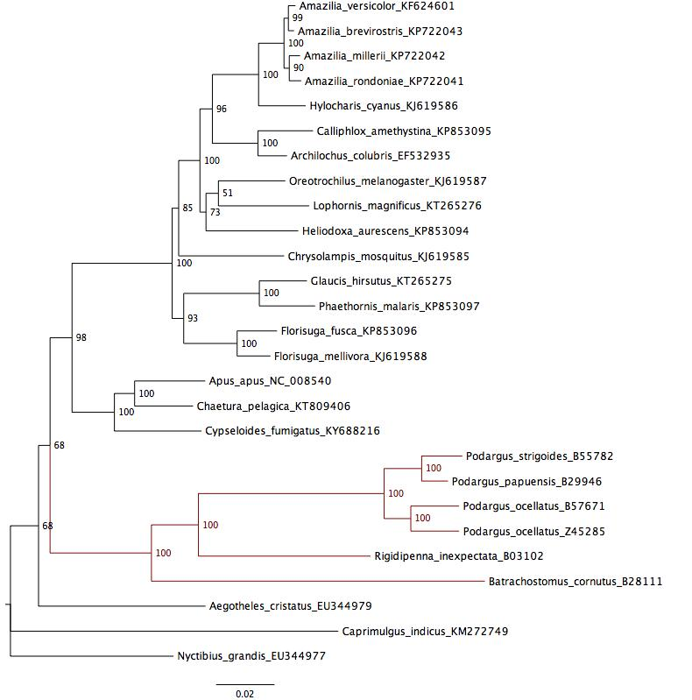

Figure S2. Bayesian phylogeny for Caprimulgiformes estimated using MrBayes and our full mitochondrial genome dataset (7,188bp). Podargidae branches are highlighted in red. Scale is in number of substitutions. Values associated with nodes reflect Bayesian posterior probabilities. All Podargidae mitochondrial genomes were newly generated in this study (see electronic supplementary material, table S1).

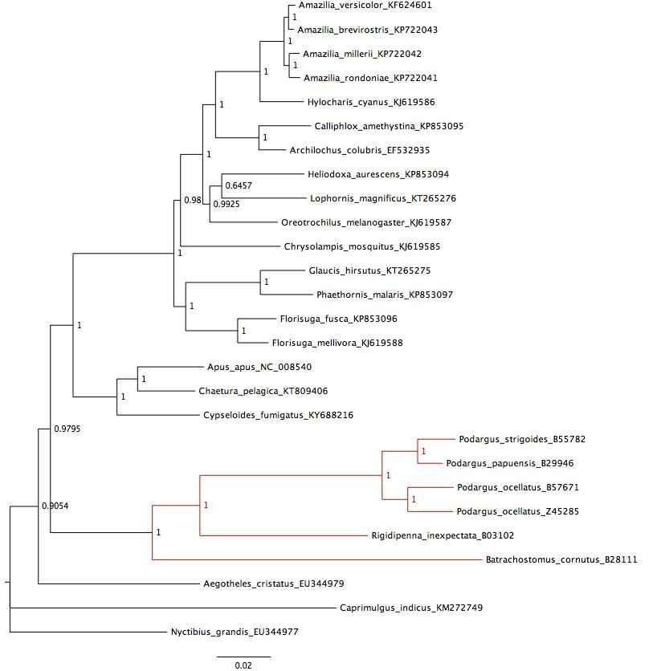

Figure S3. Chronogram for the Caprimulgiformes estimated using BEAST from a concatenated dataset of two nuclear and three mitochondrial genes. Scale axis is in millions of years before present. Podargidae branches are in red. Nodes at which topology was constrained are indicated with an asterisk. Bars associated with nodes reflect 95% Highest Posterior Densities of node age estimates. Values associated with branches reflect Bayesian posterior probabilities.
