A new marine woodground ichnotaxon from the Lower Cretaceous Mannville Group, Saskatchewan, Canada

Scott Melnyk¹, Stephen Packer¹, John-Paul Zonneveld¹ and Murray K. Gingras¹

¹Department of Earth and Atmospheric Sciences, University of Alberta, Edmonton, Alberta, Canada, T6E 2E3; e-mail: smelnyk@ualberta.ca

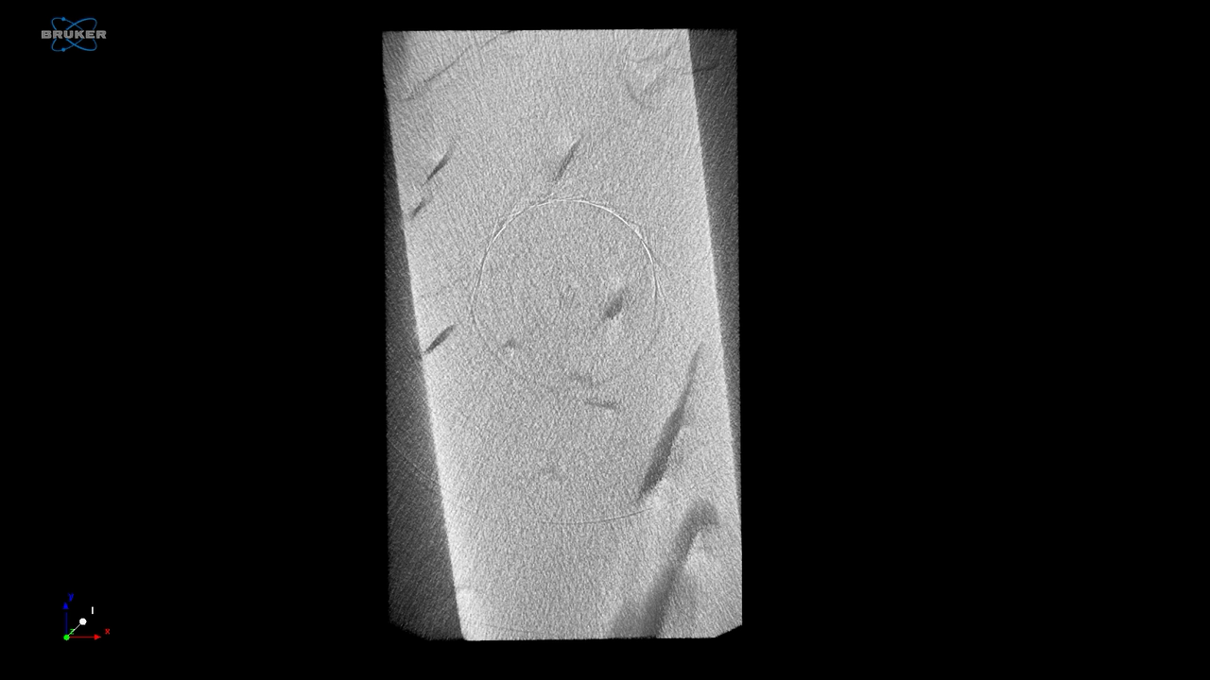
Supplemental Data 1. Computed Tomography (CT) Scan movie of paratype UAI080 showing the internal structure of Apectoichnus lignummasticans.

