Appendix 1. Maximum, median, and minimum of environmental factors at each sampling site. Abbreviations are as follows: 4-km forest/250-m forest: forest cover within 4-km and 250-m of each sampling site; Temperature: average temperature during breeding season.

 | 4-km forest (%) | 250-m forest (%) | Temperature (°C) | Elevation (m)
Maximum | 99.66 | 95.63 | 19.43 | 1082
Median | 70.24 | 50.77 | 16.9 | 100
Minimum | 0.79 | 0 | 12.83 | 2

Appendix 2. Value of each environmental factor at the centre of each 500 × 500-m grid. Abbreviations are as follows: 4-km forest/250-m forest: forest cover within 4-km and 250-m of the centre of each grid; Temperature: average temperature during breeding season.
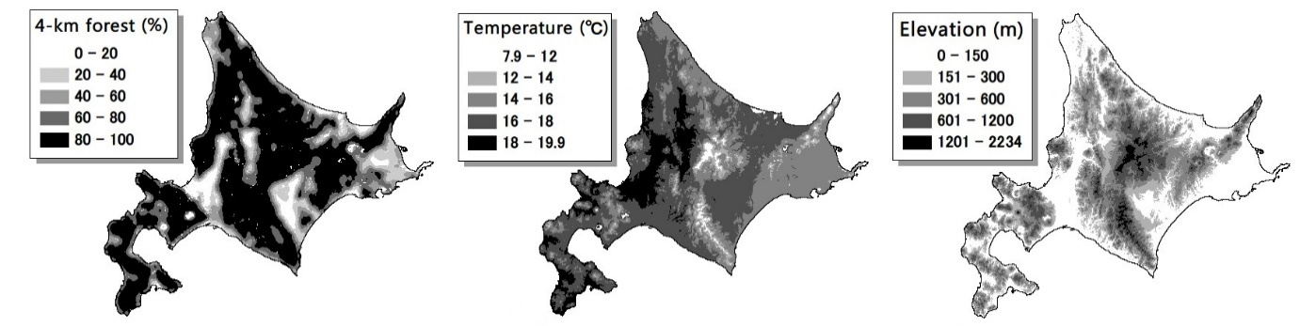
Appendix 3. Correlation coefficients and scatter plots among five environmental factors at the sampling sites, and histograms of each environmental factor. The name of the environmental factor is written in each histogram. The vertical axis of a scatter plot corresponds to the right histogram, and horizontal axis of a scatter plot corresponds to the upper histogram. A correlation coefficient was calculated from two environmental factors corresponding to left and upper histograms. Abbreviations are as follows: 4-km forest/250-m forest: forest cover within 4-km and 250-m of each sampling site; Temperature: average temperature during breeding season. All environmental factors were standardised.
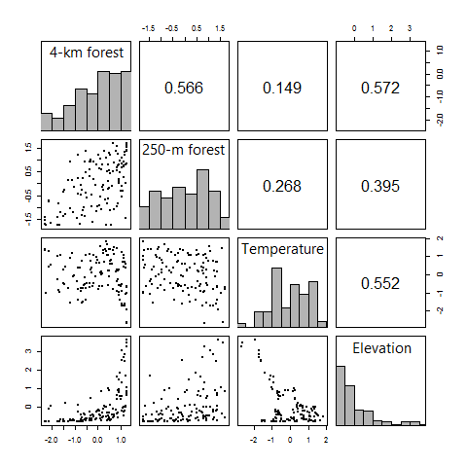

Appendix 4. Monthly average temperature during the breeding season at each sampling site. Dots represent the monthly average temperature at each sampling site; dots representing the value at the same sampling site are connected by dotted lines. All values are derived from Mesh Climate Value 2000, which is a contiguous nationwide grid consisting of 1-km² squares with 30-year (1971–2000) mean monthly temperatures, provided by the Meteorological Agency of Japan.
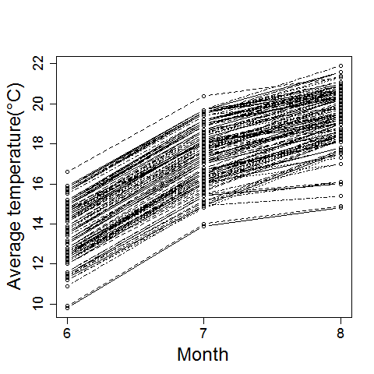

Appendix 5. Details of the N-mixture model.
In the N-mixture model, the latent (partially observed) abundance of the Jungle Nightjar at site i (${\text{N}}_{\text{i}}$) was assumed as a Poisson random variable:
${\text{N}}_{\text{i}} \sim \text{Poisson(}λ_{\text{i}}\text{)}$, Eq. 1
where $λ_{\text{i}}$ is the expected abundance at site i, modelled as a function of the explanatory variables:
$\text{log(}{\text{λ}}_{\text{i}}\text{)}={\text{β}}_{\text{0}}+\sum_{\text{k}=\text{1}}^{\text{K}}{{\text{β}}_{\text{k}}}{\text{x}}_{\text{ki}}$, Eq. 2
where ${\text{β}}_{\text{0}}$ is the intercept term, ${\text{β}}_{\text{k}}$ is a vector of the regression parameters of the explanatory variable k, and ${\text{x}}_{\text{ki}}$ is a vector of k at site i. The number of individuals detected at site i for visit j (${\text{y}}_{\text{ij}}$) was assumed to follow a binomial distribution:
${\text{y}}_{\text{ij}} \sim \text{Binomial(}{\text{N}}_{\text{i}}\text{, }{\text{p}}_{\text{ij}}\text{)}$, Eq. 3
where ${\text{p}}_{\text{ij}}$ is the detection probability of an individual at site i for visit j, also modelled as a function of the explanatory variables as
$\text{logit(}{\text{p}}_{\text{ij}}\text{)}={\text{α}}_{\text{0}}+\sum_{\text{k}\text{=1}}^{\text{K}}{{\text{α}}_{\text{k}}}{\text{v}}_{\text{kij}}$, Eq. 4
where ${\text{α}}_{\text{0}}$is the intercept term,${\text{α}}_{\text{k}}$ is a vector of the regression parameters of explanatory variable k, and ${\text{v}}_{\text{kij}}$ is a vector of k at site i for visit j.

Appendix 6. Results of model averaging for the N-mixture models when we used observation clock time and its squared term as explanatory variables in the detection model. Abbreviations are as follows: SE: standard error; z: Wald statistic; Pr(> |z|): p-value derived from z; RIV: relative importance of variables; 4-km forest/250-m forest: forest cover within 4-km and 250-m of each sampling site; Temperature: average temperature during breeding season; Observation time: clock time when a survey was started.

Variables |  | Coefficient | SE | Z | Pr(> |z|) | RIV | N containing models
Abundance | Intercept | −0.84 | 0.36 | 2.327 | 0.02
 | 250-m forest | −0.01 | 0.21 | 0.063 | 0.95 | 0.05 | 1
 | (250-m forest)² | −0.22 | 0.25 | 0.881 | 0.38 | 0.2 | 3
 | 4-km forest | 1.39 | 0.68 | 2.036 | 0.042 | 1 | 13
 | (4-km forest)² | −1.85 | 0.77 | 2.394 | 0.017 | 1 | 13
 | Temperature | 0.45 | 0.26 | 1.744 | 0.082 | 0.71 | 9
 | Elevation | −0.53 | 0.42 | 1.261 | 0.21 | 0.38 | 5
Detection probability | Intercept | 0.57 | 0.49 | 1.15 | 0.25
 | Observation time | 0.11 | 0.13 | 0.844 | 0.40 | 0.69 | 9
 | (Observation time)² | −0.017 | 0.06 | 0.283 | 0.78 | 0.36 | 5
 | Observation date | 0.01 | 0.02 | 0.499 | 0.62 | 0.06 | 1
RIV takes a value between zero and one, and high RIV indicates that the variable is important.
Number of containing models indicates the number of models containing the variable among models with ∆AIC < 2.

Appendix 7. Results of model selection. All N-mixture models with ∆AIC < 2 are shown below. The numbers in parentheses represent model rank. Meanings of abbreviations are as follows: Coef: coefficient; SE: standard error; z: Wald statistic; Pr(> |z|): p-value derived from z; 4-km forest/250-m forest: forest cover within 4-km and 250-m of each sampling site; Temperature: average temperature during breeding season.

Variables |  | - ∆AIC: 0 |  |  |  |  | - ∆AIC: 1.02 |  |  |  |  | - ∆AIC: 1.06
 |  | Coef | SE | z | Pr(> |z|) |  | Coef | SE | z | Pr(> |z|) |  | Coef | SE | z | Pr(> |z|)
Abundance | Intercept | −0.96 | 0.33 | −2.86 | 0.004 |  | −1.05 | 0.35 | −3.01 | 0.003 |  | −0.94 | 0.34 | −2.8 | 0.005
 | 250-m forest
 | (250-m forest)²
 | 4-km forest | 1.12 | 0.62 | 1.81 | 0.070 |  | 1.34 | 0.66 | 2.04 | 0.042 |  | 1.73 | 0.62 | 2.78 | 0.005
 | (4-km forest)² | −1.72 | 0.75 | −2.28 | 0.022 |  | 1.71 | 0.75 | −2.28 | 0.023 |  | −2.05 | 0.75 | −2.73 | 0.006
 | Temperature | 0.52 | 0.25 | 2.11 | 0.035 |  | 0.38 | 0.28 | 1.40 | 0.16
 | Elevation |  |  |  |  |  | −0.42 | 0.44 | −0.96 | 0.34 |  | −0.67 | 0.39 | −1.72 | 0.086
Detection probability | Intercept | 0.6 | 0.42 | 1.45 | 0.15 |  | 0.6 | 0.42 | 1.45 | 0.147 |  | 0.61 | 0.41 | 1.46 | 0.144
 | Observation date
Variables |  | (4) ∆AIC: 1.24 |  |  |  |  | (5) ∆AIC: 1.4 |  |  |  |  | (6) ∆AIC: 1.99
 |  | Coef | SE | z | Pr(> |z|) |  | Coef | SE | z | Pr(> |z|) |  | Coef | SE | z | Pr(> |z|)
Abundance | Intercept | −0.82 | 0.37 | −2.21 | 0.027 |  | −0.97 | 0.33 | −2.93 | 0.003 |  | −0.96 | 0.34 | −2.86 | 0.0042
 | 250-m forest |  |  |  |  |  |  |  |  |  |  | 0.03 | 0.21 | 0.12 | 0.90
 | (250-m forest)² | −0.21 | 0.25 | −0.84 | 0.40
 | 4-km forest | 1.14 | 0.62 | 1.83 | 0.067 |  | 1.13 | 0.62 | 1.81 | 0.070 |  | 1.11 | 0.63 | 1.78 | 0.074
 | (4-km forest)² | −1.72 | 0.75 | −2.27 | 0.023 |  | −1.72 | 0.75 | −2.29 | 0.022 |  | −1.73 | 0.76 | −2.29 | 0.022
 | Temperature | 0.54 | 0.25 | 2.12 | 0.030 |  | 0.52 | 0.25 | 2.11 | 0.035 |  | 0.53 | 0.25 | 2.09 | 0.037
 | Elevation
Detection probability | Intercept | 0.59 | 0.42 | 1.42 | 0.155 |  | 0.29 | 0.55 | 0.53 | 0.60 |  | 0.60 | 0.42 | 1.45 | 0.14
 | Observation date |  |  |  |  |  | 0.02 | 0.02 | 0.759 | 0.45

Appendix 8. Results of the Generalised Linear Mixed Models (GLMMs) used to test for the effect of spatial autocorrelation among sites. (a) The GLMM, wherein the maximum number of detected individuals at each sampling site was treated as the response variable, seven environmental factors were treated as explanatory variables, and each study region was treated as a single random variable. The random variable was assumed to follow a normal distribution with a mean of zero and a standard deviation of s (s was estimated to be 0.60). (b) The most parsimonious GLMM, wherein environmental factors that were significant in other analyses (i.e., 4-km forest, its squared term and the average temperature) were treated as explanatory variables, and the remaining variables were the same as for (a) (s was estimated to be 0.61). (a–b) Abbreviations are as follows: SE: standard error; z: Wald statistic; Pr(> |z|): p-value derived from z; 4-km forest/250-m forest: forest cover within 4-km and 250-m of each sampling site; Temperature: average temperature during breeding season.

Variables | (a) |  |  |  |  |  | (b)
 | Coefficient | SE | z | Pr(> |z|) |  |  | Coefficient | SE | Z | Pr(> |z|)
Intercept | −1.23 | 0.44 | −2.773 |  | 0.006 |  | −1.26 | 0.4 | −3.113 | 0.002
4-km forest | 1.49 | 0.70 | 2.117 |  | 0.034 |  | 1.23 | 0.66 | 1.853 | 0.064
(4-km forest)² | −1.69 | 0.83 | −2.041 |  | 0.041 |  | −1.8311 | 0.84 | −2.171 | 0.030
250-m forest | -0.02 | 0.23 | −0.101 |  | 0.92
(250-m forest)² | −0.24 | 0.26 | −0.907 |  | 0.37
Temperature | 0.26 | 0.36 | 0.743 |  | 0.46 |  | 0.43 | 0.31 | 1.397 | 0.16
Elevation | −0.27 | 0.45 | −0.591 |  | 0.56

