Appendix B

Balance measurements

Dynamic balance measurements
Timed Up and Go (1)
Description | Illustration
The subject was instructed to stand up from a chair (approximately 45 cm high), walk three meters, turn around the taped mark (see black arrow), walk back and sit down on the chair in a comfortable, safe pace (with closed, flat comfortable shoes). This was also demonstrated by the assessor and questions were answered after the instruction.

The starting position was with the back against the backrest and both arms on armrests.

The stopwatch (recording 100th of a second) was started when the subjects initiated movement and stopped when the subject’s rear touched the chair.

Habitual walking aids were allowed.

Two trials were recorded without practice trials.

Step Test (1)
Description | Illustration
The subject was instructed to stand unsupported with feet parallel (with closed, flat comfortable shoes) approximately 5 cm from the step bench (height 10 cm). The subject was asked to place the foot of the dominant leg up on to the step bench and down on the floor as many times as possible in 15 seconds. This was also demonstrated by the assessor and questions were answered after the instruction.

Definition of one step: foot moving from floor, on to step bench, and back down on floor.

The stopwatch (recording 100th of a second) was started when the foot began to lift from the floor and stopped after 15 seconds or if the subject needed support or the foot on the standing leg moved. Two trials were recorded without practice trials.

Static balance measurements
modified Clinical Test of Sensory Integration and Balance
Description | Illustration
The subject was instructed to stand as quiet as possible (with closed, flat comfortable shoes) in four different conditions: 1. firm surface, eyes open, 2. firm surface, eyes closed, 3. foam surface, eyes open and 4. foam surface, eyes closed on a balance platform. The subject was informed of each condition before execution. Each condition was initiated with a “3-2-1-go”-countdown. Questions were answered after the instruction.

The subject was asked to stand with feet hip width apart, arms alongside the body, and to look straight ahead (the cursor was off).

Duration of each condition was 20 seconds with a 10 seconds rest between each condition.

Two trials were recorded without practice trials.
The mCTSIB was performed on a balance platform (BioSway Portable Balance System 950-460, Biodex Medical Systems, NY).

Feet-Together stance (1)
Description | Illustration
The subject was instructed to stand as long as possible with feet together (with closed, flat comfortable shoes) and arms alongside the body with eyes open. This was also demonstrated by the assessor and questions were answered after the instruction.

The stopwatch (recording 100th of a second) was started when the subject was ready and stood unsupported in the correct position and stopped after 60 seconds or if the subject lost balance (defined as a step or arm elevation above approximately 45 degrees).

Two trials were recorded without practice trials.

Tandem-Stance (1)
Description | Illustration
The subject was instructed to stand as long as possible with the dominant foot in front of the non-dominant foot (with closed, flat comfortable shoes) so the toes of the rear foot touched the heel of the front foot. Arms were alongside the body and eyes open. This was also demonstrated by the assessor and questions were clarified after the instruction.

The stopwatch (recording 100th of a second) was started when the subject was ready and stood unsupported in the correct position and stopped after 40 seconds or if the subject lost balance (defined as a step or arm elevation above approximately 45 degrees).

Two trials were recorded without practice trials.

One-Leg-Stance eyes open and eyes closed (1)
Description | Illustration
The subject was instructed to stand as long as possible on the dominant leg (with closed, flat comfortable shoes) with eyes open. The non-dominant leg was raised from the floor and it was not permitted to touch the standing leg. Arms were alongside the body. This was also demonstrated by the assessor and questions were answered after the instruction.

The stopwatch (precision of 100th of a second) was started when the participant was ready and stood unsupported in the correct position and stopped after 40 seconds or if the subject lost balance (defined as a step or arm elevation above approximately 45 degrees).

Two trials were recorded without practice trials.

If the subject maintained balance for at least 30 seconds, the same test position was repeated with eyes closed.

Each trial was separated by a 15-seconds rest to avoid muscle fatigue.

Functional mobility measurements
10-meters Walk Test (maximum pace) (1)
Description | Illustration
The subject was instructed to walk as fast as possible, yet safely, on a 13-meter walk way. The subject was asked to walk on “go” once the assessor said “ready-set-go” (with closed, flat comfortable shoes). This was also demonstrated by the assessor and questions were answered after the instruction.  The 10mWT was performed on a 13-meters walk way with 1.5-meters for acceleration and 1.5-meters for deceleration. The start and finish were marked with tape and cones.  The stopwatch (recording 100th of a second) was started when the subject’s trunk passed the 1.5-meters mark and stopped at the 11.5-meters mark.  Habitual walking aids were allowed.  Two trials were recorded without practice trials. | 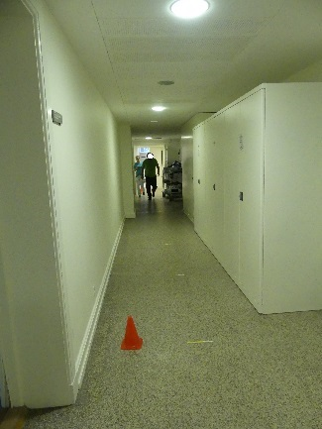

10-times Sit-To-Stand test (2)
Description | Illustration
The subject was instructed to stand up from a chair in a fully upright stance and sit down on a chair (the height was approximately 45 cm) 10 times as fast as possible with arms crossed in front of chest (with closed, flat comfortable shoes). This was also demonstrated by the assessor and questions were answered after the instruction.  The stopwatch (precision of 100th of a second) was started when the subject’s back left the backrest and stopped when the rear touched the chair. Two trials were recorded without practice trials. | 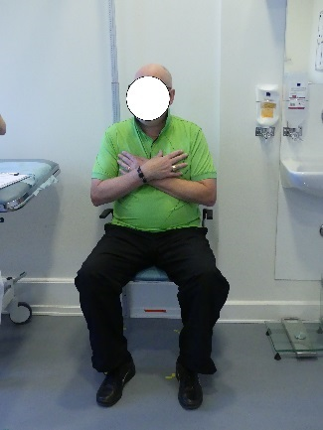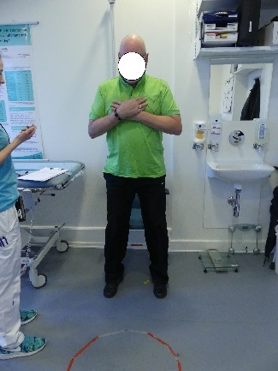

Muscle strength measurements

Stationary Dynamometry measurements
Stationary Dynamometry
Description | Illustrated
The subject was instructed to perform three maximal isometric muscle contractions by pushing against the dynamometer’s lever arm:
Ankle plantar flexion: push forefoot and toes away from the face
Ankle dorsal flexion: push forefoot and toes toward the face
Knee extension: stretch the leg
Knee flexion: bend the leg
Hip flexion: press knee towards the face
Hip extension: press knee away from the face

The subject was permitted to begin after a “ready-set-push”-countdown.

This was also demonstrated by the assessor and questions were answered after the instruction.

Standardized verbal encouragement (“push, push, push”) was provided during muscle contraction.

The flexor and extensor muscles were tested alternately in the following order in the dominant leg with shoes: 1. ankle, 2. knee, and 3. hip.

Before each contraction, the push direction was clarified and a “ready-set-push”-countdown was provided.

The contraction time was 5 seconds and rest time 17 seconds between agonist and antagonist muscle groups (approximately 40 seconds rest for a single muscle group).

Two practice trials (50 % of maximum strength) were conducted followed by three maximum recorded trials.
Positions for Stationary Dynamometry
Muscle group | Participant position | Dynamometer position | Stabilization | Illustration
Ankle plantar flexors | Sitting, knee angle 120°, ankle 24° dorsal flexed from maximal plantar flexion | Proximal and distal straps on dorsum pedis | Straps placed across the trunk, waist, distal thigh and proximal and distal foot, hands around handgrips.
Ankle dorsal flexors | Sitting, knee angle 120°, ankle 24° dorsal flexed from maximal plantar flexion | Proximal and distal straps on dorsum pedis | Straps placed across the trunk, waist, distal thigh and proximal and distal foot, hands around handgrips.
Knee flexors | Sitting, knee 85° flexed from in situ | Just proximal to malleoli | Straps placed across the trunk, waist, distal thigh and distal crus, hands around handgrips.
Knee extensors | Sitting, knee 85° flexed from in situ | Just proximal to malleoli | Straps placed across the trunk, waist, distal thigh and distal crus, hands around handgrips.
Hip flexors | Supine, hip 85° flexed from in situ, knee flexed | Just proximal to femoral condyles | Straps placed across the trunk, waist and distal thigh, hands around trunk straps.
Hip extensors | Supine, hip 85° flexed from in situ, knee flexed | Just proximal to femoral condyles | Straps placed across the trunk, waist and distal thigh, hands around trunk straps.

Hand-Held Dynamometry measurements
Hand-Held Dynamometry
Description | Illustration
The subject was instructed to perform three maximal isometric muscle contractions by pushing against the assessor once a “ready-set-push”-countdown was given:  Ankle plantar flexion: push forefoot and toes away from the face  Ankle dorsal flexion: push forefoot and toes toward the face  Knee extension: stretch the leg  Knee flexion: bend the leg  Hip flexion: press knee towards the face  Hip extension: press knee away from the face  This was also demonstrated by the assessor and questions were clarified after the instruction.  Standardized verbal encouragement (“push, push, push”) was provided during muscle contraction.  The flexor and extensor muscles were tested alternately in the following order in the dominant leg without shoes: 1. ankle, 2. knee, and 3. hip.  Before each contraction, the push direction was clarified and a “ready-set-push”-countdown was provided.  This was an isometric make test for all muscles tested (no movement).  The contraction time was 5 seconds with 17 seconds rest (measured with a stopwatch with a precision of 1/100 s) between opposite muscle groups (approximately 40 seconds rest for each muscle group).  Two practice trials (50 % of maximum strength) were conducted followed by three maximum recorded trials. | 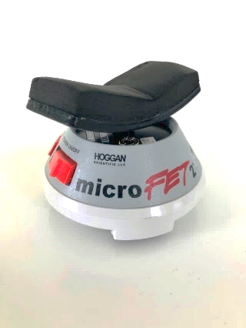
Positions for Hand-Held Dynamometry
Muscle group | Participant position | Dynamometer position | Illustration
Ankle plantar flexors | Supine, arms crossed, calf supported on a pillow, knee angle 120°, ankle 24° dorsal flexed from maximal plantar flexion | Just proximal to metatarsophalangeal joints
Ankle dorsal flexors | Supine, arms crossed, calf supported on a pillow, knee angle 120°, ankle 24° dorsal flexed from maximal plantar flexion | Just proximal to metatarsophalangeal joints
Knee flexors | Sitting, arms crossed, knee 85° flexed from in situ | Just proximal to malleoli | 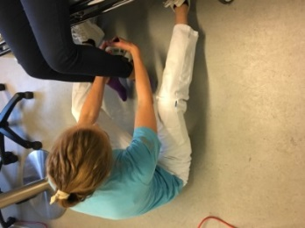
Knee extensors | Sitting, arms crossed, knee 85° flexed from in situ | Just proximal to malleoli
Hip flexors | Supine, arms crossed, calf supported on a pillow, hip 85° flexed from in situ, knee flexed | Just proximal to femoral condyles
Hip extensors | Supine, arms crossed, calf supported on a pillow, hip 85° flexed from in situ, knee flexed | Just proximal to femoral condyles
The degrees were visually estimated.

References
1. Hammarén E, Ohlsson JA, Lindberg C, Kjellby-Wendt G. Reliability of static and dynamic balance tests in subjects with myotonic dystrophy type 1. Advances in Physiotherapy. 2012 Jun;14(2):48–54.
2. Kierkegaard M, Petitclerc E, Hébert LJ, Gagnon C. Is one trial enough for repeated testing? Same-day assessments of walking, mobility and fine hand use in people with myotonic dystrophy type 1. Neuromuscul Disord. 2017 Feb;27(2):153–8.

