Welcome, A.K., and Van Wyk, B.-E., Spatial patterns, availability and cultural preferences for edible plants in southern Africa
Supplementary Material (S1)

S1 Table 1 Distance matrix of the 19 language groups in the FSA region calculated based on language classification.
 | Herero | Kalanga | Kwangali | Lozi | Manyo | Mbukushu | NSotho | SSotho | Swati | Tsonga | Tswana | Venda | Wambo | Xhosa | Zulu | Ju│’hoan | Khoekhoe | Kxoe | !Xóõ
Herero | 0 | 3 | 3 | 3 | 3 | 3 | 3 | 3 | 3 | 3 | 3 | 3 | 3 | 3 | 3 | 12 | 14 | 14 | 12
Kalanga | 3 | 0 | 3 | 3 | 3 | 3 | 3 | 3 | 3 | 3 | 3 | 3 | 3 | 3 | 3 | 12 | 14 | 14 | 12
Kwangali | 3 | 3 | 0 | 3 | 3 | 3 | 3 | 3 | 3 | 3 | 3 | 3 | 3 | 3 | 3 | 12 | 14 | 14 | 12
Lozi | 3 | 3 | 3 | 0 | 3 | 3 | 3 | 3 | 3 | 3 | 3 | 3 | 3 | 3 | 3 | 12 | 14 | 14 | 12
Manyo | 3 | 3 | 3 | 3 | 0 | 3 | 3 | 3 | 3 | 3 | 3 | 3 | 3 | 3 | 3 | 12 | 14 | 14 | 12
Mbukushu | 3 | 3 | 3 | 3 | 3 | 0 | 3 | 3 | 3 | 3 | 3 | 3 | 3 | 3 | 3 | 12 | 14 | 14 | 12
N Sotho | 3 | 3 | 3 | 3 | 3 | 3 | 0 | 3 | 3 | 3 | 3 | 3 | 3 | 3 | 3 | 12 | 14 | 14 | 12
S Sotho | 3 | 3 | 3 | 3 | 3 | 3 | 3 | 0 | 3 | 3 | 3 | 3 | 3 | 3 | 3 | 12 | 14 | 14 | 12
Swati | 3 | 3 | 3 | 3 | 3 | 3 | 3 | 3 | 0 | 3 | 3 | 3 | 3 | 3 | 3 | 12 | 14 | 14 | 12
Tsonga | 3 | 3 | 3 | 3 | 3 | 3 | 3 | 3 | 3 | 0 | 3 | 3 | 3 | 3 | 3 | 12 | 14 | 14 | 12
Tswana | 3 | 3 | 3 | 3 | 3 | 3 | 3 | 3 | 3 | 3 | 0 | 3 | 3 | 3 | 3 | 12 | 14 | 14 | 12
Venda | 3 | 3 | 3 | 3 | 3 | 3 | 3 | 3 | 3 | 3 | 3 | 0 | 3 | 3 | 3 | 12 | 14 | 14 | 12
Wambo | 3 | 3 | 3 | 3 | 3 | 3 | 3 | 3 | 3 | 3 | 3 | 3 | 0 | 3 | 3 | 12 | 14 | 14 | 12
Xhosa | 3 | 3 | 3 | 3 | 3 | 3 | 3 | 3 | 3 | 3 | 3 | 3 | 3 | 0 | 3 | 12 | 14 | 14 | 12
Zulu | 3 | 3 | 3 | 3 | 3 | 3 | 3 | 3 | 3 | 3 | 3 | 3 | 3 | 3 | 0 | 12 | 14 | 14 | 12
Juhoansie | 12 | 12 | 12 | 12 | 12 | 12 | 12 | 12 | 12 | 12 | 12 | 12 | 12 | 12 | 12 | 0 | 6 | 6 | 4
Khoekhoe | 14 | 14 | 14 | 14 | 14 | 14 | 14 | 14 | 14 | 14 | 14 | 14 | 14 | 14 | 14 | 6 | 0 | 3 | 6
Kxo | 14 | 14 | 14 | 14 | 14 | 14 | 14 | 14 | 14 | 14 | 14 | 14 | 14 | 14 | 14 | 6 | 3 | 0 | 6
Xoo | 12 | 12 | 12 | 12 | 12 | 12 | 12 | 12 | 12 | 12 | 12 | 12 | 12 | 12 | 12 | 4 | 6 | 6 | 0

S1 Table 2 Distance matrix of geographical distances for the 19 language groups in the FSA region based on their distributions.
 | Herero | Kalanga | Kwangali | Lozi | Manyo | Mbukushu | NSotho | SSotho | Swati | Tsonga | Tswana | Venda | Wambo | Xhosa | Zulu | Ju│’hoan | Khoekhoe | Kxoe | !Xóõ
Herero | 0 | 813.7 | 199.4 | 518.8 | 192.8 | 294.7 | 1097 | 1317 | 1416 | 1376 | 609 | 1213 | 345.4 | 1538 | 1455 | 218.9 | 424.4 | 384 | 542.1
Kalanga | 813.7 | 0 | 907.2 | 450.8 | 786.1 | 550 | 391.6 | 918.3 | 741.1 | 653.1 | 397.2 | 442.2 | 1143 | 1205 | 876.7 | 624.5 | 1021 | 476 | 641
Kwangali | 199.4 | 907.2 | 0 | 527.4 | 124.4 | 357.2 | 1231 | 1501 | 1564 | 1512 | 772.4 | 1332 | 255.5 | 1730 | 1621 | 285.2 | 593 | 435.1 | 235.8
Lozi | 518.8 | 450.8 | 527.4 | 0 | 404.6 | 232.3 | 833.6 | 1276 | 1185 | 1103 | 556.2 | 892.4 | 782.1 | 1549 | 1298 | 300.9 | 879.2 | 153 | 698.5
Manyo | 192.8 | 786.1 | 124.4 | 404.6 | 0 | 237.7 | 1119 | 1420 | 1456 | 1400 | 679 | 1215 | 377.6 | 1659 | 1523 | 172.1 | 617.1 | 311.9 | 675.8
Mbukushu | 294.7 | 550 | 357.2 | 232.3 | 237.7 | 0 | 883.6 | 1223 | 1224 | 1164 | 473.8 | 976.8 | 597 | 1477 | 1301 | 78.56 | 649.7 | 89.27 | 537.7
N Sotho | 1097 | 391.6 | 1231 | 833.6 | 1119 | 883.6 | 0 | 604.5 | 351.1 | 280.7 | 515.4 | 157.9 | 1442 | 887.7 | 493.2 | 947.8 | 1179 | 826.9 | 726.5
S Sotho | 1317 | 918.3 | 1501 | 1276 | 1420 | 1223 | 604.5 | 0 | 490.7 | 594.5 | 748.7 | 713.9 | 1641 | 287.7 | 312.3 | 1258 | 1187 | 1204 | 784.2
Swati | 1416 | 741.1 | 1564 | 1185 | 1456 | 1224 | 351.1 | 490.7 | 0 | 130.8 | 810.7 | 344 | 1761 | 716.2 | 219.8 | 1284 | 1431 | 1173 | 974.8
Tsonga | 1376 | 653.1 | 1512 | 1103 | 1400 | 1164 | 280.7 | 594.5 | 130.8 | 0 | 782.8 | 227.6 | 1721 | 837 | 348 | 1228 | 1430 | 1105 | 972.3
Tswana | 609 | 397.2 | 772.4 | 556.2 | 679 | 473.8 | 515.4 | 748.7 | 810.7 | 782.8 | 0 | 654.4 | 952.7 | 1006 | 848.6 | 512.4 | 671.3 | 460.9 | 246.7
Venda | 1213 | 442.2 | 1332 | 892.4 | 1215 | 976.8 | 157.9 | 713.9 | 344 | 227.6 | 654.4 | 0 | 1554 | 986.2 | 537.4 | 1046 | 1324 | 910.7 | 876.4
Wambo | 345.4 | 1143 | 255.5 | 782.1 | 377.6 | 597 | 1442 | 1641 | 1761 | 1721 | 952.7 | 1554 | 0 | 1844 | 1795 | 519.8 | 565.6 | 680.8 | 856.9
Xhosa | 1538 | 1205 | 1730 | 1549 | 1659 | 1477 | 887.7 | 287.7 | 716.2 | 837 | 1006 | 986.2 | 1844 | 0 | 501.2 | 1505 | 1344 | 1467 | 995.9
Zulu | 1455 | 876.7 | 1621 | 1298 | 1523 | 1301 | 493.2 | 312.3 | 219.8 | 348 | 848.6 | 537.4 | 1795 | 501.2 | 0 | 1532 | 1405 | 1262 | 962.9
Juhoansie | 218.9 | 624.5 | 285.2 | 300.9 | 172.1 | 78.56 | 947.8 | 1258 | 1284 | 1228 | 512.4 | 1046 | 519.8 | 1505 | 1352 | 0 | 595.6 | 167 | 540.8
Khoekhoe | 424.4 | 1021 | 593 | 879.2 | 617.1 | 649.7 | 1179 | 1187 | 1431 | 1430 | 671.3 | 1324 | 565.6 | 1344 | 1405 | 595.6 | 0 | 726.9 | 458
Kxo | 384 | 476 | 435.1 | 153 | 311.9 | 89.27 | 826.9 | 1204 | 1173 | 1105 | 460.9 | 910.7 | 680.8 | 1467 | 1262 | 167 | 726.9 | 0 | 565.5
Xoo | 542.1 | 641 | 235.8 | 698.5 | 675.8 | 537.7 | 726.6 | 784.2 | 974.8 | 972.3 | 246.7 | 876.4 | 856.9 | 995.9 | 962.9 | 540.8 | 458 | 565.5 | 0

S1 Table 3 Distance matrix of the simmilarity of available species between the 19 language groups in the FSA region based on the Sorrensen index
 | Herero | Kalanga | Kwangali | Lozi | Manyo | Mbukushu | NSotho | SSotho | Swati | Tsonga | Tswana | Venda | Wambo | Xhosa | Zulu | Juhoansie | Khoekhoe | Kxo | Xoo
Herero | 0 | 0.74 | 0.69 | 0.70 | 0.70 | 0.73 | 0.71 | 0.70 | 0.70 | 0.70 | 0.73 | 0.72 | 0.75 | 0.68 | 0.69 | 0.77 | 0.79 | 0.74 | 0.70
Kalanga | 0.74 | 0 | 0.71 | 0.73 | 0.71 | 0.75 | 0.70 | 0.69 | 0.69 | 0.70 | 0.71 | 0.71 | 0.74 | 0.68 | 0.69 | 0.77 | 0.71 | 0.76 | 0.70
Kwangali | 0.69 | 0.71 | 0 | 0.71 | 0.80 | 0.71 | 0.68 | 0.67 | 0.67 | 0.67 | 0.68 | 0.68 | 0.71 | 0.67 | 0.67 | 0.72 | 0.68 | 0.71 | 0.69
Lozi | 0.70 | 0.73 | 0.71 | 0 | 0.72 | 0.73 | 0.68 | 0.67 | 0.68 | 0.68 | 0.69 | 0.69 | 0.70 | 0.67 | 0.68 | 0.73 | 0.68 | 0.74 | 0.69
Manyo | 0.70 | 0.71 | 0.80 | 0.72 | 0 | 0.72 | 0.68 | 0.67 | 0.68 | 0.68 | 0.68 | 0.68 | 0.71 | 0.67 | 0.67 | 0.74 | 0.68 | 0.73 | 0.69
Mbukushu | 0.73 | 0.75 | 0.71 | 0.73 | 0.72 | 0 | 0.69 | 0.68 | 0.68 | 0.69 | 0.70 | 0.70 | 0.73 | 0.67 | 0.68 | 0.79 | 0.69 | 0.81 | 0.70
NSotho | 0.71 | 0.70 | 0.68 | 0.68 | 0.68 | 0.69 | 0 | 0.76 | 0.83 | 0.86 | 0.80 | 0.80 | 0.69 | 0.74 | 0.79 | 0.70 | 0.70 | 0.70 | 0.68
SSotho | 0.70 | 0.69 | 0.67 | 0.67 | 0.67 | 0.68 | 0.76 | 0 | 0.77 | 0.75 | 0.77 | 0.73 | 0.68 | 0.77 | 0.79 | 0.68 | 0.71 | 0.68 | 0.68
Swati | 0.70 | 0.69 | 0.67 | 0.68 | 0.68 | 0.68 | 0.83 | 0.77 | 0 | 0.86 | 0.77 | 0.77 | 0.68 | 0.74 | 0.83 | 0.69 | 0.70 | 0.69 | 0.67
Tsonga | 0.70 | 0.70 | 0.67 | 0.68 | 0.68 | 0.69 | 0.86 | 0.75 | 0.86 | 0 | 0.77 | 0.79 | 0.69 | 0.74 | 0.81 | 0.69 | 0.70 | 0.69 | 0.67
Tswana | 0.73 | 0.71 | 0.68 | 0.69 | 0.68 | 0.70 | 0.80 | 0.77 | 0.77 | 0.77 | 0 | 0.76 | 0.70 | 0.73 | 0.77 | 0.71 | 0.73 | 0.71 | 0.68
Venda | 0.72 | 0.71 | 0.68 | 0.69 | 0.68 | 0.70 | 0.80 | 0.73 | 0.77 | 0.79 | 0.76 | 0 | 0.70 | 0.71 | 0.74 | 0.71 | 0.71 | 0.71 | 0.68
Wambo | 0.75 | 0.74 | 0.71 | 0.70 | 0.71 | 0.73 | 0.69 | 0.68 | 0.68 | 0.69 | 0.70 | 0.70 | 0 | 0.67 | 0.68 | 0.75 | 0.72 | 0.73 | 0.71
Xhosa | 0.68 | 0.68 | 0.67 | 0.67 | 0.67 | 0.67 | 0.74 | 0.77 | 0.74 | 0.74 | 0.73 | 0.71 | 0.67 | 0 | 0.78 | 0.68 | 0.69 | 0.68 | 0.67
Zulu | 0.69 | 0.69 | 0.67 | 0.68 | 0.67 | 0.68 | 0.79 | 0.79 | 0.83 | 0.81 | 0.77 | 0.74 | 0.68 | 0.78 | 0 | 0.68 | 0.69 | 0.68 | 0.67
Juhoansie | 0.77 | 0.77 | 0.72 | 0.73 | 0.74 | 0.79 | 0.70 | 0.68 | 0.69 | 0.69 | 0.71 | 0.71 | 0.75 | 0.68 | 0.68 | 0 | 0.71 | 0.81 | 0.71
Khoekhoe | 0.79 | 0.71 | 0.68 | 0.68 | 0.68 | 0.69 | 0.70 | 0.71 | 0.70 | 0.70 | 0.73 | 0.71 | 0.72 | 0.69 | 0.69 | 0.71 | 0 | 0.70 | 0.69
Kxo | 0.74 | 0.76 | 0.71 | 0.74 | 0.73 | 0.81 | 0.70 | 0.68 | 0.69 | 0.69 | 0.71 | 0.71 | 0.73 | 0.68 | 0.68 | 0.81 | 0.70 | 0 | 0.69
Xoo | 0.70 | 0.70 | 0.69 | 0.69 | 0.69 | 0.70 | 0.68 | 0.68 | 0.67 | 0.67 | 0.68 | 0.68 | 0.71 | 0.67 | 0.67 | 0.71 | 0.69 | 0.69 | 0

S1 Table 4 Distance matrix of the simmilarity of available edible species between the 19 language groups in the FSA region based on the Sorrensen index
 | Herero | Kalanga | Kwangali | Lozi | Manyo | Mbukushu | NSotho | SSotho | Swati | Tsonga | Tswana | Venda | Wambo | Xhosa | Zulu | Juhoansie | Khoekhoe | Kxo | Xoo
Herero | 0 | 0.78 | 0.71 | 0.73 | 0.72 | 0.76 | 0.74 | 0.72 | 0.73 | 0.73 | 0.76 | 0.75 | 0.79 | 0.71 | 0.72 | 0.81 | 0.84 | 0.78 | 0.71
Kalanga | 0.78 | 0 | 0.72 | 0.75 | 0.72 | 0.77 | 0.73 | 0.71 | 0.72 | 0.72 | 0.74 | 0.74 | 0.77 | 0.69 | 0.71 | 0.80 | 0.75 | 0.79 | 0.72
Kwangali | 0.71 | 0.72 | 0 | 0.73 | 0.80 | 0.72 | 0.68 | 0.68 | 0.68 | 0.68 | 0.69 | 0.69 | 0.73 | 0.67 | 0.68 | 0.73 | 0.70 | 0.73 | 0.71
Lozi | 0.73 | 0.75 | 0.73 | 0 | 0.73 | 0.77 | 0.70 | 0.68 | 0.69 | 0.70 | 0.70 | 0.71 | 0.73 | 0.68 | 0.69 | 0.77 | 0.71 | 0.78 | 0.71
Manyo | 0.72 | 0.72 | 0.80 | 0.73 | 0 | 0.74 | 0.69 | 0.68 | 0.68 | 0.68 | 0.69 | 0.69 | 0.72 | 0.68 | 0.68 | 0.75 | 0.70 | 0.74 | 0.71
Mbukushu | 0.76 | 0.77 | 0.72 | 0.77 | 0.74 | 0 | 0.71 | 0.69 | 0.70 | 0.70 | 0.71 | 0.71 | 0.75 | 0.68 | 0.70 | 0.80 | 0.73 | 0.83 | 0.72
NSotho | 0.74 | 0.73 | 0.68 | 0.70 | 0.69 | 0.71 | 0 | 0.80 | 0.88 | 0.89 | 0.85 | 0.86 | 0.71 | 0.79 | 0.86 | 0.72 | 0.74 | 0.72 | 0.69
SSotho | 0.72 | 0.71 | 0.68 | 0.68 | 0.68 | 0.69 | 0.80 | 0 | 0.81 | 0.79 | 0.81 | 0.77 | 0.70 | 0.82 | 0.82 | 0.70 | 0.74 | 0.70 | 0.69
Swati | 0.73 | 0.72 | 0.68 | 0.69 | 0.68 | 0.70 | 0.88 | 0.81 | 0 | 0.91 | 0.82 | 0.83 | 0.70 | 0.79 | 0.89 | 0.71 | 0.72 | 0.71 | 0.68
Tsonga | 0.73 | 0.72 | 0.68 | 0.70 | 0.68 | 0.70 | 0.89 | 0.79 | 0.91 | 0 | 0.83 | 0.86 | 0.70 | 0.79 | 0.88 | 0.72 | 0.73 | 0.71 | 0.68
Tswana | 0.76 | 0.74 | 0.69 | 0.70 | 0.69 | 0.71 | 0.85 | 0.81 | 0.82 | 0.83 | 0 | 0.81 | 0.72 | 0.78 | 0.83 | 0.74 | 0.76 | 0.73 | 0.69
Venda | 0.75 | 0.74 | 0.69 | 0.71 | 0.69 | 0.71 | 0.86 | 0.77 | 0.83 | 0.86 | 0.81 | 0 | 0.72 | 0.75 | 0.81 | 0.73 | 0.74 | 0.73 | 0.69
Wambo | 0.79 | 0.77 | 0.73 | 0.73 | 0.72 | 0.75 | 0.71 | 0.70 | 0.70 | 0.70 | 0.72 | 0.72 | 0 | 0.69 | 0.70 | 0.79 | 0.76 | 0.76 | 0.72
Xhosa | 0.71 | 0.69 | 0.67 | 0.68 | 0.68 | 0.68 | 0.79 | 0.82 | 0.79 | 0.79 | 0.78 | 0.75 | 0.69 | 0 | 0.82 | 0.69 | 0.72 | 0.69 | 0.68
Zulu | 0.72 | 0.71 | 0.68 | 0.69 | 0.68 | 0.70 | 0.86 | 0.82 | 0.89 | 0.88 | 0.83 | 0.81 | 0.70 | 0.82 | 0 | 0.71 | 0.72 | 0.71 | 0.68
Juhoansie | 0.81 | 0.80 | 0.73 | 0.77 | 0.75 | 0.80 | 0.72 | 0.70 | 0.71 | 0.72 | 0.74 | 0.73 | 0.79 | 0.69 | 0.71 | 0 | 0.76 | 0.83 | 0.73
Khoekhoe | 0.84 | 0.75 | 0.70 | 0.71 | 0.70 | 0.73 | 0.74 | 0.74 | 0.72 | 0.73 | 0.76 | 0.74 | 0.76 | 0.72 | 0.72 | 0.76 | 0 | 0.74 | 0.71
Kxo | 0.78 | 0.79 | 0.73 | 0.78 | 0.74 | 0.83 | 0.72 | 0.70 | 0.71 | 0.71 | 0.73 | 0.73 | 0.76 | 0.69 | 0.71 | 0.83 | 0.74 | 0 | 0.71
Xoo | 0.71 | 0.72 | 0.71 | 0.71 | 0.71 | 0.72 | 0.69 | 0.69 | 0.68 | 0.68 | 0.69 | 0.69 | 0.72 | 0.68 | 0.68 | 0.73 | 0.71 | 0.71 | 0

S1 Table 5 Distance matrix of the simmilarity of available edible species between 13 language groups with adequate ethnobotanical data based on the Sorrensen index
 | Herero | Kwangali | Manyo | NSotho | SSotho | Swati | Tsonga | Venda | Wambo | Xhosa | Zulu | Juhoansie | Khoekhoe
Herero | 0 | 0.71 | 0.72 | 0.74 | 0.72 | 0.73 | 0.73 | 0.75 | 0.79 | 0.71 | 0.72 | 0.81 | 0.84
Kwangali | 0.71 | 0 | 0.80 | 0.68 | 0.68 | 0.68 | 0.68 | 0.69 | 0.73 | 0.67 | 0.68 | 0.73 | 0.70
Manyo | 0.72 | 0.80 | 0 | 0.69 | 0.68 | 0.68 | 0.68 | 0.69 | 0.72 | 0.68 | 0.68 | 0.75 | 0.70
NSotho | 0.74 | 0.68 | 0.69 | 0 | 0.80 | 0.88 | 0.89 | 0.86 | 0.71 | 0.79 | 0.86 | 0.72 | 0.74
SSotho | 0.72 | 0.68 | 0.68 | 0.80 | 0 | 0.81 | 0.79 | 0.77 | 0.70 | 0.82 | 0.82 | 0.70 | 0.74
Swati | 0.73 | 0.68 | 0.68 | 0.88 | 0.81 | 0 | 0.91 | 0.83 | 0.70 | 0.79 | 0.89 | 0.71 | 0.72
Tsonga | 0.73 | 0.68 | 0.68 | 0.89 | 0.79 | 0.91 | 0 | 0.86 | 0.70 | 0.79 | 0.88 | 0.72 | 0.73
Venda | 0.75 | 0.69 | 0.69 | 0.86 | 0.77 | 0.83 | 0.86 | 0 | 0.72 | 0.75 | 0.81 | 0.73 | 0.74
Wambo | 0.79 | 0.73 | 0.72 | 0.71 | 0.70 | 0.70 | 0.70 | 0.72 | 0 | 0.69 | 0.70 | 0.79 | 0.76
Xhosa | 0.71 | 0.67 | 0.68 | 0.79 | 0.82 | 0.79 | 0.79 | 0.75 | 0.69 | 0 | 0.82 | 0.69 | 0.72
Zulu | 0.72 | 0.68 | 0.68 | 0.86 | 0.82 | 0.89 | 0.88 | 0.81 | 0.70 | 0.82 | 0 | 0.71 | 0.72
Juhoansie | 0.81 | 0.73 | 0.75 | 0.72 | 0.70 | 0.71 | 0.72 | 0.73 | 0.79 | 0.69 | 0.71 | 0 | 0.76
Khoekhoe | 0.84 | 0.70 | 0.70 | 0.74 | 0.74 | 0.72 | 0.73 | 0.74 | 0.76 | 0.72 | 0.72 | 0.76 | 0

S1 Table 6 Distance matrix of the simmilarity of utilised edible species between 13 language groups with adequate ethnobotanical data based on the Sorrensen index
 | Herero | Kwangali | Manyo | NSotho | SSotho | Swati | Tsonga | Venda | Wambo | Xhosa | Zulu | Juhoansie | Khoekhoe
Herero | 0 | 0.71 | 0.71 | 0.68 | 0.67 | 0.67 | 0.69 | 0.68 | 0.70 | 0.67 | 0.67 | 0.70 | 0.67
Kwangali | 0.71 | 0 | 1.00 | 0.68 | 0.67 | 0.67 | 0.69 | 0.68 | 0.69 | 0.67 | 0.67 | 0.69 | 0.67
Manyo | 0.71 | 1.00 | 0 | 0.68 | 0.67 | 0.67 | 0.69 | 0.68 | 0.69 | 0.67 | 0.67 | 0.69 | 0.67
NSotho | 0.68 | 0.68 | 0.68 | 0 | 0.67 | 0.68 | 0.68 | 0.68 | 0.68 | 0.67 | 0.68 | 0.68 | 0.67
SSotho | 0.67 | 0.67 | 0.67 | 0.67 | 0 | 0.68 | 0.68 | 0.70 | 0.68 | 0.67 | 0.69 | 0.67 | 0.67
Swati | 0.67 | 0.67 | 0.67 | 0.68 | 0.68 | 0 | 0.71 | 0.70 | 0.68 | 0.67 | 0.70 | 0.67 | 0.67
Tsonga | 0.69 | 0.69 | 0.69 | 0.68 | 0.68 | 0.71 | 0 | 0.72 | 0.70 | 0.67 | 0.70 | 0.68 | 0.67
Venda | 0.68 | 0.68 | 0.68 | 0.68 | 0.70 | 0.70 | 0.72 | 0 | 0.70 | 0.67 | 0.70 | 0.68 | 0.67
Wambo | 0.70 | 0.69 | 0.69 | 0.68 | 0.68 | 0.68 | 0.70 | 0.70 | 0 | 0.67 | 0.68 | 0.72 | 0.67
Xhosa | 0.67 | 0.67 | 0.67 | 0.67 | 0.67 | 0.67 | 0.67 | 0.67 | 0.67 | 0 | 0.67 | 0.67 | 0.67
Zulu | 0.67 | 0.67 | 0.67 | 0.68 | 0.69 | 0.70 | 0.70 | 0.70 | 0.68 | 0.67 | 0 | 0.67 | 0.67
Juhoansie | 0.70 | 0.69 | 0.69 | 0.68 | 0.67 | 0.67 | 0.68 | 0.68 | 0.72 | 0.67 | 0.67 | 0 | 0.67
Khoekhoe | 0.67 | 0.67 | 0.67 | 0.67 | 0.67 | 0.67 | 0.67 | 0.67 | 0.67 | 0.67 | 0.67 | 0.67 | 0

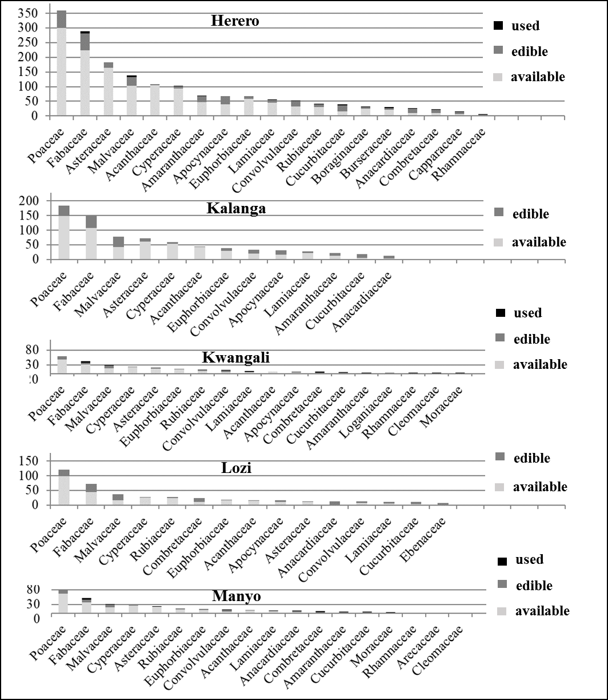
S1 Figure 1: Comparisons of the most species-rich food plant families in the Flora of southern African region, according to the numbers of available species, the numbers of edible species and the numbers of species that are actually used by the selected 13 cultural groups.
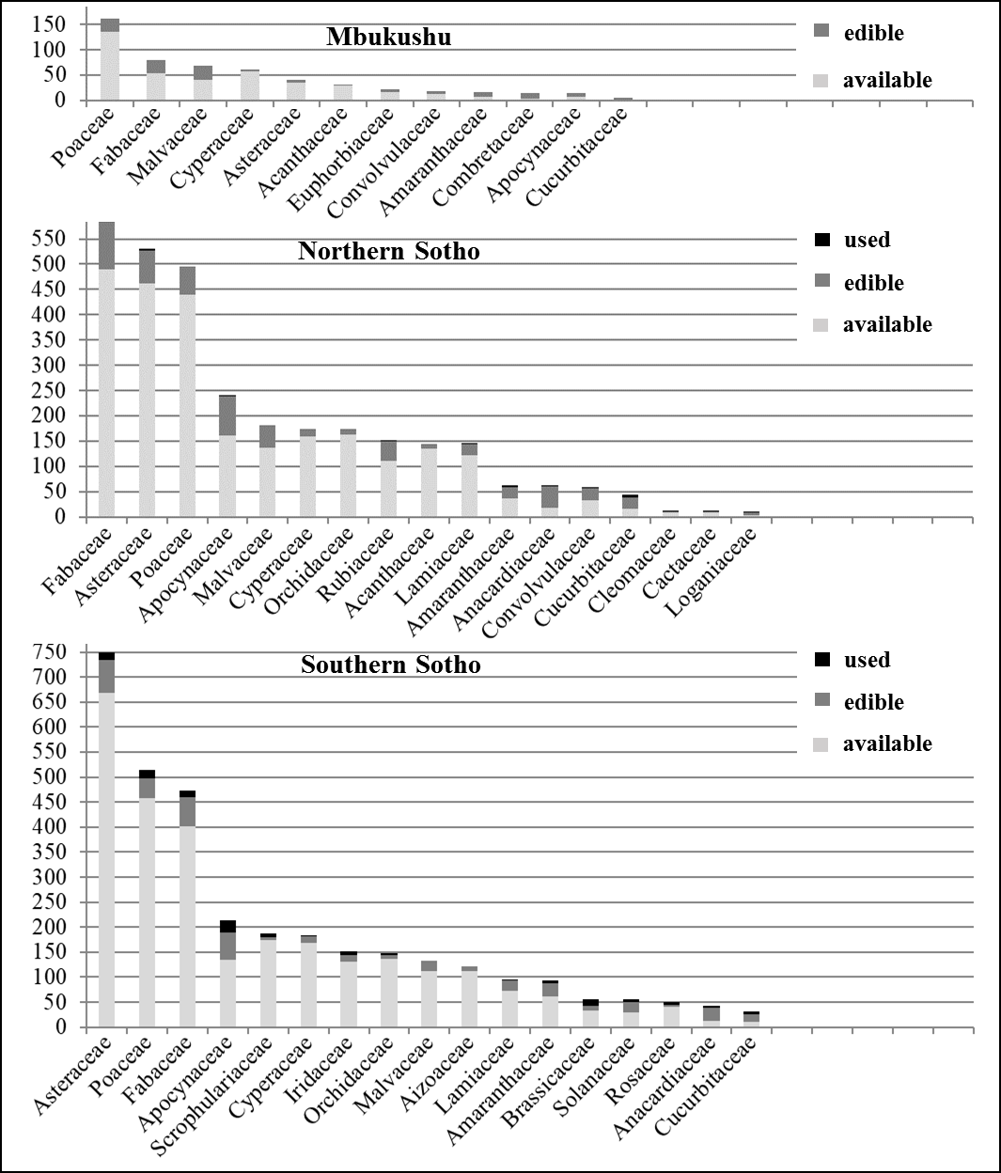
S1 Figure 1 contd.

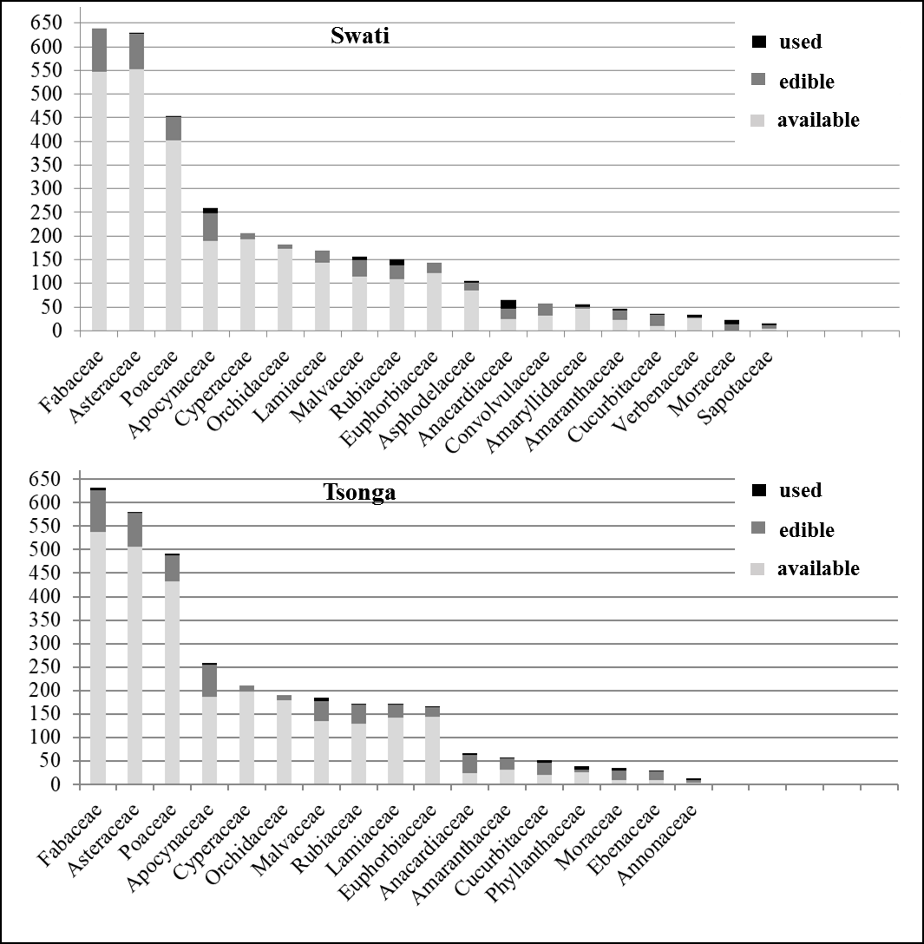
S1 Figure 1 contd.

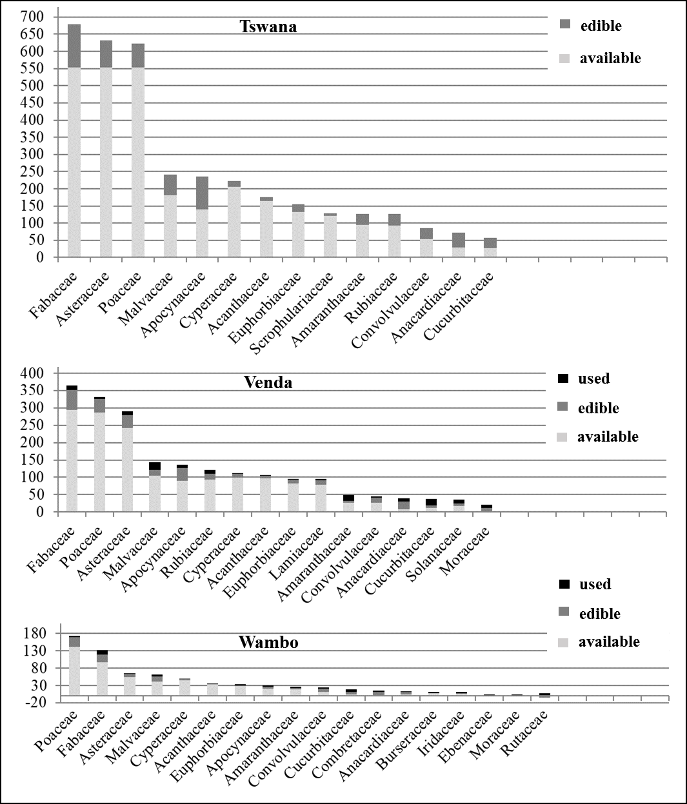
S1 Figure 1 contd.
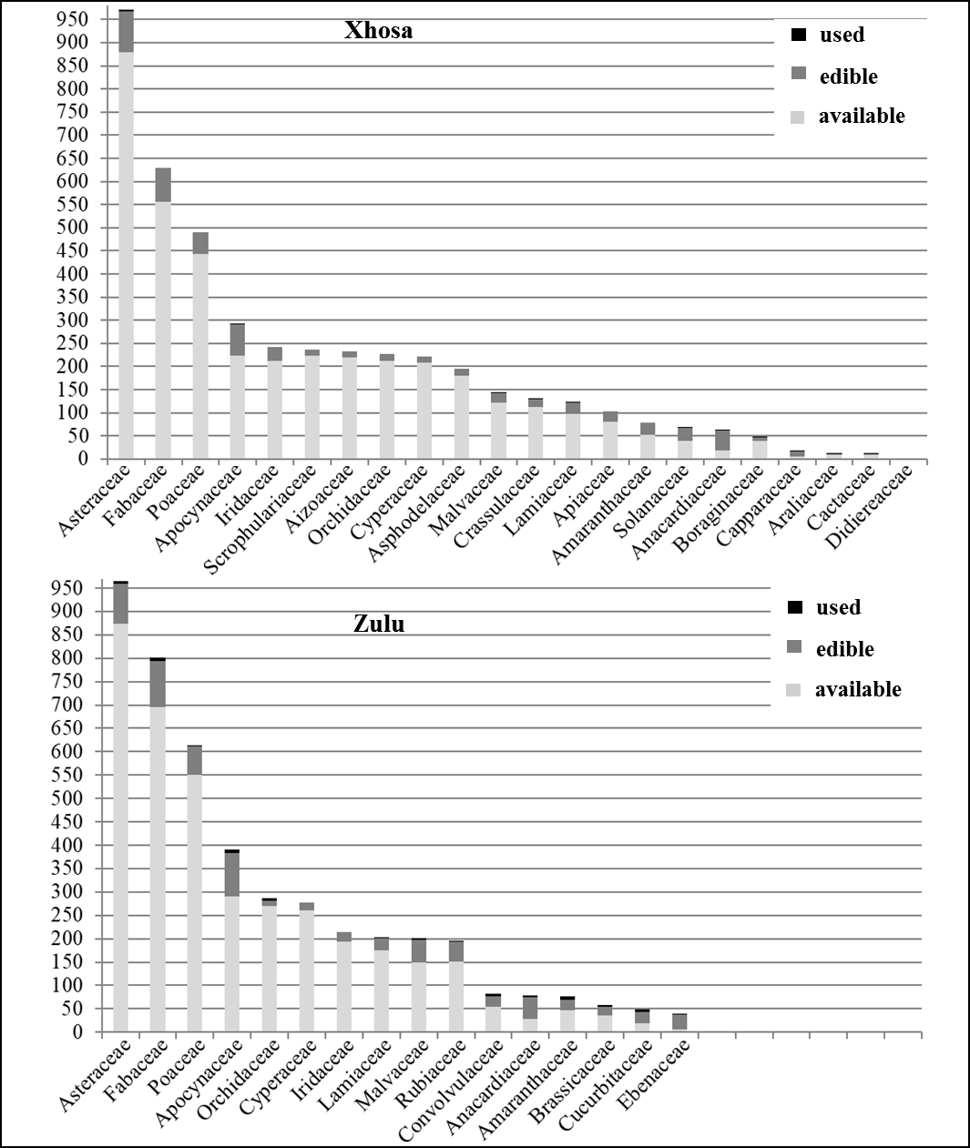
S1 Figure 1 contd.
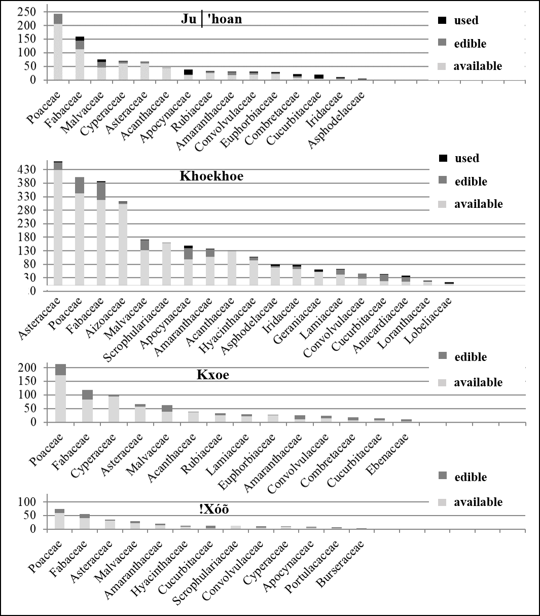
S1 Figure 1 contd.

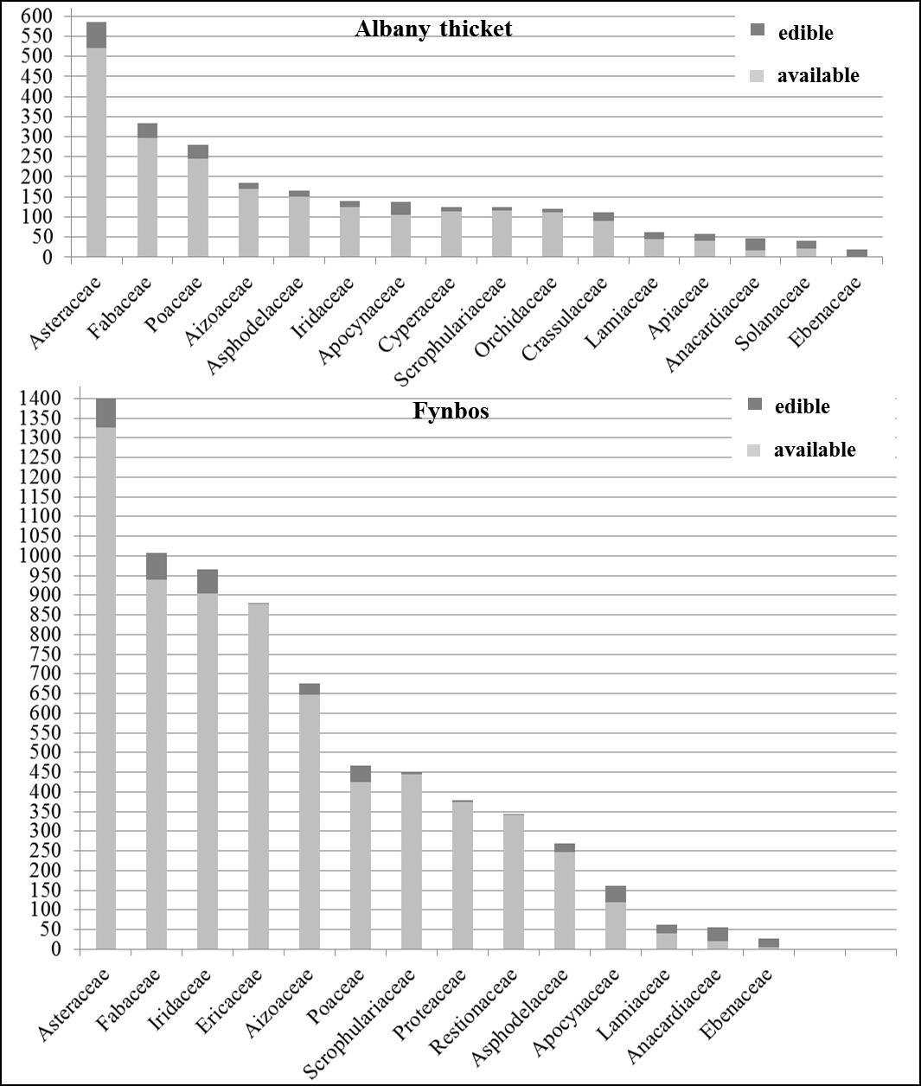

S1 Figure 2: Comparisons of the most species-rich, available and edible, food plant families within the distribution ranges of the Flora of southern Africa region's biomes.

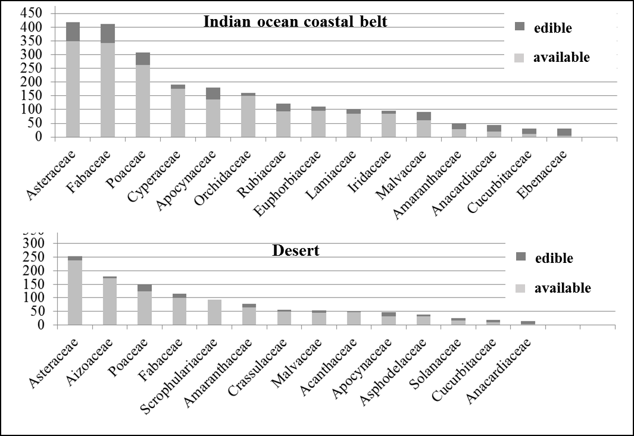
S1 Figure 2 contd.
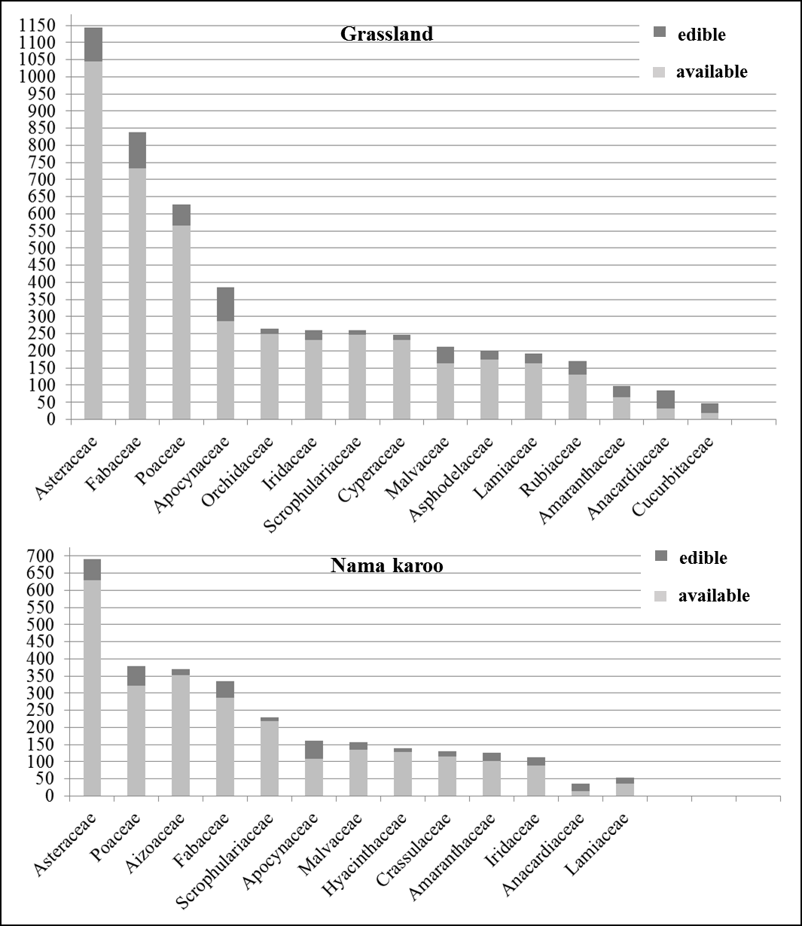
S1 Figure 2 contd.

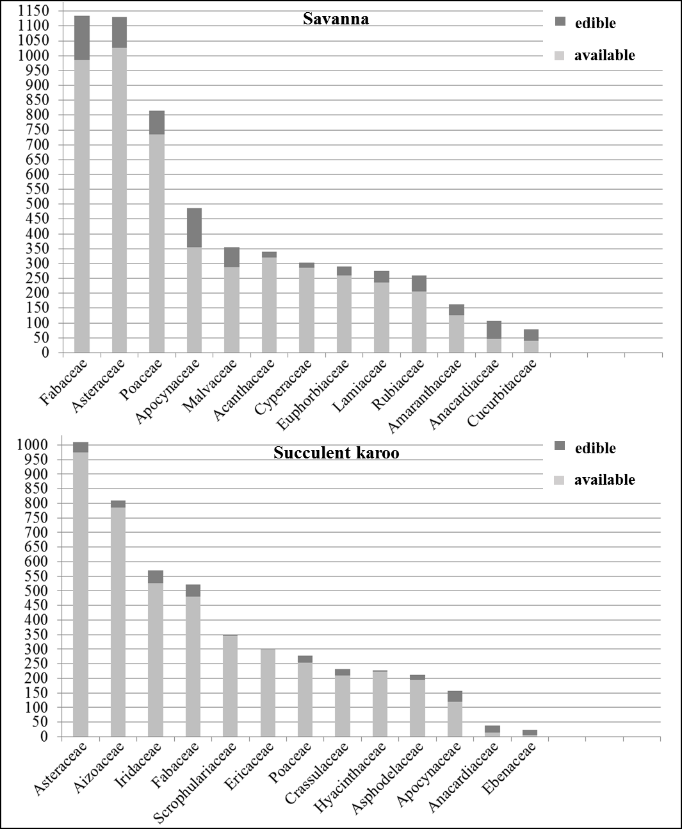
S1 Figure 2 contd.

