Supplementary Information for

Cellular bicarbonate accumulation and vesicular proton transport promote skeleton regeneration in the sea urchin larva

Marian Y. Hu¹, Inga Petersen¹, William Chang¹, Christine Blurton², Meike Stumpp²

¹Institute of Physiology, Christian-Albrechts-University Kiel, Hermann-Rodewaldstraße 5, 24118 Kiel, Germany. ²Institute of Immunobiology, Christian-Albrechts-University Kiel, Am Botanischen Garten 1-9, 24118 Kiel, Germany

Material and methods

Intracellular pH measurements and the CO2 pulse method

The CO₂ pulse technique was performed according to [1]. Briefly, FSW saturated with 5% CO₂ and Tris- buffered FSW (pH 8.0) were separately supplied to the perfusion system using dual‐syringe pumps (50 ml, Perfusor Secura, B. Braun, Messungen, Germany) adjusted to a pump rate of 2.5 ml min⁻¹. Immediately before entering the perfusion chamber solutions were mixed and resulted in an out of equilibrium solution (OOE) with pH 8.0 and 2.5% CO₂ (for CO₂ reaction kinetics see [1]). For pharmacological treatments the inhibitors 5-(N-Ethyl-N-isopropyl)amiloride (EIPA; Sigma-Aldrich A3085), Bafilomycin A1 (Sigma-Aldrich 19-148) and Disodium 4,4′-diisothiocyanatostilbene-2,2′-disulfonate; (DIDS, Sigma-Aldrich D3514) targeting Na⁺/H⁺-exchangers, V-Type H⁺-ATPases and HCO₃⁻ transporters were added to the Tris-buffered FSW at a 2 x concentration. After a compensatory period of 10 min OEE was replaced by FSW resulting in an alkalosis and subsequent recovery to initial pH_{i}. The slope of this compensatory period (compensation rate) under high CO₂ exposure was used as a measure for pH_{i} regulatory capacities of PMCs during re-calcification. The concentration for Bafilomycin and DIDS were chosen based on dose-response curves determined in previous studies and are sufficient for a maximum inhibition of the respective enzyme [2, 3]. Intracellular [HCO₃⁻] was calculated according to Roos and Boron [4] based on pH_{i} measurements of the present work and literature values for intracellular pCO₂ values (i.e. 5.8 mmHg P_{i}CO₂) determined for marine invertebrates [5].

Immunofluorescence (IF) staining and westernblot (WB) analysis using custom made antibodies
IF and WB analysis was performed as previously described [3, 6]. Polyclonal primary antibodies used in this study were generated against synthetic peptides corresponding to a carboxy-terminal region (CHGHHWIKEKWEEVNHK) of the sea urchin Sp-Slc9a2 protein and the sea urchin Na⁺/HCO₃⁻ transporter Sp-SLC4a10 (for detailed information on Sp-SLC4a10 antibody validation see [2]). In addition a mammalian ATP6V0a4 antibody [7] was used to localize the ATP6V0 subunit in sea urchin larvae. This antibody was kindly provided by Dr. C. Wagner and was raised against a peptide corresponding to a C-terminal part (CKFSPFSFKHILDGTAEE) of the human ATP6V0a4 protein. The affinity chromatography purified antibodies were diluted 1:250 and samples were incubated over night at 4°C. After washing, samples were incubated in the secondary antibody for 1 hour, and pictures were taken on a confocal microscope (Axiovert 200M, Zeiss, Germany). For double staining of the two polyclonal antibodies a direct labeling kit (ZENON, Molecular Probes, Inc.) was used according to the manufacturers protocol.
WB was performed as previously described using homogenates of whole larvae [2]. For the peptide compensation assays used in whole mount IF and WB analysis, the primary antibody was pre-absorbed with the immunization peptide at a concentration of 0.1 mg/ml for 12 hours at 4°C.

Supplemental figures

Figure S1. Differential EIPA sensitivity in ALX1 expressing primary mesenchyme cells. To assure correct identification of PMCs for pH_{i} measurements we used the PMC specific reporter construct ALX1-GFP. After imaging of the GFP signal (left image) PMCs were loaded with the membrane permeable pH sensitive dye BCECF-AM (right image). pHi recordings in combination with the ammonia pulse method demonstrate different sensitivities of PMCs to the Na⁺/H⁺ exchanger inhibitor EIPA.
Figure S2. Effects of Bafilomycin on pHi regulation in PMCs. Intracellular pH measuremnts were performed in compbination with the ammonia pulse method to study pHi regulatory abilities of PMCs in the presence of the V-type H⁺-ATPase inhibitor Bafilomycin. Compensation of an intracellular acidosis in control larvae (no recalcification) is not affected by the compound Bafilomycin. Values are presented as mean ± SEM (n= 5).

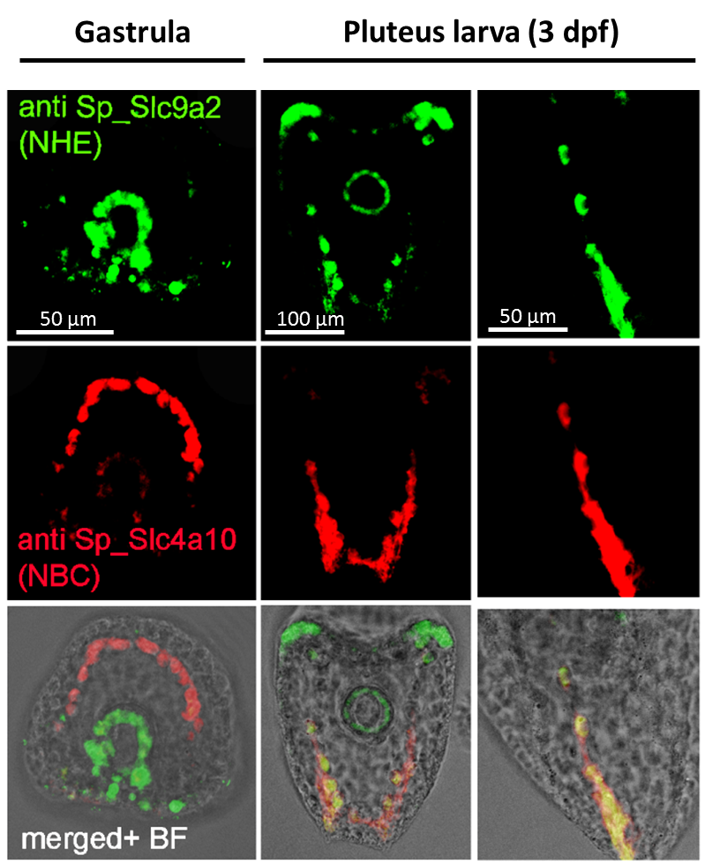
Figure S3. Colocalization of Sp-Slc4a10 and Sp-Slc9a2 in the developing sea urchin embryo. In the gastrula stage strong expression of te Na⁺/HCO₃⁻ cotransporter Sp-Slc4a10 is found in the PMCs. In this stage Sp-Slc9a2 protein abundance is restricted to the developing gut with only little expression in PMCs. In the early pluteus larva both transporters colocalize in PMCs predominantly at the tip regions of the spicules.

Figure S4 pH_{i} regulatory capacities of PMCs during re-calcification assessed by the ammonia pulse method. In this work two sets of experiments investigated the pH_{i} regulatory capacities of PMCs during regeneration of the skeleton. One set used the ammonia pulse method demonstrating reduced pH_{i} regulatory capacities of PMCs during skeleton regeneration (Figure S4). However, this method may lead to artifacts since cellular acidification depends on the pH_{i} compensation reaction during the ammonia pulse that was also affected by the re-calcification event. Thus, pH_{i} regulatory capacities of PMCs during the re-calcification phase were additionally measured by a 2.5% CO₂ induced intracellular acidification using out-of-equilibrium seawater solutions. These results are presented in Figure 2 of the main manuscript. (A) pH_{i} regulatory abilities of PMCs in different stages of re-calcification measured by the ammonia pulse method. (B) Changes in pH_{i} compensatory abilities after acidosis relative (Δ) to PMCs of control larvae. (C) Change in pH_{i} along the re-mineralization period compared to PMC pH_{i} of control larvae. (D) Changes in pH_{i} compensatory abilities after alkalosis (ammonia pulse) relative to PMCs of non-recalcifying larvae. (E) Change in [HCO₃⁻]_{i} along the re-mineralization period compared to PMC of control larvae. Values are presented as mean ± SEM (n = 6-8). Asterisks denote significant differences compared to non-re-mineralizing larvae.
Figure S5. pH_{i} regulatory capacities of PMCs assessed by the CO₂ pulse method. Intracellular acidification in non-regenerating PMCs was induced by exposure to out of equilibrium solutions of pH 8.0 and 2.5 % CO₂. (A) Real-time traces of the CO₂ pulse experiments in the presence of 500 µM DIDS or only the vehicle DMSO. (B) The compensatory slope during the CO₂ pulse was significantly (t-test ** p<0.001) reduced in the presence of DIDS compared to the vehicle control. (C) Real-time traces of the CO₂ pulse experiments in the presence of 1 µM Bafilomycin (BAF) or only the vehicle DMSO. (D) The compensatory slope during the CO₂ pulse was not affected by the inhibitor. Values are presented as mean ± SEM, n = 3-4.

Table S1. Primers used for qPCR analyses.
Gene Name |  | Primers
EF1a | F | CCGACCTTGGAAAGGGATCG
(SPU_000595) | R | ACAGTCGGCCTGTGAGGTTC
Slc4a10 | F | GTTCTTGTTCTCTTGCGCCCTC
(SPU_025515) | R | AGCCAGGAAAGCCATGAAGAC
Slc9a2 | F | AGGAGAAACCTCTGGCAGAGCG
(SPU_006845) | R | TGGGCATCACCACTAACGTCCA
Atp6voa1 | F | GTGCCTGGCCCAGCTATTCTTG
(SPU_001860) | R | CACCGCCTCACTTCGTTGACAA
Atp6voa1_1 | F | GTGGACTCCTACGGTGTAGCCA
(SPU_002051) | R | CACCACCAGCCACAGTCCAAAG
Atp6voa1_2 | F | CCATTCTGAGCTGTCAGAAG
(SPU_023764) | R | AATTCAATCCAGTGGAGACG
Atp6voa1_3 | F | TGCCTGGGCTGCTATGACTGTA
(SPU_020497) | R | AGGTTGGCAAGACTGAAGGGCA
Atp6voa1_4 | F | GCTCACGCTGAGTTGTCTGA
(SPU_024862) | R | AATTCCCACCAGTGAAGTCG
Atp6voa1 | F | CGTGGAACACAAAAAAGTGG
(SPU_028111) | R | GATAATGGCAAAGGGGGCAG
Atp6vao1 | F | TTGGCCCAGCTCTTCGTACAGT
(SPU_016916) | R | GGAAGGCGCTCACATTTGGGTT

Movie S1 (separate file) High resolution time lapse recording of PMCs and BFCs during skeleton regeneration. A group of PMCs and BFCs along a regenerating spicule were observed over the duration of 10 min. PMCs were marked by the Alx-GFP reporter construct (green). BFC endocytosed the 10 KDa labeled Texas red dye into large vesicles. Images were taken every 10 seconds and the frame rate of this video is 1 image s⁻¹ (Video speed is 10x faster than original recording duration).

Movie S2 Time lapse recording of PMCs and BFCs during skeleton regeneration at lower magnification. The aboral part of a larva including the gut and a group of PMCs and BFCs along a regenerating spicule were observed over the duration of 5 min. PMCs were marked by the Alx-GFP reporter construct (green). BFC endocytosed the 10 KDa labeled Texas red dye into large vesicles. Images were taken every 10 seconds and the frame rate of this video is 1 image s⁻¹ (Video speed is 10x faster than original recording).

References

1. K. Suffrian, K. G. Schulz, M. A. Gutowska, U. Riebesell, M. Bleich. 2011 Cellular pH measurements in Emiliania huxleyi reveal pronounced membrane proton permeability. New Phytologist 190, 595-608.
2. M. Y. Hu, J.-J. Yan, I. Petersen, N. Himmerkus, M. Bleich, M. Stumpp. 2018 A Slc4 family bicarbonate transporter is critical for intracellular pH regulation and biomineralization in sea urchin embryos. elife 7, e36600.
3. M. Stumpp, M. Y. Hu, Y.-C. Tseng, Y. J. Guh, Y. C. Chen, J. K. Yu, Y. H. Su, P. P. Hwang. 2015 Evolution of extreme stomach pH in bilateria inferred from gastric alkalization mechanisms in basal deuterostomes. Sci Rep 5, 1-9.
4. A. Roos, W. F. Boron. 1981 Intracellular pH. Physiol Rev 61(2), 297-403.
5. H. O. Pörtner, R. G. Boutilier, D. P. Toews. 1990 Determination of intracellular pH and pCO2 after metabolic inhibition by fluoride and nitrilotriacetic acid. Resp Physiol 81, 255-274.
6. M. Stumpp, M. Y. Hu, I. Casties, R. Saborowski, M. Bleich, F. Melzner, S. T. Dupont. 2013 Digestion in sea urchin larvae impaired under ocean acidification. Nature Climate Change 3, 1044.
7. C. A. Wagner, U. Lükewille, P. Valles, S. Breton, D. Brown, G. H. Giebisch, J. P. Geibel. 2003 A rapid enzymatic method for the isolation of defined kidney tubule fragments from mouse. Pflugers Arch 446(5), 623-632.

