Additional Data file
from manuscript submitted for review to Endocrinology on 23 October 2020
manuscript #: en.2020-00859

Ligand-Dependent Effects of Methionine-8 Oxidation in Parathyroid Hormone Peptide Analogs

Eileen J. Daley¹, Ashok Khatri¹, Thomas Dean¹, Jean-Pierre Vilardaga², Saheem A. Zaidi³ Vsevolod Katritch³ and Thomas J. Gardella*

Corresponding Author:
Thomas J. Gardella
Endocrine Unit
Massachusetts General Hospital
Thier 1025
50 Blossom St
Boston MA 02474
Phone: 617-726-3683
Email: Gardella@Helix.mgh.harvard.edu

Grant support: This work was supported by research grants from the NIH (DK11794; AR066261); Amolyt Pharma and the Massachusetts General Hospital Innovation Fund.

Disclosures: E.D. T.D., JP.V., S.A.Z. and V.K. have nothing to declare. T.J.G. and A.K. received royalties from Amolyt Pharma., which has licensed LA-PTH, claimed in U.S. Patent 9,492,508a, for development, with the new designation AZP-3601, as a potential treatment for hypoparathyroidism. T.J.G. received research support from Amolyt pharma.

Key Words: parathyroid hormone, peptide hormone, long-acting PTH, G protein-coupled receptor, class B GPCR, methionine oxidation

ABSTRACT
LA-PTH is a long-acting parathyroid hormone (PTH) peptide analog in pre-clinical development for hypoparathyroidism (HP). Like native PTH, LA-PTH contains a methionine at position 8 that is predicted to be critical for function. We assessed the impact of methionine oxidation on the functional properties of LA-PTH and control PTH ligands. Oxidation of PTH(1-34) resulted in marked (~20-fold) reductions in binding affinity on the PTH receptor-1 (PTHR1) in cell membranes, similarly diminished potency for cAMP signaling in osteoblastic cell lines (SaOS-2 and UMR106), and impaired efficacy for raising blood calcium in mice. Surprisingly, oxidation of LA-PTH resulted in little or no change in these functional responses. The signaling potency of oxidized-LA-PTH was, however, reduced ~40-fold compared to LA-PTH in cells expressing a PTHR1 construct that lacks the N-terminal extracellular domain (ECD). Molecular modeling revealed that while Met8 of both LA-PTH and PTH(1-34) is situated within the orthosteric ligand-binding pocket of the receptor’s transmembrane domain bundle (TMD), the Met8 sidechain position is shifted for the two ligands such that upon Met8 oxidation of PTH(1-34) steric clashes occur that are not seen with oxidized LA-PTH. The findings suggest that LA-PTH and PTH(1-34) engage the receptor differently in the Met8-interaction environment of the TMD bundle, and that this interaction environment can be allosterically influenced by the ECD component of the ligand-receptor complex. The findings should be useful for the future development of novel PTH-based peptide therapeutics for diseases of bone and mineral ion metabolism.

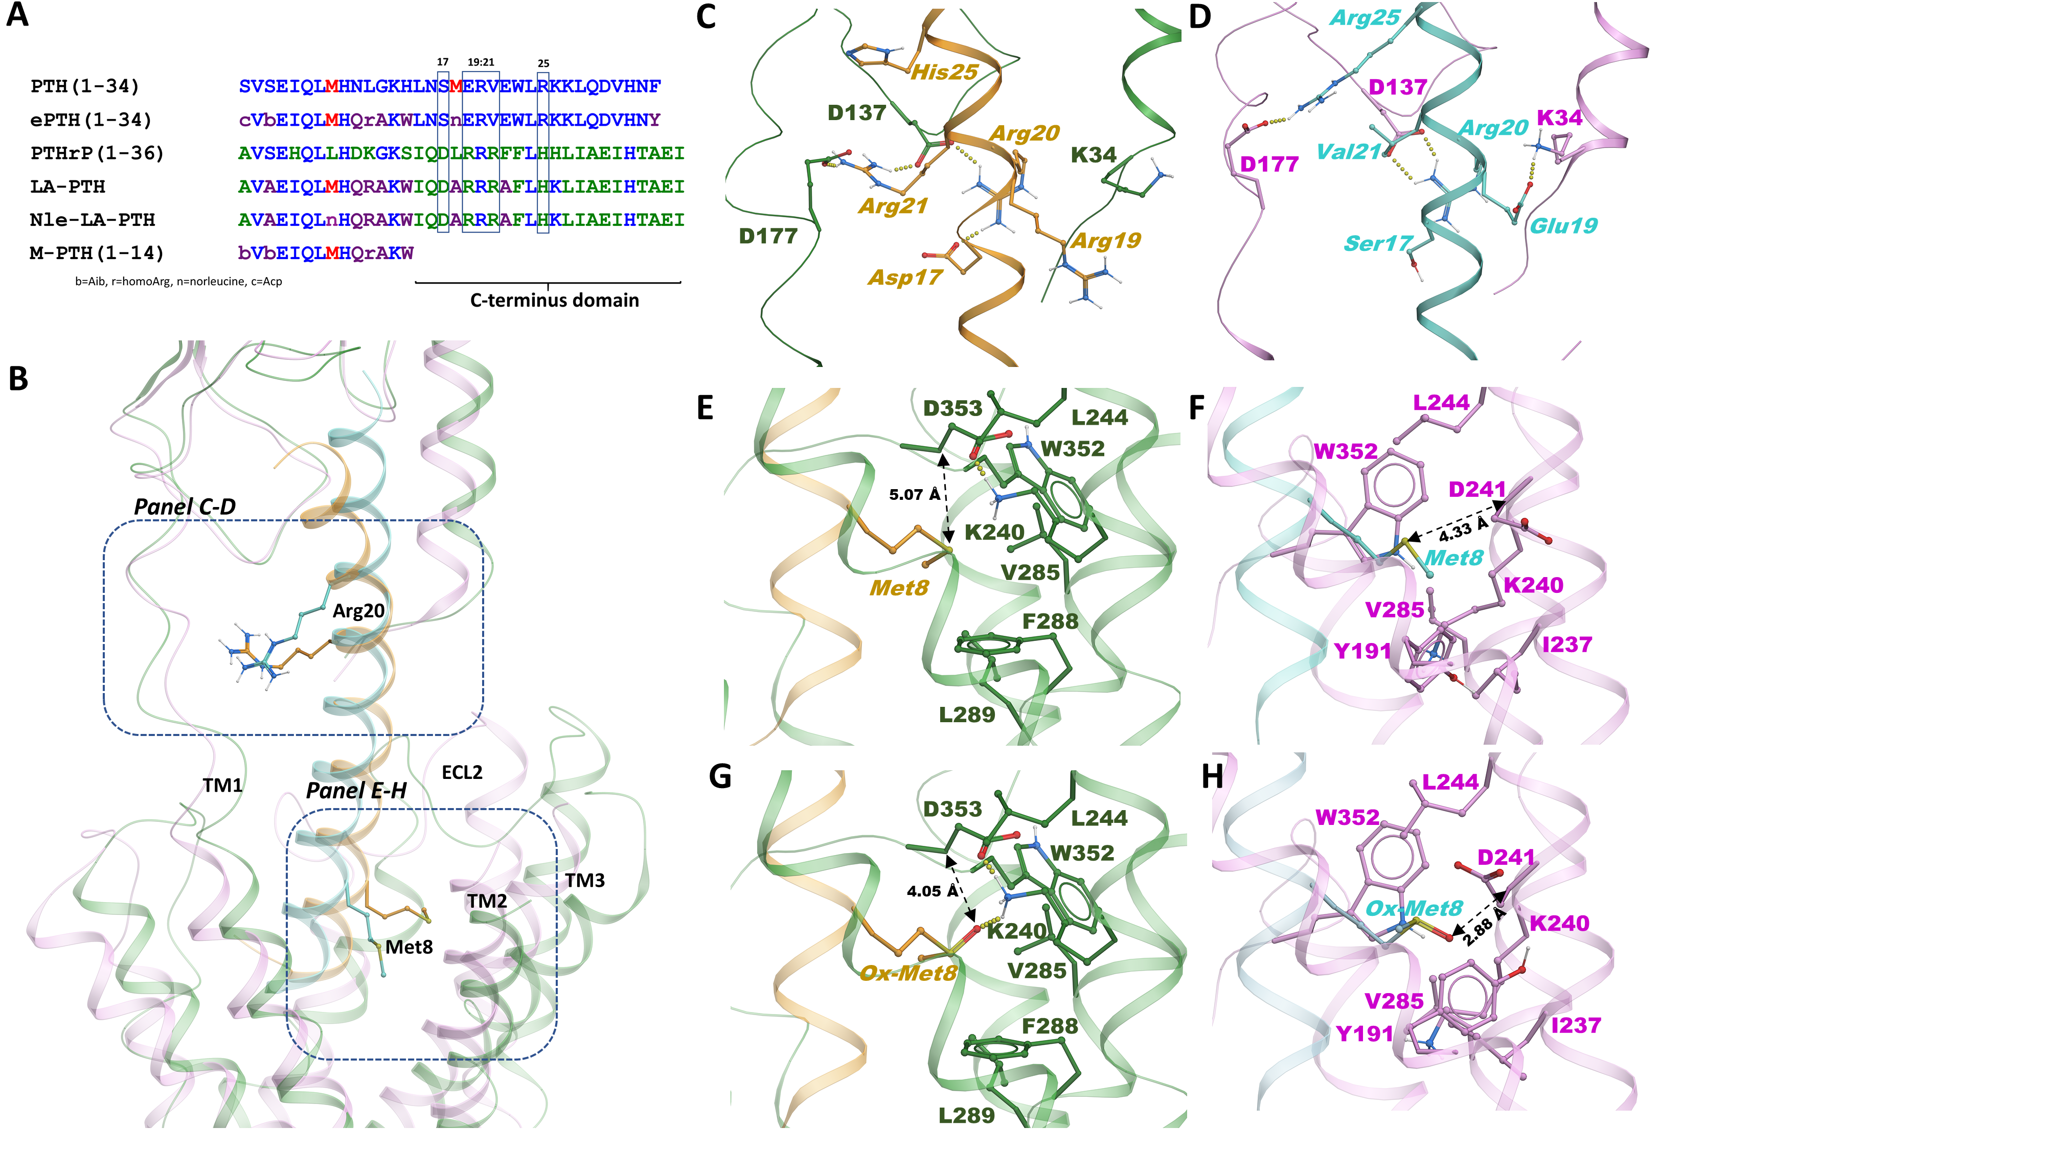
Figure S1 Altered Modes of Engagement of LA-PTH and PTH. A) Amino acid sequence alignment of PTH peptides; residues are colored to highlight methionines (red), residues native to PTH (blue); residues native to PTHrP and not in PTH (green), and substituted residues of norleucine (n), α-amino-isobutyric acid (b, Aib), homoarginine (r), aminocyclopentane-1-carboxylic acid (c, Acp) (purple). Residues involved in ionic interactions with the PTHR1 ECD are in boxes with position numbers indicated. B) Overlay of the cryoEM structure (PDB:6nbf) of the PTHR1 (green) bound to LA-PTH (orange) and the model of the PTHR1 (pink) bound to PTH (cyan) based on the ePTH-bound PTHR1 X-ray crystal structure (PDB: 6fj3). Along with distinct interactions involving the C-terminal regions of LA-PTH and PTH, and conformational shifts in ECL2, there is a shift in the positioning of the N-terminal regions of the ligands, such that the N-terminus of LA-PTH is closer to TM3 while that of PTH is closer to TM1; this shift in the N-terminal portion places Met8 of the two ligands in different interaction environments. C-D) Close-up views of the ECD region showing different ionic interactions involving the divergent 17-25 regions of LA-PTH and PTH. E-F) Close-up views of the TMD region showing residues within 5A˚ of Met8 in LA-PTH and in PTH; distances between the Met8 sulfur atom and the closest PTHR1 backbone atom are indicated. G-H) Models of the PTHR1 bound to Ox-LA-PTH and Ox-PTH showing residues within 5A˚ of Met8; distances between the oxygen of Ox-Met8 and the closest PTHR1 backbone atom are indicated.
Figure S1 Altered Modes of Engagement of LA-PTH and PTH (continued).
The overlay reveals a complete overlap of the bound peptides only in the region around conserved Arg20, which in both models interacts with D137 located in the hairpin loop between two β-sheets of the receptor’s ECD (B). Non-conserved ligand residues flanking Arg20 are involved in distinct interactions (C-D). Specifically, LA-PTH has Asp17 and Arg21 that, along with Arg20, form a network of interactions surrounding D137. Arg21 also interacts with D177 of the ECD located near the top of TM1. In contrast, PTH has Ser17 and Val21, which are not involved in any direct interaction with the receptor. However, one helical turn above Val21 is Arg25, which interacts with D177, while Glu19 of PTH interacts with K34 of the ECD N-terminal helix. LA-PTH has His25 and Arg19, which cannot form these interactions. Together, these non-conserved interactions lead to a shift in the orientation of the C-terminal portions of the peptides within the receptor ECD, which is accompanied by a change in positioning of the N-terminal portions of the ligands and the placement of Met8 within the TMD bundle. In LA-PTH, Met8 is positioned between TM3 and ECL2, while in PTH it is directed more towards TM2 (B), which changes the neighboring receptor residues, as well as the volume available to the Met8 sidechain. In the LA-PTH-bound complex, the closest receptor backbone heavy atom to the Met8 sulfur is in D353 of flexible ECL2 at a distance of 5.07Å, while in the PTH-bound complex, the closest backbone heavy atom is in helical D241 of TM2 at a distance of 4.33Å (E-F). The increase in distance seen for Met8 in LA-PTH, as compared to in PTH, provides for better accommodation of the additional oxygen atom introduced by oxidation of the sidechain sulfur. Models of the complexes of Ox-LA-PTH and Ox-PTH bound to the PTHR1 supports this hypothesis. For the Ox-LA-PTH-bound structure, the additional O atom is not only accommodated but also finds hydrogen bonding interactions with K240 of TM2 (G-H). In the Ox-PTH-bound PTHR1, the O atom of Met8SO is placed even closer to the backbone of D241 at a distance of 2.88 A˚, which introduces steric clashes that may contribute to the loss in activity seen with Ox-PTH.

