**Supplementary material 1**. Funnel plot, trim-fill and sensitivity analysis of the association between metabolic syndrome and nephrolithiasis

**Supplementary material 1a**. Funnel plot of the studies of the association between metabolic syndrome and nephrolithiasis

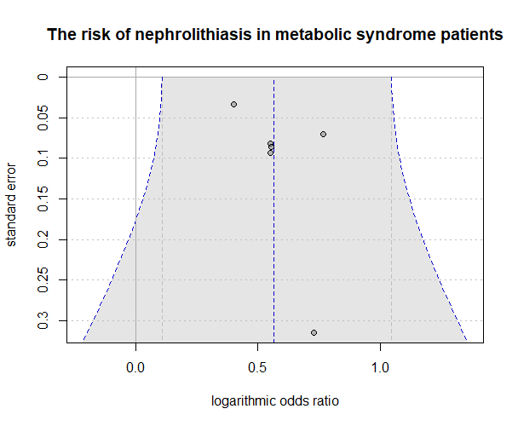

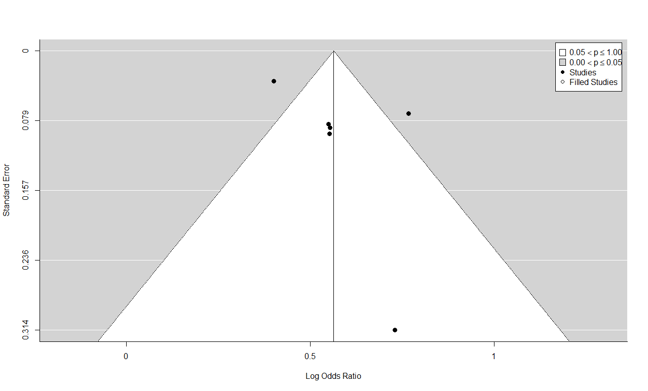**Supplementary material 1b**. Trim and fill analysis of the studies of the association between metabolic syndrome and nephrolithiasis

**Supplementary material 1c**. Sensitivity analysis of the studies of the association between metabolic syndrome and nephrolithiasis



**Supplementary material 2**. Funnel plot, trim-fill and sensitivity analysis of the association between hypertension and nephrolithiasis

**Supplementary material 2a**. Funnel plot test of the studies evaluating the association between hypertension and nephrolithiasis

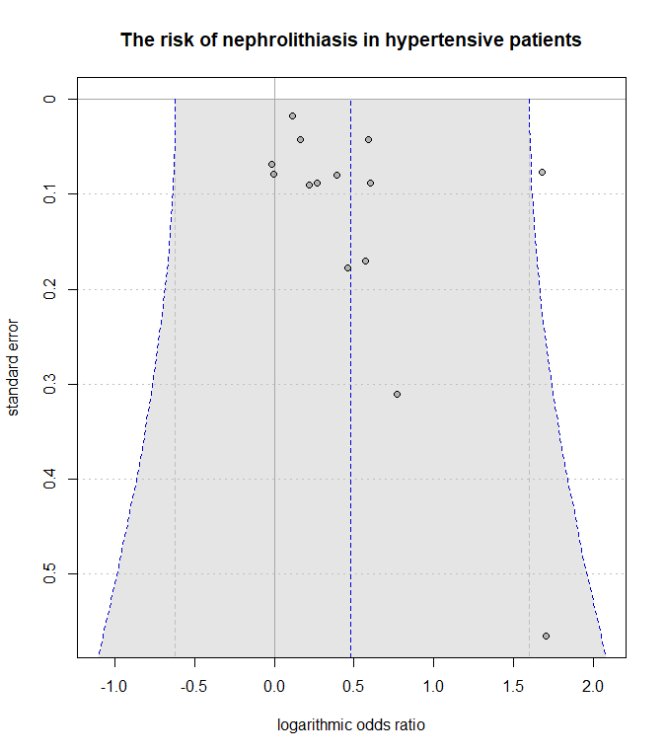

**Supplementary material 2b**. Trim and Fill Analysis of the studies evaluating the association between hypertension and nephrolithiasis

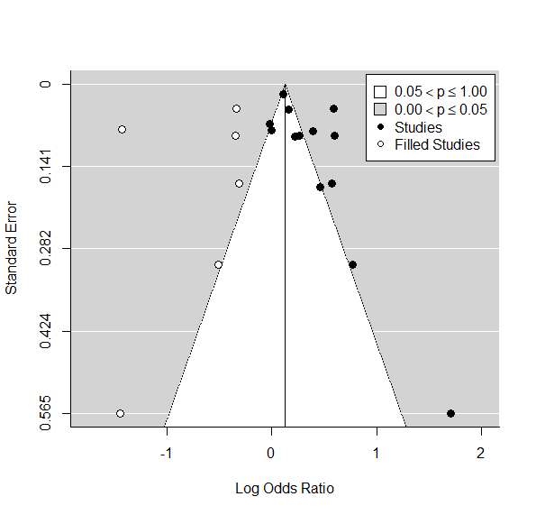

**Supplementary material 2c**. Sensitivity analysis of the studies evaluating the association between hypertension and nephrolithiasis





**Supplementary material 3**. Funnel plot, trim-fill and sensitivity analysis of the association between DM and nephrolithiasis

**Supplementary material 3a**. Funnel plot test of the studies evaluating the association between DM and nephrolithiasis

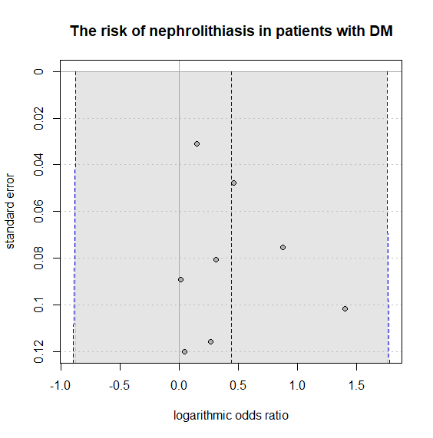

**Supplementary material 3b**. Trim and Fill analysis of the studies evaluating the association between DM and nephrolithiasis

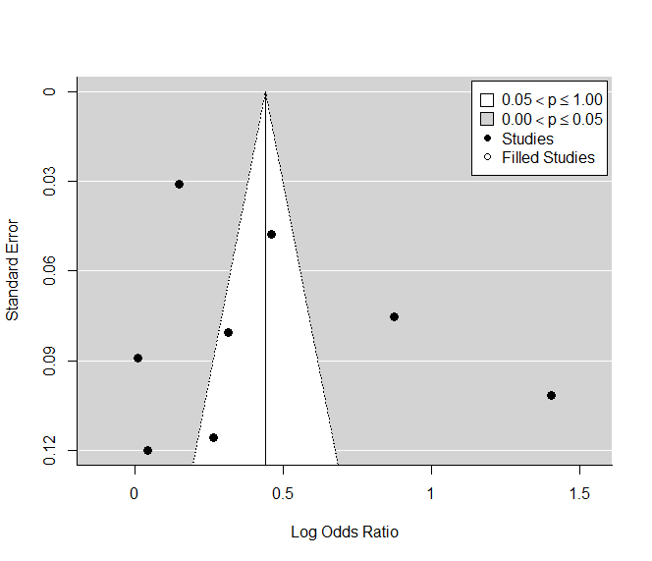

**Supplementary material 3c**. Sensitivity analysis of the studies evaluating the association between DM and nephrolithiasis





**Supplementary material 4**. Funnel plot, trim-fill and sensitivity analysis of the association between obesity and nephrolithiasis

**Supplementary material 4a**. Funnel plot test of the studies evaluating the association between obesity and nephrolithiasis

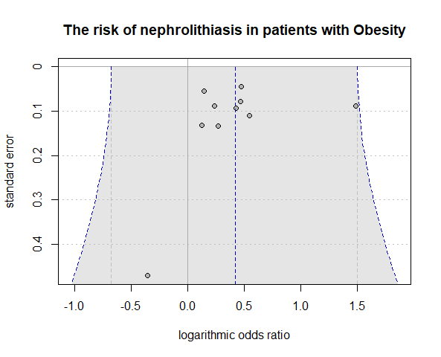

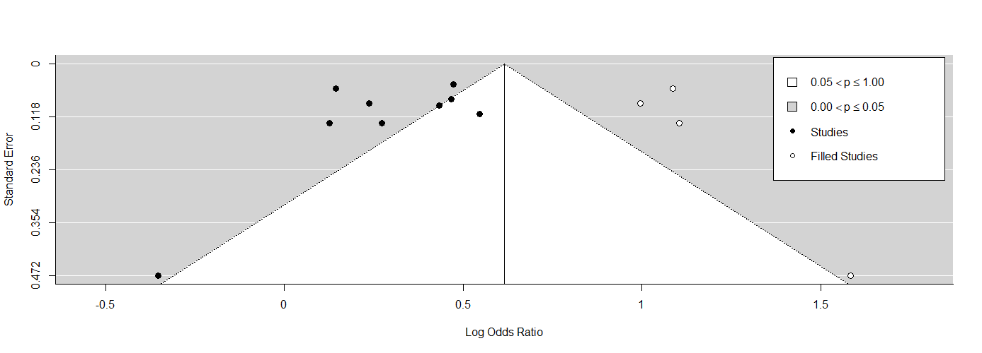**Supplementary material 4b**. Trim and fill analysis of the studies evaluating the association between obesity and nephrolithiasis

**Supplementary material 4c**. Sensitivity analysis of the studies evaluating the association between obesity and nephrolithiasis





**Supplementary material 5**. Funnel plot, trim-fill and sensitivity analysis of the association between dyslipidemia and nephrolithiasis

**Supplementary material 5a**. Funnel plot test of the studies evaluating the association between dyslipidemia and nephrolithiasis

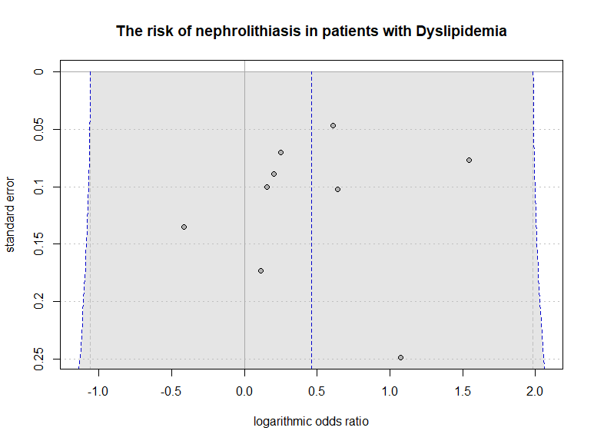

**Supplementary material 5b**. Trim and fill analysis of the studies evaluating the association between dyslipidemia and nephrolithiasis

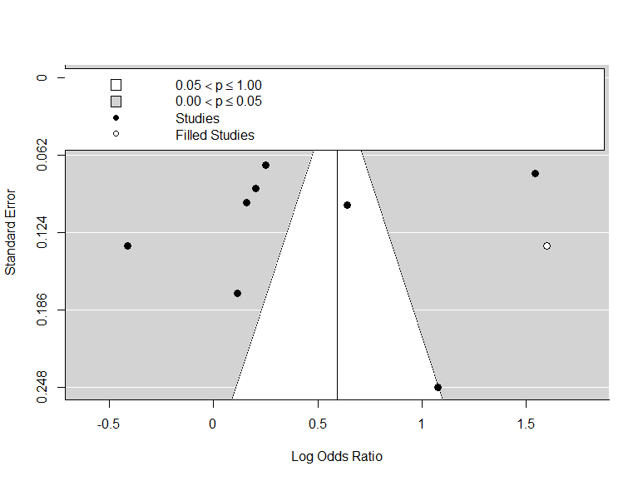

**Supplementary material 5c**. Sensitivity analysis of the studies evaluating the association between dyslipidemia and nephrolithiasis



