**Supplemental Information 2 (Questionnaire)**

**Functional extinction of dugongs in China**

Mingli Lin, Samuel T. Turvey, Chouting Han, Xiaoyu Huang, Antonios D. Mazaris, Mingming Liu, Heidi Ma, Zixin Yang , Xiaoming Tang, and Songhai Li

**Fishermen questionnaire about marine wildlife in the South China Sea**

DATE: LOCATION: INTERVIEWER:

**The Chinese Academy of Sciences is undertaking an opinion survey related to fishers’ knowledge about marine wildlife. The answers you provide will only be used for scientific research purposes, and no personal identity information will be recorded. The outcome of the survey will be published in a scientific journal but will remain anonymous. This survey is very important. We hope you can honestly answer all the questions. You have the right to terminate the interview at any time. Thank you for your participation!**

**Do you consent to participate in this study?**

**Yes No**





**BASIC INFORMATION AND FISHERY**

1. How old are you? ________Gender? _______ Ethnicity?________
2. What is your education level? __________
3. How long is your fishing vessel? ________
4. **Fishing effort**:
5. How many years have you engaged in fishing?________
6. Generally, how many days do you fish at sea each year? ________
7. Which months do you mainly fish at sea? ________
8. On a typical fishing trip, how many days are you usually out at sea for before coming back to land? ________
9. How much money per year do you usually earn from fishing?_______________
10. What are your main sources of **income** (or, what is your main livelihood) when you don't fish? ________________________
11. Which **fishing gears** have you mainly used? ____________________

1. Drift gillnets 2. Fixed gillnets









3. Trawls 4. Purse nets

5. Light-trapping 6. Electric-fishing





7. Hooking 8. Long-line









9. Stow nets 10. Bomb-fishing



11. Other fishing gears or methods (Please describe: ________________)

1. What are your main **target species** (please list three main species, which can include fish, crustaceans, and/or cephalopods)

_________________________________________________________________

1. Do you think that any of the **populations** of these target species have changed since you first became a fisherman? Y / N / Don’t know
2. If YES, which one(s)? _______________________________________
3. Have they increased or decreased? __________________
4. By how much? (approximately) ______________________
5. Approximately which year did this happen?________________
6. Has the **body size** of any of these target species changed since you first became a fisherman? Y / N / Don’t know
7. If YES, which one(s)? _________________________________
8. Have they increased or decreased? _________
9. By how much? (approximately) ______________
10. Approximately which year did this happen? ________
11. Do you think that **overall fish catch** (i.e. amount of fish caught on a typical fishing trip) has changed since you first became a fisherman? Y / N / Don’t know
12. If YES, has it increased or decreased? __________
13. By how much? (approximately) ______________
14. Approximately which year did this happen? ________
15. **How far** out from the coast do you normally go when you’re fishing? ______________nm.
16. About **how deep** is the water where you go fishing? ______________m.
17. **Where** do you typically engage in fishing? ________________(Please write down the grid numbers)
18. Have you always fished in this region? Y / N
19. If NO, where did you previously go fishing?________________(Please write down the grid numbers)
20. Which year did you change the location of where you go fishing? __________
21. Why did you change the location of where you go fishing? _______________

_______________________________________________________________

**Dugong, *Dugong dugon* (show the pictures)**

1. Do you recognize the species in this photo? Y/N __________
2. What is the name of this species? __________
3. How can you tell this species apart from other types of marine wildlife? _________________________________________________________________
4. Have you ever **seen** this species at sea?

1)Yes 2)No 3)Don't know

1. If YES, how frequently have you seen this species?

1)very often 2)often 3)sometimes 4)rarely 5)once only 6)don’t know

1. How many times have you seen it in the last five years? (give an exact number if possible) __________
2. If NO, how do you know what it is? ___________________________
3. Are there any areas where you have seen this species more often than other places? If YES, describe where: __________________
4. Do you tend to see this species more at a particular time of year? Y / N
   1. If YES, when? _______________
5. When did you last see this species at sea?
6. Which year?___________________
7. Which month?___________________
8. Where?________________________
9. Do local people ever try to **catch** this species? Y / N / Don’t know
10. If YES, how regularly is it targeted?

1) Very often 2) Often 3) Sometimes 4) Rarely 5) Very rarely

1. What is it used for? ______________________
2. Is it used locally, or traded? _____________________
3. Have you ever **caught** this species?

1)Yes 2)No 3)Don't know

1. If YES, was it accidental or were you trying to catch it? _____________
2. If YES, how many times have you caught it in the past five years? _________
3. If YES, what sort of fishing gear does it get caught in? _____________
4. Are there any areas where this species gets caught more often than other places? If YES, describe where: __________________(Please write down the grid numbers)
5. When did you last catch this species:
6. Which year?___________________
7. Which month?___________________
8. Where?________________________
9. What kind of fishing gear? ________________________
10. Was it alive or dead？_________________________
11. Have you ever seen of this species getting **stranded**?

1)Yes 2)No 3)Don't know

1. If YES, how many times do you know that it’s stranded in the past five years? __________
   1. How many of these strandings did you see yourself? _________________
2. If YES, when was the last time you saw about a stranding of this species:
3. Was it alive or dead?________________
4. Which year?___________________
5. Where?________________________
6. Have you ever **eaten** the meat of this species? YES/NO________
7. If YES, how frequently do you eat this species:

1)very often 2)often 3)sometimes 4)rarely 5)once only 6)don’t know

1. If YES, how many times have you eaten it in the last five years? (give an exact number if possible; approximate number also fine) ________
2. Which year was the last time when you ate it？________
3. Do people **sell the meat** of this species?

1)Yes 2)No 3)Don't know

1. If YES, how frequently do people sell this species:

1)very often 2)often 3)sometimes 4)rarely 5)once only 6)don’t know

1. Have you ever sold the meat of this species? YES/NO________
2. If YES, how many times have you sold it in the last five years? (give an exact number if possible; approximate number also fine) ________
3. Which year was the last time when you sold it?________
4. Have you ever used this species for **any other purpose**? Yes / No
   1. If YES, what purpose? _______________
   2. If YES, how many times have you done this in the past five years? (give an exact number if possible; approximate number also fine) ________
5. Do you think that the **population** of this species has changed since you first became a fisherman?

1)Yes 2)No 3)Don't know

1. If YES, has it increased or decreased? _____________
2. By how much? _____________
3. Approximately which year did this happen? _____________
4. Has this species disappeared from any areas where it used to be found?

1)Yes 2)No 3)Don't know

1. If YES, where?___________________
2. Which year did it disappear?___________________
3. What do you think made it disappear?___________________
4. What will you do if you **find a stranded individual**? ________

1)Free alive 2)Discard dead 3)Sell 4)Inform local fisheries administration 5)Eat 6)Don’t know 6)Other choices (Please describe: ________)

1. Is it the national protected species? Y / N / Don’t know

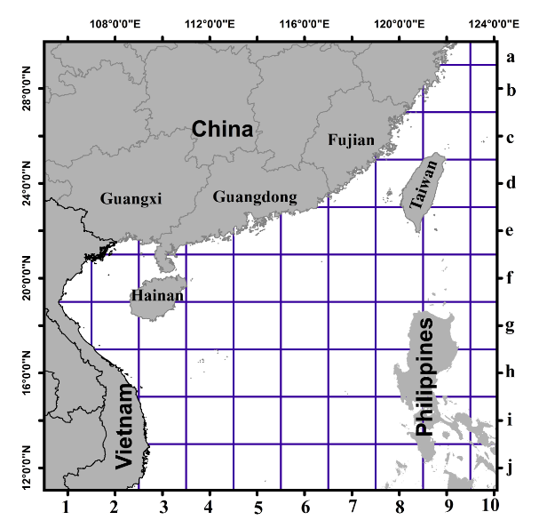

Figure 1 Grid map of the South China Sea

**Please write down grid numbers according to the format “Letter + Number” (e.g. b4).**