Supplementary materials

Pollinator sharing and gene flow among closely related sympatric dioecious fig taxa

Gang Wang^{1,2}, Charles H. Cannon^{1.3}Jin Chen^{1,}*

¹Key Laboratory of Tropical Forest Ecology, Xishuangbanna Tropical Botanical Garden, Chinese Academy of Sciences, Mengla,Yunnan 666303, China.

² University of Chinese Academy of Sciences, Beijing 100039, China.

³ Center for Tree Science, The Morton Arboretum, Lisle, IL 60532 USA.

* Corresponding author: Jin Chen: Tel: +86-0691-8715457; Fax: +86-0691-8715070; E-mail: cj@xtbg.org.cn

Table S1. Samples information of fig and fig wasp for Microsatellite or COI sequences.
Country | Site | Location | Samples numbers [fig/fig wasp (total trees-D phase-B-phase)*] |  |  |  |  | Total
 |  |  | FSS | FSM | FA | FO | FH
China | Menglun | 21º55' N, 101º15'E | 31/14  (10tree-8D-6B) | 30/16  (14tree-11D-5B) | 33/12  (4tree-12B) | 26/13  (9tree-6D-7B) | 30/13  (12tree-10D-3B) | 151/69
 | Buben | 21°36′ N, 101°34′ E | 15/0 | 14/0 | 15/7  (1tree-7B) | 0/0 | 0/0 | 47/7
Laos | Luang Prabang | 19°50′ N, 102°9′ E | 11/8  (8tree-8D) | 13/1  (1tree-1D) | 7/0 | 6/0 | 0/0 | 44/8
 | Paksan | 18°16' N, 104° 9' E | 0/0 | 0/0 | 7/0 | 0/0 | 0/0
Vietnam | Lao Cai | 22°30′ N, 103°53′ E | 0/0 | 8/1  (1tree-1D) | 0/0 | 0/0 | 0/0 | 40/3
 | Hanoi | 21°01′ N, 105°39′ E | 0/0 | 0/0 | 0/0 | 9/0 | 0/0
 | Pu Mat | 18°59′ N, 104°40′ E | 0/0 | 7/2  (2tree-2D) | 16/0 | 0/0 | 0/0
Total |  |  | 57/22  (18tree-16D-6B) | 72/20  (18tree-15D-5B) | 78/19  (5tree-19B) | 41/13  (9tree-6D-7B) | 30/13  (12tree-10D-3B) | 278/87

FSS = F. semicordata var. semicordata; FSM= Ficus semicordata var. montana; FA = F. auriculata; FO = F. oligodon; FH = F. hainanensis.

*: The number of total trees where the wasp sampled, and the number of wasps sampled from trees in D-phase and in B-phase.

Table S2. Microsatellite primers of Ficus plants used in this paper. The total number and the lengths of alleles observed across all species, PCR conditions: annealing temperature (Ta) and number of cycles, and the original primer note references are shown.
Primer | N. of alleles | Length (bp) | T_{a} | N.of cycle | Reference
B47 | 22 | 173–211 | 53 | 30 | Moe & Weiblen. 2011
Frac83 | 12 | 169–185 | 45 | 10*+20 | Crozier et al. 2007
Frac86 | 9 | 141–159 | 50 | 15*+20 | Crozier et al. 2007
Frac113 | 12 | 210–238 | 45 | 10*+20 | Crozier et al. 2007
Frac154 | 17 | 131–157 | 45 | 10*+20 | Crozier et al. 2007
Frac241 | 22 | 245–294 | 45 | 10*+20 | Crozier et al. 2007
Frub38 | 26 | 217–303 | 50 | 15*+20 | Crozier et al. 2007
Frub29 | 23 | 192–244 | 45 | 10*+20 | Crozier et al. 2007
Frub436 | 19 | 128–154 | 45 | 10*+20 | Crozier et al. 2007
FS411 | 34 | 209–307 | 54 | 10*+20 | Zavodna et al. 2005
LMFC32 | 13 | 184–202 | 47 | 10*+20 | Giraldo et al. 2005
*Indicates number of touchdown cycles starting 10◦C above the annealing temperature.

References
Crozier, Y.C., Jia, X.C., Yao, J.Y., Field, A.R., Cook, J.M. & Crozier, R.H. (2007). Microsatellite primers for Ficus racemosa and Ficus rubiginosa. Mol. Ecol. Notes, 7, 57-59.( doi:10.1111/j.1471-8286.2006.01523.x)
Giraldo, E., Viruel, M.A., Lopez-Corrales, M. & Hormaza, J.I. (2005). Characterisation and cross-species transferability of microsatellites in the common fig (Ficus carica L.). J. Hortic. Sci. Biotech., 80, 217-224.().
Moe, A.M. & Weiblen, G.D. (2011). Development and Characterization of Microsatellite Loci in Dioecious Figs (Ficus, Moraceae). Am. J. Bot., 98, E25-E27.(doi:10.3732/Ajb.1000412).
Zavodna, M., Arens, P., Van Dijk, J. & Vosman, B. (2005). Development and characterization of microsatellite markers for two dioecious Ficus species. Mol. Ecol. Notes, 5, 355-357.(doi:10.1111/j.1471-8286.2005.00924.x).

Table S3. Fig volatile samples of receptive phase in Menglun site
Species | N.ind. | Names ind. of figs | Hybrid ind.*
FA | 11 | FA2, FA3, FA7, FA8, FA14, FA15, FA29-FA33 | None
FO | 7 | FO1, FO2, FO3, FO4, FO5, FO10, FO12 | FO3, FO4
FH | 9 | FH2, FH3, FH4, FH8, FH9, FH25, FH26, FH28, FH29 | None
FSS | 6 | FSS1, FSS3, FSS7, FSS10, FSS29, FSS30 | None
FSM | 7 | FSM4, FSM6, FSM8, FSM14, FSM16, FSM18, FSM22 | None
*: Hybrids were evaluated with Bayesian clustering analysis of fig genetic data using Structure software (see Table S7). FA = F. auriculata; FO = F. oligodon; FH = F. hainanensis; FSS = F. semicordata var. semicordata; FSM= Ficus semicordata var. montana. Figs individuls with bold names are female trees, others are male trees.

Table S4. Genetic distance matrix (Mean± SE) for pollinator clades of F. semicordata and F. auricualta complex based on the P-distance mode of COI gene. The pollinators corresponding to the node labels in Figure 1. Intra-clade distance variation is shown in bold.
 | Ceratosolen sp. | C. gravelyi  clade 1 | C. gravelyi  clade 2 | C. emarginatus  clade 1 | C. emarginatus  clade 2 | C. emarginatus  clade 3
Ceratosolen sp. | 0.016±0.002 | 0.108±0.011 | 0.098±0.011 | 0.114±0.011 | 0.101±0.010 | 0.114±0.011
C. gravelyi clade 1 |  | 0.003±0.001 | 0.063±0.009 | 0.099±0.011 | 0.090±0.011 | 0.102±0.011
C. gravelyi clade 2 |  |  | 0.019±0.004 | 0.096±0.010 | 0.087±0.011 | 0.104±0.012
C. emarginatus clade 1 |  |  |  | 0.004±0.001 | 0.051±0.008 | 0.069±0.010
C. emarginatus clade 2 |  |  |  |  | 0.003±0.001 | 0.058±0.009
C. emarginatus clade 3 |  |  |  |  |  | 0.009±0.002

Table S5. Frequency of associations between sympatric Ficus species and Ceratosolen species basing on 87 de novo sequenced Ceratosolen wasps.
Ficus | Dominator pollinator |  | Nind | Nsp | Ncom | Nalter (alternative figs) | Pollinator sharing ratio
FSS | C. gravelyi clade 1 - 2 |  | 22 | 2 | 22 | 0
FSM | Ceratosolen sp. |  | 20 | 1 | 20 | 0
FA | C. emarginatus clade 1 |  | 19 | 3 | 14 | 3 (FO); 2 (FH) | FA-FO: 29.03% (9/31)
FO | C. emarginatus clade 2 |  | 13 | 2 | 6 | 6 (FA); 1 (FH) | FO-FH: 3.85% (1/26)
FH | C. emarginatus clade 3 |  | 13 | 1 | 13 | 0 | FH-FA: 6.45% (2/31)

Data including the total numbers of wasp sampled (Nind), number of wasp species observed on the fig taxa (Nsp), number of wasp collected from the common host figs (Ncom) and number of wasp collected from alternate figs other than other common host figs (Nalter) of each fig taxon. Number of species (Nsp) responding to number of main phylogeny clades with same color tips in Figure S1. Pollinator sharing ratio between two figs was calculated as: [total number of wasp in alternative host taxon (Nalter)] / [total number of wasp sampled in two fig taxa (Nind)]. FSM= Ficus semicordata var. montana; FSS = F. semicordata var. semicordata; FA = F. auriculata; FO = F. oligodon; FH = F. hainanensis.

Table S6. Posterior probabilities of assignment of 13 individuals identiﬁed as putative hybrids from Bayesian clustering analysis (K = 5) using a priori species identity information with migration rate priors of 0.10, 0.05, 0.01 are shown. A: priori (parent) species of the individual; B: the other potential parent species crossed with priori species; Individuals followed with asterisk (*) indicate the hybrid ancestray (Based on the posterior probabilities of the individuals assigned to priori species in Strucuture analysis, significant levels are indicated as ‘***’: lower than 10%; ‘**’: lower than 20%; ‘*’: lower than 50%). Bold type individuals are hybrids re-identiﬁed by BayesAss; FSM= Ficus semicordata var. montana; FSS = F. semicordata var. semicordata; FA = F. auriculata; FO = F. oligodon; FH = F. hainanensis.
Individual | Hybrid species assignment | Migration rate | Non hybrid  _A | Non hybrid  _B | F1  hybrid | F2  hybrid | Significant level
FSS28 | FSS X FO | 0.1 | 0.02 | 0 | 0 | 0.965 | ***
 | F2 hybrid | 0.05 | 0.055 | 0 | 0 | 0.926 | ***
 |  | 0.01 | 0.344 | 0 | 0 | 0.639 | *
FSS61 | FSS X FSM | 0.1 | 0.369 | 0.001 | 0 | 0.613 | *
 | F2 hybrid | 0.05 | 0.558 | 0.001 | 0 | 0.429
 |  | 0.01 | 0.904 | 0 | 0 | 0.094
FSM27 | FSM X FSS | 0.1 | 0 | 0.12 | 0.207 | 0.673 | ***
 | F2 hybrid | 0.05 | 0 | 0.114 | 0.209 | 0.677 | ***
 |  | 0.01 | 0 | 0.121 | 0.213 | 0.666 | ***
FSM29 | FSM X FSS | 0.1 | 0 | 0 | 0.972 | 0.028 | ***
 | F1 hybrid | 0.05 | 0 | 0 | 0.972 | 0.028 | ***
 |  | 0.01 | 0 | 0 | 0.972 | 0.028 | ***
FSM50 | FSM X FSS | 0.1 | 0 | 0.003 | 0.283 | 0.714 | ***
 | F2 hybrid | 0.05 | 0 | 0.001 | 0.281 | 0.718 | ***
 |  | 0.01 | 0 | 0 | 0.289 | 0.71 | ***
FA50 | FA X FO | 0.1 | 0.468 | 0.122 | 0.235 | 0.169 | *
 | F1 hybrid | 0.05 | 0.665 | 0.086 | 0.143 | 0.101
 |  | 0.01 | 0.916 | 0.024 | 0.034 | 0.024
FA79 | FA X FH | 0.1 | 0 | 0 | 0.845 | 0.155 | ***
 | F1 hybrid | 0.05 | 0 | 0 | 0.844 | 0.156 | ***
 |  | 0.01 | 0 | 0 | 0.843 | 0.156 | ***
FO3 | FO X FA | 0.1 | 0.381 | 0 | 0.123 | 0.49 | *
 | F2 hybrid | 0.05 | 0.653 | 0 | 0.067 | 0.275
 |  | 0.01 | 0.935 | 0 | 0.012 | 0.052
FO4 | FO X FA | 0.1 | 0.454 | 0.004 | 0.309 | 0.232 | *
 | F1 hybrid | 0.05 | 0.665 | 0.003 | 0.188 | 0.144
 |  | 0.01 | 0.924 | 0.001 | 0.042 | 0.033
FO10 | FO X FH | 0.1 | 0.499 | 0 | 0.002 | 0.489 | *
 | F2 hybrid | 0.05 | 0.726 | 0 | 0.001 | 0.267
 |  | 0.01 | 0.959 | 0 | 0 | 0.04
FO31 | FO X FA | 0.1 | 0.365 | 0.005 | 0.431 | 0.199 | *
 | F1 hybrid | 0.05 | 0.608 | 0.003 | 0.262 | 0.127
 |  | 0.01 | 0.907 | 0.001 | 0.061 | 0.031
FO43 | FO X FA | 0.1 | 0.067 | 0 | 0.713 | 0.22 | ***
 | F1 hybrid | 0.05 | 0.175 | 0 | 0.613 | 0.211 | **
 |  | 0.01 | 0.6 | 0 | 0.29 | 0.109
FH21 | FH X FO | 0.1 | 0.326 | 0 | 0.001 | 0.652 | *
 | F2 hybrid | 0.05 | 0.527 | 0 | 0.001 | 0.456
 |  | 0.01 | 0.857 | 0 | 0 | 0.137

Table S7. Pairwise migration rates (MR) for five sympatric morphological figs estimated in BayesAss. Values in bold indicate the migration rates around or above 1%.
MR (From/Into)  (Mean±SD) | F. semicordata  var. semicordata | F. semicordata  var. montana | F. auriculata | F. oligdon | F. hainanensis
F. semicordata var. semicordata |  | 0.0053±0.0052 | 0.0053±0.0052 | 0.0053±0.0053 | 0.0053±0.0053
F. semicordata var.  montana | 0.017±0.0083 |  | 0.0042±0.0041 | 0.0042±0.0042 | 0.0046±0.0045
F. auriculata | 0.004±0.0039 | 0.004±0.0039 |  | 0.0044±0.0043 | 0.0079±0.0055
F. oligdon | 0.0067±0.0066 | 0.0067±0.0066 | 0.0867±0.0235 |  | 0.0076±0.0074
F. hainanensis | 0.0093±0.0091 | 0.0092±0.009 | 0.0093±0.009 | 0.0092±0.009

Table S8. Tentatative results of occurrences (Occ) and relative abundances (Mean, SD) of the compounds found in fig volatiles at receptive phase of five morphological fig species. FSM= Ficus semicordata var. montana; FSS = F. semicordata var. semicordata; FA = F. auriculata; FO = F. oligodon; FH = F. hainanensis; Kovats RI = Kovats retentive index.
Compounds | Kovats  RI | FA (n=11) |  |  |  | FO (n=7) |  |  |  | FH (n=9) |  |  |  | FSS (n=6) |  |  |  | FSM (n=7)
 |  | Occ | Mean | SD |  | Occ | Mean | SD |  | Occ | Mean | SD |  | Occ | Mean | SD |  | Occ | Mean | SD
α-pinene ^{a, b} | 939 | 1 | 0.02 | 0.05 |  | 2 | 0.06 | 0.65 |  | 0 | 0 | 0 |  | 3 | 0.46 | 0.05 |  | 3 | 0.53 | 0.73
Sabinene ^{a, b} | 973 | 1 | 0.06 | 0.14 |  | 3 | 0.27 | 1.04 |  | 1 | 0.02 | 0.05 |  | 3 | 0.48 | 0.11 |  | 3 | 0.89 | 1.36
β-Pinene ^{a, b} | 989 | 0 | 0 | 0 |  | 3 | 0.02 | 0.99 |  | 0 | 0 | 0 |  | 3 | 0.45 | 0.04 |  | 0 | 0 | 0
α-Terpinene ^{a, b} | 1017 | 3 | 0.08 | 0.16 |  | 0 | 0 | 0 |  | 0 | 0 | 0 |  | 0 | 0 | 0 |  | 0 | 0 | 0
p-Methylanisole ^{a, b, c} | 1019 | 0 | 0 | 0 |  | 0 | 0 | 0 |  | 0 | 0 | 0 |  | 6 | 85.14 | 1.92 |  | 3 | 12.77 | 24.54
Limonene ^{a, b} | 1024 | 0 | 0 | 0 |  | 0 | 0 | 0 |  | 0 | 0 | 0 |  | 0 | 0 | 0 |  | 4 | 6.39 | 9.15
1,8-Cineole ^{a, b} | 1031 | 0 | 0 | 0 |  | 3 | 0.06 | 0.98 |  | 0 | 0 | 0 |  | 0 | 0 | 0 |  | 7 | 8.87 | 4.25
cis-β-Ocimene ^{a, b} | 1038 | 2 | 0.04 | 0.1 |  | 4 | 0.12 | 1.3 |  | 0 | 0 | 0 |  | 0 | 0 | 0 |  | 1 | 0.27 | 0.71
trans-β-Ocimene ^{a, b} | 1047 | 7 | 1.4 | 1.61 |  | 7 | 5.6 | 4.99 |  | 2 | 0.06 | 0.15 |  | 6 | 1.16 | 0.4 |  | 1 | 0.43 | 1.15
cis-Linaloloxide ^{a, b} | 1065 | 1 | 0.01 | 0.02 |  | 4 | 0.07 | 1.31 |  | 1 | 0.01 | 0.03 |  | 0 | 0 | 0 |  | 0 | 0 | 0
Isoundecane ^{a, b} | 1070 | 0 | 0 | 0 |  | 0 | 0 | 0 |  | 0 | 0 | 0 |  | 0 | 0 | 0 |  | 1 | 0.25 | 0.65
Undecane ^{a, b} | 1100 | 0 | 0 | 0 |  | 0 | 0 | 0 |  | 0 | 0 | 0 |  | 0 | 0 | 0 |  | 5 | 1.68 | 1.51
Linalool ^{a, b} | 1104 | 7 | 0.21 | 0.23 |  | 7 | 3.23 | 2.79 |  | 0 | 0 | 0 |  | 2 | 0.3 | 0.03 |  | 0 | 0 | 0
4,8-Dimethyl-1,3,7-  nonatriene ^{a, b} | 1110 | 0 | 0 | 0 |  | 0 | 0 | 0 |  | 0 | 0 | 0 |  | 6 | 1 | 0.12 |  | 0 | 0 | 0
(4E,6Z)-allo-Ocimene ^{a, b} | 1131 | 0 | 0 | 0 |  | 2 | 0.04 | 0.66 |  | 0 | 0 | 0 |  | 0 | 0 | 0 |  | 0 | 0 | 0
Unknown 1 | 1134 | 6 | 0.39 | 0.58 |  | 3 | 0.27 | 0.97 |  | 0 | 0 | 0 |  | 0 | 0 | 0 |  | 0 | 0 | 0
Dodecane ^{a, b} | 1200 | 0 | 0 | 0 |  | 0 | 0 | 0 |  | 0 | 0 | 0 |  | 0 | 0 | 0 |  | 2 | 0.87 | 1.51
Decanal ^{a, b} | 1207 | 2 | 0.03 | 0.06 |  | 0 | 0 | 0 |  | 0 | 0 | 0 |  | 0 | 0 | 0 |  | 0 | 0 | 0
Unknown 2 | 1219 | 3 | 0.12 | 0.24 |  | 0 | 0 | 0 |  | 0 | 0 | 0 |  | 0 | 0 | 0 |  | 0 | 0 | 0
2,6-dimethyl-Octane ^{a, b} | 1232 | 0 | 0 | 0 |  | 0 | 0 | 0 |  | 0 | 0 | 0 |  | 0 | 0 | 0 |  | 1 | 0.33 | 0.87
Isotridecane ^{a, b} | 1292 | 3 | 0.03 | 0.07 |  | 0 | 0 | 0 |  | 0 | 0 | 0 |  | 0 | 0 | 0 |  | 2 | 1.03 | 1.33
lndole ^{a, b, c} | 1294 | 0 | 0 | 0 |  | 0 | 0 | 0 |  | 0 | 0 | 0 |  | 4 | 1.14 | 0.64 |  | 0 | 0 | 0
Elixene ^{a, b} | 1330 | 2 | 0.05 | 0.14 |  | 2 | 0.01 | 0.66 |  | 0 | 0 | 0 |  | 0 | 0 | 0 |  | 0 | 0 | 0
Unknown 3 | 1335 | 0 | 0 | 0 |  | 6 | 0.26 | 1.92 |  | 0 | 0 | 0 |  | 0 | 0 | 0 |  | 0 | 0 | 0
Unknown 4 | 1340 | 9 | 0.9 | 1.52 |  | 4 | 0.27 | 1.27 |  | 0 | 0 | 0 |  | 0 | 0 | 0 |  | 0 | 0 | 0
α-Cubebene ^{a, b} | 1352 | 9 | 2.84 | 3.86 |  | 3 | 0.14 | 0.98 |  | 0 | 0 | 0 |  | 0 | 0 | 0 |  | 0 | 0 | 0
Cyclosativene ^{a, b} | 1363 | 3 | 0.06 | 0.12 |  | 1 | 0.02 | 0.33 |  | 0 | 0 | 0 |  | 0 | 0 | 0 |  | 5 | 2.8 | 2.11
Ylangene ^{a, b} | 1372 | 7 | 1 | 1.48 |  | 1 | 0.05 | 0.34 |  | 0 | 0 | 0 |  | 0 | 0 | 0 |  | 0 | 0 | 0
α-Copaene ^{a, b} | 1376 | 9 | 0.43 | 0.45 |  | 4 | 0.34 | 1.31 |  | 0 | 0 | 0 |  | 4 | 0.68 | 0.21 |  | 4 | 2.43 | 2.64
β-Cubebene ^{a, b} | 1388 | 11 | 2.91 | 1.59 |  | 7 | 5.93 | 10.72 |  | 8 | 1.26 | 1.75 |  | 0 | 0 | 0 |  | 0 | 0 | 0
Cedr-9-ene ^{a, b} | 1388 | 4 | 0.25 | 0.56 |  | 4 | 0.21 | 1.28 |  | 2 | 0.05 | 0.11 |  | 0 | 0 | 0 |  | 0 | 0 | 0
β-Elemene ^{a, b} | 1394 | 8 | 0.39 | 0.37 |  | 4 | 0.11 | 1.3 |  | 0 | 0 | 0 |  | 0 | 0 | 0 |  | 2 | 3.68 | 7.58
Unknown 5 | 1395 | 7 | 0.26 | 0.31 |  | 3 | 0.05 | 0.98 |  | 0 | 0 | 0 |  | 0 | 0 | 0 |  | 0 | 0 | 0
Longifolene ^{a, b} | 1402 | 0 | 0 | 0 |  | 0 | 0 | 0 |  | 4 | 0.14 | 0.18 |  | 0 | 0 | 0 |  | 0 | 0 | 0
α-Cedrene ^{a, b} | 1406 | 11 | 3.78 | 1.6 |  | 7 | 1.72 | 1.98 |  | 8 | 1.74 | 1.91 |  | 0 | 0 | 0 |  | 3 | 1.48 | 1.97
α-Gurjunene ^{a, b} | 1411 | 4 | 3.32 | 6.33 |  | 4 | 4.29 | 4.24 |  | 0 | 0 | 0 |  | 0 | 0 | 0 |  | 0 | 0 | 0
β-Cedrene ^{a, b} | 1424 | 11 | 9.72 | 3.88 |  | 7 | 7.14 | 3.45 |  | 9 | 6.6 | 5.42 |  | 0 | 0 | 0 |  | 0 | 0 | 0
β-Gurjunene ^{a, b} | 1426 | 10 | 2.01 | 1.15 |  | 7 | 3.55 | 2.29 |  | 9 | 1.15 | 0.96 |  | 0 | 0 | 0 |  | 0 | 0 | 0
α-Bergamotene ^{a, b} | 1428 | 11 | 1.07 | 0.56 |  | 7 | 0.84 | 2.81 |  | 4 | 0.19 | 0.29 |  | 0 | 0 | 0 |  | 0 | 0 | 0
β-Caryophyllene ^{a, b} | 1430 | 3 | 0.09 | 0.17 |  | 6 | 0.5 | 1.85 |  | 0 | 0 | 0 |  | 4 | 0.92 | 0.51 |  | 7 | 20.88 | 7.18
γ-Elemene ^{a, b} | 1435 | 6 | 1.37 | 3.77 |  | 4 | 0.52 | 3.61 |  | 3 | 0.15 | 0.53 |  | 0 | 0 | 0 |  | 0 | 0 | 0
Unknown 6 | 1438 | 8 | 0.49 | 0.41 |  | 5 | 0.48 | 1.56 |  | 1 | 0.08 | 0.26 |  | 0 | 0 | 0 |  | 0 | 0 | 0
α-Muurolene ^{a, b} | 1445 | 5 | 0.17 | 0.23 |  | 0 | 0 | 0 |  | 0 | 0 | 0 |  | 0 | 0 | 0 |  | 0 | 0 | 0
β-Sesquiphellanderene ^{a, b} | 1446 | 11 | 3.25 | 1.91 |  | 6 | 3.99 | 2.56 |  | 9 | 1.68 | 2.51 |  | 0 | 0 | 0 |  | 0 | 0 | 0
α-Caryophyllene ^{a, b} | 1452 | 0 | 0 | 0 |  | 0 | 0 | 0 |  | 0 | 0 | 0 |  | 1 | 0.15 | 0.03 |  | 7 | 15.67 | 10.21
Acoradien ^{a, b} | 1459 | 11 | 2.58 | 1.54 |  | 4 | 1.57 | 2.14 |  | 8 | 1.07 | 1.35 |  | 0 | 0 | 0 |  | 0 | 0 | 0
Alloaromadendrene ^{a, b} | 1460 | 1 | 0.01 | 0.04 |  | 0 | 0 | 0 |  | 0 | 0 | 0 |  | 0 | 0 | 0 |  | 0 | 0 | 0
Unknown 7 | 1467 | 5 | 0.86 | 1.27 |  | 0 | 0 | 0 |  | 0 | 0 | 0 |  | 0 | 0 | 0 |  | 0 | 0 | 0
α-Elemene ^{a, b} | 1469 | 10 | 0.63 | 0.33 |  | 6 | 0.39 | 1.88 |  | 2 | 0.21 | 0.46 |  | 0 | 0 | 0 |  | 0 | 0 | 0
Germacrene D ^{a, b} | 1484 | 0 | 0 | 0 |  | 0 | 0 | 0 |  | 0 | 0 | 0 |  | 0 | 0 | 0 |  | 5 | 4.51 | 3.47
β-Selinene ^{a, b} | 1489 | 2 | 0.05 | 0.13 |  | 0 | 0 | 0 |  | 0 | 0 | 0 |  | 0 | 0 | 0 |  | 0 | 0 | 0
Unknown 8 | 1493 | 11 | 7.26 | 2.35 |  | 7 | 4.46 | 3.2 |  | 9 | 3.72 | 3.34 |  | 0 | 0 | 0 |  | 0 | 0 | 0
Bicyclogermacrene ^{a, b} | 1496 | 1 | 0.49 | 1.64 |  | 0 | 0 | 0 |  | 1 | 0.02 | 0.07 |  | 0 | 0 | 0 |  | 0 | 0 | 0
(+)-Epi-bicyclosesquiph-  ellandrene ^{a, b} | 1498 | 11 | 0.83 | 0.4 |  | 6 | 0.47 | 1.87 |  | 8 | 0.54 | 0.54 |  | 0 | 0 | 0 |  | 0 | 0 | 0
Unknown 9 | 1502 | 11 | 11.78 | 6.17 |  | 7 | 4.52 | 2.18 |  | 6 | 0.36 | 0.32 |  | 0 | 0 | 0 |  | 0 | 0 | 0
α-Farnesene ^{a, b} | 1510 | 7 | 0.68 | 0.85 |  | 6 | 10.62 | 12.51 |  | 3 | 0.27 | 0.58 |  | 0 | 0 | 0 |  | 0 | 0 | 0
α-Chamigrene ^{a, b} | 1514 | 4 | 0.13 | 0.23 |  | 1 | 0.16 | 0.44 |  | 1 | 0.02 | 0.08 |  | 0 | 0 | 0 |  | 0 | 0 | 0
δ-Cadinene ^{a, b} | 1520 | 9 | 1.69 | 1.52 |  | 0 | 0 | 0 |  | 0 | 0 | 0 |  | 0 | 0 | 0 |  | 0 | 0 | 0
Nerolidol ^{a, b} | 1560 | 2 | 0.07 | 0.17 |  | 2 | 0.03 | 0.66 |  | 0 | 0 | 0 |  | 0 | 0 | 0 |  | 0 | 0 | 0
Unknown 10 | 1562 | 0 | 0 | 0 |  | 0 | 0 | 0 |  | 0 | 0 | 0 |  | 0 | 0 | 0 |  | 1 | 0.74 | 1.97
Compounds were analyzed using the Agilent GC 7890A / MS 5975C system equipped with a HP-5MS column (30 m x 250 μm x 0.25 μm) following procedures of Wang et al.(2013). Detail compound strucuture information for unknown compounds with relative abundances higher than 1%: Unknown 8: m/z, 133,999|91,875|108,526|134,462|93,451|; Unknown 9: m/z, 134,999|133,674|135,528|91,477|93,407|.
ª Identity confirmed by comparison of mass spectra;
^{b} Identity confirmed by comparison Kovats retention index with NIST chemistry Web Book (http:webbook.nist.gov) and literature;
^{c} Identity confirmed by comparison of MS and retention time with authentic standards.

References
Wang, G., Compton, S.G. & Chen, J. 2013 The mechanism of pollinator specificity between two sympatric fig varieties: a combination of olfactory signals and contact cues. Ann. Bot. 111, 173-181. (doi:10.1093/aob/mcs250).

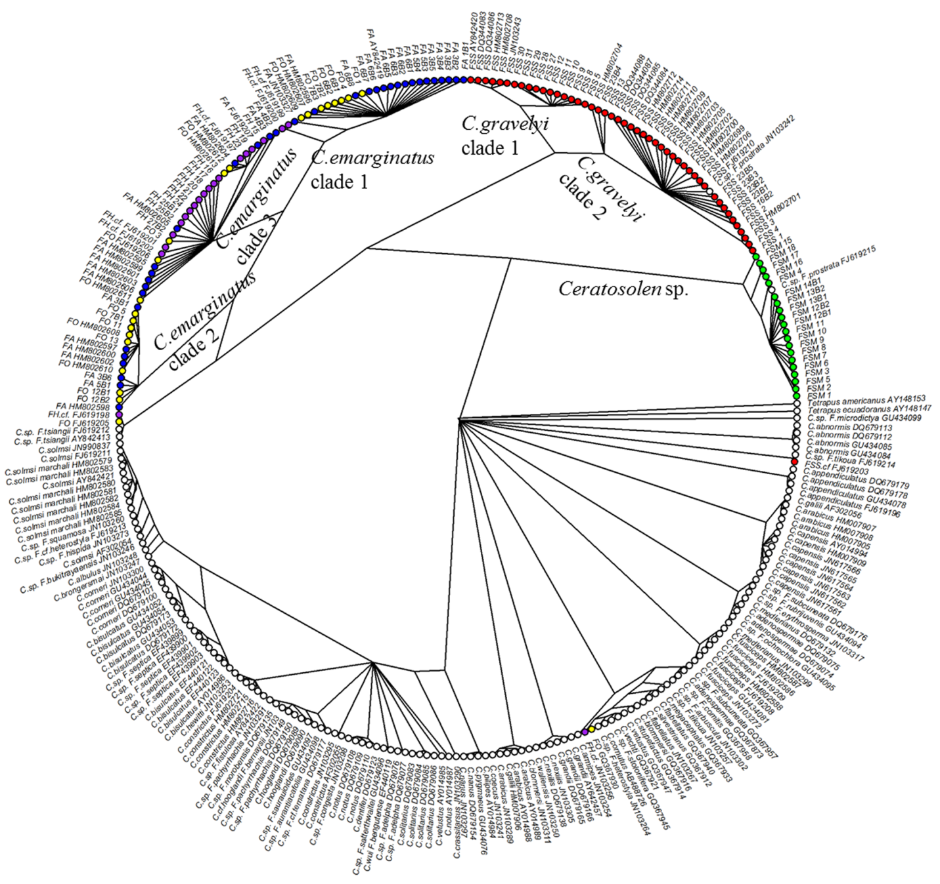

Figure S1. Bayesian tree of all Ceratosolen fig wasps with COI gene recored in GenBank. 72 out of 74 Ceratosolen wasp taxa recored in GenBank were included, except two taxa with aligned sequences shorter than 400bp. 87 individuals were de novo sequenced in this study and 202 sequences (with accession number after species names) were downloaded from GenBank. Circles with the same color at the tip of branches means fig wasp was one pollinator of five focused fig taxa, while the white circles indicate other Ceratosolen pollinators and outgroups. Composition of tip labels: host fig symbols (FSM= Ficus semicordata var. montana; FSS = F. semicordata var. semicordata; FA = F. auriculata; FO = F. oligodon; FH = F. hainanensis), The “B” after host symbols indicates that fig wasps were collected from receptive syconia while absence of “B” means that fig wasps were collected from syconia in male flower phase. See Appendix S1 for detail.

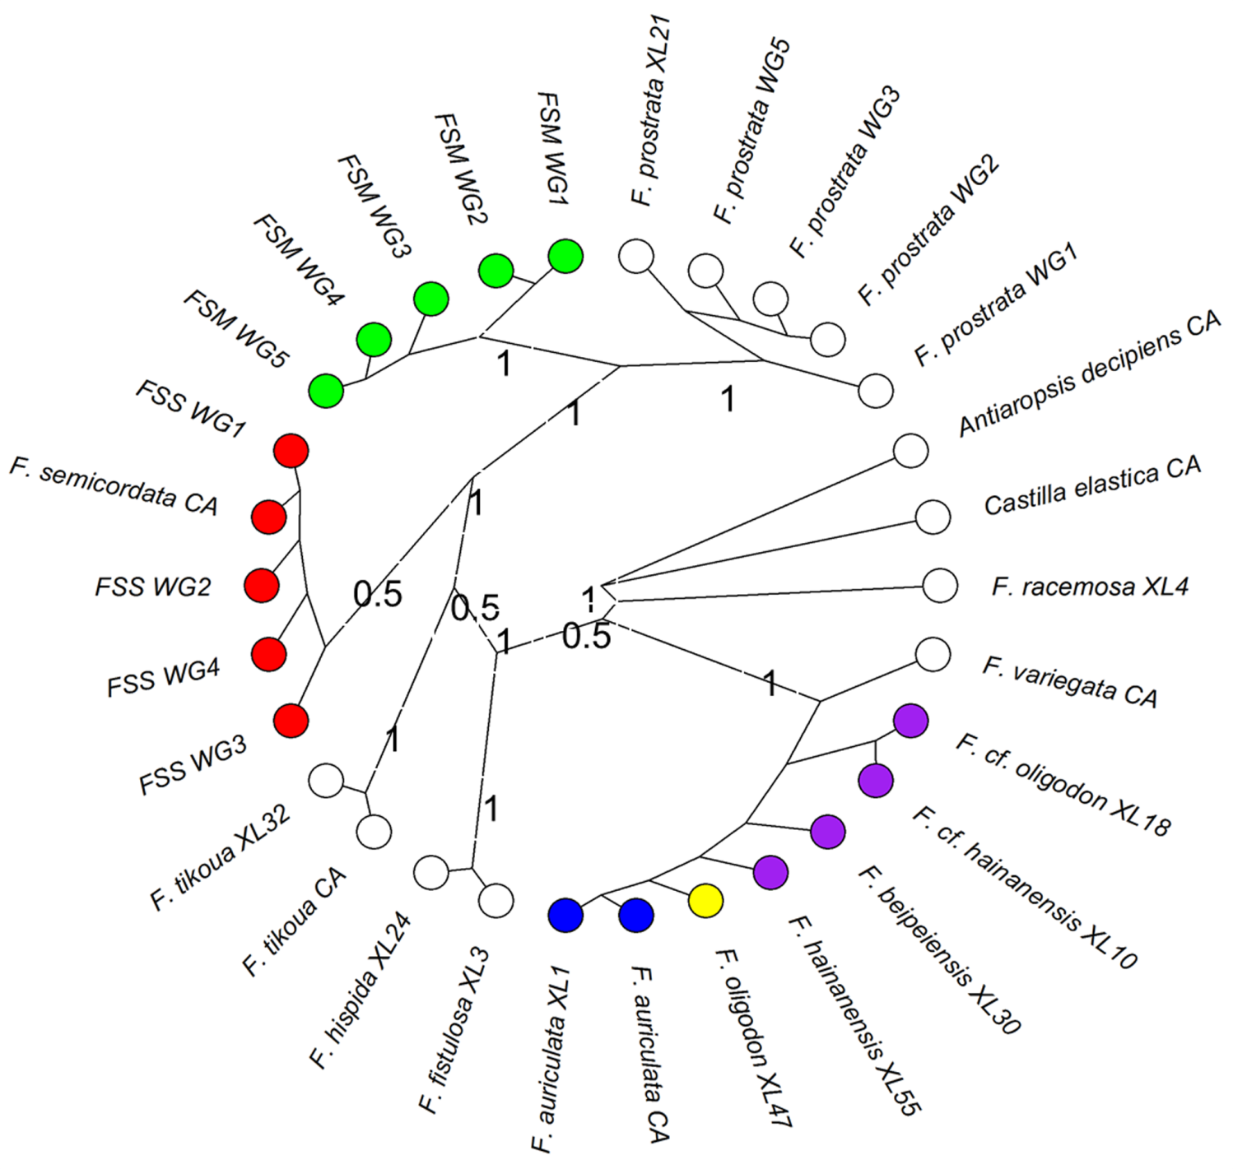

Figure S2 Bayesian tree of Ficus from Subgenus Sycomorus based on the ITS-G3pdh combined dataset. Branches are labeled with Bayesian posterior probabilities. F. semicordata and F. auriculata complex cluster in different clads, showing that they belong to different sections. FSM= Ficus semicordata var. montana; FSS = F. semicordata var. semicordata; Uppercase code following the species name indicates the reference. WG: de nove sequenced in this study; XL: Xu et al. 2011; CA: Cruaud et al. 2012. Tips with colored crcles indicate five fig taxa focused. F. beipeiensis XL30, F. cf. oligodon XL18, F. cf. hainanensis XL10 and F. hainanensis XL55, which reported in Xu et al. (2011)’s work, are morphologically similar, and are identified as F. hainanensis here based on our morphological checking. See Appendix S4 and Appendix S5 for detail.

References

Xu, L., Harrison, R.D., Yang, P. & Yang, D.-R. 2011 New insight into the phylogenetic and biogeographic history of genus Ficus: Vicariance played a relatively minor role compared with ecological opportunity and dispersal. J. Syst. Evol. 49, 546-557. (doi:10.1111/j.1759-6831.2011.00155.x).
Cruaud, A., Rønsted, N., Chantarasuwan, B., Chou, L.S., Clement, W.L., Couloux, A., Cousins, B., Genson, G., Harrison, R.D. & Hanson, P.E. 2012 An extreme case of plant-insect co-diversification: figs and fig-pollinating wasps. Syst. Biol. 61, 1029-1047. (doi:10.1093/sysbio/sys068).

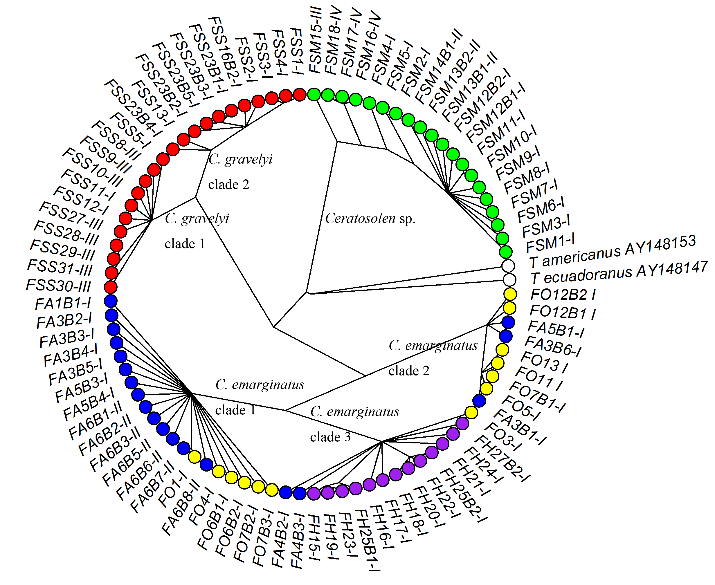Figure S3. Bayesian tree of 87 Ceratosolen fig wasps de novo sequenced in this study based on the COI gene. Circles with same color in the tip indicate fig wasps collected from same fig taxon, while the white circles are outgroups. Composition of tip labels: host fig symbols (FSM= Ficus semicordata var. montana; FSS = F. semicordata var. semicordata; FA = F. auriculata; FO = F. oligodon; FH = F. hainanensis), The “B” after host symbols indicate that fig wasp was collected from receptive syconia while absence of “B” means wasp collected from syconia of male flower phase. The Roman number at the tip labels indicate sampling sites: I: Menglun; II: Bubeng; III: Laos; IV: Vietnam. Pollinator sharing events were found to be highest in FA and FO, while that of FH is lower and Ficus semicordata (FS) did not show pollinator sharing. Geography factor may not determine which clade a wasp laying in phylogenetic tree as pollinator of same host fig taxa sampled from different sites often mix laying same clade. See Appendix S3 for detail.

Appendix S1-S5 can be found here:
Appendix S1. Byesian tree of all Ceratosolen species with COI gene recored in GenBank.nexus
Appendix S2. Bayesian tree of sympatric figs from Subgenus Sycomorus.nexus
Appendix S3. Byesian tree of 87 de nove sequenced Ceratosolen fig wasps.nexus
Appendix S4. Fig SSR data 11loci_278ind.txt
Appendix S5. List of fig wasp and fig samples used in phylogeny establishment.xlsx

