SUPPLEMENTARY Figures and Tables

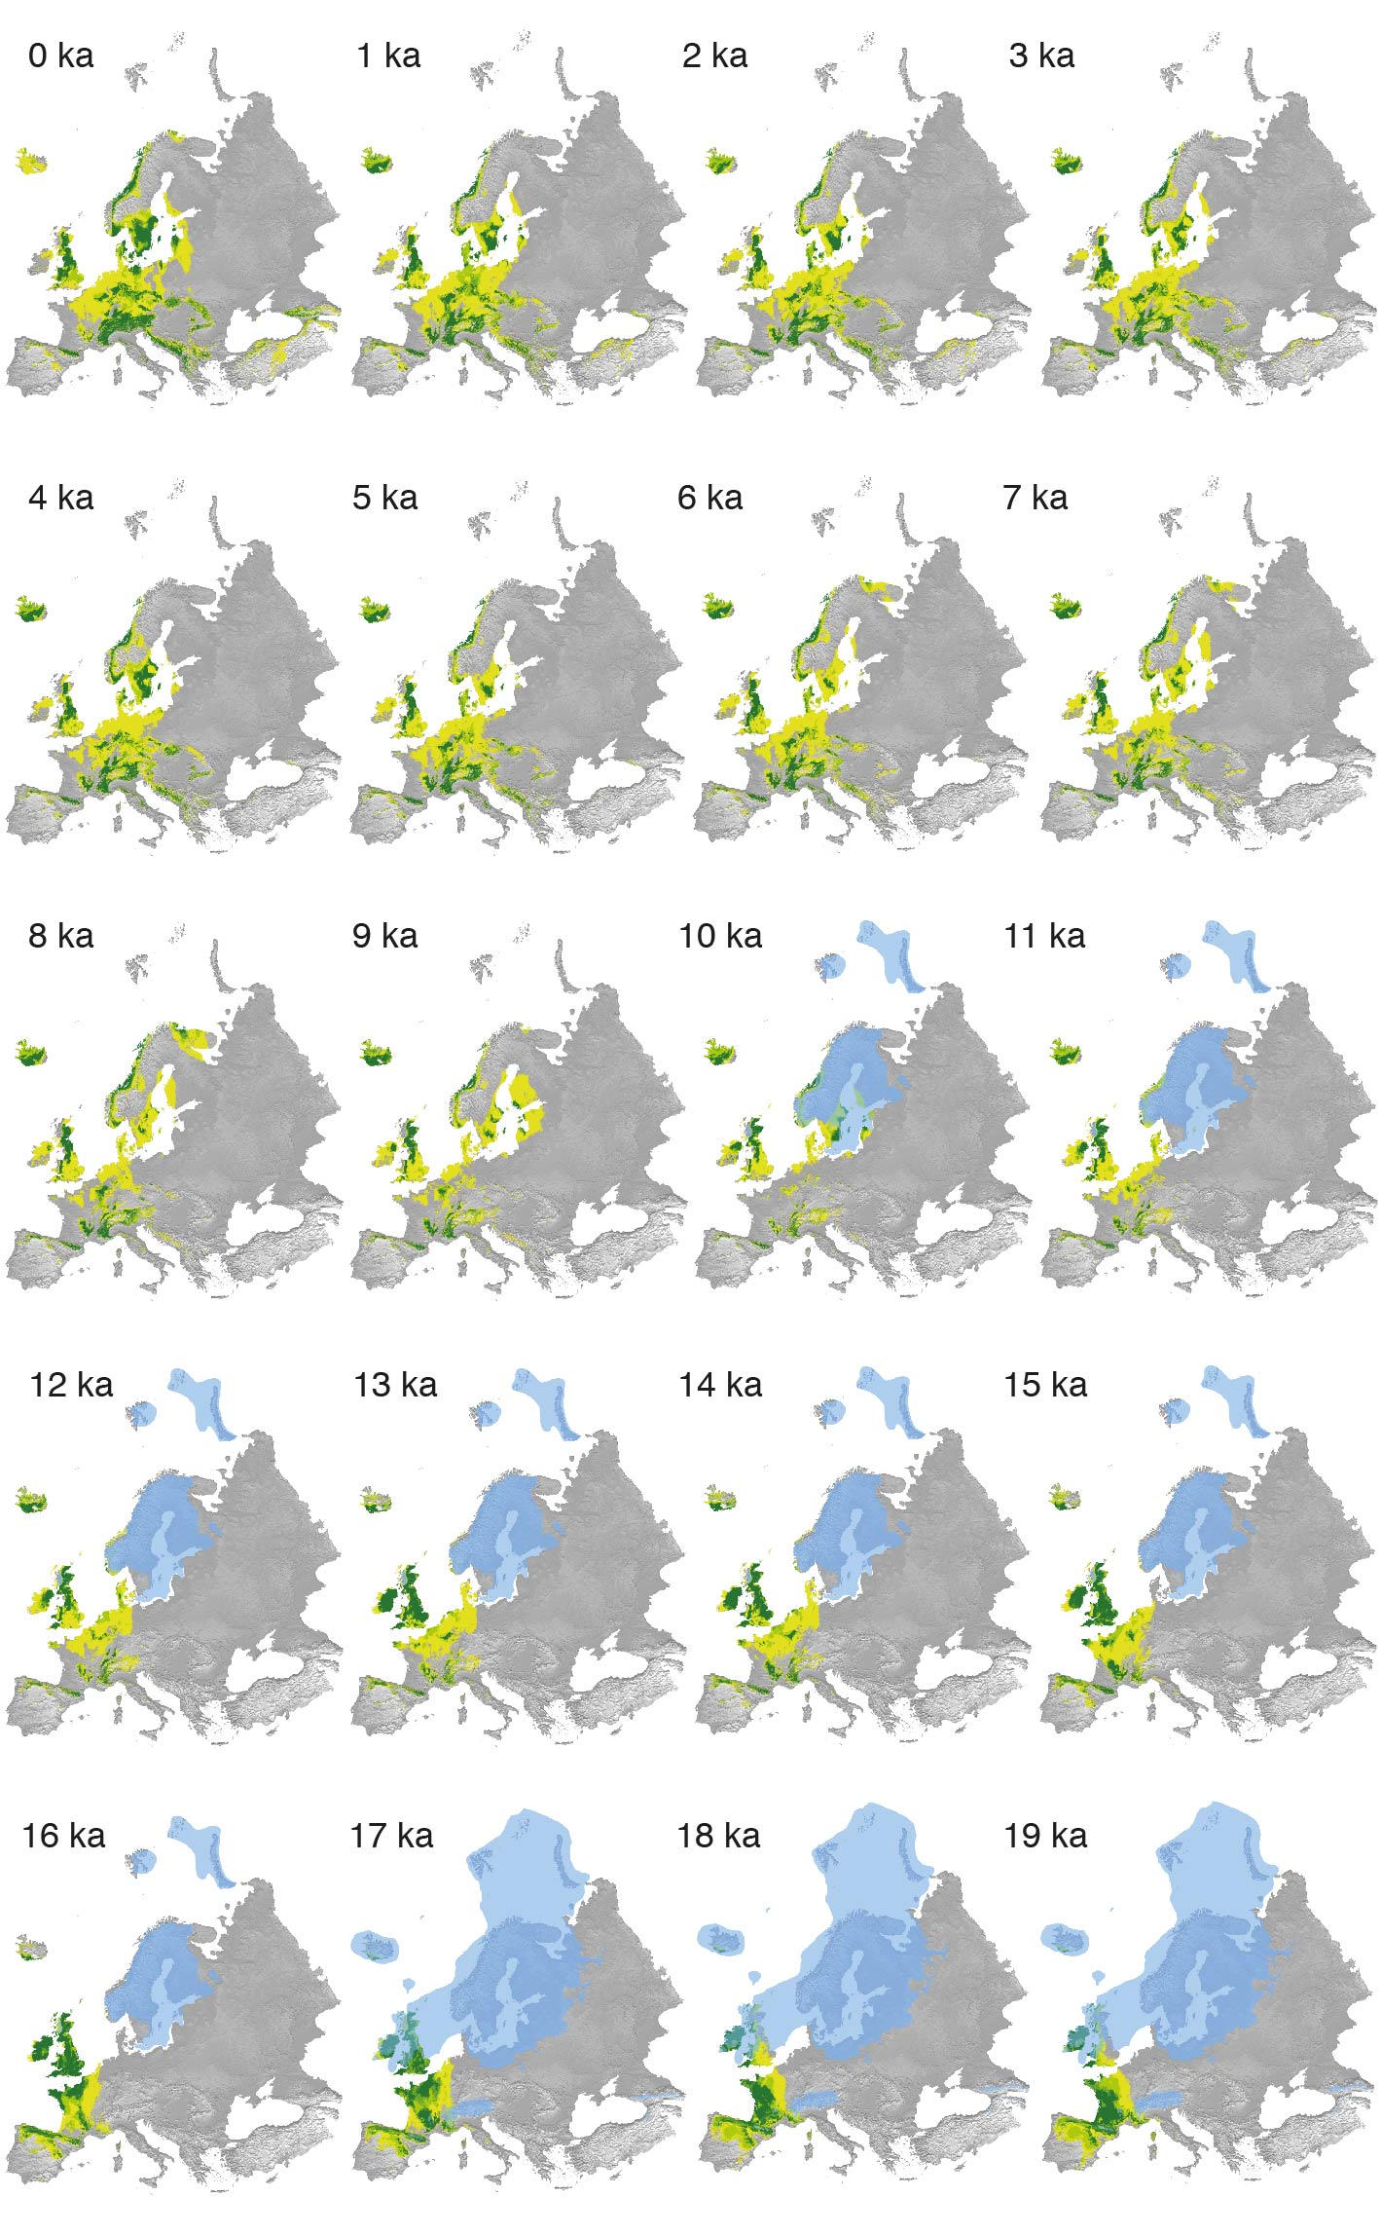
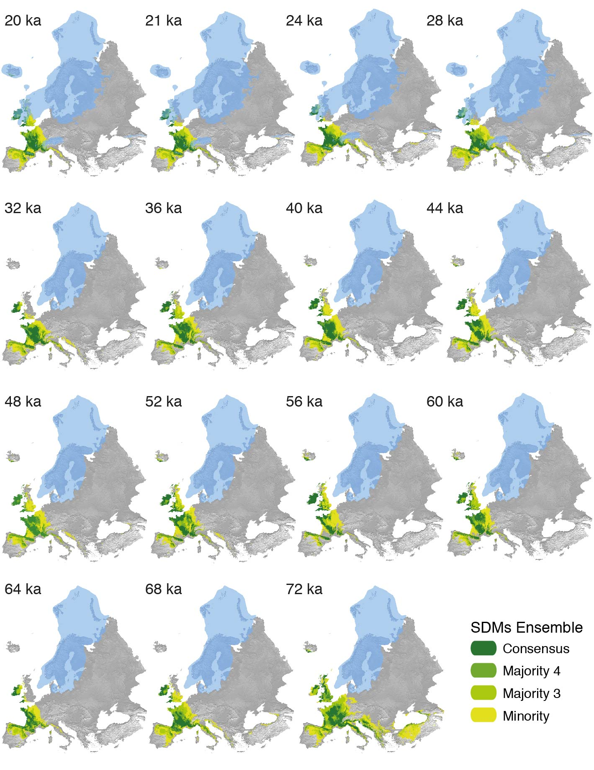
Figure S1. Predicted distribution of P. farinosa during the last 72 ka: Ice sheet layers for each stage are taken from Ehlers et al. 2011. Colors correspond to the number of modeling techniques that predicted the respective grid cells as suitable.

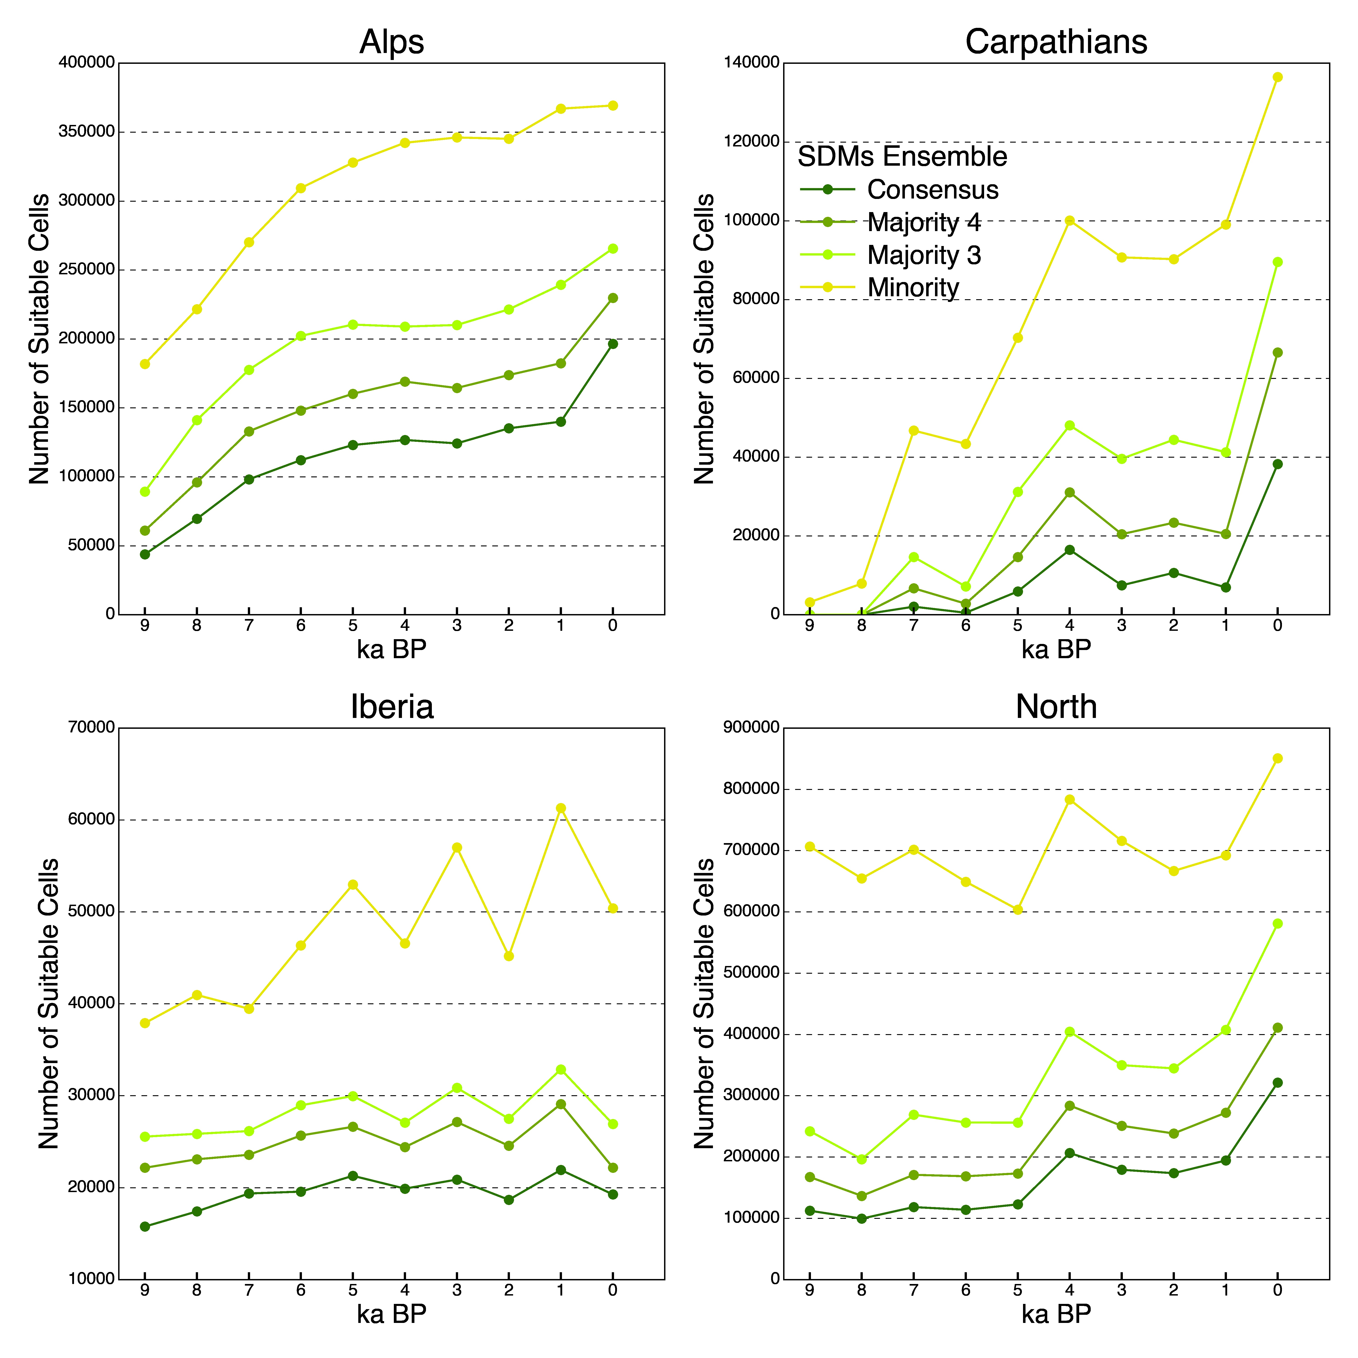
Figure S2. Region-specific distribution-through-time analysis: The results of these analyses (cell counts through the Holocene) were used to inform the prior distributions for growth rates for the respective lineages (see main text).

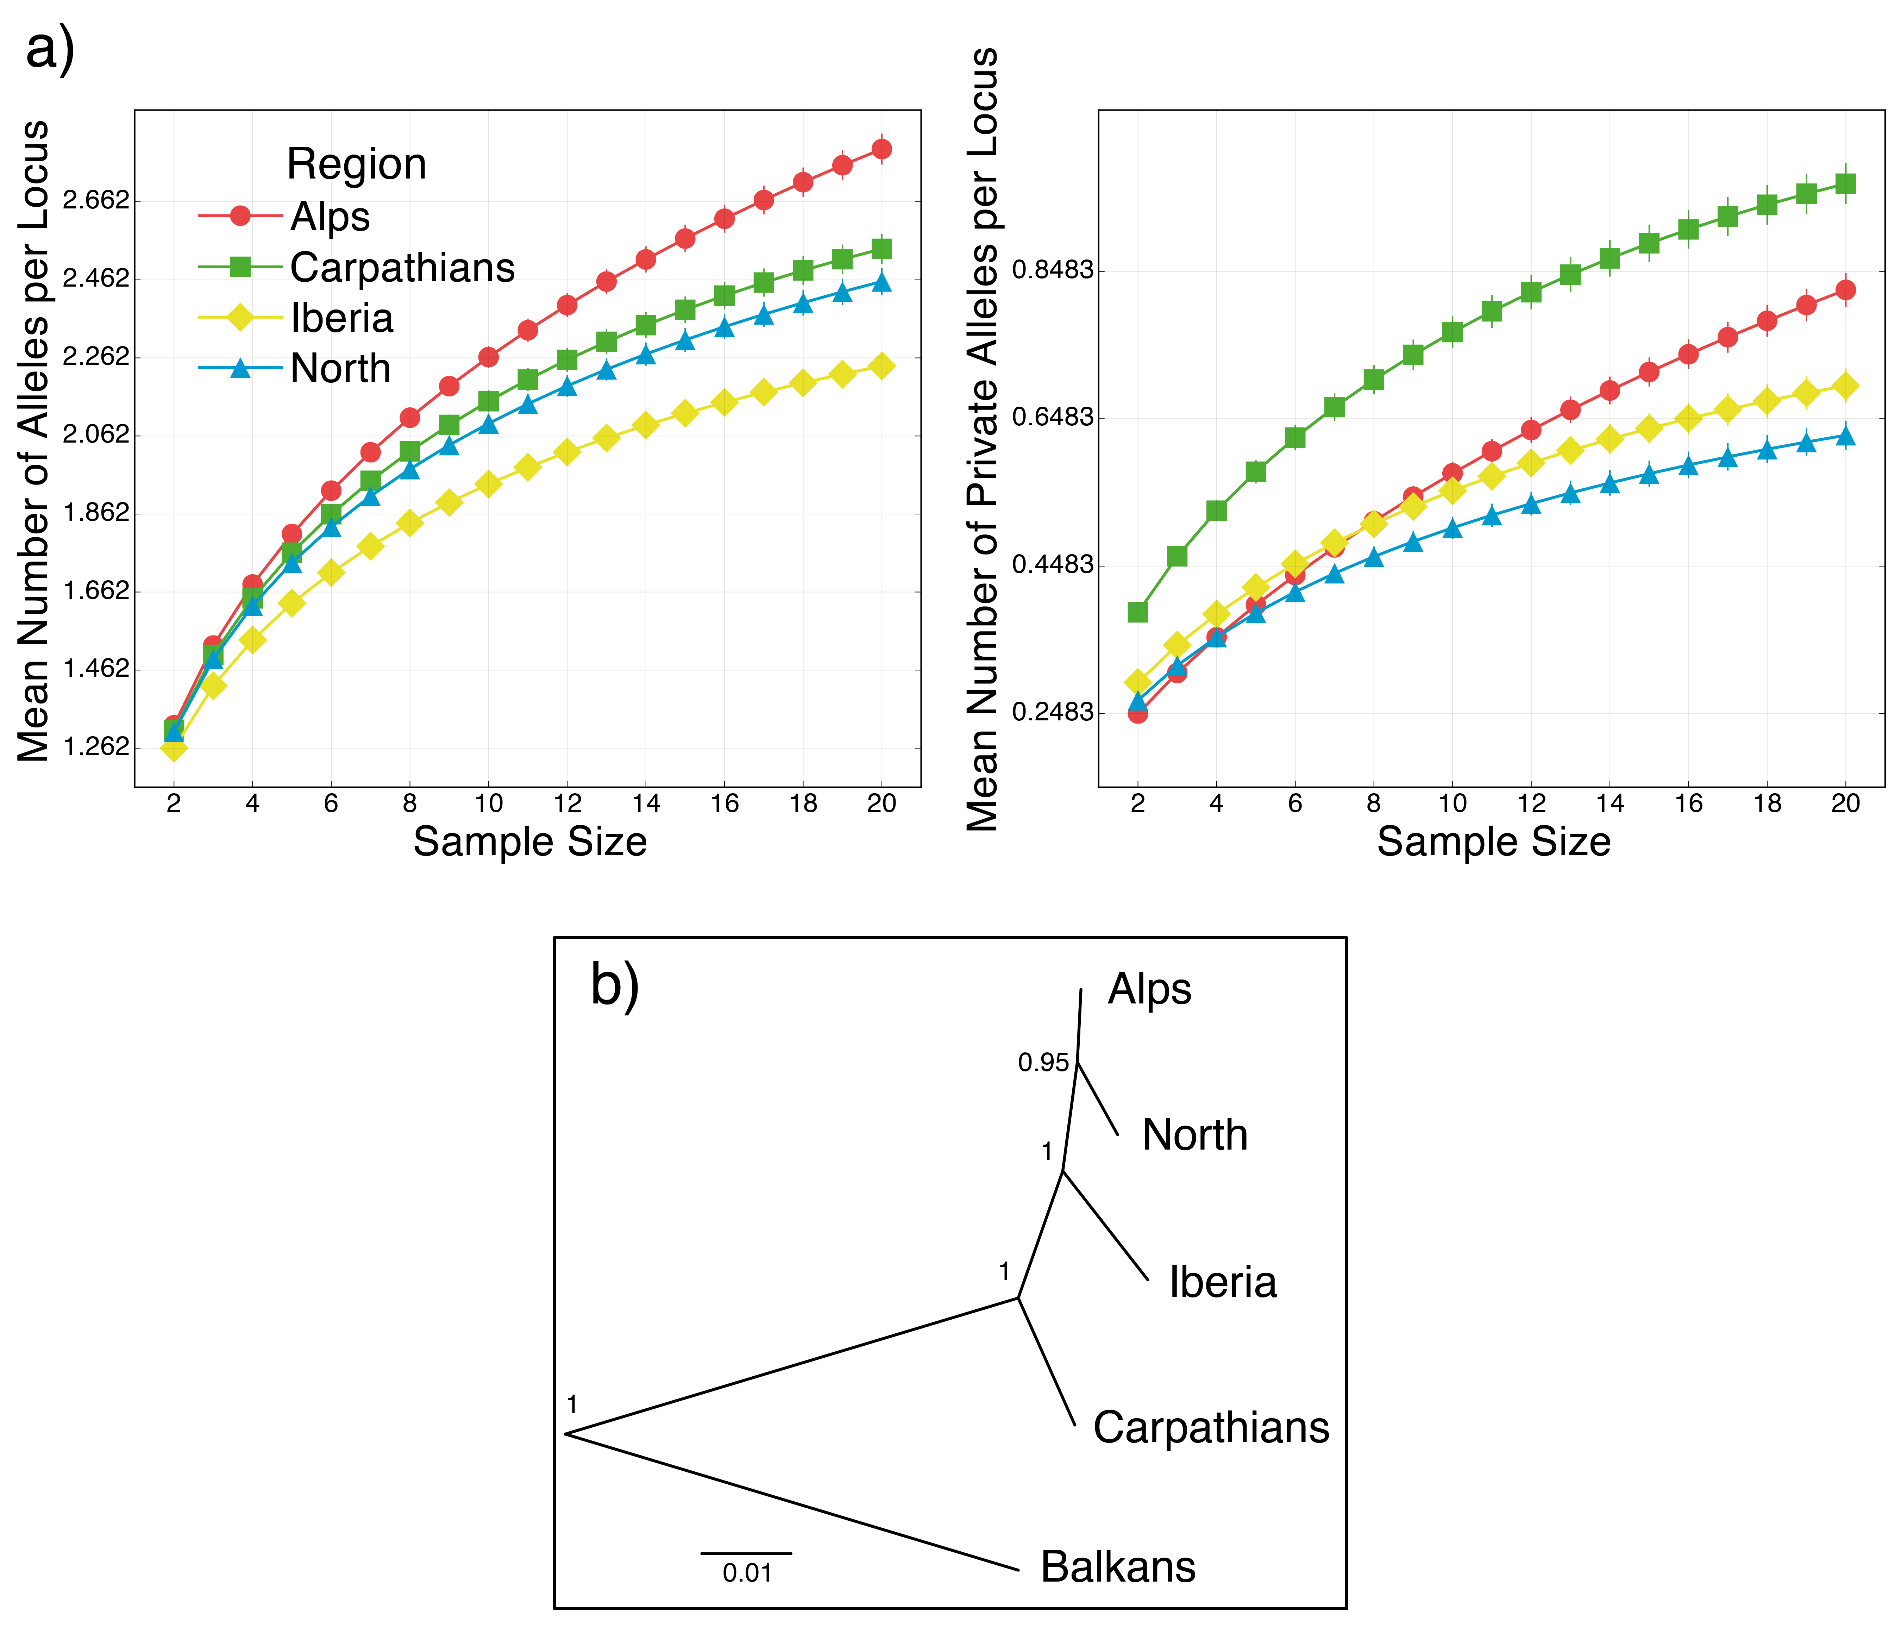 Figure S3. Genomic diversity and tree topology analyses: We initially evaluated different combinations of alignment-mismatch thresholds in the STACKS pipeline with respect to genomic diversity and tree topology. The results shown here were obtained using a minimum depth (coverage) of 20 identical reads per stack, a maximum distance (M) between stacks of four nucleotides and maximum 6 mismatches between putatively homologous loci (n) across all individuals. The total number of loci used was 1565. a) Allelic richness (mean number of alleles per locus) and private allelic richness (mean number of private alleles per locus) of the four main lineages of P. farinosa as functions of sample size. Vertical bars show standard error. b) Maximum likelihood tree obtained by TreeMix analysis. Numbers at each node represent bootstrap support values across all SNP repetitions (10) and bootstrap replicates (100). The total SNP number varied between 1777 and 1808 across SNP repetitions. The individuals of P. exigua and P. frondosa were grouped together (“Balkans” lineage) and were used as outgroups.

Table S1. Populations used in this study
Index | Population Code | Longitude | Latitude | Region | Number Of Individuals
 | Primula farinosa
1 | CH1 | 8.832097 | 47.290827 | Alps, Switzerland | 3
2 | CH2 | 7.86024 | 46.54348 | Alps, Switzerland | 3
3 | CH3 | 10.41713 | 46.88712 | Alps, Switzerland | 3
4 | CH4 | 9.49412 | 46.48514 | Alps, Switzerland | 3
5 | CH5 | 8.64811 | 46.90493 | Alps, Switzerland | 3
6 | CH6 | 7.82904 | 46.04722 | Alps, Switzerland | 3
7 | CH8 | 8.3876 | 46.57594 | Alps, Switzerland | 3
8 | AT1 | 12.9483 | 47.7515 | Alps, Austria | 3
9 | AT2 | 13.25893 | 47.81698 | Alps, Austria | 3
10 | AT3 | 13.87996 | 47.19119 | Alps, Austria | 3
11 | AT4 | 13.01694 | 46.95521 | Alps, Austria | 3
12 | AT6 | 11.51985 | 46.95977 | Alps, Austria | 3
13 | FR1 | 6.91825 | 44.31153 | Alps, France | 3
14 | FR2 | 6.91287 | 44.79785 | Alps, France | 3
15 | IT1 | 12.06242 | 46.65393 | Alps, Italy | 3
16 | IT2 | 7.13475 | 44.54756 | Alps, Italy | 3
17 | SK1 | 20.406389 | 48.989167 | Carpathians, Tatra | 2
18 | SK2 | 20.230556 | 48.879444 | Carpathians, Tatra | 2
19 | SK3 | 20.374444 | 49.220556 | Carpathians, Tatra | 2
20 | SK4 | 19.949167 | 49.070556 | Carpathians, Tatra | 3
21 | SK5 | 19.155556 | 49.148611 | Carpathians, Tatra | 3
22 | SK6 | 18.89 | 48.879167 | Carpathians, Tatra | 3
23 | RO1 | 25.66703 | 45.71715 | Carpathians, Romania | 5
24 | ES1 | 0.75656 | 42.6289 | Iberia, Pyrenees | 3
25 | ES2 | 0.84992 | 42.77107 | Iberia, Pyrenees | 3
26 | ES3 | 0.5302 | 42.64923 | Iberia, Pyrenees | 3
27 | ES4 | -0.00972 | 42.63551 | Iberia, Pyrenees | 2
28 | ES5 | -0.43295 | 42.79872 | Iberia, Pyrenees | 3
29 | ES6 | -0.35548 | 42.6975 | Iberia, Pyrenees | 3
30 | ES7 | -4.71135 | 43.26367 | Iberia, Cantabria | 5
31 | ES8 | 0.162111 | 42.939361 | Iberia, Pyrenees | 2
32 | GB1 | -2.246481 | 54.666627 | Britain | 3
33 | GB2 | -2.376468 | 54.472176 | Britain | 3
34 | SW1 | 16.41928 | 56.30038 | Sweden, Öland | 2
35 | SW2 | 16.45355 | 56.36321 | Sweden, Öland | 1
36 | SW3 | 16.48301 | 56.37928 | Sweden, Öland | 2
37 | SW4 | 16.52428 | 56.53696 | Sweden, Öland | 1
38 | SW5 | 16.56061 | 56.60441 | Sweden, Öland | 2
39 | SW6 | 14.68839 | 58.35797 | Sweden, Mainland | 3
40 | SW7 | 15.05134 | 58.41756 | Sweden, Mainland | 3
41 | SW8 | 16.73994 | 58.78976 | Sweden, Mainland | 3
42 | SW9 | 17.455 | 58.89394 | Sweden, Mainland | 3
43 | SW10 | 18.28778 | 57.32407 | Sweden, Götland | 1
44 | SW11 | 18.28949 | 57.11624 | Sweden, Götland | 2
45 | SW12 | 18.76782 | 57.60047 | Sweden, Götland | 1
46 | SW13 | 18.68452 | 57.41667 | Sweden, Götland | 2
47 | SW14 | 18.89126 | 57.81397 | Sweden, Götland | 2
48 | SW15 | 18.89523 | 59.96427 | Sweden, Mainland | 3
49 | SW16 | 17.34534 | 60.60882 | Sweden, Mainland | 3
50 | LV1 | 23.4725 | 57.0004 | Latvia | 3
51 | LV2 | 23.14614 | 57.26532 | Latvia | 3
52 | LV3 | 22.59973 | 57.0317 | Latvia | 3
53 | LV4 | 24.827085 | 57.421702 | Latvia | 3
 | Primula exigua
54 | BG1 | 23.41362 | 41.75203 | Balkans, Pirin | 3
55 | BG2 | 23.45097 | 42.1739 | Balkans, Rila | 3
56 | BG3 | 23.80462 | 42.17439 | Balkans, Rila | 3
57 | BG4 | 23.28248 | 42.57591 | Balkans, Vitosha | 3
 | Primula frondosa
58 | BGF1 | 24.81442 | 42.69094 | Balkans, Stara Planina | 1

Table S2. Climatic variables derived from the original monthly mean temperature (tmean) and precipitation (prec) layers from the WorldClim data set. The five variables that were used in this study are indicated with an asterisk.
Growing Degree Days
Precipitation Annual Range
Annual Precipitation
Precipitation of Coldest Quarter
Precipitation of Driest Month*
Precipitation of Driest Quarter
Precipitation of Warmest Quarter
Precipitation of Wettest Month
Precipitation of Wettest Quarter*
Annual range of mean monthly temperature*
Annual Mean Temperature
Mean Temperature of Coldest Month*
Mean Temperature of Coldest Quarter
Mean Temperature of Driest Quarter
Mean Temperature of Warmest Month*
Mean Temperature of Warmest Quarter
Mean Temperature of Wettest Quarter

Table S3. Number of pseudo-absences used in each modeling technique and performance of the five techniques used in this study
Modeling technique | Number of pseudo-absences | Average AUC | Average TSS
GAM | 10000 | 0.975 | 0.858
GBM | 1765 | 0.9945 | 0.9502
GLM | 10000 | 0.98 | 0.866
RF | 1765 | 0.993 | 0.9493
MaxEnt | 10000 | 0.9224 | 0.786

Table S4. Glacial ice sheet layers used as filters for the distribution through time analysis and the visualization of the paleodistribution maps (Fig. S1). Selection of time intervals based on Ehlers et al. (2011), Darnault et al. (2011) and Pallàs et al. (2006).
Years (ka bp) | Ice Sheet Layer (Stage)
72 – 32 | Mid-Glacial
28 – 17 | Last Glacial Maximum
16 – 10 | Oldest - Younger Dryas

Darnault R, Rolland Y, Braucher R, Bourlès D, Revel M, Sanchez G, Bouissou S. 2011. Timing of the last deglaciation revealed by receding glaciers at the Alpine-scale: impact on mountain geomorphology. Quat. Sci. Rev. 31:127–142.
Ehlers J, Gibbard PL, Hughes PD. 2011. Quartenary Glaciations – Extent and Chronology (Vol 15, 1st edn). Elsevier. Available from URL: http://booksite.elsevier.com/9780444534477/digital_maps.php.
Pallàs R, Rodés A, Braucher R, Carcaillet J, Ortuno M, Bordonau J, Bourlès D, Vilaplana JM, Masana E, Santanach P. 2006. Late Pleistocene and Holocene glaciation in the Pyrenees: a critical review and new evidence from 10Be exposure ages, south-central Pyrenees. Quat. Sci. Rev. 25:2937–2963.

Table S5. Predicted number of cells through time extracted from SDMs across the entire range of P. farinosa. Grey color indicates the numbers that were used to inform the demographic growth rates for the species-wide expansion model.
 | Model Ensembles
Time Slice (ka BP) | Minority | Majority 3 | Majority 4 | Consensus
0 | 3,205,337 | 1,590,183 | 1,127,839 | 866,133
1 | 2,764,936 | 1,350,587 | 8,805,63 | 618,177
2 | 2,493,871 | 1,124,465 | 756,216 | 536,601
3 | 2,604,136 | 1,179,811 | 815,147 | 588,452
4 | 2,485,795 | 1,156,245 | 807,596 | 587,922
5 | 2,281,342 | 1,003,233 | 677,782 | 487,766
6 | 2,392,058 | 988,296 | 654,336 | 462,627
7 | 2,358,284 | 961,383 | 638,301 | 454,367
8 | 2,269,090 | 882,814 | 580,596 | 416,667
9 | 2,034,858 | 733,696 | 513,213 | 363,772
10 | 1,067,574 | 519,205 | 335,787 | 244,844
11 | 1,165,667 | 528,677 | 344,251 | 247,924
12 | 1,339,603 | 595,349 | 390,871 | 274,875
13 | 1,298,445 | 631,477 | 475,287 | 386,873
14 | 1,328,266 | 654,845 | 481,259 | 378,543
15 | 1,269,847 | 719,729 | 559,298 | 427,047
16 | 803,679 | 488,654 | 369,659 | 270,656
17 | 958,749 | 629,764 | 487,766 | 304,090
18 | 874,608 | 560,168 | 384,693 | 269,477
19 | 890,674 | 596,323 | 371,751 | 272,717
20 | 1,058,522 | 678,431 | 439,176 | 282,524
21 | 1,003,742 | 625,802 | 420,046 | 292,957
24 | 1,067,351 | 646,395 | 438,590 | 328,601
28 | 1,112,805 | 675,596 | 445,054 | 289,593
32 | 1,201,652 | 746,963 | 542,835 | 397,816
36 | 1,297,964 | 885,064 | 646,944 | 455,333
40 | 1,267,373 | 780,614 | 605,995 | 456,428
44 | 1,314,909 | 777,857 | 600,691 | 453,427
48 | 1,371,394 | 810,008 | 626,329 | 464,233
52 | 1,429,614 | 920,866 | 674,165 | 472,899
56 | 1,171,502 | 688,203 | 509,182 | 398,800
60 | 1,341,933 | 917,771 | 640,460 | 446,686
64 | 945,186 | 621,747 | 409,600 | 281,559
68 | 1,481,218 | 924,225 | 575,330 | 366,944
72 | 2,507,951 | 1,562,332 | 978,167 | 617,689

Table S6. Summary statistics of the Illumina HiSeq 2000 Sequencing at different filtering stages. The statistics are calculated over 157 individuals including P. farinosa, P. exigua and P. frondosa.
 | Raw Reads | Raw Reads (Excl. Organelle Dna) | Filtered and Trimmed Reads (Nuclear QC reads)
Total Number of Reads  (size in bp) | 327,689,814  (101 bp) |  | 208,064,697  (90 bp)
Number of Reads Per Individual
Mean | 2,086,177 | 1,681,370 | 1,325,252
Min | 767,519 | 694,973 | 627,462
Max | 3,854,565 | 3,022,125 | 2,091,370
Reads represented by at least 10 and a maximum of 1000 copies each
Mean | 643,462 | 567,662 | 552,132
Min | 183,222 | 162,167 | 169,547
Max | 1,235,121 | 1,119,662 | 1,037,601
Reads represented by at least 20 and a maximum of 1000 copies each
Mean | 454,923 | 390,564 | 383,875
Min | 98,009 | 80,230 | 86,819
Max | 981,401 | 878,811 | 831,329
STACKS formed by at least 10 and a maximum of 1000 reads
Mean | 23,436 | 21,726 | 20,841
Min | 8,707 | 8,274 | 8,434
Max | 41,526 | 40,250 | 39,698
STACKS formed by at least 20 and a maximum of 1000 reads
Mean | 9,150 | 8,295 | 8,099
Min | 2,110 | 1,928 | 2,039
Max | 17,494 | 16,578 | 16,376
Mean Coverage Per Individual (>=10x, <= 1000x)
Mean | 27.28 | 25.9 | 26.35
Min | 20.73 | 19.59 | 20.10
Max | 35.02 | 33.89 | 35.37
Mean Coverage Per Individual (>=20x, <= 1000x)
Mean | 49.42 | 46.70 | 47.14
Min | 39.51 | 39.17 | 39.81
Max | 61.53 | 59.13 | 60.10

Table S7. Estimated theta parameter value (the product of effective population size and mutation rate) for the four lineages and for three SNAPP repetitions (one randomly chosen SNP per locus)
Repetition | Theta
 | Carpathians | Alps | Iberia | North
1 | 0.101 | 0.266 | 0.076 | 0.11
2 | 0.932 | 0.256 | 0.078 | 0.106
3 | 0.957 | 0.272 | 0.07 | 0.103

