Supplementary figure 1.
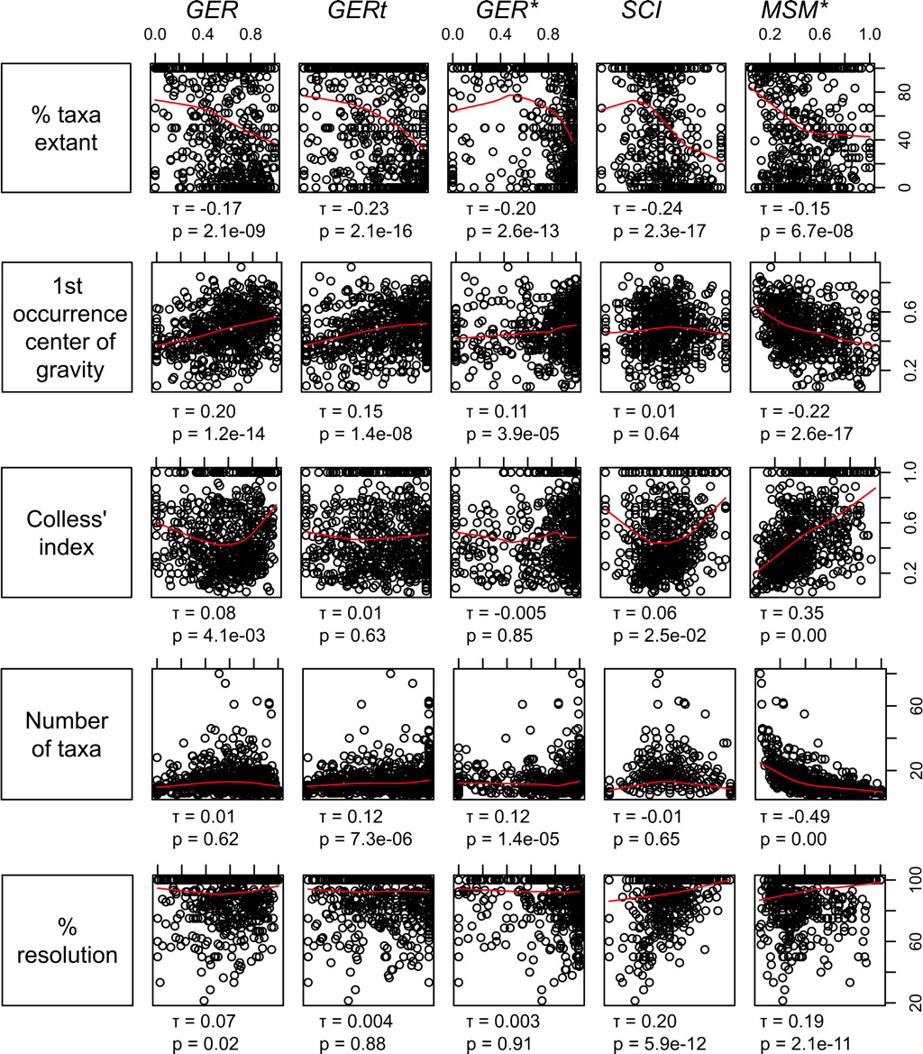
Supplementary Figure 1. Scatterplots and correlations of five independent variables demonstrated to influence stratigraphic congruence (the percentage of extant taxa, the center of gravity of first occurrence dates, Colless’s index of tree imbalance, the number of taxa and the percentage resolution) with each of five indices of stratigraphic congruence (SCI, MSM*, GER, GERt and GER*, all resolving polytomies in reverse stratigraphic order). Kendall’s τ coefficients and p values are shown below each plot. We have fitted smoothers through the scatterplots in each panel to aid visualization of the relationship between each pair.
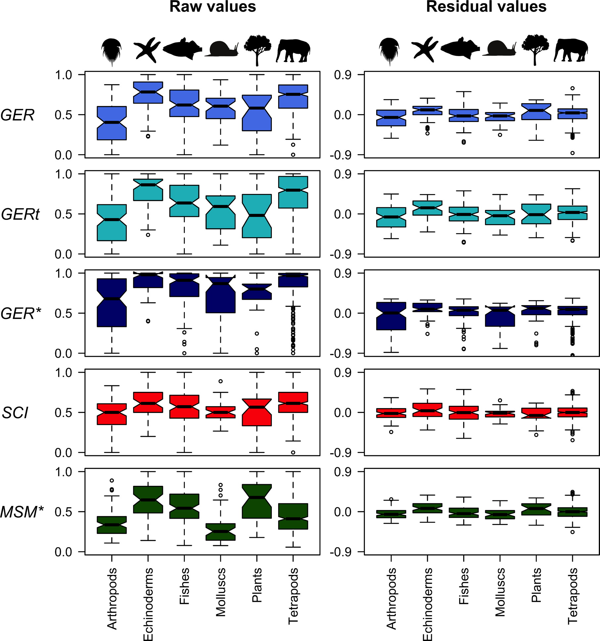

Supplementary Figure 2. Median indices of stratigraphic congruence (GER, GERt, GER*, SCI and MSM*) and their residuals (from minimum adequate models) vary significantly across higher taxa. Median values are indicated by black horizontal bars, shaded areas represent upper and lower quartiles, and dashed lines connect to the most eccentric points within 1.5 interquartile ranges of the medians. Outliers are shown as circles. All polytomies resolved stratigraphically. Residuals are for the minimum adequate model (Supplementary Table 6).

Supplementary figure 3
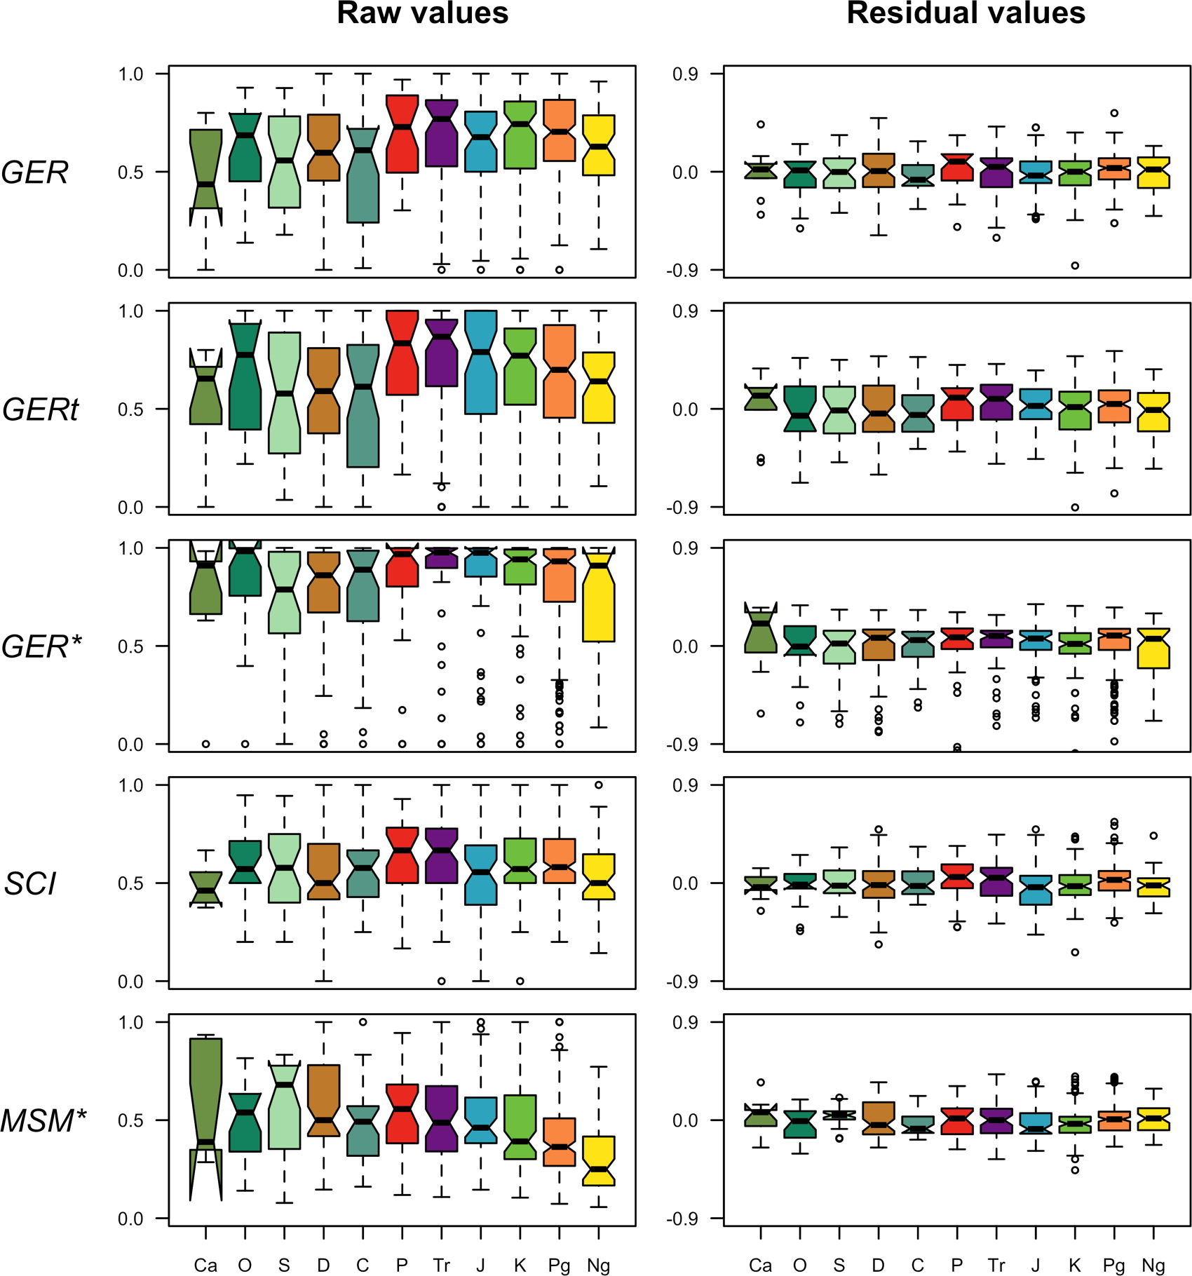

Supplementary Figure 3. Median indices of stratigraphic congruence (GER, GERt, GER*, SCI and MSM*) and their residuals (from minimum adequate models) vary significantly across geological periods. Trees are binned according to the mean date of first occurrence of their constituent taxa. Median values are indicated by black horizontal bars, shaded areas represent upper and lower quartiles, and dashed lines connect to the most eccentric points within 1.5 interquartile ranges of the medians. Outliers are shown as circles. All polytomies resolved stratigraphically. Abbreviations: Ca, Cambrian; O, Ordovician; S, Silurian; D, Devonian; C, Carboniferous; P, Permian; Tr, Triassic; J, Jurassic; K, Cretaceous; Pg, Palaeogene; Ng, Neogene.

Supplementary Figure 4. Median indices of stratigraphic congruence (GER, GERt, GER*, SCI and MSM*) vary significantly across higher taxa. Summary statistics for those trees (n = 443) in which all terminals have a fossil record (omitting trees in which one or more terminals are known only from the Recent). Median values are indicated by black horizontal bars, shaded areas represent upper and lower quartiles, and dashed lines connect to the most eccentric points within 1.5 interquartile ranges of the medians. Outliers are shown as circles. All polytomies resolved in reverse stratigraphic order.

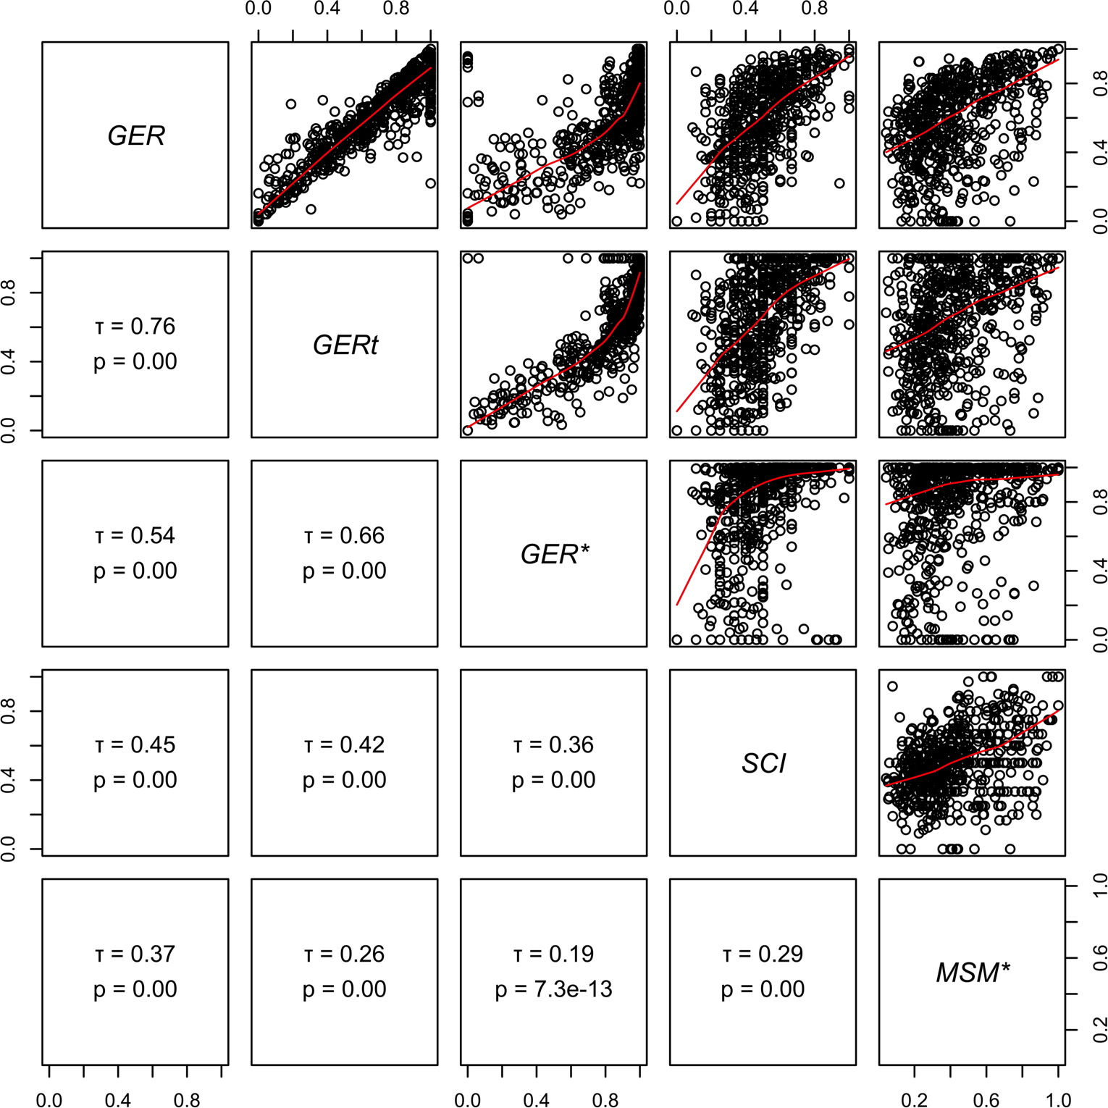

Supplementary Figure 5. Pairwise correlations of the GER*, GER, SCI, GERt and MSM* (all resolving polytomies in reverse stratigraphic order) for the empirical data set. Kendall’s tau τ coefficients and p values are shown in panels below the diagonal.

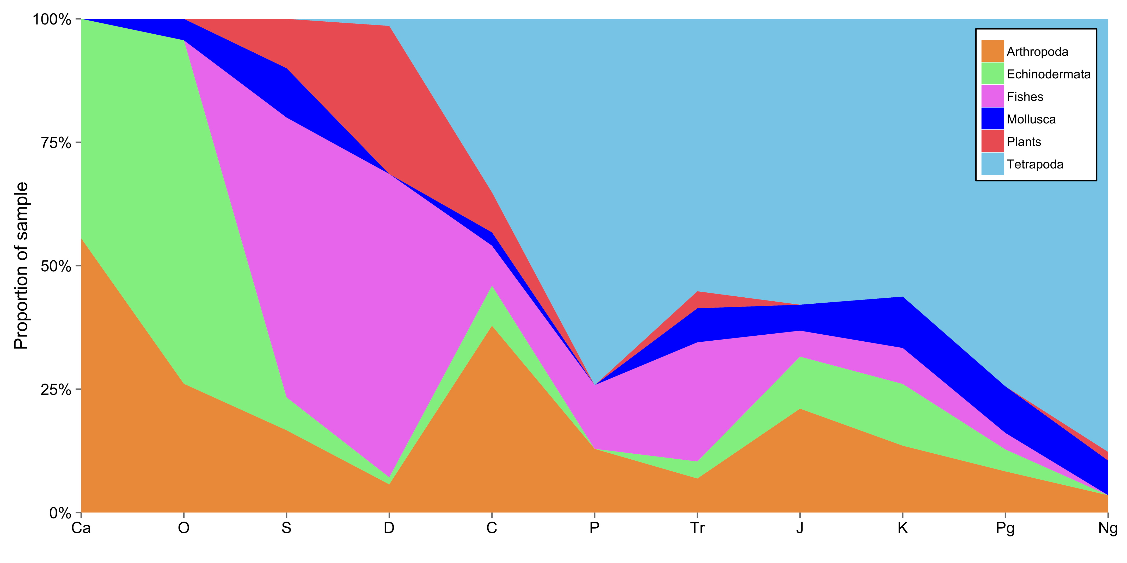

Supplementary Figure 6. Taxonomic composition of our empirical sample of 647 cladograms through the periods of the Phanerozoic. Trees are assigned to periods according to the mean origination date of their constituent taxa. Abbreviations: Ca, Cambrian; O, Ordovician; S, Silurian; D, Devonian; C, Carboniferous; P, Permian; Tr, Triassic; J, Jurassic; K, Cretaceous; Pg, Palaeogene; Ng, Neogene.

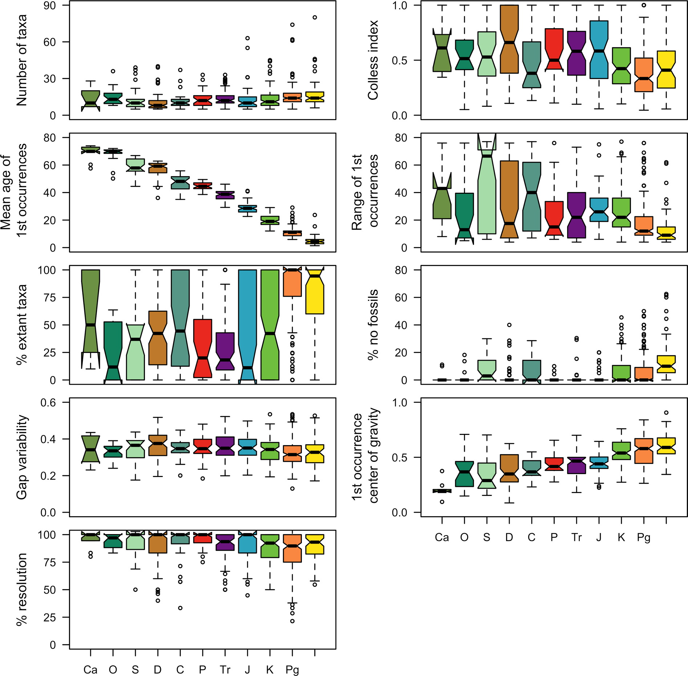

Supplementary Figure 7. Variation in nine of the independent variables reasoned or demonstrated empirically to influence stratigraphic congruence, partitioned by geological period. Trees are dated according to the mean first occurrence date of their constituent taxa. Median values are indicated by black horizontal bars, shaded areas represent upper and lower quartiles, and dashed lines connect to the most eccentric points within 1.5 interquartile ranges of the medians. Outliers are shown as circles. Abbreviations: Ca, Cambrian; O, Ordovician; S, Silurian; D, Devonian; C, Carboniferous; P, Permian; Tr, Triassic; J, Jurassic; K, Cretaceous; Pg, Palaeogene; Ng, Neogene.

Supplementary table 1.
Simulation | Tree topology | Number of different first occurrence dates | Distributions of first occurrence dates  All distributed across 128 equally spaced stratigraphic intervals
1-3 | Fully balanced | 4 | 1. Symmetrical – 16 terminals at each of 4 evenly spaced intervals  2. Bottom-heavy – 16 terminals at each of 3 oldest intervals and 1 terminal at the youngest interval  3. Top-heavy – 16 terminals at each of 3 youngest intervals and 1 terminal at the oldest interval
4-6 | Fully balanced | 8 | 1. Symmetrical – 8 terminals at each of 8 evenly spaced intervals  2. Bottom-heavy – 8 terminals at each of 7 oldest intervals and 1 terminal at the youngest interval  3. Top-heavy – 8 terminals at each of 7 youngest intervals and 1 terminal at the oldest interval
7-9 | Fully balanced | 16 | 1. Symmetrical – 4 terminals at each of 16 evenly spaced intervals  2. Bottom-heavy – 4 terminals at each of 15 oldest intervals and 1 terminal at the youngest interval  3. Top-heavy – 4 terminals at each of 15 youngest intervals and 1 terminal at the oldest interval
10-12 | Fully balanced | 32 | 1. Symmetrical – 2 terminals at each of 32 evenly spaced intervals  2. Bottom-heavy – 2 terminals at each of 31 oldest intervals and 1 terminal at the youngest interval  3. Top-heavy – 2 terminals at each of 31 youngest intervals and 1 terminal at the oldest interval
13-15 | Fully balanced | 64 | 1. Symmetrical – 1 terminal at every 2nd interval  2. Bottom-heavy – 1 terminal at each of 63 oldest intervals and 1 terminal at the youngest interval  3. Top-heavy – 1 terminal at each of 63 youngest intervals and 1 terminal at the oldest interval
16-18 | Fully pectinate | 4 | 1. Symmetrical – 16 terminals at each of 4 evenly spaced intervals  2. Bottom-heavy – 16 terminals at each of 3 oldest intervals and 1 terminal at the youngest interval  3. Top-heavy – 16 terminals at each of 3 youngest intervals and 1 terminal at the oldest interval
19-21 | Fully pectinate | 8 | 1. Symmetrical – 8 terminals at each of 8 evenly spaced intervals  2. Bottom-heavy – 8 terminals at each of 7 oldest intervals and 1 terminal at the youngest interval  3. Top-heavy – 8 terminals at each of 7 youngest intervals and 1 terminal at the oldest interval
22-24 | Fully pectinate | 16 | 1. Symmetrical – 4 terminals at each of 16 evenly spaced intervals  2. Bottom-heavy – 4 terminals at each of 15 oldest intervals and 1 terminal at the youngest interval  3. Top-heavy – 4 terminals at each of 15 youngest intervals and 1 terminal at the oldest interval
25-27 | Fully pectinate | 32 | 1. Symmetrical – 2 terminals at each of 32 evenly spaced intervals  2. Bottom-heavy – 2 terminals at each of 31 oldest intervals and 1 terminal at the youngest interval  3. Top-heavy – 2 terminals at each of 31 youngest intervals and 1 terminal at the oldest interval
28-30 | Fully pectinate | 64 | 1. Symmetrical – 1 terminal at every 2nd interval  2. Bottom-heavy – 1 terminal at each of 63 oldest intervals and 1 terminal at the youngest interval  3. Top-heavy – 1 terminal at each of 63 youngest intervals and 1 terminal at the oldest interval

Supplementary table 1. Tree topology, and number and distribution of first occurrence dates in each of 30 simulated data sets.
Supplementary table 2.

Separate Excel file

Supplementary table 2. Summary statistics for each of the 647 empirical data sets used in the study. References below. Taxonomic rank codes: species (1), genus (2), family (3), order (4), class (5), and phylum or above (6). Super and sub ranks were subsumed into the rank to which they referred (e.g., subfamilies and superfamilies were all referred to families).

References for Supplementary Table 2

Ahlberg, P. E. (1989) Paired fin skeletons and relationships of the fossil group Porolepiformes (Osteichthyes: Sarcopterygii). Zoological Journal of the Linnean Society 96, 119-166.
Ahlberg, P. E. (1991) A re-examination of sarcopterygian interrelationships, with special reference to the Porolepiformes. Zoological Journal of the Linnean Society 103, 241-287.
Albright, L. B., Alvarez, F., Rong, J. Y. & Boucot, A. J. (1998) New genus of tapir (Mammalia: Tapiridae) from the Arikareean (earliest Miocene) of the Texas coastal plain. Journal of Vertebrate Paleontology 18, 200-217.
Allain, R. & Aquesbi, N. (2008) Anatomy and phylogenetic relationships of Tazoudasaurus naimi (Dinosauria, Sauropoda) from the late Early Jurassic of Morocco. Geodiversitas
30, 345-424.
Anderson, J. S., Reisz, R. R., Scott, D., Forbisch, N. B. & Sumida S. S. (2008) A stem
batrachian from the Early Permian of Texas and the origin of frogs and salamanders. Nature 453, 515-518.
Anderson, J. S. & Reisz, R. R. (2004) Pyozia Mesenensis, a new small varanopid (Synapsida,
Eupelycosauria) from Russia: “pelycosaur: diversity in the Middle Permian. Journal of Vertebrate Paleontology 24, 173-179.
Anderson, L. C. & Roopnarine, P. D. (2003) Evolution and phylogenetic relationships of
Neogene Corbulidae (Bivalvia; Myoidea) of tropical America. Journal of Paleontology 77, 1086-1102.
Andrews, P. (1988). A phylogenetic analysis of the primates In The Phylogeny and Classification of the Tetrapods (ed. M. J. Benton), pp. 143-175. Oxford: Clarendon Press.
Azanza, B. & Ginsburg, L. (1997) A revision of the large lagomerycid artiodactyls of Europe. Palaeontology 40, 461-485.
Baehr, M. (1979) Vergleichende Untersuchungen am Skelett und an der Coxalmuskulatur des Prothorax der Coleoptera.Ein Beitrag zur Kldrung der phylogenetischen Beziehungen der Adephaga (Coleoptera, Insecta). Zoologica 44, 1-76.
Baez, A. M. & Pugener, L. A. (1998) A new Palaeogene pipid frog from northwestern Patagonia. Journal of Vertebrate Paleontology 18, 511-524.
Bailey, W. J., Slightom, J. L. & Goodman, M. (1992) Rejection of the "flying primate" hypothesis by phylogenetic evidence from the e-globin gene. Science 256, 86-89.
Bajpaj, S. & Domning, D. P. (1997) A new dugongine sirenian from the Early Miocene of India. Journal of Vertebrate Paleontology 17, 219-228.
Bajpaj, S., Kay, R. F., Williams, B. A., Das, D. P., Kapur, V. V. & Tiwan, B. N. (2008) The oldest Asian record of Anthropoidea. Proceedings of the National Academy of Sciences of the United States of America 105, 11093-11098.
Balanoff, A. M. & Norell, M. A. (2006) Embryonic ornithiscian from the Upper Cretaceous of Mongolia. Journal of Vertebrate Paleontology 26, 38A-39A.
Barry, J. C. (1988) Sissopsalis, a Middle and Late Miocene proviverrine creodont (Mammalia) from Pakistan and Kenya. ournal of Vertebrate Paleontology 8, 25-45.
Barsbold, R. & Osmólska, H. (1990). Ornithomimosauria In The Dinosauria (eds. D. B. Weishampel, P. Dodson & H. Osmólska), pp. 225-244. Berkeley: University of California Press.
Barucca, M., Olmo, E., Schiaparelli, S. & Canapa, A. (2004) Molecular phylogeny of the family Pectinidae (Mollusca: Bivalvia) based on mitochondrial 16S and 12S rRNA genes. Molecular Phylogenetics and Evolution 31, 89-95.
Baskin, J. A. (1982) Tertiary Procynoninae (Mammalia: Carnivora) of North America. Journal of Vertebrate Paleontology 2, 71-93.
Bemis, W. E. (1984) Paedomorphosis and the evolution of the Dipnoi. Paleobiology 10, 293-307.
Benton, M. J. (1985) Classification and phylogeny of the diapsid reptiles. Zoological Journal of the Linnean Society 84, 97-164.
Benton, M.J. (1990) Origin and interrelationships of dinosaurs. In The Dinosauria (eds. D.B. Weishampel, P. Dodson, & H. Osmólska), pp. 11-30. Berkeley: University of California Press.
Benton, M. J. (1991). Amniote phylogeny In Origins of the Higher Groups of Tetrapods (eds. H. P. Schultze & L. Trueb), pp. 317-330. Ithaca, N.Y.: Cornell University Press.
Benton, M. J. & Allen, J. L. (1997) Boreopricea from the Lower Triassic of Russia, and the relationships of the prolacertiform reptiles. Palaeontology 40, 931-953.
Benton, M. J. & Clark, J. (1988). Archosaur phylogeny and the relationships of the Crocodylia In The Phylogeny and Classification of the Tetrapods. (ed. M. J.Benton). Systematics Association Special Volume. Oxford: Clarendon Press.
Bernini, F. (1986) Current ideas on the phylogeny and the adaptive raditions of Acarida. Bollettino di Zoologia 53, 279-313.
Bertelli, S., Giannini, N. P. & Ksepka, D. T. (2006) Redescription and phylogenetic position of the Early Miocene penguin Paraptenodytes Antarcticus from Patagonia. American Museum Novitates 3525, 1-36.
Beutel, R. G. (1992) Larval head structures of Ommoglymmius hamatus and their implications for the relationships of Rhysodidae (Coleoptera: Carabidae). Entomologica Scandinavica 23, 169-184.
Beutel, R. G. (1993) Phylogenetic analysis of Adephaga (Coleoptera) based on characters of the larval head. Systematic Entomology 18, 127-147.
Beutel, R. G. (1995). The Adephaga (Coleoptera): phylogeny and evolutionary history In Biology, Phylogeny and Classification of Coleoptera. Papers Celebrating the 80th Birthday of Roy A. Crowson (eds. J. Pakaluk & S. A. Slipinski), pp. 173-217. Warsaw, Poland: Muzeum I Instytut Zoologii PAN.
Blake, D. B. (1987) A classification and phylogeny of post-Palaeozoic sea stars (Asteroidea: Echinodermata). Journal of Natural History 21, 481-528.
Bodenbender, B. E. & Fisher, D. C. (2001) Stratocladistic analysis of blastoid phylogeny. Journal of Paleontology 75, 351-369.
Bolt, J. R. (1991). Lissamphibian origins In Origins of the Higher Groups of Tetrapods (eds. H. P. Schultze & L. Trueb), pp. 194-222. Ithaca, N.Y.: Cornell University Press.
Bourdon, E. (2005) Osteological evidence for sister group relationship between pseudo-toothed birds (Aves: Odontopterygiformes) and waterfowls (Anseriformes). Naturwissenschaften 92, 586-591.
Bourdon, E., Bouya, B. & Iarochene, M. (2005) Earliest African Neornithine bird: a new species of Prophaethontidae (Aves) from the Paleocene of Morocco. Journal of Vertebrate Paleontology 25, 157-170.
Bourdon, E., De Ricqles, A. & Cubo, J. (2009) A new Transantarctic relationship: morphological evidence for a Rheidae-Dromaiidae-Casuariidae clade (Aves, Palaeognathae, Ratitae). Zoological Journal of the Linnean Society 156, 641-663.
Briggs, D. E. G. & Fortey, R. A. (1989) The early radiation and relationships of the major arthropod groups. Science 246, 241-243.
Briggs, D. E. G., Fortey, R. A. & Wills, M. A. (1992) Morphological disparity in the Cambrian. Science 256, 1670-1673.
Brochu, C. A. (1997) A review of "Leidyosuchus" (Crocodyliformes, Eusuchia) from the Cretaceous through Eocene of North America. Journal of Vertebrate Paleontology 16, 679-697.
Brusatte, S. L., Benton, M. J., Desojo, J. B. & Langer, M. C. (2010) The higher-level
phylogeny of Archosauria (Tetrapoda: Diapsida). Journal of Systematic Palaeontology 8, 3-47.
Brusca, C. & Brusca, G. J. (1990a) Phylum Arthropoda: the Cheliceriformes In Invertebrates (eds. C. Brusca & G. J. Brusca), pp. 493-542. Sunderland, Massachusetts: Sinauer.
Brusca, C. & Brusca, G. J. (1990b) Phylum Arthropoda: the insects and myriapods (eds. C. Brusca & G. J. Brusca), pp. 543-593. Sunderland, Massachusetts.: Sinauer.
Budd, G. (1993) A Cambrian gilled lobopod from Greenland. Nature 364, 709-711.
Butler, P. M. (1988) Phylogeny of the insectivores In The Phylogeny and Classification of the Tetrapods (ed. M. J. Benton), pp. 117-142. Oxford: Clarendon Press.
Butler, P. M. (1997) An alternative hypothesis on the origin of docodont molar teeth. Journal of Vertebrate Paleontology 17, 435-439.

Butler, J. E. & Leone, C. A. (1967) Immunotaxonomic Investigations of the Coleoptera.
Systematic Zoology 16, 56-63.
Caldwell, M. W., Carroll, R. L. & Kaiser, H. (1995) The pectoral girdle and forelimb of Carsosaurus marchesetti (Aigialosauridae), with a preliminary phylogenetic analysis of mosasauroids and varanoids. Journal of Vertebrate Paleontology 15, 516-531.
Campbell, K. S. W. & Barwick, R. E. (1990) Paleozoic dipnoan phylogeny: functional complexes and evolution without parsimony. Paleobiology 16, 143-169.
Canapa, A., Marota, F. R. & Olmo, E. (1999) The small-subunit rRNA gene sequences of venerids and the phylogeny of Bivalvia. Journal of Molecular Evolution 48, 463-468.
Canapa, A., Barucca, M., Caputo, V., Marinelli, A., Cerioni, P. N., Olmo, E., Capriglione, T. & Odierna, G. (2000) A molecular analysis of the systematics of three Antarctic bivalves. Italian Journal of Zoology 67, 127-132.
Canapa, A., Barucca, M., Marinelli, A. & Olmo, E. (2001) A molecular phylogeny of Heterodonta (Bivalvia) based on small ribosomal subunit RNA sequences. Molecular Phylogenetics and Evolution 21, 156-161.
Carr, R. K. (1991) Reanalysis of Heintzichthys gouldii (Newberry), an aspinothoracid arthrodire (Placodermi) from the Famennian of northern Ohio, with a review of brachythoracid systematics. Zoological Journal of the Linnean Society 103, 349-390.
Carr, R. K. (1995) Placoderm diversity and evolution. Bulletin du Muséum National d'Histoire Naturel, Paris, 4ème Série 17, 85-125.
Carrano, M. T. & Sampson, S. D. (2008) The phylogeny of Ceratosauria (Dinosauria: Theropoda). Journal of Systematic Palaeontology 6, 183–236.
Carroll, R. L. & de Braga, M. (1992) Aigialosaurs: mid-Cretaceous varanoid lizards. Journal of Vertebrate Paleontology 12, 66-86.
Chalifa, Y. & Tchernov, E. (1982) Pachyamia latimaxillaris, new genus and species (Actinopterygii: Amiidae), from the Cenomanian of Jerusalem. Journal of Vertebrate Paleontology 2, 269-285.
Chang, M. M. (1991). "Rhipidistians," dipnoans, and tetrapods In Origins of the Higher Groups of Tetrapods (eds. H. P. Schultze & L. Trueb), pp. 3-28. Ithaca, N.Y.: Cornell University Press.
Chatterjee, S. (1986) Malerisaurus langstoni, a new diapsid reptile from the Triassic of Texas. Journal of Vertebrate Paleontology 6, 297-312.
Chiappe, L. M. & Calvo, J. O. (1994) Neuquenornis volans, a new Late Cretaceous bird (Enantiornithes: Avisauridae) from Patagonia, Argentina. Journal of Vertebrate Paleontology 14, 230-246.
Chiappe, L. M. & Dyke, G. J. (2002) The Mesozoic radiation of birds. Annual Review of Ecology, Evolution, and Systematics 33, 91-124.
Clark, J. M. & Hernandez, R. R. (1994) A new burrowing diapsid from the Jurassic LaBoca Formation of Tamaulipas, Mexico. Journal of Vertebrate Paleontology 14, 180-195.
Clark, J. M., Welman, J., Gauthier, J. A. & Parrish, J. M. (1993) The laterosphenoid bone of early archosauriforms. Journal of Vertebrate Paleontology 13, 48-57.
Clarke, J. A. & Norell, M. A. (2002) The morphology and phylogenetic position of Apsaravis ukhaana from the Late Cretaceous of Mongolia. American Museum Novitates 3387, 1-46. Clark, J. M. (1991) A new Early Miocene species of Paleoparadoxia (Mammalia: Desmostylia) from California. Journal of Vertebrate Paleontology 11, 490-508.
Coddington, J. A. & Levi, H. W. (1991) Systematics and evolution of spiders (Araneae). Annual review of Ecology and Systematics 22, 565-592.
Colgan, D. J., Ponder, W. F. & Eggler, P. E. (2000) Gastropod evolutionary rates and phylogenetic relationships assessed using partial 28S rDNA and histone H3 sequences. The Norwegian Academy of Science and Letters, 29-43.
Colgan, D. J., Ponder, W. F., Beacham, E. & Macaranas, J. (2007) Molecular phylogenetics of Caenogastropoda (Gastropoda: Mollusca). Molecular Phylogenetics and Evolution 42, 717-737.
Coombs, M. C. (1989). Interrelationships and diversity in the Chalicotheriidae In The evolution of perissodactyls (eds. D. R. Prothero & R. M. Schoch), pp. 438-457. New York: Clarendon Press.
Coombs, W. P. & Maryanska, T. (1990). Ankylosauria In The Dinosauria (eds. D. B. Weishampel, P. Dodson & H. Osmólska), pp. 456-483. Berkeley: University of California Press.
Coria, R. A. & Salgado, L. (1996) A basal iguanodontian (Ornithischia: Ornithopoda) from the Late Cretaceous of South America. Journal of Vertebrate Paleontology 16, 445-457.
Courtney, G. W. (1990) Cuticular morphology of larval mountain midges (Diptera, Deuterophlebidae): implications for the phylogenetic relationships of Nematocera. Canadian Journal of Zoology 68, 556-578.
Cracraft, J. (1988). The major clades of birds In The Phylogeny and Classification of the Tetrapods (ed. M. J. Benton), pp. 339-361. Oxford: Clarendon Press.
Cracraft, J. (2001) Avian evolution, Gondwana biogeography and the Cretaceous-Tertiary mass extinction event. Proceedings of the Royal Society, Series B 268, 459-469.
Cripps, A. P. (1988) A new species of stem-group chordate from the Upper Ordovician of Northern Ireland. Palaeontology 31, 1053-1077.
Cumming, J. M., Sinclair, B. J. & Wood, M. (1995) Homology and phylogenetic implications of male genitalia in Diptera - Eremoneura. Entomologica Scandinavica 26, 120-151.
D'Erchia, A. M., Gissi, C., Pesole, G., Saccone, C. & Aranson, U. (1996) The guinea-pig is not a rodent. Nature 381, 597-600.
Daley, P. E. J. (1992) Two new cornutes from the Lower Ordovician of Shropshire and southern France. Palaeontology 35, 127-148.
David, B. (1988). Origins of the deep-sea holasteroid fauna In Echinoderm Phylogeny and Evolutionary Biology (eds. C. R. C. Paul & A. B. Smith), pp. 331-346. Oxford: Clarendon Press.
Dayrat, B., Tillier, A., Lecointre, G. & Tillier, S. (2001) New clades of euthyneuran gastropods (Mollusca) from 28S rRNA sequences. Molecular Phylogenetics and Evolution 19, 225-235.
de Braga, M. & Reisz, R. R. (1996) The Early Permian reptile Acleistorhinus pteroticus and its phylogenetic position. Journal of Vertebrate Paleontology 16, 384-395.
de Jong, R., Vane-Wright, R. I. & Ackery, P. R. (1996) The higher classification of butterflies (Lepidoptera): problems and prospects. Entomologca Scandinavica 27, 65-101.
de Jong, W. W., Leuinissen, J. A. M. & Wistow, G. J. (1993). Eye lens crystallins and the phylogeny of placental orders: evidence for a macroscelid-paenungulate clade. In Mammal phylogeny: Placentals (eds. F. S. Szalay, M. J. Novacek & M. C. McKenna), pp. 5-12. New York: Springer Verlag.
Dean, J. & Smith, A. B. (1998) Palaeobiology of the primitive Ordovician pelmatozoan echinoderm Cardiocystites. Palaeontology 41, 1183-1194.
Denton Jr, R. K. & O'Neill, R. C. (1995) Prototeius stageri gen.et sp.nov., a new teiid lizard from the Upper Cretaceous Marshalltown Formation of New Jersey, with a preliminary phylogenetic revision of the Teiidae. Journal of Vertebrate Paleontology 1, 235-253.
Desui, M. (1991). On the origins of mammals In Origins of the Higher Groups of Tetrapods (eds. H. P. Schultze & L. Trueb), pp. 579-597. Ithaca, N.Y.: Cornell University Press.
Donald, K. M., Kennedy, M. & Spencer, H. G. (2005) The phylogeny and taxonomy of austral monodontine topshells (Mollusca: Gastropoda: Trochidae), inferred from DNA sequences. Molecular Phylogenetics and Evolution 37, 474-483.
Donne-Goussé, C., Laudet, V. & Hänni, C. (2002) A molecular phylogeny of anseriformes based on mitochondrial DNA analysis. Molecular Phylogenetics and Evolution 23, 339-356.
Doucet-Beaupré, H., Breton, S., Chapman, E. G., Blier, P. U., Bogan, A. E., Stewart, D. T. & Hoeh, W. R. (2010) Mitochondrial phylogenomics of the Bivalvia (Mollusca): searching for the origin and mitogenomic correlates of doubly uniparental inheritance of mtDNA. BMC Evolutionary Biology 10, 1-19.
Duncan, I. (1996) (PhD, University of Bristol).
Dunlop, J. A. & Selden, P. A. (1998). The early history and phylogeny of the chelicerates In Arthropod Relationships (eds. R. A. Fortey & R. H. Thomas), pp. 221-235. London: Chapman & Hall.
Dupret, V., Zhu, M. & Wang, J. (2009) The morphology of Yujiangolepis liujingensis (Placodermi, Arthrodira) from the Pragian of Guangxi (south China) and its phylogenetic significance. Zoological Journal of the Linnean Society 157, 70-82.
Durham, J. W. (1966). Clypeasteroids In Treatise on Invertebrate Paleontology (ed. R. C. Moore), pp. U450-U491. Lawrence, Kansas: Geological Society of America and University of Kansas Press.
Edmunds, G. F. (1962) The principles applied in determining the hierarchic level of the higher categories of Ephemoptera. Systematic Zoology 11, 22-31.
Emlet, R. B. (1988). Crystallographic axes of echinoid genital plates reflect larval form: some phylogenetic implications In Echinoderm Phylogeny and Evolutionary Biology (eds. C. R. C. Paul & A. B. Smith), pp. 299-310. Oxford: Clarendon Press.
Ericson, P. G. P., Parsons, T. J. & Johansson, U. S. (2001) Morphological and molecular support for nonmonophyly of the Galloanserae. New perspectives on the origin and early evolution of birds: Proceedings of the International Symposium in Honor of John H. Ostrom, 157-168.
Ericson, P. G. P., Anderson, C. L., Britton, T., Elzanowski, A., Johansson, U. S., Källersjö, M, Ohlson, J. I., Parsons, T. J., Zuccon, D. & Mayr, G. (2006) Diversification of Neoaves: integration of molecular sequence data and fossils. Biology Letters 2, 543-547.
Estes, R., de Queiroz, K. & Gauthier, J. A. (1988). Phylogenetic relationships within Squamata In Phylogenetic Relationships of the Lizard Families. Essays Commemorating Charles L. Camp (eds. R. Estes & G. Pregill), pp. 119-281. Stanford: Stanford University Press.
Evander, R. L. (1989). Phylogeny of the Family Equidae In The Evolution of Perissodactyls (eds. D. R. Prothero & R. M. Schoch), pp. 109-126. New York: Clarendon Press.
Evans, S. E. (1988). The early history and relationships of the Diapsida In The Phylogeny and Classification of the Tetrapods (ed. M. J. Benton), pp. 221-260. Oxford: Clarendon Press.
Evans, S. E. (1994) A new anguimorph lizard from the Jurassic and Lower Cretaceous of England. Palaeontology 37, 33-49.
Evans, S. E. & Chure, D. C. (1998) Paramacellodid lizard skulls from the Jurassic Morrison Formation at Dinosaur National Monument, Utah. Journal of Vertebrate Paleontology 18, 99-114.
Fain, M. G., Krajewski, C. & Houde, P. (2007) Phylogeny of "core Gruiformes" (Aves: Grues) and resolution of the Limpkin-Sungrebe problem. Molecular Phylogenetics and Evolution 43, 515-529.
Feral, J. P. & Derelle, E. (1991). In Biology of Echinodermata (ed. T. Yanagisawa), pp. 331-338. Rotterdam: A. A. Balkema.
Fink, S. V. & Fink, W. L. (1981) Interrelationships of the ostariophysan fishes (Teleostei). Zoological Journal of the Linnean Society 72, 297-353.
Flynn, J. J., Neff, N. A. & Tedford, R. H. (1988). Phylogeny of the Carnivora In The Phylogeny and Classification of the Tetrapods (ed. M. J. Benton), pp. 73-116. Oxford: Clarendon Press.
Foreman, B. C. (1990) A revision of the cranial morphology of the Lower Permian temnospondyl amphibian Acroplous vorax Hotton. Journal of Vertebrate Paleontology 10, 390-397.
Forey, P. L. (1987). Relationships of lungfishes In The Biology and Evolution of Lungfishes (eds. W. E. Bemis, W. W. Burggren & N. E. Kemp), pp. 75-91. New York: Alan R. Liss.
Forey, P. L. & Gardiner, B. G. (1986) Observations on Ctenurella (Ptyctodontida) and the classification of placoderm fishes. Zoological Journal of the Linnean Society 86, 43-74.
Forey, P. L., Gardiner, B. G. & Patterson, C. (1991). The lungfish, the coelacanth and the cow revisited In Origins of the Higher Groups of Tetrapods (eds. H. P. Schultze & L. Trueb), pp. 145-173. Ithaca, N.Y.: Cornell University Press.
Forey, P. L. & Janvier, P. (1993) Agnathans and the origin of jawed vertebrates. Nature 361, 129-134.
Forster, C. A. (1990) The postcranial skeleton of the ornithopod dinosaur Tenontosaurus tilletti. Journal of Vertebrate Paleontology 10, 273-294.
Fountaine, T. M. R., Benton, M. J., Dyke, G. J. & Nudds, R. L. (2005) the quality of the fossil record of Mesozoic birds. Proceedings of the Royal Society, Series B 272, 289-294.
Friedlander, T. P., Regier, J. C., Mitter, C. & Wagner, D. L. (1996) A nuclear gene for higher level phylogenetics: phosphoenolpyruvate carboxykinase tracks Mesozoic-age divergences within Lepidoptera (Insecta). Molecular Biology and Evolution 13, 594-604.
Gaffney, E. S. (1979) Tetrapod monophyly: a phylogenetic analysis. Bulletin of the Carnegie Museum of Natural History 13, 92-105.
Gaffney, E. S. (1984). Progress towards a natural hierarchy of turtles In Studia Palaeocheloniologica I (eds. E. F. de Broin & E. Jiménez-Fuentes), pp. 125- 131. Salamanca: Universidad de Salamanca.
Gaffney, E. S. & Meeker, L. J. (1983) Skull morphology of the oldest turtles: a preliminary description of Proganochelys quenstedti. Journal of Vertebrate Paleontology 3, 25-28.
Gaffney, E. S. & Meylan, P. A. (1988). A phylogeny of turtles In The Phylogeny and Classification of the Tetrapods (ed. M. J. Benton), pp. 157-219. Oxford: Clarendon Press.
Gaffney, E. S., Tong, H. & Meylan, P. A. (2006) Evolution of the side-necked turtles: the
families Bothremydidae, Euraxemydidae, and Araripemydidae. Bulletin of the American Museum of Natural History 300, 1– 698.
Gale, A. S. (1987) Phylogeny and classification of the Asteroidea (Echinodermata). Zoological Journal of the Linnean Society 89, 107-132.
Galton, P. M. (1990). Basal Sauropodomorpha - prosauropods In The Dinosauria (eds. D. B. Weishampel, P. Dodson & H. Osmólska), pp. 320-344. Berkeley: University of California Press.
Gardiner, B. G. (1982) Tetrapod classification. Zoological Journal of the Linnean Society 74, 207-232.
Gardiner, B. G. (1983) Gnathostome vertebrae and the classification of the Amphibia. Zoological Journal of the Linnean Society 79, 1-59.
Gardiner, B. G. (1984a) The relationship of placoderms. Journal of Vertebrate Paleontology 4, 379-395.
Gardiner, B. G. (1984b) The relationships of the palaeoniscid fishes, a review based on new specimens of Mimia and Moythomasia from the Upper Devonian of Western Australia. Bulletin of the British Museum (Natural History), Geology Series 37, 173-428.
Gardiner, B. G. & Miles, R. S. (1994) Eubrachythoracid arthrodires from Gogo, Western Australia. Zoological Journal of the Linnean Society 112, 443-477.
Gardiner, B. G. & Schaeffer, B. (1989) Interrelationships of lower actinopterygian fishes. Zoological Journal of the Linnean Society 97, 135-187.
Gasparini, Z., Chiappe, L. M. & Fernandez, M. (1991) A new Senonian peirosaurid (Crocodylomorpha) from Argentina and a synopsis of the South American Cretaceous crocodilians. Journal of Vertebrate Paleontology 11, 316-333.
Gaudin, T. J. (1995) The ear region of edentates and the phylogeny of the Tardigrada (Mammalia: Xenarthra). Journal of Vertebrate Paleontology 15, 672-705.
Gauthier, J. (1986) Saurischian monophyly and the origin of birds. Memoirs of the California Academy of Sciences 8, 1-55.
Gauthier, J. A., Kluge, A. G. & Rowe, T. (1988a) Amniote phylogeny and the importance of fossils. Cladistics 4, 105-209.
Gauthier, J. A., Kluge, A. G. & Rowe, T. (1988b). The early evolution of the Amniota In The Phylogeny and Classification of the Tetrapods (ed. M. J. Benton), pp. 103-156. Oxford: Clarendon Press.
Gee, H. (1990) Fossil fishes and fashion. Nature 348, 194-195.
Geiger, D. L. & Thacker, C. E. (2005) Molecular phylogeny of Vetigastropoda reveals non-monophyletic Scissurellidae, Trochoidea, and Fissurelloidea. Molluscan Research 25, 47-55.
Gemmell, N. J. & Westerman, M. (1994) Phylogenetic relationships within the Class Mammalia: a study using mitochondrial 12S RNA sequences. Journal of Mammalian Evolution 2, 3-23.
Gentry, A. W. & Hooker, J. J. (1988). The phylogeny of the Artiodactyla In The Phylogeny and Classification of the Tetrapods (ed. M. J. Benton), pp. 235-272. Oxford: Clarendon Press.
Gomani, E. M. (1997) A crocodyliform from the Early Cretaceous Dinosaur Beds, northern Malawi. Journal of Vertebrate Paleontology 17, 280-294.
Goodman, M., Czelusniak, J. & Beeber, J. E. (1985) Phylogeny of Primates and other eutherian orders: a cladistic analysis using amino acid and nucleotide sequence data. Cladistics 1, 171-185.
Graf, D. L. & Cummings, K. S. (2007) Review of the systematics and global diversity of freshwater mussel species (Bivalvia: Unionoida). Journal of Molluscan Studies 73, 291-314.
Grande, L. (1988) A well preserved paracanthopterygian fish (Teleoestei) from freshwater Lower Paleocene deposits of Montana. Journal of Vertebrate Paleontology 8, 117-130.
Grande, C., Templado, J. & Zardoya, R. (2008) Evolution of gastropod mitochondrial genome arrangements. BMC Evolutionary Biology 8, 1-15.
Grande, C., Templado, J., Cervera, J. L. & Zardoya, R. (2004) Phylogenetic relationships among Opisthobranchia (Mollusca: Gastropoda) based on mitochondrial cox 1, trnV, and rrnL genes. Molecular Phylogenetics and Evolution 33, 378-388.
Graur, D. (1993) Molecular phylogeny and the higher classification of eutherian mammals. Trends in Ecology and Evolution 8, 141-147.
Greenwald, N. S. (1988) Patterns of tooth eruption and replacement in multituberculate mammals. Journal of Vertebrate Paleontology 8, 265-277.
Haas, F. (1995) The phylogeny of the Forficulina, a suborder of the Dermaptera. Systematic Entomology 20, 85-98.
Haddrath, O. & Baker, A. J. (2001) Complete mitochondrial DNA genome sequences of extinct birds: ratite phylogenetics and the vicariance biogeography hypothesis. Proceedings of the Royal Society, Series B 268, 939-945.
Halstead, L. B. (1982). Evolutionary trends and the phylogeny of the Agnatha In Problems of Phylogenetic Reconstruction (eds. K. A. Joysey & A. E. Friday), pp. 159-196. London: Academic Press.
Harasewych, M. G., Adamkewicz, S. L., Plassmeyer, M. & Gillevet, P. M. (1998) Phylogenetic relationships of the lower Caenogastropoda (Mollusca, Gastropoda, Architaenioglossa, Campaniloidea, Cerithioidea) as determined by partial 18s rDNA sequences. Zoologica Scripta 27, 361-372.
Harper, D. A. T. (2000). Dalmanellidina In Treatise on Invertebrate Paleontology (eds. A. Williams, C. H. C. Brunton & S. J. Carlson. Boulder, Colorado: Geological Society of America and University of Kansas.
Harshman, J., Braun, E. L., Braun, M. J., Huddleston, C. J., Bowie, R. C. K., Chojnowski, J. L., Hackett, S. J., Han, K-L., Kimball, R. T., Marks, B. D., Miglia, K. J., Moore, W. S., Reddy, S., Sheldon, F. H., Steadman, D. W., Steppan, S. J., Christopher C. Witt, C. C. & Yuri, T. (2008) Phylogenomic evidence for multiple losses of flight in ratite birds. Proceedings of the National Academy of Sciences of the United States of America 105, 13462-13467.
Harzhauser, M., Mandic, O., Piller, W.E., Reuter, M. & Kroh, A. (2008) Tracing back the origin of the Indo-Pacific Mollusc fauna: basal Tridacninae from the Oligocene and Miocene of the Sultanate of Oman. Palaeontology 51, 199-213.
Hayashi, S. (2005) The molecular phylogeny of the Buccinidae (Caenogastropoda : Neogastropoda) as inferred from the complete mitochondrial 16S rRNA gene sequences of selected representatives. Molluscan Research 25, 85-98.
Heb, M., Beck, F., Gensler, H., Kano, Y., Kiel, S. & Haszprunar, G. (2008) Microanatomy, shell structure and molecular phylogeny of Leptogyra, Xyleptogyra and Leptogyropsis (Gastropoda: Neomphalida: Melanodrymiidae) from sunken wood. Journal of Molluscan Studies 74, 383-401.
Hedegaard, C. (1997) Shell Structures of the Recent Vetigastropoda. Journal of Molluscan Studies 63, 369-377.
Hedges, S. B. & Sibley, C. G. (1994) Molecules vs. morphology in avian evolution: the case of the "pelecaniform" birds. Proceedings of the National Academy of Sciences of the United States of America 91, 9861-9865.
Heimer, S. & Nentwig, W. (1982) Thoughts on the phylogeny of the Araneoidea Latreille, 1806 (Arachnida, Araneae). Zeitschrift für zoologische Systematik und Evolutionsforschung 20, 284-295.
Henrici, A. C. (1998) A new pipoid anuran from the Late Jurassic Morrison Formation at Dinosaur National Monument, Utah. Journal of Vertebrate Paleontology 18, 321-332.
Hill, R. V., Witmer, L. M. & Norell, M A. (2003) A new specimen of Pinacosaurus grangeri (Dinosauris: Ornithischia) from the Late Cretaceous of Mongolia: ontogeny and phylogeny of ankylosaurs. American Museum Novitates 3395, 1-29.
Holmes, R. B., Carroll, R. L. & Reisz, R. R. (1998) The first articulated skeleton of Dendrerpeton acadianum (Temnospondyli, Dendrerpetontidae) from the Lower Pennsylvanian locality of Joggins, Nova Scotia, and a review of its relationships. Journal of Vertebrate Paleontology 18, 64-79.
Holtz Jr, T. R. (1994) The arctometatarsalian pes, an unusual structure of the metatarsus of Cretaceous Theropoda (Dinosauria: Saurischia). Journal of Vertebrate Paleontology 14, 480-519.
Hone, D. W. E. & Benton, M. J. (2008) A new genus of rhynchosaur from the Middle
Triassic of southwest England. Palaeontology 51, 95-115.
Honeycutt, R. L. & Adkins, R. M. (1993) Higher level systematics of eutherian mammals: an assessment of molecular characters and phylogenetic hypotheses. Annual Review of Ecology and Systematics 24, 279-305.
Hooks, G. E. (1998) Systematic revision of the Protostegidae, with a redescription of Calcarichelys gemma Zangerl, 1953. Journal of Vertebrate Paleontology 18, 85-98.
Hopson, J. A. (1991). Systematics of the nonmammalian Synapsida and implications for patterns of evolution in synapsids In Origins of the Higher Groups of Tetrapods (eds. H. P. Schultze & L. Trueb), pp. 635-693. Ithaca, N.Y.: Cornell University Press.
Hopson, J. A. & Barghusen, H. R. (1986). An analysis of therapsid relationships In The Ecology and Biology of Mammal-like Reptiles (eds. N. N.Hotton, III, P. D. MacLean, J. J. Roth & E. C. Roth), pp. 83-106. Washington, D. C.: Smithsonian Institution Press.
Hospitaleche, C. A., Tambussi, C., Donato, M. & Cozzuol, M. (2007) A new Miocene penguin from Patagonia and its phylogenetic relationships. Acta Palaeontologica Polonica 52, 299-314.
Hutchinson, J. H. (1991) Early Kinosterninae (Reptilia: Testudines) and their phylogenetic significance. Journal of Vertebrate Paleontology 11, 145-167.
Irwin, D. M. & Arnason, U. (1994) Cytochrome b gene of marine mammals: phylogeny and evolution. Journal of Mammalian Evolution 2, 37-55.
Jaeger, J. J. (1988). Rodent phylogeny: new data and old problems In The Phylogeny and Classification of the Tetrapods (ed. M. J. Benton. Oxford: Clarendon Press.
Jalil, N. E. (1997) A new prolacertiform diapsid from the Triassic of North Africa and the interrelationships of the Prolacertiformes. Journal of Vertebrate Paleontology 17, 506-525.
Janis, C. M. (1987) Grades and clades in hornless ruminant evolution: the reality of the Gelocidae and the systematic position of Lophiomeryx and Bachitherium. Journal of Vertebrate Paleontology 7, 200-216.
Janis, C. M. & Scott, K. M. (1988). The phylogeny of the Ruminantia (Artiodactyla, Mammalia) In The Phylogeny and Classification of the Tetrapods (ed. M. J. Benton. Oxford: Clarendon Press.
Janvier, P. (1981) The phylogeny of the Craniata, with particular reference to the significance of fossil "agnathans". Journal of Vertebrate Paleontology 1, 121-159.
Janvier, P. (1984) The relationships of the Osteostraci and Galeaspida. Journal of Vertebrate Paleontology 4, 344-358.
Janvier, P. & Blieck, A. (1993) L.B.Halstead and the heterostracan controversy. Modern Geology 18, 89-105.
Janvier, P. & Lund, R. (1983) Hardistiella montanensis n. gen. et sp. (Petromyzontida) from the Lower Carboniferous of Montana, with remarks on the affinities of the lampreys. Journal of Vertebrate Paleontology 2, 407-413.
Jefferies, R. P. S. (1986) The ancestry of the vertebrates. London: British Museum (Natural History).
Jefferies, R. P. S. (1990) The solute Dendrocystoides scoticus from the Upper Ordovician of Scotland and the ancestry of chordates and echinoderms. Palaeontology 33, 631-679.
Jefferies, R. P. S., Brown, N. A, & Daley, P. E. J. (1996) The early phylogeny of chordates and
echinoderms and the origin of chordate left-right asymmetry and bilateral symmetry. Acta Zoologica 77, 101-122.
Jermann, T. M., Opitz, J. G., Stackhouse, J. & Benner, S. A. (1995) Reconstructing the evolutionary history of the artiodactyl ribonuclease superfamily. Nature 374, 57-59.
Kano, Y., Chiba, S. & Kase, T. (2002) Major adaptive radiation in neritopsine gastropods estimated from 28S rRNA sequences and fossil records. Proceedings of the Royal Society, Series B 269, 2457-2465.
Kavanaugh, D. H. (1986) A systematic review of amphizoid beetles (Amphizoidae: Coleoptera) and their phylogenetic relationships to other Adephaga. Proceedings of the California Academy of Sciences 44, 67-109.
Kemp, T. S. (1982) Mammal-like Reptiles and the Origin of Mammals. London: Academic Press.
Kemp, T. S. (1988). Interrelationships of the Synapsida In The Phylogeny and Classification of the Tetrapods (ed. M. J. Benton. Oxford: Clarendon Press.
Kenrick, P. & Crane, P. R. (1997) The origin and early diversification of land plants: a cladistic study. Washington, D.C.: Smithsonian Institution Press.
Ketchum, H. F. & Benson, R. B. J. (2010) Global interrelationships of Plesiosauria (Reptilia,
Sauropterygia) and the pivotal role of taxon sampling in determining the outcome of phylogenetic analyses. Biological Reviews 85, 361-392.
Krajewski, C., Driskell, A. C., Baverstock, P. R. & Braun, M. J. (1992) Phylogenetic relationships of the thylacine (Mammalia: Thylacinidae) among dasyuroid marsupials: evidence from cytochrome b DNA sequences. Proceedings of the Royal Society, Series B 250, 19-27.
Kristensen, N. P. (1975) Zeitschrift f|r zoologische Systematik und Evolutionsforschung. 13, 1-44.
Ksepka, D. T., Bertelli, S. & Giannini, N. P. (2006) The phylogeny of the living and fossil Sphenisciformes (penguins). Cladistics 22, 412-441.
Kukalova-Peck, J. & Peck, S. B. (1993) Zoraptera wing structures: evidence for new genera and relationships within the blattoid orders (Insecta: Blattoneoptera). Systematic Entomology 18, 333-350.
Lamsdell, J. C., Braddy, S. J., Tetlie, E. (2010). The systematics and phylogeny of the
Stylonurina (Arthropoda: Chelicerata: Eurypterida). Journal of Systematic Palaeontology 8, 49-61.
Lauder, G. V. & Liem, K. F. (1983) The evolution and interrelationships of the actinopterygian fishes. Bulletin of the Museum of Comparative Zoology 150, 95-197.
Laurin, M. (1991) The osteology of a Lower Permian eosuchian from Texas and a review of diapsid phylogeny. Zoological Journal of the Linnean Society 101, 59-95.
Laurin, M. (1993) Anatomy and relationships of Haptodus garnettensis, a Pennsylvanian synapsid from Kansas. Journal of Vertebrate Paleontology 13, 200-229.
Li, G. Q., Grande, L. & Wilson, M. V. H. (1997) The species of Phareodus (Teleostei: Osteoglossidae) from the Eocene of North America and their phylogenetic relationships. Journal of Vertebrate Paleontology 17, 487-505.
Lieberman, B. S. & Kloc G. J. (1997) Evolutionayr and biogeographic patterns in the
asteropyginae (Trilobita, Devonian) Delo, 1935. Bulletin of the American museum of natural history 232, 1-127.
Long, J. A. (1985) The structure and relationships of a new osteolepiform fish from the Late
Devonian of Victoria, Australia. Alcheringa 9, 1-22.
Long, J. A. (1986) New ischnacanthid acanthodians from the Early Devonian of Australia, with comments on acanthodian interrelationships. Zoological Journal of the Linnean Society 87, 321-339.
Lu, J., Unwin, D. M., Jin, X., Liu, Y. & Ji, Q. (2009) Evidence for modula revolution in a
long-tailed pterosaur with a pterodactyloid skull. Proceedings of the National
Academy of Sciences of the United States of America 282, 1-7.
Lucas, S. G. & Luo, Z. (1993) Adelobasileus from the Upper Triassic of West Texas: the oldest mammal. Journal of Vertebrate Paleontology 13, 309-334.
Lucas, S. G. & Sobus, J. (1989). The systematics of indricotheres In The Evolution of Perissodactyls (eds. D. R. Prothero & R. M. Schoch), pp. 358-378. New York: Clarendon Press.
Lund, R. & Lund, W. L. (1985) Coelacanths from the Bear Gulch Limestone (Namurian) of Montana and the evolution of the Coelacanthiformes. Bulletin of the Carnegie Museum of Natural History 25, 4-74.
Luo, Z. & Crompton, A. W. (1994) Transformaton of the quadrate (incus) through the transition from non-mammalian cynodonts to mammals. Journal of Vertebrate Paleontology 14, 341-374.
Luo, Z. & Marsh, K. (1996) Petrosal (periotic) and inner ear of a Pliocene kogiine whale (Kogiinae, Odontoceti): implications on relationships and hearing evolution of toothed whales. Journal of Vertebrate Paleontology 16, 328-348.
Mader, B. J. (1989). The Brontotheriidae: a systematic revision and preliminary phylogeny of North American genera In The Evolution of Perissodactyls (eds. D. R. Prothero & R. M. Schoch), pp. 458-484. New York: Clarendon Press.
Mahidol, C., Na-Nakorn, U., Sukmanomon, S., Yoosuk, W., Taniguchi, N. & Nguyen, T. T. T. (2007) Phylogenetic relationships among nine scallop species (Bivalvia: Pectinidae) inferred from nucleotide sequences of one mitochondrial and three nuclear gene regions. Journal of Shellfish Research 26, 25-32.
Mahner, M. (1993) Systema cryptoceratorum phylogeneticum (Insecta, Heteroptera). Zoologica 143, 1-302.
Maidment, S. C. R. (2010) Stegosauria: a historical review of the body fossil record and
phylogenetic relationships. Swiss Journal of Geosciences 103, 199-210.
Maisey, J. G. (1984a) Chondrichthyan phylogeny: a look at the evidence. Journal of Vertebrate Paleontology 4, 359-371.
Maisey, J. G. (1984b) Higher elasmobranch phylogeny and biostratigraphy. Zoological Journal of the Linnean Society 82, 33-54.
Maisey, J. G. (1986) Heads and tails: a chordate phylogeny. Cladistics 2, 201-256.
Makovicky, P. J., Apesteguia, S., Agnolin, F. L. (2005) The earliest dromaeosaurid theropod from South America. Nature 473, 1007-1011.
Mallatt, J. (1984) Early vertebrate evolution: pharyngeal structure and the origin of gnathostomes. Journal of Zoology 204, 169-183.
Martin, A. P. & Palumbi, S. R. (1993) Protein evolution in different cellular environments: cytochrome b in sharks and mammals. Molecular Biology and Evolution 10, 873-891.
Martinez, R. N., May, C. L. & Forster, C. A. (1996) A new carnivorous cynodont from the Ischigualasto Formation (Late Triassic, Argentina), with comments on eucynodont phylogeny. Journal of Vertebrate Paleontology 16, 271-284.
Maruyama, T., Ishikura, M., Yamazaki, S. & Kanai, S. (1998) Molecular phylogeny of zooxanthellate bivalves. The Biological bulletin 195, 70-77.
Mayr, G. (2002) Osteological evidence for paraphyly of the avian order Caprimulgiformes (nightjars and allies). Journal of Ornithology 143, 82-97.
Mayr, G. (2003a) Phylogeny of Early Tertiary swifts and hummingbirds (Aves: Apodiformes). The Auk 120, 145-151.
Mayr, G. (2003b) The phylogenetic affinities of the Shoebill (Balaeniceps rex). Journal of Ornithology 144, 157-175.
Mayr, G. (2004a) Morphological evidence for sister group relationship between flamingos (Aves:
Phoenicopteridae) and grebes (Podicipedidae). Zoological Journal of the Linnean Society, 140, 157-169.
Mayr, G. (2004b) The phylogenetic relationships of the early Tertiary Primoscenidae and
Sylphornithidae and the sister taxon of crown group piciform birds. Journal of Ornithology 145, 188-198.
Mayr, G. (2005a) The postcranial osteology and phylogenetic position of the Middle Eocene Messelastur gratulator Peters, 1994 – a morphological link between owls (Strigiformes) and Falconiform birds? Journal of Vertebrate Paleontology 5, 635-645.
Mayr, G. (2005b) The Paleogene fossil record of birds in Europe. Biological Reviews 80, 515-542.
Mayr, G. (2005c) Tertiary plotopterids (Aves, Plotopteridae) and a novel hypothesis on the phylogenetic relationships of penguins (Spheniscidae). Journal of Zoological Systematics and Evolutionary Research 43, 61-71.
Mayr, G. (2006) New specimens of the Eocene Messelirrisoridae (Aves: Bucerotes), with comments on the preservation of uropygial gland waxes in fossil birds from Messel and the phylogenetic affinities of Bucerotes. Paläontologische Zeitschrift 80, 390-405.
Mayr, G. (2008) Avian higher-phylogeny: well-supported clades what we can learn from a phylogenetic analysis of 2954 morphological characters. Journal of Zoological Systematics and Evolutionary Research 46, 63-72.
Mayr, G. (2010) Phylogenetic relationships of the paraphyletic “caprimulgiform” birds (nightjars and allies). Journal of Zoological Systematics and Evolutionary Research 48, 126-137.
Mayr, G., Manegold, A. & Johansson, U. S. (2003) Monophyletic groups within ‘higher land birds’ – comparison of morphological
and molecular data. Journal of Zoological Systematics and Evolutionary Research 41, 233-248.
McAllister, J. A. (1987) Phylogenetic distribution and morphological reassessment of the intestines of fossil and modern fishes. Zoologische Jahrbuch für Anatomie 115, 281-294.
McAlpine, J. F. (1989). Phylogeny and classification of the Muscomorpha In Manual of Nearctic Diptera (eds. J. F. McAlpine & D. M. Wood), pp. 1397-1518: Research Branch, Agriculture Canada.
McCafferty, W. P. (1991) Towards a phylogenetic classification of the Ephemoptera (Insecta): a commentary on systematics. Annals of the Entomological Society of America 84, 343-360.
McDonald, A. T., Kirkland, J. I., DeBlieux, D. D., Madsen, S. K., Cavin, J., Milner, A. R. C.
& Panzarin, L. (2010) New basal iguanodonts from the cedar mountain formation of Utah and the evolution of thumb-spiked dinosaurs. PLoS ONE 5, e14075.
Merle, D. & Pacaud, J-M. (2004) New species of Eocithara Fischer, 1883 (Mollusca, Gastropoda, Harpidae) from the Early Paleogene with phylogenetic analysis of the Harpidae. Geodiversitas 26, 61-87.
Meylan, P. A. (1996) Skeletal morphology and relationships of the Early Cretaceous side-necked turtle, Araripemys barretoi (Testudines: Pelomedusoides: Araripemydidae), from the Sanatana Formation of Brazil. Journal of Vertebrate Paleontology 16, 20-33.
Miles, R. S. (1977) Dipnoan (lungfish) skulls and the relationships of the group: a study based on new species from the Devonian of Australia. Zoological Journal of the Linnean Society 61, 1-328.
Milner, A. R. (1988). The relationships and origin of living amphibians In The Phylogeny and Classification of the Tetrapods (ed. M. J. Benton. Oxford: Clarendon Press.
Milsom, C., Simms, M. J. & Gale, A. S. (1994) Phylogeny and palaeobiology of Marsupites and Uintacrinus. Palaeontology 38, 595-607.
Miyamoto, M. M. & Goodman, M. (1986) Biomolecular systematics of eutherian mammals: phylogenetic patterns and classification. Systematic Zoology 35, 230-240.
Modesto, S. P. (1994) The Lower Permian synapsid Glaucosaurus from Texas. Palaeontology 37, 51-60.
Modesto, S. P. (1995) The skull of the herbivorous synapsid Edaphosaurus boanerges from the Lower Permian of Texas. Palaeontology 38, 213-239.
Modesto. S. P., Scott, D. M., Botha-Brink, J., Reisz, R. R. (2010) A new and unusual procolophonid parareptile from the Lower Triassic Katberg formation of South Africa. Journal of Vertebrate Paleontology 30, 715-723.
Molnar, R. E., Kurzanov, S. M. & Dong, Z. (1990). Carnosauria In The Dinosauria (eds. D. B. Weishampel, P. Dodson & H. Osmólska), pp. 169-209. Berkeley: University of California Press.
Motani, R. (1999). Phylogeny of the Ichthyopterygia. Journal of Vertebrate Paleontology 19, 473-496.
Moura, G. & Christoffersen, M. L. (1996) The system of the mandibulate arthropods: Tracheata and Remipedia as sister groups, "Crustacea" non-monophyletic. Journal of Comparative Biology 1, 95-113.
Nagatomi, A., Saigusa, T., Nagatomi, H. & Lyneborg, L. (1991) The systematic position of the Apsilocephalidae, Rhagionemphididae, Protemphididae, Hilarimorphidae, Vermileonidae and some genera of Bombyliidae (Insecta, Diptera). Biological Science 8, 593-607.
Nedbal, M. A., Allard, M. W. & Honeycutt, R. L. (1994) Molecular systematics of hystricognath rodents: evidence from the mitochondrial 12S rRNA gene. Molecular Phylogenetics and Evolution 3, 206-220.
Neige, P., Brayard, A., Gerber, S. & Rouget, I. (2009) Les Ammonoïdes (Mollusca, Cephalopoda): avancées et contributions récentes à la paléobiologie évolutive. Comptes Rendus Palevol 8, 167-178.
Nelson, C. (1984) Numerical cladistic analysis of phylogenetic relationships in Plecoptera. Annals of the Entomological Society of America 77, 466-473.
Nelson, G. J. (1969) Gill arches and the phylogeny of fishes, with notes on the classification of the vertebrates. Bulletin of the American Museum of Natural History 141, 475-552.
Norman, D. B. (1984). A systematic reappraisal of the reptile order Ornithischia In Third symposium on Mesozoic terrestrial ecosystems, short papers (eds. W. E. Reif & F. Westphal), pp. 157-162. Tübingen: Attempto.
Norman, D. B. & Weishampel, D. B. (1990). Iguanodontidae and related Ornithopoda In The Dinosauria (eds. D. B. Weishampel, P. Dodson & H. Osmólska), pp. 510-533. Berkeley: University of California Press.
Novacek, M. J. (1989). Higher mammal phylogeny In The hierarchy of life (eds. B. Fernholm, K. Bremer & H. Jornvall), pp. 421-435. Amsterdam: Elsevier.
Novacek, M. J., Wyss, A. R. & McKenna, M. C. (1988). The major groups of eutherian mammals In The Phylogeny and Classification of the Tetrapods (ed. M. J. Benton), pp. 31-71. Oxford: Clarendon Press.
Novas, F. E. (1997) Anatomy of Patagonykus puertai (Theropoda, Avialae, Alvarezsauridae) from the Late Cretaceous of Patagonia. Journal of Vertebrate Paleontology 17, 137-166.
Olsen, P. E. (1984) The skull and pectoral girdle of the parasemionotid fish Watsonulus eugnathoides from the Early Triassic Sakamena Group of Madagascar, with comments on the relationships of the holostean fishes. Journal of Vertebrate Paleontology 4, 481-499.
Olsen, P. E. & McCune, A. R. (1991) Morphology of the Semionotus elegans species group from the Early Jurassic part of the Newark Supergroup of Eastern North America with comments on the Family Semionotidae (Neopterygii). Journal of Vertebrate Paleontology 11, 269-292.
Padian, K. & Chiappe, L. M. (1998) The origin and early evolution of birds. Biological Reviews 73, 1-42.
Panchen, A. L. & Smithson, T. R. (1988). The relationships of the earliest tetrapods In The Phylogeny and Classification of the Tetrapods (ed. M. J. Benton), pp. 1-32. Oxford: Clarendon Press.
Parrish, J. M. (1993) Phylogeny of the Crocodylotarsi, with reference to archosaurian and crurotarsan monophyly. Journal of Vertebrate Paleontology 13, 287-308.
Passamaneck, Y. J., Schander, C. & Halanych, K. M. (2004) Investigation of molluscan phylogeny using large-subunit and small-subunit nuclear rRNA sequences. Molecular Phylogenetics and Evolution 32, 25-38.
Paton, T., Haddrath, O. & Baker, A. J. (2002) Complete mitochondrial DNA genome sequences show that modern birds are not descended from transitional shorebirds. Proceedings of the Royal Society, Series B 269, 839-846.
Patterson, C. (1976). The contribution of paleontology to teleostean phylogeny In Major Patterns in Vertebrate Evolution (eds. M. K. Hecht, P. C. Goody & B. M. Hecht), pp. 579-643. New York: Plenum Press.
Patterson, C. (1982) Morphology and interrelationships of primitive actinopterygian fishes. American Zoologist 22, 241-259.
Patterson, C. & Rosen, D.E. (1977) Review of ichthyodectiform and other Mesozoic teleost fishes and the theory and practice of classifying fossils. Bulletin of the American Museum of Natural
History, 158, 81-172.
Paul, C. R. C. (1988). The phylogeny of the cystoids In Echinoderm Phylogeny and Evolutionary Biology (eds. C. R. C. Paul & A. B. Smith), pp. 199-213. Oxford: Clarendon Press.
Paul, G. S. (1984) The segnosaurian dinosaurs: relics of the prosauropod-ornithischian transition? Journal of Vertebrate Paleontology 4, 507-515.
Pawloski, J., Szadziewski, R., Kmieciak, D., Fahrni, J. & Bittar, G. (1996) Phylogeny of the infraorder Culicimorpha (Diptera: Nematocera) based on 28S RNA gene sequences. Systematic Entomology 21, 167-178.
Peterson, K. J. (1995) A phylogenetic test of the calcichordate scenario. Lethaia 28, 25-38.
Pettigrew, J. D. (1991) Wings or brain? Convergent evolution in the origins of bats. Systematic Zoology 40, 199-216.
Pettigrew, J. D., Jamieson, B. G. M., Robson, S. K., Hall, L. S., McAnally, K. I. & Cooper, H. M. (1989) Phylogenetic relations between microbats, megabats, and primates (Mammalia: Chiroptera and Primates). Philosophical Transactions of the Royal Society of London, Series B 325, 489-559.
Philippe, H. (1997) Rodent monophyly: pitfalls of molecular phylogenies. Journal of Molecular Evolution 45, 712-715.
Pires, A. M. (1987) Potiicoara brasiliensis: a new genus and species of Spelaeogriphacea (Crustacea: Peracarida) from Brazil with a phylogenetic analysis of the Peracarida. Journal of Natural History 21, 225-238.
Poe, S. & Chubb, A. L. (2004) Birds in a bush: five genes indicate explosive evolution of avian orders. Evolution 58, 404-415.
Pollitt, J. R., Fortey, R. A. & Wills, M. A. (2005) The systematics of the trilobite families
Lichidae Hawle & Corda, 1847 and Lichakephalidae Tripp, 1957: a parsimony and bayesian approach. Journal of Systematic Palaeontology 3, 225-241.
Polly, P. D. (1996) The skeleton of Gazinocyon vulpeculus Gen. et comb. nov. and the
cladistic relationships of Hyaenodontidae (Eutheria, Mammalia). Journal of Vertebrate Paleontology 16, 303-319.
Ponder, W. F. & Lindberg, D. R. (1997) Towards a phylogeny of gastropod molluscs: an analysis using morphological characters. Zoological Journal of the Linnean Society 119, 83-265.
Prado, J. L., Cerdeño, E. & Roig-Juñent, S. (1998) The giant rodent Chapalmatherium from the Pliocene of Argentina: new remains and taxonomic remarks on the family Hydrochoeridae. Journal of Vertebrate Paleontology 18, 788-798.
Presch, W. (1988). Cladistic relationships within the Scincomorpha In Phylogenetic Relationships of the Lizard Families. Essays Commemorating Charles L.Camp (eds. R. Estes & G. Pregill), pp. 471-492. Stanford: Stanford University Press.
Prothero, D. R., Manning, E. M. & Fischer, M. (1988). The phylogeny of the ungulates In The Phylogeny and Classification of the Tetrapods (ed. M. J. Benton), pp. 201-234. Oxford: Clarendon Press.
Prychitko, T. M. & Moore, W. S. (2003) Alignment and phylogenetic analysis of beta-fibrinogen intron 7 sequences among avian orders reveal conserved regions within the intron. Molecular Biology and Evolution 20, 762-771.
Puillandre, N., Cruaud, C. & Kantor, Y. I. (2010) Cryptic species in Gemmuloborsonia (Gastropoda: Conoidea). Journal of Molluscan Studies 76, 11-23.
Raff, R. A., Field, K. G., Ghiselin, M. T., Lane, D. J., Olsen, G. J., Pace, N. R., Parks, A. L., Parr, B. A. & Raff, E. C. (1988). Molecular analysis of distant phylogenetic relationships in echinoderms In Echinoderm Phylogeny and Evolutionary Biology (eds. C. R. C. Paul & A. B. Smith), pp. 29-41. Oxford: Clarendon Press.
Raven, R. J. (1985) The spider infraorder Mygalomorphae (Araneae): cladistics and systematics. Bulletin of the American Museum of Natural History 182, 1-180.
Reisz, R. R., Dilkes, D. W. & Berman, D. S. (1988) Anatomy and relationships of Elliotsmithia longiceps Broom, a small synapsid (Eupelycosauria: Varanopseidae) from the Late Permian of South Africa. Journal of Vertebrate Paleontology 18, 602-611.
Retief, J. D., Krajewski, C., Westerman, M., Winkfein, R. J. & Dixon, G. H. (1995) Molecular phylogeny and evolution of marsupial protamine P1 genes. Proceedings of the Royal Society, Series B 259, 7-14.
Reynolds, P. D. & Okusu, A. (1999) Phylogenetic relationships among families of the Scaphopoda (Mollusca). Zoological Journal of the Linnean Society 126, 131-154.
Reynoso, V. H. (1996) A Middle Jurassic Sphenodon-like sphenodontian (Diapsida: Lepidosauria) from Huizachal Canyon, Tamaulipas, Mexico. Journal of Vertebrate Paleontology 16, 210-221.
Reynoso, V. H. (1997) A "beaded" sphenodontian (Diapsida: Lepidosauria) from the Early Cretaceous of central Mexico. Journal of Vertebrate Paleontology 17, 52-59.
Reynoso, V. H. & Clark, J. M. (1998) A dwarf sphenodontian from the Jurassic La Boca Formation of Tamaulipas, Mexico. Journal of Vertebrate Paleontology 18, 333-339.
Rieger, C. (1976) Skelett und Muskulature des Kopfes und Prothorax von Ochterus marginatus Latreille. Zoomorphologie 83, 109-191.
Rieppel, O. (1988). The classification of the Squamata In The Phylogeny and Classification of the Tetrapods (ed. M. J. Benton), pp. 261-293. Oxford: Clarendon Press.
Rieppel, O. (1992) A new species of the genus Saurichthys (Pisces: Actinopterygii) from the Middle Triassic of Monte San Giorgio (Switzerland), with comments on the phylogenetic interrelationships of the genus. Palaeontographica, Abteilung A 221, 63-94.
Rieppel, O. (1998) The systematic status of Hanosaurus hupehensis (Reptilia, Sauropterygia) from the Triassic of China. Journal of Vertebrate Paleontology 18, 545-557.
Romero-Herrera, A. E., Lehmann, H., Joysey, K. A. & Friday, A. E. (1973) Molecular evolution of myoglobin and the fossil record: a phylogenetic syntheis. Nature 246, 389-395.
Rosen, D. E. (1974) Phylogeny and zoogeography of salmoniform fishes and relationships of Lepidogalaxias salamandroides. Bulletin of the American Museum of Natural History 153, 265-326.
Rosen, D. E. (1982) Teleostean interrelationships, morphological function and evolutionary inference. American Zoologist 22, 261-273.
Rosen, D. E., Forey, P. L., Gardiner, B. G. & Patterson, C. (1981) Lungfishes, tetrapods, paleontology, and plesiomorphy. Bulletin of the American Museum of Natural History 167, 163-264.
Rowe, T. (1988) Definition, diagnosis, and origin of Mammalia. Journal of Vertebrate Paleontology 8, 241-264.
Rowe, T. & Gauthier, J. A. (1990). Ceratosauria In The Dinosauria (eds. D. B. Weishampel, P. Dodson & H. Osmólska), pp. 151-168. Berkeley: University of California Press.
Rudra, P., Bardhan, S. & Shome, S. (2007) Phylogeny of the Late Jurassic-Early Cretaceous subgenus Eselaevitrigonia (Bivalvia) of Kutch, India, and paleobiogeographic constraints. Journal of Paleontology 81, 1066-1079.
Ruta, M. (1997) A new mitrate from the Lower Ordovician of southern France. Palaeontology 40, 363-383.
Ruta, M. & Coates, M. I. (2007) Dates, nodes and character conflict: addressing the lissamphibian origin problem. Journal of Systematic Palaeontology 5, 69-122.
Ruta, M. & Theron, J. N. (1997) Two Devonian mitrates from South Africa. Palaeontology 40, 201-243.
Sanders, H. L. (1965) The Cephalocarida and crustacean phylogeny. Systematic Zoology 14, 112-128.
Sansom. R. S., Freedman, K., Gabbott, S. E., Aldridge, R. J., Purnell, M. A. (2010) Taphonomy and affinity of an enigmatic Silurian vertebrate, Jamoytius kerwoodi White. Palaeontology 53, 1393-1409.
Sanz, J. L. & Buscalioni, A. D. (1992) A new bird from the Early Cretaceous of Las Hoyas, Spain, and the early radiation of birds. Palaeontology 35, 829-845.
Schaeffer, B. (1973). Interrelationships of chondrosteans In Interrelationships of Fishes (eds. P. H. Greenwood, R. S. Miles & C. Patterson), pp. 207-226. London: Academic Press.
Schaeffer, B. (1981) The xenacanth shark neurocranium, with comments on elasmobranch monophyly. Bulletin of the American Museum of Natural History 169, 1-66.
Schaeffer, B. & Williams, M. (1977) Relationships of fossil and living elasmobranchs. American Zoologist 17, 293-302.
Schaeffer, S. A. & Lauder, G. V. (1986) Historical transformation of functional design: Evolutionary morphology of feeding mechanisms in loracarioid catfishes. Systematic Zoology 35, 489-508.
Schneider, J. (2002) Phylogeny of cardiid bivalves (cockles and giant clams): revision of the Cardiinae and the importance of fossils in explaining disjunct biogeographical distributions. Zoological Journal of the Linnean Society 136, 321-369.
Schoch, R. M. (1989). A review of the tapiroids In The Evolution of Perissodactyls (eds. D. R. Prothero & R. M. Schoch), pp. 298-321. New York: Clarendon Press.
Schram, F. R. (1981) On the classification of the Eumalacostraca. Journal of Crustacean Biology 1, 1-10.
Schram, F. R. (1986) Crustacea. Oxford: Oxford University Press.
Schuh, R. T. & Stys, P. (1991) Phylogenetic analyis of cimicomorphan family relationships (Heteroptera). Journal of the New York Entomological Society 99, 298-350.
Schultze, H. P. (1987) Dipnoans as sarcopterygians. In The Biology and Evolution of Lungfishes (eds.
W. E. Bemis, W. W. Burggren & N. E. Kemp), pp. 39-74. New York: Alan R. Liss.
Schultze, H. P. (1988) Notes on the structure and phylogeny of vertebrate otoliths. Copeia 1988, 257-260.
Schultze, H. P. (1990) A new acanthodian from the Pennsylvanian of Utah, U.S.A., and the distribution of otoliths in gnathostomes. Journal of Vertebrate Paleontology 10, 49-58.
Schultze, H. P. (1994) Comparison of hypotheses on the relationships of sarcopterygians. Systematic Biology 43, 155-173.
Schwenk, K. (1988) Comparative morphology of the lepidosaur tongue and its relevance to squamate phylogeny. Phylogenetic Relationships of the Lizard Families. Essays Commemorating Charles L. Camp, 569-598.
Seilacher, A. (1979) Constructional morphology of sand dollars. Paleobiology 5, 191-221.
Selden, P. A. (1991) A spider and other arachnids from the Devonian of New York, and reinterpretations of Devonian Araneae. Palaeontology 34, 241-281.
Selden, P. A. (1993) Fossil arachnids - recent advances and future prospects. Memoirs of the Queensland Museum 33, 389-400.
Sereno, P. C. (1984). The phylogeny of the Ornithischia: a reappraisal In Third symposium on Mesozoic terrestrial ecosystems, short papers (eds. W. E. Reif & F. Westphal), pp. 219-226. Tübingen: Attempto.
Sereno, P. C. (1991) Basal archosaurs: phylogenetic relationships and functional implications. Society of Vertebrate Paleontology, Memoir 2, 1-52.
Sereno, P. C. & Dong, Z. (1992) The skull of the basal stegosaur Huayangosaurus taibaii and a cladistic diagnosis of Stegosauria. Journal of Vertebrate Paleontology 18, 318-343.
Shaffer, H. B., Meylan, P., & McKnight, M. L. (1997). Tests of turtle phylogeny: molecular, morphological and paleontological approaches. Systematic Biology 46, 235-268.
Shockey, B. J. (1997) Two new notoungulates (Family Notohippidae) from the Salla Beds of Bolivia (Deseadean: Late Oligocene): systematics and functional morphology. Journal of Vertebrate Paleontology 17, 584-599.
Shoshani, J. (1986) Mammalian phylogeny: comparison of morphological and molecular results. Molecular Biology and Evolution 3, 222-242.
Sigwart, J. D. & Sutton, M. D. (2007) Deep molluscan phylogeny: synthesis of palaeontological and neontological data. Proceedings of the Royal Society, Series B 274, 2413-2419.
Simms, M. J. (1988) The phylogeny of post-Palaeozoic crinoids. In Echinoderm Phylogeny and
Evolutionary Biology, (ed. C. R. C. Paul & A. B. Smith), pp. 269-284. Oxford: Clarendon
Press.
Simms, M. J. (1994) Reinterpretation of thecal plate homology and phylogeny in the Class Crinoidea. Lethaia 26, 303-312.
Simms, M. J. & Sevastopulo, G. D. (1993) The origin of articulate crinoids. Palaeontology 36, 91-109.
Smith, A. B. (1984a) Classification of the Echinodermata. Palaeontology 2, 431-459.
Smith, A. B. (1984b) Echinoid Palaeobiology. London: George Allen and Unwin.
Smith, A. B. (1988a) Fossil evidence for the relationships of extant echinoderm classes and their times of divergence In Echinoderm Phylogeny and Evolutionary Biology (eds. C. R. C. Paul & A. B. Smith), pp. 85-97. Oxford: Clarendon Press.
Smith, A. B. (1988b) Patterns of diversification and extinction in early Paleozoic echinoderms.
Paleontology 31,799-828.
Smith, A. B. (1992) Echinoderm phylogeny: morphology and molecules approach accord. Trends in Ecology and Evolution 7, 224-229.
Smith, A. B. (1994) Systematics and the fossil record. London: Blackwell Scientific Publications.
Smith, A. B. & Arbizu, M. A. (1987) Inverse larval development in a Devonian edrioasteroid from Spain and the phylogeny of Agelaerinitinae, Lethaia 20, 49-62.
Smith, A. B. & Wright, C. W. (1989) British Cretaceous echinoids, Part 1, Cidaroida. Monographs of the Palaeontographical Society 150, 1-101.
Smith, A. B. & Wright, C. W. (1990) British Cretaceous echinoids, Part 2. Echinothuroida, Diadematoida and Stirodona (1, Calycina). Monographs of the Palaeontographical Society 143, 101-198.
Smith, A. B., Lafay, B. & Christen, R. (1992) Comparative variation of morphological and molecular evolution through geologic time: 28S ribosomal RNA versus morphology in echinoids. Philosophical Transactions of the Royal Society of London, B 338, 365-382.
Smith, A. S. & Dyke, G. J. (2008) The skull of the giant predatory pliosaur Rhomaleosaurus cramptoni: implications for plesiosaur phylogenetics. Naturwissenschaften 95, 975-980.
Smith, N. D., Makovicky, P. J., Hammer, W. R. & Currie, P. J. (2007) Osteology of
Cryolophosaurus ellioti (Dinosauria: Theropoda) from the Early Jurassic of Antartica and implications for early theropod evolution. Zoological Journal of the Linnean Society 151, 377–421.
Soliar, T. (1988) The mosasaur Goronyosaurus from the Upper Cretaceous of Sokoto State, Nigeria. Palaeontology 31, 747-762.
Spears, T., Abele, L. G. & Kim, W. (1992) The monophyly of brachyuran crabs - a phylogenetic study based on 18S-ribosomal-RNA. Systematic Biology 41, 446-461.
Springer, M. S. & Kirsch, J. A. W. (1993) A molecular perspective on the phylogeny of placental mammals based on mitochondrial 12S rDNA sequences. Journal of Mammalian Evolution 1, 149-166.
Steiner, G. (1992) Phylogeny and Classification of Scaphopoda. Journal of Molluscan Studies 58, 385-400.
Steiner, G. & Muller, M. (1996) What can 18S rDNA do for bivalve phylogeny? Journal of Molecular Evolution 43, 58-70.
Stuart, J. A., Ooi, E. L., McLeod, J., Bourns, A. E. & Ballantyne, J. S. (1998) D- and L-ß-Hydroxybutyrate dehydrogenases and the evolution of ketone body metabolism in Gastropod Molluscs. Biological Bulletin 195, 12-16.
Stys, P. & Bilinsky, S. (1990) Ovariole types and the phylogeny of hexapods. Biological Reviews 65, 401-429.
Stys, P., Zrzavy, J. & Weyda, F. (1993) Phylogeny of the Hexapoda and ovarian metamerism. Biological Review 68, 365-379.
Sues, H. D. (1997) On Chirostenotes, a Late Cretaceous oviraptorosaur (Dinosauria: Theropoda from western North America. Journal of Vertebrate Paleontology 17, 698-716.
Sues, H. D., Averianov, A. (2009) A new basal hadrodauroid dinosaur from the Late Cretaceous of Uzbekistan and the early radiation of duck-billed dinosaurs. Proceedings of the Royal Society, Series B 276, 2549-2555.
Sues, H. D., Shubin, N. H. & Olsen, P. E. (1994) A new sphenodontian (Lepidosauria: Rhynchocephalia) from the McCoy Brook Formation (Lower Jurassic) of Nova Scotia, Canada. Journal of Vertebrate Paleontology 14, 327-340.
Sullivan, R. M. (1986) The skull of Glyptosaurus sylvestris Marsh, 1871 (Lacertilia: Anguidae). Journal of Vertebrate Paleontology 6, 28-37.
Szalay, F. S. & Trofimov, B. A. (1996) The Mongolian Late Cretaceous Asiatherium, and the early phylogeny and paleobiogeography of Metatheria. Journal of Vertebrate Paleontology 16, 474-509.
Tagle, D. A., Miyamoto, M. M., Goodman, M., Hofmann, O., Braunitzer, G. & Jalanka, H. (1986) Hemoglobin of pandas: phylogenetic relationships of carnivores as ascertained with protein sequence data. Naturwissenschaften 73, 512-514.
Tassy, P. & Shoshani, J. (1988). The Tethytheria: elephants and their relatives In The Phylogeny and Classification of the Tetrapods (ed. M. J. Benton), pp. 283-315. Oxford: Clarendon Press.
Taylor, J. D., Williams, S. T., Glover, E. A. & Dyal, P. (2007) A molecular phylogey of heterodont bivalves (Mollusca: Bivalvia: Heterodonta): a new analyses of 18S and 28S rRNA genes. Zoologica Scripta 36, 587-606.
Tetlie, O. E. & Cuggy, M. B. (2007) Phylogeny of the basal swimming Eurypterids
(Chelicerata; Eurypterida; Eurypterina). Journal of Systematic Palaeontology 5, 345-356.
Thewissen, J. G. M. & Domning, D. P. (1992) The role of phenacodontids in the origin of the modern orders of ungulate mammals. Journal of Vertebrate Paleontology 12, 494-504.
Thomas, A. T. & Holloway, D. J. (1988) Classification and phylogeny of the trilobite order Lichida. Philosophical Transactions of the Royal Society of London, B 321, 179-262.
Trueb, L. & Cloutier, R. (1991). A phylogenetic investigation of the inter- and intrarelationships of the Lissamphibia (Amphibia: Temnospondyli) In Origins of the Higher Groups of Tetrapods (eds. H. P. Schultze & L. Trueb), pp. 223-313. Ithaca, N.Y.: Cornell University Press.
Van Tuinen, M., Sibley, C. G. & Hedges, S. B. (1998) Phylogeny and biogeography of ratite birds inferred from DNA sequences of the mitochondrial ribosomal genes. Molecular Biology and Evolution 15, 370-376.
Van Tuinen, M., Stidham, T. A. & Hadly, E. A. (2006) Tempo and mode of modern bird evolution observed with large-scale taxonomic sampling. Historical Biology 18, 205-221.
Van Tuinen, M., Butvill, D. B., Kirsch, J. A. & Hedges, S. B. (2001) Convergence and divergence in the evolution of aquatic birds. Proceedings of the Royal Society, Series B 268, 1345-1350.
Vannier, J. & Abe, K. (1992) Recent and early paleozoic myodocope ostracodes - functional-morphology, phylogeny, distribution and life-styles. Palaeontology 35, 485-517.
von Dohlen, C. D. & Moran, N. A. (1995) Molecular phylogeny of the Homoptera: a paraphyletic taxon. Journal of Molecular Evolution 41, 211-223.
Vendrasco, M. J., Li, G., Porter, S. M. & Fernandez, C. Z. (2009) New data on the enigmatic Ocruranus-Eohalobia group of Early Cambrian small skeletal fossils. Palaeontology 52, 1373-1396.
Vermeij, G. J. & Carlson, S. J. (2000) The muricid gastropod subfamily Rapaninae: phylogeny and ecological history. Paleobiology 26, 19-46.
Vonnemann, V., Schrodl, M., Klussmann-Kolb, A. & Wagele, H. (2005) Reconstruction of the phylogeny of the Opisthobranchia (Mollusca: Gastropoda) by means of 18s and 28s rRNA gene sequences. Journal of Molluscan Studies 71, 113-125.
Vorobyeva, E. & Schultze, H. P. (1991). Description and systematics of panderichthyid fishes with comments on their relationship to tetrapods In Origins of the Higher Groups of Tetrapods (eds. H. P. Schultze & L. Trueb), pp. 68-109. Ithaca, N.Y.: Cornell University Press.
Vrana, P. B., Milinkovitch, M. C., Powell, J. R. & Wheeler, W. C. (1994) Higher level relationships of the arctoid Carnivora based on sequence data and "total evidence". Molecular Phylogenetics and Evolution 3, 47-58.
Wagele, H. & Klussmann-Kolb, A. (2005) Opisthobranchia (Mollusca, Gastropoda) – more than just slimy slugs. Shell reduction and its implications on defence and foraging. Frontiers in Zoology 2, 1-18.
Waller, T. R. (2006) Phylogeny of families in the Pectinoidea (Mollusca: Bivalvia): importance of the fossil record. Zoological Journal of the Linnean Society 148, 313–342.
Walossek, D. (1993) in Fossils and Strata, Vol. 32.
Wang, Y., Clemens, W. A., Hu, Y. & Li, C. (1998) A probable pseudo-tribosphenic upper molar from the Late Jurassic of China and the early radiation of the Holotheria. Journal of Vertebrate Paleontology 18, 777-787.
Watling, L. (1983). Peracaridan disunity and its bearing on eumalcostracan phylogeny with a redefinition of eumalacostracan superorders In Crustacean Issues (ed. F. R. Schram), pp. 213-228. Rotterdam: Balkema.
Wayne, R. K., Van Valkenburgh, B. & O'Brien, S. J. (1991) Molecular distance and divergence time in carnivores and primates. Molecular Biology and Evolution 8, 297-319.
Wible, J. R. (1991) Origin of Mammalia: the craniodental evidence reexamined. Journal of Vertebrate Paleontology 11, 1-28.
Wiggins, G. B. & Wichard, W. (1989) Phylogeny of pupation in Trichoptera, with proposals on the origin and higher classification of the order. Journal of the North American Benthological Society 8, 260-276.
Wiley, E. O. (1979) Ventral gill arch muscles and the interrelationships of gnathostomes, with a new classification of the Vertebrata. Zoological Journal of the Linnean Society 67, 149-179.
Wiley, E. O. & Schultze, H. P. (1984). Family Lepisosteidae (gars) as living fossils In Living Fossils (eds. N. Eldredge & S. M. Stanley), pp. 160-165. New York: Springer Verlag.
Williamson, T. E. (1996) Brachychampsa sealeyi, sp.nov.(Crocodylia, Alligatoroidea) from the Upper Cretaceous (Lower Campanian) Menefee Formation, northwestern New Mexico. Journal of Vertebrate Paleontology 16, 421-431.
Willman, R. (1987) The phylogenetic system of the Mecoptera. Systematic Entomology 12, 519-524.
Wills, M. A. (1998). A phylogeny of Recent and fossil Crustacea derived from morphological characters In Arthropod Relationships (eds. R. A. Fortey & R. H. Thomas), pp. 189-210. London: Chapman & Hall.
Wills, M. A., Briggs, D. E. G. & Fortey, R. A. (1994) Disparity as an evolutionary index - a comparison of Cambrian and Recent arthropods. Paleobiology 20, 93-130.
Wills, M. A., Briggs, D. E. G., Fortey, R. A., Wilkinson, M. & Sneath, P. H. A. (1998). An arthropod phylogeny based on fossil and Recent taxa In Arthropod Fossils and Phylogeny (ed. G. E. Edgecombe), pp. 33-105. New York: Columbia University Press.
Wilson, M. V. H. & Caldwell, M. W. (1998) The Furcacaudiformes: a new order of jawless vertebrates with thelodont scales, based on articulated Silurian and Devonian fossils from northern Canada. Journal of Vertebrate Paleontology 18, 10-29.
Wilson, M. V. H. & Marss, T. (2009) Thelodont phylogeny revisited, with inclusion of key scale-based taxa. Estonian Journal of Earth Sciences 58, 297-310.
Winkler, A. J. (1992) Systematics and biogeography of Middle Miocene rodents from the Muruyur Beds, Baringo District, Kenya. Journal of Vertebrate Paleontology 12, 236-249.
Winkler, D. A., Murry, P. A. & Jacobs, L. L. (1997) A new species of Tenontosaurus (Dinosauria: Ornithopoda) from the Early Cretaceous of Texas. Journal of Vertebrate Paleontology 17, 330-348.
Winnepenninckx, B., Backeljau, T. & De Wachter, R. (1996) Investigation of molluscan phylogeny on the basis of 18S rRNA sequences. Molecular Biology and Evolution 13, 1306-1317.
Wood, D. M. & Borkent, A. (1989). Phylogeny and classification of the Nematocera In Manual of Nearctic Diptera (eds. J. F. McAlpine & D. M. Wood), pp. 1333-1370: Research Branch, Agriculture Canada.
Woods, I. S. & Jefferies, R. P. S. (1992) A new stem-group chordate from the Lower Ordovician of South Wales, and the problem of locomotion in boot-shaped cornutes. Palaeontology 35, 1-25.
Worthy, T. H. (2009) Descriptions and phylogenetic relationships of two new genera and four new species of Oligo-Miocene waterfowl (Aves: Anatidae) from Australia. Zoological Journal of the Linnean Society 156, 411-454.
Wu, X. C. & Brinkman, D. B. (1993) A new crocodylomorph of "mesosuchian' grade from the Upper Cretaceous upper Milk River Formation, southern Alberta. Journal of Vertebrate Paleontology 13, 153-160.
Wu, X. C. & Chatterjee, S. (1993) Dibothrosuchus elaphros, a crocodylomorph from the Lower Jurassic of China and the phylogeny of the Sphenosuchia. Journal of Vertebrate Paleontology 13, 58-89.
Wu, X. C., Brinkman, D. B., & Lu, J. C. (1994) A new species of Shantungosuchus from the Lower Cretaceous of Inner Mongolia (China), with comments on S. chuhsiensis Young, 1961 and the
phylogenetic position of the genus. Journal of Vertebrate Paleontology 14, 210-229.
Wu, X. C. & Sues, H. D. (1996) Anatomy and phylogenetic relationships of Chimaerasuchus paradoxus, an unusual a new crocodyliform reptile from the Lower Cretaceous of Hubei, China. Journal of Vertebrate Paleontology 16, 688-702.
Wu, X. C., Brinkman, D. B., & Russell, A. P. (1996) A new alligator from the Upper Cretaceous of
Canada and the relationships of early eusuchians. Palaeontology 39, 351-375.
Wu, X. C., Sues, H. D. & Dong, Z. M. (1997) Sichuanosuchus shuhanensis, a new ?Early Cretaceous protosuchian (Archosauria: Crocodyliformes) from Sichuan (China), and the monophyly of Protosuchia. Journal of Vertebrate Paleontology 17, 89-103.
Wyss, A. R., Novacek, M. J. & McKenna, M. C. (1987) Amino acid sequence versus morphological data and the interordinal relationships of mammals. Molecular Biology and Evolution 4, 99-116.
Yoon, S. H. & Kim, W. (2005) Phylogenetic relationships among six vetigastropod subgroups (Mollusca, Gastropoda) based on 18S rDNA sequences. Molecules and Cells 19, 283-288.
Zaher, H. (1998) The phylogenetic position of Pachyrhachis within snakes (Squamata, Lepidosauria). Journal of Vertebrate Paleontology 18, 1-3.
Zhou, Z. & Zhang, F. (2006) A beaked basal ornithurine bird (Aves, Ornithurae) from the Lower Cretaceous of China. Zoologica Scripta 35, 363-373.
Zhu, M. & Gai, Z. (2007) Phylogenetic relationships of Galeaspids (Agnatha). Frontiers of Biology in China 2, 151-169.
Supplementary table 3

Parameter | GER | GERt | GER* | SCI | MSM*
Number of taxa |  | 4.2e-04 | 3.2e-02 | 5.3e-01 | < 2.0e-16
Colless index |  |  |  | 6.0e-04 | 4.6e-02
Percentage resolution | 9.9e-07 |  |  | 1.2e-05 | 2.3e-06
Mean age of first occurrences |  |  |  | 1.3e-01
Range of ages of first occurrences | 4.1e-03 | 1.2e-01 | 5.3e-02 |  | 1.4e-06
First occurrence centre of gravity | < 2.0e-16 | 3.8e-13 | 1.9e-08 | 9.9e-02 | 9.9e-02
Gap variability |  |  |  |  | 2.1e-02
Percentage no fossils | 8.8e-08 | 5.9e-07 | 4.3e-03 | 9.8e-02 | 1.9e-06
Percentage extant taxa | 1.4e-09 | 3.4e-08 | 8.9e-07 | 2.7e-15 | 4.0e-09
Taxonomic rank | 3.0e-01 |  |  |  | 1.8e-01
Taxonomic group | 1.6e-01 | 1.7e-01 | 2.1e-01 | 2.2e-01 | 7.6e-02
Proportion of deviance explained (%) | 38.7 | 11.3 | 3.8 | 24.6 | 58.0

Supplementary table 3. Summary of results from minimum adequate general linear models of each of five indices of stratigraphic congruence (GER*, GER, SCI, GERt and MSM*, calculated by resolving polytomies in stratigraphic order) for 647 empirical trees modelled in terms of nine independent variables without interactions. White cell = significant parameter (p < 0.05); gray cell = non-significant parameter (p > 0.05) still included in minimum adequate model; black shading indicates parameter not included in final model.

Supplementary table 4

Parameter | GER | GERt | GER* | SCI | MSM*
Number of taxa | 9 | 8 | 9 | 8 | 1
Colless’ index | 8 | 9 | 7 | 3 | 4
Percentage resolution | 10 | 11 | 10 | 7 | 10
Mean age of first occurrences | 4 | 5 | 2 | 2 | 5
Range of first occurrences | 3 | 2 | 3 | 4 | 6
First occurrence center of gravity | 1 | 1 | 1 | 5 | 3
Gap variability | 7 | 7 | 5 | 6 | 2
Percentage no fossils | 6 | 6 | 8 | 10 | 9
Percentage extant taxa | 5 | 4 | 4 | 1 | 7
Taxonomic rank | 11 | 10 | 11 | 11 | 11
Taxonomic group | 2 | 3 | 6 | 9 | 8

Supplementary table 4. Results of random forest analyses for the five indices of congruence (GER*, GER, SCI, GERt and MSM*) calculated with polytomies resolved stratigraphically. Independent variables are ranked in importance from 1 (highest importance) to 10 (lowest importance).
Supplementary table 5
Parameter | GER | GERt | GER* | SCI | MSM*
Number of taxa |  | 9.6e-06 | 9.4e-02 |  | < 2.0e-16
Colless index |  |  |  | 7.9e-04 | 2.5e-03
Percentage resolution | 3.0e-06 | 4.0e-03 | 1.5e-01 | < 2.0e-16 | 3.8e-02
Mean age of first occurrences | 5.5e-03 | 2.3e-02 |  | 3.0e-02 | 4.8e-02
Range of first occurrences |  |  |  | 1.2e-02 | 6.1e-04
First occurrence center of gravity | < 2.0e-16 | 6.0e-13 | 2.2e-07 |  | 3.6e-04
Gap variability | 4.0e-02 |  |  |  | 2.7e-02
Percentage no fossils | 5.8e-11 | 2.6e-09 | 6.1e-04 |  | 1.4e-07
Percentage extant taxa | 4.0e-15 | 7.2e-12 | 3.7e-06 | 4.4e-14 | 1.9e-11
Taxonomic rank | 1.9e-01 | 2.1e-01 |  | 4.6e-01 | 7.5e-02
Proportion of deviance explained (%) | 30.6 | 8.5 | 1.5 | 25.4 | 58.8

Supplementary table 5. Summary of results from minimum adequate general linear models of each of five indices of stratigraphic congruence (GER*, GER, SCI, GERt and MSM*, calculated by resolving polytomies in reverse stratigraphic order) for 647 empirical trees modelled in terms of ten independent variables (omitting taxonomic group a priori), without interactions. White cell = significant parameter (p < 0.05); gray cell = non-significant parameter (p > 0.05) still included in minimum adequate model; black shading indicates parameter not included in final model.

Supplementary table 6
Parameter | GER | GERt | GER* | SCI | MSM*
Number of taxa |  | 8.8e-05 | 5.6e-02 | 6.0e-01 | < 2.0e-16
Colless index |  |  |  | 1.6e-03 | 6.5e-03
Percentage resolution | 1.3e-06 |  |  | 1.3e-05 | 3.6e-07
Mean age of first occurrences | 8.1e-03 | 3.2e-02 |  | 7.6e-01 | 3.4e-02
Range of ages of first occurrences |  |  |  | 4.9e-04 | 2.9e-03
First occurrence center of gravity | < 2.0e-16 | 7.1e-15 | 1.8e-09 |  | 6.8e-03
Gap variability |  |  |  |  | 2.8e-02
Percentage no fossils | 3.7e-12 | 6.8e-10 | 3.2e-05 |  | 5.2e-08
Percentage extant taxa | 4.7e-15 | 1.1e-12 | 1.2e-09 | < 2.0e-16 | 1.2e-12
Taxonomic rank | 1.5e-01 | 1.9e-01 |  |  | 6.5e-02
Proportion of deviance explained (%) | 34.5 | 10.3 | 3.0 | 24.2 | 58.0

Supplementary table 6. Summary of results from minimum adequate general linear models of each of five indices of stratigraphic congruence (GER*, GER, SCI, GERt and MSM*, calculated by resolving polytomies stratigraphically) for 647 empirical trees modelled in terms of ten independent variables (omitting taxonomic group a priori), without interactions. White cell = significant parameter (p < 0.05); gray cell = non-significant parameter (p > 0.05) still included in minimum adequate model; black shading indicates parameter not included in final model.
Supplementary table 7

Index | Groups
GER | Arthropods-Echinoderms
 | Arthropods-Fishes
 | Arthropods-Tetrapods
 | Echinoderms-Fishes
 | Echinoderms-Molluscs
 | Echinoderms-Plants
 | Tetrapods-Molluscs
 | Tetrapods-Plants
GERt | Arthropods-Echinoderms
 | Arthropods-Fishes
 | Arthropods-Tetrapods
 | Echinoderms-Molluscs
 | Echinoderms-Plants
 | Tetrapods-Fishes
 | Tetrapods-Molluscs
 | Tetrapods-Plants
GER* | Arthropods-Echinoderms
 | Arthropods-Fishes
 | Arthropods-Tetrapods
 | Echinoderms-Molluscs
 | Echinoderms-Plants
 | Tetrapods-Molluscs
 | Tetrapods-Plants
SCI | Arthropods-Echinoderms
 | Echinoderms-Molluscs
 | Echinoderms-Plants
 | Fishes-Molluscs
 | Fishes-Plants
 | Tetrapods-Molluscs
 | Tetrapods-Plants
MSM* | Arthropods-Echinoderms
 | Arthropods-Fishes
 | Arthropods-Molluscs
 | Arthropods-Plants
 | Echinoderms-Molluscs
 | Echinoderms-Tetrapods
 | Fishes-Molluscs
 | Fishes-Tetrapods
 | Molluscs-Plants
 | Tetrapods-Molluscs
 | Tetrapods-Plants

Supplementary table 7. There are significant differences in all indices of stratigraphic congruence partitioned across higher taxonomic groups. Table summarizes Nemenyi-Damico-Wolfe-Dunn post-hoc test results for each of five GLMs (GER*, GER, SCI, GERt and MSM*, calculated by resolving polytomies in reverse stratigraphic order), listing taxonomic group comparisons for which the null hypothesis of identical medians can be rejected with p < 0.05.

Supplementary table 8

Index | Groups
GER | Arthropods-Echinoderms
 | Arthropods-Fishes
 | Arthropods-Molluscs
 | Arthropods-Tetrapods
 | Echinoderms-Fishes
 | Echinoderms-Molluscs
 | Echinoderms-Plants
 | Tetrapods-Fishes
 | Tetrapods-Molluscs
 | Tetrapods-Plants
GERt | Arthropods-Echinoderms
 | Arthropods-Fishes
 | Arthropods-Tetrapods
 | Echinoderms-Molluscs
 | Echinoderms-Plants
 | Tetrapods-Fishes
 | Tetrapods-Molluscs
 | Tetrapods-Plants
GER* | Arthropods-Echinoderms
 | Arthropods-Fishes
 | Arthropods-Tetrapods
 | Echinoderms-Molluscs
 | Echinoderms-Plants
 | Tetrapods-Molluscs
 | Tetrapods-Plants
SCI | Arthropods-Echinoderms
 | Arthropods-Fishes
 | Arthropods-Tetrapods
 | Echinoderms-Molluscs
 | Tetrapods-Molluscs
MSM* | Arthropods-Echinoderms
 | Arthropods-Fishes
 | Arthropods-Plants
 | Arthropods-Tetrapods
 | Echinoderms-Molluscs
 | Echinoderms-Tetrapods
 | Fishes-Molluscs
 | Fishes-Tetrapods
 | Molluscs-Plants
 | Tetrapods-Molluscs
 | Tetrapods-Plants

Supplementary table 8. There are significant differences in all indices of stratigraphic congruence partitioned across higher taxonomic groups. Many of these differences are retained (but less significant) when the effects of nine independent variables (omitting taxonomic group) are modelled out using a minimum adequate GLM. Table summarizes Nemenyi-Damico-Wolfe-Dunn post-hoc test results for each of five GLMs (GER*, GER, SCI, GERt and MSM*, calculated by resolving polytomies stratigraphically), listing taxonomic group comparisons for which the null hypothesis of identical medians can be rejected with p < 0.05.
Supplementary table 9

Index | Groups
GER | Arthropods-Echinoderms
 | Arthropods-Plants
 | Arthropods-Tetrapods
 | Echinoderms-Fishes
 | Echinoderms-Molluscs
 | Echinoderms-Tetrapods
 | Plants-Molluscs
 | Tetrapods-Molluscs
GERt | Arthropods-Echinoderms
 | Echinoderms-Fishes
 | Echinoderms-Molluscs
 | Echinoderms-Tetrapods
GER* | Arthropods-Echinoderms
 | Echinoderms-Molluscs
MSM* | Arthropods-Echinoderms
 | Arthropods-Plants
 | Arthropods-Tetrapods
 | Echinoderms-Fishes
 | Echinoderms-Molluscs
 | Echinoderms-Tetrapods
 | Plants-Molluscs

Supplementary table 9. Significant differences in residual indices of stratigraphic congruence, partitioned across higher taxonomic groups. The effects of nine independent variables (omitting taxonomic group) have been modelled out using a minimum adequate GLM. Table summarizes Nemenyi-Damico-Wolfe-Dunn post-hoc test results for each of five GLMs (GER*, GER, SCI, GERt and MSM*, calculated by resolving polytomies in reverse stratigraphic order), listing taxonomic group comparisons for which the null hypothesis of identical medians can be rejected with p < 0.05.

Supplementary table 10

Parameter | GER | GERt | GER* | SCI | MSM*
Number of taxa |  | 2.9e-05 |  |  | < 2.0e-16
Colless index |  |  | 1.5e-02 | 9.5e-04 | 1.3e-02
Percentage resolution | 4.3e-06 | 4.7e-03 | 4.0e-02 | < 2.0e-16 | 1.2e-02
Range of first occurrences | 1.8e-03 | 5.1e-02 | 5.8e-01 |  | 1.8e-08
First occurrence centre of gravity | < 2.0e-16 | 7.6e-13 | 3.2e-08 | 8.0e-02 | 3.5e-03
Gap variability | 4.2e-02 |  |  |  | 8.8e-03
Percentage no fossils | 8.7e-08 | 3.9e-07 | 8.5e-03 |  | 1.2e-07
Percentage extant taxa | 5.6e-09 | 2.3e-07 | 6.5e-05 | < 2.0e-16 | 1.4e-07
Taxonomic rank | 2.9e-01
Taxonomic group | 5.5e-02 | 2.0e-01 | 6.9e-02 | 2.3e-01 | 5.1e-02
Proportion of deviance explained (%) | 35.6 | 9.3 | 2.3 | 25.4 | 58.8

Supplementary table 10. Summary of results from minimum adequate general linear models of each of five indices of stratigraphic congruence (GER*, GER, SCI, GERt and MSM*, calculated assuming hard polytomies) for 647 empirical trees modelled in terms of ten independent variables (mean age of first occurrences excluded a priori), without interactions. White cell = significant parameter (p < 0.05); gray cell = non-significant parameter (p > 0.05) still included in minimum adequate model; black shading indicates parameter not included in final model.

Supplementary table 11

Parameter | GER | GERt | GER* | SCI | MSM*
Number of taxa |  | 4.2e-04 | 3.2e-02 | 3.8e-02 | < 2.0e-16
Colless index |  |  |  | 5.1e-04 | 4.6e-02
Percentage resolution | 9.9e-07 |  |  | 3.3e-06 | 2.3e-06
Range of ages of first occurrences | 4.1e-03 | 1.2e-01 | 5.3e-02 |  | 1.4e-06
First occurrence centre of gravity | < 2.0e-16 | 3.8e-13 | 1.9e-08 | 5.1e-01 | 9.9e-02
Gap variability |  |  |  |  | 2.1e-02
Percentage no fossils | 8.8e-08 | 5.9e-07 | 4.3e-03 |  | 1.9e-06
Percentage extant taxa | 1.4e-09 | 3.4e-08 | 8.9e-07 | < 2.0e-16 | 4.0e-09
Taxonomic rank | 3.0e-01 |  |  |  | 1.8e-01
Taxonomic group | 1.6e-01 | 1.7e-01 | 2.1e-01 | 1.6e-01 | 7.6e-02
Proportion of deviance explained (%) | 38.7 | 11.3 | 3.8 | 24.2 | 58.0

Supplementary table 11. Summary of results from minimum adequate general linear models of each of five indices of stratigraphic congruence (GER*, GER, SCI, GERt and MSM*, calculated by resolving polytomies stratigraphically) for 647 empirical trees modelled in terms of ten independent variables (mean age of first occurrences excluded a priori), without interactions. White cell = significant parameter (p < 0.05); gray cell = non-significant parameter (p > 0.05) still included in minimum adequate model; black shading indicates parameter not included in final model.
Supplementary table 12

Index | Groups
MSM* | Cambrian-Neogene
 | Carboniferous-Neogene
 | Devonian-Cretaceous
 | Devonian-Neogene
 | Devonian-Palaeogene
 | Jurassic-Neogene
 | Jurassic-Palaeogene
 | Neogene-Ordovician
 | Neogene-Permian
 | Neogene-Silurian
 | Neogene-Triassic
 | Permian-Palaeogene
 | Palaeogene-Silurian
 | Palaeogene-Triassic

Supplementary table 12. There are significant differences in the MSM* index (calculated assuming hard polytimes) when partitioned by geological periods (trees assigned by mean age of origination of constituent taxa). Table summarizes Nemenyi-Damico-Wolfe-Dunn post-hoc test results for the MSM*, listing taxonomic group comparisons for which the null hypothesis of identical medians can be rejected with p < 0.05.

Supplementary table 13

Index | Groups
GERt | Devonian-Triassic
GER* | Devonian-Triassic
 | Neogene-Triassic
MSM* | Cambrian-Neogene
 | Devonian-Cretaceous
 | Devonian-Neogene
 | Devonian-Palaeogene
 | Jurassic-Neogene
 | Cretaceous-Neogene
 | Neogene-Ordovician
 | Neogene-Permian
 | Neogene-Silurian
 | Neogene-Triassic

Supplementary table 13. There are significant differences in indices of stratigraphic congruence (calculated by resolving polytomies stratigraphically) when partitioned by geological periods (trees assigned by mean age of origination of constituent taxa). Table summarizes Nemenyi-Damico-Wolfe-Dunn post-hoc test results for the MSM*, GERt and GER*, listing taxonomic group comparisons for which the null hypothesis of identical medians can be rejected with p < 0.05.

