Supplementary information

Green approach for synthesis of bioactive Hantzsch 1, 4-dihydropyridine derivatives based on thiophene moiety via multicomponent reaction
Sharma¹ MG, Rajani² DP, Patel HM^{1*}
Department of Chemistry, Sardar Patel University, Vallabh Vidyanagar-388120, Gujarat, India, Email: hm_patel@spuvvn.edu

Table of contents:
Data for Hantzsch pyridine synthesis 1-4
¹H NMR, ¹³C APT, selected IR and Mass spectra 5-16
Single Crystal Study for A2 16

Data for Hantzsch pyridine synthesis

5a
Dimethyl4-(5-bromothiophene-2-yl)1,4-dihydro-2,6-dimethylpyridine-3,5-carboxylate (5a) Prepared from 5-bromothiophene-2-carbaldehyde(1.91 g, 0.01mol), methyl acetoacetate (2.32 g, 0.02 mol ) and ammoniumacetate (0.77 g, 0.01 mol) and CAN {0.28 g, 0.5 mol (5%)}; produce in pure form; Yield: 2.98 g, 77 %; light brown solid; mp: 180-185^{O}C; R_{f} value: (n-hexane: ethyl acetate, 1:1) 0.56; ¹H-NMR (CDCl_{3 ,} 400 MH_{Z}); δ = 2.27 (s, 6H) , 3.65 (s, 6H), 5.17 (s, 1H), 5.88 (s, 1H), 6.46 (dd, J= 3.6, 0.8 Hz, 1H), 6.72 (d, J= 4 Hz, 1H) ppm; ¹³C -APT (CDCl₃, 100MH_{Z}); δ = 14.3 (CH₃), 19.4 (CH₃), 34.9 (CH), 60.0 (CH₂), 102.9 (C), 109.5 (C), 123.3 (CH), 129.1 (CH), 144.8 (C), 153.0 (C), 167.1 (C=0) ppm; IR (neat) ν= 3348, 3340, 2947, 1662, 1643, 1481, 1427, 1381, 1304, 1095, 1049, 1018, 748, 579; Mass: m/z = 385, 332, 318, 304, 230, 216, 145, 45; Elemental analysis: (%) calculated for C₁₅H₁₆BrNO₄S: C 46.64, H 4.18, N 3.63; Found: C 46.48, H 4.04, N 3.27
5b
Diethyl4-(5-bromothiophene-2-yl)1,4-dihydro-2,6-dimethylpyridine-3,5-carboxylate (5b) Prepared from 5-bromothiophene-2-carbaldehyde(1.91 g, 0.01mol), ethyl acetoacetate (2.64 g, 0.02 mol ) and ammonium acetate (0.77 g, 0.01 mol); CAN {0.28 g, 0.5 mol (5%)}; product in pure form ; Yield: 2.98 g, 3.02 g, 73 %; light brown solid; mp: 140-145^{O}C; R_{f} value: (n-hexane: ethyl acetate, 1:1) 0.59; ¹H-NMR (CDCl_{3 ,} 400 MH_{Z}) δ = 1.27-1.31 (t, 6H) , 2.34 (s, 6H), 4.15-4.23 (m, 4H), 5.26 (s, 1H), 6.05 (s,1H), 6.56 (d, J= 3.6 Hz, 1H), 6.80 (d, J= 4 Hz, 1H) ppm; ¹³C -APT (CDCl₃, 100MH_{Z}) δ = 14.3 (CH₃), 19.4 (CH₃), 34.9 (CH), 60.0 (CH₂), 102.9 (C), 109.5 (C) , 123.3 (CH), 129.1 (CH), 144.8 (C), 153.0 (C), 167.1 (C=0) ppm; IR (neat) ν=3340, 1690, 1643, 1489, 1443 , 1373, 1296, 1265, 1211, 1119, 1095, 1018; Mass: m/z = 413, 368, 332, 304, 251, 232, 206, 145, 57, 45; Elemental analysis : (%) Calculated for C₁₇H₂₀BrNO₄S: C 49.28, H 4.87, N 3.38; Found: C 49.06, H 4.72, N 3.24.
5c
4-(5-bromothiophene-2-yl)-3,5-diacetyl-1,4-dihydro-2,6-dimethylpyridine(5c) Prepared from 5-bromothiophene-2-carbaldehyde(1.91 g, 0.01 mol), acetylacetone (2.04 g, 0.02 mol ) and ammonium acetate (0.77 g, 0.01 mol); CAN {0.28 g, 0.5 mol (5%)}; product in pure form ; Yield: 2.64 g, 75 %; yellowish solid; mp: 138-142^{O}C; R_{f} value: (n-hexane: ethyl acetate, 1:1) 0.19; ¹H-NMR (CDCl_{3 ,} 400 MH_{Z}) δ = 2.24 (s, 6H), 2.27 (s, 6H), 5.23 (s, 1H), 6.45 (dd, J=3.6, 0.8 Hz, 1H), 6.50 (s,1H), 6.72 (d, J=3.6 Hz, 1H) ppm; ¹³C -APT (CDCl₃, 100 MH_{Z}) δ = 20.3, 30.0, 35.5, 110.4, 112.9, 123.7, 129.3, 144.3, 151.7, 197.0 ppm; IR (neat) ν=3310, 3055, 1674, 1589, 1466, 1427, 1366, 1327, 1210, 1157, 1119, 1028, 957, 795, 517; Elemental analysis: (%) Calculated for C₁₅H₁₆BrNO₂S: C 50.86, H 4.55, N 3.95; Found: C 50.84, H 4.52, N 3.92.

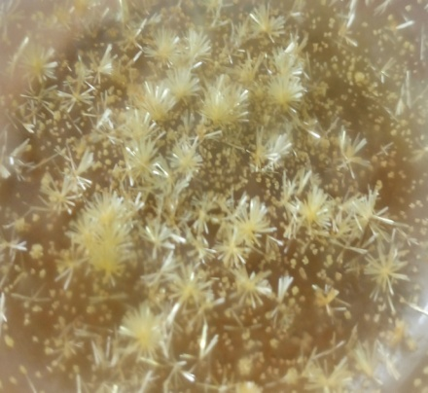
5d
3-ethyl,5-methyl,4-(5-bromothiophene-2-yl)1,4-dihydro-2,6-dimethylpyridine-3,5-carboxylate(5d) Prepared from 5-bromothiophene-2-carbaldehyde (1.91 g, 0.01 mol), ethylacetoacetate (1.32 g, 0.01 mol) methylacetoacetate (1.16 g, 0.01 mol) and ammonium acetate (0.77 g, 0.01 mol); CAN {0.28 g, 0.5 mol (5%)}; mixture of products 5a,5b and 5d, dissolved the mixture in (8:2) N-hexane : ethyl acetate solution and then filter it, light yellow colored crystals of 5d was generated in filtrate.; Yield: 2.02 g, 51 %; yellow solid crystals; mp: 118-123^{O}C; R_{f} value: (n-hexane: ethyl acetate, 1:1) 0.44; ¹H-NMR (CDCl_{3 ,} 400 MH_{Z}) δ = 1.20 (t , 3H) , 2.27 (s , 6H) , 3.65 (s, 3H) , 4.13 ( q, 2H) , 5.17 (s, 1H) , 5.86 (d, 1H) 6.47 (dd, J=2.8, 0.4 Hz, 1H) , 6.72 (dd, J=4, 1.2 Hz, 1H) ppm; ¹³C -APT (CDCl₃, 100MH_{Z}) δ =14.35 , 19.53 , 34.86 , 51.24 , 60.1 , 77.0 , 109.6 , 123.3, 129.2, 144.8 , 145.8 , 167.1 ppm; IR (neat) ν=3340, 1697, 1643, 1489, 1435, 1373, 1342, 1296, 1265, 1211, 1157, 1095, 1026, 748, 509; Mass: m/z =399, 383, 332, 318, 304, 290, 258, 230, 192, 145, 133, 91, 45.; Elemental analysis : (%) Calculated for C₁₆H₁₈BrNO₄S: C 48.01, H 4.53, N 3.50; Found: C 47.89, H 4.32, N 3.38.

5e
Ethyl-5-acetyl4-(5-bromothiophene-2-yl)1,4-dihydro-2,6-dimethylpyridine-3-carboxylate(5e) Prepared from 5-bromothiophene-2-carbaldehyde (1.91 g, 0.01 mol), ethylacetoacetate (1.32 g, 0.01 mol) acetyl acetone(1.02 g, 0.01 mol) and ammonium acetate (0.77 g, 0.01 mol); CAN {0.28 g, 0.5 mol (5%)}; mixture of products 5b, 5c and 5e, (yield: 3.55 g, 73%) separated and purified by column chromatography, Yield: 1.42 g, 29 %; yellowish solid; mp: 137-139 ^{O}C; R_{f} value: (n-hexane: ethyl acetate, 1:1) 0.40; ¹H-NMR (CDCl_{3 ,} 400 MH_{Z}) δ =1.19-1.21 (t, 3H), 2.27 (s, 6H), 3.65 (s, 3H), 4.10-4.13 (q, 2H), 5.17 (s, 1H), 5.88 (s, 1H), 6.46 (dd, J=3.6 0.8 Hz, 1H), 6.72 (d, J=4.1 Hz, 1H) ppm; Mass: m/z = 383, 332, 302, 229, 229, 214, 149, 111, 85, 57, 55.; Elemental analysis : (%) Calculated for C₁₆H₁₈BrNO₃S: C 50.01, H 4.72, N 3.64; Found: C 49.89, H 4.67, N 3.58.
5f
Methyl-5-acetyl4-(5-bromothiophene-2-yl)1,4-dihydro-2,6-dimethylpyridine-3-carboxylate(5f) Prepared from 5-bromothiophene-2-carbaldehyde (1.91 g, 0.01 mol), methylacetoacetate (1.16 g, 0.01 mol) acetylacetone(1.02 g, 0.01 mol) and ammoniumacetate (0.77 g, 0.01 mol); CAN {0.28 g, 0.5 mol (5%)} ; mixture of products 5a, 5c and 5f (yield: 3.70 g, 75 %) separated and purified by column chromatography; Yield: 1.20 g, 33 %; yellowish solid; mp: 135-139 ^{O}C; R_{f} value: (n-hexane: ethyl acetate, 1:1) 0.46; ¹H-NMR (CDCl_{3 ,} 400 MH_{Z}) δ =2.24 (s, 6H), 2.27 (s, 3H), 3.62 (s, 3H), 5.15 (s, 1H), 5.87 (s, 1H), 6.46 (dd, J= 4.4, 0.8 Hz, 1H), 6.72 (d, J= 4.8 Hz, 1H) ppm ; Elemental analysis : (%) Calculated for C₁₅H₁₆BrNO₃S: C 48.66, H 4.36, N 3.78; Found: C 48.26, H 4.34, N 3.67.
5g
9-(5-bromothiophene-2-yl)3,4,6,7-tetrahydro-3,3,6,6-tetramethylacridine 1,8(2H,5H, 9H,10H)dione(5g) Prepared from 5-bromothiophene-2-carbaldehyde (1.91 g, 0.01 mol), dimedone (2.80 g, 0.02 mol) and ammonium acetate (0.77 g, 0.01 mol); CAN {0.28 g, 0.5 mol (5%)}; product formed with some intermediates/impurities, separated by column chromatography ; Yield: 1.50 g, 35 %; yellowish solid; mp: 170-174 ^{O}C; R_{f} value: (n-hexane: ethyl acetate, 1:1) 0.26; ¹H-NMR (CDCl_{3 ,} 400 MH_{Z}) δ =0.97 (s, 6H), 1.02 (s, 6H), 2.20 (s, 4H), 2.24 (s, 4H), 5.26 (s, 1H), 6.52 (d, J=3.6 Hz, 1H), 6.66 (d, J=3.6 Hz, 1H), 7.19 (s, 1H) ppm; ¹³C -APT (CDCl₃, 100MH_{Z}) δ = 27.2, 29.5, 32.6, 40.6, 50.8, 109.3, 111.7, 124.0, 129.5, 150.3, 151.9, 196.1 ppm.; Elemental analysis : (%) Calculated for C₂₁H₂₄BrNO₂S: C 58.07, H 5.57, N 3.22; Found: C 58.08, H 5.50, N 3.20.

¹H NMR, ¹³C APT, selected IR and Mass spectra Compound 5a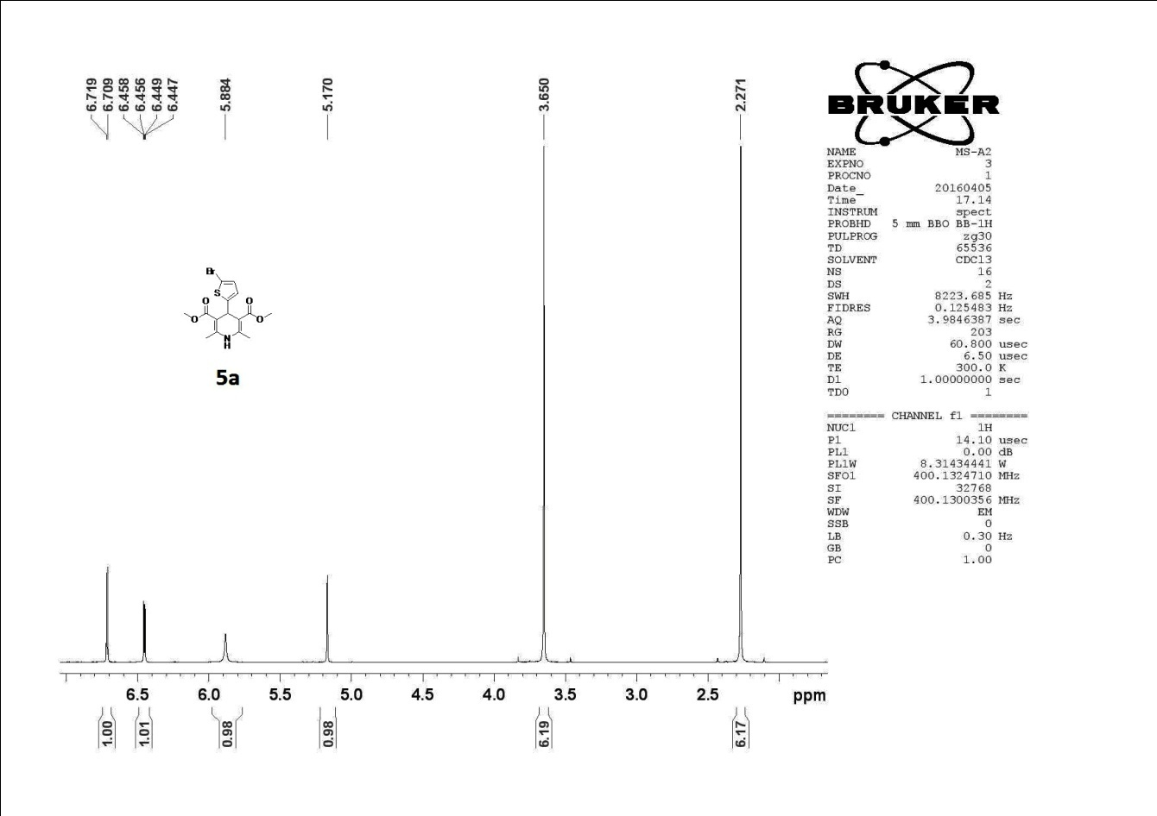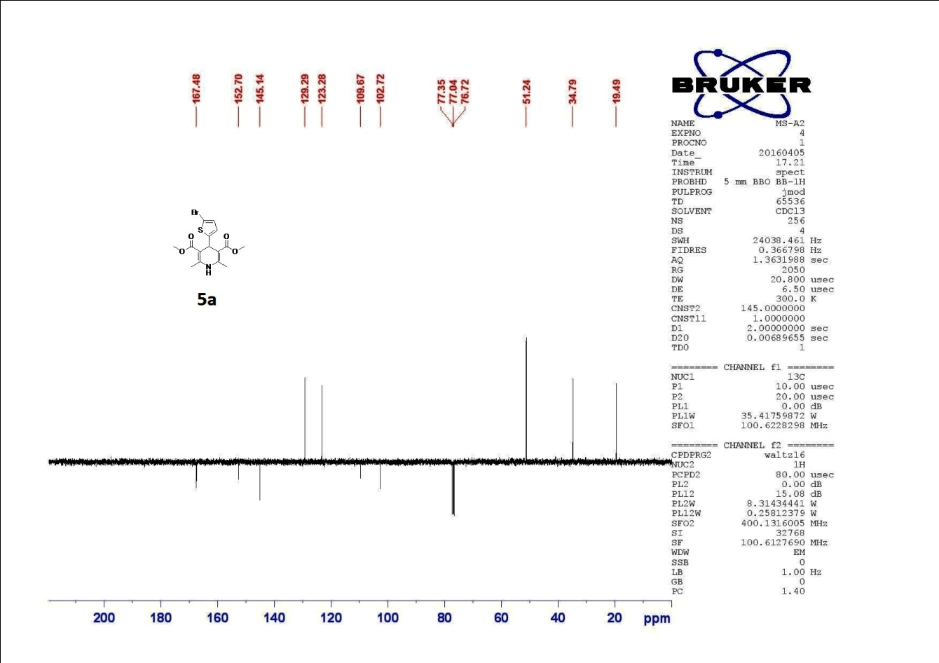

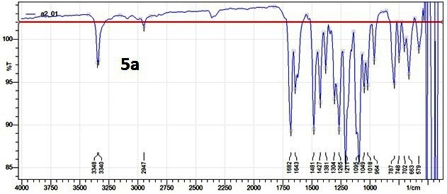

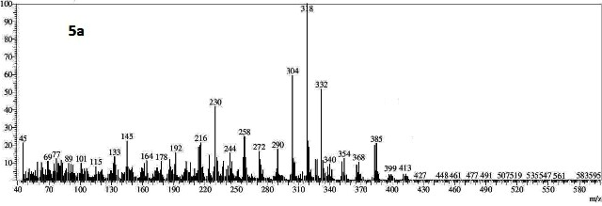

Compound 5b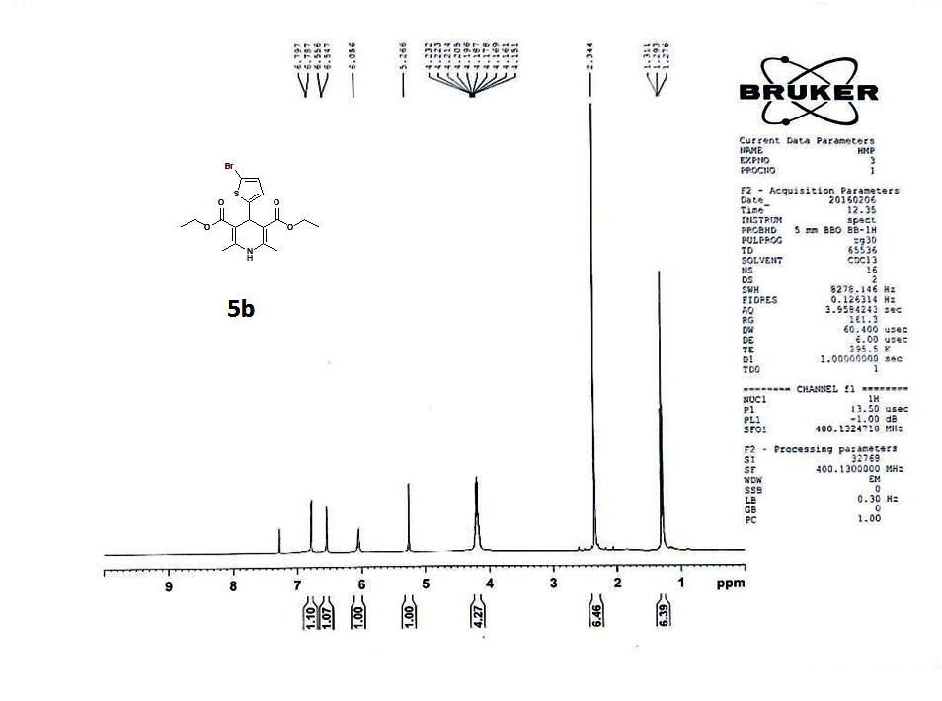
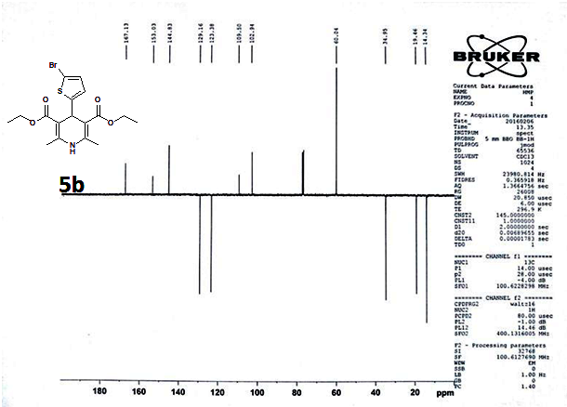

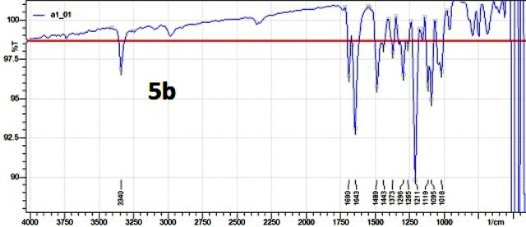

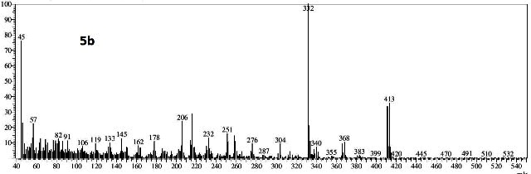

Compound 5c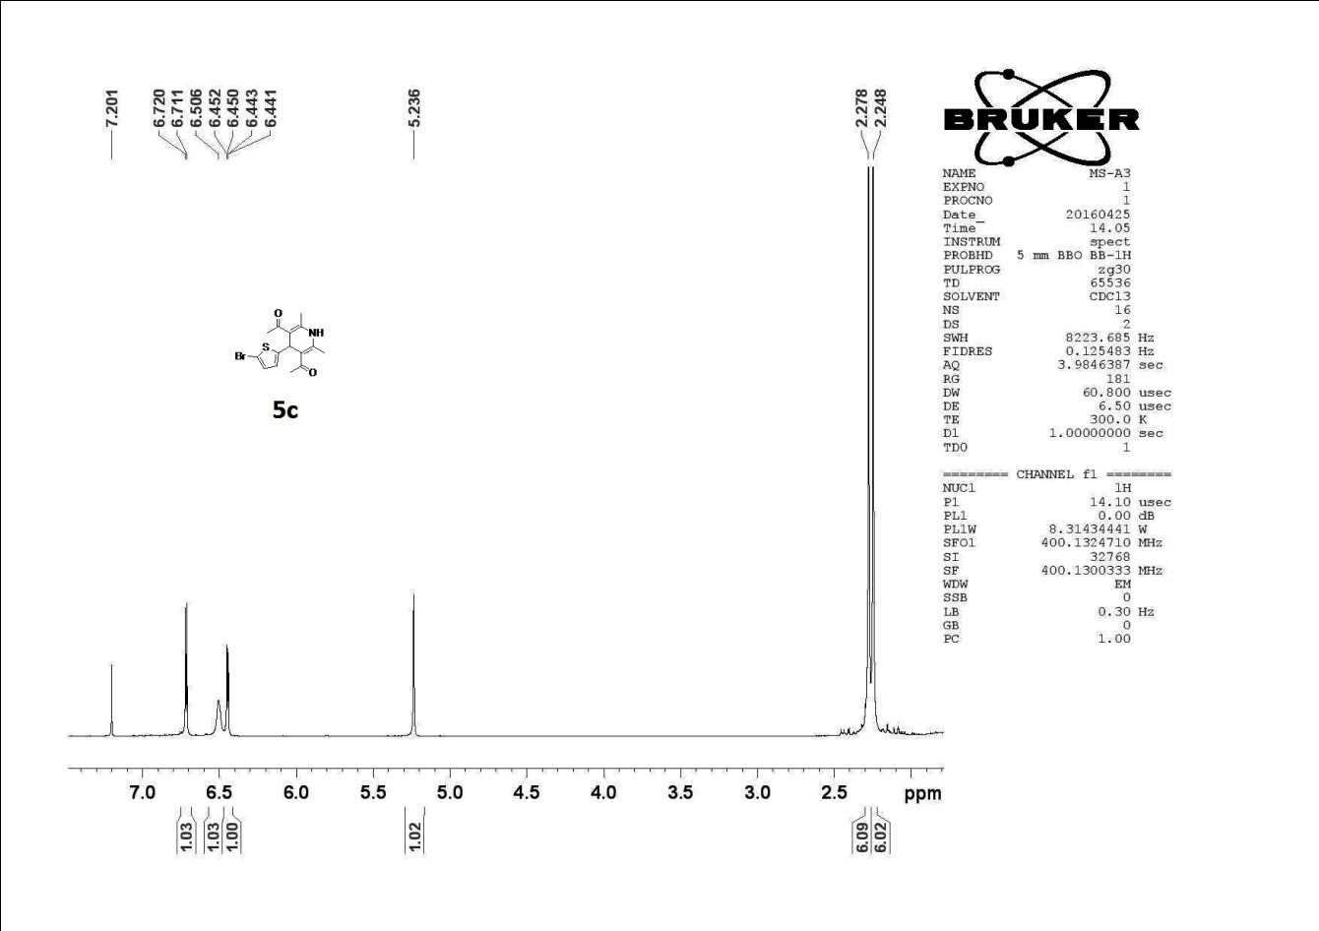
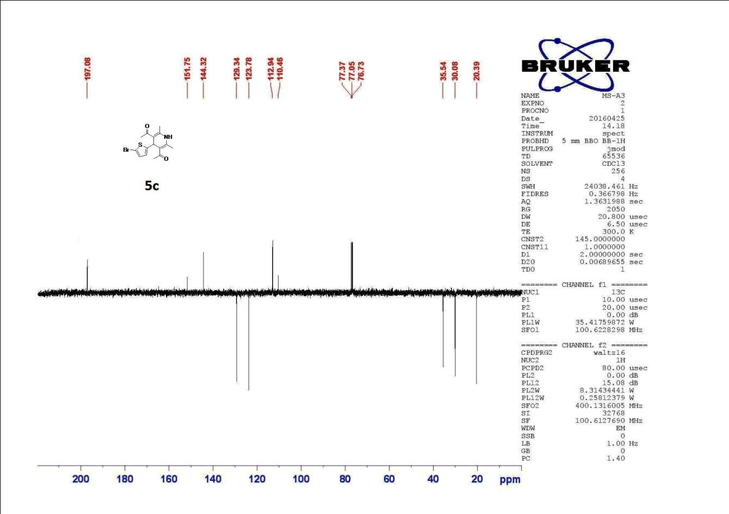

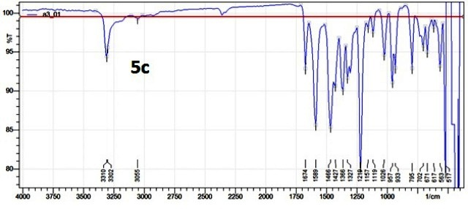

Compound 5d

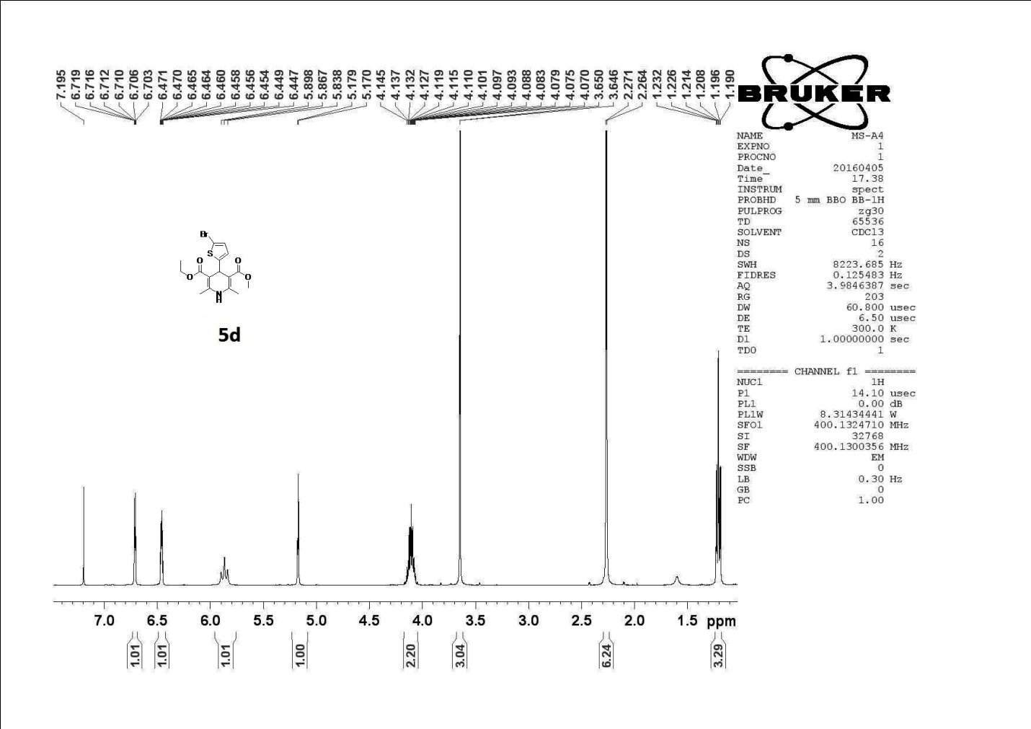
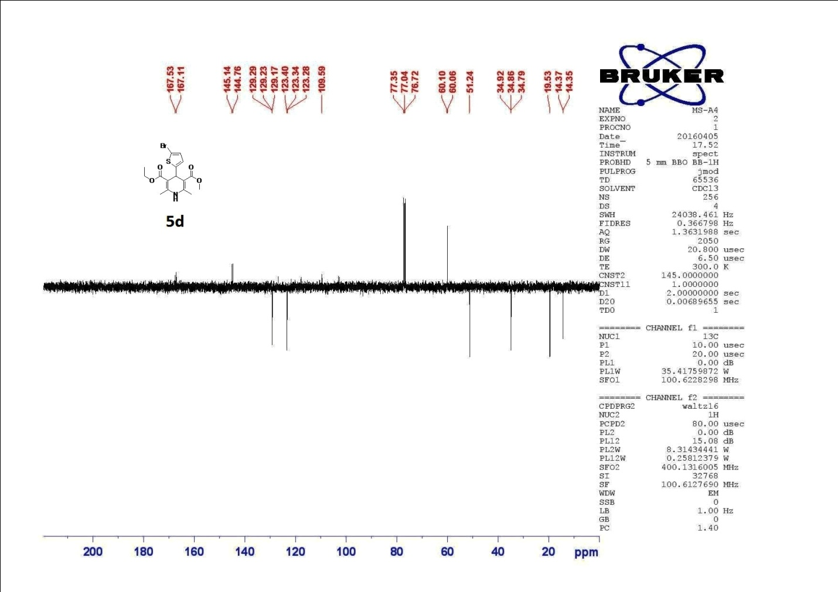

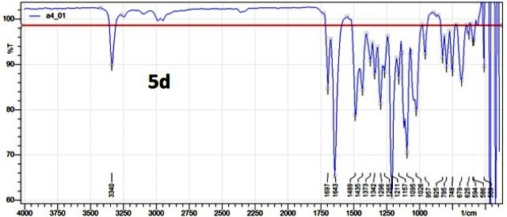

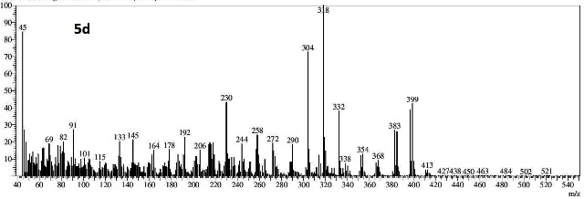

Compound 5e

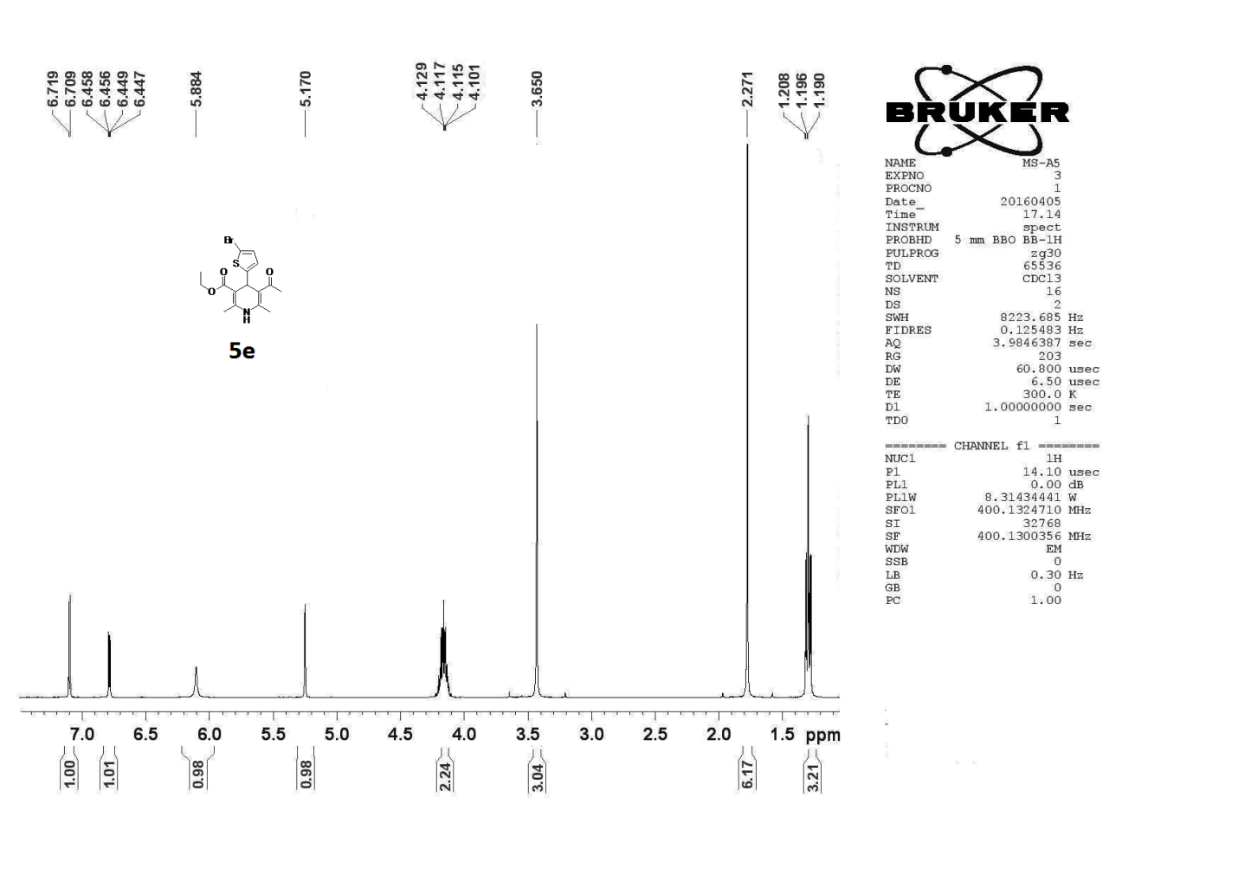

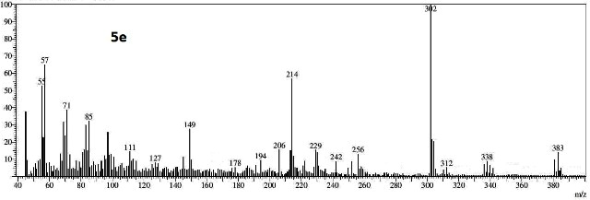

Compound 5f

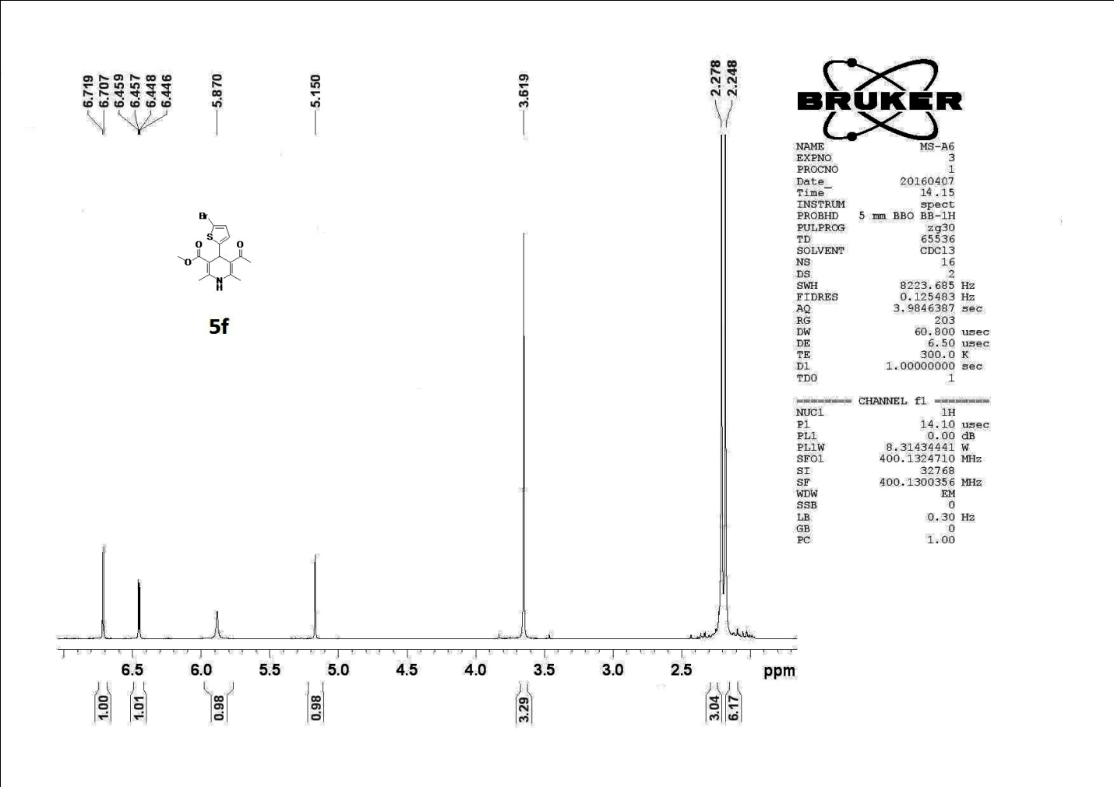

Compound 5g
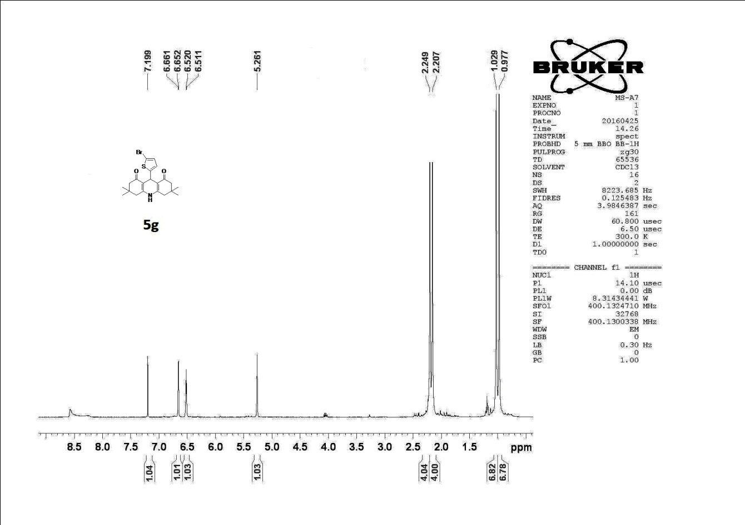
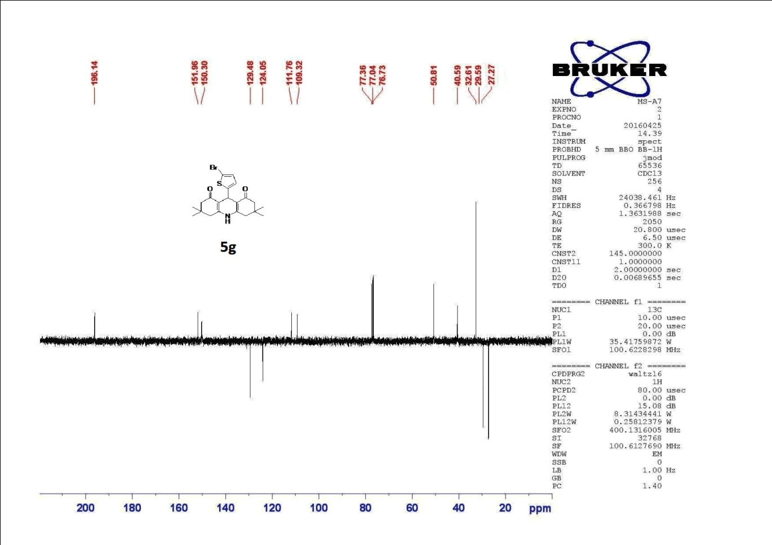

Single Crystal Study for compound 5a. 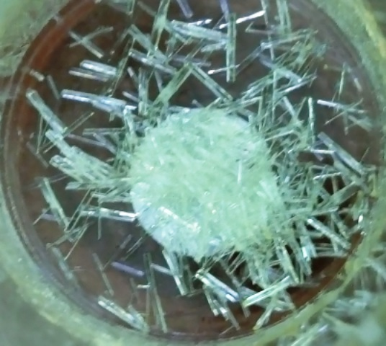
Crystals were grown from C₂H₅OH followed by charcoal treatment. A colorless block crystal of C15H16BrNO4S having approximate dimensions of 0.480 x 0.390 x 0.310 mm was mounted on a glass fiber. All measurements were made on a Rigaku SCX mini diffractometer using graphite monochromatic Mo-Kα radiation. The crystal-to-detector distance was 52.00 mm. Cell constants and an orientation matrix for data collection corresponded to a primitive monoclinic cell with dimensions:
a = 8.0516(9) Å, b= 10.072(1) Å, c = 20.119(2) Å, β = 97.803(4)o, V = 1616.4(3) Å3
For Z = 4 and F.W. = 386.26, the calculated density is 1.587 g/cm3. The reflection conditions of: h0l: l = 2n, 0k0: k = 2n
Uniquely determine the space group to be: P21/c (#14)
The data were collected at a temperature of 20 + 1oC to a maximum 2max cutoff value of 55.0o. A total of 540 oscillation images were collected. A sweep of data was done using  oscillations from -120.0 to 60.0o in 1.0o steps. The exposure rate was 10.0 [sec./o]. The detector swing angle was -30.80o. A second sweep was performed using  oscillations from -120.0 to 60.0o in 1.0o steps. The exposure rate was 10.0 [sec./o]. The detector swing angle was -30.80o. Another sweep was performed using  oscillations from -120.0 to 60.0o in 1.0o steps. The exposure rate was 10.0 [sec./o]. The detector swing angle was -30.80o. The crystal-to-detector distance was 52.00 mm. Readout was performed in the 0.146 mm pixel mode.

