Supplement

Comparing the clinical utility and diagnostic performance of cerebrospinal fluid
P-tau181, P-tau217 and P-tau231 assays
Antoine Leuzy, Shorena Janelidze, Niklas Mattsson-Carlgren, Sebastian Palmqvist, Dirk Jacobs, Claudia Cicognola, Erik Stomrud, Eugeen Vanmechelen, Jeffrey L. Dage, Oskar Hansson

Appendix e-1. Inclusion and exclusion criteria for BioFINDER-2
The BioFINDER-2 study enrolls participants in five sub-cohorts; Cohort A and B includes neurologically and cognitively healthy controls. The inclusion criteria are: i) ages 40-65 years (cohort A) and ages 66-100 years (cohort B); ii) absence of cognitive symptoms as assessed by a physician with special interest in cognitive disorders; iii) MMSE score 27-30 (A) or 26-30 (cohort B) at screening visit; iv) do not fulfill the criteria for MCI or any dementia according to DSM-5 (American Psychiatric Association, 2013); v) fluent in Swedish. The recruitment process of cohorts A and B is designed to build two study populations with 50% APOE ε4 carriers in each.
Cohort C comprises participants with subjective cognitive deficits (SCD) or minor neurocognitive impairment (MCI) (the latter according to DSM-5 (American Psychiatric Association,2013). Inclusion criteria are: i) Age 40-100 years; ii) referred to the memory clinics due to cognitive symptoms; iii) MMSE score of 24 – 30 points; iv) does not fulfill the criteria for any dementia (major neurocognitive disorder) according to DSM-5 (American Psychiatric Association, 2013), v) fluent in Swedish. In accordance with the research framework by the National Institute on Aging-Alzheimer’s Association (Jack et al., 2018) study participants with SCD were analyzed together with the cognitively healthy participants (and combined in the cognitively unimpaired group). Participants were classified as having MCI if they performed worse than -1.5 SD in any cognitive domain according to age and education stratified test norms. The neuropsychological battery covered the domains attention/executive function (Trail Making Test A and B, Symbol Digit Modalities Test, and AQT), memory (10 word immediate and delayed recall from the Alzheimer’s Disease Assessment Scale [ADAS]), verbal ability (verbal fluency and the short version of the Boston Naming Test) and visuospatial function (incomplete letters and cube analysis from the Visual Object and Space Perception battery). Those that were not classified as MCI were considered to have SCD.
Cohort D consists of participants with dementia due to AD. Inclusion criteria are: i) Age 40-100 years; ii) referred to the memory clinics due to cognitive symptoms; iii) MMSE score of ≥12 points; iv) fulfill the DSM-5 criteria for dementia (major neurocognitive disorder) due to Alzheimer’s disease (American Psychiatric Association, 2013); v) fluent in Swedish.
Cohort E covers other non-AD dementias and neurodegenerative disorders. Inclusion criteria are: i) Age 40-100 years; ii) fulfillment of criteria for dementia (major neurocognitive disorder) due to frontotemporal dementia (American Psychiatric Association, 2013), Parkinson’s disease with or without dementia (American Psychiatric Association, 2013) alternatively the criteria for Parkinson’s disease (Gelb et al., 1999), progressive supranuclear palsy (Hoglinger et al., 2017), multiple system atrophy (Gilman et al., 2008), or semantic variant primary progressive aphasia (Gorno-Tempini et al., 2011); iii) fluent in Swedish.
Exclusion criteria for all sub-cohorts are: i) significant unstable systemic illness that makes it difficult to participate in the study; ii) current significant alcohol or substance misuse; iii) refusing lumbar puncture, MRI or PET.

References
American Psychiatric Association. Diagnostic and Statistical Manual of Mental Disorders, Fifth Edition (DSM-5). Arlington, VA; 2013.
Gelb DJ, Oliver E, Gilman S. Diagnostic criteria for Parkinson disease. Arch Neurol 1999; 56(1): 33-9.
Gilman S, Wenning GK, Low PA, Brooks DJ, Mathias CJ, Trojanowski JQ, et al. Second consensus statement on the diagnosis of multiple system atrophy. Neurology 2008; 71(9): 670-6.
Gorno-Tempini ML, Hillis AE, Weintraub S, Kertesz A, Mendez M, Cappa SF, et al. Classification of primary progressive aphasia and its variants. Neurology 2011; 76(11): 1006-14.
Hoglinger GU, Respondek G, Stamelou M, Kurz C, Josephs KA, Lang AE, et al. Clinical diagnosis of progressive supranuclear palsy: The movement disorder society criteria. Mov Disord 2017; 32(6): 853-64.
Jack CR, Jr., Bennett DA, Blennow K, Carrillo MC, Dunn B, Haeberlein SB, et al. NIA-AA Research Framework: Toward a biological definition of Alzheimer's disease. Alzheimers Dement 2018; 14(4): 535-62

eFigure 1. Flow diagram of participants included in the study
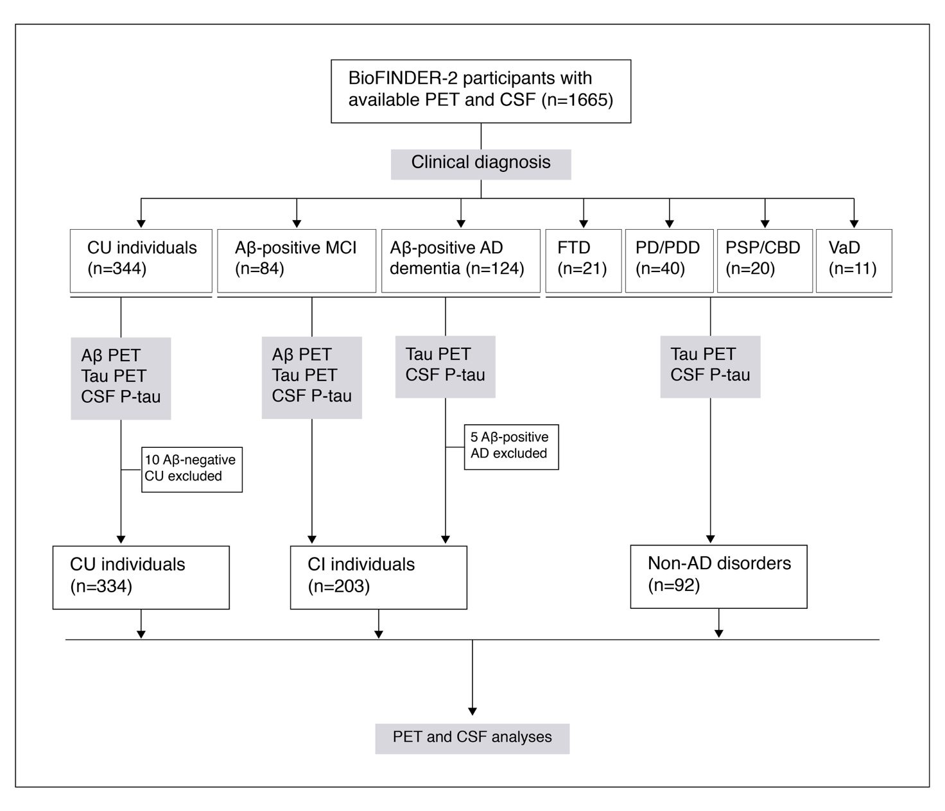
CSF, cerebrospinal fluid; PET, positron emission tomography; CU, cognitively unimpaired; Aβ, amyloid-β; MCI, mild cognitive impairment; AD, Alzheimer’s disease; FTD, frontotemporal dementia; PD, Parkinson’s disease; PDD, Parkinson’s disease with dementia; PSP, progressive supranuclear palsy; CBD, corticobasal degeneration; VaD, vascular dementia.

eFigure 2. Correlation matrix showing associations between P-tau isoforms
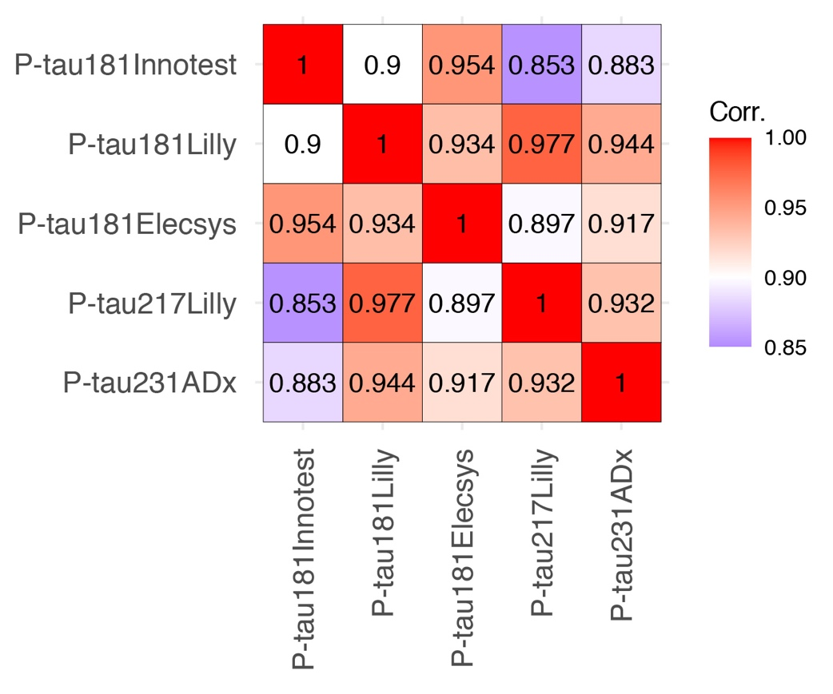
Pearson correlation coefficients are shown using all participants (n=629). Corr. = Correlation coefficient.

eFigure 3. Voxelwise associations between CSF P-tau and Aβ PET
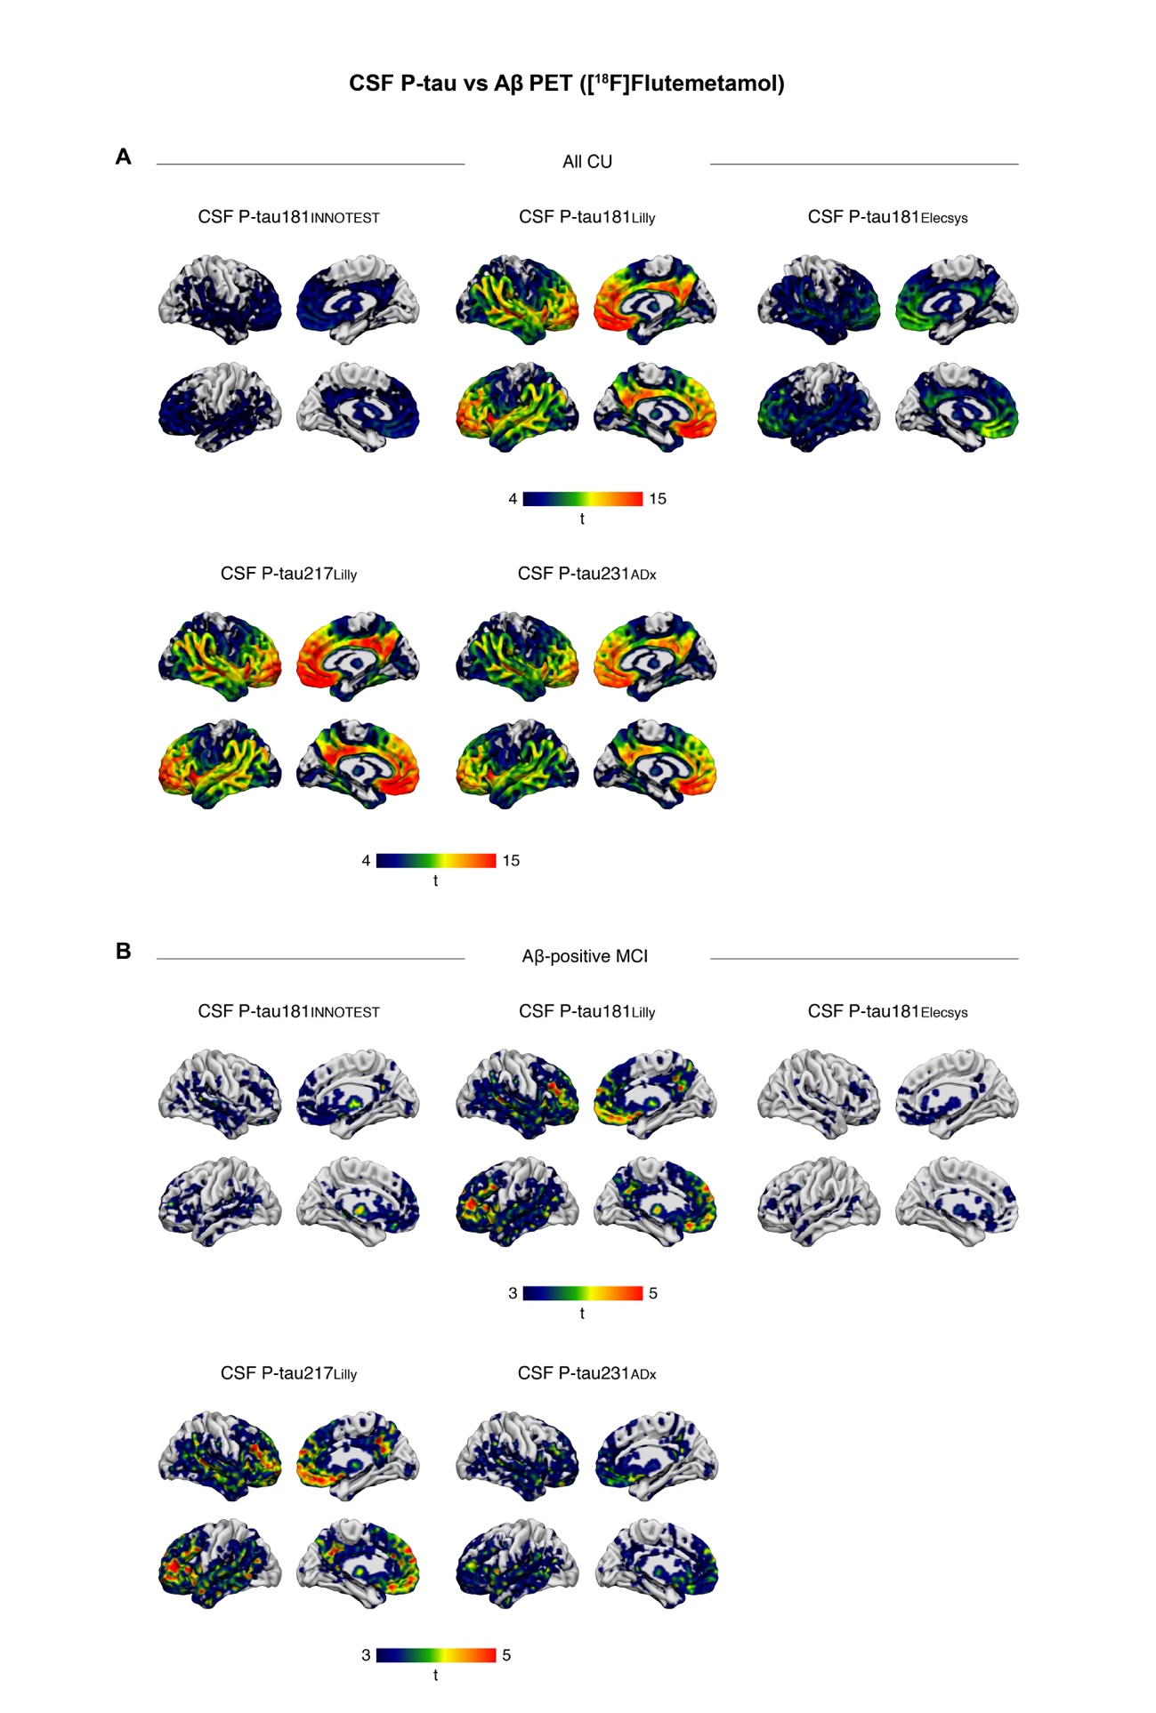

Voxelwise multilinear regression results between CSF P-tau and Aβ PET in CU individuals (A) and Aβ-positive MCI (B) (adjusted for age, sex and the interval between lumbar puncture and PET scan). All results are shown at a statistical significance threshold of P<0.001 (uncorrected).

eFigure 4. Voxelwise associations between CSF P-tau and Tau PET
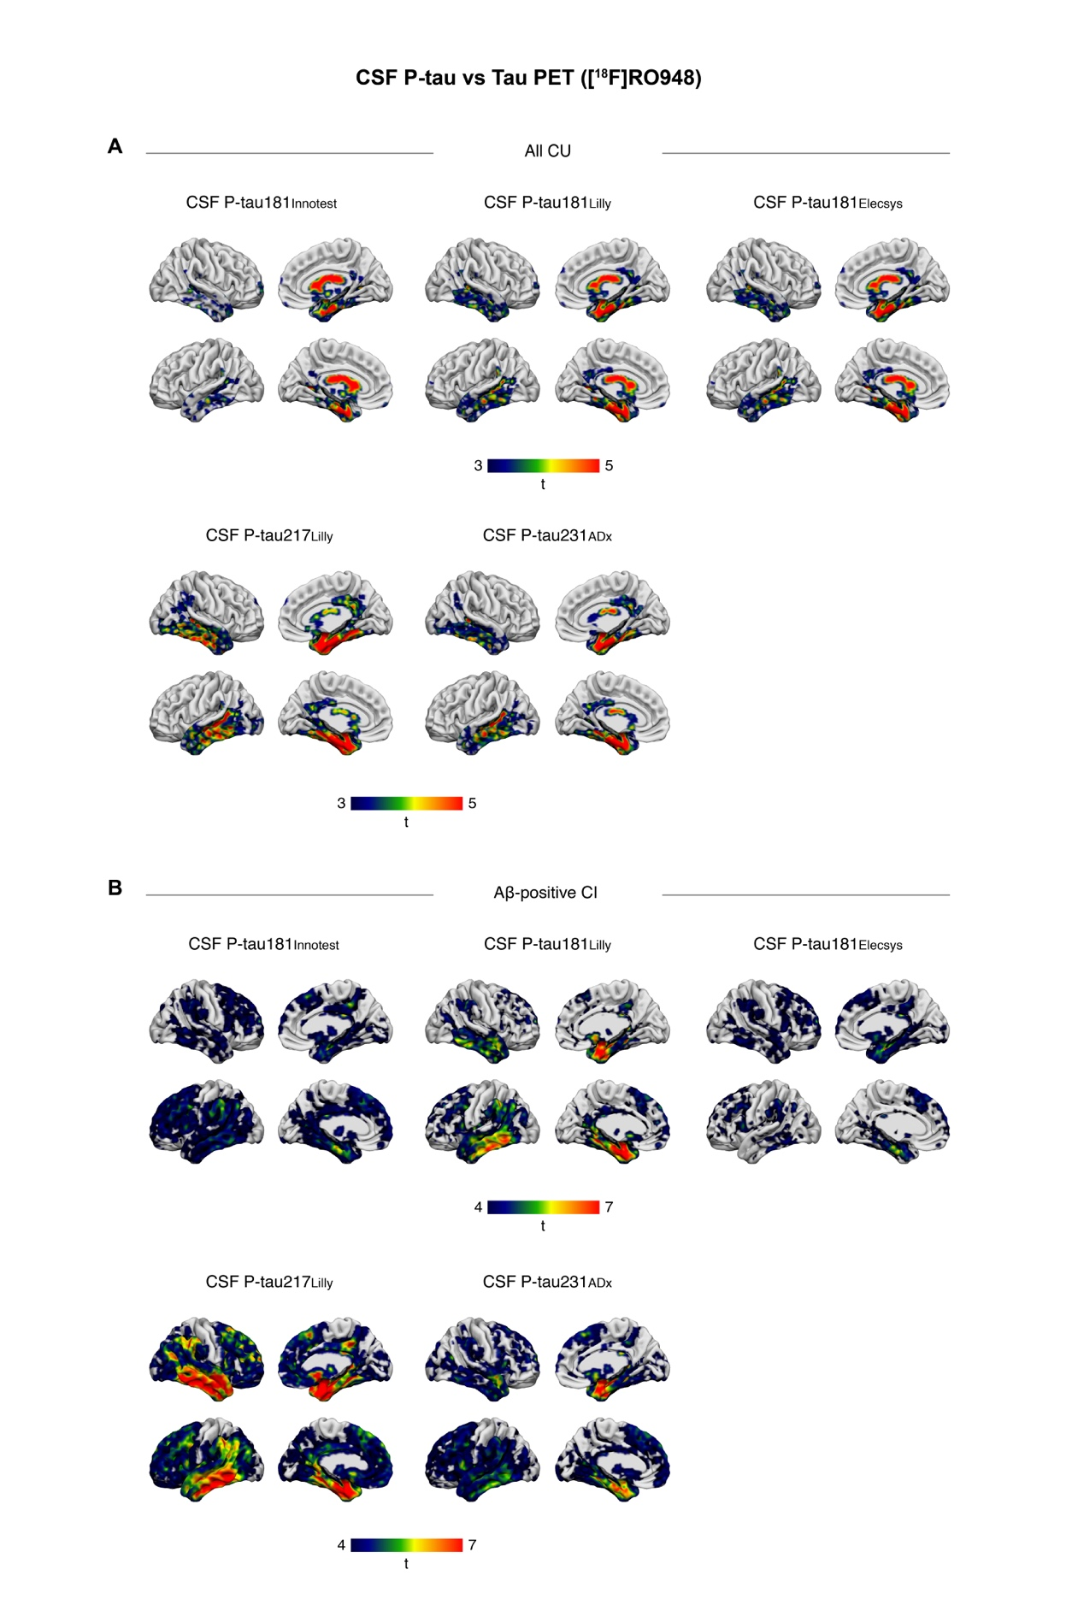

Voxelwise multilinear regression results between CSF P-tau and Tau PET in CU individuals (A) and Aβ-positive CI (Aβ-positive MCI and AD dementia) (B) (adjusted for age, sex and the interval between lumbar puncture and PET scan). All results are shown at a statistical significance threshold of P<0.001 (uncorrected).

eFigure 5. CSF P-tau slopes as a function of Aβ and Tau PET SUVR in CU individuals by Aβ status
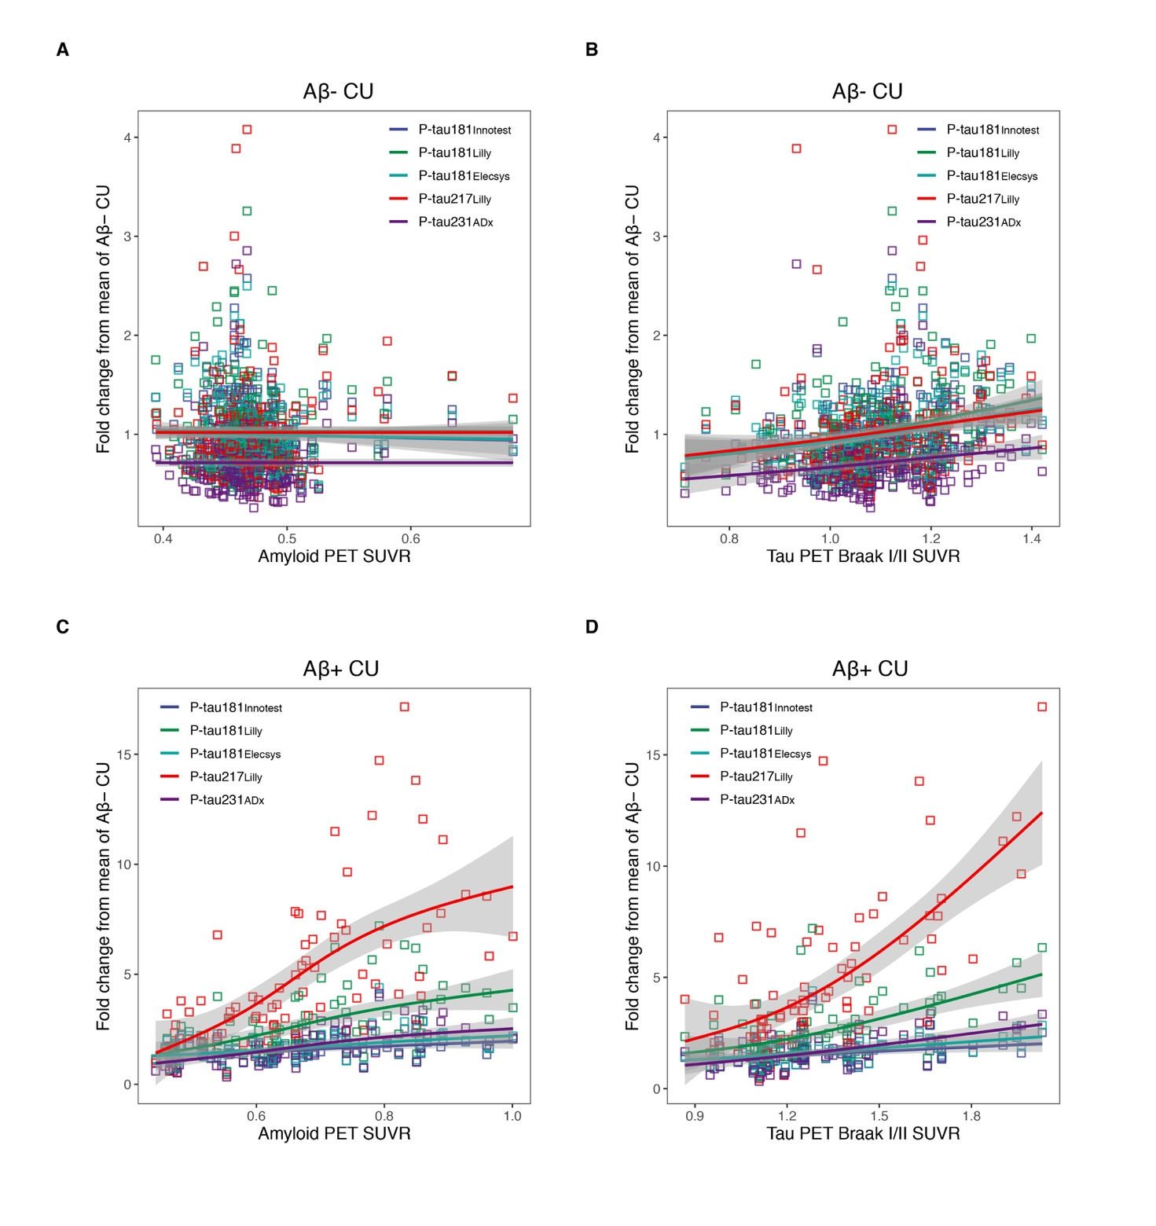CSF P-tau levels (expressed as mean fold change relative to the mean of Aβ-negative CU participants) are shown against global Aβ PET neocortical SUVR in Aβ-negative CU individuals (A and B for Aβ and Tau PET, respectively) and in Aβ-positive CU individuals (C and D for Aβ and Tau PET, respectively). Generalized additive models with cubic regression splines were used to compare the slopes of CSF P-tau isoforms across different Aβ and Tau PET SUVR values. Shaded grey areas indicate 95% confidence intervals.

eTable 1. Correlations between CSF P-tau levels and age across diagnostic groups
 | All participants  (n=629) | Non-AD  (n=92) | Aβ- CU  (n=253) | Aβ+ CU  (n=81) | Aβ+ MCI  (n=84) | AD dementia  (n=119)
CSF P-tau181_{Innotest} | 0.330  [0.258, 0.399]  P<0.0001 | 0.292  [0.090, 0.470]  P<0.01 | 0.275  [0.155, 0.388]  P<0.0001 | 0.179  [-0.041, 0.384]  P=0.111 | 0.052  [-0.164, 0.263]  P=0.637 | 0.102  [-0.082, 0.281]  P=0.275
CSF P-tau181_{Lilly} | 0.318  [0.245, 0.3884]  P<0.0001 | 0.443  [0.255, 0.595]  P<0.0001 | 0.334  [0.217, 0.441]  P<0.0001 | 0.239  [0.021, 0.436]  P<0.05 | -0.073  [-0.283, 0.143]  P=0.507 | 0.053  [-0.131‚ 0.235]  P=0.571
CSF P-tau181_{Elecsys} | 0.325  [0.252, 0.394]  P<0.0001 | 0.328  [0.130, 0.501]  P<0.01 | 0.299  [0.180, 0.410]  P<0.0001 | 0.186  [-0.034, 0.389]  P=0.098 | -0.026  [-0.239, 0.188]  P=0.809 | 0.136  [-0.048, 0.312]  P=0.147
CSF P-tau217_{Lilly} | 0.278  [0.203, 0.349]  P<0.0001 | 0.392  [0.201, 0.554]  P<0.001 | 0.280  [0.160, 0.392]  P<0.0001 | 0.247  [0.028, 0.442]  P<0.05 | -0.149  [-0.352, 0.067]  P=0.175 | -0.051  [-0.233, 0.133]  P=587
CSF P-tau231_{Adx} | 0.340  [0.265, 0.408]  P<0.0001 | 0.316  [0.117, 0.491]  P<0.01 | 0.307  [0.189, 0.417]  P<0.0001 | 0.274  [0.058, 0.466]  P<0.05 | -0.042  [-0.254, 0.173]  P=0.698 | 0.065  [-0.119, 0.246]  P=0.489

eTable 2. Correlations between CSF P-tau levels and age across Braak stages
 | All participants  (n=629) | Braak 0  (n=425) | Braak I/II+  (n=40) | Braak III/IV+  (n=87) | Braak V/VI+  (n=77)
CSF P-tau181_{Innotest} | 0.330  [0.258, 0.399]  P<0.0001 | 0.308  [0.220, 0.392]  P<0.0001 | 0.059  [-0.295, 0.399]  P=0.748 | 0.017  [-0.206, 0.240]  P=0.876 | 0.131  [-0.095, 0.345]  P=0.253
CSF P-tau181_{Lilly} | 0.318  [0.245, 0.3884]  P<0.0001 | 0.346  [0.259, 0.427]  P<0.0001 | -0.106  [-0.438, 0.251]  P=0.563 | 0.011  [-0.212, 0.235]  P=0.918 | 0.160  [-0.066, 0.370]  P=0.164
CSF P-tau181_{Elecsys} | 0.325  [0.252, 0.394]  P<0.0001 | 0.312  [0.223, 0.395] P<0.0001 | 0.039  [-0.313, 0.383]  P=0.828 | 0.076  [-0.149, 0.290]  P=0.506 | 0.160  [-0.065, 0.371]  P=0.163
CSF P-tau217_{Lilly} | 0.278  [0.203, 0.349]  P<0.0001 | 0.315  [0.227, 0.398]  P<0.0001 | -0.157  [-0.480, 0.202]  P=0.388 | -0.085  [-0.303, 0.141]  P=0.458 | 0.105  [-0.120, 0.320]  0.359
CSF P-tau231_{Adx} | 0.340  [0.265, 0.408]  P<0.0001 | 0.338  [0.251, 0.420]  P<0.0001 | -0.131  [-0.459, 0.22]  P=0.471 | 0.070  [-0.156, 0.289]  P=0.545 | 0.118  [-0.108, 0.333]  P=0.305

eTable 3. Correlations between CSF P-tau isoforms and Aβ and Tau PET
 | Aβ PET | Tau PET
All participants (n=629) | Neocortical Meta-ROI | Braak I/II | Braak III/IV | Braak V/VI
CSF P-tau181_{Innotest} | 0.585  [0.518, 0.644]  P<0.0001 | 0.607  [0.554, 0.655]  P<0.0001 | 0.527  [0.467, 0.582]  P<0.0001 | 0.420  [0.353, 0.483]  P<0.0001
CSF P-tau181_{Lilly} | ^{a ****}  0.744  [0.698, 0.784]  P<0.0001 | ^{a *** c ****}  0.760  [0.724, 0.791]  P<0.0001 | ^{a **** c ***}  0.699  [0.656, 0.738]  P<0.0001 | ^{a *** c **}  0.571  [0.515, 0.622]  P<0.0001
CSF P-tau181_{Elecsys} | ^{a **, b ****}  0.620  [0.558, 0.676]  P<0.0001 | ^{a ***}  0.641  [0.592, 0.685]  P<0.0001 | ^{a ****}  0.561  [0.504, 0.613]  P<0.0001 | ^{a **}  0.453  [0.388, 0.514]  P<0.0001
CSF P-tau217_{Lilly} | ^{a *** b ** c ****}  0.766  [0.723, 0.803]  P<0.0001 | ^{a *** b **** c ***** e *****}  0.793  [0.762, 0.821]  P<0.0001 | ^{a *** b **** c ***** e *****}  0.765  [0.730, 0.796]  P<0.0001 | ^{a *** b **** c ***** e *****}  0.645  [0.596, 0.689]  P<0.0001
CSF P-tau231_{Adx} | ^{a *** c ****}  0.753  [0.709, 0.792]  P<0.0001 | ^{a *** c ****}  0.725  [0.685, 0.761]  P<0.0001 | ^{a *** c ****}  0.645  [0.597, 0.689]  P<0.0001 | ^{a *** c ****}  0.532  [0.473, 0.587]  P<0.0001
CU (n=334)

CSF P-tau181_{Innotest} | 0.496  [0.409, 0.575]  P<0.0001 | 0.485  [0.397, 0.564]  P<0.0001 | 0.341  [0.241, 0.434]  P<0.0001 | 0.103  [-0.006, 0.209]  0.06435
CSF P-tau181_{Lilly} | ^{a *** c ***}  0.737  [0.683, 0.783]  P<0.0001 | ^{c **** e *}  0.640  [0.570, 0.700]  P<0.0001 | ^{a, **** c, ***}  0.477  [0.389, 0.557]  P<0.0001 | ^{a * c *}  0.177  [0.069, 0.281]  0.001351
CSF P-tau181_{Elecsys} | ^{a ***}  0.580  [0.503, 0.648]  P<0.0001 | ^{a ****}  0.546161  [0.464, 0.618]  P<0.0001 | ^{a ***}  0.392  [0.295, 0.480]  P<0.0001 | ^{a ***}  0.127  [0.018, 0.233]  0.02232
CSF P-tau217_{Lilly} | ^{a *** b *** c **** e ****}  0.789  [0.743, 0.827]  P<0.0001 | ^{a **** b *** c **** e ***}  0.683  [0.620, 0.737]  P<0.0001 | ^{a **** b **** c **** e ****}  0.5514117  [0.470, 0.623]  P<0.0001 | ^{a *** b **** c *** e **}  0.236  [0.130, 0.336]  P<0.0001
CSF P-tau231_{Adx} | ^{a *** b *** c ****}  0.724  [0.667, 0.772]  P<0.0001 | ^{c **}  0.604  [0.530, 0.669]  P<0.0001 | ^{a *** c **}  0.457  [0.366, 0.539]  P<0.0001 | ^{a *}  0.170  [0.062, 0.274]  P<0.01
Aβ-positive CI (n=203)

CSF P-tau181_{Innotest} | 0.312  [0.114, 0.487]  P<0.01 | 0.304  [0.171, 0.425]  P<0.0001 | 0.272  [0.138, 0.397]  P<0.001 | 0.219  [0.082, 0.347]  P<0.01
CSF P-tau181_{Lilly} | ^{a ** c ***}  0.474  [0.297, 0.620]  P<0.0001 | ^{a**** c **** e **}  0.500  [0.387, 0.597  P<0.0001 | ^{a**** c ****}  0.486  [0.371, 0.585]  P<0.0001 | ^{a**** c **** e ***}  0.390  [0.265, 0.502]  P<0.0001
CSF P-tau181_{Elecsys} | 0.313  [0.115, 0.488]  P<0.01 | 0.337  [0.207, 0.455]  P<0.0001 | 0.301  [0.168, 0.422]  P<0.0001 | 0.246  [0.110, 0.372]  0.000474
CSF P-tau217_{Lilly} | ^{a *** c ***}  0.516  [0.347, 0.652]  P<0.0001 | ^{a **** b*** c**** e ****}  0.559  [0.455, 0.648]  P<0.0001 | ^{a **** b**** c*** e ****}  0.592  [0.492, 0.675]  P<0.0001 | ^{a **** b**** c**** e ****}  0.501  [0.388, 0.598]  P<0.0001
CSF P-tau231_{Adx} | c **  0.477  [0.301, 0.622]  P<0.0001 | a ** c *  0.415  [0.292, 0.523]  P<0.0001 | ^{a ** c **}  0.393  [0.268, 0.504]  P<0.0001 | a ****  0.339  [0.209, 0.456]  P<0.0001

Results are presented in the form of correlation coefficients followed by their 95% confidence intervals and P-values. Superscripted letters indicate that the correlation coefficient is significantly different from ª P-tau181_{Innotest}, ^{b} P-tau181_{Lilly}, ^{c} P-tau181_{Elecsys}, ^{d} P-tau217_{Lilly}, ^{e} P-tau231_{Adx}. Asterisks indicate the level of significance (Bonferroni corrected to account for multiple comparisons): *P<0.05, **P<0.01, ***P<0.001, ****P<0.0001. In the Aβ-positive CI group, Aβ-PET includes only Aβ-positive MCI as Aβ PET is by design not performed in AD dementia patients in BioFINDER-2.

eTable 4. Correlations between CSF P-tau isoforms and Aβ and Tau PET in CU individuals by Aβ-status
 | Aβ PET | Tau PET
Aβ-negative CU (n=253) | Neocortical Meta-ROI | Braak I/II | Braak III/IV | Braak V/VI
CSF P-tau181_{Innotest} | -0.085  [-0.209, 0.041]  P=0.187 | 0.095  [-0.037, 0.224]  P=0.159 | 0.125  [-0.007, 0.253]  P=0.064 | -0.054  [-0.186, 0.078]  P=0.420
CSF P-tau181_{Lilly} | 0.024 a*  [-0.102, 0.150]  P=0.708 | 0.114  [-0.017, 0.243]  P=0.089 | 0.129  [-0.002, 0.257]  P=0.050 | -0.093  [-0.224, 0.039]  P=0.168
CSF P-tau181_{Elecsys} | -0.077 b*  [-0.201, 0.049]  P=0.233 | 0.122  [-0.009, 0.250]  P=0.069 | 0.132 a**, b*  [0.000, 0.260]  P=0.062 | -0.048  [-0.180, 0.085]  P=0.479
CSF P-tau217_{Lilly} | 0.093 a**, b**  [-0.03, 0.217]  P=0.338 | 0.118  [-0.014, 0.246]  P=0.080 | 0.099  [-0.032, 0.229]  P=0.139 | -0.080  [-0.211, 0.053]  P=0.237
CSF P-tau231_{Adx} | 0.062 a*, b**  [-0.065, 0.187]  P=0.338 | 0.110  [-0.022, 0.240]  P=0.103 | 0.012  [-0.119, 0.144]  P=0.852 | -0.106  [-0.236, 0.026]  P=0.116
Aβ-positive CU (n=81)

CSF P-tau181_{Innotest} | 0.365  [0.158, 0.541]  P=0.001 | 0.350  [0.141, 0.529]  P<0.01 | 0.255  [0.041, 0.452] | 0.151  [-0.070, 0.359]  P=0.179
CSF P-tau181_{Lilly} | 0.591 a***  [0.426, 0.717]  P<0.0001 | 0.577 a***  [0.409, 0.707]  P<0.0001 | 0.462 a**, b*  [0.270, 0.619]  P<0.0001 | 0.312  [0.099, 0.497]  P<0.01
CSF P-tau181_{Elecsys} | 0.441 a*, b**  [0.245, 0.602]  P<0.0001 | 0.422 a***, b**  [0.223, 0.588]  P<0.0001 | 0.3265913, b***  [0.115, 0.509]  0.00311 | 0.196  [-0.024, 0.398]  P=0.081
CSF P-tau217_{Lilly} | 0.646 a***, c**  [0.497, 0.758]  P<0.0001 | 0.668 a***, b**, c***, d**  [0.525, 0.774]  P<0.0001 | 0.5896983 a**, b***, c*  [0.425, 0.716]  P<0.0001 | 0.419 a**, b***, c**  [0.220, 0.585]  P<0.001
CSF P-tau231_{Adx} | 0.599 a***, c**  [0.436, 0.723  P<0.0001 | 0.563 a***, d**  [0.392, 0.696]  P<0.0001 | 0.471 a**, c*, d*  [0.280, 0.626]  P<0.0001 | 0.327 a*  [0.116, 0.510]  P<0.01

Results are presented in the form of correlation coefficients followed by their 95% confidence intervals and P-values. Superscripted letters indicate that the correlation coefficient is significantly different from ª P-tau181_{Innotest}, ^{b} P-tau181_{Lilly}, ^{c} P-tau181_{Elecsys}, ^{d} P-tau217_{Lilly}, ^{e} P-tau231_{Adx}. Asterisks indicate the level of significance (Bonferroni corrected to account for multiple comparisons): *P<0.05, **P<0.01, ***P<0.001, ****P<0.0001

eTable 5. Confidence intervals for differences in P-tau biomarkers at specified SUVR values for Aβ and Tau PET
 | Aβ PET (Neocortical meta-ROI) |  | Tau PET (Braak I/II) | Tau PET (Braak III/IV)
 | CU | Aβ-positive MCI | CU | Aβ-positive CI
Comparison | SUVR [95% CI] | SUVR [95% CI] | SUVR [95% CI] | SUVR [95% CI]
P-tau181_{Innotest} vs P-tau181_{Lilly} | 0.40 [-0.261, 0.113] | 0.40 [-0.575, 0.453] | 0.70 [-0.605, 0.070] | 1.00 [-1.180, -0.056]
 | 0.60 [-0.867, -0.505] | 0.60 [-1.281, -0.664] | 1.00 [-0.078, 0.039] | 2.00 [-3.483, -2.814]
 | 0.80 [-1.996 -1.378] | 0.80 [-2.307, -1.547] | 1.50 [-1.345, -0.935] | 3.00 [-4.538, -3.601]
 | 1.00 [-3.494, -1.924] | 1.00 [-3.450, -1.851] | 2.00 [-4.018, -2.814] | 4.00 [-5.224, -3.046]
P-tau181_{Innotest} vs P-tau181_{Elecsys} | 0.40 [-0.099, 0.0831] | 0.40 [-0.199, 0.280] | 0.70 [-0.177, 0.052] | 1.0 [-0.275, 0.038]
 | 0.60 [-0.093, 0.029] | 0.60 [-0.201, 0.0210] | 1.00 [-0.004, 0.034] | 2.0 [-0.356, -0.181]
 | 0.80 [-0.226, 0.122] | 0.80 [-0.348, 0.066] | 1.50 [-0.1584, -0.076] | 3.0 [-0.536, -0.257]
 | 1.00 [-0.425, 0.150] | 1.00 [-0.437, 0.136] | 2.00 [-0.488, -0.229] | 4.00 [-0.875, -0.224]
P-tau181_{Innotest} vs P-tau217_{Lilly} | 0.40 [-0.715, 0.083] | 0.40 [-1.575, 1.953] | 0.70 [-1.087, 0.214] | 1.0 [-3.282, -0.675]
 | 0.60 [-2.404, -1.510] | 0.60 [-4.626, -2.578] | 1.00 [-0.191, 0.091] | 2.0 [-12.002, -9.905]
 | 0.80 [-6.031, -4.092] | 0.80 [-7.243, -4.839] | 1.50 [-4.116, -2.968] | 3.0 [-16.564, -13.276]
 | 1.00 [-10.910, -5.898] | 1.00 [13.567, -6.799] | 2.00 [-13.081, -8.893] | 4.00 [-19.640, -11.602]
P-tau181_{Innotest} vs P-tau231_{ADx} | 0.40 [-0.223, 0.181] | 0.40 [-0.592, 0.510] | 0.70 [-0.603, 0.092] | 1.0 [-0.992, -0.266]
 | 0.60 [-0.704, -0.455] | 0.60 [-0.963, -0.546] | 1.00 [-0.082, 0.045] | 2.0 [-2.073, -1.655]
 | 0.80 [-1.478, -1.092] | 0.80 [-1.566, -1.000] | 1.50 [-1.004 -0.680] | 3.0 [-2.524, -1.806]
 | 1.00 [-2.454, -1.364] | 1.00 [-2.453, -1.272] | 2.00 [-2.851, -1.908] | 4.00 [-2.941, -0.585]
P-tau181_{Lilly} vs P-tau181_{Elecsys} | 0.40 [-0.090, 0.257] | 0.40 [-0.342, 0.566] | 0.70 [-0.074, 0.497] | 1.0 [-0.986, 0.043]
 | 0.60 [0.4617, 0.790] | 0.60 [0.618, 1.162] | 1.00 [-0.020, 0.086] | 2.0 [-3.170, -2.560]
 | 0.80 [1.228, 1.792] | 0.80 [1.410, 2.045] | 1.50 [0.841, 1.223] | 3.0 [-4.064, -3.272]
 | 1.00 [1.708, 3.106] | 1.00 [1.863, 3.108] | 2.00 [2.518, 3.617] | 4.00 [-4.567, -2.668]
P-tau181_{Lilly} vs P-tau217_{Lilly} | 0.40 [-0.553, 0.012] | 0.40 [-1.198, 1.855] | 0.7 [-0.600, 0.223] | 1.00 [-0.307, 0.173]
 | 0.60 [-1.654, -1.053] | 0.60 [-3.448, -1.784] | 1.00 [-0.101, 0.086] | 2.00 [-8.606, -5.207]
 | 0.80 [-4.121, -2.820] | 0.80 [-5.017, -3.203] | 1.50 [-2.79, -2.019] | 3.00 [-20.083, -10.737]
 | 1.00 [-7.360, -4.079] | 1.00 [-10.265, -4.885] | 2.00 [-9.234, -6.030] | 4.00 [-31.568, -15.798]
P-tau181_{Lilly} vs P-tau231_{ADx} | 0.40 [-0.126, 0.304] | 0.40 [-0.571, 0.577] | 0.7 [-0.333, 0.264] | 1.00 [-0.088, 0.093]
 | 0.60 [-0.012, 0.245] | 0.60 [-0.055, 0.496] | 1.00 [-0.066, 0.0538] | 2.00 [-0.021, 1.255]
 | 0.80 [-0.165, 0.569] | 0.80 [-0.373, 0.935] | 1.50 [-0.145, 0.429] | 3.00 [-0.869, 2.840]
 | 1.00 [-0.165, 1.189] | 1.00 [-0.368, 1.166] | 2.00 [-0.415, 1.627] | 4.00 [-1.839, 4.473]
P-tau181_{Elecsys} vs P-tau217_{Lilly} | 0.40 [-0.723, 0.073] | 0.40 [-1.598, 1.764] | 0.70 [-0.995, 0.212] | 1.00 [-0.993 -0.267]
 | 0.60 [-2.400, -1.510] | 0.60 [-4.452, -2.473] | 1.00 [-0.198, 0.069] | 2.00 [-2.072-1.659]
 | 0.80 [-6.011, -4.104] | 0.80 [-6.951, -4.671] | 1.50 [-3.956, -2.860] | 3.00 [-2.525, -1.800]
 | 1.00 [-10.854, -5.946] | 1.00 [-13.184, -6.844] | 2.00 [-12.678, -8.543] | 4.00 [-2.989 -0.549]
P-tau181_{Elecsys} vs P-tau231_{ADx} | 0.40 [-0.258, 0.185] | 0.40 [-0.643, 0.466] | 0.70 [-0.557, 0.117] | 1.00 [-0.834, -0.151]
 | 0.60 [-0.633, -0.407] | 0.60 [-0.865, -0.439] | 1.00 [-0.096, 0.028] | 2.00 [-1.771, -1.404]
 | 0.80 [-1.284, -0.941] | 0.80 [-1.302, -0.857] | 1.50 [-0.874, -0.576] | 3.00 [-2.056, -1.465]
 | 1.00 [-2.098, -1.140] | 1.00 [-2.116, -1.264] | 2.00 [-2.459, -1.558] | 4.00 [-2.288, -0.256]
P-tau217_{Lilly} vs P-tau231_{ADx} | 0.40 [0.006, 0.757] | 0.40 [-1.864, 1.330] | 0.7 [-0.381, 0.679] | 1.00 [-0.217, 0.378]
 | 0.60 [1.100, 1.852] | 0.60 [1.903, 3.816] | 1.00 [-0.113, 0.126] | 2.00 [5.264, 9.933]
 | 0.80 [3.043, 4.605] | 0.80 [3.723, 5.757] | 1.50 [2.229, 3.159] | 3.00 [10.072, 23.182]
 | 1.00 [4.417, 8.301] | 1.00 [4.972, 11.278] | 2.00 [6.676, 10.656] | 4.00 [14.401, 36.525]

Bold indicates statistical significance due zero not being included within the 95% confidence interval. SUVR values are those at which the spline fits were
compared.

eTable 6. Confidence intervals for differences in P-tau biomarkers at specified SUVR values for Aβ and Tau PET in CU individuals by Aβ status
 | Aβ PET (Neocortical meta-ROI) |  | Tau PET (Braak I/II)
 | Aβ-negative CU | Aβ-positive CU | Aβ-negative CU | Aβ-positive CU
Comparison | SUVR [95% CI] | SUVR [95% CI] | SUVR [95% CI] | SUVR [95% CI]
P-tau181_{Innotest} vs P-tau181_{Lilly} | 0.40 [-0.148, 0.164] | 0.40 [-0.539, 0.319] | 0.80 [-0.220, 0.097] | 0.90 [-1.464, 0.034]
 | 0.50 [-0.085, 0.015] | 0.60 [-0.916, -0.396] | 1.00 [-0.033, 0.053] | 1.20 [-0.945, -0.403]
 | 0.60 [-0.440, -0.013] | 0.80 [-2.332, -1.362] | 1.20 [-0.100, 0.001] | 1.50 [-1.866, -1.168]
 | 0.65 [-0.707, -0.011] | 1.00 [-3.007, -1.335] | 1.40 [-0.312, 0.070] | 1.80 [-2.825, -1.846]
P-tau181_{Innotest} vs P-tau181_{Elecsys} | 0.40 [-0.058, 0.0889] | 0.40 [-0.143, 0.114] | 0.80 [-0.091, 0.046] | 0.90 [-0.161, 0.051]
 | 0.50 [-0.030, 0.0282] | 0.60 [-0.101, 0.025] | 1.00 [0.004, 0.046] | 1.20 [-0.100, -0.027]
 | 0.60 [-0.062, 0.066] | 0.80 [-0.278, -0.116] | 1.20 [0.020, 0.032] | 1.50 [-0.195, -0.087]
 | 0.65 [-0.092, 0.133] | 1.00 [-0.424, -0.044] | 1.40 [-0.067, 0.039] | 1.80 [-0.327, -0.146]
P-tau181_{Innotest} vs P-tau217_{Lilly} | 0.40 [-0.071, 0.281] | 0.40 [-1.744, 0.643] | 0.80 [-0.196, 0.074] | 0.90 [-2.73, 0.132]
 | 0.50 [-0.077, 0.056] | 0.60 [-2.536, -1.225] | 1.00 [-0.086, 0.066] | 1.20 [-2.777, -1.509]
 | 0.60 [-0.858, 0.033] | 0.80 [-7.291, -4.323] | 1.20 [-0.080, 0.057] | 1.50 [-5.345, -3.654]
 | 0.65 [-1.398, 0.036] | 1.00 [-9.284, -4.408] | 1.40 [-0.189, 0.198] | 1.80 [-8.981, -5.916]
P-tau181_{Innotest} vs P-tau231_{ADx} | 0.40 [0.248, 0.531] | 0.40 [0.105, 0.729] | 0.80 [0.117, 0.331] | 0.90 [-0.172, 0.400]
 | 0.50 [0.231, 0.340] | 0.60 [-0.129, 0.133] | 1.00 [0.214, 0.329] | 1.20 [-0.085, 0.122]
 | 0.60 [-0.304, 0.275] | 0.80 [-0.594, -0.244] | 1.20 [0.269, 0.383] | 1.50 [-0.432, -0.155]
 | 0.65 [-0.668, 0.270] | 1.00 [-1.00, -0.179] | 1.40 [0.206, 0.544] | 1.80 [-0.814, -0.379]
P-tau181_{Lilly} vs P-tau181_{Elecsys} | 0.40 [-0.138, 0.153] | 0.40 [-0.289, 0.490] | 0.80 [-0.091, 0.155] | 0.90 [-0.025, 1.396]
 | 0.50 [-0.009, 0.089] | 0.60 [0.368, 0.848] | 1.00 [-0.031, 0.050] | 1.20 [0.355, 0.869]
 | 0.60 [-0.023, 0.439] | 0.80 [1.226, 2.099] | 1.20 [-0.010, 0.101] | 1.50 [1.054, 1.711]
 | 0.65 [-0.022, 0.710] | 1.00 [1.185, 2.677] | 1.40 [-0.078, 0.286] | 1.80 [1.653, 2.568]
P-tau181_{Lilly} vs P-tau217_{Lilly} | 0.40 [-0.107, 0.266] | 0.40 [-1.320, 0.4709] | 0.80 [-0.204, 0.162] | 0.90 [-1.419, 0.306]
 | 0.50 [-0.036, 0.0836] | 0.60 [-1.676, -0.787] | 1.00 [-0.105, 0.064] | 1.20 [-1.868, -1.056]
 | 0.60 [-0.615, 0.0619] | 0.80 [-4.978, -2.926] | 1.20 [-0.032, 0.106] | 1.50 [-3.560, -2.460]
 | 0.65 [-1.0469, 0.087] | 1.00 [-6.407, -2.979] | 1.40 [-0.047, 0.304] | 1.80 [-6.322, -3.970]
P-tau181_{Lilly} vs P-tau231_{ADx} | 0.40 [0.204, 0.543] | 0.40 [0.136, 0.918] | 0.80 [0.103, 0.436] | 0.90 [0.256, 1.511]
 | 0.50 [0.267, 0.373] | 0.60 [0.434, 0.886] | 1.00 [0.195, 0.330] | 1.20 [0.454, 0.921]
 | 0.60 [-0.119, 0.433] | 0.80 [1.039, 1.854] | 1.20 [0.314, 0.437] | 1.50 [0.947, 1.509]
 | 0.65 [-0.414, 0.509] | 1.00 [0.873, 2.284] | 1.40 [0.315, 0.663] | 1.80 [1.301, 2.212]
P-tau181_{Elecsys} vs P-tau217_{Lilly} | 0.40 [-0.115, 0.2689] | 0.40 [-1.740, 0.602] | 0.80 [-0.191, 0.090] | 0.90 [-2.592, 0.1484]
 | 0.50 [-0.082, 0.049] | 0.60 [-2.446, -1.203] | 1.00 [-0.108, 0.051] | 1.20 [-2.696, -1.454]
 | 0.60 [-0.829, 0.041] | 0.80 [-7.064, -4.172] | 1.20 [-0.095, 0.052] | 1.50 [-5.184, -3.519]
 | 0.65 [-1.351, 0.047] | 1.00 [-8.924, -4.282] | 1.40 [-0.177, 0.208] | 1.80 [-8.756, -5.711]
P-tau181_{Elecsys} vs P-tau231_{ADx} | 0.40 [0.215, 0.520] | 0.40 [-0.149, 0.691] | 0.80 [0.119, 0.348] | 0.90 [-0.107, 0.381]
 | 0.50 [0.231, 0.332] | 0.60 [-0.073, 0.176] | 1.00 [0.193, 0.311] | 1.20 [-0.004, 0.1704]
 | 0.60 [-0.286, 0.270] | 0.80 [-0.383, 0.067] | 1.20 [0.258, 0.377] | 1.50 [-0.283, -0.024]
 | 0.65 [-0.649, 0.267] | 1.00 [-0.691 0.006] | 1.40 [0.218, 0.549] | 1.80 [-0.559, -0.151]
P-tau217_{Lilly} vs P-tau231_{ADx} | 0.40 [0.216, 0.348] | 0.40 [-0.210, 2.068] | 0.80 [0.222, 0.335] | 0.90 [0.165, 2.626]
 | 0.50 [0.270, 0.322] | 0.60 [1.287, 2.486] | 1.00 [0.254, 0.311] | 1.20 [1.568, 2.749]
 | 0.60 [0.301, 0.557] | 0.80 [4.017, 6.762] | 1.20 [0.306, 0.366] | 1.50 [3.437, 5.010]
 | 0.65 [0.302, 0.729] | 1.00 [4.024, 8.494] | 1.40 [0.314, 0.420] | 1.80 [5.399, 8.416]

Bold indicates statistical significance due zero not being included within the 95% confidence interval. SUVR values are those at which the spline fits were
compared.

