Supplementary Information for

A new Mississippian tetrapod from Fife, Scotland, and its environmental context.

Timothy R. Smithson¹, Michael A. E. Browne², Sarah J Davies³, John E. A. Marshall⁴, David Millward², Stig A. Walsh⁵ and Jennifer A. Clack¹.

¹University Museum of Zoology, Downing Street, Cambridge, CB2 3EJ, UK
²British Geological Survey, The Lyell Centre, Research Avenue South, Edinburgh, EH14 4AP, UK
³Department of Geology, University of Leicester, Leicester, LE1 7RH, UK
⁴School of Ocean & Earth Science, National Oceanography Centre, University of Southampton, Waterfront Campus, European Way, Southampton, SO14 3ZH, UK
⁵Department of Natural Sciences, National Museums Scotland, Chambers Street, Edinburgh, EH1 1JF, UK

Palynology of the new tetrapod locality in Fife

Supplementary Table 1 Species recorded from Fife 1

Anapiculatisporites baccatus (Hoffmeister, Staplin & Malloy) Ravn 1886
Auroraspora solisorta Hoffmeister, Staplin & Malloy, 1955
Calamospora breviradiatus Kosanke 1950
Cingulizonates bialatus (Waltz) Smith & Butterworth 1967
Claytonispora cf. variabilis (Clayton) Playford & Melo 2012
Colatisporites decorus (Bharadwaj & Venkatachala) Williams in Neves et al., 1973
Convolutispora planimuricata Butterworth & Spinner 1967
Convolutispora superficialis Felix & Burbridge 1967
Convolutispora vermiformis Hughes & Playford 1961
Corbulispora cancellata (Waltz) Bharadwaj & Venkatachala 1962
Crassispora aculeata Neville 1968
Densosporites intermedius Butterworth & Williams 1958
Densosporites pseudoannulatus Butterworth & Williams 1958
Densosporites triangularis Kosanke 1950
Diatomozonotriletes fragilis Clayton in Neves et al., 1973
Dictyotriletes submarginatus Playford 1963
Endosporites micromanifestus Hacquebard 1957
Felixites playfordii Elsik 1990
Grandispora uncata Playford 1971
Granulatisporites microgranifer Ibrahim 1933
Knoxisporites literatus (Waltz) Playford 1963
Knoxisporites stephanephorus Love 1960
Knoxisporites triaradiatus Hoffmeister, Staplin and Malloy 1955
Leiotriletes sphaerotriangulatus (Loose) Potonié & Kremp 1954
Lophozonotriletes muricatus Hibbert & Lacey 1969
Lycospora noctuina Butterworth & Williams 1958
Lycospora pusilla (Ibrahim) Schopf, Wilson & Bentall 1944
Punctatisporites aerarius Butterworth & Williams 1958
Pustulatisporites papillosus (Knox) Potonié & Kremp 1955
Schulzospora camplyoptera (Waltz) Hoffmeister, Staplin & Malloy) 1955
Spelaeotriletes balteatus (Playford) Higgs 1975
Spelaeotriletes crustatus Higgs 1975
Tricidarisporites dumosus (Staplin) Sullivan & Marshall 1966
Vallatisporites ciliaris (Luber) Sullivan 1964
Vallatisporites communis Sullivan 1964
Velamisporites corporata (Neves & Owens) Ravn 1991
Velamisporites minutus (Neves & Ioannides) Ravn 1991
Velamisporites polyptychus (Neves & Ioannides) Ravn 1991
Velamisporites sp A, (Rugospora sp A of Neves & Ioannides 1974)
Velamisporites tesellatus (Staplin) Ravn 1991
Verrucosisporites baccatus Staplin 1960
Verrucosisporites morulatus (Knox) Smith & Butterworth 1967
Waltzispora polita (Hoffmeister, Staplin & Malloy) Smith & Butterworth 1967
Waltzispora sagittata Playford 1962
Botryococcus braunii Kützing 1849
Taxonomic citations can mostly be found in Playford & Melo (2012).
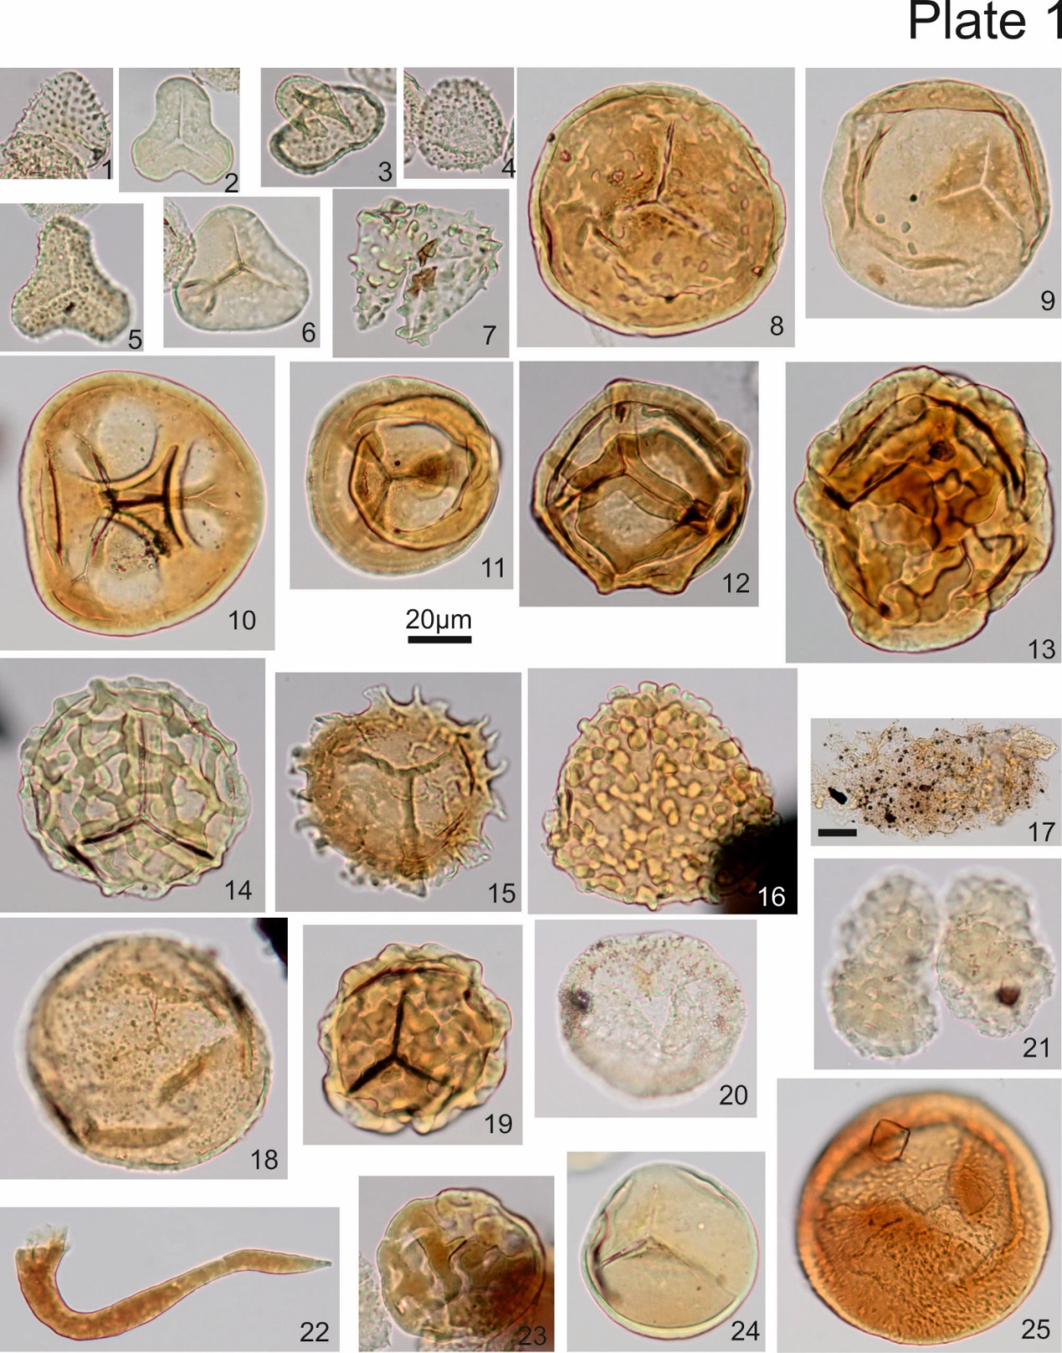

Plate 1. All x500 µm with a common 20 µm scale bar except where shown. All from sample Fife-1, with slide number in brackets, e.g. (5), microscope co-ordinates (Olympus BHS 313 No. 210685) and England Finder co-ordinates, eg., S25/2 are shown.
1. Tricidarisporites dumosus, (6), 126, 10, S25/2 2. Leiotriletes politus, (6), 131, 17.5, K30/4 3. Granulatisporites granifer, (6), 134.7, 12, Q34/2 4. Anapiculatisporites baccatus, (6), 133.9, 12.1, Q33/2 5. Waltzispora planiangulata, (6), 141, 20, G41/3. 6. Leiotriletes sphaerotriangulatus, (6), 114, 7.4, V13/3. 7. Pustulatisporites papillosus, (6), 137.4, 22, E37/4. 8. Convolutispora planimuricata, (1), 135.9, 14, O36/1. 9. Calamospora breviradiatus, (1), 112.2, 4.9, X11/4. 10. Knoxisporites triangulatus, (3), 119.1 20, G18/4. 11. Knoxisporites stephanephorus, (1), 130.5, 13.7, O30/1. 12. Knoxisporites literatus, (4), 125.8, 13.6, O25/4. 13. Convolutispora vermiformis, (3), 124, 10, S23/2. 14. Corbulispora cancellata, (2), 125.1, 14.9, N24/2. 15. Dictyotriletes submarginatus, (3), 134.6, 18.3, J34/4. 16. Verrucosisporites morulatus, (2), 130.5, 24, C30/3. 17. Thin and fluffy AOM, (5), 126, 14.5, N25/4. 18. Verrucosisporites baccatus, (1), 136.4, 3.7, Y36/4. 19. Lophozonotriletes muricatus, (1), 121, 13.7, O20/2. 20. Colatisporites decorus, (1), 135.9, 21.4, F36/3. 21. Botryococcus braunii, (1), 132.1, 17.6, K32/1. 22. Megaspore spine, (6), 120, 17.7, K19/2. 23. Convolutispora superficialis,(6), 125.5, 11.2, Q25/3. 24. Punctatisporites aerarius, (6), 140.3, 12.2, P40/4. 25. Claytonispora cf. distincta, (3), 113.5, 17.3, K12/4.

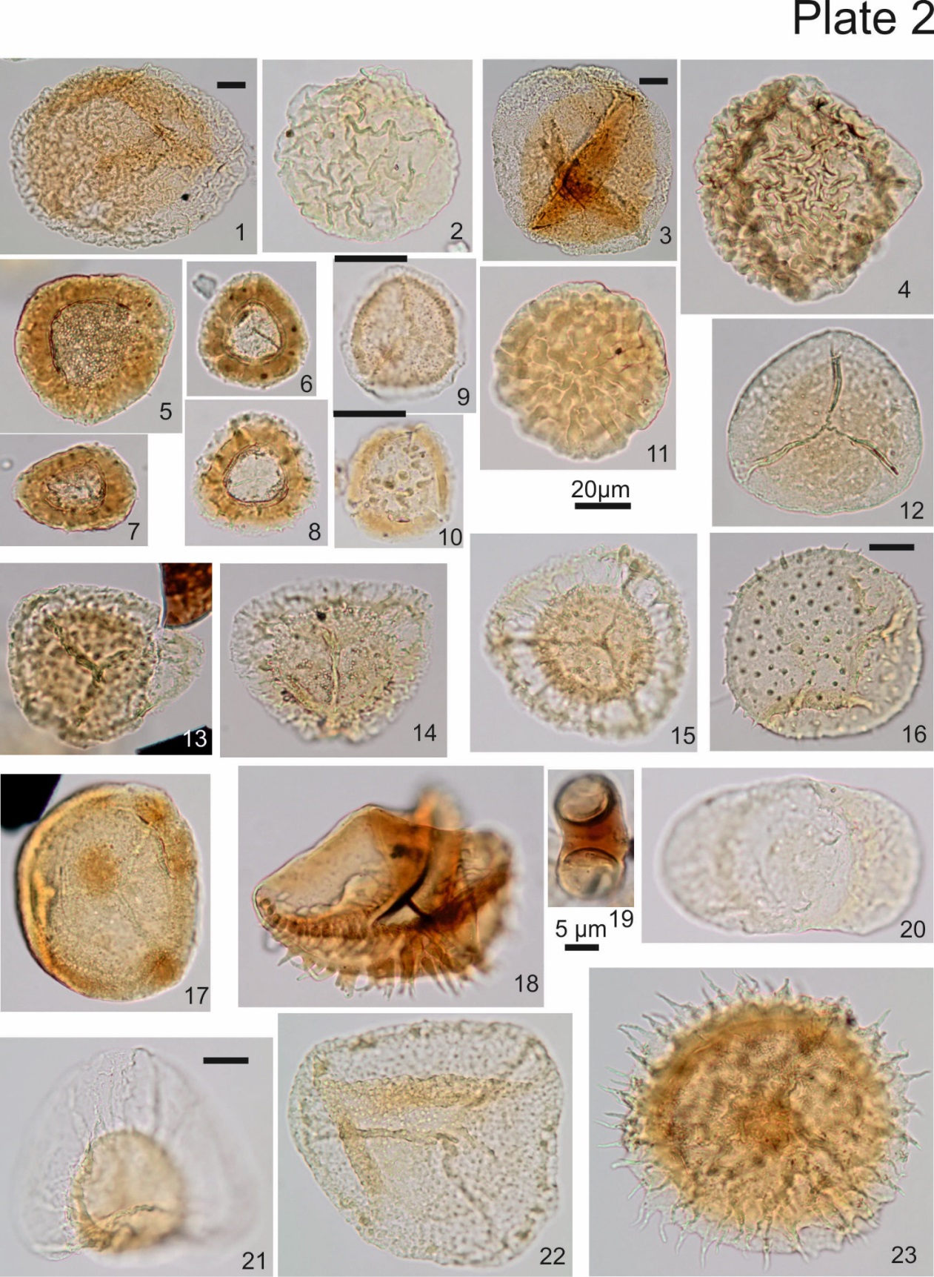
Plate 2. All x500 µm with a common 20 µm scale bar except where shown. All from sample Fife-1, with slide number in brackets, e.g. (5), microscope co-ordinates (Olympus BHS 313 No. 210685) and England Finder co-ordinates are shown.
1. Velamisporites corporatus, (2), 125.2, 21.1, F25/3. 2. Velamisporites tesellatus, (6), 115.3, 19.4, H14/4. 3. Velamisporites sp A, (4), 136.4, 17.4, K36/4. 4. Velamisporites polyptychus, (3), 126.8, 7, V26/2. 5. Densosporites pseudoannulatus, (6), 127.4, 11.3, Q27/3. 6. Densosporites intermedius, (6), 120.4, 12.7, P20/3. Densosporites triangularis, (6), 130.3, 11.8, Q30/1. 8. Cingulizonates bialatus, (6), 113.6, 5.7, W12/4. 9. Lycospora pusilla, (5), 123.5, 5, X23/1. 10. Lycospora noctuina, (5), 137.8, 8.6, T38/3. 11. Velamisporites minutus, (2), 122.3, 16.2, L23/3. 12. Endosporites micromanifestus, (1), 129.9, 9.2, T29/2. 13. Vallatisporites ciliaris, (2), 119.3, 17.9, K18/2. 14. Vallatisporites communis, (4), 126.1, 8.2, U25/2. 15. Vallatisporites galearis, (2), 118.3, 19.5, H17/2. 16. Crassispora aculeata, (2), 123.1, 19.4, H22/4. 17. Spelaeotriletes crustatus, (1), 132.6, 14.6, N32/4. 18. Diatomozonotriletes fragilis, (3), 115.3, 8.3, T14/4. 19. Felixites playfordii, (5), 130.6, 14.7, N30/2. 20. Schulzospora camplyoptera, (1), 134.4, 13.1, O34/1. 21. Auroraspora solisorta, (3), 127.1, 16, M26/2. 22. Spelaeotriletes balteatus, (1), 137, 16, M37/1. 23. Grandispora uncata, (1), 131.8, 11.1, R31/2.

