Supplementary Information

Design of cinnamaldehyde amino acids Schiff base compounds based on the quantitative structure activity relationship

Hui Wang^{1, 2}, Mingyue Jiang¹, Shujun Li^{1, ∗}, Chung-Yun Hse², Chunde Jin³, Fangli Sun³ and Zhuo Li¹
¹Key Laboratory of Bio-Based Material Science and Technology of the Ministry of Education, Northeast Forestry University, Harbin 150040, China
² Southern Research Station, USDA Forest Service, Pineville, Louisiana 71360, United States
³ Key Laboratory of Wood Science and Technology, Zhejiang agriculture and forestry University, Zhejiang 311300, China
Email: lishujun@nefu.edu.cn
Link text: https://doi.org/10.6084/m9.figshare.5202496
Table of contents:

Table S1. The antifungal activity of all compounds against Aspergillus niger 2
Table S2. The antifungal activity of all compounds against Penicillium citrinum 3
Table S3. The Experimental lgAR versus Calculated lgAR according to the best QSAR model against Aspergillus niger 4
Table S4. The Experimental lgAR versus Calculated lgAR according to the best QSAR model against Penicillium citrinum 5
Table S5. Grouping results for validation of QSAR model against Aspergillus niger and Penicillium citrinum 6
Table S6. The validation results of best QSAR models against Aspergillus niger 7
Table S7. The validation results of best QSAR models against Penicillium citrinum 8
The synthesis method of new designed compounds 9
The structures of two designed compounds 10
¹H NMR, IR and MS spectra of compound Da 11-12
¹H NMR, IR and MS spectra of compound Db 13-14

Table S1. Antifungal activity rates of all compounds against Aspergillus niger
No. | Diameter of inhibition zone(dT) | dT/Dc | Antifungal activity(AR) | lgAR
1 | 22.67 | 1.2141 | 121.4071 | 2.0842
2 | 20.30 | 1.0873 | 108.7306 | 2.0364
3 | 23.30 | 1.2480 | 124.7991 | 2.0962
4 | 8.70 | 0.4660 | 46.5988 | 1.6684
5 | 17.70 | 0.9480 | 94.8045 | 1.9768
6 | 23.00 | 1.2319 | 123.1923 | 2.0906
7 | 8.33 | 0.4462 | 44.6170 | 1.6495
8 | 10.50 | 0.5624 | 56.2400 | 1.7500
9 | 24.70 | 1.3230 | 132.2978 | 2.1216
10 | 9.80 | 0.5249 | 52.4906 | 1.7201
11 | 16.00 | 0.8570 | 85.6990 | 1.9330
12 | 20.70 | 1.1087 | 110.8731 | 2.0448
13 | 12.30 | 0.6588 | 65.8811 | 1.8188
14 | 13.30 | 0.7124 | 71.2373 | 1.8527
15 | 24.00 | 1.2855 | 128.5485 | 2.1091
16 | 18.70 | 1.0016 | 100.1607 | 2.0007
17 | 14.70 | 0.7874 | 78.7359 | 1.8962
18 | 15.67 | 0.8393 | 83.9314 | 1.9239
19 | 9.20 | 0.4928 | 49.2769 | 1.6926
20 | 13.00 | 0.6963 | 69.6304 | 1.8428
21 | 19.70 | 1.0552 | 105.5169 | 2.0233
Da | 24.00 | 1.2855 | 128.5485 | 2.1091
Db | 22.50 | 1.2051 | 120.5142 | 2.0810
Note: The antifungal activities of all the compounds were determined by paper disc method. The test concentration was 0.125mol/L. The antifungal activity rates were calculated as following equation: AR= (dT/dC) ×100%
dC was the diameter of inhibition zone of The values of dC for control compound-fluconazole, the values were 18.7mm against A. niger. lgAR used for calculating the QSAR model by Codessa 2.7.16 software.

Table S2. Antifungal activity rates of all compounds against Penicillium citrinum
No. | Diameter of inhibition zone(dT) | dT/Dc | Antifungal activity(AR) | lgAR
1 | 25.36 | 1.9508 | 195.08 | 2.2902
2 | 25.36 | 1.9508 | 195.08 | 2.2902
3 | 24.53 | 1.8869 | 188.69 | 2.2758
4 | 10.35 | 0.7958 | 79.58 | 1.9008
5 | 11.68 | 0.8985 | 89.85 | 1.9535
6 | 21.36 | 1.6431 | 164.31 | 2.2157
7 | 10.51 | 0.8087 | 80.87 | 1.9078
8 | 10.51 | 0.8087 | 80.87 | 1.9078
9 | 27.03 | 2.0792 | 207.92 | 2.3179
10 | 9.35 | 0.7188 | 71.88 | 1.8566
11 | 12.02 | 0.9242 | 92.42 | 1.9658
12 | 25.70 | 1.9765 | 197.65 | 2.2959
13 | 9.68 | 0.7444 | 74.44 | 1.8718
14 | 11.27 | 0.8665 | 86.65 | 1.9378
15 | 31.04 | 2.3877 | 238.77 | 2.3780
16 | 11.51 | 0.8857 | 88.57 | 1.9473
17 | 16.52 | 1.2708 | 127.08 | 2.1041
18 | 23.53 | 1.8100 | 181.00 | 2.2577
19 | 9.68 | 0.7445 | 74.45 | 1.8718
20 | 19.69 | 1.5146 | 151.46 | 2.1803
21 | 23.19 | 1.7842 | 178.42 | 2.2514
Da | 29.37 | 2.2592 | 225.92 | 2.3540
Db | 23.696 | 1.8228 | 182.28 | 2.2607

Note: The antifungal activities of all the compounds were determined by paper disc method. The test concentration was 0.125mol/L. The antifungal activity rates were calculated as following equation: AR= (dT/dC) × 100%
dC was the diameter of inhibition zone of The values of dC for control compound-fluconazole, the values were 13mm against P. citrinum, respectively. lgAR used for calculating the QSAR model by Codessa 2.7.16 software.

Table S3 The Experimental lgAR versus Calculated lgAR according to the best QSAR model against Aspergillus niger
No. | Experimental lgAR | Calculated lgAR | Error
1 | 2.0842 | 2.1082 | -0.024
2 | 2.0364 | 1.9903 | 0.0461
3 | 2.0962 | 2.1531 | -0.0569
4 | 1.6684 | 1.6811 | -0.0127
5 | 1.9768 | 1.927 | 0.0498
6 | 2.0906 | 2.1101 | -0.0195
7 | 1.6495 | 1.6839 | -0.0344
8 | 1.75 | 1.8399 | -0.0899
9 | 2.1216 | 2.069 | 0.0526
10 | 1.7201 | 1.7588 | -0.0387
11 | 1.933 | 1.9132 | 0.0198
12 | 2.0448 | 2.0663 | -0.0215
13 | 1.8188 | 1.7462 | 0.0726
14 | 1.8527 | 1.8718 | -0.0191
15 | 2.1091 | 2.0964 | 0.0127
16 | 2.0007 | 1.973 | 0.0277
17 | 1.8962 | 1.8851 | 0.0111
18 | 1.9239 | 1.8879 | 0.036
19 | 1.6926 | 1.6796 | 0.013
20 | 1.8428 | 1.8681 | -0.0253
21 | 2.0233 | 2.0225 | 0.0008
NOTE: The calculated lgAR were calculated by best QSAR model, and the difference between calculated lgAR and experimental lgAR indicated the predictability of the QSAR model. The above results processed by Orign 8.0 software and corresponded to Figure 4 in manuscript.

Table S4 The Experimental lgAR versus Calculated lgAR according to the best QSAR model against Penicillium citrinum
No. | Expmental lgAR | Calculated lgAR | Error
1 | 2.2902 | 2.2051 | 0.0851
2 | 2.2902 | 2.2959 | -0.0057
3 | 2.2758 | 2.3129 | -0.0371
4 | 1.9008 | 1.8724 | 0.0284
5 | 1.9535 | 1.9184 | 0.0351
6 | 2.2157 | 2.2003 | 0.0154
7 | 1.9078 | 1.875 | 0.0328
8 | 1.9078 | 1.9172 | -0.0094
9 | 2.3179 | 2.2945 | 0.0234
10 | 1.8566 | 1.8685 | -0.0119
11 | 1.9658 | 1.9738 | -0.008
12 | 2.2959 | 2.2499 | 0.046
13 | 1.8718 | 1.8823 | -0.0105
14 | 1.9378 | 1.992 | -0.0542
15 | 2.378 | 2.3865 | -0.0085
16 | 1.9473 | 1.9577 | -0.0104
17 | 2.1041 | 2.072 | 0.0321
18 | 2.2577 | 2.3201 | -0.0624
19 | 1.8718 | 1.937 | -0.0652
20 | 2.1803 | 2.2128 | -0.0325
21 | 2.2514 | 2.2341 | 0.0173
NOTE: The calculated lgAR were calculated by best QSAR model, and the difference between calculated lgAR and experimental lgAR indicated the predictability of the QSAR model. The above results processed by Orign 8.0 software and corresponded to Figure 4 in manuscript.

Table S5 Grouping results for validation of QSAR model against Aspergillus niger and Penicillium citrinum
group a | 1, 6, 8, 10, 15, 17, 19
group b | 2, 4, 9, 11, 13, 18, 20
group c | 3, 5, 7, 12, 14, 16, 21
group d | 4, 8, 12, 16, 20
group A(a+b) | 1, 2, 4, 6, 8, 9, 10, 11, 13, 15, 17, 18, 19, 20
group B(a+c) | 1, 3, 5, 6, 7, 8, 10, 12, 14, 15, 16, 17, 19, 21
group C(b+c) | 2, 3, 4, 5, 7, 9, 11, 12, 13, 14, 16, 18, 20, 21
group D | 1, 2, 3, 5, 6, 7, 9, 10, 11, 13, 14, 15, 17, 18, 19, 21
Note: The grouping details and validation results are listed in following Tables, The validation results processed by Orign 8.0 software. Following results were corresponded to Table 4 in manuscript.

Table S6 The validation results of best QSAR models against Aspergillus niger
Using group A to predict group c, the results are as follows:
No. | Predicted lgAR | Experimental lgAR
3 | 2.1809 | 2.0962
5 | 1.8887 | 1.9768
7 | 1.6849 | 1.6495
12 | 2.0925 | 2.0448
14 | 1.8523 | 1.8527
16 | 1.9863 | 2.0007
21 | 2.0487 | 2.0233
Using group B to predict group b, the results are as follows:
No. | Predicted lgAR | Experimental lgAR
2 | 1.9184 | 2.0364
4 | 1.6365 | 1.6684
9 | 2.0578 | 2.1216
11 | 1.9094 | 1.933
13 | 1.7287 | 1.8188
18 | 1.7941 | 1.9239
20 | 1.8661 | 1.8428
Using group C to predict group a, the results are as follows:
No. | Predicted lgAR | Experimental lgAR
1 | 2.113 | 2.0842
6 | 2.1275 | 2.0906
8 | 1.8664 | 1.75
10 | 1.7705 | 1.7201
15 | 2.0893 | 2.1091
17 | 1.8782 | 1.8962
19 | 1.6712 | 1.6926
Using group D to predict group d, the results are as follows:
No. | Predicted lgAR | Experimental lgAR
4 | 1.6963 | 1.6684
8 | 1.8793 | 1.75
12 | 2.0591 | 2.0448
16 | 1.9792 | 2.0007
20 | 1.8932 | 1.8428

Table S8 The validation results of best QSAR models against Penicillium citrinum
Using group A to predict group c, the results are as follows:
No. | Predicted lgAR | Experimental lgAR
3 | 2.3052 | 2.2758
5 | 1.9146 | 1.9535
7 | 1.8699 | 1.9078
12 | 2.2395 | 2.2959
14 | 1.9929 | 1.9378
16 | 1.9539 | 1.9473
21 | 2.2226 | 2.2514
Using group B to predict group b, the results are as follows:
No. | Predicted lgAR | Experimental lgAR
2 | 2.3242 | 2.2902
4 | 1.8613 | 1.9008
9 | 2.2996 | 2.3179
11 | 1.9747 | 1.9658
13 | 1.8706 | 1.8718
18 | 2.3355 | 2.2577
20 | 2.2767 | 2.1803
Using group C to predict group a, the results are as follows:
No. | Predicted lgAR | Experimental lgAR
1 | 2.1763 | 2.2902
6 | 2.2130 | 2.2157
8 | 1.9238 | 1.9078
10 | 1.8745 | 1.8566
15 | 2.3917 | 2.3780
17 | 2.0474 | 2.1041
19 | 1.9390 | 1.8718
Using group D to predict group d, the results are as follows:
No. | Predicted lgAR | Experimental lgAR
4 | 1.8683 | 1.9008
8 | 1.9124 | 1.9078
12 | 2.2356 | 2.2959
16 | 1.9467 | 1.9473
20 | 2.2762 | 2.1803

The synthesis method of new designed compounds
Equal malar ratio cinnamaldehyde and aspartic acid (0.0067mol) were added into 30 mL methanol. Then, 0.0134mol potassium hydroxide was added in to 20 mL methanol to prepare the potassium hydroxide methanol solution. Under stirring, potassium hydroxide methanol solution added into cinnamaldehyde aspartic acid mixture drop by drop until aspartic acid completely dissolved. After that, keep stirring the mixture for 5 hours at room temperature. Finally, the solvent was removed by rotary evaporation at 35 °C. The target compounds will be gained by added 15 mL diethyl ether. Then, the precipitate was washed three times and vacuum dried for 6 hours.

The structures of two designed compounds

¹H NMR, IR and MS spectra of compound Da
IR for Compound Da
¹H NMR for compound Da
MS for Compound Da
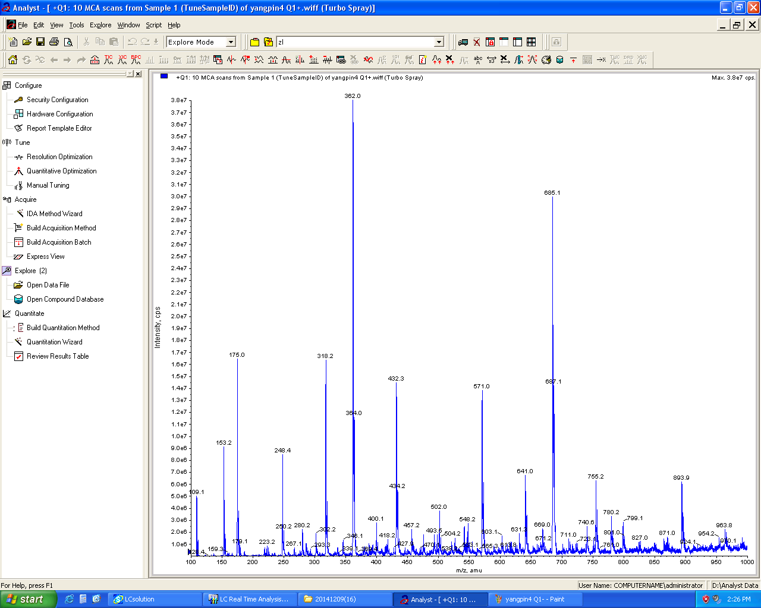

¹H NMR, IR and MS spectra of compound Db
IR for Compound Db
¹H NMR for compound Db
MS for Compound Db
