Appendix 3 - Supporting Information
Digging their own macroevolutionary grave: Fossoriality as an evolutionary dead-end in snakes

Running head: Macroevolutionary Consequences of Fossoriality in Snakes

Table S1: Number of fossorial and non-fossorial species included in each dataset and sampling fraction used for the two states in the BiSSE and HiSSE analysis for the seven datasets.
Dataset | Fossorial species |  |  | Non-fossorial species |  |  | Total Sampling Fraction
 | This study | Total number | Sampling fraction | This study | Total number | Sampling fraction
squamate | 317 | 1658 | 0.19919 | 1761 | 8238 | 0.2137 | 0.2099
lizard | 88 | 679 | 0.1296 | 734 | 5586 | 0.1314 | 0.1312
Fossorial weighted snake | 239 | 979 | 0.2441 | 1017 | 2652 | 0.3834 | 0.3459
Non-fossorial weighted snake | 196 | 979 | 0.2002 | 1060 | 2622 | 0.3996 | 0.3459
BC-squamate | 435 | 1658 | 0.2623 | 2162 | 8238 | 0.2624 | 0.2624
BC-lizard | 270 | 679 | 0.3976 | 1590 | 5586 | 0.2846 | 0.2968
BC-snake | 147 | 979 | 0.1501 | 572 | 6257 | 0.2156 | 0.1980

Table S2: BiSSE model comparisons between state dependent and state independent models for the squamate and lizard datasets. Lambda and mu are the speciation and extinction rates respectively for the fossorial (0) and non-fossorial (1) states. Transition rates between states are represented by q. The best fit model is highlighted in bold. * indicates where the analysis encountered convergence problems.
Constraint | parameters | lnLik | AIC | deltaAIC | p value
Squamate dataset
Full model | 6 | -9135.86 | 18283.71 | 0.29
lambda0 = lambda1 | 5 | -9140.58 | 18291.17 | 7.75 | 0.002109
mu0 = mu1 | 5 | -9138.08 | 18286.15 | 2.73 | 0.03516
lambda0 = lambda1, mu0 = mu1 | 4 | -9148.2 | 18304.4 | 20.98 | 0.00000436
q01=q10 | 5 | -9137.73 | 18285.46 | 2.04 | 0.05299
lambda0 = lambda1, q01=q10 | 4 | -9142.74 | 18293.49 | 10.07 | 0.001021
mu0 = mu1, q01=q10 | 4 | -9140.38 | 18288.76 | 5.34 | 0.01086
lambda0 = lambda1, mu0 = mu1, q01=q10 | 3 | -9149.05 | 18304.1 | 20.68 | 0.0000079
q01 = 0 | 5 | -9136.71 | 18283.42 | 0 | 0.1914
q10 = 0 | 5 | -9329.98 | 18669.97 | 386.55 | < 2.2e-16
Lizard dataset
Full model | 6 | -3886.331 | 7784.662 | 2.187
lambda0 = lambda1 | 5 | -3886.997 | 7783.993 | 1.518 | 0.2486
mu0 = mu1 | 5 | -3886.73 | 7783.459 | 0.984 | 0.372
lambda0 = lambda1, mu0 = mu1 | 4 | -3887.624 | 7783.249 | 0.774 | 0.2743
q01=q10 | 5 | -3886.877 | 7783.755 | 1.28 | 0.2959
lambda0 = lambda1, q01=q10 | 4 | -3887.888 | 7783.775 | 1.3 | 0.2108
mu0 = mu1, q01=q10 | 4 | -3887.581 | 7783.161 | 0.686 | 0.2866
lambda0 = lambda1, mu0 = mu1, q01=q10 | 3 | -3888.238 | 7782.475 | 0 | 0.2824
q01 = 0 | 5 | -3886.325 | 7782.65 | 0.175 | *
q10 = 0 | 5 | -3921.179 | 7852.358 | 69.883 | < 2.2e-16

Table S3: BiSSE model comparisons between state dependent and state independent models for the snake dataset and the two coding schemes. Lambda and mu are the speciation and extinction rates respectively for the fossorial (0) and non-fossorial (1) states. Transition rates between states are represented by q. The best fit model is highlighted in bold.
Constraint | parameters | lnLik | AIC | deltaAIC | p value
fossorial weighted snake dataset
Full model | 6 | -4931.98 | 9875.966 | 0
lambda0 = lambda1 | 5 | -4934.37 | 9878.743 | 2.777 | 0.02883
mu0 = mu1 | 5 | -4933.51 | 9877.017 | 1.051 | 0.08068
lambda0 = lambda1, mu0 = mu1 | 4 | -4979.27 | 9966.533 | 90.567 | < 2.2e-16
q01=q10 | 5 | -4938.95 | 9887.9 | 11.934 | 0.000189
lambda0 = lambda1, q01=q10 | 4 | -4945.77 | 9899.5 | 23.534 | 1.02E-06
mu0 = mu1, q01=q10 | 4 | -4938.96 | 9885.9 | 9.934 | 0.000935
lambda0 = lambda1, mu0 = mu1, q01=q10 | 3 | -4985.36 | 9976.718 | 100.752 | < 2.2e-16
q01 = 0 | 5 | -4934.35 | 9878.694 | 2.728 | 0.02967
q10 = 0 | 5 | -5127.69 | 10265.37 | 389.404 | < 2.2e-16
non-fossorial weighted snake dataset
Full model | 6 | -4858.66 | 9729.323 | 1.093 | -
lambda0 = lambda1 | 5 | -4859.12 | 9728.23 | 0 | 0.3408
mu0 = mu1 | 5 | -4860.85 | 9731.7 | 3.47 | 0.03638
lambda0 = lambda1, mu0 = mu1 | 4 | -4895.42 | 9798.8 | 70.57 | < 2.2e-16
q01=q10 | 5 | -4870.83 | 9751.7 | 23.47 | 8.09E-07
lambda0 = lambda1, q01=q10 | 4 | -4874.00 | 9756 | 27.77 | 2.19E-07
mu0 = mu1, q01=q10 | 4 | -4870.95 | 9749.9 | 21.67 | 4.58E-06
lambda0 = lambda1, mu0 = mu1, q01=q10 | 3 | -4904.52 | 9815.041 | 86.811 | < 2.2e-16
q01 = 0 | 5 | -4860.58 | 9731.2 | 2.97 | 0.04989
q10 = 0 | 5 | -5059.99 | 10129.99 | 401.76 | < 2.2e-16

Table S4: BiSSE model comparisons between state dependent and state independent models for the squamate, lizards and snake dataset of Bars-Closel et al., 2017. The best fit model is highlighted in bold.
Constraint | parameters | lnLik | AIC | deltaAIC | p value
BC-squamate dataset
Full model | 6 | -11139.01 | 22290.02 | 0 | -
lambda0 = lambda1 | 5 | -11141.5 | 22293 | 2.98 | 0.02574
mu0 = mu1 | 5 | -11143.51 | 22297 | 6.98 | 0.002695
lambda0 = lambda1, mu0 = mu1 | 4 | -11145.34 | 22299 | 8.98 | 0.001772
q01=q10 | 5 | -11143.48 | 22297 | 6.98 | 0.002778
lambda0 = lambda1, q01=q10 | 4 | -11152.67 | 22313 | 22.98 | 1.17E-06
mu0 = mu1, q01=q10 | 4 | -11158.88 | 22326 | 35.98 | 2.34E-09
lambda0 = lambda1, mu0 = mu1, q01=q10 | 3 | -11160.38 | 22327 | 36.98 | 2.79E-09
q01 = 0 | 5 | -11185.75 | 22382 | 91.98 | 2.2E-16
q10 = 0 | 5 | -11185.25 | 22380 | 89.98 | 2.2E-16
BC-lizard dataset
Full model | 6 | -8079.73 | 16171.46 | 0.61 | -
lambda0 = lambda1 | 5 | -8080.42 | 16170.85 | 0 | 0.2381
mu0 = mu1 | 5 | -8081.54 | 16173.08 | 2.23 | 0.0569
lambda0 = lambda1, mu0 = mu1 | 4 | -8083.36 | 16174.72 | 3.87 | 0.02652
q01=q10 | 5 | -8100.68 | 16211.35 | 40.5 | 9.64E-11
lambda0 = lambda1, q01=q10 | 4 | -8099.88 | 16207.76 | 36.91 | 1.77E-09
mu0 = mu1, q01=q10 | 4 | -8099.78 | 16207.55 | 36.7 | 1.97E-09
lambda0 = lambda1, mu0 = mu1, q01=q10 | 3 | -8099.94 | 16205.89 | 35.04 | 8.64E-09
q01 = 0 | 5 | -8112.66 | 16235.31 | 64.46 | 4.44E-16
q10 = 0 | 5 | -8092.56 | 16195.11 | 24.26 | 4.08E-07
BC-snake dataset
Full model | 6 | -2933.25 | 5878.5 | 1.301 | -
lambda0 = lambda1 | 5 | -2933.61 | 5877.2 | 0 | 0.3944
mu0 = mu1 | 5 | -2939.54 | 5889.1 | 11.9 | 0.00039
lambda0 = lambda1, mu0 = mu1 | 4 | -2965.51 | 5939 | 61.8 | 9.77E-15
q01=q10 | 5 | -2942.14 | 5894.3 | 17.1 | 2.47E-05
lambda0 = lambda1, q01=q10 | 4 | -2943.64 | 5895.3 | 18.1 | 3.08E-05
mu0 = mu1, q01=q10 | 4 | -2942.52 | 5893 | 15.8 | 9.44E-05
lambda0 = lambda1, mu0 = mu1, q01=q10 | 3 | -2966.3 | 5938.6 | 61.4 | 2.92E-14
q01 = 0 | 5 | -2950.6 | 5911.2 | 34 | 3.93E-09
q10 = 0 | 5 | -3000.1 | 6010.1 | 132.9 | < 2.2e-16

Table S5: HiSSE model comparisons between character dependent and character independent models for the squamate and lizard datasets. The best fit model is highlighted in bold.
Model | parameters | lnLik | AIC | AICc | deltaAIC
Squamate dataset
Bisse.like.hisse_null | 4 | -9178.2 | 18364.4 | 18364.4 | 1043.78
Bisse.like.hisse_irrev | 5 | -9159.7 | 18329.3 | 18329.4 | 1008.76
Bisse.like.hisse_full | 6 | -9163.4 | 18338.8 | 18338.8 | 1018.22
hisse.null2_8transRate | 12 | -8849.9 | 17723.8 | 17723.9 | 403.19
hisse.null2_Eq_Div | 10 | -9105.1 | 18230.1 | 18230.3 | 909.57
hisse.null2_1transRate | 5 | -8884.9 | 17779.7 | 17779.7 | 459.14
hisse.null4_Equal | 9 | -8673.9 | 17365.7 | 17365.8 | 45.15
hisse.null4_3transRate | 11 | -8741.9 | 17505.9 | 17506 | 185.29
hisse.full2 | 16 | -8644.3 | 17320.6 | 17320.8 | 0
hisse.full_3transRate | 11 | -8809 | 17639.9 | 17640.1 | 319.37
hisse.full_EqTransRate | 9 | -8854.1 | 17726.1 | 17726.2 | 405.55
hisse.full.10irriv | 14 | -8685.8 | 17399.5 | 17399.7 | 78.93
hisse.full.01irriv | 14 | -8680.2 | 17388.3 | 17388.5 | 67.75
Lizard dataset
Bisse.like.hisse_null | 4 | -3887.716 | 7783.432 | 7783.481 | 181.913
Bisse.like.hisse_irrev | 5 | -3922.063 | 7854.127 | 7854.2 | 252.608
Bisse.like.hisse_full | 6 | -3907.904 | 7827.808 | 7827.911 | 226.289
hisse.null2_8transRate | 12 | -3840.244 | 7704.488 | 7704.874 | 102.969
hisse.null2_Eq_Div | 10 | -3871.205 | 7762.409 | 7762.681 | 160.89
hisse.null2_1transRate | 5 | -3831.819 | 7673.637 | 7673.711 | 72.118
hisse.null4_Equal | 9 | -3791.76 | 7601.519 | 7601.741 | 0
hisse.null4_3transRate | 11 | -3803.42 | 7628.839 | 7629.165 | 27.32
hisse.full2 | 16 | -3806.751 | 7645.502 | 7646.178 | 43.983
hisse.full_3transRate | 11 | -3825.913 | 7673.825 | 7674.151 | 72.306
hisse.full_EqTransRate | 9 | -3821.717 | 7661.433 | 7661.655 | 59.914
hisse.full.10irriv | 14 | -3814.317 | 7656.634 | 7657.155 | 55.115
hisse.full.01irriv | 14 | -3842.073 | 7712.145 | 7712.666 | 110.626

Table S6: HiSSE model comparisons between character dependent and character independent models for the snake dataset under the two coding schemes. The best fit model is highlighted in bold
Model | parameters | lnLik | AIC | AICc | deltaAIC
fossorial weighted snake dataset
Bisse.like.hisse_null | 4 | -4979.18 | 9966.366 | 9966.398 | 360.247
Bisse.like.hisse_irrev | 5 | -4997.44 | 10004.88 | 10004.93 | 398.761
Bisse.like.hisse_full | 6 | -4995.57 | 10003.14 | 10003.21 | 397.021
hisse.null2_8transRate | 12 | -4804.46 | 9632.921 | 9633.172 | 26.802
hisse.null2_Eq_Div | 10 | -5022.58 | 10065.16 | 10065.34 | 459.041
hisse.null2_1transRate | 5 | -4932.16 | 9874.327 | 9874.375 | 268.208
hisse.null4_Equal | 9 | -4887.78 | 9793.561 | 9793.705 | 187.442
hisse.null4_3transRate | 11 | -4833.3 | 9688.59 | 9688.802 | 82.471
hisse.full2 | 16 | -4787.06 | 9606.119 | 9606.558 | 0
hisse.full_3transRate | 11 | -4885.09 | 9792.173 | 9792.385 | 186.054
hisse.full_EqTransRate | 9 | -4897.57 | 9813.138 | 9813.282 | 207.019
hisse.full.10irriv | 14 | -4792.5 | 9613.005 | 9613.343 | 6.886
hisse.full.01irriv | 14 | -4806.51 | 9641.024 | 9641.363 | 34.905
non-fossorial weighted snake dataset
Bisse.like.hisse_null | 4 | -5003.42 | 10014.84 | 10014.87 | 408.66
Bisse.like.hisse_irrev | 5 | -4991.71 | 9993.418 | 9993.466 | 387.24
Bisse.like.hisse_full | 6 | -4935.14 | 9882.279 | 9882.346 | 276.1
hisse.null2_8transRate | 12 | -4871.09 | 9766.182 | 9766.433 | 160
hisse.null2_Eq_Div | 10 | -4999.21 | 10018.42 | 10018.6 | 412.24
hisse.null2_1transRate | 5 | -4917.18 | 9844.358 | 9844.406 | 238.18
hisse.null4_Equal | 9 | -4824.26 | 9666.519 | 9666.663 | 60.339
hisse.null4_3transRate | 11 | -4836.86 | 9695.715 | 9695.927 | 89.535
hisse.full2 | 16 | -4787.09 | 9606.18 | 9606.62 | 0
hisse.full_3transRate | 11 | -4892.17 | 9806.34 | 9806.552 | 200.16
hisse.full_EqTransRate | 9 | -4891.16 | 9800.323 | 9800.468 | 194.14
hisse.full.10irriv | 14 | -4813.87 | 9655.748 | 9656.087 | 49.568
hisse.full.01irriv | 14 | -4812.99 | 9653.971 | 9654.309 | 47.791

Table S7: HiSSE model comparisons between character dependent and character independent models for the squamate and lizard dataset of Bars-Closel et al. (2017). The best fit model is highlighted in bold.
Model | parameters | lnLik | AIC | AICc | deltaAIC
BC-squamate dataset
Bisse.like.hisse_null | 4 | -11149 | 22306.03 | 22306.04 | 881.62
Bisse.like.hisse_irrev | 5 | -11224.6 | 22459.15 | 22459.17 | 1034.74
Bisse.like.hisse_full | 6 | -11175.7 | 22363.31 | 22363.34 | 938.9
hisse.null2_8transRate | 12 | -10700.2 | 21424.41 | 21424.53 | 0
hisse.null2_Eq_Div | 10 | -11079.2 | 22178.3 | 22178.39 | 753.89
hisse.null2_1transRate | 5 | -11015.6 | 22041.11 | 22041.14 | 616.7
hisse.null4_Equal | 9 | -10737.1 | 21492.14 | 21492.21 | 67.73
hisse.null4_3transRate | 11 | -10751.1 | 21524.25 | 21524.35 | 99.84
hisse.full2 | 16 | -10753.9 | 21539.84 | 21540.05 | 115.43
hisse.full_3transRate | 11 | -10871.1 | 21764.27 | 21764.38 | 339.86
hisse.full_EqTransRate | 9 | -10858.6 | 21735.21 | 21735.28 | 310.8
hisse.full.10irriv | 14 | -10726.4 | 21480.74 | 21480.9 | 56.33
hisse.full.01irriv | 14 | -10721.6 | 21471.21 | 21471.37 | 46.8
BC-lizard dataset
Bisse.like.hisse_null | 4 | -8083.36 | 16174.72 | 16174.74 | 607.51
Bisse.like.hisse_irrev | 5 | -8121.275 | 16252.55 | 16252.58 | 685.34
Bisse.like.hisse_full | 6 | -8105.233 | 16222.47 | 16222.51 | 655.26
hisse.null2_8transRate | 12 | -7784.816 | 15593.63 | 15593.8 | 26.42
hisse.null2_Eq_Div | 10 | -8066.377 | 16152.75 | 16152.87 | 585.54
hisse.null2_1transRate | 5 | -7949.835 | 15909.67 | 15909.7 | 342.46
hisse.null4_Equal | 9 | -7870.622 | 15759.24 | 15759.34 | 192.03
hisse.null4_3transRate | 11 | -7796.992 | 15615.98 | 15616.13 | 48.77
hisse.full2 | 16 | -7767.606 | 15567.21 | 15567.51 | 0
hisse.full_3transRate | 11 | -7893.85 | 15809.7 | 15809.84 | 242.49
hisse.full_EqTransRate | 9 | -7964.536 | 15947.07 | 15947.17 | 379.86
hisse.full.10irriv | 14 | -7877.039 | 15782.08 | 15782.31 | 214.87
hisse.full.01irriv | 14 | -7877.039 | 15782.08 | 15782.31 | 214.87

Table S8: HiSSE model comparisons between character dependent and character independent models for the snake dataset of Bars-Closel et al. (2017). The best fit model is highlighted in bold.
Model | parameters | lnLik | AIC | AICc | deltaAIC
BC-snake dataset
Bisse.like.hisse_null | 4 | -2965.56 | 5939.11 | 5939.167 | 208.911
Bisse.like.hisse_irrev | 5 | -2951.2 | 5912.394 | 5912.478 | 182.195
Bisse.like.hisse_full | 6 | -2972.47 | 5956.932 | 5957.05 | 226.733
hisse.null2_8transRate | 12 | -2973.24 | 5970.477 | 5970.919 | 240.278
hisse.null2_Eq_Div | 10 | -2950.13 | 5920.252 | 5920.562 | 190.053
hisse.null2_1transRate | 5 | -2907.02 | 5824.039 | 5824.123 | 93.84
hisse.null4_Equal | 9 | -2867.86 | 5753.725 | 5753.979 | 23.526
hisse.null4_3transRate | 11 | -2876.07 | 5774.146 | 5774.519 | 43.947
hisse.full2 | 16 | -2849.1 | 5730.199 | 5730.974 | 0
hisse.full_3transRate | 11 | -2904.36 | 5830.712 | 5831.086 | 100.513
hisse.full_EqTransRate | 9 | -2893.27 | 5804.54 | 5804.794 | 74.341
hisse.full.10irriv | 14 | -2870.48 | 5768.965 | 5769.561 | 38.766
hisse.full.01irriv | 14 | -2851.78 | 5731.556 | 5732.153 | 1.357

Table S9: Parameter estimates of the best fit HiSSE models for the four datasets and two coding schemes. Models are parameterized on net diversification rate (net.div) and relative extinction rate (ε).
Dataset | model | net.div A0 | net.div A1 | net.div B0 | net.div B1 | ε A0 | ε A1 | ε B0 | ε B1
squamate | HiSSE full10irrev | 0.0286 | 0.0364 | 0.0867 | 0.1461 | 0.3902 | 0.3903 | 0.6802 | 0.5476
Fossorial weighted snake | HiSSE full | 0.0357 | 0.0647 | 0.1859 | 0.3337 | 0.11325 | 2.5e-09 | 0.3090 | 0.3158
Non-fossorial weighted snake | HiSSE full | -0.004 | 0.0655 | 0.0964 | 0.1733 | 1.2142 | 3.2e-06 | 0.5126 | 0.3215
lizard | HiSSE null 8 rate | net.div A | net.div B | net.div C | net.div D | ε A | ε B | ε C | ε D
 |  | 0.0123 | 0.0838 | 0.2060 | 0.0586 | 2.0e-09 | 0.0628 | 0.2908 | 0.2014
BC Datasets | model | net.div A0 | net.div A1 | net.div B0 | net.div B1 | ε A0 | ε A1 | ε B0 | ε B1
BC-squamate | Hisse null 8 rate | 0.0378 | 0.0378 | 0.1354 | 0.1354 | 0.0305 | 0.0305 | 0.4046 | 0.4046
BC-lizard | HiSSE full | 0.0283 | 0.0280 | 0.1231 | 0.1378 | 4.5E-07 | 0.2539 | 0.3912 | 0.3049
BC-snake | HiSSE full | 0.0390 | 0.0806 | 0.1359 | 0.1726 | 0.3822 | 2.0e-09 | 0.5728 | 0.5074

Table S10: STRAPP analysis for association between fossoriality and estimated speciation rates from rate configurations from the BAMM analysis. A Mann Whitney U-test was used on 100000 STRAPP replicates for the rate configurations.
Dataset | Rate Shift Configuration | Estimate 0 | Estimate 1 | P value
Squamates | Maximum a posteriori probability (MAP) configuration | 0. 0601458 | 0. 1071338 | 0. 33258
 | BAMM posterior distribution | 0. 06128423 | 0. 0998389 | 0. 31525
Lizards | Maximum a posteriori probability (MAP) configuration | 0.08552478 | 0.08552478 | 0. 41263
 | BAMM posterior distribution | 0. 08773361 | 0. 08776216 | 0. 55176
Fossorial weighted snakes | Maximum a posteriori probability (MAP) configuration | 0.07342766 | 0.0708742 | 0.56621
 | BAMM posterior distribution | 0.067654 | 0.07300631 | 0.17554
Non-fossorial weighted snakes | Maximum a posteriori probability (MAP) configuration | 0.07342766 | 0.0708742 | 0.57092
 | BAMM posterior distribution | 0.05386598 | 0.07301017 | 0.17539

Figure S1: Phylorate plot showing the variation in net diversification estimated by BAMM with warm colours indicating high rates and cold colours indicating low rates for lineages in the snake tree under A – Maximum a posteriori (MAP) rate configuration, B – Maximum shift credibility (MSC) configuration.
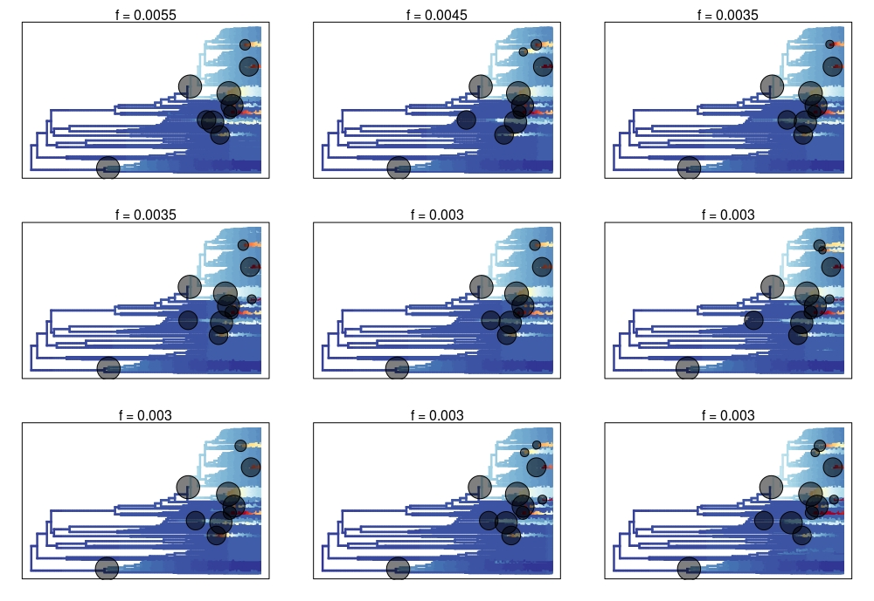
Figure S2: Credible shift set of rate shift configurations obtained from BAMM for the squamate tree using a marginal odds ratio threshold of 5. The frequency (f) of each rate shift configuration from the posterior distribution of BAMM is indicated above each plot.

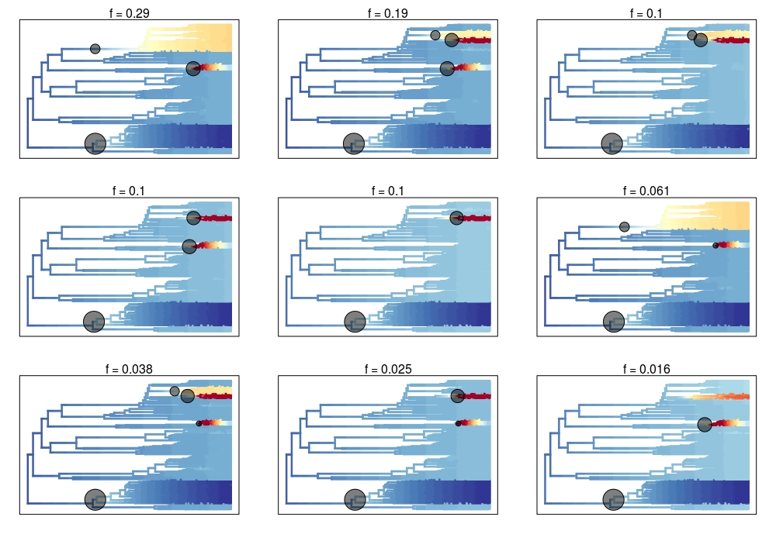
Figure S3: Credible shift set of rate shift configurations obtained from BAMM for the lizard tree using a marginal odds ratio threshold of 5. The frequency (f) of each rate shift configuration from the posterior distribution of BAMM is indicated above each plot.

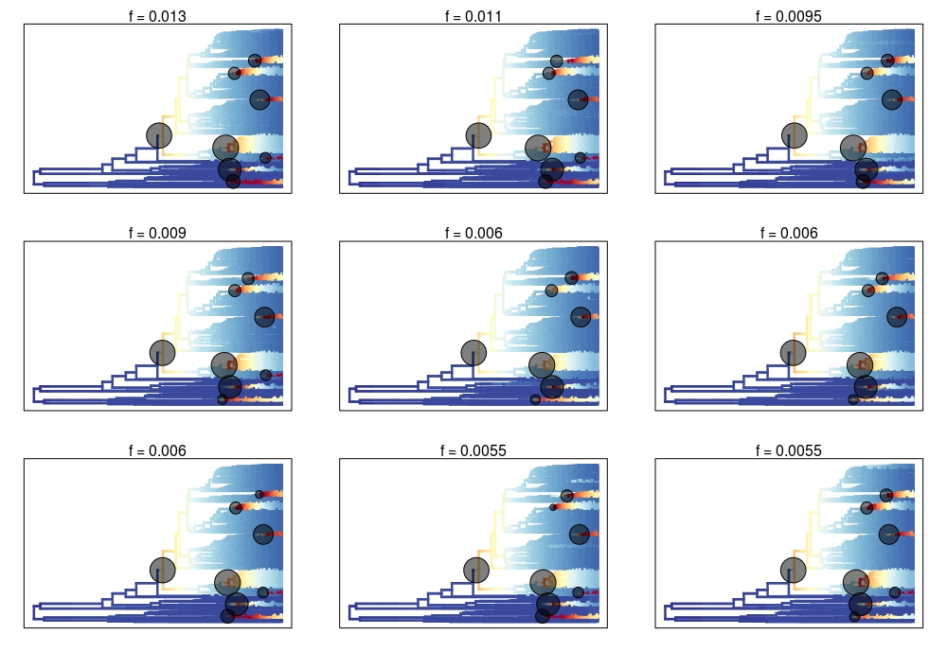
Figure S4: Credible shift set of rate shift configurations obtained from BAMM for the snake tree using a marginal odds ratio threshold of 5. The frequency (f) of each rate shift configuration from the posterior distribution of BAMM is indicated above each plot.

Figure S5: Bayesian parameter estimates and ancestral state reconstruction for the squamate dataset. A - Speciation rate, extinction rate and transition rate between the two states, 0 representing fossorial and 1 representing non-fossorial taxa, inferred from the full BiSSE model. B – Ancestral states reconstruction from the HiSSE full model where branches are colour coded as hot and cold colours based on the net diversification rate estimates. The reconstructed states, colour coded as white for fossorial and black for non-fossorial, are embedded within each branch. The snake clade is indicated by a red circle. The inset in B indicates a density plot of the net diversification rates.

Figure S6: Bayesian parameter estimates and ancestral state reconstruction for the lizard dataset. A - Speciation rate, extinction rate and transition rate between the two states, 0 representing fossorial and 1 representing non-fossorial taxa, inferred from the full BiSSE model. B – Ancestral states reconstruction from the HiSSE full model where branches are colour coded as hot and cold colours based on the net diversification rate estimates. The reconstructed states, colour coded as white for fossorial and black for non-fossorial, are embedded within each branch. The inset in B indicates a density plot of the net diversification rates.

