SUPPLEMENTAL MATERIAL for

Flower microbes as a cue mediating learning of floral preferences by bees: consequences for plant-pollinator communication

Avery L. Russell* and Tia-Lynn Ashman

Relationship between bee or flower size, forager type, and microbe quantity

We used linear models (LMs) with the response variable as ‘quantity of microbes’ and the explanatory variables as 1) ‘flower species’ and ‘flower size’ (measured as width of the flower corolla or head in cm) or 2) ‘forager type’ and ‘bee size’ (measured via head width, following Russell et al. 2017). Numerical variables were log-transformed, normalizing the residuals.

Microbe quantity did not differ significantly with flower species or flower size (LM overall effect: F_{9,40} = 1.364, P = 0.236, R² = 0.063; species effect: F₁ = 1.073, P = 0.383; log(flower width) effect: F₁ = 0.239, P = 0.627; species * log(flower width) interaction: F₁ = 0.487, P = 0.745). Bees that collected pollen had significantly more microbes than bees that collected only nectar (LM overall effect: F_{3,45} = 23.91, P < 0.0001, R² = 0.589; forage type effect: F₁ = 57.355, P < 0.0001). No significant effect of bee body size and no interaction with forager type on microbe quantity were found (LM: log(head width) effect: F₁ = 0.942, P = 0.337; log(head width) * forager type interaction: F₁ = 0.1363, P = 0.714).

Components of flowers contributing to differences in innate preferences

Here we tested whether components of live and artificial flowers contributed to differences in innate preference observed between experiment 1 and 2. We used 33 bees from two colonies. We assigned flower-naïve bees to one of two treatments that differed in the type of rewarding flowers used, and in both treatments we tested innate preference for the experimental floral microbial community in 5x4 arrays. In one treatment, Microbe and Control flowers were composed of live E. affine flowers that had their anthers excised at the filament and replaced with an artificial surrogate anther. In the other treatment, we made Microbe and Control flowers by gluing (with hotglue) the anther cone of live E. affine flowers to the centre of artificial corollas following Russell et al. (2018). We excluded four bees from analyses that would not collected pollen on flower visits.

Naïve bees avoided an experimental microbial community on artificial flowers with live surrogate anthers, but avoidance was only significant across all landings (Figure S2: first landing: G-test: G = 2.657, P = 0.103; all landings: paired t-test: t₁₃ = 2.455, P = 0.029, N = 14 bees). Naïve bees visiting live flowers with an artificial surrogate anther however showed no such preferences on their first visit or across all visits (Figure S2: first landing: G-test: G = 0.604, P = 0.437; all landings: Wilcoxon signed-rank test: V = 56, P = 0.485, N = 15 bees).

These results suggest that innate preferences for live flowers without microbes might be a consequence of microbial cues interfering with anther cues produced by live flowers. This result is consistent with previous work showing that relative to the corolla, anther chemical cues of similar species are relatively more important for pollen foraging bees (Russell et al. 2016; Russell et al. 2018).

TABLES AND FIGURES

Table S1: Bumble bee species collected in field survey
Species | Number of individuals | Sex
Bombus bimaculatus | 7 | 5F, 2M
Bombus fervidus | 7 | 7F, 0M
Bombus griseocollis | 5 | 5F, 0M
Bombus impatiens | 30 | 28F, 2M

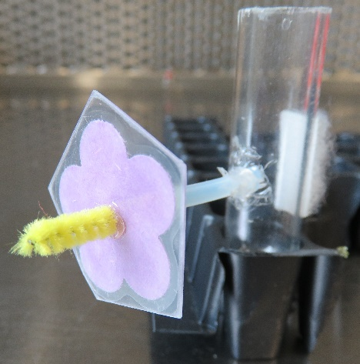
Figure S1. Artificial flowers, composed of a laminated paper ‘corolla’ and a chenille stem ‘anther’, used in experiment 1.

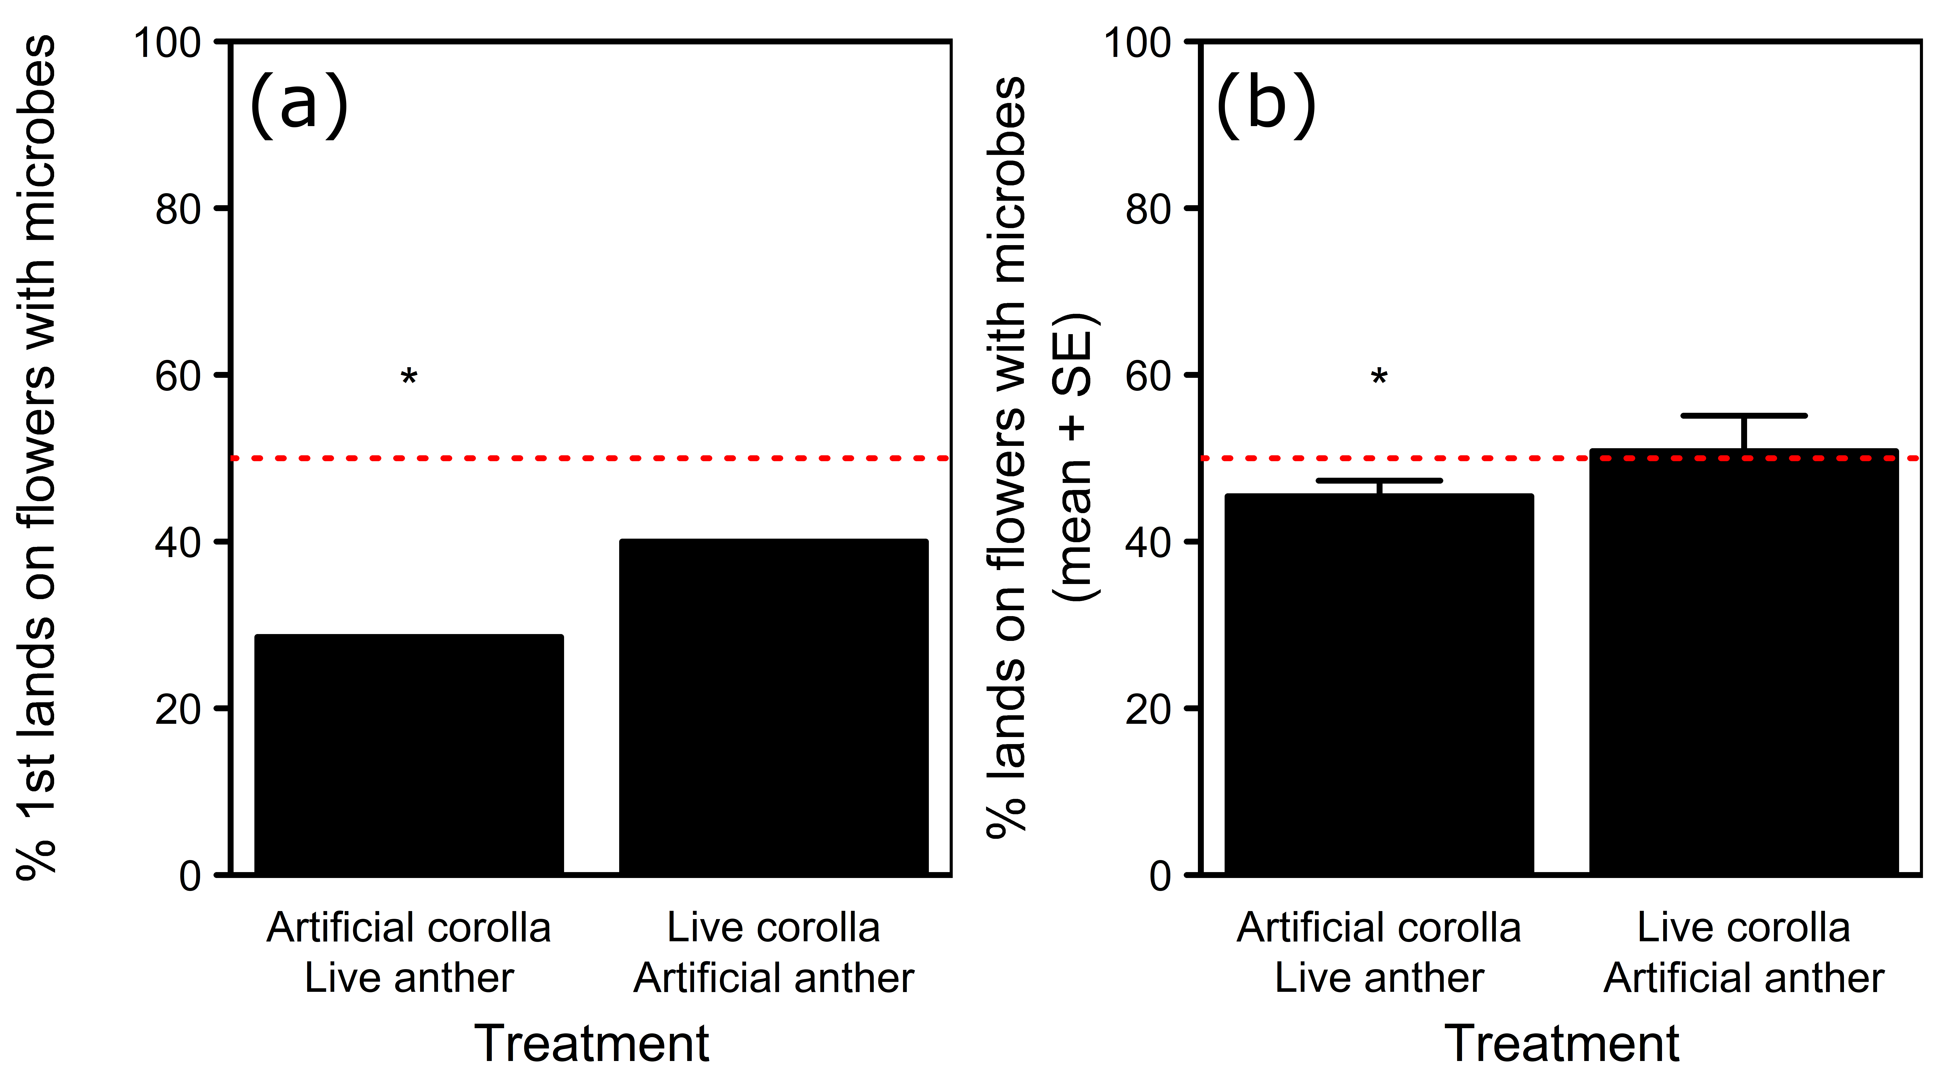
Figure S2. Percentage of (a) first landings or (b) mean percentage of landings (±SE) by naïve bees on composite flowers with an experimental microbial community. N = 14 and 15 bees for treatments with artificial corolla / live anther and live corolla / artificial anther, respectively. Dashed line at 50% indicates random expectation for an assay with two choices. Asterisks above bars indicate significant differences at P < 0.05 according to G-tests, a paired t-test, or a Wilcoxon signed-rank test.

REFERENCES

- Russell AL, Morrison SJ, Moschonas EH, Papaj DR. 2017. Patterns of pollen and nectar foraging specialization by bumblebees over multiple timescales using RFID tracking. Sci. Reports. 7, 42448 (doi:10.1038/srep42448)
- Russell AL, Golden RE, Leonard AS, Papaj DR. 2016. Bees learn preferences for plant species that offer only pollen as a floral reward. Behav. Ecol. 27, 731–74.
- Russell AL, Mauerman K, Golden RE, Papaj DR. 2018. Linking components of complex signals to morphological part: the role of anther and corolla in the complex floral display. Anim. Behav. 135, 223-236.

