PSG_Analysis_-_BMJSubmission.R
Author: Allan Kember
Mon May 21 22:49:35 2018
#Description of code: this code process the polysomnography (PSG) sleep reports in full.
#Within-participant (paired) comparisons are computed.
#Between-participant comparisons are computed FYI only.
#Summary: results reveal a statistically significant reduction in the percentage of time
#spent sleeping supine and in the number of minutes spent sleeping supine with the PrenaBelt
#versus the sham on testing via a paired Wilcoxon signed rank test.
#General Preamble and Notes:
#Regarding ANOVA:
#The result of this calculation is expressed in a test statistic called the F ratio
#(designated simply as F), the ratio of how much variability there is between the groups
#relative to how much there is within the groups.
#If the null hypothesis is true (in other words, if no true difference exists between the
#groups), then the F ratio should be close to 1.
#The p value can be calculated from the values of F, df1, and df2, and the software
#will perform this calculation for you. If the p value from the ANOVA is significant
#(less than 0.05 or your chosen alpha level), then you can conclude that the groups
#are not all the same (because the means varied from each other by too large an amount).
#setting the workspace directory
setwd("/Users/Allan/Desktop/HPTStats/08APR2017")
#importing the sleep study (SS) data
SSdatafull=read.csv("SS Data Halifax - 08APR2017.csv")
#Exclude drop outs
#How many drop outs?
summary(SSdatafull$drop.out)
## N Y
## 40 6
#6 nights = 3 participants
#Remove the drop outs ("Y")
SSdata <- SSdatafull[!(SSdatafull$drop.out=="Y"),]
nrow(SSdata)
## [1] 40
#Loading the functions (ad.test, etc.) into your workspace
library(nortest)
################### Time between studies (days) ##########################
#FYI: this data was not a pre-specified secondary outcome per the research protocol or
#trial registry. FYI only for purposes of peer reviewer's questions/comments.
#Summary
summary(SSdata$time.between.studies..days.)
## Min. 1st Qu. Median Mean 3rd Qu. Max. NA's
## 1.00 1.00 1.00 2.95 3.25 13.00 20
sd(SSdata$time.between.studies..days., na.rm = TRUE)
## [1] 3.619756
length(SSdata$time.between.studies..days.)
## [1] 40
#Check for normality
qqnorm(SSdata$time.between.studies..days.)
qqline(SSdata$time.between.studies..days.)
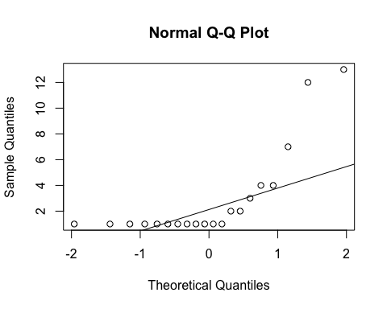
ad.test(SSdata$time.between.studies..days.)
##
## Anderson-Darling normality test
##
## data: SSdata$time.between.studies..days.
## A = 3.3009, p-value = 1.32e-08
#non-normal
####################Total sleep time#######################
#Summary
summary(SSdata$total.sleep.time)
## Min. 1st Qu. Median Mean 3rd Qu. Max.
## 154.5 317.6 351.6 336.4 373.5 431.0
sd(SSdata$total.sleep.time, na.rm = TRUE)
## [1] 63.95136
length(SSdata$total.sleep.time)
## [1] 40
qqnorm(SSdata$total.sleep.time)
qqline(SSdata$total.sleep.time)
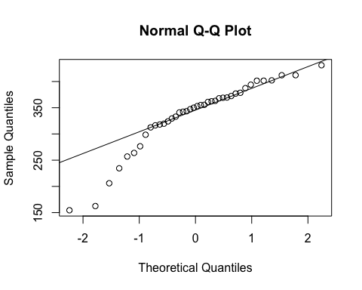
ad.test(SSdata$total.sleep.time)
##
## Anderson-Darling normality test
##
## data: SSdata$total.sleep.time
## A = 1.3949, p-value = 0.001122
#non-normal
#ANOVA
night_tx_difference <- anova(lm(total.sleep.time ~ intervention*night,
data = SSdata))
night_tx_difference
## Analysis of Variance Table
##
## Response: total.sleep.time
## Df Sum Sq Mean Sq F value Pr(>F)
## intervention 1 659 658.5 0.1527 0.6983
## night 1 3574 3574.0 0.8287 0.3687
## intervention:night 1 3 2.8 0.0006 0.9800
## Residuals 36 155266 4312.9
#No association between intervention or night on sleeptime, even when accounting for
#both factors at the same time. It does not matter whether they received the PrenaBelt
#on night one or night two.
#within-participants (paired) comparison
#need to remove drop outs in order to have balanced pairs
#Exclude drop outs
#How many drop outs?
summary(SSdata$drop.out)
## N Y
## 40 0
#Remove the drop outs ("Y")
SSdataCompletes <- SSdata[!(SSdata$drop.out=="Y"),]
nrow(SSdataCompletes)
## [1] 40
#Non-normal - perform non-parametric test (Wilcoxon)
wilcox.test(subset(SSdataCompletes, intervention == "sham")$total.sleep.time,
subset(SSdataCompletes, intervention == "PrenaBelt")$total.sleep.time,
paired = TRUE, conf.int = TRUE)
##
## Wilcoxon signed rank test
##
## data: subset(SSdataCompletes, intervention == "sham")$total.sleep.time and subset(SSdataCompletes, intervention == "PrenaBelt")$total.sleep.time
## V = 112, p-value = 0.8124
## alternative hypothesis: true location shift is not equal to 0
## 95 percent confidence interval:
## -21.80 33.75
## sample estimates:
## (pseudo)median
## 3.55
#between participants (grouped) comparison
summary(subset(SSdata, intervention == "PrenaBelt")$total.sleep.time)
## Min. 1st Qu. Median Mean 3rd Qu. Max.
## 154.5 317.6 352.6 332.4 375.6 412.1
sd(subset(SSdata, intervention == "PrenaBelt")$total.sleep.time)
## [1] 75.04747
length(subset(SSdata, intervention == "PrenaBelt")$total.sleep.time)
## [1] 20
qqnorm(subset(SSdata, intervention == "PrenaBelt")$total.sleep.time)
qqline(subset(SSdata, intervention == "PrenaBelt")$total.sleep.time)
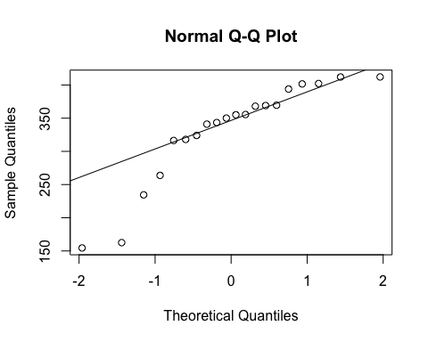
ad.test(subset(SSdata, intervention == "PrenaBelt")$total.sleep.time)
##
## Anderson-Darling normality test
##
## data: subset(SSdata, intervention == "PrenaBelt")$total.sleep.time
## A = 1.1032, p-value = 0.005239
#non-normal
summary(subset(SSdata, intervention == "sham")$total.sleep.time)
## Min. 1st Qu. Median Mean 3rd Qu. Max.
## 206.0 317.8 350.2 340.5 373.5 431.0
sd(subset(SSdata, intervention == "sham")$total.sleep.time)
## [1] 52.23046
length(subset(SSdata, intervention == "sham")$total.sleep.time)
## [1] 20
qqnorm(subset(SSdata, intervention == "sham")$total.sleep.time)
qqline(subset(SSdata, intervention == "sham")$total.sleep.time)
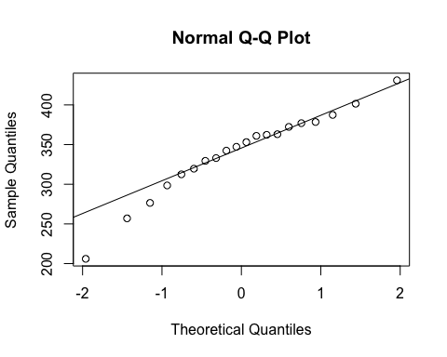
ad.test(subset(SSdata, intervention == "sham")$total.sleep.time)
##
## Anderson-Darling normality test
##
## data: subset(SSdata, intervention == "sham")$total.sleep.time
## A = 0.39153, p-value = 0.3464
#normal
#Non-normal - perform non-parametric test (Wilcoxon)
#FYI - unpaired test
wilcox.test(subset(SSdata, intervention == "sham")$total.sleep.time,
subset(SSdata, intervention == "PrenaBelt")$total.sleep.time,
conf.int = TRUE)
##
## Wilcoxon rank sum test
##
## data: subset(SSdata, intervention == "sham")$total.sleep.time and subset(SSdata, intervention == "PrenaBelt")$total.sleep.time
## W = 196, p-value = 0.9254
## alternative hypothesis: true location shift is not equal to 0
## 95 percent confidence interval:
## -35.1 32.3
## sample estimates:
## difference in location
## -2.2
####################Sleep Latency#######################
#Summary
summary(SSdata$sleep.latency)
## Min. 1st Qu. Median Mean 3rd Qu. Max.
## 2.00 6.70 12.80 19.54 23.92 79.50
sd(SSdata$sleep.latency, na.rm = TRUE)
## [1] 19.13941
length(SSdata$sleep.latency)
## [1] 40
qqnorm(SSdata$sleep.latency)
qqline(SSdata$sleep.latency)
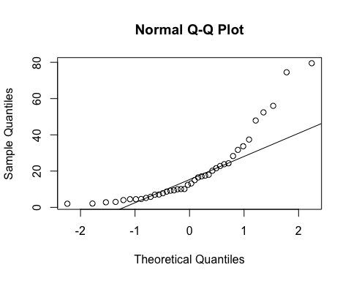
ad.test(SSdata$sleep.latency)
##
## Anderson-Darling normality test
##
## data: SSdata$sleep.latency
## A = 2.6549, p-value = 8.053e-07
#non-normal
#ANOVA
night_tx_difference <- anova(lm(sleep.latency ~ intervention*night,
data = SSdata))
night_tx_difference
## Analysis of Variance Table
##
## Response: sleep.latency
## Df Sum Sq Mean Sq F value Pr(>F)
## intervention 1 9.7 9.70 0.0247 0.8760
## night 1 1.0 0.99 0.0025 0.9602
## intervention:night 1 144.8 144.78 0.3688 0.5474
## Residuals 36 14130.9 392.52
#within-participants (paired) comparison
wilcox.test(subset(SSdataCompletes, intervention == "sham")$sleep.latency,
subset(SSdataCompletes, intervention == "PrenaBelt")$sleep.latency,
paired = TRUE, conf.int = TRUE)
##
## Wilcoxon signed rank test
##
## data: subset(SSdataCompletes, intervention == "sham")$sleep.latency and subset(SSdataCompletes, intervention == "PrenaBelt")$sleep.latency
## V = 92, p-value = 0.6477
## alternative hypothesis: true location shift is not equal to 0
## 95 percent confidence interval:
## -9.40 7.15
## sample estimates:
## (pseudo)median
## -2
#between participants (grouped) comparison
summary(subset(SSdata, intervention == "PrenaBelt")$sleep.latency)
## Min. 1st Qu. Median Mean 3rd Qu. Max.
## 2.00 6.70 11.65 19.05 21.90 74.50
sd(subset(SSdata, intervention == "PrenaBelt")$sleep.latency)
## [1] 19.76593
length(subset(SSdata, intervention == "PrenaBelt")$sleep.latency)
## [1] 20
qqnorm(subset(SSdata, intervention == "PrenaBelt")$sleep.latency)
qqline(subset(SSdata, intervention == "PrenaBelt")$sleep.latency)
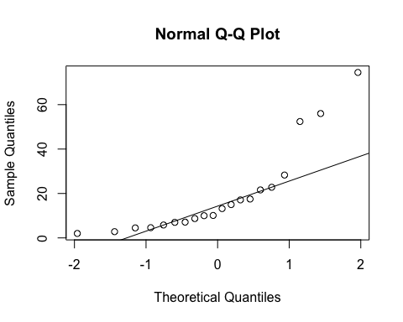
ad.test(subset(SSdata, intervention == "PrenaBelt")$sleep.latency)
##
## Anderson-Darling normality test
##
## data: subset(SSdata, intervention == "PrenaBelt")$sleep.latency
## A = 1.8095, p-value = 8.14e-05
#Non-normal
summary(subset(SSdata, intervention == "sham")$sleep.latency)
## Min. 1st Qu. Median Mean 3rd Qu. Max.
## 2.10 7.15 14.45 20.04 26.15 79.50
sd(subset(SSdata, intervention == "sham")$sleep.latency)
## [1] 18.99239
length(subset(SSdata, intervention == "sham")$sleep.latency)
## [1] 20
qqnorm(subset(SSdata, intervention == "sham")$sleep.latency)
qqline(subset(SSdata, intervention == "sham")$sleep.latency)
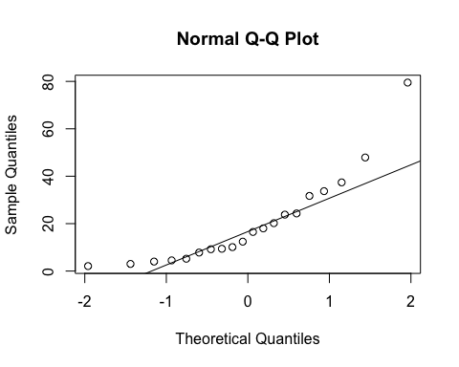
ad.test(subset(SSdata, intervention == "sham")$sleep.latency)
##
## Anderson-Darling normality test
##
## data: subset(SSdata, intervention == "sham")$sleep.latency
## A = 1.0478, p-value = 0.007272
#Non-normal - perform non-parametric test (Wilcoxon)
#FYI - unpaired test
wilcox.test(subset(SSdata, intervention == "sham")$sleep.latency,
subset(SSdata, intervention == "PrenaBelt")$sleep.latency,
conf.int = TRUE)
## Warning in wilcox.test.default(subset(SSdata, intervention == "sham")
## $sleep.latency, : cannot compute exact p-value with ties
## Warning in wilcox.test.default(subset(SSdata, intervention == "sham")
## $sleep.latency, : cannot compute exact confidence intervals with ties
##
## Wilcoxon rank sum test with continuity correction
##
## data: subset(SSdata, intervention == "sham")$sleep.latency and subset(SSdata, intervention == "PrenaBelt")$sleep.latency
## W = 214, p-value = 0.715
## alternative hypothesis: true location shift is not equal to 0
## 95 percent confidence interval:
## -5.700008 10.099985
## sample estimates:
## difference in location
## 1.01358
####################REM Latency#######################
#FYI: this data was generated in our PSG reports per default configuration but is not a
#pre-specified secondary outcome per the research protocol or trial registry. FYI only.
#Summary
summary(SSdata$rem.latency)
## Min. 1st Qu. Median Mean 3rd Qu. Max.
## 34.00 59.75 78.00 96.08 103.00 321.50
sd(SSdata$rem.latency, na.rm = TRUE)
## [1] 59.89655
length(SSdata$rem.latency)
## [1] 40
qqnorm(SSdata$rem.latency)
qqline(SSdata$rem.latency)
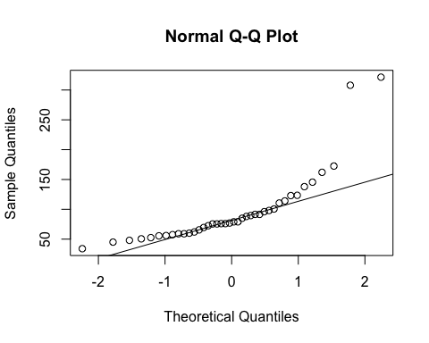
ad.test(SSdata$rem.latency)
##
## Anderson-Darling normality test
##
## data: SSdata$rem.latency
## A = 3.4165, p-value = 1.043e-08
#non-normal
#ANOVA
night_tx_difference <- anova(lm(rem.latency ~ intervention*night,
data = SSdata))
night_tx_difference
## Analysis of Variance Table
##
## Response: rem.latency
## Df Sum Sq Mean Sq F value Pr(>F)
## intervention 1 4580 4579.6 1.2379 0.2732
## night 1 1974 1974.0 0.5336 0.4698
## intervention:night 1 185 184.9 0.0500 0.8244
## Residuals 36 133178 3699.4
#within-participants (paired) comparison
wilcox.test(subset(SSdataCompletes, intervention == "sham")$rem.latency,
subset(SSdataCompletes, intervention == "PrenaBelt")$rem.latency,
paired = TRUE, conf.int = TRUE)
## Warning in wilcox.test.default(subset(SSdataCompletes, intervention ==
## "sham")$rem.latency, : cannot compute exact p-value with ties
## Warning in wilcox.test.default(subset(SSdataCompletes, intervention ==
## "sham")$rem.latency, : cannot compute exact confidence interval with ties
##
## Wilcoxon signed rank test with continuity correction
##
## data: subset(SSdataCompletes, intervention == "sham")$rem.latency and subset(SSdataCompletes, intervention == "PrenaBelt")$rem.latency
## V = 80.5, p-value = 0.37
## alternative hypothesis: true location shift is not equal to 0
## 95 percent confidence interval:
## -35.50005 17.50006
## sample estimates:
## (pseudo)median
## -5.190503
#between participants (grouped) comparison
summary(subset(SSdata, intervention == "PrenaBelt")$rem.latency)
## Min. 1st Qu. Median Mean 3rd Qu. Max.
## 48.0 61.5 82.0 106.8 103.9 321.5
sd(subset(SSdata, intervention == "PrenaBelt")$rem.latency)
## [1] 75.95402
length(subset(SSdata, intervention == "PrenaBelt")$rem.latency)
## [1] 20
qqnorm(subset(SSdata, intervention == "PrenaBelt")$rem.latency)
qqline(subset(SSdata, intervention == "PrenaBelt")$rem.latency)
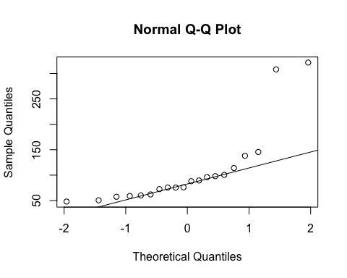
ad.test(subset(SSdata, intervention == "PrenaBelt")$rem.latency)
##
## Anderson-Darling normality test
##
## data: subset(SSdata, intervention == "PrenaBelt")$rem.latency
## A = 2.5226, p-value = 1.24e-06
#non-normal
summary(subset(SSdata, intervention == "sham")$rem.latency)
## Min. 1st Qu. Median Mean 3rd Qu. Max.
## 34.00 58.25 78.00 85.38 96.25 172.50
sd(subset(SSdata, intervention == "sham")$rem.latency)
## [1] 36.79634
length(subset(SSdata, intervention == "sham")$rem.latency)
## [1] 20
qqnorm(subset(SSdata, intervention == "sham")$rem.latency)
qqline(subset(SSdata, intervention == "sham")$rem.latency)
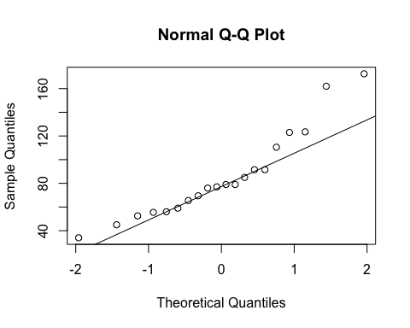
ad.test(subset(SSdata, intervention == "sham")$rem.latency)
##
## Anderson-Darling normality test
##
## data: subset(SSdata, intervention == "sham")$rem.latency
## A = 0.68703, p-value = 0.06153
#Non-normal - perform non-parametric test (Wilcoxon)
#FYI - unpaired test
wilcox.test(subset(SSdata, intervention == "sham")$rem.latency,
subset(SSdata, intervention == "PrenaBelt")$rem.latency,
conf.int = TRUE)
## Warning in wilcox.test.default(subset(SSdata, intervention == "sham")
## $rem.latency, : cannot compute exact p-value with ties
## Warning in wilcox.test.default(subset(SSdata, intervention == "sham")
## $rem.latency, : cannot compute exact confidence intervals with ties
##
## Wilcoxon rank sum test with continuity correction
##
## data: subset(SSdata, intervention == "sham")$rem.latency and subset(SSdata, intervention == "PrenaBelt")$rem.latency
## W = 178, p-value = 0.5608
## alternative hypothesis: true location shift is not equal to 0
## 95 percent confidence interval:
## -27.50004 15.50003
## sample estimates:
## difference in location
## -6.499973
####################Sleep Efficiency#######################
#Summary
summary(SSdata$sleep.efficiency)
## Min. 1st Qu. Median Mean 3rd Qu. Max.
## 39.70 76.40 82.45 79.16 88.58 93.30
sd(SSdata$sleep.efficiency, na.rm = TRUE)
## [1] 13.44863
length(SSdata$sleep.efficiency)
## [1] 40
qqnorm(SSdata$sleep.efficiency)
qqline(SSdata$sleep.efficiency)
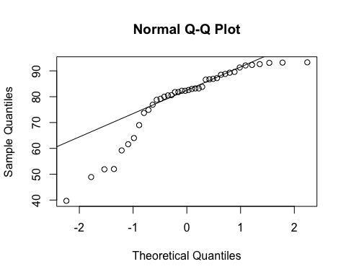
ad.test(SSdata$sleep.efficiency)
##
## Anderson-Darling normality test
##
## data: SSdata$sleep.efficiency
## A = 2.2288, p-value = 9.251e-06
#non-normal
#ANOVA
night_tx_difference <- anova(lm(sleep.efficiency ~ intervention*night,
data = SSdata))
night_tx_difference
## Analysis of Variance Table
##
## Response: sleep.efficiency
## Df Sum Sq Mean Sq F value Pr(>F)
## intervention 1 42.0 42.025 0.2179 0.6435
## night 1 36.1 36.100 0.1872 0.6679
## intervention:night 1 32.0 32.041 0.1661 0.6860
## Residuals 36 6943.6 192.877
#within-participants (paired) comparison
wilcox.test(subset(SSdataCompletes, intervention == "sham")$sleep.efficiency,
subset(SSdataCompletes, intervention == "PrenaBelt")$sleep.efficiency,
paired = TRUE, conf.int = TRUE)
## Warning in wilcox.test.default(subset(SSdataCompletes, intervention ==
## "sham")$sleep.efficiency, : cannot compute exact p-value with ties
## Warning in wilcox.test.default(subset(SSdataCompletes, intervention ==
## "sham")$sleep.efficiency, : cannot compute exact confidence interval with
## ties
##
## Wilcoxon signed rank test with continuity correction
##
## data: subset(SSdataCompletes, intervention == "sham")$sleep.efficiency and subset(SSdataCompletes, intervention == "PrenaBelt")$sleep.efficiency
## V = 125.5, p-value = 0.4552
## alternative hypothesis: true location shift is not equal to 0
## 95 percent confidence interval:
## -3.000041 5.899953
## sample estimates:
## (pseudo)median
## 1.444485
#between participants (grouped) comparison
summary(subset(SSdata, intervention == "PrenaBelt")$sleep.efficiency)
## Min. 1st Qu. Median Mean 3rd Qu. Max.
## 39.70 76.10 81.45 78.14 89.00 93.20
sd(subset(SSdata, intervention == "PrenaBelt")$sleep.efficiency)
## [1] 14.47362
length(subset(SSdata, intervention == "PrenaBelt")$sleep.efficiency)
## [1] 20
qqnorm(subset(SSdata, intervention == "PrenaBelt")$sleep.efficiency)
qqline(subset(SSdata, intervention == "PrenaBelt")$sleep.efficiency)
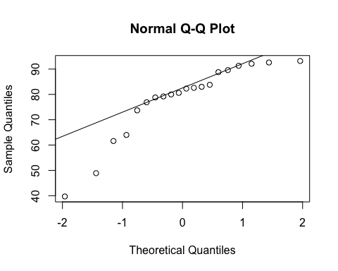
ad.test(subset(SSdata, intervention == "PrenaBelt")$sleep.efficiency)
##
## Anderson-Darling normality test
##
## data: subset(SSdata, intervention == "PrenaBelt")$sleep.efficiency
## A = 1.0955, p-value = 0.005485
#non-normal
summary(subset(SSdata, intervention == "sham")$sleep.efficiency)
## Min. 1st Qu. Median Mean 3rd Qu. Max.
## 51.90 79.10 83.20 80.18 87.52 93.30
sd(subset(SSdata, intervention == "sham")$sleep.efficiency)
## [1] 12.63143
length(subset(SSdata, intervention == "sham")$sleep.efficiency)
## [1] 20
qqnorm(subset(SSdata, intervention == "sham")$sleep.efficiency)
qqline(subset(SSdata, intervention == "sham")$sleep.efficiency)
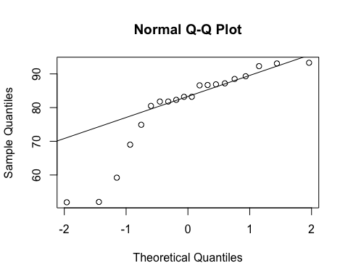
ad.test(subset(SSdata, intervention == "sham")$sleep.efficiency)
##
## Anderson-Darling normality test
##
## data: subset(SSdata, intervention == "sham")$sleep.efficiency
## A = 1.4349, p-value = 0.0007392
#non-normal
#Non-normal - perform non-parametric test (Wilcoxon)
#FYI - unpaired test
wilcox.test(subset(SSdata, intervention == "sham")$sleep.efficiency,
subset(SSdata, intervention == "PrenaBelt")$sleep.efficiency,
conf.int = TRUE)
## Warning in wilcox.test.default(subset(SSdata, intervention == "sham")
## $sleep.efficiency, : cannot compute exact p-value with ties
## Warning in wilcox.test.default(subset(SSdata, intervention == "sham")
## $sleep.efficiency, : cannot compute exact confidence intervals with ties
##
## Wilcoxon rank sum test with continuity correction
##
## data: subset(SSdata, intervention == "sham")$sleep.efficiency and subset(SSdata, intervention == "PrenaBelt")$sleep.efficiency
## W = 222.5, p-value = 0.5517
## alternative hypothesis: true location shift is not equal to 0
## 95 percent confidence interval:
## -4.800018 7.900004
## sample estimates:
## difference in location
## 1.799971
####################Number of REM Periods#######################
#FYI: this data was generated in our PSG reports per default configuration but is not a
#pre-specified secondary outcome per the research protocol or trial registry. FYI only.
#Summary
summary(SSdata$num.rem.periods)
## Min. 1st Qu. Median Mean 3rd Qu. Max.
## 1.0 3.0 4.0 3.4 4.0 5.0
sd(SSdata$num.rem.periods, na.rm = TRUE)
## [1] 1.172331
length(SSdata$num.rem.periods)
## [1] 40
qqnorm(SSdata$num.rem.periods)
qqline(SSdata$num.rem.periods)
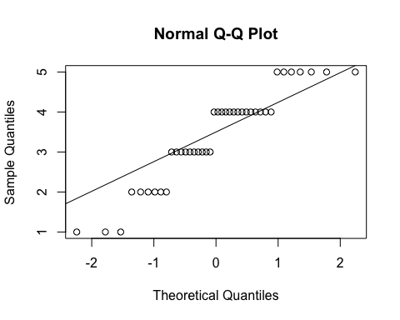
ad.test(SSdata$num.rem.periods)
##
## Anderson-Darling normality test
##
## data: SSdata$num.rem.periods
## A = 1.5069, p-value = 0.000588
#looks non-normal, but it is ordinal data
#ANOVA
night_tx_difference <- anova(lm(num.rem.periods ~ intervention*night,
data = SSdata))
night_tx_difference
## Analysis of Variance Table
##
## Response: num.rem.periods
## Df Sum Sq Mean Sq F value Pr(>F)
## intervention 1 0.4 0.4000 0.2903 0.5933
## night 1 3.6 3.6000 2.6129 0.1147
## intervention:night 1 0.0 0.0000 0.0000 1.0000
## Residuals 36 49.6 1.3778
#within-participants (paired) comparison
t.test(subset(SSdataCompletes, intervention == "sham")$num.rem.periods,
subset(SSdataCompletes, intervention == "PrenaBelt")$num.rem.periods,
paired = TRUE)
##
## Paired t-test
##
## data: subset(SSdataCompletes, intervention == "sham")$num.rem.periods and subset(SSdataCompletes, intervention == "PrenaBelt")$num.rem.periods
## t = 0.80943, df = 19, p-value = 0.4283
## alternative hypothesis: true difference in means is not equal to 0
## 95 percent confidence interval:
## -0.3171618 0.7171618
## sample estimates:
## mean of the differences
## 0.2
wilcox.test(subset(SSdataCompletes, intervention == "sham")$num.rem.periods,
subset(SSdataCompletes, intervention == "PrenaBelt")$num.rem.periods,
paired = TRUE, conf.int = TRUE)
## Warning in wilcox.test.default(subset(SSdataCompletes, intervention ==
## "sham")$num.rem.periods, : cannot compute exact p-value with ties
## Warning in wilcox.test.default(subset(SSdataCompletes, intervention ==
## "sham")$num.rem.periods, : cannot compute exact confidence interval with
## ties
## Warning in wilcox.test.default(subset(SSdataCompletes, intervention ==
## "sham")$num.rem.periods, : cannot compute exact p-value with zeroes
## Warning in wilcox.test.default(subset(SSdataCompletes, intervention ==
## "sham")$num.rem.periods, : cannot compute exact confidence interval with
## zeroes
##
## Wilcoxon signed rank test with continuity correction
##
## data: subset(SSdataCompletes, intervention == "sham")$num.rem.periods and subset(SSdataCompletes, intervention == "PrenaBelt")$num.rem.periods
## V = 73.5, p-value = 0.432
## alternative hypothesis: true location shift is not equal to 0
## 95 percent confidence interval:
## -0.4999577 1.0000552
## sample estimates:
## (pseudo)median
## 4.422455e-05
#between participants (grouped) comparison
summary(subset(SSdata, intervention == "PrenaBelt")$num.rem.periods)
## Min. 1st Qu. Median Mean 3rd Qu. Max.
## 1.00 2.75 3.00 3.30 4.25 5.00
sd(subset(SSdata, intervention == "PrenaBelt")$num.rem.periods)
## [1] 1.380313
length(subset(SSdata, intervention == "PrenaBelt")$num.rem.periods)
## [1] 20
qqnorm(subset(SSdata, intervention == "PrenaBelt")$num.rem.periods)
qqline(subset(SSdata, intervention == "PrenaBelt")$num.rem.periods)
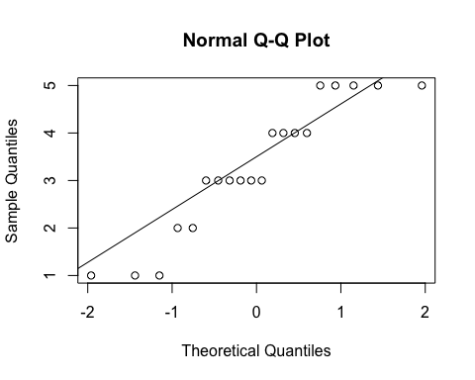
ad.test(subset(SSdata, intervention == "PrenaBelt")$num.rem.periods)
##
## Anderson-Darling normality test
##
## data: subset(SSdata, intervention == "PrenaBelt")$num.rem.periods
## A = 0.72773, p-value = 0.04835
#non-normal (ordinal data not held well by q-q plots)
summary(subset(SSdata, intervention == "sham")$num.rem.periods)
## Min. 1st Qu. Median Mean 3rd Qu. Max.
## 2.0 3.0 4.0 3.5 4.0 5.0
sd(subset(SSdata, intervention == "sham")$num.rem.periods)
## [1] 0.9459053
length(subset(SSdata, intervention == "sham")$num.rem.periods)
## [1] 20
qqnorm(subset(SSdata, intervention == "sham")$num.rem.periods)
qqline(subset(SSdata, intervention == "sham")$num.rem.periods)
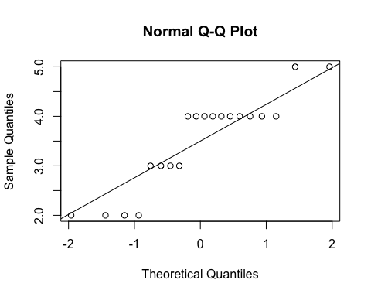
ad.test(subset(SSdata, intervention == "sham")$num.rem.periods)
##
## Anderson-Darling normality test
##
## data: subset(SSdata, intervention == "sham")$num.rem.periods
## A = 1.4725, p-value = 0.0005924
#non-normal (ordinal data not held well by q-q plots)
#FYI - unpaired test
t.test(subset(SSdata, intervention == "sham")$num.rem.periods,
subset(SSdata, intervention == "PrenaBelt")$num.rem.periods)
##
## Welch Two Sample t-test
##
## data: subset(SSdata, intervention == "sham")$num.rem.periods and subset(SSdata, intervention == "PrenaBelt")$num.rem.periods
## t = 0.53452, df = 33.621, p-value = 0.5965
## alternative hypothesis: true difference in means is not equal to 0
## 95 percent confidence interval:
## -0.5607122 0.9607122
## sample estimates:
## mean of x mean of y
## 3.5 3.3
wilcox.test(subset(SSdata, intervention == "sham")$num.rem.periods,
subset(SSdata, intervention == "PrenaBelt")$num.rem.periods,
conf.int = TRUE)
## Warning in wilcox.test.default(subset(SSdata, intervention == "sham")
## $num.rem.periods, : cannot compute exact p-value with ties
## Warning in wilcox.test.default(subset(SSdata, intervention == "sham")
## $num.rem.periods, : cannot compute exact confidence intervals with ties
##
## Wilcoxon rank sum test with continuity correction
##
## data: subset(SSdata, intervention == "sham")$num.rem.periods and subset(SSdata, intervention == "PrenaBelt")$num.rem.periods
## W = 213, p-value = 0.7263
## alternative hypothesis: true location shift is not equal to 0
## 95 percent confidence interval:
## -0.9999963 1.0000309
## sample estimates:
## difference in location
## 1.121393e-06
####################Number of Stage Shifts#######################
#FYI: this data was generated in our PSG reports per default configuration but is not a
#pre-specified secondary outcome per the research protocol or trial registry. FYI only.
#Summary
summary(SSdata$num.stage.shifts)
## Min. 1st Qu. Median Mean 3rd Qu. Max.
## 43.00 72.75 96.50 105.20 133.80 183.00
sd(SSdata$num.stage.shifts, na.rm = TRUE)
## [1] 39.29043
length(SSdata$num.stage.shifts)
## [1] 40
#ANOVA
night_tx_difference <- anova(lm(num.stage.shifts ~ intervention*night,
data = SSdata))
night_tx_difference
## Analysis of Variance Table
##
## Response: num.stage.shifts
## Df Sum Sq Mean Sq F value Pr(>F)
## intervention 1 148 148.22 0.0912 0.7644
## night 1 60 60.03 0.0369 0.8487
## intervention:night 1 1501 1500.63 0.9235 0.3430
## Residuals 36 58497 1624.91
#within-participants (paired) comparison
#Paired t-test
t.test(subset(SSdataCompletes, intervention == "sham")$num.stage.shifts,
subset(SSdataCompletes, intervention == "PrenaBelt")$num.stage.shifts,
paired = TRUE)
##
## Paired t-test
##
## data: subset(SSdataCompletes, intervention == "sham")$num.stage.shifts and subset(SSdataCompletes, intervention == "PrenaBelt")$num.stage.shifts
## t = 0.77738, df = 19, p-value = 0.4465
## alternative hypothesis: true difference in means is not equal to 0
## 95 percent confidence interval:
## -6.515809 14.215809
## sample estimates:
## mean of the differences
## 3.85
#between participants (grouped) comparison
summary(subset(SSdata, intervention == "PrenaBelt")$num.stage.shifts)
## Min. 1st Qu. Median Mean 3rd Qu. Max.
## 51.00 72.75 100.00 103.20 129.80 176.00
sd(subset(SSdata, intervention == "PrenaBelt")$num.stage.shifts)
## [1] 38.44459
length(subset(SSdata, intervention == "PrenaBelt")$num.stage.shifts)
## [1] 20
qqnorm(subset(SSdata, intervention == "PrenaBelt")$num.stage.shifts)
qqline(subset(SSdata, intervention == "PrenaBelt")$num.stage.shifts)
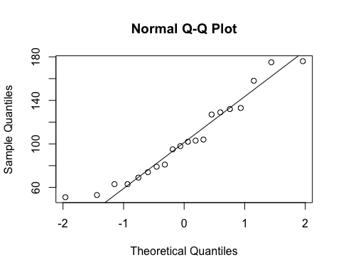
ad.test(subset(SSdata, intervention == "PrenaBelt")$num.stage.shifts)
##
## Anderson-Darling normality test
##
## data: subset(SSdata, intervention == "PrenaBelt")$num.stage.shifts
## A = 0.40309, p-value = 0.3245
#normal
summary(subset(SSdata, intervention == "sham")$num.stage.shifts)
## Min. 1st Qu. Median Mean 3rd Qu. Max.
## 43.00 80.25 95.00 107.10 147.80 183.00
sd(subset(SSdata, intervention == "sham")$num.stage.shifts)
## [1] 41.02361
length(subset(SSdata, intervention == "sham")$num.stage.shifts)
## [1] 20
qqnorm(subset(SSdata, intervention == "sham")$num.stage.shifts)
qqline(subset(SSdata, intervention == "sham")$num.stage.shifts)
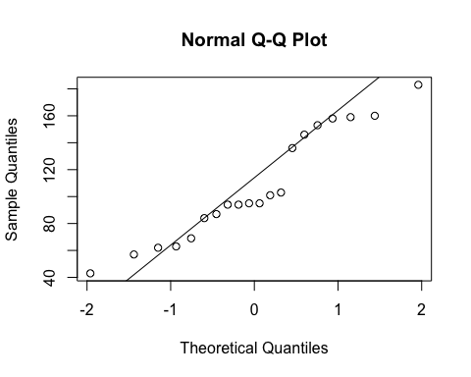
ad.test(subset(SSdata, intervention == "sham")$num.stage.shifts)
##
## Anderson-Darling normality test
##
## data: subset(SSdata, intervention == "sham")$num.stage.shifts
## A = 0.64165, p-value = 0.08053
#normal
#FYI - unpaired test
t.test(subset(SSdata, intervention == "sham")$num.stage.shifts,
subset(SSdata, intervention == "PrenaBelt")$num.stage.shifts)
##
## Welch Two Sample t-test
##
## data: subset(SSdata, intervention == "sham")$num.stage.shifts and subset(SSdata, intervention == "PrenaBelt")$num.stage.shifts
## t = 0.30624, df = 37.841, p-value = 0.7611
## alternative hypothesis: true difference in means is not equal to 0
## 95 percent confidence interval:
## -21.60347 29.30347
## sample estimates:
## mean of x mean of y
## 107.10 103.25
####################Awakenings#######################
#FYI: this data was generated in our PSG reports per default configuration but is not a
#pre-specified secondary outcome per the research protocol or trial registry. FYI only.
#Summary
summary(SSdata$awakenings)
## Min. 1st Qu. Median Mean 3rd Qu. Max.
## 10.00 14.75 19.00 19.70 24.25 32.00
sd(SSdata$awakenings, na.rm = TRUE)
## [1] 6.329418
length(SSdata$awakenings)
## [1] 40
#ANOVA
night_tx_difference <- anova(lm(awakenings ~ intervention*night,
data = SSdata))
night_tx_difference
## Analysis of Variance Table
##
## Response: awakenings
## Df Sum Sq Mean Sq F value Pr(>F)
## intervention 1 2.5 2.50 0.0589 0.8096
## night 1 19.6 19.60 0.4617 0.5012
## intervention:night 1 12.1 12.10 0.2850 0.5967
## Residuals 36 1528.2 42.45
#within-participants (paired) comparison
#Paired t-test
t.test(subset(SSdataCompletes, intervention == "sham")$awakenings,
subset(SSdataCompletes, intervention == "PrenaBelt")$awakenings,
paired = TRUE)
##
## Paired t-test
##
## data: subset(SSdataCompletes, intervention == "sham")$awakenings and subset(SSdataCompletes, intervention == "PrenaBelt")$awakenings
## t = 0.38863, df = 19, p-value = 0.7019
## alternative hypothesis: true difference in means is not equal to 0
## 95 percent confidence interval:
## -2.192823 3.192823
## sample estimates:
## mean of the differences
## 0.5
#between participants (grouped) comparison
summary(subset(SSdata, intervention == "PrenaBelt")$awakenings)
## Min. 1st Qu. Median Mean 3rd Qu. Max.
## 10.00 14.00 18.50 19.45 24.50 32.00
sd(subset(SSdata, intervention == "PrenaBelt")$awakenings)
## [1] 6.460202
length(subset(SSdata, intervention == "PrenaBelt")$awakenings)
## [1] 20
qqnorm(subset(SSdata, intervention == "PrenaBelt")$awakenings)
qqline(subset(SSdata, intervention == "PrenaBelt")$awakenings)
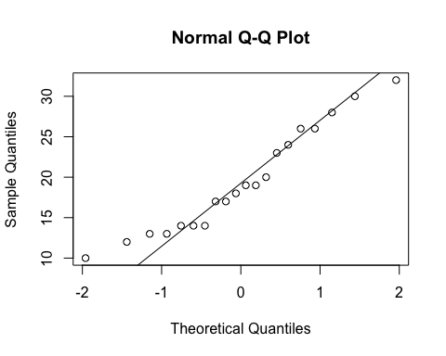
ad.test(subset(SSdata, intervention == "PrenaBelt")$awakenings)
##
## Anderson-Darling normality test
##
## data: subset(SSdata, intervention == "PrenaBelt")$awakenings
## A = 0.44596, p-value = 0.2537
#normal
summary(subset(SSdata, intervention == "sham")$awakenings)
## Min. 1st Qu. Median Mean 3rd Qu. Max.
## 10.00 16.00 19.00 19.95 23.50 31.00
sd(subset(SSdata, intervention == "sham")$awakenings)
## [1] 6.353408
length(subset(SSdata, intervention == "sham")$awakenings)
## [1] 20
qqnorm(subset(SSdata, intervention == "sham")$awakenings)
qqline(subset(SSdata, intervention == "sham")$awakenings)
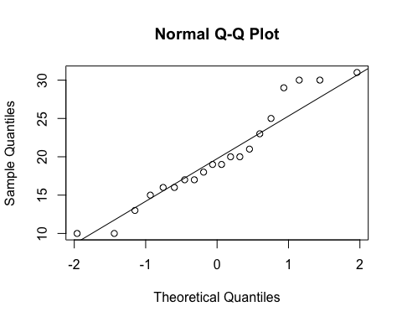
ad.test(subset(SSdata, intervention == "sham")$awakenings)
##
## Anderson-Darling normality test
##
## data: subset(SSdata, intervention == "sham")$awakenings
## A = 0.47198, p-value = 0.2179
#normal
#FYI - unpaired test
t.test(subset(SSdata, intervention == "sham")$awakenings,
subset(SSdata, intervention == "PrenaBelt")$awakenings)
##
## Welch Two Sample t-test
##
## data: subset(SSdata, intervention == "sham")$awakenings and subset(SSdata, intervention == "PrenaBelt")$awakenings
## t = 0.24678, df = 37.989, p-value = 0.8064
## alternative hypothesis: true difference in means is not equal to 0
## 95 percent confidence interval:
## -3.601622 4.601622
## sample estimates:
## mean of x mean of y
## 19.95 19.45
#################### % Stage 1 Sleep #######################
#Summary
summary(SSdata$Pstage.1)
## Min. 1st Qu. Median Mean 3rd Qu. Max.
## 1.600 4.975 7.900 9.353 12.720 26.000
sd(SSdata$Pstage.1, na.rm = TRUE)
## [1] 5.561267
length(SSdata$Pstage.1)
## [1] 40
qqnorm(SSdata$Pstage.1)
qqline(SSdata$Pstage.1)
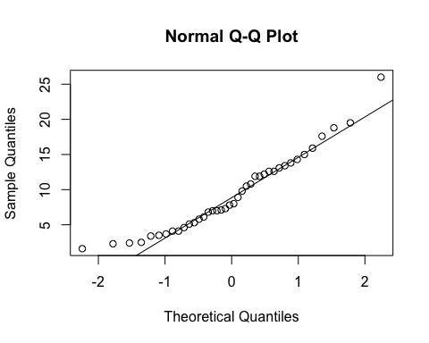
ad.test(SSdata$Pstage.1)
##
## Anderson-Darling normality test
##
## data: SSdata$Pstage.1
## A = 0.60276, p-value = 0.1097
#normal
#ANOVA
night_tx_difference <- anova(lm(Pstage.1 ~ intervention*night,
data = SSdata))
night_tx_difference
## Analysis of Variance Table
##
## Response: Pstage.1
## Df Sum Sq Mean Sq F value Pr(>F)
## intervention 1 2.55 2.550 0.0778 0.7819
## night 1 11.77 11.772 0.3593 0.5527
## intervention:night 1 12.21 12.210 0.3726 0.5454
## Residuals 36 1179.65 32.768
#within-participants (paired) comparison
#Paired t-test
t.test(subset(SSdataCompletes, intervention == "sham")$Pstage.1,
subset(SSdataCompletes, intervention == "PrenaBelt")$Pstage.1,
paired = TRUE)
##
## Paired t-test
##
## data: subset(SSdataCompletes, intervention == "sham")$Pstage.1 and subset(SSdataCompletes, intervention == "PrenaBelt")$Pstage.1
## t = 0.59457, df = 19, p-value = 0.5591
## alternative hypothesis: true difference in means is not equal to 0
## 95 percent confidence interval:
## -1.272708 2.282708
## sample estimates:
## mean of the differences
## 0.505
#between participants (grouped) comparison
summary(subset(SSdata, intervention == "PrenaBelt")$Pstage.1)
## Min. 1st Qu. Median Mean 3rd Qu. Max.
## 2.30 5.00 8.35 9.10 12.60 18.80
sd(subset(SSdata, intervention == "PrenaBelt")$Pstage.1)
## [1] 5.197368
length(subset(SSdata, intervention == "PrenaBelt")$Pstage.1)
## [1] 20
qqnorm(subset(SSdata, intervention == "PrenaBelt")$Pstage.1)
qqline(subset(SSdata, intervention == "PrenaBelt")$Pstage.1)
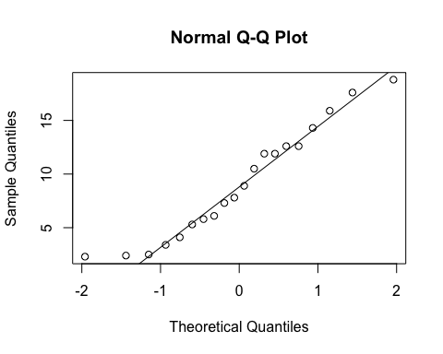
ad.test(subset(SSdata, intervention == "PrenaBelt")$Pstage.1)
##
## Anderson-Darling normality test
##
## data: subset(SSdata, intervention == "PrenaBelt")$Pstage.1
## A = 0.34971, p-value = 0.4374
#normal
summary(subset(SSdata, intervention == "sham")$Pstage.1)
## Min. 1st Qu. Median Mean 3rd Qu. Max.
## 1.600 4.975 7.550 9.605 13.180 26.000
sd(subset(SSdata, intervention == "sham")$Pstage.1)
## [1] 6.027959
length(subset(SSdata, intervention == "sham")$Pstage.1)
## [1] 20
qqnorm(subset(SSdata, intervention == "sham")$Pstage.1)
qqline(subset(SSdata, intervention == "sham")$Pstage.1)
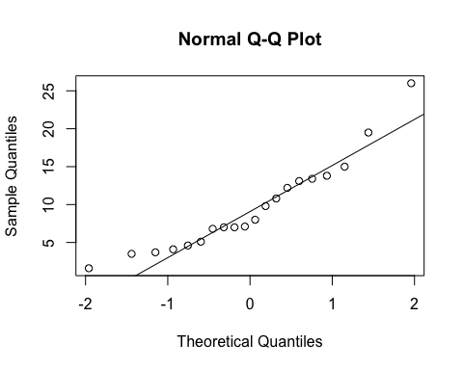
ad.test(subset(SSdata, intervention == "sham")$Pstage.1)
##
## Anderson-Darling normality test
##
## data: subset(SSdata, intervention == "sham")$Pstage.1
## A = 0.55353, p-value = 0.1336
#normal
#FYI - unpaired test
t.test(subset(SSdata, intervention == "sham")$Pstage.1,
subset(SSdata, intervention == "PrenaBelt")$Pstage.1)
##
## Welch Two Sample t-test
##
## data: subset(SSdata, intervention == "sham")$Pstage.1 and subset(SSdata, intervention == "PrenaBelt")$Pstage.1
## t = 0.28375, df = 37.194, p-value = 0.7782
## alternative hypothesis: true difference in means is not equal to 0
## 95 percent confidence interval:
## -3.100444 4.110444
## sample estimates:
## mean of x mean of y
## 9.605 9.100
#################### % Stage 2 Sleep #######################
#Summary
summary(SSdata$Pstage.2)
## Min. 1st Qu. Median Mean 3rd Qu. Max.
## 44.40 56.28 63.15 62.70 68.23 76.10
sd(SSdata$Pstage.2, na.rm = TRUE)
## [1] 7.870376
length(SSdata$Pstage.2)
## [1] 40
qqnorm(SSdata$Pstage.2)
qqline(SSdata$Pstage.2)
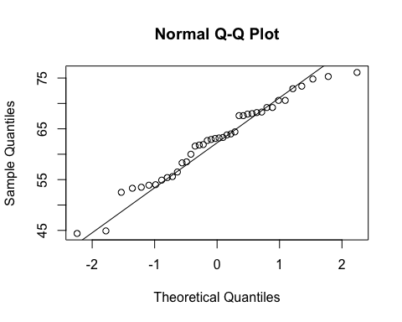
ad.test(SSdata$Pstage.2)
##
## Anderson-Darling normality test
##
## data: SSdata$Pstage.2
## A = 0.37344, p-value = 0.4014
#normal
#ANOVA
night_tx_difference <- anova(lm(Pstage.2 ~ intervention*night,
data = SSdata))
night_tx_difference
## Analysis of Variance Table
##
## Response: Pstage.2
## Df Sum Sq Mean Sq F value Pr(>F)
## intervention 1 122.85 122.850 2.0304 0.1628
## night 1 58.32 58.322 0.9639 0.3328
## intervention:night 1 56.41 56.406 0.9323 0.3407
## Residuals 36 2178.19 60.505
#within-participants (paired) comparison
#Paired t-test
t.test(subset(SSdataCompletes, intervention == "sham")$Pstage.2,
subset(SSdataCompletes, intervention == "PrenaBelt")$Pstage.2,
paired = TRUE)
##
## Paired t-test
##
## data: subset(SSdataCompletes, intervention == "sham")$Pstage.2 and subset(SSdataCompletes, intervention == "PrenaBelt")$Pstage.2
## t = -1.9128, df = 19, p-value = 0.07097
## alternative hypothesis: true difference in means is not equal to 0
## 95 percent confidence interval:
## -7.3402984 0.3302984
## sample estimates:
## mean of the differences
## -3.505
#between participants (grouped) comparison
summary(subset(SSdata, intervention == "PrenaBelt")$Pstage.2)
## Min. 1st Qu. Median Mean 3rd Qu. Max.
## 52.50 58.45 63.60 64.46 70.60 76.10
sd(subset(SSdata, intervention == "PrenaBelt")$Pstage.2)
## [1] 7.434803
length(subset(SSdata, intervention == "PrenaBelt")$Pstage.2)
## [1] 20
qqnorm(subset(SSdata, intervention == "PrenaBelt")$Pstage.2)
qqline(subset(SSdata, intervention == "PrenaBelt")$Pstage.2)
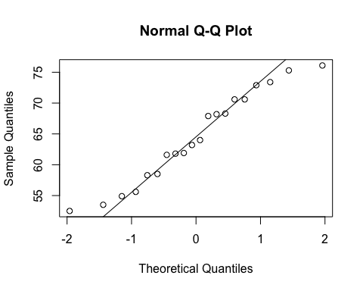
ad.test(subset(SSdata, intervention == "PrenaBelt")$Pstage.2)
##
## Anderson-Darling normality test
##
## data: subset(SSdata, intervention == "PrenaBelt")$Pstage.2
## A = 0.30768, p-value = 0.5308
#normal
summary(subset(SSdata, intervention == "sham")$Pstage.2)
## Min. 1st Qu. Median Mean 3rd Qu. Max.
## 44.40 55.05 63.00 60.95 67.60 74.80
sd(subset(SSdata, intervention == "sham")$Pstage.2)
## [1] 8.087254
length(subset(SSdata, intervention == "sham")$Pstage.2)
## [1] 20
qqnorm(subset(SSdata, intervention == "sham")$Pstage.2)
qqline(subset(SSdata, intervention == "sham")$Pstage.2)
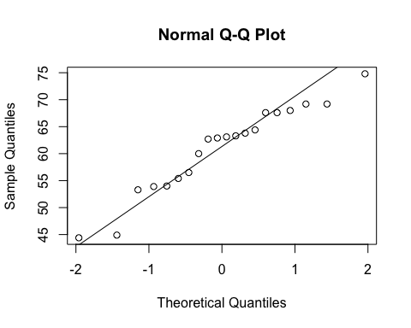
ad.test(subset(SSdata, intervention == "sham")$Pstage.2)
##
## Anderson-Darling normality test
##
## data: subset(SSdata, intervention == "sham")$Pstage.2
## A = 0.47938, p-value = 0.2087
#normal
#FYI - unpaired test
t.test(subset(SSdata, intervention == "sham")$Pstage.2,
subset(SSdata, intervention == "PrenaBelt")$Pstage.2)
##
## Welch Two Sample t-test
##
## data: subset(SSdata, intervention == "sham")$Pstage.2 and subset(SSdata, intervention == "PrenaBelt")$Pstage.2
## t = -1.4269, df = 37.734, p-value = 0.1618
## alternative hypothesis: true difference in means is not equal to 0
## 95 percent confidence interval:
## -8.478912 1.468912
## sample estimates:
## mean of x mean of y
## 60.950 64.455
#################### % Stage 3 Sleep #######################
#Summary
summary(SSdata$Pstage.3)
## Min. 1st Qu. Median Mean 3rd Qu. Max.
## 0.00 3.15 11.85 11.16 15.48 35.90
sd(SSdata$Pstage.3, na.rm = TRUE)
## [1] 8.302226
length(SSdata$Pstage.3)
## [1] 40
qqnorm(SSdata$Pstage.3)
qqline(SSdata$Pstage.3)
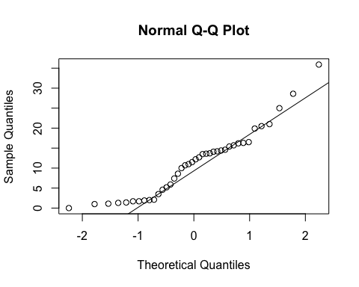
ad.test(SSdata$Pstage.3)
##
## Anderson-Darling normality test
##
## data: SSdata$Pstage.3
## A = 0.79648, p-value = 0.03569
#non-normal
#ANOVA
night_tx_difference <- anova(lm(Pstage.3 ~ intervention * night,
data = SSdata))
night_tx_difference
## Analysis of Variance Table
##
## Response: Pstage.3
## Df Sum Sq Mean Sq F value Pr(>F)
## intervention 1 3.97 3.969 0.0535 0.8184
## night 1 3.60 3.600 0.0485 0.8269
## intervention:night 1 10.40 10.404 0.1403 0.7102
## Residuals 36 2670.18 74.172
#within-participants (paired) comparison
#Paired t-test (individual distributions are normal)
t.test(subset(SSdataCompletes, intervention == "sham")$Pstage.3,
subset(SSdataCompletes, intervention == "PrenaBelt")$Pstage.3,
paired = TRUE)
##
## Paired t-test
##
## data: subset(SSdataCompletes, intervention == "sham")$Pstage.3 and subset(SSdataCompletes, intervention == "PrenaBelt")$Pstage.3
## t = 0.65795, df = 19, p-value = 0.5185
## alternative hypothesis: true difference in means is not equal to 0
## 95 percent confidence interval:
## -1.374115 2.634115
## sample estimates:
## mean of the differences
## 0.63
#between participants (grouped) comparison
summary(subset(SSdata, intervention == "PrenaBelt")$Pstage.3)
## Min. 1st Qu. Median Mean 3rd Qu. Max.
## 1.000 3.125 11.250 10.850 14.620 28.600
sd(subset(SSdata, intervention == "PrenaBelt")$Pstage.3)
## [1] 8.010027
length(subset(SSdata, intervention == "PrenaBelt")$Pstage.3)
## [1] 20
qqnorm(subset(SSdata, intervention == "PrenaBelt")$Pstage.3)
qqline(subset(SSdata, intervention == "PrenaBelt")$Pstage.3)
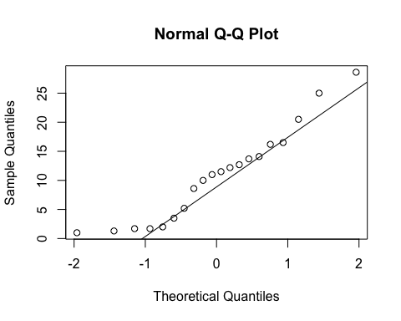
ad.test(subset(SSdata, intervention == "PrenaBelt")$Pstage.3)
##
## Anderson-Darling normality test
##
## data: subset(SSdata, intervention == "PrenaBelt")$Pstage.3
## A = 0.44499, p-value = 0.2552
#normal
summary(subset(SSdata, intervention == "sham")$Pstage.3)
## Min. 1st Qu. Median Mean 3rd Qu. Max.
## 0.000 3.975 13.550 11.480 15.480 35.900
sd(subset(SSdata, intervention == "sham")$Pstage.3)
## [1] 8.781356
length(subset(SSdata, intervention == "sham")$Pstage.3)
## [1] 20
qqnorm(subset(SSdata, intervention == "sham")$Pstage.3)
qqline(subset(SSdata, intervention == "sham")$Pstage.3)
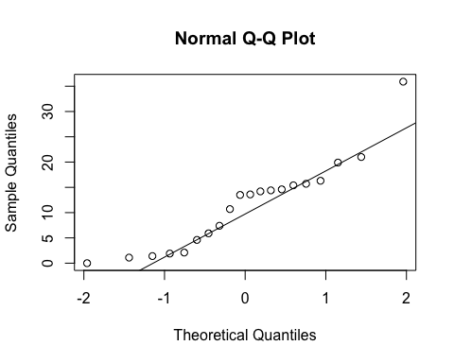
ad.test(subset(SSdata, intervention == "sham")$Pstage.3)
##
## Anderson-Darling normality test
##
## data: subset(SSdata, intervention == "sham")$Pstage.3
## A = 0.5987, p-value = 0.1039
#normal
#FYI - unpaired test
t.test(subset(SSdata, intervention == "sham")$Pstage.3,
subset(SSdata, intervention == "PrenaBelt")$Pstage.3)
##
## Welch Two Sample t-test
##
## data: subset(SSdata, intervention == "sham")$Pstage.3 and subset(SSdata, intervention == "PrenaBelt")$Pstage.3
## t = 0.23704, df = 37.683, p-value = 0.8139
## alternative hypothesis: true difference in means is not equal to 0
## 95 percent confidence interval:
## -4.75182 6.01182
## sample estimates:
## mean of x mean of y
## 11.48 10.85
#################### % Stage REM #######################
#Summary
summary(SSdata$Prem)
## Min. 1st Qu. Median Mean 3rd Qu. Max.
## 5.30 13.13 17.20 16.72 20.12 28.60
sd(SSdata$Prem, na.rm = TRUE)
## [1] 5.62027
length(SSdata$Prem)
## [1] 40
qqnorm(SSdata$Prem)
qqline(SSdata$Prem)
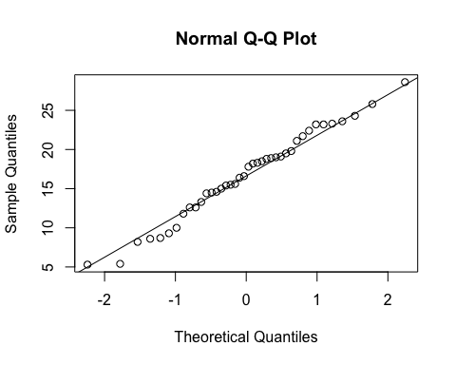
ad.test(SSdata$Prem)
##
## Anderson-Darling normality test
##
## data: SSdata$Prem
## A = 0.23648, p-value = 0.7728
#normal
#ANOVA
night_tx_difference <- anova(lm(Prem ~ intervention * night,
data = SSdata))
night_tx_difference
## Analysis of Variance Table
##
## Response: Prem
## Df Sum Sq Mean Sq F value Pr(>F)
## intervention 1 64.26 64.262 2.2623 0.14128
## night 1 89.10 89.102 3.1367 0.08501 .
## intervention:night 1 55.93 55.932 1.9690 0.16912
## Residuals 36 1022.61 28.406
## ---
## Signif. codes: 0 '***' 0.001 '**' 0.01 '*' 0.05 '.' 0.1 ' ' 1
#within-participants (paired) comparison
#Paired t-test
t.test(subset(SSdataCompletes, intervention == "sham")$Prem,
subset(SSdataCompletes, intervention == "PrenaBelt")$Prem,
paired = TRUE)
##
## Paired t-test
##
## data: subset(SSdataCompletes, intervention == "sham")$Prem and subset(SSdataCompletes, intervention == "PrenaBelt")$Prem
## t = 2.0564, df = 19, p-value = 0.05374
## alternative hypothesis: true difference in means is not equal to 0
## 95 percent confidence interval:
## -0.04510822 5.11510822
## sample estimates:
## mean of the differences
## 2.535
#between participants (grouped) comparison
summary(subset(SSdata, intervention == "PrenaBelt")$Prem)
## Min. 1st Qu. Median Mean 3rd Qu. Max.
## 5.300 9.675 15.250 15.460 20.450 24.300
sd(subset(SSdata, intervention == "PrenaBelt")$Prem)
## [1] 6.377714
length(subset(SSdata, intervention == "PrenaBelt")$Prem)
## [1] 20
qqnorm(subset(SSdata, intervention == "PrenaBelt")$Prem)
qqline(subset(SSdata, intervention == "PrenaBelt")$Prem)
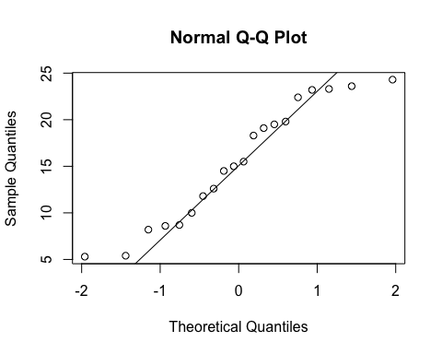
ad.test(subset(SSdata, intervention == "PrenaBelt")$Prem)
##
## Anderson-Darling normality test
##
## data: subset(SSdata, intervention == "PrenaBelt")$Prem
## A = 0.44545, p-value = 0.2545
#normal
summary(subset(SSdata, intervention == "sham")$Prem)
## Min. 1st Qu. Median Mean 3rd Qu. Max.
## 9.30 15.20 18.00 17.99 19.52 28.60
sd(subset(SSdata, intervention == "sham")$Prem)
## [1] 4.558497
length(subset(SSdata, intervention == "sham")$Prem)
## [1] 20
qqnorm(subset(SSdata, intervention == "sham")$Prem)
qqline(subset(SSdata, intervention == "sham")$Prem)
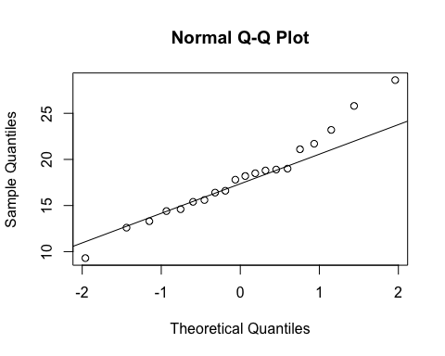
ad.test(subset(SSdata, intervention == "sham")$Prem)
##
## Anderson-Darling normality test
##
## data: subset(SSdata, intervention == "sham")$Prem
## A = 0.27628, p-value = 0.6181
#normal
#FYI - unpaired test
t.test(subset(SSdata, intervention == "sham")$Prem,
subset(SSdata, intervention == "PrenaBelt")$Prem)
##
## Welch Two Sample t-test
##
## data: subset(SSdata, intervention == "sham")$Prem and subset(SSdata, intervention == "PrenaBelt")$Prem
## t = 1.4462, df = 34.395, p-value = 0.1572
## alternative hypothesis: true difference in means is not equal to 0
## 95 percent confidence interval:
## -1.025871 6.095871
## sample estimates:
## mean of x mean of y
## 17.990 15.455
#################### %TST Supine #######################
#Summary
summary(SSdata$PtstSupine)
## Min. 1st Qu. Median Mean 3rd Qu. Max.
## 0.00 0.00 11.65 15.09 22.57 72.30
sd(SSdata$PtstSupine, na.rm = TRUE)
## [1] 17.83904
length(SSdata$PtstSupine)
## [1] 40
#ANOVA
night_tx_difference <- anova(lm(PtstSupine ~ intervention * night,
data = SSdata))
night_tx_difference
## Analysis of Variance Table
##
## Response: PtstSupine
## Df Sum Sq Mean Sq F value Pr(>F)
## intervention 1 465.8 465.81 1.4119 0.2425
## night 1 64.8 64.77 0.1963 0.6604
## intervention:night 1 3.4 3.42 0.0104 0.9194
## Residuals 36 11877.0 329.92
qqnorm(SSdata$PtstSupine)
qqline(SSdata$PtstSupine)
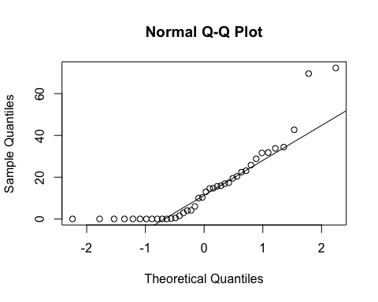
ad.test(SSdata$PtstSupine)
##
## Anderson-Darling normality test
##
## data: SSdata$PtstSupine
## A = 2.1537, p-value = 1.423e-05
#data do not follow a normal distribution; perform paired Wilcoxon rank sum test
#within-participants (paired) comparison
#Paired Wilcoxon, one-tailed
wilcox.test(subset(SSdataCompletes, intervention == "sham")$PtstSupine,
subset(SSdataCompletes, intervention == "PrenaBelt")$PtstSupine,
paired = TRUE, conf.int = TRUE, alternative = "greater")
## Warning in wilcox.test.default(subset(SSdataCompletes, intervention ==
## "sham")$PtstSupine, : cannot compute exact p-value with zeroes
## Warning in wilcox.test.default(subset(SSdataCompletes, intervention ==
## "sham")$PtstSupine, : cannot compute exact confidence interval with zeroes
##
## Wilcoxon signed rank test with continuity correction
##
## data: subset(SSdataCompletes, intervention == "sham")$PtstSupine and subset(SSdataCompletes, intervention == "PrenaBelt")$PtstSupine
## V = 142, p-value = 0.03065
## alternative hypothesis: true location shift is greater than 0
## 95 percent confidence interval:
## 0.7000854 Inf
## sample estimates:
## (pseudo)median
## 5.804603
#difference in medians = 16.4 - 3.5 = 12.9 (corresponds to Wilcoxon rank sum test)
#median of differences = pseudomedian = 5.8 (corresponds to Wilcoxon signed rank test)
#between participants (grouped) comparison
summary(subset(SSdata, intervention == "PrenaBelt")$PtstSupine)
## Min. 1st Qu. Median Mean 3rd Qu. Max.
## 0.00 0.00 3.45 11.68 16.62 72.30
sd(subset(SSdata, intervention == "PrenaBelt")$PtstSupine)
## [1] 17.9033
length(subset(SSdata, intervention == "PrenaBelt")$PtstSupine)
## [1] 20
qqnorm(subset(SSdata, intervention == "PrenaBelt")$PtstSupine)
qqline(subset(SSdata, intervention == "PrenaBelt")$PtstSupine)
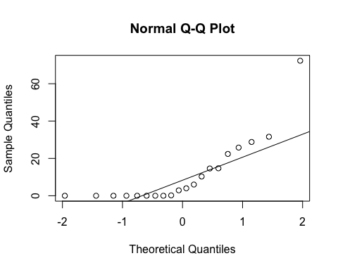
ad.test(subset(SSdata, intervention == "PrenaBelt")$PtstSupine)
##
## Anderson-Darling normality test
##
## data: subset(SSdata, intervention == "PrenaBelt")$PtstSupine
## A = 1.97, p-value = 3.17e-05
#non-normal
summary(subset(SSdata, intervention == "sham")$PtstSupine)
## Min. 1st Qu. Median Mean 3rd Qu. Max.
## 0.00 3.45 16.40 18.50 25.28 69.60
sd(subset(SSdata, intervention == "sham")$PtstSupine)
## [1] 17.55471
length(subset(SSdata, intervention == "sham")$PtstSupine)
## [1] 20
qqnorm(subset(SSdata, intervention == "sham")$PtstSupine)
qqline(subset(SSdata, intervention == "sham")$PtstSupine)
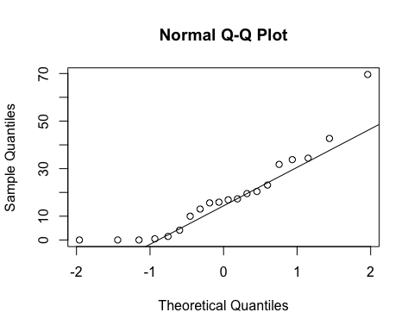
ad.test(subset(SSdata, intervention == "sham")$PtstSupine)
##
## Anderson-Darling normality test
##
## data: subset(SSdata, intervention == "sham")$PtstSupine
## A = 0.67467, p-value = 0.06621
#normal
#FYI - unpaired test
#non-parametric test for differences (one-tailed Wilcoxon, unpaired)
wilcox.test(subset(SSdata, intervention == "sham")$PtstSupine,
subset(SSdata, intervention == "PrenaBelt")$PtstSupine,
conf.int = TRUE, alternative = "greater")
## Warning in wilcox.test.default(subset(SSdata, intervention == "sham")
## $PtstSupine, : cannot compute exact p-value with ties
## Warning in wilcox.test.default(subset(SSdata, intervention == "sham")
## $PtstSupine, : cannot compute exact confidence intervals with ties
##
## Wilcoxon rank sum test with continuity correction
##
## data: subset(SSdata, intervention == "sham")$PtstSupine and subset(SSdata, intervention == "PrenaBelt")$PtstSupine
## W = 267, p-value = 0.03456
## alternative hypothesis: true location shift is greater than 0
## 95 percent confidence interval:
## 2.150084e-05 Inf
## sample estimates:
## difference in location
## 6.666346
# Use droplevels to remove the empty levels from the list of levels
SSdata$intervention <- droplevels(SSdata$intervention)
summary(SSdata$intervention)
## PrenaBelt sham
## 20 20
stripchart(SSdata$PtstSupine~SSdata$intervention,
vertical = TRUE, method="jitter", col=c("blue","deeppink"),
ylab='Percent sleep time supine (%)', xlab='Intervention',
main='Percent sleep time supine vs. Intervention',)
for(participant.s.code in split(SSdata, SSdata$participant.s.code))
lines(PtstSupine ~ intervention, participant.s.code)
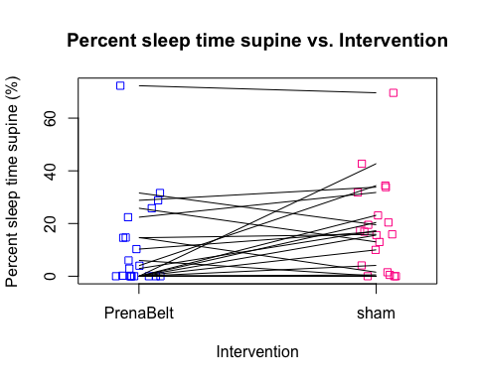
boxplot(SSdata$PtstSupine~SSdata$intervention,
col=c("lightblue1","thistle1"),
ylab='Percent sleep time supine', xlab='Intervention',
main='Percent sleep time supine vs. intervention',
medcol="blue", boxwex = 0.25)
#Get the group means & medians
means <- by(SSdata$PtstSupine, SSdata$intervention, mean)
medians <- by(SSdata$PtstSupine, SSdata$intervention, median)
#Plot symbols for each mean, centered on x = 1 and x = 2, which are the default
#center values.
points(1:2, means, pch = 23, cex = 1.0, bg = "red")
#Now label the means, formatting the values to one decimal place. Place the values
#to the left of each group plot.
text(1:2 - 0.1, means,
labels = formatC(means, format = "f", digits = 1),
pos = 2, cex = 0.9, col = "red")
## Warning in formatC(means, format = "f", digits = 1): class of 'x' was
## discarded
text(1:2 + 0.35, medians,
labels = formatC(medians, format = "f", digits = 1),
pos = 2, cex = 0.9, col = "blue")
## Warning in formatC(medians, format = "f", digits = 1): class of 'x' was
## discarded
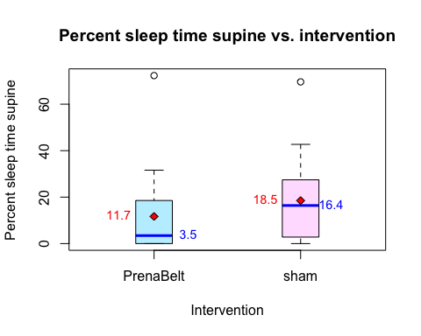
#################### %TST Right #######################
#Summary
summary(SSdata$PtstRight)
## Min. 1st Qu. Median Mean 3rd Qu. Max.
## 0.00 0.00 30.10 30.30 45.92 95.40
sd(SSdata$PtstRight, na.rm = TRUE)
## [1] 27.78612
length(SSdata$PtstRight)
## [1] 40
qqnorm(SSdata$PtstRight)
qqline(SSdata$PtstRight)
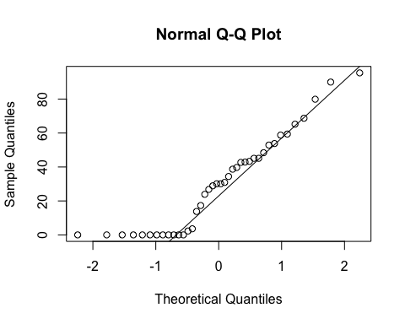
ad.test(SSdata$PtstRight)
##
## Anderson-Darling normality test
##
## data: SSdata$PtstRight
## A = 1.2731, p-value = 0.002267
#non-normal
#ANOVA
night_tx_difference <- anova(lm(PtstRight ~ intervention + night,
data = SSdata))
night_tx_difference
## Analysis of Variance Table
##
## Response: PtstRight
## Df Sum Sq Mean Sq F value Pr(>F)
## intervention 1 41.0 41.01 0.0508 0.8229
## night 1 202.1 202.05 0.2503 0.6198
## Residuals 37 29867.6 807.23
#within-participants (paired) comparison
#Paired t-test (individual distributions are normally distributed)
t.test(subset(SSdataCompletes, intervention == "sham")$PtstRight,
subset(SSdataCompletes, intervention == "PrenaBelt")$PtstRight,
paired = TRUE)
##
## Paired t-test
##
## data: subset(SSdataCompletes, intervention == "sham")$PtstRight and subset(SSdataCompletes, intervention == "PrenaBelt")$PtstRight
## t = -0.52565, df = 19, p-value = 0.6052
## alternative hypothesis: true difference in means is not equal to 0
## 95 percent confidence interval:
## -10.088139 6.038139
## sample estimates:
## mean of the differences
## -2.025
#between participants (grouped) comparison
summary(subset(SSdata, intervention == "PrenaBelt")$PtstRight)
## Min. 1st Qu. Median Mean 3rd Qu. Max.
## 0.00 0.00 29.50 31.32 47.28 95.40
sd(subset(SSdata, intervention == "PrenaBelt")$PtstRight)
## [1] 28.77236
length(subset(SSdata, intervention == "PrenaBelt")$PtstRight)
## [1] 20
qqnorm(subset(SSdata, intervention == "PrenaBelt")$PtstRight)
qqline(subset(SSdata, intervention == "PrenaBelt")$PtstRight)
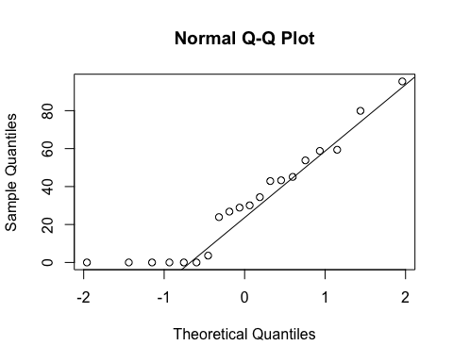
ad.test(subset(SSdata, intervention == "PrenaBelt")$PtstRight)
##
## Anderson-Darling normality test
##
## data: subset(SSdata, intervention == "PrenaBelt")$PtstRight
## A = 0.64629, p-value = 0.07835
#normal
summary(subset(SSdata, intervention == "sham")$PtstRight)
## Min. 1st Qu. Median Mean 3rd Qu. Max.
## 0.00 0.00 30.50 29.29 45.92 90.00
sd(subset(SSdata, intervention == "sham")$PtstRight)
## [1] 27.47299
length(subset(SSdata, intervention == "sham")$PtstRight)
## [1] 20
qqnorm(subset(SSdata, intervention == "sham")$PtstRight)
qqline(subset(SSdata, intervention == "sham")$PtstRight)
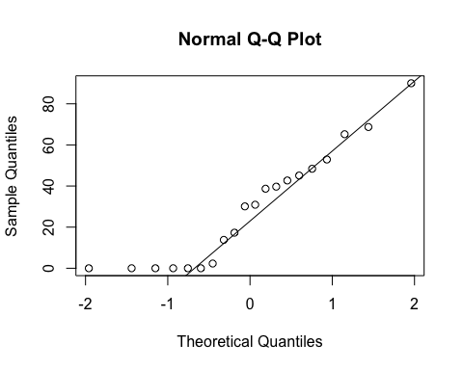
ad.test(subset(SSdata, intervention == "sham")$PtstRight)
##
## Anderson-Darling normality test
##
## data: subset(SSdata, intervention == "sham")$PtstRight
## A = 0.70627, p-value = 0.0549
#borderline normal
#FYI - unpaired test
t.test(subset(SSdata, intervention == "sham")$PtstRight,
subset(SSdata, intervention == "PrenaBelt")$PtstRight)
##
## Welch Two Sample t-test
##
## data: subset(SSdata, intervention == "sham")$PtstRight and subset(SSdata, intervention == "PrenaBelt")$PtstRight
## t = -0.22764, df = 37.919, p-value = 0.8211
## alternative hypothesis: true difference in means is not equal to 0
## 95 percent confidence interval:
## -20.03435 15.98435
## sample estimates:
## mean of x mean of y
## 29.290 31.315
wilcox.test(subset(SSdata, intervention == "sham")$PtstRight,
subset(SSdata, intervention == "PrenaBelt")$PtstRight,
conf.int = TRUE)
## Warning in wilcox.test.default(subset(SSdata, intervention == "sham")
## $PtstRight, : cannot compute exact p-value with ties
## Warning in wilcox.test.default(subset(SSdata, intervention == "sham")
## $PtstRight, : cannot compute exact confidence intervals with ties
##
## Wilcoxon rank sum test with continuity correction
##
## data: subset(SSdata, intervention == "sham")$PtstRight and subset(SSdata, intervention == "PrenaBelt")$PtstRight
## W = 195, p-value = 0.9018
## alternative hypothesis: true location shift is not equal to 0
## 95 percent confidence interval:
## -23.89994 14.80004
## sample estimates:
## difference in location
## -3.997034e-06
#################### %TST Left #######################
#Summary
summary(SSdata$PtstLeft)
## Min. 1st Qu. Median Mean 3rd Qu. Max.
## 0.00 33.78 55.75 54.63 74.92 100.00
sd(SSdata$PtstLeft, na.rm = TRUE)
## [1] 26.70052
length(SSdata$PtstLeft)
## [1] 40
qqnorm(SSdata$PtstLeft)
qqline(SSdata$PtstLeft)
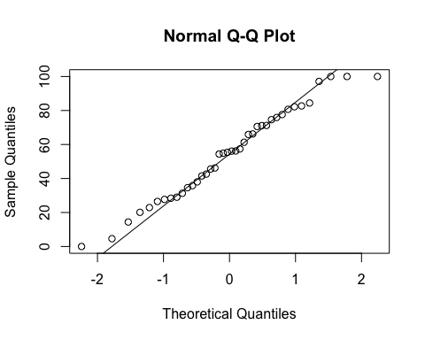
ad.test(SSdata$PtstLeft)
##
## Anderson-Darling normality test
##
## data: SSdata$PtstLeft
## A = 0.26013, p-value = 0.6934
#normal
#ANOVA
night_tx_difference <- anova(lm(PtstLeft ~ intervention + night,
data = SSdata))
night_tx_difference
## Analysis of Variance Table
##
## Response: PtstLeft
## Df Sum Sq Mean Sq F value Pr(>F)
## intervention 1 233.8 233.77 0.3141 0.5785
## night 1 35.9 35.91 0.0483 0.8273
## Residuals 37 27534.1 744.17
#within-participants (paired) comparison
#Paired t-test
t.test(subset(SSdataCompletes, intervention == "sham")$PtstLeft,
subset(SSdataCompletes, intervention == "PrenaBelt")$PtstLeft,
paired = TRUE)
##
## Paired t-test
##
## data: subset(SSdataCompletes, intervention == "sham")$PtstLeft and subset(SSdataCompletes, intervention == "PrenaBelt")$PtstLeft
## t = -1.0137, df = 19, p-value = 0.3234
## alternative hypothesis: true difference in means is not equal to 0
## 95 percent confidence interval:
## -14.817699 5.147699
## sample estimates:
## mean of the differences
## -4.835
#between participants (grouped) comparison
summary(subset(SSdata, intervention == "PrenaBelt")$PtstLeft)
## Min. 1st Qu. Median Mean 3rd Qu. Max.
## 4.60 39.78 56.40 57.04 72.38 100.00
sd(subset(SSdata, intervention == "PrenaBelt")$PtstLeft)
## [1] 26.8734
length(subset(SSdata, intervention == "PrenaBelt")$PtstLeft)
## [1] 20
qqnorm(subset(SSdata, intervention == "PrenaBelt")$PtstLeft)
qqline(subset(SSdata, intervention == "PrenaBelt")$PtstLeft)
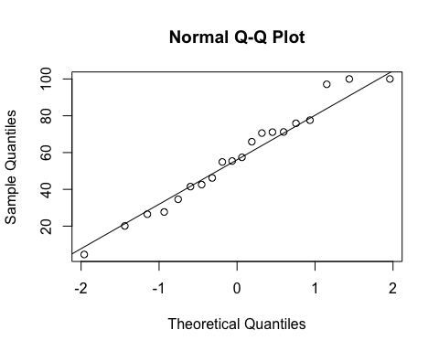
ad.test(subset(SSdata, intervention == "PrenaBelt")$PtstLeft)
##
## Anderson-Darling normality test
##
## data: subset(SSdata, intervention == "PrenaBelt")$PtstLeft
## A = 0.20177, p-value = 0.86
#normal
summary(subset(SSdata, intervention == "sham")$PtstLeft)
## Min. 1st Qu. Median Mean 3rd Qu. Max.
## 0.00 30.72 55.25 52.21 76.12 100.00
sd(subset(SSdata, intervention == "sham")$PtstLeft)
## [1] 26.99768
length(subset(SSdata, intervention == "sham")$PtstLeft)
## [1] 20
qqnorm(subset(SSdata, intervention == "sham")$PtstLeft)
qqline(subset(SSdata, intervention == "sham")$PtstLeft)
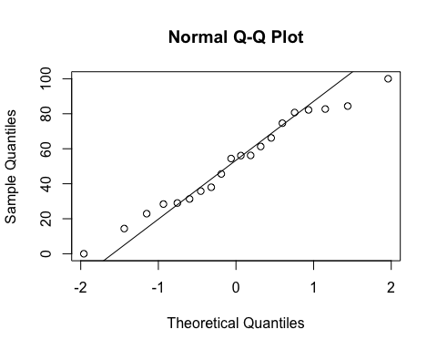
ad.test(subset(SSdata, intervention == "sham")$PtstLeft)
##
## Anderson-Darling normality test
##
## data: subset(SSdata, intervention == "sham")$PtstLeft
## A = 0.24563, p-value = 0.7241
#normal
#FYI - unpaired test
t.test(subset(SSdata, intervention == "sham")$PtstLeft,
subset(SSdata, intervention == "PrenaBelt")$PtstLeft)
##
## Welch Two Sample t-test
##
## data: subset(SSdata, intervention == "sham")$PtstLeft and subset(SSdata, intervention == "PrenaBelt")$PtstLeft
## t = -0.56764, df = 37.999, p-value = 0.5736
## alternative hypothesis: true difference in means is not equal to 0
## 95 percent confidence interval:
## -22.07837 12.40837
## sample estimates:
## mean of x mean of y
## 52.210 57.045
#no time was spent prone
summary(SSdata$PtstProne)
## Min. 1st Qu. Median Mean 3rd Qu. Max.
## 0 0 0 0 0 0
sd(SSdata$PtstProne, na.rm = TRUE)
## [1] 0
length(SSdata$PtstProne)
## [1] 40
#################### Minutes Sleeping Supine #######################
#Summary
summary(SSdata$minutesTSTSupine)
## Min. 1st Qu. Median Mean 3rd Qu. Max.
## 0.00 0.00 38.90 50.13 72.67 279.40
sd(SSdata$minutesTSTSupine, na.rm = TRUE)
## [1] 63.82465
length(SSdata$minutesTSTSupine)
## [1] 40
qqnorm(SSdata$minutesTSTSupine)
qqline(SSdata$minutesTSTSupine)
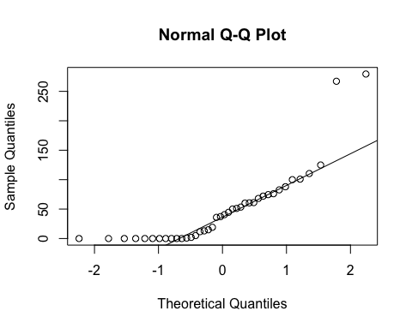
ad.test(SSdata$minutesTSTSupine)
##
## Anderson-Darling normality test
##
## data: SSdata$minutesTSTSupine
## A = 2.6888, p-value = 6.632e-07
#data do not follow a normal distribution; perform paired Wilcoxon rank sum test
#ANOVA
night_tx_difference <- anova(lm(minutesTSTSupine ~ intervention * night,
data = SSdata))
night_tx_difference
## Analysis of Variance Table
##
## Response: minutesTSTSupine
## Df Sum Sq Mean Sq F value Pr(>F)
## intervention 1 5927 5927.0 1.4014 0.2442
## night 1 500 499.8 0.1182 0.7330
## intervention:night 1 189 188.9 0.0447 0.8338
## Residuals 36 152254 4229.3
#within-participants (paired) comparison
#Paired Wilcoxon
wilcox.test(subset(SSdataCompletes, intervention == "sham")$minutesTSTSupine,
subset(SSdataCompletes, intervention == "PrenaBelt")$minutesTSTSupine,
paired = TRUE, conf.int = TRUE, alternative = "two.sided")
## Warning in wilcox.test.default(subset(SSdataCompletes, intervention ==
## "sham")$minutesTSTSupine, : cannot compute exact p-value with zeroes
## Warning in wilcox.test.default(subset(SSdataCompletes, intervention ==
## "sham")$minutesTSTSupine, : cannot compute exact confidence interval with
## zeroes
##
## Wilcoxon signed rank test with continuity correction
##
## data: subset(SSdataCompletes, intervention == "sham")$minutesTSTSupine and subset(SSdataCompletes, intervention == "PrenaBelt")$minutesTSTSupine
## V = 150, p-value = 0.02829
## alternative hypothesis: true location shift is not equal to 0
## 95 percent confidence interval:
## 2.557336 49.892997
## sample estimates:
## (pseudo)median
## 26.37306
#Paired t-test to double check and confirm non-parametric results
t.test(subset(SSdataCompletes, intervention == "sham")$minutesTSTSupine,
subset(SSdataCompletes, intervention == "PrenaBelt")$minutesTSTSupine,
paired = TRUE)
##
## Paired t-test
##
## data: subset(SSdataCompletes, intervention == "sham")$minutesTSTSupine and subset(SSdataCompletes, intervention == "PrenaBelt")$minutesTSTSupine
## t = 2.3911, df = 19, p-value = 0.02731
## alternative hypothesis: true difference in means is not equal to 0
## 95 percent confidence interval:
## 3.03469 45.65601
## sample estimates:
## mean of the differences
## 24.34535
#between participants (grouped) comparison
summary(subset(SSdata, intervention == "PrenaBelt")$minutesTSTSupine)
## Min. 1st Qu. Median Mean 3rd Qu. Max.
## 0.00 0.00 12.30 37.95 53.48 267.10
sd(subset(SSdata, intervention == "PrenaBelt")$minutesTSTSupine)
## [1] 62.65788
length(subset(SSdata, intervention == "PrenaBelt")$minutesTSTSupine)
## [1] 20
qqnorm(subset(SSdata, intervention == "PrenaBelt")$minutesTSTSupine)
qqline(subset(SSdata, intervention == "PrenaBelt")$minutesTSTSupine)
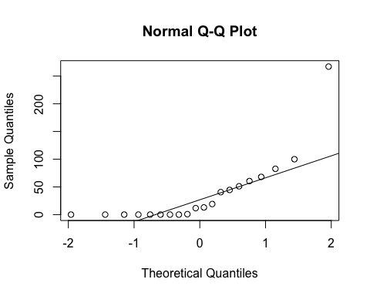
ad.test(subset(SSdata, intervention == "PrenaBelt")$minutesTSTSupine)
##
## Anderson-Darling normality test
##
## data: subset(SSdata, intervention == "PrenaBelt")$minutesTSTSupine
## A = 2.2269, p-value = 7.014e-06
#non-normal
summary(subset(SSdata, intervention == "sham")$minutesTSTSupine)
## Min. 1st Qu. Median Mean 3rd Qu. Max.
## 0.00 12.39 56.80 62.30 79.08 279.40
sd(subset(SSdata, intervention == "sham")$minutesTSTSupine)
## [1] 64.21539
length(subset(SSdata, intervention == "sham")$minutesTSTSupine)
## [1] 20
qqnorm(subset(SSdata, intervention == "sham")$minutesTSTSupine)
qqline(subset(SSdata, intervention == "sham")$minutesTSTSupine)
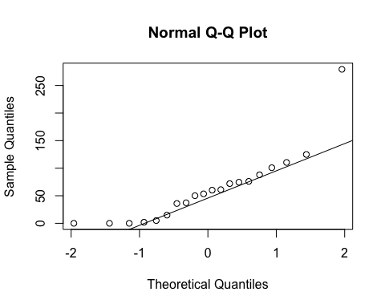
ad.test(subset(SSdata, intervention == "sham")$minutesTSTSupine)
##
## Anderson-Darling normality test
##
## data: subset(SSdata, intervention == "sham")$minutesTSTSupine
## A = 0.96839, p-value = 0.01163
#non-normal
#FYI - unpaired test
wilcox.test(subset(SSdata, intervention == "sham")$minutesTSTSupine,
subset(SSdata, intervention == "PrenaBelt")$minutesTSTSupine,
conf.int = TRUE, alternative = "greater")
## Warning in wilcox.test.default(subset(SSdata, intervention == "sham")
## $minutesTSTSupine, : cannot compute exact p-value with ties
## Warning in wilcox.test.default(subset(SSdata, intervention == "sham")
## $minutesTSTSupine, : cannot compute exact confidence intervals with ties
##
## Wilcoxon rank sum test with continuity correction
##
## data: subset(SSdata, intervention == "sham")$minutesTSTSupine and subset(SSdata, intervention == "PrenaBelt")$minutesTSTSupine
## W = 271, p-value = 0.02699
## alternative hypothesis: true location shift is greater than 0
## 95 percent confidence interval:
## 6.926608e-05 Inf
## sample estimates:
## difference in location
## 24.28712
# Use droplevels to remove the empty levels from the list of levels
SSdata$intervention <- droplevels(SSdata$intervention)
summary(SSdata$intervention)
## PrenaBelt sham
## 20 20
stripchart(SSdata$minutesTSTSupine~SSdata$intervention,
vertical = TRUE, method="jitter", col=c("blue","deeppink"),
ylab='Proportion of sleep time supine (%)', xlab='Intervention',
main='Proportion of sleep time supine (%) vs. Intervention',)
for(participant.s.code in split(SSdata, SSdata$participant.s.code))
lines(minutesTSTSupine ~ intervention, participant.s.code)
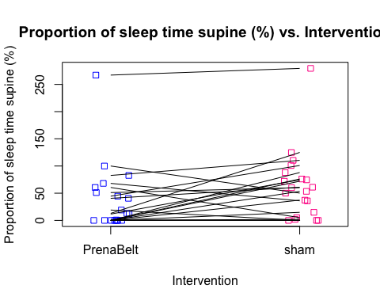
#################### Minutes Sleeping Left #######################
#Summary
summary(SSdata$minutesTSTLeft)
## Min. 1st Qu. Median Mean 3rd Qu. Max.
## 0.0 114.2 162.6 180.9 225.1 390.0
sd(SSdata$minutesTSTLeft, na.rm = TRUE)
## [1] 97.72311
length(SSdata$minutesTSTLeft)
## [1] 40
qqnorm(SSdata$minutesTSTLeft)
qqline(SSdata$minutesTSTLeft)
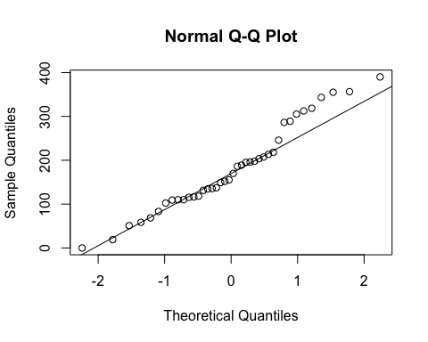
ad.test(SSdata$minutesTSTLeft)
##
## Anderson-Darling normality test
##
## data: SSdata$minutesTSTLeft
## A = 0.60089, p-value = 0.1109
#normal
#ANOVA
night_tx_difference <- anova(lm(minutesTSTLeft ~ intervention * night,
data = SSdata))
night_tx_difference
## Analysis of Variance Table
##
## Response: minutesTSTLeft
## Df Sum Sq Mean Sq F value Pr(>F)
## intervention 1 910 909.5 0.0960 0.7585
## night 1 5161 5160.9 0.5447 0.4653
## intervention:night 1 25295 25294.7 2.6698 0.1110
## Residuals 36 341077 9474.4
#within-participants (paired) comparison
#Paired t-test
t.test(subset(SSdataCompletes, intervention == "sham")$minutesTSTLeft,
subset(SSdataCompletes, intervention == "PrenaBelt")$minutesTSTLeft,
paired = TRUE)
##
## Paired t-test
##
## data: subset(SSdataCompletes, intervention == "sham")$minutesTSTLeft and subset(SSdataCompletes, intervention == "PrenaBelt")$minutesTSTLeft
## t = -0.59061, df = 19, p-value = 0.5617
## alternative hypothesis: true difference in means is not equal to 0
## 95 percent confidence interval:
## -43.33418 24.26038
## sample estimates:
## mean of the differences
## -9.5369
#between participants (grouped) comparison
summary(subset(SSdata, intervention == "PrenaBelt")$minutesTSTLeft)
## Min. 1st Qu. Median Mean 3rd Qu. Max.
## 18.95 110.00 159.60 185.60 235.30 390.00
sd(subset(SSdata, intervention == "PrenaBelt")$minutesTSTLeft)
## [1] 102.4677
length(subset(SSdata, intervention == "PrenaBelt")$minutesTSTLeft)
## [1] 20
qqnorm(subset(SSdata, intervention == "PrenaBelt")$minutesTSTLeft)
qqline(subset(SSdata, intervention == "PrenaBelt")$minutesTSTLeft)
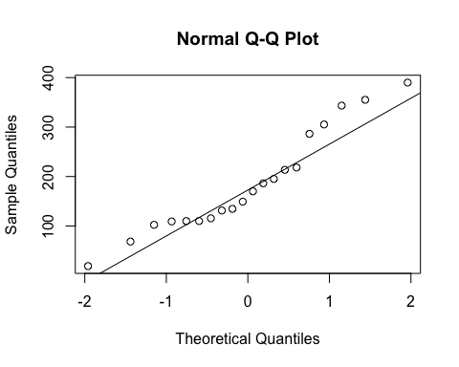
ad.test(subset(SSdata, intervention == "PrenaBelt")$minutesTSTLeft)
##
## Anderson-Darling normality test
##
## data: subset(SSdata, intervention == "PrenaBelt")$minutesTSTLeft
## A = 0.60013, p-value = 0.103
#normal
summary(subset(SSdata, intervention == "sham")$minutesTSTLeft)
## Min. 1st Qu. Median Mean 3rd Qu. Max.
## 0.0 117.6 172.0 176.1 217.0 356.4
sd(subset(SSdata, intervention == "sham")$minutesTSTLeft)
## [1] 95.1564
length(subset(SSdata, intervention == "sham")$minutesTSTLeft)
## [1] 20
qqnorm(subset(SSdata, intervention == "sham")$minutesTSTLeft)
qqline(subset(SSdata, intervention == "sham")$minutesTSTLeft)
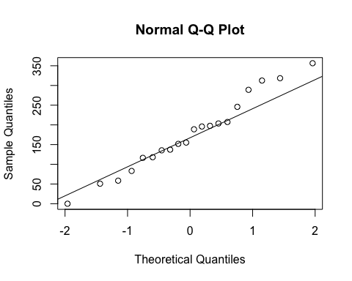
ad.test(subset(SSdata, intervention == "sham")$minutesTSTLeft)
##
## Anderson-Darling normality test
##
## data: subset(SSdata, intervention == "sham")$minutesTSTLeft
## A = 0.21195, p-value = 0.8324
#normal
#FYI - unpaired test
t.test(subset(SSdata, intervention == "sham")$minutesTSTLeft,
subset(SSdata, intervention == "PrenaBelt")$minutesTSTLeft)
##
## Welch Two Sample t-test
##
## data: subset(SSdata, intervention == "sham")$minutesTSTLeft and subset(SSdata, intervention == "PrenaBelt")$minutesTSTLeft
## t = -0.305, df = 37.794, p-value = 0.762
## alternative hypothesis: true difference in means is not equal to 0
## 95 percent confidence interval:
## -72.84799 53.77419
## sample estimates:
## mean of x mean of y
## 176.1083 185.6452
# Use droplevels to remove the empty levels from the list of levels
SSdata$intervention <- droplevels(SSdata$intervention)
summary(SSdata$intervention)
## PrenaBelt sham
## 20 20
stripchart(SSdata$minutesTSTLeft~SSdata$intervention,
vertical = TRUE, method="jitter", col=c("blue","deeppink"),
ylab='Proportion of sleep time Left (%)', xlab='Intervention',
main='Proportion of sleep time Left (%) vs. Intervention',)
for(participant.s.code in split(SSdata, SSdata$participant.s.code))
lines(minutesTSTLeft ~ intervention, participant.s.code)
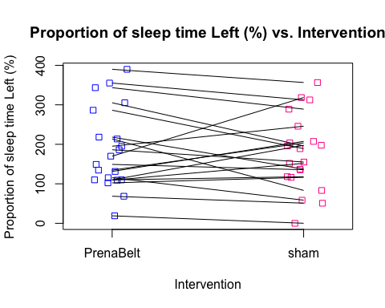
#################### Minutes Sleeping Right ############################
#Summary
summary(SSdata$minutesTSTRight)
## Min. 1st Qu. Median Mean 3rd Qu. Max.
## 0.00 0.00 90.78 105.40 166.10 393.00
sd(SSdata$minutesTSTRight, na.rm = TRUE)
## [1] 104.3365
length(SSdata$minutesTSTRight)
## [1] 40
qqnorm(SSdata$minutesTSTRight)
qqline(SSdata$minutesTSTRight)
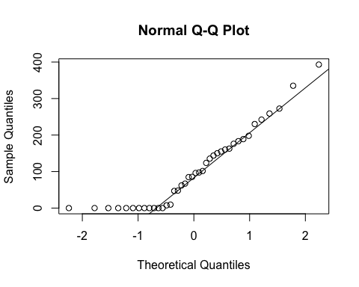
ad.test(SSdata$minutesTSTRight)
##
## Anderson-Darling normality test
##
## data: SSdata$minutesTSTRight
## A = 1.3459, p-value = 0.001489
#non-normal
#ANOVA
night_tx_difference <- anova(lm(minutesTSTRight ~ intervention * night,
data = SSdata))
night_tx_difference
## Analysis of Variance Table
##
## Response: minutesTSTRight
## Df Sum Sq Mean Sq F value Pr(>F)
## intervention 1 477 477.4 0.0427 0.8374
## night 1 1242 1242.1 0.1111 0.7408
## intervention:night 1 20504 20503.6 1.8346 0.1840
## Residuals 36 402335 11176.0
#within-participants (paired) comparison
#Paired Wilcoxon (non-normal)
wilcox.test(subset(SSdataCompletes, intervention == "sham")$minutesTSTRight,
subset(SSdataCompletes, intervention == "PrenaBelt")$minutesTSTRight,
paired = TRUE, conf.int = TRUE, alternative = "greater")
## Warning in wilcox.test.default(subset(SSdataCompletes, intervention ==
## "sham")$minutesTSTRight, : cannot compute exact p-value with zeroes
## Warning in wilcox.test.default(subset(SSdataCompletes, intervention ==
## "sham")$minutesTSTRight, : cannot compute exact confidence interval with
## zeroes
##
## Wilcoxon signed rank test with continuity correction
##
## data: subset(SSdataCompletes, intervention == "sham")$minutesTSTRight and subset(SSdataCompletes, intervention == "PrenaBelt")$minutesTSTRight
## V = 54, p-value = 0.644
## alternative hypothesis: true location shift is greater than 0
## 95 percent confidence interval:
## -47.61614 Inf
## sample estimates:
## (pseudo)median
## -7.343686
#between participants (grouped) comparison
summary(subset(SSdata, intervention == "PrenaBelt")$minutesTSTRight)
## Min. 1st Qu. Median Mean 3rd Qu. Max.
## 0.00 0.00 96.82 108.90 167.50 393.00
sd(subset(SSdata, intervention == "PrenaBelt")$minutesTSTRight)
## [1] 110.1396
length(subset(SSdata, intervention == "PrenaBelt")$minutesTSTRight)
## [1] 20
qqnorm(subset(SSdata, intervention == "PrenaBelt")$minutesTSTRight)
qqline(subset(SSdata, intervention == "PrenaBelt")$minutesTSTRight)
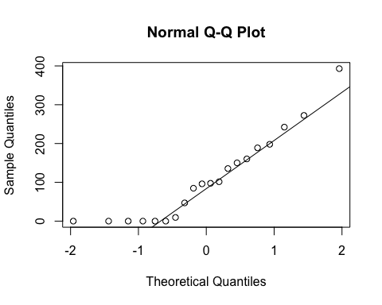
ad.test(subset(SSdata, intervention == "PrenaBelt")$minutesTSTRight)
##
## Anderson-Darling normality test
##
## data: subset(SSdata, intervention == "PrenaBelt")$minutesTSTRight
## A = 0.71202, p-value = 0.05306
#borderline normal
summary(subset(SSdata, intervention == "sham")$minutesTSTRight)
## Min. 1st Qu. Median Mean 3rd Qu. Max.
## 0.00 0.00 76.23 101.90 166.10 335.10
sd(subset(SSdata, intervention == "sham")$minutesTSTRight)
## [1] 100.9421
length(subset(SSdata, intervention == "sham")$minutesTSTRight)
## [1] 20
qqnorm(subset(SSdata, intervention == "sham")$minutesTSTRight)
qqline(subset(SSdata, intervention == "sham")$minutesTSTRight)
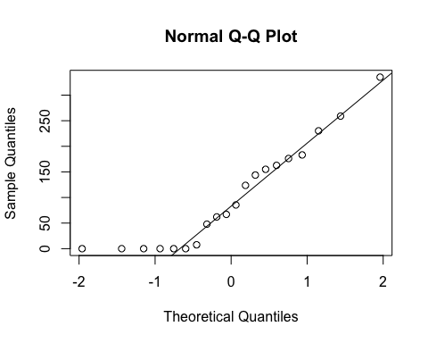
ad.test(subset(SSdata, intervention == "sham")$minutesTSTRight)
##
## Anderson-Darling normality test
##
## data: subset(SSdata, intervention == "sham")$minutesTSTRight
## A = 0.73955, p-value = 0.04508
#non-normal
#FYI - unpaired test
wilcox.test(subset(SSdata, intervention == "sham")$minutesTSTRight,
subset(SSdata, intervention == "PrenaBelt")$minutesTSTRight,
conf.int = TRUE, alternative = "greater")
## Warning in wilcox.test.default(subset(SSdata, intervention == "sham")
## $minutesTSTRight, : cannot compute exact p-value with ties
## Warning in wilcox.test.default(subset(SSdata, intervention == "sham")
## $minutesTSTRight, : cannot compute exact confidence intervals with ties
##
## Wilcoxon rank sum test with continuity correction
##
## data: subset(SSdata, intervention == "sham")$minutesTSTRight and subset(SSdata, intervention == "PrenaBelt")$minutesTSTRight
## W = 195, p-value = 0.5599
## alternative hypothesis: true location shift is greater than 0
## 95 percent confidence interval:
## -54.15088 Inf
## sample estimates:
## difference in location
## -3.909212e-05
# Use droplevels to remove the empty levels from the list of levels
SSdata$intervention <- droplevels(SSdata$intervention)
summary(SSdata$intervention)
## PrenaBelt sham
## 20 20
stripchart(SSdata$minutesTSTRight~SSdata$intervention,
vertical = TRUE, method="jitter", col=c("blue","deeppink"),
ylab='Proportion of sleep time Right (%)', xlab='Intervention',
main='Proportion of sleep time Right (%) vs. Intervention',)
for(participant.s.code in split(SSdata, SSdata$participant.s.code))
lines(minutesTSTRight ~ intervention, participant.s.code)
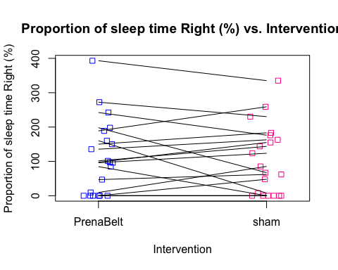
#Considering index (events per hour) data now:
#################### Central Apnea Index #######################
#FYI: this data was generated in our PSG reports per default configuration but is not a
#pre-specified secondary outcome per the research protocol or trial registry. FYI only.
#Summary
summary(SSdata$central.apneas.index)
## Min. 1st Qu. Median Mean 3rd Qu. Max.
## 0.000 0.000 0.000 0.060 0.025 0.500
sd(SSdata$central.apneas.index, na.rm = TRUE)
## [1] 0.1236206
length(SSdata$central.apneas.index)
## [1] 40
#ANOVA
night_tx_difference <- anova(lm(central.apneas.index ~ intervention * night,
data = SSdata))
night_tx_difference
## Analysis of Variance Table
##
## Response: central.apneas.index
## Df Sum Sq Mean Sq F value Pr(>F)
## intervention 1 0.001 0.001000 0.0679 0.79587
## night 1 0.001 0.001000 0.0679 0.79587
## intervention:night 1 0.064 0.064000 4.3472 0.04422 *
## Residuals 36 0.530 0.014722
## ---
## Signif. codes: 0 '***' 0.001 '**' 0.01 '*' 0.05 '.' 0.1 ' ' 1
#within-participants (paired) comparison
#Paired Wilcoxon
wilcox.test(subset(SSdataCompletes, intervention == "sham")$central.apneas.index,
subset(SSdataCompletes, intervention == "PrenaBelt")$central.apneas.index,
paired = TRUE, conf.int = TRUE)
## Warning in wilcox.test.default(subset(SSdataCompletes, intervention ==
## "sham")$central.apneas.index, : cannot compute exact p-value with ties
## Warning in wilcox.test.default(subset(SSdataCompletes, intervention ==
## "sham")$central.apneas.index, : cannot compute exact confidence interval
## with ties
## Warning in wilcox.test.default(subset(SSdataCompletes, intervention ==
## "sham")$central.apneas.index, : cannot compute exact p-value with zeroes
## Warning in wilcox.test.default(subset(SSdataCompletes, intervention ==
## "sham")$central.apneas.index, : cannot compute exact confidence interval
## with zeroes
##
## Wilcoxon signed rank test with continuity correction
##
## data: subset(SSdataCompletes, intervention == "sham")$central.apneas.index and subset(SSdataCompletes, intervention == "PrenaBelt")$central.apneas.index
## V = 26.5, p-value = 0.6746
## alternative hypothesis: true location shift is not equal to 0
## 95 percent confidence interval:
## -0.1500585 0.2000332
## sample estimates:
## (pseudo)median
## 0.04999741
#between participants (grouped) comparison
summary(subset(SSdata, intervention == "PrenaBelt")$central.apneas.index)
## Min. 1st Qu. Median Mean 3rd Qu. Max.
## 0.000 0.000 0.000 0.055 0.000 0.500
sd(subset(SSdata, intervention == "PrenaBelt")$central.apneas.index)
## [1] 0.1394538
length(subset(SSdata, intervention == "PrenaBelt")$central.apneas.index)
## [1] 20
qqnorm(subset(SSdata, intervention == "PrenaBelt")$central.apneas.index)
qqline(subset(SSdata, intervention == "PrenaBelt")$central.apneas.index)
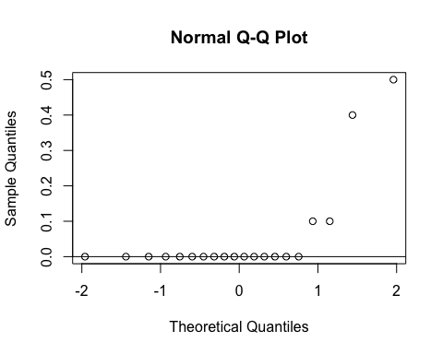
ad.test(subset(SSdata, intervention == "PrenaBelt")$central.apneas.index)
##
## Anderson-Darling normality test
##
## data: subset(SSdata, intervention == "PrenaBelt")$central.apneas.index
## A = 5.0415, p-value = 5.577e-13
#non-norma
summary(subset(SSdata, intervention == "sham")$central.apneas.index)
## Min. 1st Qu. Median Mean 3rd Qu. Max.
## 0.000 0.000 0.000 0.065 0.125 0.300
sd(subset(SSdata, intervention == "sham")$central.apneas.index)
## [1] 0.1089423
length(subset(SSdata, intervention == "sham")$central.apneas.index)
## [1] 20
qqnorm(subset(SSdata, intervention == "sham")$central.apneas.index)
qqline(subset(SSdata, intervention == "sham")$central.apneas.index)
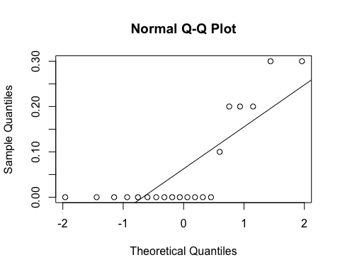
ad.test(subset(SSdata, intervention == "sham")$central.apneas.index)
##
## Anderson-Darling normality test
##
## data: subset(SSdata, intervention == "sham")$central.apneas.index
## A = 3.5176, p-value = 3.741e-09
#non-normal
#FYI - unpaired test
wilcox.test(subset(SSdata, intervention == "sham")$central.apneas.index,
subset(SSdata, intervention == "PrenaBelt")$central.apneas.index,
conf.int = TRUE)
## Warning in wilcox.test.default(subset(SSdata, intervention == "sham")
## $central.apneas.index, : cannot compute exact p-value with ties
## Warning in wilcox.test.default(subset(SSdata, intervention == "sham")
## $central.apneas.index, : cannot compute exact confidence intervals with
## ties
##
## Wilcoxon rank sum test with continuity correction
##
## data: subset(SSdata, intervention == "sham")$central.apneas.index and subset(SSdata, intervention == "PrenaBelt")$central.apneas.index
## W = 219, p-value = 0.5102
## alternative hypothesis: true location shift is not equal to 0
## 95 percent confidence interval:
## -6.326233e-05 3.161243e-05
## sample estimates:
## difference in location
## 5.5406e-05
#################### Obstructive Apnea Index #######################
#FYI: this data was generated in our PSG reports per default configuration but is not a
#pre-specified secondary outcome per the research protocol or trial registry. FYI only.
#Summary
summary(SSdata$obstructive.apneas.index)
## Min. 1st Qu. Median Mean 3rd Qu. Max.
## 0.000 0.000 0.000 0.730 0.225 11.400
sd(SSdata$obstructive.apneas.index, na.rm = TRUE)
## [1] 2.115171
length(SSdata$obstructive.apneas.index)
## [1] 40
#ANOVA
night_tx_difference <- anova(lm(obstructive.apneas.index ~ intervention + night,
data = SSdata))
night_tx_difference
## Analysis of Variance Table
##
## Response: obstructive.apneas.index
## Df Sum Sq Mean Sq F value Pr(>F)
## intervention 1 0.961 0.9610 0.2065 0.6521
## night 1 1.369 1.3690 0.2942 0.5908
## Residuals 37 172.154 4.6528
#within-participants (paired) comparison
#Paired Wilcoxon
wilcox.test(subset(SSdataCompletes, intervention == "sham")$obstructive.apneas.index,
subset(SSdataCompletes, intervention == "PrenaBelt")$obstructive.apneas.index,
paired = TRUE, conf.int = TRUE)
## Warning in wilcox.test.default(subset(SSdataCompletes, intervention ==
## "sham")$obstructive.apneas.index, : cannot compute exact p-value with
## zeroes
## Warning in wilcox.test.default(subset(SSdataCompletes, intervention
## == "sham")$obstructive.apneas.index, : cannot compute exact confidence
## interval with zeroes
##
## Wilcoxon signed rank test with continuity correction
##
## data: subset(SSdataCompletes, intervention == "sham")$obstructive.apneas.index and subset(SSdataCompletes, intervention == "PrenaBelt")$obstructive.apneas.index
## V = 18, p-value = 1
## alternative hypothesis: true location shift is not equal to 0
## 95 percent confidence interval:
## -0.7499621 3.5499235
## sample estimates:
## (pseudo)median
## 0.03901549
#between participants (grouped) comparison
summary(subset(SSdata, intervention == "PrenaBelt")$obstructive.apneas.index)
## Min. 1st Qu. Median Mean 3rd Qu. Max.
## 0.000 0.000 0.000 0.575 0.125 5.300
sd(subset(SSdata, intervention == "PrenaBelt")$obstructive.apneas.index)
## [1] 1.487094
length(subset(SSdata, intervention == "PrenaBelt")$obstructive.apneas.index)
## [1] 20
qqnorm(subset(SSdata, intervention == "PrenaBelt")$obstructive.apneas.index)
qqline(subset(SSdata, intervention == "PrenaBelt")$obstructive.apneas.index)
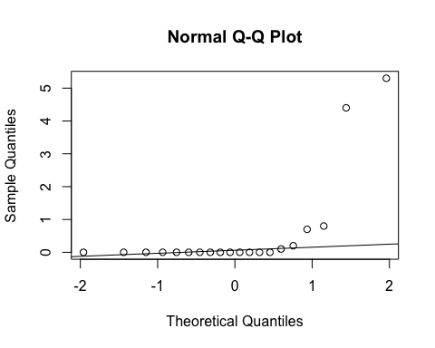
ad.test(subset(SSdata, intervention == "PrenaBelt")$obstructive.apneas.index)
##
## Anderson-Darling normality test
##
## data: subset(SSdata, intervention == "PrenaBelt")$obstructive.apneas.index
## A = 5.1462, p-value = 3.055e-13
#non-normal
summary(subset(SSdata, intervention == "sham")$obstructive.apneas.index)
## Min. 1st Qu. Median Mean 3rd Qu. Max.
## 0.000 0.000 0.000 0.885 0.300 11.400
sd(subset(SSdata, intervention == "sham")$obstructive.apneas.index)
## [1] 2.630844
length(subset(SSdata, intervention == "sham")$obstructive.apneas.index)
## [1] 20
qqnorm(subset(SSdata, intervention == "sham")$obstructive.apneas.index)
qqline(subset(SSdata, intervention == "sham")$obstructive.apneas.index)
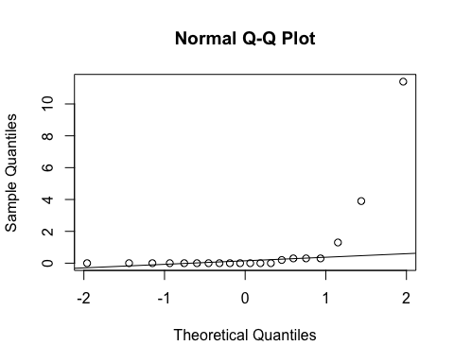
ad.test(subset(SSdata, intervention == "sham")$obstructive.apneas.index)
##
## Anderson-Darling normality test
##
## data: subset(SSdata, intervention == "sham")$obstructive.apneas.index
## A = 5.2073, p-value = 2.15e-13
#non-normal
#FYI - unpaired test
wilcox.test(subset(SSdata, intervention == "sham")$obstructive.apneas.index,
subset(SSdata, intervention == "PrenaBelt")$obstructive.apneas.index,
conf.int = TRUE)
## Warning in wilcox.test.default(subset(SSdata, intervention == "sham")
## $obstructive.apneas.index, : cannot compute exact p-value with ties
## Warning in wilcox.test.default(subset(SSdata, intervention == "sham")
## $obstructive.apneas.index, : cannot compute exact confidence intervals with
## ties
##
## Wilcoxon rank sum test with continuity correction
##
## data: subset(SSdata, intervention == "sham")$obstructive.apneas.index and subset(SSdata, intervention == "PrenaBelt")$obstructive.apneas.index
## W = 210.5, p-value = 0.7451
## alternative hypothesis: true location shift is not equal to 0
## 95 percent confidence interval:
## -3.671494e-05 4.691508e-05
## sample estimates:
## difference in location
## 2.019957e-05
#################### Mixed Apnea Index #######################
#FYI: this data was generated in our PSG reports per default configuration but is not a
#pre-specified secondary outcome per the research protocol or trial registry. FYI only.
#Summary
summary(SSdata$mixed.apneas.index)
## Min. 1st Qu. Median Mean 3rd Qu. Max.
## 0 0 0 0 0 0
sd(SSdata$mixed.apneas.index, na.rm = TRUE)
## [1] 0
length(SSdata$mixed.apneas.index)
## [1] 40
#ANOVA
night_tx_difference <- anova(lm(mixed.apneas.index ~ intervention + night,
data = SSdata))
night_tx_difference
## Analysis of Variance Table
##
## Response: mixed.apneas.index
## Df Sum Sq Mean Sq F value Pr(>F)
## intervention 1 0 0
## night 1 0 0
## Residuals 37 0 0
#within-participants (paired) comparison
#distribution is made entirely of zeroes
#difference testing not applicable
#between participants (grouped) comparison
summary(subset(SSdata, intervention == "PrenaBelt")$mixed.apneas.index)
## Min. 1st Qu. Median Mean 3rd Qu. Max.
## 0 0 0 0 0 0
sd(subset(SSdata, intervention == "PrenaBelt")$mixed.apneas.index)
## [1] 0
length(subset(SSdata, intervention == "PrenaBelt")$mixed.apneas.index)
## [1] 20
qqnorm(subset(SSdata, intervention == "PrenaBelt")$mixed.apneas.index)
qqline(subset(SSdata, intervention == "PrenaBelt")$mixed.apneas.index)
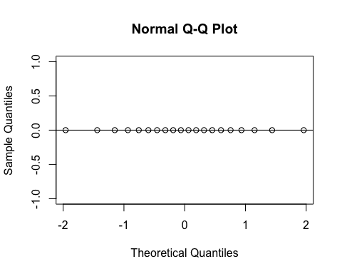
#ad.test(subset(SSdata, intervention == "PrenaBelt")$mixed.apneas.index)
#distribution is made entirely of zeroes
summary(subset(SSdata, intervention == "sham")$mixed.apneas.index)
## Min. 1st Qu. Median Mean 3rd Qu. Max.
## 0 0 0 0 0 0
sd(subset(SSdata, intervention == "sham")$mixed.apneas.index)
## [1] 0
length(subset(SSdata, intervention == "sham")$mixed.apneas.index)
## [1] 20
qqnorm(subset(SSdata, intervention == "sham")$mixed.apneas.index)
qqline(subset(SSdata, intervention == "sham")$mixed.apneas.index)
#ad.test(subset(SSdata, intervention == "sham")$mixed.apneas.index)
#distribution is made entirely of zeroes
#difference testing not applicable
#################### Obstructive hypopneas Index #######################
#FYI: this data was generated in our PSG reports per default configuration but is not a
#pre-specified secondary outcome per the research protocol or trial registry. FYI only.
#Summary
summary(SSdata$obstructive.hypopneas.index)
## Min. 1st Qu. Median Mean 3rd Qu. Max.
## 0.000 0.000 0.250 1.378 1.225 11.900
sd(SSdata$obstructive.hypopneas.index, na.rm = TRUE)
## [1] 2.738097
length(SSdata$obstructive.hypopneas.index)
## [1] 40
#ANOVA
night_tx_difference <- anova(lm(obstructive.hypopneas.index ~ intervention + night,
data = SSdata))
night_tx_difference
## Analysis of Variance Table
##
## Response: obstructive.hypopneas.index
## Df Sum Sq Mean Sq F value Pr(>F)
## intervention 1 0.210 0.2103 0.0267 0.8711
## night 1 0.702 0.7023 0.0891 0.7669
## Residuals 37 291.477 7.8778
#within-participants (paired) comparison
#Paired Wilcoxon
wilcox.test(subset(SSdataCompletes, intervention == "sham")$obstructive.hypopneas.index,
subset(SSdataCompletes, intervention == "PrenaBelt")$obstructive.hypopneas.index,
paired = TRUE, conf.int = TRUE)
## Warning in wilcox.test.default(subset(SSdataCompletes, intervention ==
## "sham")$obstructive.hypopneas.index, : cannot compute exact p-value with
## ties
## Warning in wilcox.test.default(subset(SSdataCompletes, intervention ==
## "sham")$obstructive.hypopneas.index, : cannot compute exact confidence
## interval with ties
## Warning in wilcox.test.default(subset(SSdataCompletes, intervention ==
## "sham")$obstructive.hypopneas.index, : cannot compute exact p-value with
## zeroes
## Warning in wilcox.test.default(subset(SSdataCompletes, intervention ==
## "sham")$obstructive.hypopneas.index, : cannot compute exact confidence
## interval with zeroes
##
## Wilcoxon signed rank test with continuity correction
##
## data: subset(SSdataCompletes, intervention == "sham")$obstructive.hypopneas.index and subset(SSdataCompletes, intervention == "PrenaBelt")$obstructive.hypopneas.index
## V = 87, p-value = 0.6357
## alternative hypothesis: true location shift is not equal to 0
## 95 percent confidence interval:
## -0.2999835 0.5499741
## sample estimates:
## (pseudo)median
## 0.09999107
#between participants (grouped) comparison
summary(subset(SSdata, intervention == "PrenaBelt")$obstructive.hypopneas.index)
## Min. 1st Qu. Median Mean 3rd Qu. Max.
## 0.000 0.000 0.400 1.305 1.275 9.200
sd(subset(SSdata, intervention == "PrenaBelt")$obstructive.hypopneas.index)
## [1] 2.435802
length(subset(SSdata, intervention == "PrenaBelt")$obstructive.hypopneas.index)
## [1] 20
qqnorm(subset(SSdata, intervention == "PrenaBelt")$obstructive.hypopneas.index)
qqline(subset(SSdata, intervention == "PrenaBelt")$obstructive.hypopneas.index)
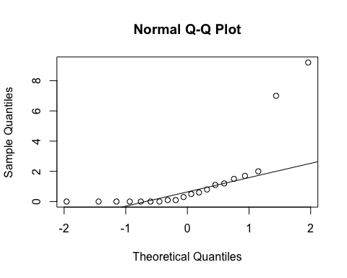
ad.test(subset(SSdata, intervention == "PrenaBelt")$obstructive.hypopneas.index)
##
## Anderson-Darling normality test
##
## data: subset(SSdata, intervention == "PrenaBelt")$obstructive.hypopneas.index
## A = 3.342, p-value = 1.039e-08
#non-normal
summary(subset(SSdata, intervention == "sham")$obstructive.hypopneas.index)
## Min. 1st Qu. Median Mean 3rd Qu. Max.
## 0.00 0.00 0.20 1.45 1.00 11.90
sd(subset(SSdata, intervention == "sham")$obstructive.hypopneas.index)
## [1] 3.073229
length(subset(SSdata, intervention == "sham")$obstructive.hypopneas.index)
## [1] 20
qqnorm(subset(SSdata, intervention == "sham")$obstructive.hypopneas.index)
qqline(subset(SSdata, intervention == "sham")$obstructive.hypopneas.index)
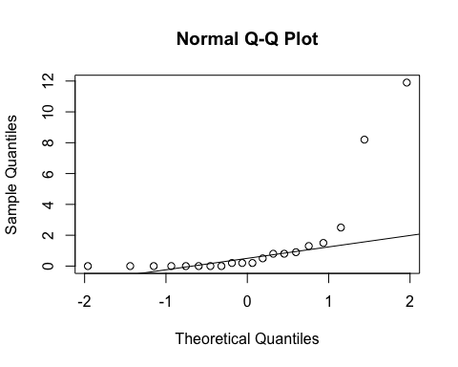
ad.test(subset(SSdata, intervention == "sham")$obstructive.hypopneas.index)
##
## Anderson-Darling normality test
##
## data: subset(SSdata, intervention == "sham")$obstructive.hypopneas.index
## A = 3.9511, p-value = 3.022e-10
#non-normal
#FYI - unpaired test
wilcox.test(subset(SSdata, intervention == "sham")$obstructive.hypopneas.index,
subset(SSdata, intervention == "PrenaBelt")$obstructive.hypopneas.index,
conf.int = TRUE)
## Warning in wilcox.test.default(subset(SSdata, intervention == "sham")
## $obstructive.hypopneas.index, : cannot compute exact p-value with ties
## Warning in wilcox.test.default(subset(SSdata, intervention == "sham")
## $obstructive.hypopneas.index, : cannot compute exact confidence intervals
## with ties
##
## Wilcoxon rank sum test with continuity correction
##
## data: subset(SSdata, intervention == "sham")$obstructive.hypopneas.index and subset(SSdata, intervention == "PrenaBelt")$obstructive.hypopneas.index
## W = 191, p-value = 0.8132
## alternative hypothesis: true location shift is not equal to 0
## 95 percent confidence interval:
## -0.5000080 0.2999871
## sample estimates:
## difference in location
## -1.817308e-06
##################### Apnea-Hypopnea Index #######################
#Summary
summary(SSdata$AHI.calculated)
## Min. 1st Qu. Median Mean 3rd Qu. Max.
## 0.0000 0.0000 0.4765 2.1800 1.4700 19.5100
sd(SSdata$AHI.calculated, na.rm = TRUE)
## [1] 4.622751
length(SSdata$AHI.calculated)
## [1] 40
qqnorm(SSdata$AHI.calculated)
qqline(SSdata$AHI.calculated)
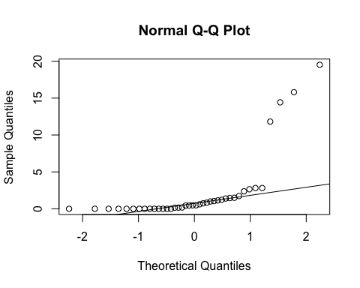
ad.test(SSdata$AHI.calculated)
##
## Anderson-Darling normality test
##
## data: SSdata$AHI.calculated
## A = 8.242, p-value < 2.2e-16
#non-normal
#ANOVA
night_tx_difference <- anova(lm(AHI.calculated ~ intervention * night,
data = SSdata))
night_tx_difference
## Analysis of Variance Table
##
## Response: AHI.calculated
## Df Sum Sq Mean Sq F value Pr(>F)
## intervention 1 1.73 1.734 0.0866 0.77027
## night 1 4.60 4.596 0.2295 0.63478
## intervention:night 1 106.12 106.123 5.2990 0.02723 *
## Residuals 36 720.97 20.027
## ---
## Signif. codes: 0 '***' 0.001 '**' 0.01 '*' 0.05 '.' 0.1 ' ' 1
#within-participants (paired) comparison
#Paired Wilcoxon
wilcox.test(subset(SSdataCompletes, intervention == "sham")$AHI.calculated,
subset(SSdataCompletes, intervention == "PrenaBelt")$AHI.calculated,
paired = TRUE, conf.int = TRUE)
## Warning in wilcox.test.default(subset(SSdataCompletes, intervention ==
## "sham")$AHI.calculated, : cannot compute exact p-value with zeroes
## Warning in wilcox.test.default(subset(SSdataCompletes, intervention ==
## "sham")$AHI.calculated, : cannot compute exact confidence interval with
## zeroes
##
## Wilcoxon signed rank test with continuity correction
##
## data: subset(SSdataCompletes, intervention == "sham")$AHI.calculated and subset(SSdataCompletes, intervention == "PrenaBelt")$AHI.calculated
## V = 91, p-value = 0.5075
## alternative hypothesis: true location shift is not equal to 0
## 95 percent confidence interval:
## -0.4367014 0.7981902
## sample estimates:
## (pseudo)median
## 0.1385676
#between participants (grouped) comparison
summary(subset(SSdata, intervention == "PrenaBelt")$AHI.calculated)
## Min. 1st Qu. Median Mean 3rd Qu. Max.
## 0.0000 0.0000 0.5321 1.9720 1.4700 14.4300
sd(subset(SSdata, intervention == "PrenaBelt")$AHI.calculated)
## [1] 3.924224
length(subset(SSdata, intervention == "PrenaBelt")$AHI.calculated)
## [1] 20
qqnorm(subset(SSdata, intervention == "PrenaBelt")$AHI.calculated)
qqline(subset(SSdata, intervention == "PrenaBelt")$AHI.calculated)
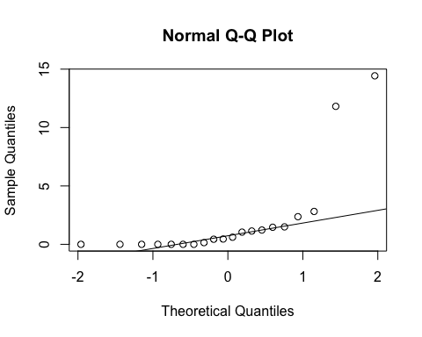
ad.test(subset(SSdata, intervention == "PrenaBelt")$AHI.calculated)
##
## Anderson-Darling normality test
##
## data: subset(SSdata, intervention == "PrenaBelt")$AHI.calculated
## A = 3.8736, p-value = 4.736e-10
#non-normal
summary(subset(SSdata, intervention == "sham")$AHI.calculated)
## Min. 1st Qu. Median Mean 3rd Qu. Max.
## 0.0000 0.0000 0.4765 2.3880 1.4770 19.5100
sd(subset(SSdata, intervention == "sham")$AHI.calculated)
## [1] 5.326686
length(subset(SSdata, intervention == "sham")$AHI.calculated)
## [1] 20
qqnorm(subset(SSdata, intervention == "sham")$AHI.calculated)
qqline(subset(SSdata, intervention == "sham")$AHI.calculated)
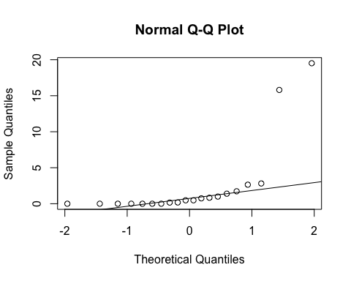
ad.test(subset(SSdata, intervention == "sham")$AHI.calculated)
##
## Anderson-Darling normality test
##
## data: subset(SSdata, intervention == "sham")$AHI.calculated
## A = 4.4571, p-value = 1.618e-11
#non-normal
#FYI - unpaired test
wilcox.test(subset(SSdata, intervention == "sham")$AHI.calculated,
subset(SSdata, intervention == "PrenaBelt")$AHI.calculated,
conf.int = TRUE)
## Warning in wilcox.test.default(subset(SSdata, intervention == "sham")
## $AHI.calculated, : cannot compute exact p-value with ties
## Warning in wilcox.test.default(subset(SSdata, intervention == "sham")
## $AHI.calculated, : cannot compute exact confidence intervals with ties
##
## Wilcoxon rank sum test with continuity correction
##
## data: subset(SSdata, intervention == "sham")$AHI.calculated and subset(SSdata, intervention == "PrenaBelt")$AHI.calculated
## W = 198.5, p-value = 0.9779
## alternative hypothesis: true location shift is not equal to 0
## 95 percent confidence interval:
## -0.6092948 0.4774410
## sample estimates:
## difference in location
## -1.726505e-05
#################### Central hypopneas Index #######################
#FYI: this data was generated in our PSG reports per default configuration but is not a
#pre-specified secondary outcome per the research protocol or trial registry. FYI only.
#Summary
summary(SSdata$central.hypopneas.index)
## Min. 1st Qu. Median Mean 3rd Qu. Max.
## 0.000 0.000 0.000 0.015 0.000 0.600
sd(SSdata$central.hypopneas.index, na.rm = TRUE)
## [1] 0.09486833
length(SSdata$central.hypopneas.index)
## [1] 40
#ANOVA
night_tx_difference <- anova(lm(central.hypopneas.index ~ intervention + night,
data = SSdata))
night_tx_difference
## Analysis of Variance Table
##
## Response: central.hypopneas.index
## Df Sum Sq Mean Sq F value Pr(>F)
## intervention 1 0.009 0.009 1 0.3238
## night 1 0.009 0.009 1 0.3238
## Residuals 37 0.333 0.009
#within-participants (paired) comparison
#Paired Wilcoxon
wilcox.test(subset(SSdataCompletes, intervention == "sham")$central.hypopneas.index,
subset(SSdataCompletes, intervention == "PrenaBelt")$central.hypopneas.index,
paired = TRUE)
## Warning in wilcox.test.default(subset(SSdataCompletes, intervention ==
## "sham")$central.hypopneas.index, : cannot compute exact p-value with zeroes
##
## Wilcoxon signed rank test with continuity correction
##
## data: subset(SSdataCompletes, intervention == "sham")$central.hypopneas.index and subset(SSdataCompletes, intervention == "PrenaBelt")$central.hypopneas.index
## V = 0, p-value = 1
## alternative hypothesis: true location shift is not equal to 0
#between participants (grouped) comparison
summary(subset(SSdata, intervention == "PrenaBelt")$central.hypopneas.index)
## Min. 1st Qu. Median Mean 3rd Qu. Max.
## 0.00 0.00 0.00 0.03 0.00 0.60
sd(subset(SSdata, intervention == "PrenaBelt")$central.hypopneas.index)
## [1] 0.1341641
length(subset(SSdata, intervention == "PrenaBelt")$central.hypopneas.index)
## [1] 20
qqnorm(subset(SSdata, intervention == "PrenaBelt")$central.hypopneas.index)
qqline(subset(SSdata, intervention == "PrenaBelt")$central.hypopneas.index)
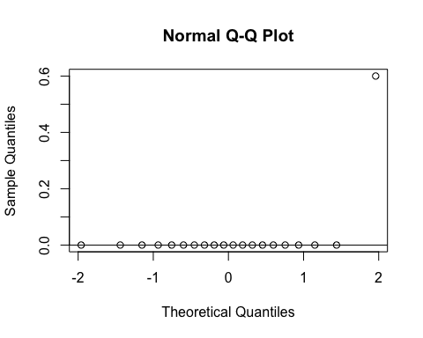
ad.test(subset(SSdata, intervention == "PrenaBelt")$central.hypopneas.index)
##
## Anderson-Darling normality test
##
## data: subset(SSdata, intervention == "PrenaBelt")$central.hypopneas.index
## A = 7.1762, p-value < 2.2e-16
#non-normal
summary(subset(SSdata, intervention == "sham")$central.hypopneas.index)
## Min. 1st Qu. Median Mean 3rd Qu. Max.
## 0 0 0 0 0 0
sd(subset(SSdata, intervention == "sham")$central.hypopneas.index)
## [1] 0
length(subset(SSdata, intervention == "sham")$central.hypopneas.index)
## [1] 20
qqnorm(subset(SSdata, intervention == "sham")$central.hypopneas.index)
qqline(subset(SSdata, intervention == "sham")$central.hypopneas.index)
#ad.test(subset(SSdata, intervention == "sham")$central.hypopneas.index)
#distribution is made entirely of zeroes
#FYI - unpaired test
wilcox.test(subset(SSdata, intervention == "sham")$central.hypopneas.index,
subset(SSdata, intervention == "PrenaBelt")$central.hypopneas.index,
conf.int = TRUE)
## Warning in wilcox.test.default(subset(SSdata, intervention == "sham")
## $central.hypopneas.index, : cannot compute exact p-value with ties
## Warning in wilcox.test.default(subset(SSdata, intervention == "sham")
## $central.hypopneas.index, : cannot compute exact confidence intervals with
## ties
##
## Wilcoxon rank sum test with continuity correction
##
## data: subset(SSdata, intervention == "sham")$central.hypopneas.index and subset(SSdata, intervention == "PrenaBelt")$central.hypopneas.index
## W = 190, p-value = 0.3421
## alternative hypothesis: true location shift is not equal to 0
## 95 percent confidence interval:
## 0 0
## sample estimates:
## difference in location
## 0
#################### RERAs Index #######################
#Summary
summary(SSdata$reras.index)
## Min. 1st Qu. Median Mean 3rd Qu. Max.
## 0.0000 0.0000 0.0000 0.4725 0.2000 8.7000
sd(SSdata$reras.index, na.rm = TRUE)
## [1] 1.66687
length(SSdata$reras.index)
## [1] 40
qqnorm(SSdata$reras.index)
qqline(SSdata$reras.index)
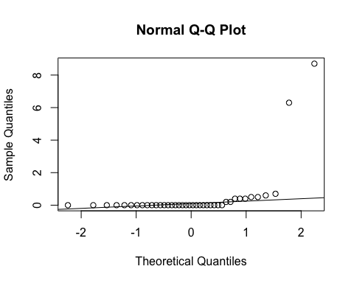
ad.test(SSdata$reras.index)
##
## Anderson-Darling normality test
##
## data: SSdata$reras.index
## A = 11.649, p-value < 2.2e-16
#non-normal
#ANOVA
night_tx_difference <- anova(lm(reras.index ~ intervention * night,
data = SSdata))
night_tx_difference
## Analysis of Variance Table
##
## Response: reras.index
## Df Sum Sq Mean Sq F value Pr(>F)
## intervention 1 4.422 4.4223 1.7011 0.2004
## night 1 4.032 4.0322 1.5511 0.2210
## intervention:night 1 6.320 6.3203 2.4313 0.1277
## Residuals 36 93.585 2.5996
#within-participants (paired) comparison
#Paired Wilcoxon
wilcox.test(subset(SSdataCompletes, intervention == "sham")$reras.index,
subset(SSdataCompletes, intervention == "PrenaBelt")$reras.index,
paired = TRUE, conf.int = TRUE)
## Warning in wilcox.test.default(subset(SSdataCompletes, intervention ==
## "sham")$reras.index, : cannot compute exact p-value with ties
## Warning in wilcox.test.default(subset(SSdataCompletes, intervention ==
## "sham")$reras.index, : cannot compute exact confidence interval with ties
## Warning in wilcox.test.default(subset(SSdataCompletes, intervention ==
## "sham")$reras.index, : cannot compute exact p-value with zeroes
## Warning in wilcox.test.default(subset(SSdataCompletes, intervention ==
## "sham")$reras.index, : cannot compute exact confidence interval with zeroes
##
## Wilcoxon signed rank test with continuity correction
##
## data: subset(SSdataCompletes, intervention == "sham")$reras.index and subset(SSdataCompletes, intervention == "PrenaBelt")$reras.index
## V = 15.5, p-value = 0.7789
## alternative hypothesis: true location shift is not equal to 0
## 95 percent confidence interval:
## -4.5999963 0.3500676
## sample estimates:
## (pseudo)median
## -0.1499727
#between participants (grouped) comparison
summary(subset(SSdata, intervention == "PrenaBelt")$reras.index)
## Min. 1st Qu. Median Mean 3rd Qu. Max.
## 0.000 0.000 0.000 0.805 0.050 8.700
sd(subset(SSdata, intervention == "PrenaBelt")$reras.index)
## [1] 2.32684
length(subset(SSdata, intervention == "PrenaBelt")$reras.index)
## [1] 20
qqnorm(subset(SSdata, intervention == "PrenaBelt")$reras.index)
qqline(subset(SSdata, intervention == "PrenaBelt")$reras.index)
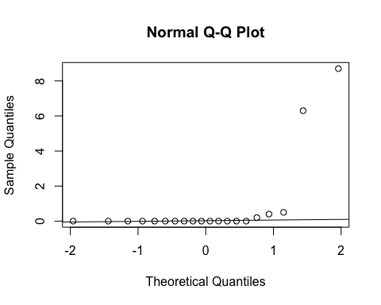
ad.test(subset(SSdata, intervention == "PrenaBelt")$reras.index)
##
## Anderson-Darling normality test
##
## data: subset(SSdata, intervention == "PrenaBelt")$reras.index
## A = 5.7736, p-value = 8.367e-15
#non-normal
summary(subset(SSdata, intervention == "sham")$reras.index)
## Min. 1st Qu. Median Mean 3rd Qu. Max.
## 0.00 0.00 0.00 0.14 0.25 0.70
sd(subset(SSdata, intervention == "sham")$reras.index)
## [1] 0.2370876
length(subset(SSdata, intervention == "sham")$reras.index)
## [1] 20
qqnorm(subset(SSdata, intervention == "sham")$reras.index)
qqline(subset(SSdata, intervention == "sham")$reras.index)
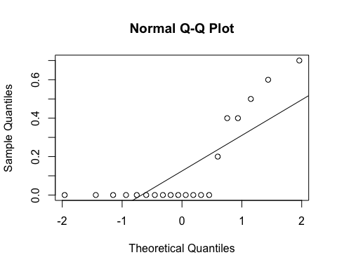
ad.test(subset(SSdata, intervention == "sham")$reras.index)
##
## Anderson-Darling normality test
##
## data: subset(SSdata, intervention == "sham")$reras.index
## A = 3.4375, p-value = 5.959e-09
#non-normal
#FYI - unpaired test
wilcox.test(subset(SSdata, intervention == "sham")$reras.index,
subset(SSdata, intervention == "PrenaBelt")$reras.index,
conf.int = TRUE)
## Warning in wilcox.test.default(subset(SSdata, intervention == "sham")
## $reras.index, : cannot compute exact p-value with ties
## Warning in wilcox.test.default(subset(SSdata, intervention == "sham")
## $reras.index, : cannot compute exact confidence intervals with ties
##
## Wilcoxon rank sum test with continuity correction
##
## data: subset(SSdata, intervention == "sham")$reras.index and subset(SSdata, intervention == "PrenaBelt")$reras.index
## W = 207, p-value = 0.8231
## alternative hypothesis: true location shift is not equal to 0
## 95 percent confidence interval:
## -3.950633e-05 5.862469e-06
## sample estimates:
## difference in location
## 4.901185e-05
#################### Respiratory Disturbance Index #######################
#Summary
summary(SSdata$rdi.index)
## Min. 1st Qu. Median Mean 3rd Qu. Max.
## 0.000 0.000 0.600 2.652 1.625 20.800
sd(SSdata$rdi.index, na.rm = TRUE)
## [1] 5.358817
length(SSdata$rdi.index)
## [1] 40
qqnorm(SSdata$rdi.index)
qqline(SSdata$rdi.index)
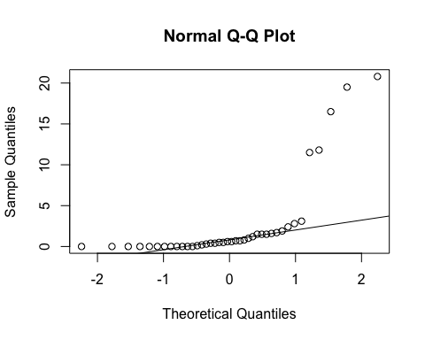
ad.test(SSdata$rdi.index)
##
## Anderson-Darling normality test
##
## data: SSdata$rdi.index
## A = 8.0555, p-value < 2.2e-16
#non-normal
#ANOVA
night_tx_difference <- anova(lm(rdi.index ~ intervention * night,
data = SSdata))
night_tx_difference
## Analysis of Variance Table
##
## Response: rdi.index
## Df Sum Sq Mean Sq F value Pr(>F)
## intervention 1 0.65 0.650 0.0245 0.87646
## night 1 0.01 0.012 0.0005 0.98297
## intervention:night 1 164.43 164.430 6.1993 0.01754 *
## Residuals 36 954.87 26.524
## ---
## Signif. codes: 0 '***' 0.001 '**' 0.01 '*' 0.05 '.' 0.1 ' ' 1
#within-participants (paired) comparison
#non-normal - do Wilcoxon
wilcox.test(subset(SSdataCompletes, intervention == "sham")$rdi.index,
subset(SSdataCompletes, intervention == "PrenaBelt")$rdi.index,
paired = TRUE, conf.int = TRUE)
## Warning in wilcox.test.default(subset(SSdataCompletes, intervention ==
## "sham")$rdi.index, : cannot compute exact p-value with ties
## Warning in wilcox.test.default(subset(SSdataCompletes, intervention ==
## "sham")$rdi.index, : cannot compute exact confidence interval with ties
## Warning in wilcox.test.default(subset(SSdataCompletes, intervention ==
## "sham")$rdi.index, : cannot compute exact p-value with zeroes
## Warning in wilcox.test.default(subset(SSdataCompletes, intervention ==
## "sham")$rdi.index, : cannot compute exact confidence interval with zeroes
##
## Wilcoxon signed rank test with continuity correction
##
## data: subset(SSdataCompletes, intervention == "sham")$rdi.index and subset(SSdataCompletes, intervention == "PrenaBelt")$rdi.index
## V = 67, p-value = 0.6699
## alternative hypothesis: true location shift is not equal to 0
## 95 percent confidence interval:
## -1.1999821 0.6499711
## sample estimates:
## (pseudo)median
## -0.199951
#between participants (grouped) comparison
summary(subset(SSdata, intervention == "PrenaBelt")$rdi.index)
## Min. 1st Qu. Median Mean 3rd Qu. Max.
## 0.000 0.000 0.650 2.780 1.525 20.800
sd(subset(SSdata, intervention == "PrenaBelt")$rdi.index)
## [1] 5.463236
length(subset(SSdata, intervention == "PrenaBelt")$rdi.index)
## [1] 20
qqnorm(subset(SSdata, intervention == "PrenaBelt")$rdi.index)
qqline(subset(SSdata, intervention == "PrenaBelt")$rdi.index)
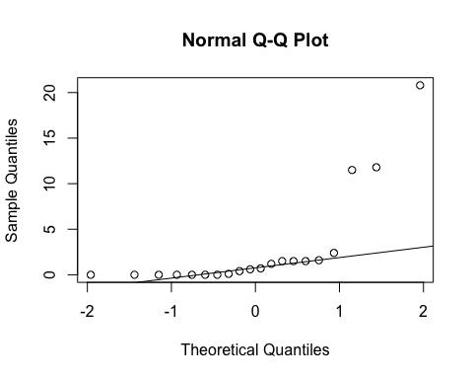
ad.test(subset(SSdata, intervention == "PrenaBelt")$rdi.index)
##
## Anderson-Darling normality test
##
## data: subset(SSdata, intervention == "PrenaBelt")$rdi.index
## A = 3.8067, p-value = 6.979e-10
hist(subset(SSdata, intervention == "PrenaBelt")$rdi.index)
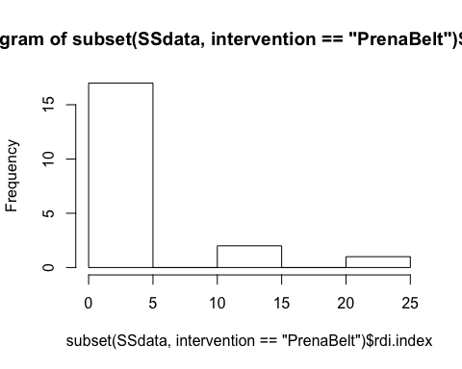
#non-normal
summary(subset(SSdata, intervention == "sham")$rdi.index)
## Min. 1st Qu. Median Mean 3rd Qu. Max.
## 0.000 0.150 0.550 2.525 1.750 19.500
sd(subset(SSdata, intervention == "sham")$rdi.index)
## [1] 5.391111
length(subset(SSdata, intervention == "sham")$rdi.index)
## [1] 20
qqnorm(subset(SSdata, intervention == "sham")$rdi.index)
qqline(subset(SSdata, intervention == "sham")$rdi.index)
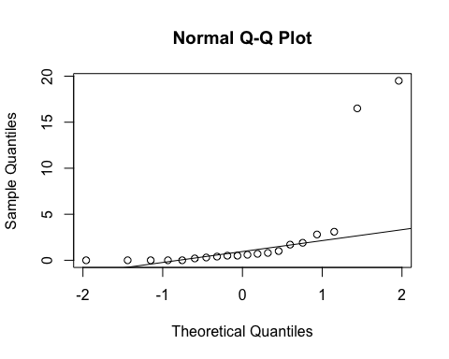
ad.test(subset(SSdata, intervention == "sham")$rdi.index)
##
## Anderson-Darling normality test
##
## data: subset(SSdata, intervention == "sham")$rdi.index
## A = 4.397, p-value = 2.29e-11
#non-normal
#FYI - unpaired test
wilcox.test(subset(SSdata, intervention == "sham")$rdi.index,
subset(SSdata, intervention == "PrenaBelt")$rdi.index,
conf.int = TRUE)
## Warning in wilcox.test.default(subset(SSdata, intervention == "sham")
## $rdi.index, : cannot compute exact p-value with ties
## Warning in wilcox.test.default(subset(SSdata, intervention == "sham")
## $rdi.index, : cannot compute exact confidence intervals with ties
##
## Wilcoxon rank sum test with continuity correction
##
## data: subset(SSdata, intervention == "sham")$rdi.index and subset(SSdata, intervention == "PrenaBelt")$rdi.index
## W = 206, p-value = 0.8801
## alternative hypothesis: true location shift is not equal to 0
## 95 percent confidence interval:
## -0.7000762 0.5000008
## sample estimates:
## difference in location
## 8.805182e-05
#################### Supine Event Index #######################
#Summary
summary(SSdata$index.of.supine.events)
## Min. 1st Qu. Median Mean 3rd Qu. Max.
## 0.000 0.000 0.000 1.652 0.850 20.500
sd(SSdata$index.of.supine.events, na.rm = TRUE)
## [1] 4.539061
length(SSdata$index.of.supine.events)
## [1] 40
qqnorm(SSdata$index.of.supine.events)
qqline(SSdata$index.of.supine.events)
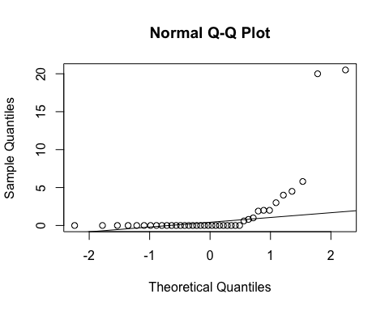
ad.test(SSdata$index.of.supine.events)
##
## Anderson-Darling normality test
##
## data: SSdata$index.of.supine.events
## A = 9.3271, p-value < 2.2e-16
#non-normal
#ANOVA
night_tx_difference <- anova(lm(index.of.supine.events ~ intervention * night,
data = SSdata))
night_tx_difference
## Analysis of Variance Table
##
## Response: index.of.supine.events
## Df Sum Sq Mean Sq F value Pr(>F)
## intervention 1 35.16 35.156 1.8529 0.18191
## night 1 63.25 63.252 3.3337 0.07618 .
## intervention:night 1 22.05 22.052 1.1622 0.28817
## Residuals 36 683.06 18.974
## ---
## Signif. codes: 0 '***' 0.001 '**' 0.01 '*' 0.05 '.' 0.1 ' ' 1
#within-participants (paired) comparison
#Paired Wilcoxon
wilcox.test(subset(SSdataCompletes, intervention == "sham")$index.of.supine.events,
subset(SSdataCompletes, intervention == "PrenaBelt")$index.of.supine.events,
paired = TRUE)
## Warning in wilcox.test.default(subset(SSdataCompletes, intervention ==
## "sham")$index.of.supine.events, : cannot compute exact p-value with zeroes
##
## Wilcoxon signed rank test with continuity correction
##
## data: subset(SSdataCompletes, intervention == "sham")$index.of.supine.events and subset(SSdataCompletes, intervention == "PrenaBelt")$index.of.supine.events
## V = 35, p-value = 0.4755
## alternative hypothesis: true location shift is not equal to 0
#between participants (grouped) comparison
summary(subset(SSdata, intervention == "PrenaBelt")$index.of.supine.events)
## Min. 1st Qu. Median Mean 3rd Qu. Max.
## 0.000 0.000 0.000 0.715 0.000 5.800
sd(subset(SSdata, intervention == "PrenaBelt")$index.of.supine.events)
## [1] 1.649011
length(subset(SSdata, intervention == "PrenaBelt")$index.of.supine.events)
## [1] 20
qqnorm(subset(SSdata, intervention == "PrenaBelt")$index.of.supine.events)
qqline(subset(SSdata, intervention == "PrenaBelt")$index.of.supine.events)
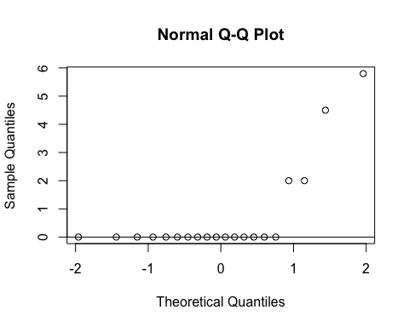
ad.test(subset(SSdata, intervention == "PrenaBelt")$index.of.supine.events)
##
## Anderson-Darling normality test
##
## data: subset(SSdata, intervention == "PrenaBelt")$index.of.supine.events
## A = 4.652, p-value = 5.253e-12
#non-normal
summary(subset(SSdata, intervention == "sham")$index.of.supine.events)
## Min. 1st Qu. Median Mean 3rd Qu. Max.
## 0.000 0.000 0.000 2.590 1.225 20.500
sd(subset(SSdata, intervention == "sham")$index.of.supine.events)
## [1] 6.141738
length(subset(SSdata, intervention == "sham")$index.of.supine.events)
## [1] 20
qqnorm(subset(SSdata, intervention == "sham")$index.of.supine.events)
qqline(subset(SSdata, intervention == "sham")$index.of.supine.events)
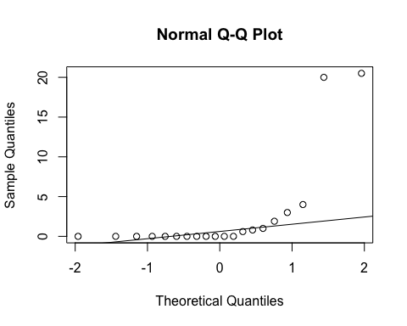
ad.test(subset(SSdata, intervention == "sham")$index.of.supine.events)
##
## Anderson-Darling normality test
##
## data: subset(SSdata, intervention == "sham")$index.of.supine.events
## A = 4.7296, p-value = 3.359e-12
#non-normal
#FYI - unpaired test
wilcox.test(subset(SSdata, intervention == "sham")$index.of.supine.events,
subset(SSdata, intervention == "PrenaBelt")$index.of.supine.events,
conf.int = TRUE)
## Warning in wilcox.test.default(subset(SSdata, intervention == "sham")
## $index.of.supine.events, : cannot compute exact p-value with ties
## Warning in wilcox.test.default(subset(SSdata, intervention == "sham")
## $index.of.supine.events, : cannot compute exact confidence intervals with
## ties
##
## Wilcoxon rank sum test with continuity correction
##
## data: subset(SSdata, intervention == "sham")$index.of.supine.events and subset(SSdata, intervention == "PrenaBelt")$index.of.supine.events
## W = 236, p-value = 0.2362
## alternative hypothesis: true location shift is not equal to 0
## 95 percent confidence interval:
## -0.0000813554 0.6000459383
## sample estimates:
## difference in location
## 7.189321e-06
#################### Non-Supine Event Index #######################
#Summary
summary(SSdata$index.of.non.supine.events)
## Min. 1st Qu. Median Mean 3rd Qu. Max.
## 0.00 0.00 0.45 2.52 1.55 20.80
sd(SSdata$index.of.non.supine.events, na.rm = TRUE)
## [1] 5.242929
length(SSdata$index.of.non.supine.events)
## [1] 40
qqnorm(SSdata$index.of.non.supine.events)
qqline(SSdata$index.of.non.supine.events)
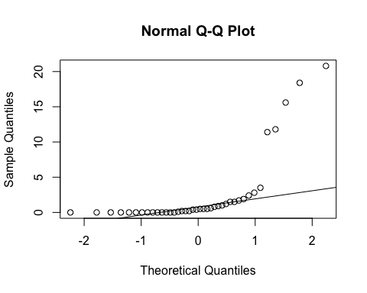
ad.test(SSdata$index.of.non.supine.events)
##
## Anderson-Darling normality test
##
## data: SSdata$index.of.non.supine.events
## A = 8.126, p-value < 2.2e-16
#non-normal
#ANOVA
night_tx_difference <- anova(lm(index.of.non.supine.events ~ intervention * night,
data = SSdata))
night_tx_difference
## Analysis of Variance Table
##
## Response: index.of.non.supine.events
## Df Sum Sq Mean Sq F value Pr(>F)
## intervention 1 0.40 0.400 0.0159 0.90038
## night 1 0.00 0.001 0.0000 0.99501
## intervention:night 1 165.65 165.649 6.5821 0.01461 *
## Residuals 36 905.99 25.166
## ---
## Signif. codes: 0 '***' 0.001 '**' 0.01 '*' 0.05 '.' 0.1 ' ' 1
#within-participants (paired) comparison
#non-normal - use Wilcoxon
wilcox.test(subset(SSdataCompletes, intervention == "sham")$index.of.non.supine.events,
subset(SSdataCompletes, intervention == "PrenaBelt")$index.of.non.supine.events,
paired = TRUE, conf.int = TRUE)
## Warning in wilcox.test.default(subset(SSdataCompletes, intervention ==
## "sham")$index.of.non.supine.events, : cannot compute exact p-value with
## ties
## Warning in wilcox.test.default(subset(SSdataCompletes, intervention ==
## "sham")$index.of.non.supine.events, : cannot compute exact confidence
## interval with ties
## Warning in wilcox.test.default(subset(SSdataCompletes, intervention ==
## "sham")$index.of.non.supine.events, : cannot compute exact p-value with
## zeroes
## Warning in wilcox.test.default(subset(SSdataCompletes, intervention ==
## "sham")$index.of.non.supine.events, : cannot compute exact confidence
## interval with zeroes
##
## Wilcoxon signed rank test with continuity correction
##
## data: subset(SSdataCompletes, intervention == "sham")$index.of.non.supine.events and subset(SSdataCompletes, intervention == "PrenaBelt")$index.of.non.supine.events
## V = 70.5, p-value = 0.9176
## alternative hypothesis: true location shift is not equal to 0
## 95 percent confidence interval:
## -1.0000733 0.8499829
## sample estimates:
## (pseudo)median
## 0.04999832
#between participants (grouped) comparison
summary(subset(SSdata, intervention == "PrenaBelt")$index.of.non.supine.events)
## Min. 1st Qu. Median Mean 3rd Qu. Max.
## 0.00 0.00 0.20 2.62 1.50 20.80
sd(subset(SSdata, intervention == "PrenaBelt")$index.of.non.supine.events)
## [1] 5.512245
length(subset(SSdata, intervention == "PrenaBelt")$index.of.non.supine.events)
## [1] 20
qqnorm(subset(SSdata, intervention == "PrenaBelt")$index.of.non.supine.events)
qqline(subset(SSdata, intervention == "PrenaBelt")$index.of.non.supine.events)
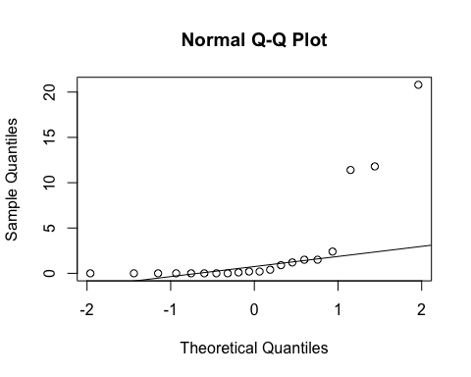
ad.test(subset(SSdata, intervention == "PrenaBelt")$index.of.non.supine.events)
##
## Anderson-Darling normality test
##
## data: subset(SSdata, intervention == "PrenaBelt")$index.of.non.supine.events
## A = 4.0472, p-value = 1.731e-10
#non-normal
summary(subset(SSdata, intervention == "sham")$index.of.non.supine.events)
## Min. 1st Qu. Median Mean 3rd Qu. Max.
## 0.00 0.00 0.50 2.42 1.75 18.40
sd(subset(SSdata, intervention == "sham")$index.of.non.supine.events)
## [1] 5.100733
length(subset(SSdata, intervention == "sham")$index.of.non.supine.events)
## [1] 20
qqnorm(subset(SSdata, intervention == "sham")$index.of.non.supine.events)
qqline(subset(SSdata, intervention == "sham")$index.of.non.supine.events)
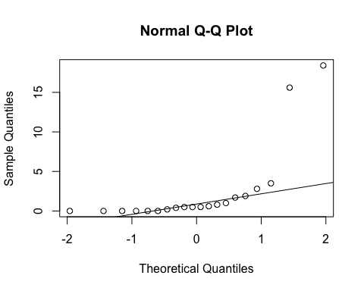
ad.test(subset(SSdata, intervention == "sham")$index.of.non.supine.events)
##
## Anderson-Darling normality test
##
## data: subset(SSdata, intervention == "sham")$index.of.non.supine.events
## A = 4.229, p-value = 6.047e-11
#non-normal
#FYI - unpaired test
wilcox.test(subset(SSdata, intervention == "sham")$index.of.non.supine.events,
subset(SSdata, intervention == "PrenaBelt")$index.of.non.supine.events,
conf.int = TRUE)
## Warning in wilcox.test.default(subset(SSdata, intervention == "sham")
## $index.of.non.supine.events, : cannot compute exact p-value with ties
## Warning in wilcox.test.default(subset(SSdata, intervention == "sham")
## $index.of.non.supine.events, : cannot compute exact confidence intervals
## with ties
##
## Wilcoxon rank sum test with continuity correction
##
## data: subset(SSdata, intervention == "sham")$index.of.non.supine.events and subset(SSdata, intervention == "PrenaBelt")$index.of.non.supine.events
## W = 222.5, p-value = 0.5428
## alternative hypothesis: true location shift is not equal to 0
## 95 percent confidence interval:
## -0.3999612 0.5999875
## sample estimates:
## difference in location
## 5.005918e-06
#################### Mean SpO2 AWAKE #######################
#Summary
summary(SSdata$mean.sao2.awake)
## Min. 1st Qu. Median Mean 3rd Qu. Max.
## 95.20 96.00 96.70 96.76 97.20 99.40
sd(SSdata$mean.sao2.awake, na.rm = TRUE)
## [1] 0.99242
length(SSdata$mean.sao2.awake)
## [1] 40
#ANOVA
night_tx_difference <- anova(lm(mean.sao2.awake ~ intervention * night,
data = SSdata))
night_tx_difference
## Analysis of Variance Table
##
## Response: mean.sao2.awake
## Df Sum Sq Mean Sq F value Pr(>F)
## intervention 1 0.049 0.0490 0.0464 0.8306
## night 1 0.256 0.2560 0.2425 0.6254
## intervention:night 1 0.100 0.1000 0.0947 0.7600
## Residuals 36 38.006 1.0557
#within-participants (paired) comparison
#Paired t-test
t.test(subset(SSdataCompletes, intervention == "sham")$mean.sao2.awake,
subset(SSdataCompletes, intervention == "PrenaBelt")$mean.sao2.awake,
paired = TRUE)
##
## Paired t-test
##
## data: subset(SSdataCompletes, intervention == "sham")$mean.sao2.awake and subset(SSdataCompletes, intervention == "PrenaBelt")$mean.sao2.awake
## t = 0.53846, df = 19, p-value = 0.5965
## alternative hypothesis: true difference in means is not equal to 0
## 95 percent confidence interval:
## -0.2020931 0.3420931
## sample estimates:
## mean of the differences
## 0.07
#between participants (grouped) comparison
summary(subset(SSdata, intervention == "PrenaBelt")$mean.sao2.awake)
## Min. 1st Qu. Median Mean 3rd Qu. Max.
## 95.20 95.95 96.75 96.73 97.20 98.70
sd(subset(SSdata, intervention == "PrenaBelt")$mean.sao2.awake)
## [1] 0.909077
length(subset(SSdata, intervention == "PrenaBelt")$mean.sao2.awake)
## [1] 20
qqnorm(subset(SSdata, intervention == "PrenaBelt")$mean.sao2.awake)
qqline(subset(SSdata, intervention == "PrenaBelt")$mean.sao2.awake)
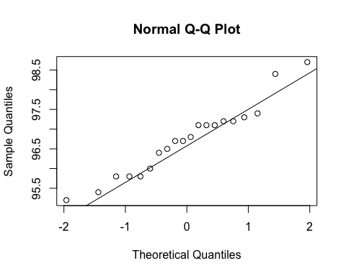
ad.test(subset(SSdata, intervention == "PrenaBelt")$mean.sao2.awake)
##
## Anderson-Darling normality test
##
## data: subset(SSdata, intervention == "PrenaBelt")$mean.sao2.awake
## A = 0.38206, p-value = 0.3654
#normal
summary(subset(SSdata, intervention == "sham")$mean.sao2.awake)
## Min. 1st Qu. Median Mean 3rd Qu. Max.
## 95.30 96.15 96.65 96.80 97.05 99.40
sd(subset(SSdata, intervention == "sham")$mean.sao2.awake)
## [1] 1.092077
length(subset(SSdata, intervention == "sham")$mean.sao2.awake)
## [1] 20
qqnorm(subset(SSdata, intervention == "sham")$mean.sao2.awake)
qqline(subset(SSdata, intervention == "sham")$mean.sao2.awake)
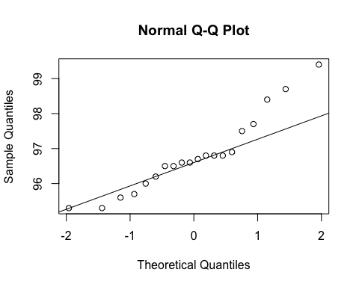
ad.test(subset(SSdata, intervention == "sham")$mean.sao2.awake)
##
## Anderson-Darling normality test
##
## data: subset(SSdata, intervention == "sham")$mean.sao2.awake
## A = 0.61087, p-value = 0.09665
#normal
#FYI - unpaired test
t.test(subset(SSdata, intervention == "sham")$mean.sao2.awake,
subset(SSdata, intervention == "PrenaBelt")$mean.sao2.awake)
##
## Welch Two Sample t-test
##
## data: subset(SSdata, intervention == "sham")$mean.sao2.awake and subset(SSdata, intervention == "PrenaBelt")$mean.sao2.awake
## t = 0.22031, df = 36.79, p-value = 0.8268
## alternative hypothesis: true difference in means is not equal to 0
## 95 percent confidence interval:
## -0.5739073 0.7139073
## sample estimates:
## mean of x mean of y
## 96.80 96.73
#################### Mean SpO2 NREM #######################
#Summary
summary(SSdata$mean.sao2.nrem)
## Min. 1st Qu. Median Mean 3rd Qu. Max.
## 94.40 95.60 96.15 96.23 96.93 99.10
sd(SSdata$mean.sao2.nrem, na.rm = TRUE)
## [1] 0.9680505
length(SSdata$mean.sao2.nrem)
## [1] 40
qqnorm(SSdata$mean.sao2.nrem)
qqline(SSdata$mean.sao2.nrem)
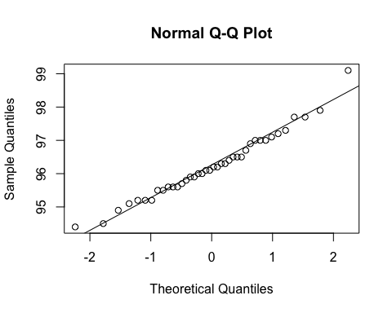
ad.test(SSdata$mean.sao2.nrem)
##
## Anderson-Darling normality test
##
## data: SSdata$mean.sao2.nrem
## A = 0.24673, p-value = 0.7391
#normal
#ANOVA
night_tx_difference <- anova(lm(mean.sao2.nrem ~ intervention * night,
data = SSdata))
night_tx_difference
## Analysis of Variance Table
##
## Response: mean.sao2.nrem
## Df Sum Sq Mean Sq F value Pr(>F)
## intervention 1 0.812 0.81225 0.8438 0.3644
## night 1 0.992 0.99225 1.0308 0.3167
## intervention:night 1 0.090 0.09025 0.0938 0.7612
## Residuals 36 34.653 0.96258
#within-participants (paired) comparison
#Paired t-test
t.test(subset(SSdataCompletes, intervention == "sham")$mean.sao2.nrem,
subset(SSdataCompletes, intervention == "PrenaBelt")$mean.sao2.nrem,
paired = TRUE)
##
## Paired t-test
##
## data: subset(SSdataCompletes, intervention == "sham")$mean.sao2.nrem and subset(SSdataCompletes, intervention == "PrenaBelt")$mean.sao2.nrem
## t = 1.4182, df = 19, p-value = 0.1723
## alternative hypothesis: true difference in means is not equal to 0
## 95 percent confidence interval:
## -0.1356036 0.7056036
## sample estimates:
## mean of the differences
## 0.285
#between participants (grouped) comparison
summary(subset(SSdata, intervention == "PrenaBelt")$mean.sao2.nrem)
## Min. 1st Qu. Median Mean 3rd Qu. Max.
## 94.40 95.57 96.05 96.09 96.55 97.90
sd(subset(SSdata, intervention == "PrenaBelt")$mean.sao2.nrem)
## [1] 0.8837123
length(subset(SSdata, intervention == "PrenaBelt")$mean.sao2.nrem)
## [1] 20
qqnorm(subset(SSdata, intervention == "PrenaBelt")$mean.sao2.nrem)
qqline(subset(SSdata, intervention == "PrenaBelt")$mean.sao2.nrem)
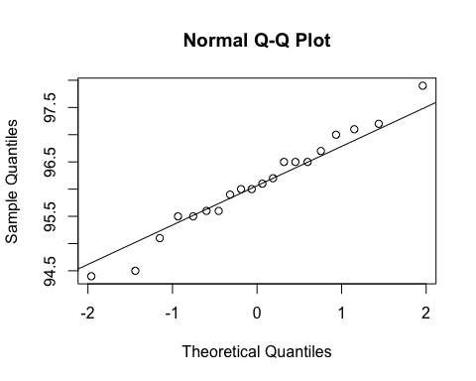
ad.test(subset(SSdata, intervention == "PrenaBelt")$mean.sao2.nrem)
##
## Anderson-Darling normality test
##
## data: subset(SSdata, intervention == "PrenaBelt")$mean.sao2.nrem
## A = 0.18102, p-value = 0.9013
#normal
summary(subset(SSdata, intervention == "sham")$mean.sao2.nrem)
## Min. 1st Qu. Median Mean 3rd Qu. Max.
## 94.90 95.68 96.25 96.38 97.00 99.10
sd(subset(SSdata, intervention == "sham")$mean.sao2.nrem)
## [1] 1.048746
length(subset(SSdata, intervention == "sham")$mean.sao2.nrem)
## [1] 20
qqnorm(subset(SSdata, intervention == "sham")$mean.sao2.nrem)
qqline(subset(SSdata, intervention == "sham")$mean.sao2.nrem)
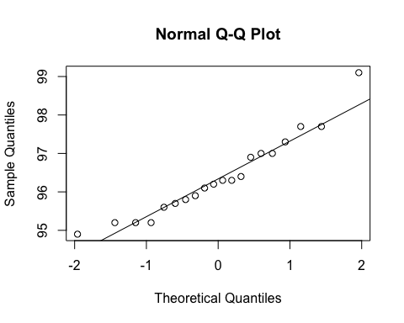
ad.test(subset(SSdata, intervention == "sham")$mean.sao2.nrem)
##
## Anderson-Darling normality test
##
## data: subset(SSdata, intervention == "sham")$mean.sao2.nrem
## A = 0.35668, p-value = 0.4209
#normal
#FYI - unpaired test
t.test(subset(SSdata, intervention == "sham")$mean.sao2.nrem,
subset(SSdata, intervention == "PrenaBelt")$mean.sao2.nrem)
##
## Welch Two Sample t-test
##
## data: subset(SSdata, intervention == "sham")$mean.sao2.nrem and subset(SSdata, intervention == "PrenaBelt")$mean.sao2.nrem
## t = 0.92937, df = 36.938, p-value = 0.3587
## alternative hypothesis: true difference in means is not equal to 0
## 95 percent confidence interval:
## -0.3363889 0.9063889
## sample estimates:
## mean of x mean of y
## 96.375 96.090
#################### Mean SpO2 REM #######################
#Summary
summary(SSdata$mean.sao2.rem)
## Min. 1st Qu. Median Mean 3rd Qu. Max.
## 93.30 95.20 96.05 96.02 96.85 99.00
sd(SSdata$mean.sao2.rem, na.rm = TRUE)
## [1] 1.234244
length(SSdata$mean.sao2.rem)
## [1] 40
qqnorm(SSdata$mean.sao2.rem)
qqline(SSdata$mean.sao2.rem)
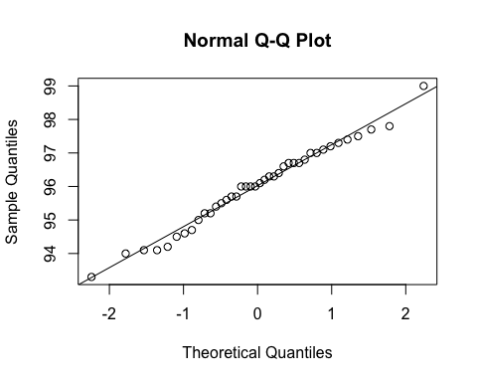
ad.test(SSdata$mean.sao2.rem)
##
## Anderson-Darling normality test
##
## data: SSdata$mean.sao2.rem
## A = 0.23901, p-value = 0.7646
#normal
#ANOVA
night_tx_difference <- anova(lm(mean.sao2.rem ~ intervention * night,
data = SSdata))
night_tx_difference
## Analysis of Variance Table
##
## Response: mean.sao2.rem
## Df Sum Sq Mean Sq F value Pr(>F)
## intervention 1 2.116 2.1160 1.4834 0.2312
## night 1 3.025 3.0250 2.1206 0.1540
## intervention:night 1 2.916 2.9160 2.0442 0.1614
## Residuals 36 51.354 1.4265
#within-participants (paired) comparison
#Paired t-test
t.test(subset(SSdataCompletes, intervention == "sham")$mean.sao2.rem,
subset(SSdataCompletes, intervention == "PrenaBelt")$mean.sao2.rem,
paired = TRUE)
##
## Paired t-test
##
## data: subset(SSdataCompletes, intervention == "sham")$mean.sao2.rem and subset(SSdataCompletes, intervention == "PrenaBelt")$mean.sao2.rem
## t = 1.5919, df = 19, p-value = 0.1279
## alternative hypothesis: true difference in means is not equal to 0
## 95 percent confidence interval:
## -0.1447888 1.0647888
## sample estimates:
## mean of the differences
## 0.46
#between participants (grouped) comparison
summary(subset(SSdata, intervention == "PrenaBelt")$mean.sao2.rem)
## Min. 1st Qu. Median Mean 3rd Qu. Max.
## 93.30 94.90 96.00 95.78 96.70 97.80
sd(subset(SSdata, intervention == "PrenaBelt")$mean.sao2.rem)
## [1] 1.229581
length(subset(SSdata, intervention == "PrenaBelt")$mean.sao2.rem)
## [1] 20
qqnorm(subset(SSdata, intervention == "PrenaBelt")$mean.sao2.rem)
qqline(subset(SSdata, intervention == "PrenaBelt")$mean.sao2.rem)
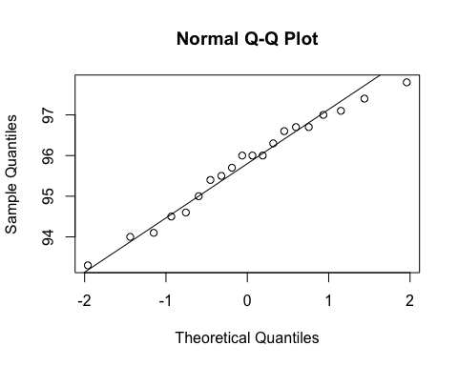
ad.test(subset(SSdata, intervention == "PrenaBelt")$mean.sao2.rem)
##
## Anderson-Darling normality test
##
## data: subset(SSdata, intervention == "PrenaBelt")$mean.sao2.rem
## A = 0.22902, p-value = 0.7802
#normal
summary(subset(SSdata, intervention == "sham")$mean.sao2.rem)
## Min. 1st Qu. Median Mean 3rd Qu. Max.
## 94.10 95.50 96.25 96.24 97.05 99.00
sd(subset(SSdata, intervention == "sham")$mean.sao2.rem)
## [1] 1.226237
length(subset(SSdata, intervention == "sham")$mean.sao2.rem)
## [1] 20
qqnorm(subset(SSdata, intervention == "sham")$mean.sao2.rem)
qqline(subset(SSdata, intervention == "sham")$mean.sao2.rem)
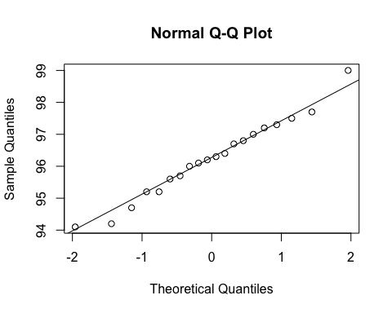
ad.test(subset(SSdata, intervention == "sham")$mean.sao2.rem)
##
## Anderson-Darling normality test
##
## data: subset(SSdata, intervention == "sham")$mean.sao2.rem
## A = 0.13652, p-value = 0.9718
#normal
#FYI - unpaired test
t.test(subset(SSdata, intervention == "sham")$mean.sao2.rem,
subset(SSdata, intervention == "PrenaBelt")$mean.sao2.rem)
##
## Welch Two Sample t-test
##
## data: subset(SSdata, intervention == "sham")$mean.sao2.rem and subset(SSdata, intervention == "PrenaBelt")$mean.sao2.rem
## t = 1.1847, df = 38, p-value = 0.2435
## alternative hypothesis: true difference in means is not equal to 0
## 95 percent confidence interval:
## -0.3260709 1.2460709
## sample estimates:
## mean of x mean of y
## 96.245 95.785
#################### Mean SpO2 TST #######################
#FYI: this data was generated in our PSG reports per default configuration but is not a
#pre-specified secondary outcome per the research protocol or trial registry. FYI only.
#Summary
summary(SSdata$mean.sao2.tst)
## Min. 1st Qu. Median Mean 3rd Qu. Max.
## 94.60 95.70 96.30 96.33 96.93 99.10
sd(SSdata$mean.sao2.tst, na.rm = TRUE)
## [1] 0.9626319
length(SSdata$mean.sao2.tst)
## [1] 40
#ANOVA
night_tx_difference <- anova(lm(mean.sao2.tst ~ intervention * night,
data = SSdata))
night_tx_difference
## Analysis of Variance Table
##
## Response: mean.sao2.tst
## Df Sum Sq Mean Sq F value Pr(>F)
## intervention 1 0.600 0.60025 0.6241 0.4347
## night 1 0.870 0.87025 0.9048 0.3479
## intervention:night 1 0.042 0.04225 0.0439 0.8352
## Residuals 36 34.627 0.96186
#within-participants (paired) comparison
#Paired t-test
t.test(subset(SSdataCompletes, intervention == "sham")$mean.sao2.tst,
subset(SSdataCompletes, intervention == "PrenaBelt")$mean.sao2.tst,
paired = TRUE)
##
## Paired t-test
##
## data: subset(SSdataCompletes, intervention == "sham")$mean.sao2.tst and subset(SSdataCompletes, intervention == "PrenaBelt")$mean.sao2.tst
## t = 1.3161, df = 19, p-value = 0.2038
## alternative hypothesis: true difference in means is not equal to 0
## 95 percent confidence interval:
## -0.1446432 0.6346432
## sample estimates:
## mean of the differences
## 0.245
#between participants (grouped) comparison
summary(subset(SSdata, intervention == "PrenaBelt")$mean.sao2.tst)
## Min. 1st Qu. Median Mean 3rd Qu. Max.
## 94.60 95.68 96.30 96.20 96.70 98.20
sd(subset(SSdata, intervention == "PrenaBelt")$mean.sao2.tst)
## [1] 0.8672249
length(subset(SSdata, intervention == "PrenaBelt")$mean.sao2.tst)
## [1] 20
qqnorm(subset(SSdata, intervention == "PrenaBelt")$mean.sao2.tst)
qqline(subset(SSdata, intervention == "PrenaBelt")$mean.sao2.tst)
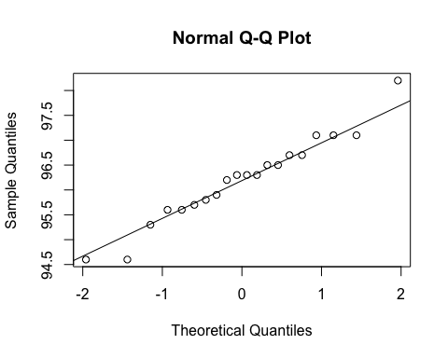
ad.test(subset(SSdata, intervention == "PrenaBelt")$mean.sao2.tst)
##
## Anderson-Darling normality test
##
## data: subset(SSdata, intervention == "PrenaBelt")$mean.sao2.tst
## A = 0.2726, p-value = 0.6304
#normal
summary(subset(SSdata, intervention == "sham")$mean.sao2.tst)
## Min. 1st Qu. Median Mean 3rd Qu. Max.
## 94.90 95.85 96.30 96.45 97.02 99.10
sd(subset(SSdata, intervention == "sham")$mean.sao2.tst)
## [1] 1.057554
length(subset(SSdata, intervention == "sham")$mean.sao2.tst)
## [1] 20
qqnorm(subset(SSdata, intervention == "sham")$mean.sao2.tst)
qqline(subset(SSdata, intervention == "sham")$mean.sao2.tst)
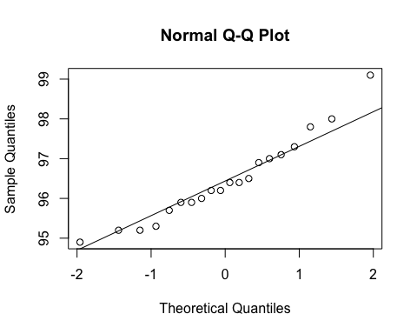
ad.test(subset(SSdata, intervention == "sham")$mean.sao2.tst)
##
## Anderson-Darling normality test
##
## data: subset(SSdata, intervention == "sham")$mean.sao2.tst
## A = 0.30299, p-value = 0.5413
#normal
#FYI - unpaired test
t.test(subset(SSdata, intervention == "sham")$mean.sao2.tst,
subset(SSdata, intervention == "PrenaBelt")$mean.sao2.tst)
##
## Welch Two Sample t-test
##
## data: subset(SSdata, intervention == "sham")$mean.sao2.tst and subset(SSdata, intervention == "PrenaBelt")$mean.sao2.tst
## t = 0.80113, df = 36.596, p-value = 0.4282
## alternative hypothesis: true difference in means is not equal to 0
## 95 percent confidence interval:
## -0.3748781 0.8648781
## sample estimates:
## mean of x mean of y
## 96.450 96.205
#################### Min SpO2 AWAKE #######################
#Summary
summary(SSdata$min.sao2.awake)
## Min. 1st Qu. Median Mean 3rd Qu. Max.
## 70.00 88.75 91.00 89.75 93.00 94.00
sd(SSdata$min.sao2.awake, na.rm = TRUE)
## [1] 5.026851
length(SSdata$min.sao2.awake)
## [1] 40
#ANOVA
night_tx_difference <- anova(lm(min.sao2.awake ~ intervention * night,
data = SSdata))
night_tx_difference
## Analysis of Variance Table
##
## Response: min.sao2.awake
## Df Sum Sq Mean Sq F value Pr(>F)
## intervention 1 40.0 40.00 1.8391 0.18350
## night 1 25.6 25.60 1.1770 0.28518
## intervention:night 1 136.9 136.90 6.2943 0.01676 *
## Residuals 36 783.0 21.75
## ---
## Signif. codes: 0 '***' 0.001 '**' 0.01 '*' 0.05 '.' 0.1 ' ' 1
#within-participants (paired) comparison
#Paired Wilcoxon
wilcox.test(subset(SSdataCompletes, intervention == "sham")$min.sao2.awake,
subset(SSdataCompletes, intervention == "PrenaBelt")$min.sao2.awake,
paired = TRUE, conf.int = TRUE)
## Warning in wilcox.test.default(subset(SSdataCompletes, intervention ==
## "sham")$min.sao2.awake, : cannot compute exact p-value with ties
## Warning in wilcox.test.default(subset(SSdataCompletes, intervention ==
## "sham")$min.sao2.awake, : cannot compute exact confidence interval with
## ties
## Warning in wilcox.test.default(subset(SSdataCompletes, intervention ==
## "sham")$min.sao2.awake, : cannot compute exact p-value with zeroes
## Warning in wilcox.test.default(subset(SSdataCompletes, intervention ==
## "sham")$min.sao2.awake, : cannot compute exact confidence interval with
## zeroes
##
## Wilcoxon signed rank test with continuity correction
##
## data: subset(SSdataCompletes, intervention == "sham")$min.sao2.awake and subset(SSdataCompletes, intervention == "PrenaBelt")$min.sao2.awake
## V = 53, p-value = 0.1609
## alternative hypothesis: true location shift is not equal to 0
## 95 percent confidence interval:
## -3.9999632 0.5000467
## sample estimates:
## (pseudo)median
## -1.49991
#between participants (grouped) comparison
summary(subset(SSdata, intervention == "PrenaBelt")$min.sao2.awake)
## Min. 1st Qu. Median Mean 3rd Qu. Max.
## 85.00 89.75 91.00 90.75 93.00 94.00
sd(subset(SSdata, intervention == "PrenaBelt")$min.sao2.awake)
## [1] 2.572629
length(subset(SSdata, intervention == "PrenaBelt")$min.sao2.awake)
## [1] 20
qqnorm(subset(SSdata, intervention == "PrenaBelt")$min.sao2.awake)
qqline(subset(SSdata, intervention == "PrenaBelt")$min.sao2.awake)
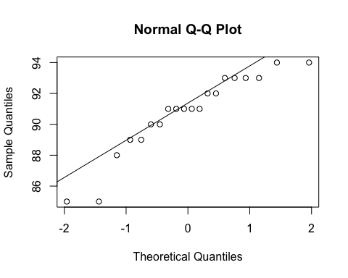
ad.test(subset(SSdata, intervention == "PrenaBelt")$min.sao2.awake)
##
## Anderson-Darling normality test
##
## data: subset(SSdata, intervention == "PrenaBelt")$min.sao2.awake
## A = 0.68841, p-value = 0.06104
#normal
summary(subset(SSdata, intervention == "sham")$min.sao2.awake)
## Min. 1st Qu. Median Mean 3rd Qu. Max.
## 70.00 88.00 90.00 88.75 93.25 94.00
sd(subset(SSdata, intervention == "sham")$min.sao2.awake)
## [1] 6.568465
length(subset(SSdata, intervention == "sham")$min.sao2.awake)
## [1] 20
qqnorm(subset(SSdata, intervention == "sham")$min.sao2.awake)
qqline(subset(SSdata, intervention == "sham")$min.sao2.awake)
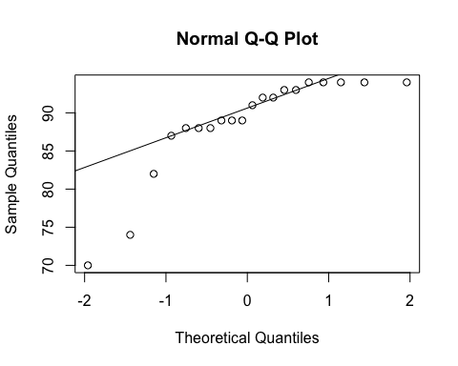
ad.test(subset(SSdata, intervention == "sham")$min.sao2.awake)
##
## Anderson-Darling normality test
##
## data: subset(SSdata, intervention == "sham")$min.sao2.awake
## A = 1.7154, p-value = 0.0001417
#non-normal
#FYI - unpaired test
wilcox.test(subset(SSdata, intervention == "sham")$min.sao2.awake,
subset(SSdata, intervention == "PrenaBelt")$min.sao2.awake,
conf.int = TRUE)
## Warning in wilcox.test.default(subset(SSdata, intervention == "sham")
## $min.sao2.awake, : cannot compute exact p-value with ties
## Warning in wilcox.test.default(subset(SSdata, intervention == "sham")
## $min.sao2.awake, : cannot compute exact confidence intervals with ties
##
## Wilcoxon rank sum test with continuity correction
##
## data: subset(SSdata, intervention == "sham")$min.sao2.awake and subset(SSdata, intervention == "PrenaBelt")$min.sao2.awake
## W = 184, p-value = 0.6726
## alternative hypothesis: true location shift is not equal to 0
## 95 percent confidence interval:
## -2.999945 1.000048
## sample estimates:
## difference in location
## -7.483333e-05
#################### Min SpO2 NREM #######################
#Summary
summary(SSdata$min.sao2.nrem)
## Min. 1st Qu. Median Mean 3rd Qu. Max.
## 74.00 90.75 92.00 91.50 94.00 96.00
sd(SSdata$min.sao2.nrem, na.rm = TRUE)
## [1] 3.928854
length(SSdata$min.sao2.nrem)
## [1] 40
qqnorm(SSdata$min.sao2.nrem)
qqline(SSdata$min.sao2.nrem)
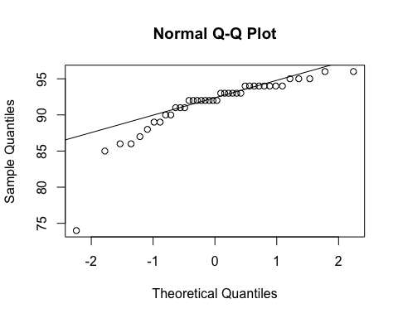
ad.test(SSdata$min.sao2.nrem)
##
## Anderson-Darling normality test
##
## data: SSdata$min.sao2.nrem
## A = 2.2647, p-value = 7.529e-06
#non-normal
#ANOVA
night_tx_difference <- anova(lm(min.sao2.nrem ~ intervention * night,
data = SSdata))
night_tx_difference
## Analysis of Variance Table
##
## Response: min.sao2.nrem
## Df Sum Sq Mean Sq F value Pr(>F)
## intervention 1 10.0 10.000 0.6475 0.4263
## night 1 3.6 3.600 0.2331 0.6322
## intervention:night 1 32.4 32.400 2.0978 0.1562
## Residuals 36 556.0 15.444
#within-participants (paired) comparison
#Paired Wilcoxon
wilcox.test(subset(SSdataCompletes, intervention == "sham")$min.sao2.nrem,
subset(SSdataCompletes, intervention == "PrenaBelt")$min.sao2.nrem,
paired = TRUE, conf.int = TRUE)
## Warning in wilcox.test.default(subset(SSdataCompletes, intervention ==
## "sham")$min.sao2.nrem, : cannot compute exact p-value with ties
## Warning in wilcox.test.default(subset(SSdataCompletes, intervention ==
## "sham")$min.sao2.nrem, : cannot compute exact confidence interval with ties
## Warning in wilcox.test.default(subset(SSdataCompletes, intervention ==
## "sham")$min.sao2.nrem, : cannot compute exact p-value with zeroes
## Warning in wilcox.test.default(subset(SSdataCompletes, intervention ==
## "sham")$min.sao2.nrem, : cannot compute exact confidence interval with
## zeroes
##
## Wilcoxon signed rank test with continuity correction
##
## data: subset(SSdataCompletes, intervention == "sham")$min.sao2.nrem and subset(SSdataCompletes, intervention == "PrenaBelt")$min.sao2.nrem
## V = 46, p-value = 0.26
## alternative hypothesis: true location shift is not equal to 0
## 95 percent confidence interval:
## -2.4999583 0.5000763
## sample estimates:
## (pseudo)median
## -0.500039
#between participants (grouped) comparison
summary(subset(SSdata, intervention == "PrenaBelt")$min.sao2.nrem)
## Min. 1st Qu. Median Mean 3rd Qu. Max.
## 86 91 92 92 94 96
sd(subset(SSdata, intervention == "PrenaBelt")$min.sao2.nrem)
## [1] 2.575185
length(subset(SSdata, intervention == "PrenaBelt")$min.sao2.nrem)
## [1] 20
qqnorm(subset(SSdata, intervention == "PrenaBelt")$min.sao2.nrem)
qqline(subset(SSdata, intervention == "PrenaBelt")$min.sao2.nrem)
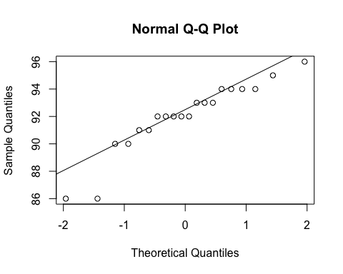
ad.test(subset(SSdata, intervention == "PrenaBelt")$min.sao2.nrem)
##
## Anderson-Darling normality test
##
## data: subset(SSdata, intervention == "PrenaBelt")$min.sao2.nrem
## A = 0.79126, p-value = 0.03318
#non-normal
summary(subset(SSdata, intervention == "sham")$min.sao2.nrem)
## Min. 1st Qu. Median Mean 3rd Qu. Max.
## 74.0 89.0 92.5 91.0 94.0 96.0
sd(subset(SSdata, intervention == "sham")$min.sao2.nrem)
## [1] 4.952405
length(subset(SSdata, intervention == "sham")$min.sao2.nrem)
## [1] 20
qqnorm(subset(SSdata, intervention == "sham")$min.sao2.nrem)
qqline(subset(SSdata, intervention == "sham")$min.sao2.nrem)
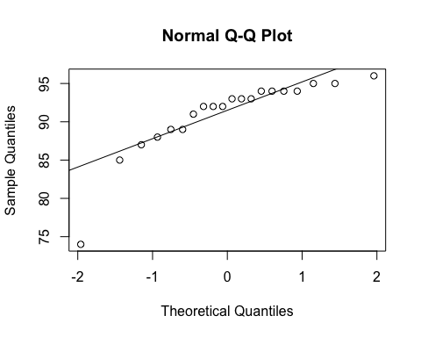
ad.test(subset(SSdata, intervention == "sham")$min.sao2.nrem)
##
## Anderson-Darling normality test
##
## data: subset(SSdata, intervention == "sham")$min.sao2.nrem
## A = 1.4186, p-value = 0.0008139
#non-normal
#FYI - unpaired test
wilcox.test(subset(SSdata, intervention == "sham")$min.sao2.nrem,
subset(SSdata, intervention == "PrenaBelt")$min.sao2.nrem,
conf.int = TRUE)
## Warning in wilcox.test.default(subset(SSdata, intervention == "sham")
## $min.sao2.nrem, : cannot compute exact p-value with ties
## Warning in wilcox.test.default(subset(SSdata, intervention == "sham")
## $min.sao2.nrem, : cannot compute exact confidence intervals with ties
##
## Wilcoxon rank sum test with continuity correction
##
## data: subset(SSdata, intervention == "sham")$min.sao2.nrem and subset(SSdata, intervention == "PrenaBelt")$min.sao2.nrem
## W = 196.5, p-value = 0.9347
## alternative hypothesis: true location shift is not equal to 0
## 95 percent confidence interval:
## -2.000016 1.999967
## sample estimates:
## difference in location
## -3.487271e-05
#################### Min SpO2 REM #######################
#Summary
summary(SSdata$min.sao2.rem)
## Min. 1st Qu. Median Mean 3rd Qu. Max.
## 81.00 90.00 92.00 91.35 94.00 95.00
sd(SSdata$min.sao2.rem, na.rm = TRUE)
## [1] 3.332436
length(SSdata$min.sao2.rem)
## [1] 40
qqnorm(SSdata$min.sao2.rem)
qqline(SSdata$min.sao2.rem)
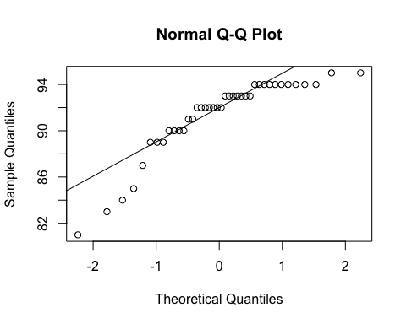
ad.test(SSdata$min.sao2.rem)
##
## Anderson-Darling normality test
##
## data: SSdata$min.sao2.rem
## A = 2.4334, p-value = 2.861e-06
#non-normal
#ANOVA
night_tx_difference <- anova(lm(min.sao2.rem ~ intervention * night,
data = SSdata))
night_tx_difference
## Analysis of Variance Table
##
## Response: min.sao2.rem
## Df Sum Sq Mean Sq F value Pr(>F)
## intervention 1 3.6 3.600 0.3264 0.57131
## night 1 0.1 0.100 0.0091 0.92466
## intervention:night 1 32.4 32.400 2.9380 0.09512 .
## Residuals 36 397.0 11.028
## ---
## Signif. codes: 0 '***' 0.001 '**' 0.01 '*' 0.05 '.' 0.1 ' ' 1
#within-participants (paired) comparison
#Paired Wilcoxon
wilcox.test(subset(SSdataCompletes, intervention == "sham")$min.sao2.rem,
subset(SSdataCompletes, intervention == "PrenaBelt")$min.sao2.rem,
paired = TRUE, conf.int = TRUE)
## Warning in wilcox.test.default(subset(SSdataCompletes, intervention ==
## "sham")$min.sao2.rem, : cannot compute exact p-value with ties
## Warning in wilcox.test.default(subset(SSdataCompletes, intervention ==
## "sham")$min.sao2.rem, : cannot compute exact confidence interval with ties
## Warning in wilcox.test.default(subset(SSdataCompletes, intervention ==
## "sham")$min.sao2.rem, : cannot compute exact p-value with zeroes
## Warning in wilcox.test.default(subset(SSdataCompletes, intervention ==
## "sham")$min.sao2.rem, : cannot compute exact confidence interval with
## zeroes
##
## Wilcoxon signed rank test with continuity correction
##
## data: subset(SSdataCompletes, intervention == "sham")$min.sao2.rem and subset(SSdataCompletes, intervention == "PrenaBelt")$min.sao2.rem
## V = 45, p-value = 0.4029
## alternative hypothesis: true location shift is not equal to 0
## 95 percent confidence interval:
## -2.4999536 0.9999402
## sample estimates:
## (pseudo)median
## -0.4999916
#between participants (grouped) comparison
summary(subset(SSdata, intervention == "PrenaBelt")$min.sao2.rem)
## Min. 1st Qu. Median Mean 3rd Qu. Max.
## 83.00 90.75 92.50 91.65 94.00 95.00
sd(subset(SSdata, intervention == "PrenaBelt")$min.sao2.rem)
## [1] 3.150188
length(subset(SSdata, intervention == "PrenaBelt")$min.sao2.rem)
## [1] 20
qqnorm(subset(SSdata, intervention == "PrenaBelt")$min.sao2.rem)
qqline(subset(SSdata, intervention == "PrenaBelt")$min.sao2.rem)
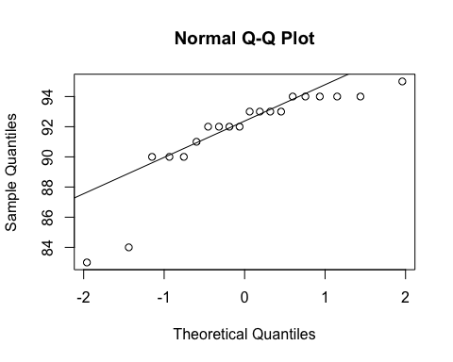
ad.test(subset(SSdata, intervention == "PrenaBelt")$min.sao2.rem)
##
## Anderson-Darling normality test
##
## data: subset(SSdata, intervention == "PrenaBelt")$min.sao2.rem
## A = 1.6375, p-value = 0.000224
#non-normal
summary(subset(SSdata, intervention == "sham")$min.sao2.rem)
## Min. 1st Qu. Median Mean 3rd Qu. Max.
## 81.00 89.00 92.00 91.05 94.00 95.00
sd(subset(SSdata, intervention == "sham")$min.sao2.rem)
## [1] 3.56112
length(subset(SSdata, intervention == "sham")$min.sao2.rem)
## [1] 20
qqnorm(subset(SSdata, intervention == "sham")$min.sao2.rem)
qqline(subset(SSdata, intervention == "sham")$min.sao2.rem)
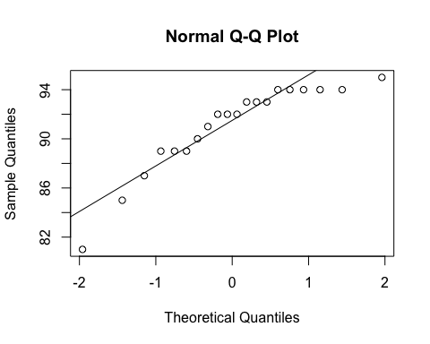
ad.test(subset(SSdata, intervention == "sham")$min.sao2.rem)
##
## Anderson-Darling normality test
##
## data: subset(SSdata, intervention == "sham")$min.sao2.rem
## A = 0.98564, p-value = 0.0105
#non-normal
#FYI - unpaired test
wilcox.test(subset(SSdata, intervention == "sham")$min.sao2.rem,
subset(SSdata, intervention == "PrenaBelt")$min.sao2.rem,
conf.int = TRUE)
## Warning in wilcox.test.default(subset(SSdata, intervention == "sham")
## $min.sao2.rem, : cannot compute exact p-value with ties
## Warning in wilcox.test.default(subset(SSdata, intervention == "sham")
## $min.sao2.rem, : cannot compute exact confidence intervals with ties
##
## Wilcoxon rank sum test with continuity correction
##
## data: subset(SSdata, intervention == "sham")$min.sao2.rem and subset(SSdata, intervention == "PrenaBelt")$min.sao2.rem
## W = 181, p-value = 0.6118
## alternative hypothesis: true location shift is not equal to 0
## 95 percent confidence interval:
## -2.000020 1.000041
## sample estimates:
## difference in location
## -6.982535e-05
#################### Min SpO2 TST #######################
#FYI: this data was generated in our PSG reports per default configuration but is not a
#pre-specified secondary outcome per the research protocol or trial registry. FYI only.
#Summary
summary(SSdata$min.sao2.tst)
## Min. 1st Qu. Median Mean 3rd Qu. Max.
## 70.00 88.00 91.00 89.28 93.00 94.00
sd(SSdata$min.sao2.tst, na.rm = TRUE)
## [1] 5.11402
length(SSdata$min.sao2.tst)
## [1] 40
#ANOVA
night_tx_difference <- anova(lm(min.sao2.tst ~ intervention * night,
data = SSdata))
night_tx_difference
## Analysis of Variance Table
##
## Response: min.sao2.tst
## Df Sum Sq Mean Sq F value Pr(>F)
## intervention 1 46.22 46.225 2.0356 0.16227
## night 1 15.63 15.625 0.6881 0.41229
## intervention:night 1 140.62 140.625 6.1927 0.01759 *
## Residuals 36 817.50 22.708
## ---
## Signif. codes: 0 '***' 0.001 '**' 0.01 '*' 0.05 '.' 0.1 ' ' 1
#within-participants (paired) comparison
#Paired Wilcoxon
wilcox.test(subset(SSdataCompletes, intervention == "sham")$min.sao2.tst,
subset(SSdataCompletes, intervention == "PrenaBelt")$min.sao2.tst,
paired = TRUE, conf.int = TRUE)
## Warning in wilcox.test.default(subset(SSdataCompletes, intervention ==
## "sham")$min.sao2.tst, : cannot compute exact p-value with ties
## Warning in wilcox.test.default(subset(SSdataCompletes, intervention ==
## "sham")$min.sao2.tst, : cannot compute exact confidence interval with ties
## Warning in wilcox.test.default(subset(SSdataCompletes, intervention ==
## "sham")$min.sao2.tst, : cannot compute exact p-value with zeroes
## Warning in wilcox.test.default(subset(SSdataCompletes, intervention ==
## "sham")$min.sao2.tst, : cannot compute exact confidence interval with
## zeroes
##
## Wilcoxon signed rank test with continuity correction
##
## data: subset(SSdataCompletes, intervention == "sham")$min.sao2.tst and subset(SSdataCompletes, intervention == "PrenaBelt")$min.sao2.tst
## V = 45, p-value = 0.07952
## alternative hypothesis: true location shift is not equal to 0
## 95 percent confidence interval:
## -3.999980e+00 6.891261e-05
## sample estimates:
## (pseudo)median
## -1.500056
#between participants (grouped) comparison
summary(subset(SSdata, intervention == "PrenaBelt")$min.sao2.tst)
## Min. 1st Qu. Median Mean 3rd Qu. Max.
## 83.00 89.75 91.00 90.35 92.25 94.00
sd(subset(SSdata, intervention == "PrenaBelt")$min.sao2.tst)
## [1] 3.116594
length(subset(SSdata, intervention == "PrenaBelt")$min.sao2.tst)
## [1] 20
qqnorm(subset(SSdata, intervention == "PrenaBelt")$min.sao2.tst)
qqline(subset(SSdata, intervention == "PrenaBelt")$min.sao2.tst)
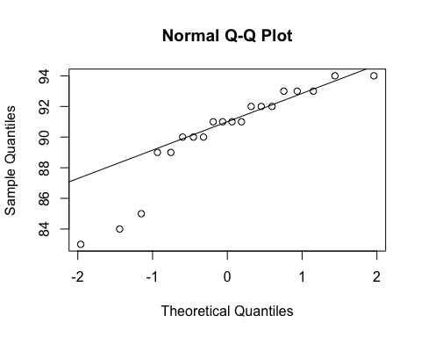
ad.test(subset(SSdata, intervention == "PrenaBelt")$min.sao2.tst)
##
## Anderson-Darling normality test
##
## data: subset(SSdata, intervention == "PrenaBelt")$min.sao2.tst
## A = 1.0583, p-value = 0.006831
#non-normal
summary(subset(SSdata, intervention == "sham")$min.sao2.tst)
## Min. 1st Qu. Median Mean 3rd Qu. Max.
## 70.00 87.75 89.00 88.20 93.00 94.00
sd(subset(SSdata, intervention == "sham")$min.sao2.tst)
## [1] 6.444908
length(subset(SSdata, intervention == "sham")$min.sao2.tst)
## [1] 20
qqnorm(subset(SSdata, intervention == "sham")$min.sao2.tst)
qqline(subset(SSdata, intervention == "sham")$min.sao2.tst)
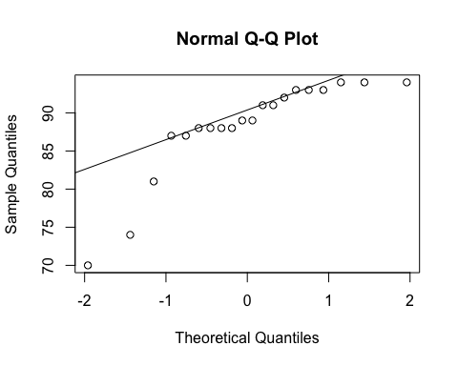
ad.test(subset(SSdata, intervention == "sham")$min.sao2.tst)
##
## Anderson-Darling normality test
##
## data: subset(SSdata, intervention == "sham")$min.sao2.tst
## A = 1.5634, p-value = 0.0003467
#non-normal
#FYI - unpaired test
wilcox.test(subset(SSdata, intervention == "sham")$min.sao2.tst,
subset(SSdata, intervention == "PrenaBelt")$min.sao2.tst,
conf.int = TRUE)
## Warning in wilcox.test.default(subset(SSdata, intervention == "sham")
## $min.sao2.tst, : cannot compute exact p-value with ties
## Warning in wilcox.test.default(subset(SSdata, intervention == "sham")
## $min.sao2.tst, : cannot compute exact confidence intervals with ties
##
## Wilcoxon rank sum test with continuity correction
##
## data: subset(SSdata, intervention == "sham")$min.sao2.tst and subset(SSdata, intervention == "PrenaBelt")$min.sao2.tst
## W = 166, p-value = 0.362
## alternative hypothesis: true location shift is not equal to 0
## 95 percent confidence interval:
## -3.000006 1.000035
## sample estimates:
## difference in location
## -1.000019
#################### Max SpO2 AWAKE #######################
#Summary
summary(SSdata$max.sao2.awake)
## Min. 1st Qu. Median Mean 3rd Qu. Max.
## 98.00 99.00 100.00 99.68 100.00 100.00
sd(SSdata$max.sao2.awake, na.rm = TRUE)
## [1] 0.5256254
length(SSdata$max.sao2.awake)
## [1] 40
#ANOVA
night_tx_difference <- anova(lm(max.sao2.awake ~ intervention * night,
data = SSdata))
night_tx_difference
## Analysis of Variance Table
##
## Response: max.sao2.awake
## Df Sum Sq Mean Sq F value Pr(>F)
## intervention 1 0.625 0.625 2.2727 0.1404
## night 1 0.025 0.025 0.0909 0.7648
## intervention:night 1 0.225 0.225 0.8182 0.3717
## Residuals 36 9.900 0.275
#within-participants (paired) comparison
#Paired Wilcoxon
wilcox.test(subset(SSdataCompletes, intervention == "sham")$max.sao2.awake,
subset(SSdataCompletes, intervention == "PrenaBelt")$max.sao2.awake,
paired = TRUE)
## Warning in wilcox.test.default(subset(SSdataCompletes, intervention ==
## "sham")$max.sao2.awake, : cannot compute exact p-value with ties
## Warning in wilcox.test.default(subset(SSdataCompletes, intervention ==
## "sham")$max.sao2.awake, : cannot compute exact p-value with zeroes
##
## Wilcoxon signed rank test with continuity correction
##
## data: subset(SSdataCompletes, intervention == "sham")$max.sao2.awake and subset(SSdataCompletes, intervention == "PrenaBelt")$max.sao2.awake
## V = 4, p-value = 0.0726
## alternative hypothesis: true location shift is not equal to 0
#between participants (grouped) comparison
summary(subset(SSdata, intervention == "PrenaBelt")$max.sao2.awake)
## Min. 1st Qu. Median Mean 3rd Qu. Max.
## 99.0 100.0 100.0 99.8 100.0 100.0
sd(subset(SSdata, intervention == "PrenaBelt")$max.sao2.awake)
## [1] 0.4103913
length(subset(SSdata, intervention == "PrenaBelt")$max.sao2.awake)
## [1] 20
qqnorm(subset(SSdata, intervention == "PrenaBelt")$max.sao2.awake)
qqline(subset(SSdata, intervention == "PrenaBelt")$max.sao2.awake)
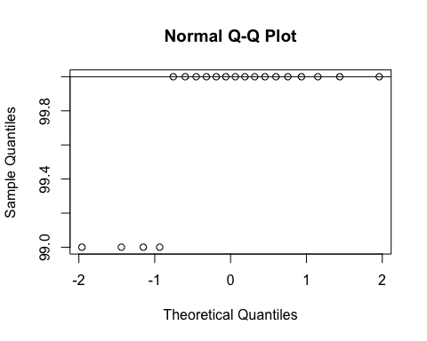
ad.test(subset(SSdata, intervention == "PrenaBelt")$max.sao2.awake)
##
## Anderson-Darling normality test
##
## data: subset(SSdata, intervention == "PrenaBelt")$max.sao2.awake
## A = 5.1941, p-value = 2.32e-13
#non-normal
summary(subset(SSdata, intervention == "sham")$max.sao2.awake)
## Min. 1st Qu. Median Mean 3rd Qu. Max.
## 98.00 99.00 100.00 99.55 100.00 100.00
sd(subset(SSdata, intervention == "sham")$max.sao2.awake)
## [1] 0.6048053
length(subset(SSdata, intervention == "sham")$max.sao2.awake)
## [1] 20
qqnorm(subset(SSdata, intervention == "sham")$max.sao2.awake)
qqline(subset(SSdata, intervention == "sham")$max.sao2.awake)
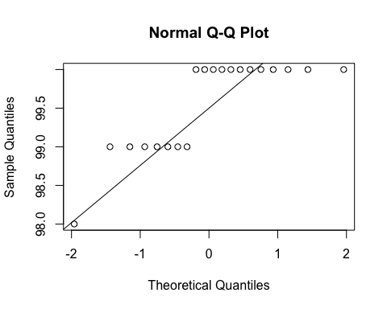
ad.test(subset(SSdata, intervention == "sham")$max.sao2.awake)
##
## Anderson-Darling normality test
##
## data: subset(SSdata, intervention == "sham")$max.sao2.awake
## A = 2.8091, p-value = 2.322e-07
#non-normal
#FYI - unpaired test
wilcox.test(subset(SSdata, intervention == "sham")$max.sao2.awake,
subset(SSdata, intervention == "PrenaBelt")$max.sao2.awake,
conf.int = TRUE)
## Warning in wilcox.test.default(subset(SSdata, intervention == "sham")
## $max.sao2.awake, : cannot compute exact p-value with ties
## Warning in wilcox.test.default(subset(SSdata, intervention == "sham")
## $max.sao2.awake, : cannot compute exact confidence intervals with ties
##
## Wilcoxon rank sum test with continuity correction
##
## data: subset(SSdata, intervention == "sham")$max.sao2.awake and subset(SSdata, intervention == "PrenaBelt")$max.sao2.awake
## W = 158, p-value = 0.1594
## alternative hypothesis: true location shift is not equal to 0
## 95 percent confidence interval:
## -9.999288e-01 1.199059e-06
## sample estimates:
## difference in location
## -1.027475e-05
#################### Max SpO2 NREM #######################
#Summary
summary(SSdata$max.sao2.nrem)
## Min. 1st Qu. Median Mean 3rd Qu. Max.
## 97.00 98.00 99.00 98.88 100.00 100.00
sd(SSdata$max.sao2.nrem, na.rm = TRUE)
## [1] 0.9111137
length(SSdata$max.sao2.nrem)
## [1] 40
qqnorm(SSdata$max.sao2.nrem)
qqline(SSdata$max.sao2.nrem)
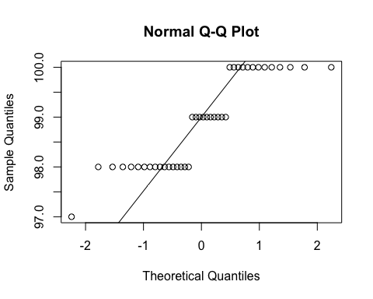
ad.test(SSdata$max.sao2.nrem)
##
## Anderson-Darling normality test
##
## data: SSdata$max.sao2.nrem
## A = 3.1852, p-value = 3.895e-08
#non-normal
#ANOVA
night_tx_difference <- anova(lm(max.sao2.nrem ~ intervention * night,
data = SSdata))
night_tx_difference
## Analysis of Variance Table
##
## Response: max.sao2.nrem
## Df Sum Sq Mean Sq F value Pr(>F)
## intervention 1 0.225 0.225 0.2571 0.6152
## night 1 0.625 0.625 0.7143 0.4036
## intervention:night 1 0.025 0.025 0.0286 0.8667
## Residuals 36 31.500 0.875
#within-participants (paired) comparison
#Paired Wilcoxon
wilcox.test(subset(SSdataCompletes, intervention == "sham")$max.sao2.nrem,
subset(SSdataCompletes, intervention == "PrenaBelt")$max.sao2.nrem,
paired = TRUE, conf.int = TRUE)
## Warning in wilcox.test.default(subset(SSdataCompletes, intervention ==
## "sham")$max.sao2.nrem, : requested conf.level not achievable
## Warning in wilcox.test.default(subset(SSdataCompletes, intervention ==
## "sham")$max.sao2.nrem, : cannot compute exact p-value with ties
## Warning in wilcox.test.default(subset(SSdataCompletes, intervention ==
## "sham")$max.sao2.nrem, : cannot compute exact confidence interval with ties
## Warning in wilcox.test.default(subset(SSdataCompletes, intervention ==
## "sham")$max.sao2.nrem, : cannot compute exact p-value with zeroes
## Warning in wilcox.test.default(subset(SSdataCompletes, intervention ==
## "sham")$max.sao2.nrem, : cannot compute exact confidence interval with
## zeroes
##
## Wilcoxon signed rank test with continuity correction
##
## data: subset(SSdataCompletes, intervention == "sham")$max.sao2.nrem and subset(SSdataCompletes, intervention == "PrenaBelt")$max.sao2.nrem
## V = 20, p-value = 0.4575
## alternative hypothesis: true location shift is not equal to 0
## 90 percent confidence interval:
## -1.499922 1.000000
## sample estimates:
## (pseudo)median
## -0.4999789
#between participants (grouped) comparison
summary(subset(SSdata, intervention == "PrenaBelt")$max.sao2.nrem)
## Min. 1st Qu. Median Mean 3rd Qu. Max.
## 98.00 98.00 99.00 98.95 100.00 100.00
sd(subset(SSdata, intervention == "PrenaBelt")$max.sao2.nrem)
## [1] 0.8870412
length(subset(SSdata, intervention == "PrenaBelt")$max.sao2.nrem)
## [1] 20
qqnorm(subset(SSdata, intervention == "PrenaBelt")$max.sao2.nrem)
qqline(subset(SSdata, intervention == "PrenaBelt")$max.sao2.nrem)
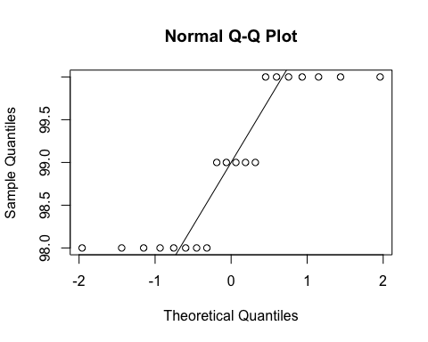
ad.test(subset(SSdata, intervention == "PrenaBelt")$max.sao2.nrem)
##
## Anderson-Darling normality test
##
## data: subset(SSdata, intervention == "PrenaBelt")$max.sao2.nrem
## A = 1.809, p-value = 8.166e-05
#non-normal
summary(subset(SSdata, intervention == "sham")$max.sao2.nrem)
## Min. 1st Qu. Median Mean 3rd Qu. Max.
## 97.0 98.0 99.0 98.8 100.0 100.0
sd(subset(SSdata, intervention == "sham")$max.sao2.nrem)
## [1] 0.9514532
length(subset(SSdata, intervention == "sham")$max.sao2.nrem)
## [1] 20
qqnorm(subset(SSdata, intervention == "sham")$max.sao2.nrem)
qqline(subset(SSdata, intervention == "sham")$max.sao2.nrem)
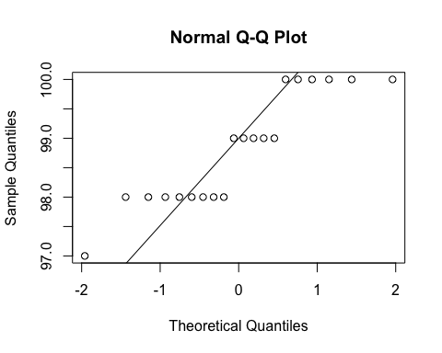
ad.test(subset(SSdata, intervention == "sham")$max.sao2.nrem)
##
## Anderson-Darling normality test
##
## data: subset(SSdata, intervention == "sham")$max.sao2.nrem
## A = 1.3653, p-value = 0.001115
#non-normal
#FYI - unpaired test
wilcox.test(subset(SSdata, intervention == "sham")$max.sao2.nrem,
subset(SSdata, intervention == "PrenaBelt")$max.sao2.nrem,
conf.int = TRUE)
## Warning in wilcox.test.default(subset(SSdata, intervention == "sham")
## $max.sao2.nrem, : cannot compute exact p-value with ties
## Warning in wilcox.test.default(subset(SSdata, intervention == "sham")
## $max.sao2.nrem, : cannot compute exact confidence intervals with ties
##
## Wilcoxon rank sum test with continuity correction
##
## data: subset(SSdata, intervention == "sham")$max.sao2.nrem and subset(SSdata, intervention == "PrenaBelt")$max.sao2.nrem
## W = 183.5, p-value = 0.6458
## alternative hypothesis: true location shift is not equal to 0
## 95 percent confidence interval:
## -9.999960e-01 6.876513e-05
## sample estimates:
## difference in location
## -7.969806e-05
#################### Max SpO2 REM #######################
#Summary
summary(SSdata$max.sao2.rem)
## Min. 1st Qu. Median Mean 3rd Qu. Max.
## 95.00 98.00 98.00 98.35 99.00 100.00
sd(SSdata$max.sao2.rem, na.rm = TRUE)
## [1] 1.001281
length(SSdata$max.sao2.rem)
## [1] 40
qqnorm(SSdata$max.sao2.rem)
qqline(SSdata$max.sao2.rem)
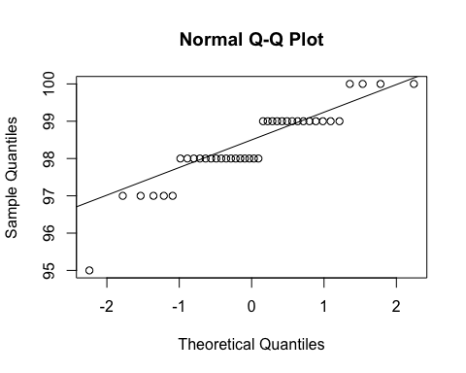
ad.test(SSdata$max.sao2.rem)
##
## Anderson-Darling normality test
##
## data: SSdata$max.sao2.rem
## A = 1.9711, p-value = 4.063e-05
#non-normal
#ANOVA
night_tx_difference <- anova(lm(max.sao2.rem ~ intervention * night,
data = SSdata))
night_tx_difference
## Analysis of Variance Table
##
## Response: max.sao2.rem
## Df Sum Sq Mean Sq F value Pr(>F)
## intervention 1 1.6 1.6000 1.7041 0.200
## night 1 3.6 3.6000 3.8343 0.058 .
## intervention:night 1 0.1 0.1000 0.1065 0.746
## Residuals 36 33.8 0.9389
## ---
## Signif. codes: 0 '***' 0.001 '**' 0.01 '*' 0.05 '.' 0.1 ' ' 1
#within-participants (paired) comparison
#Paired Wilcoxon
wilcox.test(subset(SSdataCompletes, intervention == "sham")$max.sao2.rem,
subset(SSdataCompletes, intervention == "PrenaBelt")$max.sao2.rem,
paired = TRUE, conf.int = TRUE)
## Warning in wilcox.test.default(subset(SSdataCompletes, intervention ==
## "sham")$max.sao2.rem, : cannot compute exact p-value with ties
## Warning in wilcox.test.default(subset(SSdataCompletes, intervention ==
## "sham")$max.sao2.rem, : cannot compute exact confidence interval with ties
## Warning in wilcox.test.default(subset(SSdataCompletes, intervention ==
## "sham")$max.sao2.rem, : cannot compute exact p-value with zeroes
## Warning in wilcox.test.default(subset(SSdataCompletes, intervention ==
## "sham")$max.sao2.rem, : cannot compute exact confidence interval with
## zeroes
##
## Wilcoxon signed rank test with continuity correction
##
## data: subset(SSdataCompletes, intervention == "sham")$max.sao2.rem and subset(SSdataCompletes, intervention == "PrenaBelt")$max.sao2.rem
## V = 78, p-value = 0.2819
## alternative hypothesis: true location shift is not equal to 0
## 95 percent confidence interval:
## -5.341455e-06 1.000049e+00
## sample estimates:
## (pseudo)median
## 4.140595e-05
#between participants (grouped) comparison
summary(subset(SSdata, intervention == "PrenaBelt")$max.sao2.rem)
## Min. 1st Qu. Median Mean 3rd Qu. Max.
## 95.00 98.00 98.00 98.15 99.00 99.00
sd(subset(SSdata, intervention == "PrenaBelt")$max.sao2.rem)
## [1] 0.9880869
length(subset(SSdata, intervention == "PrenaBelt")$max.sao2.rem)
## [1] 20
qqnorm(subset(SSdata, intervention == "PrenaBelt")$max.sao2.rem)
qqline(subset(SSdata, intervention == "PrenaBelt")$max.sao2.rem)
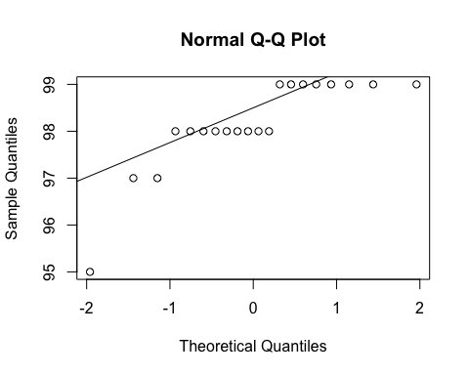
ad.test(subset(SSdata, intervention == "PrenaBelt")$max.sao2.rem)
##
## Anderson-Darling normality test
##
## data: subset(SSdata, intervention == "PrenaBelt")$max.sao2.rem
## A = 1.7444, p-value = 0.0001194
#non-normal
summary(subset(SSdata, intervention == "sham")$max.sao2.rem)
## Min. 1st Qu. Median Mean 3rd Qu. Max.
## 97.00 98.00 98.50 98.55 99.00 100.00
sd(subset(SSdata, intervention == "sham")$max.sao2.rem)
## [1] 0.9986833
length(subset(SSdata, intervention == "sham")$max.sao2.rem)
## [1] 20
qqnorm(subset(SSdata, intervention == "sham")$max.sao2.rem)
qqline(subset(SSdata, intervention == "sham")$max.sao2.rem)
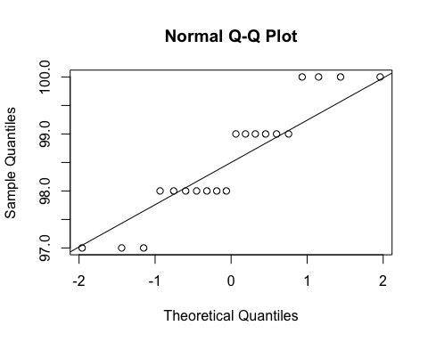
ad.test(subset(SSdata, intervention == "sham")$max.sao2.rem)
##
## Anderson-Darling normality test
##
## data: subset(SSdata, intervention == "sham")$max.sao2.rem
## A = 0.89914, p-value = 0.01752
#non-normal
#FYI - unpaired test
wilcox.test(subset(SSdata, intervention == "sham")$max.sao2.rem,
subset(SSdata, intervention == "PrenaBelt")$max.sao2.rem,
conf.int = TRUE)
## Warning in wilcox.test.default(subset(SSdata, intervention == "sham")
## $max.sao2.rem, : cannot compute exact p-value with ties
## Warning in wilcox.test.default(subset(SSdata, intervention == "sham")
## $max.sao2.rem, : cannot compute exact confidence intervals with ties
##
## Wilcoxon rank sum test with continuity correction
##
## data: subset(SSdata, intervention == "sham")$max.sao2.rem and subset(SSdata, intervention == "PrenaBelt")$max.sao2.rem
## W = 234.5, p-value = 0.3298
## alternative hypothesis: true location shift is not equal to 0
## 95 percent confidence interval:
## -5.707564e-05 9.999595e-01
## sample estimates:
## difference in location
## 5.182881e-05
#################### Max SpO2 TST #######################
#FYI: this data was generated in our PSG reports per default configuration but is not a
#pre-specified secondary outcome per the research protocol or trial registry. FYI only.
#Summary
summary(SSdata$max.sao2.tst)
## Min. 1st Qu. Median Mean 3rd Qu. Max.
## 98.00 99.00 100.00 99.68 100.00 100.00
sd(SSdata$max.sao2.tst, na.rm = TRUE)
## [1] 0.5256254
length(SSdata$max.sao2.tst)
## [1] 40
#ANOVA
night_tx_difference <- anova(lm(max.sao2.tst ~ intervention * night,
data = SSdata))
night_tx_difference
## Analysis of Variance Table
##
## Response: max.sao2.tst
## Df Sum Sq Mean Sq F value Pr(>F)
## intervention 1 0.625 0.625 2.2727 0.1404
## night 1 0.025 0.025 0.0909 0.7648
## intervention:night 1 0.225 0.225 0.8182 0.3717
## Residuals 36 9.900 0.275
#within-participants (paired) comparison
#Paired Wilcoxon
wilcox.test(subset(SSdataCompletes, intervention == "sham")$max.sao2.tst,
subset(SSdataCompletes, intervention == "PrenaBelt")$max.sao2.tst,
paired = TRUE)
## Warning in wilcox.test.default(subset(SSdataCompletes, intervention ==
## "sham")$max.sao2.tst, : cannot compute exact p-value with ties
## Warning in wilcox.test.default(subset(SSdataCompletes, intervention ==
## "sham")$max.sao2.tst, : cannot compute exact p-value with zeroes
##
## Wilcoxon signed rank test with continuity correction
##
## data: subset(SSdataCompletes, intervention == "sham")$max.sao2.tst and subset(SSdataCompletes, intervention == "PrenaBelt")$max.sao2.tst
## V = 4, p-value = 0.0726
## alternative hypothesis: true location shift is not equal to 0
#between participants (grouped) comparison
summary(subset(SSdata, intervention == "PrenaBelt")$max.sao2.tst)
## Min. 1st Qu. Median Mean 3rd Qu. Max.
## 99.0 100.0 100.0 99.8 100.0 100.0
sd(subset(SSdata, intervention == "PrenaBelt")$max.sao2.tst)
## [1] 0.4103913
length(subset(SSdata, intervention == "PrenaBelt")$max.sao2.tst)
## [1] 20
qqnorm(subset(SSdata, intervention == "PrenaBelt")$max.sao2.tst)
qqline(subset(SSdata, intervention == "PrenaBelt")$max.sao2.tst)
ad.test(subset(SSdata, intervention == "PrenaBelt")$max.sao2.tst)
##
## Anderson-Darling normality test
##
## data: subset(SSdata, intervention == "PrenaBelt")$max.sao2.tst
## A = 5.1941, p-value = 2.32e-13
#non-normal
summary(subset(SSdata, intervention == "sham")$max.sao2.tst)
## Min. 1st Qu. Median Mean 3rd Qu. Max.
## 98.00 99.00 100.00 99.55 100.00 100.00
sd(subset(SSdata, intervention == "sham")$max.sao2.tst)
## [1] 0.6048053
length(subset(SSdata, intervention == "sham")$max.sao2.tst)
## [1] 20
qqnorm(subset(SSdata, intervention == "sham")$max.sao2.tst)
qqline(subset(SSdata, intervention == "sham")$max.sao2.tst)
ad.test(subset(SSdata, intervention == "sham")$max.sao2.tst)
##
## Anderson-Darling normality test
##
## data: subset(SSdata, intervention == "sham")$max.sao2.tst
## A = 2.8091, p-value = 2.322e-07
#non-normal
#FYI - unpaired test
wilcox.test(subset(SSdata, intervention == "sham")$max.sao2.tst,
subset(SSdata, intervention == "PrenaBelt")$max.sao2.tst,
conf.int = TRUE)
## Warning in wilcox.test.default(subset(SSdata, intervention == "sham")
## $max.sao2.tst, : cannot compute exact p-value with ties
## Warning in wilcox.test.default(subset(SSdata, intervention == "sham")
## $max.sao2.tst, : cannot compute exact confidence intervals with ties
##
## Wilcoxon rank sum test with continuity correction
##
## data: subset(SSdata, intervention == "sham")$max.sao2.tst and subset(SSdata, intervention == "PrenaBelt")$max.sao2.tst
## W = 158, p-value = 0.1594
## alternative hypothesis: true location shift is not equal to 0
## 95 percent confidence interval:
## -9.999288e-01 1.199059e-06
## sample estimates:
## difference in location
## -1.027475e-05
#################### %TST with SpO2 90-100% #######################
#FYI: this data was generated in our PSG reports per default configuration but is not a
#pre-specified secondary outcome per the research protocol or trial registry. FYI only.
#Summary
summary(SSdata$sao2.Ptst.100to90)
## Min. 1st Qu. Median Mean 3rd Qu. Max.
## 30.60 96.48 98.40 96.47 99.60 100.00
sd(SSdata$sao2.Ptst.100to90, na.rm = TRUE)
## [1] 10.81533
length(SSdata$sao2.Ptst.100to90)
## [1] 40
#ANOVA
night_tx_difference <- anova(lm(sao2.Ptst.100to90 ~ intervention * night,
data = SSdata))
night_tx_difference
## Analysis of Variance Table
##
## Response: sao2.Ptst.100to90
## Df Sum Sq Mean Sq F value Pr(>F)
## intervention 1 106.6 106.60 0.9253 0.3425
## night 1 130.0 129.96 1.1280 0.2953
## intervention:night 1 177.7 177.66 1.5420 0.2223
## Residuals 36 4147.7 115.21
#within-participants (paired) comparison
#Paired Wilcoxon
wilcox.test(subset(SSdataCompletes, intervention == "sham")$sao2.Ptst.100to90,
subset(SSdataCompletes, intervention == "PrenaBelt")$sao2.Ptst.100to90,
paired = TRUE, conf.int = TRUE)
## Warning in wilcox.test.default(subset(SSdataCompletes, intervention ==
## "sham")$sao2.Ptst.100to90, : cannot compute exact p-value with ties
## Warning in wilcox.test.default(subset(SSdataCompletes, intervention ==
## "sham")$sao2.Ptst.100to90, : cannot compute exact confidence interval with
## ties
##
## Wilcoxon signed rank test with continuity correction
##
## data: subset(SSdataCompletes, intervention == "sham")$sao2.Ptst.100to90 and subset(SSdataCompletes, intervention == "PrenaBelt")$sao2.Ptst.100to90
## V = 108, p-value = 0.9256
## alternative hypothesis: true location shift is not equal to 0
## 95 percent confidence interval:
## -0.7499482 1.2500240
## sample estimates:
## (pseudo)median
## 0.02366365
#between participants (grouped) comparison
summary(subset(SSdata, intervention == "PrenaBelt")$sao2.Ptst.100to90)
## Min. 1st Qu. Median Mean 3rd Qu. Max.
## 30.60 96.28 98.35 94.84 99.72 99.90
sd(subset(SSdata, intervention == "PrenaBelt")$sao2.Ptst.100to90)
## [1] 15.20458
length(subset(SSdata, intervention == "PrenaBelt")$sao2.Ptst.100to90)
## [1] 20
qqnorm(subset(SSdata, intervention == "PrenaBelt")$sao2.Ptst.100to90)
qqline(subset(SSdata, intervention == "PrenaBelt")$sao2.Ptst.100to90)
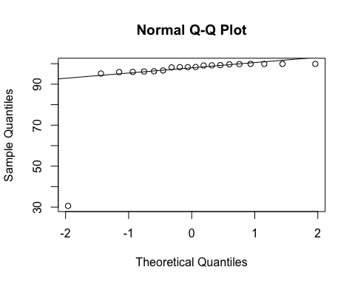
ad.test(subset(SSdata, intervention == "PrenaBelt")$sao2.Ptst.100to90)
##
## Anderson-Darling normality test
##
## data: subset(SSdata, intervention == "PrenaBelt")$sao2.Ptst.100to90
## A = 5.6171, p-value = 2.05e-14
#non-normal
summary(subset(SSdata, intervention == "sham")$sao2.Ptst.100to90)
## Min. 1st Qu. Median Mean 3rd Qu. Max.
## 92.90 97.55 98.60 98.10 99.38 100.00
sd(subset(SSdata, intervention == "sham")$sao2.Ptst.100to90)
## [1] 1.819044
length(subset(SSdata, intervention == "sham")$sao2.Ptst.100to90)
## [1] 20
qqnorm(subset(SSdata, intervention == "sham")$sao2.Ptst.100to90)
qqline(subset(SSdata, intervention == "sham")$sao2.Ptst.100to90)
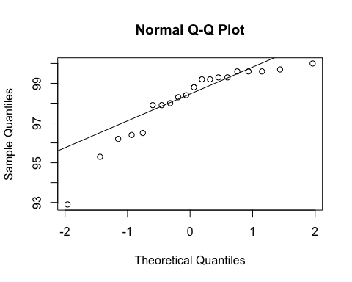
ad.test(subset(SSdata, intervention == "sham")$sao2.Ptst.100to90)
##
## Anderson-Darling normality test
##
## data: subset(SSdata, intervention == "sham")$sao2.Ptst.100to90
## A = 1.0547, p-value = 0.006979
#non-normal
#FYI - unpaired test
wilcox.test(subset(SSdata, intervention == "sham")$sao2.Ptst.100to90,
subset(SSdata, intervention == "PrenaBelt")$sao2.Ptst.100to90,
conf.int = TRUE)
## Warning in wilcox.test.default(subset(SSdata, intervention == "sham")
## $sao2.Ptst.100to90, : cannot compute exact p-value with ties
## Warning in wilcox.test.default(subset(SSdata, intervention == "sham")
## $sao2.Ptst.100to90, : cannot compute exact confidence intervals with ties
##
## Wilcoxon rank sum test with continuity correction
##
## data: subset(SSdata, intervention == "sham")$sao2.Ptst.100to90 and subset(SSdata, intervention == "PrenaBelt")$sao2.Ptst.100to90
## W = 199.5, p-value = 1
## alternative hypothesis: true location shift is not equal to 0
## 95 percent confidence interval:
## -0.7000278 1.2000028
## sample estimates:
## difference in location
## -3.177747e-05
#################### %TST with SpO2 85-89.9% #######################
#FYI: this data was generated in our PSG reports per default configuration but is not a
#pre-specified secondary outcome per the research protocol or trial registry. FYI only.
#Summary
summary(SSdata$sao2.Ptst.89.9to85)
## Min. 1st Qu. Median Mean 3rd Qu. Max.
## 0.0000 0.0000 0.0000 0.0775 0.0000 1.0000
sd(SSdata$sao2.Ptst.89.9to85, na.rm = TRUE)
## [1] 0.2069157
length(SSdata$sao2.Ptst.89.9to85)
## [1] 40
#ANOVA
night_tx_difference <- anova(lm(sao2.Ptst.89.9to85 ~ intervention * night,
data = SSdata))
night_tx_difference
## Analysis of Variance Table
##
## Response: sao2.Ptst.89.9to85
## Df Sum Sq Mean Sq F value Pr(>F)
## intervention 1 0.01225 0.012250 0.2994 0.58764
## night 1 0.00225 0.002250 0.0550 0.81593
## intervention:night 1 0.18225 0.182250 4.4542 0.04183 *
## Residuals 36 1.47300 0.040917
## ---
## Signif. codes: 0 '***' 0.001 '**' 0.01 '*' 0.05 '.' 0.1 ' ' 1
#within-participants (paired) comparison
#Paired Wilcoxon
wilcox.test(subset(SSdataCompletes, intervention == "sham")$sao2.Ptst.89.9to85,
subset(SSdataCompletes, intervention == "PrenaBelt")$sao2.Ptst.89.9to85,
paired = TRUE, conf.int = TRUE)
## Warning in wilcox.test.default(subset(SSdataCompletes, intervention ==
## "sham")$sao2.Ptst.89.9to85, : cannot compute exact p-value with ties
## Warning in wilcox.test.default(subset(SSdataCompletes, intervention ==
## "sham")$sao2.Ptst.89.9to85, : cannot compute exact confidence interval with
## ties
## Warning in wilcox.test.default(subset(SSdataCompletes, intervention ==
## "sham")$sao2.Ptst.89.9to85, : cannot compute exact p-value with zeroes
## Warning in wilcox.test.default(subset(SSdataCompletes, intervention ==
## "sham")$sao2.Ptst.89.9to85, : cannot compute exact confidence interval with
## zeroes
##
## Wilcoxon signed rank test with continuity correction
##
## data: subset(SSdataCompletes, intervention == "sham")$sao2.Ptst.89.9to85 and subset(SSdataCompletes, intervention == "PrenaBelt")$sao2.Ptst.89.9to85
## V = 18, p-value = 0.1198
## alternative hypothesis: true location shift is not equal to 0
## 95 percent confidence interval:
## -0.0999194 0.3999194
## sample estimates:
## (pseudo)median
## 0.1000482
#between participants (grouped) comparison
summary(subset(SSdata, intervention == "PrenaBelt")$sao2.Ptst.89.9to85)
## Min. 1st Qu. Median Mean 3rd Qu. Max.
## 0.00 0.00 0.00 0.06 0.00 0.60
sd(subset(SSdata, intervention == "PrenaBelt")$sao2.Ptst.89.9to85)
## [1] 0.1698296
length(subset(SSdata, intervention == "PrenaBelt")$sao2.Ptst.89.9to85)
## [1] 20
qqnorm(subset(SSdata, intervention == "PrenaBelt")$sao2.Ptst.89.9to85)
qqline(subset(SSdata, intervention == "PrenaBelt")$sao2.Ptst.89.9to85)
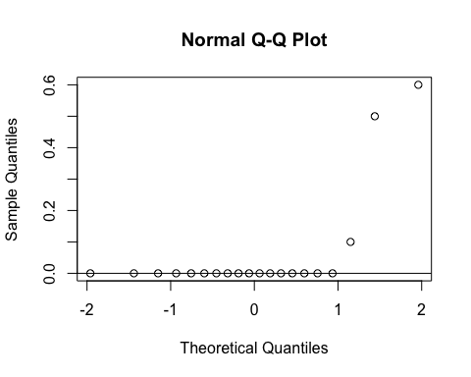
ad.test(subset(SSdata, intervention == "PrenaBelt")$sao2.Ptst.89.9to85)
##
## Anderson-Darling normality test
##
## data: subset(SSdata, intervention == "PrenaBelt")$sao2.Ptst.89.9to85
## A = 5.7807, p-value = 8.032e-15
#non-normal
summary(subset(SSdata, intervention == "sham")$sao2.Ptst.89.9to85)
## Min. 1st Qu. Median Mean 3rd Qu. Max.
## 0.000 0.000 0.000 0.095 0.100 1.000
sd(subset(SSdata, intervention == "sham")$sao2.Ptst.89.9to85)
## [1] 0.24165
length(subset(SSdata, intervention == "sham")$sao2.Ptst.89.9to85)
## [1] 20
qqnorm(subset(SSdata, intervention == "sham")$sao2.Ptst.89.9to85)
qqline(subset(SSdata, intervention == "sham")$sao2.Ptst.89.9to85)
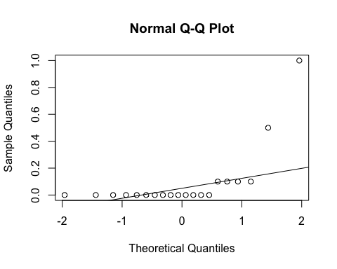
ad.test(subset(SSdata, intervention == "sham")$sao2.Ptst.89.9to85)
##
## Anderson-Darling normality test
##
## data: subset(SSdata, intervention == "sham")$sao2.Ptst.89.9to85
## A = 4.6098, p-value = 6.704e-12
#non-normal
#FYI - unpaired test
wilcox.test(subset(SSdata, intervention == "sham")$sao2.Ptst.89.9to85,
subset(SSdata, intervention == "PrenaBelt")$sao2.Ptst.89.9to85,
conf.int = TRUE)
## Warning in wilcox.test.default(subset(SSdata, intervention == "sham")
## $sao2.Ptst.89.9to85, : cannot compute exact p-value with ties
## Warning in wilcox.test.default(subset(SSdata, intervention == "sham")
## $sao2.Ptst.89.9to85, : cannot compute exact confidence intervals with ties
##
## Wilcoxon rank sum test with continuity correction
##
## data: subset(SSdata, intervention == "sham")$sao2.Ptst.89.9to85 and subset(SSdata, intervention == "PrenaBelt")$sao2.Ptst.89.9to85
## W = 227.5, p-value = 0.317
## alternative hypothesis: true location shift is not equal to 0
## 95 percent confidence interval:
## -1.534144e-05 1.959457e-05
## sample estimates:
## difference in location
## 3.556854e-06
#################### Total Arousal Index in NREM #######################
#FYI: this data was generated in our PSG reports per default configuration but is not a
#pre-specified secondary outcome per the research protocol or trial registry. FYI only.
#Summary
summary(SSdata$total.arousals.nrem.index)
## Min. 1st Qu. Median Mean 3rd Qu. Max.
## 5.20 8.30 12.05 14.89 17.62 60.80
sd(SSdata$total.arousals.nrem.index, na.rm = TRUE)
## [1] 10.14672
length(SSdata$total.arousals.nrem.index)
## [1] 40
#ANOVA
night_tx_difference <- anova(lm(total.arousals.nrem.index ~ intervention * night,
data = SSdata))
night_tx_difference
## Analysis of Variance Table
##
## Response: total.arousals.nrem.index
## Df Sum Sq Mean Sq F value Pr(>F)
## intervention 1 63.3 63.252 0.6102 0.4398
## night 1 190.5 190.532 1.8381 0.1836
## intervention:night 1 29.8 29.756 0.2871 0.5954
## Residuals 36 3731.7 103.660
#within-participants (paired) comparison
#Paired Wilcoxon
wilcox.test(subset(SSdataCompletes, intervention == "sham")$total.arousals.nrem.index,
subset(SSdataCompletes, intervention == "PrenaBelt")$total.arousals.nrem.index,
paired = TRUE, conf.int = TRUE)
##
## Wilcoxon signed rank test
##
## data: subset(SSdataCompletes, intervention == "sham")$total.arousals.nrem.index and subset(SSdataCompletes, intervention == "PrenaBelt")$total.arousals.nrem.index
## V = 100, p-value = 0.8695
## alternative hypothesis: true location shift is not equal to 0
## 95 percent confidence interval:
## -4.70 1.65
## sample estimates:
## (pseudo)median
## -0.2
#between participants (grouped) comparison
summary(subset(SSdata, intervention == "PrenaBelt")$total.arousals.nrem.index)
## Min. 1st Qu. Median Mean 3rd Qu. Max.
## 5.700 7.925 12.000 16.140 20.800 60.800
sd(subset(SSdata, intervention == "PrenaBelt")$total.arousals.nrem.index)
## [1] 12.68192
length(subset(SSdata, intervention == "PrenaBelt")$total.arousals.nrem.index)
## [1] 20
qqnorm(subset(SSdata, intervention == "PrenaBelt")$total.arousals.nrem.index)
qqline(subset(SSdata, intervention == "PrenaBelt")$total.arousals.nrem.index)
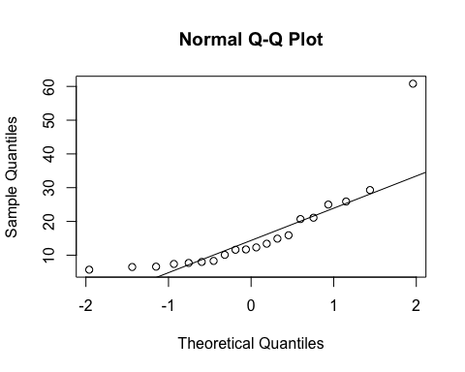
ad.test(subset(SSdata, intervention == "PrenaBelt")$total.arousals.nrem.index)
##
## Anderson-Darling normality test
##
## data: subset(SSdata, intervention == "PrenaBelt")$total.arousals.nrem.index
## A = 1.5656, p-value = 0.0003422
#non-normal
summary(subset(SSdata, intervention == "sham")$total.arousals.nrem.index)
## Min. 1st Qu. Median Mean 3rd Qu. Max.
## 5.20 9.20 12.05 13.63 16.52 30.10
sd(subset(SSdata, intervention == "sham")$total.arousals.nrem.index)
## [1] 6.868088
length(subset(SSdata, intervention == "sham")$total.arousals.nrem.index)
## [1] 20
qqnorm(subset(SSdata, intervention == "sham")$total.arousals.nrem.index)
qqline(subset(SSdata, intervention == "sham")$total.arousals.nrem.index)
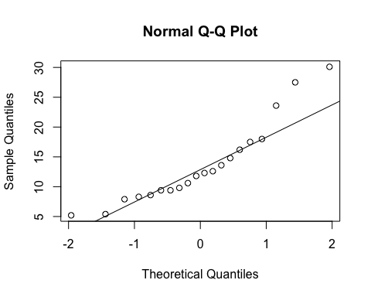
ad.test(subset(SSdata, intervention == "sham")$total.arousals.nrem.index)
##
## Anderson-Darling normality test
##
## data: subset(SSdata, intervention == "sham")$total.arousals.nrem.index
## A = 0.79128, p-value = 0.03318
#non-normal
#FYI - unpaired test
wilcox.test(subset(SSdata, intervention == "sham")$total.arousals.nrem.index,
subset(SSdata, intervention == "PrenaBelt")$total.arousals.nrem.index,
conf.int = TRUE)
## Warning in wilcox.test.default(subset(SSdata, intervention == "sham")
## $total.arousals.nrem.index, : cannot compute exact p-value with ties
## Warning in wilcox.test.default(subset(SSdata, intervention == "sham")
## $total.arousals.nrem.index, : cannot compute exact confidence intervals
## with ties
##
## Wilcoxon rank sum test with continuity correction
##
## data: subset(SSdata, intervention == "sham")$total.arousals.nrem.index and subset(SSdata, intervention == "PrenaBelt")$total.arousals.nrem.index
## W = 198, p-value = 0.9676
## alternative hypothesis: true location shift is not equal to 0
## 95 percent confidence interval:
## -4.900032 3.200041
## sample estimates:
## difference in location
## -0.09996643
#################### Total Arousal Index in REM #######################
#FYI: this data was generated in our PSG reports per default configuration but is not a
#pre-specified secondary outcome per the research protocol or trial registry. FYI only.
#Summary
summary(SSdata$total.arousals.rem.index)
## Min. 1st Qu. Median Mean 3rd Qu. Max.
## 0.00 4.15 7.30 12.68 10.35 84.00
sd(SSdata$total.arousals.rem.index, na.rm = TRUE)
## [1] 17.59224
length(SSdata$total.arousals.rem.index)
## [1] 40
#ANOVA
night_tx_difference <- anova(lm(total.arousals.rem.index ~ intervention * night,
data = SSdata))
night_tx_difference
## Analysis of Variance Table
##
## Response: total.arousals.rem.index
## Df Sum Sq Mean Sq F value Pr(>F)
## intervention 1 13.1 13.11 0.0447 0.83377
## night 1 10.3 10.30 0.0351 0.85241
## intervention:night 1 1484.7 1484.74 5.0607 0.03068 *
## Residuals 36 10561.8 293.38
## ---
## Signif. codes: 0 '***' 0.001 '**' 0.01 '*' 0.05 '.' 0.1 ' ' 1
#within-participants (paired) comparison
#Paired t-test
wilcox.test(subset(SSdataCompletes, intervention == "sham")$total.arousals.rem.index,
subset(SSdataCompletes, intervention == "PrenaBelt")$total.arousals.rem.index,
paired = TRUE, conf.int = TRUE)
## Warning in wilcox.test.default(subset(SSdataCompletes, intervention ==
## "sham")$total.arousals.rem.index, : cannot compute exact p-value with ties
## Warning in wilcox.test.default(subset(SSdataCompletes, intervention
## == "sham")$total.arousals.rem.index, : cannot compute exact confidence
## interval with ties
##
## Wilcoxon signed rank test with continuity correction
##
## data: subset(SSdataCompletes, intervention == "sham")$total.arousals.rem.index and subset(SSdataCompletes, intervention == "PrenaBelt")$total.arousals.rem.index
## V = 91, p-value = 0.6142
## alternative hypothesis: true location shift is not equal to 0
## 95 percent confidence interval:
## -3.350040 2.100039
## sample estimates:
## (pseudo)median
## -0.4334441
#between participants (grouped) comparison
summary(subset(SSdata, intervention == "PrenaBelt")$total.arousals.rem.index)
## Min. 1st Qu. Median Mean 3rd Qu. Max.
## 1.60 4.90 6.65 13.25 10.35 64.30
sd(subset(SSdata, intervention == "PrenaBelt")$total.arousals.rem.index)
## [1] 17.26717
length(subset(SSdata, intervention == "PrenaBelt")$total.arousals.rem.index)
## [1] 20
qqnorm(subset(SSdata, intervention == "PrenaBelt")$total.arousals.rem.index)
qqline(subset(SSdata, intervention == "PrenaBelt")$total.arousals.rem.index)
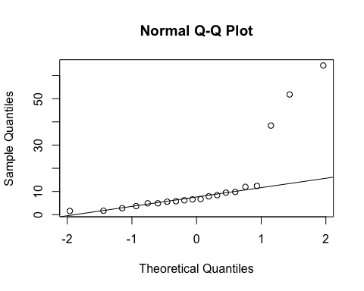
ad.test(subset(SSdata, intervention == "PrenaBelt")$total.arousals.rem.index)
##
## Anderson-Darling normality test
##
## data: subset(SSdata, intervention == "PrenaBelt")$total.arousals.rem.index
## A = 3.3345, p-value = 1.085e-08
#non-normal
summary(subset(SSdata, intervention == "sham")$total.arousals.rem.index)
## Min. 1st Qu. Median Mean 3rd Qu. Max.
## 0.000 3.975 8.000 12.100 10.220 84.000
sd(subset(SSdata, intervention == "sham")$total.arousals.rem.index)
## [1] 18.34168
length(subset(SSdata, intervention == "sham")$total.arousals.rem.index)
## [1] 20
qqnorm(subset(SSdata, intervention == "sham")$total.arousals.rem.index)
qqline(subset(SSdata, intervention == "sham")$total.arousals.rem.index)
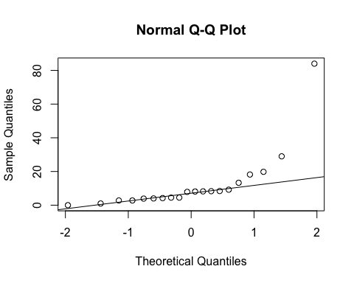
ad.test(subset(SSdata, intervention == "sham")$total.arousals.rem.index)
##
## Anderson-Darling normality test
##
## data: subset(SSdata, intervention == "sham")$total.arousals.rem.index
## A = 3.0671, p-value = 5.152e-08
#non-normal
#FYI - unpaired test
wilcox.test(subset(SSdata, intervention == "sham")$total.arousals.rem.index,
subset(SSdata, intervention == "PrenaBelt")$total.arousals.rem.index,
conf.int = TRUE)
## Warning in wilcox.test.default(subset(SSdata, intervention == "sham")
## $total.arousals.rem.index, : cannot compute exact p-value with ties
## Warning in wilcox.test.default(subset(SSdata, intervention == "sham")
## $total.arousals.rem.index, : cannot compute exact confidence intervals with
## ties
##
## Wilcoxon rank sum test with continuity correction
##
## data: subset(SSdata, intervention == "sham")$total.arousals.rem.index and subset(SSdata, intervention == "PrenaBelt")$total.arousals.rem.index
## W = 186, p-value = 0.7149
## alternative hypothesis: true location shift is not equal to 0
## 95 percent confidence interval:
## -3.899974 2.800023
## sample estimates:
## difference in location
## -0.6999841
#################### Total Arousal Index (TST = NREM + REM) #######################
#Summary
summary(SSdata$total.arousals.total.index)
## Min. 1st Qu. Median Mean 3rd Qu. Max.
## 4.60 8.40 11.30 14.45 17.95 59.60
sd(SSdata$total.arousals.total.index, na.rm = TRUE)
## [1] 10.25068
length(SSdata$total.arousals.total.index)
## [1] 40
qqnorm(SSdata$total.arousals.total.index)
qqline(SSdata$total.arousals.total.index)
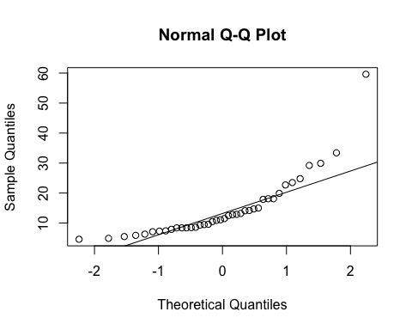
ad.test(SSdata$total.arousals.total.index)
##
## Anderson-Darling normality test
##
## data: SSdata$total.arousals.total.index
## A = 2.5308, p-value = 1.638e-06
#non-normal
#ANOVA
night_tx_difference <- anova(lm(total.arousals.total.index ~ intervention * night,
data = SSdata))
night_tx_difference
## Analysis of Variance Table
##
## Response: total.arousals.total.index
## Df Sum Sq Mean Sq F value Pr(>F)
## intervention 1 59.8 59.78 0.5720 0.4544
## night 1 158.0 158.01 1.5119 0.2268
## intervention:night 1 118.0 117.99 1.1291 0.2951
## Residuals 36 3762.2 104.51
#within-participants (paired) comparison
#Paired Wilcoxon
wilcox.test(subset(SSdataCompletes, intervention == "sham")$total.arousals.total.index,
subset(SSdataCompletes, intervention == "PrenaBelt")$total.arousals.total.index,
paired = TRUE, conf.int = TRUE)
## Warning in wilcox.test.default(subset(SSdataCompletes, intervention ==
## "sham")$total.arousals.total.index, : cannot compute exact p-value with
## ties
## Warning in wilcox.test.default(subset(SSdataCompletes, intervention ==
## "sham")$total.arousals.total.index, : cannot compute exact confidence
## interval with ties
##
## Wilcoxon signed rank test with continuity correction
##
## data: subset(SSdataCompletes, intervention == "sham")$total.arousals.total.index and subset(SSdataCompletes, intervention == "PrenaBelt")$total.arousals.total.index
## V = 90, p-value = 0.5883
## alternative hypothesis: true location shift is not equal to 0
## 95 percent confidence interval:
## -3.499935 1.499994
## sample estimates:
## (pseudo)median
## -0.5984439
#between participants (grouped) comparison
summary(subset(SSdata, intervention == "PrenaBelt")$total.arousals.total.index)
## Min. 1st Qu. Median Mean 3rd Qu. Max.
## 5.500 8.125 11.200 15.680 17.950 59.600
sd(subset(SSdata, intervention == "PrenaBelt")$total.arousals.total.index)
## [1] 12.89508
length(subset(SSdata, intervention == "PrenaBelt")$total.arousals.total.index)
## [1] 20
qqnorm(subset(SSdata, intervention == "PrenaBelt")$total.arousals.total.index)
qqline(subset(SSdata, intervention == "PrenaBelt")$total.arousals.total.index)
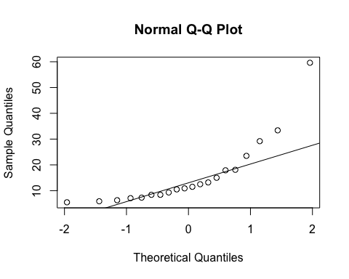
ad.test(subset(SSdata, intervention == "PrenaBelt")$total.arousals.total.index)
##
## Anderson-Darling normality test
##
## data: subset(SSdata, intervention == "PrenaBelt")$total.arousals.total.index
## A = 1.7931, p-value = 8.964e-05
#non-normal
summary(subset(SSdata, intervention == "sham")$total.arousals.total.index)
## Min. 1st Qu. Median Mean 3rd Qu. Max.
## 4.600 8.475 11.950 13.230 15.550 29.900
sd(subset(SSdata, intervention == "sham")$total.arousals.total.index)
## [1] 6.801014
length(subset(SSdata, intervention == "sham")$total.arousals.total.index)
## [1] 20
qqnorm(subset(SSdata, intervention == "sham")$total.arousals.total.index)
qqline(subset(SSdata, intervention == "sham")$total.arousals.total.index)
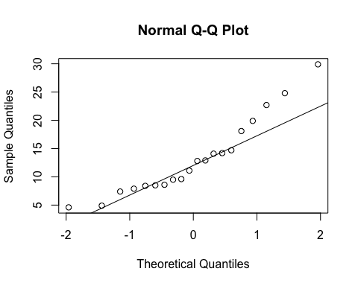
ad.test(subset(SSdata, intervention == "sham")$total.arousals.total.index)
##
## Anderson-Darling normality test
##
## data: subset(SSdata, intervention == "sham")$total.arousals.total.index
## A = 0.65641, p-value = 0.07378
#normal
#FYI - unpaired test
t.test(subset(SSdata, intervention == "sham")$total.arousals.total.index,
subset(SSdata, intervention == "PrenaBelt")$total.arousals.total.index)
##
## Welch Two Sample t-test
##
## data: subset(SSdata, intervention == "sham")$total.arousals.total.index and subset(SSdata, intervention == "PrenaBelt")$total.arousals.total.index
## t = -0.75003, df = 28.811, p-value = 0.4593
## alternative hypothesis: true difference in means is not equal to 0
## 95 percent confidence interval:
## -9.11411 4.22411
## sample estimates:
## mean of x mean of y
## 13.230 15.675
wilcox.test(subset(SSdata, intervention == "sham")$total.arousals.total.index,
subset(SSdata, intervention == "PrenaBelt")$total.arousals.total.index,
conf.int = TRUE)
## Warning in wilcox.test.default(subset(SSdata, intervention == "sham")
## $total.arousals.total.index, : cannot compute exact p-value with ties
## Warning in wilcox.test.default(subset(SSdata, intervention == "sham")
## $total.arousals.total.index, : cannot compute exact confidence intervals
## with ties
##
## Wilcoxon rank sum test with continuity correction
##
## data: subset(SSdata, intervention == "sham")$total.arousals.total.index and subset(SSdata, intervention == "PrenaBelt")$total.arousals.total.index
## W = 201.5, p-value = 0.9784
## alternative hypothesis: true location shift is not equal to 0
## 95 percent confidence interval:
## -4.099936 3.599950
## sample estimates:
## difference in location
## 0.04235554
#################### Spontaneous Arousal Index in NREM #######################
#FYI: this data was generated in our PSG reports per default configuration but is not a
#pre-specified secondary outcome per the research protocol or trial registry. FYI only.
#Summary
summary(SSdata$spontaneous.arousals.nrem.index)
## Min. 1st Qu. Median Mean 3rd Qu. Max.
## 0.800 7.475 10.550 11.490 13.180 26.500
sd(SSdata$spontaneous.arousals.nrem.index, na.rm = TRUE)
## [1] 6.188624
length(SSdata$spontaneous.arousals.nrem.index)
## [1] 40
#ANOVA
night_tx_difference <- anova(lm(spontaneous.arousals.nrem.index ~ intervention * night,
data = SSdata))
night_tx_difference
## Analysis of Variance Table
##
## Response: spontaneous.arousals.nrem.index
## Df Sum Sq Mean Sq F value Pr(>F)
## intervention 1 0.03 0.030 0.0007 0.9784
## night 1 26.73 26.732 0.6565 0.4231
## intervention:night 1 1.06 1.056 0.0259 0.8729
## Residuals 36 1465.84 40.718
#within-participants (paired) comparison
#Paired Wilcoxon
wilcox.test(subset(SSdataCompletes, intervention == "sham")$spontaneous.arousals.nrem.index,
subset(SSdataCompletes, intervention == "PrenaBelt")$spontaneous.arousals.nrem.index,
paired = TRUE, conf.int = TRUE)
## Warning in wilcox.test.default(subset(SSdataCompletes, intervention ==
## "sham")$spontaneous.arousals.nrem.index, : cannot compute exact p-value
## with ties
## Warning in wilcox.test.default(subset(SSdataCompletes, intervention ==
## "sham")$spontaneous.arousals.nrem.index, : cannot compute exact confidence
## interval with ties
##
## Wilcoxon signed rank test with continuity correction
##
## data: subset(SSdataCompletes, intervention == "sham")$spontaneous.arousals.nrem.index and subset(SSdataCompletes, intervention == "PrenaBelt")$spontaneous.arousals.nrem.index
## V = 116.5, p-value = 0.6813
## alternative hypothesis: true location shift is not equal to 0
## 95 percent confidence interval:
## -2.650033 1.900025
## sample estimates:
## (pseudo)median
## 0.3000532
#between participants (grouped) comparison
summary(subset(SSdata, intervention == "PrenaBelt")$spontaneous.arousals.nrem.index)
## Min. 1st Qu. Median Mean 3rd Qu. Max.
## 2.000 7.375 10.750 11.520 13.850 25.000
sd(subset(SSdata, intervention == "PrenaBelt")$spontaneous.arousals.nrem.index)
## [1] 6.15709
length(subset(SSdata, intervention == "PrenaBelt")$spontaneous.arousals.nrem.index)
## [1] 20
qqnorm(subset(SSdata, intervention == "PrenaBelt")$spontaneous.arousals.nrem.index)
qqline(subset(SSdata, intervention == "PrenaBelt")$spontaneous.arousals.nrem.index)
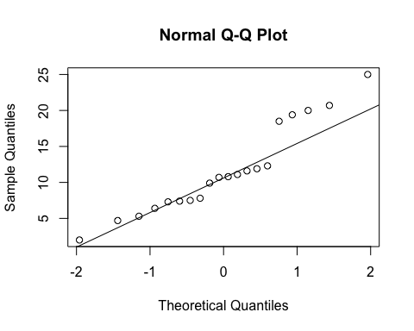
ad.test(subset(SSdata, intervention == "PrenaBelt")$spontaneous.arousals.nrem.index)
##
## Anderson-Darling normality test
##
## data: subset(SSdata, intervention == "PrenaBelt")$spontaneous.arousals.nrem.index
## A = 0.69502, p-value = 0.05869
#normal
summary(subset(SSdata, intervention == "sham")$spontaneous.arousals.nrem.index)
## Min. 1st Qu. Median Mean 3rd Qu. Max.
## 0.80 7.85 10.15 11.46 13.18 26.50
sd(subset(SSdata, intervention == "sham")$spontaneous.arousals.nrem.index)
## [1] 6.379853
length(subset(SSdata, intervention == "sham")$spontaneous.arousals.nrem.index)
## [1] 20
qqnorm(subset(SSdata, intervention == "sham")$spontaneous.arousals.nrem.index)
qqline(subset(SSdata, intervention == "sham")$spontaneous.arousals.nrem.index)
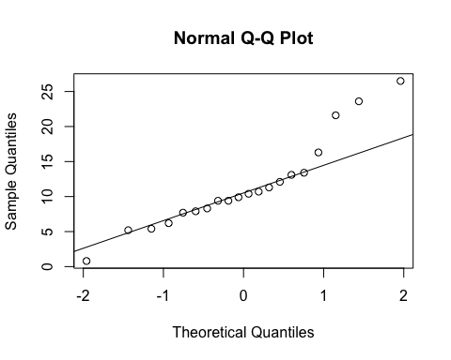
ad.test(subset(SSdata, intervention == "sham")$spontaneous.arousals.nrem.index)
##
## Anderson-Darling normality test
##
## data: subset(SSdata, intervention == "sham")$spontaneous.arousals.nrem.index
## A = 0.77235, p-value = 0.03712
#non-normal
#FYI - unpaired test
t.test(subset(SSdata, intervention == "sham")$spontaneous.arousals.nrem.index,
subset(SSdata, intervention == "PrenaBelt")$spontaneous.arousals.nrem.index)
##
## Welch Two Sample t-test
##
## data: subset(SSdata, intervention == "sham")$spontaneous.arousals.nrem.index and subset(SSdata, intervention == "PrenaBelt")$spontaneous.arousals.nrem.index
## t = -0.027742, df = 37.952, p-value = 0.978
## alternative hypothesis: true difference in means is not equal to 0
## 95 percent confidence interval:
## -4.068685 3.958685
## sample estimates:
## mean of x mean of y
## 11.460 11.515
wilcox.test(subset(SSdata, intervention == "sham")$spontaneous.arousals.nrem.index,
subset(SSdata, intervention == "PrenaBelt")$spontaneous.arousals.nrem.index,
conf.int = TRUE)
## Warning in wilcox.test.default(subset(SSdata, intervention == "sham")
## $spontaneous.arousals.nrem.index, : cannot compute exact p-value with ties
## Warning in wilcox.test.default(subset(SSdata, intervention == "sham")
## $spontaneous.arousals.nrem.index, : cannot compute exact confidence
## intervals with ties
##
## Wilcoxon rank sum test with continuity correction
##
## data: subset(SSdata, intervention == "sham")$spontaneous.arousals.nrem.index and subset(SSdata, intervention == "PrenaBelt")$spontaneous.arousals.nrem.index
## W = 203, p-value = 0.9461
## alternative hypothesis: true location shift is not equal to 0
## 95 percent confidence interval:
## -3.399998 3.200034
## sample estimates:
## difference in location
## 0.15
#################### Spontaneous Arousal Index in REM #######################
#FYI: this data was generated in our PSG reports per default configuration but is not a
#pre-specified secondary outcome per the research protocol or trial registry. FYI only.
#Summary
summary(SSdata$spontaneous.arousals.rem.index)
## Min. 1st Qu. Median Mean 3rd Qu. Max.
## 0.000 2.000 4.250 5.612 7.950 24.000
sd(SSdata$spontaneous.arousals.rem.index, na.rm = TRUE)
## [1] 4.976312
length(SSdata$spontaneous.arousals.rem.index)
## [1] 40
#ANOVA
night_tx_difference <- anova(lm(spontaneous.arousals.rem.index ~ intervention * night,
data = SSdata))
night_tx_difference
## Analysis of Variance Table
##
## Response: spontaneous.arousals.rem.index
## Df Sum Sq Mean Sq F value Pr(>F)
## intervention 1 15.25 15.252 0.6246 0.4345
## night 1 37.44 37.442 1.5334 0.2236
## intervention:night 1 34.04 34.040 1.3941 0.2455
## Residuals 36 879.05 24.418
#within-participants (paired) comparison
#Paired Wilcoxon
wilcox.test(subset(SSdataCompletes, intervention == "sham")$spontaneous.arousals.rem.index,
subset(SSdataCompletes, intervention == "PrenaBelt")$spontaneous.arousals.rem.index,
paired = TRUE, conf.int = TRUE)
## Warning in wilcox.test.default(subset(SSdataCompletes, intervention ==
## "sham")$spontaneous.arousals.rem.index, : cannot compute exact p-value with
## ties
## Warning in wilcox.test.default(subset(SSdataCompletes, intervention ==
## "sham")$spontaneous.arousals.rem.index, : cannot compute exact confidence
## interval with ties
##
## Wilcoxon signed rank test with continuity correction
##
## data: subset(SSdataCompletes, intervention == "sham")$spontaneous.arousals.rem.index and subset(SSdataCompletes, intervention == "PrenaBelt")$spontaneous.arousals.rem.index
## V = 93, p-value = 0.6676
## alternative hypothesis: true location shift is not equal to 0
## 95 percent confidence interval:
## -2.950065 1.549957
## sample estimates:
## (pseudo)median
## -0.3500398
#between participants (grouped) comparison
summary(subset(SSdata, intervention == "PrenaBelt")$spontaneous.arousals.rem.index)
## Min. 1st Qu. Median Mean 3rd Qu. Max.
## 0.000 1.675 4.900 6.230 8.075 24.000
sd(subset(SSdata, intervention == "PrenaBelt")$spontaneous.arousals.rem.index)
## [1] 6.025132
length(subset(SSdata, intervention == "PrenaBelt")$spontaneous.arousals.rem.index)
## [1] 20
qqnorm(subset(SSdata, intervention == "PrenaBelt")$spontaneous.arousals.rem.index)
qqline(subset(SSdata, intervention == "PrenaBelt")$spontaneous.arousals.rem.index)
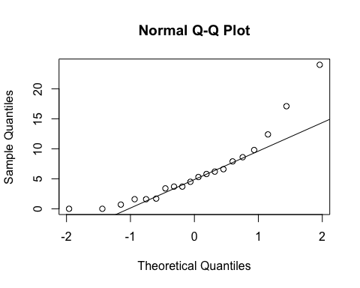
ad.test(subset(SSdata, intervention == "PrenaBelt")$spontaneous.arousals.rem.index)
##
## Anderson-Darling normality test
##
## data: subset(SSdata, intervention == "PrenaBelt")$spontaneous.arousals.rem.index
## A = 0.94606, p-value = 0.01327
#non-normal
summary(subset(SSdata, intervention == "sham")$spontaneous.arousals.rem.index)
## Min. 1st Qu. Median Mean 3rd Qu. Max.
## 0.000 2.400 3.800 4.995 7.800 14.000
sd(subset(SSdata, intervention == "sham")$spontaneous.arousals.rem.index)
## [1] 3.70483
length(subset(SSdata, intervention == "sham")$spontaneous.arousals.rem.index)
## [1] 20
qqnorm(subset(SSdata, intervention == "sham")$spontaneous.arousals.rem.index)
qqline(subset(SSdata, intervention == "sham")$spontaneous.arousals.rem.index)
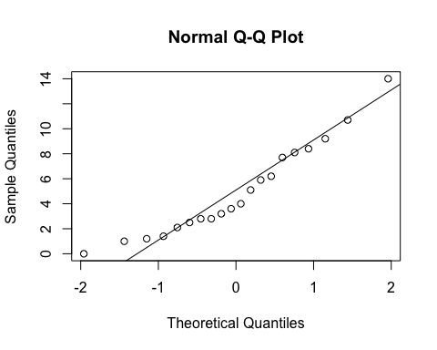
ad.test(subset(SSdata, intervention == "sham")$spontaneous.arousals.rem.index)
##
## Anderson-Darling normality test
##
## data: subset(SSdata, intervention == "sham")$spontaneous.arousals.rem.index
## A = 0.47886, p-value = 0.2093
#normal
#FYI - unpaired test
t.test(subset(SSdata, intervention == "sham")$spontaneous.arousals.rem.index,
subset(SSdata, intervention == "PrenaBelt")$spontaneous.arousals.rem.index)
##
## Welch Two Sample t-test
##
## data: subset(SSdata, intervention == "sham")$spontaneous.arousals.rem.index and subset(SSdata, intervention == "PrenaBelt")$spontaneous.arousals.rem.index
## t = -0.78086, df = 31.571, p-value = 0.4407
## alternative hypothesis: true difference in means is not equal to 0
## 95 percent confidence interval:
## -4.458294 1.988294
## sample estimates:
## mean of x mean of y
## 4.995 6.230
wilcox.test(subset(SSdata, intervention == "sham")$spontaneous.arousals.rem.index,
subset(SSdata, intervention == "PrenaBelt")$spontaneous.arousals.rem.index,
conf.int = TRUE)
## Warning in wilcox.test.default(subset(SSdata, intervention == "sham")
## $spontaneous.arousals.rem.index, : cannot compute exact p-value with ties
## Warning in wilcox.test.default(subset(SSdata, intervention == "sham")
## $spontaneous.arousals.rem.index, : cannot compute exact confidence
## intervals with ties
##
## Wilcoxon rank sum test with continuity correction
##
## data: subset(SSdata, intervention == "sham")$spontaneous.arousals.rem.index and subset(SSdata, intervention == "PrenaBelt")$spontaneous.arousals.rem.index
## W = 185.5, p-value = 0.7048
## alternative hypothesis: true location shift is not equal to 0
## 95 percent confidence interval:
## -3.199951 2.099934
## sample estimates:
## difference in location
## -0.4476729
#################### Spontaneous Arousal Index (TST = NREM + REM) #######################
#Summary
summary(SSdata$spontaneous.arousals.total.index)
## Min. 1st Qu. Median Mean 3rd Qu. Max.
## 1.100 6.975 9.800 10.410 11.980 23.800
sd(SSdata$spontaneous.arousals.total.index, na.rm = TRUE)
## [1] 5.594264
length(SSdata$spontaneous.arousals.total.index)
## [1] 40
qqnorm(SSdata$spontaneous.arousals.total.index)
qqline(SSdata$spontaneous.arousals.total.index)
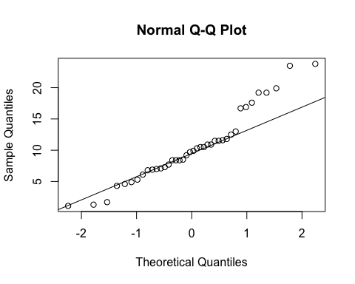
ad.test(SSdata$spontaneous.arousals.total.index)
##
## Anderson-Darling normality test
##
## data: SSdata$spontaneous.arousals.total.index
## A = 0.84189, p-value = 0.02744
#non-normal
#ANOVA
night_tx_difference <- anova(lm(spontaneous.arousals.total.index ~ intervention * night,
data = SSdata))
night_tx_difference
## Analysis of Variance Table
##
## Response: spontaneous.arousals.total.index
## Df Sum Sq Mean Sq F value Pr(>F)
## intervention 1 0.40 0.400 0.0120 0.9132
## night 1 23.72 23.716 0.7138 0.4038
## intervention:night 1 0.26 0.256 0.0077 0.9305
## Residuals 36 1196.16 33.227
#within-participants (paired) comparison
#Paired t-test
t.test(subset(SSdataCompletes, intervention == "sham")$spontaneous.arousals.total.index,
subset(SSdataCompletes, intervention == "PrenaBelt")$spontaneous.arousals.total.index,
paired = TRUE)
##
## Paired t-test
##
## data: subset(SSdataCompletes, intervention == "sham")$spontaneous.arousals.total.index and subset(SSdataCompletes, intervention == "PrenaBelt")$spontaneous.arousals.total.index
## t = -0.17543, df = 19, p-value = 0.8626
## alternative hypothesis: true difference in means is not equal to 0
## 95 percent confidence interval:
## -2.586125 2.186125
## sample estimates:
## mean of the differences
## -0.2
#Double check with Wilcoxon (borderline normal)
wilcox.test(subset(SSdataCompletes, intervention == "sham")$spontaneous.arousals.total.index,
subset(SSdataCompletes, intervention == "PrenaBelt")$spontaneous.arousals.total.index,
paired = TRUE, conf.int = TRUE)
## Warning in wilcox.test.default(subset(SSdataCompletes, intervention ==
## "sham")$spontaneous.arousals.total.index, : cannot compute exact p-value
## with ties
## Warning in wilcox.test.default(subset(SSdataCompletes, intervention ==
## "sham")$spontaneous.arousals.total.index, : cannot compute exact confidence
## interval with ties
##
## Wilcoxon signed rank test with continuity correction
##
## data: subset(SSdataCompletes, intervention == "sham")$spontaneous.arousals.total.index and subset(SSdataCompletes, intervention == "PrenaBelt")$spontaneous.arousals.total.index
## V = 114.5, p-value = 0.7368
## alternative hypothesis: true location shift is not equal to 0
## 95 percent confidence interval:
## -2.500005 1.850093
## sample estimates:
## (pseudo)median
## 0.25
#between participants (grouped) comparison
summary(subset(SSdata, intervention == "PrenaBelt")$spontaneous.arousals.total.index)
## Min. 1st Qu. Median Mean 3rd Qu. Max.
## 1.30 6.95 10.10 10.51 12.88 23.50
sd(subset(SSdata, intervention == "PrenaBelt")$spontaneous.arousals.total.index)
## [1] 5.841854
length(subset(SSdata, intervention == "PrenaBelt")$spontaneous.arousals.total.index)
## [1] 20
qqnorm(subset(SSdata, intervention == "PrenaBelt")$spontaneous.arousals.total.index)
qqline(subset(SSdata, intervention == "PrenaBelt")$spontaneous.arousals.total.index)
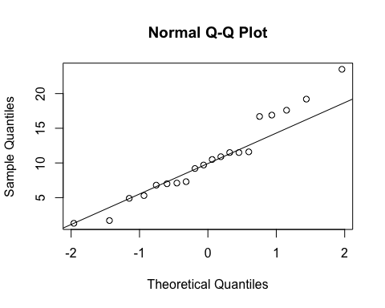
ad.test(subset(SSdata, intervention == "PrenaBelt")$spontaneous.arousals.total.index)
##
## Anderson-Darling normality test
##
## data: subset(SSdata, intervention == "PrenaBelt")$spontaneous.arousals.total.index
## A = 0.37989, p-value = 0.3699
#normal
summary(subset(SSdata, intervention == "sham")$spontaneous.arousals.total.index)
## Min. 1st Qu. Median Mean 3rd Qu. Max.
## 1.10 7.50 9.20 10.31 11.98 23.80
sd(subset(SSdata, intervention == "sham")$spontaneous.arousals.total.index)
## [1] 5.485474
length(subset(SSdata, intervention == "sham")$spontaneous.arousals.total.index)
## [1] 20
qqnorm(subset(SSdata, intervention == "sham")$spontaneous.arousals.total.index)
qqline(subset(SSdata, intervention == "sham")$spontaneous.arousals.total.index)
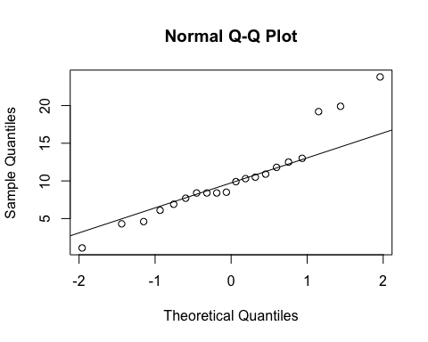
ad.test(subset(SSdata, intervention == "sham")$spontaneous.arousals.total.index)
##
## Anderson-Darling normality test
##
## data: subset(SSdata, intervention == "sham")$spontaneous.arousals.total.index
## A = 0.71308, p-value = 0.05273
#normal
#FYI - unpaired test
t.test(subset(SSdata, intervention == "sham")$spontaneous.arousals.total.index,
subset(SSdata, intervention == "PrenaBelt")$spontaneous.arousals.total.index)
##
## Welch Two Sample t-test
##
## data: subset(SSdata, intervention == "sham")$spontaneous.arousals.total.index and subset(SSdata, intervention == "PrenaBelt")$spontaneous.arousals.total.index
## t = -0.11161, df = 37.85, p-value = 0.9117
## alternative hypothesis: true difference in means is not equal to 0
## 95 percent confidence interval:
## -3.827971 3.427971
## sample estimates:
## mean of x mean of y
## 10.31 10.51
#################### PLMs Index in NREM #######################
#FYI: this data was generated in our PSG reports per default configuration but is not a
#pre-specified secondary outcome per the research protocol or trial registry. FYI only.
#Summary
summary(SSdata$plms.nrem.index)
## Min. 1st Qu. Median Mean 3rd Qu. Max.
## 0.000 0.000 0.850 13.280 9.775 87.800
sd(SSdata$plms.nrem.index, na.rm = TRUE)
## [1] 24.58884
length(SSdata$plms.nrem.index)
## [1] 40
#ANOVA
night_tx_difference <- anova(lm(plms.nrem.index ~ intervention * night,
data = SSdata))
night_tx_difference
## Analysis of Variance Table
##
## Response: plms.nrem.index
## Df Sum Sq Mean Sq F value Pr(>F)
## intervention 1 11.6 11.56 0.0178 0.8945
## night 1 213.9 213.91 0.3303 0.5691
## intervention:night 1 40.6 40.60 0.0627 0.8037
## Residuals 36 23313.8 647.60
#within-participants (paired) comparison
#Paired Wilcoxon
wilcox.test(subset(SSdataCompletes, intervention == "sham")$plms.nrem.index,
subset(SSdataCompletes, intervention == "PrenaBelt")$plms.nrem.index,
paired = TRUE, conf.int = TRUE)
## Warning in wilcox.test.default(subset(SSdataCompletes, intervention ==
## "sham")$plms.nrem.index, : cannot compute exact p-value with zeroes
## Warning in wilcox.test.default(subset(SSdataCompletes, intervention ==
## "sham")$plms.nrem.index, : cannot compute exact confidence interval with
## zeroes
##
## Wilcoxon signed rank test with continuity correction
##
## data: subset(SSdataCompletes, intervention == "sham")$plms.nrem.index and subset(SSdataCompletes, intervention == "PrenaBelt")$plms.nrem.index
## V = 29, p-value = 0.4561
## alternative hypothesis: true location shift is not equal to 0
## 95 percent confidence interval:
## -18.84993 13.74994
## sample estimates:
## (pseudo)median
## -0.8327795
#between participants (grouped) comparison
summary(subset(SSdata, intervention == "PrenaBelt")$plms.nrem.index)
## Min. 1st Qu. Median Mean 3rd Qu. Max.
## 0.000 0.000 1.150 13.820 9.775 87.800
sd(subset(SSdata, intervention == "PrenaBelt")$plms.nrem.index)
## [1] 25.55123
length(subset(SSdata, intervention == "PrenaBelt")$plms.nrem.index)
## [1] 20
qqnorm(subset(SSdata, intervention == "PrenaBelt")$plms.nrem.index)
qqline(subset(SSdata, intervention == "PrenaBelt")$plms.nrem.index)
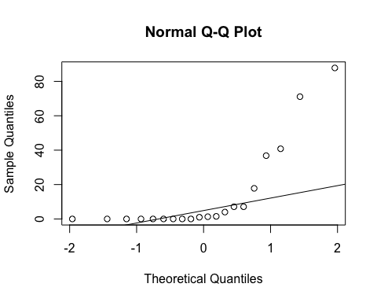
ad.test(subset(SSdata, intervention == "PrenaBelt")$plms.nrem.index)
##
## Anderson-Darling normality test
##
## data: subset(SSdata, intervention == "PrenaBelt")$plms.nrem.index
## A = 3.3293, p-value = 1.119e-08
#non-normal
summary(subset(SSdata, intervention == "sham")$plms.nrem.index)
## Min. 1st Qu. Median Mean 3rd Qu. Max.
## 0.00 0.00 0.35 12.74 8.65 75.10
sd(subset(SSdata, intervention == "sham")$plms.nrem.index)
## [1] 24.23984
length(subset(SSdata, intervention == "sham")$plms.nrem.index)
## [1] 20
qqnorm(subset(SSdata, intervention == "sham")$plms.nrem.index)
qqline(subset(SSdata, intervention == "sham")$plms.nrem.index)
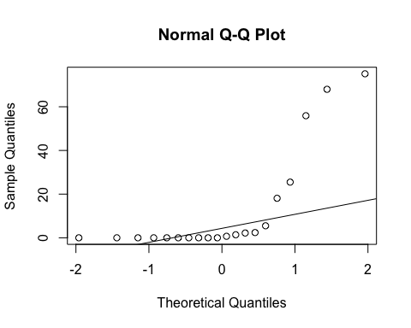
ad.test(subset(SSdata, intervention == "sham")$plms.nrem.index)
##
## Anderson-Darling normality test
##
## data: subset(SSdata, intervention == "sham")$plms.nrem.index
## A = 3.7582, p-value = 9.247e-10
#non-normal
#FYI - unpaired test
wilcox.test(subset(SSdata, intervention == "sham")$plms.nrem.index,
subset(SSdata, intervention == "PrenaBelt")$plms.nrem.index,
conf.int = TRUE)
## Warning in wilcox.test.default(subset(SSdata, intervention == "sham")
## $plms.nrem.index, : cannot compute exact p-value with ties
## Warning in wilcox.test.default(subset(SSdata, intervention == "sham")
## $plms.nrem.index, : cannot compute exact confidence intervals with ties
##
## Wilcoxon rank sum test with continuity correction
##
## data: subset(SSdata, intervention == "sham")$plms.nrem.index and subset(SSdata, intervention == "PrenaBelt")$plms.nrem.index
## W = 189, p-value = 0.7637
## alternative hypothesis: true location shift is not equal to 0
## 95 percent confidence interval:
## -1.800001 1.100068
## sample estimates:
## difference in location
## -3.550462e-05
#################### PLMs Index in REM #######################
#FYI: this data was generated in our PSG reports per default configuration but is not a
#pre-specified secondary outcome per the research protocol or trial registry. FYI only.
#Summary
summary(SSdata$plms.rem.index)
## Min. 1st Qu. Median Mean 3rd Qu. Max.
## 0.00 0.00 0.00 2.43 0.00 37.80
sd(SSdata$plms.rem.index, na.rm = TRUE)
## [1] 8.281682
length(SSdata$plms.rem.index)
## [1] 40
#ANOVA
night_tx_difference <- anova(lm(plms.rem.index ~ intervention * night,
data = SSdata))
night_tx_difference
## Analysis of Variance Table
##
## Response: plms.rem.index
## Df Sum Sq Mean Sq F value Pr(>F)
## intervention 1 1.94 1.936 0.0268 0.8708
## night 1 0.04 0.036 0.0005 0.9823
## intervention:night 1 73.98 73.984 1.0248 0.3181
## Residuals 36 2598.91 72.192
#within-participants (paired) comparison
#Paired Wilcoxon
wilcox.test(subset(SSdataCompletes, intervention == "sham")$plms.rem.index,
subset(SSdataCompletes, intervention == "PrenaBelt")$plms.rem.index,
paired = TRUE, conf.int = TRUE)
## Warning in wilcox.test.default(subset(SSdataCompletes, intervention ==
## "sham")$plms.rem.index, : requested conf.level not achievable
## Warning in wilcox.test.default(subset(SSdataCompletes, intervention ==
## "sham")$plms.rem.index, : cannot compute exact p-value with zeroes
## Warning in wilcox.test.default(subset(SSdataCompletes, intervention ==
## "sham")$plms.rem.index, : cannot compute exact confidence interval with
## zeroes
##
## Wilcoxon signed rank test with continuity correction
##
## data: subset(SSdataCompletes, intervention == "sham")$plms.rem.index and subset(SSdataCompletes, intervention == "PrenaBelt")$plms.rem.index
## V = 11, p-value = 0.4185
## alternative hypothesis: true location shift is not equal to 0
## 80 percent confidence interval:
## -0.8000532 4.5500270
## sample estimates:
## (pseudo)median
## 1.799949
#between participants (grouped) comparison
summary(subset(SSdata, intervention == "PrenaBelt")$plms.rem.index)
## Min. 1st Qu. Median Mean 3rd Qu. Max.
## 0.00 0.00 0.00 2.21 0.00 36.00
sd(subset(SSdata, intervention == "PrenaBelt")$plms.rem.index)
## [1] 8.055459
length(subset(SSdata, intervention == "PrenaBelt")$plms.rem.index)
## [1] 20
qqnorm(subset(SSdata, intervention == "PrenaBelt")$plms.rem.index)
qqline(subset(SSdata, intervention == "PrenaBelt")$plms.rem.index)
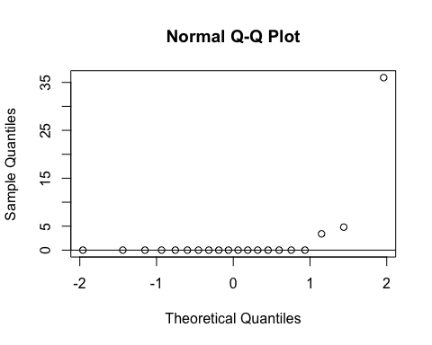
ad.test(subset(SSdata, intervention == "PrenaBelt")$plms.rem.index)
##
## Anderson-Darling normality test
##
## data: subset(SSdata, intervention == "PrenaBelt")$plms.rem.index
## A = 6.0576, p-value = 1.651e-15
#non-normal
summary(subset(SSdata, intervention == "sham")$plms.rem.index)
## Min. 1st Qu. Median Mean 3rd Qu. Max.
## 0.00 0.00 0.00 2.65 0.00 37.80
sd(subset(SSdata, intervention == "sham")$plms.rem.index)
## [1] 8.705745
length(subset(SSdata, intervention == "sham")$plms.rem.index)
## [1] 20
qqnorm(subset(SSdata, intervention == "sham")$plms.rem.index)
qqline(subset(SSdata, intervention == "sham")$plms.rem.index)
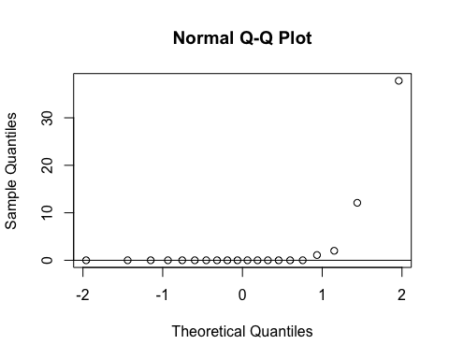
ad.test(subset(SSdata, intervention == "sham")$plms.rem.index)
##
## Anderson-Darling normality test
##
## data: subset(SSdata, intervention == "sham")$plms.rem.index
## A = 5.7316, p-value = 1.064e-14
#non-normal
#FYI - unpaired test
wilcox.test(subset(SSdata, intervention == "sham")$plms.rem.index,
subset(SSdata, intervention == "PrenaBelt")$plms.rem.index,
conf.int = TRUE)
## Warning in wilcox.test.default(subset(SSdata, intervention == "sham")
## $plms.rem.index, : cannot compute exact p-value with ties
## Warning in wilcox.test.default(subset(SSdata, intervention == "sham")
## $plms.rem.index, : cannot compute exact confidence intervals with ties
##
## Wilcoxon rank sum test with continuity correction
##
## data: subset(SSdata, intervention == "sham")$plms.rem.index and subset(SSdata, intervention == "PrenaBelt")$plms.rem.index
## W = 209, p-value = 0.7285
## alternative hypothesis: true location shift is not equal to 0
## 95 percent confidence interval:
## -2.226857e-05 1.825006e-06
## sample estimates:
## difference in location
## 4.496583e-05
#################### PLMs Total Index (TST = NREM + REM) #######################
#FYI: this data was generated in our PSG reports per default configuration but is not a
#pre-specified secondary outcome per the research protocol or trial registry. FYI only.
#Summary
summary(SSdata$plms.total.index)
## Min. 1st Qu. Median Mean 3rd Qu. Max.
## 0.000 0.000 0.850 11.360 8.775 75.200
sd(SSdata$plms.total.index, na.rm = TRUE)
## [1] 21.15996
length(SSdata$plms.total.index)
## [1] 40
#ANOVA
night_tx_difference <- anova(lm(plms.total.index ~ intervention * night,
data = SSdata))
night_tx_difference
## Analysis of Variance Table
##
## Response: plms.total.index
## Df Sum Sq Mean Sq F value Pr(>F)
## intervention 1 23.3 23.26 0.0487 0.8265
## night 1 219.5 219.49 0.4599 0.5020
## intervention:night 1 37.1 37.06 0.0776 0.7821
## Residuals 36 17182.2 477.28
#within-participants (paired) comparison
#Paired Wilcoxon
wilcox.test(subset(SSdataCompletes, intervention == "sham")$plms.total.index,
subset(SSdataCompletes, intervention == "PrenaBelt")$plms.total.index,
paired = TRUE, conf.int = TRUE)
## Warning in wilcox.test.default(subset(SSdataCompletes, intervention ==
## "sham")$plms.total.index, : cannot compute exact p-value with zeroes
## Warning in wilcox.test.default(subset(SSdataCompletes, intervention ==
## "sham")$plms.total.index, : cannot compute exact confidence interval with
## zeroes
##
## Wilcoxon signed rank test with continuity correction
##
## data: subset(SSdataCompletes, intervention == "sham")$plms.total.index and subset(SSdataCompletes, intervention == "PrenaBelt")$plms.total.index
## V = 25, p-value = 0.2896
## alternative hypothesis: true location shift is not equal to 0
## 95 percent confidence interval:
## -17.249992 8.399971
## sample estimates:
## (pseudo)median
## -1.298512
#between participants (grouped) comparison
summary(subset(SSdata, intervention == "PrenaBelt")$plms.total.index)
## Min. 1st Qu. Median Mean 3rd Qu. Max.
## 0.000 0.000 1.150 12.120 8.975 75.200
sd(subset(SSdata, intervention == "PrenaBelt")$plms.total.index)
## [1] 22.62638
length(subset(SSdata, intervention == "PrenaBelt")$plms.total.index)
## [1] 20
qqnorm(subset(SSdata, intervention == "PrenaBelt")$plms.total.index)
qqline(subset(SSdata, intervention == "PrenaBelt")$plms.total.index)
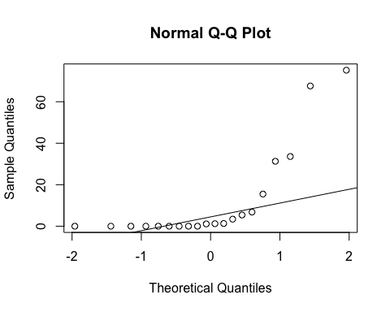
ad.test(subset(SSdata, intervention == "PrenaBelt")$plms.total.index)
##
## Anderson-Darling normality test
##
## data: subset(SSdata, intervention == "PrenaBelt")$plms.total.index
## A = 3.4069, p-value = 7.121e-09
#non-normal
summary(subset(SSdata, intervention == "sham")$plms.total.index)
## Min. 1st Qu. Median Mean 3rd Qu. Max.
## 0.000 0.000 0.300 10.600 7.425 68.000
sd(subset(SSdata, intervention == "sham")$plms.total.index)
## [1] 20.14637
length(subset(SSdata, intervention == "sham")$plms.total.index)
## [1] 20
qqnorm(subset(SSdata, intervention == "sham")$plms.total.index)
qqline(subset(SSdata, intervention == "sham")$plms.total.index)
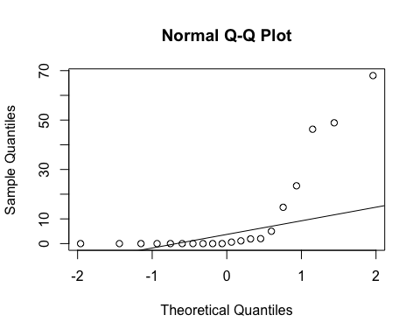
ad.test(subset(SSdata, intervention == "sham")$plms.total.index)
##
## Anderson-Darling normality test
##
## data: subset(SSdata, intervention == "sham")$plms.total.index
## A = 3.6327, p-value = 1.917e-09
#non-normal
#FYI - unpaired test
wilcox.test(subset(SSdata, intervention == "sham")$plms.total.index,
subset(SSdata, intervention == "PrenaBelt")$plms.total.index,
conf.int = TRUE)
## Warning in wilcox.test.default(subset(SSdata, intervention == "sham")
## $plms.total.index, : cannot compute exact p-value with ties
## Warning in wilcox.test.default(subset(SSdata, intervention == "sham")
## $plms.total.index, : cannot compute exact confidence intervals with ties
##
## Wilcoxon rank sum test with continuity correction
##
## data: subset(SSdata, intervention == "sham")$plms.total.index and subset(SSdata, intervention == "PrenaBelt")$plms.total.index
## W = 186.5, p-value = 0.7098
## alternative hypothesis: true location shift is not equal to 0
## 95 percent confidence interval:
## -1.8000395 0.7000302
## sample estimates:
## difference in location
## -4.60136e-05
#################### PLM Arousals Index in NREM #######################
#FYI: this data was generated in our PSG reports per default configuration but is not a
#pre-specified secondary outcome per the research protocol or trial registry. FYI only.
#Summary
summary(SSdata$plm.arousals.nrem.index)
## Min. 1st Qu. Median Mean 3rd Qu. Max.
## 0.000 0.000 0.000 2.245 0.850 38.900
sd(SSdata$plm.arousals.nrem.index, na.rm = TRUE)
## [1] 6.766886
length(SSdata$plm.arousals.nrem.index)
## [1] 40
#ANOVA
night_tx_difference <- anova(lm(plm.arousals.nrem.index ~ intervention * night,
data = SSdata))
night_tx_difference
## Analysis of Variance Table
##
## Response: plm.arousals.nrem.index
## Df Sum Sq Mean Sq F value Pr(>F)
## intervention 1 27.89 27.889 0.5852 0.4493
## night 1 40.80 40.804 0.8563 0.3610
## intervention:night 1 1.60 1.600 0.0336 0.8556
## Residuals 36 1715.55 47.654
#within-participants (paired) comparison
#Paired Wilcoxon
wilcox.test(subset(SSdataCompletes, intervention == "sham")$plm.arousals.nrem.index,
subset(SSdataCompletes, intervention == "PrenaBelt")$plm.arousals.nrem.index,
paired = TRUE, conf.int = TRUE)
## Warning in wilcox.test.default(subset(SSdataCompletes, intervention ==
## "sham")$plm.arousals.nrem.index, : cannot compute exact p-value with ties
## Warning in wilcox.test.default(subset(SSdataCompletes, intervention ==
## "sham")$plm.arousals.nrem.index, : cannot compute exact confidence interval
## with ties
## Warning in wilcox.test.default(subset(SSdataCompletes, intervention ==
## "sham")$plm.arousals.nrem.index, : cannot compute exact p-value with zeroes
## Warning in wilcox.test.default(subset(SSdataCompletes, intervention ==
## "sham")$plm.arousals.nrem.index, : cannot compute exact confidence interval
## with zeroes
##
## Wilcoxon signed rank test with continuity correction
##
## data: subset(SSdataCompletes, intervention == "sham")$plm.arousals.nrem.index and subset(SSdataCompletes, intervention == "PrenaBelt")$plm.arousals.nrem.index
## V = 24.5, p-value = 0.4767
## alternative hypothesis: true location shift is not equal to 0
## 95 percent confidence interval:
## -15.000023 1.300048
## sample estimates:
## (pseudo)median
## -0.2999436
#between participants (grouped) comparison
summary(subset(SSdata, intervention == "PrenaBelt")$plm.arousals.nrem.index)
## Min. 1st Qu. Median Mean 3rd Qu. Max.
## 0.000 0.000 0.000 3.080 1.025 38.900
sd(subset(SSdata, intervention == "PrenaBelt")$plm.arousals.nrem.index)
## [1] 8.933886
length(subset(SSdata, intervention == "PrenaBelt")$plm.arousals.nrem.index)
## [1] 20
qqnorm(subset(SSdata, intervention == "PrenaBelt")$plm.arousals.nrem.index)
qqline(subset(SSdata, intervention == "PrenaBelt")$plm.arousals.nrem.index)
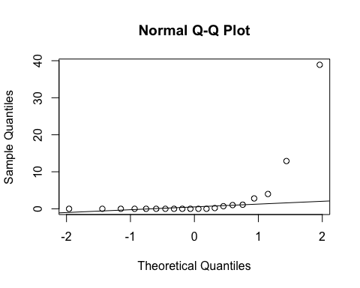
ad.test(subset(SSdata, intervention == "PrenaBelt")$plm.arousals.nrem.index)
##
## Anderson-Darling normality test
##
## data: subset(SSdata, intervention == "PrenaBelt")$plm.arousals.nrem.index
## A = 5.0288, p-value = 5.999e-13
#non-normal
summary(subset(SSdata, intervention == "sham")$plm.arousals.nrem.index)
## Min. 1st Qu. Median Mean 3rd Qu. Max.
## 0.000 0.000 0.000 1.410 0.725 15.400
sd(subset(SSdata, intervention == "sham")$plm.arousals.nrem.index)
## [1] 3.56502
length(subset(SSdata, intervention == "sham")$plm.arousals.nrem.index)
## [1] 20
qqnorm(subset(SSdata, intervention == "sham")$plm.arousals.nrem.index)
qqline(subset(SSdata, intervention == "sham")$plm.arousals.nrem.index)
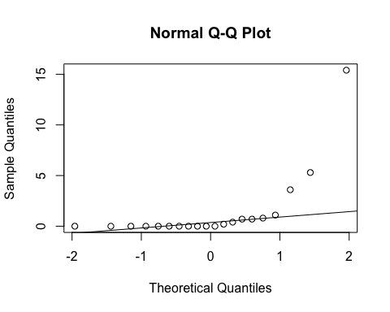
ad.test(subset(SSdata, intervention == "sham")$plm.arousals.nrem.index)
##
## Anderson-Darling normality test
##
## data: subset(SSdata, intervention == "sham")$plm.arousals.nrem.index
## A = 4.353, p-value = 2.952e-11
#non-normal
#FYI - unpaired test
wilcox.test(subset(SSdata, intervention == "sham")$plm.arousals.nrem.index,
subset(SSdata, intervention == "PrenaBelt")$plm.arousals.nrem.index,
conf.int = TRUE)
## Warning in wilcox.test.default(subset(SSdata, intervention == "sham")
## $plm.arousals.nrem.index, : cannot compute exact p-value with ties
## Warning in wilcox.test.default(subset(SSdata, intervention == "sham")
## $plm.arousals.nrem.index, : cannot compute exact confidence intervals with
## ties
##
## Wilcoxon rank sum test with continuity correction
##
## data: subset(SSdata, intervention == "sham")$plm.arousals.nrem.index and subset(SSdata, intervention == "PrenaBelt")$plm.arousals.nrem.index
## W = 202, p-value = 0.964
## alternative hypothesis: true location shift is not equal to 0
## 95 percent confidence interval:
## -0.1999861 0.1999049
## sample estimates:
## difference in location
## 4.324873e-05
#################### PLM Arousals Index in REM #######################
#FYI: this data was generated in our PSG reports per default configuration but is not a
#pre-specified secondary outcome per the research protocol or trial registry. FYI only.
#Summary
summary(SSdata$plm.arousals.rem.index)
## Min. 1st Qu. Median Mean 3rd Qu. Max.
## 0.00 0.00 0.00 0.44 0.00 5.90
sd(SSdata$plm.arousals.rem.index, na.rm = TRUE)
## [1] 1.342749
length(SSdata$plm.arousals.rem.index)
## [1] 40
#ANOVA
night_tx_difference <- anova(lm(plm.arousals.rem.index ~ intervention * night,
data = SSdata))
night_tx_difference
## Analysis of Variance Table
##
## Response: plm.arousals.rem.index
## Df Sum Sq Mean Sq F value Pr(>F)
## intervention 1 0.169 0.1690 0.0894 0.7666
## night 1 1.600 1.6000 0.8468 0.3636
## intervention:night 1 0.529 0.5290 0.2800 0.6000
## Residuals 36 68.018 1.8894
#within-participants (paired) comparison
#Paired Wilcoxon
wilcox.test(subset(SSdataCompletes, intervention == "sham")$plm.arousals.rem.index,
subset(SSdataCompletes, intervention == "PrenaBelt")$plm.arousals.rem.index,
paired = TRUE, conf.int = TRUE)
## Warning in wilcox.test.default(subset(SSdataCompletes, intervention ==
## "sham")$plm.arousals.rem.index, : requested conf.level not achievable
## Warning in wilcox.test.default(subset(SSdataCompletes, intervention ==
## "sham")$plm.arousals.rem.index, : cannot compute exact p-value with zeroes
## Warning in wilcox.test.default(subset(SSdataCompletes, intervention ==
## "sham")$plm.arousals.rem.index, : cannot compute exact confidence interval
## with zeroes
##
## Wilcoxon signed rank test with continuity correction
##
## data: subset(SSdataCompletes, intervention == "sham")$plm.arousals.rem.index and subset(SSdataCompletes, intervention == "PrenaBelt")$plm.arousals.rem.index
## V = 7, p-value = 1
## alternative hypothesis: true location shift is not equal to 0
## 80 percent confidence interval:
## -2.100052 1.150009
## sample estimates:
## (pseudo)median
## -0.05003072
#between participants (grouped) comparison
summary(subset(SSdata, intervention == "PrenaBelt")$plm.arousals.rem.index)
## Min. 1st Qu. Median Mean 3rd Qu. Max.
## 0.000 0.000 0.000 0.505 0.000 4.800
sd(subset(SSdata, intervention == "PrenaBelt")$plm.arousals.rem.index)
## [1] 1.391506
length(subset(SSdata, intervention == "PrenaBelt")$plm.arousals.rem.index)
## [1] 20
qqnorm(subset(SSdata, intervention == "PrenaBelt")$plm.arousals.rem.index)
qqline(subset(SSdata, intervention == "PrenaBelt")$plm.arousals.rem.index)
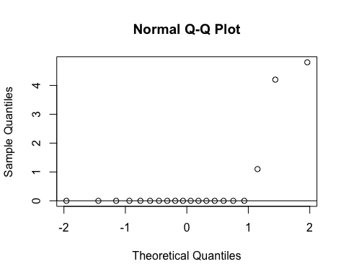
ad.test(subset(SSdata, intervention == "PrenaBelt")$plm.arousals.rem.index)
##
## Anderson-Darling normality test
##
## data: subset(SSdata, intervention == "PrenaBelt")$plm.arousals.rem.index
## A = 5.6741, p-value = 1.478e-14
#non-normal
summary(subset(SSdata, intervention == "sham")$plm.arousals.rem.index)
## Min. 1st Qu. Median Mean 3rd Qu. Max.
## 0.000 0.000 0.000 0.375 0.000 5.900
sd(subset(SSdata, intervention == "sham")$plm.arousals.rem.index)
## [1] 1.325012
length(subset(SSdata, intervention == "sham")$plm.arousals.rem.index)
## [1] 20
qqnorm(subset(SSdata, intervention == "sham")$plm.arousals.rem.index)
qqline(subset(SSdata, intervention == "sham")$plm.arousals.rem.index)
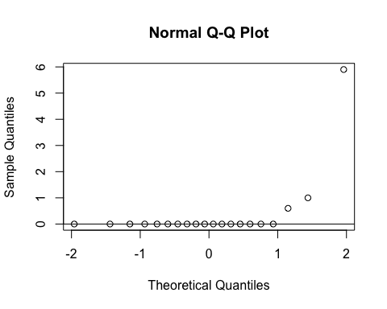
ad.test(subset(SSdata, intervention == "sham")$plm.arousals.rem.index)
##
## Anderson-Darling normality test
##
## data: subset(SSdata, intervention == "sham")$plm.arousals.rem.index
## A = 5.9139, p-value = 3.75e-15
#non-normal
#FYI - unpaired test
wilcox.test(subset(SSdata, intervention == "sham")$plm.arousals.rem.index,
subset(SSdata, intervention == "PrenaBelt")$plm.arousals.rem.index,
conf.int = TRUE)
## Warning in wilcox.test.default(subset(SSdata, intervention == "sham")
## $plm.arousals.rem.index, : cannot compute exact p-value with ties
## Warning in wilcox.test.default(subset(SSdata, intervention == "sham")
## $plm.arousals.rem.index, : cannot compute exact confidence intervals with
## ties
##
## Wilcoxon rank sum test with continuity correction
##
## data: subset(SSdata, intervention == "sham")$plm.arousals.rem.index and subset(SSdata, intervention == "PrenaBelt")$plm.arousals.rem.index
## W = 198.5, p-value = 0.9653
## alternative hypothesis: true location shift is not equal to 0
## 95 percent confidence interval:
## -1.538669e-05 6.131588e-05
## sample estimates:
## difference in location
## -3.635924e-05
#################### PLM Arousals Total Index (TST = NREM + REM) #######################
#Summary
summary(SSdata$plm.arousals.total.index)
## Min. 1st Qu. Median Mean 3rd Qu. Max.
## 0.000 0.000 0.000 2.040 0.825 37.100
sd(SSdata$plm.arousals.total.index, na.rm = TRUE)
## [1] 6.334877
length(SSdata$plm.arousals.total.index)
## [1] 40
qqnorm(SSdata$plm.arousals.total.index)
qqline(SSdata$plm.arousals.total.index)
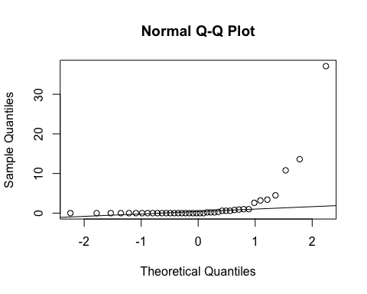
ad.test(SSdata$plm.arousals.total.index)
##
## Anderson-Darling normality test
##
## data: SSdata$plm.arousals.total.index
## A = 9.7136, p-value < 2.2e-16
#non-normal
#ANOVA
night_tx_difference <- anova(lm(plm.arousals.total.index ~ intervention * night,
data = SSdata))
night_tx_difference
## Analysis of Variance Table
##
## Response: plm.arousals.total.index
## Df Sum Sq Mean Sq F value Pr(>F)
## intervention 1 25.28 25.281 0.6075 0.4408
## night 1 38.81 38.809 0.9326 0.3406
## intervention:night 1 2.92 2.916 0.0701 0.7927
## Residuals 36 1498.09 41.614
#within-participants (paired) comparison
#Paired Wilcoxon
wilcox.test(subset(SSdataCompletes, intervention == "sham")$plm.arousals.total.index,
subset(SSdataCompletes, intervention == "PrenaBelt")$plm.arousals.total.index,
paired = TRUE, conf.int = TRUE)
## Warning in wilcox.test.default(subset(SSdataCompletes, intervention ==
## "sham")$plm.arousals.total.index, : cannot compute exact p-value with
## zeroes
## Warning in wilcox.test.default(subset(SSdataCompletes, intervention
## == "sham")$plm.arousals.total.index, : cannot compute exact confidence
## interval with zeroes
##
## Wilcoxon signed rank test with continuity correction
##
## data: subset(SSdataCompletes, intervention == "sham")$plm.arousals.total.index and subset(SSdataCompletes, intervention == "PrenaBelt")$plm.arousals.total.index
## V = 23, p-value = 0.6835
## alternative hypothesis: true location shift is not equal to 0
## 95 percent confidence interval:
## -15.999946 1.499952
## sample estimates:
## (pseudo)median
## -0.2999886
#between participants (grouped) comparison
summary(subset(SSdata, intervention == "PrenaBelt")$plm.arousals.total.index)
## Min. 1st Qu. Median Mean 3rd Qu. Max.
## 0.000 0.000 0.000 2.835 1.000 37.100
sd(subset(SSdata, intervention == "PrenaBelt")$plm.arousals.total.index)
## [1] 8.438712
length(subset(SSdata, intervention == "PrenaBelt")$plm.arousals.total.index)
## [1] 20
qqnorm(subset(SSdata, intervention == "PrenaBelt")$plm.arousals.total.index)
qqline(subset(SSdata, intervention == "PrenaBelt")$plm.arousals.total.index)
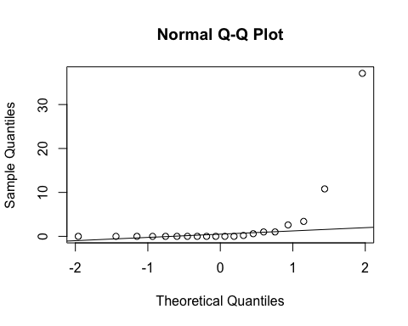
ad.test(subset(SSdata, intervention == "PrenaBelt")$plm.arousals.total.index)
##
## Anderson-Darling normality test
##
## data: subset(SSdata, intervention == "PrenaBelt")$plm.arousals.total.index
## A = 5.1126, p-value = 3.705e-13
#non-normal
summary(subset(SSdata, intervention == "sham")$plm.arousals.total.index)
## Min. 1st Qu. Median Mean 3rd Qu. Max.
## 0.000 0.000 0.100 1.245 0.650 13.600
sd(subset(SSdata, intervention == "sham")$plm.arousals.total.index)
## [1] 3.135447
length(subset(SSdata, intervention == "sham")$plm.arousals.total.index)
## [1] 20
qqnorm(subset(SSdata, intervention == "sham")$plm.arousals.total.index)
qqline(subset(SSdata, intervention == "sham")$plm.arousals.total.index)
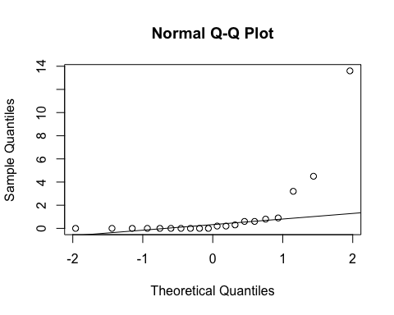
ad.test(subset(SSdata, intervention == "sham")$plm.arousals.total.index)
##
## Anderson-Darling normality test
##
## data: subset(SSdata, intervention == "sham")$plm.arousals.total.index
## A = 4.3437, p-value = 3.116e-11
#non-normal
#FYI - unpaired test
wilcox.test(subset(SSdata, intervention == "sham")$plm.arousals.total.index,
subset(SSdata, intervention == "PrenaBelt")$plm.arousals.total.index,
conf.int = TRUE)
## Warning in wilcox.test.default(subset(SSdata, intervention == "sham")
## $plm.arousals.total.index, : cannot compute exact p-value with ties
## Warning in wilcox.test.default(subset(SSdata, intervention == "sham")
## $plm.arousals.total.index, : cannot compute exact confidence intervals with
## ties
##
## Wilcoxon rank sum test with continuity correction
##
## data: subset(SSdata, intervention == "sham")$plm.arousals.total.index and subset(SSdata, intervention == "PrenaBelt")$plm.arousals.total.index
## W = 207, p-value = 0.8472
## alternative hypothesis: true location shift is not equal to 0
## 95 percent confidence interval:
## -0.1999686 0.2000065
## sample estimates:
## difference in location
## 4.063208e-05
#################### Respiratory Arousals Index in NREM #######################
#FYI: this data was generated in our PSG reports per default configuration but is not a
#pre-specified secondary outcome per the research protocol or trial registry. FYI only.
#Summary
summary(SSdata$respiratory.arousals.nrem.index)
## Min. 1st Qu. Median Mean 3rd Qu. Max.
## 0.00 0.00 0.20 1.11 0.80 11.10
sd(SSdata$respiratory.arousals.nrem.index, na.rm = TRUE)
## [1] 2.639716
length(SSdata$respiratory.arousals.nrem.index)
## [1] 40
#ANOVA
night_tx_difference <- anova(lm(respiratory.arousals.nrem.index ~ intervention * night,
data = SSdata))
night_tx_difference
## Analysis of Variance Table
##
## Response: respiratory.arousals.nrem.index
## Df Sum Sq Mean Sq F value Pr(>F)
## intervention 1 6.084 6.0840 0.9328 0.34058
## night 1 4.624 4.6240 0.7089 0.40535
## intervention:night 1 26.244 26.2440 4.0237 0.05242 .
## Residuals 36 234.804 6.5223
## ---
## Signif. codes: 0 '***' 0.001 '**' 0.01 '*' 0.05 '.' 0.1 ' ' 1
#within-participants (paired) comparison
#Paired Wilcoxon
wilcox.test(subset(SSdataCompletes, intervention == "sham")$respiratory.arousals.nrem.index,
subset(SSdataCompletes, intervention == "PrenaBelt")$respiratory.arousals.nrem.index,
paired = TRUE, conf.int = TRUE)
## Warning in wilcox.test.default(subset(SSdataCompletes, intervention ==
## "sham")$respiratory.arousals.nrem.index, : cannot compute exact p-value
## with ties
## Warning in wilcox.test.default(subset(SSdataCompletes, intervention ==
## "sham")$respiratory.arousals.nrem.index, : cannot compute exact confidence
## interval with ties
## Warning in wilcox.test.default(subset(SSdataCompletes, intervention ==
## "sham")$respiratory.arousals.nrem.index, : cannot compute exact p-value
## with zeroes
## Warning in wilcox.test.default(subset(SSdataCompletes, intervention ==
## "sham")$respiratory.arousals.nrem.index, : cannot compute exact confidence
## interval with zeroes
##
## Wilcoxon signed rank test with continuity correction
##
## data: subset(SSdataCompletes, intervention == "sham")$respiratory.arousals.nrem.index and subset(SSdataCompletes, intervention == "PrenaBelt")$respiratory.arousals.nrem.index
## V = 30, p-value = 0.09338
## alternative hypothesis: true location shift is not equal to 0
## 95 percent confidence interval:
## -1.15001291 0.05002172
## sample estimates:
## (pseudo)median
## -0.3500664
#between participants (grouped) comparison
summary(subset(SSdata, intervention == "PrenaBelt")$respiratory.arousals.nrem.index)
## Min. 1st Qu. Median Mean 3rd Qu. Max.
## 0.0 0.0 0.3 1.5 0.8 11.1
sd(subset(SSdata, intervention == "PrenaBelt")$respiratory.arousals.nrem.index)
## [1] 3.251558
length(subset(SSdata, intervention == "PrenaBelt")$respiratory.arousals.nrem.index)
## [1] 20
qqnorm(subset(SSdata, intervention == "PrenaBelt")$respiratory.arousals.nrem.index)
qqline(subset(SSdata, intervention == "PrenaBelt")$respiratory.arousals.nrem.index)
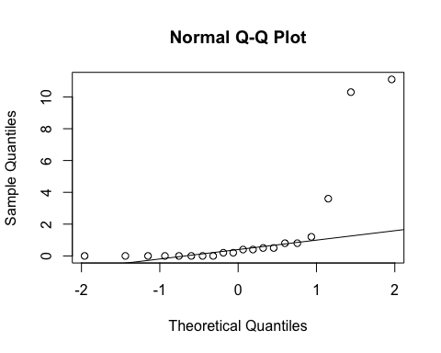
ad.test(subset(SSdata, intervention == "PrenaBelt")$respiratory.arousals.nrem.index)
##
## Anderson-Darling normality test
##
## data: subset(SSdata, intervention == "PrenaBelt")$respiratory.arousals.nrem.index
## A = 4.3757, p-value = 2.59e-11
#non-normal
summary(subset(SSdata, intervention == "sham")$respiratory.arousals.nrem.index)
## Min. 1st Qu. Median Mean 3rd Qu. Max.
## 0.00 0.00 0.00 0.72 0.80 8.30
sd(subset(SSdata, intervention == "sham")$respiratory.arousals.nrem.index)
## [1] 1.846647
length(subset(SSdata, intervention == "sham")$respiratory.arousals.nrem.index)
## [1] 20
qqnorm(subset(SSdata, intervention == "sham")$respiratory.arousals.nrem.index)
qqline(subset(SSdata, intervention == "sham")$respiratory.arousals.nrem.index)
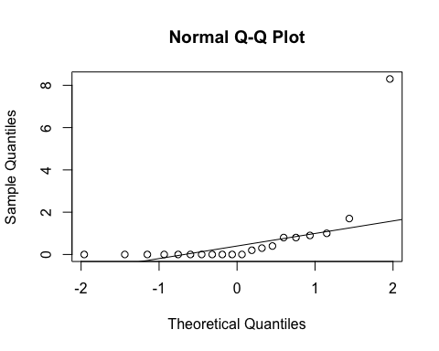
ad.test(subset(SSdata, intervention == "sham")$respiratory.arousals.nrem.index)
##
## Anderson-Darling normality test
##
## data: subset(SSdata, intervention == "sham")$respiratory.arousals.nrem.index
## A = 4.3196, p-value = 3.581e-11
#non-normal
#FYI - unpaired test
wilcox.test(subset(SSdata, intervention == "sham")$respiratory.arousals.nrem.index,
subset(SSdata, intervention == "PrenaBelt")$respiratory.arousals.nrem.index,
conf.int = TRUE)
## Warning in wilcox.test.default(subset(SSdata, intervention == "sham")
## $respiratory.arousals.nrem.index, : cannot compute exact p-value with ties
## Warning in wilcox.test.default(subset(SSdata, intervention == "sham")
## $respiratory.arousals.nrem.index, : cannot compute exact confidence
## intervals with ties
##
## Wilcoxon rank sum test with continuity correction
##
## data: subset(SSdata, intervention == "sham")$respiratory.arousals.nrem.index and subset(SSdata, intervention == "PrenaBelt")$respiratory.arousals.nrem.index
## W = 171, p-value = 0.4142
## alternative hypothesis: true location shift is not equal to 0
## 95 percent confidence interval:
## -4.000240e-01 3.702807e-05
## sample estimates:
## difference in location
## -5.97387e-05
#################### Respiratory Arousals Index in REM #######################
#FYI: this data was generated in our PSG reports per default configuration but is not a
#pre-specified secondary outcome per the research protocol or trial registry. FYI only.
#Summary
summary(SSdata$respiratory.arousals.rem.index)
## Min. 1st Qu. Median Mean 3rd Qu. Max.
## 0.000 0.000 0.950 6.612 4.225 70.000
sd(SSdata$respiratory.arousals.rem.index, na.rm = TRUE)
## [1] 14.61077
length(SSdata$respiratory.arousals.rem.index)
## [1] 40
#ANOVA
night_tx_difference <- anova(lm(respiratory.arousals.rem.index ~ intervention * night,
data = SSdata))
night_tx_difference
## Analysis of Variance Table
##
## Response: respiratory.arousals.rem.index
## Df Sum Sq Mean Sq F value Pr(>F)
## intervention 1 0.4 0.42 0.0021 0.96365
## night 1 18.6 18.63 0.0934 0.76166
## intervention:night 1 1124.7 1124.66 5.6376 0.02303 *
## Residuals 36 7181.8 199.49
## ---
## Signif. codes: 0 '***' 0.001 '**' 0.01 '*' 0.05 '.' 0.1 ' ' 1
#within-participants (paired) comparison
#Paired Wilcoxon
wilcox.test(subset(SSdataCompletes, intervention == "sham")$respiratory.arousals.rem.index,
subset(SSdataCompletes, intervention == "PrenaBelt")$respiratory.arousals.rem.index,
paired = TRUE, conf.int = TRUE)
## Warning in wilcox.test.default(subset(SSdataCompletes, intervention ==
## "sham")$respiratory.arousals.rem.index, : cannot compute exact p-value with
## ties
## Warning in wilcox.test.default(subset(SSdataCompletes, intervention ==
## "sham")$respiratory.arousals.rem.index, : cannot compute exact confidence
## interval with ties
## Warning in wilcox.test.default(subset(SSdataCompletes, intervention ==
## "sham")$respiratory.arousals.rem.index, : cannot compute exact p-value with
## zeroes
## Warning in wilcox.test.default(subset(SSdataCompletes, intervention ==
## "sham")$respiratory.arousals.rem.index, : cannot compute exact confidence
## interval with zeroes
##
## Wilcoxon signed rank test with continuity correction
##
## data: subset(SSdataCompletes, intervention == "sham")$respiratory.arousals.rem.index and subset(SSdataCompletes, intervention == "PrenaBelt")$respiratory.arousals.rem.index
## V = 67, p-value = 0.7119
## alternative hypothesis: true location shift is not equal to 0
## 95 percent confidence interval:
## -3.249966 3.599990
## sample estimates:
## (pseudo)median
## 0.3582702
#between participants (grouped) comparison
summary(subset(SSdata, intervention == "PrenaBelt")$respiratory.arousals.rem.index)
## Min. 1st Qu. Median Mean 3rd Qu. Max.
## 0.00 0.00 0.55 6.51 4.35 47.10
sd(subset(SSdata, intervention == "PrenaBelt")$respiratory.arousals.rem.index)
## [1] 13.60003
length(subset(SSdata, intervention == "PrenaBelt")$respiratory.arousals.rem.index)
## [1] 20
qqnorm(subset(SSdata, intervention == "PrenaBelt")$respiratory.arousals.rem.index)
qqline(subset(SSdata, intervention == "PrenaBelt")$respiratory.arousals.rem.index)
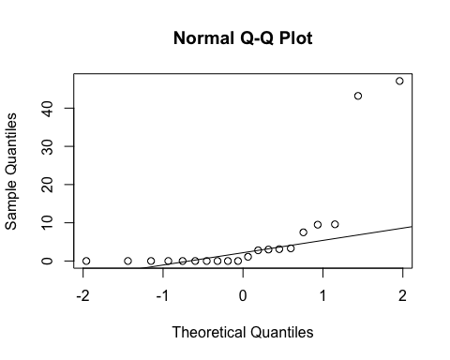
ad.test(subset(SSdata, intervention == "PrenaBelt")$respiratory.arousals.rem.index)
##
## Anderson-Darling normality test
##
## data: subset(SSdata, intervention == "PrenaBelt")$respiratory.arousals.rem.index
## A = 4.0123, p-value = 2.119e-10
#non-normal
summary(subset(SSdata, intervention == "sham")$respiratory.arousals.rem.index)
## Min. 1st Qu. Median Mean 3rd Qu. Max.
## 0.000 0.000 0.950 6.715 3.775 70.000
sd(subset(SSdata, intervention == "sham")$respiratory.arousals.rem.index)
## [1] 15.9123
length(subset(SSdata, intervention == "sham")$respiratory.arousals.rem.index)
## [1] 20
qqnorm(subset(SSdata, intervention == "sham")$respiratory.arousals.rem.index)
qqline(subset(SSdata, intervention == "sham")$respiratory.arousals.rem.index)
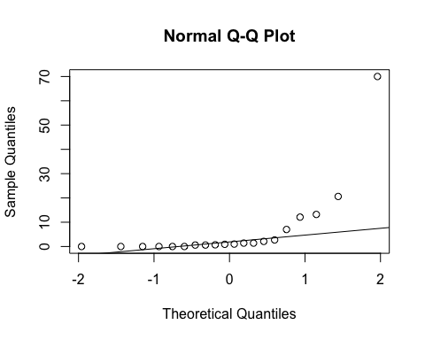
ad.test(subset(SSdata, intervention == "sham")$respiratory.arousals.rem.index)
##
## Anderson-Darling normality test
##
## data: subset(SSdata, intervention == "sham")$respiratory.arousals.rem.index
## A = 4.0308, p-value = 1.904e-10
#non-normal
#FYI - unpaired test
wilcox.test(subset(SSdata, intervention == "sham")$respiratory.arousals.rem.index,
subset(SSdata, intervention == "PrenaBelt")$respiratory.arousals.rem.index,
conf.int = TRUE)
## Warning in wilcox.test.default(subset(SSdata, intervention == "sham")
## $respiratory.arousals.rem.index, : cannot compute exact p-value with ties
## Warning in wilcox.test.default(subset(SSdata, intervention == "sham")
## $respiratory.arousals.rem.index, : cannot compute exact confidence
## intervals with ties
##
## Wilcoxon rank sum test with continuity correction
##
## data: subset(SSdata, intervention == "sham")$respiratory.arousals.rem.index and subset(SSdata, intervention == "PrenaBelt")$respiratory.arousals.rem.index
## W = 213, p-value = 0.7267
## alternative hypothesis: true location shift is not equal to 0
## 95 percent confidence interval:
## -1.900003 1.399993
## sample estimates:
## difference in location
## 5.850022e-05
#################### Respiratory Arousals Total Index (TST = NREM + REM) ###############
#Summary
summary(SSdata$respiratory.arousals.total.index)
## Min. 1st Qu. Median Mean 3rd Qu. Max.
## 0.000 0.000 0.350 1.878 1.025 16.400
sd(SSdata$respiratory.arousals.total.index, na.rm = TRUE)
## [1] 3.840706
length(SSdata$respiratory.arousals.total.index)
## [1] 40
qqnorm(SSdata$respiratory.arousals.total.index)
qqline(SSdata$respiratory.arousals.total.index)
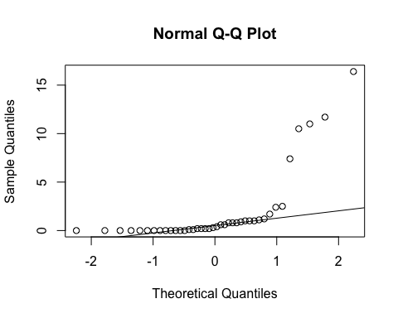
ad.test(SSdata$respiratory.arousals.total.index)
##
## Anderson-Darling normality test
##
## data: SSdata$respiratory.arousals.total.index
## A = 7.9786, p-value < 2.2e-16
#non-normal
#ANOVA
night_tx_difference <- anova(lm(respiratory.arousals.total.index ~ intervention * night,
data = SSdata))
night_tx_difference
## Analysis of Variance Table
##
## Response: respiratory.arousals.total.index
## Df Sum Sq Mean Sq F value Pr(>F)
## intervention 1 2.35 2.352 0.1732 0.67973
## night 1 0.87 0.870 0.0641 0.80159
## intervention:night 1 83.23 83.232 6.1296 0.01813 *
## Residuals 36 488.83 13.579
## ---
## Signif. codes: 0 '***' 0.001 '**' 0.01 '*' 0.05 '.' 0.1 ' ' 1
#within-participants (paired) comparison
#Paired Wilcoxon
wilcox.test(subset(SSdataCompletes, intervention == "sham")$respiratory.arousals.total.index,
subset(SSdataCompletes, intervention == "PrenaBelt")$respiratory.arousals.total.index,
paired = TRUE, conf.int = TRUE)
## Warning in wilcox.test.default(subset(SSdataCompletes, intervention ==
## "sham")$respiratory.arousals.total.index, : cannot compute exact p-value
## with ties
## Warning in wilcox.test.default(subset(SSdataCompletes, intervention ==
## "sham")$respiratory.arousals.total.index, : cannot compute exact confidence
## interval with ties
## Warning in wilcox.test.default(subset(SSdataCompletes, intervention ==
## "sham")$respiratory.arousals.total.index, : cannot compute exact p-value
## with zeroes
## Warning in wilcox.test.default(subset(SSdataCompletes, intervention ==
## "sham")$respiratory.arousals.total.index, : cannot compute exact confidence
## interval with zeroes
##
## Wilcoxon signed rank test with continuity correction
##
## data: subset(SSdataCompletes, intervention == "sham")$respiratory.arousals.total.index and subset(SSdataCompletes, intervention == "PrenaBelt")$respiratory.arousals.total.index
## V = 62, p-value = 0.776
## alternative hypothesis: true location shift is not equal to 0
## 95 percent confidence interval:
## -2.0999697 0.5000137
## sample estimates:
## (pseudo)median
## -0.1000365
#between participants (grouped) comparison
summary(subset(SSdata, intervention == "PrenaBelt")$respiratory.arousals.total.index)
## Min. 1st Qu. Median Mean 3rd Qu. Max.
## 0.00 0.00 0.40 2.12 1.05 16.40
sd(subset(SSdata, intervention == "PrenaBelt")$respiratory.arousals.total.index)
## [1] 4.371149
length(subset(SSdata, intervention == "PrenaBelt")$respiratory.arousals.total.index)
## [1] 20
qqnorm(subset(SSdata, intervention == "PrenaBelt")$respiratory.arousals.total.index)
qqline(subset(SSdata, intervention == "PrenaBelt")$respiratory.arousals.total.index)
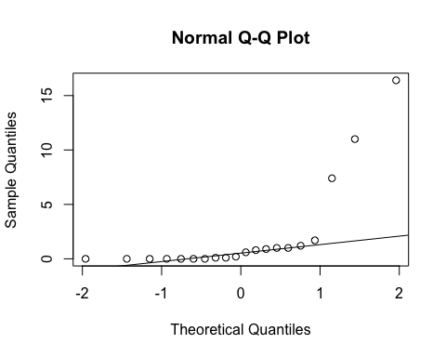
ad.test(subset(SSdata, intervention == "PrenaBelt")$respiratory.arousals.total.index)
##
## Anderson-Darling normality test
##
## data: subset(SSdata, intervention == "PrenaBelt")$respiratory.arousals.total.index
## A = 3.9897, p-value = 2.416e-10
#non-normal
summary(subset(SSdata, intervention == "sham")$respiratory.arousals.total.index)
## Min. 1st Qu. Median Mean 3rd Qu. Max.
## 0.000 0.000 0.350 1.635 1.025 11.700
sd(subset(SSdata, intervention == "sham")$respiratory.arousals.total.index)
## [1] 3.323802
length(subset(SSdata, intervention == "sham")$respiratory.arousals.total.index)
## [1] 20
qqnorm(subset(SSdata, intervention == "sham")$respiratory.arousals.total.index)
qqline(subset(SSdata, intervention == "sham")$respiratory.arousals.total.index)
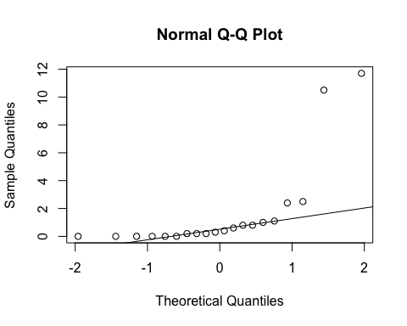
ad.test(subset(SSdata, intervention == "sham")$respiratory.arousals.total.index)
##
## Anderson-Darling normality test
##
## data: subset(SSdata, intervention == "sham")$respiratory.arousals.total.index
## A = 4.0437, p-value = 1.767e-10
#non-normal
#FYI - unpaired test
wilcox.test(subset(SSdata, intervention == "sham")$respiratory.arousals.total.index,
subset(SSdata, intervention == "PrenaBelt")$respiratory.arousals.total.index,
conf.int = TRUE)
## Warning in wilcox.test.default(subset(SSdata, intervention == "sham")
## $respiratory.arousals.total.index, : cannot compute exact p-value with ties
## Warning in wilcox.test.default(subset(SSdata, intervention == "sham")
## $respiratory.arousals.total.index, : cannot compute exact confidence
## intervals with ties
##
## Wilcoxon rank sum test with continuity correction
##
## data: subset(SSdata, intervention == "sham")$respiratory.arousals.total.index and subset(SSdata, intervention == "PrenaBelt")$respiratory.arousals.total.index
## W = 203, p-value = 0.9451
## alternative hypothesis: true location shift is not equal to 0
## 95 percent confidence interval:
## -0.5999724 0.3999323
## sample estimates:
## difference in location
## 9.000537e-06
########### Arousing events NOT meeting respiratory criteria Index in NREM ###########
#FYI: this data was generated in our PSG reports per default configuration but is not a
#pre-specified secondary outcome per the research protocol or trial registry. FYI only.
#Summary
summary(SSdata$arousals.with.respiratory.nrem.index)
## Min. 1st Qu. Median Mean 3rd Qu. Max.
## 0.000 0.000 0.000 0.045 0.000 0.400
sd(SSdata$arousals.with.respiratory.nrem.index, na.rm = TRUE)
## [1] 0.09594336
length(SSdata$arousals.with.respiratory.nrem.index)
## [1] 40
#ANOVA
night_tx_difference <- anova(lm(arousals.with.respiratory.nrem.index ~ intervention * night,
data = SSdata))
night_tx_difference
## Analysis of Variance Table
##
## Response: arousals.with.respiratory.nrem.index
## Df Sum Sq Mean Sq F value Pr(>F)
## intervention 1 0.001 0.0010000 0.1034 0.7496
## night 1 0.001 0.0010000 0.1034 0.7496
## intervention:night 1 0.009 0.0090000 0.9310 0.3410
## Residuals 36 0.348 0.0096667
#within-participants (paired) comparison
#Paired Wilcoxon
wilcox.test(subset(SSdataCompletes, intervention == "sham")$arousals.with.respiratory.nrem.index,
subset(SSdataCompletes, intervention == "PrenaBelt")$arousals.with.respiratory.nrem.index,
paired = TRUE)
## Warning in wilcox.test.default(subset(SSdataCompletes, intervention ==
## "sham")$arousals.with.respiratory.nrem.index, : cannot compute exact p-
## value with ties
## Warning in wilcox.test.default(subset(SSdataCompletes, intervention ==
## "sham")$arousals.with.respiratory.nrem.index, : cannot compute exact p-
## value with zeroes
##
## Wilcoxon signed rank test with continuity correction
##
## data: subset(SSdataCompletes, intervention == "sham")$arousals.with.respiratory.nrem.index and subset(SSdataCompletes, intervention == "PrenaBelt")$arousals.with.respiratory.nrem.index
## V = 2, p-value = 0.7728
## alternative hypothesis: true location shift is not equal to 0
#between participants (grouped) comparison
summary(subset(SSdata, intervention == "PrenaBelt")$arousals.with.respiratory.nrem.index)
## Min. 1st Qu. Median Mean 3rd Qu. Max.
## 0.00 0.00 0.00 0.05 0.00 0.40
sd(subset(SSdata, intervention == "PrenaBelt")$arousals.with.respiratory.nrem.index)
## [1] 0.1100239
length(subset(SSdata, intervention == "PrenaBelt")$arousals.with.respiratory.nrem.index)
## [1] 20
qqnorm(subset(SSdata, intervention == "PrenaBelt")$arousals.with.respiratory.nrem.index)
qqline(subset(SSdata, intervention == "PrenaBelt")$arousals.with.respiratory.nrem.index)
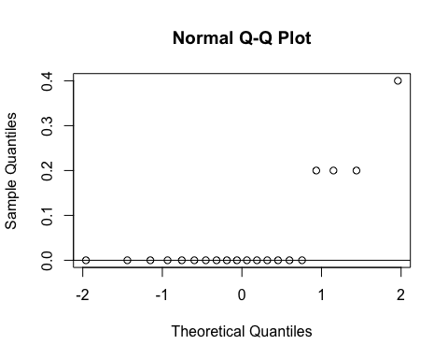
ad.test(subset(SSdata, intervention == "PrenaBelt")$arousals.with.respiratory.nrem.index)
##
## Anderson-Darling normality test
##
## data: subset(SSdata, intervention == "PrenaBelt")$arousals.with.respiratory.nrem.index
## A = 4.6088, p-value = 6.743e-12
#non-normal
summary(subset(SSdata, intervention == "sham")$arousals.with.respiratory.nrem.index)
## Min. 1st Qu. Median Mean 3rd Qu. Max.
## 0.00 0.00 0.00 0.04 0.00 0.20
sd(subset(SSdata, intervention == "sham")$arousals.with.respiratory.nrem.index)
## [1] 0.08207827
length(subset(SSdata, intervention == "sham")$arousals.with.respiratory.nrem.index)
## [1] 20
qqnorm(subset(SSdata, intervention == "sham")$arousals.with.respiratory.nrem.index)
qqline(subset(SSdata, intervention == "sham")$arousals.with.respiratory.nrem.index)
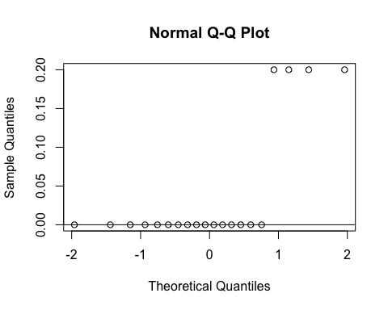
ad.test(subset(SSdata, intervention == "sham")$arousals.with.respiratory.nrem.index)
##
## Anderson-Darling normality test
##
## data: subset(SSdata, intervention == "sham")$arousals.with.respiratory.nrem.index
## A = 5.1941, p-value = 2.32e-13
#non-normal
#FYI - unpaired test
wilcox.test(subset(SSdata, intervention == "sham")$arousals.with.respiratory.nrem.index,
subset(SSdata, intervention == "PrenaBelt")$arousals.with.respiratory.nrem.index,
conf.int = TRUE)
## Warning in wilcox.test.default(subset(SSdata, intervention == "sham")
## $arousals.with.respiratory.nrem.index, : cannot compute exact p-value with
## ties
## Warning in wilcox.test.default(subset(SSdata, intervention == "sham")
## $arousals.with.respiratory.nrem.index, : cannot compute exact confidence
## intervals with ties
##
## Wilcoxon rank sum test with continuity correction
##
## data: subset(SSdata, intervention == "sham")$arousals.with.respiratory.nrem.index and subset(SSdata, intervention == "PrenaBelt")$arousals.with.respiratory.nrem.index
## W = 198, p-value = 0.9534
## alternative hypothesis: true location shift is not equal to 0
## 95 percent confidence interval:
## -1.407869e-05 9.852765e-06
## sample estimates:
## difference in location
## -3.692335e-06
####### Arousing events NOT meeting respiratory criteria Index in REM #########
#FYI: this data was generated in our PSG reports per default configuration but is not a
#pre-specified secondary outcome per the research protocol or trial registry. FYI only.
#Summary
summary(SSdata$arousals.with.respiratory.rem.index)
## Min. 1st Qu. Median Mean 3rd Qu. Max.
## 0.000 0.000 0.000 0.015 0.000 0.600
sd(SSdata$arousals.with.respiratory.rem.index, na.rm = TRUE)
## [1] 0.09486833
length(SSdata$arousals.with.respiratory.rem.index)
## [1] 40
#ANOVA
night_tx_difference <- anova(lm(arousals.with.respiratory.rem.index ~ intervention * night,
data = SSdata))
night_tx_difference
## Analysis of Variance Table
##
## Response: arousals.with.respiratory.rem.index
## Df Sum Sq Mean Sq F value Pr(>F)
## intervention 1 0.009 0.009 1 0.324
## night 1 0.009 0.009 1 0.324
## intervention:night 1 0.009 0.009 1 0.324
## Residuals 36 0.324 0.009
#within-participants (paired) comparison
#Paired Wilcoxon
wilcox.test(subset(SSdataCompletes, intervention == "sham")$arousals.with.respiratory.rem.index,
subset(SSdataCompletes, intervention == "PrenaBelt")$arousals.with.respiratory.rem.index,
paired = TRUE)
## Warning in wilcox.test.default(subset(SSdataCompletes, intervention ==
## "sham")$arousals.with.respiratory.rem.index, : cannot compute exact p-value
## with zeroes
##
## Wilcoxon signed rank test with continuity correction
##
## data: subset(SSdataCompletes, intervention == "sham")$arousals.with.respiratory.rem.index and subset(SSdataCompletes, intervention == "PrenaBelt")$arousals.with.respiratory.rem.index
## V = 1, p-value = 1
## alternative hypothesis: true location shift is not equal to 0
#between participants (grouped) comparison
summary(subset(SSdata, intervention == "PrenaBelt")$arousals.with.respiratory.rem.index)
## Min. 1st Qu. Median Mean 3rd Qu. Max.
## 0 0 0 0 0 0
sd(subset(SSdata, intervention == "PrenaBelt")$arousals.with.respiratory.rem.index)
## [1] 0
length(subset(SSdata, intervention == "PrenaBelt")$arousals.with.respiratory.rem.index)
## [1] 20
qqnorm(subset(SSdata, intervention == "PrenaBelt")$arousals.with.respiratory.rem.index)
qqline(subset(SSdata, intervention == "PrenaBelt")$arousals.with.respiratory.rem.index)
#ad.test(subset(SSdata, intervention == "PrenaBelt")$arousals.with.respiratory.rem.index)
#distribution is entirely zeroes
summary(subset(SSdata, intervention == "sham")$arousals.with.respiratory.rem.index)
## Min. 1st Qu. Median Mean 3rd Qu. Max.
## 0.00 0.00 0.00 0.03 0.00 0.60
sd(subset(SSdata, intervention == "sham")$arousals.with.respiratory.rem.index)
## [1] 0.1341641
length(subset(SSdata, intervention == "sham")$arousals.with.respiratory.rem.index)
## [1] 20
qqnorm(subset(SSdata, intervention == "sham")$arousals.with.respiratory.rem.index)
qqline(subset(SSdata, intervention == "sham")$arousals.with.respiratory.rem.index)
ad.test(subset(SSdata, intervention == "sham")$arousals.with.respiratory.rem.index)
##
## Anderson-Darling normality test
##
## data: subset(SSdata, intervention == "sham")$arousals.with.respiratory.rem.index
## A = 7.1762, p-value < 2.2e-16
#non-normal
#FYI - unpaired test
wilcox.test(subset(SSdata, intervention == "sham")$arousals.with.respiratory.rem.index,
subset(SSdata, intervention == "PrenaBelt")$arousals.with.respiratory.rem.index,
conf.int = TRUE)
## Warning in wilcox.test.default(subset(SSdata, intervention == "sham")
## $arousals.with.respiratory.rem.index, : cannot compute exact p-value with
## ties
## Warning in wilcox.test.default(subset(SSdata, intervention == "sham")
## $arousals.with.respiratory.rem.index, : cannot compute exact confidence
## intervals with ties
##
## Wilcoxon rank sum test with continuity correction
##
## data: subset(SSdata, intervention == "sham")$arousals.with.respiratory.rem.index and subset(SSdata, intervention == "PrenaBelt")$arousals.with.respiratory.rem.index
## W = 210, p-value = 0.3421
## alternative hypothesis: true location shift is not equal to 0
## 95 percent confidence interval:
## 0 0
## sample estimates:
## difference in location
## 0
####### Arousing events NOT meeting respiratory criteria Index (TST = NREM + REM) ######
#FYI: this data was generated in our PSG reports per default configuration but is not a
#pre-specified secondary outcome per the research protocol or trial registry. FYI only.
#Summary
summary(SSdata$arousals.with.respiratory.total.index)
## Min. 1st Qu. Median Mean 3rd Qu. Max.
## 0.0000 0.0000 0.0000 0.0425 0.0000 0.4000
sd(SSdata$arousals.with.respiratory.total.index, na.rm = TRUE)
## [1] 0.09577618
length(SSdata$arousals.with.respiratory.total.index)
## [1] 40
#ANOVA
night_tx_difference <- anova(lm(arousals.with.respiratory.total.index ~ intervention * night,
data = SSdata))
night_tx_difference
## Analysis of Variance Table
##
## Response: arousals.with.respiratory.total.index
## Df Sum Sq Mean Sq F value Pr(>F)
## intervention 1 0.00025 0.00025 0.0256 0.8737
## night 1 0.00025 0.00025 0.0256 0.8737
## intervention:night 1 0.00625 0.00625 0.6410 0.4286
## Residuals 36 0.35100 0.00975
#within-participants (paired) comparison
#Paired Wilcoxon
wilcox.test(subset(SSdataCompletes, intervention == "sham")$arousals.with.respiratory.total.index,
subset(SSdataCompletes, intervention == "PrenaBelt")$arousals.with.respiratory.total.index,
paired = TRUE, conf.int = TRUE)
## Warning in wilcox.test.default(subset(SSdataCompletes, intervention ==
## "sham")$arousals.with.respiratory.total.index, : requested conf.level not
## achievable
## Warning in wilcox.test.default(subset(SSdataCompletes, intervention ==
## "sham")$arousals.with.respiratory.total.index, : cannot compute exact p-
## value with ties
## Warning in wilcox.test.default(subset(SSdataCompletes, intervention ==
## "sham")$arousals.with.respiratory.total.index, : cannot compute exact
## confidence interval with ties
## Warning in wilcox.test.default(subset(SSdataCompletes, intervention ==
## "sham")$arousals.with.respiratory.total.index, : cannot compute exact p-
## value with zeroes
## Warning in wilcox.test.default(subset(SSdataCompletes, intervention ==
## "sham")$arousals.with.respiratory.total.index, : cannot compute exact
## confidence interval with zeroes
##
## Wilcoxon signed rank test with continuity correction
##
## data: subset(SSdataCompletes, intervention == "sham")$arousals.with.respiratory.total.index and subset(SSdataCompletes, intervention == "PrenaBelt")$arousals.with.respiratory.total.index
## V = 5.5, p-value = 0.6831
## alternative hypothesis: true location shift is not equal to 0
## 90 percent confidence interval:
## -0.2 0.2
## sample estimates:
## (pseudo)median
## -5.079939e-05
#between participants (grouped) comparison
summary(subset(SSdata, intervention == "PrenaBelt")$arousals.with.respiratory.total.index)
## Min. 1st Qu. Median Mean 3rd Qu. Max.
## 0.000 0.000 0.000 0.045 0.000 0.400
sd(subset(SSdata, intervention == "PrenaBelt")$arousals.with.respiratory.total.index)
## [1] 0.1050063
length(subset(SSdata, intervention == "PrenaBelt")$arousals.with.respiratory.total.index)
## [1] 20
qqnorm(subset(SSdata, intervention == "PrenaBelt")$arousals.with.respiratory.total.index)
qqline(subset(SSdata, intervention == "PrenaBelt")$arousals.with.respiratory.total.index)
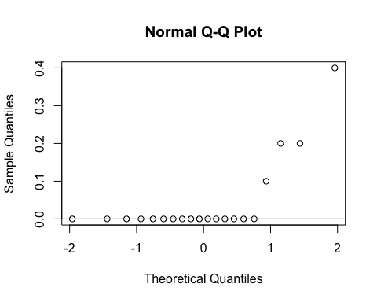
ad.test(subset(SSdata, intervention == "PrenaBelt")$arousals.with.respiratory.total.index)
##
## Anderson-Darling normality test
##
## data: subset(SSdata, intervention == "PrenaBelt")$arousals.with.respiratory.total.index
## A = 4.5718, p-value = 8.347e-12
#non-normal
summary(subset(SSdata, intervention == "sham")$arousals.with.respiratory.total.index)
## Min. 1st Qu. Median Mean 3rd Qu. Max.
## 0.00 0.00 0.00 0.04 0.00 0.30
sd(subset(SSdata, intervention == "sham")$arousals.with.respiratory.total.index)
## [1] 0.088258
length(subset(SSdata, intervention == "sham")$arousals.with.respiratory.total.index)
## [1] 20
qqnorm(subset(SSdata, intervention == "sham")$arousals.with.respiratory.total.index)
qqline(subset(SSdata, intervention == "sham")$arousals.with.respiratory.total.index)
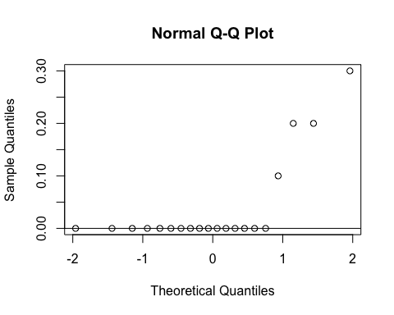
ad.test(subset(SSdata, intervention == "sham")$arousals.with.respiratory.total.index)
##
## Anderson-Darling normality test
##
## data: subset(SSdata, intervention == "sham")$arousals.with.respiratory.total.index
## A = 4.6836, p-value = 4.379e-12
#non-normal
#FYI - unpaired test
wilcox.test(subset(SSdata, intervention == "sham")$arousals.with.respiratory.total.index,
subset(SSdata, intervention == "PrenaBelt")$arousals.with.respiratory.total.index,
conf.int = TRUE)
## Warning in wilcox.test.default(subset(SSdata, intervention == "sham")
## $arousals.with.respiratory.total.index, : cannot compute exact p-value with
## ties
## Warning in wilcox.test.default(subset(SSdata, intervention == "sham")
## $arousals.with.respiratory.total.index, : cannot compute exact confidence
## intervals with ties
##
## Wilcoxon rank sum test with continuity correction
##
## data: subset(SSdata, intervention == "sham")$arousals.with.respiratory.total.index and subset(SSdata, intervention == "PrenaBelt")$arousals.with.respiratory.total.index
## W = 199.5, p-value = 1
## alternative hypothesis: true location shift is not equal to 0
## 95 percent confidence interval:
## -5.011195e-06 5.395622e-05
## sample estimates:
## difference in location
## -6.56778e-05
#end

