Feedback_Analysis_-_BMJSubmission.R
Allan Kember
Tue Feb 20 16:14:40 2018
#Description of code: this code processes the PUFQs looking at summary of these data,
#within-participant comparison of PUFQ data ("before/after"), and between-participants
#comparison of PUFQ data (bulk test for differences btw all treatment nights vs all
#sham nights)
#Summary/Status:
#08APR: No difference on within-participant or between-participant comparisons (treatment
#vs. sham) for all variables.
#setting the workspace directory
setwd("/Users/Allan/Desktop/HPTStats/08APR2017")
#importing the PrenaBelt User Feedback (PBUF) Data
PBUFdata=read.csv("PUFD Data Halifax - 08APR2017.csv")
#Loading the functions (ad.test, etc.) into your workspace
library(nortest)
#Exclude drop outs
#How many drop outs?
summary(PBUFdata$drop.out)
## N Y
## 40 6
#6 dropout nights = 3 participants
#Remove the drop outs ("Y")
PBUFdata <- PBUFdata[!(PBUFdata$drop.out=="Y"),]
nrow(PBUFdata)
## [1] 40
#Separate into sham and treat group for within-participant comparisons
PBUF_sham <- subset(PBUFdata, Intervention == "sham")
PBUF_treat <- subset(PBUFdata, Intervention == "treatment")
#############################SR POSITION ADOPTED#############################
#summary data
summary(PBUFdata$SR.position.adopted)
## left left and right left and supine
## 0 27 5 1
## right supine
## 5 2
length(PBUFdata$SR.position.adopted)
## [1] 40
#between participants (grouped) comparison
xtabs(~SR.position.adopted + Intervention, data = PBUFdata)
## Intervention
## SR.position.adopted sham treatment
## 0 0
## left 13 14
## left and right 2 3
## left and supine 1 0
## right 3 2
## supine 1 1
#build 2-row table for fisher test: sham vs treatment
SR.position.adopted_table <- matrix(c(16,17,5,5,2,1),
nrow = 2)
colnames(SR.position.adopted_table) <- c("left","right","supine")
rownames(SR.position.adopted_table) <- c("Sham",
"Treatment")
SR.position.adopted_table
## left right supine
## Sham 16 5 2
## Treatment 17 5 1
t(SR.position.adopted_table)
## Sham Treatment
## left 16 17
## right 5 5
## supine 2 1
#Perform Fisher's Exact Tests
temp_table <- t(SR.position.adopted_table)
j=nrow(temp_table)
ControlCsum=colSums(temp_table)[1]
TreatmentCsum=colSums(temp_table)[2]
for(i in 1:j) {
a=temp_table[i,1]
b=temp_table[i,2]
c=ControlCsum-a
d=TreatmentCsum-b
ORtable <- matrix(c(a,c,b,d),nrow = 2)
colnames(ORtable) <- c("Sham","Treatment")
rownames(ORtable) <- c(row.names(temp_table)[i],"Other")
print(row.names(temp_table)[i])
print(ORtable)
print(fisher.test(ORtable))
}
## [1] "left"
## Sham Treatment
## left 16 17
## Other 7 6
##
## Fisher's Exact Test for Count Data
##
## data: ORtable
## p-value = 1
## alternative hypothesis: true odds ratio is not equal to 1
## 95 percent confidence interval:
## 0.181121 3.522335
## sample estimates:
## odds ratio
## 0.810505
##
## [1] "right"
## Sham Treatment
## right 5 5
## Other 18 18
##
## Fisher's Exact Test for Count Data
##
## data: ORtable
## p-value = 1
## alternative hypothesis: true odds ratio is not equal to 1
## 95 percent confidence interval:
## 0.1927805 5.1872475
## sample estimates:
## odds ratio
## 1
##
## [1] "supine"
## Sham Treatment
## supine 2 1
## Other 21 22
##
## Fisher's Exact Test for Count Data
##
## data: ORtable
## p-value = 1
## alternative hypothesis: true odds ratio is not equal to 1
## 95 percent confidence interval:
## 0.1003416 129.0322645
## sample estimates:
## odds ratio
## 2.062812
#############################SR POSITION FELL ASLEEP#############################
#summary data
summary(PBUFdata$SR.position.fell.asleep)
## left left and right
## 0 27 5
## left, right and back right supine
## 1 5 2
length(PBUFdata$SR.position.fell.asleep)
## [1] 40
#between participants (grouped) comparison
xtabs(~SR.position.fell.asleep + Intervention, data = PBUFdata)
## Intervention
## SR.position.fell.asleep sham treatment
## 0 0
## left 13 14
## left and right 2 3
## left, right and back 1 0
## right 3 2
## supine 1 1
#build 2-row table for fisher test: sham vs treatment
SR.position.fell.asleep_table <- matrix(c(16,17,6,5,2,1),
nrow = 2)
colnames(SR.position.fell.asleep_table) <- c("left","right","supine")
rownames(SR.position.fell.asleep_table) <- c("Sham",
"Treatment")
t(SR.position.fell.asleep_table)
## Sham Treatment
## left 16 17
## right 6 5
## supine 2 1
#Perform Fisher's Exact Tests
temp_table <- t(SR.position.fell.asleep_table)
j=nrow(temp_table)
ControlCsum=colSums(temp_table)[1]
TreatmentCsum=colSums(temp_table)[2]
for(i in 1:j) {
a=temp_table[i,1]
b=temp_table[i,2]
c=ControlCsum-a
d=TreatmentCsum-b
ORtable <- matrix(c(a,c,b,d),nrow = 2)
colnames(ORtable) <- c("Sham","Treatment")
rownames(ORtable) <- c(row.names(temp_table)[i],"Other")
print(row.names(temp_table)[i])
print(ORtable)
print(fisher.test(ORtable))
}
## [1] "left"
## Sham Treatment
## left 16 17
## Other 8 6
##
## Fisher's Exact Test for Count Data
##
## data: ORtable
## p-value = 0.7516
## alternative hypothesis: true odds ratio is not equal to 1
## 95 percent confidence interval:
## 0.1630989 2.9521011
## sample estimates:
## odds ratio
## 0.7111464
##
## [1] "right"
## Sham Treatment
## right 6 5
## Other 18 18
##
## Fisher's Exact Test for Count Data
##
## data: ORtable
## p-value = 1
## alternative hypothesis: true odds ratio is not equal to 1
## 95 percent confidence interval:
## 0.2513307 5.9379379
## sample estimates:
## odds ratio
## 1.195355
##
## [1] "supine"
## Sham Treatment
## supine 2 1
## Other 22 22
##
## Fisher's Exact Test for Count Data
##
## data: ORtable
## p-value = 1
## alternative hypothesis: true odds ratio is not equal to 1
## 95 percent confidence interval:
## 0.09605226 123.17436447
## sample estimates:
## odds ratio
## 1.971677
#############################SR SNORING#############################
#summary data
summary(PBUFdata$SR.snored.last.night)
## don't know no yes
## 3 26 8 3
length(PBUFdata$SR.snored.last.night)
## [1] 40
#between participants (grouped) comparison
xtabs(~SR.snored.last.night + Intervention, data = PBUFdata)[-1,]
## Intervention
## SR.snored.last.night sham treatment
## don't know 13 13
## no 4 4
## yes 1 2
#Perform Fisher's Exact Tests
temp_table <- xtabs(~SR.snored.last.night + Intervention, data = PBUFdata)[-1,]
j=nrow(temp_table)
ControlCsum=colSums(temp_table)[1]
TreatmentCsum=colSums(temp_table)[2]
for(i in 1:j) {
a=temp_table[i,1]
b=temp_table[i,2]
c=ControlCsum-a
d=TreatmentCsum-b
ORtable <- matrix(c(a,c,b,d),nrow = 2)
colnames(ORtable) <- c("Sham","Treatment")
rownames(ORtable) <- c(row.names(temp_table)[i],"Other")
print(row.names(temp_table)[i])
print(ORtable)
print(fisher.test(ORtable))
}
## [1] "don't know"
## Sham Treatment
## don't know 13 13
## Other 5 6
##
## Fisher's Exact Test for Count Data
##
## data: ORtable
## p-value = 1
## alternative hypothesis: true odds ratio is not equal to 1
## 95 percent confidence interval:
## 0.2341604 6.3402606
## sample estimates:
## odds ratio
## 1.1941
##
## [1] "no"
## Sham Treatment
## no 4 4
## Other 14 15
##
## Fisher's Exact Test for Count Data
##
## data: ORtable
## p-value = 1
## alternative hypothesis: true odds ratio is not equal to 1
## 95 percent confidence interval:
## 0.1643428 6.9643241
## sample estimates:
## odds ratio
## 1.06941
##
## [1] "yes"
## Sham Treatment
## yes 1 2
## Other 17 17
##
## Fisher's Exact Test for Count Data
##
## data: ORtable
## p-value = 1
## alternative hypothesis: true odds ratio is not equal to 1
## 95 percent confidence interval:
## 0.008017856 10.654170427
## sample estimates:
## odds ratio
## 0.509154
#############################SR LEGS TWITCH/JERK#############################
#summary data
summary(PBUFdata$SR.legs.twitch.jerk)
## don't know no yes
## 3 19 14 4
length(PBUFdata$SR.legs.twitch.jerk)
## [1] 40
#between participants (grouped) comparison
xtabs(~SR.legs.twitch.jerk + Intervention, data = PBUFdata)[-1,]
## Intervention
## SR.legs.twitch.jerk sham treatment
## don't know 9 10
## no 8 6
## yes 2 2
#Perform Fisher's Exact Tests
temp_table <- xtabs(~SR.legs.twitch.jerk + Intervention, data = PBUFdata)[-1,]
j=nrow(temp_table)
ControlCsum=colSums(temp_table)[1]
TreatmentCsum=colSums(temp_table)[2]
for(i in 1:j) {
a=temp_table[i,1]
b=temp_table[i,2]
c=ControlCsum-a
d=TreatmentCsum-b
ORtable <- matrix(c(a,c,b,d),nrow = 2)
colnames(ORtable) <- c("Sham","Treatment")
rownames(ORtable) <- c(row.names(temp_table)[i],"Other")
print(row.names(temp_table)[i])
print(ORtable)
print(fisher.test(ORtable))
}
## [1] "don't know"
## Sham Treatment
## don't know 9 10
## Other 10 8
##
## Fisher's Exact Test for Count Data
##
## data: ORtable
## p-value = 0.7459
## alternative hypothesis: true odds ratio is not equal to 1
## 95 percent confidence interval:
## 0.1631369 3.1478545
## sample estimates:
## odds ratio
## 0.7264619
##
## [1] "no"
## Sham Treatment
## no 8 6
## Other 11 12
##
## Fisher's Exact Test for Count Data
##
## data: ORtable
## p-value = 0.7374
## alternative hypothesis: true odds ratio is not equal to 1
## 95 percent confidence interval:
## 0.3156971 6.8777204
## sample estimates:
## odds ratio
## 1.439815
##
## [1] "yes"
## Sham Treatment
## yes 2 2
## Other 17 16
##
## Fisher's Exact Test for Count Data
##
## data: ORtable
## p-value = 1
## alternative hypothesis: true odds ratio is not equal to 1
## 95 percent confidence interval:
## 0.06145761 14.45806216
## sample estimates:
## odds ratio
## 0.9426919
#############################SR WAKE POSITION#############################
#summary data
summary(PBUFdata$SR.position.woke.up)
## left right
## 0 28 12
length(PBUFdata$SR.position.woke.up)
## [1] 40
#between participants (grouped) comparison
xtabs(~SR.position.woke.up + Intervention, data = PBUFdata)[-1,]
## Intervention
## SR.position.woke.up sham treatment
## left 13 15
## right 7 5
fisher.test(xtabs(~SR.position.woke.up + Intervention, data = PBUFdata)[-1,])
##
## Fisher's Exact Test for Count Data
##
## data:
## p-value = 0.7311
## alternative hypothesis: true odds ratio is not equal to 1
## 95 percent confidence interval:
## 0.1235598 2.9574108
## sample estimates:
## odds ratio
## 0.6265621
#############################SR - did you change positions?#############################
#summary data
summary(PBUFdata$SR.position.changed)
## don\xcdt know no yes
## 1 1 3 35
length(PBUFdata$SR.position.changed)
## [1] 40
#between participants (grouped) comparison
xtabs(~SR.position.changed + Intervention, data = PBUFdata)[-1,]
## Intervention
## SR.position.changed sham treatment
## don\xcdt know 1 0
## no 1 2
## yes 18 17
#Perform Fisher's Exact Tests
temp_table <- xtabs(~SR.position.changed + Intervention, data = PBUFdata)[-1,]
j=nrow(temp_table)
ControlCsum=colSums(temp_table)[1]
TreatmentCsum=colSums(temp_table)[2]
for(i in 1:j) {
a=temp_table[i,1]
b=temp_table[i,2]
c=ControlCsum-a
d=TreatmentCsum-b
ORtable <- matrix(c(a,c,b,d),nrow = 2)
colnames(ORtable) <- c("Sham","Treatment")
rownames(ORtable) <- c(row.names(temp_table)[i],"Other")
print(row.names(temp_table)[i])
print(ORtable)
print(fisher.test(ORtable))
}
## [1] "don\xcdt know"
## Sham Treatment
## don\xcdt know 1 0
## Other 19 19
##
## Fisher's Exact Test for Count Data
##
## data: ORtable
## p-value = 1
## alternative hypothesis: true odds ratio is not equal to 1
## 95 percent confidence interval:
## 0.02435859 Inf
## sample estimates:
## odds ratio
## Inf
##
## [1] "no"
## Sham Treatment
## no 1 2
## Other 19 17
##
## Fisher's Exact Test for Count Data
##
## data: ORtable
## p-value = 0.605
## alternative hypothesis: true odds ratio is not equal to 1
## 95 percent confidence interval:
## 0.007216433 9.507277143
## sample estimates:
## odds ratio
## 0.456456
##
## [1] "yes"
## Sham Treatment
## yes 18 17
## Other 2 2
##
## Fisher's Exact Test for Count Data
##
## data: ORtable
## p-value = 1
## alternative hypothesis: true odds ratio is not equal to 1
## 95 percent confidence interval:
## 0.0693477 16.1216542
## sample estimates:
## odds ratio
## 1.057301
#Take out the pts that we don't have complete data on (these participants' studies were
#before the PUFQ was revised to ask about the participant's estimate of how much time
#she spent in each position)
PBUF_shamSRpos <- PBUF_sham[-c(1,2,3),]
PBUF_treatSRpos <- PBUF_treat[-c(1,2,3),]
#############################SR PROPORTION OF TIME ON LEFT#############################
#summary data
summary(PBUFdata$SR.Ptime.left)
## Min. 1st Qu. Median Mean 3rd Qu. Max. NA's
## 0.00 41.50 66.00 59.91 84.00 100.00 5
sd(PBUFdata$SR.Ptime.left, na.rm = TRUE)
## [1] 28.14915
length(na.omit(PBUFdata$SR.Ptime.left))
## [1] 35
#within-participants (paired) comparison
#Paired t-test
t.test(PBUF_shamSRpos$SR.Ptime.left, PBUF_treatSRpos$SR.Ptime.left, paired = TRUE)
##
## Paired t-test
##
## data: PBUF_shamSRpos$SR.Ptime.left and PBUF_treatSRpos$SR.Ptime.left
## t = 0.38979, df = 16, p-value = 0.7018
## alternative hypothesis: true difference in means is not equal to 0
## 95 percent confidence interval:
## -6.266297 9.089826
## sample estimates:
## mean of the differences
## 1.411765
#between participants (grouped) comparison
summary(PBUF_treatSRpos$SR.Ptime.left)
## Min. 1st Qu. Median Mean 3rd Qu. Max.
## 10.00 36.00 60.00 58.76 85.00 95.00
sd(PBUF_treatSRpos$SR.Ptime.left)
## [1] 28.77831
length(PBUF_treatSRpos$SR.Ptime.left)
## [1] 17
qqnorm(PBUF_treatSRpos$SR.Ptime.left)
qqline(PBUF_treatSRpos$SR.Ptime.left)
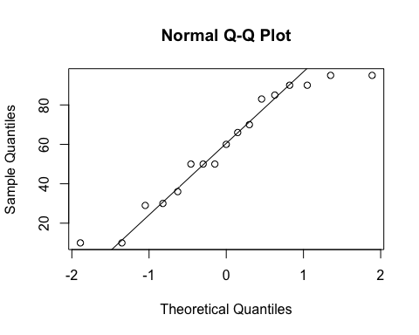
ad.test(PBUF_treatSRpos$SR.Ptime.left)
##
## Anderson-Darling normality test
##
## data: PBUF_treatSRpos$SR.Ptime.left
## A = 0.40809, p-value = 0.3093
#normal
summary(PBUF_shamSRpos$SR.Ptime.left)
## Min. 1st Qu. Median Mean 3rd Qu. Max.
## 0.00 43.00 70.00 60.18 80.00 100.00
sd(PBUF_shamSRpos$SR.Ptime.left)
## [1] 28.9811
length(PBUF_shamSRpos$SR.Ptime.left)
## [1] 17
qqnorm(PBUF_shamSRpos$SR.Ptime.left)
qqline(PBUF_shamSRpos$SR.Ptime.left)
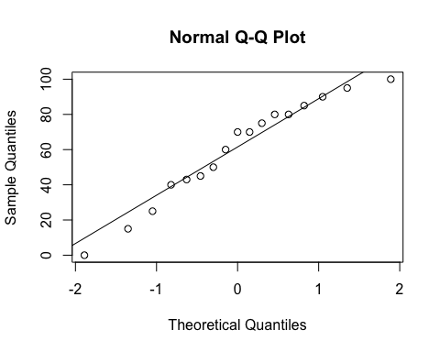
ad.test(PBUF_shamSRpos$SR.Ptime.left)
##
## Anderson-Darling normality test
##
## data: PBUF_shamSRpos$SR.Ptime.left
## A = 0.31945, p-value = 0.506
#normal
#Perform 2-sample t-test (Welch's t-test)
t.test(PBUF_shamSRpos$SR.Ptime.left, PBUF_treatSRpos$SR.Ptime.left)
##
## Welch Two Sample t-test
##
## data: PBUF_shamSRpos$SR.Ptime.left and PBUF_treatSRpos$SR.Ptime.left
## t = 0.14252, df = 31.998, p-value = 0.8876
## alternative hypothesis: true difference in means is not equal to 0
## 95 percent confidence interval:
## -18.76556 21.58909
## sample estimates:
## mean of x mean of y
## 60.17647 58.76471
#############################SR PROPORTION OF TIME ON RIGHT#############################
#summary data
summary(PBUFdata$SR.Ptime.right)
## Min. 1st Qu. Median Mean 3rd Qu. Max. NA's
## 0.00 2.50 30.00 31.29 50.00 90.00 5
sd(PBUFdata$SR.Ptime.right, na.rm = TRUE)
## [1] 27.30177
length(na.omit(PBUFdata$SR.Ptime.right))
## [1] 35
#within-participants (paired) comparison
#Paired t-test
t.test(PBUF_shamSRpos$SR.Ptime.right, PBUF_treatSRpos$SR.Ptime.right, paired = TRUE)
##
## Paired t-test
##
## data: PBUF_shamSRpos$SR.Ptime.right and PBUF_treatSRpos$SR.Ptime.right
## t = -0.10277, df = 16, p-value = 0.9194
## alternative hypothesis: true difference in means is not equal to 0
## 95 percent confidence interval:
## -7.633106 6.927224
## sample estimates:
## mean of the differences
## -0.3529412
#between participants (grouped) comparison
summary(PBUF_treatSRpos$SR.Ptime.right)
## Min. 1st Qu. Median Mean 3rd Qu. Max.
## 0.00 0.00 34.00 31.65 50.00 88.00
sd(PBUF_treatSRpos$SR.Ptime.right)
## [1] 27.92387
length(PBUF_treatSRpos$SR.Ptime.right)
## [1] 17
qqnorm(PBUF_treatSRpos$SR.Ptime.right)
qqline(PBUF_treatSRpos$SR.Ptime.right)
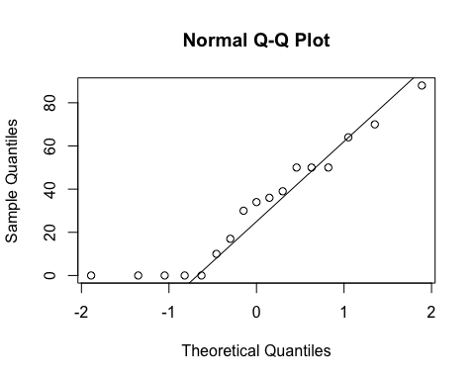
ad.test(PBUF_treatSRpos$SR.Ptime.right)
##
## Anderson-Darling normality test
##
## data: PBUF_treatSRpos$SR.Ptime.right
## A = 0.51449, p-value = 0.1649
#normal
summary(PBUF_shamSRpos$SR.Ptime.right)
## Min. 1st Qu. Median Mean 3rd Qu. Max.
## 0.00 5.00 30.00 31.29 50.00 90.00
sd(PBUF_shamSRpos$SR.Ptime.right)
## [1] 28.31246
length(PBUF_shamSRpos$SR.Ptime.right)
## [1] 17
qqnorm(PBUF_shamSRpos$SR.Ptime.right)
qqline(PBUF_shamSRpos$SR.Ptime.right)
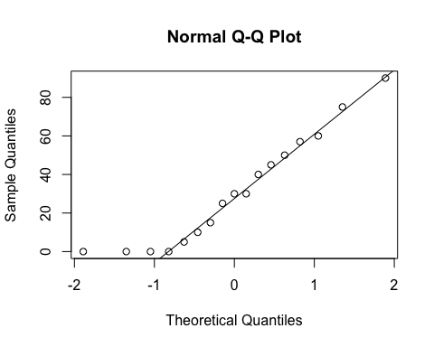
ad.test(PBUF_shamSRpos$SR.Ptime.right)
##
## Anderson-Darling normality test
##
## data: PBUF_shamSRpos$SR.Ptime.right
## A = 0.43793, p-value = 0.2602
#normal
#Perform 2-sample t-test (Welch's t-test)
t.test(PBUF_shamSRpos$SR.Ptime.right, PBUF_treatSRpos$SR.Ptime.right)
##
## Welch Two Sample t-test
##
## data: PBUF_shamSRpos$SR.Ptime.right and PBUF_treatSRpos$SR.Ptime.right
## t = -0.036594, df = 31.994, p-value = 0.971
## alternative hypothesis: true difference in means is not equal to 0
## 95 percent confidence interval:
## -19.99866 19.29278
## sample estimates:
## mean of x mean of y
## 31.29412 31.64706
#############################SR PROPORTION OF TIME ON BACK#############################
#summary data
summary(PBUFdata$SR.Ptime.back)
## Min. 1st Qu. Median Mean 3rd Qu. Max. NA's
## 0.0 0.0 0.0 7.8 5.0 90.0 5
sd(PBUFdata$SR.Ptime.back, na.rm = TRUE)
## [1] 19.98205
length(na.omit(PBUFdata$SR.Ptime.back))
## [1] 35
#within-participants (paired) comparison - non-normal, use parametric test (Wilcoxon)
wilcox.test(PBUF_shamSRpos$SR.Ptime.back, PBUF_treatSRpos$SR.Ptime.back,
paired = TRUE, conf.int = TRUE)
## Warning in wilcox.test.default(PBUF_shamSRpos$SR.Ptime.back,
## PBUF_treatSRpos$SR.Ptime.back, : cannot compute exact p-value with ties
## Warning in wilcox.test.default(PBUF_shamSRpos$SR.Ptime.back,
## PBUF_treatSRpos$SR.Ptime.back, : cannot compute exact confidence interval
## with ties
## Warning in wilcox.test.default(PBUF_shamSRpos$SR.Ptime.back,
## PBUF_treatSRpos$SR.Ptime.back, : cannot compute exact p-value with zeroes
## Warning in wilcox.test.default(PBUF_shamSRpos$SR.Ptime.back,
## PBUF_treatSRpos$SR.Ptime.back, : cannot compute exact confidence interval
## with zeroes
##
## Wilcoxon signed rank test with continuity correction
##
## data: PBUF_shamSRpos$SR.Ptime.back and PBUF_treatSRpos$SR.Ptime.back
## V = 18.5, p-value = 0.4951
## alternative hypothesis: true location shift is not equal to 0
## 95 percent confidence interval:
## -7.499958 8.999966
## sample estimates:
## (pseudo)median
## 4.090518
#between participants (grouped) comparison
summary(PBUF_treatSRpos$SR.Ptime.back)
## Min. 1st Qu. Median Mean 3rd Qu. Max.
## 0.000 0.000 0.000 7.529 5.000 90.000
sd(PBUF_treatSRpos$SR.Ptime.back)
## [1] 21.67406
length(PBUF_treatSRpos$SR.Ptime.back)
## [1] 17
qqnorm(PBUF_treatSRpos$SR.Ptime.back)
qqline(PBUF_treatSRpos$SR.Ptime.back)
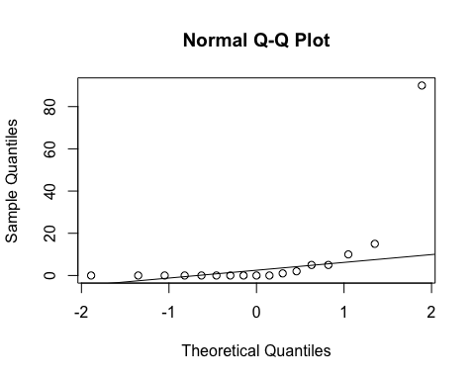
ad.test(PBUF_treatSRpos$SR.Ptime.back)
##
## Anderson-Darling normality test
##
## data: PBUF_treatSRpos$SR.Ptime.back
## A = 4.2859, p-value = 3.533e-11
#non-normal
summary(PBUF_shamSRpos$SR.Ptime.back)
## Min. 1st Qu. Median Mean 3rd Qu. Max.
## 0.000 0.000 0.000 8.529 5.000 80.000
sd(PBUF_shamSRpos$SR.Ptime.back)
## [1] 19.34592
length(PBUF_shamSRpos$SR.Ptime.back)
## [1] 17
qqnorm(PBUF_shamSRpos$SR.Ptime.back)
qqline(PBUF_shamSRpos$SR.Ptime.back)
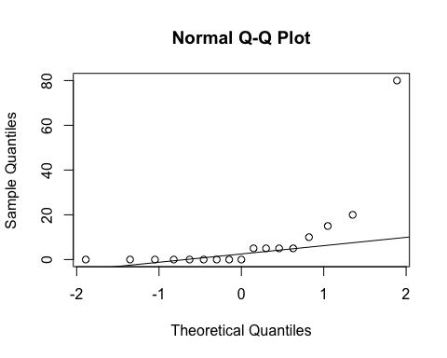
ad.test(PBUF_shamSRpos$SR.Ptime.back)
##
## Anderson-Darling normality test
##
## data: PBUF_shamSRpos$SR.Ptime.back
## A = 3.3048, p-value = 1.097e-08
#non-normal
#Perform non-parametric test (Wilcoxon)
wilcox.test(PBUF_shamSRpos$SR.Ptime.back, PBUF_treatSRpos$SR.Ptime.back, conf.int = TRUE)
## Warning in wilcox.test.default(PBUF_shamSRpos$SR.Ptime.back,
## PBUF_treatSRpos$SR.Ptime.back, : cannot compute exact p-value with ties
## Warning in wilcox.test.default(PBUF_shamSRpos$SR.Ptime.back,
## PBUF_treatSRpos$SR.Ptime.back, : cannot compute exact confidence intervals
## with ties
##
## Wilcoxon rank sum test with continuity correction
##
## data: PBUF_shamSRpos$SR.Ptime.back and PBUF_treatSRpos$SR.Ptime.back
## W = 159, p-value = 0.5944
## alternative hypothesis: true location shift is not equal to 0
## 95 percent confidence interval:
## -3.745025e-05 4.999982e+00
## sample estimates:
## difference in location
## 3.7504e-05
#############################SR PROPORTION OF TIME ON STOMACH#############################
#summary data
summary(PBUFdata$SR.Ptime.stomach)
## Min. 1st Qu. Median Mean 3rd Qu. Max. NA's
## 0.0000 0.0000 0.0000 0.7143 0.0000 18.0000 5
sd(PBUFdata$SR.Ptime.stomach, na.rm = TRUE)
## [1] 3.231931
length(na.omit(PBUFdata$SR.Ptime.stomach))
## [1] 35
#within-participants (paired) comparison - non-normal, use parametric test (Wilcoxon)
wilcox.test(PBUF_shamSRpos$SR.Ptime.stomach, PBUF_treatSRpos$SR.Ptime.stomach,
paired = TRUE)
## Warning in wilcox.test.default(PBUF_shamSRpos$SR.Ptime.stomach,
## PBUF_treatSRpos$SR.Ptime.stomach, : cannot compute exact p-value with
## zeroes
##
## Wilcoxon signed rank test with continuity correction
##
## data: PBUF_shamSRpos$SR.Ptime.stomach and PBUF_treatSRpos$SR.Ptime.stomach
## V = 0, p-value = 0.3711
## alternative hypothesis: true location shift is not equal to 0
#between participants (grouped) comparison
summary(PBUF_treatSRpos$SR.Ptime.stomach)
## Min. 1st Qu. Median Mean 3rd Qu. Max.
## 0.000 0.000 0.000 1.471 0.000 18.000
sd(PBUF_treatSRpos$SR.Ptime.stomach)
## [1] 4.58418
length(PBUF_treatSRpos$SR.Ptime.stomach)
## [1] 17
qqnorm(PBUF_treatSRpos$SR.Ptime.stomach)
qqline(PBUF_treatSRpos$SR.Ptime.stomach)
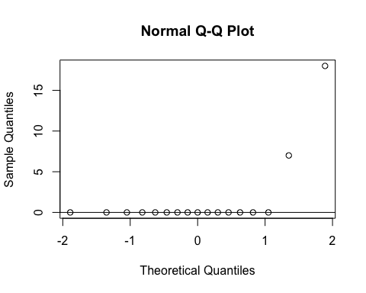
ad.test(PBUF_treatSRpos$SR.Ptime.stomach)
##
## Anderson-Darling normality test
##
## data: PBUF_treatSRpos$SR.Ptime.stomach
## A = 4.9879, p-value = 5.961e-13
#non-normal
summary(PBUF_shamSRpos$SR.Ptime.stomach)
## Min. 1st Qu. Median Mean 3rd Qu. Max.
## 0 0 0 0 0 0
sd(PBUF_shamSRpos$SR.Ptime.stomach)
## [1] 0
length(PBUF_shamSRpos$SR.Ptime.stomach)
## [1] 17
qqnorm(PBUF_shamSRpos$SR.Ptime.stomach)
qqline(PBUF_shamSRpos$SR.Ptime.stomach)
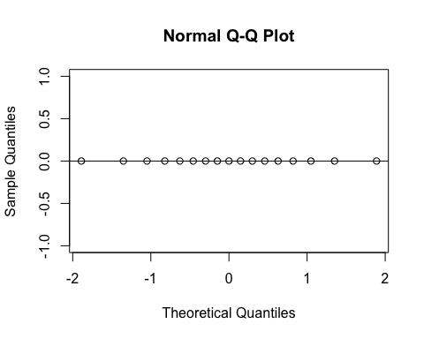
#ad.test(PBUF_shamSRpos$SR.Ptime.stomach)
#distribution is entirely zeroes
#Perform non-parametric test (Wilcoxon)
wilcox.test(PBUF_shamSRpos$SR.Ptime.stomach, PBUF_treatSRpos$SR.Ptime.stomach, conf.int = TRUE)
## Warning in wilcox.test.default(PBUF_shamSRpos$SR.Ptime.stomach,
## PBUF_treatSRpos$SR.Ptime.stomach, : cannot compute exact p-value with ties
## Warning in wilcox.test.default(PBUF_shamSRpos$SR.Ptime.stomach,
## PBUF_treatSRpos$SR.Ptime.stomach, : cannot compute exact confidence
## intervals with ties
##
## Wilcoxon rank sum test with continuity correction
##
## data: PBUF_shamSRpos$SR.Ptime.stomach and PBUF_treatSRpos$SR.Ptime.stomach
## W = 127.5, p-value = 0.1635
## alternative hypothesis: true location shift is not equal to 0
## 95 percent confidence interval:
## -7.272004e-05 0.000000e+00
## sample estimates:
## difference in location
## 0
#############################REMEMBER CHANGING POSITIONS#############################
#summary data
summary(PBUFdata$remember.changing.positions)
## no yes
## 0 7 33
length(PBUFdata$remember.changing.positions)
## [1] 40
#between participants (grouped) comparison
xtabs(~remember.changing.positions + Intervention, data = PBUFdata)[-1,]
## Intervention
## remember.changing.positions sham treatment
## no 4 3
## yes 16 17
fisher.test(xtabs(~remember.changing.positions + Intervention, data = PBUFdata)[-1,])
##
## Fisher's Exact Test for Count Data
##
## data:
## p-value = 1
## alternative hypothesis: true odds ratio is not equal to 1
## 95 percent confidence interval:
## 0.2020801 11.1277720
## sample estimates:
## odds ratio
## 1.404393
#Remove rows with missing data or with participants who did not change position or did
#not remember changing positions
PBUF_shamSRchangepos <- PBUF_sham[-c(1,5,6,7,14,19),]
PBUF_treatSRchangepos <- PBUF_treat[-c(1,5,6,7,14,19),]
#############################SR NUMBER OF TIMES CHANGED POSITION###########################
#summary data
summary(PBUFdata$SR.how.many.times.changed.positions)
## Min. 1st Qu. Median Mean 3rd Qu. Max. NA's
## 0.000 2.000 3.000 3.194 4.000 7.000 9
sd(PBUFdata$SR.how.many.times.changed.positions, na.rm = TRUE)
## [1] 1.740103
length(na.omit(PBUFdata$SR.how.many.times.changed.positions))
## [1] 31
#within-participants (paired) comparison
#Paired t-test
t.test(PBUF_shamSRchangepos$SR.how.many.times.changed.positions,
PBUF_treatSRchangepos$SR.how.many.times.changed.positions,
paired = TRUE)
##
## Paired t-test
##
## data: PBUF_shamSRchangepos$SR.how.many.times.changed.positions and PBUF_treatSRchangepos$SR.how.many.times.changed.positions
## t = 0.31382, df = 13, p-value = 0.7586
## alternative hypothesis: true difference in means is not equal to 0
## 95 percent confidence interval:
## -0.8405766 1.1262909
## sample estimates:
## mean of the differences
## 0.1428571
#between participants (grouped) comparison
summary(PBUF_treat$SR.how.many.times.changed.positions)
## Min. 1st Qu. Median Mean 3rd Qu. Max. NA's
## 1.000 2.000 3.000 3.125 4.000 7.000 4
sd(PBUF_treat$SR.how.many.times.changed.positions, na.rm = TRUE)
## [1] 1.586401
length(na.omit(PBUF_treat$SR.how.many.times.changed.positions))
## [1] 16
qqnorm(PBUF_treat$SR.how.many.times.changed.positions)
qqline(PBUF_treat$SR.how.many.times.changed.positions)
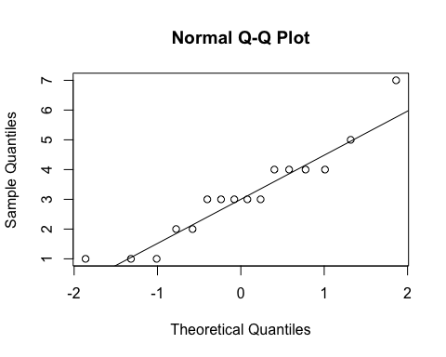
ad.test(PBUF_treat$SR.how.many.times.changed.positions)
##
## Anderson-Darling normality test
##
## data: PBUF_treat$SR.how.many.times.changed.positions
## A = 0.51178, p-value = 0.1658
#normal
summary(PBUF_sham$SR.how.many.times.changed.positions)
## Min. 1st Qu. Median Mean 3rd Qu. Max. NA's
## 0.000 1.500 4.000 3.267 4.500 7.000 5
sd(PBUF_sham$SR.how.many.times.changed.positions, na.rm = TRUE)
## [1] 1.944467
length(na.omit(PBUF_sham$SR.how.many.times.changed.positions))
## [1] 15
qqnorm(PBUF_sham$SR.how.many.times.changed.positions)
qqline(PBUF_sham$SR.how.many.times.changed.positions)
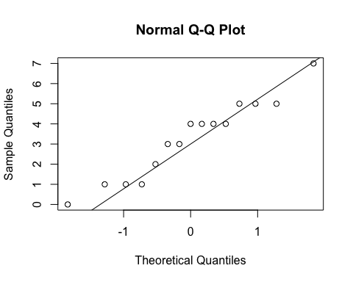
ad.test(PBUF_sham$SR.how.many.times.changed.positions)
##
## Anderson-Darling normality test
##
## data: PBUF_sham$SR.how.many.times.changed.positions
## A = 0.41783, p-value = 0.287
#normal
#Perform 2-sample t-test (Welch's t-test)
t.test(PBUF_sham$SR.how.many.times.changed.positions,
PBUF_treat$SR.how.many.times.changed.positions)
##
## Welch Two Sample t-test
##
## data: PBUF_sham$SR.how.many.times.changed.positions and PBUF_treat$SR.how.many.times.changed.positions
## t = 0.22142, df = 27.082, p-value = 0.8264
## alternative hypothesis: true difference in means is not equal to 0
## 95 percent confidence interval:
## -1.170927 1.454261
## sample estimates:
## mean of x mean of y
## 3.266667 3.125000
#############################SATISFACTION LEVEL#############################
#summary data
summary(PBUFdata$satisfaction.level)
## Min. 1st Qu. Median Mean 3rd Qu. Max.
## 1.000 6.000 7.500 7.338 9.000 10.000
sd(PBUFdata$satisfaction.level)
## [1] 1.988388
length(PBUFdata$satisfaction.level)
## [1] 40
qqnorm(PBUFdata$satisfaction.level)
qqline(PBUFdata$satisfaction.level)
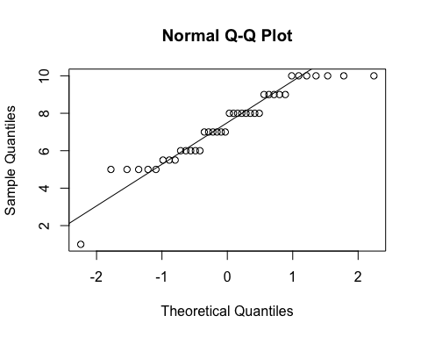
ad.test(PBUFdata$satisfaction.level)
##
## Anderson-Darling normality test
##
## data: PBUFdata$satisfaction.level
## A = 0.79381, p-value = 0.03625
#within-participants (paired) comparison
#t-test (individual distributions are normal)
t.test(PBUF_sham$satisfaction.level,PBUF_treat$satisfaction.level, paired = TRUE)
##
## Paired t-test
##
## data: PBUF_sham$satisfaction.level and PBUF_treat$satisfaction.level
## t = 0.74891, df = 19, p-value = 0.4631
## alternative hypothesis: true difference in means is not equal to 0
## 95 percent confidence interval:
## -0.4935575 1.0435575
## sample estimates:
## mean of the differences
## 0.275
#between participants (grouped) comparison
summary(PBUF_treat$satisfaction.level)
## Min. 1st Qu. Median Mean 3rd Qu. Max.
## 1.00 6.00 7.50 7.20 8.25 10.00
sd(PBUF_treat$satisfaction.level, na.rm = TRUE)
## [1] 2.142306
length(na.omit(PBUF_treat$satisfaction.level))
## [1] 20
qqnorm(PBUF_treat$satisfaction.level)
qqline(PBUF_treat$satisfaction.level)
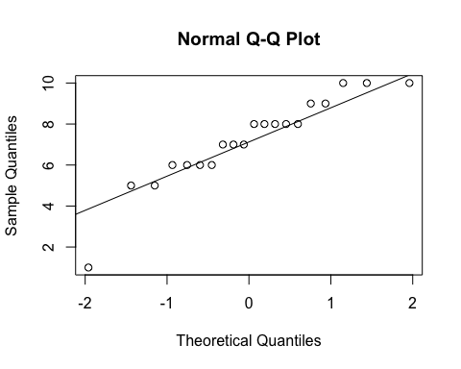
ad.test(PBUF_treat$satisfaction.level)
##
## Anderson-Darling normality test
##
## data: PBUF_treat$satisfaction.level
## A = 0.54062, p-value = 0.1445
#normal
summary(PBUF_sham$satisfaction.level)
## Min. 1st Qu. Median Mean 3rd Qu. Max.
## 5.000 5.500 7.500 7.475 9.000 10.000
sd(PBUF_sham$satisfaction.level, na.rm = TRUE)
## [1] 1.867133
length(na.omit(PBUF_sham$satisfaction.level))
## [1] 20
qqnorm(PBUF_sham$satisfaction.level)
qqline(PBUF_sham$satisfaction.level)
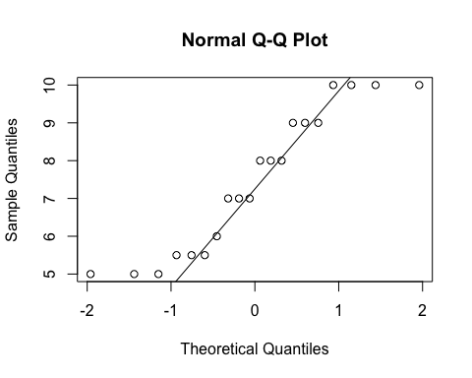
ad.test(PBUF_sham$satisfaction.level)
##
## Anderson-Darling normality test
##
## data: PBUF_sham$satisfaction.level
## A = 0.69241, p-value = 0.0596
#normal
#Perform 2-sample t-test (Welch's t-test)
t.test(PBUF_sham$satisfaction.level,
PBUF_treat$satisfaction.level)
##
## Welch Two Sample t-test
##
## data: PBUF_sham$satisfaction.level and PBUF_treat$satisfaction.level
## t = 0.43277, df = 37.304, p-value = 0.6677
## alternative hypothesis: true difference in means is not equal to 0
## 95 percent confidence interval:
## -1.012168 1.562168
## sample estimates:
## mean of x mean of y
## 7.475 7.200
#############################COMFORT LEVEL#############################
#summary data
summary(PBUFdata$comfort.level)
## Min. 1st Qu. Median Mean 3rd Qu. Max.
## 1.000 7.000 9.000 8.175 10.000 10.000
sd(PBUFdata$comfort.level)
## [1] 1.982455
length(PBUFdata$comfort.level)
## [1] 40
qqnorm(PBUFdata$comfort.level)
qqline(PBUFdata$comfort.level)
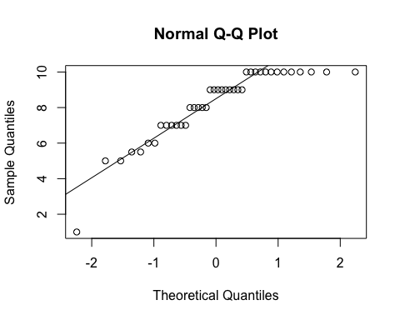
ad.test(PBUFdata$comfort.level)
##
## Anderson-Darling normality test
##
## data: PBUFdata$comfort.level
## A = 1.8563, p-value = 7.865e-05
#within-participants (paired) comparison
#non-normal - perform Wilcoxon
wilcox.test(PBUF_sham$comfort.level,PBUF_treat$comfort.level,
paired = TRUE, conf.int = TRUE)
## Warning in wilcox.test.default(PBUF_sham$comfort.level, PBUF_treat
## $comfort.level, : cannot compute exact p-value with ties
## Warning in wilcox.test.default(PBUF_sham$comfort.level, PBUF_treat
## $comfort.level, : cannot compute exact confidence interval with ties
## Warning in wilcox.test.default(PBUF_sham$comfort.level, PBUF_treat
## $comfort.level, : cannot compute exact p-value with zeroes
## Warning in wilcox.test.default(PBUF_sham$comfort.level, PBUF_treat
## $comfort.level, : cannot compute exact confidence interval with zeroes
##
## Wilcoxon signed rank test with continuity correction
##
## data: PBUF_sham$comfort.level and PBUF_treat$comfort.level
## V = 54.5, p-value = 0.0574
## alternative hypothesis: true location shift is not equal to 0
## 95 percent confidence interval:
## -0.0000318032 2.7499508366
## sample estimates:
## (pseudo)median
## 1.000052
#between participants (grouped) comparison
summary(PBUF_treat$comfort.level)
## Min. 1st Qu. Median Mean 3rd Qu. Max.
## 1.00 6.75 9.00 7.80 9.25 10.00
sd(PBUF_treat$comfort.level, na.rm = TRUE)
## [1] 2.330575
length(na.omit(PBUF_treat$comfort.level))
## [1] 20
qqnorm(PBUF_treat$comfort.level)
qqline(PBUF_treat$comfort.level)
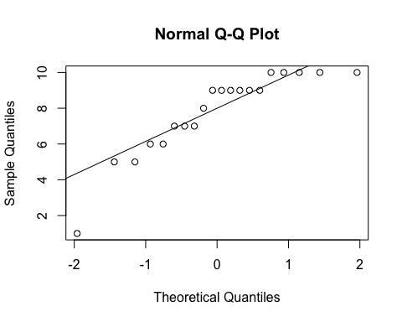
ad.test(PBUF_treat$comfort.level)
##
## Anderson-Darling normality test
##
## data: PBUF_treat$comfort.level
## A = 1.0308, p-value = 0.008039
#non-normal
summary(PBUF_sham$comfort.level)
## Min. 1st Qu. Median Mean 3rd Qu. Max.
## 5.50 7.75 9.00 8.55 10.00 10.00
sd(PBUF_sham$comfort.level, na.rm = TRUE)
## [1] 1.529534
length(na.omit(PBUF_sham$comfort.level))
## [1] 20
qqnorm(PBUF_sham$comfort.level)
qqline(PBUF_sham$comfort.level)
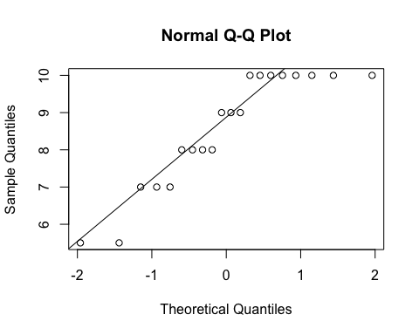
ad.test(PBUF_sham$comfort.level)
##
## Anderson-Darling normality test
##
## data: PBUF_sham$comfort.level
## A = 1.1179, p-value = 0.004803
#non-normal
#Perform non-parametric test (Wilcoxon)
wilcox.test(PBUF_sham$comfort.level, PBUF_treat$comfort.level, conf.int = TRUE)
## Warning in wilcox.test.default(PBUF_sham$comfort.level, PBUF_treat
## $comfort.level, : cannot compute exact p-value with ties
## Warning in wilcox.test.default(PBUF_sham$comfort.level, PBUF_treat
## $comfort.level, : cannot compute exact confidence intervals with ties
##
## Wilcoxon rank sum test with continuity correction
##
## data: PBUF_sham$comfort.level and PBUF_treat$comfort.level
## W = 235.5, p-value = 0.3312
## alternative hypothesis: true location shift is not equal to 0
## 95 percent confidence interval:
## -0.4999358 1.0000188
## sample estimates:
## difference in location
## 0.3425784
#################INTENTION TO USE IN FUTURE PREGNANCY LEVEL######################
#summary data
summary(PBUFdata$intention.to.use)
## Min. 1st Qu. Median Mean 3rd Qu. Max.
## 1.00 6.00 7.50 7.05 8.25 10.00
sd(PBUFdata$intention.to.use)
## [1] 2.363722
length(PBUFdata$intention.to.use)
## [1] 40
qqnorm(PBUFdata$intention.to.use)
qqline(PBUFdata$intention.to.use)
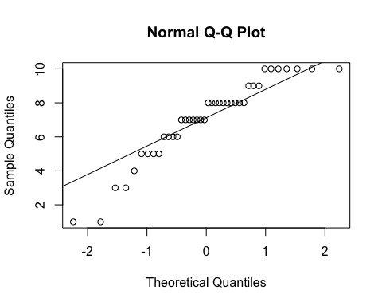
ad.test(PBUFdata$intention.to.use)
##
## Anderson-Darling normality test
##
## data: PBUFdata$intention.to.use
## A = 1.0575, p-value = 0.00788
#within-participants (paired) comparison
#t-test (individual distributions are normal)
t.test(PBUF_sham$intention.to.use,PBUF_treat$intention.to.use, paired = TRUE)
##
## Paired t-test
##
## data: PBUF_sham$intention.to.use and PBUF_treat$intention.to.use
## t = 0.24031, df = 19, p-value = 0.8127
## alternative hypothesis: true difference in means is not equal to 0
## 95 percent confidence interval:
## -0.7709543 0.9709543
## sample estimates:
## mean of the differences
## 0.1
#between participants (grouped) comparison
summary(PBUF_treat$intention.to.use)
## Min. 1st Qu. Median Mean 3rd Qu. Max.
## 1.00 5.75 8.00 7.00 8.00 10.00
sd(PBUF_treat$intention.to.use, na.rm = TRUE)
## [1] 2.339591
length(na.omit(PBUF_treat$intention.to.use))
## [1] 20
qqnorm(PBUF_treat$intention.to.use)
qqline(PBUF_treat$intention.to.use)
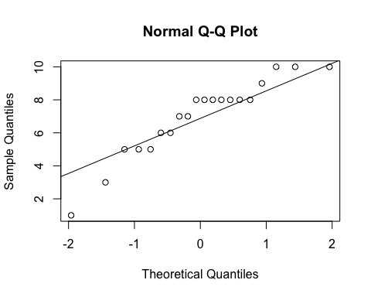
ad.test(PBUF_treat$intention.to.use)
##
## Anderson-Darling normality test
##
## data: PBUF_treat$intention.to.use
## A = 0.70743, p-value = 0.05453
#normal
summary(PBUF_sham$intention.to.use)
## Min. 1st Qu. Median Mean 3rd Qu. Max.
## 1.0 6.0 7.0 7.1 9.0 10.0
sd(PBUF_sham$intention.to.use, na.rm = TRUE)
## [1] 2.44734
length(na.omit(PBUF_sham$intention.to.use))
## [1] 20
qqnorm(PBUF_sham$intention.to.use)
qqline(PBUF_sham$intention.to.use)
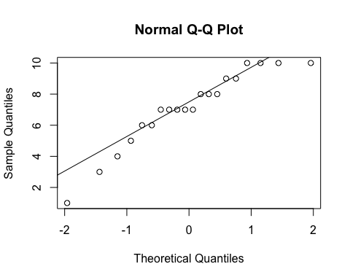
ad.test(PBUF_sham$intention.to.use)
##
## Anderson-Darling normality test
##
## data: PBUF_sham$intention.to.use
## A = 0.54305, p-value = 0.1424
#normal
#Perform 2-sample t-test (Welch's t-test)
t.test(PBUF_sham$intention.to.use,
PBUF_treat$intention.to.use)
##
## Welch Two Sample t-test
##
## data: PBUF_sham$intention.to.use and PBUF_treat$intention.to.use
## t = 0.13209, df = 37.923, p-value = 0.8956
## alternative hypothesis: true difference in means is not equal to 0
## 95 percent confidence interval:
## -1.432714 1.632714
## sample estimates:
## mean of x mean of y
## 7.1 7.0
#################WOULD MAKE CHANGES######################
#summary data
summary(PBUFdata$would.make.changes)
## no yes
## 2 31 7
length(PBUFdata$would.make.changes)
## [1] 40
#7 nights, but only 6 participants of 20 (30%)
#between participants (grouped) comparison
xtabs(~would.make.changes + Intervention, data = PBUFdata)[-1,]
## Intervention
## would.make.changes sham treatment
## no 16 15
## yes 3 4
fisher.test(xtabs(~would.make.changes + Intervention, data = PBUFdata)[-1,])
##
## Fisher's Exact Test for Count Data
##
## data:
## p-value = 1
## alternative hypothesis: true odds ratio is not equal to 1
## 95 percent confidence interval:
## 0.2007118 11.2700012
## sample estimates:
## odds ratio
## 1.409106
#END

