Electronic Supplementary Materials

S1. Supplementary Figures

S2. Supplementary Text on models

S3. Supplementary Videos

S1. Supplementary Figures And Tables

**Figure S1.** Size-frequency distribution of green turtles caught on the seagrass meadows around Derawan Island (2009 *n =* 116, 2011 *n =* 141). Data from 2011 show an increase of smaller sub-adults and juveniles, which may indicate an increase in turtle numbers due to conservation inside MPAs.

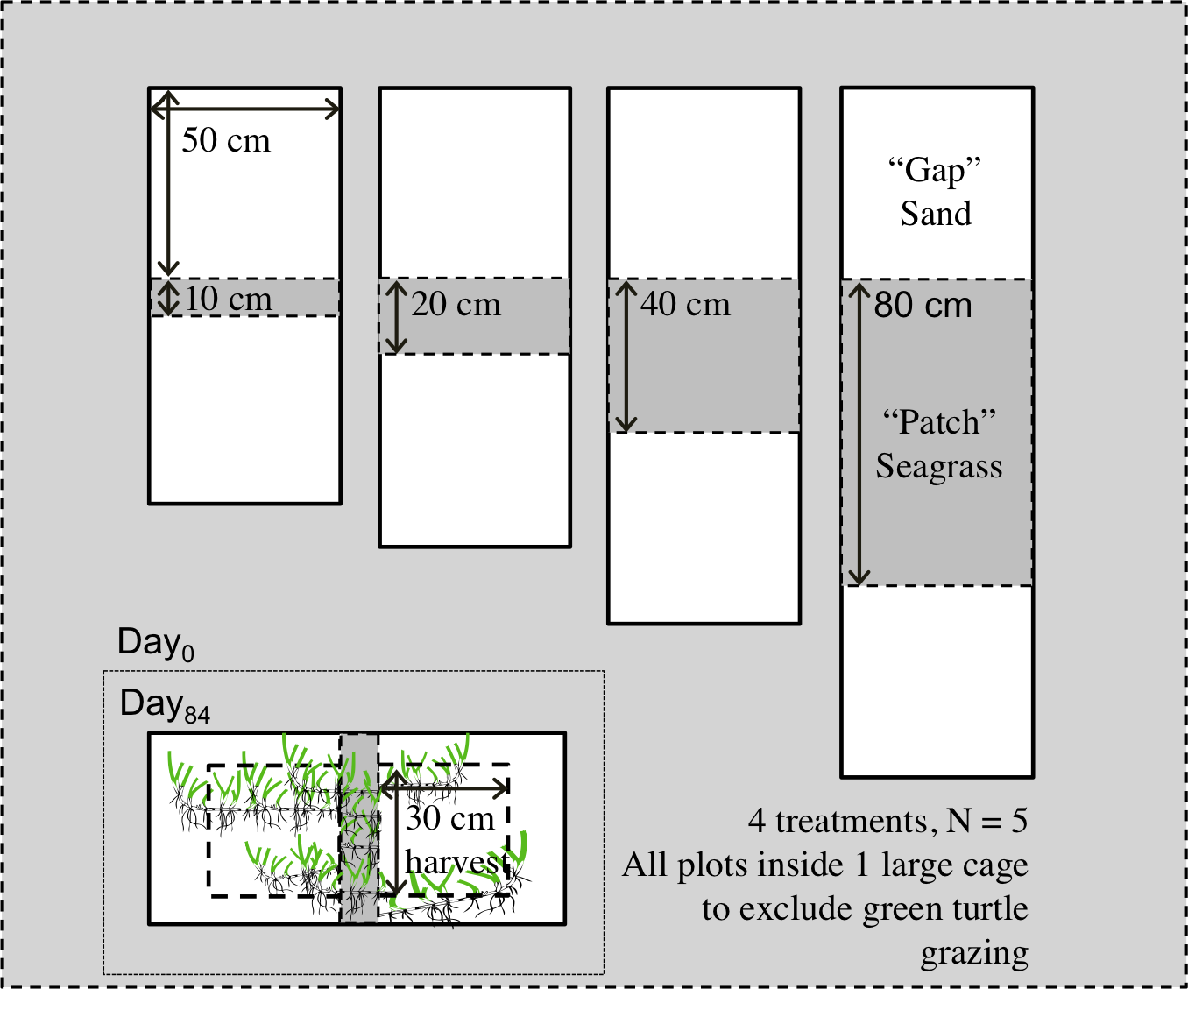

**Figure S2.** Setup of the gap regrowth experiment; Experimental units consisted of a seagrass strip (width 10, 20, 40, or 80 cm, length 50 cm), surrounded by 2 gaps (50 * 50 cm). The unit was surrounded by root canvas (solid black line) that extended 15 cm into the sediment, to prevent all regrowth from the outside. Seagrass biomass expansion in gaps and erosion probability of seagrass strips were measured at the end of the experiment (84 days). Experimental units were located inside a large cage (l * w * h: 15 * 10 * 3.5 m), to prevent green turtle grazing.

S2 Supplementary Text On Models,

S2*a* General description model 1 and 2

We compare two models. In the first model, turtles do not dig and only graze on leaves. Belowground biomass constitutes an ungrazable reserve. The second model includes the effect of digging, which reduces seagrass regrowth by creating gaps in the vegetation and enhancing erosion. The models follow the general differential equation: *dB/dt=G(B)-F(B)H*

Here *G(B)* describes the rate of growth of seagrass as a function of seagrass biomass (S2.3 and fig S4), and *F(B)* describes the feeding rate per herbivore.

Model 1

In the first model without digging, we adopted a classical grazing model. Growth of seagrass is modelled with the logistic growth equation, *G(B) = r (1 - B/K) B*, where *r* is the intrinsic growth rate, and *K* is the maximum biomass per unit area. Turtle grazing was modelled as a linear function of seagrass biomass, taking into account an ungrazable, belowground reserve *Bb* : *F(B) = c (B - Bb)*, where *c* is a grazing constant.

Model 2

The second model considers the effect of digging by including gap formation and decreased regrowth of seagrass due to erosion. In this model, we implicitly incorporate the spatial heterogeneity relation between gap size and regrowth obtained in our experiments, *G(B) = P(B) · E(B).* Here *P(B)* is a spatially implicit function that describes the effect of reduced cover in gaps and subsequent erosion on seagrass growth rate, which is maximal at low to intermediate gap cover (figure S4). *E(B)* describes the effect of erosion on seagrass regrowth, where at low seagrass biomass, increased erosion depresses seagrass growth. This function is derived by fitting a model to our experimental results. We again used a linear functional response without ungrazable reserve: *F(B) = c · B*.

S2*b* Derivation of the seagrass biomass-growth relation in a gap mosaic landscape (model 2)

Here, we derive a mathematical description of the effect that spatial heterogeneity induced by the digging strategy of the turtles has on the growth of the seagrass, which we use in model 2 (figure S3). The basal assumption that underlies this growth model is that the seagrass landscape is composed of gaps in various states of recovery after past turtle digging events.

Within each gap, growth starts at an initial biomass *B0* (g DW m-2) remaining after a grazing event, and growth proceeds according to logistic growth equation. The rate of growth per gap is given by the logistic growth equation:

 (Eqn. S1)

where *B* is biomass (g DW m-2), *r* is the intrinsic rate of growth (d-1), and *K* is the carrying capacity (g DW m-2). The biomass in a gap of age *t* is given by the solution of the growth equation:

 (Eqn. S2)  
Where *B0* is biomass at *t* = 0 (g DW m-2).

We further assume that the turtles dig new gaps at places with the highest biomass, i.e., those locations that have had the longest time for recovery. As a fixed number of gaps are dug out per time unit by a given number of turtles *T*, this implies that an even distribution of ages can be found at any time, ranging from just dug out (*t = 0*) up to the maximum age of a recovering gap *tm*. *tm* is calculated as the total surface of the seagrass meadow divided by the surface that is dug out each day, and could hence be derived from experimental data. At the current density and activity of turtles, it equals to approximately *tm* = 200 days in this system.   
The total biomass of seagrass in the landscape is given as:

 (Eqn. S3)

Where *A* is the surface of the landscape (m2), and  is the average biomass density (g DW m-2) in a recovering gap.  can, for a uniform age distribution of recovering gaps, be calculated as:

 (Eqn. S4)

Inserting equation (S2) in (S4) and solving the integral yields:

 (Eqn. S5)

The total growth of seagrass over the landscape, *Gtot* (g DW m-2 d-1) is, in a similar way, given as:

 (Eqn. S6)  
Where is the average growth rate of seagrass in a recovering gap (g DW m-2 d-1).

**Figure S3.** Seagrass biomass (solid line, Eqn. S2) and production (dashed line, Eqn. S6) for gaps of different age or different stage of regrowth.

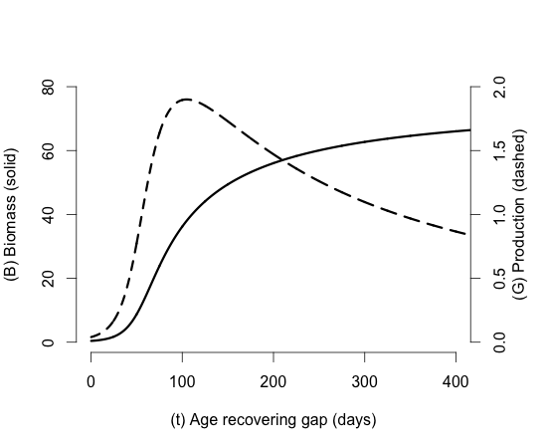

Again, given the uniform age distribution, calculating this average can be achieved by integration over time. This yields the function for the average growth rate:

 (Eqn. S7)

Where the actual growth rate *G(t)* is given by the right-hand side of equation (S1). Obviously, the solution of the integral in equation (S7) is given as *Btm – B0,* since the integration of growth is the biomass at time tm, minus the initial biomass. Therefore, equation (S7) is solved as:

 (Eqn. S8)

We numerically calculated both average biomass and average growth rate as a function of lifetime tm of the gaps, in order to obtain a numerical relation of as a function of , as it could not be solved analytically. This yields the growth function in a gap mozaik landscape *P(B)* used in equation *G(B) = P(B) · E(B)* in the supplementary text (S2.1), with *B* in the main model standing for the landscape-averaged biomass (denoted in this derivation).

S2.c Deriving erosion function *E(B*)

The growth function is further multiplied by the erosion function *E(B),* to yield the net growth (figure S4). We assume that erosion decreases the growth rate by a fraction *E(B)* that is a function of seagrass biomass *B*. We used a function where *E(B)* increases from a fraction *G0a* at zero seagrass density up to unity when *B* becomes large:

 (Eqn. S9)

Where *k* is the half saturation biomass (g DW m-2), and *a* is a parameter determining the steepness of the curve at point *B=k*. We assumed for simplicity that seagrass belowground biomass does not decrease because of grazing of the aboveground part [*23*], and hence we did not include a dependency of belowground biomass to aboveground biomass.

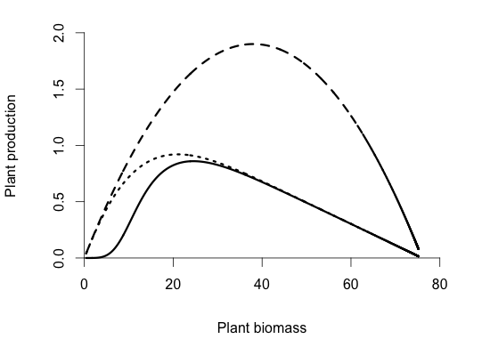**Figure S4.** Model 1 (dashed line); Seagrass production in a continuous meadow . Seagrass production  in a gap mosaic landscape (dotted line). Model 2 (solid line); Seagrass production in a gap mosaic landscape. where erosion disturbs recovery.

S3*c* Parameters

Most of the parameters of model 2 were based on measurements and experiments that we performed on location at our study sites (table S2). We measured turtle density and seagrass biomass within the meadow (S1)**.**

Estimation of K

We estimated K indirectly based on regrowth experiments and observations of belowground biomass at the beginning of the study period (2008). It is difficult to estimate K, because exclosures that exclude all grazers without fostering epiphyte growth cannot be maintained over very long periods in the field. During regrowth experiments in 2010, where plots were stripped of seagrass biomass and left to recover in grazing exlosures, we observed that belowground and aboveground biomass increased closely in parallel, with almost equal values. We used this observation to infer that total biomass at K will be double the belowground biomass. We used the 2008 observations of average belowground biomass outside gaps (38 g DW m-2) referred to in the model as the “ungrazable reserve” Bb, and doubled this value as an estimate of K.

Estimation of r, the intrinsic rate of increase

Two series of observations were used to estimate the value of r. The first consisted of measurements of total biomass in natural gaps that were protected from further grazing or disturbance immediately after they were created. The total biomass in the plots was measured after 28 or 29 days. Using the estimated average initial biomass in a gap (0.4 g DW m-2), r in this first period of growth was estimated from

 (Eqn. S10)

Where Δt is the duration of the observation, K is 76 g DW m-2 as before, B0 and Bt are biomass at the beginning and end of the observation, respectively. The average r calculated from these observations is 0.083 d-1.

The second series of observations is a set of field experiments, conducted in 2009, where artificial gaps were created and monitored over time. We did not have adequate estimates of the biomass left in the gaps at the moment of creation, but we did have observations of mean biomass left after 14, 28, 42 and 56 days of regrowth (protected from grazing). For every observation interval (14-28, 28-42 and 42-56 days) we calculated the realized relative growth rate as:

 (Eqn. S11)

Where Bt is biomass at the end of the observation interval, and B0 at the beginning of the interval, and Δt is the duration of the interval. We then regressed this growth rate against (geometric) average biomass during the interval. The regression was linear (r2=0.99, n = 3). The intercept of the regression line is an estimate of the intrinsic rate of natural increase, with a value of 0.11 d-1. This value is slightly higher than the one estimated from the first series of observations. We used a value of 0.1 d-1 in the model calculations.

Estimation of the grazing constant

A grazing constant was determined by dividing the measured uptake rate of above and belowground biomass by the turtle density times the maximum available biomass in the meadow measured in 2008).

a and k in the erosion formulation

*a* and *k* were derived by fitting a curve  (Eqn. S12)

to the data points of biomass regrowth at different seagrass biomass as was measured during the field experiment (S1.2) using non-linear minimization in R.

**Table S2. Parameters for the seagrass – turtle grazing model**, see S2.5 for further explanation.

|  |  |  |  |
| --- | --- | --- | --- |
| **Parameter** | **Value** | **Unit** | **Description** |
| *K* | 76 | g DW m-2 | Maximum seagrass biomass in meadow study area |
| *r* | 0.1 | d-1 | Intrinsic growth rate of seagrass |
| *cb* | 5.7 | turtle -1 m2 d-1 | grazing constant “digging” at 2008 grazing pressure |
| *c* | 11.4 | turtle -1 m2 d-1 | grazing constant “leaf grazing” at 2008 grazing pressure |
| *k* | 11 | g DW m-2 | half-saturation parameter erosion function |
| *a* | 3.6 |  | exponent in erosion function |
| *B0* | 0.4 | G DW m-2 | Remaining seagrass biomass after a digging event |
| Bb | 38 | g DW m-2 | Ungrazable seagrass biomass (belowground biomass at K) |

**Supplementary videos:**

Movie showing the digging behaviour of the green turtle (*Chelonia mydas*).

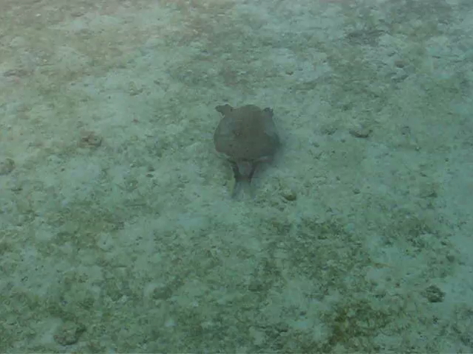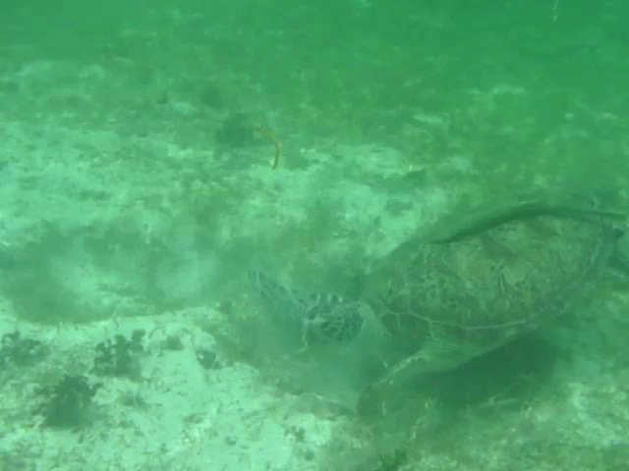

*a)*

*b)*

1. Still image for video S1 (https://www.youtube.com/watch?v=I2K LMiEf_7U), b) Still image for video S2 (<https://www.youtube.com/watch?v=dxwJt8Zgias>)