Supplementary Information 3
Time Binning Schemes
To explore the impact of different binning schemes, occurrence data were pooled into: (1) approximately equal length (~10 million year, n = 14) time bins (Alroy, Aberhan et al. 2008, Alroy 2010) (Table S1); and (2) stage-level time bins based on the Standard European Stages and absolute dates provided by (Gradstein, Ogg et al. 2012) (Table S2). Although the former addresses potential problems of uneven time bin duration on biodiversity reconstruction, it obscures the finer scale timings of any changes in biodiversity across the J/K boundary, in that the Kimmeridgian is combined with the Tithonian, and the Berriasian with the Valanginian. To avoid over-counting taxa in multiple time bins, resulting from uncertainty in their temporal durations, only occurrences that could be assigned to a single time bin were used, resulting in 681 non-marine occurrences from 669 collections, and 330 marine occurrences from 284 collections. We followed Mannion et al. (in press) by including occurrences from the equivocally-aged Adamantina Formation within K6 (see Table 1) for the analyses with 10 million year time bins, but excluded them from any Stage-level analyses.

Abbreviation | 10 million year time bin | Stage equivalent | Temporal range
K8 | Cretaceous 8 | Maastrichtian | 72.1–66.0
K7 | Cretaceous 7 | Campanian | 83.6–72.1
K6 | Cretaceous 6 | Turonian–Santonian | 93.9–83.6
K5 | Cretaceous 5 | Cenomanian | 100.5–93.9
K4 | Cretaceous 4 | Albian | 113–100.5
K3 | Cretaceous 3 | Aptian | 126.3–113
K2 | Cretaceous 2 | Hauterivian–Barremian | 133.9–126.3
K1 | Cretaceous 1 | Berriasian–Valanginian | 145.0–133.9
J6 | Jurassic 6 | Kimmeridgian–Tithonian | 157.3–145.0
J5 | Jurassic 5 | Callovian–Oxfordian | 166.1–157.3
J4 | Jurassic 4 | Bajocian–Bathonian | 170.3–166.1
J3 | Jurassic 3 | Toarcian–Aalenian | 182.7–170.3
J2 | Jurassic 2 | Pliensbachian | 190.8–182.7
J1 | Jurassic 1 | Hettangian–Sinemurian | 201.3–190.8

Supplementary Table 1. Approximately equal 10 million year time bins used in the present study. Absolute dates are based on Gradstein et al. (2012).

Abbreviation | Stage | Bin base (Ma)
K12 | Maastrichtian | 70.6
K11 | Campanian | 83.5
K10 | Santonian | 85.8
K9 | Coniacian | 89.3
K8 | Turonian | 93.5
K7 | Cenomanian | 99.6
K6 | Albian | 112
K5 | Aptian | 125
K4 | Barremian | 130
K3 | Hauterivian | 136.4
K2 | Valanginian | 140.2
K1 | Berriasian | 145.5
J11 | Tithonian | 150.8
J10 | Kimmeridgian | 155.7
J9 | Oxfordian | 161.2
J8 | Callovian | 164.7
J7 | Bathonian | 167.7
J6 | Bajocian | 171.6
J5 | Aalenian | 175.6
J4 | Toarcian | 183
J3 | Pliensbachian | 189.6
J2 | Sinemurian | 196.5
J1 | Hettangian | 201.6

Supplementary Table 2. Stage-level time bins used in the present study. Absolute dates are based on Gradstein et al. (2012).

Subsampling approach
Shareholder quorum subsampling (SQS) standardises in-bin taxonomic occurrence samples based on an estimate of coverage to determine the relative magnitude of taxonomic biodiversity trends (Alroy 2010, Alroy 2010). Coverage is estimated by using randomised subsampling to calculate the mean value of Good’s u (Good 1953), the sum of the frequencies of sampled taxa within an occurrence list, and used to set the desired quorum level. Coverage of zero implies that data within a bin are poorly sampled, either because occurrences are non-existent or because all taxa are singletons (i.e., taxa with only a single occurrence per bin), whereas a higher coverage value implies more even sampling of taxa. In this model, the frequency of occurrences of each taxon within a pool becomes their share, from which taxa are randomly drawn until the pre-set quorum is met. Although it has been suggested that SQS can remove a genuine signal that might be underlying both sampling and biodiversity (Hannisdal and Peters 2011), Mannion et al. (2015) found that the relationships between environmental variables and pseudosuchian biodiversity were strengthened upon application of SQS, suggesting that this signal dampening is unlikely to be a problem, at least for crocodyliforms.
In addition to analyses using the same dataset for calculating SQSP, but using the R script (i.e., SQSRc), we calculated SQSRu using the following rule: if a single non-marine occurrence is present in only two adjacent time bins (e.g., K3 and K4), it can be added to the occurrence lists for both time bins. This provides the basis for two estimates of biodiversity using this version of SQSR: (1) using a strict minimum number of occurrences to provide a minimal estimate, i.e., constrained SQS (SQSRc); and (2) incorporating an additional measure of uncertainty based on low resolution of terrestrial fossil record dating, i.e., unconstrained SQS (SQSRu). The temporal durations of marine crocodyliforms are relatively well-constrained, and therefore we did not calculate SQSRu for them.

Model fitting procedure
Because the environmental data (Table S3) were previously presented at the stage level, they were also transformed into 10 million year time bin data by taking the mean of values for data points that fall within our individual time bin intervals. We constrained correlation tests involving PDEs to the Bathonian–Albian interval, and J2 to K7 for PDEt, to remove potential skewing by edge effects associated with phylogenetic methods of estimating biodiversity. We also constrained SQSPs to the Bathonian–Albian, as the results had little resolution outside of this interval. All of these time series data were detrended by using maximum likelihood to fit a first-order autoregressive integrated moving average model using the arima() function, and extracting the residuals to eliminate the effect of serial correlation. The residuals of each of the environmental parameters were independently compared using linear regression to each of our measures of biodiversity. The relative fit of each variable was assessed using the sample-size corrected Akaike Information Criterion (AICc) (Hurvich and Tsai 1989) by calculating the likelihood and weight for each environmental parameter as a way of assessing the probability of each one among the candidate set of models. The strength of the fit of each model was further tested through calculation of the parametric Pearson’s product moment correlation coefficient and the non-parametric Spearman’s rank correlation coefficient. To be considered as having strong statistical support, a parameter had to satisfy the following criteria: (1) a correlation score of greater than 0.5 for both correlation tests; (2) a traditional p-value of <0.05 for both correlation tests; (3) having the best-fitting model based on AICc likelihood scores; and (4) having the highest Akaike weight. Combinations were considered where these criteria were met by multiple parameters.

Parameter | Source | Proxy for
Non-marine rock outcrop area (NMA) | Benson and Butler, 2011 | Area of shallow marine habitat available
Fossiliferous marine formation (FMF) | Benson and Butler, 2011 | Geological sampling of marine environments
Eustatic sea-level (1) | Miller et al., 2005 | Area of shallow marine habitat available
Eustatic sea-level (2) | Haq et al., 1997 | Area of shallow marine habitat available
δ¹⁸O | Prokoph et al., 2008 | Inverse proxy for temperature
δ¹³C | Prokoph et al., 2008 | Biological activity
δ³⁴S | Prokoph et al., 2008 | Organic nutrient inputs or shelf redox conditions
⁸⁷Sr/⁸⁶Sr | Prokoph et al., 2008 | Inorganic nutrient inputs
Sea-surface temperature (based on δ¹⁸O) | Martin et al., 2014 | Global sea-surface temperature
Global subsampled marine diversity | Hannisdal and Peters, 2011 | Prey availability

Supplementary Table 3. Extrinsic variables used in the present study, their sources, and the environmental factors they represent.

Informal supertree construction protocol
Background
Phylogenies provide information on ‘hidden’ biodiversity that we know must have existed but that has not been preserved in the fossil record. Based on the bifurcation model of speciation, sister taxa originate at the same time as each other and therefore we can extrapolate their known fossil ranges so that they have equal origination times. The creation of these ‘ghost lineages’ increases biodiversity by extending unsampled taxonomic ranges into older time bins (Norell 1993). To produce a phylogenetic diversity estimate (PDE), we constructed a new crocodyliform ‘informal’ supertree comprising 252 species (source trees below) using Mesquite (version 2.75). This involves the ‘bolting together’ of different parts of independent trees to increase phylogenetic taxon sampling, without creating spurious relationships not found in any of the source trees. We created an additional supertree at the genus level (146 genera) to account for uncertainty in the taxonomy of anomalously speciose genera, such as Goniopholis, Steneosaurus, and Teleosaurus. Here, we provide details of our tree construction. A full list of taxa and sources are provided in Supplementary Information 1 (SI 1).
The taxonomy for our trees is based on a list of all Jurassic–Cretaceous crocodyliform species from the Paleobiology Database (accessed December 1, 2014). This is a comprehensive occurrence-based list that JPT, PDM and numerous others (Carrano et al. 2015) have contributed to, and is a faithful representation of the current state of knowledge of crocodyliform taxonomy based on the published literature. Information on phylogenetic relationships was obtained from a range of sources from the primary literature (see below). Phylogenetic information could not be collected for some of the genera, which were omitted. For time-scaling purposes, we used the full genus range implied by each of its constituent species, including specifically indeterminate remains. By comparing the two supertrees, we can identify where taxonomic issues might confound the signal, and identify key areas for future taxonomic research. Both supertrees are available at the end of this document (after the supplementary figures), and can be read into R by creating separate files with a .tre file extension.
These supertrees contained multiple polytomies, which can skew biodiversity estimation by extending the durations of poorly resolved lineages to a more basal position than they should occupy, and therefore incorrectly inflating biodiversity in older time bins (Wagner 2000). To combat this issue, we applied three different methods of resolving polytomies (see main text for details), and calculated PDE as the mean of the results using each of these. In instances where not all species of a multispecific genus have previously been included in a phylogeny, we incorporate these but create a polytomy for all inclusive species. However, if there are only two species then we include them as sister taxa.
Crocodyliformes
For crocodyliform taxa outside of Mesoeucrocodylia, we follow Pol et al. (2004: fig. 5) as a starting point. The three species of Hsisosuchus (H. chowi, H. chungkingensis, and H. dashanpuensis) are resolved according to Halliday et al. (2015). Fiorillo and Calvo (2007) was used as the basis to position several basal mesoeucrocodylian taxa: along with Zosuchus, Shantungosuchus (comprising S. chuhsienensis and S. hangjinensis) and Sichuanosuchus (S. huidongensis and S. shuhanensis) were placed as sister taxa to Fruitachampsa. The position of Shartegosuchus was based on Clark (2011), placing it as the sister taxon to Fruitachampsa. Additionally, both Gobiosuchus (comprising two species: G. kielanae and G. parvus) and Protosuchus (comprising three species: P. micmac, P. haughtoni and P. richardsoni) were forced into multi-specific polytomies. Entradasuchus is included within this assemblage of ‘protosuchian’-grade taxa, in an unresolved basal position, based on Hunt and Lockley (1995). Both Orthosuchus and Edentosuchus are included as successive sister taxa to Protosuchus based on Pol et al. (2004). Dianosuchus was placed within Protosuchia based on discussion in Peng (1996). Platyognathus was included in the unresolved polytomy at the base of Crocodyliformes due to its ‘protosuchian’ relationships with Protosuchus and Shantungosuchus outlined in Wu and Sues (1996). We used this position to place other shartegosuchids, Kyasuchus and Nominosuchus, in a basal polytomy with Shartegosuchus. Zaraasuchus was placed as the sister taxon to Gobiosuchus, based on Pol and Norell (2004: fig. 11). For the position of Mesoeucrocodylia, we follow Pol et al. (2004). Contrary to Adams (2014), this excludes taxa such as Hsisosuchus and Fruitachampsa as basal mesoeucrocodylians. This decision is based on the fact that Pol et al. (2004) sample a much broader range of basal crocodyliform taxa, and therefore we have increased confidence in their placement of these taxa. Leardi et al. (2015) found Microsuchus to be unstable, but positioned in an resolved position outside of Notosuchia and Neosuchia within Mesoeucrocodylia, a position which we followed here.
Notosuchia
For Notosuchia, we used the cladogram from Pol et al. (2014: fig. 31). This includes Uruguaysuchidae, Peirosauridae, Sphagesauridae and Baurusuchidae as subclades, with the latter two placed within Ziphosuchia. Neuquensuchus was repositioned from a basal crocodyliform to a ziphosuchian based on Leardi et al. (2015: fig. 8), and placed with Pakasuchus and Malawisuchus, which we collapsed into a polytomy. These taxa comprise a basal assemblage of ziphosuchians, along with Libycosuchus and Simosuchus (Pol et al., 2014). We follow Pol et al. (2014) for the position of Stolokrosuchus, retaining it as a notosuchian (and sister taxon to Peirosauridae + Mahajungasuchidae) instead of the basal-most neosuchian as proposed by Adams (2014). Doratodon ibericus and Doratodon carcharidens are placed within Ziphosuchia, one step higher than Libycosuchus, following Company et al. (2005).
Mahajangasuchidae: Mahajangasuchus and Kaprosuchus are placed as sister taxa to Peirosauridae, comprising Mahajangasuchidae.
Peirosauridae: Peirosauridae was placed within Notosuchia, together with Uruguaysuchidae + Mahajangasuchidae + Stolokrosuchus comprising the sister group to Ziphosuchia. We revised the internal relationships of Peirosauridae (Pol et al., 2014) to conform to that of Sertich and O’Connor (2014). Note that this also includes the ‘trematochampsid’ taxon Trematochampsa. Unfortunately, this placement of Trematochampsus renders the phylogenetic affinities of all other ‘trematochampsids’ as questionable, and therefore we exclude members previously assigned to this group from our supertree, pending further analysis of their taxonomy and phylogenetics. Barcinosuchus is placed in a polytomy within Peirosauridae and closely related taxa (including Lomasuchus and Montealtosuchus) based on discussion within Martinelli et al. (2012). Peirosaurus is placed in an unresolved position at the base of Peirosauridae based on discussion in Martinelli et al. (2012). Pepesuchus is also placed in an unresolved polytomy at the base of Peirosauridae, based on discussion in Campos et al. (2011).
Uruguaysuchidae: Pol et al. (2014) found Araripesuchus to be paraphyletic. Araripesuchus rattoides is placed in the existing polytomy between several species of Araripesuchus and Anatosuchus based on Sereno and Larsson (2009: fig. 43). Uruguaysuchus is included as the sister taxon to Anatosuchus + Araripesuchus, together comprising Uruguaysuchidae.
Baurusuchidae: Baurusuchidae is the sister clade to Sebecidae, which together comprise Sebecosuchia (Pol et al., 2014). Pabwehshi is placed at the base of Baurusuchidae in a polytomy with Cynodontosuchus, based on discussion provided in Wilson et al. (2001). Gondwanasuchus is placed as the sister taxon to all pissarachampsids and baurusuchines. Aplestosuchus is placed within Baurusuchidae, as the sister taxon to ‘Baurusuchus’ albertoi based on Godoy et al. (2014: fig. 9). Wargosuchus is placed as the sister taxon to Pissarachampsa, which together with Campinasuchus comprises Pissarachampsinae, which along with Baurusuchinae comprises Baurusuchidae (Godoy et al., 2014). Pehuenchesuchus is the most basal sebecosuchian according to Turner and Calvo (2005: fig. 5). Baurusuchids were resolved within Sebecosuchia by Company et al. (2005); as such we place them in a basal polytomy with Pabweshi and Cynodontosuchus.
Sphagesauridae: The internal relationships of Sphagesauridae and ‘advanced notosuchians’ are based on Pol et al. (2014: fig. 31). Together, these form the sister taxon to Sebecosuchia (to the exclusion of Comahuesuchus and Chimaerasuchus.

Neosuchia
Neosuchia and Notosuchia are sister taxa, and together comprise Mesoeucrocodylia (e.g., Adams, 2014). For Neosuchia, we used the cladogram from Adams (2014: fig. 13). Both species of Laganosuchus (L. thaumastos and L. maghrebensis) are placed within Neosuchia, outside of Eusuchia, and in a position basal to Bernissartiidae, in accordance with Sereno and Larsson (2009: fig. 43).
Atoposauridae: Atoposauridae are placed at the base of Neosuchia (Adams, 2014; Martin et al., 2014), and we follow Martin et al. (2010) for the internal relationships of this clade. For Alligatorium, we use the two species A. meyeri and A. franconicum, although the only specimens of the latter are lost to science. We also include the two species of Alligatorellus, based on Tennant and Mannion (2014). Brillanceausuchus (Michard et al., 1990) and Karatausuchus (Storrs and Efimov, 1976) have been considered to belong to Atoposauridae by some authors, but this has never been confirmed via phylogenetic analysis, and therefore we exclude them here.
Goniopholididae: The position of Goniopholididae is established using Adams (2014). The internal relationships of this clade follow Andrade et al. (2011). The “Hooley goniopholidid” is now named Anteopthalmosuchus, and the “Hulke goniopholidid” is Hulkepholis (Salisbury and Naish, 2011). Sunosuchus thailandicus was recombined recently as Chalawan thailandicus (Martin et al., 2014). Goniopholis stovalli is collapsed into a basal polytomy, as Eutretauranosuchus nests within Sunosuchus instead of being in a sister taxon relationship, as proposed by Adams (2014). Denazinosuchus is also placed in an unresolved basal position based on Andrade et al. (2011). Goniopholis is a problematic genus, as there are an additional eight species of this taxon not included in either Andrade et al. (2011) or Adams (2014), but with a lack of work on them meaning that they are retained in the Paleobiology Database as valid species. For now, we tentatively include each of these species of Goniopholis as part of a basal polytomy with G. stovalli and Denazinosuchus, pending future taxonomic revision. Goniopholis paulistanus is excluded as it is explicitly stated as a nomen dubium belonging to Neosuchia by Andrade et al. (2011). Coelosuchus is placed in a basal polytomy within Goniopholididae based on Williston (1906). Given the length of time that has passed since this assignment, this placement is regarded as extremely tentative. Kanjasuchus is included as a goniopholidid, according to Halliday et al. (2015). These authors recovered it as part of a polytomous assemblage, along with Calsoyasuchus, Sunosuchus and others. As such, we place it in a basal polytomy with these taxa along with Entradasuchus. These authors also considered Turanosuchus to be a nomen dubium, which we follow here. Woodbinesuchus is placed in a basal polytomy within Goniopholididae based on Lee (1997). Vectisuchus is placed as part of the basal polytomy within Goniopholididae based on Bronzati et al. (2012: fig. 3).
Thalattosuchia: For Thalattosuchia, we use the cladogram from Young et al. (2013a: fig. 15). Most recently, Wilberg (2015) recovered Thalattosuchia in a more basal position, as the sister group to all remaining crocodyliforms. However, this hypothesis has yet to be subject to further scrutiny, and we retain their position within Neosuchia, pending further analysis.
Teleosauroidea: Teleosauroidea is placed as the sister taxon to all other metriorhynchoids. Taxa that are not formally named (e.g., “Ricla crocodile” and “Mr Leeds Specimen”) are not included in our supertree. Those of questionable genus referral (e.g., “Metriorhynchus” westermanni) are included in their current taxonomic status as recorded within the Paleobiology Database (as of December, 2014). The internal relationships of Teleosauridae follow Young (2014: fig. 7). Geosaurus araucaniensis is placed in an unresolved basal position within Geosarini, based on its generic relationship with other species of Geosaurus. For Machimosaurus, we chose to consider just a single taxon to be valid, Machimosaurus hugii (following Martin et al. 2014), and not with two or more species (Young, 2014; Young et al., 2014). Haematosaurus is placed in an unresolved position at the base of Teleosauridae, based on Sauvage (1874). Given the length of time that has passed since this assignment, this placement is regarded as extremely tentative. Peipehsuchus is placed within Teleosauridae in an unresolved basal position based on discussion in Li (1993). Pelagosaurus brongniarti is placed as sister taxon to Pelagosaurus typus based on its generic affinity, within Teleosauridae. Steneosaurus is clearly a problematic taxon. According to the Paleobiology Database, there are currently 20 valid species within this genus. Making a taxonomic statement about each of these taxa is beyond the scope of the present study. However, it is obvious that this taxon is in need of a comprehensive taxonomic reappraisal. For the purposes of the present study, we place all taxa not already included by Young (2014) in a generic polytomy at the base of Teleosauridae. We note caution that doing this for such a large number of unstable species is likely to create error in our phylogenetic diversity estimates, and therefore Middle and Late Jurassic diversity should be assessed at both the genus and species level. Teleosaurus suffers from similar taxonomic issues to Steneosaurus and Goniopholis. We include the additional six species in a polytomy with Teleosaurus cadomensis, as the sister taxon to Platysuchus.
Metriorhynchoidea: The node comprising the last common ancestor of Pelagosaurus and Metriorhynchus is taken as the point to attach Metriorhynchoidea of Young et al. (2013a). Metriorhynchus is a paraphyletic taxon and clearly in need of taxonomic revision. M. littoreus, M. moreli, and M. palpebosus, were placed in an unresolved position at the base of Metriorhynchidae, based on their generic affinity. Aggiosaurus is placed at the base of Geosaurini following Young et al. (2012). Both Cricosaurus gracilis and Cricosaurus lithographicus are placed within Metriorhynchidae based on Herrera et al. (2013). Cricosaurus species were arranged to conform to this relatively well-resolved topology, instead of representing a polytomy as in Young et al. (2013a). Maledictosuchus is placed at the base of Rhacheosaurini according to Parilla-Bel et al. (2013: fig. 17). Purranisaurus is placed as the sister taxon to Geosaurini within Metriorhynchidae based on Cau and Fanti (2011: fig. 6). Suchodus is placed at the base of Geosaurinae according to Young et al. (2009: fig. 2), as the sister taxon to all other geosaurines. Tyrannoneustes is placed as the sister taxon to the Torvoneustes species, as part of the polytomy within Geosaurini, based on of Young et al. (2013b: fig. 21).
Pholidosauridae: Pholidosauridae + Dyrosauridae is the sister taxon to Thalattosuchia, which together comprise the sister clade to Goniopholididae and other higher neosuchians (including Eusuchia), following Adams (2014). According to Martin et al. (2014), Pholidosaurus constitutes the most basal member of Pholidosauridae, and comprises four species which are unresolved with respect to each other (P. decipiens, P. meyeri, P. purbeckensis and P. schaumbergensis). Similarly, Terminonaris includes the two species T. browni and T. robusta, Sarcosuchus includes S. hartti and S. imperator, and Elosuchus includes E. cherifiensis and E. felixi. We position Chalawan in a polytomy with Elosuchus and Sarcosuchus, as in Martin et al. (2014), which also collapses Terminonaris, Oceanosuchus, and Meridiosaurus into this polytomy.
Dyrosauridae: Dyrosauridae is placed as the sister group to Pholidosauridae. The position of this group is still uncertain within ‘Tethysuchia’. Chenanisuchus is placed as the sister taxon to Dyrosaurus, following Jouve et al. (2005).
Bernissartiidae: Koumpiodontosuchus is placed as sister taxon to Bernissartia based on Sweetman et al. (2015). Khoratosuchus is placed as sister taxon to Bernissartia and Koumpiodontosuchus, outside of Paralligatoridae and Eusuchia, based on Lauprasert et al. (2009). Note that this topology places Bernissartiidae outside of Eusuchia.
Susisuchidae: Susisuchus, comprising the two species S. anatoceps and S. juaguaribensis, are placed according to Young et al. (2012: fig. 26), who found them to be outside of Eusuchia as the sister taxon to Isisfordia, a position recently confirmed by Turner and Pritchard (2015).
Eusuchia: Eusuchia follows Holliday and Gardner (2012: fig. 9), and is positioned as the sister taxon to Paralligatoridae following Adams (2014), and more recently Turner (2015). Allodaposuchus is placed within Eusuchia as the sister taxon to Hylaeochampsa (see below) following Adams (2014) and Puértolas-Pascual et al. (2014). Aigialosuchus is placed as the basalmost member of Eusuchia, apart from Isisfordia, due to its uncertain position within this clade (Martin and Delfino, 2010). Gilchristosuchus is placed as the sister taxon to Eusuchia, following Wu and Brinkmann (1993). This position also places it outside of Paralligatoridae, and more derived than Bernissartia. The ‘Shamosuchus’ complex was historically considered to include ten species. Recently, Turner (2015) reviewed the taxonomy of this genus, finding only Shamosuchus djadochtaensis, S. gradilifrons, and S. major to be valid species. However, Turner (2015) transferred the latter two species to their own genus, Paralligator. Shamosuchus sungaricus, S. borealis, and S. karakalpakensis are considered to be nomina dubia, and S. ancestralis, S. ulgicus, S. tersus, and S. ulanicus are considered by Turner (2015) to be junior subjective synonyms of S. gradilifrons.
Hylaeochampsidae: For Hylaeochampsidae, we used Puértolas-Pascual et al. (2014), which includes the taxa Acynodon, Hylaeochampsa, Iharkutosuchus, Pachycheilosuchus and Pietraroiasuchus. Acynodon lopezi is added to the genus Acynodon to form a polytomy. The group is placed as the sister taxon to Allodaposuchus following Puértolas-Pascual et al. (2014).

Crocodylia
The positions of Crocodylia, Gavialoidea and Aegyptosuchidae follow Holliday and Gardner (2012). Along with Thoracosaurus macrorhynchus, the other three species of Thoracosaurus (T. bahiensis, T. borissai and T. neocesariensis) are placed in a polytomy in a position more derived than Eothoracosaurus at the base of Gavialoidea. Ocepesuchus is placed as the sister taxon to Thoracosaurus within Gavialoidea, based on Jouve et al. (2008: fig. 5). Arenysuchus is placed within Crocodylia basal to Eothoracosaurus, based on its position within Crocodyloidea in Puértolas et al. (2011: fig. 5), a group which is relatively under-sampled in the present study due its Late Cretaceous origins. Albertochampsa langstoni is placed as the sister taxon to Brachychampsus following Norell et al. (1994). Deinosuchus is placed in a more derived position than Leidyosuchus within Brevirostres according to Erickson and Brochu (1999). Its two species, D. riograndensis and D. rugosus, are retained as sister taxa to each other based on generic affinity. Massaliasuchus is placed in a basal polytomy with Leidyosuchus within Brevirostres based on Martin and Buffetaut (2008). Five Cretaceous species attributed to Crocodylus are also still considered as valid within the database: C. blavieri, C. humilis, C. proavus, C. selaslophensis, and C. vetustus. However, these taxa are almost definitely invalid (Mannion et al., 2015), with Crocodylus more likely originating in the Miocene, and therefore we exclude them.

Excluded taxa due to unknown or uncertain affinities
Amargasuchus minor, Artzosuchus brachicephalus, Baharijodon carnosauroides, Barreirosuchus franciscoi, Bottosaurus harlani, Brachydectes major, Brasileosaurus pachecoi, Caririsuchus camposi, Chiayusuchus cingulatus, Coringasuchus anisodontis, Dakotasuchus kingi, Dianchungosaurus lufegnesis, Diplosaurus felix, Eopneumatosuchus colberti, Hadangsuchus acerdentis, Heterosuchus valdensis, Hoplosuchus kayi, Ischyrochampsa meridionalis, Itasuchus jesuinoi, Kemkemia auditorei, Leiokarinosuchus brookensis, Lisboasaurus estesi, Lisboasaurus mitracostatus, Lusitanisuchus mitracostatus, Megalosaurus mersensis, Miadanasuchus oblita, Musturzabalsuchus buffetauti, Neustosaurus gigondarum, Notochampsa istedana, Pinacosuchus mantiensis, Prodiplocynodon langi, Stomatosuchus inermis, Stromerosuchus aegypticus, Tadzhikosuchus macrodentis, Tagarosuchus kulemzini, Unasuchus reginae, Zholsuchus procevus, Zhyrasuchus angustifrons.

References
Adams, T. L. (2014) Small crocodyliform from the Lower Cretaceous (late Aptian of central Texas and its systematic relationship to the evolution of Eusuchia, Journal of Paleontology, 88, 1031-1049.
Alroy, J. (2008) Dynamics of origination and extinction in the marine fossil record, Proceedings of the National Academy of Sciences of North America, 105: 11536-42.
Alroy, J. (2014) Accurate and precise estimates of origination and extinction rates, Paleobiology, 40, 374-97.
Alroy, J. et al. (2008) Phanerozoic trends in the global diversity of marine invertebrates, Science, 321, 97-100.
Bronzati, M., Montefeltro, F. C. and Langer, M. C. (2012) A species-level supertree of Crocodyliformes, Historical Biology, 24, 598-606.
Campos, D. A., Oliveira, G. R., Figueirido, R. G., Riff, D., Azevedo, S. A. K., Carvalho, L. B. and Kellner, A. W. A. (2011) On a new peirosaurid crocodyliform from the Upper Cretaceous Bauru Group, southeastern Brazil, Annais da Academia Brasileira de Ciências, 83, 317-327.
Carrano M, Mannion P, Alroy J. (2015) Taxonomic occurrences of Jurassic to Cretaceous Crocodyliformes recorded in Fossilworks, the Evolution of Terrestrial Ecosystems database, and the Paleobiology Database, https://paleobiodb.org/.
Cau, A. and Fanti, F. (2011) The oldest known metriorhynchid crocodylian from the Middle Jurassic of North-eastern Italy: Neuptunidraco ammoniticus gen. et sp. nov., Gondwana Research, 19, 550-565.
Clark, J. M. and Norell, M. A. (1992) The Early Cretaceous crocodylomorph Hylaeochampsa vectiana from the Wealden of the Isle of Wight, American Museum Novitates, 3032, 1-19.
Clark, J. M. (2011) A new shartegosuchid crocodyliform from the Upper Jurassic Morrison Formation of western Colorado, Zoological Journal of the Linnean Society, 163, S152-S172.
Company, J., Suberbiola, X. P., Ruiz-Omeñaca, J. I., and Buscalioni, A. D. (2005) A new species of Doratodon (Crocodyliformes: Ziphosuchia) from the Late Cretaceous of Spain, Journal of Vertebrate Paleontology, 25, 343-353.
Delfino, M., Martin, J. E. and Buffetaut, E. (2008) A new species of Acynodon (Crocodylia) from the Upper Cretaceous (Santonian-Campanian) of Villagio del Pescatore, Italy, Palaeontology, 51, 1091-1106.
Erickson, G. M. and Brochu, C. A. (1999) How the ‘terror crocodile’ grew so big, Nature, 398, 205-206.
Fiorillo, L. E. and Calvo, J. O. (2007) The first “protosuchian” (Archosauria: Crocodyliformes) from the Cretaceous (Santonian) of Gondwana, Arquivos do Museu Nacional, Rio de Janeiro, 65, 417-459.
Godoy, P. L., Montefeltro, F. C., Norell, M. A., Langer, M. C. (2014) An additional baurusuchid from the Cretaceous of Brazil with evidence of interspecific predation among Crocodyliformes, PLOS ONE, 9, e97138.
Good, I. J. (1953) The population frequencies of species and the estimation of population parameters, Biometrika, 403, 237-64.
Gradstein, F. M. et al. (2012) The Geologic Time Scale 2012, Elsevier.
Halliday, T. J. D., de Andrade, M. B., Benton, M. J. and Efimov, M. B. (2015) A re-evaluation of goniopholidid crocodylomorph material from Central Asia: biogeographic and phylogenetic implications, Acta Palaeontologica Polonica, 60, 291-312.
Hannisdal, B., Peters, S. E. (2011) Phanerozoic Earth system evolution and marine biodiversity, Science, 334, 1121-1124.
Herrera, Y., Gasparini, Z. and Fernández, M. S. (2013) A new Patagonian species of Cricosaurus (Crocodyliformes, Thalattosuchia): first evidence of Cricosaurus in Middle-Upper Tithonian lithographic limestone from Gondwana, Palaeontology, 56, 663-678.
Holliday, C. M. and Gardner, N. M. (2012) A new eusuchian crocodyliform with novel cranial integument and its significance for the origin and evolution of Crocodylia, PLOS ONE, 7, e30471.
Hunt, A. P. and Lockley, M. G. (1995) A nonmarine tetrapod from the Middle Jurassic of the United States: a primitive crocodyliform from the Entrada Sandstone of Eastern Utah, Journal of Vertebrate Paleontology, 15, 554-560.
Hurvich, C. M. and C. L. Tsai (1989) Regression and time-series model selection in small samples, Biometrika, 76, 297-307.
Jouve, S., Bouya, B. and Amaghzaz, M. (2005) A short-snouted dyrosaurid (Crocodyliformes, Mesoeucrocodylia) from the Palaeocene of Morocco, Palaeontology, 48, 359-369.
Jouve, S., Bardet, N., Jalil, N.-E. and Suberbiola, X. P. (2008) The oldest African crocodylian: phylogeny, paleobiogeography, and differential survivorship of marine reptiles through the Cretaceous-Tertiary boundary, Journal of Vertebrate Paleontology, 28, 409-421.
Lauprasert, K., Cuny, G., Thirakhupt, K. and Suteethorn, V. (2009) Khoratosuchus jintasakuli gen. et sp. nov., an advanced neosuchian crocodyliform from the Early Cretaceous (Aptian-Albian) of NE Thailand, In: Late Palaeozoic and Mesozoic Continental Ecosystems in SE Asia, Buffetaut, E., Cuny, G., Le Loeeuff, J. and Suteethorn, V. (eds.), The Geological Society of London, Special Publications, 315, 175-187.
Leardi, J. M., Fiorelli, L. E. and Gasparini, Z. (2015) Redescription and reevaluation of the taxonomical status of Microsuchus schilleri (Crocodyliformes: Mesoeucrocodylia) from the Upper Cretaceous of Neuquén, Argentina, Cretaceous Research, 52, 153-166.
Lee, Y.-N. (1997) The Archosauria from the Woodbine Formation (Cenomanian) in Texas, Journal of Palaeontology, 71, 1147-1156.
Li, J. (1993) A new specimen of Peipehsuchus teleorhinus from Ziliujing Formation of Daxian, Sichuan, Vertebrate PalAsiatica, 31, 85-94.
Mannion, P. D., Benson, R. B. J., Carrano, M. T., Tennant, J. P., Judd, J., Butler, R. J. (2015) Climate constrains the evolutionary history and biodiversity of crocodylians, Nature Communications, 6, 8438.
Martin, J. E. and Buffetaut, E. (2008) Crocodilus affuvelensis Matheron, 1869 from the Late Cretaceous of southern France: a reassessment, Zoological Journal of the Linnean Society, 152, 567-580.
Martin, J. E. and Delfino, M. (2010) Recent advances in the comprehension of biogeography of Cretaceous European eusuchians, Palaeogeography, Palaeoclimatology, Palaeoecology, 293, 4016-418.
Martin, J. E., Rabi, M. and Csiki, Z. (2010) Survival of Theriosuchus (Mesoeucrocodylia: Atoposauridae) in a Late Cretaceous archipelago: a new species from the Maastrichtian of Romania, Naturwissenschaften, 97, 845-854.
Martin, J. E., Lauprasert, K., Buffetaut, E., Liard, R. and Suteethorn, V. (2014) A large pholidosaurid in the Phu Kradung Formation of north-eastern Thailand, Palaeontology, 57, 757-769.
Martin, J. E., Vincent, P. and Falconnet, J. (2015) The taxonomic content of Machimosaurus (Crocodylomorpha, Thalattosuchia), Comptes Rendus Palevol, doi:10.1016/j.crpv.2015.03.006.
Martinelli, A. G., Sertich, J. J. W., Garrido, A. C. and Praderio, Á. M. (2012) A new peirosaurid from the Upper Cretaceous of Argentina: implications for specimens referred to Peirosaurus torminni Price (Crocodyliformes: Peirosauridae), Cretaceous Research, 37, 191-200.
Michard, J.-G., de Broin, F., Brunet, M., and Hell J. (1990) Le plus ancient crocodilien néosuchien spécialisé a caracteres eusuchiens du continent Africain (Crétacé inférieur, Cameroun), Comptes Rendus de l'Académie des Sciences Paris, 311, 365–371.
Norell, M. A. (1993) Tree-Based Approaches to Understanding History - Comments on Ranks, Rules, and the Quality of the Fossil Record, American Journal of Science 293A, 407–417.
Norell, M. A., Clark, J. M. and Hutchison, J. H. (1994) The Late Cretaceous alligatoroid Brachychampsa montana (Crocodylia): new material and putative relationships, American Museum Novitates, 3116, 1-26.
Parilla-Bel, J., Young, M. T., Moreno-Azanza, M. and Canudo, J. I. (2013) The first metriorhynchid crocodylomorph from the Middle Jurassic of Spain, with implications for the evolution of the subclade Rhacheosaurini, PLOS ONE, 8, e54275.
Peng G. (1996) A Late Jurassic Protosuchian Sichuanosuchus huidongensis from Zigong, Sichuan Province, Vertebrata PalAsiatica, 34, 269-278.
Pol, D. and Norell, M. A. 2004) A new gobiosuchid crocodyliform taxon from the Cretaceous of Mongolia, American Museum Novitates, 3458, 1-31.
Pol, D., Ji, S.-A., Clark, J. M. and Chiappe, L. M. (2004) Basal crocodyliforms from the Lower Cretaceous Tugulu Group (Xinjiang, China), and the phylogenetic position of Edentosuchus, Cretaceous Research, 25, 603-622.
Pol, D., Nascimento, P. M., Carvalho, A. B., Riccomini, C., Pires-Domingues, R. A. and Zaher, H. (2014) A new notosuchian from the Late Cretaceous of Brazil and the phylogeny of advanced notosuchians, PLOS ONE, 9, e93105.
Puértolas, E., Canudo, J. I. and Cruzado-Caballero, P. (2011) A new crocodylian from the Late Maastrichtian of Spain: implications for the initial radiation of crocodyloids, PLOS ONE, 6, e20011.
Puértolas-Pascual, E., Canudo, J. I. and Moreno-Azanza, M. (2014) The eusuchian crocodylomorph Allodaposuchus subjuniperus sp. nov., a new species from the latest Cretaceous (Upper Maastrichtian) of Spain, Historical Biology, 26, 91-109.
Salisbury, S. W. and Naish, D. (2011) Crocodilians, In: English Wealden Fossils, Batten, D. J. (ed.), The Palaeontological Association, London, 305-369.
Sereno, P. C. and Larsson, H. C. E. (2009) Cretaceous crocodyliforms from the Sahara, ZooKeys, 28, 1-143.
Storrs G. W. and Efimov M. B. (2000) Mesozoic crocodyliforms of north-central Eurasia, In: The Age of Dinosaurs in Russia and Mongolia, Eds: Benton, M. J., Sishikin, M. A. and Unwin, D., Cambridge University Press, pp. 402–419.
Sweetman, S. C., Pedreira-Segade, U. and Vidovic. S. U. (2015) A new bernissartiid crocodyliform from the Lower Cretaceous Wessex Formation (Wealden Group, Barremian) of the Isle of Wight, southern England, Acta Palaeontologica Polonica, DOI: 10.4202/app.00038.2013
Tennant, J. P. and Mannion. P. D. (2014) Revision of the Late Jurassic crocodyliform Alligatorellus, and evidence for allopatric speciation driving high diversity in western European atoposaurids, PeerJ, 2, e599.
Turner, A. H. (2015) A review of Shamosuchus and Paralligator (Crocodyliformes, Neosuchia) from the Cretaceous of Asia, PLOS ONE, 10, e0118116.
Turner, A. H. and Calvo, J. O. (2005) A new sebecosuchian crocodyliform from the Late Cretaceous of Patagonia, Journal of Vertebrate Paleontology, 25, 87-98.
Turner, A. H. and Pritchard, A. C. (2015) The monophyly of Susisuchidae (Crocodyliformes) and its phylogenetic placement in Neosuchia, PeerJ, 3, e759.
Vasse, D, (1995) Ischyrochampsa meridionalis n. g. n. sp., un crocodilien d’affinité gondwanienne dans le Crétacé supérieur du Sud de la France, Neues Jahrbuch für Geologie und Paläontologie, Monatshefte, 8, 501-512.
Wagner, P. J. (2000) The quality of the fossil record and the accuracy of phylogenetic inferences about sampling and diversity, Systematic Biology, 49, 65-86.
Wilberg, E. W. (2015) What’s in an outgroup? The impact of outgroup choice on the phylogenetic position of Thalattosuchia (Crocodylomorpha) and the origin of Crocodyliformes, Systematic Biology, 64, 621-637.
Williston, S. W. (1906) American amphicoelian crocodiles, The Journal of Geology, 14, 1-17.
Wilson, J. A., Malkani, M. S. and Gingerich, P. D. (2001) New crocodyliform (Reptilia, Mesoeucrocodylia) from the Upper Cretaceous Pab Formation of Vitakri, Balochistan (Pakistan), Contributions from the Museum of Paleontology, The University of Michigan, 30, 321-336.
Wu, X.-C. and Brinkmann, D. B. (1993) A new crocodylomorph of “mesosuchian” grade from the Upper Cretaceous Upper Milk River Formation, southern Alberta, Journal of Vertebrate Paleontology, 13, 153-160.
Wu, X.-C. and Sues, H.-D. (1996) Reassessment of Platyognathus hsui Young, 1944 (Archosauria, Crocodyliformes) from the Lower Lufeng Formation (Lower Jurassic) of Yunnan, China, Journal of Vertebrate Paleontology, 16, 42-48.
Young, M. T. (2014) Filling the ‘Corralian Gap’: re-description of a mtereiorhynchid crocodylomorph from the Oxfordian (Late Jurassic) of Headington, England, Historical Biology, 26, 80-90.
Young, M. T, Brusatte, S. L., de Andrade, M. D., Desojo, J. B., Beatty, B. L., Steeel, L., Fernández, M. S., Sakamoto, M., Ruiz-Omeñaca and Schoch, R. R. (2012) The cranial osteology and feeding ecology of the metriorhynchid crocodylomorph genera Dakosaurus and Plesiosuchus from the Late Jurassic of Europe, PLOS ONE, 7, e44985.
Young, M. T., de Andrade, M. B., Etches, S. and Beatty, B. L. (2013a) A new metriorhynchid crocodylomorph from the Lower Jurassic Kimmeridge Clay Formation (Late Jurassic) of England, with implications for the evolution of dermatocranium ornamentation in Geosaurini, Zoological Journal of the Linnean Society, 169, 820-848.
Young, M. T., de Anndrade, M. B., Brusatte, S. L., Sakamoto, M. and Liston, J. (2013b) The oldest known metriorhynchid super-predator: a new genus and species from the Middle Jurassic of England, with implications for serration and mandibular evolution in predacious clades, Journal of Systematic Palaeontology, 11, 475-513.
Young, M. T., Hua, S., Steel, L., Foffa, D., Brusatte, S. L., Thüring, S., Mateus, O., Ruiz-Omeñaca, J. I., Havlik, P., Lepage, Y. and de Andrade, M. B. (2014) Revision of the Late Jurassic teleosaurid genus Machimosaurus (Crocodylomorpha, Thalattosuchia), Royal Society Open Science, 1, 140222.

Supplementary Figure 1. Palaeolatitudinal distribution of all crocodyliform occurrences assigned to genera through the Jurassic and Cretaceous. The Jurassic/Cretaceous boundary (145 Ma) is highlighted in red. Palaeolatitudes are based on Scotese rotations, and acquired from the Paleobiology Database (SI 2).

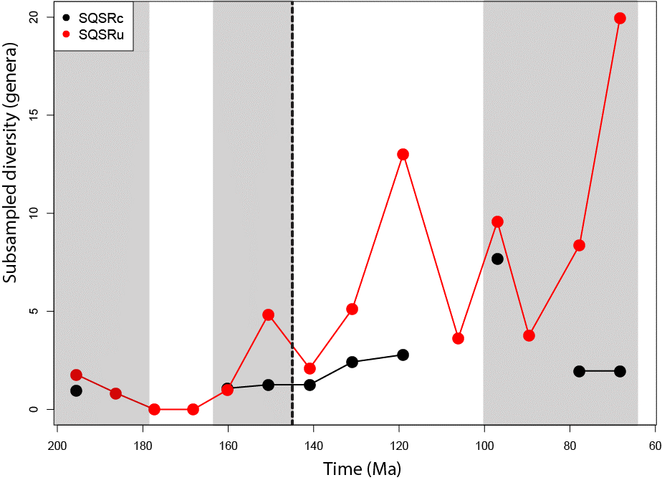
Supplementary Figure 2. Comparison between SQSRc and SQSRu for global terrestrial crocodyliforms.

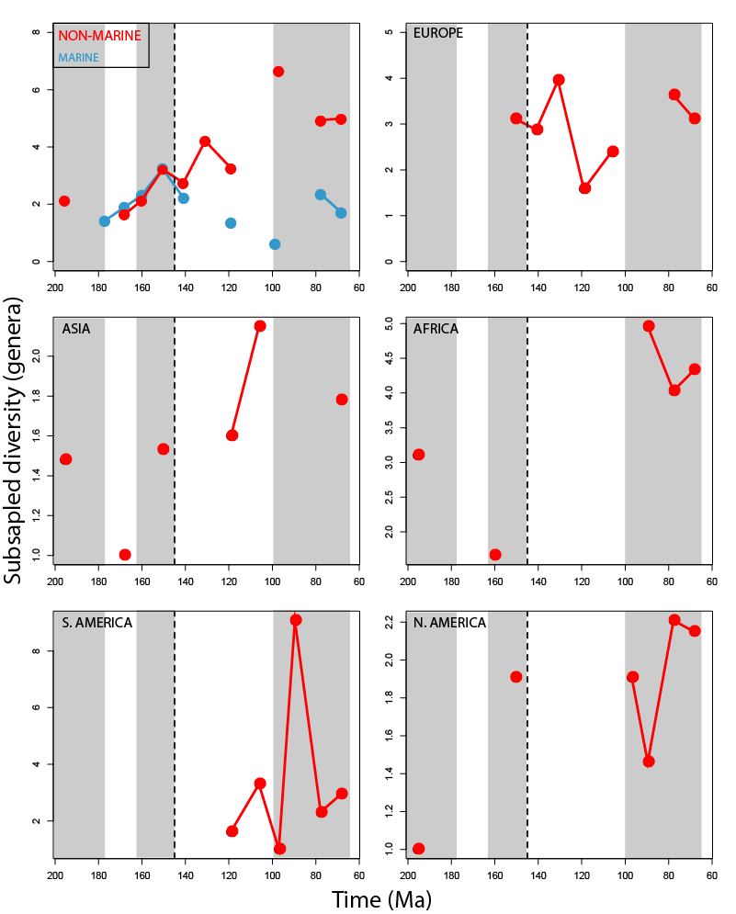
Supplementary Figure 3. Results obtained using SQSPt on a global and palaeocontinental level.

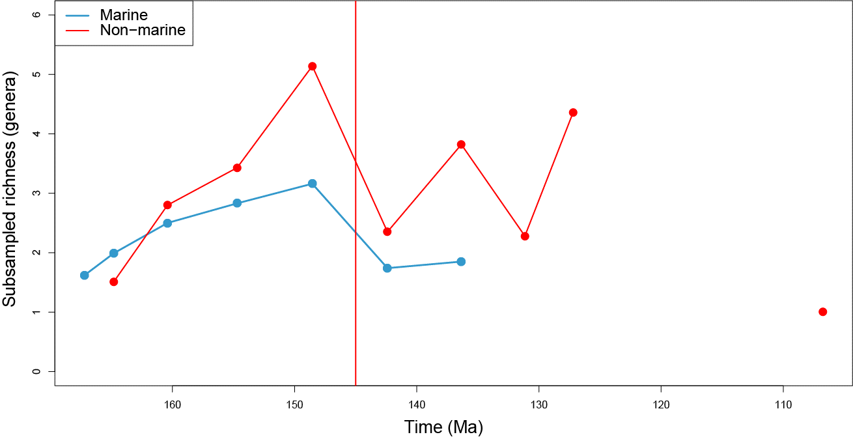
Supplementary Figure 4. Results obtained using SQSRs for marine and non-marine taxa.

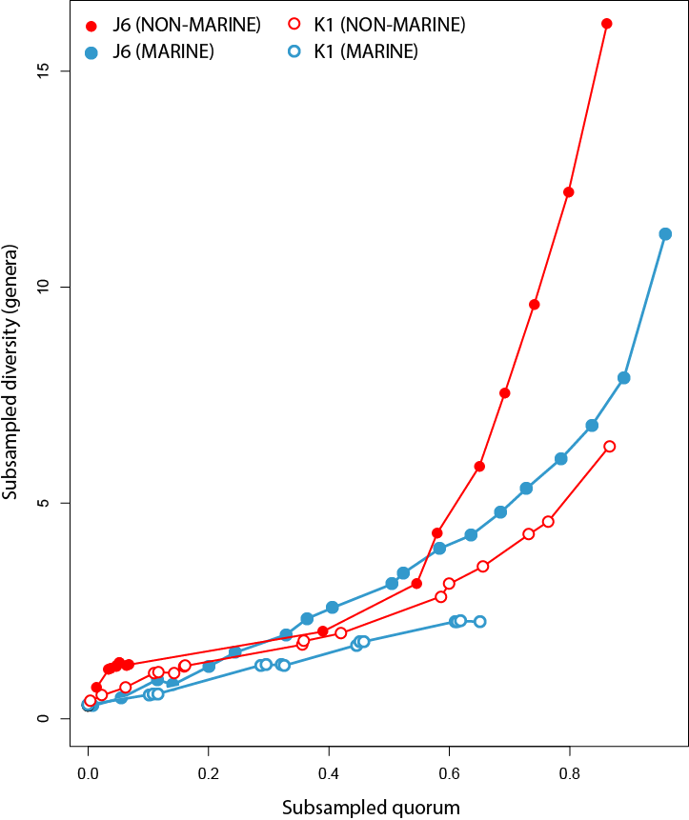
Supplementary Figure 5. Comparison between subsampled quorum level and subsampled richness in the time bins either side of the J/K boundary.

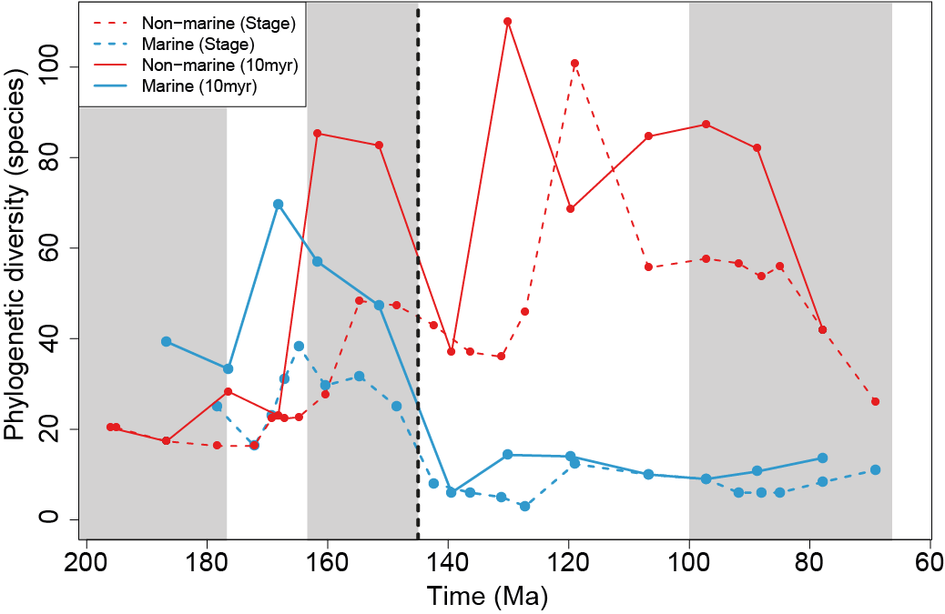
Supplementary Figure 6. Phylogenetic diversity estimate (PDE) at the species level for marine and non-marine sub-groups.

Supertrees in machine readable notation
To read each one of these trees into R, copy them into a new text file, and append the file extension to .tre. See main text for more details.
Genus tree
(((((((((((Shamosuchus,Paralligator),Wannchampsus),Batrachomimus),Rugosuchus)Paralligatoridae,(Gilchristosuchus,(Susisuchus,(((((((Eothoracosaurus,(Thoracosaurus,Ocepesuchus))Gavialoidea,Arenysuchus),(((Stangerochampsa,(Albertochampsa,Brachychampsa)),Deinosuchus),Massaliasuchus,Leidyosuchus)Brevirostres),((Aegyptosuchus,Aegisuchus)Aegyptosuchidae,Borealosuchus))Crocodylia,(Allodaposuchus,(((Pachycheilosuchus,Pietraroiasuchus),Iharkutosuchus),(Acynodon,Hylaeochampsa))Hylaeochampsidae)),Aigialosuchus),Isisfordia)Eusuchia))),(Laganosuchus,(Khoratosuchus,(Koumpiodontosuchus,Bernissartia)))),((Calsoyasuchus,(Eutretauranosuchus,Sunosuchus)),Denazinosuchus,Goniopholis,Woodbinesuchus,Coelosuchus,Vectisuchus,(Siamosuchus,(Nannosuchus,(Hulkepholis,Anteophthalmosuchus))))Goniopholididae),Paluxysuchus),((((((Dyrosaurus,Chenanisuchus),Rhabdognathus),Hyposaurus),Sokotosuchus),(Pholidosaurus,(Terminonaris,Sarcosuchus,Oceanosuchus,Elosuchus,Chalawan,Meridiosaurus))Pholidosauridae),((Pelagosaurus,(Teleidosaurus,(Eoneustes,((((((Geosaurus,Dakosaurus,Aggiosaurus,Plesiosuchus,(Tyrannoneustes,Torvoneustes))Geosaurini,Purranisaurus),Neptunidraco),Metriorhynchus),Suchodus)Geosaurinae,(Gracilineustes,(Maledictosuchus,(Cricosaurus,Rhacheosaurus))Rhacheosaurini))Metriorhynchidae))),((Teleosaurus,Platysuchus),Peipehsuchus,Steneosaurus,Haematosaurus,Machimosaurus)Teleosauridae)Thalattosuchia)),Microsuchus,(((((Alligatorium,Alligatorellus),Montsecosuchus),Atoposaurus),Theriosuchus)Atoposauridae,((Candidodon,(Libycosuchus,(Simosuchus,(Doratodon,((Malawisuchus,Pakasuchus,Neuquensuchus),(((((((((Baurusuchus,Aplestosuchus),Campinasuchus),Stratiotosuchus),(Wargosuchus,Pissarrachampsa)),Gondwanasuchus),Pehuenchesuchus,Pabwehshi,Cynodontosuchus)Baurusuchidae,Comahuesuchus),Chimaerasuchus),(Morrinhosuchus,(Notosuchus,((Mariliasuchus,Labidiosuchus),((Yacarerani,Adamantinasuchus),(Caipirasuchus,(Sphagesaurus,(Armadillosuchus,Caryonosuchus))))Sphagesauridae))))))))Ziphosuchia),(((Araripesuchus,Anatosuchus),Uruguaysuchus)Uruguaysuchidae,((Kaprosuchus,Mahajangasuchus),(Gasparinisuchus,Pepesuchus,Barcinosuchus,Peirosaurus,Lomasuchus,(Montealtosuchus,(Trematochampsa,(Hamadasuchus,Rukwasuchus,Stolokrosuchus))))Peirosauridae)))Notosuchia)Neosuchia)Mesoeucrocodylia,(((Protosuchus,Edentosuchus),Orthosuchus),Kansajsuchus,Platyognathus,Entradasuchus,((Gobiosuchus,Zaraasuchus),(((Shantungosuchus,Sichuanosuchus),Zosuchus),((Fruitachampsa,(Nominosuchus,Shartegosuchus,Kyasuchus)),Hsisosuchus)))))Crocodyliformes;

Species tree
((((((((((Shamosuchus_djadochtaensis,Paralligator_gradilifrons,Paralligator_major),Wannchampsus_kirpachi),Batrachomimus_pastosbonensis),Rugosuchus_nonganensis)Paralligatoridae,(Gilchristosuchus_palatinus,((Susisuchus_jaguaribensis,Susisuchus_anatoceps),(((((((Eothoracosaurus_mississippiensis,((Thoracosaurus_neocesariensis,Thoracosaurus_bahiensis,Thoracosaurus_borissiaki,Thoracosaurus_macrorhynchus),Ocepesuchus_eoafricanus))Gavialoidea,Arenysuchus_gascabadiolorum),(((Stangerochampsa_mccabei,(Albertochampsa_langstoni,Brachychampsa_montana)),(Deinosuchus_riograndensis,Deinosuchus_rugosus)),Massaliasuchus_affuvelensis,Leidyosuchus_canadensis)Brevirostres),((Aegyptosuchus_peyeri,Aegisuchus_witmeri)Aegyptosuchidae,(Borealosuchus_formidabilis,Borealosuchus_sternbergii)))Crocodylia,((Allodaposuchus_subjuniperus,Allodaposuchus_precedens),(((Pachycheilosuchus_trinquei,Pietraroiasuchus_ormezzanoi),Iharkutosuchus_makadii),(Acynodon_lopezi,Acynodon_iberoccitanus,Acynodon_adriaticus,Hylaeochampsa_vectiana))Hylaeochampsidae)),Aigialosuchus_villandensis),Isisfordia_duncani)Eusuchia))),((Laganosuchus_thaumastos,Laganosuchus_maghrebensis),(Khoratosuchus_jintasakuli,(Koumpiodontosuchus_aprosdokiti,Bernissartia_fagesii)))),((Calsoyasuchus_valliceps,((Sunosuchus_junggarensis,Eutretauranosuchus_delfsi),Sunosuchus_miaoi,Sunosuchus_shunanensis)),Denazinosuchus_kirtlandicus,Goniopholis_felchi,Goniopholis_affinis,Goniopholis_undidens,Goniopholis_lucasii,Woodbinesuchus_byersmauricei,Coelosuchus_reedii,Vectisuchus_leptognathus,Goniopholis_phuwiangensis,Goniopholis_brodiei,Goniopholis_crassidens,Goniopholis_stovalli,(Siamosuchus_phuphokensis,(Nannosuchus_gracilidens,(((Hulkepholis_plotos,Hulkepholis_willetti),(Anteophthalmosuchus_hooleyi,Anteophthalmosuchus_esuchae)),(Goniopholis_baryglyphaeus,(Goniopholis_kiplingi,Goniopholis_simus))))))Goniopholididae),Paluxysuchus_newmani),((((((Dyrosaurus_phosphaticus,Chenanisuchus_lateroculi),Rhabdognathus_keiniensis),Hyposaurus_rogersii),Sokotosuchus_ianwilsoni),((Pholidosaurus_decipiens,Pholidosaurus_meyeri,Pholidosaurus_purbeckensis,Pholidosaurus_schaumburgensis),((Terminonaris_browni,Terminonaris_robusta),(Sarcosuchus_hartti,Sarcosuchus_imperator),Oceanosuchus_boecensis,(Elosuchus_felixi,Elosuchus_cherifiensis),Chalawan_thailandicus,Meridiosaurus_vallisparadisi))Pholidosauridae),(((Pelagosaurus_typus,Pelagosaurus_brongniarti),(Teleidosaurus_calvadosii,((Eoneustes_bathonicus,Eoneustes_gaudryi),((((((((Geosaurus_grandis,Geosaurus_giganteus),Geosaurus_lapparenti),Geosaurus_araucaniensis,(Dakosaurus_andiniensis,Dakosaurus_maximus),Aggiosaurus_nicaeensis,Plesiosuchus_manselii,(Tyrannoneustes_lythrodectikos,(Torvoneustes_coryphaeus,Torvoneustes_carpenteri)))Geosaurini,Purranisaurus_potens),Metriorhynchus_brachyrhynchus,Neptunidraco_ammoniticus),(Metriorhynchus_casamiquelai,Metriorhynchus_westermanni)),Suchodus_durobrivensis)Geosaurinae,(Metriorhynchus_palpebosus,Metriorhynchus_littoreus,Metriorhynchus_moreli,(((Metriorhynchus_geoffroyii,Metriorhynchus_hastifer),Metriorhynchus_superciliosus),((Gracilineustes_acutus,Gracilineustes_leedsi),(Maledictosuchus_riclaensis,(((Cricosaurus_saltillensis,Cricosaurus_elegans,(Cricosaurus_gracilis,Cricosaurus_vignaudi,(Cricosaurus_araucanensis,Cricosaurus_macrospondylus,Cricosaurus_lithographicus))),Cricosaurus_suevicus),Rhacheosaurus_gracilis))Rhacheosaurini))))Metriorhynchidae))),(((Teleosaurus_cadomensis,Teleosaurus_chapmani,Teleosaurus_geoffroyi,Teleosaurus_sublidens,Teleosaurus_picteti,Teleosaurus_temporalis,Teleosaurus_megarhinus),Platysuchus_multiscrobiculatus),Peipehsuchus_teleorhinus,Steneosaurus_boutilieri,(Steneosaurus_brevidens,Steneosaurus_brevior,Steneosaurus_brevirostris,Steneosaurus_durobrivensis,Steneosaurus_larteti,Steneosaurus_morinicus,Steneosaurus_gerthi,Steneosaurus_heberti,Steneosaurus_jugleri,Steneosaurus_pictaviensis,Steneosaurus_dasycephalus,Steneosaurus_rudis,Steneosaurus_subulidens,Steneosaurus_gracilirostris,Steneosaurus_intermedius),Haematosaurus_lanceolatus,(((Machimosaurus_hugii,Steneosaurus_edwardsi),(Steneosaurus_megistorhynchus,Steneosaurus_leedsi)),Steneosaurus_bollensis))Teleosauridae)Thalattosuchia)),Microsuchus_schilleri,((((((Alligatorium_meyeri,Alligatorium_franconicum),(Alligatorellus_bavaricus,Alligatorellus_beaumonti)),Montsecosuchus_depereti),(Atoposaurus_jourdani,Atoposaurus_oberndorferi)),((Theriosuchus_ibericus,Theriosuchus_sympiestodon),(Theriosuchus_grandinaris,(Theriosuchus_pusillus,Theriosuchus_guimarotae))))Atoposauridae,((Candidodon_itapecuruense,(Libycosuchus_brevirostris,(Simosuchus_clarki,((Doratodon_carcharidens,Doratodon_ibericus),((Malawisuchus_mwakasyungutiensis,Pakasuchus_kapilimai,Neuquensuchus_universitas),((((((((((Baurusuchus_albertoi,Aplestosuchus_sordidus),(Baurusuchus_salgadoensis,Baurusuchus_pachecoi)),Campinasuchus_dinizi),Stratiotosuchus_maxhechti),(Wargosuchus_australis,Pissarrachampsa_sera)),Gondwanasuchus_scabrosus),Pehuenchesuchus_enderi,Pabwehshi_pakistanensis,Cynodontosuchus_rothi)Baurusuchidae,Comahuesuchus_brachybuccalis),Chimaerasuchus_paradoxus),(Morrinhosuchus_luziae,(Notosuchus_terrestris,((Mariliasuchus_robustus,Mariliasuchus_amarali,Labidiosuchus_amicum),((Yacarerani_boliviensis,Adamantinasuchus_navae),((Caipirasuchus_paulistanus,Caipirasuchus_stenognathus),((Sphagesaurus_huenei,Sphagesaurus_montealtensis),(Armadillosuchus_arrudai,Caryonosuchus_pricei))))Sphagesauridae))))))))Ziphosuchia),(((Araripesuchus_wegeneri,Araripesuchus_rattoides,Araripesuchus_tsangatsangana,Anatosuchus_minor),(((Araripesuchus_patagonicus,(Uruguaysuchus_aznarezi,Uruguaysuchus_terrai)),Araripesuchus_gomesii),Araripesuchus_buitreraensis))Uruguaysuchidae,((Kaprosuchus_saharicus,Mahajangasuchus_insignis),(Gasparinisuchus_peirosauroides,Pepesuchus_deiseae,Barcinosuchus_gradilis,Peirosaurus_tormini,Lomasuchus_palpebrosus,((Montealtosuchus_arrudacamposi,Uberabasuchus_terrificus),(Trematochampsa_taqueti,(Hamadasuchus_rebouli,Rukwasuchus_yajabalijekundu,Stolokrosuchus_lapparenti))))Peirosauridae)))Notosuchia)Neosuchia)Mesoeucrocodylia,((((Protosuchus_haughtoni,Protosuchus_richardsoni,Protosuchus_micmac),Edentosuchus_tienshanensis),Orthosuchus_stormbergi),Kansajsuchus_extensus,Platyognathus_hsui,Entradasuchus_spinosus,(((Gobiosuchus_parvus,Gobiosuchus_kielanae),Zaraasuchus_shepardi),((((Shantungosuchus_chuhsienensis,Shantungosuchus_hangjinensis),(Sichuanosuchus_huidongensis,Sichuanosuchus_shuhanensis)),Zosuchus_davidsoni),((Fruitachampsa_callisoni,(Nominosuchus_matutinus,Shartegosuchus_asperopalatum,Kyasuchus_saevi)),(Hsisosuchus_chungkingensis,(Hsisosuchus_chowi,Hsisosuchus_dashanpuensis)))))))Crocodyliformes;

