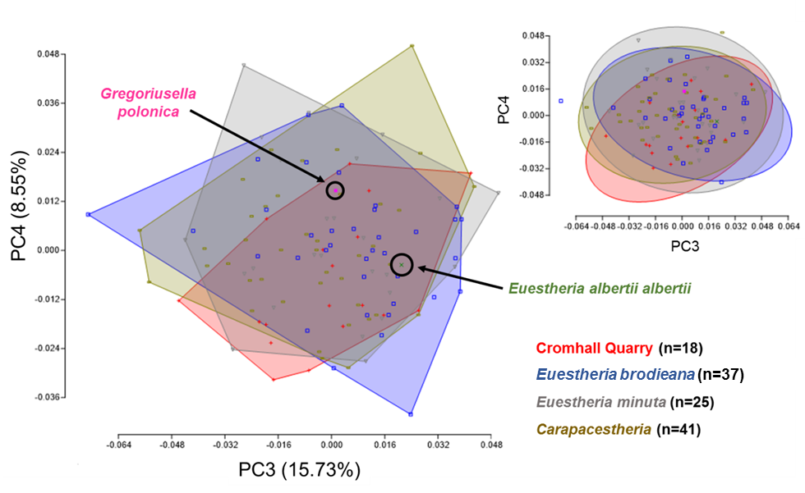
Figure S4.1. Plot of principal components 3 and 4 for Fourier coefficients for the four major groupings (Cromhall Quarry, Euestheria brodieana, Euestheria minuta and Carapacestheria), with single specimens of Euestheria albertii albertii from Germanic deposits (green) and Gregoriusella polonica digitised from Kozur and Weems (2010) (pink) included for comparison. The smaller plot to the top right represents 95% confidence ellipses for the same clusters. NPMANOVA values are shown in Appendix S5.1.

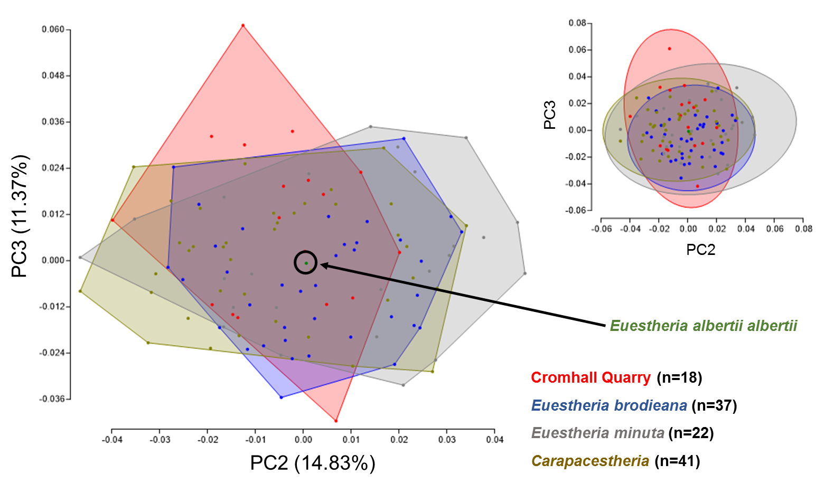
Figure S4.2. Plot of principal components 2 and 3 for Fourier coefficients for the four major groupings (Cromhall Quarry, Euestheria brodieana, Euestheria minuta and Carapacestheria), with a single specimen of Euestheria albertii albertii from Germanic deposits (green) included for comparison. Here the dorsal margin has been removed by connecting the anterior and posterior dorsal extremities with a straight line, and removing excess carapace above this point. Specimens NHMUK 9B3/9(13) and NHMUK 9B3/9(15) were removed from this plot as anomalous, due to their displaying an unrealistic amount of variation in PC2 relative to the rest of the dataset. The smaller plot to the top right represents 95% confidence ellipses for the same clusters. NPMANOVA values are shown in Appendix S5.2.
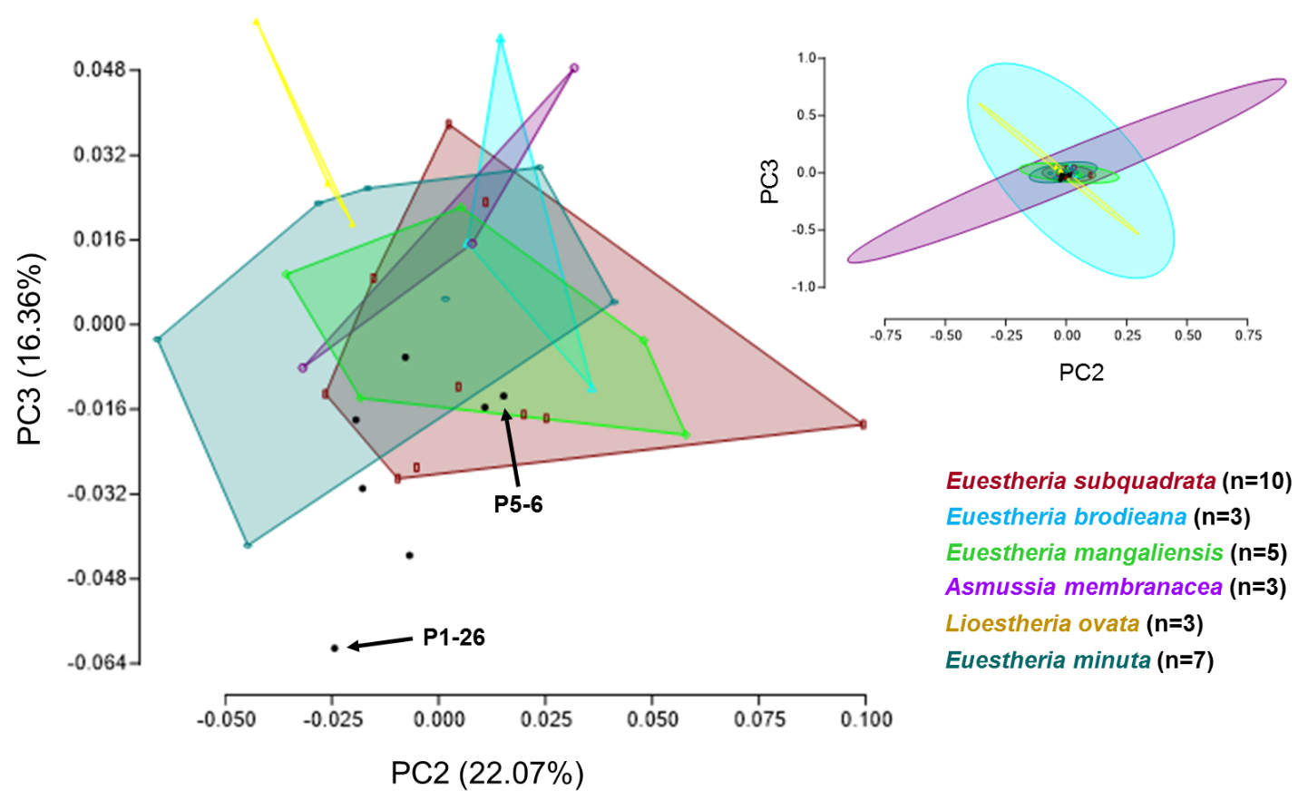
Figure S4.3. Plot of principal components 2 and 3 for Fourier coefficients comparing species previously assigned to the genus Euestheria. Images were taken from the publication A Monograph of the Fossil Estheriae (Jones 1862). The specimens represented by black points are those previously assigned to Euestheria tenella. P1-26 is identified as Limnestheria muensteriana by Jones and Woodward (1993), while P5-6 is assigned to Megasitum tenellum by Kozur and Sittig, 1981). The identity of the other specimens remains unclear. The smaller plot to the top right represents 95% confidence ellipses for the same clusters. Only species with three or more specimens are plotted here. NPMANOVA values are shown in Appendix S5.6.

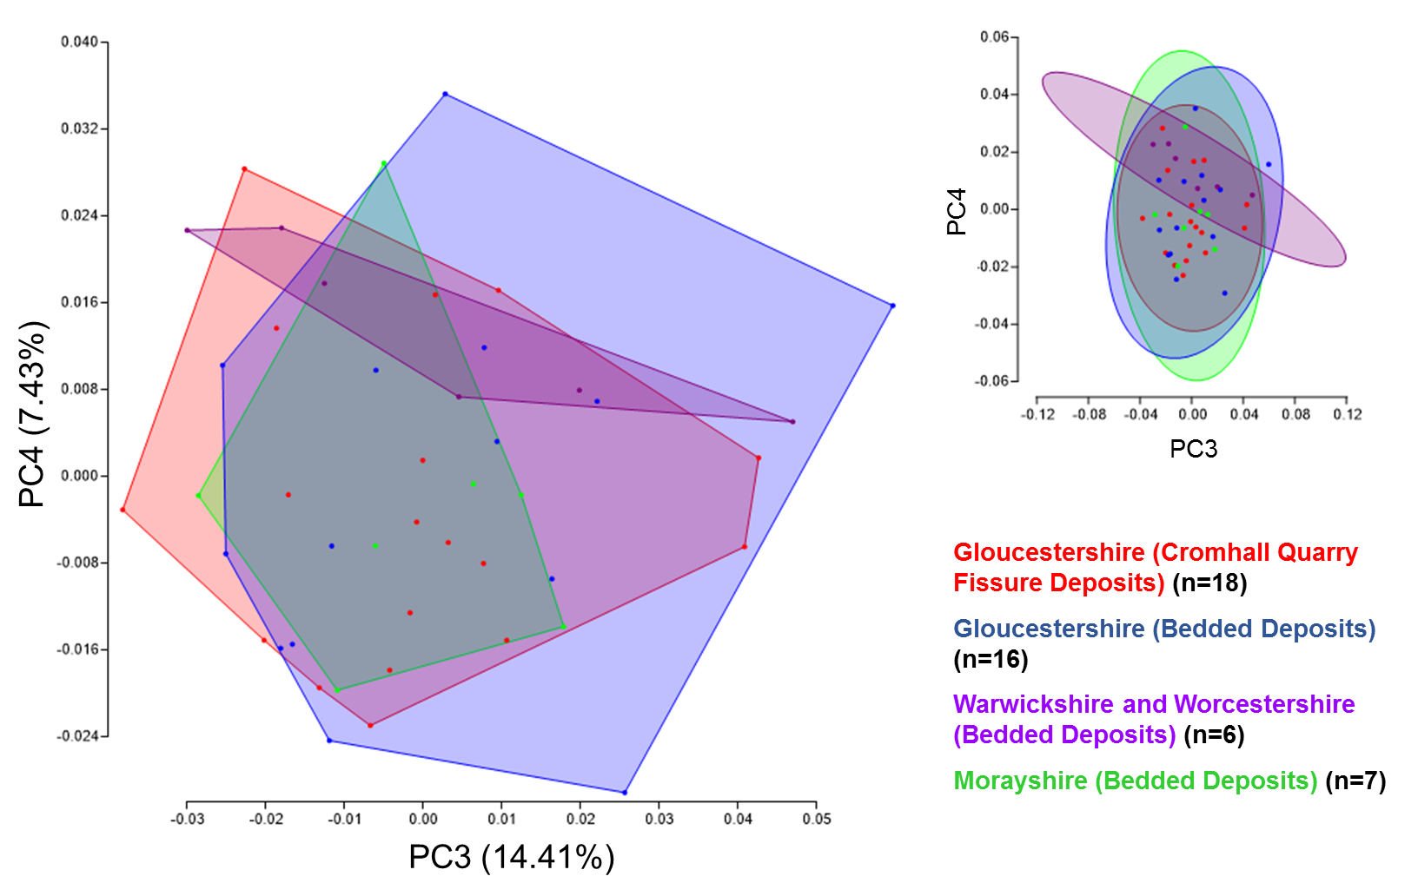
Figure S4.4. Plot of principal components 3 and 4 for Fourier coefficients comparing Euestheria brodieana from various sites around the UK. Localities have been grouped based on broad geographic region, but represent specimens from 18 normally bedded localities (see Appendix 1) and a single fissure locality (Cromhall Quarry, Gloucestershire). The smaller plot to the top right represents 95% confidence ellipses for the same clusters. NPMANOVA values are shown in Appendix S5.5.

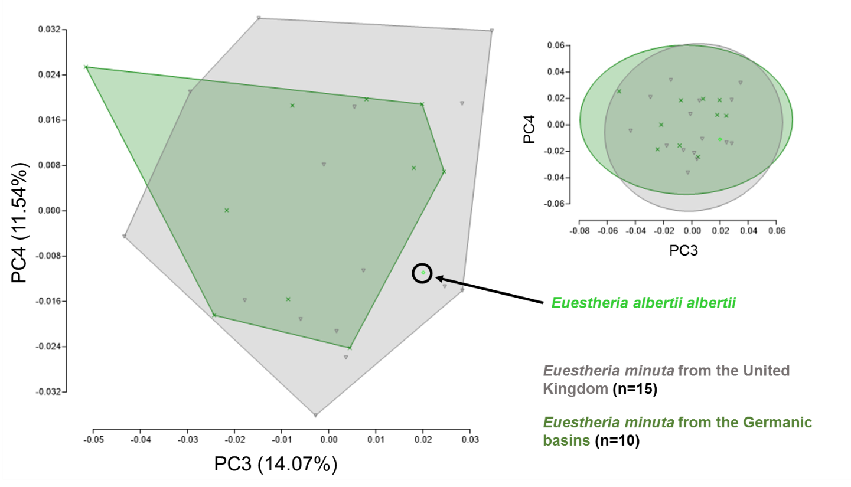
Figure S4.5. Plot of principal components 3 and 4 for Fourier coefficients comparing specimens of Euestheria minuta from the UK and Germany. Specimens in both clusters are from a number of different bedded localities (see Appendix 1). A single specimen of Euestheria albertii albertii from Sinshein, Germany is included for comparison. The smaller plot to the top right displays 95% confidence ellipses for the same clusters. NPMANOVA p-value = 0.2398.

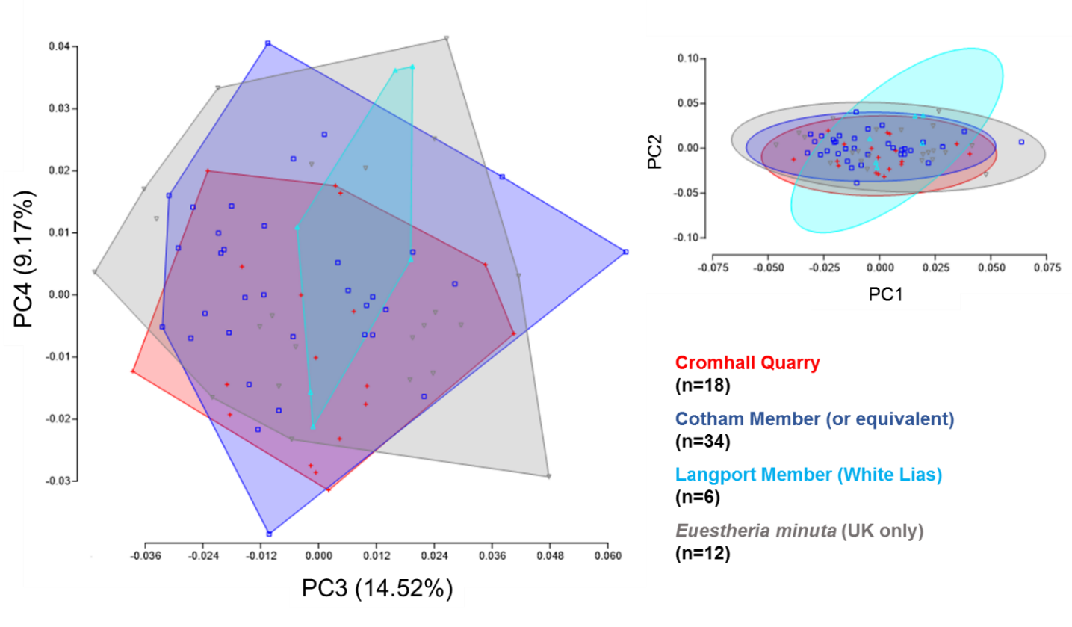
Figure S4.6. Plot of principal components 3 and 4 for Fourier coefficients comparing Euestheria brodieana and Euestheria minuta specimens from Langport Member (White Lias) localities from the UK to specimens of E. brodieana from the Cotham Member or one of its regional equivalents, and E. minuta from other UK localities. The smaller plot to the top right shows 95% confidence ellipses for the same clusters. NPMANOVA values are shown in Appendix S5.4.

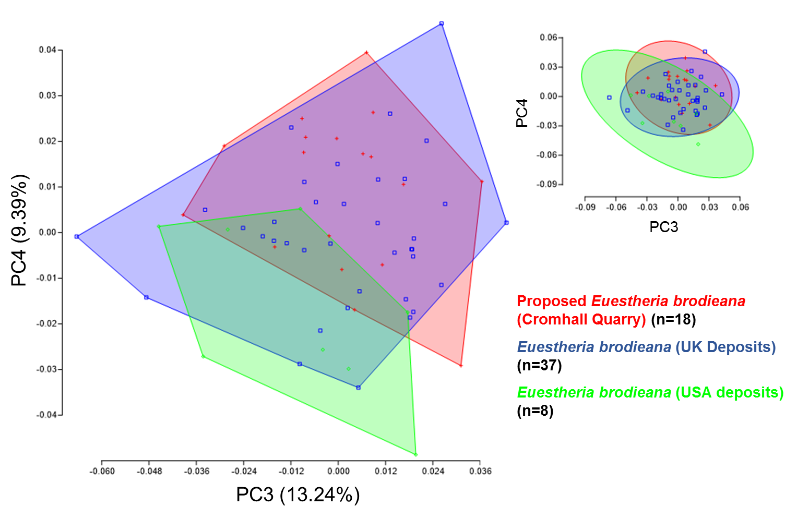
Figure S4.7. Plot of principal components 3 and 4 for Fourier coefficients comparing specimens of Euestheria brodieana from bedded UK deposits, Cromhall Quarry (proposed) and US deposits. Specimens are from a number of different bedded localities (see Appendix 1). The smaller plot to the top right displays 95% confidence ellipses for the same clusters. NPMANOVA values are shown in Appendix S5.3.

