Figure representing the ID of demes in function of their spatial positioning in the network. This figure will help readers to assess to which deme corresponds each summary statistic provided in the simulated datasets shared in DRYAD.
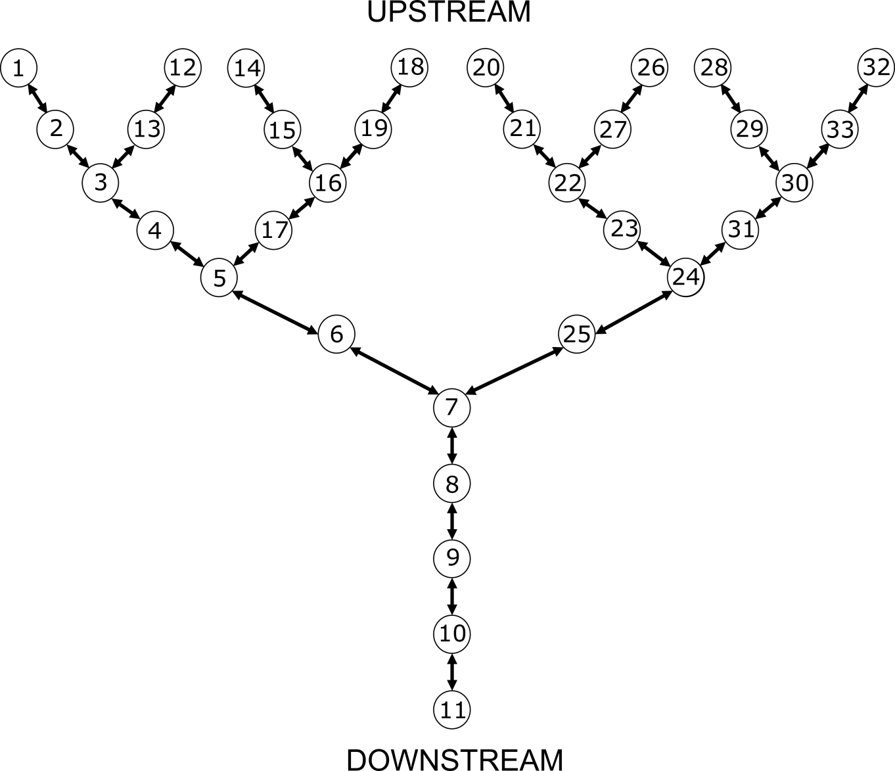
Table reporting the equivalences between the name of the parameters we used in the article and those we used in the .est and .par scripts we share in DRYAD (i.e., the scripts that were used to simulate genetic data with ABCSampler and SIMCOAL 2). We also report the description of the parameters and the prior parameter values we used.
Model | Parameter  (article) | Parameter  (datafiles, .par and .est scripts) | Description | Prior parameter  values
gene-flow | N_{DEMES} | NDEMES | Size of the demes (diploid individuals) | 50; 1,000 or 10,000
 | P_{ASYM} | A2 | Asymmetry in dispersal rate | 1 to 20 by 0.1
 | D_{DOWNSTREAM} | Maval | Downstream-directed dispersal rate | 0.01 to 0.3 by 0.01
habitat availability | N_{HEADWATER} | NDEMESK | Size of the most upstream demes (diploid individuals) | 50 to 500 by 5
 | P_{SCAL} | X | Scaling parameter for calculating downstream demes sizes | 1.0 to 1.5 by 0.1
 | D_{SYMMETRIC} | M | Symmetric dispersal rate | 0.01 to 0.3 by 0.01
colonization | N_{DEMES} | NDEMES | Size of the demes (diploid individuals) | 50; 1,000 or 10,000
 | D_{SYMMETRIC} | M | Symmetric dispersal rate | 0.01 to 0.3 by 0.01
 | T_{END} | TFIN | Time of the ending of the stepwise colonization (generations) | 10 to 500 by 10
 | T_{COLONIZATION} | X | Time elapsed between each colonization step (generations) | 5 to 100 by 5
 | P_{FRAC} | FRAC | Fraction of individuals colonizing a new deme | 0.1 to 0.3 by 0.1
gene-flow  /  habitat | N_{HEADWATER} | NDEMESK | Size of the most upstream demes (diploid individuals) | 50 to 500 by 5
 | P_{ASYM} | A2 | Asymmetry in dispersal rate | 1 to 20 by 0.1
 | D_{DOWNSTREAM} | Maval | Downstream-directed dispersal rate | 0.01 to 0.3 by 0.01
 | P_{SCAL} | X | Scaling parameter for calculating downstream demes sizes | 1.0 to 1.5 by 0.1
gene-flow  /  colonization | N_{DEMES} | NDEMES | Size of the demes (diploid individuals) | 50; 1,000 or 10,000
 | P_{ASYM} | A2 | Asymmetry in dispersal rate | 1 to 20 by 0.1
 | D_{DOWNSTREAM} | Maval | Downstream-directed dispersal rate | 0.01 to 0.3 by 0.01
 | T_{END} | TFIN | Time of the ending of the stepwise colonization (generations) | 10 to 500 by 10
 | T_{COLONIZATION} | Y | Time elapsed between each colonization step (generations) | 5 to 100 by 5
 | P_{FRAC} | FRAC | Fraction of individuals colonizing a new deme | 0.1 to 0.3 by 0.1
habitat  /  colonization | N_{HEADWATER} | NDEMESK | Size of the most upstream demes (diploid individuals) | 50 to 500 by 5
 | P_{SCAL} | X | Scaling parameter for calculating downstream demes sizes | 1.0 to 1.5 by 0.1
 | D_{SYMMETRIC} | M | Symmetric dispersal rate | 0.01 to 0.3 by 0.01
 | T_{END} | TFIN | Time of the ending of the stepwise colonization (generations) | 10 to 500 by 10
 | T_{COLONIZATION} | Y | Time elapsed between each colonization step (generations) | 5 to 100 by 5
 | P_{FRAC} | FRAC | Fraction of individuals colonizing a new deme | 0.1 to 0.3 by 0.1
gene-flow  /  habitat  /  colonization | N_{HEADWATER} | NDEMESK | Size of the most upstream demes (diploid individuals) | 50 to 500 by 5
 | P_{ASYM} | A2 | Asymmetry in dispersal rate | 1 to 20 by 0.1
 | D_{DOWNSTREAM} | Maval | Downstream-directed dispersal rate | 0.01 to 0.3 by 0.01
 | P_{SCAL} | X | Scaling parameter for calculating downstream demes sizes | 1.0 to 1.5 by 0.1
 | T_{END} | TFIN | Time of the ending of the stepwise colonization (generations) | 10 to 500 by 10
 | T_{COLONIZATION} | Y | Time elapsed between each colonization step (generations) | 5 to 100 by 5
 | P_{FRAC} | FRAC | Fraction of individuals colonizing a new deme | 0.1 to 0.3 by 0.1
null model | N_{DEMES} | NDEMES | Size of the demes (diploid individuals) | 50; 1,000 or 10,000
 | D_{SYMMETRIC} | Maval AND Mamont | Symmetric dispersal rate | 0.01 to 0.3 by 0.01

